# Appendix 12: Genograms

## Symbols for drawing the genogram or family tree

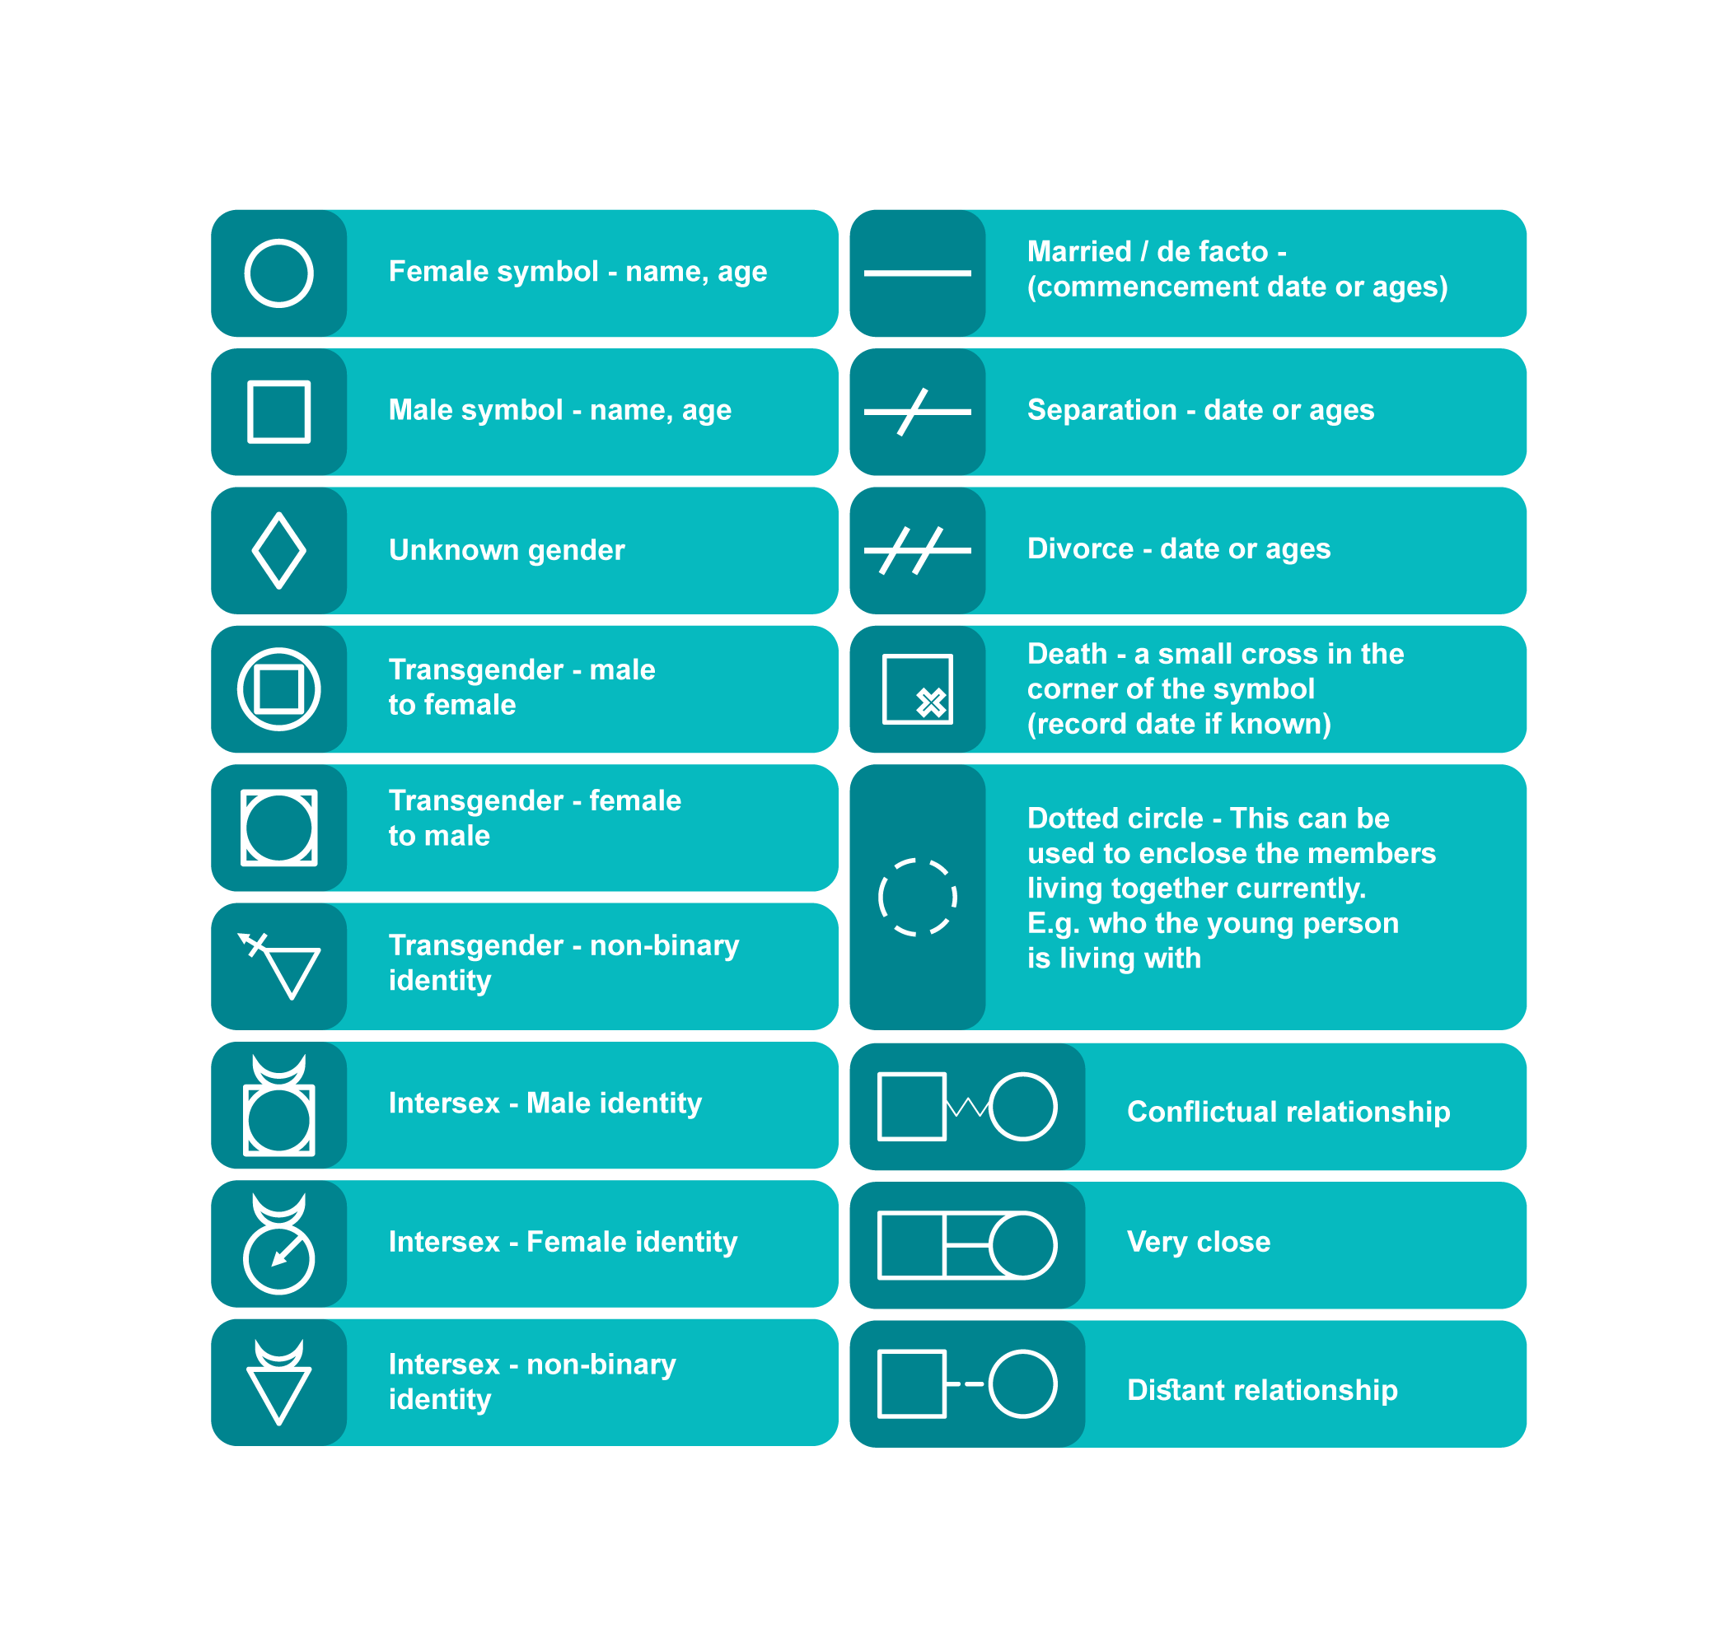

## Any other identities can be added

* Ask about characteristics or behaviours of family members, particularly those relevant to your professional or therapeutic role. For example, health and mental health, issues, alcohol/drug misuse, history of violent crime or criminal history, employment, education.
* Ask linguistic, cultural or faith identity.

## Developing a genogram

* Start by drawing the family structure, who is in the family, in which generations, how they are connected, birth/marriage, deaths etc.
* Include significant others who lived with or cared for the family. You may ask them to tell you a bit about each person.
* As you gather information about family members and relationships, make a note alongside the name.
* Ask about relationships between family members:
  + Who are you closest to?
  + What is/was your relationship like with...?
  + How often do you see...?
  + Where does...live now?
  + Is there any one here that you really don’t get along with?
  + Is there anyone else who is very close in the family? Or who you really don’t get along?