

|  |
| --- |
| Workplace Environment  Statement of Direction  for the Victorian Public Service |

Contents

Vision, purpose and document details 3

Introduction 4

Key objectives 6

Scope 6

How does this help the user? 7

Direction 8

Workplace and collaboration requirements 8

Implementation 19

Timing 19

Constraints 19

Document control 19

Approval 19

Version history 19

Glossary 20

# Vision, purpose and document details

|  |  |  |  |
| --- | --- | --- | --- |
| **VISION** | Simple, effective, modern and standardised workplace systems that free up public servants to focus on delivering services to Victorians. | | |
| **PURPOSE** | To increase productivity of public servants; reduce costs; avoid productivity loss for transferred employees; create an attractive working environment; reduce information management overhead; increase collaboration; simplify systems administration. | | |
| **APPLIES TO** | All Departments and Victoria Police | AUTHORITY | Victorian Secretaries Board |
| **PERIOD** | 2015 to 2019 | ADVISED BY | DPC |
| **ISSUE DATE** | September 2015 | DOCUMENT ID | SOD/ Workplace/01  TRIM DPC D16/138568 |
| **REVIEW DATE** | September 2017 | VERSION | 1.1 – 31 August 2016 |

# Introduction

This document defines the Victorian Public Service/Sector direction for the Workplace Environment.

### Implementation Process

Each department and agency has the responsibility to apply the Information Technology Strategy to the extent that it is applicable within their agency. Agency systems across the public service/sector are at different stages of their lifecycle, therefore the implementation of the Strategy will apply in most cases at points of natural refresh and only in areas where a common approach across more than one agency makes sense (i.e. for back house systems not systems unique to that agencies core functions) – when agencies have developed a business case that supports investment in new or refreshed technology system.

The following implementation process will align department and agency investment cycles to Victorian Government (Victorian Public Service/Sector) solutions. The implementation process is also supported by an opt-out philosophy where government-based solutions are treated as the default.

Figure 1: Implementation process for aligning department and agency investment cycles to Victorian Government Solutions

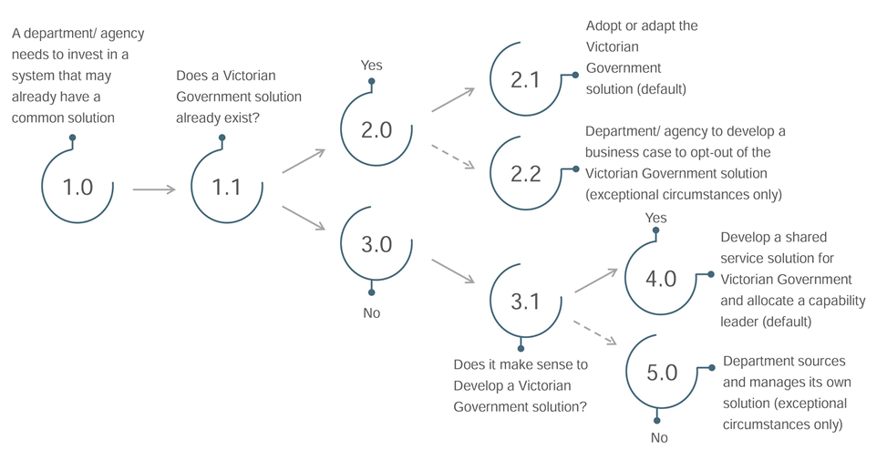

This process:

* best recognises the investment management lifecycle for departments and agencies and utilises their existing funding drivers and commitments;
* continues to support a level of financial and operational autonomy for departments and agencies, whilst ensuring they are mindful of the Victorian Government’s needs and are not building complexity and cost unnecessarily;
* provides an avenue for non-participation in specific initiatives if warranted through the ability for departments and agencies to submit a business case for opting out; and
* strongly supports a common approach as business cases must address the potential loss of benefits to the Victorian Government.

# Key objectives

* Create an attractive working environment – through providing more flexibility to employees to use their preferred systems for basic services where an effective support cost model can be implemented.
* Increase collaboration – through common platforms and modern tools.
* Increase productivity of public servants – through simplified approaches to common tasks, ease of accessing relevant information through standardised systems, and simplified data transfer.
* Reduce costs – through consolidated licensing, single instances of systems and avoiding multiple procurements by agencies.
* Reduce machinery of government costs – through avoided productivity loss for transferred employees in not needing to understand new systems and their underlying email address not needing to change.
* Reduce information management overhead – through standard systems and approaches to managing documents, records, data and search.
* Simplify systems administration – through standardised, single instance ‘back end’ systems.

# Scope

The following departments and agencies are formally in scope:

|  |  |
| --- | --- |
| ***All departments***  Department of Economic Development, Jobs, Transport and Resources  Department of Education and Training  Department of Environment, Land, Water and Planning  Department of Health and Human Services  Department of Justice and Regulation  Department of Premier and Cabinet  Department of Treasury and Finance | ***Agencies***  Ambulance Victoria  CenITex  Country Fire Authority  Court Services Victoria  Emergency Services Telecommunications Authority  Environment Protection Authority  Metropolitan Fire and Emergency Services Board  Public Transport Victoria  State Revenue Office  Victoria Police  VicRoads  Victoria State Emergency Service |

# How does this help the user?

The ideal Victorian Government workplace experience sees a user as part of the whole Government first, followed by their specific department or agency. This statement of direction focuses on user experience. An overview of the Workplace Environment is provided below.

**OFFICE PRODUCTIVITY**

* Choice of Office Productivity tools across all devices
* Common standard for final document versions for improved portability
* Access to printing and scanning services on all devices from all locations
* Digital signatures to reduce paper consumption and improve workflow
* Hot desk for ‘work anywhere’ capability
* Co-authoring for improved efficiency in document collaboration

**DEVICES**

* Bring-Your-Own-Device (BYOD) or corporate provided
* Choice and range of desktops/laptop - Windows, Mac
* Choice and range of mobile devices - iOS, Windows, Android
* Current up to date ‘tech’

**APP STORE**

* Consistent experience requesting and accessing applications
* Business applications (internal and cloud)
* Productivity applications (desktop, Mac, tablet etc..)   
    
  .

**CORPORATE SERVICES**

* Consistent HR systems, processes and self-service tools
* One time on/off-boarding
* Common financial procurement systems and processes, including expenses and travel
* Shared training and learning process, systems liked to HR
* VG intranet
* Common fleet system and processes

**COLLABORATION**

* Common tools for communicating with Victorian Government staff, related entities and citizens
* One email and calendar system with common address book and resources reservations
* User choice of mail client across devices
* Video conferencing from any location and device
* Instant messaging with availability status
* One common social, team room platform
* Internal knowledge sharing or WiKi

**DOCUMENT MANAGEMENT**

* Consistent experience when creating, searching, accessing, maintaining and sharing documents
* Real time co-authoring of documents
* One Victorian Electronic Records Strategy (VERS) compliant document management system for Victorian Government
* Common repository for file sync and share
* Caters for Cabinet-In-Confidence documents

**ACCESS**

* Consistent experience when accessing a common VG network from any location
* Seamless WiFi connectivity from any VG location
* Remote access to all shared systems from any device
* Low latency when accessing shared services from any location – particularly regional

**IDENTITY**

* One network logon - single username and password for logon to common network
* VG ID card/smartcard for building access and remote access
* Single-sign-on to applications

**FOUNDATIONAL COMPONENTS**

* *STANDARD SYSTEMS & BUSINESS PROCESSES*

Identity and Access Management

Collaboration systems

Human Capital Management system

Financial Management system

Central repository for common data

Information security

Records management policy

* *COMMON INFORMATION TYPES*

Master data definition - Chart of Accounts, Employee

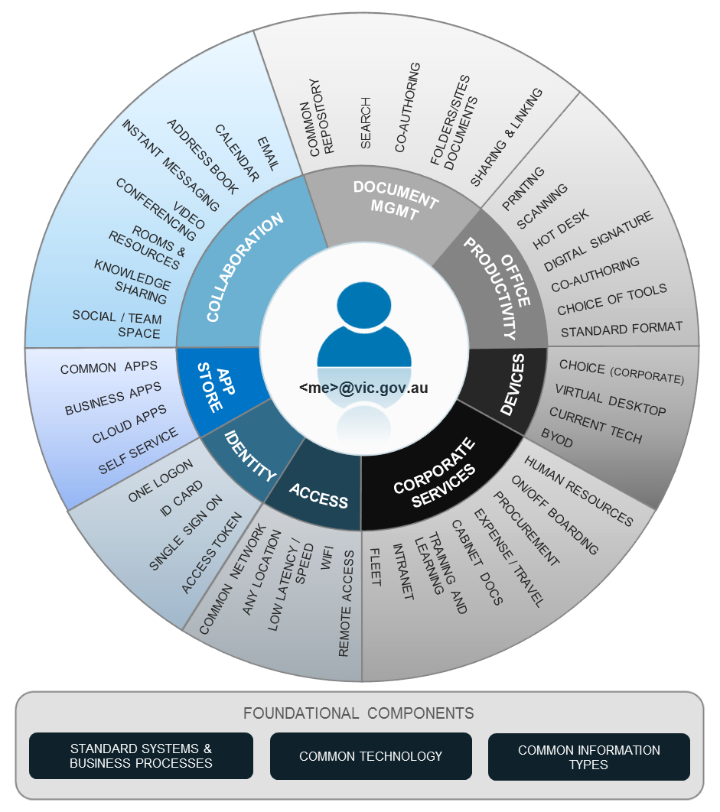

* *COMMON TECHNOLOGY*

Secure information exchange technologies

Network carriage

Mobile device management

Base operating environments

# Direction

The following section outlines the Workplace Environment future direction by way of high level requirements

## Workplace and collaboration requirements

There are eight sections that define the high level user experience requirements.

* 1. Collaboration
  2. Document management
  3. Office productivity
  4. App Store
  5. Identity
  6. Devices
  7. Access (network access)
  8. Corporate services

### Collaboration

The following table defines the user experience direction (requirements) for collaboration.

##### Objective

A government user will have a consistent collaboration experience, including common methods and tools for communicating with other government staff, related entities and citizens.

|  |  |  |  |
| --- | --- | --- | --- |
| **Reference** | **Direction** | **Category** | **User Experience** |
| C-01 | A user will have one primary email address based on first.last.[id]@vic.gov.au | Email | One email account regardless of the actual department or agency. This will remain current throughout Victorian Government working life.  The email address will conform to the federal Email Address Naming Standard - first.last.[id]@vic.gov.au. Note: [id] only exists when more than one staff person has the same name.  All emails sent will be from this primary account (from a system perspective).  Machinery-of-Government (MoG) changes will not impact the primary email account.  Access to email will be available from any device and location. |
| C-02 | A user may have one or more aliases linked to their primary account | Email | An alias will allow for agency branding, however all email will resolve to the one primary account.  All email sent will be from the primary account.  MoG changes may involve a change in email alias only.  The alias address will conform to the federal Email Address Naming Standard.  Agencies are not required to use an alias. |
| C-03 | A user will have one primary calendar account attached to their primary email | Calendar | One calendar system regardless of the actual department or agency they work for.  MoG changes will not impact the primary calendar account.  Access to the calendar will be available from any device, any location, any time. |
| C-04 | Calendar availability for all users will be accessible by all users across Victorian Government | Calendar | Calendar availability will be visible by all users across Victorian Government for the purpose of meeting scheduling.  Ability to mark calendar entries and/or availability as private/hidden. |
| C-05 | A user will have access to and be able to book rooms and resources at any Victorian Government location | Calendar (Rooms & Resource) | Access to all rooms and resources reservations across all government locations for scheduling meetings in offices other than their own.  Note – a resource owner will have the option to restrict and/or apply workflow approval for all rooms and resource under their control.  Note – this does not include physical access to the actual premises itself. |
| C-06 | A user will have access to one global Victorian Government address book | Address book | Access to a Victorian Government global address book will provide contact information and calendar availability for users across the government. |
| C-07 | A user will have access to a common Victorian Government Instant Messaging (IM) environment | IM | Access to a common IM environment for real time collaboration with co-workers across government.  The IM capability will be available from any device and location. |
| C-08 | A user will have access to a common Victorian Government Video Conferencing (VC) environment | IM | Access to a common VC environment for real time video collaboration with co-workers, related entities and citizens.  The VC capability will be available from any device and location. |
| C-09 | A user will have access to a common Victorian Government knowledge sharing environment | Knowledge share | Access to a common knowledge sharing (e.g Wiki) environment to find and share (publish) information. |
| C-10 | A user will have access to a common Victorian Government Social Collaboration environment | Social | Access to a common environment for social collaboration with local team members, departmental colleagues/ staff/groups and other government departments.  Access to the social collaboration environment will be available from any device and location. |

### Document management

The following table defines the user experience direction (requirements) for working with general office documents.

##### Objective

A user will have a consistent experience for creating, searching, accessing, maintaining and sharing documents (any file-based data e.g. PDF, rich text documents, spreadsheets, images etc…).

|  |  |  |  |
| --- | --- | --- | --- |
| Reference | Direction | Category | User Experience |
| DM-01 | A user will have access to a common government document management system | System | One common document management (DM) environment for consistent data access regardless of the actual department or agency. |
| The following requirements are an extension to the common DM environment listed in DM-01. | | | |
| DM-02 | Compliant with security and records management policies | Policy | ‘Compliance by stealth’ – The DM environment makes it easy to comply with records management policies.  One data classification schema.  Consistent approach in applying protective markings.  Consistent data version and archiving controls.  Caters for Cabinet-In-Confidence. |
| DM-03 | VERS-compliant | Policy | Unknown to the user, the system will comply with the Public Records Office Victoria (PROV) Victorian Electronic Records Strategy (VERS). |
| DM-04 | Access to team sites and/or folders | Data | Common team sites and team folders for segregation of data. |
| DM-05 | Access to personal (work) folders | Data | One personal work folder that never changes, including during MoG or a voluntary change from one department to another. |
| DM-06 | Sharing and linking | Share | File and/or folder sharing within the government and external agencies where applicable.  Allows for sending links to documents rather than the document itself – reduces redundant copies, improves collaboration and improves security. |
| DM-07 | Co-authoring | Share | Online/real time co-authoring (for some documents) allows for improved efficiency in creating and updating documents. |
| DM-08 | Access methods | Access | Access to the DM environment will be available from any device and location. |
| DM-09 | Enterprise search | Search | Common tools for searching across the repository.  Improve accuracy and response time of FOI requests. |
| DM-10 | Minimise impact of MoG | System | Common repository minimises the impact of MoG changes.  Large data transfers will become changes in security and permissions.  Data moves within the common repository and retains metadata, version history and access logs. |

### Office productivity

The following table defines the user experience direction (requirements) for office productivity.

##### Objective

A user will have a choice of compatible office productivity tools and access to printing and scanning services from all government devices and locations.

|  |  |  |  |
| --- | --- | --- | --- |
| Reference | Direction | Category | User Experience |
| OP-01 | A user will have a choice of any office productivity tools | Tools | Choice of office productivity tools (e.g. document editing, spreadsheets, and presentations) across all devices.  Any corporate provided office productivity tools will be available via the Victorian Government App store. |
| OP-02 | Common standard for all final document versions | Standards | To allow for choice of tools (OP-01), all final documents will be saved/converted to Portable Document Format (PDF). |
| OP-03 | A user will be able to print to any printer at any location | Printing | Search for and print a document to any shared printer on the government network from any device and location. |
| OP-04 | A user will be able to scan a document from any scanner at any location and access the files via the document management system (refer above) | Scanning | Scan a document and have the files sent to any folder within the common government document management system. |
| OP-05 | A user will be able to digitally sign a document | Standards | Digital signatures will be an acceptable alternative to paper-based signatures and remove the need to print and collect signatures on scanned documents.  Digital signature capability will be available for PDF documents. |
| OP-06 | A user will be able to work at any office location | Hot desk | Hot desks (desktops) for access to the common VG network (refer to network access) will be available from any office.  Hot desk desktops will be fully patched and maintained and provide fast logon /logoff capability.  Hot desk facilities (WiFi, network cable) will be available from any office. |

### App Store

The following table defines the user experience direction (requirements) for accessing and provisioning applications.

##### Objective

A user will have a consistent experience in requesting, accessing and installing applications (internal, external and cloud) via a common Victorian Government App Store.

|  |  |  |  |
| --- | --- | --- | --- |
| Reference | Direction | Category | User Experience |
| AS-01 | A user will have access to a common internal Victorian Government ‘App Store’ | Apps | The App Store will provide a consistent self-service experience for requesting, installing and accessing applications. |
| The following requirements are an extension to the common App Store environment listed  in AS-01. | | | |
| AS-02 | Common applications | Common Apps | Common applications that do not require approval to install can be installed via the App Store to the target device.  For corporate devices, the installation will not require administrative privileges on the device.  Application versions will be frequently updated to current or near-current version. |
| AS-03 | Business/restricted applications | Business Apps | Business or restricted applications that require approval can be requested via the App Store.  The App Store will manage the approval via a customised workflow.  On approval, the application can be installed via the App Store to the target device.  Note - device restrictions/limitation may apply for some businesses or restricted applications. |
| AS-04 | Software-as-a-service (SaaS - i.e cloud apps) | Cloud Apps | SaaS application access can be requested via the App Store.  The App Store will manage the approval via a customised workflow.  Applications delivered as a service will be provisioned and de-provisioned to the service provider by the App Store. |
| AS-05 | Launch portal | Cloud Apps | Access to a common government application portal to run cloud applications.  Authentication to the cloud portal will be via a single Victorian Government credential – refer to identity.  The portal will be available from any device and location. |

### Identity

The following table defines the user experience direction (requirements) for a single Victorian Government identity.

##### Objective

A user will have a single Victorian Government identity (ID) and related security credentials for gaining access to Victorian Government network and related services.

|  |  |  |  |
| --- | --- | --- | --- |
| Reference | Direction | Category | User Experience |
| ID-01 | Common Victorian Government staff ID | One ID | One unique Victorian Government ID.  The ID stays the same regardless of changes as a result of MoG, marital status, gender, employment type or even gaps in employment (i.e. returning to VG). |
| ID-02 | Common Victorian Government ID card | One ID | One staff ID card can be used as approved identification at all Victorian Government offices.  ID card can be used to gain security access to multiple office locations (where applicable).  ID card can also be used as Smartcard for authentication.  ID cards will be issued, validated and cancelled by a common system and linked to common HR for on/off boarding. |
| ID-03 | Common Victorian Government network logon/username | One Logon | One logon/username that is same as or linked to the staff ID.  Username can be associated with a password, token or smartcard for authentication to the common VG network and related services – refer to access (network access). |
| ID-04 | Access to common systems | One Logon | One username can be used to access the App Store for requesting, installing and running applications – refer to App Store.  Allows for single-sign-on – using the one username to access multiple systems without the need to re-authenticate (application dependent).  Allows for same-sign-on – use the one username to access multiple systems with the same credentials (requires re-logon).  This username can be used to:  access collaboration systems and tools – refer to collaboration  access and assign file/folder permissions to the common document management system – refer to document management  access the hot desk environment – refer to office productivity  access the virtual desk environment – refer to devices. |

### Devices

The following table defines the user experience direction (requirements) for device of choice.

##### Objective

A user will have a number of options for their device of choice; these include Bring-Your-Own-Device (BYOD), corporate provided desktop and/or mobile devices.

|  |  |  |  |
| --- | --- | --- | --- |
| **Reference** | **Direction** | **Category** | **User Experience** |
| DV-01 | A user will have access to a corporate provided desktop and/or mobile device | Corporate | Choice of corporate desktop (e.g. Windows, Mac) and mobile devices (e.g. iOS, Android, Windows). |
| DV-02 | A user will have access to a corporate virtual desktop | Corporate | Access to a common virtual desktop accessible from any device and location using a VG username – refer to identity. |
| DV-03 | Acceptable logon/off times | Corporate | Corporate provided desktops (including virtual) and laptops will have acceptable logon/off times.  Note – logon/off times are also related to access requirements. |
| DV-04 | A user will have access to current ‘tech’ | Currency | Corporate provided desktops and laptops (including hot desks) will run the near current version of their applicable operating system.  New corporate provided devices will be provided on modern hardware. |
| DV-05 | A user will have the choice to provide and use their own device(s) for activities related to government work | BYOD | Access the corporate network and related resources (within reason, as approved) using personal device (BYOD).  BYOD devices include but are not limited to laptops (Windows and Mac), tablets and smartphones. |

### Access (network access)

The following table defines the user experience direction (requirements) for accessing the common Victorian Government network and related services.

##### Objective

A user will access the workplace services via a common Victorian Government network.

|  |  |  |  |
| --- | --- | --- | --- |
| Reference | Direction | Category | User Experience |
| NA-01 | A user will have access to a common Victorian Government (VG) network | Common network | New workplace services and select existing services will be accessible via a common VG network. |
| The following requirements are an extension to the common network environment listed  in NA-01. | | | |
| NA-02 | Logon using a Victorian Government username | Access | Access to the VG network will be authenticated using the VG username (refer to identity). |
| NA-03 | From multiple devices and locations | Access | Access to the VG network will be available from any corporate and approved BYOD device at any VG location via cable or WiFi.  Remote (offsite) access to the network will be available for any corporate and approved BYOD device via the internet.  Note – remote access will require additional security and/or authentication. |
| NA-04 | Network performance | Latency | ‘Fast/consistent network speed’:  low latency from all VG office locations including regional offices.  minimal impact on desktop logon/off times for all corporate provide devices – refer to devices.  responsive access to all workplace services. |

### Corporate services

The following table provides a sample of common corporate services that can be available via the Victorian Government workplace.

##### Objective

Through the delivery of the identity, App Store and access requirements, a variety of shared corporate services will to available to a user via the common network.

|  |  |  |  |
| --- | --- | --- | --- |
| **Reference** | **Direction** | **Category** | **User Experience** |
| CS-01 | A user will have access to common Victorian Government Human resources (HR) system and services | HR | Consistent/common set of HR processes and procedures for on/off-boarding.  Common recruitment processes and systems.  Payroll and leave entitlements – no more transfers.  Common employee self-services tools – pay slips, personal information and tax/super/bank details.  Common performance and progression system. |
| CS-02 | HR will have access to a single Victorian Government On/off-boarding process | HR | One on/off boarding system for easy provisioning to the common network – refer to identity and access. |
| CS-03 | A user will have access common Victorian Government process and system for managing travel and expense claims | Expense | One system for requesting and entering travel requirements.  One process and system for entering expense claims for approval. |
| CS-04 | A user will have access common Victorian Government eLearning/training environment | Training | One process and related system for requesting and managing corporate training requests.  Common system for internal training/eLearning. |
| CS-05 | A user will have access to common Victorian Government approach to creating, maintaining and submitting Cabinet documentation | Cabinet | One process and related system for creating, submitting and archiving all cabinet documentation. |
| CS-06 | A user will have access to common Victorian Government fleet | Fleet | One process and related system for requesting access to VG car pool. |
| CS-07 | A user will have access common Victorian Government intranet | Intranet | One common intranet environment for VG access via the common network. |

### Foundational components

The following table lists the core foundational systems, business process, policies, technologies and information types that underpin this standard.

| **Reference** | **Foundation component** | **Category** | **Dependency/details** |
| --- | --- | --- | --- |
| FC-01 | Identity and access management (IDAM) | Standard systems & business processes | Identity - a common set of standards and systems relating to IDAM are essential for the implementation of the identity requirements.  A common IDAM will provide:  user directory and authentication services for accessing all workplace services, including SaaS.  user tools for account management, including password reset.  The identity requirements from a user logon perspective are critical for the implementation of the following requirements:  collaboration  document management  office productivity – printing, scanning and digital signatures  device – logon  App Store  corporate services  access. |
| FC-02 | Central repository for common data | Standard systems & business processes | Document management – a common data repository is essential for the implementation of the document management requirements. |
| FC-03 | Information security and records management policies | Standard systems & business processes | All sections of the workplace standard will benefit from common and consistent implementation of records management and information security polices, standards and frameworks. |
| FC-04 | Human capital management (HCM) system | Standard systems & business processes | Identity and a common HCM are interrelated. While they can be implemented separately, they provide a better user experience and improve security when they are fully integrated.  Corporate services – common HR services, tools and process will benefit from a common HCM system.  Workforce data reporting – Victorian Public Sector Commission (VPSC). |
| FC-05 | Financial management system (FMS) | Standard systems & business processes | All workplace systems would benefit from a common VG financial management system, in particular a common chart of accounts for service charge-back.  System integration is less complex with one common FMS.  A common approach to ICT expenditure assists VAGO reporting requirements. |
| FC-06 | Mobile device management (MDM) | Common technology | Devices – corporate provided mobile devices and BYOD devices will require a common approach and system for device management. |
| FC-07 | Integration platform | Common technology | All workplace systems would benefit from a common set of integration standards and implementation of a common VG integration platform.  Application/service integration will be via a common API gateway to fully de-couple systems.  A VG integration platform will provide a secure mechanism for department data transfer. |
| FC-08 | Network | Common technology | All workplace systems require a common VG network including policies and procedures for connecting existing networks.  The common network will provide the backbone for accessing common workplace services.  Low latency from all locations, particularly regional offices. |
| FC-09 | Master data definitions | Common information types | All common workplace systems require a common definition of data types across VG.  At a minimum, common data definitions are required for:  chart of accounts  employee record  network user  data classification and protective markings. |

# Implementation

## Timing

Departments will adopt these requirements at the time of consideration for new or refreshed services that fall within the sections of the systems described in this document.

## Constraints

DPC recognises departments may have existing systems and/or vendor contracts in place that may affect their timing for implementing this direction.

# Document control

## Approval

This document was approved by the Victorian Secretaries Board on 30th September 2015 and applies from the date of issue (see cover).

## Version history

|  |  |  |
| --- | --- | --- |
| Version | Date | Comments |
| 1.0 | 30 Sept 2015 | Approved by VSB |
| 1.1 | 17 Aug 2016 | Changes approved by VSB:  Document renamed from Workplace Environment Standard  Minor content changes to reflect this document name change. |

# Glossary

|  |  |
| --- | --- |
| Term | Meaning |
| BYOD | Bring-Your-Own-Device |
| CEO | Chief Executive Office |
| direction | Statement of Direction (this document) |
| HCM | Human Capital Management |
| HR | Human Resources |
| IDAM | Identity and Access Management |
| IM | instant messaging |
| instant messaging | Instant messaging or ‘IM’ is the exchange of text messages through a software application in real-time. IM includes the ability to see whether a chosen co-worker is online and connected through the selected service. |
| IT Strategy | Information Technology Strategy for the Victorian Government, 2016 to 2020 |
| MoG | Machinery of Government |
| public entity/entities | Refer to Victorian Public Entities |
| public service body/bodies | Refer to Victorian Public Service |
| Workplace Environment | The Workplace Environment Statement of Direction (this document) |
| PROV | Public Records Office Victoria |
| SOD/SoD | Statement of Direction |
| VPSC | Victorian Public Sector Commission http://vpsc.vic.gov.au/ |
| VERS | Victorian Electronic Records Strategy http://prov.vic.gov.au/government/vers |
| VC | Video conferencing |
| video conferencing | Video conferencing (VC) is the conduct of a video conference (also known as video teleconference) by a set of telecommunication technologies which allow two or more locations to communicate by simultaneous two-way video and audio transmissions |
| VG | Victorian Government |
| Victorian Public Entities | The definition of a public entity is comprehensive and will not be reproduced here. For a full definition please refer to the *Public Administration Act 2004.* |
| Victorian Public Sector | The Victorian Public Sector comprises the Victorian Public Service and Victoria Public Entities – refer to the *Public Administration Act 2004.* |
| Victorian Public Service | The Victorian Public Service, also referred to as public service bodies, means a) Departments, b) an Administrative Office; or (c) the State Services Authority - refer to the *Public Administration Act 2004.* |
| VSB | Victorian Secretaries Board |