|  |
| --- |
| DecorativeData Management |
| Position paper |

# Position

The need for data reform is articulated in the [*Information Technology Strategy for the Victorian Government, 2016-2020*](http://www.enterprisesolutions.vic.gov.au/it-strategy/) (IT Strategy). The Victorian Government’s [*Information Management Framework*](http://www.enterprisesolutions.vic.gov.au/information-management/) (framework) further highlights the importance of data as a tactical and strategic asset, and an enabler of insight and business transformation. In the framework, data management is one of seven key enablers supporting better information management.

The aim is for trusted and holistically managed data that is protected where required, shared routinely, released appropriately, and used strategically to improve decision making, policy development, service design and operational delivery.

The Victorian Government (the government) will develop a range of standards and supporting guidance to establish consistent practices for managing its data. These standards will be adopted by departments, with implementation prioritised according to business needs, value and risks.

For the purpose of this paper, *department* implies ‘department’ and ‘Victoria Police’.

# Glossary

The glossary of terms and abbreviations used in this document are defined in the [*IM GUIDE 03 Information Management Glossary*](http://www.enterprisesolutions.vic.gov.au/information-management/)*.*

# Business drivers

* An increasing expectation that decisions on public policy should be based on evidence and insights.
* Data is driving fundamental changes to daily life and the economy.[1] Government needs to keep pace; using its data to provide more effective and joined-up services that meet users’ needs.
* Recent commissions, audits and reports (see Appendix 1) have found that fragmented, inconsistent and poor quality data is preventing an integrated view of citizens (increasing risks to their safety and wellbeing) and the ability to make informed decisions.
* Increasing concerns around privacy and data protection mean the government must keep its citizens’ personal and sensitive data secure in order to earn and maintain their trust.
* The lack of consistent practice in data collection and management (e.g. common definitions and standards) mean that the government’s data is not easily compared, shared or integrated; reducing its potential for creating greater insight and operational transformation.

# Objectives

* Treat data assets with the same strategic oversight as other public assets; through appropriate governance and protection.
* Derive maximum value from the government’s data assets; ensuring they are discoverable, available for analysis and sharing, and released where appropriate.
* Remove (or reduce) data duplication to achieve more efficient business processes, collection and storage.
* Identify and address data gaps preventing a complete view of citizens, and the government’s service delivery and outcomes.
* Improve the government’s data quality to ensure trust, integrity and fitness for purpose.
* Overcome barriers to data sharing (integration and exchange) through the use of common reference data, shared master data sets and data standards.

# Data Management

*Data management is the business function of planning for, controlling  
 and delivering data assets. This function includes:*

* *The disciplines of development, execution, and supervision*
* *of plans, policies, projects, processes, practices and procedures*
* *that control, protect, deliver and enhance*
* *the value of data assets*[2]

The government has the opportunity to improve its data management practices by agreeing on a common approach and direction.

The primary focus is on data governance (as a subset of information governance) and those components comprising the data management enabler in the framework (see Figure 1 – data management components).



Figure – data management components

As per the framework, initiatives around sharing (with government and partners) and release (to the public) are being progressed via the Information Sharing and Release Working Group, and a forthcoming position paper.

Data governance

Under the framework, data ownership and governance is covered by the Information Governance enabler. An updated Information Management Governance Standard is being developed and will replace the existing published [standards and guidelines](http://www.enterprisesolutions.vic.gov.au/information-management/). In addition to this standard:

1. The government will develop an **Enterprise Data Management Plan Standard** that requires departments to have an Enterprise Data Management Plan (or similar) endorsed by an executive level board, which includes:
2. An assessment of the current data state, and future data needs (to support growth, new initiatives and strategic direction).
3. Governance arrangements for the department’s enterprise data architecture and enterprise data model.
4. A plan for sharing and release of data assets, including principles and metrics to evaluate success (TBD: may be a separate Information Sharing and Release Plan).
5. Identification of critical data assets subject to data quality planning, monitoring and reporting.
6. Details of how the department will manage its data in line with regulatory and statutory requirements such as data protection, public records, freedom of information, privacy and security.
7. Identification, development, and monitoring of operational data policies and procedures such as data change control.
8. Processes for identification, management, escalation and resolution of data related issues.
9. Requirements for data related projects (e.g. considerations for data specifications, data migration, interoperability, etc.).

### Data architecture and modelling

Data architecture is a domain of enterprise architecture (EA) and documents the data types, sources and flows needed to support business objectives.[3] Through visualisation, data architecture highlights gaps and duplication, and opportunities to simplify and standardise.

Data modelling is a method to analyse existing data, and design data requirements. An enterprise conceptual data model depicts significant business entities and their associations (e.g. citizen → *provided with* → services) independent of applications or systems. More detailed models (including logical and physical) specify links, data types and other details necessary for system design and integration.

Adopting a common approach to data architecture and modelling will lead to greater clarity of the government’s data holdings and their potential for integration, sharing and re-use.

1. The government will develop a **Data Architecture and Modelling Standard** (based on an agreed methodology) requiring that departments should at a minimum:
   1. Document an enterprise data architecture (baseline and/or target as appropriate) that includes (at a minimum) critical data assets.
   2. Develop an enterprise conceptual data model and share this across the government.
   3. Develop conceptual data models for critical data assets, and share these as appropriate.
   4. Develop conceptual and lower level data models where appropriate for assets, subject areas and initiatives where data is shared or regularly used in analysis – within or outside the department.

Data quality management

Trusted and high-quality data is essential for evidence based decision making, policy development, and service design and delivery.

The government should have data quality management in place for its most important data, and clear and consistent data quality statements available. Data quality should be a key consideration in the design of the government’s business processes and systems.

1. The government will develop a **Data Quality Standard** which:
2. Identifies key dimensions of data quality and fitness for purpose.
3. Requires the development of Data Quality Management Plans and Data Quality Statements for critical data assets, as well as any data assets shared or released.
4. The government will develop a **Data Quality Guideline**, which provides:
5. Guidance on implementing the Data Quality Standard.
6. Advice and suggested resources on:
   1. Data quality assessment, including consistent methods of grading common data.
   2. Data quality statements.
   3. Data profiling, analysis and cleansing.

Metadata management

Much of the government’s data is not consistently described, making it difficult to know what exists, where it’s located, and what else it could be used for. Consistent metadata is the key to unlocking this data and maximising its business value through reuse and repurpose.

Descriptive metadata such as titles, subjects and keywords enable search and discovery, and help users understand meaning and context. Administrative metadata such as dates, provenance and quality statements describe data integrity; building trust and allowing fit-for-purpose assessment. Structural metadata describes an object’s components and their relationships; supporting navigation and advanced search. Metadata also supports governance, risk management and compliance through appropriate privacy and security classifications.

1. The government will develop a **Metadata Standard** which sets out:
2. The requirement to adopt and adhere to specific government or industry metadata schemas for different asset types, business functions and subject areas.
3. Metadata schemas for sharing data.
4. The requirement to follow at least a subset of [*ISO/IEC 11179 Metadata Registries*](http://metadata-standards.org/11179/) when developing a metadata collection, dataset specification, registry or metadata management solution.
5. The government will develop a **Metadata Guideline** to assist in the implementation of the Metadata Standard, including advice, good practices and suggested tools.

Metadata, reference data, master data, and data standards are overlapping concepts. Appendix 2 clarifies the scope of these components for the purposes of this paper (and the framework).

Reference and master data management

### Reference data

Standardisation of reference data (sets of permissible values) improves accuracy, consistency and efficiency in collection, makes it easier to share and integrate, and leads to more accurate performance reporting and business analytics. Adopting existing standards also removes the need to spend time re-defining well established concepts.

1. The government will develop a **Reference Data Guideline** which includes:
2. Preferred government, national or industry reference data sets to use where applicable.
3. Principles and good practices for managing and using reference data.
4. Essential metadata elements for reference data such as effective dates, hierarchical links and external references.
5. Identification of authoritative reference data sources which should be used where possible and when technically feasible.
6. The government will conduct further consultation and analysis to investigate options for consolidation and sharing of reference data.

Adoption of reference data and associated standards (e.g. minimum datasets for employees and clients – see data standards) will lay the foundations for future master data initiatives. The government may, over time, identify and mandate the use of specific reference and master data.

### Master data

Master data is a single source of core business concepts such as employees, citizens and services. When shared across systems and departments, this ‘360o view’ can break down operational silos for more integrated service delivery, and allows for powerful business insights drawn from cross-government data.

A number of potential master data initiatives are being considered across the government:

* Service Victoria will provide customers with a single view of their transactions across agencies.
* CenITex are piloting Office 365 as a WoVG service offering, with the intention of maintaining a single user directory.
* RCFV recommendations such as the Central Information Point (CIP) and future single case management system will require sets of common clients, perpetrators, and service providers.

Data standards

For data to be reported, analysed and shared accurately, its meaning must be understood, and format and structure specified.

Data standards include concepts (e.g. residential address) and elements (e.g. street number, street name, suburb), definitions, procedures for collection, business rules and validations, minimum dataset requirements, and exchange specifications.

Ideally, all government systems and datasets would conform to agreed data standards; however, retrospective application of standards to bespoke and legacy systems should only occur where required and where feasible.

1. The government will adopt industry best practice data standards where they exist and are suitable; if standards need to be developed, they will be informed by relevant national or international standards.
2. The government will ensure that data standards established in response to the RCFV recommendations[4] have applicability beyond the family violence context and are adopted as WoVG data standards.
3. The government will develop **minimum dataset standards for address, client and workforce** (employees and contractors).
4. The government will determine **preferred interchange standards for client information**, including party (person or organisation) and address.
5. The government will conduct further consultation and analysis to determine other priorities for WoVG data standards.

# Scope

The following departments and agencies are formally in scope:

* Department of Economic Development, Jobs, Transport and Resources
* Department of Education and Training
* Department of Environment, Land, Water and Planning
* Department of Health and Human Services
* Department of Justice and Regulation
* Department of Premier and Cabinet
* Department of Treasury and Finance
* Victoria Police

These are referred to collectively as ‘departments’ in this document.

This position on data management is also intended to be applicable to the broader Victorian Government.

# Approach

This position paper has been developed by:

* Cross-government consultation with data management specialists, information management experts, technologists, and the government’s Data Management Working Group (DMWG).
* Seeking input from industry partners and the private sector.
* Carrying out a literature review of contemporary best practice and developments in data management, nationally and internationally.

# Appendix 1 – Findings supporting data management improvement

1. The Victorian Auditor General’s Office report [*Access to Public Sector Information*](http://www.audit.vic.gov.au/reports_and_publications/latest_reports/2015-16/20151210-access-to-information.aspx)called for the development of an Information Management Framework to establish and apply systematic and consistent practices for categorising, storing and managing public sector information.
2. The Royal Commission into Family Violence [*Report and recommendations*](http://www.rcfv.com.au/Report-Recommendations) identified improved data collection practices, data standards and data sharing as crucial to family violence reform.
3. The Productivity Commission’s [*draft report on Data Availability and Use*](http://www.pc.gov.au/inquiries/current/data-access/draft) highlighted insufficient data sharing between agencies, unmet potential in data integration and widespread use of non-standardised datasets.
4. The Department of Prime Minister and Cabinet’s [*Public Sector Data Management Project*](https://www.dpmc.gov.au/public-data/public-sector-data-management-project)is currently implementing a suite of initiatives to make better use of public data. These include requiring the use of evidence – based on data analytics – for policy proposals, establishing a model for sharing linked and integrated datasets, and a commitment for Australian Government entities to use agreed open data standards.
5. The Victorian Auditor General’s Report into [*Patient Safety in Victorian Public Hospitals*](http://www.audit.vic.gov.au/reports_and_publications/latest_reports/2015-16/20160323-patient-safety.aspx)found a lack of consistent system wide data and the failure to utilise available data effectively posed an unacceptably high risk to patient safety.
6. The [*Report of the Review of Hospital Safety and Quality Assurance in Victoria*](https://www2.health.vic.gov.au/hospitals-and-health-services/quality-safety-service/hospital-safety-and-quality-review) recommended investing in data quality, and better utilisation and integration of data from hospitals and registries, to expedite identification and investigation of potential deficiencies in care.

# Appendix 2 – Related and overlapping concepts of metadata, reference and master data, and data standards

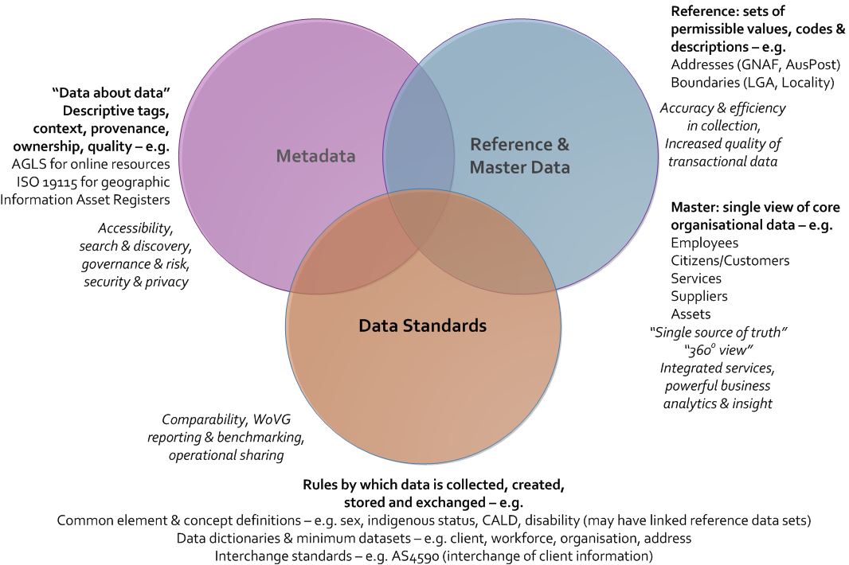

# Further information

For further information regarding this position paper, please contact Enterprise Solutions, Department of Premier and Cabinet, at: [enterprisesolutions@dpc.vic.gov.au](mailto:enterprisesolutions@dpc.vic.gov.au)

# Document control

|  |  |  |  |
| --- | --- | --- | --- |
| **APPLIES TO** | All Departments and  Victoria Police | AUTHORITY | CIO Leadership Group |
| **PERIOD** | 2017 – 2020 | ADVISED BY | Enterprise Solutions Department of Premier and Cabinet |
| **ISSUE DATE** | June 2017 | DOCUMENT ID | IM-PP-01 |
| **REVIEW DATE** | June 2020 | VERSION | 1.0 |

### Approval

This document was approved by the CIO Leadership Group on 5 June 2017 and applies from this date.

### Version history

|  |  |  |
| --- | --- | --- |
| **Version** | **Date** | **Comments** |
| 1.0 | 05/06/2017 | Final version for publication |

1. Government Transformation Strategy, Gov.UK, 9 February 2017, <https://www.gov.uk/government/publications/government-transformation-strategy-2017-to-2020/>
2. M, Mosley et al. (2010). *The DAMA Guide to the Data Management Body of Knowledge (DAMA-DMBOK Guide).* Technics Publications, USA.
3. Harrison, R (2009), *Study Guide TOGAF,* Van Haren Publishing, Zaltbommel, Netherlands.
4. The RCFV recommendations identify several priorities for improving data via standards, including those relating to indigenous people, people with disability, cultural and linguistic diversity (CALD), and lesbian, gay, bisexual, transgender and intersex (LGBTI) people.