### End-to-end project delivery



framework



### Introduction

This document outlines end-to-end project mechanisms, including key activities, stage gates, templates, governance, and tools for monitoring and controls.

The project delivery framework is aligned to DTF’s investment lifecycle and high- value/ high-risk guidelines. The governance framework is aligned to the ICT Governance Education Program.

### Purpose



To enhance delivery of information and communications technology (ICT) projects across government by:

##### Providing reusable tools and templates, repeatable processes and implementing a consistent management approach for project delivery.

* Improving oversight and visibility of projects by ensuring information is presented consistently, enhancing decision-making, reducing risks and increasing confidence in project delivery.
* Defining key stakeholders’ roles and responsibilities in relation to the project, including when and how they will be engaged.

### Framework components

* **Activities** – During each of the project stages, there are a set of activities that have to be performed. For ease of display, these have not been reflected in a sequential manner but have instead been grouped.
* **Stage gates** – At the end of each stage, the project must go through a check point (gate) before continuing. The gate can be governed by the project board, steering committee or the executive and ensures the project is ready to proceed to the next stage.
* **Project management templates** – As an output of the activities performed during each stage. These templates are used as tools for communication with project stakeholders. Note: these templates do not cover project-specific outputs such as strategies, policy, etc.
* **Governance** – Project governance is required to ensure the project is delivering its intended objectives and achieving the anticipated outcomes and benefits. This section provides governance principles, a structure, roles and descriptions.
* **Monitoring and controls tools** – A successful project has appropriate tools in place to monitor and control the progress of the project. This section outlines the tools required for project monitoring and controls.

### Activities

**0**

**Investment SET GOVERNMENT 1**

**2 3 4 5**

**Lifecycle Stages**

**PRIORITIES & DIRECTION**

*Consider portfolio wide and WoVG investment*

**CONCEPTUALISE**

*Confirm the need*

**PROVE**

*Recommend an investment*

**PROCURE**

*Award a contract*

**IMPLEMENT**

*Deliver the solution*

**REALISE**

*Deliver the benefits*

**Stage Gates**

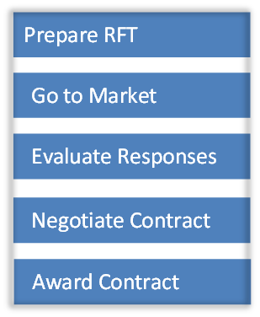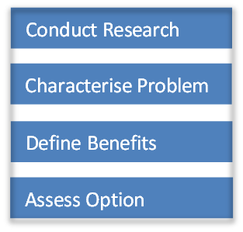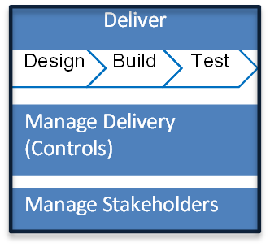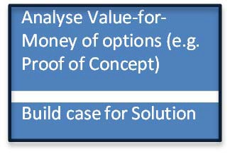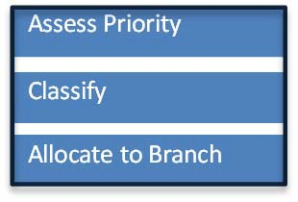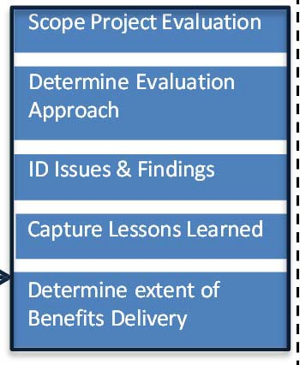

**G2**



**G1**



**G3**



**G4**



**G5**



**G6**

**Activities grouped by**

**Lifecycle Stage**

**Arrows in the diagram represent a sequential flow from the last activity in a stage group to the first activity in the next stage group.**

Prepare RFT Go to Market

Evaluate Responses

Negotiate Contract Award Contract

Conduct Research Characterise Problem Define Benefits

Assess Option

Deliver

Design Build Test

Manage Delivery (Controls)

Manage Stakeholders

Analyse Value‐for‐ Money of options (e.g. Proof of Concept)

Build case for Solution

Assess Priority Classify

Allocate to Branch

Scope Project Evaluation

Determine Evaluation Approach

ID Issues & Findings Capture Lessons Learned

Determine extent of Benefits Delivery

UNCLASSIFIED



## Stage gates

***nt***

***Re***

***ward a co***

***D***

***ion D***

***ts***



**STAGE**

**1 - CONCEPTUALISE**

***Confirm the need***

**2 - PROVE**

***commend an investme***

**3 - PROCURE**

***A ntract***

**4 - IMPLEMENT**

***eliver the solut***

**5 - REALISE**

***eliver the benefi***

Stage Gate assessments enable projects to progress

to the next stage

**G1**

**G2**

**G3**

**G4**

**G5**

**G6**

|  |  |  |  |  |  |  |
| --- | --- | --- | --- | --- | --- | --- |
| **GATE (G) #**  **& NAME** | ***Gate 1 Concept and Feasibility*** | ***Gate 2***  ***Full Business Case*** | ***Gate 3 Readiness for Market*** | ***Gate 4 Tender Decision*** | ***Gate 5 Readiness For Service*** | ***Gate 6 Benefits Realisation*** |
| **RESULT** | Early filtering | Funding decision | Tender Requested | Contract awarded | Project handover | Benefits materialise |
| **PURPOSE** | To investigate the strategic direction and concept development of the proposed investment against the wider agency, portfolio or whole-of- government goals or needs. | To investigate the business case and the proposed way forward to confirm the project is achievable and likely to deliver what is required. | To investigate assumptions in the business case and procurement strategy proposed for the project. | To investigate the business case and the governance arrangements for the tender decision to confirm the project is still required, affordable and achievable. The review also checks implementation plans are robust. | To investigate how ready the organisation is to make the transition from the specification and/or solution to implementation. It assesses the capabilities of delivery partners and service providers and confirms ownership of the project is clearly identified after handover to operations. | To confirm benefits set out in the business case are being achieved and the operational service or facility is running smoothly. |
| **DECISION CONFIRMS** | * the policy merit is sound and evidence based; * options in response to the problem have been sufficiently explored; and * the way forward is achievable. | * stakeholders approve the intended benefits from the project; * the link with program and organisational objectives is clear; and * the optimum balance of cost, benefits and risk has been identified. | * details of the sourcing options, proposed procurement route and supporting information. * implementation plans are in place. | * that the recommended tender decision is appropriate before the contract is awarded to a supplier / partner, or the work order is placed with existing supplier or other delivery partner. * that sound processes are used to select a supplier. * The process has been well managed; * business needs are met; * whether client and supplier can implement and manage the proposed solution; * whether a successful outcome can be achieved. | * whether the solution is robust before implementation; * how prepared the organisation is to implement the business changes before and after delivery; * the contract management arrangements; and * whether there is a basis for evaluating ongoing performance. (contract management phase.) | * First review – concentrates on the business case and how well arrangements have been set up for service delivery and associated contract management. * Mid term Review - examines aspects such as contract management, improvements in value-for-money and performance incentives against the baseline. * Final Review - looks at activities relating to the closure of the current service contract and ensuring suitable arrangements are in place for the future. |
| **KEY OUTPUT**  for assessment | * Strategic assessment (non-HVHR) * Preliminary Business Case (HVHR) | - Full Business case | * Expressions of Interest * Request for tender * Project status reports | * Expressions of Interest * Request for tender * Project status reports | - Project status reports | * Project status reports * Benefits realisation report   Page 7 |

### Project management templates for

each activity 

**Investment Lifecycle Stages**

0 - **SET GOVERNMENT PRIORITIES & DIRECTION**

*Consider portfolio wide*



*and WoVG investment*

1

**CONCEPTUALISE**

*Confirm the need*

2

**PROVE**

*Recommend an investment*

3

**PROCURE**

*Award a contract*

4

**IMPLEMENT**

*Deliver the solution*

5

**REALISE**

*Deliver the benefits*

**Stage Gates**

**G1 G2 G3 G4 G5 G6**

**TEMPLATES TASK / ACTION**

* Project sizing spreadsheet
* Establish project governance
  + Appoint Action Lead
  + Determine Owner
* Allocate funding
* Status Report (ICT Actions Register)
* Create Lessons Learned Register
* Close Lessons Learned

**TEMPLATES SMALL & MEDIUM PROJECT**

As above - Establish project governance (PCB)

* Idea Brief (N/A Large/HVHR) includes:
  + Scope Statement
  + Funding/ Cost Benefits
  + ID key stakeholders
  + Timescale (incl. high level schedule)
* Register Project with PMO by submitting brief
* Strategic assessment (non- HVHR)
* Full Business Case
* PID
* Stakeholder Engagement (Communication) Plan
* Create project controls *
* Detailed Schedule
* Status Report
* Create Benefits Realisation Plan (BRP)
* Stage Plan (N/A Small)
* Update project controls *
* Update Schedule
* Status Report
* Expressions of Interest (EOI)
* Request for tender (RFT)
* Contract
* Stage Plan (N/A Small)
* Refine Business Case
* Update project controls *
* Status Report
* Update Benefits Realisation Plan
* Transition (Implementation) Plan
* Operational Readiness Review
* Stage Plan (N/A Small)
* Close project controls *
* Post Implementation Review workshop
  + Lessons Learned
  + Follow on Actions / Recommendations
* Benefits Realisation report

**TEMPLATES HVHR / LARGE PROJECT**

As above As above PLUS

* Create project controls *
* High level Schedule (MSP)
* Status Report
* Preliminary Business Case (HVHR)

As above PLUS

* Change Management Plan

As above As above As above PLUS

- Post Implementation Review includes detailed interviews conducted by independent party

**\* NOTE PROJECT CONTROLS** include Registers for Risks, Issues & Changes, Dependencies, Actions, Decisions, Financials and Lesson Learned. Each Register is a separate tab/sheet in the Control Workbook template

### Process from idea to project

Large/ HVHR?

**Brief**

No

Conduct Res Characterise Assess Optio Define Benefi

Yes

**Preliminary**

earch Problem n

ts

Analyse Value‐for‐ Money of options

Build case for Solution

Go / No Go

**Idea**

**ess Case** (Send to PMO)

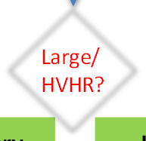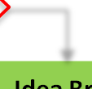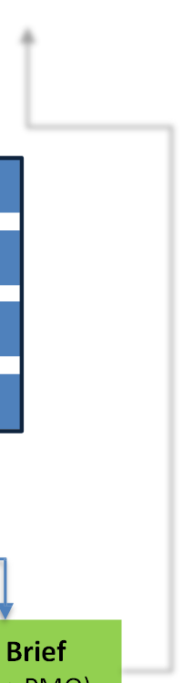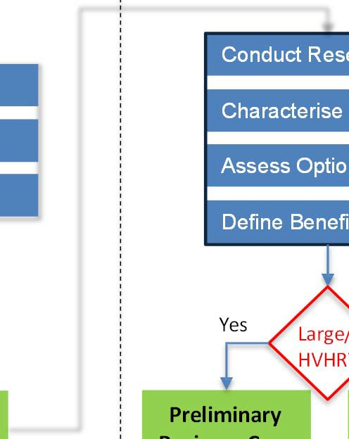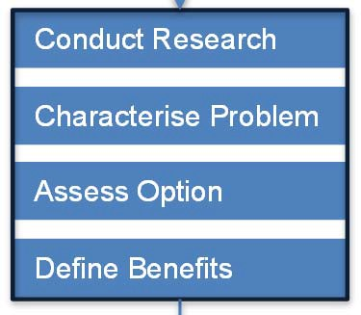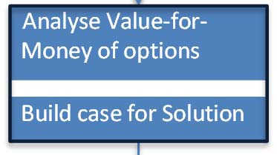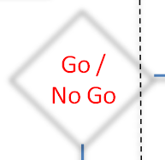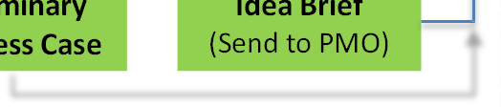

**Investment**

**Lifecycle Stages**

0 SET GOVERNMENT

PRIORITIES & DIRECTION

1 CONCEPTUALISE

*Confirm the need*

**Stage Gate**

**G1**

2 PROVE

*Recommend an Investment*

**IDEA**

Executive / Portfolio

Governance Group

Project

Manager

PMO

(receives Idea Brief & allocates Projects ID)

Portfolio

Governance Group (reviews)

Yes

**STOP**

Access Priority

Classify

Allocate to branch

No

**Project Sizing**

**Spreadsheet**

**Busin**

**See full list of templates on End‐to‐End Delivery Framework – Project Management Templates**

**Templates**

**Activities grouped by**

**Lifecycle Stage**

Governance: principles

|  |  |
| --- | --- |
| **Principle** | **Application** |
| Accountability | * There should be a single point of accountability for the project (i.e. the project sponsor) * Their accountability is for the realisation of project benefits. * Accountability cannot be delegated. |
| Role clarity | * Members of the project board should understand and be clear on their role. * Members of a project board should be clear that their primary concern – and loyalty – is to ensure a successful outcome from the project. * Project board members should also clearly define the roles for others, such as the project manager. |
| Authority | * The project sponsor must have sufficient authority (within the organisation) to effectively discharge accountability to the project. |
| Transparency | * Decisions made regarding ICT‐enabled projects should be communicated to stakeholders in a timely and comprehensive manner. |
| Commitment | * Prospective members should ensure they have time to govern the project before committing to membership of a project board. |

A governance structure that adheres to these principles requires a mandatory project control board (PCB). Programmes, high‐value/high‐risk (HVHR) projects or projects spanning multiple departments or agencies may require a steering committee in addition to a PCB. Stakeholders should be informed about ICT‐enabled projects in a timely and comprehensive manner.

### Governance: structure

ior Supplie

Change Ma

nag

User or User Gr

upplier

r

Project Management Team

This governance structure is based on PRINCE2 and ICT Governance Education Program Learning Resource v2.0.

**onsor**

er

enior

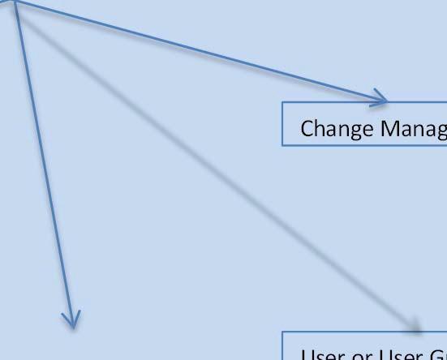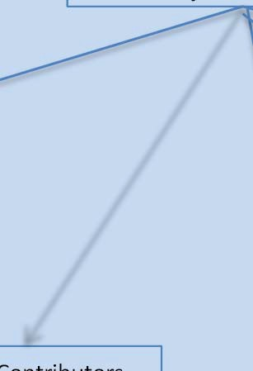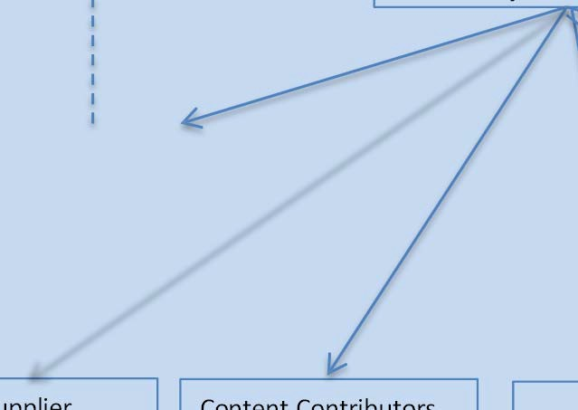

Chair

Advisory: Members

Project Manager

Technical Lead er

S Content Contributors Project Officer oup

**Steering Committee**

*(Advisory)*

2nd tier for

large/complex

projects

**Project Board**

*(Accountable)*

**Sp**

Sen

System Owner

S

Us

Mandatory

Governing Body level (1st tier)

Governing Body

UNCLASSIFIED

### Governance: roles and description



|  |  |
| --- | --- |
| **Role** | **Description** |
| Project Sponsor | * The executive (also known as the project sponsor or customer or project owner) leads the project board, is the ultimate   decision‐maker, ensures that that project meets its intended objectives, and is ultimately accountable for project success.   * The person paying for the project. * Appoints people to the roles of senior user and senior supplier. * Chairs meetings and conducts briefings. * Monitors progress and any changes to the project plan. * Also a member of the project board. |
| Senior Supplier | * Responsible for ensuring that the best solution is adopted to deliver the project and that the integrity of the solution is maintained, so that the project is capable of delivering its intended benefits. |
| Senior User | * Responsible for representing and specifying the needs of those who will use the end result of the project, and monitoring the project to ensure that these needs are met (within the constraints of the business case); |
| Project Assurance | Project assurance involves monitoring all aspects of a project’s performance, including the quality of deliverables. It may include ensuring that:   * risks are controlled; * correct process and procedures are being followed; * project scope changes are not going unnoticed; * internal and external communications are effective; and * the solution being developed meets business requirements.   Project board members may carry out project assurance if they have the time, skills and experience. It can be delegated to individuals who then report to the board, including those external to the project and the organisation undertaking the project. Because the project assurance function provides ongoing oversight of the project, the project manager and the supplier(s), it is not appropriate to delegate project assurance to the project manager or to a vendor account manager. Those with responsibility for this function should be selected by and answerable to project board members. |

### Governance: roles and descriptions (ctn’d)



|  |  |
| --- | --- |
| **Role** | **Description** |
| Project Manager | * Works on behalf of the project board to manage the project to agreed specifications and tolerances * Selects project team members * Is responsible for making sure work is performed within tolerances * Prepares project plans * Keeps the project board informed of progress, and highlights any current or emerging problems * The project manager is the manager of the project team, and reports to the project board. * The role of the project manager in relation to the project team is to determine what work needs to be done, in what order, and how, to deliver the project outcomes. They also manage the allocation of project resources, including finances and staff, and contracts associated with the project. |
| Supplier | * The person or team who will do the work or deliver the project. |
| User | * The person who is going to use the results or outcome of the project, or who will be impacted by the outcome. |
| Technical Lead | (Undefined in the training material) |
| Change Manager | The role of the change manager will vary from project to project, depending on the scope of change required. In general, the change manager will:   * establish and specify the extent of change required; * lead change (to business processes, work practices, organisational structure, training, communications, roles and responsibilities, etc.) to ensure the realisation of business benefits; and * evaluate the extent to which business change activities have contributed to the realisation of business benefits. |
| Project Officers | Depending on the scale and complexity of the project, the project management tasks might be undertaken by staff working with the project manager. Typically, these staff undertake specific sets of project management tasks – such as:   * business case preparation, financial management, contract management, communications – and they need to have capabilities relevant to these tasks. * Sometimes project officers are fully engaged in the project, however, the project will often be just one of a number of activities in which they are involved at the same time. |
| Content Contributors | * These members of the team are responsible for creating specific content – in the case of ICT this might be: * the development or modification of certain software solutions, * the development or refinement of a software interface, * the transference of data from one system to another, * developing and implementing change actions, including developing new work processes and training stakeholders about how to use a new system. |

# Monitoring & controls: principles

#### The controls should be developed to be fit for purpose.

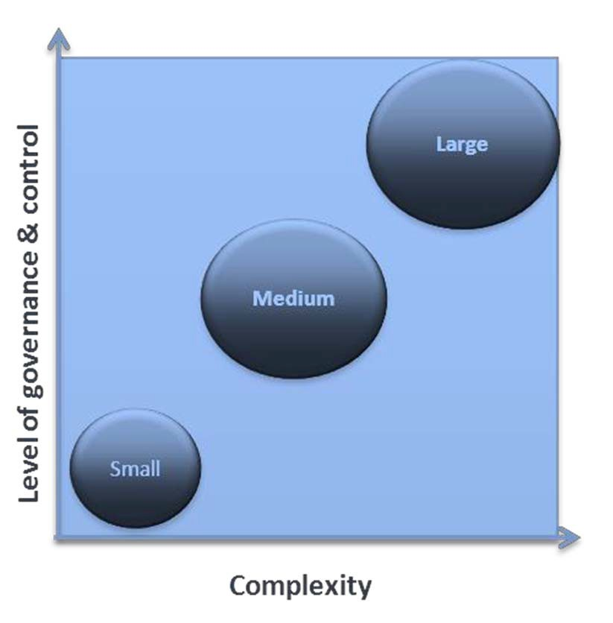

* The controls should be adding value – not be seen as unnecessary work.
* Project controls will focus on providing visibility and accountability, and upholding quality as well as effective delivery.
* The PMO will be a central point of contact and the ‘point of truth’ for project management, tools, templates and processes.
* The PMO will be responsive to stakeholder feedback for continuous improvement.

#### Project sizing spreadsheet

* + Idea brief
  + Project board terms of reference
  + Project initiation document
  + Schedule
  + Stakeholder engagement plan
  + Change management plan
  + Benefits realisation plan
  + Stage plan
  + Workbook

‐ Risk and issue/change management

‐ Dependency register

‐ Decision register

‐ Lessons learned register

* + Project status report
  + Post implementation review

|  |  |  |  |  |  |  |
| --- | --- | --- | --- | --- | --- | --- |
| **When** | | | | | |  |
| **Applicable activity** | Set Direction | Conceptualise | Prove | Procure | Implement | Realise |
| ✓ |  |  |  |  |  |
| **Project Type** | | | | | |  |
| * **Required**   **\* Optional** | Task | Small | Medium | HV/HR |  |  |
| ✓ | ✓ | ✓ | ✓ |

The purpose of the project sizing spread sheet is to use high‐level descriptions of a piece of work and decision factors to provide guidance about the size of a project and the level of documentation and detail required for varying sizes of projects.

Example:

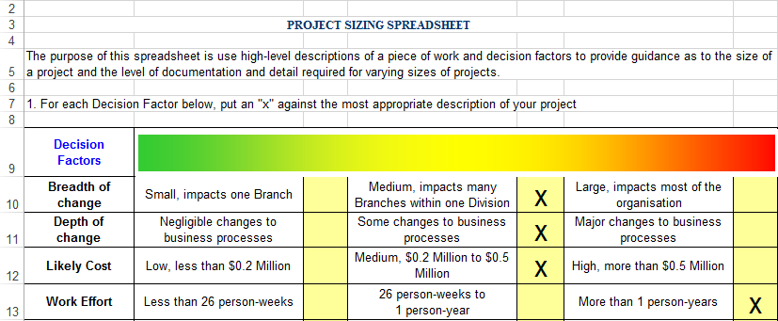

# Monitoring & control: idea brief

|  |  |  |  |  |  |  |
| --- | --- | --- | --- | --- | --- | --- |
| **When** | | | | | |  |
| **Applicable Phases** | Set Direction | Conceptualise | Prove | Procure | Implement | Realise |
|  | ✓ |  |  |  |  |
| **Project Type** | | | | | |  |
| * **Required**   **\* Optional** | Task | Small | Medium | HV/HR |  |  |
|  | ✓ | ✓ |  |

The purpose of the idea brief is to provide a level of understanding of project time and cost in order to decide whether the project executive should:

* Proceed with the investment without further analysis, or
* Invest the time and effort required to produce a full business case.

This document brings together (at a high level) what is known and what has been assumed in order to produce initial estimates.

The idea brief will also outline the project’s intended:

* + Governance (see section on governance)
  + Stakeholder engagement approach
  + Quality management plan

|  |  |  |  |  |  |  |
| --- | --- | --- | --- | --- | --- | --- |
| **When** | | | | | |  |
| **Applicable Phases** | Set Direction | Conceptualise | Prove | Procure | Implement | Realise |
|  | ✓ | ✓ | ✓ | ✓ |  |
| **Project Type** | | | | | |  |
| * **Required**   **\* Optional** | Task | Small | Medium | HV/HR |  |  |
|  | ✓ | ✓ | ✓ |

The purpose of the project board terms of reference is to describe the role and responsibilities of the project control board or steering committee, which is responsible for ensuring:

* the project meets its objectives and the board’s requirements
* Project milestones are achieved and stakeholders are satisfactorily consulted and kept informed of future changes.

The project manager is responsible for ensuring all relevant and necessary issues are included in the terms of reference.

|  |  |  |  |  |  |  |
| --- | --- | --- | --- | --- | --- | --- |
| **When** | | | | | |  |
| **Applicable Phases** | Set Direction | Conceptualise | Prove | Procure | Implement | Realise |
|  |  | ✓ | ✓ | ✓ |  |
| **Project Type** | | | | | |  |
| * **Required**   **\* Optional** | Task | Small | Medium | HV/HR |  |  |
|  | ✓ | ✓ | ✓ |

The purpose of the PID is to provide the project information required for senior management and stakeholders to commit to the resources and timelines proposed. It is a sort of ‘contract’ between the project manager and project sponsor/project board that defines how the project will be run.

A PID will include:

* a detailed proposition against which success can be measured;
* how the project will be developed and when it will be delivered based on the approved idea brief; and
* a detailed understanding of the costs and benefits of the project and, in particular, the resources, risks and timelines required for successful delivery.

# Monitoring & control: schedule

|  |  |  |  |  |  |  |
| --- | --- | --- | --- | --- | --- | --- |
| **When** | | | | | |  |
| **Applicable Phases** | Set Direction | Conceptualise | Prove | Procure | Implement | Realise |
|  | ✓ | ✓ | ✓ | ✓ |  |
| **Project Type** | | | | | |  |
| * **Required**   **\* Optional** | Task | Small | Medium | HV/HR |  |  |
|  | ✓ | ✓ | ✓ |

The purpose of the project schedule is to allow the project manager to plan for tasks, time and resources required to deliver the project. The following questions should be considered:

* + Does your scheduling allow for weekends, public holidays and other non‐working days?
  + Will the resources/skills be available in sufficient quantities when you need them?
  + Are there any internal and/or external stakeholder tasks/events that coincide with the project and limit the availability of resources?
  + Are any individuals scheduled to work on other projects when you need them?
  + Will any individuals or skill/types be overloaded with project work at any time?
  + Have you adjusted the timing and allocation of work to spread the load evenly?
  + Can you meet your time constraints/target delivery dates?
  + Do you need to include recruitment, procurement, training or induction activities?

# Monitoring & control: stakeholder engagement plan



|  |  |  |  |  |  |  |
| --- | --- | --- | --- | --- | --- | --- |
| **When** | | | | | |  |
| **Applicable Phases** | Set Direction | Conceptualise | Prove | Procure | Implement | Realise |
|  |  | ✓ | ✓ | ✓ |  |
| **Project Type** | | | | | |  |
| * **Required**   **\* Optional** | Task | Small | Medium | HV/HR |  |  |
|  | ✓ | ✓ | ✓ |
| **Tools & Artefacts: *< insert template name>*** | | | | | | |

The purpose of the stakeholder engagement plan is to outline the engagement approach to ensure key stakeholders buy‐in through the project life. The scale of change caused by the project will determine how this plan should be developed. If the change scale is small, a simple table in the PID can be used. If the change scale is medium/large, it is suggested that a separate plan is used to capture this information.

The plan will include:

* Stakeholder identification and analysis (who, their needs, and how the project will impact them)
* Engagement approach (time, resources, channels) to ensure stakeholder involvement and minimise change impacts. For example, business reference groups (if appropriate), workshops with subject matter expert to design the future or analyse the change, and one‐on‐one briefings with senior stakeholders.

# Monitoring & Control

- Change Management Plan 

|  |  |  |  |  |  |  |
| --- | --- | --- | --- | --- | --- | --- |
| **When** | | | | | |  |
| **Applicable Phases** | Set Direction | Conceptualise | Prove | Procure | Implement | Realise |
|  |  | ✓ | ✓ | ✓ |  |
| **Project Type** | | | | | |  |
| * **Required**   **\* Optional** | Task | Small | Medium | HV/HR |  |  |
|  | ✓ | ✓ | ✓ |

The purpose of the change management plan is to provide specific details, including actions, timelines, dates and the allocation of responsibility, required to effectively manage project change from inception to delivery. It aims to capture a complete and holistic view of various planning components of the change. The intended audience is the project manager, project team, project sponsor and any senior leaders whose support is needed to carry out the plan.

The scale of change will determine how this information should be captured. If change scale is small, the change approach can be described in the PID. If the change scale is medium/large, it is suggested that a separate change management plan is used to capture this information.

# Monitoring & control:

benefits realisation plan 

|  |  |  |  |  |  |  |
| --- | --- | --- | --- | --- | --- | --- |
| **When** | | | | | |  |
| **Applicable Phases** | Set Direction | Conceptualise | Prove | Procure | Implement | Realise |
|  | ✓ | ✓ | ✓ | ✓ | * (report) |
| **Project Type** | | | | | |  |
| * **Required**   **\* Optional** | Task | Small | Medium | HV/HR |  |  |
|  | ✓ | ✓ | ✓ |

The purpose of the benefits realisation plan is to provide details of how the benefits management process will be applied to a project. It describes the tasks, resources, time frame and approach to benefits management.

The plan will describe:

• Benefits ownership

• Benefits activity plan

• Baseline measures

• Post go‐live benefits tracking framework

|  |  |  |  |  |  |  |
| --- | --- | --- | --- | --- | --- | --- |
| **When** | | | | | |  |
| **Applicable Phases** | Set Direction | Conceptualise | Prove | Procure | Implement | Realise |
|  | ✓ | ✓ | ✓ | ✓ |  |
| **Project Type** | | | | | |  |
| * **Required**   **\* Optional** | Task | Small | Medium | HV/HR |  |  |
|  | ✓ | ✓ | ✓ |

The purpose of the stage plan is to design the work up to the point where the project sponsor/project board should:

* review achievements to date and assess project viability
* take key decisions outside the level of authority of the project manager
* approve a more detailed plan for the next stage of work
* commit resources in accordance with the project or stage plan
* assess the impact of some significant external event that will influence the project (e.g.: legislation, decision point in other project, review of business operation).

The detailed plan for a stage will be produced towards the end of the preceding stage, when the information needed for planning is available.

|  |  |  |  |  |  |  |
| --- | --- | --- | --- | --- | --- | --- |
| **When** | | | | | |  |
| **Applicable Phases** | Set Direction | Conceptualise | Prove | Procure | Implement | Realise |
|  | ✓ | ✓ | ✓ | ✓ |  |
| **Project Type** | | | | | |  |
| * **Required**   **\* Optional** | Task | Small | Medium | HV/HR |  |  |
|  | ✓ | ✓ | ✓ |

The risk and issues/change management tool is a central register that records risks, issues and required changes that impact on a project/program’s scope, schedule and budget.

A project manager is required to review the risk and issues/change management register to ensure appropriate management and controls are in place for these registered risks/issues/required changes. The project manager also needs to report these risks/issues/changes in the project status report to ensure project sponsor/project board/project team and other senior stakeholders are aware of the project challenges and that necessary actions have been undertaken to mitigate them.

A **risk** is any area of uncertainty that represents a threat or an opportunity to the project. To manage and mitigate risks, the project manager needs to identify risks, assess the likelihood of risks happening and estimate the impact these risks might have on the project.

An **issue** is a risk that has materialised or an unplanned event that (unless action is taken) will impact the project scope, cost, quality or schedule. A project **change** may be a result of a specific issue.

|  |  |  |  |  |  |  |
| --- | --- | --- | --- | --- | --- | --- |
| **When** | | | | | |  |
| **Applicable Phases** | Set Direction | Conceptualise | Prove | Procure | Implement | Realise |
|  | ✓ | ✓ | ✓ | ✓ |  |
| **Project Type** | | | | | |  |
| * **Required**   **\* Optional** | Task | Small | Medium | HV/HR |  |  |
|  | ✓ | ✓ | ✓ |

The purpose of the dependency management tool is to provide a project’s central register of all dependencies.

A **dependency** describes where successful performance of an activity (or set of activities) is reliant on the actions of a third party. The third party actions will be outside the immediate project schedule, i.e. they may be within or across a branch/division, or external to the portfolio of projects and programmes.

Managing project dependencies and reporting them in the regular project status report helps a project manager to monitor project progress and take remedial actions if necessary.

|  |  |  |  |  |  |  |
| --- | --- | --- | --- | --- | --- | --- |
| **When** | | | | | |  |
| **Applicable Phases** | Set Direction | Conceptualise | Prove | Procure | Implement | Realise |
|  | ✓ | ✓ | ✓ | ✓ |  |
| **Project Type** | | | | | |  |
| * **Required**   **\* Optional** | Task | Small | Medium | HV/HR |  |  |
|  | ✓ | ✓ | ✓ |

A decision register is a central register used for recording key project decisions, justifications and actions so that it is easy to review what was agreed and when.

Decisions can be reviewed and reversed or changed if necessary as long as the history and justification for the change (and approval record) is logged.

For example, a decision register may provide clarity when the project team is working on a project that involves changes to strategy or approach, or has a long duration.

|  |  |  |  |  |  |  |
| --- | --- | --- | --- | --- | --- | --- |
| **When** | | | | | |  |
| **Applicable Phases** | Set Direction | Conceptualise | Prove | Procure | Implement | Realise |
|  |  |  |  | ✓ | ✓ |
| **Project Type** | | | | | |  |
| * **Required**   **\* Optional** | Task | Small | Medium | HV/HR |  |  |
| ✓ | ✓ | ✓ | ✓ |

The purpose of a lessons‐learned register is for a project team to share knowledge gained from project delivery. A successful lessons‐learned program will help project teams to repeat desirable outcomes and avoid undesirable outcomes so the entire organisation may benefit.

The lessons‐learned register is intended to be used throughout the project lifecycle to collect information that has been obtained during any phase of the project. Project staff performing different functions on the project will have a different outlook on successes, failures, and possible solutions.

|  |  |  |  |  |  |  |
| --- | --- | --- | --- | --- | --- | --- |
| **When** | | | | | |  |
| **Applicable Phases** | Set Direction | Conceptualise | Prove | Procure | Implement | Realise |
|  | ✓ | ✓ | ✓ | ✓ |  |
| **Project Type** | | | | | |  |
| * **Required**   **\* Optional** | Task | Small | Medium | HV/HR |  |  |
|  | ✓ | ✓ | ✓ |

##### Status reporting is a key element of the project monitoring and control process.

Its purpose is to ensure that the objectives of the project are met, and variances from the plan are identified by monitoring and measuring progress regularly. When variances are identified, corrective action can be taken.

Status reporting also communicates project status to stakeholders and keeps them informed of the critical project controls including schedule, cost, budget, scope/quality of risks, issues and changes.

|  |  |  |  |  |  |  |
| --- | --- | --- | --- | --- | --- | --- |
| **When** | | | | | |  |
| **Applicable Phases** | Set Direction | Conceptualise | Prove | Procure | Implement | Realise |
|  |  |  |  |  | ✓ |
| **Project Type** | | | | | |  |
| * **Required**   **\* Optional** | Task | Small | Medium | HV/HR |  |  |
|  | ✓ | ✓ | ✓ |

The purpose of the post implementation review is to:

* + evaluate the efficiency and effectiveness of the project in meeting the stakeholder requirements.
  + identify improvements and key success factors that can be applied to future projects.

The content of this report is input provided by the Project Manager and all key members of the project team. It can be done through a questionnaire and a Post Implementation Review workshop.

The review of the project should be conducted by appointing a qualified person or a project manager who is independent to the project. Where this is not possible, the project manager will conduct this review.



## E2E framework for agile products

nefits

**Lifecycle Activities**

Assess Priority

Classify

Allocate to Branch

Conduct Research

Characterise Problem

Define Benefits

Assess Option

Build case for Solution

Analyse Value‐for‐Money of

options

### End-to-end framework for agile projects

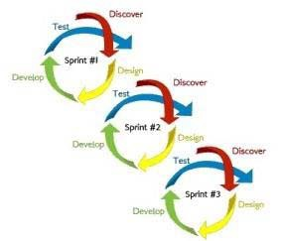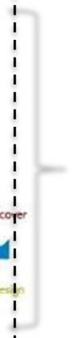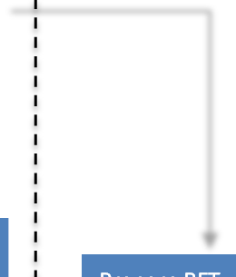

**Investment**

**Lifecycle Stages**

0

SET GOVERNMENT PRIORITIES & DIRECTION

1 CONCEPTUALISE

*Confirm the need*

4 IMPLEMENT

*Deliver the solution*

2 PROVE

*Recommend an Investment*

3 PROCURE

*Confirm the need Award a contract*

5 REALISE

*Deliver the Benefits*

Measure Be

Scope Review

Deliver

MVP

MVP & additional

features from product backlog

Prepare RFT

Go to Market

Evaluate Responses

Capture Lessons Learnt

(retrospectives)

Negotiate Contract

Award Contract

Manage Delivery (Controls)

Manage Stakeholders

ID Issues & Findings

Determine extent of Benefits Delivered



Key: patterned rectangles are those activities that happen in ‘Realise’ for non‐agile projects