**Recycling Victoria**

A new economy

February 2020

### 

### Photo credit

Cover Image from DELWP Image Library and Level Crossing Removal Project, 2019

© The State of Victoria Department of Environment, Land, Water and Planning 2019

This work is licensed under a Creative Commons Attribution 4.0 International licence. You are free to re-use the work under that licence, on the condition that you credit the State of Victoria as author. The licence does not apply to any images, photographs or branding, including the Victorian Coat of Arms, the Victorian Government logo and the Department of Environment, Land, Water and Planning (DELWP) logo. To view a copy of this licence, visit http://creativecommons.org/licenses/by/4.0/

### Disclaimer

This publication may be of assistance to you, but the State of Victoria and its employees do not guarantee that the publication is without flaw of any kind or is wholly appropriate for your particular purposes and therefore disclaims all liability for any error, loss or other consequence which may arise from you relying on any information in this publication.

### Accessibility

If you would like to receive this publication in an alternative format, please telephone the DELWP Customer Service Centre on 136186, email customer.service@delwp.vic.gov.au, or via the National Relay Service on 133 677 www.relayservice.com.au. This document is also available on the internet at www.delwp.vic.gov.au.

# CONTENTS

CONTENTS 2

MINISTER’S FOREWORD 3

A NEW PLAN FOR WASTE AND RECYCLING 4

INTRODUCTION 6

Victoria’s circular economy goals 7

Building on current work 7

What we heard 8

Complementary policies 8

Measuring progress 9

MAKE 11

More value from fewer resources 11

USE 16

Support Victorian communities and councils to reduce waste 16

Prevent plastic pollution 17

Support the reuse economy 18

RECYCLE 19

Maximise resource recovery and value 19

Use more recycled materials 26

Encourage appropriate waste to energy 30

MANAGE 32

Manage waste safely 32

MEASURE OUR PROGRESS 34

Modernise Victoria’s waste data 34

REFERENCES 35

# MINISTER’S FOREWORD

**From waste to value—a pathway to smarter, cleaner growth for Victoria.**

Across Australia and around the world, governments, businesses and communities are grappling with how to waste less and recycle more.

It’s a big, complex problem with no easy, quick fix. It’s why over the next decade, *Recycling Victoria*—Victoria’s circular economy policy and action plan—will fundamentally overhaul our recycling system.

This investment—worth more than $300 million—will grow our economy, help to create 3,900 jobs and protect our environment. Importantly, it will also ensure Victorians have a recycling system they can actually rely on.

*Recycling Victoria* addresses the urgent challenges that have caused disruptions to Victoria’s recycling services and makes fundamental changes to help prevent these issues from recurring.

Under this plan, we’ll overhaul our household recycling services, introducing a four-bin system and a container deposit scheme to improve the value captured from the materials we recycle.

We’ll also introduce new legislation and establish a waste authority to ensure greater accountability and transparency, and improve services.

We’ll continue to take a zero-tolerance approach to waste crime and protect the Victorian community and environment from illegal and unsafe storage of waste.

And we’ll support industry and innovation, advancing research and development and supporting clean technologies that will create new markets and new business opportunities for recycled materials.

*Recycling Victoria* will reduce waste, increase recycling and create more value from our resources.

And with it, help transform our entire economy.

# A NEW PLAN FOR WASTE AND RECYCLING

Recycling Victoria is the Victorian Government's 10-year policy and action plan for waste and recycling.

It outlines our sweeping plan of reform to establish a recycling system that Victorians can rely on. It transforms how our economy uses materials and how our state reuses, repairs and recycles.

|  |  |  |
| --- | --- | --- |
| Kerbside reform  We are changing how Victorians recycle so that materials collected from households are high quality and can be used again to make new products. | Stronger recycling oversight  New Act and new waste authority to make sure our recycling system is reliable and transparent. | New rules to cut waste  New rules to improve waste sorting and make sure we pay the right amount for disposing of waste in landfill. |
| Waste to energy  We will encourage investment in appropriate waste to energy facilities that reduce the need for landfills. | **High-risk and hazardous waste management**  Make sure risks to the Victorian community and environment from hazardous waste and high-risk sites are properly managed. | **Reducing business waste**  A new Circular Economy Business Innovation Centre will help businesses reduce waste and generate more value with fewer resources. |
| Invest in priority infrastructure  Victoria will have the right infrastructure to support increased recycling, respond to new bans on waste export and safely manage hazardous waste. | **Provide support for local communities and councils**  A new Supporting Victorian Communities and Councilsprogram will support regional growth and community connectivity. | **Behaviour change**  Victorians will have the information and tools they need to reduce waste by reusing, sharing, repairing and recycling products. |

Transitioning to a circular economy will:

* potentially **boost Victoria’s economy** up to $6.7 billion by improving material efficiency and recycling[1]
* help to **create more than 3,900 new jobs and establish new skills** in design, repair, efficiency and materials usage across Victoria
* **help businesses grow in new ways and create new sectors** in the Victorian economy, including materials research, product design, repair, refurbishment, re-sale, reuse and product leasing
* **produce cost savings for households** through reduced waste and extended product utility
* **improve social inclusion** through local initiatives that support repair cafes, product sharing and community composting
* **abate greenhouse gas emissions** from the waste sector
* **drive greater resource recovery,** reducing the reliance on virgin materials
* **establish a recycling system that Victorians can rely on.**

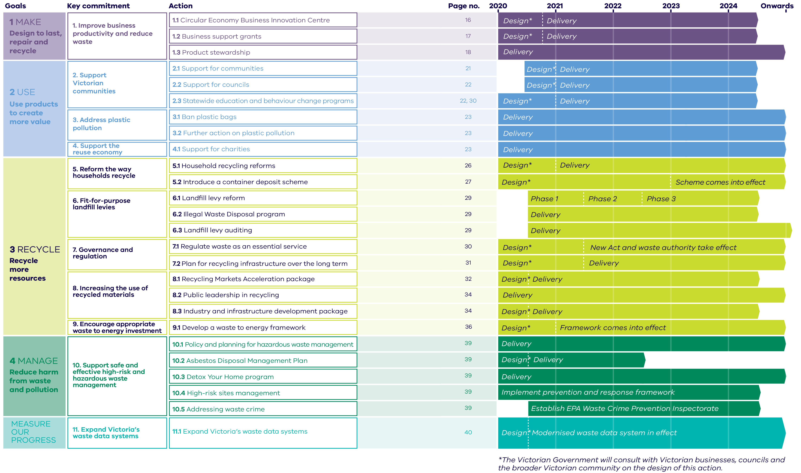

Figure 1: Strategic interventions to key commitments

# INTRODUCTION

***Victoria’s circular economy will create jobs and economic growth while reducing waste, cutting pollution and establishing a strong recycling system. Businesses, governments and individuals need to work together to realise the benefits of a circular economy.***

Figure 2: Resource flows in a circular economy



### What is a circular economy?

A circular economy continually seeks to reduce the environmental impacts of production and consumption, while enabling economic growth through more productive use of natural resources.

It allows us to avoid waste with good design and effective recovery of materials that can be reused.

It promotes more efficient business models that encourage intense and efficient product use, such as sharing products between multiple users, or supplying a product as a service that includes maintenance, repair and disposal.

The value people obtain from the resources used to create goods and services increases.

It transforms our linear economy mindset—take, use and throw away—and fosters innovation and productivity that invigorates existing businesses and creates new ones, delivering more jobs and more growth for local, regional, state and global economies.

Victoria, like many other states and nations, exports large amounts of recycled materials. Approximately 1.27 million tonnes of paper, plastic and cardboard each year are sent to overseas markets such as China and Malaysia. This includes 30 per cent of all recycling collected from Victorian households.

In 2018, China placed and enforced strict contamination thresholds on its import of recycled materials. This caused widespread disruptions to global recycling markets—including our own.

*Recycling Victoria* represents the Victorian Government’s action plan to reform our waste and recycling system over the next decade.

It includes a complete overhaul of our recycling system, with reform to kerbside recycling, the introduction of a container deposit scheme, new investment in industry and the creation of waste management as an essential service.

Just as we engage in new efforts to reuse, repair and recycle, this is also an opportunity to change the way Victoria does business and grow new jobs. This means building our capacity for cutting-edge recycling. It means growing an advanced manufacturing sector that makes products from recycled materials. And it means supporting Victorian businesses to innovate and succeed.

Beyond recycling, this shift will fundamentally transform Victoria’s economy. Our state is ideally placed to advance and grow in this space, with a highly-skilled workforce, connected supply chains, exceptional design and engineering expertise, world-class infrastructure and leading education and research and development.

With *Recycling Victoria*, we’ll help Victorians reduce, reuse, repair and recycle *and* strengthen our economy—setting up a more sustainable future for our state.

## Victoria’s circular economy goals

Victoria’s transition to a circular economy will be guided by four goals spanning the life cycle of materials (make, use, recycle and manage). Each goal is designed to maximise value and minimise waste.

* **Goal 1 - Design to last, repair and recycle.**  
  Generate less waste in businesses through innovation and design; use recycled materials in products and consider impacts across product life cycles; and support business to explore new circular economy business models (‘Make’ Chapter).
* **Goal 2 - Use products to create more value**.  
  Help people make smart purchasing decisions and extend the life of products and support the reuse economy; repair goods where possible (‘Use’ Chapter).
* **Goal 3 - Recycle more resources.**  
  Reform kerbside collections to generate more value from waste; improve the separation of recyclable materials; develop markets for recovered materials; plan for and boost investment in recycling infrastructure; embed the waste hierarchy in the management of materials; support the development of appropriate waste to energy facilities (‘Recycle’ Chapter).
* **Goal 4 - Reduce harm from waste and pollution.**  
  Protect communities and the environment from high-risk and hazardous wastes (‘Manage’ Chapter).

These goals align with the United Nations Sustainable Development Goals, including Goal 8 (‘promote sustained, inclusive and sustainable economic growth’) and Goal 12 (‘ensure sustainable consumption and production patterns’).

## Building on current work

The good news is that Victoria has a head start in transitioning to a more circular economy.

*Recycling Victoria* builds on many years of work by the Victorian Government to improve waste management and increase recycling in Victoria. We now recover 69 per centof our waste[2].

Victoria led the nation in 2015 by launching Australia’s first 30-year plan for waste and recycling infrastructure and leads collaborative waste and recycling services procurement across local councils. The Victorian Government has also banned single-use plastic bags and the disposal of e‑waste in landfill.

### What we have already delivered

The Victorian Government has provided record funding of more than $135 million since 2015 for waste and resource recovery initiatives.

Recent initiatives include:

* $37 million to develop and implement the *Recycling Industry Strategic Plan* to stabilise and improve the productivity of the recycling sector, increase the quality of recycled materials, and develop new markets for materials
* $35 million for more reliable household recycling services, co-investment with industry in infrastructure to better process plastics and other recycling, and development of stronger end markets for recycled resources
* $6.6 million to councils directly affected by the closure of SKM Recycling
* $12.8 million to combat illegal stockpiling and mismanagement of hazardous waste, and to address illegal dumping of industrial waste in Victoria.

## What we heard

In developing this policy, the Victorian Government listened to more than 550 people at 15 public workshops and considered more than 350 submissions on the issues paper—*A circular economy for Victoria: creating more value and less waste*. We heard from businesses, peak bodies, councils, academic institutions, non-government organisations, community groups and individuals.

We heard that the Victorian Government must set clear policy direction and a long-term plan to improve our recycling system. Our community wants a circular economy that prioritises more sustainable and innovative use of materials, minimises the impacts of climate change and creates less waste and pollution.

Victorians sought strong action on specific materials, including plastics and food waste. They asked for targeted, long-term public awareness campaigns to support effective behaviour change.

Victorians want to see a balance of regulation and supporting initiatives, improved data collection and sharing, and investment in research and development.

*Recycling Victoria* responds to community feedback with ambitious targets to reduce waste, grow the economy and establish a reliable recycling system for Victorians.

## Complementary policies

This action plan is supported across government by related policies and investments. For example, Victoria’s water and energy sectors already contribute to a circular economy by ensuring those resources are used efficiently for economic and environmental benefit.

**Figure 3** shows current waste and resource recovery policies, and other Victorian policies and strategies that apply circular economy principles.

A *National Waste Policy* was released in 2018. In August 2019, the Australian Government and all state and territory governments committed to ban the export of waste glass, paper, cardboard, plastic and tyres.[3] *Recycling Victoria* will ensure local infrastructure and markets are in place to support the ban and safely manage materials in Victoria.

All levels of government need to help businesses and communities make the transition to a circular economy.

The Victorian Government is investing strongly in the circular economy transition. The Australian Government must do the same—showing strong leadership, coordinating national efforts and taking the initiative with national legislation in areas such as product stewardship.

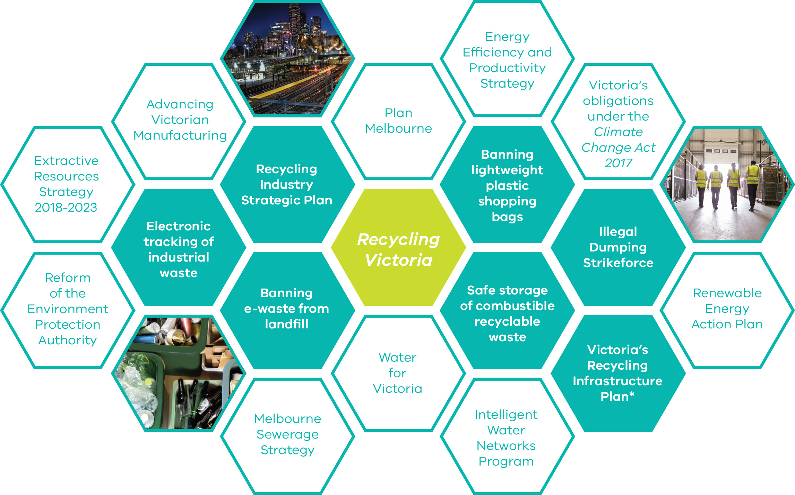

Figure 3: Complementary Victorian Government policy and strategy

## Measuring progress

Four ambitious new targets will help Victoria measure our progress.

1. Divert 80 per cent of waste from landfill by 2030, and an interim target of 72 per cent by 2025.
2. Cut total waste generation by 15 per cent per capita by 2030.
3. Halve the volume of organic material going to landfill between 2020 and 2030, with an interim target of 20 per cent reduction by 2025.
4. Ensure every Victorian household has access to food and garden organic waste recycling services or local composting by 2030.

These complement the following seven national targets agreed through the *National Waste Policy Action Plan*.

1. Ban the export of waste plastic, paper, cardboard, glass and tyres commencing in the second half of 2020.
2. Reduce total waste generation in Australia by 10 per cent per person by 2030.
3. 80 per cent average resource recovery rate from all waste streams following the waste hierarchy by 2030.
4. Significantly increase the use of recycled content by government and industry.
5. Phase out problematic and unnecessary plastics by 2025.
6. Halve the amount of organic waste sent to landfill for disposal by 2030.
7. Make comprehensive, economy-wide and timely data publicly available to support better consumer, investment and policy decisions.

*Recycling Victoria* will also help deliver on the national target to halve Australia’s food waste by 2030.

New Victorian circular economy metrics will measure increases in materials productivity and decreases in environmental impacts achieved through these reforms.

To measure progress accurately, Victoria will change the way it collects waste and recycling data—establishing a new data system that provides reliable and comprehensive information on the flow of materials within the economy. It will include clear, up-to-date information provided by the waste sector, local councils and businesses, and will be available to the community. It will support decision-making and provide the transparency our waste and recycling system needs.

Shifting to a circular economy will require action from all Victorians. **Figure 4** shows the roles and responsibilities of Australian governments, businesses and the broader community in managing waste and supporting this shift.

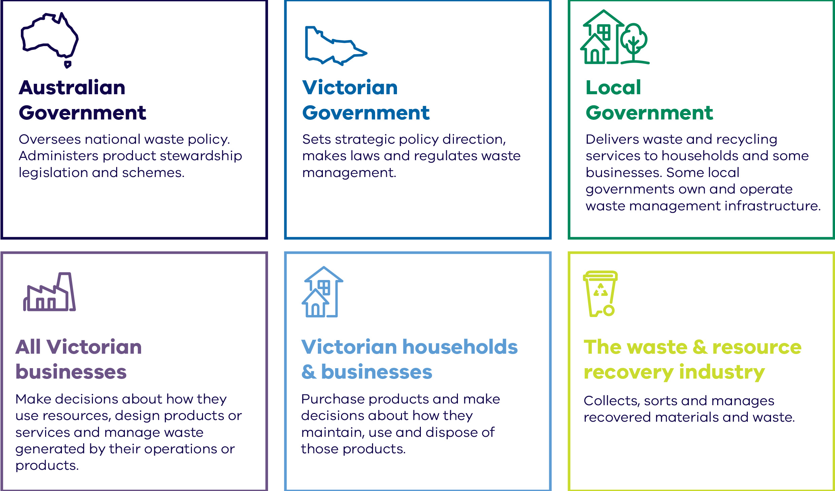

Figure 4: Roles and responsibilities in the circular economy

# MAKE

Goal 1: Design to last, repair and recycle

Victorian businesses will be central in the transition to a circular economy –creating new jobs and harnessing opportunities for growth, while reducing waste.

### Targets:

* 15 per cent reduction in total waste generation per capita between 2020 and 2030.
* Divert 80 per cent of waste from landfill by 2030, with an interim target of 72 per cent by 2025.
* Cut the volume of organic material going to landfill by 50 per cent between 2020 and 2030, with an interim target of 20 per cent reduction by 2025.

Victoria is growing rapidly. By 2046, it is estimated that Victoria’s use of extractive resources—to build infrastructure, provide services and to make and transport our products and food—will almost double[4] and our waste generation will increase by about 40 per cent.[5] To realise the opportunities and limit the impacts of this growth, we need to produce more with less and create less waste.

There are significant gains to be made, especially in material-intensive sectors such as construction, manufacturing and food and fibre. A global circular economy could reduce greenhouse gas emissions from four major industry sectors (plastics, steel, aluminium and cement) by 56 per cent in developed economies by 2050.[6] Greater recycling and reuse of materials within a more circular economy could also lower the costs of reducing emissions in those sectors by between 40 and 45 per cent.[7]

## More value from fewer resources

***Materials productivity is achieved when businesses use fewer resources to create more value. This means designing, making and having products that are reusable, durable, repairable and recyclable. It also means using business models that promote the intensive use of products.***

Businesses have a pivotal role to play in the circular economy. A five per cent improvement in materials efficiency could increase the size of the Victorian economy by $6.4 billion.[8] Materials-intensive businesses such as the construction, food and fibre sectors and manufacturing have a particularly important role.

The shift to a circular economy means changing how we do business. Global circular economy business leaders are adopting new technologies and business models that increase their competitiveness and productivity.

In 2017, circular activities—such as repair, reuse and recycling—in the European Union added almost €155 billion (A$251 billion) in value to the economy.[9]

Further, in 2012, it was estimated that Victorian businesses spent $5.4 billion on materials they discarded during production.[10]

In a circular economy, businesses can:

* replace traditional raw materials with renewable or recovered materials—or use fewer materials
* design and make more durable products that are repairable and recyclable
* offer services that promote sharing under-used products, like cars and tools
* adopt product-as-a-service models, where consumers pay to use a product (rather than own it) and businesses oversee maintenance and end-of-life management.[11]

|  |
| --- |
| Case study: e-waste design platform The National Gallery of Victoria (NGV) and Creative Victoria have partnered to run the Victorian Design Challenge 2020—an opportunity for Victorian school students, designers, engineers and entrepreneurs to tackle e-waste.  The 2020 e-waste challenge highlights the essential role Victorian innovators play in shifting behaviours, raising awareness and devising smart solutions to reduce e-waste. A two-stage design-and-pitch competition will give winners funding to prototype and develop their ideas, hold workshops and enter mentorships.  The Challenge has been developed in association with the eWaste Watch Institute—a not-for-profit organisation focused on accelerating electronics sustainability and environmental stewardship in Australia and New Zealand. |

### Key commitment 1: Improve business productivity and reduce waste

The Victorian Government will help position Victoria as a recycling leader by stimulating innovation in design and material use, and finding new ways of doing business.

It will build on existing sustainable business support and connections such as the Victorian Government’ssupport for the *Cleantech Cluster.* **Figure 5** outlines the suite of actions that will help Victorian businesses improve productivity and reduce waste.

#### 1.1 Circular Economy Business Innovation Centre

A new Circular Economy Business Innovation Centre will foster business innovation and collaboration across supply chains to reduce waste, increase recycling and reuse, and generate new streams of revenue for businesses. It will encourage investment in the digital economy, and leverage Victoria’s design and engineering expertise.

The Centre will bring together governments, industry, research organisations and communities to collaborate and respond to innovation challenges addressing Victoria’s circular economy priorities.

By assisting businesses to transition to a circular economy, we will help reduce waste and create new opportunities for innovation.

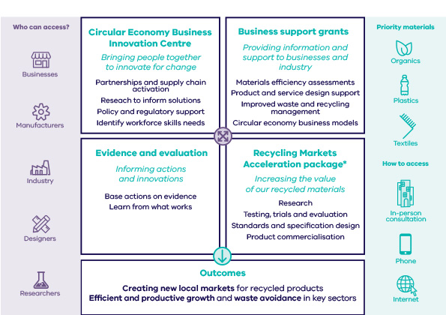

Figure 5: Support for Victorian businesses

#### Skills and training

The transition to a more circular economy will mean new jobs and businesses that will require new and different skills. The Victorian Government can develop leading circular workforce skills through Victoria’s vocational education and training (VET) system.

Initiatives for skills development could include:

* subsidised training for priority courses aligned with industry skill needs delivered under *Skills First*
* training through community-based *Learn Local* education organisations
* expert advice at *Skills and Job Centres* for workers transitioning to new sectors.

The government will work with the Victorian Skills Commissioner to understand the industry and skills needed for the transition.

#### 1.2 Business support grants

The Victorian Government will also establish a new grants program to help businesses improve resource efficiency, reduce waste to landfill, increase recycling and reduce business costs. Peak industry bodies, industry associations and coordinated business groups will also be able to seek funding to deliver sector-wide programs that promote waste avoidance, improved waste management and sustainable supply chain solutions.

These grants will support businesses to save money by identifying and implementing measures to reduce waste, improve materials efficiency and review waste and recycling contracts. Businesses will also be supported to investigate the feasibility of implementing business practices with circular economy principles such as redesigning products, changing service offerings, remanufacturing used products or delivering product stewardship arrangements.

|  |
| --- |
| Case study: Improving material use—eWater Systems Australian company eWater Systems is replacing traditional cleaning products with electrolysed water—a product that could replace harmful chemicals and reduce packaging waste.  The eWater system operates on site. It applies electricity to a mixture of tap water and salt. The process, known as electrolysis, splits the mixture into two solutions – a degreaser and a sanitiser.  eWater replaces traditional cleaners such as hand wash and disinfectants, and avoids shipping costs and packaging because it is produced at the site.  It is already used in the health care, recreation and hospitality sectors. It can replace up to 80 per cent of current cleaning products and reduces cleaning costs by up to 95 per cent.  eWater Systems estimates its technology has cut the need to use more than 83 million litres of packaged chemicals, saving businesses more than $8 million. |

|  |
| --- |
| Case study: Reducing food waste–Yume Food Yume has created the world’s leading business-to-business online marketplace dedicated to the sale of quality surplus food that would otherwise be at risk of going to landfill. Yume leverages technology to connect suppliers with buyers to offer a solution for quality food that may be close to best-before, mislabelled, discontinued, falling short of cosmetic standards, or otherwise stranded due to demand and supply imbalances. This solution ensures that precious food resources can realise their maximum value through sale for human consumption.  Yume works with primary producers and leading food manufacturers such as Kellogg’s, Mondelez and Unilever to re-home surplus food with large food service operators, such as Sodexo, Spotless, Accor, and independent retailers and manufacturers. Monash Health recently started purchasing through Yume to provide menu variety, cut costs and reduce food waste. This is a demonstration of the public sector adopting circular economy principles by utilising sustainable procurement practices to deliver substantial economic, environmental and social benefits.  To date Yume has sold over 1.3 million kilograms of high-quality surplus food, returning over $4.5 million to Australian farmers and manufacturers. Yume won three categories at the 2018 Premier’s Sustainability Awards and Yume’s founder and CEO, Katy Barfield, was the winner of the 2019 AFR Women of Influence Award for Business & Entrepreneur. |

#### 1.3 Product stewardship

Product stewardship schemes share the responsibility for managing products and their waste between producers, importers and consumers. This encourages businesses to design products that are more readily recyclable.

In Australia, national product stewardship schemes can be established voluntarily by an industry or through the Australian Government’s regulatory powers. Effective product stewardship schemes are essential to support a successful circular economy.

Existing product stewardship schemes across Australia cover televisions, computers, tyres and fluorescent lights and have driven large improvements in the collection of product waste. Since 2011, the *National Television and Computer Recycling Scheme*, funded by manufacturers and importers, has diverted more than 290,000 tonnes of e-waste from landfill.[12]

With voluntary schemes taking time to develop and become effective, the Victorian Government will continue to advocate for strong and effective product stewardship arrangements. Effective product stewardship schemes must be supported by all parts of the supply chain, and effective regulatory oversight from the Australian Government.

To accelerate change, stronger product stewardship arrangements should be pursued for priority products, including e-waste and products made from complex plastics. That is why the Victorian Government is leading the development of a national scheme for photovoltaic panels. Future product stewardship activity will also emphasise better product design and management for reuse, repair, recovery and refurbishment.

The Victorian Government supports the Australian Packaging Covenant Organisation’s (APCO) target of 100 per cent recyclable, reusable or compostable packaging by 2025.[13] The government will continue to support APCO’s work to improve packaging labelling, making it clear which packaging can be recycled and how it can be collected.

# USE

***GOAL 2: Use products to create more value***

***Victorians are committed recyclers who have separated waste for decades. But we need to think beyond what we put in our bins to what we buy, reuse or repair, and how we can make a difference in our communities.***

### Target:

* 15 per cent reduction in total waste generation per capita between 2020 and 2030.

Australia has one of the largest material footprints in the world at 35 tonnes per person.

That’s 10 tonnes (40 per cent) higher than the United States, Japan, the United Kingdom and Chile,[14] and it has significant environmental impacts and costs.

To reduce this footprint, governments, households and businesses must change how products and materials are purchased, maintained, repaired and disposed of.

Victorian communities are national leaders when it comes to reducing their environmental impacts. Victorians have been keen recyclers since the 1970s and increasingly use online platforms to share, trade, lend, sell, and give away items.[15] 61 per cent of Australians buy second-hand items at least once a year.[16]

To transition to a circular economy, Victorians must become world-class recyclers, repairers, resellers and reusers.

In a circular economy, businesses offer products in different ways. Renting and sharing become more common choices and products are used for longer or by more people—saving consumers money and reducing waste.

## Support Victorian communities and councils to reduce waste

***Businesses and households can help make the shift to a circular economy. Increasing the lifespan of materials and reducing waste requires awareness, access to alternatives and a shift in social practices. Shifting to a circular economy will require action at local, regional, state and national levels.***

Every purchase we make affects the environment. In a circular economy, we will choose goods and services that create more value from fewer resources. This might involve decisions to reduce, reuse, share, maintain, repair and recycle – or buy products that are durable, repairable, recyclable or made from recycled materials.

Councils and communities are well placed to support the transition at a local level, and can benefit from circular initiatives such as repair cafes, community gardens and local sharing platforms to reduce cost-of-living pressures and waste, build local skills, encourage social connections and create new business opportunities.

### Key commitment 2: Support Victorian communities

Circular economy practices are increasing, but it is often difficult for people to understand the environmental impacts of their purchases. We need greater awareness, information and access to alternative purchasing options to help Victorians to make this change.

Helping households reduce waste by making different purchasing decisions can save them money and unlock value for the broader Victorian economy.

The Victorian Government will encourage councils and their communities to identify and pursue local opportunities for improving material use and management. It will also provide information and tools to help consumers move towards low-waste, low-resource living. Over time, sharing, repairing, loaning and buying second-hand will become more common.

#### 2.1 Support for communities

The Victorian Government will provide grants to support local community groups, social enterprises and other not-for-profit businesses working to reduce waste and improve recycling, including through repair cafes and product-sharing schemes. Initiatives to tackle litter and illegal dumping will also be supported.

For example, micro-grants for local community initiatives through the Victorian Government’s *Can Do Communities* program have supported programs including Granny Skills workshops that teach participants how to reduce their waste, and established community food hubs that allow locals to shop packaging-free.

#### 2.2 Support for councils

Local councils will be able to apply for funding to identify and implement local services and solutions that enable their community to participate in a circular economy. Councils will be supported to act on opportunities to reduce waste and increase recycling locally and grow local businesses with high-value, secure jobs.

Circular economy initiatives will differ depending on the strengths of local economies. They will include opportunities for local businesses to use materials more efficiently and make more productive use of local waste resources.

Kalundborg Symbiosis, an industrial ecology initiative in Denmark, is an established example of a precinct-scale circular economy initiative.

At Kalundborg Symbiosis, surplus materials from one organisation become valuable resources to another, maximising efficiency and reducing overall resource use and transport costs. It’s estimated that Kalundborg Symbiosis has saved US$310 million (A$448 million).[17]

#### 2.3 Statewide education and behaviour change programs

The Victorian Government will deliver education and behaviour change programs to support a range of initiatives included in *Recycling Victoria*, including reforming kerbside recycling services (Action 5.1). The Victorian Government will also consider what information, education and tools could help people to avoid and minimise waste, and reuse, repair and share products.

These programswill build on existing successful campaigns on avoidance and reuse, such as *Love Food Hate Waste* (helping households and businesses to reduce food waste) and the *Better Bag Habits* campaign (helping Victorians remember to bring their reusable bags when shopping). They will complement the *ResourceSmart Schools* program, which helps schools embed sustainability in their facilities, curriculum and communities.

Support to change purchasing decisions and other behaviours can be effective in reducing waste. For example, 90 per cent of people surveyed as part of Sustainability Victoria’s *Love a List* challenge reduced their food waste and saved an average of $30 a week for four weeks.[18]

In addition to these programs, the Victorian Government will support more informed consumer decisions by advocating for the Australian Government to consider better product labelling toinform purchasersabout durability, repair and end-of-life management of the products they buy. This could be similar to energy and water efficiency labelling on whitegoods.

## Prevent plastic pollution

***Plastic pollution causes environmental harm and attracts significant clean-up costs.***

Plastics are an important part of our daily lives. Because most plastics are strong, lightweight, and inexpensive, they are widely used in packaging, transport, healthcare, textiles, construction and electronics.

But plastics can cause significant environmental harm and many single-use plastic items are difficult and economically unviable to recycle. These items can usually be avoided or replaced with alternative durable products.

### Key commitment 3: Address plastics pollution

We’ve already banned single use plastic bags, with further action on plastic pollution to be announced shortly.

## Support the reuse economy

***In a circular economy, greater value is generated from products by prolonging their life through repair and reuse.***

The charitable sector and its network of second-hand shops play an important role in a circular economy by redistributing goods for reuse. Around 780 charitable ‘op shops’ and reuse stores in Victoria extend the life of more than 76 million products each year, diverting more than 158,000 tonnes of waste from landfill.[19]

Australia’s charitable sector, however, spends $13 million a year on waste management of inappropriate donations and illegal rubbish dumping, with 60,000 tonnes of waste going to landfill.[20]

By helping charitable recyclers manage costs and ensuring Victorians understand appropriate options for donating goods, Victoria can maximise the value of second-hand goods and help people in need.

### Key commitment 4: Support the reuse economy

The Victorian Government is committed to supporting a thriving second-hand economy and helping charitable recyclers reduce the amount of materials sent to landfill.

#### 4.1 Support for charities

To achieve these outcomes, the government will:

* **support the reuse, repair and share sectors** through the Circular Economy Business Innovation Centre (see Action 1.1), business support grants (Action 1.2) and the Support Victorian Communities and Councils programs (see Actions 2.1 and 2.2)
* **undertake research,** in partnership with Monash University and the National Association of Charitable Recycling Organisations, to understand the contribution of the charitable sector to the reuse economy and expand product donation and reuse.

The Victorian Government will continue to support charities with funding that reduces their waste management costs. We will also work with the sector on a strategy to reduce waste at charities so that over the long term their waste management costs are reduced.

The Victorian Government is also committed to making it easier for Victorians to get their products safely repaired. We will work with the Australian Government to support national action on right-to-repair legislation and identify any Victorian legislative barriers to product repair.

# RECYCLE

GOAL 3: Recycle more resources

Victoria’s recycling system must change. Greater separation of recyclable materials and investment in the right infrastructure will produce higher-quality recycled materials with stronger market demand. A clearer understanding of where our recycling ends up will support a recycling system that communities and businesses can rely on.

### **Targets**:

* Divert 80 per cent of waste from landfill by 2030, with an interim target of 72 per cent by 2025.
* Halve the volume of organic material going to landfill by 50 per cent between 2020 and 2030, with an interim target of 20 per cent reduction by 2025.
* 100 per cent of households have access to a separate food and organics recovery service or local composting by 2030.

## Maximise resource recovery and value

***When materials are sent to landfill, their value is lost to the economy. Recycling materials keeps their value in the economy, prevents the need for new or expanded landfills, and creates jobs.***

Rapid population growth means Victoria’s waste is expected to increase. By 2046, we will create over 40 per cent more waste than in 2017-18.[21]

Even though Victoria already recovers 69 per cent of our waste[22], we can do better.

We will pursue an 80 per cent landfill diversion target by prioritising our activities in line with the waste hierarchy, which highlights the importance of waste minimisation and acknowledges the environmental benefits of recycling over converting waste to energy.

Increasing how much we recycle is a challenge. It will mean changing how we recycle at home and improving how businesses sort their waste. But there are many good reasons for Victoria to meet this challenge.

When waste is landfilled, we discard more than waste—we’re throwing away money and jobs. For example, the Australian recycling sector creates 9.2 jobs for every 10,000 tonnes of waste managed, while landfilling creates only 2.8.[23] One recent study estimates that nationally, we waste more than $324 million of resources that could be used productively by the manufacturing, construction and agricultural sectors.[24] This is an opportunity to develop new and innovative technologies and businesses, and position Victoria as a leader in the global economy.

Recycling creates environmental benefits, by preserving precious resources. Increasing the recycling and recovery of organic waste will also help reduce greenhouse gas emissions from the waste sector.[25]

It also reduces reliance on new landfills. For example, recycling one tonne of paper saves three cubic metres of landfill space.[26]

Going forward, Victoria needs the right settings in place to ensure waste and recycling services are reliable and transparent. This will include:

* **changing the way we collect waste from households**, including introducing a container deposit scheme, to reduce contamination and increase the value of the materials collected
* setting **landfill levies** at the right level to make recycling and energy recovery more cost-effective than landfill - and ensuring Victoria does not become a dumping ground for waste coming from other states
* improved **regulation and planning** to ensure we maintain reliable and transparent recycling services into the future.

### Key commitment 5: Reform the way households recycle

The way Victorians recycle is going to change. Putting all our recycling into a single ‘commingled’ bin produces low-quality materials that are no longer in demand. Two complementary reforms will encourage greater separation of waste, recover more materials and preserve their value.

The Victorian Government will establish a kerbside collection system that is better aligned with our local recycling markets and introduce a container deposit scheme.

Changing how we recycle will take time and will require the engagement of all Victorians—from households to local governments and recycling businesses.

#### 5.1 Household recycling reforms

To manage this transition, the Victorian Government will provide a kerbside reform package to support local government—key delivery partners in this reform—to roll out this new recycling system for Victoria.

This system will include access to four core waste and recycling services:

1. combined food and garden organics
2. glass
3. combined paper, plastic and metals
4. residual waste.

Standardising bins (including bin lid colours), and kerbside services (including items accepted) across Victoria will simplify household recycling, backed by a statewide education program.

Standardised recycling services will look different in metropolitan, regional and rural areas. A standard four-bin service may not be suitable for some communities or dwelling types such as large apartment buildings or more remote areas, where alternative arrangements, such as transfer stations, local drop-off points, home composting support or worm farms might be more appropriate.

The Victorian Government will work closely with councils to find options that meet local needs while maintaining a consistent statewide service and associated education program. Councils will be supported to work together, aggregating waste volumes and pursuing collaborative procurement of waste and recycling contracts to achieve improved services and recycling outcomes.

The reforms will be implemented gradually, with the Victorian Government supporting the rollout of new glass bins and new bin lids from 2021. All Victorians will have a new glass bin or access to glass services by 2027. Mandatory rollout of food and garden organics recovery services to households that don’t already have access will commence in 2026-27, with all Victorians to have access to a bin or service by 2030.

To support the reforms, the Victorian Government will review relevant existing guidelines, policies and regulation to make sure people living in diverse dwelling types, including multi-unit developments, have equitable access to best practice recycling.

These changes will substantially improve the value of materials Victorians recycle. For example, separating glass from other materials can increase the value of recycled glass, plastic, paper and cardboard by up to $210 million annually.[27]

Giving all Victorian households access to a combined food and garden waste services could divert up to 650,000 tonnes of organic waste from landfill each year[28] and significantly reduce greenhouse gas emissions associated with disposing of organic waste in landfill. Other actions to address food and organic waste are outlined in **Figure 6**.

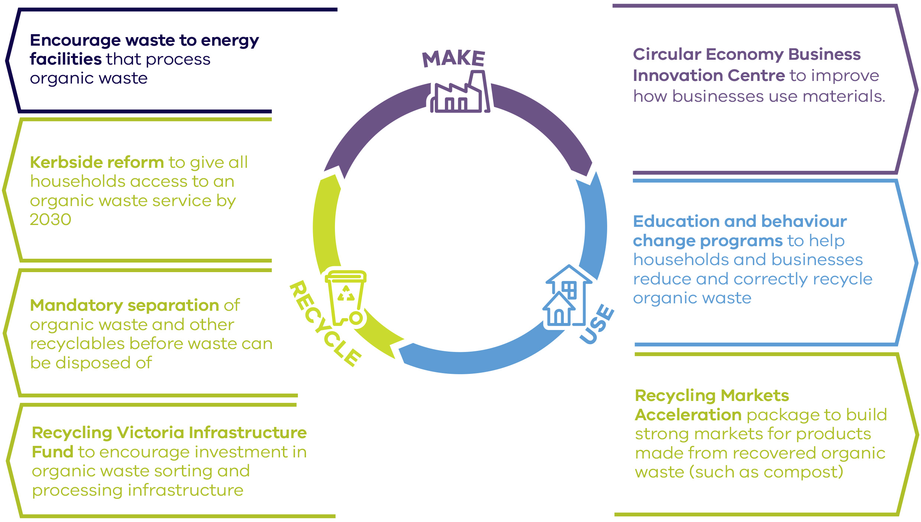

Figure 6: Organic waste and the circular economy

#### 5.2 Introduce a container deposit scheme

A container deposit schemewill encourage Victorians to recycle even when they are not at home. It does this by offering a refund on every eligible bottle or can returned to a collection point. This produces very clean and high-quality material that can be manufactured into new products (like more drink bottles).

We are learning from the experience of other jurisdictions as they develop and implement their schemes so that we can adopt the best mix of approaches in our model. As with other states, the beverage industry pays for this scheme, refunding a small amount of money) for each bottle returned to collection points for recycling. Where containers are collected at the kerbside, councils and recyclers will share the deposit refund. Victoria’s scheme will be introduced by 2022/23.

The scheme will be designed to ensure that the community benefits directly, and that it reduces litter and produces high-quality recycled material for manufacturing, including food-grade packaging. Glass, plastics and other materials collected through a container deposit scheme are significantly cleaner and more valuable – for example, glass collected through a container deposit scheme is worth up to $100 more per tonne than glass mixed with other recyclable materials.[29]

These cleaner, higher value streams of recyclable materials will attract investment and offer opportunities to create new, high-value recycled products in Victoria.

A container deposit scheme is also expected to halve beverage container litter in Victoria within 10 years.[30] In its first year alone, this scheme is expected to create more than 115 local jobs.

|  |
| --- |
| Case study: Separate glass collections for households in the City of Yarra Since June 2019, Yarra City Council has run trials of separate glass and food waste collections for 1,300 residents in Abbotsford. The system aims to increase the quality of recycled materials and send less waste to landfill.  Mixed recycling presents challenges for councils. Yarra estimates that around 38 per cent of recyclable waste in the trial area consists of glass bottles and jars. Glass creates problems when mixed with other recyclables because it often breaks and becomes embedded in plastics and paper, making them harder to recycle and of lower value. Food contamination further reduces the value and use of recyclables.  Yarra City Council has provided households in the trial area with two new bins: a plastic crate or mini-bin for glass and a wheelie bin for food and garden waste. Separating glass from other recyclables results in a higher quality of material that can create markets of higher value.  The collected glass will be turned into new glass products. Any glass that can’t be recycled will be used in road resurfacing in the City of Yarra. Food and garden waste collected in the trial is sent to a local facility and recycled to produce compost for Victorian farmers. Yarra City Council intends to expand this trial across the municipality.  The Victorian Government supported this project with two grants, totalling $600,000, through the Research Development and Demonstration grants program, and Resource Recovery Infrastructure Fund. |

#### Education to support household recycling reform

Recycling can be confusing. What can and cannot be recycled is not always clear, and while most of us want to do the right thing, we sometimes get it wrong.

In the past 12 months alone, more than half of Victorians recycled at least one item incorrectly. Putting the wrong items in the wrong bins ‘contaminates’ the recycling stream and currently leads to between 15 and 20 per cent of recycling being sent to landfill.[31]

For the recycling system to work, waste must be effectively separated.

Standardising household collection systems will reduce confusion for Victorians. The Victorian Government will invest in coordinated education and behaviour change programs (Action 2.3) that will include:

* a consistent, statewide campaignto educate households about what items go in which bin
* support for local government to align and deliver locally-tailored waste-related communications that are consistent with the integrated statewide program.

The Victorian Government will undertake research to determine the most effective approach to improve the community’s recycling habits.

### Recycling disruptions in 2019

In 2019, changes in global recycling markets left many recycling businesses with limited buyers for low-quality recycled paper, plastic and cardboard. This led to an oversupply and a major drop in the value of these materials.

Victoria’s recycling system was particularly exposed to these changes, because approximately 46 per cent of all recycled paper and 65 per cent of all recycled plastic were previously exported overseas for processing.

These challenges, alongside ongoing financial and compliance issues, forced SKM Recycling into liquidation in July 2019, leaving 33 Victorian councils without a kerbside recycling service. While some councils secured alternative recycling providers, many had no choice but to send recyclable material to landfill.

The Victorian Government worked in partnership with councils and the recycling industry to minimise this kerbside service disruption to Victorian households. A $6.6 million relief package to alleviate financial pressure on councils also helped to reduce impacts on households and councils.

### Key commitment 6: Fit-for-purpose landfill levies

Right now, Victoria’s landfill levy is significantly lower than our neighbouring states. In fact, Victoria has one of the lowest landfill levies for municipal and industrial waste in the nation.

We don’t want Victoria to become a dumping ground for waste coming from other states.

Victoria’s landfill levies also place a cost on disposing of household and business waste, creating a strong incentive to recycle and recover materials.

This means it is incumbent upon government to consider the most appropriate settings for Victoria’s landfill levy.

#### 6.1 Landfill levy changes

Ours is currently one of the lowest landfill levies for municipal and industrial waste in the country.

We don’t want Victoria to become a dumping ground for waste coming from other states

The landfill levy rate should instead recognise the social, economic and environmental value of recycling, and support a shift to a circular economy.

For this reason, the Victorian Government will progressively increase the landfill levy to bring it in line with other states.

That means a shift in the landfill levy for metropolitan household and business waste to $125.90 per tonne over the next three years. Proportional increases will be reflected at regional landfills.

An increase in levies:

* discourages waste from being transported from interstate into Victorian landfills
* creates a strong incentive to reduce and recycle waste and drive innovation in new technologies.

Landfill levies for certain priority wastes will also increase to ensure that they do not fall below the rates set for municipal and industrial waste.*

The change reflects an agreement reached by state and territory Treasurers to work towards the harmonisation of landfill levies.

This reform will be complemented by other actions including greater separation of recyclable materials through kerbside reform.

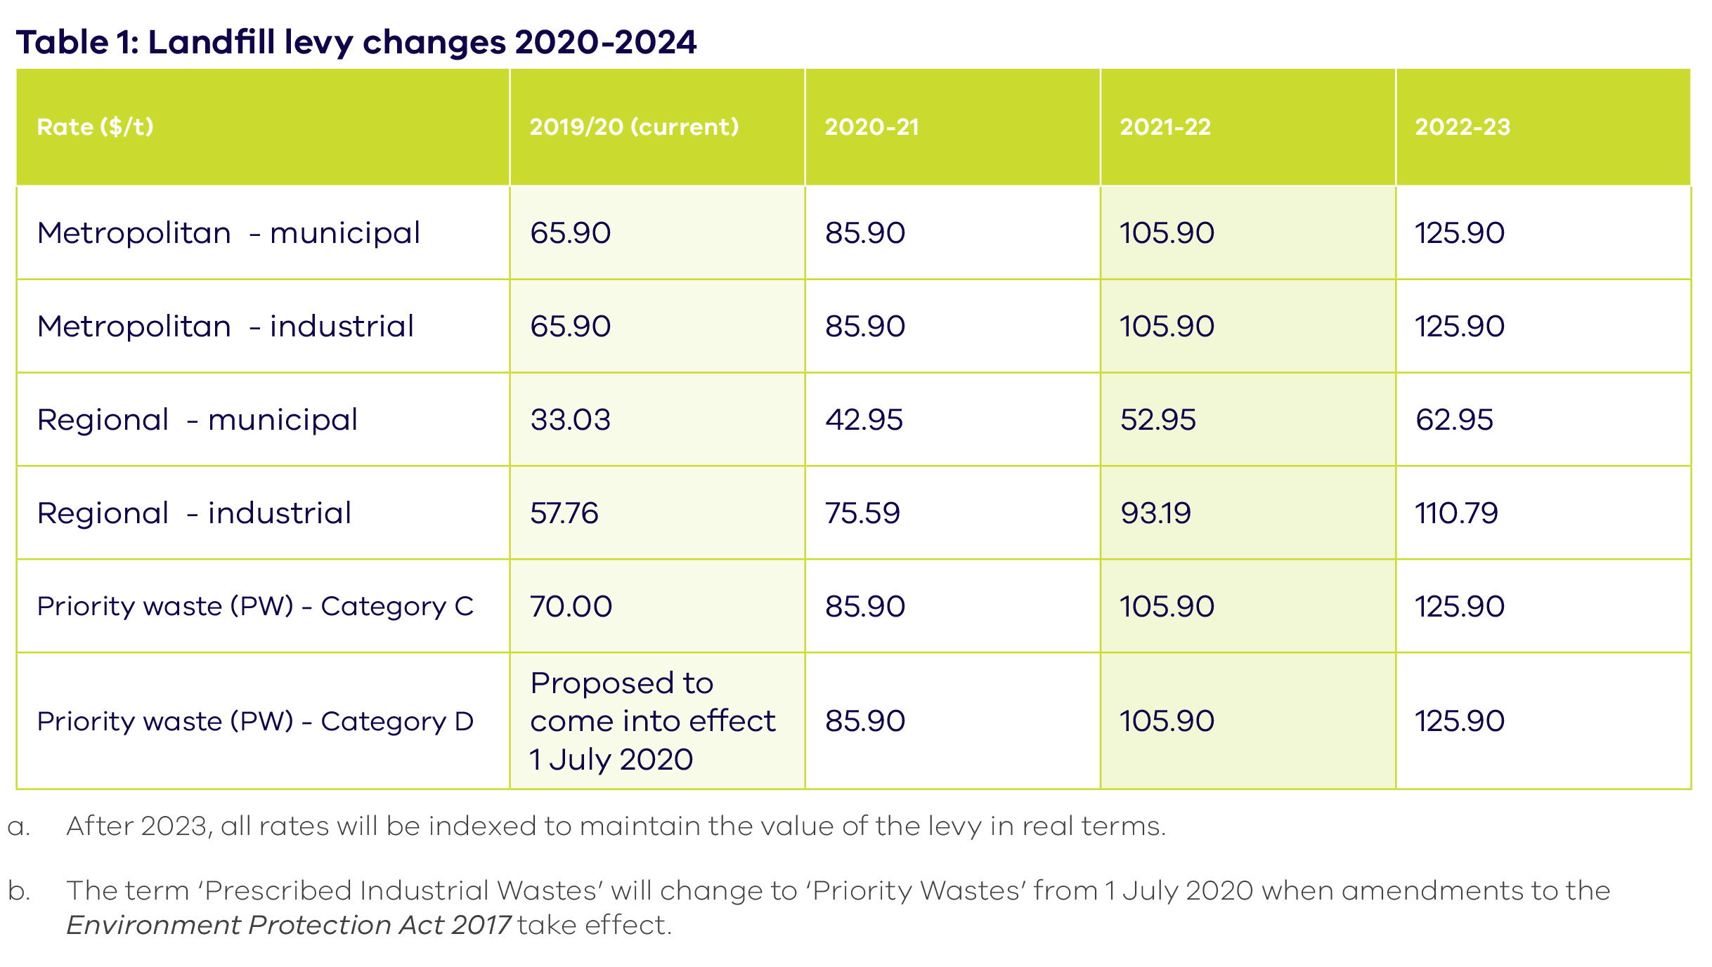

Table 1: Landfill levy changes 2020-2024

#### 6.2 Illegal Waste Disposal program

Changes to the landfill levy will encourage greater resource recovery, however, it must be accompanied by strong anti-avoidance measures to prevent illegal waste stockpiling and disposal.

The Environment Protection Authority Victoria will be given additional resources to monitor, investigate and prosecute illegal behaviour through the existing Illegal Waste Disposal program (formerly known as the Illegal Dumping Strikeforce).

As discussed in Key commitment 10, the Victorian Government will also tackle the stockpiling of waste for long periods to ensure the safety of our state.

#### 6.3 Landfill levy auditing

The Victorian Government will also continue and expand existing landfill levy auditing activities to ensure compliance.

### Key commitment 7: Governance and regulation

The Victorian Government recognises that major reforms are needed to lift the performance of our recycling sector, achieve ambitious resource recovery targets and shift to a circular economy. These reforms will target the reliability and transparency of household waste collections, make sure that recyclable materials are not disposed of, and ensure Victoria plans for waste and recycling needs in the coming years.

#### 7.1 Regulate waste as an essential service

To ensure greater transparency and service standards across the state, the Victorian Government will establish a new dedicated waste and recycling Act that governs all aspects associated with waste and recycling services.

This new Act will ensure waste and recycling services are reliable and meet community expectations. It will address current gaps by requiring improved data collection from waste and recycling organisations (including material recovery facilities) to provide transparency and accountability for what happens to our waste. Councils will also be required to provide information on the cost of delivering waste and recycling services.

The Essential Services Commission will undertake further analysis to inform what these new laws and broader legislative framework should look like.

#### Institutional reform

Through the new Act, the Victorian Government will establish a new waste authority in 2021 to better govern our waste and recycling systems, and hold waste service providers to account to ensure recent recycling disruptions are not repeated.

We will consult with Victorians, local governments and businesses about the proposed reforms, including the purpose, functions and powers of the new waste authority, in 2020.

#### Mandatory separation of commercial recyclable materials

Recovering more resources for productive use is central to a circular economy. Increased separation of materials at the source of disposal provides higher-value material streams than mixed or unsorted waste.[32]

While many Victorian households already sort waste before disposal, and the kerbside collection reforms will boost this, there is scope to improve the separation of commercial waste. Barriers to businesses separating waste where the waste is generated include limited time and money, a lack of skills and knowledge, space constraints and limited recycling service availability.[33]

The Victorian Government will introduce new rules to require businesses to sort commonly recyclable materials and organic waste from unrecoverable wastes. It is expected that these rules will apply to businesses that do not use the kerbside collection system.

Research from the European Union[34] found that separating recyclable materials efficiently where the waste is generated increases the volume of high-quality material available to resource recovery and manufacturing markets. Sorting requirements in the Netherlands and Belgium (Flanders) led to substantial diversion of waste from landfill.[35]

Materials to be separated from unrecoverable waste could include paper and cardboard, glass, plastics, metals and organic materials.

New rules that require materials to be sorted from other wastes are expected to deliver economic benefits for Victoria and will save businesses money.

The Victorian Government will consult with businesses to develop these rules, which are expected to come into effect by 2025.

#### 7.2 Plan for recycling infrastructure over the long term

Victoria was the first Australian jurisdiction to develop a comprehensive framework that plans for waste and resource recovery infrastructure.

This framework, which includes the *Victorian Recycling Infrastructure Plan*\* and associated regional plans, guides planning and investment in waste and resource recovery infrastructure over the next 30 years.

The Victorian Government will build on this framework, planning for all waste streams, undertaking contingency planning to address major system disruptions and forecasting how much residual (non-recyclable) waste we will have in the future, so that we have in place the infrastructure that we need.

As part of the upcoming review of the *Victorian Recycling Infrastructure Plan*\*, the Victorian Government will:

* **include hazardous waste infrastructure**
* **plan for waste to energy facilities** so that we have the infrastructure that we need in place (see Key commitment 9)
* **improve statewide risk and contingency planning** for waste and resource recovery infrastructure
* make sure land use planning systems align with infrastructure planning so that expanding recycling infrastructure can be accommodated.

## Use more recycled materials

***The foundation of a circular economy is a strong demand for recycled materials. The Victorian Government will help drive market demand by increasing innovation and supporting the next generation of jobs.***

Using more recycled materials in production is a critical part of the circular economy. Recycled materials have many productive uses in everything from manufacturing, to construction and to farming applications.

Over the past two years global markets for recyclable materials have diminished, and the Australian Government has committed to banning the export of waste plastic, paper, cardboard, glass and tyres.[36] Victoria, along with other Australian states and territories, currently exports significant amounts of these materials every year.[37] This means more recycled materials must be processed and used locally.

Programs in this plan will target materials that can no longer be exported and other materials where markets need to grow alongside increased recovery, particularly organic waste.

#### Key commitment 8: Increasing the use of recycled materials

#### 8.1 Recycling Markets Acceleration package

To drive demand for recycled materials across the economy, the Victorian Government will help identify new uses for recycled materials and make it easier for these products to be used. An early focus will be products made from recovered organic materials, such as compost and biofuels, and materials subject to Australia’s new waste export ban—plastics, paper, cardboard, glass and tyres.

The Victorian Government will:

* **Expand existing innovation programs** to encourage researchers and businesses to collaborate to take new products using recycled materials from research through to commercialisation
* **Develop and promote standards, specifications and guidance materials** for using recycled materials in commercial, industrial and construction settings.

This package could lead to the recovery and reuse of up to two million tonnes of materials every year that do not have strong domestic markets now.

It will also support business growth and innovation for advanced manufacturing and construction sectors that make use of recycled materials.

This package is one of a suite of actions that will support Victorian businesses to transition to a circular economy(**Figure 5**).

**Figure 7** shows the flow of some waste materials through the Victorian economy. It highlights opportunities to recycle more materials, and areas where Victoria must build stronger domestic markets.

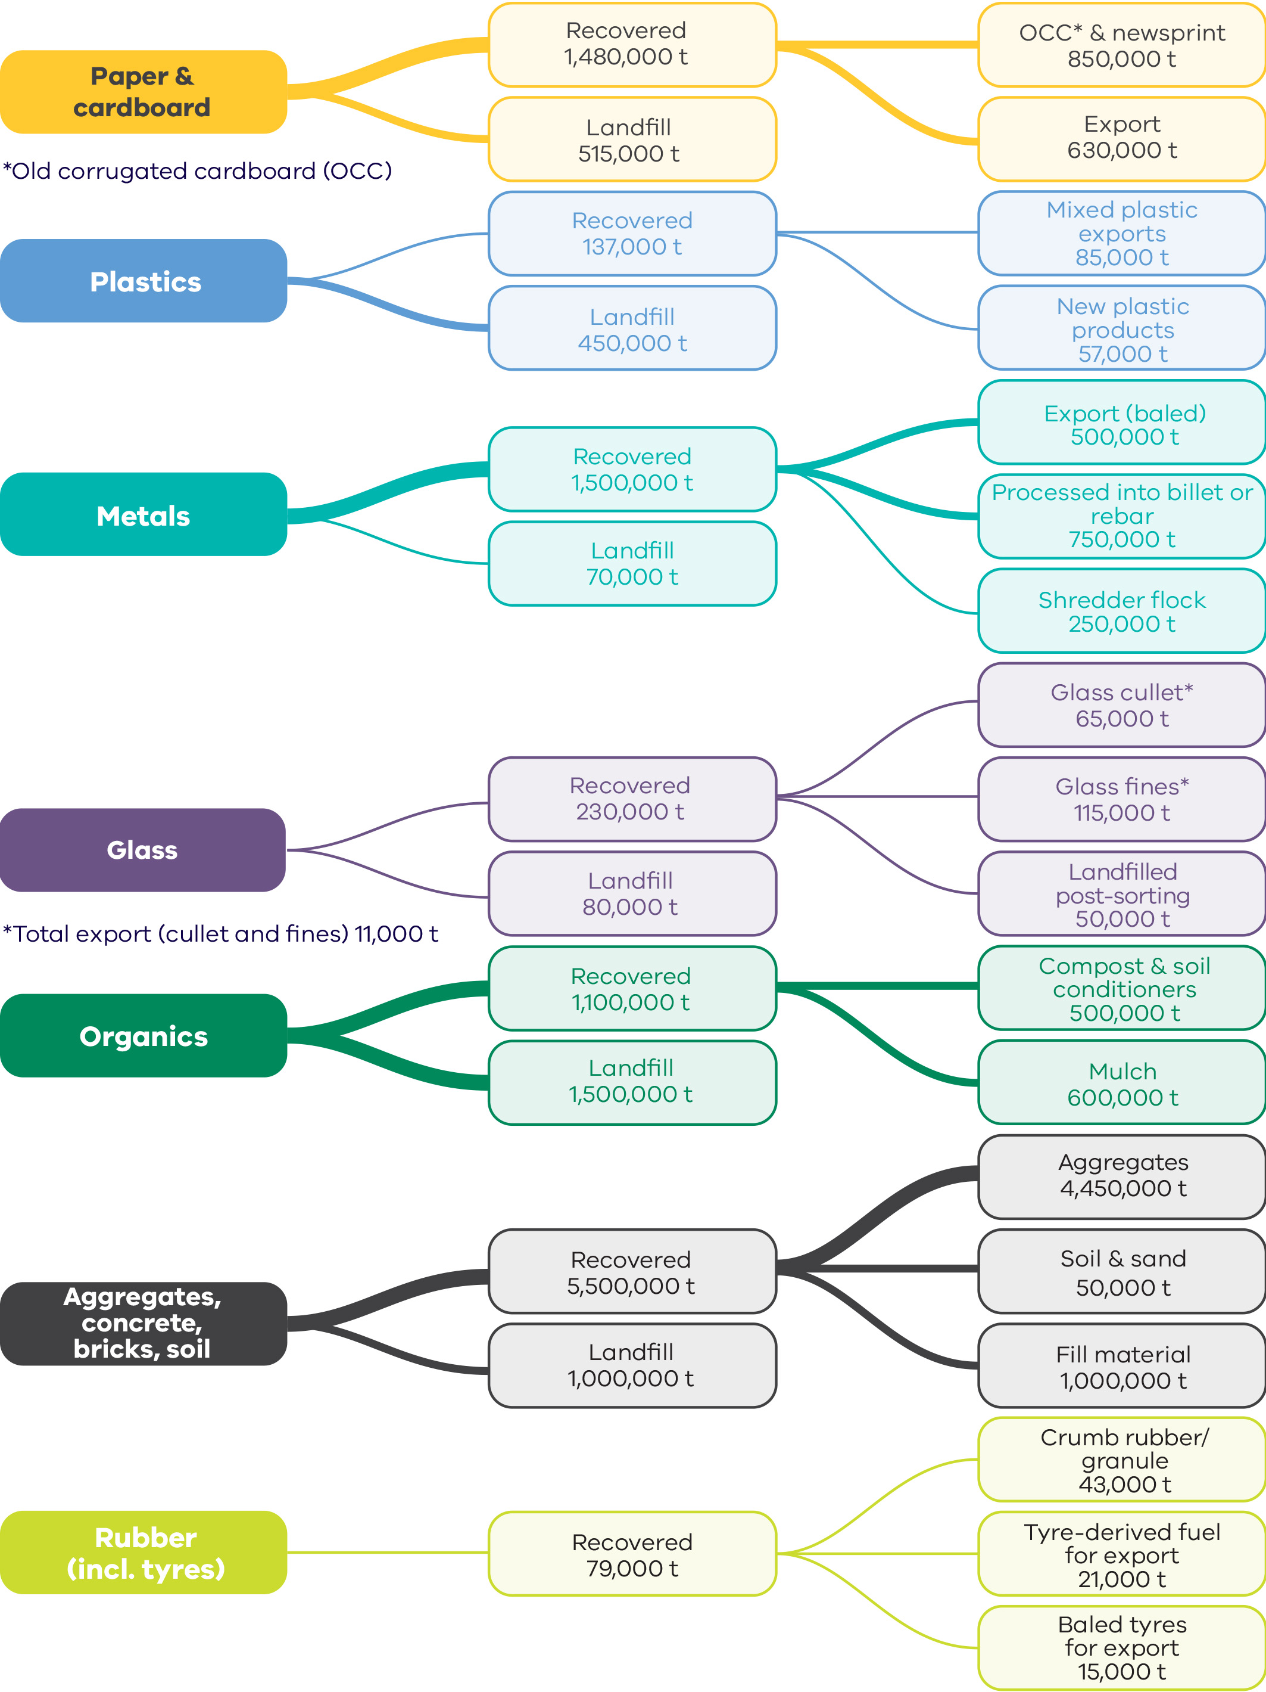

Figure 7: Key waste flows in Victoria

*\*Numbers in Figure 7 have been rounded and may not add up to other figures reported elsewhere in this document.*

#### 8.2 Public leadership in recycling

As a large buyer of goods and services, the Victorian Government can help create strong markets for recycled materials. We will seek new opportunities to purchase products containing recycled material (such as recycled printing paper) and use recycled materials to build roads, railways and other public infrastructure.

The Victorian Government’s *Social Procurement Framework* requires government buyers to consider opportunities to deliver social and sustainable outcomes in every procurement activity. This includes sustainable material choices and buying products made from recycled content where appropriate.

This already happens in many parts of government. Glass and tyres are used in road construction and plastic railway sleepers are being trialled at Richmond Station, in Melbourne. More than 200,000 tonnes of recycled materials have been identified to be used as part of upgrades to the M80 Ring Road, Monash Freeway and South Gippsland Highway.

That’s just the beginning. The Victorian Government will actively look for more opportunities to increase the use of recycled materials in state construction projects. We’ll provide more information about this commitment, and explain how it will work, by mid-2020.

The government will report regularly on its progress in this area.

We will also develop specifications to use more recycled materials in construction, and in 2020, will publish a product directory to help government source recycled materials.

We know that Victoria’s 79 municipalities are keen to use more recycled content to build and maintain local infrastructure. Local governments will be encouraged and supported to adopt a similar approach to the Victorian Government.

|  |
| --- |
| Case study: Paving the way with recycled glass and plastics The Department of Transport, through VicRoads, has been a national leader in the use of recycled products and is trialling Reconophalt, an asphalt pavement application made with recycled materials, in new roads around the state.  The creators of Reconophalt, Downer, in partnership with Close the Loop and RED Group, won the 2019 Premier’s Sustainability Award in the large business category for this asphalt replacement product.  Reconophalt uses more sustainable, waste-derived materials to replace bitumen. Every kilometre of road paved with Reconophalt uses approximately 530,000 plastic bags along with other forms of waste plastic packaging, the equivalent of 170,000 glass bottles, toner from 12,500 used printer cartridges and 130 tonnes of recycled asphalt. |

#### 8.3 Industry and infrastructure development package

Victoria’s ambitious resource recovery targets and the national ban on waste exports mean that we must process more recycled materials locally.

Currently, Victoria exports about 1.27 million tonnes of recyclable materials each year for reprocessing, which includes materials that will be subject to the export ban.[38]

Kerbside reforms enable increased recovery of recyclable materials. Giving Victorians access to more organic waste collection services could lead to the recovery of up to 650,000 tonnes of food and garden waste each year.[39]

The initial focus of this package is to accelerate and stimulate investment in infrastructure for the increased recovery of organic, plastic, paper, cardboard, glass, textile, chemical and tyre waste and to manage those materials in line with the waste hierarchy and export ban.

Victoria also needs best-practice infrastructure to safely manage waste. This includes infrastructure to recover energy from waste that cannot be recycled and would otherwise be sent to landfill, and facilities to better manage hazardous wastes.

Infrastructure Victoria’s report on recycling and resource recovery infrastructure needs, when it is provided in April 2020, will inform longer-term priorities for the package.

Victoria is already a national leader in recycling. *Recycling Victoria* creates new opportunities for business to invest in Victoria, using new technologies to collect, sort, process and use these valuable resources.

This will require new specialised skills to design and operate advanced reprocessing technologies, which will mean more jobs for Victoria.

#### Recycling infrastructure

The Victorian Government will attract the level of private investment we need to handle increased recycling though the Recycling VictoriaInfrastructure Fund.

The Fund will initially focus on stimulating investment in infrastructure that can sort and process organic, plastic, paper, cardboard, glass, textile, and tyre waste into high-value material streams.

In the future, the Recycling Victoria Infrastructure Fund will focus on other priority materials for recovery.

To support new facilities under the Fund, the Victorian Government’s *Investment Facilitation Service*will also be expanded to help resource recovery and other Victorian businesses:

* access government grants
* understand planning, policy and regulatory requirements
* learn about new technologies
* better understand viability of new investment in resource recovery and remanufacturing
* identify and understand feedstock by providing high quality waste and recycling data
* establish off-take agreements
* prepare business cases for investment.

#### Waste to energy infrastructure

As part of a comprehensive industry and infrastructure development package, the Victorian Government will support early entrants into Victoria’s waste to energy market, including facilities that use organic waste to make bioenergy or provide precinct-scale energy. This will help expand Victoria’s developing waste to energy market.

Investment support will include grant or loan funding and investment facilitation to help proponents navigate regulatory and financial processes.

The government will also fund research to develop safe end uses for the residual products (like ash and digestate) of waste to energy facilities. This work will create investment certainty for project proponents.

Victoria’s broader waste to energy framework is outlined in the ‘Encourage appropriate waste to energy’section.

#### Hazardous waste infrastructure

Through this package, the government will stimulate investment in infrastructure and innovation to better manage hazardous waste, and products that contain hazardous materials—with an initial focus on increasing capacity to safely recycle chemical waste and reduce stockpiles.

## Encourage appropriate waste to energy

***The Victorian Government supports waste to energy projects where they create clear net benefits and complement efforts to reduce or recycle waste.***

Waste to energy technologies have a role in an integrated waste and resource recovery system. As Victoria shifts towards a circular economy, and as part of a comprehensive policy approach, waste to energy facilities will divert waste from landfills and use it to create valuable energy. Generating energy from waste is better than sending waste to landfill, once valuable recyclable materials have been removed.

Waste to energy refers to any technology that is used to convert waste into useful energy resources such as heat, electricity, gas and liquid fuels. It includes thermal treatments (which can convert residual waste into heat, steam and electricity), and biological technologies such as anaerobic digestion (which create biogas and organic residues).

The Victorian Government recognises a role for waste to energy investment in Victoria, and supports waste to energy projects where they:

* meet best-practice environment protection requirements including air pollution controls
* reduce the amount of waste sent to landfill and do not displace reuse or recycling
* do not inhibit innovation in reuse or recycling of materials
* meet best-practice energy efficiency standards
* reduce greenhouse gas emissions compared to the waste and energy services they displace
* have sustainable business models that create jobs and economic development
* work well with local communities in which they operate.

Waste to energy can complement other outcomes under the waste hierarchy. For example, it can provide energy to other recycling, processing and manufacturing facilities, and use waste from a business hub to power those businesses, supporting circular economy outcomes.

The need for biological waste to energy treatments, such as anaerobic digestion, will be critical as Victoria recovers more organic wastes.[40] This will be a priority for the Victorian Government when leveraging investment in waste to energy infrastructure (see Action 8.3).

### Key commitment 9: Encourage appropriate waste to energy investment

It is important that the volumes of residual (non-recyclable) waste made available for thermal waste to energy facilities are monitored carefully. Over-investment in waste to energy infrastructure in the short term has the potential to undermine efforts to decrease waste generation and increase recycling in the long term. Experience in other jurisdictions indicates that over-investment in waste to energy infrastructure could be a disincentive to innovation in reuse and recycling and transitioning to a circular economy.[41] For this reason, the Victorian Government will monitor the development of waste to energy facilities closely.

The composition of Victoria’s residual waste will also change over time. As we move to a circular economy, the amount of waste that can be used to generate energy (such as paper and organic waste) as a proportion of total residual waste, will fall.

#### 9.1 Develop a waste to energy framework

Thermal waste to energy technologies that process residual wastes can achieve Victoria’s waste to energy goals if we have the right number and scale of facilities.

Infrastructure Victoria identified the potential risk of over-investing in waste to energy infrastructure, as observed in other jurisdictions like Denmark and the Netherlands.[42] During consultation on circular economy actions, households and community groups highlighted the role of government in addressing these concerns.

The Victorian Government will plan for waste to energy facilities as part of the Victorian Recycling Infrastructure Plan, to provide policy certainty for waste to energy facility proponents. This will include placing a cap of one million tonnes each year until 2040 on the amount of residual waste that can be used in thermal waste to energy facilities. The cap will be implemented through new rules which will be given effect by legislation or regulations.

The cap will include all thermal waste to energy facilities and apply to the quantity of waste they use as feedstocks.

In 2023, the Victorian Government will review the progress of the waste to energy sector to make sure it is helping to meet Victoria’s waste reduction and resource recovery targets.

|  |
| --- |
| Case study: Victoria’s water authorities leading the circular economy transition The water sector plays an important role in the circular economy. Organisations in the water sector are well placed to support the transition because of their access to suitable land, expertise managing organic waste and treatment technologies, and commitments to resource recovery and reducing greenhouse gas emissions.  One such leader is Yarra Valley Water, which operates an anaerobic digestion facility at its Aurora Sewage Treatment Plant in Wollert.  The digester at the facility accepts 33,000 tonnes of food waste per year (sourced from markets and food manufacturers) and produces 22,000 kilowatt-hours of electricity a day—enough to power 1,300 homes. This bioenergy is used to power not only the waste to energy facility itself, but also the neighbouring sewage treatment plant. The remaining energy is exported to the grid.  This system reduces costs for Yarra Valley Water, diverts waste from landfill, reduces greenhouse gas emissions and produces renewable energy.  Policies and actions within *Recycling Victoria* will support and provide opportunities for the water sector in a Victorian circular economy. |

# MANAGE

**GOAL 4: Reduce harm from waste and pollution**

**The safe management of waste is a fundamental principle of a circular economy.**

## Manage waste safely

***Risks posed to human health and the environment from waste will be better understood and effectively managed.***

In a circular economy, waste is reduced and recyclable materials are used productively.

However, there will still be some wastes that require disposal because there are no viable recycling options, or because they pose a risk to human health and the environment. To safely manage these wastes, Victoria needs the right scale and type of infrastructure, including dedicated hazardous waste treatment facilities and landfills.

Several high-profile incidents of unsafe storage and stockpiling have highlighted the importance of a strong regulatory framework for waste handling and storage. The Victorian Government has zero tolerance for unsafe waste management practices and will use its newly-strengthened environment protection legislation to enforce compliance.

Amendments to the *Environment Protection Act 2017* and associated regulations, which come into effect from 1 July 2020, introduce new duties for waste and recycling businesses to safely manage waste. They also ensure those businesses have appropriate scrutiny and oversight by the Environment Protection Authority and strengthen penalties for non-compliance.

Waste mismanagement creates costs for the whole community. The Victorian Government spends an estimated $58 million each year in clean-up costs at abandoned waste sites and $105 million each year to respond to stockpile fires. Clean-up costs and lost landfill levy revenue from illegal dumping equates to $30 million a year.[43]

Where waste is stockpiled for long periods of time, to avoid paying landfill levies, it can create safety risks for communities. The application of levies on long-term stockpiles can help avoid this risk. The Victorian Government will consider the introduction of new measures to reduce stockpiling, including a stockpiling levy following a regulatory impact statement and industry consultation. We will remove the financial incentive to illegally stockpile waste rather than disposing of it correctly.

The Victorian Government has introduced new rules to manage fire risks associated with stockpiles. The new rules allow agencies to intervene on sites that pose an immediate risk to nearby communities.

It has also developed a Coordinated Prevention and Response Framework to improve the way we identify and manage high-risk and hazardous waste sites and deal with illegal waste storage activity.

### Key commitment 10: Support safe and effective high-risk and hazardous waste management

The Victorian Government will ensure the safe management of high‑risk and hazardous wastes through stronger regulation, policy and planning (Action 10.1). Industry investment in better hazardous waste management, including opportunities to maximise the safe and cost-effective recovery and recycling of these wastes, will be encouraged.

The Victorian Government will:

* **consider the potential introduction of new levies for waste being stockpiled for long periods**encouraging the safe storage of these materials and managing associated public safety risks. Consultation will occur in 2020, with new mechanisms proposed to be introduced from 2021 (Action 10.4)
* **recover avoided waste levies and disposal fees for illegally stockpiled wastes** (Action 10.4)
* **ensure adequate disposal points for asbestos across the state,** through an Asbestos Disposal Management Plan (Action 10.2)
* **continue the successful *Detox Your Home* program**, encouraging the safe management and disposal of hazardous waste from households (Action 10.3)

The Coordinated Prevention and Response Framework establishes and documents a cross-government coordination approach for the management of high-risk and hazardous waste sites, including those that store combustible recyclable and waste materials and those associated with criminal activity.

### To implement the Framework the Victorian Government will:

### establish a Waste Crime Prevention Inspectorate within the Environment Protection Authority to work across government with WorkSafe Victoria, emergency service agencies, local government and other regulators, to address illegal activities and combat waste crime in Victoria (Action 10.5)

### improve intelligence sharing arrangements across regulatory and emergency management agencies (Action 10.4)

### build the regulatory capacity and capability of these agencies (Action 10.4)

### introduce new measures to ensure that the cost of managing or cleaning up high-risk sites is borne by those responsible for the site, to the greatest extent possible (Action 10.4).

# MEASURE OUR PROGRESS

The shift to a circular economy relies on high-quality and transparent data. Good data will support investment in waste and recycling, inform better decision-making and allow the government to monitor progress towards a circular economy.

## Modernise Victoria’s waste data

***Investment in a circular economy must be underpinned by reliable and useful data. To support this, the Victorian Government will develop new Victorian circular economy metrics and expand the waste data system to cover the entire Victorian economy—from product and process design to material use, reuse and recycling, and ultimately safe and effective disposal.***

The provision of high-quality data and reporting will help businesses and government better manage waste and make better investment decisions. It will also help the government track Victoria’s progress towards a circular economy.

**Key commitment 11: Expand Victoria’s waste data systems**

To achieve these outcomes, the Victorian Government will:

* **establish a framework for monitoring progress towards the circular economy**, including the identification of indicators and metrics
* **introduce a new waste and recycling data system** to enable better waste management and circular economy monitoring
* **continue to provide public waste and recycling market intelligence reporting.**

# REFERENCES

1. The Centre for International Economics. (2017). *Headline economic value for waste materials efficiency in Australia*. Prepared for the Department of Environment and Energy. Table 7.4, p.64. <http://www.environment.gov.au/system/files/resources/2cb83be1-2352-484e-b176-bd4328a27c76/files/headline-economic-values-waste-final-report-2017.pdf> (Note: This figure assumes a 5% improvement in materials efficiency and a 5% improvement in resource recovery.).
2. Sustainability Victoria (2019) Waste projection model, available at [https://www.sustainability.vic.gov.au/Government/Victorian-Waste-data-portal/Interactive-waste-data-mapping/Waste-projection-model#](https://www.sustainability.vic.gov.au/Government/Victorian-Waste-data-portal/Interactive-waste-data-mapping/Waste-projection-model) (Note: The figure is based on total waste data for 2017-18.)
3. COAG (2019, August). Meeting of the Council of Australian Governments Cairns - 9 August 2019 communique. <https://www.coag.gov.au/sites/default/files/communique/coag-communique-august-9-2019.pdf>
4. Department of Economic Development, Jobs, Transport and Resources (2018) *Helping Victoria Grow: Extractive Resources Strategy*, p.10, available at <https://earthresources.vic.gov.au/__data/assets/pdf_file/0003/453909/Extractive-resources-strategy.pdf> (Note: Derived from PwC (2016) high scenario demand forecasts that project demand will double between 2015 and 2050, and DJPR (2019) update showing demand to be tracking above PwC (2016) high scenario.)
5. Sustainability Victoria (2019) Waste projection model, available at [https://www.sustainability.vic.gov.au/Government/Victorian-Waste-data-portal/Interactive-waste-data-mapping/Waste-projection-model#](https://www.sustainability.vic.gov.au/Government/Victorian-Waste-data-portal/Interactive-waste-data-mapping/Waste-projection-model), (Note: The figure was arrived at by calculating the difference between total waste 2017-18 and 2045-46 for Construction and Demolition source sector information.)
6. Material Economics (2018) *The circular economy - A powerful force for climate mitigation*, p. 5 available at <https://materialeconomics.com/publications/the-circular-economy-a-powerful-force-for-climate-mitigation-1>
7. Energy Transition Council (2018) *Mission Possible*, available at <http://www.energy-transitions.org/mission-possible>, at pp. 91. (Note: The cost reduction figure assumes that logistics efficiency and shifts in the transport sector would also be made.)
8. The Centre for International Economics. (2017). *Headline economic value for waste materials efficiency in Australia*. Prepared for the Department of Environment and Energy. Table 7.4, p.64. <http://www.environment.gov.au/system/files/resources/2cb83be1-2352-484e-b176-bd4328a27c76/files/headline-economic-values-waste-final-report-2017.pdf>
9. European Commission (2019) Eurostat, Private investments, jobs and gross value added related to circular economy sectors [table], available at <https://ec.europa.eu/eurostat/tgm/refreshTableAction.do?tab=table&plugin=1&pcode=cei_cie010&language=en>, (conversion of €147 billion to A$251 billion completed on 8 January 2020)
10. Sustainability Victoria (2014) *Victorian Market Development Strategy for Recovered Resources Discussion Paper*, p.6, <https://www.sustainability.vic.gov.au/About-us/What-we-do/Strategy-and-planning/Victorian-market-development-strategy-for-recovered-resources>
11. OECD (2019), *Business Models for the Circular Economy: Opportunities and Challenges for Policy*, OECD Publishing, Paris. p.13, <https://doi.org/10.1787/g2g9dd62-en>
12. Department of the Environment and Energy, *National Television and Computer Recycling Scheme*, available at: <https://www.environment.gov.au/protection/waste-resource-recovery/television-and-computer-recycling-scheme>
13. Australian Packaging Covenant Organisation (2019) *Australian Packaging Covenant Strategic Plan 2017-2022* Version 2 – 1 January 2019. p. 2, available at <https://www.packagingcovenant.org.au/documents/item/2153>
14. Wiedmann T, et al. (2015) *The Material Footprint of Nations*, Proceedings of the National Academy of Sciences,vol. 122, no. 20, pp.6271-6276, available at <https://www.pnas.org/content/112/20/6271>
15. Hafermalz, E., et al., *Exploring dimensions of sharing economy business models enabled by IS: An Australian study.* 2016. <http://ro.uow.edu.au/cgi/viewcontent.cgi?article=1060&context=acis2016>
16. Gumtree (2019) *Second hand economy report*, p.8, available at <https://www.gumtree.com.au/second-hand-economy-report/>
17. Domenech, T, Davies, M (2011) St*ructure and morphology of industrial symbiosis networks: The case of Kalundborg*, Procedia - Social and Behavioral Sciences, Volume 10, p.82, <https://www.sciencedirect.com/science/article/pii/S1877042811000127?via%3Dihub> (Note: The dollar figure for economic benefits is from 2006; conversion of US$310 million to A$448 million completed on 13 January 2020.)
18. Derived from data collected by Sustainability Victoria.
19. Submission by Australia’s National Association of Charitable Recycling Organisations (NACRO) to the Victorian Government’s consultation, Shifting Victoria to a circular economy, July 2019, p.2-3, <https://www.nacro.org.au/wp-content/uploads/2019/08/NACRO-Submission-Victorian-Circular-Economy-1.pdf>
20. ibid. p.1,6
21. Sustainability Victoria (2019) Waste projection model, available at [https://www.sustainability.vic.gov.au/Government/Victorian-Waste-data-portal/Interactive-waste-data-mapping/Waste-projection-model#](https://www.sustainability.vic.gov.au/Government/Victorian-Waste-data-portal/Interactive-waste-data-mapping/Waste-projection-model) (Note: The figure is based on total waste for 2017-18 and total waste projected for 2045-46.)
22. Sustainability Victoria (2019) Waste projection model, available at [https://www.sustainability.vic.gov.au/Government/Victorian-Waste-data-portal/Interactive-waste-data-mapping/Waste-projection-model#](https://www.sustainability.vic.gov.au/Government/Victorian-Waste-data-portal/Interactive-waste-data-mapping/Waste-projection-model) (Note: The figure is based on total waste for 2017-18 and total waste projected for 2045-46.)
23. Access Economics (2009) *Employment in waste management and recycling*. Report by Access Economics Pty Ltd for the former Department of the Environment, Water, Heritage and the Arts (Commonwealth), p.2,21 <https://www.environment.gov.au/system/files/resources/5cc6a848-a93e-4b3f-abf7-fc8891d21405/files/waste-and-recycling-employment.doc>
24. Ernst & Young (2019) *Finding treasure in our trash: The $324 million wasted opportunity sitting on our kerbs*, p.4, <https://assets.ey.com/content/dam/ey-sites/ey-com/en_au/topics/climate-change/finding-treasure-in-our-trash-report.pdf>
25.
26. The State of Victoria Department of Environment, Land, Water and Planning (2018) *Recycling Industry Strategic Plan*, p.8, <https://www.environment.vic.gov.au/__data/assets/pdf_file/0013/326110/Recycling-Industry-Strategic-Plan.pdf>
27. Analysis undertaken or commissioned by Sustainability Victoria in 2019 to inform Victoria’s household recycling reform
28. Sustainability Victoria (2019) Waste projection model, available at [https://www.sustainability.vic.gov.au/Government/Victorian-Waste-data-portal/Interactive-waste-data-mapping/Waste-projection-model#](https://www.sustainability.vic.gov.au/Government/Victorian-Waste-data-portal/Interactive-waste-data-mapping/Waste-projection-model) (Note: The figure is based on organics going to landfill in 2017-18.)
29. Analysis undertaken or commissioned by Sustainability Victoria in 2019 to inform Victoria’s household recycling reform
30. Analysis undertaken or commissioned by Sustainability Victoria in 2019 to inform Victoria’s household recycling reform
31. Derived from data collected by Sustainability Victoria in 2019.
32. Ernst & Young (2019) *Finding treasure in our trash: The $324 million wasted opportunity sitting on our kerbs*, <https://assets.ey.com/content/dam/ey-sites/ey-com/en_au/topics/climate-change/finding-treasure-in-our-trash-report.pdf>
33. Sustainability Victoria, Sustainable Resource Use (2013) *Waste flows in the Victorian commercial and industrial sector*, p.106, <https://www.sustainability.vic.gov.au/-/media/SV/Publications/About-us/Research/Waste-flows-in-the-commercial-and-industrial-sector/Waste-Flows-in-CI-Sector-Full-Report-Jun-2013.pdf>
34. BiPRO/CRI (2015) *Assessment of separate collection schemes in the 28 capitals of the EU, Final report*, November 2015. <https://ec.europa.eu/environment/waste/studies/pdf/Separate%20collection_Final%20Report.pdf>
35. Hyder Consulting (2010) *Landfill Ban Investigation*, Department of Sustainability, Environment, Water, Population and Communities. <https://www.environment.gov.au/system/files/resources/6a763e66-ce3b-4f86-87b1-6522cfa977c7/files/landfill-ban.pdf>
36. COAG (2019, August). Meeting of the Council of Australian Governments Cairns - 9 August 2019 communique. <https://www.coag.gov.au/sites/default/files/communique/coag-communique-august-9-2019.pdf>
37. Sustainability Victoria (2019) *Victorian Recycling Industry Annual Report. 2017-18*, p.15, <https://www.sustainability.vic.gov.au/Government/Victorian-Waste-data-portal/Victorian-Recycling-Industry-Annual-Report> (Note: The export figure provides a total for ‘rubber’ which includes rubber tyres and other rubber waste).
38. ibid, table on p.15 (Note: 1.27 tonnes is based on the 2017-18 figure.)
39. Sustainability Victoria (2019) Waste projection model, available at [https://www.sustainability.vic.gov.au/Government/Victorian-Waste-data-portal/Interactive-waste-data-mapping/Waste-projection-model#](https://www.sustainability.vic.gov.au/Government/Victorian-Waste-data-portal/Interactive-waste-data-mapping/Waste-projection-model) (Note: The figure is based on organics going to landfill in 2017-18.)
40. Analysis undertaken or commissioned by DELWP in 2019 to inform *Recycling Victoria*
41. European Commission (2017) *Communication from the Commission to European Parliament, the Council, the European Economic and Social Committee and the Committee of the Regions*, European Commission, Brussels, available at <https://ec.europa.eu/environment/waste/waste-to-energy.pdf>
42. ibid.
43. Deloitte (2019) *Regulatory Impact Statement: Proposed Environment Protection Regulations*, Victorian Government, Melbourne. P.10, available at <https://engage.vic.gov.au/new-environmental-laws/subordinate-legislation>.