**What is family violence?**

**There are people you can speak with and numbers to phone if**

**you, or someone you know, is living in fear or needs help or support.**

Family violence is emotional abuse, financial abuse, physical or sexual violence, and coercive and controlling behaviour. This can include abusers restricting your movement or isolating you from friends or family.

**Services and people who can help**

  This can significantly limit a person’s opportunities to get help and support.

Children, young people and older people, people with health conditions, disability or additional communication needs are at increaserisk dring isolation, andfromed access to supports.



Are you experiencing family violence?

Are you concerned a friend or family

member is experiencing family violence?



You are not alone, there is help available. If you feel frightened or are concerned about your own or someone’s safety and wellbeing, or if you need to reach a place of safety, **call safe steps 1800 015 188** for advice, help and support.

**If you or someone you know is in immediate danger call 000**

**What can I do if I’m concerned someone I know needs help?**

**Safe communication:** Reach out to let them know you understand and that there is help. Think about secure ways to communicate, such as using WhatsApp or Signal. Agree a code word or signal if they need help or need to call the police.

**Safe accommodation:** There are options for accessing safe housing during isolation. **Call safe steps 1800 015 188** for help.

**Safety at home:** Leaving is not always a safe option. Talk through a plan that might help increase their safety and to protect any children. **Call safe steps on 1800 015 188** for help with safety planning.

**Contact help:** Safe housing and support services are available if someone is at risk and requires protection, such as refuges.

**Call safe steps 1800 015 188**, 24 hours a day, 7 days a week. Or Email [**safesteps@safesteps.org.au**](mailto:safesteps@safesteps.org.au)[**www.safesteps.org.au**](http://www.safesteps.org.au)

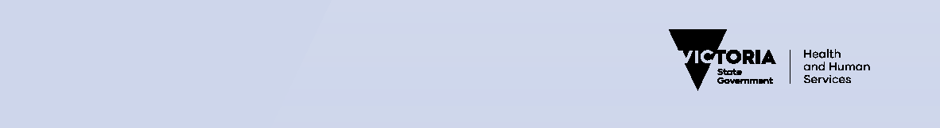

To receive this publication in an accessible format email [COVID-19@dhhs.vic.gov.au](mailto:COVID-19@dhhs.vic.gov.au)

Authorised and published by the Victorian Government, 1 Treasury Place, Melbourne. © State of Victoria, March 2020. (2001628)