

|  |
| --- |
| ICT Project Quality Assurance Framework  For non-High Value High Risk  ICT projects |

Contents

Vision, purpose and document details 3

Overview 4

Purpose 4

Scope 4

The problem 4

Objectives 5

Issues 5

Glossary 6

ICT Project Quality assurance (QA) process 7

Is my ICT project subject to the whole-of-Victorian Government (WoVG) ICT project assurance requirement? 7

What are the minimum requirements for quality assurance? 8

What information do we provide in our QA attestation to DPC? 8

Resources and references 9

Further information 10

Document control 10

Version history 10

# Vision, purpose and document details

|  |  |  |  |
| --- | --- | --- | --- |
| VISION | Increase the success rate in delivering ICT projects in Victorian Government | | |
| PURPOSE | To set up a formal assurance mechanism to enhance quality assurance for all Victorian Government’s ICT projects with a total estimated investment of  $10 million and above that are not classified as ‘High Value, High Risk’. | | |
| APPLIES TO | All departments and agencies that are subject to Financial Management Act 1994 (Vic) | **AUTHORITY** | Victorian Government |
| PERIOD | 2018 to 2023 | **ADVISED BY** | Department of Premier and Cabinet |
| ISSUE DATE | December 2018 | **DOCUMENT ID** | Assurance/STD/01 |
| REVIEW DATE | December 2023 | **VERSION** | V1.0 |

# Overview

Investing in technology is critical in making government services more accessible to the public and undertaking government business more efficiently. In funding ICT projects, it is important that appropriate controls exist so that project delivery issues are identified earlier and risks are appropriately managed.

The Victorian Government approved for an ICT Project Assurance Framework (the framework) in 2016 to ensure a formal process is applied to Victorian Government’s ICT projects or an IT component in a larger business program (ICT projects) of certain value to receive independent and impartial quality assurance advice.

# Purpose

All government ICT projects with a total estimated investment (TEI) of $10 million and above will be classified as either ‘High Value High Risk’(HVHR) or non-HVHR.

This framework is intended to ensure that departments and agencies engage and receive independent quality assurance advice for their **non-HVHR** ICT projects.

For ICT projects which are classified as HVHR, please refer to [the Department of Treasury and Finance’s (DTF) Investment Lifecycle and HVHR guidelines.](https://www.dtf.vic.gov.au/infrastructure-investment/high-value-high-risk-framework)

The framework also responds to Action 22 of the [*Information Technology Strategy for the Victorian Government, 2016–2020*](http://www.enterprisesolutions.vic.gov.au/it-strategy/) (IT strategy), which calls for improved assurance for major ICT projects.

# Scope

This framework applies to all Victorian Government departments and agencies that:

* are subject to the *Financial Management Act 1994* (VIC)
* have ICT projects with a TEI of $10 million and above that are not classified as a HVHR project, regardless of funding source
* have a project initiation start date from March 2017 and onwards.

# The problem

The need of a formal project assurance frame work is to address findings in several reviews of large Victorian ICT projects have been undertaken in recent years, most notably:

1. The Ombudsman’s 2011 ‘[Own motion investigation into ICT-enabled projects](https://www.ombudsman.vic.gov.au/getattachment/d5e69dd1-400d-42cd-a570-9c6b21c4bb1e)’ found that Victorian Public Sector did not effectively manage major ICT projects, and with repeated mistakes around planning, governance, project management and procurement.
2. The Victorian Auditor-General’s Office (VAGO) 2015 ‘[Digital Dashboard: Status Review of ICT Projects and Initiatives](https://www.audit.vic.gov.au/sites/default/files/20150415-Digital-dashboard.pdf)’ that found Victorian agencies and entities were not in a position to assure Parliament and the Victorian community that their ICT investments have resulted in sufficient public value to justify the significant expenditure of taxpayers’ money.

These reviews reached similar conclusions that ICT projects largely fail due to a variety of reasons, including inadequate management of business and technical requirements, as well as failing to manage risks and intended benefits to achieve the transformational impacts. In many cases, it is not the technology itself that has resulted in ICT projects struggling to deliver on their original objectives by poor scoping or vendor management.

# Objectives

The objectives of the framework aim to:

* implement a formal process to ensure departments and agencies engage independent and impartial project quality assurance advice throughout project lifecycle for their in-scope ICT projects
* ensure project sponsors, as the project investor, are responsible for their ICT projects to receive rigorous independent quality oversight to help realise project objectives and benefits and increase the success of project delivery.

# Issues

The framework addresses some, but not limited to, common issues in ICT project delivery:

* **lack of understanding of project governance** including lack of senior management sponsorship and commitment to the project, inappropriate and inconsistent expectations, lack of direction, accountability and responsibility, and inability or unwillingness to terminate poor performing projects;
* **misunderstanding of scope and business requirements** including misunderstanding of user requirements, poorly described scope and objectives, lack of definition of the essential functional and non-functional business requirements, and scope creep /changes;
* **inadequate stakeholder management** including lack of adequate user and stakeholder involvement/commitment, and failure to recognise the importance of training and change management;
* **inadequate organisational change capacity** – over committing the organisation to implementing change across multiple functions, without consideration of the ability of the organisation to support such as change; and
* **insufficient project management resource and capability** including inadequate staffing, poor project management skills, teams and methodology (lack of project controls – planning, scheduling and resource management).

These factors are not unique to ICT projects but the nature of ICT projects makes them more significant.

There is a need to ensure that good practice guidance is adopted; that ICT projects are appropriately scoped and planned with clear statement of works before they are taken to market; and that implementation is undertaken in a disciplined way.

# Glossary

For the purpose of this document, the following terms are defined

|  |  |
| --- | --- |
| Term | Definition |
| **TEI** | Total estimated investment  All capital spending or funding that is required to achieve the agreed objectives, benefits or outputs of the ICT project. |
| **ICT** | Information and communications technology.  For the purposes of this standard, the definition of ICT is any technology that stores, retrieves, manipulates, transmits or receives information electronically or in a digital form. It includes communication devices or applications, computer hardware, software, network infrastructure, video conferencing technology, telephones and mobile phones. |
| **ICT Project** | For the purposes of this standard the definition of ICT Project is any project or initiative where ICT investment is fundamental to achieving the agreed objectives, benefits or outputs. ICT projects have a defined start and end dates, and focus on delivering:   * technological change or business capability and may extend to information management, information security or infrastructure improvements, e.g. upgrades, asset replacement, etc. * a government strategy or program where ICT is used in whole or in part to effect change and/or deliver outputs and outcomes and/or realise benefits, including business change – not necessarily technological in nature, e.g. business process improvement, community engagement, legislative policy. |
| Project initiation start date | For the purpose of this standard, project initiation start date refers to the date the projects commence the following tasks:   * feasibility study * planning including: i) business case development; ii) requirements definition; iii) solution option analysis; iv) planned procurement; v) funding request. |
| **HVHR** | High value high risk  A project will be classified by DTF as being HVHR if it is a budget-funded project that is:   * considered high risk using DTF’s risk assessment tool, the Project Profile Model (PPM); * considered medium risk using the PPM and has a total estimated investment (TEI) of between $100 million and $250 million; * considered low risk using the PPM but has a TEI over $250 million; or * identified by Government as warranting the rigour applied to HVHR investments. |
| **FMA departments and agencies** | Victorian Government departments and public bodies that are subject to the *Financial Management Act (FMA) 1994* (Vic),including:   * a department within the meaning of the *Public Administration Act (PAC) 2004* * an office specified in section 16(1) of PAC * a public body that is declared by the Minister, by notice published in the Government Gazette, to be a body or office to which Part 7 of FMA applies, including:   1. a public statutory authority   2. a State business corporation or State body within the meaning of the *State Owned Enterprises Act 1992* (Vic)   3. a body, office or trust body:      + - established by or under an Act or enactment; or        - established by the Governor in Council or a Minister |
| **DTF** | The Department of Treasury and Finance  DTF oversees all projects classified as ‘high value’ or ‘high risk’ through budget process. |

# ICT project quality assurance (QA) requirements

The QA requirements should augment existing project management functions and assist in defining the scope of key milestones and deliverables based on formal QA report. Throughout project implementation, this process should provide rigorous oversight and timely advice to the project sponsor and project control board where appropriate.

### Is my ICT project subject to the whole-of-Victorian Government (WoVG) ICT project assurance requirement?

The following figure provides the steps to check if your ICT project is in scope:

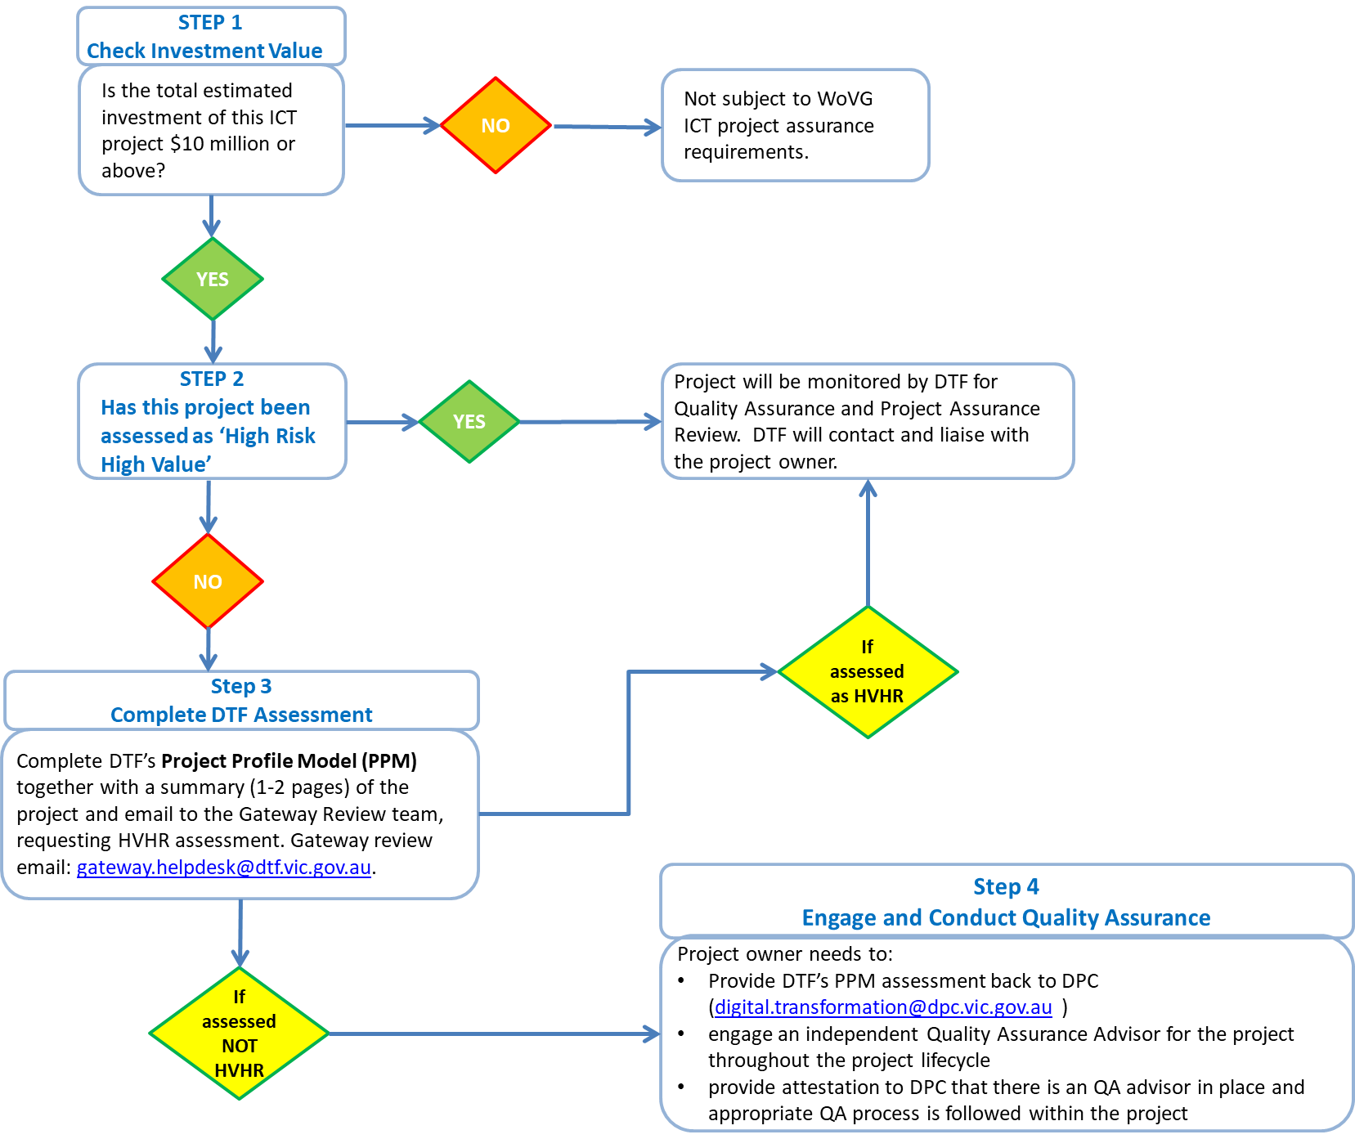

### What are the minimum requirements for quality assurance?

The project owner should ensure that an independent QA advisor, with relevant experience and capability, is engaged on a continuous basis to identify and act early on project issues and to provide advice on how to address risks. The QA role is there to monitor project delivery actively and interject with recommendations to address elements of concern.

The QA process should be:

* independent and impartial from project management
* fit for purpose
* relying on project documentation and key deliverables to check the health of the project and recommend specific deep dive reviews at key gates or milestones where appropriate.

At the beginning of the project and at each major milestone, the minimum QA requirements should include:

* **Governance** - Continuity and capability of individual members within the PCB to receive, digest and act upon timely accurate project reporting
* **Business Case** - Ensuring that the business case is being regularly reviewed by the PCB to ensure benefits remain valid
* **Project Management** – Ensuring consistent and effective project management – encouraging continuity and management of risks and issues
* **Delivery** – Ensuring the whole-of-project lifecycle is considered including post implementation;
* **Stakeholder management** – Ensuring key stakeholders are involved throughout project lifecycle with a clear RASCI (responsible, accountable, support, consult and inform) map
* **Vendor/contract management** - Focus on vendor/contract management throughout the project lifecycle, not only as major issues emerge;
* **Evidence based best practice** – ensuring the identification of external and internal lessons learned are captured to support the implementation of ICT projects; and
* **Project monitoring** - Forecasting the end-to-end project delivery effort, cost and timeline, focusing on what it will take to achieve the outcomes/benefits promised.

### What information do we provide in our QA attestation to DPC?

All departments and agencies with in-scope project will need to use the attached attestation form to provide written confirmation of the QA function for their specific project, endorsed by project sponsor.



### Who can I engage to provide QA advice?

Departments and agencies are responsible for procurement, service evaluation and contract negotiation to ensure the appropriate QA advisor is engaged. This can include vendors approved on the [Professional Advisory Services (PAS) Panel](http://www.procurement.vic.gov.au/State-Purchase-Contracts/Professional-Advisory-Services) (under Commercial and Financial Advisory Services – Category 5). If you have further questions, please contact Digital Strategy and Transformation Branch ([digital.transformation@dpc.vic.gov.au](mailto:digital.transformation@dpc.vic.gov.au)).

# Resources and references

**Project Profile Model**

To determine if your project is ‘High Value High Risk’, the project can be assessed using the DTF Gateway project profile model form, which can be found at: <https://www.dtf.vic.gov.au/gateway-review-process/book-gateway-review>.

**Investment lifecycle Guidelines**

These guidelines provide practical assistance to anyone developing investment projects in Victoria. They help shape proposals, inform investment decisions, monitor project delivery and track the benefits of investments.

<https://www.dtf.vic.gov.au/infrastructure-investment/investment-lifecycle-and-high-value-high-risk-guidelines>

**Investment Management Standard practice and principles**

The investment management standard (IMS) is a process for applying simple, common-sense ideas and practices that help organisations to direct their resources and achieve the best outcomes from their investments.

<https://www.dtf.vic.gov.au/infrastructure-investment/investment-management-standard>

**High Value High Risk (HVHR) Framework**

Government infrastructure and ICT projects identified as high value or high risk are subject to more rigorous scrutiny and approval processes. The HVHR Framework comprises a series of project assurance checks and processes to increase the likelihood that these projects will achieve their stated benefits and be delivered successfully, on time and to budget.

<https://www.dtf.vic.gov.au/infrastructure-investment/high-value-high-risk-framework>

**Project Governance Executive Program**

This program is designed for senior executives, who are existing or potential Project Control Board members, to help them build solid understanding of the governance, risk and benefit management of an ICT-enabled project in public sector.  <https://www.vic.gov.au/digital-capability-uplift>

**Victorian Government ICT Dashboard**

ICT Dashboard provides status reporting of ICT projects of $1 million and above.

<https://ictdashboard.enterprisesolutions.vic.gov.au>

**WoVG ICT Project Management Community of Practice**

The WoVG ICT Project Management Community of Practice brings together all ICT project managers, subject matter experts (change managers, PMO managers, project coordinators etc.) and other ICT practitioners across Victorian Government departments and agencies.

This community of practice supports its members to share knowledge and experience, promote best practice and improve common capabilities and foster collaboration.

<https://innovationnetwork.vic.gov.au/groups/wovg-ict-project-management-community-practice>

# Further information

Please email Digital Strategy and Transformation Branch in the Department of Premier and Cabinet at [digital.transformation@dpc.vic.gov.au](mailto:digital.transformation@dpc.vic.gov.au).

# Document control

### Version history

|  |  |  |
| --- | --- | --- |
| Version | Date | Comments |
| 0.1 | 10/09/2018 | Draft for review |
| 1.0 | 21/12/2018 | Final |