|  |
| --- |
| Cabinet in Confidence and Caretaker Period Digital Information Management |
| Information Management Framework |



# Standard

Departments must create, manage and transfer cabinet in confidence records digitally in accordance with requirements set out in this standard.

# Document control

|  |  |  |  |
| --- | --- | --- | --- |
| **APPLIES TO** | All departments and  Victoria Police | AUTHORITY | Integrity and Corporate Reform Subcommittee under authority of the Victorian Secretaries Board |
| **PERIOD** | 2017 – 2020 | ADVISED BY | Digital Strategy and Transformation Department of Premier and Cabinet |
| **ISSUE DATE** | September 2017 | DOCUMENT ID | IM-STD-06 |
| **REVIEW DATE** | September 2020 | VERSION | 1.0 |

  
Except for any logos, emblems, trademarks and contents attributed to other parties, the statement of directions, policies and standards of the Victorian Government’s Victorian Secretaries Board or CIO Leadership Group are licensed under the Creative Commons Attribution 4.0 International licence. To view a copy of this licence, visit <https://creativecommons.org/licenses/by/4.0/>.

# Requirements

## Digital records

Departments must at a minimum:

1. Create complete and authoritative digital cabinet in confidence (CIC) records as follows.
   1. In compliance with the 2018 Caretaker Conventions (when developed). Departments will create, manage and transfer their CIC records digitally as far as possible. Hardcopy records may be created and/or transferred to PROV by exception in consultation with the Cabinet Office.
   2. By the 2022 caretaker period, all departments will create, manage and transfer all CIC records in digital format.
2. Ensure that digitisation of hardcopy CIC records is undertaken in accordance with each department’s PROV-compliant digitisation plan (see [*PROV Capture Standard and Specifications PROS 11/07*](https://www.prov.vic.gov.au/recordkeeping-government/about-standards-framework-policies/capture-standard)) that includes establishing processes for the quality control and auditing of scanned images.
3. Capture and manage CIC records separately from corporate records.
4. Classify CIC records as permanent or temporary, according to Class 7.4 ‘Cabinet Business Management’ in [*PROS 07/01 Retention and Disposal Authority for Records of Common Administrative Functions*](https://www.prov.vic.gov.au/recordkeeping-government/document-library/pros-0701-common-administrative-functions), and capture and manage temporary CIC records separately from permanent CIC records.
5. Identify and organise all CIC documents by portfolio. Where the records are hardcopy, also identify the year of creation.
6. Ensure that, at the commencement of a caretaker period, all CIC records reflect any machinery of government (MOG) changes applicable to the term of the government.
7. Ensure all CIC records are filed according to the common file structure.0F[1]

## VERS compliant

Departments must at a minimum:

1. Ensure permanent CIC records are created in VERS-compliant preservation formats and managed in systems that can produce VEOs. 1F[2]

## Data protection

Departments must at a minimum:

1. Apply the dissemination limiting marker (DLM) ‘Cabinet in Confidence’ to all CIC material.

This ‘legacy’ marking will be superseded by the DLM *Sensitive: Vic Cabinet* in 2018. Regardless of DLM, the creation, distribution, storage and disposal of Cabinet records must be in line with PROV advice and the [*Cabinet Handbook*](http://www.dpc.vic.gov.au/index.php/policies/governance/23-policies/governance/813-the-cabinet-handbook).

## Annual transfer

Departments must at a minimum:

1. Ensure digital CIC records are transferred to PROV annually by:
   * Identifying permanent digital CIC records relating to matters that are closed
   * Assessing the digital CIC records for completeness and authoritativeness
   * Preparing the records as VEOs to meet long term preservation requirements
   * Transferring records in VEO format to PROV (from 2019 onwards).

## Audit and compliance

Departments must at a minimum:

1. Undertake an ongoing annual self-administered audit of all departmental CIC material to ensure that:
   * Documents are being correctly sentenced as either temporary or permanent according to[*PROS 07/01 Retention and Disposal Authority for Records of Common Administrative Functions*](https://www.prov.vic.gov.au/recordkeeping-government/document-library/pros-0701-common-administrative-functions).
   * Documents have been correctly protectively marked and stored according to their security controls.
   * Documented evidence of all policy development is complete for any given CIC matter including background, issue context, decision point linkages and other developmental material as per Class 7.4 ‘Cabinet Business Management’ in [*PROS 07/01 Retention and Disposal Authority for Records of Common Administrative Functions*](https://www.prov.vic.gov.au/recordkeeping-government/document-library/pros-0701-common-administrative-functions).

For further information on the CIC records required as State Archives (known as ’permanent records’) and those not required (known as ‘temporary records’), see the PROV fact sheet [*PROS 10/13 FS3* *Identifying Permanent and Temporary Departmental Cabinet-in-Confidence Records*](https://www.prov.vic.gov.au/recordkeeping-government/document-library/pros1013-fs3b-identifying-permanent-and-temporary-cabinet)*.*

## Policies and procedures

Departments must at a minimum:

1. Document internal policy and procedures for the creation and ongoing management of digital CIC records for policy officers, ministerial and Cabinet support staff.
2. Document internal procedures and systems for the departmental management of digital CIC records in the lead up to the transfer of custody to the Cabinet Office and during the caretaker period, in compliance with the advice and timelines issued by the Cabinet Office.

## Education

Departments must at a minimum:

1. Educate all departmental staff in ongoing good management of digital CIC records in compliance with the Caretaker Conventions and advice issued by the Cabinet Office and PROV.

Education should cover the process from creation through to change of government and target specific roles such as ministerial support staff, policy officers, cabinet support and executive.

# Overview

The purpose of the *Cabinet in Confidence and Caretaker Period Digital Information Management Standard* (the standard) is to define minimum requirements for managing digital CIC records for the 2018 caretaker period and beyond. Moving to digital CIC records and digital caretaker period:

* is consistent with the government’s IT strategy
* will ensure consistency of practice across departments and
* will realise time, resource and cost efficiencies.



In this standard ‘information’ means information, records or data.

# Rationale

Cabinet deliberations and decisions must remain confidential to ensure the proper consideration of an issue by government. The Caretaker Conventions2F[3] ensure that the security and confidentiality of this discussion and decision-making process is maintained during a caretaker period3F[4] and after an election.

The Secretary of the Department of Premier and Cabinet (DPC) is the custodian of all Cabinet in Confidence (CIC) material during the caretaker period. The Cabinet Office is the delegated custodian of on behalf of the Secretary of DPC4F[5].

Prior to the 2014 election, a substantial number of reforms and process changes were put in place to improve the management of CIC information in the lead up to and during the caretaker period.

These reforms emphasised the:

* creation and management of **digital** CIC records
* transfer to the Public Record Office Victoria (PROV) of CIC records as Victorian Electronic Records Strategy (VERS) Encapulated Objects (VEOs)
* reduction in the departmental creation and storage of hardcopy CIC records.

The business drivers for change include/d:

* The manual handling of hardcopy CIC records during a caretaker period is resource-intensive, time consuming and costly. This burden is replicated in every department, every four years.
* The growing volume of CIC records is increasing the information management burden on all departments each caretaker period.
* Inconsistency in CIC recordkeeping practice makes it difficult for PROV to maintain the authenticity and integrity of CIC records both now and into the future.

Developing a *Caretaker Period and Cabinet in Confidence Digital Information Management Standard* builds on the momentum of the reforms implemented in 2014. Implementation of the standard will:

* Transition the Victorian Government (government) to creating and managing all CIC records in a digital format.
* Decrease the complexity and cost of the management of CIC information for DPC, PROV and departments and agencies.
* Standardise practice for the ongoing management of digital CIC records in the lead up to and during the caretaker period.
* Increase staff awareness of their responsibilities for managing digital CIC material in the lead up to and during the caretaker period.

# Supporting Information

## Guidance

As at the release of this standard, the Cabinet Advice and the associated PROV fact sheets are flagged for review. These documents will provide further guidance required by departments for implementing this standard (see Figure 1 - Guidance for implementing this standard below).

It is the responsibility of departments to assist agency and entity staff and Ministers’ Offices to ensure compliance with the Caretaker Conventions and it will also be their responsibility to implement and ensure compliance with this standard.

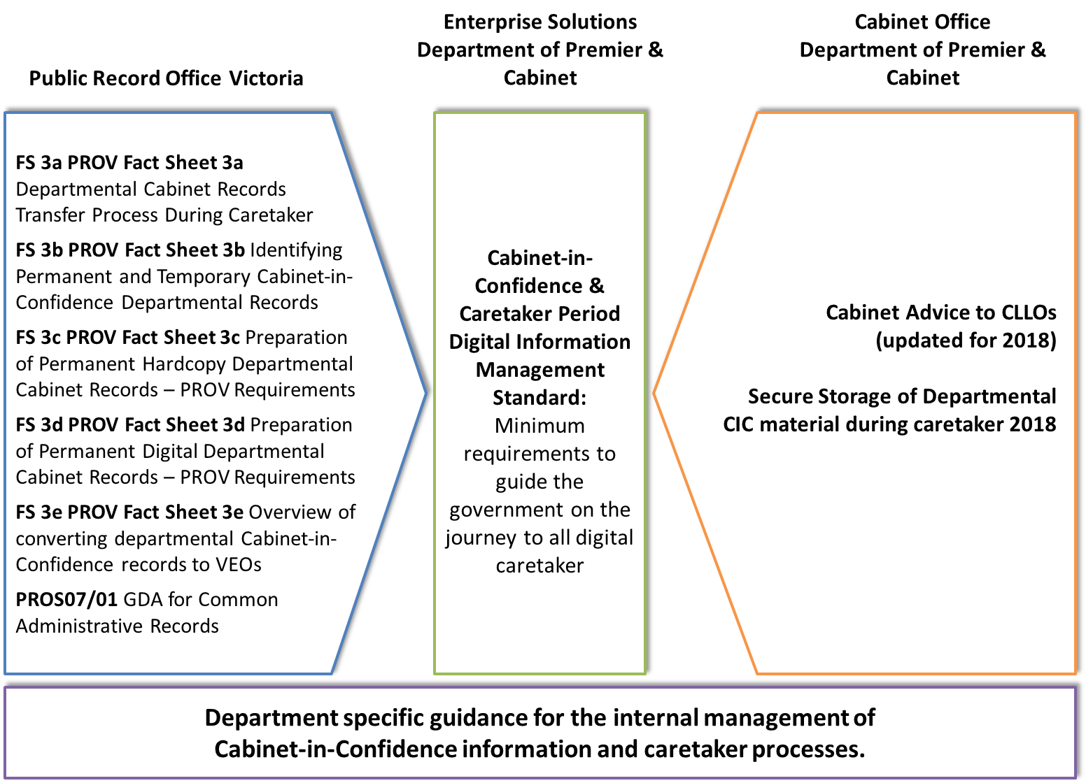

Figure 1 - Guidance for implementing this standard

# Derivation, scope and glossary

### Derivation

This standard is derived from:

* *IM STD 03 Information Management Governance (awaiting approval).*

### Scope

### All departments and Victoria Police, referred to collectively as ‘departments’, are formally in-scope and the standard is applicable to the Victorian Public Service as appropriate.

### Glossary

The glossary of terms and abbreviations used in this document are defined in the [Information Management Glossary](https://www.vic.gov.au/information-management-policies-and-standards#information-management-glossary)

# Related documents, tools and references

* [*Cabinet Handbook*](http://www.dpc.vic.gov.au/index.php/policies/governance/23-policies/governance/813-the-cabinet-handbook)
* [*Public Record Office of Victoria (PROV) Standards Framework and Policies*](https://www.prov.vic.gov.au/recordkeeping-government/about-standards-framework-policies)
* [*Victorian Protective Data Security Framework (VPDSF)*](https://www.cpdp.vic.gov.au/menu-data-security/victorian-protective-data-security-framework/vpdsf)
* [*WoVG Information Management Framework*](https://www.vic.gov.au/information-management-policies-and-standards#information-management-framework)
* [*WoVG Information Management Policy*](https://www.vic.gov.au/information-management-policies-and-standards#information-management-policy)

# Further information

For further information regarding this standard, please contact Digital Strategy and Transformation, Department of Premier and Cabinet, at: [digital.transformation@dpc.vic.gov.au](mailto:digital.transformation@dpc.vic.gov.au)

# Document control

### Approval

This document was approved by the Integrity and Corporate Reform Subcommittee under authority of the Victorian Secretaries Board on 27 September 2017 and applies from the date of issue (see first page).

### Version history

|  |  |  |
| --- | --- | --- |
| **Version** | **Date** | **Comments** |
| 0.1 | 17/07/2017 | First draft of standard for review |
| 0.2 | 07/08/2017 | Incorporate change to requirement 1(a) |
| 0.3 | 24/08/2017 | Endorsed by the IMG |
| 1.0 | 27/09/2017 | Approved |

1. As directed by the Cabinet Office.
2. A VEO, or VERS Encapsulated Object, is a representation of a record that contains both record content and associated metadata. It is the format used for the long term preservation of records. Please see the [Victorian Electronic Records Strategy (VERS)](https://www.prov.vic.gov.au/recordkeeping-government/a-z-topics/vers) for further information.
3. A document endorsed by Cabinet that allows for the business of government to continue and ordinary matters of administration to be addressed in the lead up to an election.
4. The period between when the government is dissolved until the next ministry is appointed is known as the caretaker period.
5. The Cabinet Office, within the Department of Premier and Cabinet, facilitates executive government decision- making and during a caretaker period ensures compliance with the Caretaker Conventions regarding CIC material.