|  |
| --- |
| The Orange Door and inTouch Multicultural Centre Against Family Violence  Referral pathways  July 2020 |



## About The Orange Door

The Orange Door is a new way for women, children and young people experiencing family violence, perpetrators of family violence, and families who need support with the care, wellbeing and development of children and young people to access services and supports. The Orange Door seeks to be culturally safe and respectful of Aboriginal people, meet the diverse needs of the Victorian community and be accessible for people of all ages.

The Orange Door brings together the access points for family violence services, family services and perpetrator/men’s services. It brings together existing referral points for victims and perpetrators of family violence (including police L17 referral points), and children and families in need of support (Child FIRST).

The Orange Door is delivered by a partnership in each of the DHHS areas between government and Community Service Organisations (CSOs) and Aboriginal services. Family Safety Victoria provide strategic and operational oversight of The Orange Door which is staff by workers employed by CSOs, Aboriginal Services, FSV and DHHS, with each worker continuing to be employed and managed by their employing organisation.

To date, The Orange Door has been established in five DHHS areas: Bayside Peninsula, Inner Gippsland, Mallee, Barwon and North Eastern Melbourne. The Orange Door will roll out to all 17 DHHS areas by 2022.

The Orange Door, when fully established, provides:

* a more visible contact point so that people know where to go for support
* an approach across the spectrum of prevention, early intervention and response
* help for people to identify family violence and child and family safety and wellbeing issues
* advice based on the latest risk assessment tools and best available information
* specialist support and tailored advice for victims, families and children, and perpetrators
* a strong focus on perpetrator accountability
* a system-wide view of service capacity, client experience and outcomes.

## About inTouch

inTouch Multicultural Centre Against Family Violence (inTouch) is an organisation that provides integrated, culturally appropriate services to migrant and refugee communities experiencing family violence across Victoria.

inTouch’s specialist area of expertise is working with women and their children who require culturally specific, tailored responses and family violence services. inTouch has a specific understanding of the issues related to the intersection of culture, family violence, family law and temporary migration.

Key services provided include:

* family violence case management (primarily phone based, face-to-face support in Richmond and Dandenong and via some metropolitan outreach)
* flexible support packages (for eligible clients)
* legal information, advice and referrals or immigration support (via phone)
* limited legal casework for inTouch clients (face-to-face in Richmond and Dandenong)
* immigration advice and support
* perpetrator case management (face-to-face, individual and group work in Dandenong).

## Referring clients to inTouch

Migrant and refugee clients referred to inTouch are supported to decide how they receive help, whether they choose to go to a local migrant and refugee service, or a specialist service such as inTouch.

Practitioners working at The Orange Door may refer eligible clients to inTouch for specialist *inLanguage*, *inCulture* family violence services.

Clients requiring a comprehensive range of service options or multiple referrals may be suitable for a co-case management approach. Some clients may benefit from a referral to inTouch as well as a local family violence case management service. Co-case management requires a shared understanding between inTouch and local service providers of the needs of the client and their family, and agreement on the role and responsibilities of each worker. Together, services work towards meeting the needs of the client through effective ongoing communication during assessment, case planning and care coordination, until further engagement with inTouch is no longer required.

### Eligibility

inTouch provides services and a range of support to individuals 18 years and older who:

* are newly arrived or established migrant and refugees, irrespective of visa status
* are from culturally and linguistically diverse backgrounds
* are experiencing or have recently experienced family violence
* reside in the state of Victoria, Australia.

## Secondary consultation from inTouch

The Orange Door practitioners can also seek secondary consultation support from inTouch when working with clients from migrant and refugee backgrounds who are or have experienced family violence, or who are perpetrators of family violence.

Examples of the type of information or advice that could be provided are:

* how to support engagement with clients
* understanding and navigating barriers to accessing mainstream services
* temporary migration visas and eligibility for services such as Centrelink
* information about forced marriage
* referrals to culturally specific support agencies
* dowry and dowry abuse.

### Referrals

The Orange Door practitioners making referrals to inTouch should maximise the likelihood that the client will take up the service and support being offered by including all relevant documentation, including current risk assessment, safety plan and consent to share information.

Referrals for client support or a secondary consultation can be made by:

* emailing a completed [referral form](https://intouch.org.au/wp-content/uploads/2018/11/inTouch-Referral-Form-2018.docx) or [secondary consultation request form](https://intouch.org.au/wp-content/uploads/2018/11/Cultural-Secondary-Consultation-Form-2018.docx) from the inTouch website to [intake@intouch.org.au](mailto:intake@intouch.org.au)

OR

* telephoning the inTouch intake team on 1800 755 988

The inTouch team will record your request for a secondary consultation and a case manager will contact you within five working days.

inTouch delivers telephone and face-to-face services, Monday to Friday, 9 am to 5 pm.

## inTouch referring clients to The Orange Door

inTouch may refer clients to The Orange Door when it is identified that a client:

* has previous or current family violence risks and needs, or
* has needs related to the care and wellbeing of children, or
* is a perpetrator of family violence.

Referral to The Orange Door should be discussed with the client, whether they are a victim-survivor or perpetrator, prior to a referral being made.

The Orange Door operates Monday to Friday 9am – 5pm (excluding public holidays) and can be contacted on:

|  |  |  |
| --- | --- | --- |
| Location | Email | Telephone Number |
| Bayside Peninsula | [bpa@orangedoor.vic.gov.au](mailto:bpa@orangedoor.vic.gov.au) | 1800 319 353 |
| North East Melbourne | [nema@orangedoor.vic.gov.au](mailto:nema@orangedoor.vic.gov.au) | 1800 319 355 |
| Mallee | [mallee@orangedoor.vic.gov.au](mailto:mallee@orangedoor.vic.gov.au) | 1800 290 943 |
| Barwon | [barwon@orangedoor.vic.gov.au](mailto:barwon@orangedoor.vic.gov.au) | 1800 312 820 |
| Inner Gippsland | [iga@orangedoor.vic.gov.au](mailto:iga@orangedoor.vic.gov.au) | 1800 319 354 |

Or search online at [Find a service near you](https://orangedoor.vic.gov.au/find-a-service-near-you).

**Afterhours services can be contacted on:**

|  |  |  |
| --- | --- | --- |
| After hours service | For | Contact information |
| safesteps | Victim survivors of family violence requiring afterhours crisis, emergency or refuge accommodation | 1800 015 188 Toll free (not free from mobile) |
| After Hours Child Protection Emergency Service | Children who are identified as being at significant risk of harm | 13 12 78 (5pm to 9am Monday to Friday, 24 hours on weekends and public holidays) |
| Victims Support Agency | Adult males experiencing family violence and all people affected by crime requiring practical assistance, counselling and support through the justice system. Includes the *Victims of Crime Helpline* | Phone 1800 819 817, Text 0427 767 891 (8am to 11pm, 7 days)  vsa@justice.vic.gov.au |
| Sexual Assault Crisis Line | People who have experienced both past and recent sexual assault requiring confidential, telephone crisis counselling | 1800 806 292 (5pm-9am mon-fri, 24hrs on weekends and public holidays) |
| Men’s Referral Service | Men who are using controlling behaviour towards a partner or family member  Women seeking information about men’s use of family violence  Family or colleagues of people who may be using or experiencing family violence | 1300 766 491 (8am to 9pm Monday to Friday and 9am to 5pm Saturday and Sunday) |

# Local migrant and refugee services: Key contact information

*[Local contact information to be populated by The Orange Door*]

|  |  |  |  |
| --- | --- | --- | --- |
| **Agency** | **Location** | **Phone contact** | **Hours of operation** |
|  |  |  |  |
|  |  |  |  |
|  |  |  |  |
|  |  |  |  |

## Statewide Interpreter Services

Statewide interpreter services are available to practitioners at The Orange Door via Language Loop on 03 9280 1955, by quoting the PIN number below for each area of The Orange Door.

Client ID:………………………….. PIN:………………….. *[to be completed locally]*

## S:\Communications\Logos, graphic elements and style guides\Full files from designer Studio Binocular\1 – inTouch\Logos\Brandmark with strapline underneath\inTouch Strap Under Green.jpgAdditional information on inTouch

inTouch works across the family violence continuum, from prevention and early intervention, to crisis intervention, post-crisis support and recovery. Services and programs include:

* an integrated, culturally responsive model based on *inLanguage*, *inCulture* case management. Its 18 case managers are highly diverse, offering direct client services in over 20 languages. They have a unique understanding of a client’s lived migration experience, cultural influences, and the barriers faced when trying to seek help.
* an in-house accredited community legal centre, the only one of its kind in a specialist family violence service, which provides legal advice, court advocacy and immigration support. Due to limited capacity, legal casework is only provided to inTouch clients following a referral from one of our case managers.
* capacity building of specialist and non-specialist family violence providers, and community organisations to better deliver support to refugee and migrant women experiencing family violence. This includes a public training [calendar](https://intouch.arlo.co/w/events/).
* an early intervention program, Motivation for Change, working directly with men from culturally and linguistically diverse communities who use violence towards their families. The program comprises of one-on-one case management and group sessions for men from Afghan and South Asian communities. This program is based in Dandenong.

For more information on inTouch visit [www.intouch.org.au](http://www.intouch.org.au)

## Referral pathways diagram

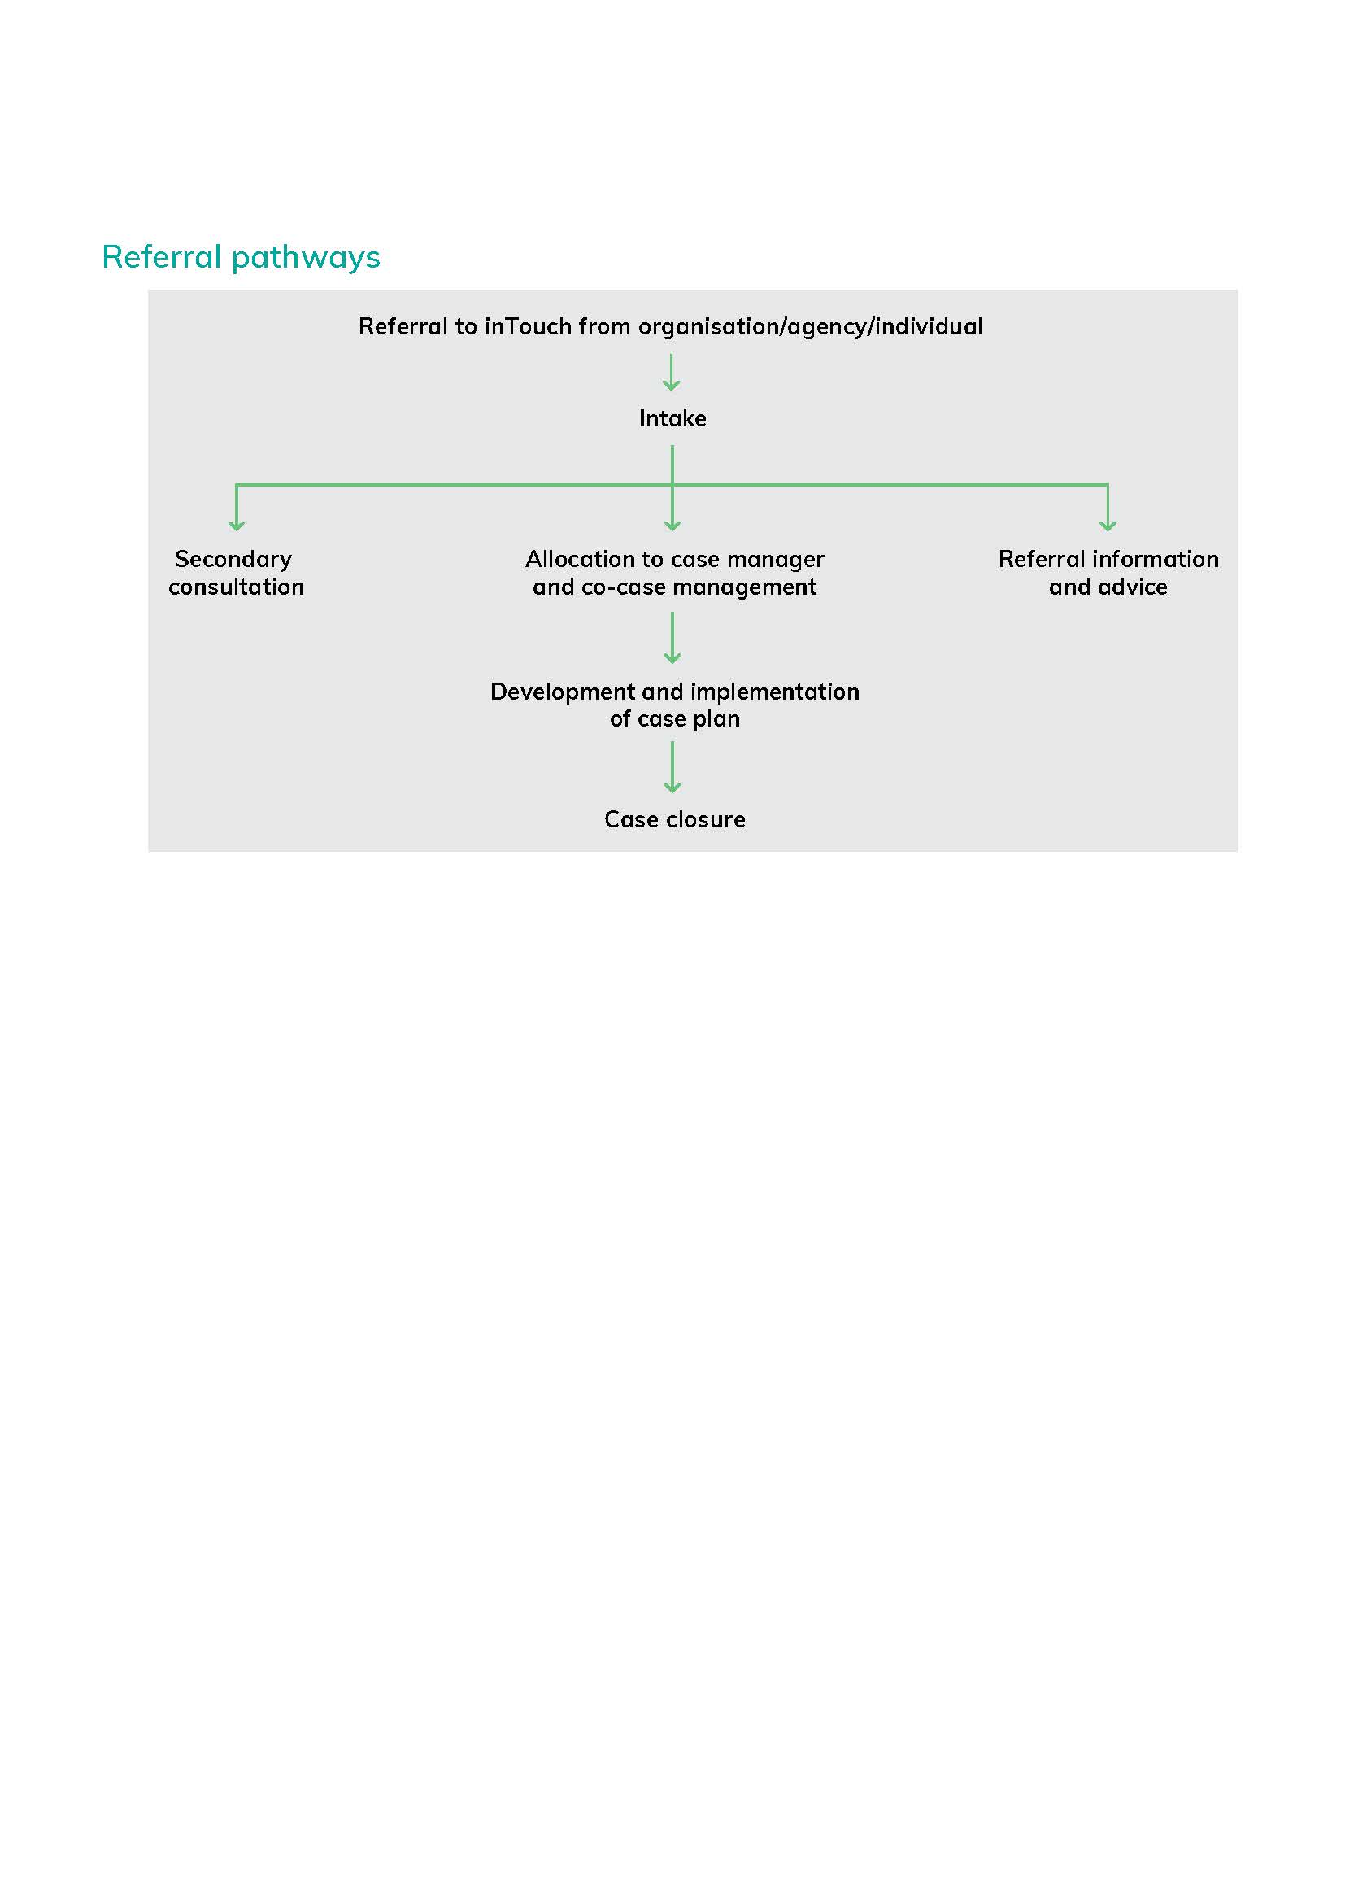

The following page includes case examples of how inTouch provides co-case management, secondary consultation, and referral information and advice.

## Case studies

**Co-case management**

*Case example: A local family violence service contacted inTouch to request co-case management of Ayaan, a 27 year old Malawi citizen on a partner visa, who has experienced family violence. Ayaan’s husband Cawil has been emotionally, verbally, financially and physically abusive towards her, and their three young children have witnessed the abuse.*

*Following a recent incident at which police attended, an intervention order was taken out against Cawil, and the family violence service supported Ayaan and her children to access crisis accommodation in a motel, pending access to a refuge. The family violence service continued to provide a range of support to meet the needs of Ayaan and her children.*

*On request, inTouch worked alongside the family violence service, supporting Ayaan through culturally sensitive counselling, support, safety planning and referrals. inTouch also provided specialist visa and legal advice to Ayaan and worked with the local housing agency to progress a government housing priority access application.*

*As a result of inTouch’s work alongside the local family violence and housing services, Ayaan and her children secured long-term housing. Ayaan’s application for permanent residency was supported which enabled her to receive the parenting and family tax benefit through Centrelink. inTouch has now closed their case with Ayaan and her children, and the local family violence service is leading the provision of further supports and referrals to Ayaan and her children to assist them to rebuild their lives.*

**Secondary consultation**

*Case example: inTouch was contacted by Sue, a TAFE teacher, for advice about how to support one of her students, Nasrin, who had migrated from Sudan with her family four years ago. Nasrin has disclosed that she was finding it difficult to concentrate on her studies and feels fearful for her mother’s wellbeing at home as her father was being physically and verbally abusive.*

*Sue told inTouch that she didn’t feel confident having a conversation about family violence with Nasrin. Sue was concerned that she might say the wrong thing to Nasrin and inadvertently offend Nasrin’s culture, causing Nasrin to ‘shut down’.*

*The inTouch case manager spoke to Sue about culturally responsive practice. That is, understanding and recognising the barriers victim-survivors from migrant and refugee communities face and that underpin their access and level of engagement with support services. inTouch also sent Sue some useful questions to guide a discussion about family violence with Nasrin*

*Sue contacted inTouch again a few weeks later to report that Nasrin told her that she feels supported and understood and knows that what is happening at home is family violence. Nasrin told Sue that she will call 000 if she is feeling unsafe.*

**Referral information and advice**

*Case example: Jenny, who has a spousal visa and is experiencing family violence, contacted inTouch for advice. She hadn’t decided if she was going to leave her partner but wanted to be informed of her options. The intake team provided information on:*

* *the different forms of family violence*
* *intervention orders*
* *inTouch services including the legal centre*
* *how to navigate the service system and seek help*
* *who to call in case of a crisis*
* *housing options*
* *safety planning*

*Jenny chose not to be referred to an inTouch case manager or a local specialist family violence service. inTouch’s intake team advised her how to make contact with services when/if she decides to seek support.*