

|  |  |  |  |  |  |  |  |  |  |  |  |  |  |  |  |  |  |  |  |  |
| --- | --- | --- | --- | --- | --- | --- | --- | --- | --- | --- | --- | --- | --- | --- | --- | --- | --- | --- | --- | --- |
| Automated Briefing and Correspondence  Statement of Direction  for the Victorian Public Service  May 2017  Vision: *Briefings and correspondence are managed using a common modern system and consistent processes, improving quality and reducing overhead.*   |  |  |  |  | | --- | --- | --- | --- | | PURPOSE | To increase the Victorian Government’s productivity through the use of a common briefing and correspondence system combined with a consistent governance model, formats and processes.  To improve quality and reduce the time it takes to administer and approve briefs and correspondence by digitising and automating the process. | | | | APPLIES TO | All Departments, Victoria Police & VPS as appropriate | **AUTHORITY** | Victorian Secretaries Board | | PERIOD | 2017 to 2020 | **ADVISED BY** | DPC, following consultation with the Information Management Group and the CIO Leadership Group | | ISSUE DATE | August 2017 | **DOCUMENT ID** | SOD ABC 01 – TRIM D17/121 | | REVIEW DATE | August 2020 | **VERSION** | 1.0 | |

Contents

Introduction 3

Key objectives 4

Related documents, scope and glossary 5

Overview 6

Direction 7

Governance model 7

Briefing and correspondence process 8

Approvals 10

Monitoring and reporting 11

The system 11

Implementation 14

Document control 15

Further information 15

# Introduction

### Background

Briefs and correspondence are an important component in how the government makes decisions and communicates. The Victorian Government’s [*Information Technology Strategy 2016-2020*](https://www.vic.gov.au/information-technology-strategy)called for the development of this Statement of Direction (SoD). There is an identified need to streamline, automate and digitalise briefing and correspondence approval processes, incorporate digital document management and create clear accompanying data on the authority and status of documents.

### Problem

Due to a reliance on hardcopy documents, physical signatures and manual to semi-automatic processes, the government’s briefing and correspondence processes are inconsistent, complicated, resource intensive and time-consuming.

Cross-government consultation identified that current briefing and correspondence processes and systems are seen as:

* Compromising the ability to be responsive
* Complex and resource intensive
* Preventing knowledge and capability portability (due to process and system differences)
* Affecting confidence in the reliability of captured records
* Creating administrative burden, version control and duplication issues (due to hardcopy dependency).

### Statement of Direction

This Statement provides high level requirements for consistent briefing and correspondence within the Victorian Government. It describes the overarching components required, and the systems platform requirements needed to support improved and consistent briefing and correspondence processes.

The SoD covers at a mimimum all inter and intra department briefs including event briefs, briefs to the secretary, briefs to the Minister, Cabinet documents, all correspondence including ministerial correspondence and other parliamentary process documents as required.

This statement describes a future desired state, but not the mechanisms or timing to implement it (see Implementation).

For the purpose of this Statement: *automate* implies ‘digital’, ‘digitalise’ and ‘digitisation’, *system* implies ‘platform’, ‘system’ or ‘application’ and *department* implies ‘department’ and ‘Victoria Police’.

# Key objectives

To establish a consistent Victorian Government briefing and correspondence platform that will:

* Improve briefing and correspondence processes, efficiency and effectiveness
* Increase cross-government productivity through the use of a common system, governance model, and consistent formats and processes
* Reduce the government’s dependency on hardcopy and manual briefing and correspondence processes through digitalisation and automation of workflows and approval processes
* Increase records management compliance and reduce the cost of hard-copy storage of temporary and permanent records
* Provide the ability to monitor, manage and report on briefs and correspondence to determine real-time status
* Increase the government’s responsiveness by reducing the time it takes to administer and approve government briefs and correspondence
* Reduce caretaker period and machinery of government transfer costs through consistent and easily-transferred digital storage and access to briefs and correspondence
* Improve usability and enable mobile-device delivery through a Software-as-a-Service delivery model (cloud computing)
* Mitigate the need for multiple procurements by each department; realising economies of scale, a reduction in deployment timeframes, and avoiding costly upgrade projects to on-premise installations
* Provide an implementation approach that does not require all departments to move at once (no ‘big bang’ project) and instead allows staged adoption when departments are ready.

# Related documents, scope and glossary

### Documents

* *[Victorian Government Information Technology Strategy 2016 to 2020](https://www.vic.gov.au/information-technology-strategy)*
* [*Workplace Environment Statement of Direction* (SOD/Workplace/01)](https://www.vic.gov.au/digital-strategy-transformation-statements-direction#workplace-environment)
* [*Network and Cyber Security Statement of Direction* (SOD/NetworkCyberSec/01)](https://www.vic.gov.au/digital-strategy-transformation-statements-direction#network-and-cybersecurity)
* [*Information Management Framework* (IM/FW/01)](https://www.vic.gov.au/information-management-policies-and-standards#information-management-framework)

### Scope

All departments and Victoria Police, referred to collectively as ‘departments’, are formally in-scope and the SoD is applicable to the Victorian Public Service as appropriate.

### Glossary

The glossary of terms and abbreviations used in this document are defined in the [IM GUIDE 03 Information Management Glossary](https://www.vic.gov.au/automated-briefing-and-correspondence-policies-standards-and-guidelines#abc-glossary).

# Overview

The government wants a consistent and streamlined platform that provides a better user experience, an end-to-end digital business process, electronic notation and approvals, reduced effort in performing upgrades, and modern functionality, for simpler whole of government briefing and correspondence. See Figure 1 - Overview.

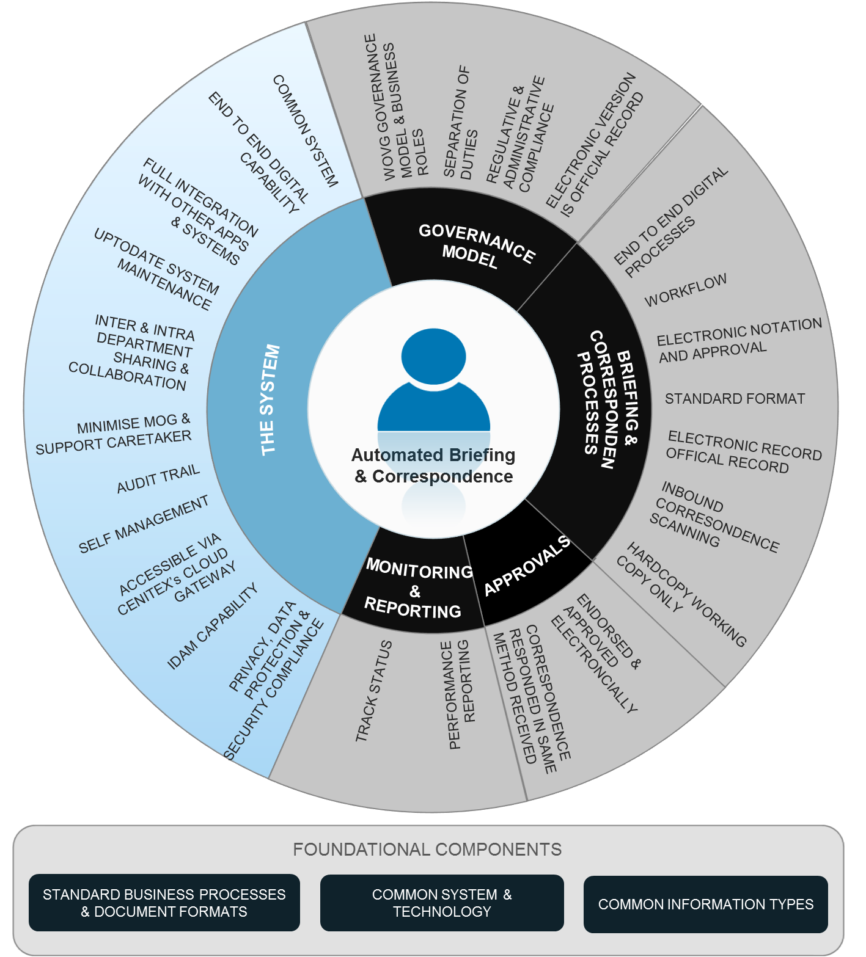

Figure 1 - Overview

# Direction

The following section outlines the high level requirements for an automated briefing and correspondence system (system).

There are five components of the proposed system covered in this statement:

1. Governance model
2. Briefing and correspondence process
3. Approvals
4. Monitoring and reporting
5. The (software) system

The minimum scope of delivery for the automated briefing and correspondence system will include:

* inter and intra departmental briefs
* event briefs
* briefs to the secretary
* briefs to the Minister
* Cabinet documents
* parliamentary documents and
* all correspondence including ministerial correspondence.

## Governance model

#### Objective

To drive digitisation and automation, standardise practice, and ensure a co-ordinated approach to the control and management of briefs and correspondence processes and systems.

| Reference | Direction | | Benefits to Government |
| --- | --- | --- | --- |
|  | | A whole of government (WoVG) briefing and correspondence governance model. | The governance model will help to:   * minimise machinery of government impact * increase cross-government collaboration and co-production * reduce inter and intra departmental duplication * ensure separation of duties * ensure compliance to applicable legislation and administrative requirements in both the process and the system * promote the cultural shift required to succeed.   **Note**: The governance model will define:   * principles * accountabilities and responsibilities (both across government and within departments) * common processes and document types, terminology and business rules, and methods for their deployment within the system * cross-government mechanisms for maintaining a consistent approach e.g. change management. |
|  | There will continue to be a separation of duties in relation to briefing and correspondence between the public sector and the elected government. | | The separation of duties between the public sector and the elected government will help to safeguard the integrity of briefing and the authority of the public sector’s position. |
|  | The creation and management of briefs and correspondence will continue to be compliant with relevant legislative, conventions and administrative requirements. | | By embedding legislative and administrative compliance requirements into the design, development and implementation of the governance model, the process and the system, the government will be offered a level of assurance to the confidentiality, integrity and availability of a brief or correspondence. |
|  | The electronic version of a brief or correspondence will be the official record and will be managed according to the Public Record Office Victoria’s (PROV) policies and standards. | | The movement towards fully digital briefing and correspondence will help the government to meet future digital records management deadlines, and improve the digital continuity (long term availability) of briefing and correspondence information.  **Note**: The Public Record Office Victoria (PROV) has advised that there will be a deadline (to be determined) for when it will no longer accept hardcopy permanent records. |

## Briefing and correspondence process

#### Objective

To reduce the government’s dependence on hardcopy records and semi-manual briefing and correspondence processes, and remove current inefficiencies and redundancies through process re-engineering and the digitalisation and automation of workflows and approval processes.

| Reference | Direction | | Benefits to Government |
| --- | --- | --- | --- |
|  | | Common end-to-end digital briefing and correspondence processes, including configurable workflow and approval processes. | The development of end-to-end integrated digital briefing and correspondence processes will provide the government with the opportunity to improve security, remove process inefficiencies, increase productivity and rethink how it makes decisions and communicates, including:   * creating a greater level of flexibility and responsiveness (particularly out of normal office hours) * increasing portability of knowledge and capability across government * streamlining connections between briefing and correspondence processes and other corporate processes * reducing the complexity and resource intensiveness (multiple points of handling) of existing manual and semi-manual processes. |
|  | All briefs and correspondence will have a standard format including font, layout, signature block, and branding. | | A standard format for briefs and correspondence will help:   * reduce the impact of executive and ministerial preferences and machinery of government changes * reduce the administrative burden of editorial and format changes * increase productivity through portability of knowledge and capability between departments * promote best practice across the government.   **Note**: the system must be able to have changes to the format undertaken without customisation being required. |
|  | All briefs and correspondence will be created, edited and managed as a record electronically within the system. | | By embedding records management into the design, development and implementation of the governance model, the process and the system, records management compliance (Public Records Act 1973) will be largely removed from the desktop (the user) and become an automated part of producing a brief or correspondence.  The benefits of this approach will be a:   * greater level of compliance to associated legislation and administrative regulations * reduction in the administrative burden and the costs associated with managing hardcopy records (paper, storage, physical records management etc.) * reduction in the environmental impact of using paper * better control of content quality, by permitting specific users to perform specific functions, like editing. |
|  | All inbound hardcopy correspondence will be captured via scanning and managed as a record electronically. | | Capturing inbound correspondence as a digital record will reduces the cost and turnaround times associated with handling and responding to hardcopy correspondence (walking documents around and managing hardcopy records).  It will also enhance the accessibility of current and historical correspondence. |
|  | All outbound correspondence will be created, edited and managed as a record electronically. | | Government correspondence will be managed entirely as a digital record, increasing records management compliance and reducing the administrative burden and cost of hardcopy records.  **Note**: The government will continue to support the needs of Victorians by responding to correspondence in hardcopy as required (see ABC-12).  Up to the point of printing out the hardcopy document, all correspondence will be created, edited and managed electronically and the signed hardcopy will be captured as a digital record by scanning it back into the system. |
|  | Hardcopies will only be printed as working copies and will not be considered an official record. | | Digital records will reduce the administrative burden and cost of storage, retrieval and handling of hardcopy records.  **Note**: The government recognises user preferences for reading documents offline. Hardcopies will only be printed for offline reading and ideally stamped as a ‘working copy’.  **Note:** In some instances a document of correspondence may need to be printed (see ABC-09 and ABC-12), signed and scanned back in. |

## Approvals

#### Objective

To increase the government’s responsiveness by reducing the time it takes to administer, note and approve government briefs and correspondence.

| Reference | Direction | | Benefits to Government |
| --- | --- | --- | --- |
|  | | The government will note, endorse and approve briefs electronically. | Electronic endorsement and approval will provide the government with a higher level of flexibility, responsiveness and security.  The physical location of the authoriser will no longer be an issue; nor will the errors, time wasted and security concerns associated with physical documents, ‘wet’ signatures and walking documents around.  **Note:** To ensure confidence in separation of duties, there may be a phased approach to implementation with electronic ministerial signatures implemented over time. |
|  | Correspondence will be responded to in the same method as received and signed electronically where possible. | | The government will continue to meet the engagement needs and expectations of the citizen and the community.  **Note**: Resistance to engaging with government online, and the continuing lack of ‘digital inclusion’0F[1], will mean that the government will need to continue to respect the needs of Victorians by accommodating both electronic and hardcopy correspondence (to be monitored and phased out over time). |

## Monitoring and reporting

#### Objective

To provide the government with the ability to monitor and report on briefs and correspondence; to determine real-time status and performance improvement opportunities.

| Reference | Direction | | Benefits to Government |
| --- | --- | --- | --- |
|  | | Departments will be able to track operational status of briefs and correspondence at the portfolio, branch/unit, division and departmental level. | Automation would provide departments with:   * The real-time ability to monitor and report on briefing and correspondence processes * being able to track the progress of a brief or correspondence * being able to track compliance and approval functions * more visibility of duplication i.e. 3-4 briefs on the same topic. |
|  | | Departments will be able to report on performance around briefs and correspondence at the portfolio, branch/unit, division and departmental level. | Automation would also help the government to monitor and report on performance. This would enable departments to identify the number of active briefs or correspondence, who owns the brief or correspondence, how many have been signed, and how many are outstanding.  Performance reporting would provide management with relevant trends and statistics for making informed decisions about the briefing and correspondence function, including the ability to identify inefficiencies and process improvement opportunities (pipeline blockages)  **Note**: The level of data insight available to departments will vary according to the sources (and types) of data collected and the level of investment made in Business Intelligence (BI) tools to support the briefing and correspondence function. |

## The system

#### Objective

To provide robust systems that makes briefing and correspondence simpler, easier, contemporary and more responsive.

| Reference | Direction | | Benefits to Government |
| --- | --- | --- | --- |
|  | | The government will operate a common briefing and correspondence system | A common briefing and correspondence system (from a single vendor) will provide:   * consistent technology across departments, creating productivity and licensing benefits * uniform agreement with the vendor, allowing departments to procure from a standard contract * user familiarity between departments, enabling staff to work more easily across government.   **Note**: “common” does **not** mean a single instance for the whole of government. See ABC-255. |
|  | | The system will be accessible via a ‘cloud computing’ model. | A public ‘cloud’ model (software-as-a-service) will allow government:   * to shift much of the technological burden and responsibility to third party providers * greater flexibility, accessibility and mobility options by leveraging internet services * to maintain currency, with regular system and legislative updates * to provide consistency in versioning, functionality and security updates across departments * to ensure access to software assurance from the vendor * to avoid large and expensive upgrades when major system releases are required in the future. |
|  | | The system will have a simple and intuitive interface. | A familiar and easy user experience will mean:   * minimal training is required to become proficient and productive * increased user satisfaction, leading to greater uptake and acceptance of the system as it is implemented across departments |
|  | | The system will provide end-to-end digital briefing and correspondence capability, as well as workflow (including exceptions management) and electronic approval (including delegations and separation of duties). | The common end-to-end digital briefing and correspondence capability will:   * help drive consistency in practice and business systems i.e. compatibility in electronic approval * reduce the costs associated with manual processes, hardcopy records and physical signatures * increase responsiveness by reducing the time it takes to edit and approve documents * reduce non-repudiation and imposter fraud (authenticity is easier to determine) * increase confidence in integrity and accountability (changes to content are captured by the audit trail) * increase visibility of the status of briefs and correspondence. |
|  | | The system will have the capability to facilitate integration and two-way data flows with third party applications. | Third party integration will enable the government to:   * connect with other systems that are related to briefing and correspondence, but operate separately (such as department electronic document management systems or business intelligence tools) * take advantage of new enterprise technology services, in line with the Victorian Government Workplace Environment Statement of Direction. |
|  | | The system will be kept current by the vendor, with regular system and legislative updates. | Maintaining current software, will:   * provide consistency in versioning, functionality and security updates across departments * ensure access to software assurance from the vendor * avoid large and expensive upgrades when major system releases are required in the future. |
|  | | The system will allow for inter-department and intra-department sharing and collaboration in the creation, management and editing of briefs and correspondence. | The system will:   * provide improved interconnectivity for sharing documents internally and across government (where applicable), resulting in briefs and correspondence being “entered once and shared” (security profile allowing) * reduce walking documents around, increased collaboration in the crafting of documents and increased access to government information * result in digital briefing between departments and agencies becoming standard practice * make the process of creating correspondence on behalf of the minister more efficient. |
|  | | The system will be set up in a manner which minimises disruption arising from Machinery of Government (MOG) changes and which supports Caretaker Period extraction and de-identification requirements. | During Caretaker Period the effort, time taken and cost of identifying, batching and returning Cabinet documentation (Cabinet documents) to the custody of the Cabinet Office will be reduced by the use of digital documentation and electronic workflows.  **Note**: Wherever possible, departments will work together to ensure consistency in the configuration and use of their instances, so that the process of joining or separating environments or groups will be conducted in a straightforward and inexpensive manner. |
|  | | The system will provide an audit trail to support monitoring and reporting on system access and user actions. | The audit trail will help government monitor real time and historical user, process or system interactions with the system. An audit trail will:   * ensure individual accountability for user actions * trigger alarms about hazardous real-time system events such as attempts at unauthorised access * increase the level of compliance assurance * help to reconstruct events that have resulted in a security breach or system problem. |
|  | | The system will be accessible from multiple platforms including mobile devices. | A more accessible system will allow the government to be more flexible in when, where and how it accesses documents, increasing responsiveness and allowing for offsite and afterhours edits and approvals. |
|  | | Departments (including ‘clusters’ of similar departments) will be able to manage their own configuration of the system. | Where applicable, independent instances will allow:   * configuration of workflow automation and digital approval to support organisational processes * interfaces with other critical corporate systems that may be unique to a department (or cluster) * personalisation of user screens. |
|  | | The system will be able to make use of identity management capability provided as a separate service. | By being able to use a single unique identifier for Victorian Government employees envisaged in the *Workplace Environment Statement of Direction*, the concept of identity can be abstracted from the briefing and correspondence system itself, allowing for fewer logons needed for staff and more consistent identity management across multiple systems. |
|  | | The system will be designed, developed and operated within the framework of related privacy, data protection and security requirements to maintain security classified, sensitive and personal information. | The system is an opportunity to realise the benefits of a secure environment with an overarching governance model and integrated business process.  By embedding privacy and data protection into the design, development and implementation of the system, users will be offered a level of assurance as to the confidentiality, integrity and availability of briefs and correspondence.  **Note:** If feasible or applicable, the system should have the capability to manage records up to a PROTECTED level of classification. |

# Implementation

This Statement of Direction does not imply a timeline. Rather, implementation of automated briefing and correspondence systems will align with the *Information Technology Strategy 2016-2020* and the broad principles of governance and implementation set out in the *Business Support Services Strategic Review*. A ‘first’ agency will be identified. DPC will assist to establish a working group of relevant stakeholders to develop a future design, implementation roadmap, and preliminary business case. Other departments will join the system over time as their existing investments are due to be refreshed.

# Document control

### Approval

This document was approved by the Victorian Secretaries Board on 23 August 2017 and applies from the date of issue (see cover).

### Version history

|  |  |  |
| --- | --- | --- |
| Version | Date | Comments |
| 0.01 | 08/02/2017 | First draft incorporating feedback from the position paper |
| 0.02 | 24/02/2017 | Executive review within Enterprise Solutions Branch |
| 0.03 | 14/03/2017 | Final draft for review |
| 0.04 | 22/03/2017 | Recommended by the Information Management Group |
| 0.05 | 03/04/2017 | Endorsed by the CIO Leadership Group |
| 0.06 | 18/05/2017 | For endorsement by the Integrity and Corporate Reform Subcommittee |
| 0.07 | 03/08/2017 | For approval by the VSB |
| 1.00 | 23/08/2017 | Approved by VSB |

# Further information

Please contact Digital Strategy and Transformation ([digital.transformation@dpc.vic.gov.au](mailto:digital.transformation@dpc.vic.gov.au)), Department of Premier and Cabinet.

1. Measuring Australia’s Digital Divide The Australian Digital Inclusion Index 2016, Roy Morgan Research, 2016, <https://digitalinclusionindex.org.au/wp-content/uploads/2016/08/Australian-Digital-Inclusion-Index-2016.pdf>