

|  |
| --- |
| Digital Workplace Strategy  14 August 2018 |

Contents

Executive summary 4

Business drivers direct the strategy 8

Address a gap between current and future state 10

A framework to understand the strengths and gaps 10

Three high impact challenges to address 11

A vision and plan for a future state digital workplace 13

Principles frame the initiatives and their implementation 13

Clear and shared outcomes 14

Five objectives will deliver on the vision 15

Objective 1 - Track digital workplace benefits against agreed plans 16

Objective 2 - Develop sustainable funding approach linked to accommodation strategy 17

Objective 3 - Embed ongoing process digitalisation 18

Objective 4 - Move towards paperless record keeping 20

Objective 5 - Collaborate to improve network and access 22

A roadmap and implementation plan in three horizons 24

Appendices 26

Appendix A -Digital workplace 26

Appendix B - Mega-trends 27

Appendix C - Policies, strategies, and reviews 28

Glossary 30

Document Control 31

Intentionally left blank

# Executive summary

The [*Victorian Government Information Technology Strategy 2016-2020*](https://www.vic.gov.au/information-technology-strategy) (IT strategy) recognises the importance of providing Victorian Government (government) employees with a digital and mobile workplace0F[1] to enable a faster and more responsive government as well as improved service delivery to citizens. The development of this Digital Workplace Strategy (strategy) is one of the actions set out in the IT strategy.

The strategy was developed following an assessment of the current digital workplace which was informed by current Victorian Public Sector (VPS) employee experiences, engagement with experts, and identification of best practice through case studies. The findings from this assessment are documented in the [*Digital Workplace Study*](https://www.vic.gov.au/digital-workplace-strategy#digital-workplace-study) *(s*tudy*)*. The study formed a major input into the strategy and two strategy workshops with digital workplace leaders. Opportunities identified in the study were refined and prioritised by workshop participants.

The strategy defines a vision, principles, and strategic objectives - supported by key initiatives - which will enable the Department of Premier and Cabinet (DPC) to work with government to progress the five outcomes of a digital and automated workplace:

* higher productivity
* accommodation and resource savings
* improved employee climate
* greater collaboration
* greater digitalisation

The scope of the strategy is the internal workplace, rather than citizen services, as a digital workplace is a key enabler of the shift to digital service delivery.

The strategy is more than an IT strategy and is intended to impact all components of departments - direction setting, the enabling environment and the digital environment - as well as how these fit together. As a result, implementation also involves stakeholders beyond IT including leadership, people & culture, strategic communication, information and records, data management and accommodation and facilities.

Figure 1 below sets out the strategy and summarises all its components and underpinning rationale.

Figure | Summary of strategy

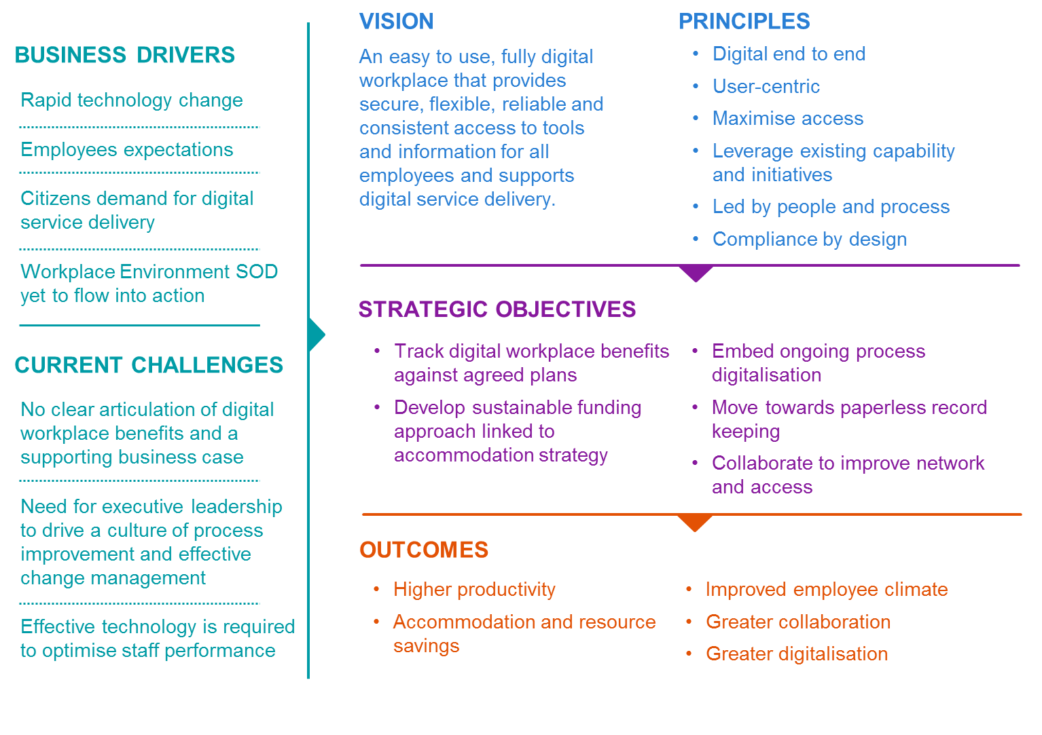

Strategic objectives identified include:

* Objective 1 - Track digital workplace benefits against agreed plans
* Objective 2 - Develop sustainable funding approach linked to accommodation strategy
* Objective 3 - Embed ongoing process digitalisation
* Objective 4 - Move towards paperless record keeping
* Objective 5 - Collaborate to improve network and access

Each objective is achieved through DPC delivering on key initiatives and tasks. These are outlined in Table 1 below.

Table | Summary of initiatives and tasks

| Initiative | Tasks |
| --- | --- |
| Objective 1 - Track digital workplace benefits against agreed plans | |
| Develop digital workplace implementation plans | * Confirm the minimum requirements for the development of annual digital workplace implementation plans within departments. |
| Establish common outcome reporting | * Confirm whole of Victorian Government (WOVG) key performance measures (e.g. employee satisfaction with the digital environment) and establish annual reporting by departments of progress against digital workplace outcomes. * Consolidate lessons, share case studies, and provide a summary progress report to Victorian Secretaries Board (VSB). |
| Objective 2 - Develop sustainable funding approach linked to accommodation strategy | |
| Investigate integrated accommodation and digital uplift | Develop a discussion paper to explore the reduction of accommodation footprint versus digital uplift. |
| Pilot integrated accommodation and digital uplift | Jointly develop a concept business case with DTF to determine funding, governance model and target outcomes for the pilot.  In collaboration with DTF, identify a business function that is moving to act as a pilot and work with that business function to roll out digital uplift alongside accommodation move.  Business function supports new ways of working through appropriate change management. |
| Develop position paper | Collaboratively develop a position paper that explores the outcomes of the pilot and the potential way forward. Lessons learnt inform accommodation strategy. |
| Objective 3 - Embed ongoing process digitalisation | |
| Uplift digitalisation capabilities | Define capabilities for effective digital change management and digital leadership.  Design, develop and deliver pilot training program to control group.  Evaluate results, refine program, and scale up across government. |
| Digitalise priority processes | Determine minimum requirements for departments to identify pilot process for digitalisation based on low complexity, large pain point, and high potential for impact as well as to track and measure benefits of process reform. |
| Develop WOVG approaches for common processes | Work with departments to identify, digitalise, test and implement priority common processes for digitalisation based on low complexity, large pain point, and high potential for impact (i.e. expenses and travel) and alignment with government-wide upgrades to corporate systems. |
| Objective 4 - Move towards paperless record keeping | |
| Set digital records management target | Set and communicate ‘born digital stay digital’ target.  Set and communicate digital only records target.  Update all existing SODs (e.g. Workplace Environment, HR, Finance etc.) to require all departments to transfer all permanent records with no business value to PROV when these systems are upgraded. |
| Develop Microsoft Office 365 guidelines | Work with a department implementing Microsoft 365 to develop security, records and document management guidelines. |
| Objective 5 - Collaborate to improve network and access | |
| Take steps to improve network performance | DPC to develop a discussion paper, in consultation with departments, that defines reasonable performance expectations, reviews and benchmarks current network performance, diagnoses issues and provides potential solutions. |
| Strengthen remote access | DPC to develop a discussion paper that reviews performance and current approaches to remote access, and provides a market scan of available technology and potential solution improvement opportunities. |

The strategy will be implemented in three horizons. The focus of each horizon is as follows:

* **HORIZON 1: Set shared direction and targets** – establish the whole-of-government backbone for digital workplace changes so that initiatives have an immediate and sustained impact that can transform the digital workplace over time.
* **HORIZON 2: Pilot high impact initiatives** – implement initiatives at a small scale to prove and realise benefits and validate uncertainties for large scale implementation.
* **HORIZON 3: Scale up across government** – implement larger scale, higher impact, and higher risk changes that will rapidly move the government towards its vision for a digital workplace.

# Business drivers direct the strategy

The importance of the digital workplace environment was set out in the IT strategy. The IT strategy states:

“In today’s busy world, a good government works effectively and efficiently. Moving away from paper-based manual processes towards digital information and service delivery is faster and more convenient. Providing an agile, mobile workplace for public sector workers will mean better, faster, more responsive and efficient government.”

Action 14 of the [*Information Technology Strategy 2016-2020 2017–2018 Action Plan*](https://www.vic.gov.au/information-technology-strategy-2017-18-action-plan) is to develop a Digital Workplace Strategy. The strategy addresses the internal workplace for government rather than citizen service delivery. However, a digital workplace is a key enabler of accelerated digital citizen service delivery.

The business drivers and objectives for a digital workplace (explained in Appendix A -Digital workplace) are well understood. The study was a key input to the identification of these business drivers, it included a synthesis of existing VPS strategies and plans and engagement with a cross-section of VPS employees to understand their experiences with the digital environment.

The business drivers are:

* **Rapid technology change is enabling a different workplace:** There are megatrends influencing the world of work including artificial intelligence (AI) and big data. These, combined with increasingly available collaboration tools, mean that the future workplace will look very different.
* **Employees have expectations of a vastly different workplace experience:** Ubiquitous connectivity and rapidly advancing social technologies, combined with the growth of the gig economy is changing employee expectations of the workplace and how, where, and when work is conducted.
* **Citizens demand digital service delivery and a different relationship with government:** There is clear citizen demand for quality online services to match their experiences with other service providers**.** This requires a digital first workplace to work effectively.
* **The**[***Workplace Environment Statement of Direction***](https://www.vic.gov.au/digital-strategy-transformation-statements-direction#workplace-environment)**(workplace environment SoD)**1F***[2]* is yet to flow into action:** Government approved the workplace environment SoD in 2015. However, the pathway towards a digital workplace is currently unclear and yet to gain traction. There are pockets of leading practice and activity throughout government, yet experts and users describe the Victorian digital workplace as behind best practice - resulting in mixed performance.

Global workforce mega-trends (as outlined in Appendix B - Mega-trends) informed the study and the workshop, and through this, the objectives, context and drivers for this strategy.

There are also tangible benefits to government from a mature digital workplace. It can support employee productivity and collaboration2F[3], attract the best talent and improve satisfaction3F[4], and meet citizen expectations from government4F[5]. Victoria has already acknowledged the case for change through its own policies, strategies, and reviews - including the [*Public Sector Innovation Strategy*](https://www.vic.gov.au/system/user_files/Documents/psif/Public%20Sector%20Innovation%20Strategy%20-%20Putting%20Innovation%20In%20Motion%20-%202017-06-20.PDF). Many of the actions in that strategy are pre-conditioned on a digital workplace where collaboration, free flowing and accessible information, digital tools, and frictionless digitally enabled processes are prevalent. Existing policies, strategies and reviews are set out in Appendix C - Policies, strategies, and reviews.

# Address a gap between current and future state

This section outlines the main challenges to the Victorian Government’s transition to a digital workplace as informed by current VPS employee experiences and expert engagement. It also illustrates a possible target state through examples of best practice organisations.

## A framework to understand the strengths and gaps

Digital investments deliver value to workplaces when they are integrated with the strategy and operations of the organisation in which they exist. In addition, standard digital investments, processes, capability, and language across government can overcome barriers to integrated service delivery.

To do this successfully, it is important to consider the full context of the organisation and how all components fit together. For example, digital tools provide little value to workers if they have a limited capability to use them within their role. A framework allows us to map current activity and identify strengths, challenges, or gaps.

Figure 2 below shows the Nous Group’s organisational architecture framework. It sets out all components of an organisation and how they fit together, from direction setting to the enabling environment to the digital environment. The enabling and digital environments also incorporated the full scope of the workplace environment SoD.

Figure | Organisational architecture framework

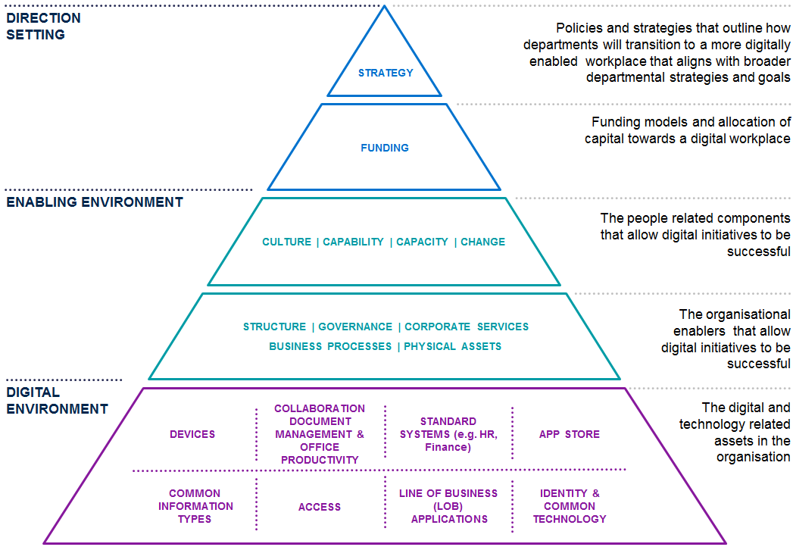

## Three high impact challenges to address

The government is making advances towards a more digital and automated workplace in line with the workplace environment SoD in particular, the introduction of up to date collaboration and productivity tools. Nevertheless, there are still gaps between the current and target state. There are three key challenges to overcome in order to deliver against the government’s digital workplace aspirations.

### No clear articulation of digital workplace benefits and supporting business case

There is currently limited awareness of the return on investment in digital workplace changes across government. For example, the study finds that the workplace environment SoD is in place but there are no specific targets or implementation plans. There is a need to clearly articulate the benefits of a digital workplace – productivity gains, financial savings, cultural improvements, etc. benefit delivery and tracking can provide the business case evidence for investment.

### Need for executive leadership to drive a culture of process improvement and effective change management

Accountability for delivering improvements to the digital workplace environment must be apparent through the organisational structure, especially at director and assistant director level, where risk aversion and conflicting priorities can limit focus on digitalising and improving processes and services. For example, the study finds that there is mixed leadership appetite for change and a poor history of technology change management resulting in limited benefits.

Employees and staff also reported that benefits are not often fully realised - even after technological change because inefficient processes still remain. For example, while TRIM5F[6] provides workflow functionally it has not been adopted by all departments and hard copy signatures are still being relied on (e.g. to support briefing and document approval processes).

### Effective technology, supported by the enabling environment for uptake and use, is required to optimise staff performance

Current technology (devices, applications, and network performance), is limiting staff productivity and flexibility. Not all staff are given the choice to select fit for purpose devices, with access to technology often limited by seniority. Legacy applications are difficult to access remotely and poor network performance results in inefficient work-arounds. Employees anticipate being disconnected and move to alternative tasks or make alternative plans to access documents when they are unable to access the network e.g. requesting an executive assistant to send documents via email.

Employee journeys defined in the [*Digital Workplace St*](https://www.vic.gov.au/digital-workplace-strategy#digital-workplace-study)*udy* (Six employee experiences highlight these pain points) outline these employee pain points in greater detail. A synthesis of the employee journeys and pain points in the form of user stories are outlined on Table 2 below.

Table : Employee pain points

| EMPLOYEE PAIN POINT | DESCRIPTION |
| --- | --- |
| *I want to work flexibly across locations and times so I can be effective in my role while balancing other parts of my life.* | Flexibility is important and one of the major reasons employees choose to work in government. They want more choice over when, where and how they work, enabling them to be effective in their role, while balancing personal commitments. Employees state that the lack of and suitability of mobile devices, limitations in accessing applications remotely and low reliability of connectivity outside major offices prevent them from working flexibly. |
| *I want digital workplace investments to go-live quickly and effectively so I get the full benefits* | Employees are frustrated with the slow rate of adoption and change within government. For example, employees recognise SharePoint’s strengths for collaborating on document production and the value of TRIM for document management. However, because not all employees have adopted the technology consistently, efficient co-authoring is undermined by colleagues creating multiple document versions. Employees want effective change support and faster department and government-wide adoption so that they can get the full productivity benefit of working digitally. |
| *I want consistency between agencies so that I can work and collaborate seamlessly across government departments* | Employee’s highlighted the impact of different systems, processes and culture across government. This is seen as driving digital practices to the ‘lowest common denominator’, creating friction when collaborating, and circumventing the benefits of existing digital workplaces. For example, when interacting with the courts, one employee noted that their paper-based processes prevented a fully digital working style for working effectively. It is also seen as a major driver of complexity after the machinery of government changes. |
| *I want a leader who embraces digital opportunities so changes are invested in and embraced by everyone* | Employees highlighted the importance of leaders who role model digital workplace behaviours and are willing to trial and invest in digital workplace improvements. For example, one employee noted that their direct leader was a proactive driver of digital workplace changes which supported uptake across teams. |
| *I want reliable access and quick trouble shooting support so I can stay productive when working remotely* | Employees confirmed the importance of reliability of remote access. Employees stated that it is quite common that they are unable to access the intranet, emails, documents and other applications when working remotely. This leads to workarounds, frustration and reduced productivity. Compounding this, employees stated that service desk support is often unavailable which further adds to the frustration. |
| *I want common risk averse and legacy processes to be updated so I can release time to be more productive* | Employees often raised the frustrating, slow and outdated briefing processes as a major pain point to their productivity and engagement with their role. Employees find the number of physical signatures (often from hard-to-get decision makers), the reliance on hardcopy and focus on risk management disproportionate. |

# A vision and plan for a future state digital workplace

Figure 3 below outlines a summary of the vision and strategy which is explained in greater detail over the following pages.

Figure | Vision and strategy summary



## Principles frame the initiatives and their implementation

Five principles describe how the initiatives are to be implemented to safeguard early and sustained impact and benefits. The principles were developed based on the findings of the study and the strategy design workshops with digital leaders from across government.

* **Digital end to end:** A shared ambition for end to end digital service delivery, information and records management, and internal processes.
* **User-centric:** Technology and processes designed for users and that make a tangible difference to mobility, flexibility, and productivity.
* **Maximise access:** Investments that lead to greater access and information sharing across agencies - with limited friction for staff, recognising privacy and security risks.
* **Leverage existing capability and initiatives:** Initiatives and investments that leverage and maximise the benefit of existing capabilities, strategic plans, and strategic initiatives already in place across government**.**
* **Led by people and process:** Digital investments that follow process redesign and process harmonization, and are supported by appropriate change management to ensure adoption.
* **Compliance by design:** Compliance obligations such as records management, privacy, information security and intellectual property management are designed into systems and processes to reduce the burden on staff, improve efficiency and compliance.

## Clear and shared outcomes

There are five outcome areas that define the collective impact of the strategy for government and departments. While different initiatives will have their own benefits, the collective impact of the strategy will result in tangible, measurable, and trackable improvements in performance that align with government imperatives.

Table | Outcome Areas

|  |  |
| --- | --- |
| Outcome | Detail |
| Higher productivity | Digital workplace initiatives should reduce employee time spent on low value, repetitive, transactional tasks. Reduce wasted effort and downtime and improve rate of output delivery from improved collaboration. |
| Accommodation and resource savings | Digital workplace improvements have been shown to reduce the use of office resources such as paper and optimise office space leading to reduced accommodation costs per employee. |
| Improved employee climate | A digital workplace can help achieve employee goals, overcome pain points, and assist collaboration which can drive improved satisfaction and engagement and better workplace climate across the public service. |
| Greater collaboration | Implementation of the digital workplace initiatives and the outcomes will support frictionless collaboration between agencies and departments, supporting information sharing, and common technology and processes. |
| Greater digitalisation | A greater number of internal processes that are digitally enabled, automated and online will provide the backbone for improving the effectiveness, efficiency, and experience of employee and citizen facing services. |

Key performance measures will be identified as a part of Objective 1 - Track digital workplace benefits against agreed plans below.

# Five objectives will deliver on the vision

The strategic initiatives address each part of the organisational framework. This will achieve a future state where all components of public services’ strategy and operations fit together to result in an integrated digital workplace strategy. The net result will be a shared direction at whole of government and department level with clarity as to how this is measured and tracked, an enabling environment to realise the benefits of investments and adjust dynamically over time, and a digital environment that enhances productivity and employee experience. Each component of the organisational framework mutually reinforces the other to create a functional digital workplace ecosystem that will be sustainable in the long term.

Table 4 outlines the future state with the Strategy implemented. This has been informed by case studies of successful digital workplace initiatives outlined in the [*Digital Workplace Study*](https://www.vic.gov.au/digital-workplace-strategy#digital-workplace-study) (We can draw lessons from others).

Table | Comparison of target and current state

|  |  |  |
| --- | --- | --- |
|  | CURRENT STATE | TARGET STATE |
| DIRECTION SETTING | No clear articulation of digital workplace benefits and a supporting business case  Insufficient funding available due to competing department priorities  Some departments have developed specific digital workplace strategies | Accepted and sustainably funded government-wide digital workplace strategy that meets the needs of government and the employees  All departments have fully implemented the Workplace Environment SOD  Digital workplace outcomes are understood and inform future business cases |
| ENABLING ENVIRONMENT | Mixed leadership appetite for change  Poor history of technology change management resulting in limited benefits  Deeply imbedded paper-based processes and record keeping | Leaders who embrace digital change in all government departments  High-level of process transformation capability across departments with teams empowered to digitalise processes they own  More common and high value processes digitalised and associated benefits realised  Record keeping policy supports ‘born digital, stay digital’  Records management and compliance largely invisible to the user and embedded in systems and process |
| DIGITAL ENVIRONMENT | Dated devices and limited choice  Collaboration, document management, and office productivity suite are being upgraded  SoDs in place for briefings, human resources, finance, and procurement  WOVG and department work underway on briefing and correspondence  Network outages and poor quality remote access experience  Pockets of application innovation but many legacy systems cannot be accessed remotely and do not support digital record keeping  Some progress on identity & common technology | Core productivity suite that supports digital working e.g. document collaboration, video conferencing etc  Government-wide digitalisation of core processes including correspondence, briefings, human resources and finance  Reliable network access  Remote access to key line of business systems |

Each objective and initiative is presented in detail in the next section.

## Objective 1 - Track digital workplace benefits against agreed plans

### Context and rationale

Many of the pain points raised by VPS employees (legacy systems and processes, limited access to fit for purpose devices, limited mobility, and poor quality network) are already addressed in the workplace environment SoD. Some departments have made investments in line with the SoD and have developed specific digital workplace implementation plans but coverage is incomplete across government.

Departments are also at different levels of maturity with respect to their capabilities and components of the digital workplace. Each has different needs and will benefit from individually tailored plans. Once departments have developed plans, ongoing tracking provides an opportunity to share successes and learn from them while providing an evidence base for ongoing investment.

### Desired state

All departments move towards systematic implementation of the workplace environment SoD with progress and digital workplace outcomes tracked to provide a single view of WOVG progress, maturity improvement, and to inform future business cases.

### Initiatives

#### Develop digital workplace implementation plans

Each department is to develop a digital workplace implementation plan that sets out how it will move towards the workplace environment SoD. The implementation plan will be structured consistently across government, while its content is customised to the needs of each department. The implementation plan will also need to align with the initiative *Develop WOVG approaches for common processes* to ensure a common approach where needed and to build on the centralised leadership to be developed within the objective *Embed ongoing process digitalisation*.

Departments that already have existing implementation plans or strategies in place that capture minimum requirements will not need to develop additional plans. Rather, these departments can review existing strategies and plans to ensure consistency.

#### Establish common outcome reporting

DPC is to establish WOVG reporting template and annual reporting schedule. DPC will also be responsible for establishing WOVG measures such as employee satisfaction with the digital workplace through existing staff surveys. Consolidated reports will be used to build awareness of collective success and provide case study based evidence for continued investment.

### Implementation

|  |  |
| --- | --- |
| Initiatives | Task |
| Develop digital workplace implementation plans | Confirm the minimum requirements for the development of annual digital workplace implementation plans within departments. |
| Establish common outcome reporting | Confirm whole of Victorian Government (WOVG) key performance measures (e.g. employee satisfaction with the digital environment) and establish annual reporting by departments of progress against digital workplace outcomes.  Consolidate lessons, share case studies, and provide a summary progress report to Victorian Secretaries Board (VSB). |

## Objective 2 - Develop sustainable funding approach linked to accommodation strategy

### Context and rationale

Access to funding is currently a barrier to investment in digital workplace improvements.

Integrating accommodation and digital workplace strategies provides a unique opportunity to improve the workplace experience while reducing the total cost of accommodation. Case studies, such as Cardinia Council’s relocation (see the [*Digital Workplace Study*](https://www.vic.gov.au/digital-workplace-strategy#digital-workplace-study)), demonstrate that improvements to digital technology can change the way office space is used allowing organisations to reduce their overall accommodation footprint.

Reductions in ongoing accommodation costs can provide an ongoing off-set for upfront digital technology and change management costs. The relocation of a business unit provides an opportunity to test this approach, including the return on investment, before scaling to a multi-agency project.

### Desired state

An accepted and sustainably funded government-wide digital workplace strategy that meets the needs of government and the employees. Access to funding and proven benefit realisation encourage progressive improvements to workplace environment.

### Initiatives

#### Investigate integrated accommodation and digital uplift

DPC will develop a discussion paper to explore the reduction of accommodation footprint versus digital uplift. Government has previously adopted similar approaches to fund investment in energy efficiency improvements which resulted in utility savings.

#### Pilot integrated accommodation and digital uplift

Create a pilot program to test the benefits and challenges of combining uplift in digital workplace technology with office relocation. DPC to jointly develop a concept business case with DTF to determine funding, governance model and target outcomes for the pilot. DTF (and DPC) will identify a business function that is moving to act as a pilot.

#### Develop position paper

DPC will collaboratively develop a position paper that explores the outcomes of the pilot and the potential way forward.

### Implementation

|  |  |
| --- | --- |
| Initiatives | Tasks |
| Investigate integrated accommodation and digital uplift | Develop a discussion paper to explore the reduction of accommodation footprint versus digital uplift. |
| Pilot integrated accommodation and digital uplift | Jointly develop a concept business case with DTF to determine funding, governance model and target outcomes for the pilot.  In collaboration with DTF, identify a business function that is moving to act as a pilot and work with that business function to roll out digital uplift alongside accommodation move.  Business function supports new ways of working through appropriate change management. |
| Develop position paper | Collaboratively develop a position paper that explores the outcomes of the pilot and the potential way forward. Lessons learnt inform accommodation strategy. |

## Objective 3 - Embed ongoing process digitalisation

### Context and rationale

Out-dated, lengthy paper-based corporate and common processes are a clear employee pain point. However, it is insufficient to simply undertake digitisation - converting existing paper-based processes, documents and data to online - without reviewing underlying inefficiencies. To achieve productivity benefits, digitisation must be coupled with process reform to achieve full digitalisation. Some departments have embarked on process changes but to scale this approach, departments will need support to develop an ongoing improvement culture and capability.

Departments are well placed to identify high volume and value business processes which should be digitalised. Prioritisation could leverage related work departments are already doing to identify their critical assets and systems. The focus is digitalising processes not retrospective digitisation - unless there is a business need to do so.

The ICT Capability uplift plan provides an opportunity to address lack of process digitalisation skills, and leadership and cultural gaps. This will result in realising the benefits of technological investments due to top-down leadership driving change, staff uptake, and effective use of technology.

Departments are at various levels of capability maturity and this needs to be addressed by customised focus and planning for capability uplift.

Work is already underway to develop WOVG templates and processes in finance, HR, and briefings and correspondence processes. Collective work in these areas should continue.

### Desired state

The future state will be one where:

* Leaders embrace digital change in all government departments, and individuals have the competencies to apply them.
* There is a high-level of process transformation capability across departments with teams empowered to digitalise processes they own and supporting digital citizen service delivery.
* Compliance obligations such as records management, privacy, information security and intellectual property management are designed into digital systems and processes to reduce the burden on staff, improve efficiency and improve compliance.
* More common and high value processes are digitalised, and government realises the associated benefits.

### Initiatives

#### Uplift digitalisation capabilities

Leverage the ICT Capability Uplift Plan to define key capabilities and implement an uplift plan to develop these capabilities on an organisational level and critical competencies on an individual level. Currently, the ICT Capability Uplift Plan addresses some capabilities, while others require greater attention to achieve the outcomes of this strategy. These include IT/business culture and change on an organisational and individual level, IT leadership, process redesign, reengineering, and data and digital information management. Each of these capability areas will need to be defined and a plan developed to uplift organisational capabilities and individual competencies that augment the roadmap in the ICT Capability Uplift Plan.

The ICT Capability Uplift Plan should also include the development of centralised leadership in process and business systems re-engineering. This centralised leadership can lead and support departments and champion process digitalisation efforts.

#### Digitalise priority processes

The government needs to identify priority processes for digitalisation and sequence these for progressive implementation. Process digitalisation activities will be included in digital workplace implementation plans. Paper/process audits will be conducted for high-risk, high-volume, and high-value business processes and prioritise based on a common WOVG approach.

DPC will support department level digitalisation efforts using a capability transfer approach to embed consistent approaches and capability across government.

Departments will need to identify and resolve access to management information that is needed to support process reform for each prioritised process. To overcome barriers to digitalisation, managers need real time access to information from dispersed systems to make real time decisions without process delays. For example, managers are unable to make quick recruitment decision without access to finance and HR data which will need to be made available to enable process reform.

This initiative should also be implemented consistently with the objective *Move towards paperless record keeping*. Process reform is also a key step in the digitisation of records and paperless processes.

#### Develop WOVG approaches for common processes

The workplace environment SOD sets a future direction for corporate services that needs to be implemented through common approaches. The corporate services are HR systems, processes and self-service tools, on/off-boarding, financial procurement systems and processes (including expenses and travel), training and learning process, systems linked to HR, VG intranet, and fleet systems and processes.

The common processes need to be developed through WOVG approaches, sequenced, and rolled out in a consistent way across government. To achieve traction, deadlines for specific processes will be established for departments.

### Implementation

|  |  |
| --- | --- |
| Initiative | Detail |
| Uplift digitalisation capabilities | Define capabilities for effective digital change management and digital leadership.  Design, develop and deliver pilot training program to control group.  Evaluate results, refine program, and scale up across government. |
| Digitalise priority processes | Determine minimum requirements for departments to identify pilot process for digitalisation (based on low complexity, large pain point, and high potential for impact) as well as to track and measure benefits of process reform. |
| Develop WOVG approaches for common processes | Work with departments to identify, digitalise, test and implement priority common processes for digitalisation based on low complexity, large pain point, and high potential for impact (i.e. expenses and travel) and alignment with government-wide upgrades to corporate systems. |

## Objective 4 - Move towards paperless record keeping

### Context and rationale

Paper-based record keeping is a pain point for users and continues to persist in departments. There are still many operational records that are born digital but are converted to paper due to internal policy and processes.

The Public Record Office Victoria (PROV) has made a significant investment in upgrading its digital archive. It anticipates that as more processes are digitalised and many of the systems currently used in government age, there will be an increasing need to transfer permanent digital records to PROV. Decommissioning systems is often a trigger for this transfer. Departments must transfer permanent records after 25 years but if done earlier, it can reduce the risk that records will become inaccessible.

Engagement with National Archives Australia (NAA) confirmed that digital records management must be planned for as an inevitable consequence of increasing digital processes. NAA addressed this problem proactively by setting a deadline for agencies to no longer produce hard copy records, and generally no-longer accept records created digitally after 2015 in hardcopy format. This has resulted in the change in practice across agencies. In Victoria, these digital processes are already being undertaken by some agencies such as VAGO, and can be used as examples of best practice.

In addition, there is a clear opportunity to review and improve the way records created in the Microsoft Office suites are managed with the introduction of Microsoft Office 365. All departments are transitioning to Microsoft Office 365 over time and will have to address the question of how to achieve record keeping and security compliance.

### Desired state

Record keeping is digital by default and records management and compliance is largely invisible to the user and embedded in systems. Records digitalisation will help achieve compliance by design, effectively removing compliance from the desktop. Departments proactively transfer permanent records to the PROV digital archive.

### Initiatives

#### Encourage digital record keeping

Three new requirements will accelerate the transition to digital record keeping:

* The government will set a deadline for departments to stop producing new paper records for records that are born digital. The deadline will require departments to use, maintain, and store records in digital format, and digitally transfer these to the PROV archive in line with existing policy. It will not apply retrospectively to existing paper records or to records that are born on paper i.e. incoming hard copy correspondence.
* The government will set a deadline from which departments will only work with digital records. Departments will be required to digitise all new incoming and new hard copy documents that have business value. It will not apply retrospectively to existing paper records6F[7].
* All existing SoDs (e.g. HR, Finance etc.) will be updated to ensure departments transfer all permanent records no longer required for current business to PROV when these systems are upgraded.

#### Develop Microsoft Office 365 guidelines

DPC will work closely with a department implementing Office 365 to develop best-practice advice on how to achieve records and security compliance in the Microsoft Office 365 environment. This advice will be document as a guideline and will include approaches for automating the application of metadata and movement of records into appropriate repositories making the process invisible to the end user. Not all departments will implement Microsoft Office 365 in the same way, including how they integrate existing records management systems. However, there will be commonalities and opportunities to learn from each other. Selecting a department currently working with CenITex would increase the opportunity to re-use solutions and approaches.

### Implementation

|  |  |
| --- | --- |
| Initiative | Detail |
| Set digital records management target | * Set and communicate ‘born digital stay digital’ target. * Set and communicate digital only records target. * Update all existing SoDs (e.g. Workplace Environment, HR, Finance etc.) to require all departments to transfer all permanent records with no business value to PROV when these systems are upgraded. |
| Develop Microsoft Office 365 guidelines | * Work with a department implementing Microsoft 365 to develop security, records and document management guidelines. |

## Objective 5 - Collaborate to improve network and access

### Context and rationale

Network and access infrastructure are the backbone of an effective digital workplace environment. Currently, departments are able to procure the services of several network providers. While some departments benefit from reliable access, many departments do not experience optimal network performance. For too many employees the current experience is one of regular network outages, poor quality remote access and limited access to Wi-Fi - particularly in regional locations. Working across offices is also challenging given current identity and access set-ups. Addressing these basic infrastructure and access challenges is critical to improving the digital workplace experience.

### Desired state

A digital environment that optimises staff performance and supports flexible, mobile work practices. The future state will allow seamless access when working across government that is supported by a reliable network and access infrastructure.

### Initiatives

#### Take steps to improve network performance

It is unclear what is causing current performance problems. It requires a collaborative investigation to define reasonable performance expectations, document current performance against key metrics, diagnose the cause of performance issues, and develop remediation strategies. This may include improvements to hardware, network management software or the commercial arrangements associated with network provision.

#### Strengthen remote access

We know that many employees are currently unhappy with the remote access experience. There are multiple technology solutions that can improve mobile and remote access. The more detailed understanding of the current experience and potential alternatives is needed. DPC will develop a discussion paper that will describe how departments can improve remote access to network and business applications. This should build on the access requirements outlined the in the workplace environment SoD (requirement NA 043). The discussion paper will be further developed into guidelines, which are not intended to be prescriptive, but will provide high-level guidance to departments relating to technological and operational changes. It will also guide departments in identifying key remote access priorities (i.e. which data and applications should be made accessible).

### Implementation

|  |  |
| --- | --- |
| Initiatives | Detail |
| Take steps to improve network performance | DPC to develop a discussion paper working with departments that defines reasonable performance expectations, reviews and benchmarks current network performance, diagnoses issues and provides potential solutions |
| Strengthen remote access | DPC to develop a discussion paper that reviews performance and current approaches to remote access, and provides a market scan of available technology and potential solution improvement opportunities. |

# A roadmap and implementation plan in three horizons

A roadmap and implementation plan in three horizons can ensure quick and sustained progress to the desired state and overcome the existing challenges to achieving traction. It is intended that the strategy will be delivered by the yearly action plan of the IT strategy.

Each horizon has a theme that dictates the allocation of resources, capabilities, and decisions and expected outcomes. The focus of each horizon is as follows:

* **HORIZON 1: Set shared direction and targets** – Establish the whole-of-government backbone for digital workplace changes so that initiatives have an immediate and sustained impact that can transform the digital workplace over time.
* **HORIZON 2: Pilot high impact initiatives** – Implement initiatives at a small scale to prove and realise benefits and validate uncertainties for large scale implementation.
* **HORIZON 3: Scale up across government** – Implement larger scale, higher impact, and higher risk changes that will rapidly move the government towards its vision for a digital workplace.

The three horizon implementation roadmap is outlined on Figure 4. Project and change management, evaluation and reporting will occur throughout the implementation roadmap.

Figure | Implementation roadmap

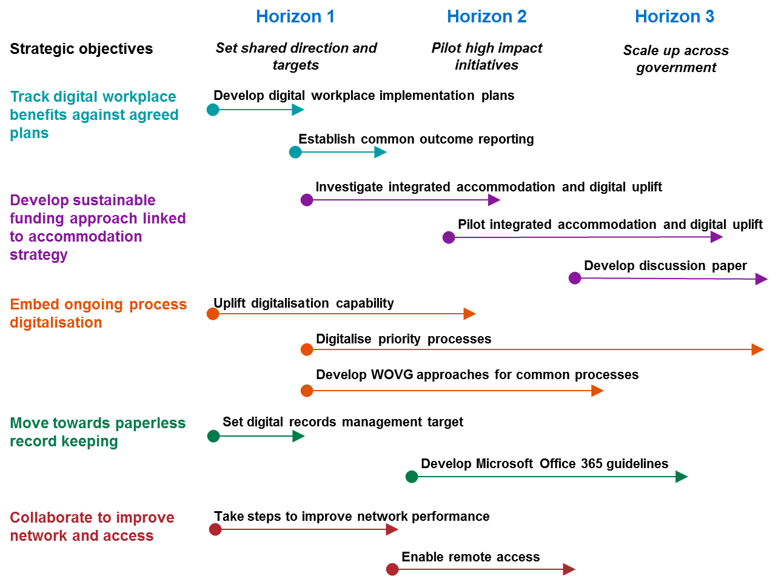

# Appendices

## Appendix A -Digital workplace

|  |
| --- |
| What is the Victorian Government digital workplace?  The digital workplace is made up of the common digital tools, data and processes that employee’s use. In line with the Workplace Environment SOD, this comprises:   * collaboration tools * app store * network and remote access * standard business systems and processes * common information types (Chart of Accounts, employee etc.) * common technology (secure information exchange, network carriage, mobile device management, base operating environments) * document and records management * office productivity tools * devices * corporate services (human resources, on-boarding, finance, learning and training, intranet, fleet etc.).   In addition, this strategy also considers line of business applications as they heavily influence the employee experience of the workplace. |

## Appendix B - Mega-trends

Figure - Nous Mega Trends

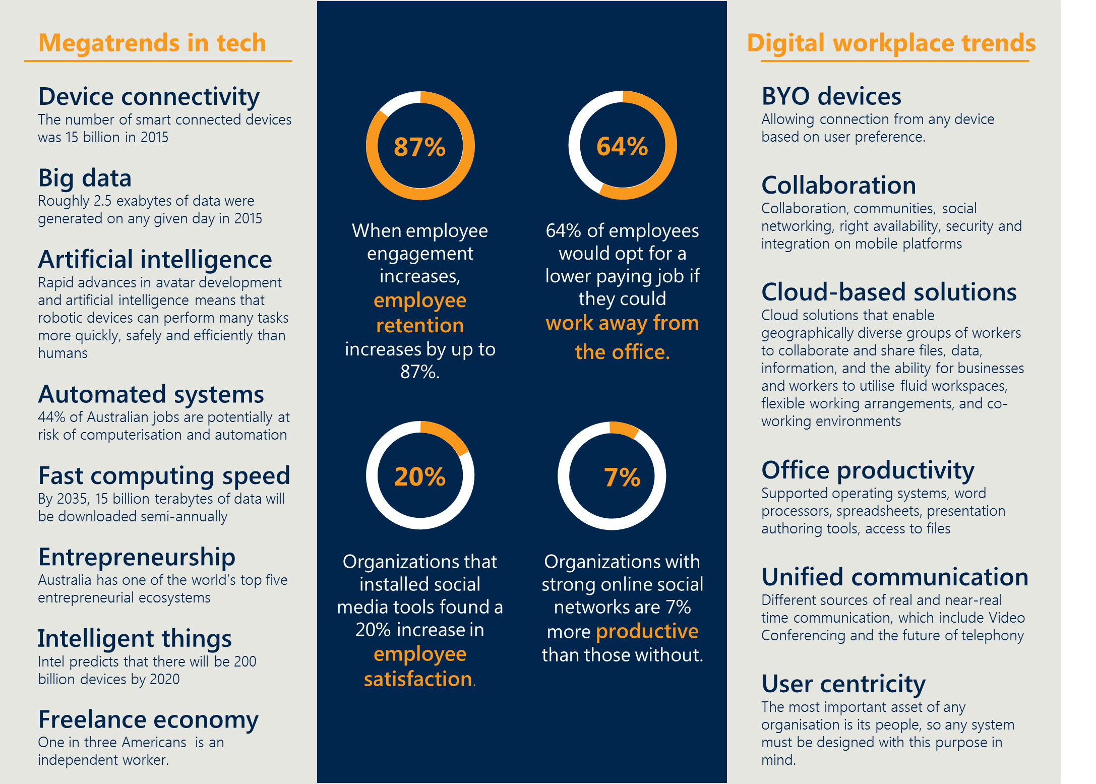

## Appendix C - Policies, strategies, and reviews

**The *Victorian Government’s Information Technology Strategy******2016-2020*** sets direction for four key priorities:

* reform in how government manages and makes transparent its information and data
* seizing opportunities from the digital revolution
* reforming government’s underlying technology
* lifting the capability of government employees to implement ICT solutions.

**The *Workplace Environment SOD*** (Figure 6) defines the vision of a digital workplace as being simple, effective, modern, and standardised workplace systems that free up public servants to focus on delivering services to Victorians. The digital workplace enables public servants to be more productive and collaborative and reduces information management overhead.

Figure | Summary of Workplace Environment Statement of Direction

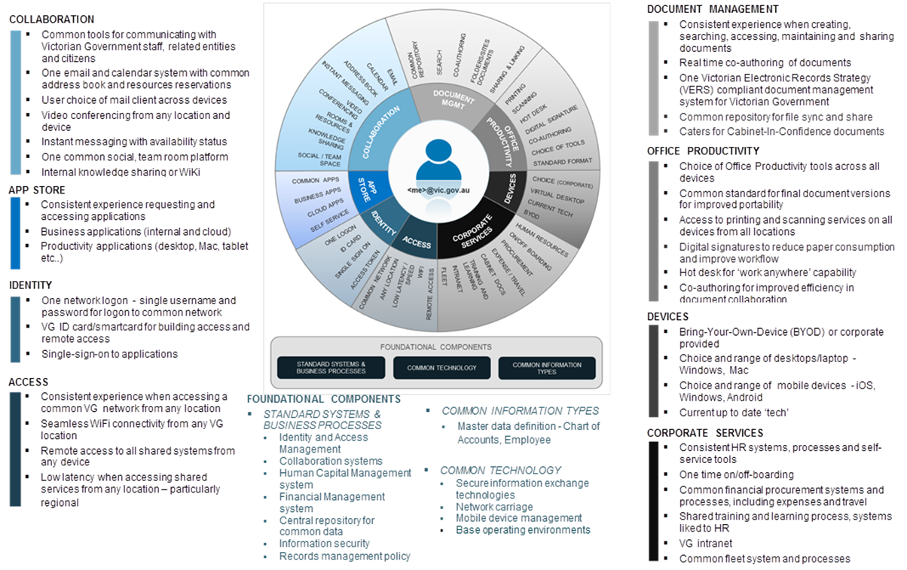

**Service Victoria** received $81.1 million in the 2016 State Budget to create an online one-stop-shop for individuals. The aim is to create a new WOVG service capability to enhance the delivery of government transactions with citizens, enable the delivery of a more effective customer experience and create new distribution channels for simple, high volume transactions.

**The Royal Commission on Family Violence** was launched in 2015 to address the scale and impact of family violence in Victoria with the aim of finding solutions to prevent family violence, better support victim survivors, and to make perpetrators accountable. The Royal Commission’s recommendations on data sharing changed the privacy principles behind information sharing in the family safety context. One of the recommendations of the report was ‘to create a specific family violence information-sharing regime’ under the *Family Violence Protection Act*. The regime would provide clear authority for relevant prescribed organisations to share information related to risk assessment.

**Victorian Auditor General’s Office** **(VAGO) 2015 Audit *‘Access to Public Sector Information’*** found that poor WOVG leadership and governance of information management has failed to drive the organisational changes required to achieve open access to Public Sector Information (PSI). The audit found that there was no single point of accountability for PSI management, along with a fragmented information management landscape (i.e. numerous unconnected, overlapping and inconsistent plans, standards, and materials). The VAGO recommended that DPC establish a WOVG information management framework (delivered in 2016), and for agencies to implement better practice information management. The Victorian Centre for Data Insights and Victorian Agency for Health Information were both established in 2017 to transform the way government uses data to inform policy and service delivery.

Government has made some progress towards a paperless, automated, digitally enabled, and connected workplace environment in response to these policies, strategies, and reviews. However, there is currently no unifying WOVG strategy or roadmap for transitioning the Victorian Government workplace.

**The *Public Sector Innovation Strategy*** sets out six themes for what great innovation looks like in the public sector. This is accompanied by a set of actions to put innovation in motion. These are whole of government themes and actions that are enabled by and align closely with a digital workplace.



# Glossary

Table : Terms and Abbreviations

| Terms and Abbreviations | Definition |
| --- | --- |
| Compliance by design | A process of developing a software system that implements a business process in such a way that its ability to meet specific compliance requirements is ascertained. Formal methods are typically involved to automate compliance rule verification. |
| Digital workplace | The digital workplace is made up of the common digital tools, data and processes that employees use. The workplace includes the physical environment along with the devices and applications connected to a network accessing system, supported by documents, data and information for VPS employees to perform their role and tasks. |
| Digitalisation | The process of moving to digital business practices. It involves using digital technology to change a business model and provide new revenue and value-producing opportunities. |
| Digitisation | The process of converting analogue source material into numerical format. |
| DPC | Department of Premier and Cabinet |
| DTF | Department of Treasury and Finance |
| DPC | Digital Strategy and Transformation, Department of Premier and Cabinet |
| HR | Human resources |
| In scope | All Victorian Departments and Victoria Police |
| Information management (IM) | The collection and management of information from one or more sources and the distribution of that information to one or more audiences. This involves the organisation of and control over the structure, processing and delivery of information. |
| Network | Infrastructure that enables communication between various devices through a series of protocols to exchange information. |
| Physical signature | Handwritten depictions of someone’s name, nickname. Physical signatures serve as a proof of identity on documents. |
| PROV | Public Record Office Victoria |
| Records management | Records management refers to the set of activities required for systematically controlling the creation, distribution, use, maintenance and disposition of recorded information maintained as evidence of business activities and transactions. |
| SoD | Statement of direction |
| VPS | Victorian Public Sector |
| VSB | Victorian Secretaries Board |

# Document Control

### Approval

As this document outlines a work plan for the creation of whole of government artefacts that will be the subject of approval in each instance, this strategy is approved by the Acting Executive Director, Digital Strategy and Transformation, informed and endorsed by the Whole of Victorian Government Information Working Group.

### Version history

|  |  |  |
| --- | --- | --- |
| Version | Date | Comments |
| 1.0 | 23/05/2018 | Final version for consideration |
| 1.1 | 14/08/2018 | Approval version |

  
Except for any logos, emblems, trademarks and contents attributed to other parties, the statements of direction, policies and standards of the Victorian Government’s Victorian Secretaries Board or CIO Leadership Group are licensed under the Creative Commons Attribution 4.0 International licence. To view a copy of this licence, visit <https://creativecommons.org/licenses/by/4.0/>.

1. The workplace includes the physical environment along with the devices and applications connected to a network accessing system, supported by documents, data and information for VPS employees to perform their role and tasks.
2. The Victorian Secretaries Board approved Workplace Environment Statement of Direction describes the foundational technical components and associated user experience direction of the Victorian Government’s workplace of the future.
3. Organisations with strong online social networks are 7% more productive than those without. Deloitte (2014), ‘The Digital Workplace: Think, Share, Do’.
4. A survey showed that 64% of employees would opt for a lower paying job if they could work away from the office and organisations that used social media tools found a 20% increase in employee satisfaction. Deloitte (2014), ‘The Digital Workplace: Think, Share, Do’.
5. eGovernment research commissioned by Australia Post in 2016 found that: ‘94% of Australians want all government services to be available online’ and that: ‘only 29 percent of eGov users were satisfied with their experience’.
6. TRIM (or HP CM) is the electronic documents and records management system adopted by many departments and agencies within the Victorian Government.
7. Departments can still use or refer to hardcopy files but new hardcopy content won’t be created or added to files.