

|  |
| --- |
| Digital Workplace Study  8 February 2018 |

Contents

Executive Summary 3

A workplace study to understand the target, current state and opportunities 8

The current digital workplace environment is limiting staff flexibility and productivity 11

The study builds on three employee profiles 11

Employees share common goals and pain points 12

Six employee experiences highlight these pain points 13

The workplace environment SoD provides the basis for a target vision 20

Progress is being made but there are still challenges and constraints 21

An organisational framework helps us understand the strengths and gaps 21

Initiatives are in place but there are still gaps 22

We can draw lessons from others 28

Leading cases highlight opportunities and lessons 29

There are opportunities for Victoria across the organisational framework 35

Appendix A: Methodology 37

Glossary 44

Document Control 45

# Executive Summary

### Towards a digital workplace

Digital workplaces are important for governments; they help to increase workplace productivity, support better decision making and support digital service delivery.

The importance of the digital workplace environment was set out in the *Victorian Government Information Technology Strategy 2016-2020* (IT strategy). The IT strategy states: “In today’s busy world, a good government works effectively and efficiently. Moving away from paper-based manual processes towards digital information and service delivery is faster and more convenient. Providing an agile, mobile workplace for public sector workers will mean better, faster, more responsive and efficient government.”

The evolution of the digital workplace in Victoria must consider the following external and internal factors:

* **Workplaces of the future will be different**: There are major megatrends influencing the world of work and expectations of employees including artificial intelligence (AI), big data and the growth of the gig economy.
* **Governments of the future will also be different**: The role of government will shift to expectations of government-as-a-platform, which will require a digital first workplace to work effectively.
* **A pathway towards a digital workplace is currently unclear**: While a *Workplace Environment Statement of Direction* (workplace environment SoD) is in place, the government currently needs a coordinated plan and roadmap for delivering against the statement.
* **There is mixed performance across government**: While there are pockets of leading practice and activity throughout government, experts and users describe the Victorian digital workplace as behind best practice.

### The purpose of this study

This *Digital Workplace Study* (workplace study) is action 13 of the IT strategy. The workplace study is informed by the workplace environment SoD and is the first phase of this initiative.

The workplace study assesses the government’s readiness to meet future digital workplace needs, describes a target digital workplace experience and calls out opportunities to adapt and evolve. It considers the development/establishment/creation of common digital tools, data and processes for employees in the digital workplace and the line-of-business applications that heavily influence an employee’s workplace experience.

The second phase of this initiative is to develop the Digital Workplace Strategy (workplace strategy), action 14 of the IT strategy. It will include a vision and strategic directions and initiatives to achieve this vision. This phase will also test with stakeholders the opportunities identified in the workplace study.

### The current digital workplace environment is limiting staff flexibility and productivity

This study explores the experience of six Victorian Public Sector employees across three common employee profiles. Employees interviewed by Nous highlighted a number of common pain points. Table 1 collates these ‘user stories’ in further detail below.

Table 1: Employee pain points

| EMPLOYEE PAIN POINT | DESCRIPTION |
| --- | --- |
| *I want to work flexibly across locations and times so I can be effective in my role while balancing other parts of my life.* | Flexibility is important and one of the major reasons employees choose to work in government. They want more choice over when, where and how they work, enabling them to be effective in their role, while balancing personal commitments. Employees state that the suitability of mobile devices, the limitations in accessing applications remotely and the low reliability of connectivity outside major offices prevent them from working flexibly. |
| *I want digital workplace investments to go live quickly and effectively so I get the full benefits* | Employees are frustrated with the slow rate of adoption and change within government. For example, employees recognise SharePoint’s strengths for collaborating on document production and the value of TRIM for document management. However, because not all employees have adopted the technology consistently, efficient co-authoring is undermined by colleagues creating multiple document versions. Employees want effective change support and faster department and government-wide adoption so that they get the full productivity benefit of working digitally. |
| *I want consistency between departments and agencies so that I can work and collaborate seamlessly across government* | Employee’s highlight the impact of different systems, processes and culture across government. This is seen as driving digital practices to the ‘lowest common denominator’, creating friction when collaborating and circumventing the benefits of existing digital workplaces. For example, when interacting with the courts, one employee noted that their paper-based processes prevent a fully digital working style in order to work effectively. It is also seen as a major driver of complexity after machinery of government changes. |
| *I want a leader who embraces digital opportunities so changes are invested in and embraced by everyone* | Employees highlighted the importance of leaders who role model digital workplace behaviours and are willing to trial and invest in digital workplace improvements. For example, one employee noted that their direct leader was a proactive driver of digital workplace changes which supported uptake across teams. |
| *I want reliable access and quick troubleshooting support so I can stay productive when working remotely* | Employees confirmed the importance of reliability of remote access. Employees stated that it is quite common that they are unable to access the intranet, emails, documents and other applications when working remotely. This leads to workarounds, frustration and reduced productivity. Compounding this, employees state that service desk support is often unavailable which further adds to the frustration. |
| *I want common risk averse and legacy processes to be updated so I can release time to be more productive* | Employees often raised the frustrating, slow and outdated briefing processes as a major pain point to their productivity and engagement with their role. Employees find the number of physical signatures (often from hard-to-get decision makers), the reliance on hardcopy and focus on risk management disproportionate. |

### The workplace environment SoD provides the basis for a target vision

By implementing the elements of the workplace environment SoD, departments will improve the employee experience.

Figure 1 shows a target sample day in the life of a Victorian Government employee. The experience is characterised by high-levels of mobility and common cross-government processes, with up to-date supporting technology.

Figure 1: Target employee experience – Day in the life

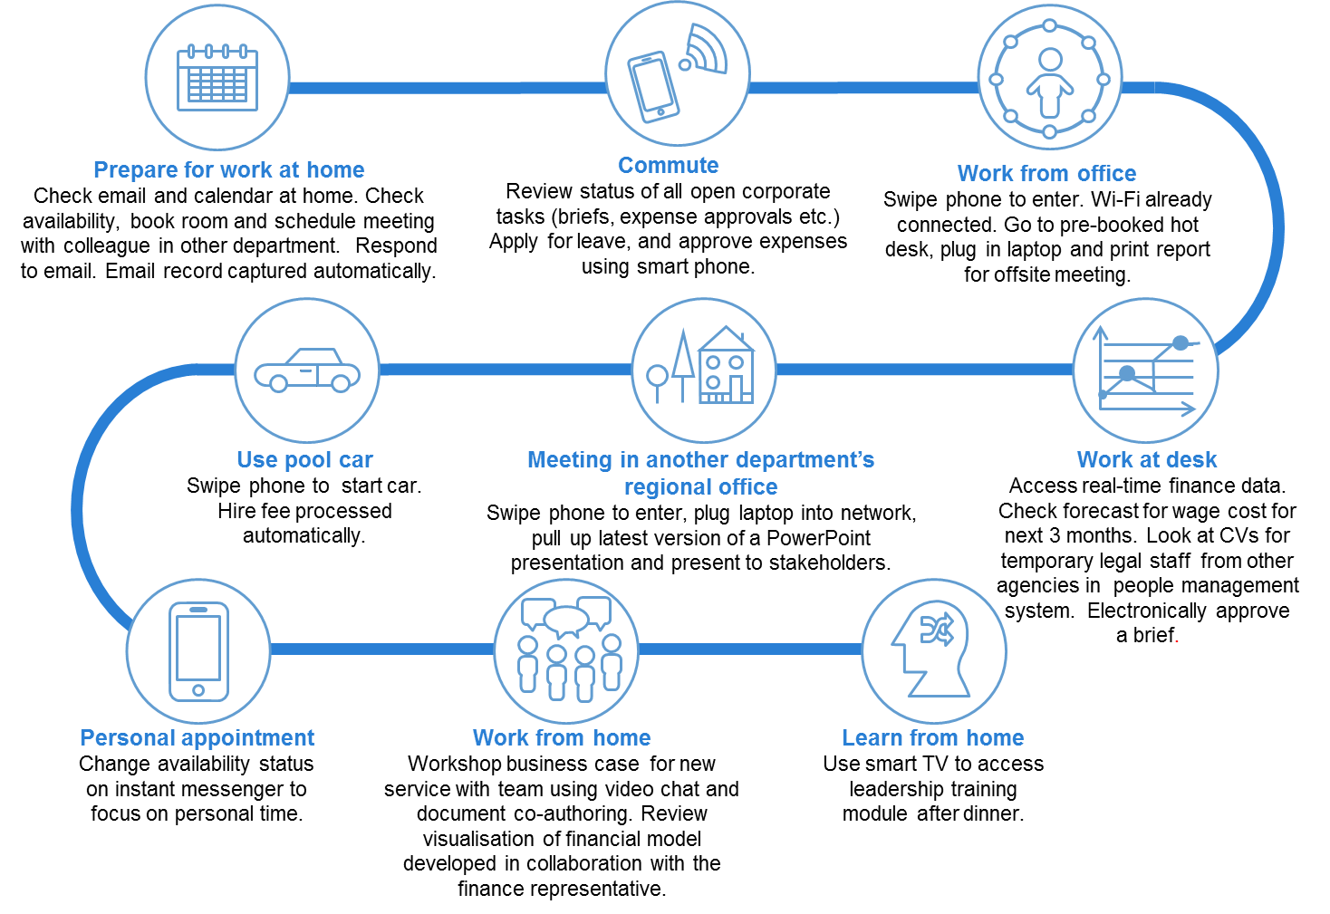

### Progress is being made against the workplace environment SoD but there are still challenges and constraints

The government is making advances towards a more digital and automated workplace in line with the workplace environment SoD. However, there are still gaps between the current and target state:

* **Direction setting:** a unifying strategy across government and comprehensive department plans and funding models will support digital transformation.
* **Enabling environment:** updated processes and improved process change capability and culture, will support progress
* **Digital environment:** Outdated devices, inconsistent network connections and varying remote access experience.

A high-level comparison of the target and current state is provided in Table 2 below.

Table 2: Comparison of target and current state

|  |  |  |
| --- | --- | --- |
|  | TARGET STATE | CURRENT STATE |
| DIRECTION SETTING | * Accepted and funded government-wide digital workplace strategy that meets the needs of government and the employees. * Digital workplace benefits that are tracked and offset technology investment costs. * Records policy that supports ‘born digital, stay digital’ and managing digital information wherever it is held. | * The workplace environmentSoD is in place but there are no specific targets and comprehensive implementation plans are needed. * Some departments have developed specific digital workplace strategies. * Insufficient funding available due to competing department priorities. * Funding models that don’t support continuous agile development. |
| ENABLING ENVIRONMENT | * Leaders who embrace digital change across and in all government departments. * High-level of process transformation capability across departments with teams empowered to digitalise processes they own. * Investment in change management when new digital tools are introduced. | * Mixed leadership appetite for change. * Poor history of technology change management resulting in limited benefits. * *ICT Capability Uplift Plan* (uplift plan) is in development. * Deeply imbedded paper-based processes and record keeping. |
| DIGITAL ENVIRONMENT | * Devices that support mobility and user choice. * Core productivity suit that supports digital working e.g. document collaboration, video conferencing etc. * Records management and compliance largely invisible to user and embedded in systems. * Government-wide digitalisation of core processes including mail, briefings, human resources and finance. * Remote access to line of business systems. * Easy access to support. | * Dated devices and limited choice. * Collaboration, document management and office productivity suite are being upgraded. * SoDs in place for briefings, human resources, finance and procurement. * Some departments progressing with an app store. * Whole Of Victorian Government (WOVG) and department work underway on briefing and correspondence. * Network outages and poor quality remote access experience. * Pockets of application innovation but many legacy systems cannot be accessed remotely and do not support digital record keeping. * Some progress on identity & common technology. |

### There are opportunities for Victoria across the organisational framework

We have developed a preliminary list of opportunities by bringing together feedback from staff on their expectations, expert views on the current state of the digital workplace environment and lessons from leaders in mature digital workplaces. There are many elements of the workplace environmentSoD that could be accelerated. The three opportunities identified against digital enablers focus on the areas which users identified as most problematic. Table 3 will be tested with stakeholders during development of the strategy.

Table 3: Potential opportunities

|  |  |
| --- | --- |
|  | POTENTIAL OPPORTUNITIES |
| DIRECTION SETTING | Each department to establish a digital workplace strategy that meets their organisational needs and pain points. |
| Set records management policy that supports ‘born digital stay digital’ and ‘managing digital information wherever it is held’. |
| Apply timing targets to key elements of the workplace environmentSoD. |
| FUNDING | Establish a funding pool that incentivises innovation and change or makes funding available based on achievement of set targets. |
| ENABLING ENVIRNONMENT | Leverage the uplift plan to define and develop capabilities in effective digital change management and digital leadership. |
| Continue to develop WOVG approaches for common processes (human resources, finance, procurement, briefing and correspondence) and consider creating deadlines for briefing and correspondence, human resources, finance and e-procurement SoDs. |
| Consider extending digital mailroom across government. |
| Conduct department paper/process audits for high-risk, high-volume and high-value business processes, including identifying the management information needed to support process reform. Plan digitisation and commit to process redesign targets. |
| DIGITAL EN VIRONMENT | Increase user visibility of options and provide employees with greater choice in the selection of devices. |
| Develop WOVG approach to desktop document compliance (records management etc.) that leverages and aligns to the rollout of Microsoft Office 365. |
| Review network performance issues and establish remediation project. |
| Review remote access technology and approaches. |

# A workplace study to understand the target, current state and opportunities

### Purpose of the study

This study assesses the government’s readiness to meet future digital workplace needs, and calls out opportunities to adapt and evolve. This study will inform the workplace strategy.

|  |
| --- |
| 0BWhat is the Victorian government digital workplace? The digital workplace is made up of the common digital tools, data and processes that employee’s use. In line with the workplace environment SoD, this comprises of:   * collaboration tools * app store * network and remote access * standard business systems and processes * common information types (Chart of Accounts, employee etc.) * common technology (secure information exchange, network carriage, mobile device management, base operating environments) * document and records management * office productivity * devices * corporate services (human resources, on-boarding, finance, learning and training, intranet, fleet etc.).   In addition, this study also considers line of business applications as they heavily influence the employee experience of the workplace. |

### Background

We know that a mature digital workplace is needed to:

* **Support employee productivity and collaboration:** Research indicates that about 40% of Australian jobs are at risk of automation over the next 10 to15 years.0F[1] Technological transformation presents an opportunity for employers to automate repetitive tasks and divert existing human capital to value-add areas. Digital tools can also improve employee productivity by enabling teams to connect remotely. Organisations with strong online social networks are 7% more productive than those without.1F[2]
* **Attract the best talent and meet employee expectations:** Job seekers, especially young job seekers, expect digital technology to enable flexible work practices where possible. A survey showed that 64% of employees would opt for a lower paying job if they could work away from the office.2F[3] Furthermore, organisations that used social media tools internally found a 20% increase in employee satisfaction.3F[4]
* **Support digital citizen service delivery:** There is clear citizen demand for quality online services. eGovernment research commissioned by Australia Post in 2016 found that: ‘94% of Australians want all government services to be available online’ and that: ‘only 29 percent of eGov users were satisfied with their experience’4F[5]. Moreover, to realise the full benefit of timely, integrated and digitally enabled service delivery, citizen facing services need to be linked with efficient digitised internal processes.

Victoria has already acknowledged this case for change through its own policies, strategies and reviews.

**The *Victorian Government’s Information Technology Strategy******2016-2020*** sets direction for four key priorities:

* reform in how government manages and makes transparent its information and data
* seizing opportunities from the digital revolution
* reforming government’s underlying technology
* lifting the capability of government employees to implement ICT solutions.

**The workplace environment SoD** defines the vision of a digital workplace as being simple, effective, modern; and standardised workplace systems that free up public servants to focus on delivering services to Victorians. The digital workplace enables public servants to be more productive and collaborative and reduces information management overhead.

**Service Victoria** received $81.1 million in the 2016 State Budget to create an online one-stop-shop for individuals. The aim is to create a new WOVG service capability to enhance the delivery of government transactions with citizens, enable the delivery of a more effective customer experience and create new distribution channels for simple, high volume transactions.

**The Royal Commission on Family Violence** was launched in 2015 to address the scale and impact of family violence in Victoria, with the aim of finding solutions to prevent family violence, better support victim survivors and to make perpetrators accountable. The Royal Commission’s recommendations on data sharing changed the privacy principles behind information sharing in the family safety context. One of the recommendations of the report was ‘to create a specific family violence information-sharing regime’ under the Family Violence Protection Act. The regime would provide clear authority for relevant prescribed organisations to share information related to risk assessment.

**VAGO 2015 Audit ‘Access to Public Sector Information’** found that poor WOVG leadership and governance of information management has failed to drive the organisational changes required to achieve open access to Public Sector Information (PSI). The audit found that there was no single point of accountability for PSI management, along with a fragmented information management landscape (i.e. numerous unconnected, overlapping and inconsistent plans, standards and materials). VAGO recommended that DPC establish a WOVG information management framework (delivered in 2016), and for agencies to implement better practice information management. The Victorian Centre for Data Insights and Victorian Agency for Health Information were both established in 2017 to transform the way government uses data to inform policy and service delivery.

Government has made some progress towards a paperless, automated, digitally enabled and connected workplace environment in response to these policies, strategies and reviews. However, there is currently no unifying WOVG strategy or roadmap for transitioning the Victorian Government workplace.

# The current digital workplace environment is limiting staff flexibility and productivity

This section outlines the current VPS employee experience in their workplaces. It covers the common pain points across government and the specific experiences of the employee case studies explored for the purposes of the study.

## The study builds on three employee profiles

This study explores the experience of six VPS employees across three common employee profiles. The Victorian Government has a large and diverse workforce and to capture the full range of needs and experiences is a challenge. The profiles assist to capture a level of commonality and coverage across the VPS so that the depth and richness of the interviews has application to the study.

The profiles build on work undertaken by Department of Environment, Land, Water and Planning (DELWP) to develop its *Workforce Persona and Device Strategy*. DELWP’s strategy incorporated a number of personas that are both specific to DELWP portfolio activities and general VPS workers. Three personas from the strategy have been used for this study. These three personas were selected as:

* they apply generally across all in-scope departments
* each persona represents a large segment of VPS employees
* together, the three personas encompass a large proportion of the VPS.

The three profiles and their characteristics are outlined in Table 4 below.

Table 4: User profiles

| PERSONA AND TYPICAL ROLES | NEED AND CHARACTERISTICS |
| --- | --- |
| OFFICE WORKER  Executive assistants, Business support, project officers | Works from a single office location with Activity Based Working (ABW) and occasional work from home or other locations as a requirement for this persona. This persona relies heavily on a device-centric laptop/computer/personal computer to access network, applications and software. Collaboration with other colleagues within the office is face to face, telephone, instant messaging and video conferencing. |
| FLEXIBLE WORKER Executive, change manager | Working in multiple locations and frequently after hours at home, the office transient persona requires the ability to work flexibly. This persona relies heavily on a device-centric laptop/personal computer/mobile device with a mobile functionality overlay. Collaboration with colleagues and external stakeholders is face to face, telephone, instant messaging and video conferencing. |
| FIELD-BASED  Field officers, case workers | Working with clients or finding, gathering and analysing data in the field and the office, this persona works in varying environments. This persona relies on efficient mobile technology to manage tasks out in the field. Their work can be time-sensitive and rely on accurate location data. They are most interested in technology that works consistently on the road. Collaboration with colleagues, clients and external stakeholders is face to face, telephone, instant messaging and occasionally by two-way radio. |

## Employees share common goals and pain points

Interviews with employees highlighted a number of common goals and pain points related to employee experiences with the digital workplace. Table 5 below synthesises these in the form of ‘user stories’ and explains each in further detail.

While persona segmentation was used to ensure we captured the diverse needs of the VPS, there are many common pain points. This suggests that workplaces are increasingly allowing for - and expecting - flexible working from home, remote collaboration between teams and departments and travel out of the office. Therefore, while employees have a dominant work profile, the digital workplace demands across these profiles are similar. Over time, the needs and demands of the VPS with respect to the digital workplace are likely to continue to converge as flexible working, travel and inter-department remote collaboration become the norm.

Table 5: Employee pain points

| EMPLOYEE PAIN POINT | DESCRIPTION |
| --- | --- |
| *I want to work flexibly across locations and times so I can be effective in my role while balancing other parts of my life.* | Flexibility is important and one of the major reasons employees choose to work in government. They want more choice over when, where and how they work, enabling them to be effective in their role, while balancing personal commitments. Employees state that the suitability of mobile devices, the limitations in accessing applications remotely and the low reliability of connectivity outside major offices prevent them from working flexibly. |
| *I want digital workplace investments to go-live quickly and effectively so I get the full benefits* | Employees are frustrated with the slow rate of adoption and change within government. For example, employees recognise SharePoint’s strengths for collaborating on document production and the value of TRIM for document management. However, because not all employees have adopted the technology consistently, efficient co-authoring is undermined by colleagues creating multiple document versions. Employees want effective change support and faster department and government-wide adoption so that they get the full productivity benefit of working digitally. |
| *I want consistency between agencies so that I can work and collaborate seamlessly across government departments* | Employee’s highlight the impact of different systems, processes and culture across government. This is seen as driving digital practices to the ‘lowest common denominator’, creating friction when collaborating and circumventing the benefits of existing digital workplaces. For example, when interacting with the courts, one employee noted that their paper-based processes prevent a fully digital working style in order to work effectively. It is also seen as a major driver of complexity after the machinery of government changes. |
| *I want a leader who embraces digital opportunities so changes are invested in and embraced by everyone* | Employees highlighted the importance of leaders who role model digital workplace behaviours and are willing to trial and invest in digital workplace improvements. For example, one employee noted that their direct leader was a proactive driver of digital workplace changes which supported uptake across teams. |
| *I want reliable access and quick trouble shooting support so I can stay productive when working remotely* | Employees confirmed the importance of reliability of remote access. Employees stated that it is quite common that they are unable to access the intranet, emails, documents and other applications when working remotely. This leads to workarounds, frustration and reduced productivity. Compounding this, employees state that service desk support is often unavailable which further adds to the frustration. |
| *I want common risk averse and legacy processes to be updated so I can release time to be more productive* | Employees often raised the frustrating, slow and outdated briefing processes as a major pain point to their productivity and engagement with their role. Employees find the number of physical signatures (often from hard-to-get decision makers), the reliance on hardcopy and focus on risk management disproportionate. |

## Six employee experiences highlight these pain points

Six employees from across government and under each employee profile were interviewed to understand their daily experiences with the digital workplace. The 90 minute interviews explored the employees’ role, goals and expectations, typical workplace journeys, technical maturity (my digital maturity) and needs (my tech demand), pain points and asked them to share their suggestions for improvement (my suggestions).

The six employee journeys are outlined over the following pages. The journeys are not intended to be a complete depiction of the individual’s role and work experience, rather the key components that assist to understand the range of experiences with the digital workplace and where employees are currently seeking improvements.

Figure 2: Office worker persona - Department of Treasury and Finance

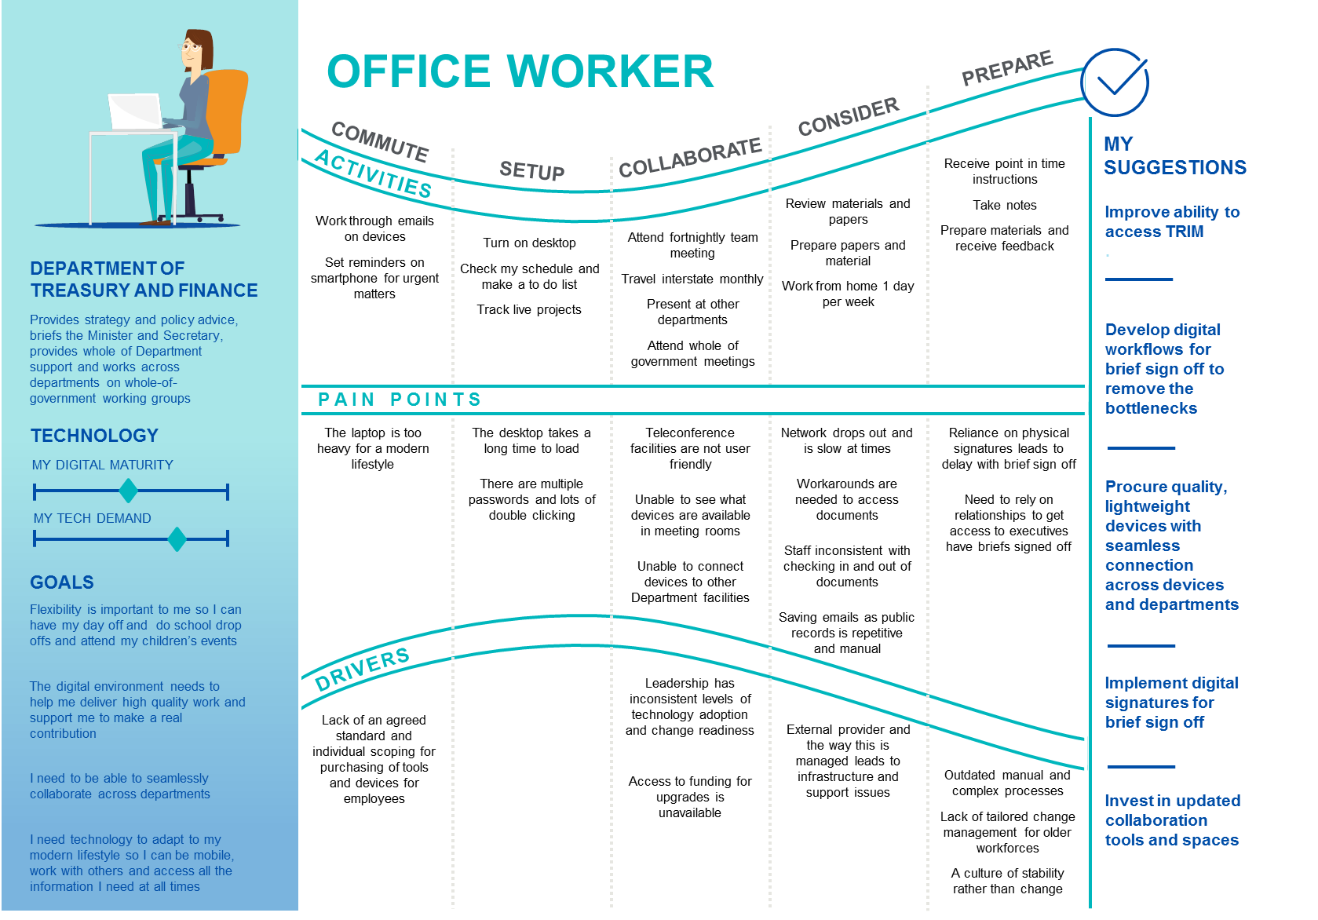

Figure 3: Office worker persona - Department of Premier and Cabinet

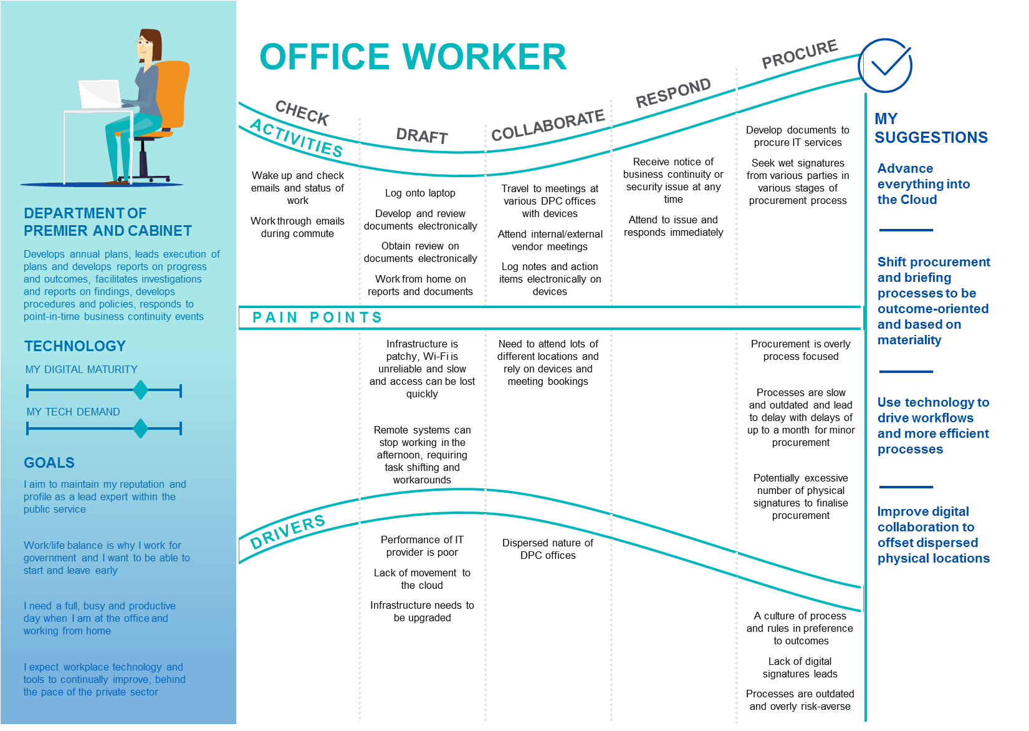

Figure 4: Office worker persona - Department of Health and Human Services

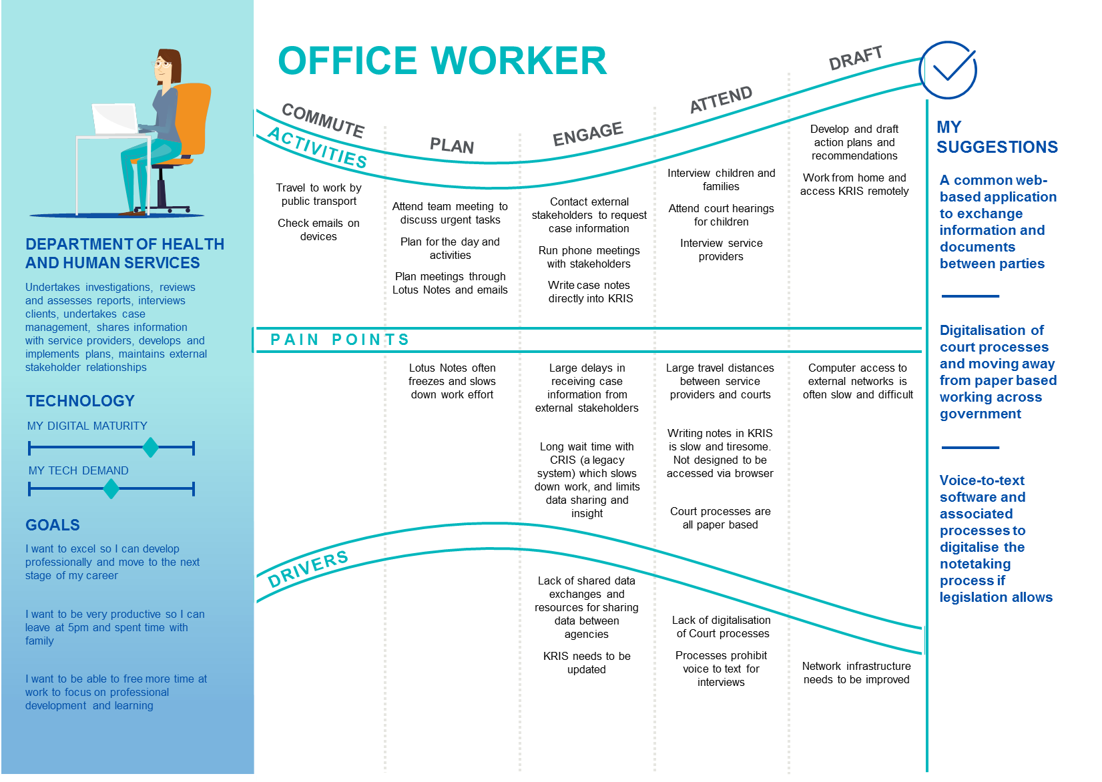

Figure 5: Field worker - Department of Justice and Regulation

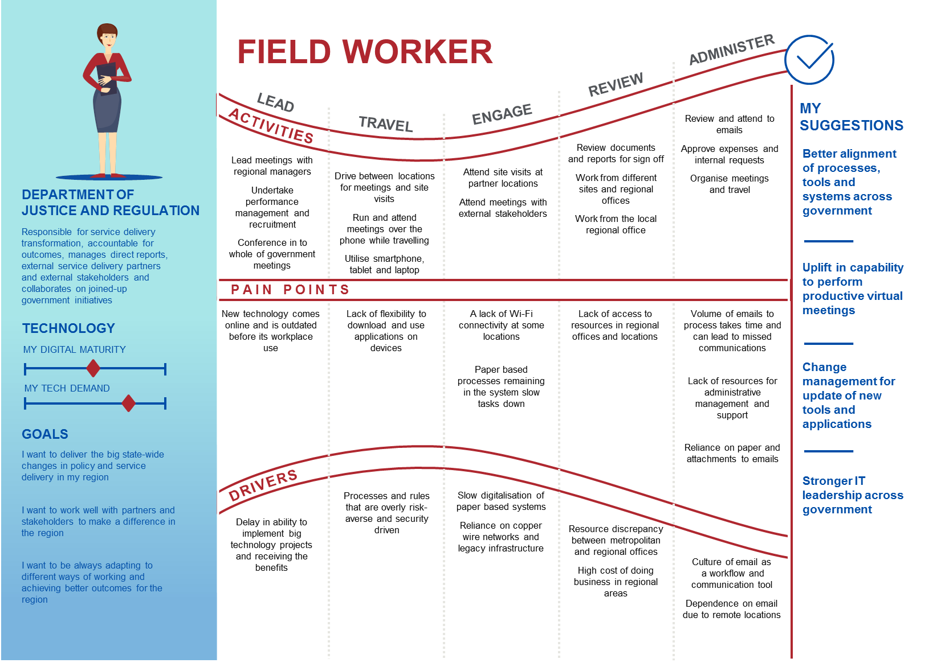’

Figure 6: Field worker - Department of Economic Development, Jobs, Transport and Resources

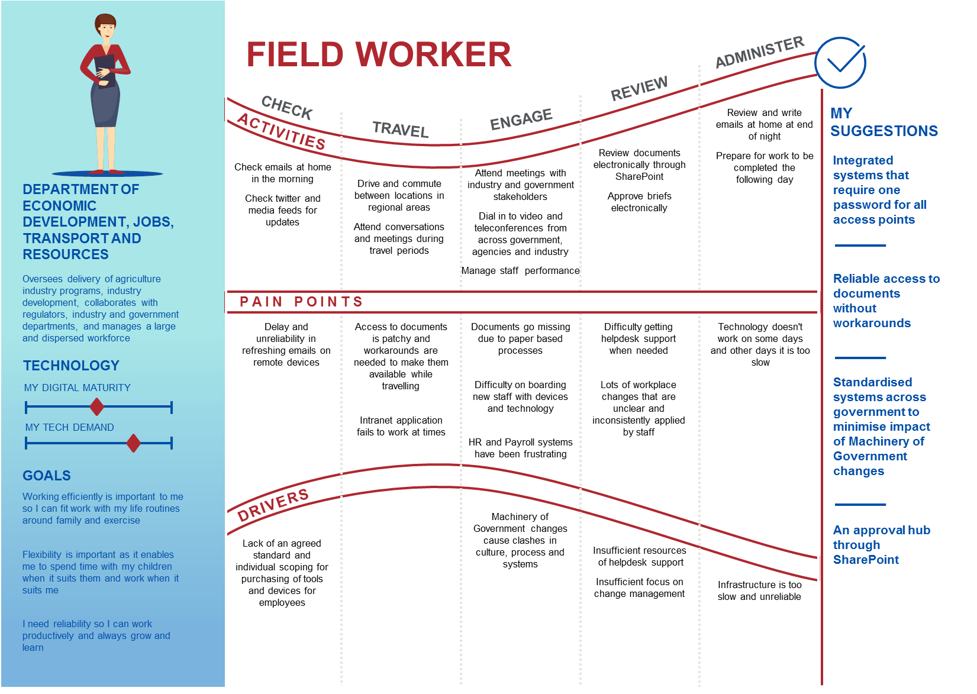

Figure 7: Flexible worker - Department of Education and Training

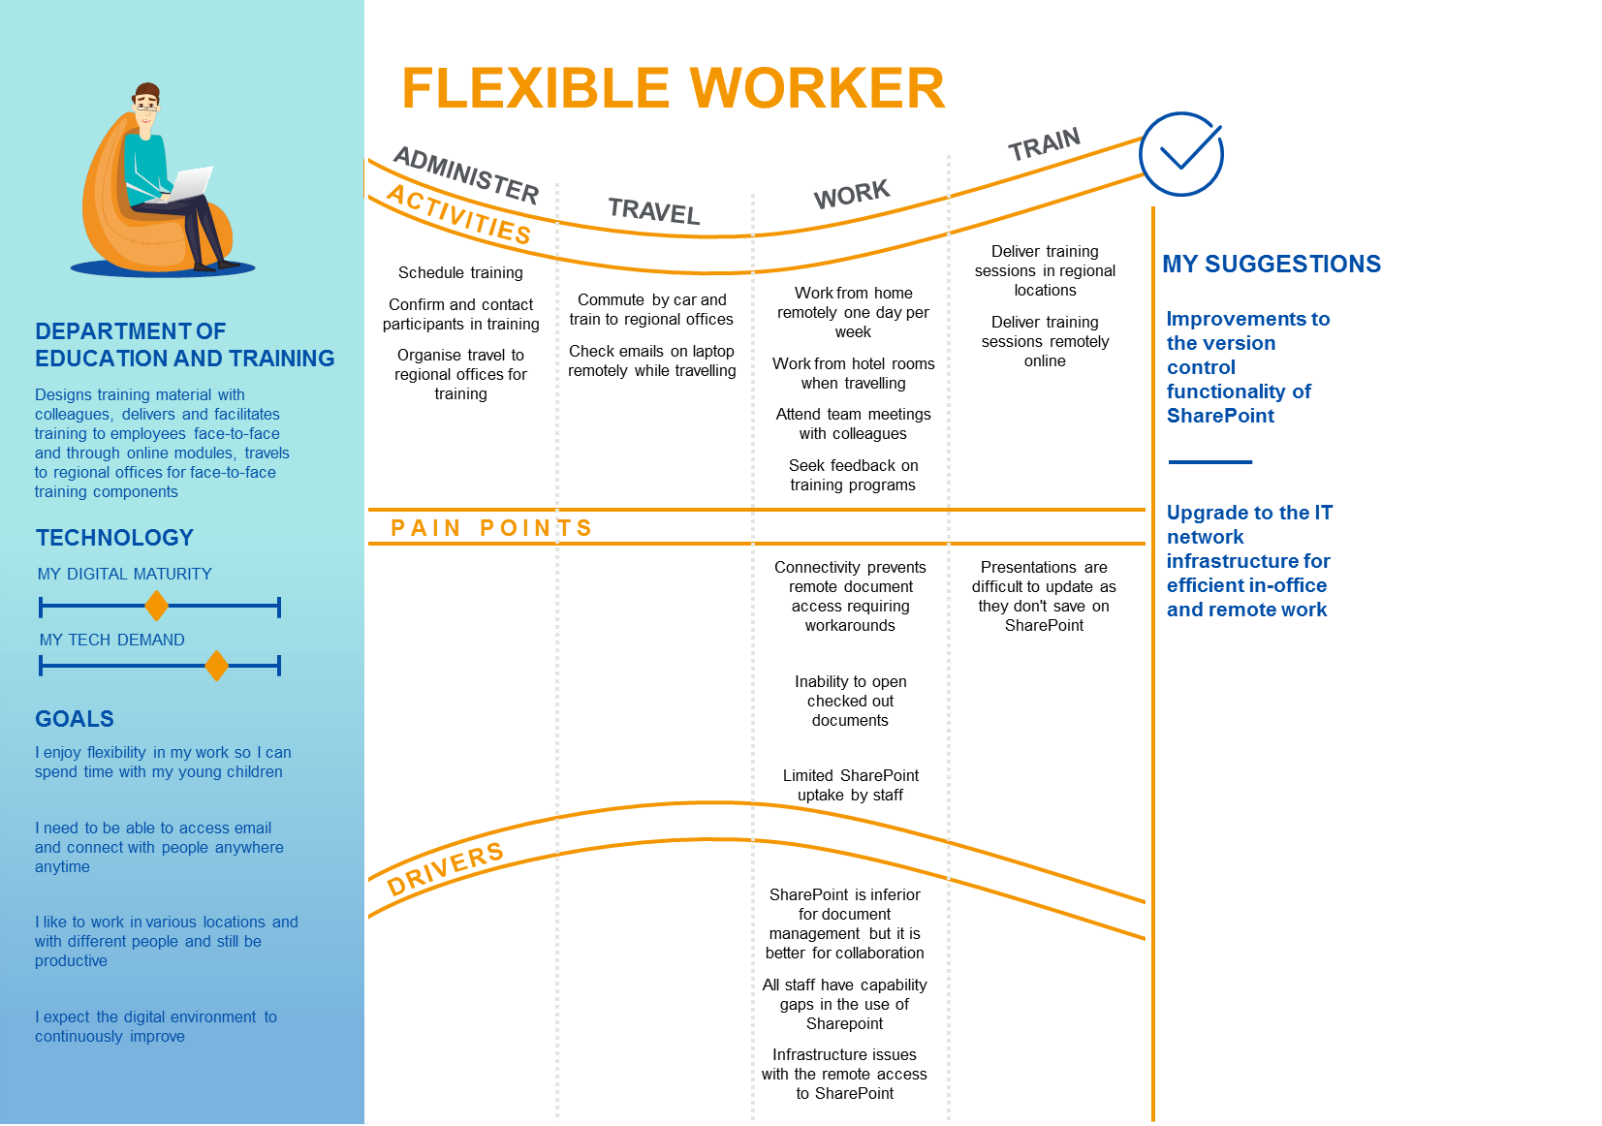

# The workplace environment SoD provides the basis for a target vision

By implementing the elements of the workplace environment SoD, departments will change the employee experience. Figure 8 shows a target sample day in the life of a VPS employee. The experience is characterised by high-levels of mobility and common cross-government processes with up to-date supporting technology.

Figure 8: Target employee experience – Day in the life



# Progress is being made but there are still challenges and constraints

This section outlines the initiatives and investments in place across the government to move towards a digital workplace while highlighting current gaps. A more detailed summary of department strategies can also be found in Appendix A.

## An organisational framework helps us understand the strengths and gaps

Digital investments deliver value to workplaces when they are integrated with the strategy and operations of the organisation in which they exist. To do this successfully, it is important to consider the full context of the organisation and how all components fit together. For example, digital tools provide little value to workers if they have a limited capability to use them within their role. The framework allows us to map current activity and identify strengths, challenges or gaps.

Figure 9 below shows the Nous organisational architecture framework. It sets out all components of an organisation and how they fit together from direction setting to the enabling environment to the digital environment. The enabling and digital environments also incorporated the full scope of the workplace environment SoD.

Figure 9: Organisational architecture framework

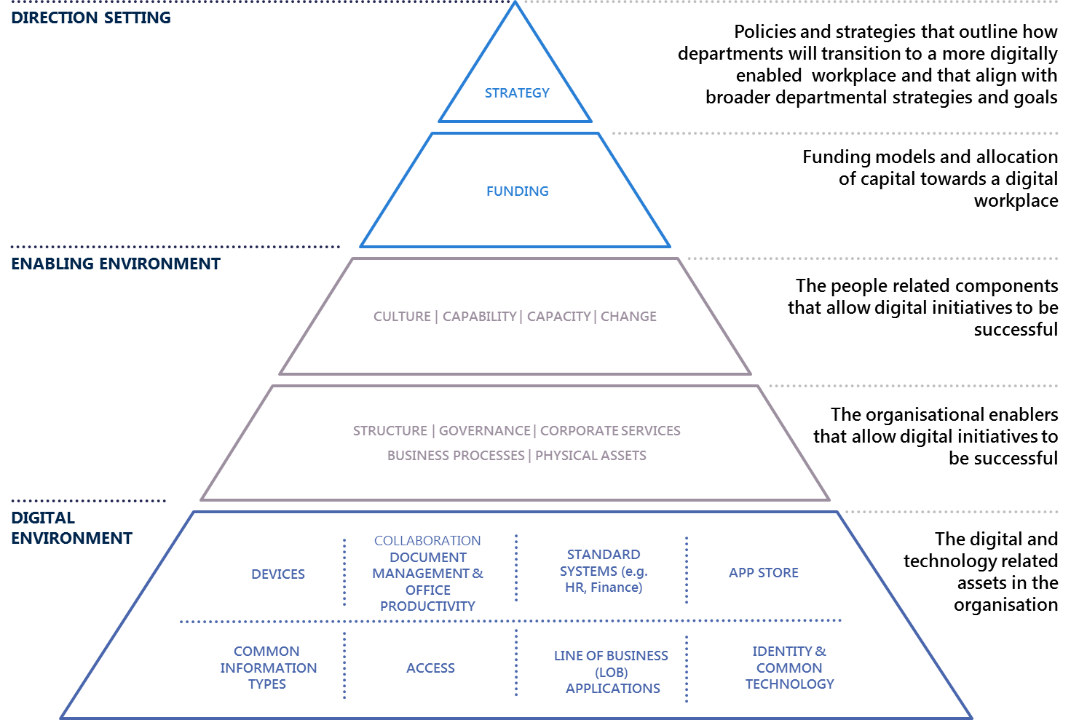

Digital workplace initiatives need to:

* align with the achievement of strategic and policy goals
* be supported by appropriate funding arrangements and levels
* have the right investments in people; including culture, capability, capacity and change management to adapt to the technologies and use them
* have the right organisational enablers in place; including structure, governance, processes and services.

Along with these elements, there needs to be the right digital tools, applications, information and infrastructure to support key tasks and ways of working.

## Initiatives are in place but there are still gaps

The government is making advances towards a more digital and automated workplace in line with the workplace environment SoD, in particular, the introduction of up to date collaboration and productivity tools. Nevertheless, there are still gaps between the current and target state:

* **Direction setting:** a unifying strategy across government and comprehensive department plans and funding models will support digital transformation.
* **Enabling environment:** updated processes and improved process change capability and culture, will support progress
* **Digital environment:** Outdated devices, inconsistent network connections and varying remote access experience.

A high-level comparison of the target and current state and provided in Table 6 below.

Table 6: Comparison of target and current state

|  | TARGET STATE | CURRENT STATE |
| --- | --- | --- |
| DIRECTION SETTING | * Accepted and funded government-wide digital workplace strategy that meets the needs of government and the employees. * Digital workplace benefits that are tracked and offset technology investment costs. * Records policy that supports ‘born digital, stay digital’ and managing digital information wherever it is held. | * The workplace environment SoD is in place but there are no specific targets or comprehensive implementation plans. * Some departments have developed specific digital workplace strategies. * Insufficient funding available due to competing department priorities. * Funding models that don’t support continuous agile development. |
| ENABLING ENVIRONMENT | * Leaders who embrace digital change across and in all government departments. * High-level of process transformation capability across departments with teams empowered to digitalise processes they own. * Investment in change management when new digital tools are introduced. | * Mixed leadership appetite for change. * Poor history of technology change management resulting in limited benefits. * The uplift plan is in development. * Deeply imbedded paper-based processes and record keeping. |
| DIGITAL ENVIRONMENT | * Devices that support mobility and user choice. * Core productivity suit that supports digital working e.g. document collaboration, video conferencing etc. * Records management and compliance largely invisible to user and embedded in systems. * Government-wide digitalisation of core processes including mail, briefings, human resources and finance. * Remote access to line of business systems. * Easy access to support. | * Dated devices and limited choice. * Collaboration, document management and office productivity suite are being upgraded. * SoDs in place for briefings, human resources, finance and procurement * Some departments progressing with an app store. * WOVG and department work underway on briefing and correspondence. * Network outages and poor quality remote access experience. * Pockets of application innovation but many legacy systems can’t be accessed remotely and do not support digital record keeping. * Some progress on identity and common technology. |

### Direction setting

##### The workplace environment SoD is in place but there are no specific targets or implementation plans

The workplace environment SoD sets a clear vision for the digital workplace of the future, though progress against the SoD has been slow. In line with the current SoD, the approach is not being measured against any targets. Some departments have already developed digital workplace related strategies (DELWP, Department of Education and Training (DET), Victoria Police (VicPol) and VicRoads).

However at this time, these strategies do not comprehensively address the full SoD scope.

In addition, many elements of the SoD require a coordinated, government-wide approach including common collaboration tools, one single email and calendar system, WOVG Identity and building access management. The low coordination across the breadth of activity being undertaken has made it difficult for departments to create a seamless and integrated experience within both their organisation and across government.

##### Insufficient funding and funding models that don’t support ongoing agile development

The digital workplace requires ongoing investment to stay current with technology, to rethink processes, build capability and capacity and to effectively manage change. Many stakeholders interviewed believe receiving funding for ongoing internal corporate projects to be a challenge as there are often insufficient incentives in the short to medium term, along with competing priorities.

### Enabling environment

##### Mixed leadership appetite for change

Stakeholders believed that accountability for delivering improvements to the digital workplace environment must be apparent through the organisational structure, especially at director and assistant director level, where risk aversion is more apparent.

##### Poor history of technology change management resulting in limited benefits

Employees and staff report that benefits are not often fully realised, even after technological change, because inefficient processes still remain. For example, while TRIM provides workflow functionally it has not been adopted by all departments (e.g. to support briefing and document approval processes) that still rely on hard-copy signatures.

##### An ICT Capability Uplift Plan has been developed

Current capability in the purchase, implementation and use of contemporary ICT systems and services is limited and varied across government departments. In particular there is limited experience in process re-design, which is essential to unlocking the benefits of digitisation.

Shortly the Victorian Government will release an uplift plan, of which Phase 1 sets the vision, recommendations and implementation plan to strengthen the government’s internal capability to purchase, implement and use contemporary ICT systems and services. Phase 2 of the uplift plan seeks to validate and revise while designing the programs of work to support the execution of the IT Strategy priority to uplift capability across the Victorian Public Service (Priority 4).

##### Deeply imbedded paper-based processes

Previous Nous analysis of digital record keeping found that most hard-copy based documents and records created today are born digital but converted to paper due to internal business policy and processes. The key barriers to ‘born digital, stay digital’ include:

* digital workflows need to improve
* technology and acceptance of digital signatures need to improve
* cultural attachment to paper
* Line of business (LOB) systems that have not been designed to support long-term digital records management driven by:
  + classification and retention schedules applied in LOBs and network storage drives need to improve
  + aging systems and storage media where export has not been considered
  + complexity, cost, low records management knowledge and influence resulting in records management requirements being omitted in newer system developments and purchasing.

Overcoming these challenges in existing systems could be complex and costly. However, the need to simplify classification and embed minimum requirements in new system developments and procurements is evident.

### Digital environment

##### Dated devices and limited choice

Devices used by the VPS are dated, but most departments and agencies are slowly upgrading their devices to support mobility and flexible work practices. For instance, the Department of Health and Human Services (DHHS) has incrementally rolled out iPads to field-based caseworkers. The Department of Treasury and Finance’s (DTF) IT strategy includes device upgrades for staff and uplift to meeting rooms. VicPol has also made new technology and tools available to employees to support mobility and flexible work practices.

##### Collaboration, document management and office productivity suite are being upgraded

Many departments are investing in upgrades to Office365 and SharePoint to foster collaboration. DELWP’s Enterprise Content Management System is based on SharePoint and includes records management. However it is unclear if digital record keeping is being embedded as part of Microsoft Office 365 upgrades in other departments. Two departments do not currently have document management systems in place across the whole organisation (DHHS and VicPol). DTF’s IT strategy includes an upgrade to TRIM to incorporate electronic workflow.

Most departments are leveraging messaging and video conferencing systems, such as Skype for Business, to enable teleconferencing.

##### Some departments are progressing an App Store but a risk averse culture is holding others back

DET is working to secure funding for an authorisation platform to streamline staff access to various applications. However, stakeholders from other departments detailed a technology procurement process that involved gathering physical signatures over several weeks in order to simply download a basic program such as Adobe Photoshop. They saw the risk averse culture of government as the major barrier slowing progress.

##### WOVG and department work underway on human resources (HR), finance, briefing and correspondence

There are WOVG and department level activities aimed at digitalising dated manual and paper-based processes for common corporate services. Initiatives are underway to deliver common platforms, governance models and processes for HR, finance, e-procurement, briefing and correspondence.

DEDJTR recently commenced a process redesign project, which aims to simplify and normalise business processes to maximise the value of any digitalisation and automation activities. This project is being undertaken as part of a broader initiative to improve the operating model for corporate support services. The premise for the process re-design is that common processes (from preparing briefings to hiring a new employee) generally involve common steps and they can be supported by one workflow system.

Once implemented, employees (and the department) will have a single view of the status of all their open processes. Currently employees have to engage with multiple systems and processes. This is particularly inefficient when processes are multidisciplinary. For example, to on-board a new employee, a hiring manager must engage separately with HR, Finance, IT etc. A challenge in improving the current lengthy sign-off processes is ensuring decision makers have access to the management information they need i.e. budget position, HR policy etc. This approach also relies on accurate role-based HR information. DEDJTR is undertaking a project to improve its HR data. DELWP is also undertaking a process digitalisation project.

##### Network outages and poor quality remote access experience

Stakeholders spoke of being inhibited by the network performance both when working in the office and when working remotely. VPS employees anticipate being disconnected and prepare alternative work tasks to complete, or have alternative plans to access documents when they are unable to access the network e.g. requesting an assistant to send a local copy of a document via email then uploading it after a review.

Regional sites are behind metropolitan sites. Connection to Wi-Fi is often slow or unavailable in regional sites. One government employee noted that there is no Wi-Fi at any of the regional offices that their department oversees, though it is noted that this is also not uncommon at Melbourne offices as well. The perception of some regional employees is that they are being left behind.

DHHS and VicPol have invested in VPN/network improvements to enhance network reliability for regional and remote workers.

##### Pockets of application innovation but many legacy systems don’t support digital working

A range of innovative digitalisation activities are occurring across government for LOB systems and processes, including:

* DHHS’ implementation of smart forms to improve form processing
* DEDJTR, DTF, DELWP, DPC and DHHS’s use of streamlined performance reporting using data analytics tools like Power BI
* DHHS working with Child Protection and Housing to introduce digitalisation activities to reduce duplication and reliance on hardcopy records
* VicPol’s implementation of a tool that enables the auto recognition of number plates and a home-grown iFace biometric system that helps identify persons of interest
* VicPol’s Police Assistance Line and online reporting system
* DET’s implementation of an online planning tool for schools
* DHHS’s Hubs Client Relationship Management System
* DEWLP’s implementation of Dynamics 365 as the department’s new customer case system
* DET’s identity and access management (IDAM) solution for parents, carers and guardians
* DJR is digitalising processes related to the Adult Parole Board, working with children and graffiti removal.

However, stakeholders observed that business processes are generally not designed for ‘digital first’; business processes can still be siloed and involve manual intervention even after they have been digitalised. In addition many core applications cannot be accessed effectively remotely.

There is more incentive for agencies to invest in the digitalisation of front end citizen processes, which means that these processes are generally more digitally mature than employee facing processes.

##### Some progress on identity & common technology

Digital Strategy and Transformation is leading work on identity and access management including staff authentication, passwords and credentials.

DET has updated its staff/students identity management platform to integrate with the HR system to lessen the time required to identify a staff/student.

##### Work has commenced on central data repository

The Victorian Centre for Data Insights is progressing work on a WOVG information asset register. Their strategy includes delivering a pilot repository.

# We can draw lessons from others

Nous engaged with digital workplace transformation leaders from a range of organisations. The government can learn from their experiences. A summary of our key insights and implications are provided below with more detail in the individual case studies.

1. **Digitisation requires investments in base technology and capability but the costs can be off-set by space and productivity gains:** As noted in theprevious chapter funding is considered a major constraint. Case studies suggest that by aligning accommodation and digital strategies organisation can quantify and realise financial benefits.
2. **To achieve productivity benefits, digitisation must be coupled with process reform.** Again as noted above government does not have a strong track record of fully leveraging its technology investments by coupling it with process reform.Therefore this may be an area for capability development.
3. **Strong leadership and change management are needed to guide the organisation towards digitisation and overcome cultural barriers:** Employees and expert stakeholders have noted the importance of digital leadership but also report mixed appetite for change across their leadership structures.
4. **Records management should be integrated as part of a broader agenda of digital transformation.** PROV currently provides good advice to departments seeking to move to digital record keeping but not formalised this as a policy direction.

## Leading cases highlight opportunities and lessons

#### VicRoads

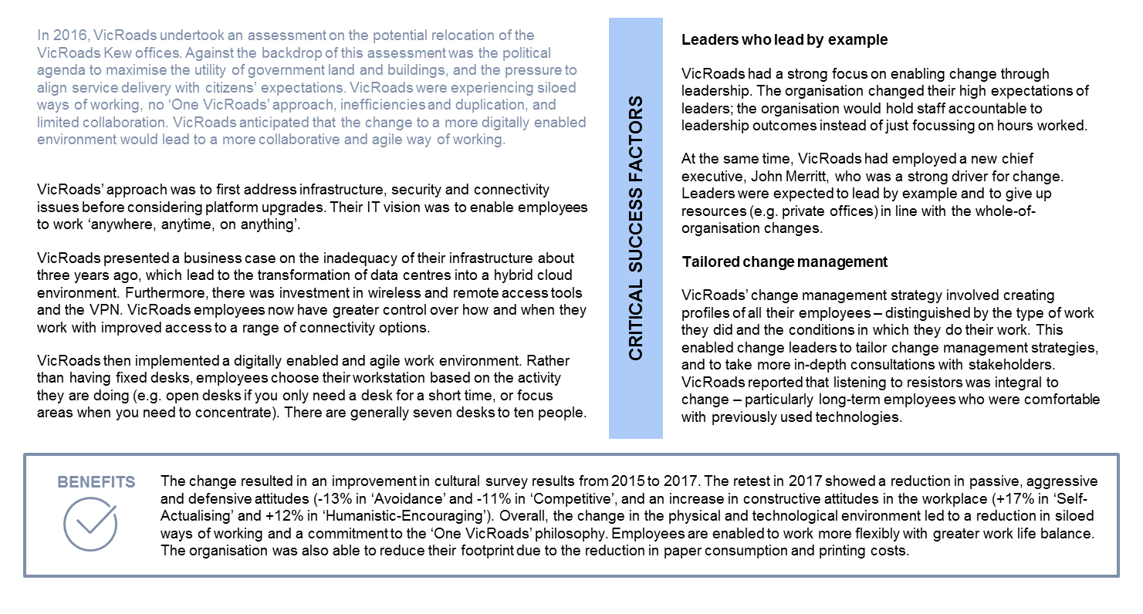

#### National Archives Australia

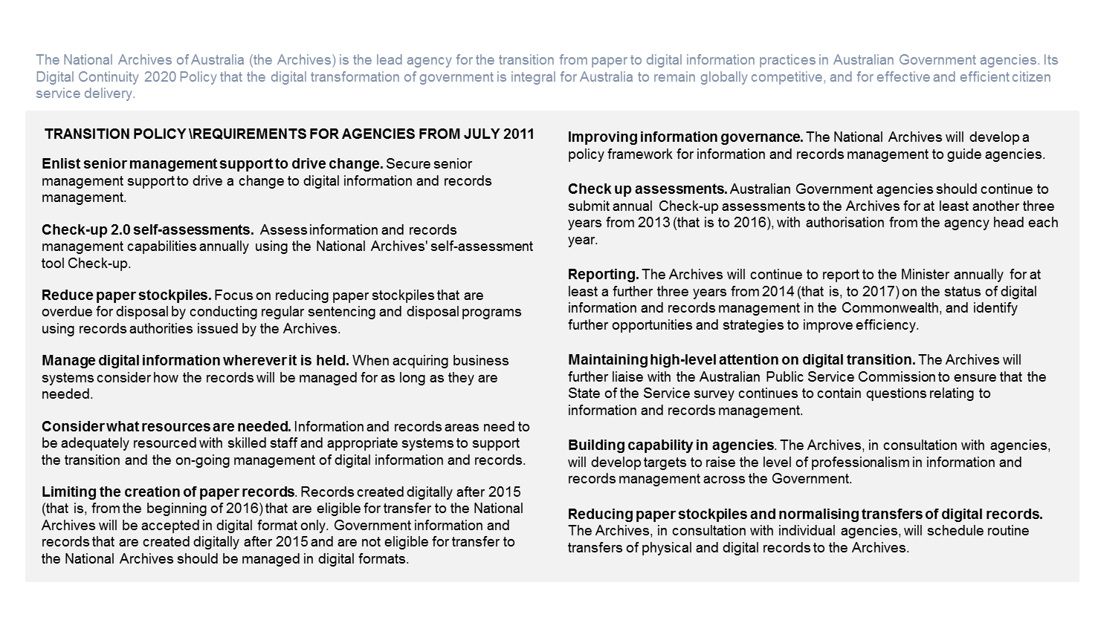

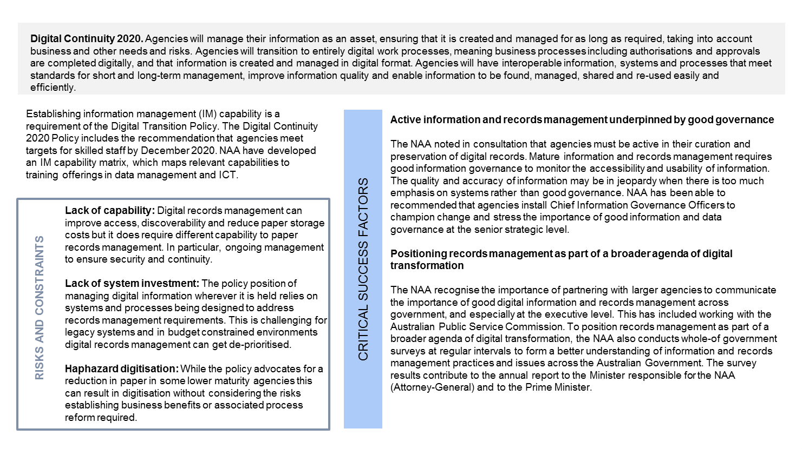

#### Cardinia Shire Council

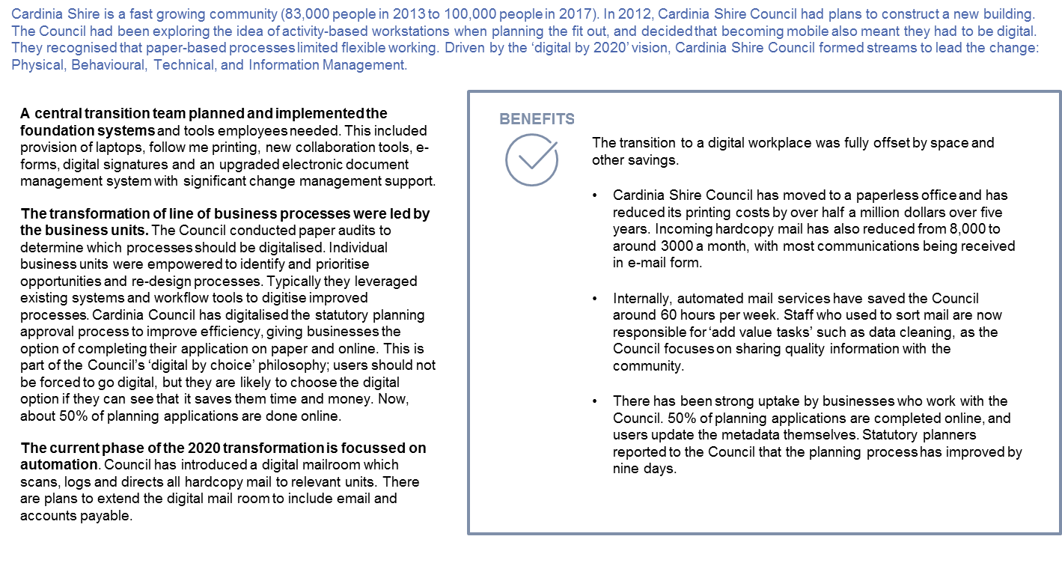

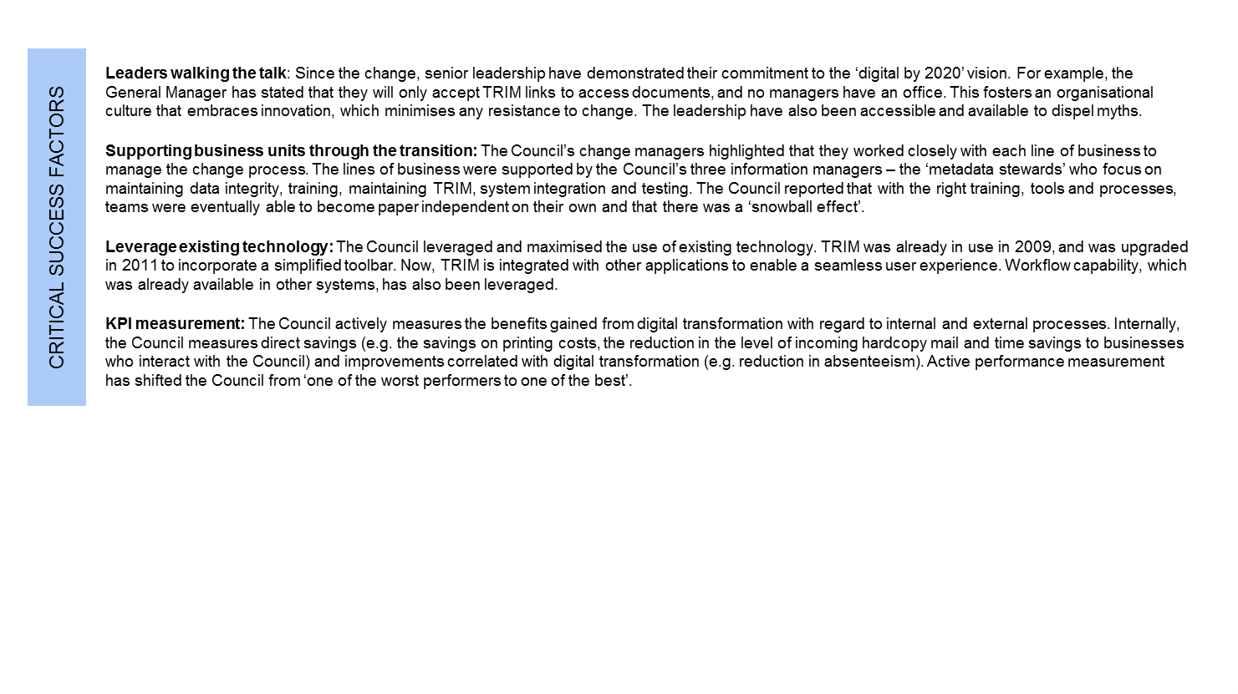

#### Federal Court

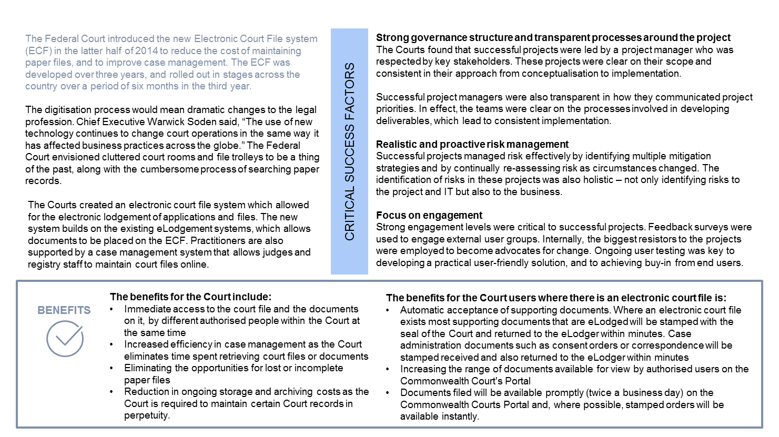

# There are opportunities for Victoria across the organisational framework

We have developed a preliminary list of opportunities by bringing together feedback from staff on their expectations, expert views on the current state of the digital workplace environment and lesson from leaders in mature digital workplaces. There are many elements of the workplace environment SoD that could be accelerated. The three opportunities identified against digital enablers focus on the areas that users identified as most problematic. The opportunities listed in Table 7 will be tested with stakeholders in the development of the strategy.

Table 7: Potential opportunities

|  | POTENTIAL OPPORTUNITIES | RATIONALE |
| --- | --- | --- |
| DIRECTION SETTING | Each department to establish a digital workplace strategy that meets their organisational needs and pain points | Some departments have already developed strategies but coverage is incomplete.  Employees have identified common requirements that should be addressed in department specific strategies, i.e.:   * technology that supports flexibility * digital workplace investments that go-live quickly * leaders who embrace digital opportunities * reliable access and quick trouble shooting support * updates to legacy processes * greater control to choose devices. |
| Set records management policy that supports ‘born digital stay digital’ and ‘managing digital information wherever it is held’ | Engagement with National Archives Australia confirmed that while digital records management may not drive the digitisation agenda it must be acknowledged and planned for as an inevitable consequence of increasing digital processes. Two key policy positions: ‘born digital stay digital’; and ‘managing digital information wherever it is held’ provide strong and clear direction to agencies. In addition, NAA set deadline for agencies to no longer produce hard copy records, and generally no-longer accepts records created digitally after 2015 in hardcopy format. This has resulted in the change in practice across agencies. |
| Apply timing targets to key elements of the workplace environment SoD | Many of the pain points raised by VPS employees are already addressed in the workplace environment SoD but progress against the SoD has been slow. Coupling the SoD with a timing target for agencies may accelerate change. |
| FUNDING | Establish a funding pool that incentivises innovation and change or makes funding available based on achievement of set targets | All departments raised funding as a limitation. Cardinia Council noted that dedicated investment was required but could be offset by increased productivity and space gains.  The WOVG IT strategy has funding attached to it but it has been ear-marked for delivery of strategy initiatives not department implementation.  There may be an opportunity to couple access to digitisation funding with the government’s accommodation strategy and seek to directly offset investment in digital with reductions in accommodations costs. |
| ENABLING ENVIRNONMENT | Leverage the uplift plan to define and develop capabilities in effective digital change management and digital leadership | Victoria has a poor history of technology change management resulting in a low benefit realisation. The development of the uplift plan provides an opportunity to address skill, leadership and cultural gaps. The specific skill requirements need further consideration but should include a focus on process digitalisation. |
| Continue to develop WOVG approaches for common processes (HR, finance, procurement, briefing and correspondence) and consider creating deadlines for briefing and correspondence, HR, Finance SoDs | Out-dated paper processes for common corporate services and paper based-briefing and correspondence processes are clear employee pain points. Work is already underway to develop WOVG approaches in these areas and should continue. Coupling the SoDs with a timing target for agencies may accelerate change. |
| Consider extending digital mailroom across government | Digital mailroom has been adopted in leading organisations and has delivered significant organisational productivity gains. Some agencies have already introduced digital mailroom services but there is potential to extend these across government. |
| Conduct department paper/process audits for high-risk, high-volume and high-value business processes, including identifying the management information needed to support process reform. Plan digitisation and commit to process redesign targets. | To achieve benefits, digitisation must be coupled with process reform. Department paper/process audits for high volume and value business processes could provide a mechanism to accelerate the review of processes. The focus is digitalising processes not retrospective digitisation unless there is a business need to do so. This approach could leverage related work agencies are already doing to identify their critical assets and systems. |
| DIGITAL EN VIRONMENT | Increase user visibility of options and provide employees with greater choice in the selection of devices. | The government already has an End User Computing Equipment (EUC) state purchase contract (SPC) in place. However, the process for accessing the contract at department level could be reviewed to provide users visibility and more direct access to select their preferred devices. Departments would also need to review their device policies to ensure greater choice. |
| Develop WOVG approach to desktop document compliance (records management etc.) that leverages and aligns to the rollout of Microsoft Office 365 | There is a clear opportunity to develop a consistent WOVG approach to digital records management (and general compliance) in the rollout of Microsoft Office 365. This should include automating the application of metadata and movement of records into appropriate repositories making the process invisible to the end user. |
| Review network performance issues and establish remediation project | Network outages in the CBD and low speed network access in regional locations is impacting employee productivity and should be addressed. This may include developing an options paper on network performance. |
| Review remote access technology and approaches | Inability to access core business systems remotely is impacting staff flexibility and productivity. Work underway with departments to identify critical assets and systems could be leveraged to consider how these systems are accessed remotely including moving towards cloud-based applications. |

# Appendix A: Methodology

The study builds on the existing IT strategy and internal and external inputs. Overall this study brings together insights from four key sources to identify real opportunities that can inform the development of the strategy:

* existing strategies and directions across government
* expert opinion from across government to understand the current state
* case studies from existing digital transformations
* employee experiences and existing pain points.

These are outlined in greater detail below.

### Builds on existing strategy and direction

The government has already applied thought and invested in digital transformation. The workplace strategy must be aligned with existing priority areas and leverage the work already underway. As a part of the study, Nous conducted a review of key policy documents and initiatives to understand the current state of digital workplace investment, and the context and aims of these investments.

#### Whole of government initiatives

Table 8: Policy documents

| TITLE | AUTHOR |
| --- | --- |
| **Digital First Discussion Paper**  Digital First focuses on converting the government to a digital workplace by digitally transforming key internal government processes and removing hardcopy from the workplace. It emphasises moving away from paper-based manual processes and recordkeeping. | DPC |
| **Information Management Framework for the Victorian Public Service**  The Information Management Framework provides a high-level view of the Victorian Government’s information management landscape and a shared direction for government and department information management practice. | DPC |
| **Information Management Governance Standard**  The purpose of the Information Management Governance Standard is to define a common approach to information governance within the Victorian Government. | DPC |
| **Cabinet in Confidence and Caretaker Period Digital Information Management**  The Caretaker Period and Cabinet in Confidence Digital Information Management Standard sets out the requirements departments must adhere to in their creation, management and transfer of cabinet in confidence records digitally. | DPC |
| **Information Technology Strategy 2016-2020**  The IT strategy charts the government’s direction over the next four years for open information, digital services, strong modern systems and increased capability. | DPC |
| **Workplace Environment Statement of Direction**  The SoD defines the vision of a digital workplace as being simple, effective, modern and standardised workplace systems that free up public servants to focus on delivering services to Victorians. | DPC |
| **API Strategy for WOVG**  The paper articulates how an API Strategy for the WOVG can enable the sharing of government data between different departments, agencies and other authorised entities. | DPC |
| **Information Technology Strategy Action Plan 2017-18**  The Action Plan details the government’s areas of focus and actions for 2017-18 with regard to information and data reform; digital opportunity; technology reform and capability uplift. | DPC |
| **Automated Briefing and Correspondence Statement of Direction**  The SoD aims to increase the Victorian Government’s productivity through the use of a common briefing and correspondence system combined with a consistent governance model, formats and processes. | DPC |

#### Summary of departmental strategies

Figure 10: Initiatives mud map



#### Contextual research

Table 9: Documents reviewed

| Title | Author |
| --- | --- |
| **Review of government digital records** | Alex Allan |
| **Choice and Convenience Drive ‘Digital First’ Success** | Australia Post |
| **Digitisation Procedure: Using TRIM Records Manager** | Births, Deaths and Marriages |
| **Government Transformation Strategy 2017-2020** | Cabinet Office |
| **Better Information for Better Government** | Cabinet Office (UK Government) |
| **Open Government Data and Why it Matters** | Department of Communications and the Arts |
| **Public Sector Innovation Strategy** | DPC |
| **Information Governance: Current situation analysis and implementation strategy** | Ministry of Economic Affairs and Communications (Republic of Estonia) |
| **Check-Up Digital** | National Archives of Australia |
| **Digital information and records management capability matrix** | National Archives of Australia |
| **Enhancing Victoria’s Economic Performance and Productivity** | Premier’s Jobs and Investment Panel |
| **Digital Disruption: What do governments need to do?** | Productivity Commission |
| **Queensland Government Information Management Policy Framework Definitions** | Queensland Government, Chief Information Officer |
| **Information sharing – Lessons learnt report** | Queensland Government, Chief Information Officer |
| **The application of technology-assisted review to born-digital records transfer, Inquiries and beyond** | The National Archives (UK Government) |
| **Managing Public Sector Records** | Victorian Auditor-General’s Office |

### Informed by expert opinion from across government

Nous undertook consultations with experts from across government to gain insight into the current state of the digital workplace in government. Consultations involved five one-hour workshops with experts from government working in selected areas: information and records management, data management, business process, technologists, citizen engagement.

This assisted Nous to understand the current state of initiatives from across government and the key barriers that need to overcome for digital workplaces initiatives to be successful and deliver on government strategic and policy objectives.

Table 10: Government experts consulted

| Organisation | Organisation |
| --- | --- |
| DEDJTR | Manager, Ministerial and Portfolio Services |
| DEDJTR | Executive Director, Corporate Services Centre |
| DELWP | Information Architect |
| DELWP | Director Strategy, Architecture and Policy |
| DELWP | Raster Data Processing Officer |
| DELWP | Information Architect |
| DELWP | Technology Architect |
| DELWP | Project Manager |
| DELWP | Lead Architect |
| DELWP | Portfolio Management Office Lead |
| DELWP | Online Services Manager |
| DELWP | Manager Business Services, Fishing Business Services |
| DELWP | Adviser - Analytics and Reporting |
| DELWP | Manager, Digital First Communications |
| DET | Manager, Information and Knowledge Systems |
| DET | Manager, Enterprise Platforms |
| DET | Senior Policy Officer, IT Policy & Resource |
| DET | Manager, Infrastructur Engineering |
| DET | Director, Project Services |
| DHHS | Manager, CS BTIM SD Records |
| DHHS | CS BTIM Engagement and Innovation |
| DHHS | CS BTIM SD Architecture |
| DJR | Business Initiative Manager |
| DJR | Systems Administration Officer |
| DJR | Senior Team Lead |
| DJR | Business Analyst |
| DJR | Prison Officer |
| DJR | Solutions Architect |
| DJR | General Manager, Online Strategy and Communication, Transformation & Reform |
| DPC | Manager Information Strategy |
| DPC | Senior Document and Records Advisor |
| DPC | FOI Manager |
| DPC | Principal Advisor, Technology |
| DPC | Acting Chief Information Officer |
| DPC | Principal Advisor, IdAM |
| DPC | ICT Manager |
| DTF | Manager, Information Management |
| DTF | Chief Information Office (stepped down at present due to health reasons) |
| DTF | Project Manager |
| DTF | Manager, Intellectual Property Policy |
| DTF | Acting Chief Information Officer |
| DTF | Project Manager |
| DTF | Executive Services Officer, Cabinet and Parliamentary Services |
| DTF | Manager - Procurement Resource Unit |
| DTF | Manager, Cabinet and Parliamentary Services |
| DTF | Human Resources |
| DTF | Assistant Director, Human Resources |
| DTF | Manager, Communication and Executive Services |
| DTF | Acting Chief Information Officer |
| DTF | Manager, Applications and Delivery |
| Family Violence Victoria | FSV SPR Departmental Systems |
| OVIC | Senior Data Protection Advisor |
| OVIC | Senior Data Protection Advisor |
| PROV | Senior Manager, Government Recordkeeping |
| VicPol | Information Manager Officer |
| VicPol | Data Architect |
| VicPol | Principal Enterprise Architect |
| VicPol | Enterprise Architect Analyst |
| VicPol | Domain Architect - Applications |
| VicPol | Principal Enterprise Architect |
| VicPol | Business Architect |
| Victorian Centre for Data Insights | Senior Policy Officer |

### Inspired by leading practice case studies

Nous conducted desktop research and consultation into best practices related to the digital workplace. The case studies included digital workplace leaders from various levels of government in Australia and overseas. This involved five one-hour interviews with external experts from best practice organisations: Cardinia Shire Council, Courts, NSW Government, National Archives of Australia, VicRoads. These organisations were selected as case studies because of their relevance to the Victorian Government context. Nous also conducted research into international case examples from well-known digital workplace projects.

This assisted Nous to understand the range of possible initiatives that can be applied, the success factors that make these initiatives successful and the outcomes that can be achieved from digital workplace investments.

Table 11: External experts consulted

|  |  |
| --- | --- |
| Organisation | Role |
| Cardinia Shire Council | Corporate Information Team Leader |
| Cardinia Shire Council | EDRMS Support, Development and Education Officer |
| Courts | Nous Director |
| NSW Government | Director, Digital Government |
| National Archives of Australia | Director, Agency Accountability |
| National Archives of Australia | Assistant Director, Government Information Management |
| VicRoads | Director, Corporate Transformation |
| VicRoads | Director, IT Operations |

### Directed to resolving existing employee pain points

Nous conducted empathy-based interviews with seven employees across three different profiles to explore their experiences of the digital workplace, goals and pain points. As shown in the table below.

Table 12: User profile summary

|  |  |
| --- | --- |
| Persona and typical roles | Employee department |
| **Office-based**  EAs, Business support, project officers | DTF, DET, DPC |
| **Flexible worker** Executive, change manager | DJR, DEDJTR |
| **Field-based**  Field officers, case workers | DHHS |

The profiles intended to capture the common needs of key groupings of employees to ensure the small sample size created more helpful and applicable insight. This assisted Nous to understand the immediate experiences, goals and frustrations of employees so that digital workplace initiatives can be directed towards improving the employee experience and assisting with the achievement of employee goals and productivity.

# Glossary

Table 13: Glossary

|  |  |
| --- | --- |
| Term | Definition |
| Application programming interface (API) | An API is code that allows two software programs to communicate with each other. The API defines the correct way for a developer to write a program that requests services from an operating system or other application. |
| Electronic document and records management system (EDRMS) | An EDRMS is an automated software application designed to assist with the creation, management, use, storage and disposal of information and records. An EDRMS may also automate business processes such as workflows and approvals and be integrated with other business systems. |
| Digital mailroom | Digital mailroom is the automation of incoming mail processes using document scanning and document capture technologies. This typically involves digitising incoming mail, and automating the classification and distribution of mail within an organisation. |
| Digital signature | Digital signatures ensure that an electronic document is authentic, meaning that there is transparency around who created the document and subsequent alterations. Digital signatures rely on encryption to ensure authentication. |
| Digitalisation | Digitalisation is the process of moving to digital business practices. It involves using digital technology to change a business model and provide new revenue and value-producing opportunities. |
| Digitisation | Digitisation is the process of converting analog source material into numerical format |
| Information management (IM) | Information management is the collection and management of information from one or more sources and the distribution of that information to one or more audiences. This involves the organisation of and control over the structure, processing and delivery of information. |
| Physical signature | Physical signatures are handwritten depictions of someone’s name, nickname. Physical signatures serve as a proof of identity on documents. |
| Records management | Records management refers to the set of activities required for systematically controlling the creation, distribution, use, maintenance and disposition of recorded information maintained as evidence of business activities and transactions. |

# Document Control

### Approval

This document was approved by the Acting Executive Director, Digital Strategy and Transformation, Department of Premier and Cabinet on 08/02/2018 and applies from the date of issue (see first page).

### Version history

|  |  |  |
| --- | --- | --- |
| Version | Date | Comments |
| 1.0 | 08/02/2018 | Final version |

  
Except for any logos, emblems, trademarks and contents attributed to other parties, the statements of direction, policies and standards of the Victorian Government’s Victorian Secretaries Board or CIO Leadership Group are licensed under the Creative Commons Attribution 4.0 International licence. To view a copy of this licence, visit <https://creativecommons.org/licenses/by/4.0/>.

1. CEDA, More than five million jobs gone in 10 to 15 years, accessed December 2017, <https://www.ceda.com.au/News-and-analysis/Media-releases/More-than-five-million-Aussie-jobs-gone-in-10-to-15-years>
2. Deloitte, The digital workplace: Think, share, do, accessed December 2017, <https://www2.deloitte.com/content/dam/Deloitte/mx/Documents/human-capital/The_digital_workplace.pdf>
3. ibid
4. Ibid.
5. Australia Post, Choice and convenience drive ‘digital first’ success Enterprise & government solutions Insight paper, Nov 2016, accessed December 2017, <https://auspostenterprise.com.au/content/dam/auspost_corp_microsites/enterprise-government/documents/egov-insights-paper.pdf>