

Remuneration bands for  
executives employed in  
prescribed public entities  
(Victoria) Determination No. 01/2020



|  |  |
| --- | --- |
| DETERMINATION | [2020] DPPE 01 |

Victorian Independent Remuneration Tribunal and Improving Parliamentary Standards Act 2019 (Vic)

Part 3—Determination of the remuneration bands for executives employed in prescribed public entities.

Remuneration bands for executives employed in prescribed public entities (Victoria) Determination No. 01/2020



Table of contents

**Part 1 – Legal matters and definitions**

1. Title
2. Effective date
3. Definitions
4. Coverage and application

**Part 2 – Remuneration bands for executives**

1. Values of the remuneration bands
2. Executives whose roles have not been determined using the Public Entity Executive Classification Framework
3. Executives whose roles have been classified using the Public Entity Executive Classification Framework
4. Relevant bands for executives who are employed under Part 3 of the *Public Administration Act 2004* (Vic)

**Statement of Reasons**

Part 1 – Legal matters and definitions

1. **Title:** This Determination is the Remuneration bands for executives employed in prescribed public entities (Victoria) Determination No. 01/2020 and is made under Part 3 of the *Victorian Independent Remuneration Tribunal and Improving Parliamentary Standards Act 2019* (Vic) by the Victorian Independent Remuneration Tribunal.
2. **Effective date:** This Determination takes effect on 20 March 2020.
3. **Definitions**
   1. Terms not defined in this Determination have the same meaning as in the *Public Administration Act 2004* (Vic), unless the contrary intention appears.
   2. In this Determination, unless the contrary intention appears:

**Executive** means an individual to whom the PEER Policy applies under paragraphs 4.1 and 4.2 of the PEER Policy;

**FTE** means Full Time Equivalent;

**PAA** means the *Public Administration Act 2004* (Vic);

**PEECF** means the Victorian Public Entity Executive Classification Framework in relation to Public Entity Senior Executive Service classifications issued by the Victorian Public Sector Commission and available on its website, as amended from time to time;

**PEER Policy** means the Victorian Government Public Entity Executive Remuneration Policy (which is a Schedule to an Order made by the Governor in Council under section 92 of the PAA) as amended from time to time;

**TRP** means total remuneration package, and is the sum of —

1. base salary;
2. superannuation contributions;
3. employment benefits (i.e. non-salary) specified in the executive’s contract of employment; and
4. the annual cost to the employer of providing the non-monetary benefits, including any fringe benefits tax payable —

but for the avoidance of doubt, TRP excludes any bonus opportunity specified in the contract of employment;

Note: the PEER Policy requires that all new or renewed executive contracts entered into from 4 February 2020 must not include a bonus opportunity, subject to an exception for specific roles at Treasury Corporation of Victoria and the Victorian Funds Management Corporation. Refer to the PEER Policy for further information.

**VIRTIPS Act** means the *Victorian Independent Remuneration Tribunal and Improving Parliamentary Standards Act 2019* (Vic).

1. **Coverage and application**
   1. This Determination sets the values of the remuneration bands for executives employed in prescribed public entities.

Part 2 – Remuneration bands for executives

1. **Values of the remuneration bands**
   1. Subject to clause 8, the values of the remuneration bands for executives employed in prescribed public entities are the values set out in table 1.
   2. Clause 6 sets out the relevant band for an executive if the classification of their position **has not** been determined using the PEECF, and Clause 7 sets out the relevant band for an executive if the classification of their position **has** been determined using that Framework.

Table 1: values of remuneration bands for executives employed in prescribed public entities

|  |  |  |
| --- | --- | --- |
| **Classification** | **Base of band TRP(a) $ per annum** | **Top of band TRP $ per annum** |
| Public Entity Senior Executive Service-3 | 360,001 | 479,900 |
| Public Entity Senior Executive Service-2 | 249,701 | 360,000 |
| Public Entity Senior Executive Service-1(b) | 135,000 | 249,700 |

Notes: (a) The values in table 1 are for executives employed on a 1.0 FTE basis, and apply pro rata to executives employed on a part-time basis. (b) Under clause 7.2, when the work value of an executive’s position has been assessed using the PEECF and the position has a work value score of at least 21 points, the executive’s TRP must be no lower than $192,800 per annum (based on 1.0 FTE). Once the work value of executive roles in prescribed public entities has been obtained using the PEECF, the only executives in prescribed public entities with a TRP between $135,000 and $192,799 per annum (based on 1.0 FTE) may be Chief Executive Officers (or equivalent roles) whose position does not meet the minimum work value score required for their classification to be determined under that framework (21 points).

1. **Executives whose roles have not been determined using the Public Entity Executive Classification Framework**
   1. This clause applies to an executive if the classification of their position **has not** been determined using the PEECF. The relevant remuneration band for that executive is:
2. if their TRP (based on 1.0 FTE) immediately prior to the making of this Determination was $360,001 per annum or greater, Public Entity Senior Executive Service-3;
3. if their TRP (based on 1.0 FTE) immediately prior to the making of this Determination was between $249,701 and $360,000 (inclusive) per annum, Public Entity Senior Executive Service-2;
4. if their TRP (based on 1.0 FTE) immediately prior to the making of this Determination was $249,700 per annum or less, Public Entity Senior Executive Service-1.
5. **Executives whose roles have been classified using the Public Entity Executive Classification Framework**
   1. This clause applies to an executive when the classification of their position **has** been determined using the PEECF. Subject to clause 7.2, the relevant remuneration band for that executive corresponds to the Public Entity Senior Executive Service classification of that position determined under that framework.
   2. When the work value of an executive’s position has been assessed using the PEECF and the position has a work value score of at least 21 points, then the executive’s TRP must be no lower than $192,800 per annum (based on 1.0 FTE).
   3. This clause applies to a Chief Executive Officer (or equivalent role if not titled as such) if they have been assessed using the PEECF, and their position does not meet the minimum work value score required for their classification to be determined under that framework (21 points). The relevant remuneration band for that executive is Public Entity Senior Executive Service-1.

Note: In accordance with clause 4.1 of the PEER Policy, a role must have a work value score of at least 21 points under the PEECF for the holder of that role to be considered an executive. However, a Chief Executive Officer (or equivalent role if not titled as such) is considered an executive regardless of the work value score of their role.

1. **Relevant bands for executives who are employed under Part 3 of the *Public Administration Act 2004* (Vic)**
   1. This clause applies to an executive employed in a prescribed public entity under Part 3 of the PAA. For the purposes of this Determination and section 25(4) of the PAA, the relevant remuneration band for that executive corresponds to that which applies to an executive with the same Senior Executive Service or Executive Officer classification, under the latest Determination made by the Victorian Independent Remuneration Tribunal under section 21 or 22 of the VIRTIPS Act.



|  |  |  |
| --- | --- | --- |
| Warren McCann | The Honourable Jennifer Acton | Barbara Belcher AM |
| *Chair* | *Member* | *Member* |
| Victorian Independent Remuneration Tribunal | Victorian Independent Remuneration Tribunal | Victorian Independent Remuneration Tribunal |

Date: 18/12/2020



Remuneration bands for  
executives employed in  
prescribed public entities  
(Victoria) Determination   
No. 01/2020

Statement of Reasons





Contents  


Contents 9

List of figures 10

List of tables and boxes 11

Glossary 13

1 Introduction 15

1.1 Scope of this Determination 16

1.2 Consultation 17

1.3 Data 19

1.4 Structure of this Statement of Reasons 19

2 Context 20

2.1 The Victorian public sector 20

2.2 Types of public entities 24

2.3 Other executive workforce reforms 29

3 Roles of executives 33

3.1 Role of Chief Executive Officers 34

3.2 Roles of subordinate executives 38

3.3 Changing role of executives 40

Summary 44

4 Existing employment and remuneration arrangements 45

4.1 Employment policy 45

4.2 Remuneration policy 46

4.3 Trends in executive remuneration 52

Summary 59

5 Labour market considerations 61

5.1 Impact of regulation 61

5.2 Target skills and experience 62

5.3 Sources of public entity executives 63

5.4 High demand in particular industries 65

5.5 Attraction of executive talent 67

5.6 Retention of executive talent and career intentions 72

5.7 Limitations 73

Summary 74

6 Economic factors 75

6.1 Current and projected economic conditions and trends 75

6.2 Financial position and fiscal strategy of the State of Victoria 78

6.3 Victorian Government remuneration policies 79

7 Tribunal’s considerations 81

7.1 Concurrent executive employment reforms 82

7.2 Structure of remuneration bands 85

7.3 Values of the remuneration bands 91

7.4 The new executive remuneration framework 99

7.5 Conclusion 102

Reference list 105

Appendix A – prescribed public entities by industry segment 107

Appendix B – consultation summary 113

B.1 Chief Executive Officer questionnaire 114

B.2 Subordinate executive questionnaire 129

List of figures

Figure 2.1: overview of the structure of the Victorian public sector 21

Figure 2.2: number of staff (headcount) employed in prescribed public entities across industry segments, as at June 2019 26

Figure 2.3: remuneration bands for executives employed in public service bodies, as at 1 July 2020 32

Figure 3.1: principles supporting public entity CEOs to deliver legislative responsibilities 35

Figure 3.2: general responsibilities of CEOs (or equivalent) in public entities 36

Figure 4.1: principles to guide public entity boards in preparing submissions under the PEER Policy 47

Figure 4.2: distribution of public entity executive TRPs across the new VPS subordinate executive remuneration bands effective 1 July 2020 55

Figure 5.1: prior roles of CEOs and subordinate executives employed in prescribed public entities 64

Figure 5.2: prior roles of CEOs and subordinate executives employed in prescribed public entities by industry segment 65

Figure 5.3: importance of remuneration to decision of executives to apply for their current role 67

Figure 7.1: new remuneration structure for executives employed in prescribed public entities 91

Figure 7.2: remuneration bands for subordinate executives in public service bodies 94

Figure 7.3: summary of the Tribunal’s Determination of remuneration bands for executives employed in prescribed public entities 100

Figure 7.4: summary of how executives will be assigned to remuneration bands under this Determination 101

List of tables and boxes

Box 2.1: extract of the definition of ‘public entity’ under section 5 of the PAA 22

Table 2.1: comparison of key features - public entities and departments 24

Table 2.2: number of prescribed public entities and employed executives in each industry segment, as at 30 June 2020 29

Table 2.3: VPSC ISR Final Report recommendations relevant to this Determination 30

Table 2.4: PEECF classification framework for public entity executives and associated work value scores 31

Table 3.1: summary of core competencies of public entity executives 34

Box 3.1: stakeholder views on the role of a CEO 37

Box 3.2: stakeholder views on the roles of subordinate executives 39

Table 4.1: summary of mandatory contract terms for public entity executives 46

Table 4.2: pre-approved remuneration band structure for CEOs of certain public entities, as at 1 July 2020 48

Table 4.3: cost-sharing arrangement for executive vehicle scheme managed by VicFleet 51

Table 4.4: TRP ranges and average TRP for all reported executives in each industry segment, as at June 2020 52

Table 4.5: changes to the Premier’s guideline rate, all groups CPI Melbourne and all sectors WPI Victoria, 2015-2020 53

Table 4.6: average growth in TRP for same reported roles in 2015 and 2020 54

Box 4.1: stakeholder views on remuneration compression 57

Box 5.1: stakeholder views about the 70/80% rules 62

Box 5.2: stakeholder views about the importance of remuneration to attracting executive talent 69

Box 5.3: stakeholder views about the attraction and retention of staff in regional areas 70

Box 6.1: Victorian Government Wages Policy and Enterprise Bargaining Framework 80

Table 7.1: classification framework for public entity executives and associated work value scores 83

Box 7.1: executives covered by the updated PEER Policy 84

Glossary  


|  |  |
| --- | --- |
| Term or abbreviation | Definition |
| 70/80% rules | Rules in the PEER Policy (as it was prior to the making of this Determination) requiring that the TRP of a subordinate executive in a specified public entity should not:   * exceed 80 per cent of the approved TRP for the CEO of the same public entity, or * result in the average TRP of all the CEO’s direct reports exceeding 70 percent of the CEO’s TRP. |
| AAWI | Average Annualised Wage Increase |
| AO | Administrative Office – a type of Victorian public service body established by the Governor in Council under section 11 of the PAA. |
| ABS | Australian Bureau of Statistics |
| AWOTE | Average Weekly Ordinary Time Earnings |
| CEO | Chief Executive Officer |
| CPI | Consumer Price Index |
| Department | A type of Victorian public service body established by the Governor in Council under section 10 of the PAA. |
| Handbook | Victorian Public Entity Executive Employment Handbook |
| Headcount | The number of people employed in an organisation, whether employed on a full-time, part-time or casual basis. |
| GDP | Gross Domestic Product |
| GSERP | Government Sector Executive Remuneration Panel |
| GSP | Gross State Product |
| PAA | *Public Administration Act 2004* (Vic) |
| PEECF | Public Entity Executive Classification Framework |
| PEER Policy | Victorian Government Public Entity Executive Remuneration Policy |
| Public service bodies | As defined in Part 1 of the PAA*,* public service bodies are:   * Departments * AOs * the VPSC. |
| Public service body Head | As defined in Part 1 of the PAA*,* a public service body Head means:   * in relation to a Department – the Head of that Department * in relation to an AO – the Head of that AO * in relation to the VPSC – the Victorian Public Sector Commissioner. |
| RBA | Reserve Bank of Australia |
| Standard contract | Standard Contract for Public Entity Executives, published by the VPSC. |
| Subordinate executive | A term used in this Statement of Reasons to refer to an executive who is not a CEO (or equivalent). |
| TRP | Total Remuneration Package |
| VIRTIPS Act | *Victorian Independent Remuneration Tribunal and Improving Parliamentary Standards Act 2019* (Vic) |
| VIRTIPS Regulations | *Victorian Independent Remuneration Tribunal and Improving Parliamentary Standards (Prescribed Public Entities) Regulations 2019* (Vic) |
| VPSC | Victorian Public Sector Commission |
| VPS Determination | *Remuneration bands for executives employed in public service bodies (Victoria) Determination No. 01/2020*, made by the Tribunal in May 2020 |
| VPS | Victorian Public Service |
| WPI | Wage Price Index |

1 Introduction  


The *Victorian Independent Remuneration Tribunal and Improving Parliamentary Standards Act 2019* (Vic)(VIRTIPS Act) requires the Tribunal to inquire into and make Determinations in relation to:

* salaries and allowances for Members of the Parliament of Victoria
* remuneration bands for executives employed in public service bodies
* remuneration bands for executives employed in prescribed public entities
* allowances provided to Mayors, Deputy Mayors and Councillors in local government.

In performing its functions and the exercise of its powers, the Tribunal must act independently and impartially and is not subject to the control or direction of any person, including the Minister (s5).

The Tribunal is required to include in a Determination, a Statement of Reasons for the making of this Determination. This Statement of Reasons relates to the Tribunal’s first Determination of remuneration bands for executives employed in prescribed public entities.

The VIRTIPS Act also provides the Tribunal with other functions and powers in relation to public entities:

* issuing guidelines with respect to the placement of executives within the relevant remuneration bands (s6(1)(e))
* at the request of the Minister, inquiring into and determining the remuneration package for a Chief Executive Officer (CEO) employed in a prescribed public entity (s6(1)(f))
* providing advice about requests to approve remuneration for executives which is above the relevant remuneration band (s6(1)(i)).

1.1 Scope of this Determination

Section 19(1) of the VIRTIPS Act requires the Tribunal to make a Determination setting the values of the remuneration bands for executives employed in prescribed public entities. The *Remuneration bands for executives employed in prescribed public entities (Victoria) Determination No. 01/2020* is the first Determination to be made under this section of the Act.

The VIRTIPS Act specifies the matters the Tribunal is required to take into account in making its Determination:

* the roles of executives employed in prescribed public entities and the existing remuneration provided to executives (s19(1)(a))
* any statement or policy issued by the Government of Victoria which is in force with respect to its Wages Policy (or equivalent) and the remuneration and allowances of any specified occupational group (s24(2)(a))
* the financial position and fiscal strategy of the State of Victoria (s24(2)(b))
* current and projected economic conditions and trends (s24(2)(c))
* submissions received in relation to the proposed Determination (s24(2)(d)).

Prescribed public entities are listed in the *Victorian Independent Remuneration Tribunal and Improving Parliamentary Standards (Prescribed Public Entities) Regulations 2019* (Vic) (VIRTIPS Regulations).

At the time of making this Determination, there are 139 entities prescribed, including water corporations, catchment management authorities, TAFE institutes, sports and facilities management entities and regulators. Based on the latest available data as at 30 June 2020, these entities employ around 750 executives who will be in scope of this Determination, including CEOs (or equivalent).0F[1] Appendix A lists these prescribed public entities organised by industry segment.

This Determination sets the framework for an executive’s remuneration based on their relevant band. This Determination works in conjunction with the Public Entity Executive Classification Framework (PEECF) developed by the Victorian Public Sector Commission (VPSC), and the Victorian Government’s Public Entity Executive Remuneration Policy (PEER Policy). The PEER Policy defines which individuals employed in prescribed public entities are considered to be executives and are in scope of this Determination. In addition, the PEER Policy stipulates that:

* executives in prescribed public entities must be paid within the relevant remuneration band set in this Determination
* the remuneration paid to an executive may exceed the maximum of the relevant remuneration band only if the employer of the executive has obtained the advice of the Tribunal under section 37 of the VIRTIPS Act.

There are some executives in prescribed public entities who are employed under Part 3 of the *Public Administration Act* *2004* (Vic) (PAA), which means that they have historically been covered by Victorian public service employment and remuneration policies.

The Tribunal has made Prescribed Public Entity Executive Remuneration Guidelines with respect to the placement of executives within the remuneration bands (s36(6)(a) of the VIRTIPS Act). This Determination should be read together with these Guidelines which are available on the Tribunal’s website.

1.2 Consultation

Pursuant to section 24(1) of the VIRTIPS Act, and before making this Determination, the Tribunal:

* published a notice of its intention to make a Determination on its website, including details about the proposed Determination
* gave any affected person or a class of affected persons a reasonable opportunity to make a submission in relation to the proposed Determination.

The Tribunal also published a summary of the matters being considered by the Tribunal on its website to assist interested parties in making a submission.

To inform this Determination, the Tribunal:

* distributed an online questionnaire to executives employed in public entities, with responses anonymised
* invited written and oral submissions from affected and interested parties
* held round table discussions with nominated representatives of prescribed public entities.

A summary of questionnaire responses is available at appendix B.

The Tribunal expresses its appreciation to all those who made submissions and assisted the Tribunal in the performance of its functions.

Questionnaire

Early in 2020, the Tribunal invited executives employed in prescribed public entities to make an anonymous submission via an online questionnaire. The questionnaire helped the Tribunal understand the nature of executive roles, the motivations of executives moving into executive employment and how current remuneration arrangements could be improved. The Tribunal received around 170 responses to the questionnaire.

Written and oral submissions

The Tribunal also invited Board Chairs (or equivalent) of all prescribed public entities to make a submission with respect to the proposed Determination on behalf of their organisation. The Tribunal received 31 written submissions from Board Chairs, Managing Directors and CEOs and heard three oral submissions from representatives of public entities.

Written submissions, where permission was granted to publish, and agreed summaries of the oral submissions, are available on the Tribunal’s website.

Submissions cited by the Tribunal in this Statement of Reasons have not been corrected for publication, other than to make the meaning clear, and do not necessarily represent the views of the Tribunal.

Round table discussions

In June 2020, the Tribunal held a series of virtual round table discussions with Board Chairs and CEOs of public entities nominated by their relevant portfolio departmental Secretary.

The round tables sought feedback from entities regarding options for the remuneration structure for executives employed in prescribed public entities. Around 45 representatives from a range of public entities across industry segments attended the round tables, which were held over six sessions.

1.3 Data

This Determination and Statement of Reasons draws extensively on the VPSC’s public sector workforce data collection. This Determination and Statement of Reasons refer to workforce data for executives employed in prescribed public entities collected as at 30 June 2020. Other workforce data, such as employee numbers in public entities, was reported as at 30 June 2019.

Historic data referring to public entity executives should be treated with caution as:

* the definition of who is considered a public entity executive for reporting purposes has changed over time1F[2]
* public entities have discretion in reporting to the VPSC on which of their staff have significant management responsibility, and this affects whether they may have been considered to be an executive for data collection purposes.[3]

The Tribunal has also drawn on Victorian public sector enterprise agreements, and data provided by the Commonwealth Attorney-General’s Department from the Workplace Agreements Database, to inform its analysis relating to non-executive remuneration in public entities.

1.4 Structure of this Statement of Reasons

The remainder of this Statement of Reasons reflects the requirements of the VIRTIPS Act. Chapter 2 provides an overview of the structure of the Victorian public sector and places this Determination within the context of broader public entity executive workforce reforms recently completed or underway. Chapters 3 to 5 provide contextual information about the roles and responsibilities of executives, trends in prescribed public entity executive remuneration and the employment and remuneration framework in place prior to this Determination. Chapter 6 details the economic considerations relevant to this Determination. Chapter 7 details the Tribunal’s considerations in determining the structure and values of the remuneration bands.

2 Context  


The State of Victoria has a highly devolved system of public administration, relying on many public entities to deliver essential services and functions.3F[4]

This chapter provides contextual information relevant to this Determination, focusing on:

* an overview of the Victorian public sector, and the role of public entities within the sector
* the types of public entities covered by this Determination
* other executive workforce reforms across the public sector.

2.1 The Victorian public sector

Victoria has experienced significant population growth over the last four years.[5] Over this same period, government expenditure on service delivery and infrastructure has increased. The government’s budgeted output expenditure, which relates to the delivery of services such as education, health, public order and transport, was approximately $90 billion for the 2020-21 financial year.5F[6] This is around 67 per cent higher than for the 2015-16 financial year.6F[7]

The Victorian public sector supports the government of the day to serve the Victorian community and is divided into two core groups, the Victorian public service (VPS) and public entities (figure 2.1).

Figure 2.1: overview of the structure of the Victorian public sector

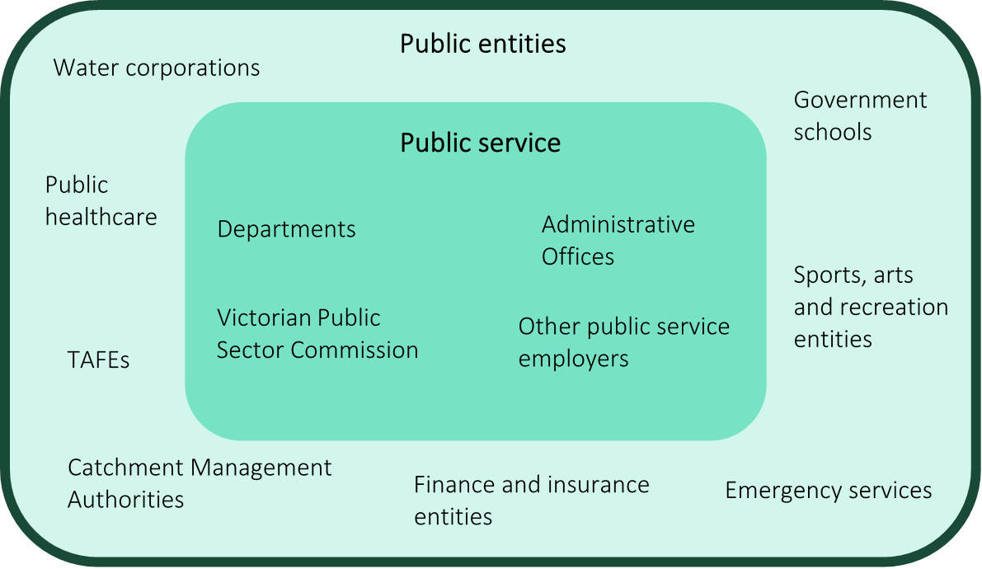Source: adapted from VPSC, ‘The Victorian Public Sector’, <https://vpsc.vic.gov.au/about-public-sector/the-victorian-public-sector/>.

The VPS comprises departments, Administrative Offices (AOs), the VPSC and other public service employers. Departments are the primary policy advisers and program administrators for Ministers of the Crown, including advice in relation to public entities in their portfolio. As at 30 June 2019, the VPS employed around 50,400 staff, including approximately 1,300 executives.

Public entities are statutory authorities, state owned corporations and advisory bodies established outside the public service in order to perform defined public functions such as:

* providing essential services such as health, education and water
* managing significant public assets
* regulating industries and professional groups
* providing specialist advice to the government of the day.[8]

The legal definition of a ‘public entity’ under the PAA is complex. A key threshold for determining if an organisation is a public entity is whether it satisfies at least one of the following:

* has a public function to exercise on behalf of the State
* is wholly owned by the State.

Several types of bodies are excluded from being categorised as public entities, for example, a Royal Commission (box 2.1).

Box 2.1: extract of the definition of ‘public entity’ under section 5 of the PAA

Source: PAA, s5.

(1) For the purposes of this Act a public entity is a body, whether corporate or unincorporated—

(a) that is established—

(i) by or under an Act (other than a private Act) or the Corporations Act; or

(ii) by the Governor in Council; or

(iii) by a Minister; and

(b) in the case of a body corporate, the right to appoint at least one half of the directors of which is vested in the Governor in Council or a Minister or could have been so vested in the case of a body corporate established by an Order made by the Governor in Council or a Minister under the power given by the Act under which the Order is made; and

(c) that has a public function to exercise on behalf of the State or is wholly owned by the State; and

(d) in the case of a body that does not have any function to exercise other than the provision of advice or a report to any person or body—

(i) has written terms of reference guiding its operation; and

(ii) is required to provide the advice or report to a Minister or the Government; and

(iii) is declared to be a public entity for the purposes of this Act—

(A) by the Act or subordinate instrument or other document under which it is established; or

(B) by an Order under subsection (3)—

but does not include—

(da) a Department or an Administrative Office; or

(e) an exempt body; or

(f) a special body in its capacity as a special body; or

(fa) a Royal Commission, Board of Inquiry or Formal Review; or

(g) a registered community health centre within the meaning of the Health Services Act 1988 or a body that provides aged care services that is, or is capable of being, registered under that Act; or

(h) a body, or a class of body, that is declared by an Order under subsection (2) not to be a public entity for the purposes of this Act.

(1A) To avoid doubt and without limiting subsection (1), the following are public entities for the purposes of this Act—

(a) a TAFE institute within the meaning of the Education and Training Reform Act 2006;

(b) AMES within the meaning of the Education and Training Reform Act 2006.

Public entities may be established using a number of legal forms, depending on factors such as the functions of the entity and the degree of ministerial control required.8F[9] For example, some public entities are:

* established under their own bespoke legislation (e.g. Dairy Food Safety Victoria), or under sector specific legislation (e.g. water corporations)
* incorporated under legislation that is not sector specific, such as the *State Owned Enterprises Act 1992* (Vic) (e.g. the Victorian Asbestos Eradication Agency) or the *Corporations Act 2001* (Cth) (e.g. Melbourne Recital Centre)
* non-statutory advisory bodies that are established by a Minister or the Governor in Council (in general, these public entities do not employ staff).

Unlike departments, public entities operate at an ‘arm’s length’ from government and perform their functions with varying degrees of autonomy. This may be desirable where it is determined that a particular function (e.g. delivery of a service) does not require a high degree of oversight by the relevant Minister, where the government will be bound by the decisions of the organisation, or because the organisation is established to scrutinise government actions.[10] In some cases, this independence provides scope for enhanced local involvement in decision-making and responsiveness to the local community and instils greater public confidence (especially for integrity, regulatory or quasi-judicial functions).[11]

A significant difference between public service bodies and public entities can be their source of funding. Some Victorian public entities do not receive any government funding or receive only minimal funding. These entities may therefore rely on the commercial acumen of their workforce to meet their objectives.

Table 2.1 summarises how departments and public entities differ across a range of key attributes.

Table 2.1: comparison of key features - public entities and departments

| Feature | Public entity | Department |
| --- | --- | --- |
| Legal form | Many possible forms, including both unincorporated and incorporated bodies. Generally have separate legal status to the Crown. | Part of Crown. No separate legal identity. |
| Establishment mechanisms | Many possible mechanisms, including ministerial direction, specific legislation, *State Owned Enterprises Act 1992* (Vic). | Order in Council under s10 of the *Public Administration Act 2004* (Vic). |
| Governance structure and relationship with Minister | Typically has a governing Board appointed by the Minister. Degree of ministerial control varies. Minister’s powers of direction usually identified in enabling or umbrella legislation. | Secretary appointed by the Premier and responsible to their Minister(s). Minister has high level of direction and control. |
| Financial arrangements | Various sources of funding, including appropriation by the monitoring department, commercial revenue, fees, fines and levies. | Direct appropriation from Parliament. |
| Employment arrangements | Typically, executives employed under contracts and other public sector staff employed under various public sector awards and agreements. | Executives employed under contracts and other public service staff employed under  an enterprise agreement. |
| Functions | Provide a wide range of functions at arm’s length from Ministers, including service delivery, commercial activities and stewardship of public assets. | Provide strategic policy advice to Ministers. Implement government policy. Provide a range of service delivery, regulatory and other functions. |

Source: adapted from VPSC, *Legal Form and Governance Arrangements for Public Entities* (State Government of Victoria: Melbourne, Victoria, May 2013).

2.2 Types of public entities

At 30 June 2019, there were around 1,680 public entities across Victoria, employing nearly 273,000 people.[12] Public entity employees account for around 84 per cent of the public sector workforce (with VPS employees making up the remaining 16 per cent).

At the time of making this Determination, there are 139 public entities prescribed in the VIRTIPS Regulations. Non-prescribed entities include significant employers such as public schools, public hospitals and Ambulance Victoria.[13]

As at 30 June 2019, around 38,000 employees were employed in prescribed public entities (excluding employees employed under Part 3 of the PAA).12F[14]

Based on the latest data available from the VPSC, prescribed public entities employed approximately 750 executives as at 30 June 2020 (excluding executives employed under Part 3 of the PAA).

In 2018, the VPSC released its *Executive Workforce Reform – Industry Segment Reviews: Final Report* (ISR Final Report), summarising a program of reviews into executive employment and remuneration arrangements in public entities. The VPSC’s review grouped public entities by the following ‘industry segments’:

* emergency services
* finance and insurance
* public healthcare
* regulators and other agencies
* sport, recreation, arts and facilities management
* TAFE and other education
* transport, construction and infrastructure
* water and land management.

For ease of reference, the Tribunal has used the same categorisation of industry segments for the purposes of this Statement of Reasons. A list of entities categorised in these industry segments is at appendix A.

The largest industry segments are ‘TAFE and other education’ and ‘water and land management’, which employ 28 and 25 per cent of prescribed public entity employees, respectively (figure 2.2).13F[15]

Figure 2.2: number of staff (headcount) employed in prescribed public entities across industry segments, as at June 2019

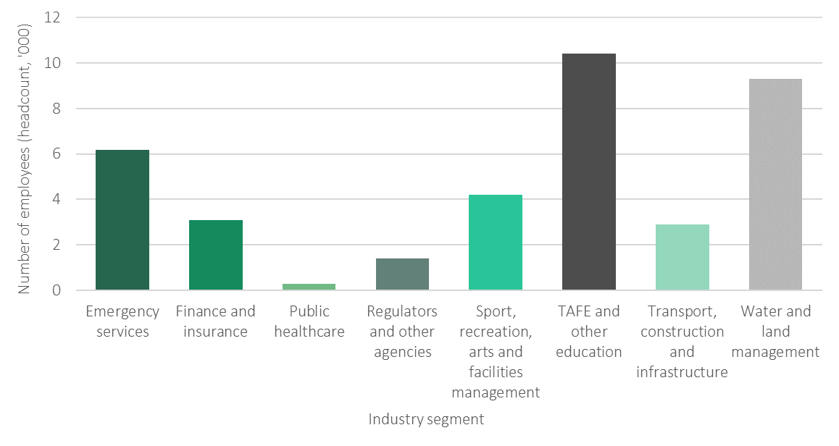

Note: excludes employees employed under Part 3 of the PAA.

Source: VPSC, *The State of the Public Sector in Victoria 2018-2019*.

Prescribed public entities range from small waste management agencies and cemetery trusts with few employees, to large financial and event management organisations responsible for billions of dollars in assets and hundreds of employees. A brief description of each industry segment is set out below.

Emergency services

The following emergency service entities are within the scope of this Determination:

* Country Fire Authority
* Fire Rescue Victoria14F[16]
* Victoria State Emergency Service
* Emergency Services Telecommunications Authority.

The Country Fire Authority, Fire Rescue Victoria and Victoria State Emergency Service provide fire, rescue and emergency response services for Victorians.

The Emergency Services Telecommunications Authority provides 24-hour emergency call-taking and dispatch services for police, fire, ambulance and the Victoria State Emergency Service. It also manages the provision of advanced, operational communications for Victoria’s emergency services.

Finance and insurance

There are seven entities in this industry segment:

* The Emergency Services Superannuation Board is a not-for-profit superannuation fund serving Victorian emergency services and State employees.
* State Trustees Limited serves as the State's public trustee, providing administration, trustee and estate related services.
* The Transport Accident Commission provides insurance for those who have been injured on Victoria's roads.
* The Treasury Corporation of Victoria is the central financing authority and financial adviser for the State, serving as the interface between the State and wholesale financial markets.
* The Victorian Funds Management Corporation provides asset management and investment services to Victorian public authorities.
* The Victorian Managed Insurance Authority is the Victorian Government's insurer and risk adviser.
* The Victorian WorkCover Authority is the State’s health and safety regulator and manages Victoria’s workers compensation scheme.

Public healthcare

Public healthcare entities within the scope of this Determination provide coordinated, state-wide monitoring and regulation services. For example, BreastScreen Victoria is a central point of information regarding breast health in Victoria, while Health Purchasing Victoria partners with Victoria’s public health services to procure best-value goods and services.

The majority of executives employed in public healthcare entities in Victoria, in particular, public hospitals, are not covered by this Determination. These executives are covered by other arrangements in place under the *Health Services Act 1988* (Vic).

Regulators and other agencies

This industry segment comprises regulators (e.g. PrimeSafe), cemetery trusts and several other specialised agencies (e.g. VITS LanguageLoop and the Accident Compensation Conciliation Service).

Sport, recreation, arts and facilities management

Entities in this industry segment manage and maintain government owned cultural, tourism, sporting and entertainment facilities and/or administer events. For example, Kardinia Park Stadium Trust is responsible for the maintenance and management of the Kardinia Park precinct in Geelong, while the Australian Grand Prix Corporation is responsible for staging the Formula 1 Australian Grand Prix and Australian Motorcycle Grand Prix.

TAFE and other education

Entities in the TAFE and other education segment are responsible for delivering a wide range of education, migrant support, regulatory and sector development functions.

Transport, construction and infrastructure

Entities in the transport, construction and infrastructure industry segments are responsible for the management, maintenance and delivery of transport and infrastructure projects across Victoria. Entities covered by this segment include the Victorian Rail Track Corporation which owns Victoria’s transport land, assets and infrastructure, and the Victorian Regional Channels Authority which is responsible for aspects of channel management in Geelong (among other functions).

Water and land management

Entities in the water and land management industry segment are responsible for delivering a range of services related to water, waste recovery and land. Entities range in size from state-wide management of parks and forests (such as Parks Victoria) to water providers (e.g. Barwon Region Water Corporation and South East Water Corporation), local, regional waste services (e.g. Gippsland Waste and Resource Recovery Group) and alpine resort management.

Table 2.2 summarises the number of prescribed entities, and the number of executives they employ, in each segment, as at 30 June 2020. The water and land management industry segment employs the greatest number of executives within scope of this Determination.

Table 2.2: number of prescribed public entities and employed executives in each industry segment, as at 30 June 2020

|  |  |  |
| --- | --- | --- |
| Industry segment | Number of prescribed entities | Number of executives, as at 30 June 2020 |
| Emergency services | 4 | 67 |
| Finance and insurance | 7 | 109 |
| Public healthcare | 4 | 13 |
| Regulators and other agencies | 28 | 52 |
| Sport, recreation, arts and facilities management | 23 | 82 |
| TAFE and other education | 15 | 83 |
| Transport, construction and infrastructure | 7 | 115 |
| Water and land management | 51 | 225 |

Source: VPSC, public entity executive workforce data collection, 2020; VPSC, *Executive Workforce Reform – Industry Segment Reviews: Final Report*.

2.3 Other executive workforce reforms

This Determination takes into account broader public sector executive workforce reforms recommended in the VPSC’s ISR Final Report.

In its ISR Final Report, the VPSC noted that:15F[17]

… governance arrangements for executive employment and remuneration in public entities are distributed, inconsistent, and confusing.

Furthermore, the report found that the existing arrangements exposed the Victorian Government and employers to financial, integrity and employment risks.[18] Table 2.3 summarises the recommendations of the review that were considered by the Tribunal as part of making this Determination.

Table 2.3: VPSC ISR Final Report recommendations relevant to this Determination

|  |
| --- |
| **VPSC recommendations** |
| The Special Minister of State to request that the Tribunal consider:   * aligning executive remuneration levels between the VPS and public entities * abolishing existing industry segment-specific public entity remuneration bands (where these exist) and replacing them with a common band structure for all public entity executives. An individual public entity should remain bound by the existing remuneration bands until such time as the Tribunal has determined new remuneration bands for that public entity. |
| The new VPS Classification Framework be refined to ensure that it is fit-for-purpose for the broader public sector and can inform the development of new remuneration bands for public entity executives. |
| Percentage rules for subordinate executives be abolished, affirming CEO responsibility for determining subordinate remuneration within the limits of the Tribunal’s remuneration determination. |

Source: adapted from VPSC, *Executive Workforce Reform – Industry Segment Reviews: Final Report*.

Public entity executive classification framework

In 2018, the Premier of Victoria requested that the VPSC develop classification and performance management frameworks for public entity executives.

The VPSC issued a draft PEECF in December 2019, and it was finalised in late 2020. The framework closely aligns with the classification framework developed by the VPSC for classifying VPS executive roles. Key elements of the classification framework include:

* the introduction of a three-tier public entity executive classification band structure, where Public Entity Senior Executive Service Band 1 (PESES-1) is the lowest band and Public Entity Senior Executive Service Band 3 (PESES-3) is the highest band)
* a methodology for evaluating the degree of complexity and responsibility associated with a role to support an assessment of where it sits within the band structure.

The classification band to which an executive role is assigned is determined by a work value score for that role. Work value scores are calculated by assessing each executive role against eight competencies, with the methodology providing for a score of 1, 3, 5 or 7 against each competency. The final tally is the work value score. The classification bands and associated work value score ranges are summarised in table 2.4.

Table 2.4: PEECF classification framework for public entity executives and associated work value scores

|  |  |
| --- | --- |
| Band | Work value score range |
| PESES-1 | 21 to 35 |
| PESES-2 | 36 to 47 |
| PESES-3 | 48 to 56 |

Source: PEECF.

Determination of remuneration bands for executives employed in public service bodies

The ISR Final Report recommended that the Tribunal consider aligning remuneration arrangements across the VPS and public entities.

The Tribunal made the first *Remuneration bands for executives employed in public service bodies (Victoria) Determination No. 01/2020* (VPS Determination) in May 2020.

This Determination applied to executives employed by departments, AOs and the VPSC, and set a new executive remuneration framework consisting of:

* three distinct and contiguous bands for subordinate executives
* three distinct and contiguous bands for AO Heads aligned to the subordinate executive bands
* a single band for the remuneration of Secretaries and the VPSC Commissioner.

The remuneration bands for executives employed in public service bodies as at 1 July 2020 are set out in figure 2.3.

Figure 2.3: remuneration bands for executives employed in public service bodies, as at 1 July 2020

Secretaries and the VPSC Commissioner placed into this band

**Secretary/VPSC Commissioner  
$360,001-$479,900**

**SES-1  
$192,800-$249,700**

**SES-2  
$249,701-$360,000**

**SES-3  
$360,001-$479,900**

All subordinate executives placed into these bands

**AO Head 1  
$192,800-$249,700**

**AO Head 2  
$249,701-$360,000**

**AO Head 3  
$360,001-$479,900**

AO Heads placed into these bands

Source: adapted from VPS Determination.

Bonus removal and buy-out offers

Another key recommendation of the VPSC’s review was the removal of bonus opportunities from public entity executive contracts, which the Premier subsequently agreed to implement. In February 2020, an updated PEER Policy was issued by the Governor in Council. This required that all new contracts — both new appointments and re-appointments — for public entity executives entered into on, or after, 4 February 2020 must not include a bonus opportunity. In addition, public entity executives employed before 4 February 2020 who had a bonus opportunity in their contract had to be provided with an offer to ‘buy out’ the bonus opportunity.

The bonus buy-out offer for executives was not mandatory. As such, some existing public entity executives may retain a bonus opportunity until the expiry of their contract.

Specific roles at the Treasury Corporation of Victoria and the Victorian Funds Management Corporation, as determined by the Premier and the responsible Minister, may continue to be eligible for bonus opportunities.

For the purposes of this Determination, bonus opportunities are not considered part of an executive’s total remuneration package (TRP).

3 Roles of executives  


The Tribunal is required to consider the roles of executives employed in prescribed public entities (s19(1)(a) of the VIRTIPS Act). Generally speaking, the remuneration paid for a given role reflects factors such as the knowledge and skills required for the role, the level of risk and the span of its responsibilities.

This chapter discusses the roles and responsibilities of public entity CEOs and their subordinate executives, drawing on the Tribunal’s consultations and research.

Public entity executives are senior leaders responsible for delivering the objectives of their organisation. Executive roles involve the management of significant risks. For example, executives may be directly responsible for the personal safety of patrons, clients, customers, members of the general public and/or their organisation’s staff.

Executives must also uphold and demonstrate the values of the VPS Code of Conduct and support their staff to achieve high performance across the public sector.17F[19] The VPSC’s PEECF notes that executive roles generally require eight core competencies (table 3.1).

Table 3.1: summary of core competencies of public entity executives

| Competency | Definition |
| --- | --- |
| Knowledge | level of required knowledge; skills and expertise; proficiency in a specialised discipline; level of authority; depth of understanding of the work environment. |
| Relationships | requirement to influence and negotiate; interact with internal and external stakeholders; level of sensitivity and complexity of issues and interactions. |
| Judgement and risk | level of required judgement and degree of ambiguity inherent in the role; degree to which role must consider alternative courses of action; level of risk to be mitigated. |
| Independence | requirement to make decisions without support; authority and freedom to plan objectives; requirement to contribute to or lead whole of entity strategic direction. |
| Strategic change | extent of responsibility for significant strategic change management or reform agenda; contribution to business improvement; impact and complexity of change. |
| Impact | scope of role’s impact within an organisation, into the sector, across state, national or international impact. |
| Breadth | diversity of activities; geographical breadth of responsibility; variety of products and services to be managed by the role. |
| Resource management | number of staff and size of resources and budget. |

Source: PEECF.

3.1 Role of Chief Executive Officers

Each public entity covered by this Determination is headed by a CEO or equivalent (e.g. Managing Director). CEOs are employed by the entity’s governing body (typically a board), usually under employment contracts of up to five years.

The board of a public entity is accountable to its responsible Minister for the exercise of its functions. The powers and functions of a public entity are typically conferred through an entity’s enabling legislation. The powers are then delegated by the board to a CEO and senior staff. The CEO is accountable to their board for the overall performance of the entity, including outcomes and behaviour.18F[20]

The VPSC’s *Serving Victoria: Guide for public sector CEOs,* identifies four core principles to support CEOs in the delivery of their legislative obligations. These principles underpin and inform all actions and decisions undertaken by public entity CEOs (figure 3.1).

Figure 3.1: principles supporting public entity CEOs to deliver legislative responsibilities

**CEOs must act…**

rather than competitively, towards other public sector organisations, and delegate responsibility to others within the entity so as to maximise efficiency and effectiveness

collaboratively

to adapt themselves and their entity as circumstances require

flexibly

of responsiveness, integrity, impartiality, accountability, respect and the application of human rights to their work and the work of others within the entity

with public sector values

with prudence

by carefully considering all decisions and being transparent regarding the process and rationale behind any decisions taken

Source: VPSC, *Serving Victoria: A Guide for Public Sector CEOs.*

Functions of a public entity CEO (or equivalent)

According to the VPSC, a public entity CEO is the ‘operational arm’ of the board. They are responsible for the everyday management of the entity.

In fulfilling the core aspects of their role, public entity CEOs have some common responsibilities, including managing the entity’s workforce, finances and assets, setting strategies to deliver the board’s priorities and managing compliance with legislation (including the entity’s enabling legislation), government policies and financial reporting requirements (figure 3.2).

Figure 3.2: general responsibilities of CEOs (or equivalent) in public entities

Source: adapted from VPSC, *Serving Victoria: A Guide for Public Sector CEOs*.

establishing and revising the way the entity is designed to ensure effective and efficient delivery of outcomes

managing compliance and reporting

delivering organisational impact

establishing a productive workplace culture

establishing and delivering plans that detail how the entity’s vision will lead to tangible outcomes

supporting the board in articulating and promoting the entity’s vision



setting strategies to deliver the board’s priorities and meet entity obligations

leading and managing the entity’s workforce

providing authoritative advice to the board, Minister, department, entity staff and stakeholders

identifying and managing risk

managing the entity’s finances and assets

establishing and managing relationships (together with the board) with other organisations

establishing and managing the entity’s reputation

Those fulfilling the role of CEO in a prescribed public entity may have a significant public profile. In particular, this may be the case for CEOs working in regionally based entities.19F[21] For example, Grampians Wimmera Mallee Water Corporation (GWMWater) submitted:

In the case of more remote Water Corporations it is important to recognise that incumbents in executive roles, including Managing Directors are relatively speaking very public.

They work in and live in communities that are much smaller than would be the case in larger provincial centres or in the Melbourne and Geelong metropolitan area. Consequently they spend a lot of time out of hours dealing with relevant interactions with individual community members or with larger community groups. [p.2]

Box 3.1 sets out some other comments from submissions on the roles played by a CEO.

Box 3.1: stakeholder views on the role of a CEO

Source: written submissions.

**TAFE Gippsland**

The competency requirements differ in environments where CEOs are deemed to be prominent public entity identities within regional and local communities. The complexities of the role including public relations, stakeholder engagement, industry liaison, security differing revenue streams including regulated, commercial and government funding, community and regional representation as well as community and stakeholder support agency, adds a higher level of expertise and experience requirements than is required in metropolitan appointments. [p.2]

**Shrine of Remembrance Trust**

The CEO is responsible to the Board for the day to day operation of all aspects of the Shrine and ensuring that the key accountabilities of Stewardship and Commemoration are met. [p.1]

**North East Waste and Recovery Group**

To be successful in the role our EO is required to perform a wide breadth of management including developing strategy, business planning, corporate governance, financial management, people leadership, stakeholder management and operational delivery. [p.2]

Depending on the industry segment, needs of the entity and the environment it operates in, CEOs may have specific requirements or face challenges in fulfilling their roles, for example:

* responding and adapting to climate change is a focus for some entities across the water and land management entities20F[22]
* TAFEs and other education institutions must establish and maintain relationships across industries to supplement and support students undertaking vocational training21F[23]
* smaller, regional entities that operate over significant geographical areas may face challenges in managing resources or staff required to fulfil the entity’s obligations efficiently and effectively22F[24]
* entities within the sport, arts and facilities management industry segment may compete globally and domestically to attract events, shows, exhibitions and conventions to Victoria.23F[25]

Some public entities have a Managing Director instead of a CEO. As explained in the submission from GWMWater, this changes the requirements of the role as Managing Directors:

… have the added role and responsibility of being a Director on the Board of the Corporation and this, added or different role is significant in terms of governance, corporate decision making and the strategic operation of the Board. [p.2]

3.2 Roles of subordinate executives

CEOs employ subordinate executives to contribute to the delivery of the government’s objectives for their organisations.24F[26] The duties of individual executives vary from entity to entity and between industry segments.

Generally speaking, the PEECF sets out the responsibilities of subordinate executives as:25F

* implementing a strategic direction for their area
* providing leadership and contributing to the improvement of their area by deciding how goals will be achieved and priorities set
* providing authoritative advice to their CEO
* managing close liaison and effective relationships with stakeholders
* ensuring compliance with legislation, directives, policies, regulations and processes
* managing and mitigating risk for their area of responsibility.

In addition, subordinate executives may also be responsible for managing teams of employees and carrying out other managerial tasks, including human resource functions, information technology operations and financial matters (e.g. budget management).

Common role titles of subordinate executives across prescribed public entities are:

* Chief Operations Officer / Chief Operating Officer
* Chief Information Officer
* Chief Financial Officer
* Chief Procurement Officer
* Executive Manager
* General Manager
* Executive Director
* Director
* Human Resources Director.

Several submissions discussed the demanding nature of subordinate executive roles (box 3.2).

Box 3.2: stakeholder views on the roles of subordinate executives

Source: written submissions.

**Victorian Water Industry Association**

In recent years water corporation executives have been required to provide an increasing number of attestations across multiple regulators, and they are also dealing with new and emerging categories of risk such as cybersecurity and climate change. [p.1]

**Wannon Region Water Corporation**

Executives based in regional areas and [operating] within regional communities have a significant regional leadership and collaboration role to advance whole of Government policies to achieve improved regional outcomes across economic, health and wellbeing, environmental, social and governance areas.

Typically regional executives operate in a self-sufficient and autonomous way, banding together across sectors within regional communities to strengthen the region’s outcomes. These executives play an under recognised leadership role within regional working groups and organisations by virtue of their position. [p.2]

**Australian Grand Prix Corporation**

The AGPC works in a truly international workplace/landscape/market. Besides the demands on the executives to work international-friendly hours (because of the commercial rights holders in England and Spain), many of the sponsors and suppliers are also internationally based. This places a high demand on AGPC executives to ensure that risk management, governance and commercial practices stand-up to international scrutiny. [p.2]

There are also a number of specialist roles in some public entities which are unique to an entity or industry segment and which require specific technical or professional expertise. For example, in the finance and insurance industry segment only the Victorian Funds Management Corporation employs a Chief Investment Officer, and only the Victorian Regional Channels Authority and the Victorian Ports Corporation employ Harbour Masters.

The need for specialist skills and experience was raised in several submissions, including from the:

* Country Fire Authority, which stated that ‘operational executive positions require a significant level of emergency management and fire suppression work experience together with highly specialised technical qualifications’ [p.3]
* V/Line Corporation, which noted that the organisation ‘competes with the state owned and private markets, both nationally and internationally, to fill executive roles that require rail infrastructure and rail passenger operations expertise’ [p.1].

3.3 Changing role of executives

Around 170 subordinate executives and CEOs responded to the Tribunal’s questionnaire providing their views on any trends or significant changes over the last five years that have affected their role.

Greater scope and complexity

Executives noted that the scope and complexity of their roles have changed over the last five years. As one executive from the transport and construction industry segment said:

The role has doubled in size and has become [a] far greater risk due to the complexities caused by the massive build program.

And another executive from the water and land management industry segment commented:

My Accountabilities and Responsibilities have significantly increased in the time I have been employed at my [entity]…

A CEO from the same industry segment noted that their role has increased in complexity due to a range of factors such as:

… climate change, policy parameters, increasing customer and community expectations, pressure to keep prices competitive, increasing ethical/integrity standards and increasing regulation.

Further, another CEO noted that their role has changed in such a way that they are expected to achieve outcomes for the broader community, not just their organisation, adding greater complexity to their role.

Management of risk is another component of the complexity of public entity executive roles. For example, the Victorian Water Industry Association noted in its written submission that:

… the regulatory and political environment within which water corporation executives operate is highly demanding with significant risk exposure … they are also dealing with new and emerging categories of risk such as cybersecurity… [p.1]

This greater scope and complexity of executive roles is reflected in the changing nature of skills required.

For example, respondents to the questionnaire reported that, over the last five years, executives are increasingly required to demonstrate greater commercial capability. As one respondent from the water and land management industry stated:

… the commercial acumen required is becoming more and more important…

And another executive noted:

I am expected to bring a broad enterprise, business and commercial view and experience beyond my professional and technical expertise.

Some respondents said that there was demand in the public sector for skills that are traditionally developed in the private sector and public entities need to be able to offer market competitive remuneration to bring in the required talent. For example, a respondent from the transport, construction and infrastructure industry segment noted that entities need:

The ability to attract and retain the capability required to manage risk and deliver outcomes. This capability is commercial in nature and requires higher, market competitive remuneration.

The need for some public entities to be able to attract executives with private sector commercial skill sets was also discussed in submissions to the Tribunal. For example, in its oral submission, the Victorian Rail Track Corporation highlighted that it must operate with a strong commercial focus, and that it must be responsive and adaptive to external market pressures to attract and retain talent.

The Melbourne Convention Exhibition Trust also submitted that:

… there needs to be special consideration for entities with a commercial focus – the requirement to drive revenue and key targets against profit margins – to ensure these entities can remain not just competitive, but also viable, into the future…

All of our current executive leadership team have significant experience gained from commercial entities — we do not typically attract high interest from public service candidates due to the strong commercial delivery requirements of our executive roles. [pp.2-3]

These views are supported by a research report from global consulting firm Deloitte which notes that capabilities often associated with business, such as commercial acumen, are essential in driving organisational effectiveness and efficiency and that these skills have become more necessary than ever in the public sector.26F[27]

Increased expectations and demands

Changed or increased expectations and demands from the government and the Victorian community were also a common theme in CEO and subordinate executive questionnaire responses. As one executive from the water and land management industry noted, expectations placed on an executive include:

… the requirement to lead through more diverse & complex situations [and] balancing the expectations of diverse groups and generational change.

A CEO respondent in the regulators and other agencies industry segment also said that they have seen an increase in:

Community expectations for transparency and active communication to maintain trust and confidence [and]… for regulators to appropriately use the full range of policy tools commensurate with risk to the individual (as distinct from the group).

Some public entity executives reported that they are expected to deliver commercial quality services, but with greater transparency and sometimes smaller budgets. For example, one executive noted in their response to the Tribunal’s questionnaire:

I work in a role that services the breadth of the Victorian public sector and expectations have increased to the point where a service that is equivalent to what would be provided by a commercial operator is not only expected, but demanded.

Greater oversight

Respondents to the Tribunal’s questionnaire noted that there has been an increase in the level of oversight from the ‘centre of government’ and increased scrutiny from agencies such as the Victorian Ombudsman and the Victorian Auditor-General’s Office. In some cases, this increased scrutiny is taking time away from the ‘core’ business of the entity. As one water and land management industry CEO said:

As [a] public sector statutory authority the level of autonomy and trust by central government has appeared to decrease. This has resulted in increased compliance and assurance requirements that at times diverts attention and resources away from actual delivery.

Further, another CEO in the regulatory and other agencies segment commented that the entity is expected to report more information to the government than in previous years:

[There are] Greater levels of reporting to government in relation to financial, record keeping frameworks, Ministerial statements of expectations in additional to annual report production etc.

Summary

Public entity CEOs and their subordinate executives are critical to the successful delivery of services and performance of key functions which benefit the Victorian community.

CEOs assume the stewardship, leadership and direction of, and accountability for, the effective operation of their entity. They also have widespread responsibilities as leaders and employers.

Subordinate executives are expected to set the strategic direction for their area of responsibility, provide authoritative advice and support to their CEO and support their staff to achieve high performance. They also manage and maintain close liaison and effective relationships with stakeholders.

The Tribunal heard that the demands on public entity executives are increasing. Executives require a broader skillset and knowledge to respond to increased government and community expectations, advances in technology and complex policy issues.

4 Existing employment and remuneration arrangements  


The Tribunal is required to consider existing remuneration provided to executives employed in prescribed public entities (s19(1)(a) of the VIRTIPS Act).

This chapter outlines existing employment and remuneration policies applicable to executives employed in prescribed public entities and identifies movements and trends in remuneration arrangements.

4.1 Employment policy

The VPSC publishes and maintains the Victorian Public Entity Executive Employment Handbook (Handbook) and the Standard Contract for Public Entity Executives (standard contract), which are approved by the Premier.27F[28]

While use of the standard contract is not mandatory, around 90 per cent of executives in prescribed public entities are employed under the standard contract.28F[29] The PEER Policy outlines six mandatory terms which must be included in an employment contract (table 4.1). For example, public entity executives must be employed on a contract of no more than five years, in contrast with non‑executive public entity employees who are typically employed on an ongoing basis.29F[30]

Table 4.1: summary of mandatory contract terms for public entity executives

|  |  |
| --- | --- |
| Provision | Conditions |
| Contract term | Maximum contract term is up to five years. |
| Total remuneration package | TRP includes base salary, superannuation contributions, employment benefits (i.e. non-salary) and the annual cost to the employer of providing the non-monetary benefits, including any fringe benefits tax payable. |
| Termination | Employer may terminate a contract by providing the executive with four months’ notice in writing. |
| No compensation for termination | No compensation for termination of a contract beyond payment in lieu of notice and accrued leave. |
| Capped bonus opportunity(a) | The maximum bonus opportunity available to public entity executives is either 17% or 20%. |
| Unexpired portion of contract | An unexpired portion of a contract may only be paid out in exceptional circumstances, with the written consent of the relevant department Secretary. |

Note: (a) As stated in Chapter 2, the Victorian Government’s revised PEER Policy removed bonus opportunities from all new executive contracts from 4 February 2020 with limited exceptions for the Victorian Funds Management Corporation and Treasury Corporation Victoria.   
Source: VPSC, *Standard Public Entity Executive Employment Contract*; PEER Policy.

4.2 Remuneration policy

Prior to this Determination, there was no common remuneration band framework for executives employed in public entities. However, the government had issued policies regulating the remuneration of public entity executives.

Pre-2018 remuneration policies

From the early 2000s to 2018, public entities were required to comply with the Victorian Government’s *Policy on Executive Remuneration for Public Entities in the Broader Public Sector*. This policy was administered by the Government Sector Executive Remuneration Panel (GSERP), supported by the VPSC.

2018 reforms

In 2018, the Victorian Government issued the PEER Policy. At the same time, GSERP was abolished and responsibility for administering the PEER Policy was given to the Department of Premier and Cabinet’s Office of Public Sector Executive Remuneration. Responsibility for administering the PEER Policy was transferred to the Tribunal following its establishment in 2019.

The PEER Policy required specified public entities to make a submission to the Tribunal for the approval of a CEO’s remuneration in the following circumstances:

* an incoming CEO in a newly established or existing entity
* the reappointment of an incumbent CEO, where an increase in TRP is proposed
* any proposed mid-contract adjustment to a CEO’s TRP that is greater than a guideline rate set each year by the Premier.

The policy also set out five key principles to guide decision-making with respect to executive remuneration (figure 4.1).

Figure 4.1: principles to guide public entity boards in preparing submissions under the PEER Policy

|  |  |
| --- | --- |
| **Executive remuneration should:** | |
|  | **1. Be fair and reasonable** |
| Coins | **2. Have regard to Victoria’s fiscal and economic conditions** |
|  | **3. Be competitive** |
| Cheers | **4. Reflect the non-financial benefits of public sector employment** |
| Magnifying glass | **5. Be robust and transparent** |

Source: adapted from the PEER Policy.

In December 2020, the government made amendments to the PEER Policy as part of a suite of reforms designed to reform Victoria’s public sector executive employment and remuneration framework and to give effect to this Determination (Chapter 7). The updated PEER Policy takes effect from the day that this Determination is made.

Remuneration structure for CEOs

There were some GSERP-approved remuneration bands for CEOs of certain public entities.[31] The Tribunal adopted these bands as a transition measure when it assumed responsibility for the PEER Policy (table 4.2).

Table 4.2: pre-approved remuneration band structure for CEOs of certain public entities, as at 1 July 2020

|  | Minimum TRP ($) | Maximum TRP ($) |
| --- | --- | --- |
| **Catchment Management Authorities** | | |
| Corangamite Catchment Management Authority; East Gippsland Catchment Management Authority; Glenelg Hopkins Catchment Management Authority; Goulburn Broken Catchment Management Authority; Mallee Catchment Management Authority; North Central Catchment Management Authority; North East Catchment Management Authority; Port Phillip and Westernport Catchment Management Authority; West Gippsland Catchment Management Authority; Wimmera Catchment Management Authority | $188,640 | $233,369 |
| **Metropolitan Water Organisations** | | |
| Melbourne Water Corporation | $389,014 | $537,045 |
| City West Water Corporation; South East Water Corporation; Yarra Valley Water Corporation | $286,956 | $396,227 |
| **Rural and Regional Water Authorities** | | |
| Goulburn-Murray Rural Water Corporation | $351,412 | $458,933 |
| Barwon Region Water Corporation | $329,574 | $394,759 |
| Central Highlands Region Water Corporation; Coliban Region Water Corporation; East Gippsland Region Water Corporation; Gippsland and Southern Rural Water Corporation; Goulburn Valley Region Water Corporation; Grampians Wimmera Mallee Water Corporation; Lower Murray Urban and Rural Water Corporation; North East Region Water Corporation; South Gippsland Region Water Corporation; Wannon Region Water Corporation; Western Region Water Corporation; Westernport Region Water Corporation | $228,166 | $331,091 |

|  | Minimum TRP ($) | Maximum TRP ($) |
| --- | --- | --- |
| **TAFEs** | | |
| AMES Australia; Bendigo Kangan Institute, Box Hill Institute; Chisholm Institute; Holmesglen Institute; Melbourne Polytechnic | $279,346 | $348,499 |
| Federation Training Institute; Gordon Institute of TAFE; Goulburn Ovens Institute of TAFE; South West Institute of TAFE; Sunraysia Institute of TAFE; William Angliss Institute of TAFE; Wodonga Institute of TAFE | $230,473 | $280,629 |
| **Finance Group entities** | | |
| Treasury Corporation of Victoria; Transport Accident Commission; Victorian Funds Management Corporation | $443,646 | $598,496 |
| State Trustees Limited; Victorian Managed Insurance Authority | $316,858 | $445,685 |
| **Waste and Resource Recovery Groups** | | |
| Barwon South West Waste and Resource Recovery Group; Gippsland Waste and Resource Recovery Group; Goulburn Valley Waste and Resource Recovery Group; Grampians Central West Waste and Resource Recovery Group; Loddon Mallee Waste and Resource Recovery Group; North East Waste and Resource Recovery Group | $122,642 | $167,239 |

Source: Tribunal data based on GSERP-approved remuneration bands.

The VPSC’s ISR Final Report outlined that the purpose of the remuneration bands was to ensure that executive remuneration reflected the size and complexity of individual entities (i.e. allowing larger and more complex entities to offer greater remuneration than their smaller and less complex peers). However, even within segments with a remuneration band framework, it noted that not all entities were complying with it. The ISR Final Report also noted that the GSERP approved bands were the cause of confusion and frustration among CEOs and Board Chairs.[32]

Remuneration structure for subordinate executives

Subordinate executives are ordinarily employed by the public entity’s CEO (or equivalent) on behalf of the entity. Prior to this Determination, there were no remuneration band structures for subordinate executives in public entities. However, the original PEER Policy set limits on the remuneration that could be provided to executives employed in specified public entities.

The original PEER Policy required that the TRP of a subordinate executive in a specified public entity should not:

* exceed 80 per cent of the approved TRP for the CEO of the same public entity, or
* result in the average TRP of all the CEO’s direct reports exceeding 70 percent of the CEO’s TRP.

If the proposed TRP of a subordinate executive would exceed either of these thresholds (commonly referred to as the ‘70/80% rules’ or ‘percentage rules’), the public entity was required to make a submission to the Tribunal seeking its advice.

The VPSC’s ISR Final Report noted that entities would often seek independent advice regarding subordinate executive remuneration (e.g. benchmarking and appropriate comparators), either for individual roles or as a whole-of-entity remuneration strategy. Further, it noted that certain public entities sought to align their remuneration offerings with the bands used for executives in the VPS.[33]

Mechanisms for adjustments to remuneration

The standard contract provides for an annual review of an executive’s remuneration. The Handbook requires employers to assess the performance of an executive when adjusting remuneration.

An executive’s remuneration may be adjusted annually by their employer, commencing from the start of each financial year. The Premier sets an ‘annual adjustment guideline rate’. In 2020‑21 the guideline rate was set at zero.

The Handbook also provides for an employer to undertake an ad hoc review of an executive’s remuneration at any time in recognition of changes in responsibility, accountability or for retention purposes.

Non-salary benefits

Under the Handbook, executives are able to include non-salary beneﬁts as part of their TRP, including (and normally limited to):[34]

* a motor vehicle obtained through an executive vehicle scheme
* a motor vehicle obtained through a novated leasing arrangement
* a health insurance scheme (subject to the employer participating in the scheme)
* salary sacrificed superannuation contributions.

Executive Vehicle Scheme

Individual employers are responsible for determining how motor vehicles will be provided to executives. Employers may decide to:34F[35]

* participate in the executive vehicle scheme administered by VicFleet
* establish their own scheme by entering into an agreement with another provider (including for novated leasing arrangements)
* purchase the vehicle directly.

Executives are not required to access a motor vehicle as part of their package. Those who elect to do so are able to choose from a list of approved vehicles (as determined by their employer) for personal and business use. The executive and their employer typically share the costs in such an arrangement (table 4.3).

Table 4.3: cost-sharing arrangement for executive vehicle scheme managed by VicFleet

|  |  |
| --- | --- |
| Responsible party | Conditions |
| Executive | * pays two-thirds of the approved costs of the vehicle and any accessories agreed with the employer through a salary sacrifice plan * pays all e-tags * observes the Victorian Government’s Standard Motor Vehicle Policy * pays the fringe benefits tax associated with the arrangement * may nominate other persons to use the vehicle for private purposes * ensures the vehicle is available for business use during business hours, if required. |
| Employer | * approves the provision of the vehicle * meets one-third of the approved costs for business use * arranges provision of a fuel card * provides car parking at work site(s) * is responsible for the maintenance, insurance and servicing of vehicles, and arranges accident management services and manufacturer’s roadside assistance. |

Source: VPSC, *Victorian* *Public Entity Executive Employment Handbook*.

Other benefits

The VPSC’s Handbook also outlines other benefits that may be available to executives working in the public sector such as:35F[36]

* flexible work arrangements, for example, the ability to negotiate part-time work arrangements and opportunities to work from home
* professional development opportunities, including those offered through the Australia and New Zealand School of Government
* access to personal and professional support, including the Employee Assistance Program
* culturally and linguistically diverse workforce and inclusion programs and training.

4.3 Trends in executive remuneration

Table 4.4 sets out the range of TRPs of executives in prescribed public entities in each industry segment. The ‘finance and insurance’ industry segment had the highest paid executive and the highest average TRP, while the lowest paid executive was in the ‘regulators and other agencies’ segment. The average TRP across all industry segments was $248,078 per annum.

Table 4.4: TRP ranges and average TRP for all reported executives in each industry segment, as at June 2020

|  |  |  |
| --- | --- | --- |
| Industry segment | TRP range  ($) | Average TRP  ($) |
| Emergency services | 185,983 – 400,000 | 235,370 |
| Finance and insurance | 185,924 – 591,957 | 264,825 |
| Public healthcare | 190,000 – 358,567 | 239,679 |
| Regulators and other agencies | 137,700 – 431,766 | 251,760 |
| Sport, recreation, arts and facilities management | 153,300 – 548,921 | 257,383 |
| TAFE and other education | 186,585 – 350,847 | 235,076 |
| Transport, construction and infrastructure | 188,392 – 515,000 | 239,643 |
| Water and land management | 148,569 – 538,977 | 249,100 |
| **All industry segments** | **137,700 – 591,957** | **248,078** |

Note: excludes executives employed under Part 3 of the PAA.

Source: VPSC, public entity executive workforce data collection, 2020.

The Tribunal identified a number of broad trends in the remuneration of executives employed in prescribed public entities between 2015 and 2020:

* the Premier’s annual adjustment guideline rate has generally been lower than growth in Victorian wages
* average growth in executive remuneration across most industry segments has been higher than that provided for by the Premier’s annual adjustment guideline rate
* there has been variation in the average rate of growth of TRPs between industry segments, with the regulators and other agencies industry segment showing the greatest percentage increase between 2015 and 2020  
  (18 per cent) and the public healthcare segment showing the smallest increase (seven per cent)
* for the most part, executives in public entities have been remunerated within the VPS executive remuneration bands.

In addition, the Tribunal has considered reported compression in remuneration for executives and non-executive staff.

Annual adjustments

The Tribunal compared the Premier’s annual adjustment guideline rate against the movement of prices and wages in the Victorian economy between 2015 and 2020 (table 4.5). In this time, the cumulative increase in the guideline rate was 11.5 per cent, which was:

* above the cumulative increase in the rate of inflation of 9 per cent, based on the Consumer Price Index (CPI) for Melbourne
* less than the cumulative increase in wages growth of around 15 per cent, based on the Wage Price Index (WPI) for Victoria.

Caution should be exercised when considering the 2020 figures as these likely reflect some of the broader economic and financial impacts resulting from the Commonwealth and Victorian Government responses to the coronavirus (COVID‑19) pandemic.

Table 4.5: changes to the Premier’s guideline rate, all groups CPI Melbourne and all sectors WPI Victoria, 2015-2020

|  |  |  |  |
| --- | --- | --- | --- |
| Year | Premier’s guideline rate (%) | All groups CPI Melbourne (June to June change) (%) | All sectors WPI Victoria (June to June change) (%) |
| 2015 | 2.5 | 1.1 | 2.7 |
| 2016 | 2.5 | 1.4 | 2.3 |
| 2017 | 2.0 | 2.2 | 1.9 |
| 2018 | 2.0 | 2.5 | 2.3 |
| 2019 | 2.0 | 1.3 | 2.6 |
| 2020 | 0.0 | 0.3 | 2.4 |

Sources: Department of Premier and Cabinet; VPSC, *The State of the Public Sector in Victoria reports* 2015 – 2019; ABS, *Consumer Price Index, Australia*, cat. no. 6401.0, June 2020; ABS, *Wage Price Index, Australia* cat. no. 6345.0, June 2020.

Growth in TRP by industry segment for same reported roles

The Tribunal used VPSC data to examine how the average TRP of executives in prescribed public entities has changed in the last five years, by industry segment. The Tribunal restricted its analysis to roles that were reported by a prescribed public entity in both 2015 and 2020. This removed any changes in TRP arising from the creation of new roles, elimination of existing roles or changes in data collection practices. However, it did not account for changes in the role itself (e.g. growth or reduction in scope or accountabilities).

On average, the TRP for the same reported role grew by around 15 per cent across all industry segments between 2015 and 2020. The highest growth in average TRP was observed for executives in the ‘emergency services’ and ‘regulators and other agencies’ segments (18 per cent). This was closely followed by ‘transport, construction and infrastructure’ (16 per cent), and ’TAFE and other education’ and ‘water and land management’ (both 15 per cent) (table 4.6).

From 2015 to 2020, the average growth in TRPs was above the total increase available to an employer passing on the Premier’s annual guideline rate in full (cumulative growth of 11.5 per cent). This likely reflects that some new executives may receive a TRP that is greater than that of their predecessor, as well as the discretion entities had to increase their executives’ remuneration beyond the guideline rate, as long as they complied with the requirements in the PEER Policy.

Table 4.6: average growth in TRP for same reported roles in 2015 and 2020

|  |  |
| --- | --- |
| Industry segment | Average TRP growth in same reported roles 2015-2020 (%) |
| Emergency services | 18 |
| Finance and insurance | 11 |
| Public healthcare | 7 |
| Regulators and other agencies | 18 |
| Sport, recreation, arts and facilities management | 13 |
| TAFE and other education | 15 |
| Transport, construction and infrastructure | 16 |
| Water and land management | 15 |
| **All industries combined** | **15** |

Note: 2020 data may reflect bonus buy-out arrangements that had been settled by 30 June 2020.

Source: VPSC, public entity executive workforce data collection 2015, 2020.

Alignment with VPS subordinate remuneration bands

VPS executives are remunerated within the bands set by the Tribunal in its VPS Determination*.* The VPS Determination made three remuneration bands for subordinate executives, SES-1 (lowest band), SES-2 and SES-3, along with a separate remuneration band for department Secretaries and the VPSC Commissioner.

Analysis of the TRPs for executives employed in prescribed public entities shows that a majority of public entity executives across industry segments are remunerated within the VPS subordinate executive remuneration bands set by the Tribunal effective from 1 July 2020 (figure 4.2).

Figure 4.2: distribution of public entity executive TRPs across the new VPS subordinate executive remuneration bands effective 1 July 2020

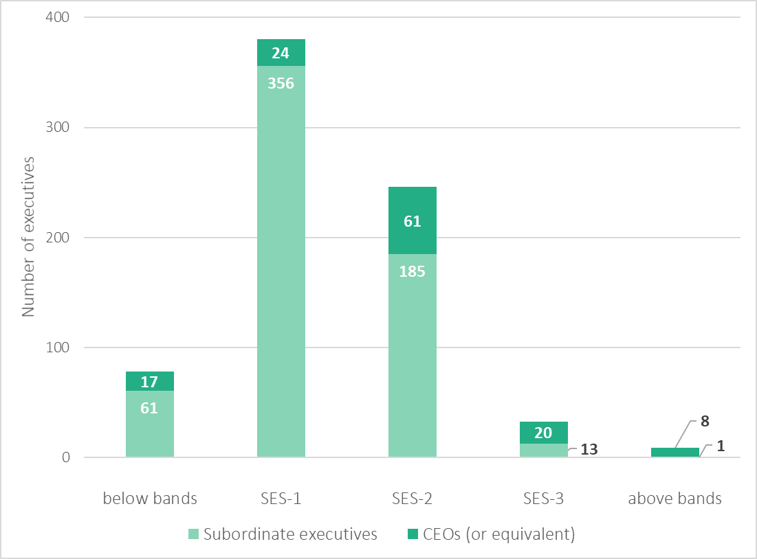

Source: VPSC, public entity executive workforce data collection, 2020.

Based on 30 June 2020 data:

* around half (380 executives) of public entity executives receive a TRP within the new SES-1 remuneration band
* 11 per cent of executives (87 executives) receive a TRP outside of the SES bands, consisting of:
  + 8 CEOs and one subordinate executive paid above the top of the SES-3 band ($479,900)
  + 17 CEOs and 61 subordinate executives paid below the base of the SES-1 band ($192,800).

Through consultations, the Tribunal heard that alignment with VPS remuneration bands may be a consequence of the restrictions imposed by government remuneration policies. For example, some round table participants noted that a larger number of CEOs would likely have been paid above the SES-3 band in the absence of regulation.

Non-executive remuneration trends in public entities

The Tribunal was informed by some participants that there has been compression, and in some cases, overlap, between the highest non-executive and the lowest executive remuneration rates in their entity. Several submissions highlighted that the salaries of non‑executive staff have, in general, grown at a faster rate than executive salaries, and in some cases the salary of some higher paid staff covered by enterprise agreements was very close to or had overtaken executive remuneration (box 4.1).

The Tribunal heard that remuneration compression and/or overlap can reduce the incentive for non‑executive employees to seek advancement to executive positions, in particular as:

* executive roles generally have greater levels of responsibility and risk
* non-executive employees covered by an enterprise agreement may be provided with additional entitlements (e.g. allowances or overtime rates) that are not provided to executives
* taking on an executive role may reduce job security, as the PEER Policy requires that executives are employed using a fixed-term contract of no more than five years and are subject to termination with four months’ notice, while non‑executive staff may have greater job security, for example, by being employed on ongoing arrangements.

Box 4.1: stakeholder views on remuneration compression

Source: written submissions.

**North East Waste and Resource Recovery Group**

… the remuneration level of the EO position has been inconsistent with the salary structure of the Statewide Waste and Resource Groups EBA that the balance of the staff operate under, meaning that benefits offered to senior staff other than the EO position are... significantly more attractive — especially when considering the reduced level of responsibility and risk these roles hold. [p.2]

**Royal Botanic Gardens Board**

In determining the values for remuneration bands… it would seem that average movement of wages for employees covered by enterprise agreements who report to the agency executives, should be taken into account. For example, whilst the maximum executive increase over the past two years has been 2% in accordance with the prescribed guideline rate increase, other RBGV employees have received a higher average in accordance with the EA, therefore skewing the role relativities. [p.1]

**South West Institute of TAFE**

Senior manager remuneration is governed by our enterprise agreement and market factors, both of which have resulted in a relatively small pay gap between senior managers and executives.

Because of the remuneration rules that apply to executives… (namely the 70% and 80% rules), a lower CEO remuneration has a flow on effect which exacerbates recruitment and retention of high performing executives and provides little incentive for a senior manager within the education sector to take on the additional responsibilities and accountabilities and progress to executive management. [p.2]

**Victorian Water Industry Association**

With Managing Director and subordinate executive salaries increasing at 2% annually (as per the guideline rate set by the Premier of Victoria) and many Enterprise Bargaining Agreements (EBAs) across the sector in recent history increasing at a higher margin, some of our members are now experiencing the situation where the TRPs for the highest EBA band is very close to some manager salaries, and in some cases higher. This has put pressure on water corporations to increase manager salaries, which in turn places some managers very close to the lowest bracket for executives (with executive TRPs constrained by the guideline rate). While EBA increases are likely to be at a lower margin in future, the legacy effects will continue to have an impact for several years ahead. [p.2]

In the VPS Determination, the Tribunal set a nine per cent gap between the top of the VPS Grade 6 (VPS-6) remuneration band under the VPS Enterprise Agreement 2016,36F[37] and the base of the SES-1 executive band. The VPS-6 band was used for comparison purposes as the VPS Grade 7 band should be reserved for a small number of ‘Senior Technical Specialist’ roles that require specialist skills and do not usually have a people management function.37F[38] The Tribunal considered that a nine per cent gap would increase the incentive for non-executive VPS staff to apply for executive roles by, at least in part, compensating for the reduction in employment conditions when moving from a non-executive to an executive role.38F[39]

The Tribunal reviewed Victorian public sector enterprise agreements to identify patterns relating to compression or overlap between executive and non‑executive remuneration. The Tribunal’s analysis was limited as some non-executive employees are not employed under an enterprise agreement and there is limited information available about their remuneration.

Notwithstanding this limitation, from examining 95 prescribed public entity enterprise agreements, the Tribunal found some evidence of either similar or higher levels of remuneration for some roles, across industry segments, provided to staff covered by an enterprise agreement relative to executives.

Based on available data, there is some evidence of higher growth in non‑executive remuneration compared to executive remuneration in the public sector. The Average Annualised Wage Increase (AAWI) under the 95 enterprise agreements reviewed ranged from 1.5 per cent to 5.5 per cent, and the average AAWI across agreements was 3.3 per cent.39F[40] In comparison, between June 2015 and June 2020 the Premier’s annual adjustment guideline rate for executive TRP increases averaged 2.2 per cent.

Further, evidence from the broader Victorian public sector labour market supports the notion that non‑executive public sector salaries have grown faster than executive TRPs in prescribed public entities. According to Australian Bureau of Statistics (ABS) data, between May 2015 and May 2020 the Average Weekly Ordinary Time Earnings (AWOTE) of public sector employees in Victoria increased by approximately 19 per cent.40F[41] As noted, over the same period:

* the cumulative increase in public entity executive remuneration, based on the Premier’s annual guideline rate, was 11.5 per cent
* based on the Tribunal’s analysis, the average growth in executive TRPs in prescribed public entities was 15 per cent.

Summary

Prior to this Determination, there was no common remuneration band structure in place for executives employed in public entities. The maximum TRP that could be offered to subordinate executives was tied to the TRP of the entity’s CEO by the 70/80% rules in the PEER Policy. Further, the annual growth in executive remuneration was influenced by the Premier’s annual adjustment guideline rate.

It is likely these factors have contributed to the slower rate of growth in public entity executive remuneration when compared with that of non-executive public sector employees, resulting in compression between non-executive and executive remuneration in some prescribed public entities.

Some public entities have sought to align their executive remuneration with the VPS executive remuneration band structure. A majority of public entity executives across industry segments are remunerated within the VPS subordinate executive remuneration bands set by the Tribunal effective from 1 July 2020.

5 Labour market considerations  


To inform its Determination, the Tribunal considered the characteristics of the public entity executive labour market. In broad terms, the public entity executive labour market reflects:

* the supply of people who want to become an executive or take up a higher executive role in the public sector
* the demand from public entities for executives.

There are a range of factors which affect the demand for and supply of executive labour in the Victorian public sector. Factors that the Tribunal considered include:

* the impact of government regulation on remuneration offerings
* the skills and experiences sought by public entities when recruiting executives
* increased demand for senior and executive talent in particular industries
* sources of existing public entity executives
* attraction of executive talent
* retention of existing executives and their career intentions.

5.1 Impact of regulation

The remuneration that public entities were able to offer to executives has been regulated through the PEER Policy (and its predecessors). These regulatory requirements were outlined in chapter 4. Within these requirements, the Tribunal observed — through its administration of the PEER Policy — that a common target for CEO remuneration offerings has been the 25th percentile of remuneration in the general market. This was also evidenced by some submissions to the Tribunal.[42]

In addition, subordinate executive remuneration offerings have been restricted by the operation of the 70/80% rules. Several submissions provided to the Tribunal noted the negative effect of the 70/80% rules on their ability to attract and retain executive talent. However, this was not a consistent view across all submissions (box 5.1).

Box 5.1: stakeholder views about the 70/80% rules

Source: written submissions.

**City West Water**

Due to the requirement of meeting the 70/80% rule we are unable to go to market with a competitive remuneration package… This has resulted in CWW missing out on talent, talent who have expressed a desire to join the sector, accepting that they would need to [take] a lower pay, but then not applying because we were unable to come close to their revised expectations and remain within 70/80% of the MD’s TRP. [p.4]

**Goulburn Ovens Institute of TAFE**

Given that the TAFE CEO salaries set the upper limits for broader TAFE Executive remuneration (through the 70% and 80% rules), restrictions placed on the GOTAFE CEO’s total remuneration package is limiting GOTAFE’s ability to attract and retain talented TAFE executives with the right skills to our regional organisation. [p.2]

**Wannon Region Water Corporation**

Because of the remuneration rules that apply to executives… (namely the 70% and 80% rules), a lower CEO remuneration has a flow on effect which exacerbates recruitment and retention of high performance executives and provides little incentive for a senior manager within the water sector to take on the additional responsibilities and accountabilities and progress to executive management. [p.4]

**Victorian Managed Insurance Authority**

Existing 80/70 rules in the Public Sector Entity Executive Remuneration policy have afforded VMIA suitable flexibility to accommodate a wide spread of pay positions for its executives. [p.2]

5.2 Target skills and experience

In broad terms, executives may be sourced internally — via promotion or lateral movement — or externally, for example, from other Commonwealth or state public sectors, the private sector or the not-for-profit sector.

The Tribunal was informed through round tables and submissions that public entity preferences and approaches to sourcing executive candidates varies by industry segment. For example, as noted in Bendigo Kangan Institute’s submission:

The Board’s preference is to first source suitable candidates from within the TAFE/VET sector and/or the Victorian Public Sector given they would have relevant experience, understanding of government relations, stakeholder management and cultural alignment. [p.2]

As discussed in chapter 3, some public entities said in submissions that they required executives with skills traditionally developed in the private sector (e.g. commercial skills), and that they needed to attract candidates from outside the public sector to fill those roles.

To further help understand the hiring preferences of public entities, the Tribunal’s questionnaire asked CEOs what prior experience they valued most when hiring new executives to their organisation.

The results showed that, in general, CEOs value both public sector and private sector experience. However, some CEOs in the finance and insurance industry segment appear to place particular importance on experience in the private for‑profit sector. This preference may place upward pressure on the remuneration offered in that industry segment as:

* it limits the potential ‘supply’ of executive talent to individuals with private for-profit sector experience
* the private for-profit sector generally pays higher salaries than the public sector.

5.3 Sources of public entity executives

The Tribunal took into account the previous roles of existing executives in prescribed public entities to understand whether individuals in a variety of market segments were willing to transition to executive roles in the Victorian public sector, and had been found suitable for the role.

The Tribunal’s questionnaire asked executives to report their position immediately prior to their current role (figure 5.1).

Figure 5.1: prior roles of CEOs and subordinate executives employed in prescribed public entities

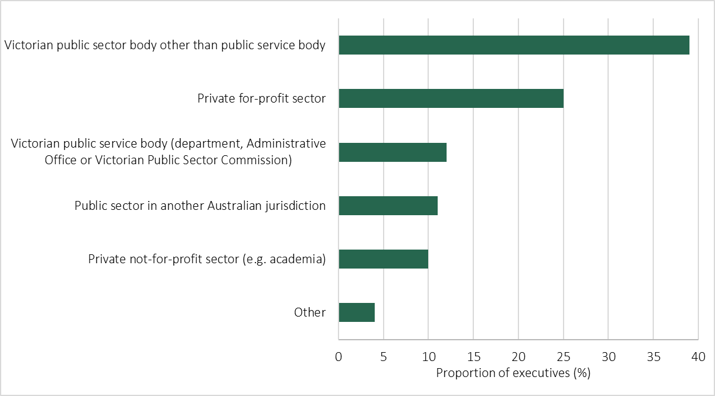

Source: Tribunal executive questionnaire.

Across all public entities, of those CEOs and subordinate executives who responded to the questionnaire, around half had been in the Victorian public sector in their previous role at either an executive or non‑executive level — around 39 per cent were from Victorian public sector bodies, while 12 per cent had come from the VPS. Factoring in other public sectors, the majority (approximately 60 per cent) of executives who responded to the questionnaire came from a previous public sector role in Australia. In comparison, approximately three-quarters of VPS executives said that they came from a previous public sector role in Australia.46F[43] Around 20 per cent of public entity respondents were previously executives in a private, for‑profit organisation.

Further examination of this data by industry segment showed that the proportion of executives that come from a previous public sector position can vary considerably between segments. To give an indication of the distribution, approximately 82 per cent of executives in the regulators and other agencies industry segment, 45 per cent of executives in the finance and insurance segment and 33 per cent in the sport, recreation, arts and facilities management industry segment came from the public sector in an Australian jurisdiction (figure 5.2).

Figure 5.2: prior roles of CEOs and subordinate executives employed in prescribed public entities by industry segment

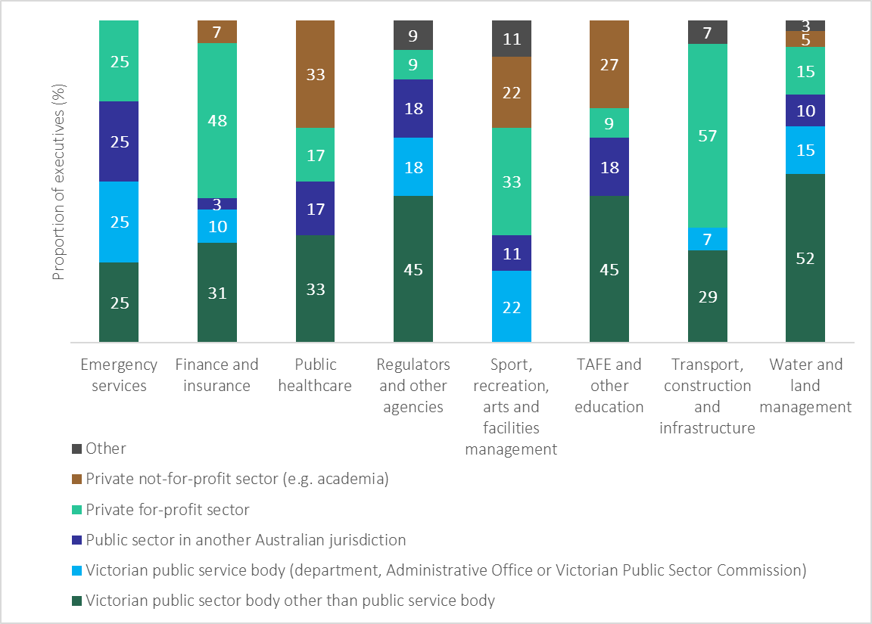Source: Tribunal executive questionnaire.

5.4 High demand in particular industries

Several written submissions stated that there is high demand in some industries for executives with relevant skills and experience. For example, the V/Line Corporation submission said:

V/Line competes with the state owned and private markets, both nationally and internationally, to fill executive roles that require rail infrastructure and rail passenger operations expertise. In V/Line’s experience it is a highly competitive recruitment market to attract experienced and skilled rail industry executives. [p.1.]

The Melbourne and Olympics Parks Trust said that:

… the recruitment and retention of high calibre executives in our sector is highly competitive in the global market we operate in… [p.1.]

The Victorian Managed Insurance Authority said there was:

… high demand for insurance and risk management specialties… [p.2.]

To further explore this issue, the Tribunal reviewed available data about demand for executive talent in Victoria and nationally across Australia. From what was obtained, the Tribunal observed that at least in the rail infrastructure and civil construction sectors, there appears to be increased demand for experienced and senior employees to perform executive roles.

The Victorian Skills Commissioner has recently identified (using public data and insights provided by experienced employers within these sectors) that there is a shortage of qualified staff in the rail infrastructure and civil sectors, as workforce supply has not kept pace with increasing demand. The Commissioner stated that, in the civil sector, project management skills for major projects are in high demand, and experienced leadership and project management can prove difficult to source. The Commissioner observed that, to fill gaps in the workforce, employers sometimes pay inflated wages to attract workers from competitors or promote workers into positions before they may be ready. However, employers noted that even when promoting from within the organisation at times they find it equally challenging to find someone for the vacated role.44F[44]

The Commonwealth Government Department of Employment, Skills, Small and Family Business has also identified a shortage in the national labour market of construction project managers, which has been worsening in recent years.45F[45]

The Tribunal noted that there was limited other publicly available data about the supply and demand for executive talent in other industries in Australia. The Tribunal will seek to undertake further research on this topic as part of its forward program, to inform its next comprehensive Determination of remuneration bands for executives in prescribed public entities.

5.5 Attraction of executive talent

The Tribunal considered the factors that motivated executives to seek employment in prescribed public entities. In order to attract the executive talent prescribed public entities require, they must be able to compete with other entities and sectors.

Importance of remuneration to attracting executive talent

The results of the executive questionnaire show that remuneration is a key consideration (if not the most important consideration) for many executives when deciding to take on an executive role.

Executives were asked how important remuneration was to their decision to apply to their current role. Nineteen per cent of CEOs and 22 per cent of subordinate executives said remuneration was the most important consideration, while 75 per cent of CEOs and 71 per cent of subordinate executives said it was somewhat important. The remainder of respondents said it was the least important consideration (figure 5.3).

Figure 5.3: importance of remuneration to decision of executives to apply for their current role

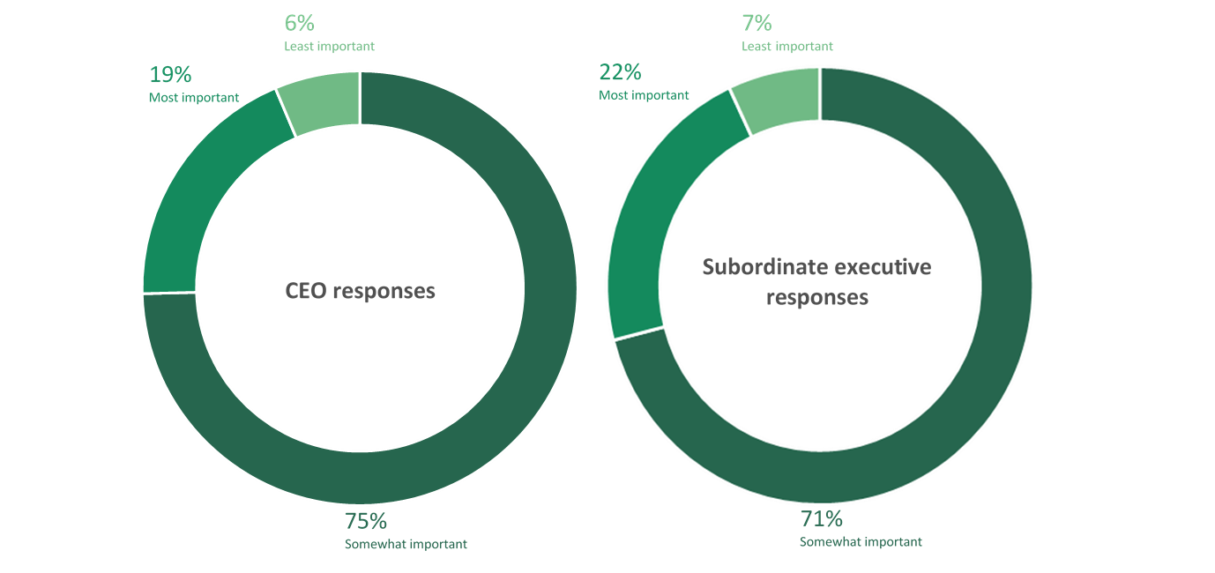Source: Tribunal executive questionnaire.

A subordinate executive stated:

… the balance of remuneration and community service is complex given the ability to work in [the] private sector and be rewarded at a significantly higher overall rate… versus providing a positive community service and seeing the benefits of those services as a real difference to our community. The outcome of achieving positive change and outcomes is very satisfying, but must be weighed up against the attractiveness of private sector offered remuneration to be considered.

Approximately half of CEOs who responded to the Tribunal’s questionnaire said that existing levels of public entity executive remuneration are not competitive against the general market. The questionnaire results highlighted that in some cases, existing remuneration arrangements act as a barrier to attracting and retaining the highest quality candidates. Recent research published by Hays shows that, for example, salaries for CEOs of private sector entities with a turnover of up to $50 million can be as a high as $450,000 — above the pay of almost all prescribed public entity CEOs.[46]

When asked specifically about the role of remuneration in attracting and retaining talent to their organisations, 38 per cent of CEO respondents indicated that existing remuneration arrangements were not sufficient, and 55 per cent said that existing arrangements are somewhat sufficient. Only eight per cent of CEOs said that existing arrangements were sufficient.

The Tribunal also heard in submissions that remuneration plays an integral part in the attraction of public sector executive talent (box 5.2).

Box 5.2: stakeholder views about the importance of remuneration to attracting executive talent

Source: written submissions.

**Victorian Managed Insurance Authority**

The benefits of working in the Victorian Public Sector… and VMIA’s value proposition are attractive to candidates and are well marketed and articulated. However, competitive remuneration remains one of the top-three considerations for candidate attraction and offer acceptance. [p.2]

**Victorian Water Industry Association**

While we acknowledge that remuneration is not the only consideration for executive candidates, it is nonetheless a very important consideration. A candidate may be prepared to accept a slightly lower TRP to take on a more senior role and advance their overall career prospects, but it is not reasonable to expect a candidate to accept a significantly lower TRP than they could expect to earn in a similar role in a comparable sector. [p.2]

**Sustainability Victoria**

It is recognised that being an executive in the public sector by definition is about public service and thus remuneration would be expected to be lower than similar roles in publicly listed companies. However, the level of difference in remuneration makes it challenging to attract the best suite of high calibre candidates. [p.1]

During consultation, the Tribunal heard from public entities about the importance of competitive remuneration to securing a skilled and diverse executive workforce. For example, Bendigo Kangan Institute submitted that:

… the existing TAFE remuneration settings and associated public sector EO directions and guidelines have impacted upon our ability to retain existing executive leaders and to attract candidates from within the wider public sector or from external markets. [p.2]

During round tables, many participants representing regionally based public entities spoke about their difficulties in attracting and retaining executives. For example, there may be a smaller executive labour market in regional areas, or candidates may be required to relocate to take up roles. Some participants suggested that the remuneration structure needs to take into consideration these challenges.

Some CEOs who responded to the Tribunal’s questionnaire also noted that the existing remuneration framework is particularly challenging when recruiting for roles in regional Victoria. This issue was also raised in several written submissions (box 5.3).

Box 5.3: stakeholder views about the attraction and retention of staff in regional areas

Source: written submissions.

**Wannon Region Water Corporation**

There are challenges posed by regional employment markets which are significant. These include: distance to Melbourne and a general unwillingness for experienced executives to relocate to regional areas for reasons such as, family considerations, perceptions of future career mobility and ability to re-enter the Melbourne housing market in the future… [p.3]

**Victorian Water Industry Association**

These water corporations face added challenges in attracting and retaining talented and experienced executives including… unwillingness of high calibre candidates to relocate to regional areas, with family considerations, fixed term contracts and uncertainty about their future prospects... [p.2]

**Transport Accident Commission**

… a majority of our quality executive candidates that are considered for industry specific roles, reside in the Melbourne area. In order to attract these candidates to travel to Geelong, our remuneration offering needs to compensate for travel cost, travel time and be competitive against the Melbourne market. [p.2]

**Goulburn Ovens Institute of TAFE**

Regional TAFEs have their own complexities which should be considered in setting executive remuneration levels; many of which do not correlate with TAFE income. CEO roles within regional TAFEs are arguably no less complex or demanding when compared to metro TAFE CEO roles. Reasons include greater community expectations, political demands, socio-economic disadvantage, thin markets and travel requirements… [p.2]

Other motivations for applying for an executive role

Notwithstanding the importance of remuneration in attraction and retention of executive talent, the Tribunal found evidence of other contributing factors.

Several written submissions highlighted the non-financial benefits that drew executives to the public sector. For example, the submission from the Mount Buller and Mount Stirling Alpine Resort Management Board noted that:

… the environment dictates a lifestyle choice that is more influential than remuneration per se. [p.1]

A respondent to the questionnaire from the finance and insurance industry segment said:

Salaries continue to be below private sector roles, however, offset by social good and work life balance.

On the other hand, several public entities noted in submissions that some of the non-financial benefits that have been historically associated with the public sector, such as flexible work arrangements, are no longer a differentiating factor from the private sector.[47]

The Tribunal’s questionnaire asked executives to describe their motivation for applying for their current role.

Close to 30 per cent of CEOs indicated that the opportunity to progress their career was a key motivating factor in applying for their current role. Many respondents noted that taking on a CEO, or equivalent, role was the natural progression in their career.

The ability to drive change and increase value for the community were cited as key motivations for around one in five CEOs. The nature of the work or the opportunity presented by the role was also identified as a motivating factor for around 16 per cent of respondents. Respondents cited the opportunity to establish and lead a new organisation, to develop strategy, and the desire to lead a team as relevant examples of this motivation.

The nature of the role or work was the most common theme emerging from subordinate executives’ responses to this question (22 per cent). These respondents referred to the challenge and complexity of the work and the opportunity to work in a government organisation. Around 18 per cent of responses also cited the organisation as a key motivating reason.

Career progression was identified as a motivating factor for around 18 per cent of subordinate executives. Approximately 15 per cent of respondents saw the opportunity to make a difference in their community as an important reason for seeking their current role.

Other factors cited by a small number of subordinate executives included:

* a desire to try something new
* better work-life balance
* the leadership and/or management dimension of the new role
* unhappiness in their previous role
* re-location or geographical location.

5.6 Retention of executive talent and career intentions

The Tribunal also considered the extent to which prescribed public entities retain executives once they have commenced employment.

Comprehensive data was not available to the Tribunal on the separation rate of executives in public entities. For that reason, the Tribunal instead gave consideration to available data on the separation rates for the broader set of public sector employees, written submissions and questionnaire data about the future career intentions of executives in prescribed public entities.

From 2015-16 to 2018-19, the annual separation rate of employees across all public entities remained constant at around 10 per cent.[48] This rate is slightly higher than the ABS estimate for the general employee population — around 8.2 per cent of Australian workers changed employers or occupations in the 12 months to February 2020.[49]

In the VPS Determination, the Tribunal noted that the separation rate for VPS executives ranged from 12 to 16 per cent from 2015-16 to 2018-19.[50]

Two written submissions referred to their entity’s executive turnover rate, linking remuneration to challenges in retaining executive talent.[51] For example, the Bendigo Kangan Institute reported:

Over the past ten years there have been six CEOs of BKI and the Institute has seen a high turnover of over 25 of its Executive Team… The average tenure of EOs on a five-year contract who have departed BKI in recent years is around 20‑24 months… while not all the EO turnover can be ascribed to remuneration, it was a significant factor for a number of exiting EOs. [pp.2‑3]

The Tribunal’s questionnaire asked executives in prescribed public entities about their career intentions in the next five years. Close to half of respondents (46 per cent) said they intend to remain an executive in a Victorian Government organisation, while around 34 per cent are intending to leave the Victorian public sector.

There was some variation between CEO and subordinate executive responses:

* around 53 per cent of CEOs and 41 per cent of subordinate executives stated that they were likely to remain an executive in a Victorian public sector organisation
* around 30 per cent of subordinate executives — compared with 11 per cent of CEOs — indicated their intention to take on an executive role in the for‑profit private sector
* ten per cent of CEOs and four per cent of subordinate executives said they were likely to move to an executive role in the not-for-profit sector.

Remuneration is an important consideration for those that intend to leave the Victorian public sector — around 40 per cent of CEOs and 46 per cent of subordinate executives who indicated this intention said that remuneration was the most important factor. Further, some 48 per cent of CEOs and nearly half of subordinate executives said that remuneration was somewhat important to their decision to leave.

5.7 Limitations

While the Tribunal considered a range of characteristics of the public entity executive labour market, its analysis would have benefited from robust data on matters such as:

* the number of candidates applying for executive roles in public entities
* the quality of candidates entering the public sector executive workforce
* the movement of executives both in and out of the Victorian public sector and between public entities
* attraction and retention issues faced by the public sector
* the expectations of candidates and employers during and after the recruitment process.

In addition, there was limited publicly available data about the supply and demand for executive talent in particular industries.

Further research and data collection on these matters, including by the VPSC, will be of value to the Tribunal in the course of making future Determinations.

Summary

The remuneration outcomes for public entity executives reflect numerous factors, which affect the demand for and supply of public entity executives, as well as the impacts of government regulation.

Many stakeholders said that regulations governing executive remuneration, such as the 70/80% rules, were acting as a barrier to attracting and retaining executive talent.

The Tribunal heard in submissions that remuneration plays an integral part in the attraction and retention of public sector executive talent. Questionnaire responses indicated that while remuneration is an important consideration in taking on executive roles, individuals are also motivated by the opportunity to progress their career or make a difference in their community.

Approximately 60 per cent of executives in prescribed public entities who responded to the questionnaire came from a previous public sector role in Australia. However, this varied considerably between industry segments.

Roughly one in five executives who responded to the questionnaire worked as an executive in the private for-profit sector immediately prior to their current role. A similar proportion of VPS executives reported that they had transitioned directly from that sector.

CEOs generally value both public sector and private sector experience when recruiting subordinate executives, although CEOs in some industry segments show a clear preference for private sector, commercial skill sets and experience.

The separation rate in Victorian public entities is slightly higher than in the general Australian labour market. The Tribunal noted that remuneration is an important factor for many executives in prescribed public entities who are considering leaving their role.

6 Economic factors  


In making this Determination, the VIRTIPS Act required the Tribunal to give consideration to:

* current and projected economic conditions and trends (s24(2)(c))
* the financial position and fiscal strategy of the State of Victoria (s24(2)(b))
* any statement or policy issued by the Government of Victoria which is in force with respect to its Wages Policy (or equivalent) and the remuneration and allowances of any specified occupational group (s24(2)(a)).

6.1 Current and projected economic conditions and trends

The Tribunal examined international, Australian and Victorian economic and financial conditions and trends. There is considerable uncertainty about future conditions, following policy responses to the coronavirus (COVID‑19) pandemic. The Tribunal relied upon the trend and forecast data available to it at the time of publication of this Statement of Reasons.

International economic conditions

The Reserve Bank of Australia’s (RBA) *Statement on Monetary Policy – November 2020* noted that the global economy is recovering from the initial shock and disruption caused by the COVID-19 pandemic. While the June quarter 2020 saw the biggest contraction in global Gross Domestic Product (GDP) since the Second World War, the September quarter 2020 then had the strongest growth in GDP since that time. However, the rebound in activity in the September quarter 2020 still left global GDP well below pre-pandemic levels in the major economies, with the exception of China.

Australian economic conditions

The RBA’s Statement noted that while an economic recovery is underway in Australia, it is proceeding at an uneven pace. Some industries remain constrained by social distancing measures and others are affected by the broader economic downturn. Substantial policy stimulus implemented by the Commonwealth and state governments has also played an important role in supporting the economy. For example, despite the decline in output, large levels of fiscal support led to increases in aggregate household income.

The RBA’s Statement said that the decline in Australian GDP for the year ending June 2020 was 6.3 per cent. This factors in the record seven per cent contraction in the June quarter 2020.52F[52] The Australian economy subsequently recorded a 3.3 per cent increase in GDP for the September quarter 2020. The ABS noted this was associated with the easing of restrictions related to the COVID-19 pandemic across most states and territories. However, it also noted the level of economic activity remains lower than prior to the pandemic.53F[53]

According to the RBA, the near-term economic outlook is expected to depend significantly on health outcomes, the prevention of the spread of the virus, and advances in medical treatment. In the RBA’s baseline scenario (which assumed that no further large COVID-19 outbreaks occur in Australia and restrictions do not need to be tightened materially) GDP is not expected to return to pre-pandemic levels until the end of 2021. The RBA also noted there has been a significant deterioration in labour market conditions. The national unemployment rate is expected to rise to approximately eight per cent by the end of 2020, and then gradually decline to approximately six per cent by the end of 2022. There were also large declines in hours worked. Both wages growth and underlying inflation are expected to remain below two per cent in the coming years.54F[54]

The *Commonwealth of Australia Budget 2020-21*, released in October 2020, also reported significant levels of government expenditure committed in response to the COVID-19 pandemic. The pandemic has also resulted in large declines in Commonwealth taxation revenue. A budget deficit of $85.3 billion (4.3 per cent of GDP) was reported for the 2019‑20 financial year, and a deficit of $213.7 billion (11 per cent of GDP) is estimated for the 2020‑21 financial year. Net government debt is expected to continue to increase in the forward years, reaching an estimated 43.8 per cent of GDP in the 2023‑24 financial year.[55]

Victorian economic conditions

The *Victorian Budget 2020/21,* released in November 2020, reported the following economic conditions for Victoria:5

* Gross State Product (GSP) is estimated to have contracted by a quarter of a per cent in 2019‑20 and is forecast to contract by four per cent in 2020-21, due to the COVID-19 pandemic
* employment is forecast to fall by 3.25 per cent in 2020-21, and then increase by 3.5 per cent in 2021-22
* the unemployment rate is expected to peak at 8.25 per cent in the December quarter 2020, and is projected to decrease to 5.75 per cent in 2023-24.

The *Victorian Budget 2020/21* stated that risks to the Victorian economic outlook are much greater than normal, and mainly relate to the spread of COVID-19 and related domestic and global policy responses. Victoria’s economic outlook could be affected by a slower recovery in global economic growth due to renewed virus spread or further escalation of global trade tensions. Further, financial market volatility could lead to large negative effects on confidence and spending.57F On the other hand, the economy would be supported by early and widespread deployment of a vaccine or treatment that enables remaining   
border- and health-related restrictions to be eased more quickly than expected. Additional international or domestic economic policy support measures could also contribute to a more robust economic recovery.58F[56]

Caution needs to be exercised in relation to data reporting movements in prices and wages over the 12 months to 30 June 2020. This data has been impacted by significant changes in the economy due to the pandemic and temporary policy changes to address its impacts and may not be representative of long-term trends. For example, the ABS has noted that the temporary provision of free childcare in response to COVID-19, and drops in the price for fuel, significantly lowered the CPI figure for the June quarter 2020.59F[57] ABS data show that the Melbourne CPI remained fairly constant over 2019‑20, increasing by only 0.3 per cent compared to the previous financial year.60F[58] The *Victorian Budget 2020/21* forecast annual growth in the Melbourne CPI of 0.75 per cent in 2020‑21, increasing to two per cent by 2023‑24.

Regarding wage movements, ABS data show that, in 2019-20, the WPI increased by 2.4 per cent.61F[59] The *Victorian Budget 2020/21* forecast wage growth to fall to one per cent in 2020-21, before increasing to 2.25 per cent by 2023‑24.62F[60]

Another indicator of wage growth, AWOTE for adults in Victoria, increased by 6.3 per cent between May 2019 and May 2020.63F[61] However, this figure must be treated with caution as the reported increase in average earnings may not reflect increased wages at the individual level, or an increase in labour demand. The ABS explained that reported AWOTE data was affected by compositional changes in the workforce due to the COVID‑19 pandemic, including many industries being forced to cease operating due to quarantine measures and rising unemployment. ABS data shows that between March and May 2020 job losses were particularly severe in the industries with the lowest median earnings (e.g. accommodation and food services), leading to an increase in the reported average earnings of Australians that remained employed (including under Commonwealth Government wage subsidy arrangements for businesses affected by the pandemic).64F[62]

6.2 Financial position and fiscal strategy of the State of Victoria

The Tribunal considered the Victorian Auditor-General Office’s financial report on Victoria’s finances and the *Victorian Budget* *2020/21,* including the impact of the COVID‑19 pandemic.

Victorian Auditor-General Office’s financial report

The Victorian Auditor-General Office’s financial report on the State of Victoria, released in November 2020, noted that the COVID-19 pandemic ‘necessitated a significant shift in the state's revenue and expenditure policies, with longer‑term consequences for financial sustainability’.65F[63] The report highlighted the significant unexpected falls in revenue, and increases in expenditure in 2019-20 and consequently debt, as compared to last year and to the original and revised budgets.

Victorian Budget

The *Victorian Budget 2020/21* reported an operating deficit of approximately $6.5 billion for 2019-20. An operating deficit of approximately $23.3 billion is expected for 2020-21, with smaller deficits expected in the following years. Net debt is forecast to be 19.5 per cent of GSP at June 2021 and to increase to 28.9 per cent by June 2024.

The *Victorian Budget 2020/21* included significant infrastructure spending. Annual capital investment is estimated to average $19.6 billion over the next four years, a substantial increase over the previous four years.

The Victorian Government outlined several efficiency measures for Victorian Government departments in its budget for the 2019-20 financial year. However, given the government’s current priorities of responding to the COVID-19 pandemic and the economic recovery, the Budget papers noted that implementation of these efficiency measures has been deferred.[64]

6.3 Victorian Government remuneration policies

Chapter 3 details the Victorian Government remuneration policies in relation to public entity executives. In particular, under the PEER Policy (as it was prior to this Determination), a specified public entity must make a submission to the Tribunal:

* for any proposed adjustment to a CEO’s TRP that is greater than the Premier’s guideline rate
* seeking advice if the TRPs of subordinate executives would breach the 70/80% rules.

Box 6.1 reproduces the *Victorian Government Wages Policy and Enterprise Bargaining Framework* (Wages Policy) which currently applies to departments and agencies in the Victorian public sector.

Box 6.1: Victorian Government Wages Policy and Enterprise Bargaining Framework

Source: Industrial Relations Victoria, ‘Victorian Government Wages Policy,’ *Wages Policy and the Enterprise Bargaining Framework* (State Government of Victoria: Melbourne, Victoria, 2019).

The Victorian Government Wages Policy and Enterprise Bargaining Framework has three pillars:

* Pillar 1: Wages — increases in wages and conditions will be capped at a rate of growth of 2 per cent per annum over the life of the agreement. In practice this means employee wages and conditions will be allowed to grow at this rate.
* Pillar 2: Best Practice Employment Commitment — all public sector agencies will be required to make a Best Practice Employment Commitment which will outline measures to operationalise elements of the Government’s Public Sector Priorities that reflect good practice within Government and can be implemented operationally or without significant costs.
* Pillar 3: Additional strategic changes — additional changes to allowances and other conditions (not general wages) will only be allowed if the Government agrees that the changes will address key operational or strategic priorities for the agency, and/or one or more of the Public Sector Priorities.

A ‘Secondary Pathway’ is also available for public sector agencies whose current enterprise agreement reaches its nominal expiry date on or before 30 June 2020 which permits one annual wage and allowance increase capped at 2.5 per cent (instead of at 2 per cent).

In considering the Wages Policy, the Tribunal was cognisant that caution should be taken when comparing the Tribunal’s Determinations with the changes in the growth of wages and conditions under an enterprise agreement, as the period to which a Determination from the Tribunal applies is generally different from an enterprise agreement. An enterprise agreement is typically set for a period of between one and four years, and annual wage adjustments are agreed at the time it is signed. In comparison, under section 19 of the VIRTIPS Act, the Tribunal must make a comprehensive Determination of executive remuneration bands for executives in prescribed public entities. While the Tribunal may elect to phase in changes to bands over time, it is also required to consider making annual adjustments to the bands, noting that it cannot make an annual adjustment if a Determination has been made in the preceding nine months (s20 of the VIRTIPS Act).

7 Tribunal’s considerations   


The Tribunal now turns to determining the structure and values of the remuneration bands for executives employed in prescribed public entities.

In making its Determination, the Tribunal considered the legislative requirements set out in the VIRTIPS Act. As earlier indicated, these are:

* the role of executives and existing remuneration provided to executives (s19(1)(a)) (chapters 3 and 4)
* any statement or policy issued by the Government of Victoria which is in force with respect to its Wages Policy (or equivalent) and the remuneration and allowances of any specified occupational group (s24(2)(a)) (chapter 6)
* the financial position and fiscal strategy of the State of Victoria (s24(2)(b)) (chapter 6)
* current and projected economic conditions and trends (s24(2)(c)) (chapter 6)
* submissions received in relation to the proposed Determination (s24(2)(d)) (discussed throughout the Statement of Reasons).

In addition, the Tribunal considered the characteristics of the public sector executive labour market (chapter 5).

This chapter analyses options and sets out the rationale for the new public entity executive remuneration framework.

7.1 Concurrent executive employment reforms

As part of its deliberations, the Tribunal was cognisant of concurrent executive workforce reforms affecting prescribed public entities being carried out by the Victorian Government, in particular:

* the completion of the PEECF and the commencement of its roll-out across the public sector
* changes to the PEER Policy.

Public Entity Executive Classification Framework

In December 2020, the VPSC issued the PEECF. The PEECF is the Victorian Government’s first whole-of-government system for objectively and transparently comparing executive roles across public entities.

The VPSC’s PEECF introduces a three-band classification structure for public entity executives and provides a methodology for evaluating the work value of each executive role and determining the relevant band.

The PEECF was based on, and aligns closely to, the VPS Executive Classification Framework. However, some modifications were made to better reflect the accountabilities and responsibilities of public entity CEOs and other executives.

The classification band to which an executive role is assigned is determined by a work value score for that role. Work value scores are calculated by assessing each executive role against eight competencies, with the methodology providing for a score of 1, 3, 5 or 7 against each competency. The final tally is the work value score, with a minimum score of 21 points required for the role to be classified as an executive. The classification bands and associated work value score ranges are summarised in table 7.1.

Table 7.1: classification framework for public entity executives and associated work value scores

|  |  |
| --- | --- |
| Band | Work value score range |
| PESES-1 | 21 to 35 |
| PESES-2 | 36 to 47 |
| PESES-3 | 48 to 56 |

Source: PEECF.

Changes to the PEER Policy

In December 2020, the Victorian Government made changes to the PEER Policy. The updated PEER Policy takes effect on the day this Determination is made, and applies to the same public entities (these entities are set out in appendix A).

The government consulted with the Tribunal on the proposed changes to the PEER Policy prior to it being made by the Governor in Council.

Changes to support implementation of the PEECF and this Determination

The updated PEER Policy supports the implementation of the PEECF and this Determination by requiring:

* public entities to facilitate the VPSC undertaking and moderating the classification of executive positions using the PEECF within a set timeframe
* a current work value assessment under the applicable classification framework (PEECF or VPS Executive Classification Framework) be in place, and the relevant position be classified accordingly, before a public entity creates a new executive position, renews an expiring executive contract or adjusts an executive’s remuneration within the relevant band (other than as a result of an annual adjustment determined by the Tribunal or government)
* the remuneration of an executive employed in a prescribed public entity be within the relevant remuneration band set in this Determination, although it may exceed the relevant band if the Tribunal’s advice is obtained.

The updated policy also defines who is considered to be an executive employed in a public entity, for the purposes of whole-of-government employment and remuneration policies and instruments.

Executives covered by the PEER Policy and this Determination

The Tribunal noted that the VIRTIPS Act does not provide a definition of who is considered to be an executive for the purposes of this Determination.

The updated PEER Policy sets out which employees it applies to and are considered to be executives in a prescribed public entity for the purposes of that policy (box 7.1).

Box 7.1: executives covered by the updated PEER Policy

Source: PEER Policy.

Paragraphs 4.1 and 4.2 of the updated PEER Policy set out which executives are covered by the PEER Policy.

4.1 The PEER Policy applies to executives in a public entity prescribed under the VIRTIPS Regulations that are:

* a CEO (or similar role if not titled as such); or
* in a role that has been classified under the Public Entity Executive Classification Framework (PEECF) with a work value score of at least 21; or
* in a role that has not yet been classified under PEECF that has a Total Remuneration Package (TRP) on or after 1 July 2019 of at least $185,711.

but does not include:

* staff whose remuneration rates are specified by an award or enterprise agreement; or
* technical specialists who meet one of the criteria outlined above, but do not have a people management function; or
* statutory or prerogative office holders appointed to public entities.

4.2 The PEER Policy also applies to executives in a public entity prescribed under the VIRTIPS Regulations that are employed as an executive under Part 3 of the PAA, including by virtue of a specific legislative reference or an order/instrument made under legislation.

The Minister for Government Services wrote to the Tribunal to inform it that the application of the PEER Policy ensures that all executives employed in prescribed public entities, including executives employed under Part 3 of the PAA, are in scope of the PEER Policy. The Minister’s letters to the Tribunal advised it that:

* the scope of the updated PEER Policy sets out the government’s intended employee cohort to be covered by this Determination
* the government considers that there would be merit in aligning the coverage of the Determination with that in the updated PEER Policy, as that would ensure that the remuneration of all executives in prescribed public entities is regulated by the Determination.

The Tribunal agreed that there is merit in aligning the definition of ‘executive’ for the purposes of this Definition with the scope of the PEER Policy. That approach ensures that this Determination operates consistently with other Victorian Government executive remuneration reforms and policies.

The Tribunal adopted a definition of the term ‘executive’ in this Determination based on the relevant provisions of the updated PEER Policy set out above. This ensures that this Determination and the PEER Policy apply to the same cohort of staff.

The Tribunal noted that this definition includes a small number of public entity executives who are employed under Part 3 of the PAA. Under the updated PEER Policy, the roles of these executives will be classified into the applicable SES band using the VPS Executive Classification Framework. The Tribunal understood that as a matter of convention, this group of executives has been remunerated in accordance with the remuneration bands set in the VPS Determination, which sets out what the relevant remuneration band for an executive is based on the SES classification of their role. The Tribunal has clarified in this Determination that this approach is to continue.

Changes to remuneration rules

Under the VIRTIPS Act, prescribed public entities are required to seek the Tribunal’s advice if they propose to pay an executive above the relevant remuneration band. When this Determination is made, the following executive remuneration rules and constraints will be removed from the PEER Policy:

* ‘70/80% rules’, which limit the maximum remuneration that can be offered to a subordinate executive based on the TRP of the entity’s CEO
* requirement that the Tribunal determine the remuneration of CEOs of specified public entities (including a requirement that the entity bring a submission to the Tribunal if it proposes to provide the CEO with a mid‑contract remuneration increase above the applicable Premier’s guideline rate).

7.2 Structure of remuneration bands

Prior to the Tribunal making this Determination, there was no common remuneration band framework for public entity executives, although there were several industry-specific remuneration bands for CEOs.

In addition to the legislative factors explained above, the Tribunal also took into account the following matters when developing the structure of the remuneration bands:

* the executive classification framework established by the PEECF consisting of three distinct and contiguous work value ranges
* the wide range of executive roles that are within the scope of this Determination
* the need to encourage existing executives to seek promotion and incentivise non-executives to take on executive roles
* the benefits (or otherwise) of greater alignment between the public entity executive remuneration framework with the remuneration framework for executives employed in public service bodies.

As noted in the summary of the matters being considered by the Tribunal published in January 2020,70F[65] the Tribunal’s starting point for developing the structure was to set three remuneration bands that correspond to the PEECF. The Tribunal gave consideration to whether:

* a unified remuneration structure is appropriate for all public entities, or whether bespoke remuneration bands are required for particular industries or entities
* separate remuneration structures are required for CEOs and subordinate executives.

Whether a unified structure is appropriate

In its ISR Final Report, the VPSC recommended that the Tribunal abolish the previous industry segment-specific public entity remuneration bands and replace them with a common remuneration band structure for all executives. The Report said that:71F[66]

… there are some cases where comparison between public entities reveals Total Remuneration Packages that are clearly inequitable by any measure of the relative risk, complexity or significance to Victoria, especially when roles are compared across segments. In these cases, there is an elevated risk that agencies will be unable to retain the highest calibre executives.

Several submissions received by the Tribunal supported the development of a single executive remuneration framework for all prescribed public entities. That approach would support smaller or regionally located entities, or entities from industry segments that have historically been required to offer lower remuneration, to retain executive talent crucial for their success.

The submission from the Gordon Institute of TAFE observed that:

… evidence points to a clear need for parity of CEO remuneration within a particular band regardless of the geographical location or industry sector. Parity of remuneration would ensure TAFEs and regional organisations can fairly compete in securing appropriate talent from across the state. The competitiveness of offerings would also safeguard a viable approach to the retention of key talent. [p.1]

Both the South West TAFE and TAFE Gippsland submissions noted a:

… consistent work value assessment and associated TRP application will enhance opportunities for cross public sector executive employment opportunities and the potential for a broader talent pool availability. [p.1]

The Tribunal also heard that existing discrepancies in the remuneration being offered to executives by public entities create challenges for some entities to attract executive talent.72F[67] The Western Region Water Corporation submitted that it was:

… often challenged to attract high quality and capable candidates where better remuneration can be achieved in central Melbourne or where the candidate lives in Metropolitan Melbourne. [p.1]

Several submissions noted that the existing pre-approved industry-specific CEO remuneration bands originally set by GSERP were generally based on the ‘size’ of the entity (e.g. revenue, customer volume or assets under management).

Some submissions argued against different remuneration frameworks or bands being applied to public entities based exclusively on such metrics, as that approach would not take into account other relevant considerations (e.g. the challenges posed by operating in a regional setting and servicing a large geographic area). For example, in its oral submission the Goulburn Valley Water Corporation asserted that the governance expectations of water entities are the same regardless of the size of the business, while the Goulburn Ovens Institute of TAFE submitted:

As a Board, we find the current determined executive remuneration band value settings (based primarily on revenue) insufficient to support a high functioning executive office workforce… Regional TAFEs have their own complexities which should be considered in setting executive remuneration levels; many of which do not correlate with TAFE income… [these] include greater community expectations, political demands, socio-economic disadvantage, thin markets and travel requirements. [pp.1-2]

During round table discussions, some participants supported the development of industry-specific remuneration bands.[68] Reasons for industry-specific remuneration bands being preferred included:

* industry pressures and high demand for specific roles and skills, requiring greater competitiveness with private sector remuneration offerings in particular industries
* executives in particular industry segments being required to drive revenue growth for their entity and manage large sums of money
* upper and lower remuneration rates could be benchmarked against the broader market, allowing entities to better compete with the private sector for executive talent.

Some entities said that they need to compete with the private sector for talent. For example, the Victorian Managed Insurance Authority submission stated:

VMIA sources select executive roles from the private sector as the required talent is often unavailable internally or within the public sector. For these roles, VMIA is competing against larger, multinational organisations in the financial services sector, where attractive base remuneration packages and significant commercially-based incentives are common features. [p.2]

In its oral submission, the Treasury Corporation of Victoria said that it is unique within government, as all executive positions require a working knowledge of financial markets, and the various areas that support its risk management activities. It needs to attract and retain private sector expertise, for example, from banks and fund managers.

In considering these differing positions, the Tribunal took into account information gathered using the executive questionnaire about where prescribed public entities sourced executive talent. The responses indicated that:

* all industry segments recruit at least some executive talent from the private sector
* in most industry segments both public sector and private sector experiences were valued by CEOs when recruiting new executives, although CEOs in the finance and insurance industry segment placed particular importance on private sector experience.

Based on this data, the Tribunal observed that all industry segments, to some degree, recruit from the private sector. This suggested that unique remuneration bands may not be required for particular industry segments to attract and retain talent. Rather, a single remuneration structure would not preclude entities from sourcing executive talent from the private sector when required. The Tribunal further considered this in the context of its analysis of the values of the bands, discussed below.

Whether a separate structure is required for CEOs

The Tribunal also considered whether separate remuneration frameworks were required for CEOs (and equivalent roles) and subordinate executives. The submission from the Shrine of Remembrance Trust emphasised the need for the remuneration bands set by the Tribunal to adequately differentiate between the CEO and other executives in the entity, particularly for an organisation with a lean executive structure.

The Tribunal noted that the PEECF does not distinguish between CEOs and subordinate executives, but rather uses the same work value methodology to assess all executive roles. Within an organisation, CEO roles would be expected to score higher than other executive roles. In contrast, the VPS Executive Classification Framework does not apply to Secretaries of departments or the VPSC Commissioner. This was a reason for the Tribunal making a separate remuneration band for Secretaries and the VPSC Commissioner in the VPS Determination.

Tribunal’s decision on the structure of the bands

The Tribunal acknowledged that public entities and executives expressed a variety of differing views on the preferred approach for setting the framework for the remuneration bands, and each approach comes with its own benefits and risks. Taking into account these views and the matters discussed above, the Tribunal decided to adopt a single remuneration framework for all industry segments. The Tribunal considered that, on balance, this was the preferable approach as it will:

* enhance the mobility of executives between public entities, which will promote greater dissemination of knowledge and skills across the public sector
* promote fairness as all executives are covered by the same remuneration framework
* not preclude recruitment of executives from the private sector.

The Tribunal also decided to make a single remuneration band framework that would apply to both CEOs and subordinate executives, to ensure consistency with the PEECF. The Tribunal considered that alignment between the PEECF and the remuneration band framework would be beneficial as it would:

* ensure this Determination worked cohesively with other executive reforms, in particular the implementation of the PEECF
* provide a single, objective metric (the role’s work value score) to determine an executive’s classification and their remuneration band.

In the VPS Determination, the Tribunal set remuneration bands for subordinate executives, and a distinct band for Secretaries of departments and the VPSC Commissioner. F[69] In contrast, as the PEECF applies to both CEOs and subordinate executives, the Tribunal was able to establish a remuneration band framework that applied to both types of roles.

Figure 7.1 outlines the structure of the new executive framework, consisting of three distinct and contiguous bands for all executives employed in prescribed public entities.

Figure 7.1: new remuneration structure for executives employed in prescribed public entities

**PESES-1**

**PESES-2**

**PESES-3**

All executives placed into these bands

7.3 Values of the remuneration bands

Having addressed issues related to the band structure, the Tribunal turned to setting the values of the remuneration bands. As set out in this Statement of Reasons, the Tribunal took into the account the factors it was required to consider under sections 19 and 24 of the VIRTIPS Act. In relation to setting the values of the remuneration bands, this included consideration of:

* the roles and responsibilities of executives in prescribed public entities
* remuneration ranges for roles with similar work value, and how this compares with the existing remuneration of executives employed in prescribed public entities
* trends in the attraction and retention of executives
* the gap between non-executive and executive remuneration.

Roles and responsibilities of executives

Chapter 3 sets out the roles and responsibilities of executives employed in prescribed public entities.

A core feature of an executive role is significant management responsibility — the primary role of the executive is to provide leadership and strategic direction for other staff members.[70]

Each public entity is led by a CEO (or an equivalent role), who is responsible for the everyday management of the entity, and is accountable to their board for the overall performance of the entity, including outcomes and behaviour.

While some smaller public entities may employ only a single executive, most employ a number of subordinate executives that report to the CEO. Generally speaking, subordinate executives are responsible for:

* implementing a strategic direction for their area
* providing leadership and contributing to the improvement of their area by deciding how goals will be achieved and priorities set
* providing authoritative advice to their CEO
* managing close liaison and effective relationships with stakeholders
* ensuring compliance with legislation, directives, policies, regulations and processes
* managing and mitigating risk for their area of responsibility.

Public entity executives are increasingly expected to have commercial capability and acumen, and to bring a broad enterprise, business and commercial view. The Tribunal heard that the scope and complexity of executive roles is increasing, as is the workload of those holding those offices. At the same time, executives are required to operate under enhanced levels of oversight and scrutiny by departments and external audit agencies, such as the Victorian Ombudsman and Victorian Auditor-General’s Office.

Some executives are also required to have in-depth technical experience, knowledge or qualifications. Further, as noted in chapter 3, public entity roles may come with a significant amount of risk. For example, executives may be directly responsible for the personal safety of patrons, clients, customers, members of the general public and/or their organisation’s staff.

Labour market considerations

In setting the values of the remuneration bands, the Tribunal considered the public entity executive labour market (chapter 5). It took into account factors that influence demand for and supply of executive labour in the Victorian public sector.

The Tribunal was informed during consultations that public entity preferences and approaches to sourcing executive candidates vary by industry segment. The results of the questionnaire indicate that, in general, CEOs value both public sector and private sector experience. CEOs in entities in the finance and insurance industry segment appear to place particular importance on experience in the private for‑profit sector.

Several submissions also stated that there was high demand in some industries for executives with relevant skills and experience. The Tribunal noted there was some publicly available data in support of this.

Remuneration plays an integral part in the attraction and retention of executive talent to public entities. As discussed in chapter 5, over 70 per cent of executives who responded to the questionnaire indicated that remuneration was somewhat important in deciding to apply to their current role, with a further 20 per cent indicating it was the most important factor.

Through submissions and round tables the Tribunal also heard concerns about the ability of public entities to attract and retain talent, including for senior roles in regional areas or those requiring specialist skills, and called for the Tribunal to ensure remuneration bands were competitive against similar positions across the labour market. The questionnaire also showed that many CEOs considered existing remuneration arrangements to not be competitive, and to be insufficient to attract and retain talent. On the other hand, the results of the questionnaire suggested that a majority (62 per cent) of public entity executives are sourced from the public sector, suggesting a willingness of executives to take up public entity executive roles at the offered remuneration, at least in some industry segments.

The Tribunal also heard about the role of remuneration in the decisions by executives to leave their role. Around one-third of questionnaire respondents said that they are intending to leave the Victorian public sector, and the vast majority of these said that remuneration was either the most important factor, or somewhat important to their decision to leave.

As explained in chapter 4, prior to this Determination there was no common remuneration band framework for public entity executives. Executive remuneration was instead regulated through the former *Policy on Executive Remuneration for Public Entities in the Broader Public Sector*, and since 2018, by the PEER Policy.

From the day that this Determination is made, some of the regulations on executive remuneration in the previous PEER policy, such as the 70/80% rules, will be abolished. As outlined in chapter 5, several submissions provided to the Tribunal noted the negative effect of the 70/80% rules on their ability to attract and retain executive talent. The Tribunal noted that the removal of these requirements will likely address some of the concerns raised during the Tribunal’s consultation process.

Remuneration ranges for roles with similar work value

Generally speaking, a key factor in determining remuneration is the work value of the position. Given that the VPS and public entity sectors will be using very similar work value methodologies, the most relevant remuneration comparison for roles with a similar work value is the VPS remuneration bands, namely the SES bands (figure 7.2).77F[71] The Tribunal also considered arrangements in other jurisdictions, but found this to be of limited value given their different classification and remuneration frameworks.78F[72]

Figure 7.2: remuneration bands for subordinate executives in public service bodies

**SES-1  
$192,800 - $249,700**

**SES-2  
$249,701 - $360,000**

**SES-3  
$360,001 - $479,900**

All subordinate executives placed into these bands

Source: VPS Determination.

The VPS executive bands were based on the 15th percentile of remuneration offered to roles with comparable work values in the Australian General Market, based on advice and analysis provided to the Tribunal by Mercer Consulting (Australia). In contrast, the Tribunal has observed, through its administration of the PEER Policy, that a common target used by public entities for executive remuneration has been the 25th percentile of the Australian General Market. This metric was also cited in submissions from the City West Water Corporation and the Country Fire Authority.

There was a range of views expressed by participants about whether the public entity executive remuneration bands should be aligned with those set by the Tribunal in the VPS Determination. These are discussed further below.

Support for alignment

The VPSC’s ISR Final Report recommended bringing executive remuneration arrangements in public entities into line with the VPS, noting that:79F[73]

… there is much to be gained by moving all public entity executives into a common remuneration band framework aligned to arrangements in the VPS.

The VPSC’s report said that remuneration offerings within the VPS executive remuneration range (at the time of the VPSC’s review, $178,500 to $439,332) were generally adequate to attract high calibre executives to the sector. The Report said that there remains a genuine need for remuneration outside this range in a limited range of roles, and access to such remuneration should be retained with appropriate checks and balances.80F[74]

Several round table participants expressed support for the VPS and public entity remuneration bands being aligned, noting:

* alignment would support executive mobility
* the fundamental aspects of executive roles are broadly similar between the VPS and public entities.

The Emergency Services Telecommunications Authority reflected these sentiments in its submission, stating that it:

… broadly supports the establishment of more harmonised executive remuneration models between the public service and public entities. In particular, the benefits to be gained from greater clarity in relation to career portability and pathways are positive where they assist in the retention of talent within the Victorian public sector. [p.1]

The submission from Sustainability Victoria also recommended the Tribunal take into account VPS executive remuneration when setting the remuneration bands for executives in prescribed public entities, stating that:

… there seems to be a significant disparity with CEOs of prescribed public entities being disadvantaged compared to their departmental colleagues. [p.1]

**Arguments against alignment**

Some round table participants were not in favour of aligning the public entity executive remuneration bands with the VPS executive bands. These participants said that, in the future, the primary source of their entity’s executives is likely to be the private for-profit sector, rather than the public sector, and alignment with the VPS may encumber future recruitment activity.

The gap between non-executive and executive remuneration

The Tribunal examined relativities between executive TRPs in prescribed public entities and the TRPs of other employees in those entities (chapter 4). Many (although not all) non-executive employees in public entities are remunerated based on rates set in enterprise agreements. The Tribunal was informed during consultation that there was compression (and in some cases overlap) between non-executive and executive remuneration, due in part to public sector enterprise agreements providing greater increases in remuneration than the Premier’s guideline rate for executives. The Tribunal heard that remuneration compression and/or overlap can reduce the incentive for non‑executive employees to seek advancement to executive positions.

The Tribunal considered that the value ranges of the executive remuneration bands should enable public entities to offer their executives higher remuneration than that provided under their respective enterprise agreements, as this would:

* recognise executive roles generally have a higher work value
* reflect that executive roles carry greater risk, and may come with lower security of employment
* provide non-executive employees with an incentive to apply for executive roles.

However, an exception may be specialist technical roles covered by an enterprise agreement, where it may be appropriate to offer executive-level remuneration to obtain specialist, scarce skills.81F[75]

In the VPS Determination, the Tribunal set a nine per cent gap between the base of the VPS-6 remuneration band under the VPS Enterprise Agreement 2016,82F[76] and the base of the SES-1 executive band. However, the Tribunal was unable to take the same approach in this Determination between non-executive and executive remuneration, as:

* there is significant variation in salaries provided to non-executive employees under enterprise agreements covering prescribed public entities
* some non-executive employees in prescribed public entities are not employed under an enterprise agreement.

Further, as discussed below, the Tribunal took into account the need to lower the base of the PESES‑1 band to accommodate public entity CEOs whose role may have a work value of less than 21 points. The maximum remuneration of non‑executive staff in those entities is also likely to be lower than in other entities, due to their limited size and budget.

For these reasons, rather than seeking to establish a gap between non-executive and executive remuneration by increasing the base of the PESES-1 band, the Tribunal sought to ensure that the PESES-1 band was sufficiently broad to allow each prescribed public entity to set an appropriate gap for their specific employee cohort.

Based on the Tribunal’s analysis, the highest salary payable under a prescribed public entity enterprise agreement is approximately $221,000 per annum.83F[77] In comparison, the top of the SES-1 band for VPS executives is a TRP of $249,700 per annum (which is equivalent to a salary of approximately $228,000, assuming the TRP includes a 9.5 per cent superannuation component). The Tribunal noted that if the top of the PESES-1 band is aligned with the SES-1 band, then in most circumstances prescribed public entities should be able to ensure that there is an appropriate differential between their executive and non-executive staff.

Adjustments required due to the scope of this Determination

A consequence of the Tribunal adopting the definition of the term ‘executive’ in relation to this Determination, based on the scope of the updated PEER Policy, is that it will apply to CEOs (or equivalent roles) of public entities even if the work value of their role is less than 21 points under the PEECF.

In addition, some public entities that this Determination will apply to may face limited budgets and resources. For example, the submission from the North East Waste and Resource Recovery Group requested that the Tribunal take into account its:

… ongoing commitment to financial stability given the limited funding model that we operate under… [p.3]

In light of this, the Tribunal considered whether a lower base value for the PESES‑1 band is needed to accommodate public CEOs whose role may have a work value of less than 21 points. This issue is explored below.

Tribunal’s decision on the value of the remuneration bands

Taking into account all of the above, the Tribunal decided to broadly align the values of the PESES remuneration bands with the remuneration bands for executives employed in public service bodies, set in the VPS Determination.

The Tribunal considered that, together with changes that have been made to the PEER Policy, this remuneration framework will provide sufficient flexibility for public entities to attract and retain talent, for example, by providing for roles to be remunerated at a targeted percentile of the Australian General Market where required. As discussed in chapter 4, the Tribunal noted that based on the latest available data, the TRP of most executives in prescribed public entities falls within the SES bands. This suggested that broad alignment of the PESES and SES remuneration bands is appropriate.

In making its decision, the Tribunal took into consideration the Victorian Government Wages Policy and the PEER Policy (including changes that will take effect from the day that this Determination is made).

The Tribunal also took into account the current uncertain economic and financial outlook when making its decision, and budgetary constraints faced by entities.

The Tribunal’s decision also recognised that while some entities have a preference for recruitment from the private sector, submissions and the executive questionnaire suggest that a substantial proportion of executives are sourced from the public sector. Broad alignment of the PESES and SES remuneration bands will further promote mobility between the VPS and public entities, retention of executives, and fairness in remuneration outcomes across the public sector.

The Tribunal noted that under the VIRTIPS Act and the updated PEER Policy, a prescribed public entity may set an executive’s remuneration above the relevant band if the Tribunal’s advice is obtained and considered. This provides an appropriate mechanism for remuneration above a relevant band to be provided, where exceptional circumstances necessitate it.

The one exception to alignment with the SES bands is that this Determination provides for a lower base to the PESES-1 band to accommodate the existing remuneration of the CEO of some small public entities.

The Tribunal decided to set the base of the PESES-1 band at $135,000 per annum, factoring in the executive salary data available for the last three years. The Tribunal considered that setting the base of the band at $135,000 will provide smaller public entities (which may employ a single executive) with an appropriate degree of flexibility to set the remuneration of their CEO, including a CEO who may have less experience than existing incumbents.

The Tribunal also considered that the wide range of the PESES-1 band would give prescribed public entities the flexibility to offer executives a higher TRP than that provided to non-executive employees under enterprise agreements. This will also provide an incentive for non‑executive staff to apply for executive roles in public entities.

Finally, the Tribunal decided that when the work value of an executive’s position has been assessed using the PEECF and the position has a work value score of at least 21 points, then the executive’s TRP must be no lower than $192,800, which is the base of the SES-1 band under the VPS Determination (clause 7.2 of this Determination). This will help ensure that the remuneration of executives employed in public entities is aligned with the remuneration of VPS executives whose role has an equivalent or similar work value.

7.4 The new executive remuneration framework

The new executive remuneration framework for executives employed in prescribed public entities consists of three distinct and contiguous bands aligned to the PEECF. It is illustrated in figure 7.3.

Figure 7.3: summary of the Tribunal’s Determination of remuneration bands for executives employed in prescribed public entities

Roles with a work value score of at least 21 points must have a TRP no lower than $192,800 per annum.

**PESES-1  
$135,000 - $249,700**

**PESES-2  
$249,701 - $360,000**

**PESES-3  
$360,001 - $479,900**

All executives placed into these bands

Note: the above remuneration bands apply to executives who are not employed under Part 3 of the PAA. The relevant remuneration band for an executive employed under Part 3 of the PAA corresponds to that which applies to an executive with the same SES or Executive Officer classification, under the VPS Determination in effect at the time.

Implementation of the remuneration framework

The remuneration bands set by the Tribunal are aligned to the PEECF, with implementation expected to be carried out by the end of 2021. The classification of an executive role under the PEECF can only be determined by the relevant employer once the work value score is known.

Given this, the Tribunal was required to set an interim method for assigning an executive to a remuneration band before the classification of their role is determined using the PEECF. The Tribunal decided to assign existing executives to remuneration bands based on their TRP immediately prior to the making of this Determination (clause 6 of this Determination).

The Tribunal was cognisant that some CEO roles (or similar roles if not titled as such) may not meet the minimum work value score required for their classification to be determined under the PEECF. This Determination stipulates that the PESES‑1 band is the relevant remuneration band for those CEOs (or similar roles if not titled as such) (clause 7.3 of this Determination). Other employees whose role has a work value score of less than 21 points are considered not to be executives for the purposes of this Determination, and the remuneration bands do not apply to them.

Figure 7.4 illustrates how executives are assigned to their relevant band in various circumstances.

Commencing from the day that this Determination is made, the PEER Policy will require prescribed public entities to ensure that the remuneration of each executive is within the relevant remuneration band that applies under this Determination. The remuneration of an executive may exceed the maximum remuneration band, only if the employer of that executive has obtained and considered advice from the Tribunal under section 37 of the VIRTIPS Act.

Figure 7.4: summary of how executives will be assigned to remuneration bands under this Determination

**Method used if the classification of the role has not been determined using the PEECF(a)**

**PESES-1(b)  
$135,000-$249,700**

**PESES-2  
$249,701-$360,000**

**PESES-3  
$360,001-$479,900**

If TRP immediately prior to Determination is:

≤$249,700

Between $249,701-$360,000

≥$360,001

**PESES-1(b)  
$135,000-$249,700**

**PESES-2  
$249,701-$360,000**

**PESES-3  
$360,001-$479,900**

If classification of the role is:

PESES-1

PESES-2

PESES-3

If role does not meet the 21‑point threshold under the PEECF:

Subordinate executive

CEO (or equivalent)

**Bands do not apply**

**Method used when the classification of the role has been determined using the PEECF(a)**

Notes: (a) the above remuneration bands apply to executives who are not employed under Part 3 of the PAA. The relevant remuneration band for an executive employed under Part 3 of the PAA corresponds to that which applies to an executive with the same SES or Executive Officer classification, under the VPS Determination in effect at the time. (b) Roles with a work value of score of at least 21 points under the PEECF must have a TRP no lower than $192,800 per annum.

The Determination will not have an immediate impact on the remuneration of individual executives, as initially executives will be assigned to remuneration bands based on their existing TRP.

This Determination may affect the remuneration of executives as their roles are assessed and classified using the PEECF. The updated PEER Policy requires public entities to facilitate the VPSC undertaking and moderating the classification of executive positions using the PEECF by the end of 2021, subject to exceptional circumstances. It also requires a work value assessment to be undertaken, and for the relevant position to be classified accordingly, prior to a prescribed public entity:

* creating a new position
* renewing an expiring contract
* making a remuneration adjustment (other than as a result of an annual adjustment determined by the Tribunal or government).

Under the VIRTIPS Act, this Determination takes effect retrospectively from 20 March 2020. However, the requirement under the updated PEER Policy that prescribed public entities comply with this Determination only takes effect from the day that this Determination is made. For that reason, this Determination does not give rise to any backpay requirements for prescribed public entities.

7.5 Conclusion

This Statement of Reasons deals with the Tribunal’s first Determination of the remuneration bands for executives employed in prescribed public entities. Under the VIRTIPS Act, the Tribunal can adjust the values of the remuneration bands it has set annually, except when a Determination has been made under section 19 of the VIRTIPS Act in the preceding nine months (s20(2) of the VIRTIPS Act).

In making this Determination, the Tribunal has comprehensively reviewed the roles of public entity executives and their existing remuneration arrangements, as well as relevant policies and financial and labour market factors. This has included consideration of the labour market for public entity executives and the appropriateness of basing remuneration bands on those made for VPS executives with similar work value scores.

The Tribunal has also taken into account the need for the executive remuneration framework to support fair remuneration outcomes for executives and to attract and retain executive talent to public entities.

The Tribunal has been assisted by the many submissions it received in relation to the proposed Determination for executives in prescribed public entities, including the responses to the public entity executive questionnaire and participation of public entities in round tables.

The resultant Determination for executives employed in prescribed public entities takes effect from 20 March 2020 pursuant to section 25 of the VIRTIPS Act.

Reference list  


Australian Bureau of Statistics. *Australian Demographic Statistics.*  
cat. no. 3101.0. March 2020.

———. *Average Weekly Earnings, Australia.* cat. no. 6302.0. May 2020.

———. *Consumer Price Index.* cat. no. 6401.0. June 2020.

———. *Participation, Job Search and Mobility.* cat. no. 6226.0. February 2020*.*

———. *Wage Price Index.* cat. no. 6345.0. June 2020.

Department of Treasury and Finance. *Victorian Budget 2015/16.* State Government of Victoria: Melbourne, Victoria, May 2015.

———. *Victorian Budget 2020/21*. State Government of Victoria: Melbourne, Victoria, November 2020.

George, Rebecca, Alex Massey, Adam King, Ed Roddis. “A new mindset for public sector leadership” in *Deloitte Insights*, June 2019.

Hays. *FY2020/21 Salary Guide Australia and New Zealand*. 2020.

Industrial Relations Victoria. ‘Victorian Government Wages Policy,’ *Wages Policy and the Enterprise Bargaining Framework*. State Government of Victoria: Melbourne, Victoria, 2019.

Metropolitan Fire and Emergency Services Board, United Firefighters Union of Australia, Operational Staff Agreement 2016 [AG2018/1278].

Reserve Bank of Australia. *Statement on Monetary Policy*. Sydney, New South Wales, November 2020.

Treasury of the Commonwealth of Australia. *Budget 2020-21.* Commonwealth Government of Australia: Canberra, Australian Capital Territory, October 2020.

Victorian Auditor-General’s Office. *Auditor-General’s Report on the Annual Financial Report of the State of Victoria: 2019-20*. Victorian Government Printer: Melbourne, Victoria, November 2020.

Victorian Independent Remuneration Tribunal. *Matters being considered by the Tribunal in the making of its Determination of remuneration bands for executives employed in prescribed public entities*. Victorian Independent Remuneration Tribunal: Melbourne, Victoria, 2020.

———. *Remuneration bands for executives employed in public service bodies (Victoria) Determination No. 01/2020*. Victorian Independent Remuneration Tribunal: Melbourne, Victoria, May 2020.

Victorian Ombudsman. *A Review of the Governance of Public Sector Boards in Victoria*. State Government of Victoria: Melbourne, Victoria, December 2013.

Victorian Public Service Enterprise Agreement 2016 [AG2016/2919].

Victorian Public Sector Commission. *Draft Public Entity Executive Classification Framework*. State Government of Victoria: Melbourne, Victoria, February 2020.

———. *Executive Workforce Reform – Industry Segment Reviews: Final Report*. State Government of Victoria: Melbourne, Victoria, February 2020.

———. *Legal Form and Governance Arrangement for Public Entities*. State Government of Victoria: Melbourne, Victoria, May 2013.

———. *Public Entity Executive Classification Framework*. State Government of Victoria: Melbourne, Victoria, 2020.

———. *Public Entity Executive Workforce Data Collection*.

———. *Serving Victoria: A Guide for Public Sector CEOs* – last updated 11 June 2015. State Government of Victoria: Melbourne, Victoria, 2015.

———. *‘Staff turnover’, Public Sector Workforce Data Sets*.

———. *Standard Public Entity Executive Employment Contract*. State Government of Victoria: Melbourne, Victoria, 2020.

———. *The Victorian Public Sector*. <https://vpsc.vic.gov.au/about-public-sector/the-victorian-public-sector/>.

———. *Victorian Public Entity Executive Handbook*. State Government of Victoria: Melbourne, Victoria, 2020.

Appendix A – prescribed public entities by industry segment

| Prescribed public entity | Schedule in VIRTIPS Regulations(a) | |
| --- | --- | --- |
| **Emergency services** | | |
| Country Fire Authority | | Schedule 1 |
| Emergency Services Telecommunications Authority | | Schedule 1 |
| Fire Rescue Victoria(b) | | Schedule 1 |
| Victoria State Emergency Service | | Schedule 2 |
| **Finance and insurance** | | |
| State Trustees Limited | | Schedule 1 |
| Transport Accident Commission | | Schedule 1 |
| Treasury Corporation of Victoria | | Schedule 1 |
| Victorian Funds Management Corporation | | Schedule 1 |
| Victorian Managed Insurance Authority | | Schedule 1 |
| Emergency Services Superannuation Board(c) | | Schedule 2 |
| Victorian WorkCover Authority | | Schedule 2 |
| **Public healthcare** | | |
| BreastScreen Victoria | | Schedule 1 |
| Health Purchasing Victoria | | Schedule 1 |
| Victorian Assisted Reproductive Treatment Authority | | Schedule 1 |
| Victorian Health Promotion Foundation | | Schedule 2 |
| **Regulators and other agencies(d)** | | |
| Accident Compensation Conciliation Service | | Schedule 1 |
| Agriculture Victoria Services Pty Ltd | | Schedule 1 |
| Architects Registration Board of Victoria | | Schedule 1 |
| Ballarat General Cemeteries Trust | | Schedule 1 |
| Bendigo Cemeteries Trust | | Schedule 1 |
| Capel Sound Foreshore Committee of Management Inc. | | Schedule 1 |
| Consumer Policy Research Centre | | Schedule 1 |
| Dairy Food Safety Victoria | | Schedule 1 |
| Energy Safe Victoria | | Schedule 1 |
| Geelong Cemeteries Trust | | Schedule 1 |
| Greater Metropolitan Cemeteries Trust | | Schedule 1 |
| Launch Victoria | | Schedule 1 |
| Legal Practitioners' Liability Committee | | Schedule 1 |
| Office of the Convenor of Medical Panels | | Schedule 1 |
| PrimeSafe | | Schedule 1 |
| Respect Victoria | | Schedule 1 |
| Southern Metropolitan Cemeteries Trust | | Schedule 1 |
| Veterinary Practitioners Registration Board of Victoria | | Schedule 1 |
| Victorian Asbestos Eradication Agency | | Schedule 1 |
| Victorian Building Authority | | Schedule 1 |
| Victorian Pharmacy Authority | | Schedule 1 |
| VITS LanguageLoop | | Schedule 1 |
| Environment Protection Authority | | Schedule 2 |
| Game Management Authority | | Schedule 2 |
| Victorian Commission for Gambling and Liquor Regulation | | Schedule 2 |
| Victorian Equal Opportunity and Human Rights Commission | | Schedule 2 |
| Victorian Fisheries Authority | | Schedule 2 |
| Victorian Responsible Gambling Foundation | | Schedule 2 |
| **Sport, recreation, arts and facilities management** | | |
| Australian Grand Prix Corporation | | Schedule 1 |
| Centre for Books, Writing and Ideas | | Schedule 1 |
| Docklands Studios Melbourne | | Schedule 1 |
| Emerald Tourist Railway Board | | Schedule 1 |
| Fed Square Pty Ltd | | Schedule 1 |
| Geelong Performing Arts Centre Trust | | Schedule 1 |
| Greyhound Racing Victoria | | Schedule 1 |
| Harness Racing Victoria | | Schedule 1 |
| Kardinia Park Stadium Trust | | Schedule 1 |
| Melbourne Convention and Exhibition Trust | | Schedule 1 |
| Melbourne Convention Bureau | | Schedule 1 |
| Melbourne Market Authority | | Schedule 1 |
| Melbourne Recital Centre | | Schedule 1 |
| Phillip Island Nature Park Board of Management | | Schedule 1 |
| Queen Victoria Women's Centre Trust | | Schedule 1 |
| Royal Botanic Gardens Board | | Schedule 1 |
| Shrine of Remembrance Trust | | Schedule 1 |
| State Sport Centres Trust | | Schedule 1 |
| Victorian Arts Centre Trust | | Schedule 1 |
| Victorian Institute of Sport | | Schedule 1 |
| Visit Victoria | | Schedule 1 |
| Working Heritage | | Schedule 1 |
| Zoological Parks and Gardens Board | | Schedule 1 |
| **TAFE and other education** | | |
| AMES Australia | | Schedule 1 |
| Bendigo Kangan Institute | | Schedule 1 |
| Box Hill Institute (including the Centre for Adult Education) | | Schedule 1 |
| Chisholm Institute | | Schedule 1 |
| Federation Training Institute | | Schedule 1 |
| Gordon Institute of TAFE | | Schedule 1 |
| Goulburn Ovens Institute of TAFE | | Schedule 1 |
| Holmesglen Institute | | Schedule 1 |
| Melbourne Polytechnic | | Schedule 1 |
| South West Institute of TAFE | | Schedule 1 |
| Sunraysia Institute of TAFE | | Schedule 1 |
| VET Development Centre | | Schedule 1 |
| Victorian Institute of Teaching | | Schedule 1 |
| William Angliss Institute of TAFE | | Schedule 1 |
| Wodonga Institute of TAFE | | Schedule 1 |
| **Transport, construction and infrastructure** | | |
| Melbourne and Olympic Parks Trust(e) | | Schedule 1 |
| Port of Hastings Development Authority | | Schedule 1 |
| Public Transport Development Authority | | Schedule 1 |
| V/Line Corporation | | Schedule 1 |
| Victorian Ports Corporation (Melbourne) | | Schedule 1 |
| Victorian Rail Track Corporation | | Schedule 1 |
| Victorian Regional Channels Authority | | Schedule 1 |
| **Water and land management** | | |
| Barwon Coast Committee of Management | | Schedule 1 |
| Barwon Region Water Corporation | | Schedule 1 |
| Barwon South West Waste and Resource Recovery Group | | Schedule 1 |
| Bellarine Bayside Foreshore Committee of Management (Inc.) | | Schedule 1 |
| Central Gippsland Region Water Corporation | | Schedule 1 |
| Central Highlands Region Water Corporation | | Schedule 1 |
| City West Water Corporation | | Schedule 1 |
| Coliban Region Water Corporation | | Schedule 1 |
| Corangamite Catchment Management Authority | | Schedule 1 |
| Development Victoria | | Schedule 1 |
| East Gippsland Catchment Management Authority | | Schedule 1 |
| East Gippsland Region Water Corporation | | Schedule 1 |
| Falls Creek Alpine Resort Management Board | | Schedule 1 |
| Gippsland and Southern Rural Water Corporation | | Schedule 1 |
| Gippsland Ports Committee of Management | | Schedule 1 |
| Gippsland Waste and Resource Recovery Group | | Schedule 1 |
| Glenelg Hopkins Catchment Management Authority | | Schedule 1 |
| Goulburn Broken Catchment Management Authority | | Schedule 1 |
| Goulburn Valley Region Water Corporation | | Schedule 1 |
| Goulburn Valley Waste and Resource Recovery Group | | Schedule 1 |
| Goulburn-Murray Rural Water Corporation | | Schedule 1 |
| Grampians Central West Waste and Resource Recovery Group | | Schedule 1 |
| Grampians Wimmera Mallee Water Corporation | | Schedule 1 |
| Great Ocean Road Coast Committee Inc. | | Schedule 1 |
| Loddon Mallee Waste and Resource Recovery Group | | Schedule 1 |
| Lower Murray Urban and Rural Water Corporation | | Schedule 1 |
| Mallee Catchment Management Authority | | Schedule 1 |
| Melbourne Water Corporation | | Schedule 1 |
| Metropolitan Waste and Resource Recovery Group | | Schedule 1 |
| Mount Buller and Mount Stirling Alpine Resort Management Board | | Schedule 1 |
| Mount Hotham Resort Management Board | | Schedule 1 |
| North Central Catchment Management Authority | | Schedule 1 |
| North East Catchment Management Authority | | Schedule 1 |
| North East Region Water Corporation | | Schedule 1 |
| North East Waste and Resource Recovery Group | | Schedule 1 |
| Parks Victoria | | Schedule 1 |
| Port Phillip and Westernport Catchment Management Authority | | Schedule 1 |
| South East Water Corporation | | Schedule 1 |
| South Gippsland Region Water Corporation | | Schedule 1 |
| Southern Alpine Resort Management Board | | Schedule 1 |
| Trust for Nature (Victoria) | | Schedule 1 |
| VicForests | | Schedule 1 |
| Victorian Planning Authority | | Schedule 1 |
| Wannon Region Water Corporation | | Schedule 1 |
| West Gippsland Catchment Management Authority | | Schedule 1 |
| Western Region Water Corporation | | Schedule 1 |
| Westernport Region Water Corporation | | Schedule 1 |
| Wimmera Catchment Management Authority | | Schedule 1 |
| Winton Wetlands Committee of Management | | Schedule 1 |
| Yarra Valley Water Corporation | | Schedule 1 |
| Sustainability Victoria | | Schedule 2 |

Notes:

1. Prescribed public entities are listed in Schedules 1 and 2 of the *Victorian Independent Remuneration Tribunal and Improving Parliamentary Standards (Prescribed Public Entities) Regulations 2019* (Vic) (VIRTIPS Regulations). As explained in regulation 5 of the VIRTIPS Regulations:

* Schedule 1 includes entities that are prescribed because executives employed in these entities are not employed under Part 3 of the *Public Administration Act 2004* (Vic) (PAA)
* Schedule 2 includes entities that are prescribed because **some** executives employed in these are not employed under Part 3 of the PAA.

1. Schedule 1 of the VIRTIPS Regulations includes the Metropolitan Fire and Emergency Services Board. Under the *Firefighters' Presumptive Rights Compensation and Fire Services Legislation Amendment (Reform) Act 2019* (Vic), the Metropolitan Fire and Emergency Services Board was abolished and Fire Rescue Victoria was established to take on its functions. Pursuant to Part 6 of that Act, the reference to the Metropolitan Fire and Emergency Services Board in the VIRTIPS Regulations is taken to be a reference to Fire Rescue Victoria.
2. The Emergency Services Superannuation Board was not included in the Victorian Public Sector Commission’s (VPSC) *Executive Workforce Reform – Industry Segment Reviews: Final Report*. For the purposes of its analysis, the Tribunal has included it in the finance and insurance industry segment.
3. For the purposes of its analysis, the Tribunal included several prescribed public entities in scope of this Determination in the regulators and other agencies industry segment that were not considered in the VPSC’s *Executive Workforce Reform – Industry Segment Reviews: Final Report.*
4. The Melbourne and Olympic Parks Trust is generally considered a sport and recreation agency. It was included in the transport, construction and infrastructure industry segment in the VPSC’s *Executive Workforce Reform – Industry Segment Reviews: Final Report* because it was undertaking a major upgrade to facilities including Rod Laver Arena.

Appendix B – consultation summary

In accordance with section 24(1) of the VIRTIPS Act, in January 2020 the Tribunal:

* published notice of its intention to make a Determination on its website (www.remunerationtribunal.vic.gov.au), including details about the proposed Determination (Notice of Intention)
* gave any affected person or a class of affected persons a reasonable opportunity to make a submission in relation to the proposed Determination.

The Tribunal:

* invited submissions from any person through its Notice of Intention
* invited Chief Executive Officers (CEOs) and subordinate executives employed in prescribed public entities to make an anonymous submission via an online questionnaire (executive questionnaire)
* held a series of round table discussions with nominated representatives of public entities (Board Chairs and CEOs).

In total, the Tribunal:

* received 31 written submissions from Board Chairs, Managing Directors and CEOs in response to the Notice of Intention
* heard three oral submissions from public entities
* received 169 responses to the anonymous questionnaire, including 65 responses from CEOs
* held six round tables with 48 participants.

This appendix contains a list of the questions asked in the executive questionnaire and summarises the responses received. Where questionnaire results are presented as percentages, these may not total to 100 per cent due to rounding. Other written submissions (except those where the submitter has requested, and the Tribunal has agreed to, confidentiality) are available on the Tribunal’s website.

Submissions cited in this appendix and published on the Tribunal’s website have not been corrected for publication and do not necessarily represent the views of the Tribunal.

B.1 Chief Executive Officer questionnaire

Each public entity covered by the Determination is headed by a CEO or equivalent (e.g. Managing Director).

The CEO questionnaire sought to understand the roles and responsibilities of CEOs and their motivations, gather views on executive remuneration and identify how current arrangements could be improved.

The questionnaire also sought to understand how the existing remuneration arrangements supported CEOs to attract and retain talent for their organisations.

Sixty-five respondents identified as a CEO or equivalent (Q1). These respondents were asked the following questions:

Q2. What is your total remuneration package per annum?

Q3. In which industry does your organisation primarily operate?

Q4. What is your primary work stream?

Q5. How long have you been an executive in the Victorian public sector?

Q6. What was your role immediately prior to your current role?

Q7. What motivated you to apply for your current role?

Q8. How important was remuneration to your decision to apply for your current role, relative to other considerations (e.g. relocation, interest in field, other employment conditions)?

Q9. Please provide comment on any trends, or significant changes over the last five years, that affect your role.

Q10. Please provide your views on executive remuneration, for example, the competitiveness of remuneration structures in attracting and retaining suitable executives in a public sector context.

Q11. What do you consider to be relevant factors and comparators for informing the determination of remuneration bands for executives in Victorian public entities, and for determining the relativities between them?

Q12. What are your future career intentions (next five years)?

Q13. If you have indicated that you intend to leave the Victorian public sector in the next five years, how important is remuneration to your decision to leave, relative to other considerations?

Q14. Please provide any other comment or feedback in relation to your role, or the remuneration of public entity executives, that you consider relevant to inform the Tribunal's deliberations.

Q15. When hiring a new executive for your organisation, what previous experience do you value the most? (pick up to three)

Q16. How important a factor is a competitive remuneration offer in attracting executives to your organisation, in the context of the overall employment offer?

Q17. Are the current remuneration arrangements available to you sufficient to attract and retain suitably qualified and talented executives to your organisation?

Q18. How would you describe the rate at which executives leave your organisation?

Q19. For executives that choose to leave your organisation, how important is remuneration to their decision to leave, relative to other considerations?

Q20. Please provide any other comment or feedback in relation to your role as an employer that you consider relevant to inform the Tribunal’s deliberations.

Characteristics of respondents

The characteristics of CEO respondents are summarised in the data and figures presented below.

CEOs were asked to indicate their TRP per annum. Figure B.1 shows that:

* 11 per cent of TRPs were less than $200,000 per annum
* 69 per cent of TRPs were between $200,000 and $350,000 per annum
* 14 per cent of TRPs were between $350,000 and $450,000 per annum
* 6 per cent of TRPs were greater than $450,000 per annum.

Figure B.1: CEO responses – current TRP per annum

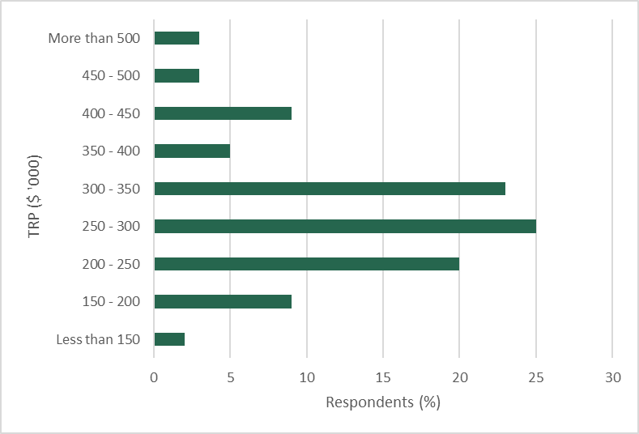

Number of responses = 64

CEOs were asked to identify their industry segment. Reflecting the distribution of prescribed public entities by industry segment, around 40 per cent of CEOs who responded to the questionnaire were from the water and land management industry segment, 16 per cent were from the regulators and other agencies segment and 13 per cent were from the sport, recreation, arts and facilities management segment (figure B.2).84F[78] As there was an uneven distribution in the industry segments that respondents came from, some industry segments may be represented to a greater extent in the questionnaire results than others.

Figure B.2: CEO responses – industry segment

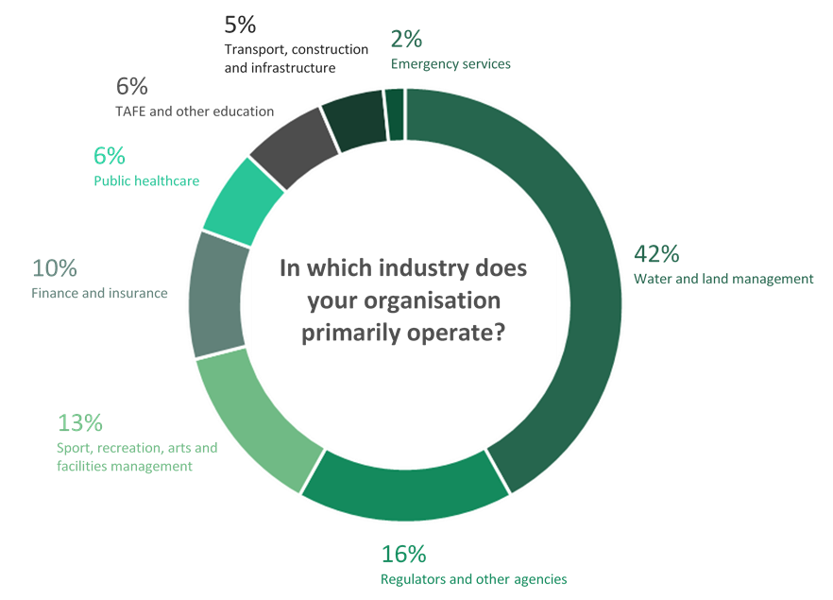

Number of responses = 62

CEOs were asked to identify their primary role or responsibility. The highest responses were for project and program implementation and delivery (both recording around 30 per cent of responses), followed by regulatory (11 per cent). Approximately 20 per cent of CEOs chose ‘other’, and specified finance and insurance, strategic leadership and business management roles in this category (figure B.3).

Some 44 per cent of respondents had been an executive in the public sector for less than 5 years. Another 16 per cent had been an executive in the public sector for between 5 and 9 years, while 41 per cent had been an executive for over   
10 years (figure B.4)

Figure B.3: CEO responses – primary work stream

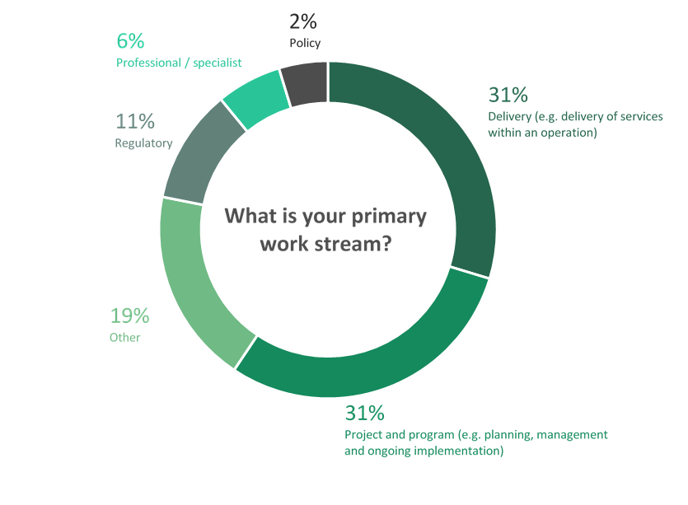

Number of responses = 62

Figure B.4: CEO responses – length of executive tenure



Number of responses = 64

CEOs were asked to identify their role immediately prior to their current role. Figure B.5 shows that the most common responses were:

* executive in the Victorian public sector (excluding the VPS): 28 per cent of respondents
* executive in the private, for-profit sector: 14 per cent
* executive in the private, not-for-profit sector: 11 per cent.

Figure B.5: CEO responses – immediate prior role

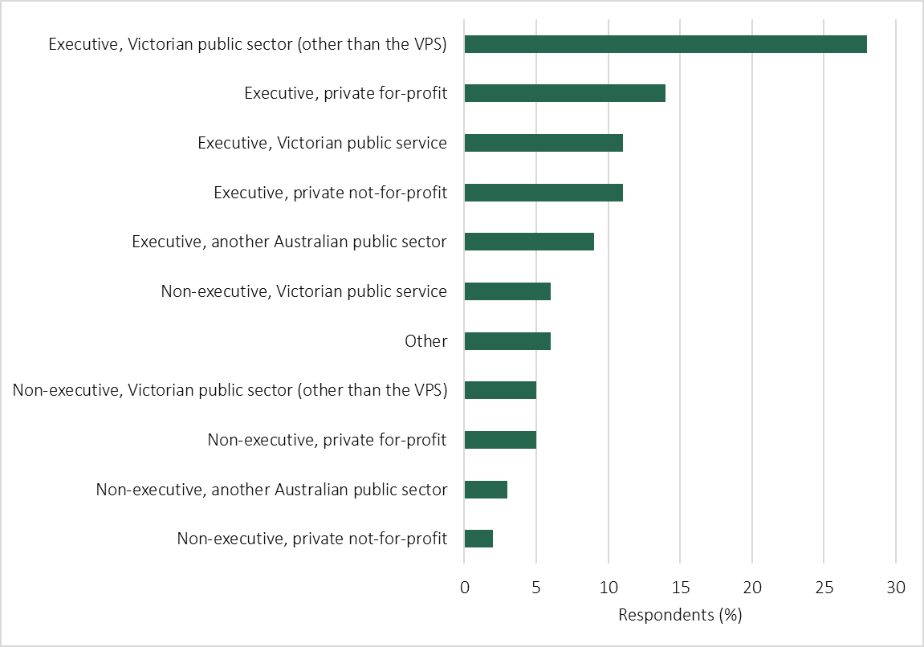

Number of responses = 64

Motivation

CEOs were asked to identify their motivation for applying for their current role. Respondents were able to list multiple motivating factors.

Around 30 per cent of respondents cited the opportunity to progress their career as a key motivating factor for applying for their current role — taking on a CEO, or equivalent, role was considered the natural progression in their career. Others also noted that the role matched their ambitions and offered a new challenge. For example, an executive from the water and land management industry segment said they were motivated by the:

Challenge of leading a new public sector organization providing essential services to urban communities in regional Victoria.

And another CEO from the same industry segment noted:

The challenge [the role] presents and the contribution to the community.

The ability to drive change and increase value for the community were cited as key motivations for around 20 per cent of respondents. A respondent from the water and land management industry segment noted that they took the role due to the:

Clear evidence that work makes a difference to the region.

And another noted the:

Opportunity offered by the position to have societal impact.

The nature of the work or the opportunity presented by the role was also identified as a motivating factor for around 15 per cent of respondents. Respondents cited the opportunity to establish and lead a new organisation, to develop a strategy, and the desire to lead a team as relevant examples of this motivation. For example, an executive from the sport, recreation, arts and facilities management industry segment noted:

The challenge of leading a cultural institution during a period of reform, transformation and change. The opportunity to utilize my commercial, people leadership and stakeholder management skills in an environment where I could have a direct and positive outcome was attractive.

Some 13 per cent of respondents were attracted to working for their specific organisation, while five per cent took on their role due to the location. Around two per cent of executives reported that remuneration was a motivating factor.

CEOs were also asked how important remuneration was to their decision to apply for their current role.

Around 75 per cent of respondents said remuneration was ‘somewhat important’ to their decision, while 19 per cent said it was ‘most important’. Only around six per cent said that it was ‘least important’ (figure B.6).

Figure B.6: CEO responses – importance of remuneration in applying for role

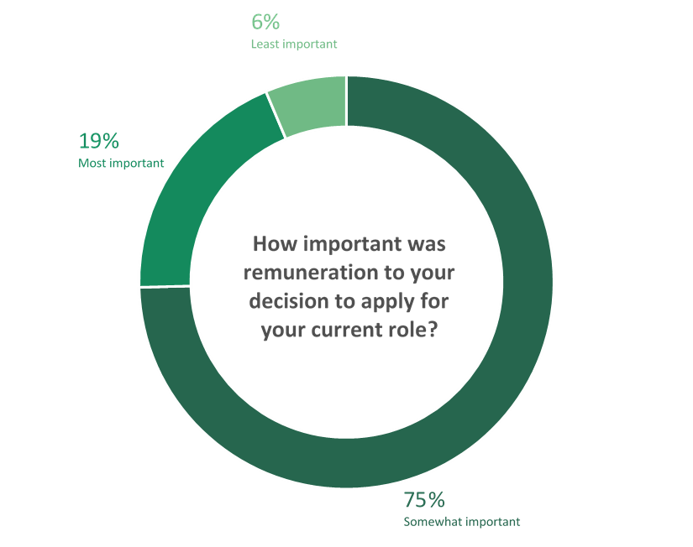

Number of responses = 63

Trends, or significant changes over the last five years

Executives were asked to comment on the trends or significant changes over the last five years that have affected their role.

Approximately 25 per cent of executives reported an increase in work associated with greater regulation and compliance attestation in their industry.

A CEO from the water and land management industry segment noted the:

Increased regulation and control in some areas.

An executive in the public healthcare industry segment said there was:

Greater levels of reporting to government in relation to financial, record keeping frameworks, Ministerial statements of expectations.

Eighteen per cent of respondents identified an increase in the complexity of their work. A respondent from the water and land management industry segment stated there are:

Significant complexities in the operating environment including climate change, policy parameters, increasing customer and community expectations, pressure to keep prices competitive, increasing ethical/integrity standards and increasing regulation.

Budget pressures were also cited by around 10 per cent of respondents as having significant impacts on their role. For example, an executive from the TAFE and other education industry segment noted:

Continued budget cuts over the last decade… Funding has not changed for a decade in fact has declined…

Eight per cent of respondents reflected that changing expectations of the community were also affecting their role. An executive from the regulators and other agencies industry segment noted the:

Community expectations for transparency and active communication to maintain trust and confidence.

Eight per cent of CEO respondents also noted that there has been increased competition for executive talent in the labour market. An executive from the finance and insurance industry segment noted:

Significant pressure on external labour market to gain qualified staff at the executive level (including diversity options).

Views on current executive remuneration arrangements

CEOs were asked to provide their views on public entity executive remuneration arrangements, for example, the competitiveness of remuneration structures in attracting and retaining suitable executives in a public sector context.

Around half of respondents said that the existing remuneration levels are not competitive against the general market, and in some cases are a barrier to attracting and retaining the highest quality candidates. A CEO from the water and land management industry segment said it is:

Becoming more difficult to compete for quality applicants outside the public sector due to wage levels.

And another noted that in their organisation:

All director positions became vacant at various time in the past two years. None could be filled with the best candidate identified through recruitment due to uncompetitive remuneration.

Several respondents noted that Victorian public entity remuneration is below that of the remuneration offered in other jurisdictions, such as New South Wales. An executive from the regulators and other agencies industry segment stated:

Significantly less remuneration [is offered] compared to counterparts in NSW and QLD.

Some CEOs also noted that the existing remuneration framework is particularly challenging when recruiting for roles in regional Victoria. For example, an executive from the water and land management industry segment noted:

There is a need to consider remuneration within regional Victoria, as it is often more difficult to attract/recruit to the regions compared with Metropolitan areas.

Around 15 per cent of respondents expressed satisfaction or were content with the level of remuneration they were receiving. For example, an executive from the finance and insurance industry segment said:

Remuneration structures are, in general, working adequately to ensure attraction and retention of suitable executives.

And another from the water and land management industry segment stated:

For me, generally comparable although a little lower (in relative terms) to what I was getting for a similar role [overseas].

Twelve per cent of respondents stated that remuneration was insufficient. A respondent from the water and land management industry segment noted:

Remuneration is less than the current bandings and I have asked the Committee of Management to review - the pay rates for this position have not changed in 10 years.

Around 17 per cent of respondents also noted other concerns with the existing remuneration framework, including a lack of transparency and equity between public entities and government departments, the removal of bonus arrangements and the rigidity of the remuneration framework.

Relevant factors and comparators

CEOs were asked about what they would consider to be relevant factors and comparators for informing the Determination of remuneration bands, and for determining relativities between bands.

Around 30 per cent of respondents stated that the complexity of the role should be considered as a factor for determining remuneration. For example, a CEO working in the public healthcare industry segment said:

Executive remuneration should reflect the complexity of the role in all areas as proposed, rather than having the major focus on the resource level for the entity. As a CEO of a small statutory authority, the role complexity spans lower and mid tiers of current executive remuneration bands. The size of the entity currently determines that the remuneration will be in the lower band.

Similarly, a CEO in the TAFE and other education industry segment suggested the Determination:

Needs to consider the complexity of the organisation and not place as much emphasis/weighting solely on size of an organisation. All TAFEs have the same responsibility regardless of size and in fact there may be an argument that the smaller the organisation the more difficult the CEO and Exec roles are as they don't have the budget capacity to employ specialist[s] required to meet all expectations.

And another CEO from the sport, recreation, arts and facilities management industry segment suggested that the:

Complexity of the role and its operating environment should be considered alongside size and commerciality...

Many of the respondents also identified that the breadth and the responsibilities of individual roles should be considered when setting remuneration. For example, an executive from the water and land management industry segment stated:

… the breadth of responsibilities for the executives within organisations, and the proportion of those responsibilities that sit with the particular executives, should be considered.

Around 20 per cent of respondents proposed the market competitiveness for executives, including specific skills, as a relevant factor, while around eight per cent recommended the Tribunal take into account comparable organisations and roles when considering the remuneration bands. Approximately five per cent of respondents also suggested other jurisdictions as relevant comparators. For example, an executive in the finance and insurance industry segment suggested:

Interstate & Commonwealth comparisons are relevant, as are private sector rates. While Victoria does not need to be the market leader in terms of payments, remuneration should be in a close band with other major states.

Thirteen per cent of respondents also suggested that organisational context is an important factor, taking into account factors such as the number of staff, budget, operating environment and the entity’s location.

Future career intentions

CEOs were asked about their career intentions over the next five years.

Around 50 per cent of respondents stated that they were likely to remain an executive in a Victorian public sector organisation, and a further five per cent indicated they would likely move to an executive role in another Australian public sector.

Around 11 per cent of respondents indicated an intention to take on an executive role in the for-profit private sector and 10 per cent said they were likely to move to an executive role in the not-for-profit sector.

Some three per cent of respondents said they were intending to retire, and 8 per cent identified ‘other’ career intentions (for example, moving overseas). Finally, another 10 per cent responded that they were unsure about their future career intentions (figure B.7).

Figure B.7: CEO responses – future career intentions



Number of responses = 62

Of the CEOs who indicated they intend to leave the Victorian public sector, around 40 per cent said that remuneration was the most important factor. Some 48 per cent stated that it was somewhat important, while for around 13 per cent remuneration was the least important consideration (figure B.8).

Figure B.8: CEO responses – importance of remuneration to intention to leave

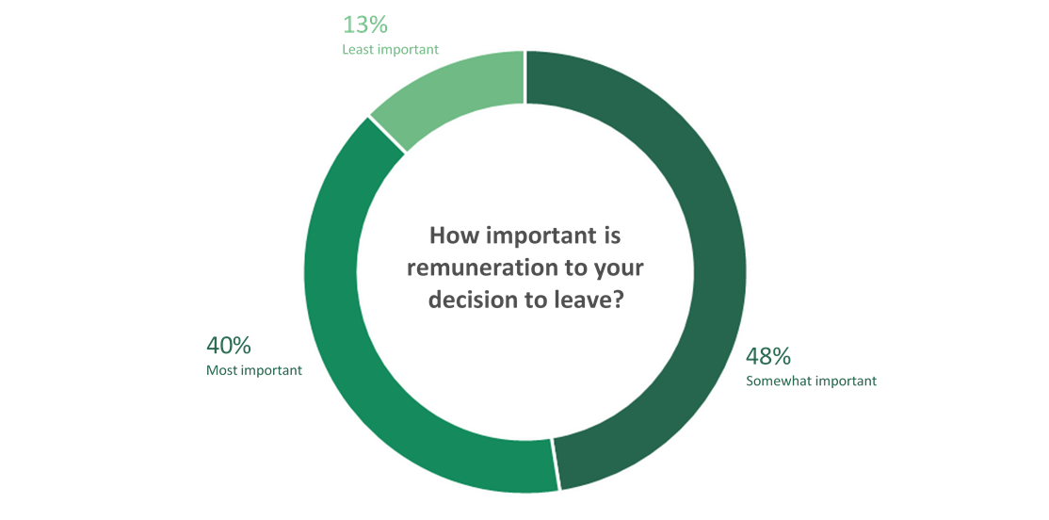

Number of responses = 40

Questions in relation to subordinate executives

CEOs have a dual role in the remuneration framework. They are employees subject to the framework, as well as employers of subordinate executives. The Tribunal sought to understand how CEOs view the remuneration framework in the context of employing executives.

CEOs were asked to nominate the prior experience they value the most when hiring new executives to their organisation. Respondents could select up to three options from five pre-filled answers or nominate ‘other’ and type in an alternative response. The most common response from the pre-filled options was ‘private, for-profit sector’, followed by ‘Victorian public sector body other than public service body’. CEOs that wrote in an alternative response discussed a variety of qualities that they valued including:

* skills and experience specific to the role or industry
* leaderships skills and potential
* a broad range of experience across multiple sectors (rather than experience in a specific sector).

The results, expressed as a percentage of all responses, are shown in table B.1.

Table B.1: CEO responses – most valued prior experience when hiring subordinate executives

|  |  |
| --- | --- |
| Choice of response | Responses (%) |
| Private for-profit sector | 26 |
| Other | 24 |
| Victorian public sector body other than public service body | 20 |
| Victorian public service body (department, Administrative Office or VPSC) | 12 |
| Public sector in another Australian jurisdiction | 11 |
| Private not-for-profit sector (e.g. academia) | 7 |

CEOs were also asked about the influence remuneration has on attracting and retaining talent to their organisation.

CEOs were asked about whether existing remuneration arrangements are sufficient to attract and retain executives. Approximately 55 per cent believed existing arrangements are ‘somewhat sufficient’, while around 38 per cent chose the option of ‘not sufficient’. Only eight per cent of respondents said the existing arrangements are ‘sufficient’ (figure B.9).

Figure B.9: CEO responses – sufficiency of remuneration arrangements to attract and retain talent

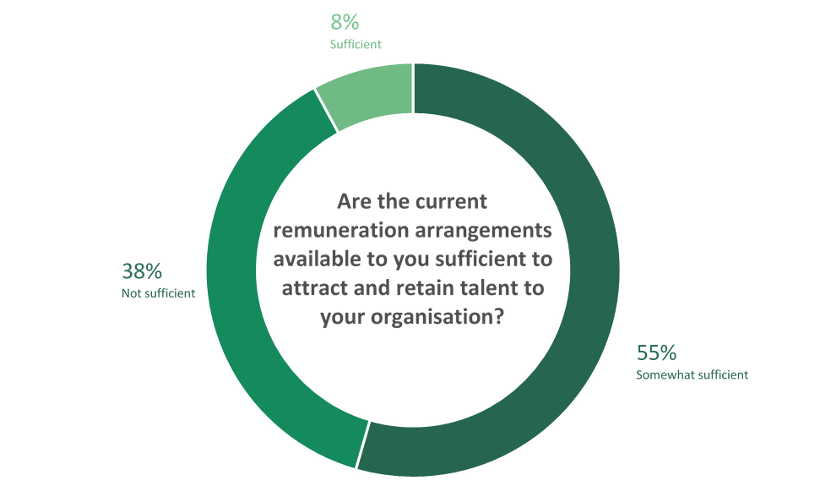

Number of responses = 53

Around 58 per cent of CEOs believed that remuneration is the ‘most important’ factor in attracting talent to their organisation, while 42 per cent believed it is only ‘somewhat important’. No CEO selected ‘least important’ as their answer.

CEOs were also asked how important remuneration is to the decision of their subordinate executives to leave their role. Some 55 per cent said it was ‘somewhat important’, while 30 per cent believe it is the ‘most important factor’ (figure B.10).

Figure B.10: CEO responses – importance of remuneration on decisions by subordinate executives to leave their role

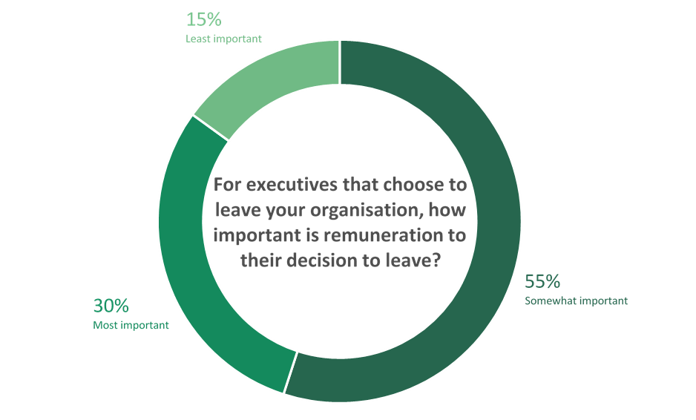

Number of responses = 53

B.2 Subordinate executive questionnaire

The questionnaire sought to understand the roles and responsibilities of subordinate executives and their motivations, gather views on executive remuneration and identify how current arrangements could be improved.

There were 104 respondents who identified as a subordinate executive (Q1). These respondents were asked the following questions:

Q2. What is your total remuneration package per annum?

Q3. In which industry does your organisation primarily operate?

Q4. What is your primary work stream?

Q5. How long have you been an executive in the Victorian public sector?

Q6. What was your role immediately prior to your current role?

Q7. What motivated you to apply for your current role?

Q8. How important was remuneration to your decision to apply for your current role, relative to other considerations (e.g. relocation, interest in field, other employment conditions)?

Q9. Please provide comment on any trends, or significant changes over the last five years, that affect your role.

Q10. Please provide your views on executive remuneration, for example, the competitiveness of remuneration structures in attracting and retaining suitable executives in a public sector context.

Q11. What do you consider to be relevant factors and comparators for informing the determination of remuneration bands for executives in Victorian public entities, and for determining the relativities between them?

Q12. What are your future career intentions (next five years)?

Q13. If you have indicated that you intend to leave the Victorian public sector in the next five years, how important is remuneration to your decision to leave, relative to other considerations?

Q14. Please provide any other comment or feedback in relation to your role, or the remuneration of public entity executives, that you consider relevant to inform the Tribunal's deliberations.

Characteristics of respondents

The characteristics of subordinate executive respondents are summarised in the data and figures presented below.

Subordinate executives were asked to indicate their TRP per annum. Figure B.11 shows that:

* approximately two-thirds of subordinate executives reported a TRP of $250,000 or less
* around 20 per cent of TRPs were between $250,001 and $300,000 per annum
* 7 per cent reported a TRP of between $300,001 and $350,000 per annum
* 7 per cent reported a TRP above $350,000 per annum.

Figure B.11: Subordinate executive responses – current TRP per annum

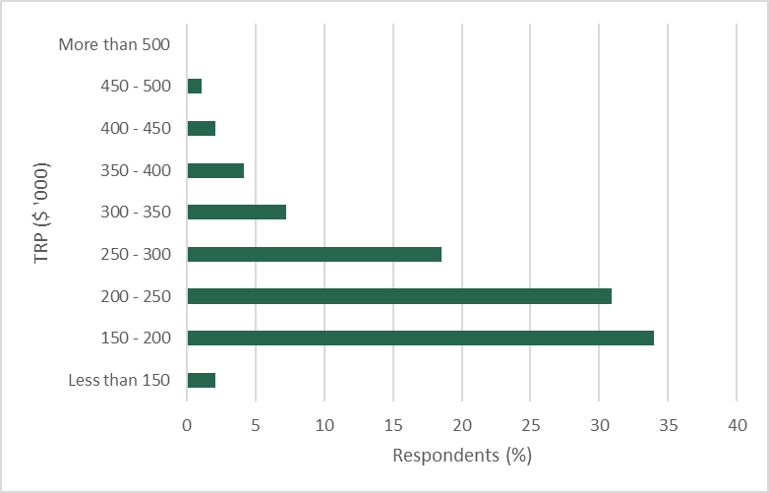

Number of responses = 97

Of the subordinate executives who responded, 34 per cent worked in the water and land management industry segment, while 22 per cent worked in the finance and insurance sector. Twenty-one per cent worked in the regulators and other agencies industry segment, and another 11 per cent worked in the transport, construction and infrastructure sector. Other industries included: TAFE and other education (seven per cent); emergency services (three per cent); and public healthcare (two per cent) (figure B.12). As there was an uneven distribution in the industry segments that respondents came from, some industry segments may be represented to a greater extent in the questionnaire results than others.

Subordinate executives were asked to identify their primary role or responsibility. The highest responses were for delivery (37 per cent), professional/specialist roles (29 per cent), project and program implementation (17 per cent) and regulatory (7 per cent). Other roles identified included communications and human resources (figure B.13).

Figure B.12: Subordinate executive responses – industry segment

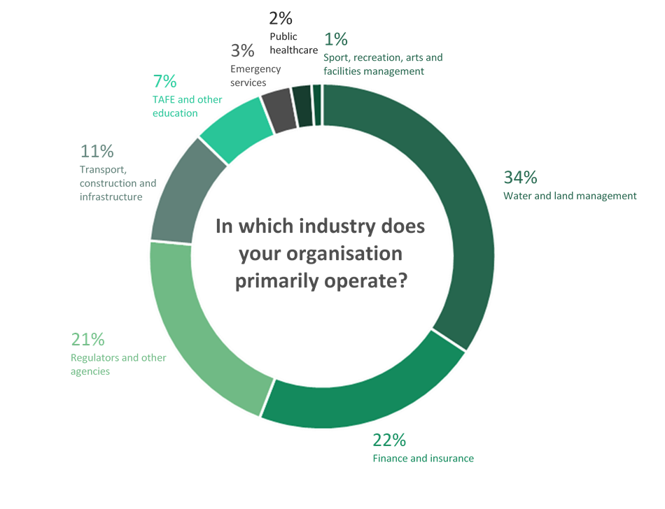

Number of responses = 102

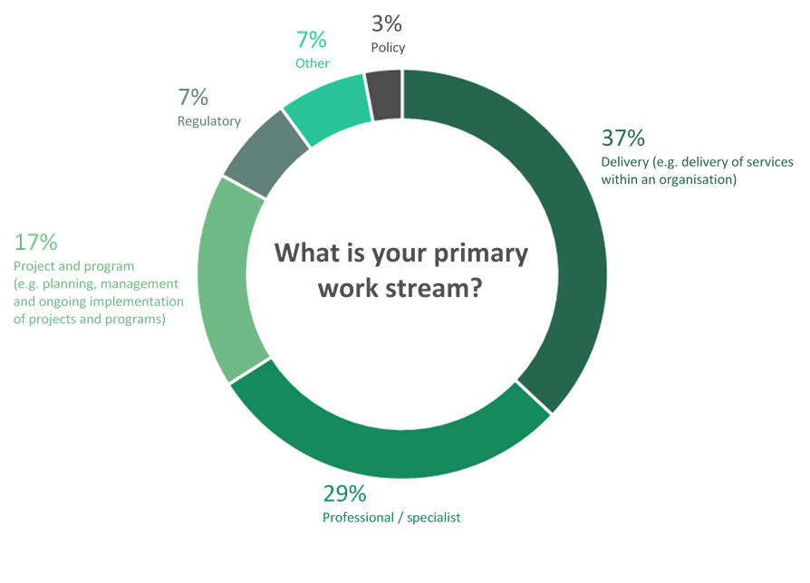Figure B.13: Subordinate executive responses – primary work stream

Number of responses = 103

Some 54 per cent of respondents had been an executive for less than five years. Another 26 per cent had been an executive for between five and nine years, and 20 per cent had been an executive for over 10 years (figure B.14).

Figure B.14: Subordinate executive responses – length of executive tenure



Number of responses = 104

Respondents were asked to identify their role immediately prior to their current role. Figure B.15 shows that the most common responses were:

* non-executive in a Victorian public sector organisation: 25 per cent
* executive in the private, for-profit sector: 22 per cent
* executive in the Victorian public sector (other than the VPS): 17 per cent.

Figure B.15: Subordinate executive responses – immediate prior role

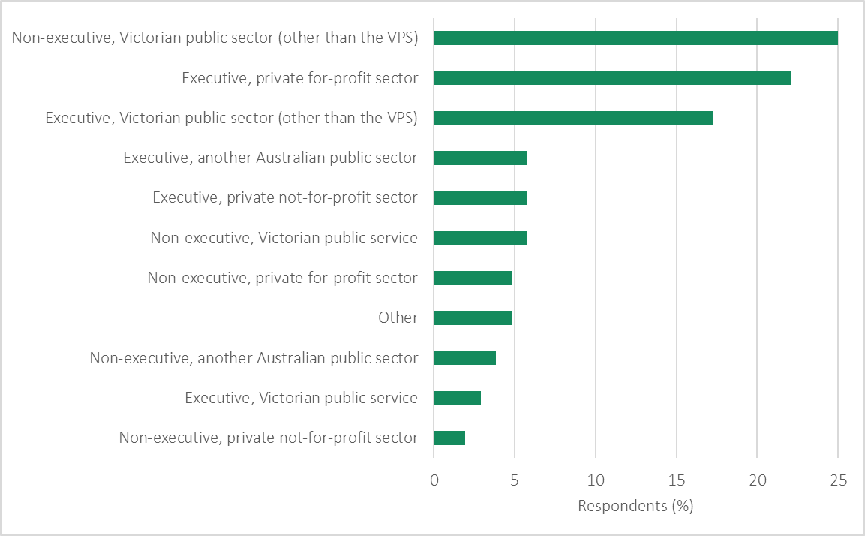

Number of responses = 104

Motivation

Around 20 per cent of subordinate executive respondents cited the nature of the role or work as a key motivating factor for applying for an executive role. In this regard, respondents referred to the challenge and complexity of the work and the opportunity to work in a government organisation. For example, one executive stated:

Nature of the role was attractive. The role draws upon a very diverse and nuanced set of leadership and managerial skills and competencies, with regular stretch opportunities.

And another executive from the water and land management industry segment noted that the role offered an:

Opportunity to be part of a growing organisation with challenges and issues not faced before.

An executive from the regulators and other agencies industry segment also said that they were attracted to the expanded scope of the role:

Move from a business unit level of focus and responsibility to an enterprise wide function.

Similarly, another executive from the water and land management industry segment noted that they were motivated to apply for the role by the:

Increased accountabilities and diversity of works program.

Around 18 per cent of responses also cited the work of their organisation as a key motivating factor. One transport, construction and infrastructure industry segment executive referred to the:

Opportunity to work with an organisation that has a very specific mission and overall objectives… and providing a level of service to the Victorian community that has real meaning.

And another executive noted:

The opportunity to be a custodian for an important global biodiversity collection and the premier collection in Australia. The opportunity to develop and enhance the value of this collection and increase the accessibility and usability of this collection for environmental and conservation decisions.

Career progression was identified as a motivating factor for 18 per cent of respondents. For example, an executive from the water and land management industry segment stated they were motivated to apply for their role for:

Progression in career, and the impact the role has on the provision of services to the broader community. It makes a difference.

And another water and land management industry segment executive noted the role offered:

Promotion to Executive Level, reporting into the MD with greater accountability in a fast moving transformational [entity].

Approximately 15 per cent of respondents saw the opportunity to make a difference in their community as an important reason for seeking their current role. For example, one executive working in the TAFE and other education industry segment was drawn to the opportunity:

To make a difference to the lives of individuals and families in our community at scale.

And another executive from the finance and insurance industry segment commented:

… I wanted an opportunity to use the leadership and technical skills developed over many years in the private sector for a more fulfilling purpose…

Other factors cited by respondents included:

* a desire to try something new
* better work-life balance
* leadership and/or management dimension of the new role
* unhappiness in their previous role
* re-location or geographical location.

Executives were also asked how important remuneration was to their decision to apply for their current role. Around 70 per cent of respondents said remuneration was ‘somewhat important’ to their decision, while 22 per cent said it was ‘most important’. Only around seven per cent said that it was ‘least important’ (figure B.16).

Figure B.16: Subordinate executive responses – importance of remuneration to apply for role

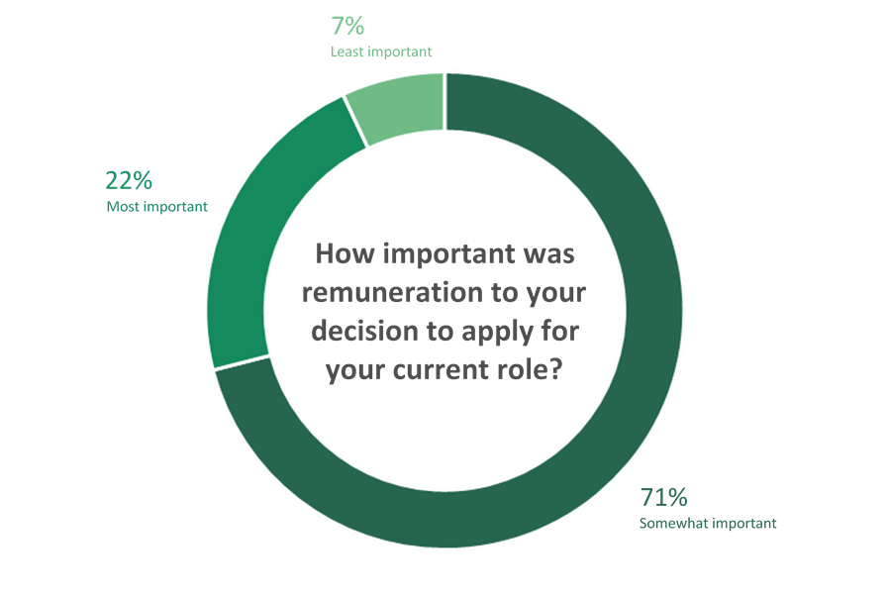

Number of responses = 103

Trends, or significant changes over the last five years

Executives were asked to comment on the trends or significant changes over the last five years that have affected their role.

Seventeen per cent of executives stated that the scope and complexity of their roles have changed over the last five years. For example, one executive working in the transport, construction and infrastructure industry segment said:

The role has doubled in size and has become [a] far greater risk due to the complexities caused by the massive build program.

And another from the water and land management industry segment commented:

My Accountabilities and Responsibilities have significantly increased in the time I have been employed at my [entity]…

Seventeen per cent of respondents also noted that there has been an increase in competition for executives over the last five years. One executive from the transport, construction and infrastructure industry segment noted:

The market for construction talent is strong and getting the best people is a big challenge.

Similarly, another from the same industry segment stated that:

The Big Build has made the job market hot and the remuneration being offered in the private sector is making attraction and retention to the public sector increasing challenging.

Some subordinate executives reported that they are expected to deliver commercial quality services, but with greater transparency and sometimes small budgets. For example, a respondent from the finance and insurance industry segment commented:

The ongoing financial pressures and need to drive efficiency dividends back to government has placed strains on the ability to maintain services and continue to be financially independent from central government.

Subordinate executives also noted that there has been an increase in the level of oversight from the ‘centre of government’ and increased scrutiny from agencies such as the Victorian Ombudsman and Victorian Auditor-General’s Office. In some cases, this increased scrutiny takes time away from the ‘core’ business of the entity.

Around 10 per cent of respondents reported that the skills required for executives have changed. In particular, subordinate executives reported that they are increasingly required to demonstrate greater commercial capability. As one executive from the water and land management industry segment noted, they are now required to have skills not traditionally expected in their role:

... I am expected to bring a broad enterprise, business and commercial view and experience beyond my professional and technical expertise.

And another respondent from the water and land management industry segment stated:

… the commercial acumen required is becoming more and more important…

Other trends identified by respondents included:

* higher levels of staff turnover
* increased pace of work
* great demand placed on executives to deliver services and projects.

Views on current executive remuneration arrangements

Subordinate executives were asked to provide their views on public entity executive remuneration, for example, the competitiveness of remuneration structures in attracting and retaining suitable executives.

Roughly half of subordinate executives who responded to the Tribunal’s questionnaire said they don’t believe the current remuneration arrangements are competitive.

Several respondents reported they had taken a reduction in their remuneration when moving from their prior private-sector roles to their current public entity role. For example, an executive from the water and land management industry segment said:

The remuneration package is not competitive with private industry, both on fixed term or short/long term pay (I've moved from ASX twice, and took a 40% pay cut first time and 120% pay cut second time round).

And another executive from the same industry noted similar outcomes when moving between roles in a regional setting:

There was a significant (>20%) reduction in remuneration in moving to the public sector in a regional setting from the private sector also in a regional setting.

Many respondents also suggested that uncompetitive levels of remuneration affected the public sector’s ability to attract talent from the private sector. For example, an executive from the water and land management industry segment commented:

The VIC public service is not competitive with similar roles in the private sector, reducing the ability to attract Good external talent to these positions.

Several executives said that while there may be interest from external talent to join their organisation, the quality of the candidates was low due to uncompetitive remuneration. For example, a respondent from the water and land management industry segment noted that there is an:

Inability to source talent with the critical leadership and technical skills at the public sector remuneration level as financially individuals would be worse off.

And another respondent from the same industry said:

The remuneration structure is not competitive - as a result when we are faced with the need to bring in experienced executives… [with the] skills required to run and transform commercial, regulated and customer-centric businesses, we are sadly lacking as the current structure does not allow us to compete for the best.

Retention of executives sourced from the private sector was also of concern for some respondents. An executive from the finance and insurance industry segment noted:

All of the executive of this organisation came from the private commercial sector and none have moved into public sector roles when they have left… public sector roles need [to] allow for an appropriate level of remuneration to maintain the current standard of organisational performance.

Fifteen per cent of respondents said that the executive remuneration structure for public entities must align, either with the entity’s relevant private market comparators or across the public sector. Reasons given for this included to ensure the attraction and retention of appropriately skilled executives and to allow ‘cross‑pollination’ between public sector organisations.

Thirteen per cent of respondents believed that their remuneration is adequate, although many noted that it is low compared to the private sector and some other public sector roles. For example, an executive from the water and land management industry segment stated:

The job is relatively well-paid compared to community standards. The jobs are varied, interesting and challenging…

Eight per cent of respondents noted that the non-salary benefits offered by working in the public sector can, at least partially, offset the lower remuneration. An executive working in the transport, construction and infrastructure industry segment stated:

… the balance of remuneration and community service is complex given the ability to work in [the] private sector and be rewarded at a significantly higher overall rate… versus providing a positive community service and seeing the benefits of those services as a real difference to our community. The outcome of achieving positive change and outcomes is very satisfying, but must be weighed up against the attractiveness of private sector offered remuneration to be considered.

And another executive from the finance and insurance industry segment noted:

Salaries continue to be below private sector roles, however, offset by social good and work life balance.

However, for some respondents, these non-salary benefits did not outweigh the low remuneration offers. A respondent from the water and land management industry segment stated:

We spend considerable time promoting the non monetary benefits of the organisation. Feedback though is that the lower remuneration is a barrier to attract private sector candidates.

Similarly, one TAFE and other education industry segment executive commented:

Increasingly Exec remuneration has fallen behind private sector but without any permanency of employment which previously compensated for lower rem.

Other issues raised by respondents included:

* compression of relativities between non-executive and executive remuneration
* the removal of bonus opportunities from public entity executive contracts
* rigidity of executive remuneration policy compared to the private sector.

Relevant factors and comparators

Subordinate executives were asked what they would consider to be relevant factors and comparators for informing the Determination of remuneration bands, and for determining relativities between bands.

Around 30 per cent of respondents said that the ‘market’ should be taken into consideration when setting the remuneration bands. When referring to the ‘market’ most respondents appeared to be suggesting that the appropriate comparators for consideration are similar roles in private sector organisations. For example, an executive from the regulators and other agencies segment said:

Regard must be had to the remuneration provided in the private sector for those with the skills and experience required for the public sector roles. Using law as an example… regard must be had to the market rates of those firms in that sector of the legal marketplace from which the potential applicants will be drawn. There are different 'markets' for different types of skills and experience within a profession - not all areas of law can be considered comparable.

For many respondents, the importance of the ‘market’ as a factor was due to the increasing demand in the public sector for skills that are traditionally developed in the private sector. This demand is leading to greater competition for talent and as such, entities must be able to offer competitive remuneration. For example, a respondent from the transport, construction and infrastructure industry segment noted that entities need:

The ability to attract and retain the capability required to manage risk and deliver outcomes. This capability is commercial in nature and requires higher, market competitive remuneration.

And another executive from the same industry commented:

It needs to be acknowledged that the Big Build is causing the battle for quality staff [to be] lost to the private sector, if we want the best and the brightest to manage the delivery we need to [be] agile and able to respond to the market.

An executive from the water and land management industry segment believed there should be:

Comparison to similar roles in the private sector as there is no difference between managing large organisations in either the private or public sector.

Around 12 per cent of respondents believed that the accountabilities and responsibilities of the role should be an important factor for informing the Determination. Similarly, approximately 11 per cent of executives said that the ‘size of the role’ should be take into account.

Some 10 per cent of respondents indicated that the complexity of the role should be an important factor for informing remuneration bands. Skills, relativity with other roles in the organisation, experience, risk and location were other factors identified for determining the value of the remuneration bands.

Future career intentions

Subordinate executives were asked about their career intentions over the next five years. Approximately 40 per cent of subordinate executives who answered the question intend to remain an executive in a Victorian Government entity. Some 30 per cent said they intend to seek an executive role in private for-profit sector.

Thirteen per cent of respondents were unsure about their future career intentions, while six per cent reported intending to move to an executive role in another Australian jurisdiction. Finally, some four per cent of respondents nominated other career intentions and four per cent indicated that they would seek executive roles in the private not-for-profit sector (figure B.17).

Figure B.17: Subordinate executive responses – future career intentions



Number of responses = 104

Of those executives who indicated they intend to leave the Victorian public sector, nearly half (49 per cent) said that remuneration was ‘somewhat important’ to their decision, while 46 per cent said that it was the ‘most important’ reason for their decision. Only 4 per cent reported that it was ‘least important’ (figure B.18).

Figure B.18: Subordinate executive responses – importance of remuneration on decision by leave role

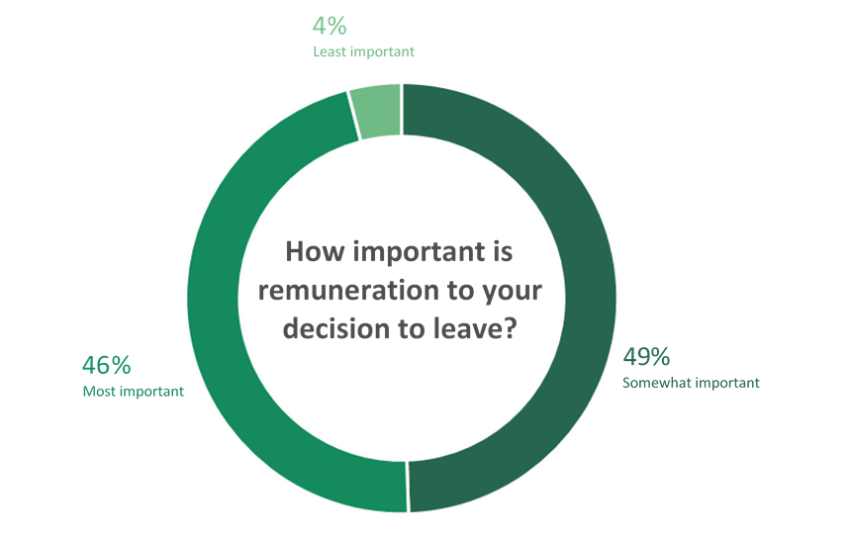

Number of responses = 71

1. This figure excludes a small number of executives employed under Part 3 of the *Public Administration Act 2004* (Vic).
2. A total remuneration package threshold has been used to determine whether an employee is considered a subordinate executive. In 2018, the PEER Policy refined the definition and increased the total remuneration package threshold, restoring the historical link to the base of the VPS executive remuneration bands. This resulted in some employees reported as ‘executives’ in previous years being excluded from the June 2019 and 2020 data collections.
3. VPSC, *Executive Workforce Reform – Industry Segment Reviews: Final Report* (State Government of Victoria: Melbourne, Victoria, February 2020), 9.
4. Victorian Ombudsman, ‘A Review of the Governance of Public Sector Boards in Victoria’, December 2013, 14.
5. ABS, A*ustralian Demographic Statistics,* cat. no. 3101.0, 31 March 2020.
6. Department of Treasury and Finance (DTF), 'Budget Paper No.2,' *Victorian Budget 2020/21* (State Government of Victoria: Melbourne, Victoria, November 2020).
7. DTF, 'Budget Paper No.2,' *Victorian Budget 2020/21*.
8. VPSC, *Executive Workforce Reform – Industry Segment Reviews: Final Report*, 20.
9. VPSC, *Serving Victoria: A Guide for Public Sector CEOs*, last updated 11 June 2015, https://vpsc.vic.gov.au/resources/serving-victoria/.
10. VPSC, *Legal Form and Governance Arrangements for Public Entities* (State Government of Victoria: Melbourne, Victoria, May 2013).
11. VPSC, *Executive Workforce Reform – Industry Segment Reviews: Final Report*, 31.
12. VPSC, *The State of the Public Sector in Victoria 2018-2019* (State Government of Victoria: Melbourne, Victoria, March 2020).
13. Entities that are designated as special bodies under section 6 of the PAA, such as Victoria Police, are also out of scope of this Determination.
14. VPSC, *The State of the Public Sector in Victoria 2018-2019*; the data excludes entities which are not prescribed for the purposes of this Determination.
15. VPSC, *The State of the Public Sector in Victoria 2018-2019;* data excludes entities which are not prescribed for the purposes of this Determination.
16. Under the *Firefighters' Presumptive Rights Compensation and Fire Services Legislation Amendment (Reform) Act 2019* (Vic), the Metropolitan Fire and Emergency Services Board was abolished and replaced by Fire Rescue Victoria from 1 July 2020.
17. VPSC, *Executive Workforce Reform – Industry Segment Reviews: Final Report*, 24.
18. VPSC, *Executive Workforce Reform – Industry Segment Reviews: Final Report,* 4.
19. VPSC, *Victorian Public Entity Executive Handbook* (State Government of Victoria: Melbourne, Victoria, 2020).
20. VPSC, *Serving Victoria: A Guide for Public Sector CEOs*.
21. See submissions from Grampians Wimmera Mallee Water Corporation, North East Waste and Resource Recovery Group and TAFE Gippsland.
22. See for example submissions from Goulburn Valley Water (oral submission) and Victorian Water Industry Association.
23. See for example submission from Bendigo Kangan Institute.
24. See for example submissions from North East Waste and Recovery Group and Goulburn Ovens Institute of TAFE.
25. See for example submissions from Australian Grand Prix Corporation and Melbourne and Olympic Parks Trust.
26. VPSC, *The State of the Public Sector in Victoria 2017-2018*.
27. Rebecca George, Alex Massey, Adam King, Ed Roddis, ‘A new mindset for public sector leadership*’, Deloitte Insights,* June 2019.
28. VPSC, *Victorian Public Entity Executive Employment Handbook* (State Government of Victoria: Melbourne, Victoria, February 2019).
29. VPSC, public entity executive data collection, 30 June 2020.
30. VPSC, *The State of the Public Sector in Victoria 2018-2019.*
31. While the GSERP bands provided guidance for pre-approved ranges, public entities were still required to make a submission before employing a CEO.
32. VPSC, *Executive Workforce Reform – Industry Segment Reviews: Final Report*, 39-44.
33. VPSC, *Executive Workforce Reform – Industry Segment Reviews: Final Report*, 39-40.
34. VPSC, *Victorian Public Entity Executive Employment Handbook,* 21.
35. VPSC, *Victorian* *Public Entity Executive Employment Handbook*, 22.
36. VPSC, *Victorian Public Entity Executive Employment Handbook*, 13-14.
37. Victorian Public Service Enterprise Agreement 2016 [AG2016/2919].
38. VPS Determination, 87.
39. VPS Determination, 93.
40. Data on AAWIs was provided by the Commonwealth Attorney-General’s Department using the Workplace Agreements Database. Data on the AAWI was available for 67 of the 95 enterprise agreements that applied to prescribed public entities and were reviewed by the Tribunal.
41. ABS, *Average Weekly Earnings, Australia*, cat. no. 6302.0, May 2020.
42. See for example submissions from Yarra Valley Water Corporation, City West Water Corporation, Country Fire Authority and Emergency Services Telecommunications Authority.
43. VPS Determination, 62 and 108.
44. Victorian Skills Commissioner, *Skills demand snapshot — Victoria’s Rail Infrastructure Sector*, (State Government of Victoria: Melbourne, Victoria, February 2020); Victorian Skills Commissioner, *Skills demand snapshot — Victoria’s Civil Sector* (State Government of Victoria: Melbourne, Victoria, March 2020).
45. Department of Employment, Skills, Small and Family Business of the Commonwealth Australia, ‘ANZSCO 1331-11 Construction Project Manager – Australia’*, Skills shortages* (Commonwealth Government of Australia: Canberra, Australian Capital Territory, April 2019).
46. Hays, *FY2020/21 Salary Guide Australia and New Zealand*, 2020.
47. Submissions from the Victorian Water Industry Association and Yarra Valley Water Corporation.
48. Includes some executives who separated to move to another agency but excludes movements due to Machinery‑of‑Government changes; VPSC, ‘Staff turnover’, *Public sector workforce data sets,* https://vpsc.vic.gov.au/data-and-research/workforce-data-and-reports.
49. ABS, *Participation, Job Search and Mobility, Australia*, cat.no. 6226.0, February 2020.
50. VPS Determination, 64.
51. Submissions from Bendigo Kangan Institute and Country Fire Authority.
52. ABS, *Australian National Accounts: National Income, Expenditure and Product*, cat. no. 5206.0, September 2020.
53. ABS, *Australian National Accounts: National Income, Expenditure and Product*, cat. no. 5206.0, September 2020.
54. RBA, *Statement on Monetary Policy,* (Sydney, New South Wales, November 2020).
55. Treasury of the Commonwealth of Australia, ‘Budget Paper No. 1,’ *Budget 2020-21* (Commonwealth Government of Australia: Canberra, Australian Capital Territory, October 2020).
56. DTF, 'Budget Paper No.2,' *Victorian Budget 2020/21.*
57. ABS, *Consumer Price Index, Australia*, cat. no. 6401.0, June 2020.
58. ABS, *Consumer Price Index, Australia*, cat. no. 6401.0, June 2020.
59. ABS, *Wage Price Index, Australia,* cat. no. 6345.0, June 2020.
60. DTF, 'Budget Paper No.2,' *Victorian Budget 2020/21.*
61. ABS, *Average Weekly Earnings*, *Australia,* cat. no. 6302.0, May 2020.
62. ABS, ‘Spotlight - increases in average weekly earnings - compositional changes during the COVID-19 period’, *Average Weekly Earnings, Australia*, cat. no. 6302.0, May 2020.
63. Victorian Auditor-General’s Office, *Auditor-General’s Report on the Annual Financial Report of the State of Victoria: 2019-20* (Melbourne, Victoria: Victorian Auditor-General's Office, November 2020), 1.
64. DTF, 'Budget Paper No.2,' *Victorian Budget 2020/21,* 67.
65. Victorian Independent Remuneration Tribunal, *Matters being considered by the Tribunal in the making of its Determination of remuneration bands for executives employed in prescribed public entities* (Victorian Independent Remuneration Tribunal: Melbourne, Victoria, 2020), 3.
66. VPSC, *Executive Workforce Reform – Industry Segment Reviews: Final Report*, 8.
67. See for example Goulburn Valley Water Corporation submission.
68. Victorian Independent Remuneration Tribunal, ‘Summary of remote round table discussions with public entities’.
69. VPS Determination, 77.
70. PEER Policy.
71. The VPS Determination also included bands for department Secretaries and the VPSC Commissioner. However, these roles are not in scope of the VPS executive classification framework.
72. For example, in the ISR Final Report, the VPSC noted that comparisons are of limited value as in other jurisdictions public entity executives are often employed under public service arrangements, or under a classification and remuneration framework that aligns with the public service arrangements.
73. VPSC, *Executive Workforce Reform – Industry Segment Reviews: Final Report*, 39.
74. VPSC, *Executive Workforce Reform – Industry Segment Reviews: Final Report*, 34.
75. For example, the salary range for the VPS STS-7 classification ($166,390 to $226,292 per annum excluding employer superannuation) under the VPS Agreement (as at March 2020) overlaps with the range of the SES-1 band ($192,800 - $249,700 including employer superannuation).
76. Victorian Public Service Enterprise Agreement 2016 [AG2016/2919].
77. Metropolitan Fire and Emergency Services Board, United Firefighters Union of Australia, Operational Staff Agreement 2016 [AG2018/1278].
78. As shown in chapter 2, there are 51 public entities from the water and land management segment in scope of the Determination, 28 from the regulators and other agencies segment, and 23 from the sport, recreation, arts and facilities management segment.