

## Overview

As part of its response to the recommendations of the Royal Commission into Family Violence, the Victorian Government outlined a staged process for the introduction of mandatory qualifications for specialist family violence practitioners in the 10-year industry plan for family violence prevention and response.

The new mandatory minimum qualification requirement will oblige funded services to require specialist family violence practitioners to hold a social work or equivalent degree from 1 July 2021.

There will be a five-year transition period for the workforce to meet the new mandatory minimum qualifications. The policy will exclude specialist family violence practitioners employed before 1 July 2021, recognising their continuous service including when changing employers, or when taking carers’, parental or long service leave.

1. **Key messages**
2. **Suggested articles for print or online publications**
3. **Letter template for staff**
4. **Sample Facebook/LinkedIn posts**
5. **Sample Twitter posts**
6. **Tile images – Facebook**
7. **Tile images – Twitter**
8. **Email signature**
9. **LinkedIn banner**

## Key messages

* We’re strengthening the family violence sector in Victoria by setting a new professional standard for specialist family violence practitioners working in response roles.
* A new mandatory minimum qualification requirement will apply to specialist family violence practitioners entering the workforce from 1 July 2021.
* The current workforce is exempt from the new requirement. This is in recognition of the specialist skills, practice, deep knowledge and diverse experience already in the sector.
* The Victorian Government is supporting employers, current and new practitioners through the change with advice and information. Employers will still decide how they wish to recruit and who is best suited to their organisation.
* Practitioners who are exempt from the new requirement will maintain the exemption for the length of their continuous service.

## Suggested articles for print or online publications

### Article 1 – Approx. 100 words

Since the [Royal Commission into Family Violence](https://www.vic.gov.au/about-royal-commission-family-violence) published its 227 recommendations in 2016, the family violence sector and the Victorian Government have worked together to drive remarkable change and create opportunity across many areas.

From 1 July 2021 and across a five year transition period a new Mandatory minimum qualifications policy will apply to specialist family violence practitioners entering the workforce.

The current workforce is exempt from the new requirement. This is in recognition of the specialist skills, practice, deep knowledge, and diverse experience already in the sector.

Find out more about what this means for you at [www.vic.gov.au/mandatory-minimum-qualifications-specialist-family-violence-practitioners](http://www.vic.gov.au/mandatory-minimum-qualifications-specialist-family-violence-practitioners)

### Article 2 - Approx. 200 words

Since the [Royal Commission into Family Violence](https://www.vic.gov.au/about-royal-commission-family-violence) published its 227 recommendations in 2016, the family violence sector and the Victorian Government have worked together to drive remarkable change and create opportunity across many areas.

The Royal Commission called for the introduction of mandatory minimum qualifications for specialist family violence response practitioners ([Recommendation 209](https://www.vic.gov.au/family-violence-recommendations/introduce-mandatory-qualifications-specialist-family-violence)) to strengthen the sector and equip Victoria’s dedicated specialist family violence practitioners to provide support and responses that are consistently high quality and culturally appropriate.

Recognising the scale of the change, as well as the specialised skills, deep knowledge and diverse experience of the current workforce, the Victorian Government outlined a five-year transition period to a mandatory minimum qualification requirement beginning 1 July 2021.

The five-year transition period will give people starting their careers as specialist family violence practitioners a number of options for meeting the new mandatory minimum qualification requirements while balancing work and life commitments.

The existing workforce will be exempt from the requirements but can choose to take advantage of new professional development pathways.

The Victorian Government is supporting employers, current and new practitioners through the change with advice and information. Employers will still decide how they wish to recruit and who is best suited to their organisation.

Find out more about what this means for you at [www.vic.gov.au/mandatory-minimum-qualifications-specialist-family-violence-practitioners](http://www.vic.gov.au/mandatory-minimum-qualifications-specialist-family-violence-practitioners)

### Article 3 – Approx. 300 words

Since the [Royal Commission into Family Violence](https://www.vic.gov.au/about-royal-commission-family-violence) published its 227 recommendations in 2016, the family violence sector and the Victorian Government have worked together to drive remarkable change and create opportunity across many areas.

The Royal Commission called for the introduction of mandatory minimum qualifications for specialist family violence response practitioners ([Recommendation 209](https://www.vic.gov.au/family-violence-recommendations/introduce-mandatory-qualifications-specialist-family-violence)) to strengthen the sector and equip Victoria’s dedicated specialist family violence practitioners to provide support and responses that are consistently high quality, culturally appropriate and inclusive.

Recognising the scale of the change, as well as the specialised skills, deep knowledge and diverse experience of the current workforce, the Victorian Government outlined a five-year transition period to a mandatory minimum qualification requirement beginning 1 July 2021.

Achieving the mandatory minimum qualification requirement should never prevent anyone from entering or staying in the sector, particularly people who have faced barriers to education. People who bring significant cultural knowledge or lived experience (for example, of disability, migrant or refugee experience, or family violence) will have 10 years from the date of their employment as a specialist family violence practitioner to work towards a minimum or equivalent qualification, subject to agreement with their employer. This will be an ongoing option available beyond the five-year transition period, reflecting the crucial role people with significant cultural knowledge or lived experience play in the sector.

The five-year transition period will give people starting their careers as specialist family violence practitioners a number of options for meeting the new mandatory minimum qualification requirements while balancing work and life commitments. The existing workforce will be exempt from the requirements but can choose to take advantage of new professional development pathways.

The Victorian Government is supporting employers, current and new practitioners through the change with advice and information. Employers will still decide how they wish to recruit and who is best suited to their organisation.

Find out more about what this means for you at [www.vic.gov.au/mandatory-minimum-qualifications-specialist-family-violence-practitioners](http://www.vic.gov.au/mandatory-minimum-qualifications-specialist-family-violence-practitioners)

## Letter template for staff

### Staff email

Colleagues,

Since the [Royal Commission into Family Violence](https://www.vic.gov.au/about-royal-commission-family-violence) published its 227 recommendations in 2016, the family violence sector and the Victorian Government have worked together to drive remarkable change and create opportunity across many areas.

Over the next five years a new Mandatory minimum qualifications policy will be introduced, and will apply to specialist family violence practitioners entering the workforce from 1 July 2021.

**Key dates**

From **1 July 2021** a five-year transition period will begin. During that time, new specialist family violence practitioners employed in a Victorian Government-funded organisation must:

* hold a minimum of a Bachelor of Social Work or equivalent qualification, or
* be working towards meeting the new mandatory minimum qualification policy requirement if they are employed based on their significant cultural knowledge and experience, or lived experience
* be working towards meeting the new mandatory minimum qualification policy requirement if they have at least five years of experience in a relevant field or hold a related qualification. The pathway is available only during the 5-year transition period

The five-year transition period will give people starting their careers as specialist family violence practitioners a number of options for meeting the new mandatory minimum qualification requirements while balancing work and life commitments.

The existing workforce will be exempt from the requirements but can choose to take advantage of new professional development pathways.

The Victorian Government is supporting employers, current and new practitioners through the change with advice and information.

Additional resources with more information and frequently asked questions are available at [www.vic.gov.au/mandatory-minimum-qualifications-specialist-family-violence-practitioners](http://www.vic.gov.au/mandatory-minimum-qualifications-specialist-family-violence-practitioners)

Kind regards

xxxxxxxx

## Sample Facebook/LinkedIn posts

### Post 1: Facebook/LinkedIn – approx. 50 words

Over the next five years the Victorian Government is introducing a new mandatory minimum qualification policy for people who enter the family violence sector as a specialist family violence practitioner from 1 July 2021.

The Victorian Government is supporting employers, current and new practitioners through the change with advice and information.

For more information visit <https://go.vic.gov.au/z0KGhv> #familyviolencereform

### Post 2: Facebook/LinkedIn – approx. 50 words

Do you employ people in the specialist family violence sector? Over the next five years the Victorian Government is setting a new professional standard for people who enter the workforce from 1 July 2021. Find out what this means for your workplace and what support is available:  <https://go.vic.gov.au/z0KGhv> #familyviolencereform

### Post 3: Facebook/LinkedIn – approx. 80 words

Over the next five years, the Victorian Government is setting a new professional standard to help keep people experiencing family violence safer. A new mandatory minimum qualification policy will apply to specialist family violence practitioners who enter the workforce from 1 July 2021.

Anyone who entered the workforce before this date is exempt from the requirement for the duration of their continuous service but may choose to take advantage of new professional development pathways. Find out more: <https://go.vic.gov.au/z0KGhv> #familyviolencereform

### Post 4: Facebook/LinkedIn – approx. 100 words

Are you a student thinking about a career in family violence? Over the next five years the Victorian Government is introducing a new mandatory minimum qualification policy for people who enter the family violence sector as a specialist family violence practitioner from 1 July 2021.

If you have already completed a qualification or on your way to completing, you may be closer than you think to achieving this standard.

Find out what these changes mean for your career path and how you can build on what you’re already studying: <https://go.vic.gov.au/z0KGhv> #familyviolencereform

### Post 5: LinkedIn – approx. 120 words

The Victorian Government is introducing a new mandatory minimum qualification policy for people who enter the family violence sector as a specialist family violence practitioner from 1 July 2021.

From 1 July 2021 a five-year transition period will begin. During that time, new specialist family violence practitioners employed in a Victorian Government-funded organisation must:

* hold a Bachelor of Social Work or equivalent qualification, or
* be working towards meeting the new mandatory minimum qualification policy requirement via one of the available employment pathways

The current workforce is exempt from the new requirement. This is in recognition of the specialist skills, practice, deep knowledge, and diverse experience already in the sector.

For more information visit <https://go.vic.gov.au/z0KGhv> #familyviolencereform

## Sample Twitter Posts

### Post 1: Twitter – 254 characters

Over the next 5 years, #VicGov is introducing a new mandatory minimum qualification policy for people who enter the #familyviolence sector as a specialist family violence practitioner from 1 July 2021. More info: <https://go.vic.gov.au/z0KGhv>

### Post 2: Twitter – 258 characters

Are you a student thinking about a career in family violence? Over the next 5 years, #VicGov is setting a new professional standard for the formal skills & knowledge that you’ll need. Find out what this means for you: <https://go.vic.gov.au/z0KGhv>

### Post 3: Twitter – 276 characters

#VicGov is setting a new professional standard to keep people experiencing #familyviolence safer. A mandatory minimum qualification policy will apply to specialist family violence practitioners entering the workforce from 1 July 2021. <https://go.vic.gov.au/z0KGhv>

### Post 4: Twitter – 275 characters

Do you employ people in the specialist family violence sector? Over the next 5 years, #VicGov is setting a new professional standard for people who enter the workforce from 1 July 2021. Find out more: <https://go.vic.gov.au/z0KGhv>

## Images

### Tile image - Facebook

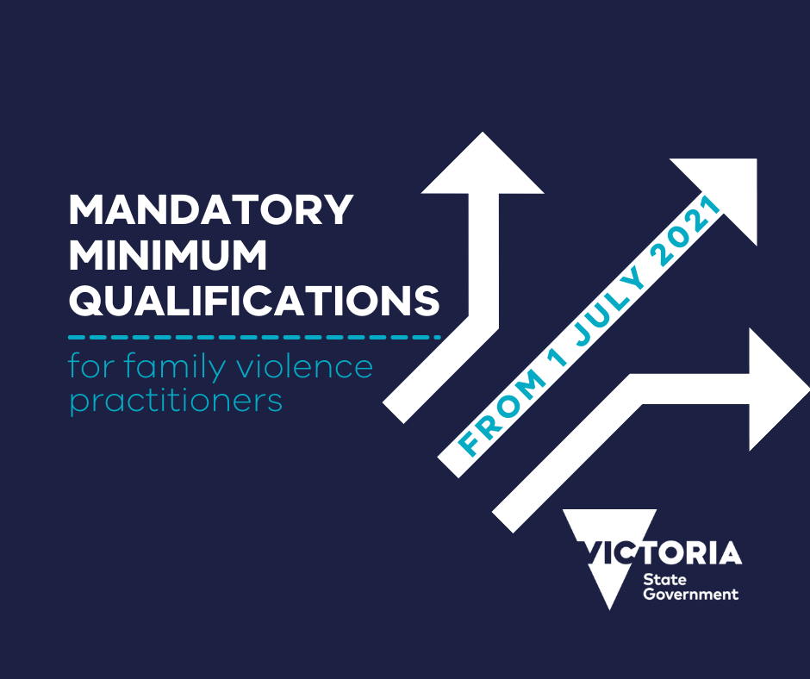

**Tile image - Twitter**

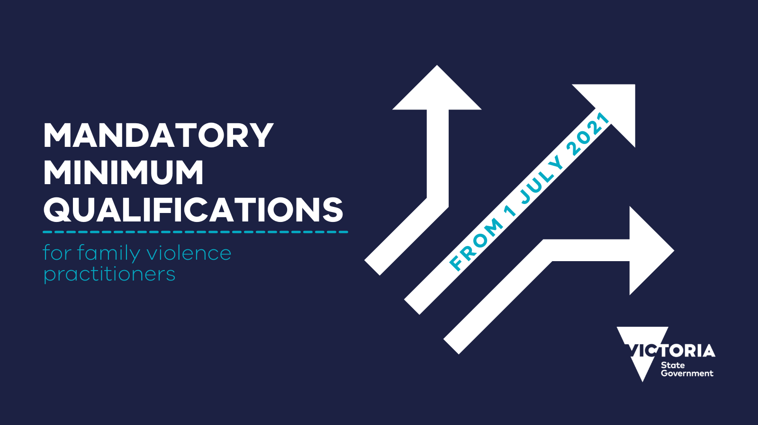

### Email signature

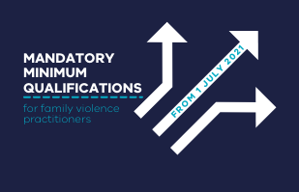

### LinkedIn banner

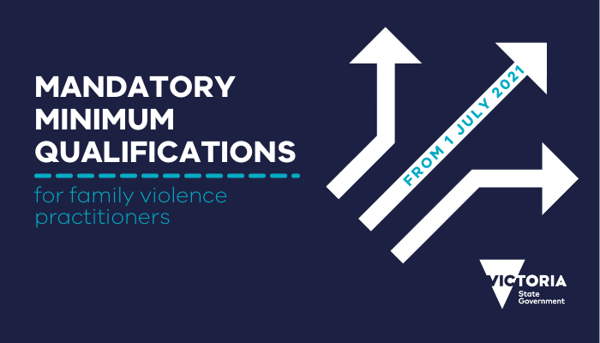

|  |
| --- |
| To receive this publication in an accessible format, email communications@familysafety.vic.gov.au  Authorised and published by the Victorian Government, 1 Treasury Place, Melbourne.  © State of Victoria, Department of Family, Fairness and Housing April 2021.  Available at <https://www.vic.gov.au/mandatory-minimum-qualifications-specialist-family-violence-practitioners> |