Department of Education and Training
Higher Education and Skills Group
Participation, Inclusion and Regional Engagement — Branch Memo
TO: Registered Learn Local providers — ALL
Statewide providers
ACFE Board
ACFE Regional Councils
Learn Local stakeholders
PIRE Branch staff
FROM: Joanne Favretto, A/Director — Participation, Inclusion and Regional Engagement Branch
DATE: 18/05/2021
SUBJECT: Reminder - Nominate now for the 2021 Learn Local Awards

Actions / Critical Dates:
- Nominate now for the 2021 Learn Local Awards. Key information, nomination guide available at: www.vic.gov.au/learn-local-awards
- New Nomination Decision Chart available to help you choose which award category to nominate for.

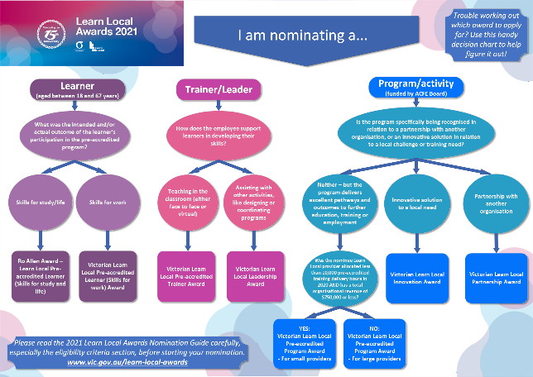
Nominate now for the 2021 Learn Local Awards
We’re ready to receive your nominations for this year’s Learn Local Awards! This year is the 15th anniversary of the Awards and to celebrate there is:
- Increased prize money
- New and refreshed award categories
- A winner and up to three finalists in each Award category.
We have also developed a new Nomination Decision Chart to help you choose which award category to nominate for (see preview to the right, a larger version is available at the end of this memo).
The 2021 Learn Local Awards are proudly brought to you by the Adult, Community and Further Education (ACFE) Board to recognise and reward the outstanding achievements of individuals, programs and training providers within the Learn Local sector.

Free Nomination Assistance
Not sure where to begin? Contact the Learn Local Awards team to enquire about FREE professional assistance with your nomination: learnlocal@education.vic.gov.au

Prize pool and award categories
This year there are eight general awards with a total prize pool of up to $84,000.
For learners
1. The Ro Allen Award – Learn Local Pre-accredited Learner (Skills for study and life)
2. Victorian Learn Local Pre-accredited Learner (Skills for work) Award
The winner of each award will receive $5,000. Up to three finalists for each award will each receive $1,000.

For trainers and leaders
3. Victorian Learn Local Pre-accredited Trainer Award
4. Victorian Learn Local Leadership Award
The winner of each award will receive $5,000. Up to three finalists for each award will each receive $1,000.
For Learn Local programs
5. Victorian Learn Local Pre-accredited Program Award (For small provider)
6. Victorian Learn Local Pre-accredited Program Award (For large provider)
7. Victorian Learn Local Innovation Award
8. Victorian Learn Local Partnerships Award
The winner of each award will receive $10,000. Up to three finalists for each award will receive $1,000. The winner of the Victorian Learn Local Partnership Award will receive $10,000 (to be shared by all parties). Up to three finalists for this award will each receive $1,000 (to be shared by all parties).
Further information on all categories is available on the Learn Local Awards website: www.vic.gov.au/learn-local-awards

Nomination process
The Nomination Guide (which includes the selection criteria and other information such as tips on what the judges are looking for in nominations) is available from the Learn Local Awards website. Please read this document carefully before you start your nomination.
Each general award category has its own nomination form. This year we have introduced word limits on each of the selection criteria to help guide the level of response that is expected by the judges.
All nominations are to be submitted via the online nomination portal. All you have to do is register to nominate and then follow the step by step process. Nominations can only be submitted via this portal: https://lla.awardsplatform.com/

Start your nomination today!
For more information and to make a start, visit: www.vic.gov.au/learn-local-awards

