## Appendix 4: Workforce data

### Comparative data

#### Table 1: Details of DPC employment levels in 2021 and 2020

|  |  | June 2021 | | | | | | | June 2020 | | | | | | |
| --- | --- | --- | --- | --- | --- | --- | --- | --- | --- | --- | --- | --- | --- | --- | --- |
| All employees | | Ongoing | | | Fixed-term and casual | | All employees | | Ongoing | | | Fixed-term and casual | |
| Number (headcount) | FTE | Full-time (headcount) | Part-time (headcount) | FTE | Number (headcount) | FTE | Number (headcount) | FTE | Full-time (headcount) | Part-time (headcount) | FTE | Number (headcount) | FTE |
| Demographic data | Gender | | | | | | | | | | | | | | |
| Men | 379 | 370.6 | 235 | 12 | 244.1 | 132 | 126.5 | 381 | 369.2 | 248 | 19 | 261.8 | 114 | 107.4 |
| Women | 585 | 553.9 | 319 | 79 | 375.8 | 187 | 178.1 | 685 | 643.8 | 379 | 113 | 461.1 | 193 | 182.7 |
| Self-described | 2 | 2.0 | 2 | 0 | 2.0 | 0 | 0.0 | 4 | 3.6 | 2 | 2 | 3.6 | 0 | 0.0 |
| Age | | | | | | | | | | | | | | |
| 15–24 | 37 | 34.6 | 16 | 0 | 16.0 | 21 | 18.6 | 38 | 33.6 | 14 | 1 | 14.2 | 23 | 19.4 |
| 25–34 | 325 | 316.6 | 174 | 13 | 182.9 | 138 | 133.7 | 387 | 375.9 | 228 | 25 | 246.2 | 134 | 129.7 |
| 35–44 | 326 | 311.8 | 186 | 44 | 219.0 | 96 | 92.8 | 356 | 334.6 | 202 | 69 | 253.4 | 85 | 81.2 |
| 45–54 | 176 | 167.4 | 104 | 25 | 122.1 | 47 | 45.3 | 181 | 172.0 | 110 | 27 | 129.4 | 44 | 42.6 |
| 55–64 | 83 | 78.1 | 64 | 8 | 69.1 | 11 | 9.0 | 90 | 85.4 | 65 | 10 | 71.9 | 15 | 13.5 |
| 65+ | 19 | 18.0 | 12 | 1 | 12.8 | 6 | 5.2 | 18 | 15.1 | 10 | 2 | 11.4 | 6 | 3.7 |
| Classification data | VPS grades 1–6 | | | | | | | | | | | | | | |
| VPS 1 | 6 | 6.0 | 0 | 0 | 0.0 | 6 | 6.0 | 3 | 3.0 | 0 | 0 | 0.0 | 3 | 3.0 |
| VPS 2 | 16 | 13.1 | 9 | 1 | 9.4 | 6 | 3.7 | 24 | 19.9 | 10 | 1 | 10.4 | 13 | 9.5 |
| VPS 3 | 103 | 98.7 | 67 | 8 | 72.6 | 28 | 26.1 | 118 | 112.4 | 73 | 13 | 81.4 | 32 | 31.0 |
| VPS 4 | 213 | 209.8 | 125 | 8 | 130.8 | 80 | 79.0 | 253 | 245.9 | 154 | 15 | 164.8 | 84 | 81.1 |
| VPS 5 | 306 | 292.0 | 150 | 36 | 176.6 | 120 | 115.4 | 307 | 290.6 | 161 | 52 | 200.2 | 94 | 90.4 |
| VPS 6 | 190 | 179.6 | 101 | 27 | 120.0 | 62 | 59.6 | 217 | 205.1 | 123 | 34 | 147.4 | 60 | 57.7 |
| Senior employees | | | | | | | | | | | | | | |
| Secretary | 1 | 1.0 | 1 | 0 | 1.0 | 0 | 0.0 | 1 | 1.0 | 1 | 0 | 1.0 | 0 | 0.0 |
| Executives(1) | 74 | 71.7 | 60 | 10 | 67.7 | 4 | 4.0 | 93 | 88.3 | 70 | 18 | 83.5 | 5 | 4.8 |
| STS | 22 | 21.6 | 11 | 1 | 11.8 | 10 | 9.8 | 17 | 16.8 | 4 | 1 | 4.8 | 12 | 12.0 |
| Legal officers | 0 | 0.0 | 0 | 0 | 0.0 | 0 | 0.0 | 0 | 0.0 | 0 | 0 | 0.0 | 0 | 0.0 |
| PS | 0 | 0.0 | 0 | 0 | 0.0 | 0 | 0.0 | 0 | 0.0 | 0 | 0 | 0.0 | 0 | 0.0 |
| SMA | 0 | 0.0 | 0 | 0 | 0.0 | 0 | 0.0 | 0 | 0.0 | 0 | 0 | 0.0 | 0 | 0.0 |
| SRA | 0 | 0.0 | 0 | 0 | 0.0 | 0 | 0.0 | 0 | 0.0 | 0 | 0 | 0.0 | 0 | 0.0 |
| Casual | 3 | 1.0 | 0 | 0 | 0.0 | 3 | 1.0 | 4 | 0.6 | 0 | 0 | 0.0 | 4 | 0.6 |
| Other | 32 | 32.0 | 32 | 0 | 32.0 | 0 | 0.0 | 33 | 33.0 | 33 | 0 | 33.0 | 0 | 0.0 |
| Total employees | **966** | **926.5** | **556** | **91** | **621.9** | **319** | **304.6** | **1,070** | **1,016.6** | **629** | **134** | **726.5** | **307** | **290.1** |

Legend: FTE: full-time equivalent; STS: senior technical specialists; PS: principal scientists; SMA: senior medical advisers; SRA: senior regulatory analysts.

Note:

(1) As at 30 June 2021, 15 employees were acting as a senior employee (Executive) for more than three months (one VPS-5 and 14 VPS-6) and are not included in the Executive data.

#### Table 2: Details of Office of the Chief Parliamentary Counsel employment levels in 2021 and 2020

|  |  | June 2021 | | | | | | | June 2020 | | | | | | |
| --- | --- | --- | --- | --- | --- | --- | --- | --- | --- | --- | --- | --- | --- | --- | --- |
| All employees | | Ongoing | | | Fixed-term and casual | | All employees | | Ongoing | | | Fixed-term and casual | |
| Number (headcount) | FTE | Full-time (headcount) | Part-time (headcount) | FTE | Number (headcount) | FTE | Number (headcount) | FTE | Full-time (headcount) | Part-time (headcount) | FTE | Number (headcount) | FTE |
| Demographic data | Gender | | | | | | | | | | | | | | |
| Men | 13 | 12.5 | 10 | 1 | 10.8 | 2 | 1.7 | 16 | 14.8 | 14 | 0 | 14.0 | 2 | 0.8 |
| Women | 30 | 24.5 | 14 | 11 | 20.4 | 5 | 4.1 | 33 | 27.0 | 18 | 11 | 24.2 | 4 | 2.8 |
| Self-described | 0 | 0.0 | 0 | 0 | 0.0 | 0 | 0.0 | 0 | 0.0 | 0 | 0 | 0.0 | 0 | 0.0 |
| Age | | | | | | | | | | | | | | |
| 15–24 | 0 | 0.0 | 0 | 0 | 0.0 | 0 | 0.0 | 0 | 0.0 | 0 | 0 | 0.0 | 0 | 0.0 |
| 25–34 | 9 | 8.4 | 5 | 2 | 6.4 | 2 | 2.0 | 12 | 12.0 | 11 | 0 | 11.0 | 1 | 1.0 |
| 35–44 | 17 | 14.4 | 8 | 6 | 11.8 | 3 | 2.6 | 15 | 11.7 | 7 | 8 | 11.7 | 0 | 0.0 |
| 45–54 | 9 | 7.4 | 6 | 3 | 7.4 | 0 | 0.0 | 10 | 8.3 | 6 | 2 | 6.9 | 2 | 1.4 |
| 55–64 | 6 | 5.7 | 5 | 0 | 5.0 | 1 | 0.7 | 8 | 6.8 | 6 | 0 | 6.0 | 2 | 0.8 |
| 65+ | 2 | 1.1 | 0 | 1 | 0.6 | 1 | 0.5 | 4 | 3.0 | 2 | 1 | 2.6 | 1 | 0.4 |
| Classification data | VPS grades 1–6 | | | | | | | | | | | | | | |
| VPS 1 | 0 | 0.0 | 0 | 0 | 0.0 | 0 | 0.0 | 0 | 0.0 | 0 | 0 | 0.0 | 0 | 0.0 |
| VPS 2 | 1 | 1.0 | 1 | 0 | 1.0 | 0 | 0.0 | 1 | 1.0 | 1 | 0 | 1.0 | 0 | 0.0 |
| VPS 3 | 7 | 6.2 | 2 | 1 | 2.6 | 4 | 3.6 | 6 | 5.2 | 3 | 1 | 3.4 | 2 | 1.8 |
| VPS 4 | 5 | 4.0 | 3 | 2 | 4.0 | 0 | 0.0 | 7 | 6.0 | 5 | 1 | 5.4 | 1 | 0.6 |
| VPS 5 | 7 | 5.8 | 4 | 3 | 5.8 | 0 | 0.0 | 4 | 3.5 | 3 | 1 | 3.5 | 0 | 0.0 |
| VPS 6 | 4 | 3.6 | 2 | 1 | 2.6 | 1 | 1.0 | 4 | 3.6 | 3 | 1 | 3.6 | 0 | 0.0 |
| Senior employees | | | | | | | | | | | | | | |
| Administrative Office Head(1) | 1 | 1.0 | 1 | 0 | 1.0 | 0 | 0.0 | 0 | 0.0 | 0 | 0 | 0.0 | 0 | 0.0 |
| Executives | 3 | 3.0 | 3 | 0 | 3.0 | 0 | 0.0 | 4 | 4.0 | 4 | 0 | 4.0 | 0 | 0.0 |
| STS | 3 | 2.2 | 1 | 0 | 1.0 | 2 | 1.2 | 4 | 3.0 | 2 | 0 | 2.0 | 2 | 1.0 |
| Legal officers | 12 | 10.2 | 7 | 5 | 10.2 | 0 | 0.0 | 18 | 15.3 | 11 | 7 | 15.3 | 0 | 0.0 |
| PS | 0 | 0.0 | 0 | 0 | 0.0 | 0 | 0.0 | 0 | 0.0 | 0 | 0 | 0.0 | 0 | 0.0 |
| SMA | 0 | 0.0 | 0 | 0 | 0.0 | 0 | 0.0 | 0 | 0.0 | 0 | 0 | 0.0 | 0 | 0.0 |
| SRA | 0 | 0.0 | 0 | 0 | 0.0 | 0 | 0.0 | 0 | 0.0 | 0 | 0 | 0.0 | 0 | 0.0 |
| Casual | 0 | 0.0 | 0 | 0 | 0.0 | 0 | 0.0 | 1 | 0.2 | 0 | 0 | 0.0 | 1 | 0.2 |
| Other | 0 | 0.0 | 0 | 0 | 0.0 | 0 | 0.0 | 0 | 0.0 | 0 | 0 | 0.0 | 0 | 0.0 |
| Total employees | **43** | **37.0** | **24** | **12** | **31.2** | **7** | **5.8** | **49** | **41.8** | **32** | **11** | **38.2** | **6** | **3.6** |

Legend: FTE: full-time equivalent; STS: senior technical specialists; PS: principal scientists; SMA: senior medical advisers; SRA: senior regulatory analysts.

Note:

(1) Before 2020–21, Administrative Office Head classification data was included under the Executive classification where applicable.

#### Table 3: Details of Office of the Governor employment levels in 2021 and 2020

|  |  | June 2021 | | | | | | | June 2020 | | | | | | |
| --- | --- | --- | --- | --- | --- | --- | --- | --- | --- | --- | --- | --- | --- | --- | --- |
| All employees | | Ongoing | | | Fixed-term and casual | | All employees | | Ongoing | | | Fixed-term and casual | |
| Number (headcount) | FTE | Full-time (headcount) | Part-time (headcount) | FTE | Number (headcount) | FTE | Number (headcount) | FTE | Full-time (headcount) | Part-time (headcount) | FTE | Number (headcount) | FTE |
| Demographic data | Gender | | | | | | | | | | | | | | |
| Men | 22 | 22.0 | 17 | 0 | 17.0 | 5 | 5.0 | 20 | 20 | 16 | 0 | 16.0 | 4 | 4.0 |
| Women | 25 | 20.2 | 12 | 8 | 16.6 | 5 | 3.6 | 22 | 17.9 | 10 | 8 | 14.6 | 4 | 3.3 |
| Self-described | 0 | 0.0 | 0 | 0 | 0.0 | 0 | 0.0 | 0 | 0.0 | 0 | 0 | 0.0 | 0 | 0.0 |
| Age | | | | | | | | | | | | | | |
| 15–24 | 0 | 0.0 | 0 | 0 | 0.0 | 0 | 0.0 | 1 | 0.3 | 0 | 0 | 0.0 | 1 | 0.3 |
| 25–34 | 9 | 8.5 | 3 | 0 | 3.0 | 6 | 5.5 | 9 | 9.0 | 4 | 0 | 4.0 | 5 | 5.0 |
| 35–44 | 11 | 9.7 | 7 | 3 | 8.7 | 1 | 1.0 | 9 | 7.7 | 5 | 3 | 6.7 | 1 | 1.0 |
| 45–54 | 16 | 14.7 | 13 | 1 | 13.6 | 2 | 1.1 | 12 | 11.7 | 11 | 1 | 11.7 | 0 | 0.0 |
| 55–64 | 8 | 7.1 | 5 | 3 | 7.1 | 0 | 0.0 | 8 | 7.1 | 5 | 3 | 7.1 | 0 | 0.0 |
| 65+ | 3 | 2.2 | 1 | 1 | 1.2 | 1 | 1.0 | 3 | 2.1 | 1 | 1 | 1.1 | 1 | 1.0 |
| Classification data | VPS grades 1–6 | | | | | | | | | | | | | | |
| VPS 1 | 0 | 0.0 | 0 | 0 | 0.0 | 0 | 0.0 | 0 | 0.0 | 0 | 0 | 0.0 | 0 | 0.0 |
| VPS 2 | 12 | 10.3 | 7 | 2 | 7.8 | 3 | 2.5 | 10 | 8.1 | 6 | 2 | 6.8 | 2 | 1.3 |
| VPS 3 | 11 | 9.7 | 8 | 3 | 9.7 | 0 | 0.0 | 11 | 9.7 | 8 | 3 | 9.7 | 0 | 0.0 |
| VPS 4 | 12 | 11.4 | 5 | 2 | 6.4 | 5 | 5.0 | 12 | 11.4 | 5 | 2 | 6.4 | 5 | 5.0 |
| VPS 5 | 9 | 8.7 | 7 | 1 | 7.7 | 1 | 1.0 | 8 | 7.7 | 6 | 1 | 6.7 | 1 | 1.0 |
| VPS 6 | 0 | 0.0 | 0 | 0 | 0.0 | 0 | 0.0 | 0 | 0.0 | 0 | 0 | 0.0 | 0 | 0.0 |
| Senior employees | | | | | | | | | | | | | | |
| Administrative Office Head(1) | 1 | 1.0 | 1 | 0 | 1.0 | 0 | 0.0 | 0 | 0.0 | 0 | 0 | 0.0 | 0 | 0.0 |
| Executives | 1 | 1.0 | 1 | 0 | 1.0 | 0 | 0.0 | 1 | 1.0 | 1 | 0 | 1.0 | 0 | 0.0 |
| STS | 0 | 0.0 | 0 | 0 | 0.0 | 0 | 0.0 | 0 | 0.0 | 0 | 0 | 0.0 | 0 | 0.0 |
| Legal officers | 0 | 0.0 | 0 | 0 | 0.0 | 0 | 0.0 | 0 | 0.0 | 0 | 0 | 0.0 | 0 | 0.0 |
| PS | 0 | 0.0 | 0 | 0 | 0.0 | 0 | 0.0 | 0 | 0.0 | 0 | 0 | 0.0 | 0 | 0.0 |
| SMA | 0 | 0.0 | 0 | 0 | 0.0 | 0 | 0.0 | 0 | 0.0 | 0 | 0 | 0.0 | 0 | 0.0 |
| SRA | 0 | 0.0 | 0 | 0 | 0.0 | 0 | 0.0 | 0 | 0.0 | 0 | 0 | 0.0 | 0 | 0.0 |
| Casual | 1 | 0.1 | 0 | 0 | 0.0 | 1 | 0.1 | 0 | 0.0 | 0 | 0 | 0.0 | 0 | 0.0 |
| Other | 0 | 0.0 | 0 | 0 | 0.0 | 0 | 0.0 | 0 | 0.0 | 0 | 0 | 0.0 | 0 | 0.0 |
| Total employees | **47** | **42.2** | **29** | **8** | **33.6** | **10** | **8.6** | **42** | **37.9** | **26** | **8** | **30.6** | **8** | **7.3** |

Legend: FTE: full-time equivalent; STS: senior technical specialists; PS: principal scientists; SMA: senior medical advisers; SRA: senior regulatory analysts.

Note:

(1) This is the first year that the Administrative Office Head for the Office of the Governor has been reported in this table.

#### Table 4: Details of Office of the Victorian Government Architect employment levels in 2021 and 2020

|  |  | June 2021 | | | | | | | June 2020 | | | | | | |
| --- | --- | --- | --- | --- | --- | --- | --- | --- | --- | --- | --- | --- | --- | --- | --- |
| All employees | | Ongoing | | | Fixed-term and casual | | All employees | | Ongoing | | | Fixed-term and casual | |
| Number (headcount) | FTE | Full-time (headcount) | Part-time (headcount) | FTE | Number (headcount) | FTE | Number (headcount) | FTE | Full-time (headcount) | Part-time (headcount) | FTE | Number (headcount) | FTE |
| Demographic data | Gender | | | | | | | | | | | | | | |
| Men | 7 | 6.5 | 1 | 0 | 1.0 | 6 | 5.5 | 6 | 5.7 | 1 | 0 | 1.0 | 5 | 4.7 |
| Women | 10 | 8.3 | 3 | 3 | 5.2 | 4 | 3.1 | 9 | 7.7 | 4 | 2 | 5.6 | 3 | 2.1 |
| Self-described | 0 | 0.0 | 0 | 0 | 0.0 | 0 | 0.0 | 0 | 0.0 | 0 | 0 | 0.0 | 0 | 0.0 |
| Age | | | | | | | | | | | | | | |
| 15–24 | 0 | 0.0 | 0 | 0 | 0.0 | 0 | 0.0 | 0 | 0.0 | 0 | 0 | 0.0 | 0 | 0.0 |
| 25–34 | 2 | 2.0 | 0 | 0 | 0.0 | 2 | 2.0 | 1 | 1.0 | 0 | 0 | 0.0 | 1 | 1.0 |
| 35–44 | 6 | 4.6 | 1 | 1 | 1.6 | 4 | 3.0 | 7 | 6.2 | 3 | 0 | 3.0 | 4 | 3.2 |
| 45–54 | 7 | 6.6 | 3 | 1 | 3.8 | 3 | 2.8 | 5 | 4.6 | 2 | 1 | 2.8 | 2 | 1.8 |
| 55–64 | 2 | 1.6 | 0 | 1 | 0.8 | 1 | 0.8 | 2 | 1.6 | 0 | 1 | 0.8 | 1 | 0.8 |
| 65+ | 0 | 0.0 | 0 | 0 | 0.0 | 0 | 0.0 | 0 | 0.0 | 0 | 0 | 0.0 | 0 | 0.0 |
| Classification data | VPS grades 1–6 | | | | | | | | | | | | | | |
| VPS 1 | 0 | 0.0 | 0 | 0 | 0.0 | 0 | 0.0 | 0 | 0.0 | 0 | 0 | 0.0 | 0 | 0.0 |
| VPS 2 | 0 | 0.0 | 0 | 0 | 0.0 | 0 | 0.0 | 0 | 0.0 | 0 | 0 | 0.0 | 0 | 0.0 |
| VPS 3 | 1 | 1.0 | 0 | 0 | 0.0 | 1 | 1.0 | 1 | 1.0 | 0 | 0 | 0.0 | 1 | 1.0 |
| VPS 4 | 4 | 3.3 | 1 | 0 | 1.0 | 3 | 2.3 | 4 | 3.3 | 2 | 0 | 2.0 | 2 | 1.3 |
| VPS 5 | 3 | 2.6 | 1 | 1 | 1.6 | 1 | 1.0 | 2 | 2.0 | 1 | 0 | 1.0 | 1 | 1.0 |
| VPS 6 | 6 | 5.5 | 2 | 1 | 2.8 | 3 | 2.7 | 5 | 4.7 | 2 | 1 | 2.8 | 2 | 1.9 |
| Senior employees | | | | | | | | | | | | | | |
| Administrative Office Head(1) | 1 | 0.8 | 0 | 1 | 0.8 | 0 | 0.0 | 0 | 0.0 | 0 | 0 | 0.0 | 0 | 0.0 |
| Executives | 0 | 0.0 | 0 | 0 | 0.0 | 0 | 0.0 | 1 | 0.8 | 0 | 1 | 0.8 | 0 | 0.0 |
| STS | 2 | 1.6 | 0 | 0 | 0.0 | 2 | 1.6 | 2 | 1.6 | 0 | 0 | 0.0 | 2 | 1.6 |
| Legal officers | 0 | 0.0 | 0 | 0 | 0.0 | 0 | 0.0 | 0 | 0.0 | 0 | 0 | 0.0 | 0 | 0.0 |
| PS | 0 | 0.0 | 0 | 0 | 0.0 | 0 | 0.0 | 0 | 0.0 | 0 | 0 | 0.0 | 0 | 0.0 |
| SMA | 0 | 0.0 | 0 | 0 | 0.0 | 0 | 0.0 | 0 | 0.0 | 0 | 0 | 0.0 | 0 | 0.0 |
| SRA | 0 | 0.0 | 0 | 0 | 0.0 | 0 | 0.0 | 0 | 0.0 | 0 | 0 | 0.0 | 0 | 0.0 |
| Casual | 0 | 0.0 | 0 | 0 | 0.0 | 0 | 0.0 | 0 | 0.0 | 0 | 0 | 0.0 | 0 | 0.0 |
| Other | 0 | 0.0 | 0 | 0 | 0.0 | 0 | 0.0 | 0 | 0.0 | 0 | 0 | 0.0 | 0 | 0.0 |
| Total employees | **17** | **14.8** | **4** | **3** | **6.2** | **10** | **8.6** | **15** | **13.4** | **5** | **2** | **6.6** | **8** | **6.8** |

Legend: FTE: full-time equivalent; STS: senior technical specialists; PS: principal scientists; SMA: senior medical advisers; SRA: senior regulatory analysts.

Note:

(1) Before 2020–21, Administrative Office Head classification data was included under the Executive classification where applicable.

#### Table 5: Details of Public Record Office Victoria employment levels in 2021 and 2020

|  |  | June 2021 | | | | | | | June 2020 | | | | | | |
| --- | --- | --- | --- | --- | --- | --- | --- | --- | --- | --- | --- | --- | --- | --- | --- |
| All employees | | Ongoing | | | Fixed-term and casual | | All employees | | Ongoing | | | Fixed-term and casual | |
| Number (headcount) | FTE | Full-time (headcount) | Part-time (headcount) | FTE | Number (headcount) | FTE | Number (headcount) | FTE | Full-time (headcount) | Part-time (headcount) | FTE | Number (headcount) | FTE |
| Demographic data | Gender | | | | | | | | | | | | | | |
| Men | 24 | 23.2 | 12 | 4 | 15.2 | 8 | 8.0 | 24 | 23.2 | 13 | 4 | 16.2 | 7 | 7.0 |
| Women | 43 | 36.9 | 21 | 19 | 34.7 | 3 | 2.2 | 44 | 36.8 | 19 | 16 | 29.8 | 9 | 7.0 |
| Self-described | 1 | 1.0 | 1 | 0 | 1.0 | 0 | 0.0 | 1 | 1.0 | 1 | 0 | 1.0 | 0 | 0.0 |
| Age | | | | | | | | | | | | | | |
| 15–24 | 0 | 0.0 | 0 | 0 | 0.0 | 0 | 0.0 | 1 | 1.0 | 0 | 0 | 0.0 | 1 | 1.0 |
| 25–34 | 13 | 11.8 | 7 | 3 | 9.2 | 3 | 2.6 | 13 | 11.8 | 9 | 1 | 9.6 | 3 | 2.2 |
| 35–44 | 16 | 14.8 | 8 | 4 | 11.2 | 4 | 3.6 | 19 | 16.0 | 6 | 7 | 10.4 | 6 | 5.6 |
| 45–54 | 20 | 18.0 | 10 | 7 | 15.0 | 3 | 3.0 | 18 | 16.5 | 9 | 4 | 12.1 | 5 | 4.4 |
| 55–64 | 13 | 11.7 | 6 | 6 | 10.7 | 1 | 1.0 | 13 | 11.7 | 7 | 6 | 11.7 | 0 | 0.0 |
| 65+ | 6 | 4.8 | 3 | 3 | 4.8 | 0 | 0.0 | 5 | 4.0 | 2 | 2 | 3.2 | 1 | 0.8 |
| Classification data | VPS grades 1–6 | | | | | | | | | | | | | | |
| VPS 1 | 0 | 0.0 | 0 | 0 | 0.0 | 0 | 0.0 | 0 | 0.0 | 0 | 0 | 0.0 | 0 | 0.0 |
| VPS 2 | 21 | 17.5 | 7 | 10 | 13.9 | 4 | 3.6 | 19 | 15.7 | 6 | 6 | 10.1 | 7 | 5.6 |
| VPS 3 | 15 | 14.0 | 9 | 3 | 11.4 | 3 | 2.6 | 16 | 15.6 | 10 | 2 | 11.6 | 4 | 4.0 |
| VPS 4 | 12 | 10.5 | 7 | 5 | 10.5 | 0 | 0.0 | 15 | 11.5 | 7 | 7 | 11.1 | 1 | 0.4 |
| VPS 5 | 9 | 8.7 | 5 | 2 | 6.7 | 2 | 2.0 | 8 | 7.9 | 5 | 1 | 5.9 | 2 | 2.0 |
| VPS 6 | 9 | 8.7 | 5 | 2 | 6.7 | 2 | 2.0 | 9 | 8.6 | 4 | 3 | 6.6 | 2 | 2.0 |
| Senior employees | | | | | | | | | | | | | | |
| Administrative Office Head(1) | 1 | 1.0 | 1 | 0 | 1.0 | 0 | 0.0 | 0 | 0.0 | 0 | 0 | 0.0 | 0 | 0.0 |
| Executives | 0 | 0.0 | 0 | 0 | 0.0 | 0 | 0.0 | 1 | 1.0 | 1 | 0 | 1.0 | 0 | 0.0 |
| STS | 1 | 0.7 | 0 | 1 | 0.7 | 0 | 0.0 | 1 | 0.7 | 0 | 1 | 0.7 | 0 | 0.0 |
| Legal officers | 0 | 0.0 | 0 | 0 | 0.0 | 0 | 0.0 | 0 | 0.0 | 0 | 0 | 0.0 | 0 | 0.0 |
| PS | 0 | 0.0 | 0 | 0 | 0.0 | 0 | 0.0 | 0 | 0.0 | 0 | 0 | 0.0 | 0 | 0.0 |
| SMA | 0 | 0.0 | 0 | 0 | 0.0 | 0 | 0.0 | 0 | 0.0 | 0 | 0 | 0.0 | 0 | 0.0 |
| SRA | 0 | 0.0 | 0 | 0 | 0.0 | 0 | 0.0 | 0 | 0.0 | 0 | 0 | 0.0 | 0 | 0.0 |
| Casual | 0 | 0.0 | 0 | 0 | 0.0 | 0 | 0.0 | 0 | 0.0 | 0 | 0 | 0.0 | 0 | 0.0 |
| Other | 0 | 0.0 | 0 | 0 | 0.0 | 0 | 0.0 | 0 | 0.0 | 0 | 0 | 0.0 | 0 | 0.0 |
| Total employees | **68** | **61.1** | **34** | **23** | **50.9** | **11** | **10.2** | **69** | **61.0** | **33** | **20** | **47.0** | **16** | **14.0** |

Legend: FTE: full-time equivalent; STS: senior technical specialists; PS: principal scientists; SMA: senior medical advisers; SRA: senior regulatory analysts.

Note:

(1) Before 2020–21, Administrative Office Head classification data was included under the Executive classification where applicable.

#### Table 6: Details of Service Victoria employment levels in 2021 and 2020

|  |  | June 2021 | | | | | | | June 2020 | | | | | | |
| --- | --- | --- | --- | --- | --- | --- | --- | --- | --- | --- | --- | --- | --- | --- | --- |
| All employees | | Ongoing | | | Fixed-term and casual | | All employees | | Ongoing | | | Fixed-term and casual | |
| Number (headcount) | FTE | Full-time (headcount) | Part-time (headcount) | FTE | Number (headcount) | FTE | Number (headcount) | FTE | Full-time (headcount) | Part-time (headcount) | FTE | Number (headcount) | FTE |
| Demographic data | Gender | | | | | | | | | | | | | | |
| Men | 73 | 73.0 | 10 | 0 | 10.0 | 63 | 63.0 | 40 | 40.0 | 5 | 0 | 5.0 | 35 | 35.0 |
| Women | 40 | 38.8 | 7 | 1 | 7.8 | 32 | 31.0 | 25 | 24.6 | 5 | 0 | 5.0 | 20 | 19.6 |
| Self-described | 0 | 0.0 | 0 | 0 | 0.0 | 0 | 0.0 | 0 | 0.0 | 0 | 0 | 0.0 | 0 | 0.0 |
| Age | | | | | | | | | | | | | | |
| 15–24 | 5 | 5.0 | 0 | 0 | 0.0 | 5 | 5.0 | 2 | 2.0 | 1 | 0 | 1.0 | 1 | 1.0 |
| 25–34 | 32 | 31.2 | 2 | 0 | 2.0 | 30 | 29.2 | 23 | 22.7 | 0 | 0 | 0.0 | 23 | 22.7 |
| 35–44 | 49 | 48.8 | 7 | 1 | 7.8 | 41 | 41.0 | 24 | 24.0 | 3 | 0 | 3.0 | 21 | 21.0 |
| 45–54 | 22 | 21.8 | 5 | 0 | 5.0 | 17 | 16.8 | 11 | 10.9 | 4 | 0 | 4.0 | 7 | 6.9 |
| 55–64 | 5 | 5.0 | 3 | 0 | 3.0 | 2 | 2.0 | 5 | 5.0 | 2 | 0 | 2.0 | 3 | 3.0 |
| 65+ | 0 | 0.0 | 0 | 0 | 0.0 | 0 | 0.0 | 0 | 0.0 | 0 | 0 | 0.0 | 0 | 0.0 |
| Classification data | VPS grades 1–6 | | | | | | | | | | | | | | |
| VPS 1 | 3 | 3.0 | 0 | 0 | 0.0 | 3 | 3.0 | 0 | 0.0 | 0 | 0 | 0.0 | 0 | 0.0 |
| VPS 2 | 11 | 11.0 | 0 | 0 | 0.0 | 11 | 11.0 | 3 | 3.0 | 0 | 0 | 0.0 | 3 | 3.0 |
| VPS 3 | 4 | 4.0 | 1 | 0 | 1.0 | 3 | 3.0 | 3 | 2.8 | 1 | 0 | 1.0 | 2 | 1.8 |
| VPS 4 | 3 | 3.0 | 1 | 0 | 1.0 | 2 | 2.0 | 1 | 1.0 | 0 | 0 | 0.0 | 1 | 1.0 |
| VPS 5 | 21 | 20.2 | 1 | 0 | 1.0 | 20 | 19.2 | 16 | 15.9 | 1 | 0 | 1.0 | 15 | 14.9 |
| VPS 6 | 49 | 48.8 | 4 | 0 | 4.0 | 45 | 44.8 | 27 | 26.9 | 0 | 0 | 0.0 | 27 | 26.9 |
| Senior employees | | | | | | | | | | | | | | |
| Administrative Office Head(1) | 1 | 1.0 | 1 | 0 | 1.0 | 0 | 0.0 | 0 | 0.0 | 0 | 0 | 0.0 | 0 | 0.0 |
| Executives | 9 | 8.8 | 8 | 1 | 8.8 | 0 | 0.0 | 8 | 8.0 | 7 | 0 | 7.0 | 1 | 1.0 |
| STS | 12 | 12.0 | 1 | 0 | 1.0 | 11 | 11.0 | 7 | 7.0 | 1 | 0 | 1.0 | 6 | 6.0 |
| Legal officers | 0 | 0.0 | 0 | 0 | 0.0 | 0 | 0.0 | 0 | 0.0 | 0 | 0 | 0.0 | 0 | 0.0 |
| PS | 0 | 0.0 | 0 | 0 | 0.0 | 0 | 0.0 | 0 | 0.0 | 0 | 0 | 0.0 | 0 | 0.0 |
| SMA | 0 | 0.0 | 0 | 0 | 0.0 | 0 | 0.0 | 0 | 0.0 | 0 | 0 | 0.0 | 0 | 0.0 |
| SRA | 0 | 0.0 | 0 | 0 | 0.0 | 0 | 0.0 | 0 | 0.0 | 0 | 0 | 0.0 | 0 | 0.0 |
| Casual | 0 | 0.0 | 0 | 0 | 0.0 | 0 | 0.0 | 0 | 0.0 | 0 | 0 | 0.0 | 0 | 0.0 |
| Other | 0 | 0.0 | 0 | 0 | 0.0 | 0 | 0.0 | 0 | 0.0 | 0 | 0 | 0.0 | 0 | 0.0 |
| Total employees | **113** | **111.8** | **17** | **1** | **17.8** | **95** | **94.0** | **65** | **64.6** | **10** | **0** | **10** | **55** | **54.6** |

Legend: FTE: full-time equivalent; STS: senior technical specialists; PS: principal scientists; SMA: senior medical advisers; SRA: senior regulatory analysts.

Note:

(1) Before 2020–21, Administrative Office Head classification data was included under the Executive classification where applicable.

### Executive officer data

* For a department, an executive officer (EO) is defined as a person employed as an executive under Part 3 of the *Public Administration Act 2004*.
* For a portfolio entity, an EO is an executive as defined under Part 3 of the Act or a person to whom the Victorian Government’s Public Entity Executive Remuneration Policy applies.
* All figures in the following tables reflect employment levels at the last full pay period in June of the current and corresponding previous reporting year.
* The definition of an EO does not include a statutory office holder, an Accountable Officer or an Administrative Office Head.

#### Table 7: Number of DPC executive officers as of 2021 and 2020

| Class | Men | | | Women | | | Self-described | | | Total | | |
| --- | --- | --- | --- | --- | --- | --- | --- | --- | --- | --- | --- | --- |
| 2021 | 2020 | Var | 2021 | 2020 | Var | 2021 | 2020 | Var | 2021 | 2020 | Var |
| EO1 | 1 | 2 | −1 | 2 | 4 | −2 | 0 | 0 | 0 | 3 | 6 | −3 |
| EO2 | 12 | 13 | −1 | 14 | 14 | 0 | 0 | 0 | 0 | 26 | 27 | −1 |
| EO3 | 16 | 19 | −3 | 29 | 41 | −12 | 0 | 0 | 0 | 45 | 60 | −15 |
| **Total** | **29** | **34** | **−5** | **45** | **59** | **−14** | **0** | **0** | **0** | **74** | **93** | **−19** |

#### Table 8: Number of DPC portfolio entity executive officers as of 2021 and 2020

| Portfolio entity | Men | | | Women | | | Self-described | | | Total | | |
| --- | --- | --- | --- | --- | --- | --- | --- | --- | --- | --- | --- | --- |
| 2021 | 2020 | Var | 2021 | 2020 | Var | 2021 | 2020 | Var | 2021 | 2020 | Var |
| Bushfire Recovery Victoria(1) | – | 7 | −7 | – | 8 | -8 | – | 0 | 0 | – | 15 | −15 |
| Office of the Chief Parliamentary Counsel | 1 | 2 | −1 | 2 | 2 | 0 | 0 | 0 | 0 | 3 | 4 | –1 |
| Office of the Governor | 0 | 0 | 0 | 1 | 1 | 0 | 0 | 0 | 0 | 1 | 1 | 0 |
| Office of the Victorian Government Architect | 0 | 0 | 0 | 0 | 1 | −1 | 0 | 0 | 0 | 0 | 1 | −1 |
| Public Record Office Victoria | 0 | 0 | 0 | 0 | 1 | −1 | 0 | 0 | 0 | 0 | 1 | −1 |
| Respect Victoria(2) | – | 0 | 0 | – | 2 | −2 | – | 0 | 0 | – | 2 | −2 |
| Service Victoria | 6 | 5 | 1 | 3 | 3 | 0 | 0 | 0 | 0 | 9 | 8 | 1 |
| **Total** | **7** | **14** | **−7** | **6** | **18** | **−12** | **0** | **0** | **0** | **13** | **32** | **−19** |

Notes: Due to MoG changes:

1. Bushfire Recovery Victoria transferred to the Department of Justice and Community Safety on 1 July 2020.
2. Respect Victoria transferred to DFFH on 1 February 2021.

#### Table 9: Reconciliation of DPC executive numbers

|  |  | 2021 | 2020 |
| --- | --- | --- | --- |
|  | Executives(1) | 99 | 115 |
|  | Accountable Officer (Secretary) | 1 | 1 |
| *Less* | Separations | 25 | 22 |
|  | **Total executive numbers** | **75** | **94** |

Note:

(1) Excludes DPC portfolio entity executive officers.

#### Table 10: Annualised total salary, by $20,000 bands, for executives and other senior non-executive staff

Table 10 discloses the annualised total salary for senior employees of DPC categorised by classification. The salary amount is reported as the full-time annualised salary.

| Income band (salary) | Executives | STS | PS | SMA | SRA | Other |
| --- | --- | --- | --- | --- | --- | --- |
| < $160,000 |  |  |  |  |  |  |
| $160,000–$179,999 |  | 4 |  |  |  |  |
| $180,000–$199,999 | 14^ | 10^ |  |  |  |  |
| $200,000–$219,999 | 16^ | 7 |  |  |  |  |
| $220,000–$239,999 | 13^ | 1 |  |  |  |  |
| $240,000–$259,999 | 9^ |  |  |  |  |  |
| $260,000–$279,999 | 12^ |  |  |  |  |  |
| $280,000–$299,999 | 3 |  |  |  |  |  |
| $300,000–$319,999 | 4 |  |  |  |  |  |
| $320,000–$339,999 |  |  |  |  |  |  |
| $340,000–$359,999 |  |  |  |  |  |  |
| $360,000–$379,999 | 3 |  |  |  |  |  |
| $380,000–$399,999 |  |  |  |  |  |  |
| $400,000–$419,999 |  |  |  |  |  |  |
| $420,000–$439,999 |  |  |  |  |  |  |
| $440,000–$459,999 |  |  |  |  |  |  |
| $460,000–$479,999 |  |  |  |  |  |  |
| $480,000–$499,999 |  |  |  |  |  |  |
| > $500,000 | 1 |  |  |  |  |  |
| **Total** | **75** | **22** |  |  |  |  |

^ Includes employees on part-time arrangements, which cover the following FTE: 0.40, 0.45, 0.60, 0.70, 0.80 and 0.90.

Executives’ remuneration is inclusive of superannuation.

Legend: FTE: full-time equivalent; STS: senior technical specialists; PS: principal scientists; SMA: senior medical advisers; SRA: senior regulatory analysts.

#### Workforce inclusion policy

DPC is committed to creating a workforce that is genuinely inclusive and better reflects the diversity of the communities  
we serve.

Table 11 outlines the progress DPC has made against key workforce inclusion targets relating to gender profiles at the executive level, people with disability and employees who identify as Aboriginal or Torres Strait Islander.

##### Gender profile at the executive levels

DPC acknowledges gender diversity within our workforce and is committed to developing strategies that promote opportunities for all staff, including gender diverse employees.

Consistent with Safe and Strong: A Victorian Gender Equality Strategy, DPC has a target to ensure at least 50 per cent of women are represented in executive-level officer roles. The representation of women in executive level roles was 61 per cent in 2020–21, a decrease from 63 per cent in 2019–20.

Under the new *Gender Equality Act 2020*, DPC will be required to develop a Gender Equality Action Plan that outlines the department’s strategies and measures for promoting gender equality in the workplace. The plan will consider the needs of all employees including gender diverse staff and examine intersectional gender inequality.

##### People with disability

DPC’s ongoing intent to reach an employment rate of 10 per cent or greater is in progress as the next DPC Disability Action Plan 2022–2025 is in development. The DPC Enablers Network has a reinvigorated mission and a determination to improve the attraction and retention of people with disabilities at DPC. DPC has a dedicated position of Senior Adviser, Disability Access and Inclusion to oversee the systemic improvements and inclusion for people with disability at DPC and the greater Victorian public service (VPS).

##### Aboriginal or Torres Strait Islander staff

DPC is committed to improving the attraction and recruitment of Aboriginal and Torres Strait islander staff by creating a culturally safe workplace, strengthening cultural capability and providing progressive career experiences.

Barring Djinang is the Victorian public sector’s five-year Aboriginal employment strategy. The strategy adopts an Aboriginal employment target of 2 per cent for the Victorian public sector. DPC has continued at a consistent level against this target over the past 12 months, with 2.8 per cent of staff identifying as Aboriginal or Torres Strait Islander in 2020–21 compared with 3.0 per cent in 2019–20.

DPC’s commitment to Aboriginal employment will continue with the development of a new Aboriginal workforce strategy in 2021–22.

#### Table 11: Workforce inclusion policy

| Workforce inclusion policy initiative | Target | 2020–21 actual  (headcount) | 2019–20 actual  (headcount) |
| --- | --- | --- | --- |
| Gender profile at executive levels | Representation of at least 50 per cent women in executive officer roles | 61% | 63% |
| People with disability | People with disability at DPC increases to 10 per cent by 2020(1) | 0.4% | 1% |
| Aboriginal or Torres Strait Islander staff | Barring Djinang has adopted an Aboriginal employment target of 2 per cent for the Victorian public service | 2.8% | 3% |

Note:

(1) Headcount is based on payroll system data. Note that DPC’s 2020 People Matter Survey results indicate that 7 per cent of DPC’s survey respondents have a disability.

### Occupational health and safety management

The purpose of DPC’s occupational health and safety (OHS) strategy is to ensure action is taken to remove any risks to health, safety and wellbeing and, where injury or illness occurs, implement measures to support recovery. The collation of the OHS data allows for the integration of a strategic approach to address any trends and take preventative and proactive action to respond to concerns.

During 2020–21 DPC implemented several measures to improve the health, safety and wellbeing of all staff and maintain a high standard of OHS practice. DPC’s health, safety and wellbeing e-learning module, developed to educate and equip staff with crucial OHS information, was continued in 2020–21. In addition, quarterly reports were provided to DPC’s Board of Management, relaying performance indicator data developed from the Victorian Government’s Leading the Way strategy, with the aim of providing transparent information to improve health and safety performance.

#### Incident management

Reported incidents across DPC decreased by 1.6 per cent per 100 FTE staff in 2020–21, with 10 incidents reported. This decrease equates to 17 fewer incidents reported compared with the previous year. Incidents include injuries, detected hazards and ‘near misses’.

‘Psychological illness’ was the most commonly reported incident (30 per cent). This differs from 2019–20 where ‘slips, trips, falls and bumps’ was the most common incident. These changes were expected given the public health challenges related to COVID-19 in 2020–21 and the subsequent reduction in workplace attendance.

There were no notifiable incidents across DPC. Notifiable incidents are those that require the OHS Regulator (WorkSafe) to be notified if they occur.

#### Figure 1: Number of incidents and rate per 100 FTE

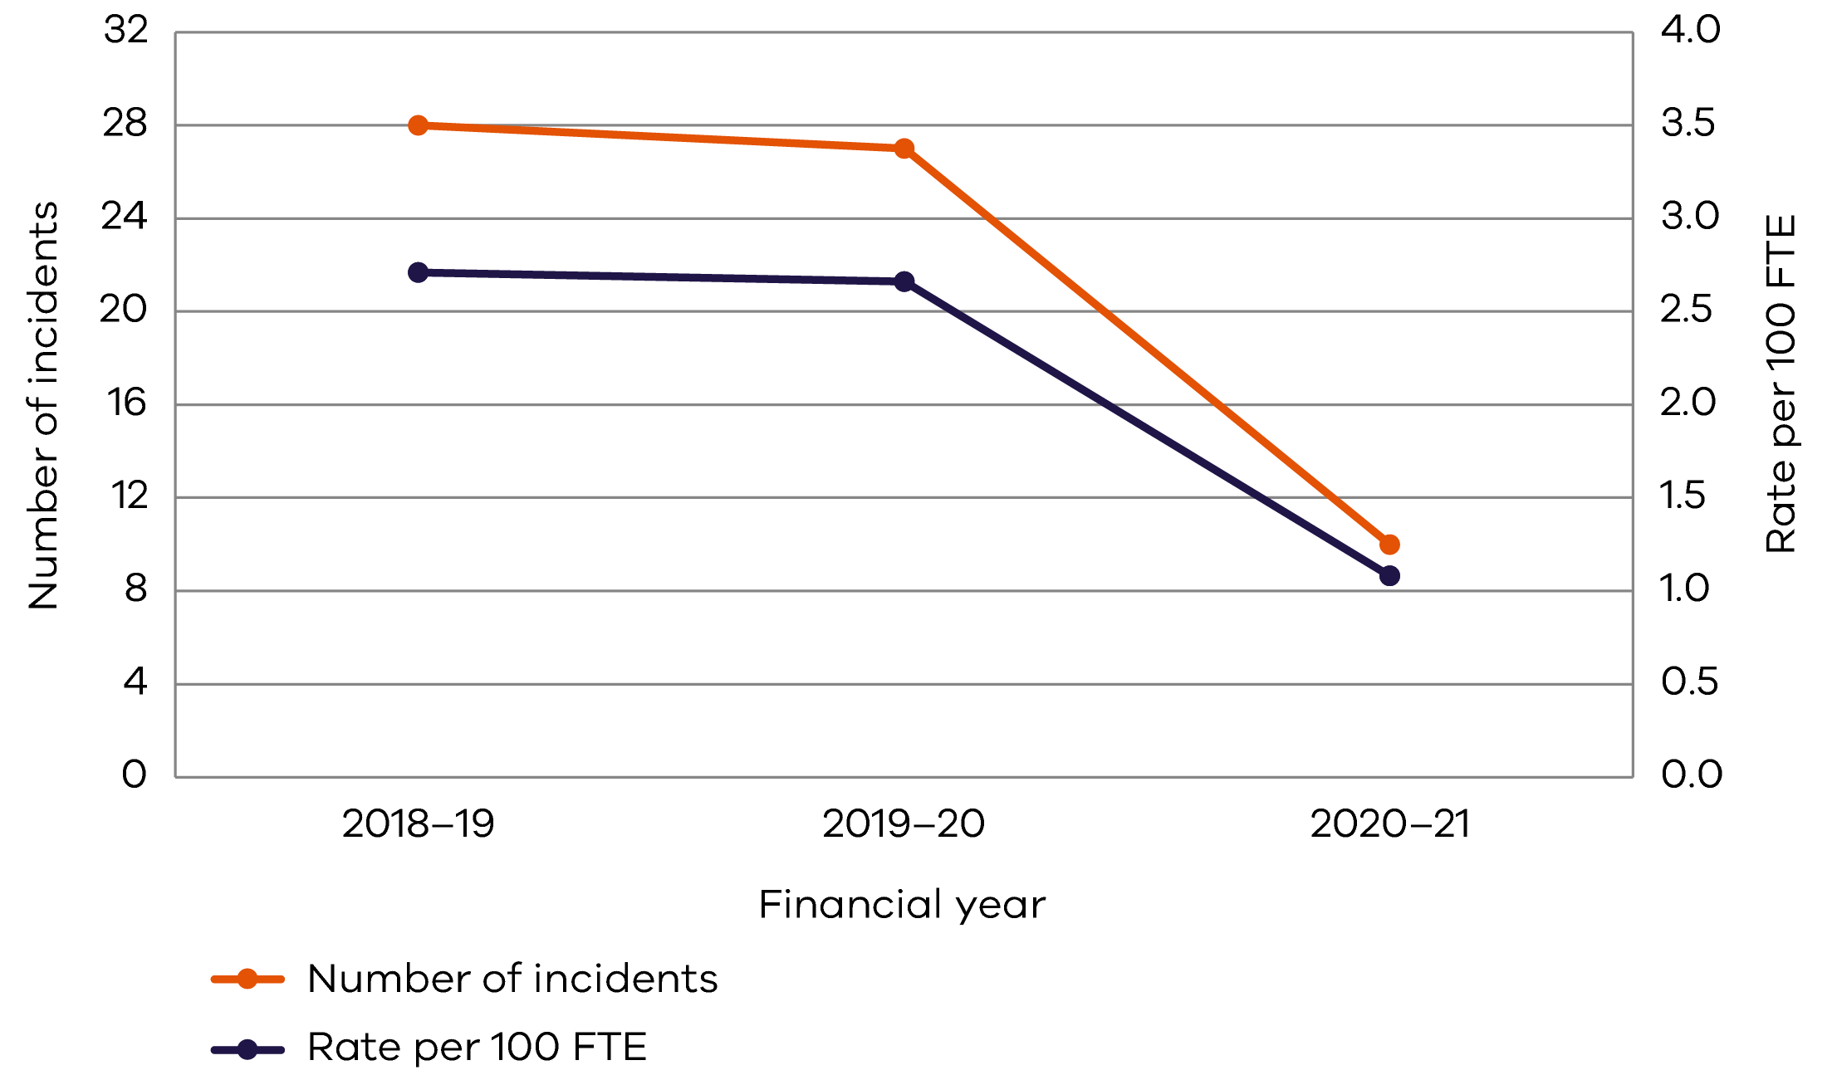

The number of standard claims remained constant in 2020–21, while the rate per 100 FTE increased (Figure 2). Five of the six standard claims were due to psychological injuries, and the remaining claim was due to physical injury with a secondary psychological component.

#### Figure 2: Number of standard claims and rate per 100 FTE

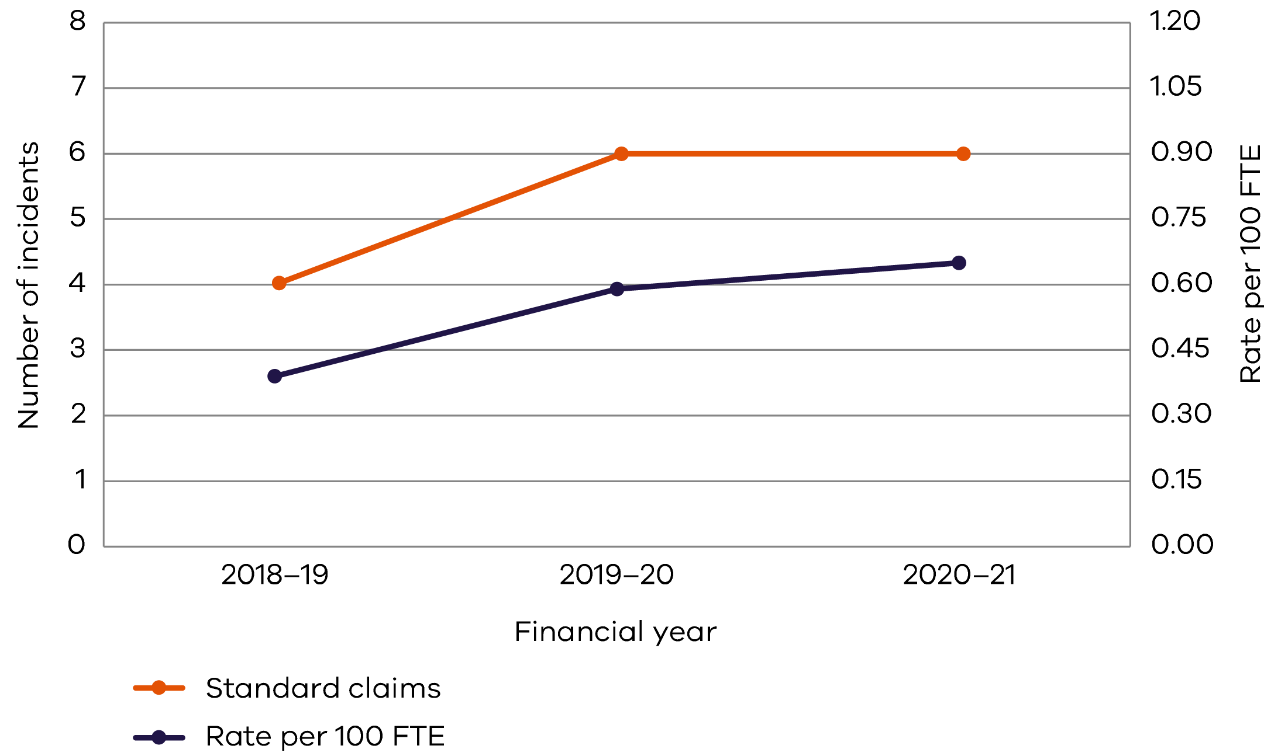

The total number of WorkCover claims lodged in 2020–21 has remained the same compared with the previous year (Figures 3 and 4). Similarly, the number of lost-time claims has remained constant in comparison with the previous year. The average cost per claim has continued to decrease from $34,955 to $30,365.

#### Figure 3: Lost-time claims and rate per 100 FTE

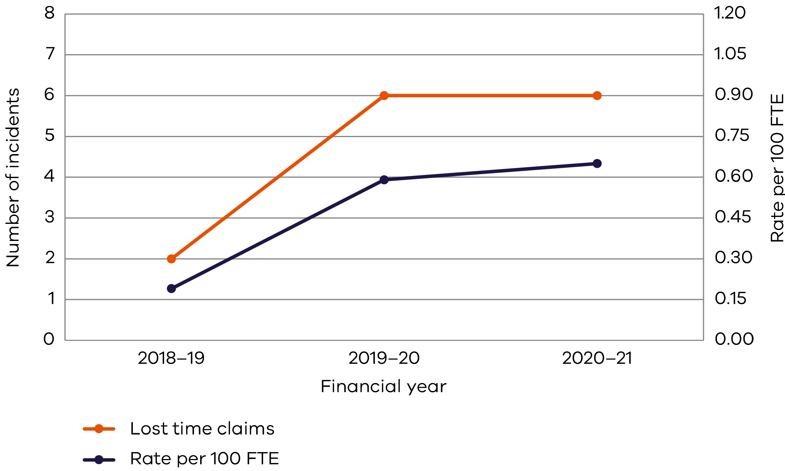

#### Figure 4: Claims exceeding 13 weeks and rate per 100 FTE

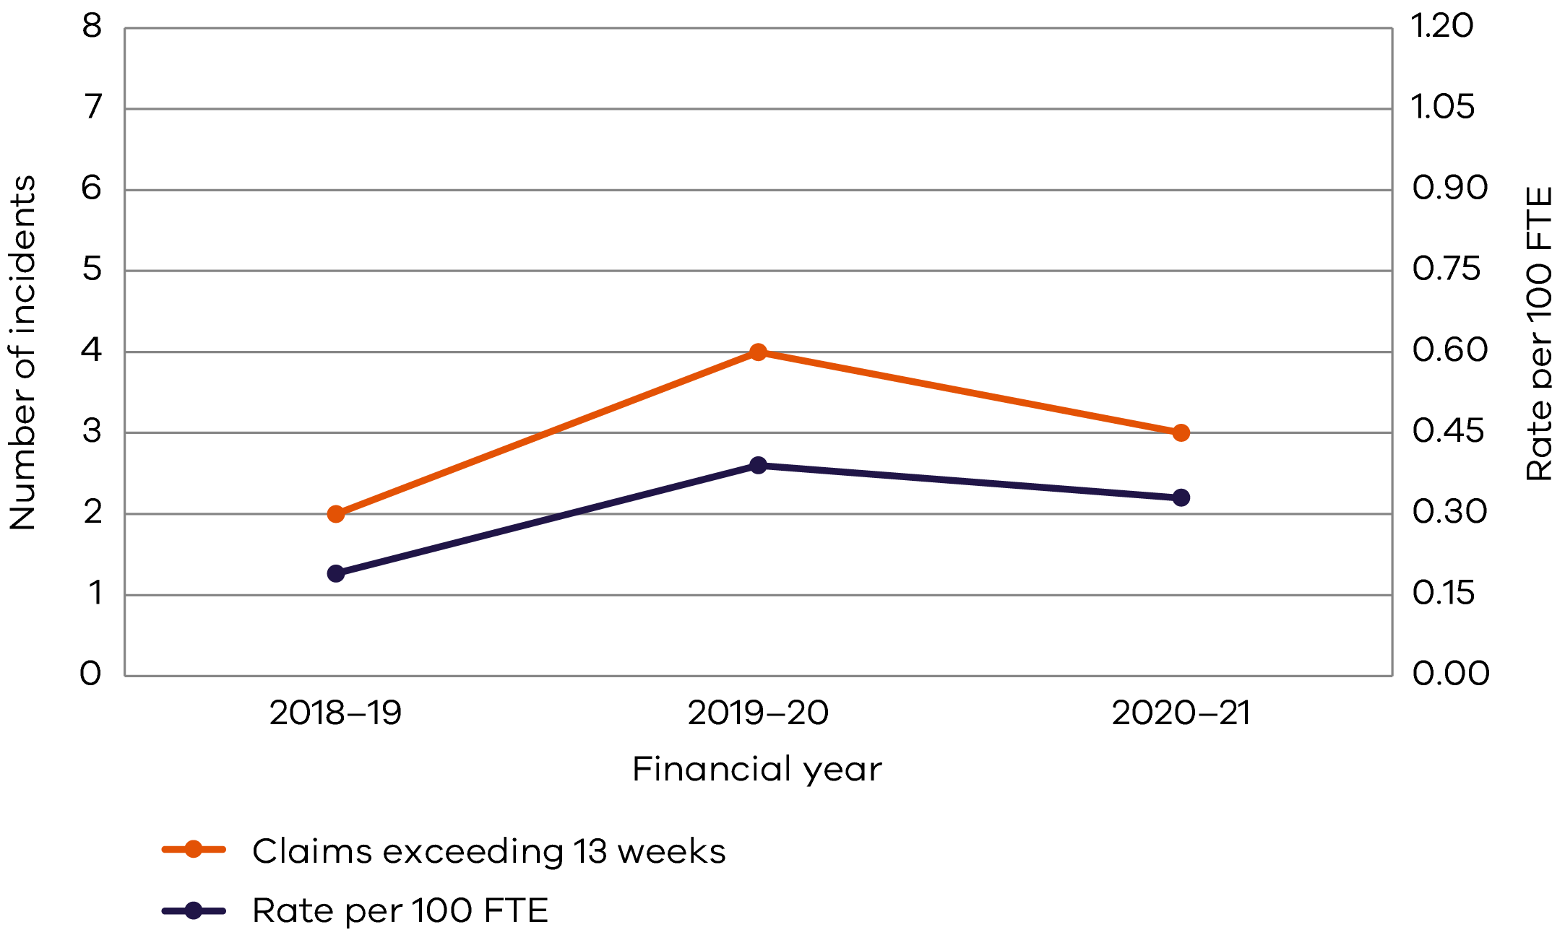

The department’s premium rate has increased over time (Figure 5). Although the premium rate has increased, the rate for 2020–21 is below the industry standard.

#### Figure 5: Department of Premier and Cabinet premium rate, 2016–2021

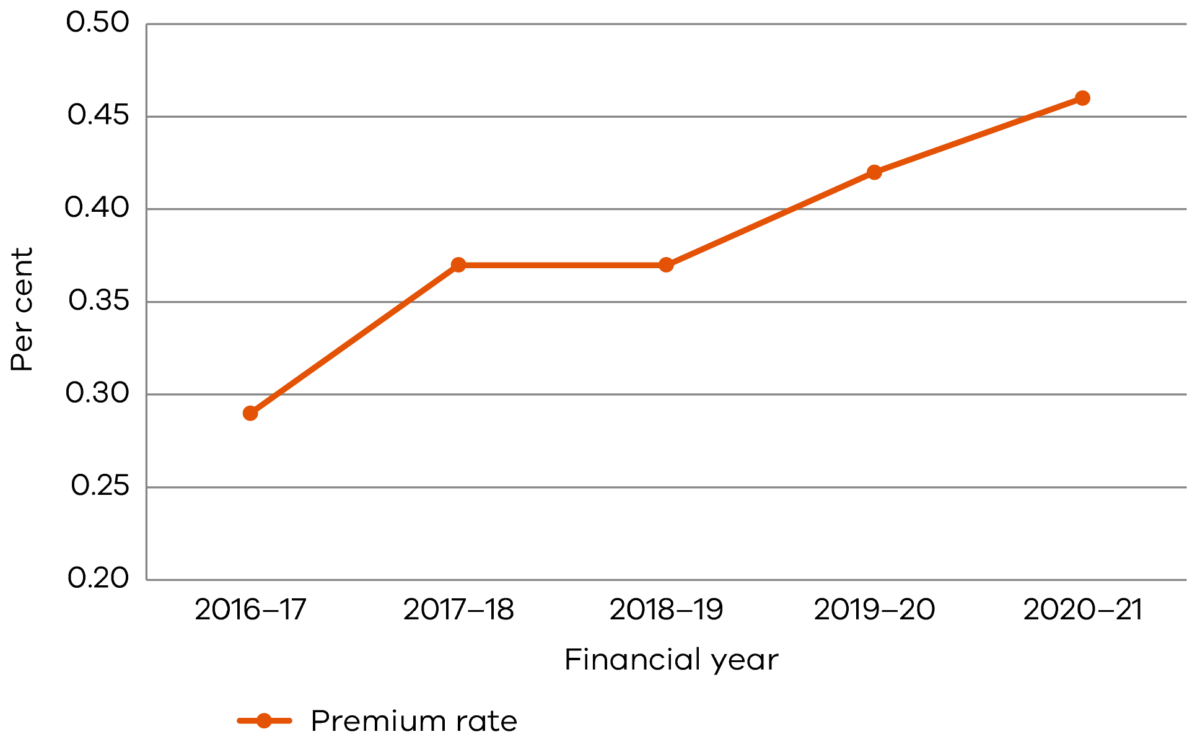

#### DPC’s performance against occupational health and safety management measures

| Measure | Key performance indicator | 2018–19 | 2019–20 | 2020–21 |
| --- | --- | --- | --- | --- |
| Incidents | Number of incidents | 28 | 27 | 10 |
| Rate per 100 FTE | 2.71 | 2.66 | 1.08 |
| Number of incidents requiring first aid or further medical treatment(1) | 18 | 15 | 4 |
| Claims | Number of standard claims | 4 | 6 | 6 |
| Rate per 100 FTE | 0.39 | 0.59 | 0.65 |
| Number of lost-time claims | 2 | 6 | 6 |
| Rate per 100 FTE | 0.19 | 0.59 | 0.65 |
| Number of claims exceeding 13 weeks | 2 | 4 | 3 |
| Rate per 100 FTE | 0.19 | 0.39 | 0.33 |
| Fatalities | Fatality claims | 0 | 0 | 0 |
| Claim costs | Average cost per standard claim | $46,688 | $34,955 | $30,365 |
| Return to work | Percentage of claims with return-to-work plan < 30 days | n/a | 33% | 16% |
| Management commitment | Evidence of OHS policy statement, OHS objectives, OHS plans and regular reporting to senior management about OHS | Completed | Completed | Completed |
| Evidence of OHS criteria in purchasing guidelines (including goods, services and personnel) | Completed | Completed | Completed |
| Consultation and participation | Compliance with agreed structure on designated work groups, health and safety representatives (HSRs) and issue resolution procedures | Completed | Completed | Completed |
| Evidence of agreed structure of designated workgroups, HSRs and issue resolution procedures(2) | n/a | n/a | Completed |
| Number of quarterly OHS Committee meetings | 4 | 4 | 4 |
| Risk management | Percentage of internal audits and inspections conducted as planned(3) | 67% | 67% | n/a |
| Percentage of reported incidents investigated | 100% | 100% | 100% |
| Number of improvement notices issued by a WorkSafe inspector | 0 | 0 | 0 |
| Number of prosecutions | 0 | 0 | 0 |
| Percentage of issues arising from: |  |  |  |
| * internal audits | 100% | n/a | n/a |
| * HSR provisional improvement notices | n/a | n/a | n/a |
| * WorkSafe notices | n/a | n/a | n/a |
| Training | Percentage of managers and staff who have received OHS training (online induction module): |  |  |  |
| * induction(2) | n/a | n/a | 93% |
| * management training | 26% | 42% | 93% |
| * contractors and temps(4) | 7% | n/a | n/a |
| Percentage of HSRs trained:(5) |  |  |  |
| * upon acceptance of the role (initial training) | 100% | 19% | 31% |
| * retraining (refresher) | 100% | 0% | 8% |

This information only incorporates the core groups of DPC.

Notes:

1. Number of incidents reported for 2018–19 and 2019–20 do not include detectable hazards or near misses.
2. Newly introduced measures that were not reported in 2018–19 and 2019–20.
3. Workplace inspections were on hold from March 2020 to June 2021 due to COVID-19.
4. Due to COVID-19 only urgent contractors and temps were used.
5. All HSRs are given the opportunity to register for WorkSafe-approved optional HSR training, which all HSRs are encouraged to attend. Further information and reminders are provided in quarterly OHS Committee meetings.