Education and Training   
Climate Change Adaptation Action Plan   
2022–2026



**Acknowledgement**

The Department of Education and Training respectfully acknowledges the Traditional Owners of Country throughout Victoria and pays respect to Elders past and present and the ongoing living cultures of First Peoples.

© The State of Victoria Department of Education and Training 2022

#### For more information

Refer to the Education and Training website at <https://www.education.vic.gov.au/>

Authorised by the Hon James Merlino MP

Minister for Education

Department of Education and Training,

41 St Andrews Place, East Melbourne VIC 3002 Telephone (03) 9637 2000

 This work is licensed under a Creative Commons Attribution 4.0 International licence. You are free to re-use the work under that licence, on the condition that you credit the State of Victoria as author. The licence does not apply to any images, photographs or branding, including the Victorian Coat of Arms and the Victorian Government logo. To view a copy of this licence, visit <https://creativecommons.org/licenses/by/4.0/>

ISBN 978-1-76105-879-0 (pdf/online/MS word)

#### Disclaimer

This publication may be of assistance to you but the State of Victoria and its employees do not guarantee that the publication is without flaw of any kind or is wholly appropriate for your particular purposes and therefore disclaims all liability for any error, loss or other consequence which may arise from you relying on any information in this publication.

#### Accessibility

**This document is also available in an accessible format on the internet at**

[**education.vic.gov.au**](https://www.education.vic.gov.au/Pages/default.aspx)

# Photograph of the Hon. James Merlino MP, Deputy Premier and Minister for Education

# Minister’s foreword

#### The Victorian Government is taking strong and lasting action to cut Victoria’s emissions to net zero by 2050 and to help Victoria adapt to a changing climate with more frequent and intense events.

The Education and Training Climate Change Adaption Action Plan 2022–2026 is one of seven plans that will make sure we have the skills, knowledge and infrastructure needed for our changing world. These 5-year plans are a requirement of Victoria’s world-leading Climate Change Act 2017.

The Education and Training adaptation action plan covers the people, places and services involved in lifelong learning here in Victoria.

This initial plan is practical, positive and broad. It talks about what we can do right now to adapt and prepare for a changing climate, and how we can set up solid foundations to manage the challenges ahead.

From early childhood education to school, technical and further education, almost two million Victorians participate in some form of education and training every year – and we know climate change is already having an impact on where and how they learn. We have more very hot days and less rain, the bushfire season is longer than it used to be, and when the big rains come, they are more intense and may cause flash flooding.

This plan explores what we need to do to make sure schools, early childhood education services and other places where Victorians teach and learn can withstand more extreme weather. We’ve already made a start on some of this work through our bushfire recovery support programs, policies on heat health and collaboration with the emergency management sector. But we can go much further.

Climate change adaptation needs to be embedded in all our decision making for education and training – from the way we design and build new schools to how we teach children and young people about climate change and build their capacity to adapt to climate change impacts.

There are plenty of opportunities to do things differently, so people, buildings and systems are more resilient, and our most vulnerable Victorians and school communities are protected.

Many learners are already very aware of how our choices – including what we eat, what we wear, how we travel and the sorts of jobs we do – impact the environment. This adaption action plan looks at how we can extend learners’ knowledge and understanding and help them adapt to the increasing frequency, intensity and magnitude of extreme weather events in Victoria.

The plan also considers how education and training can support Victorian business, industry and communities to adapt to the impacts of climate change.

I want to thank everyone who had their say on the draft document. Your input has helped make this plan a really solid foundation for building a climate-resilient Victorian Education and Training system.

Signature of the Hon. James Merlino MP, 
Deputy Premier and Minister for Education


The Hon. James Merlino MP   
Deputy Premier

Minister for Education

# Contents

Minister’s foreword 3

Executive summary 6

1. Introduction 8
   1. A systems-based approach to adaptation 8
   2. Education and Training AAP objectives 10
   3. Scope of the Education and Training system 11
2. Governance, roles and responsibilities 16
   1. Roles and responsibilities of the Victorian Government for climate adaptation

in the Education and Training system 16

* 1. Working with Traditional Owners and Aboriginal Victorians 16
  2. Emergency management 17
  3. The curriculum, environmental sustainability and education for climate

change adaptation 18

* 1. Cross-system department and agency roles and responsibilities 18
  2. Industry role 18
  3. National arrangements 19
  4. Community and individual roles 19
  5. Cross-cutting stakeholders and policy areas 20

1. Climate change and the Education and Training system 22
   1. Climate change in Victoria 22
   2. Impacts of climate change on the Education and Training system 23
2. Key climate change risks and opportunities for the Education and Training system 24
   1. Non-climatic drivers of change 24
   2. Climate change risks and opportunities for the Education and Training system 24
   3. Cross-system climate change risks 28
3. Existing climate change adaptation policies, programs and projects, and gap analysis 29
   1. Victoria’s Climate Change Strategy priority: Address current climate change impacts 29
   2. Victoria’s Climate Change Strategy priority: Reduce barriers to adaptation 30
   3. Victoria’s Climate Change Strategy priority: Lay the foundations for

transformational adaptation 30

1. Climate change adaptation actions: 5-year plan 32
2. Implementation 34
3. Monitoring, evaluation, reporting and improvement 35

Appendix 1. Summary of policies, programs and legislation relevant to the

Education and Training system 36

Appendix 2. Key terms and acronyms 38

Appendix 3. References 40

Appendix 4. Alignment between focus areas and adaptation actions 41

# Executive summary

#### Victoria’s Education and Training system is critical to the learning, development and support of children and adults across the state, and our changing climate is already being felt within the system.

Our climate is changing, and the Victorian Government has set ambitious and achievable interim emissions reduction targets on a path to net zero emissions by 2050. As part of the government’s initiative, the Education and Training system (including early childhood education, schools, TAFEs and universities, and Learn Local and Registered Training Providers) must also adapt to meet the challenges and realise the opportunities of climate change.

In Victoria, action on climate change is underpinned by the Climate Change Act 2017, which requires nominated Ministers for 7 different systems, including Education and Training, to prepare Climate Change adaptation action plans. Reviewed every 5 years, these plans will ensure that Victoria is prepared for the inevitable effects of a changing climate caused by past, current and projected future emissions. The Education and Training system’s adaptation approach will be led by the Department of Education and Training,

in close collaboration with education and training organisations across the system from early childhood education providers to schools (government and non-government), TAFEs and universities, and Learn Local and Registered Training Providers.

This Education and Training Climate Change Adaptation Action Plan 2022–2026 (the plan) aims to build knowledge and capacity to respond to current and expected impacts on the system, particularly those related to health and wellbeing, and infrastructure and assets. The plan explores how the Education and Training system can best support the education and training workforce and learners to build the necessary knowledge, skills and capability to adapt and build resilience in a world affected by climate change.

This plan is the first in a series of 5-yearly plans that will guide the climate change adaptation policies of the Education and Training system up to the year 2050.

Foundational and exploratory in nature, this 2022–2026 plan forms part of a larger, iterative process being conducted by the Victorian Government to address the current and projected impacts of climate change, with the goal of net zero greenhouse gas emissions by 2050.

While Victoria’s Education and Training system is vulnerable to the impacts of climate change, it is fundamental to promoting innovation, embedding awareness, and building resilience, particularly in younger generations.

Throughout this plan, we review both the vulnerabilities and opportunities within the system in relation to climate change and propose a new set of actions to build the system’s resilience.

Education and Training Climate Change Adaptation Action Plan 2022–2026 6

**Figure 1. The Education and Training system is one of 7 systems planning climate change adaptation actions**

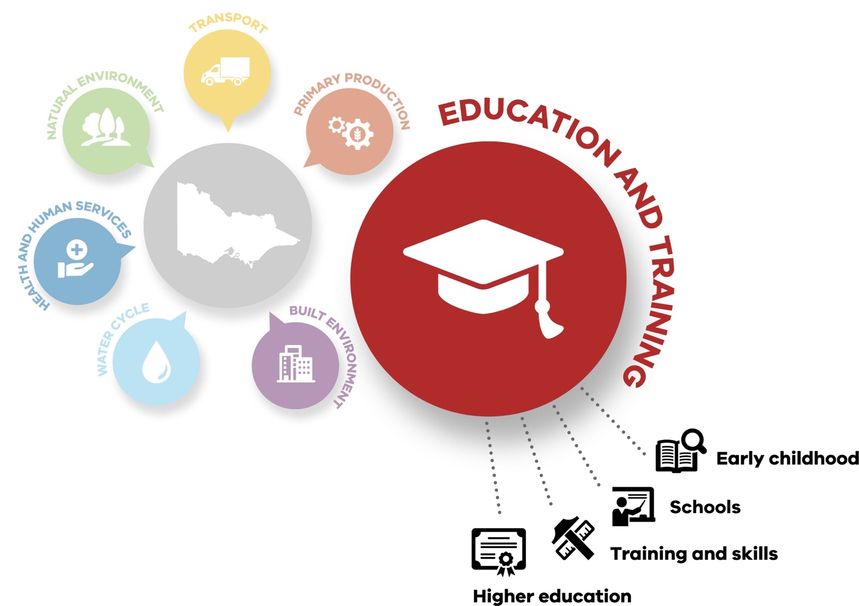

# Introduction

The Education and Training system is vital to Victoria adapting to the impacts of climate change and maximising opportunities from it.

The Education and Training system delivers services to at least one third of Victorians every year across the early childhood education, schools education, and training and skills sectors. The system achieves excellence by:

* raising standards of learning and development

achieved by Victorians using education and training

* increasing participation in education and training
* increasing the contribution that education and training makes to all Victorians’ quality of life, particularly children and young people.

The Education and Training system is already affected by extreme weather events, some of which are projected to increase in intensity or frequency as a result of climate change. Overall, warmer temperatures will

continue to present challenges to learners, the system’s workforce, services and

built assets.

This adaptation action plan is needed because our climate is already changing, and decisive action to adapt now will reduce current and future risks,

build social and economic resilience, and ensure

Victoria is best placed to take advantage of opportunities.

### A SYSTEMS- BASED APPROACH TO ADAPTATION

The Victorian Government is taking strong and lasting action to reduce Victoria’s

emissions to net zero by 2050 and build resilient communities prepared to deal with the impacts of climate change.

Victoria was one of the first jurisdictions in the world to legislate a net-zero emissions target with the *Climate Change Act 2017* and set a strong foundation for future climate resilience with action under Victoria’s Climate Change Adaptation Plan 2017–2020.

Victoria’s Climate Change Strategy sets out the Victorian Government’s current action on climate change alongside its next steps in accordance with the Paris Agreement.

To avoid the worst effects of climate change, the Paris Agreement aims to limit

the rise in global average temperature to between

1.5 and 2 degrees Celsius. To help achieve this goal,

Victoria – along with many governments around the world

* is committed to net zero emissions by 2050.

The Department of Education and Training will reduce emissions by:

* increasing energy efficiency in government school buildings and increasing

on-site renewable electricity through the Greener Government School Buildings program

* sourcing 100 per cent of electricity for schools from renewable sources by 2025
* upgrading Department of Education and Training offices to reduce energy consumption.

The *Climate Change Act 2017* defines adaptation as: ‘… any process of adjusting to actual or expected climate and its effects, that:

* in human systems, seeks to moderate or avoid harm or exploit beneficial opportunities; and
* in natural systems, may be facilitated by human intervention’.

Adaptation measures will help improve the resilience of the Education and Training system. Resilience, in this context, is defined as:

‘The capacity of social, economic, and environmental systems to cope with a hazardous event or trend or disturbance, responding or reorganising in ways that maintain their essential function, identity, and structure, while also maintaining the capacity for adaptation, learning, and transformation’.1

1. IPCC, 2014: Summary for policymakers. In: Climate Change 2014: Impacts, Adaptation, and Vulnerability. Part A: Global and Sectoral Aspects. Contribution of Working Group II to the Fifth Assessment Report of the Intergovern mental Panel on Climate Change [Field, C.B., V.R. Barros, D.J. Dokken, K.J. Mach, M.D. Mastrandrea, T.E. Bilir, M. Chatterjee, K.L. Ebi, Y.O.

Estrada, R.C. Genova, B. Girma, E.S. Kissel, A.N. Levy, S. MacCracken, P.R. Mastrandrea, and L.L. White (eds.)]. Cambridge University Press, Cambridge, United Kingdom and New York, NY, USA, p.5

**Figure 2. Emissions reduction and system adaptation**

**Emissions reduction means reducing or avoiding greenhouse gas emissions to minimise the rate and magnitude of climate change (e.g. renewable and alternative energy sources). Climate change adaptation means taking steps to prepare for and respond to the effects of the changing climate (e.g. disaster risk reduction). Some actions  (e.g. improved energy efficiency, green recreational spaces) contribute to both mitigation and adaptation.**

This plan focuses on building resilience to climate change impacts. Some of its actions will help us adapt to climate change impacts while also reducing emissions.

Reducing our emissions will help lessen the impact of climate change but it will not prevent it. Some degree of climate change is already locked in, so we must adapt to our changing climate and its effects while also reducing future risks.

Victoria’s Climate Change Strategy sets our adaptation objectives for the next decade and our priorities for the next 5 years, consisting of priority focus areas to:

* address current climate change impacts
* reduce barriers to adaptation
* lay the foundations for transformational adaptation.

It also outlines the enablers that will support action:

* capacity building and partnerships
* governance and strategic planning
* sustainable adaptation finance
* leadership and innovation.

Guided by Victoria’s Climate Change Strategy, the Victorian Government is planning for climate impacts and delivering adaptation action at multiple scales, including by preparing adaptation action plans across 7 systems to ensure Victoria’s climate resilience now and in the future. The 7 systems are:

* Built Environment
* Education and Training
* Health and Human Services
* Natural Environment
* Primary Production
* Transport
* Water Cycle.

This systems-based approach to climate change adaptation enables a targeted response to climate change, focused

on each system’s unique characteristics and needs. This approach is complemented by regional adaptation strategies, developed in partnership

with regional communities, including Traditional Owners, to identify, prioritise and deliver place-based actions informed by local knowledge and

needs. These strategies are being developed for Greater Melbourne, Gippsland, Hume, Loddon Mallee, Grampians and Barwon South West.

Work also continues with local governments and community groups to understand and address the risks posed

by climate change to local communities.

The plan will iteratively guide adaptation efforts during the next 5 years, building on strong foundations and seizing opportunities to accelerate adaptation.

### EDUCATION AND TRAINING AAP OBJECTIVES

This plan’s overall objective is to guide the Education and Training system’s adaptation efforts and build its climate resilience. This includes building our knowledge of effective adaptation options; developing the capacity of Victoria’s education and training workforce to support climate change adaptation;

and supporting children, young people and adult learners to build the knowledge, skills

and capability needed to participate in and contribute to a climate-resilient future.

The plan’s proposed adaptation actions are designed to respond to the Victorian Government’s priority focus areas for adaptation during the next 5 years and help achieve the following short, medium and long-term objectives.

#### Short-term objectives (2026)

* Build the education and training sector’s ability to identify risks and opportunities, adjust

to potential damage, take advantage of

opportunities and respond to consequences of climate change.

* Strengthen the resilience of education assets and infrastructure to support the health and safety of learners, teachers and

educators, and education and training staff.

* Prepare learners, through the curriculum and in

age-appropriate ways, to understand climate change and its impacts on them and their world; and provide opportunities to use this knowledge via appropriate teaching and learning programs, and a supported teaching workforce.

* Incorporate climate change adaptation – supported

by appropriate training, guidance and evidence

– into decision-making processes and practices, and across the emergency management cycle, including by:

* + developing approaches to support the people in our system who are most vulnerable to the impacts of climate change
  + developing age- appropriate approaches to engage and empower

children and young people to understand their role and take action on climate change

* + improving our understanding of how the health and wellbeing impacts of climate change can be managed

throughout the system and embed this understanding into health and wellbeing programs (where it has been identified as a priority)

* + identifying how the training and skills, and higher education sectors can support the Victorian workforce to build its adaptive capacity and resilience
  + engaging with Aboriginal Victorians to incorporate First Peoples knowledge into tools and decision making.

#### Medium-term objectives (2031)

* Support climate change adaptation throughout the Education and Training system, via governance, regulation, guidance, policy development and capability building.
* Implement approaches to enable Victorian industries, businesses and workers

to identify and manage risks, and take advantage of opportunities (such

as new jobs) created by the transition to net zero emissions and a climate- resilient future.

#### Long-term objectives (2050)

* Ensure the Education and Training system is resilient to the impacts of climate change and supports a net-zero, climate-resilient economy.

### SCOPE OF THE EDUCATION AND TRAINING SYSTEM

The Education and Training system spans early childhood education services; independent, Catholic and government schools; and TAFEs, universities and

adult education institutions

* all with different delivery, management, funding and regulatory arrangements.

The system is focused on improving outcomes and opportunities for all Victorians and supporting them to build happy, healthy and rewarding lives while delivering the workforce skills and training needs for job development and growth.

The Education and Training system includes the people, places and services participating in lifelong learning from early childhood education through to training and skills, and higher education. Services provided by this system and

its sub-systems are shown in Table 1.

**Table 1. Education and Training system services overview2**

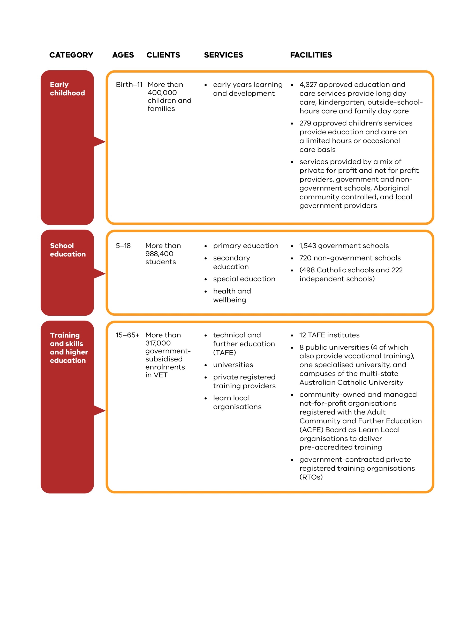

The scope of the Education and Training system (Table 2) highlights that, while government’s level of influence varies for different system components, different levers (for example, regulation, funding, and

partnerships) can be applied to support climate

change adaptation. Successful adaptation will involve working collaboratively with

communities, businesses and non-government organisations.

1. State of Victoria Department of Education and Training (DET) (2020) Department of Education and Training Annual Report 2019-2020, p. 6

**Table 2. Victorian Government Education and Training system responsibilities**

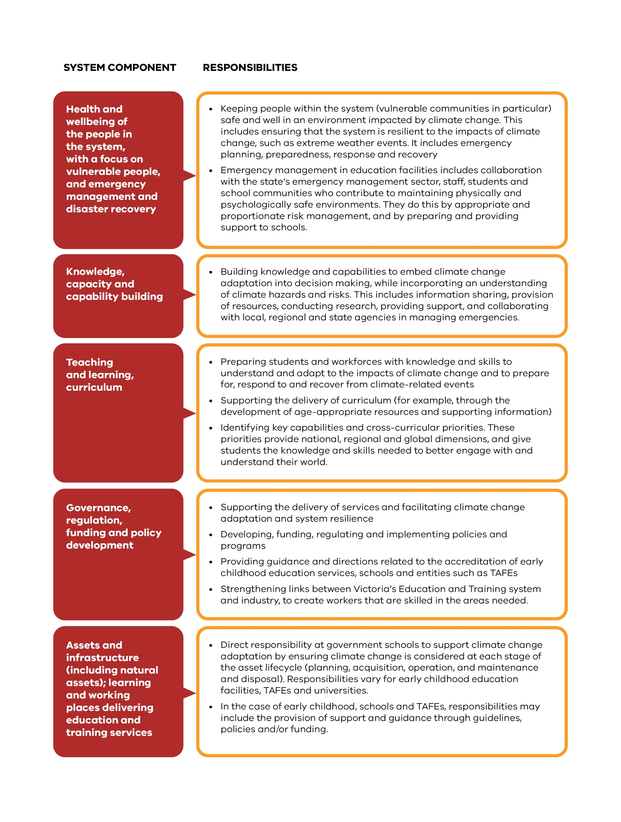

#### Cross-system connections and dependencies

The Education and Training system is connected to the 6 other adaptation systems across Victoria. These connections are important because the Education and

Training system may depend on other systems’ policies and actions to support adaptation and build resilience.

Importantly, the training and skills, and higher education sectors are crucial to enabling successful adaptation in all systems. Providing skilled workers who understand climate change, and who have the capacity, knowledge and skills to consider climate change in their decision making, will be beneficial

to businesses, industries, communities and the government.

This plan aligns with the other 6 systems’ plans and their climate change

adaptation actions and will be implemented in a coordinated way with the other plans.

An overview of some key connections between the Education and Training system and the other adaptation systems is shown in Figure 3.

**Figure 3. Cross-system adaptation connections and requirements**

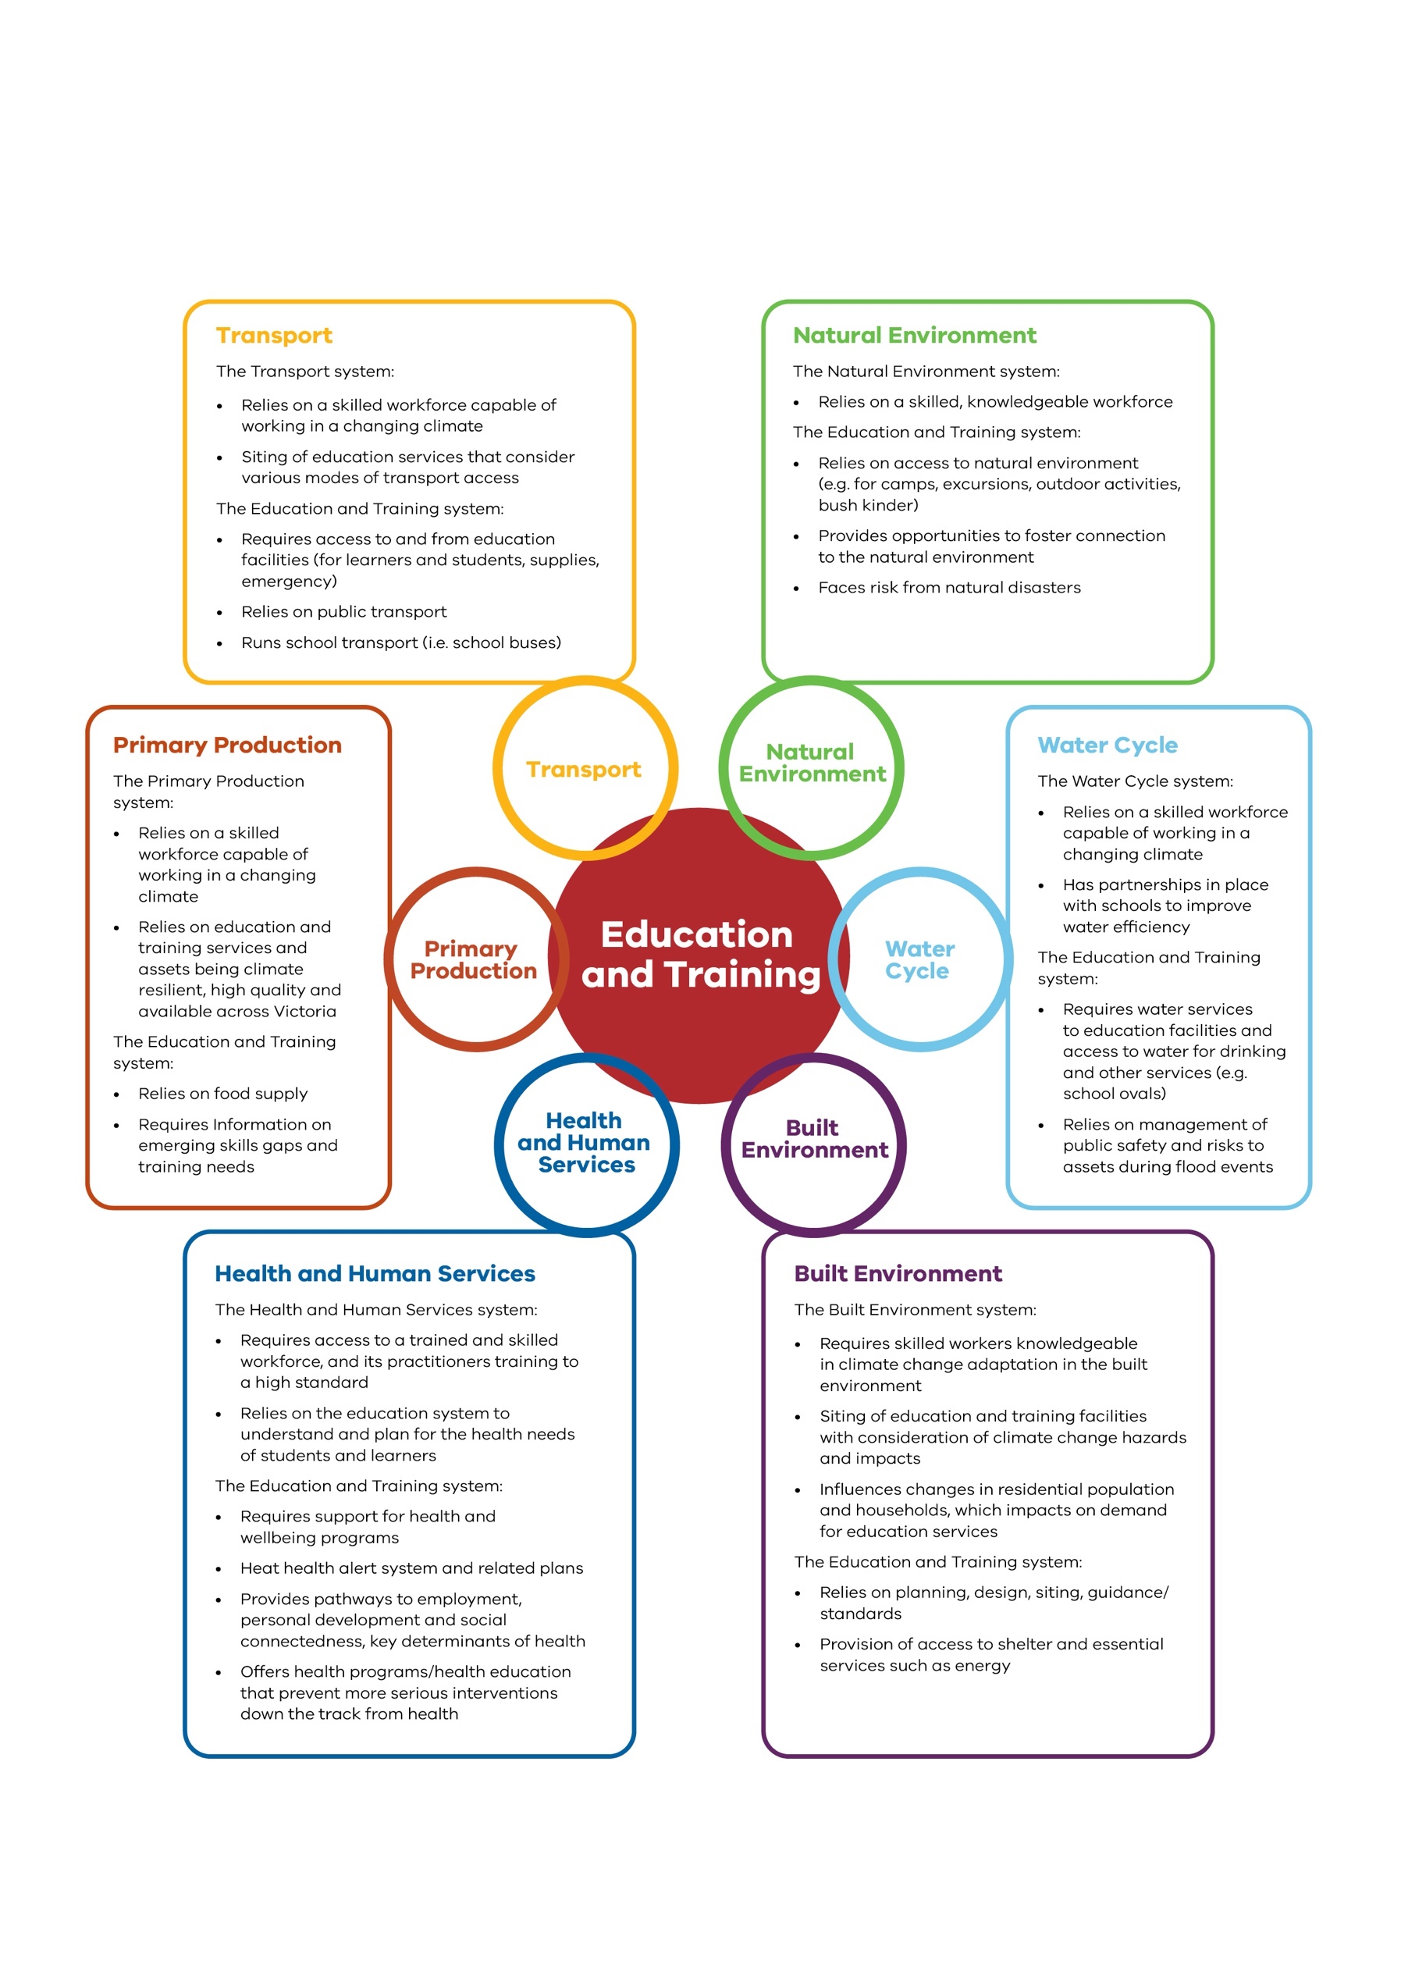

# Governance, roles and responsibilities

Climate change adaptation is a shared responsibility. Government, industry, individual businesses

and communities all have important roles to play in effective adaptation for the Education and Training system.

### ROLES AND RESPONSIBILITIES OF THE VICTORIAN GOVERNMENT FOR CLIMATE ADAPTATION IN THE EDUCATION AND TRAINING SYSTEM

Ministerial responsibility for education and training is shared between:

* the Minister for Education
* the Minister for Training and Skills
* the Minister for Higher Education
* the Minister for Early Childhood.

Under the *Climate Change Act 2017*, the Minister

for Energy, Environment and Climate Change has nominated ministers for the purposes of preparing climate change adaptation

action plans. The Minister for Education has been assigned lead responsibility for the development of this adaptation action plan, supported by

the Minister for Police and Emergency Services, the Minister for Training

and Skills and the Minister for Higher Education.

The Department of Education and Training supported the Minister for Education in developing this plan and will lead the implementation of the plan’s actions, in consultation and collaboration with schools, relevant agencies and its stakeholders. The Department of Education and Training

will support its staff (school and corporate staff), partners and providers across the education and training sectors to effectively deliver this plan.

The Education and Training system is supported by the Department of Education and Training, and a range of agencies with responsibilities

for curriculum, adult education, training and skills, higher education, regulation and registration (for example, Victorian Skills Authority, Adult, Community and Further Education Board (ACFE)

and the Victorian Curriculum and Assessment Authority (VCAA)). The training and skills and higher education component of the system includes universities, a network of internationally recognised vocational training institutions (TAFEs), and private colleges and training institutions.

### WORKING WITH TRADITIONAL OWNERS AND ABORIGINAL VICTORIANS

Through our delivery of this adaptation action plan, we will embrace principles that facilitate Aboriginal Self-Determination and the respectful application of traditional knowledge and Caring for Country

principles. The Department of Education and Training will partner with the Victorian Aboriginal Education Association Incorporated (VAEAI), Traditional Owners and Aboriginal Victorians

to learn about Aboriginal understandings of climate change adaptation and ensure Aboriginal peoples’ opportunities to access training are not adversely impacted by climate change.

Barriers to education, including post-compulsory education, will be addressed.

The Victorian Government’s Aboriginal Education Plan, Marrung 2016–2026, is a strategy that aims for Victoria to be a state where the

rich and thriving cultures, knowledge and experience of our First Nations peoples are celebrated by all Victorians and Koorie Victorians achieving their learning aspirations.3 The Education and Training system will support Self-Determination and climate change education.

1. Marrung Aboriginal Engagement Plan 2016-2026, accessed 12 October 2021 [https://www.education.vic.gov.au/about/](http://www.education.vic.gov.au/) programs/Pages/marrung.aspx

### EMERGENCY MANAGEMENT

The Department of Education and Training is allocated specific responsibilities as part of the whole of government regarding the management of emergencies and collaborates with emergency services at all levels, including:

* state and regional: collaborative planning for the sector; and collaborative guidance and policy development
* local (school) level: collaborative preparation of facility emergency management plans; and collaborative responses to local emergency events.

Emergency management planning is required by schools and early childhood education services under:

* *Emergency Management Acts 1986 and 2013*
* *Education and Training Reform Act 2006* and Education and Training Reform Regulations 2017 minimum standards and requirements
* Education and Care Services National Regulations 2012
* *Victorian Occupational Health and Safety Act 2004*.

The Department of Education and Training’s emergency management practices align with the ethos of ‘working as

one’ and share the emergency management services’ vision of ‘safer and more resilient communities’. In line with

this vision, the Department of Education and Training

strives to build a safe, secure and more resilient education community capable of withstanding, planning for, responding to and recovering from emergencies.

Schools and child-care centres are identified as facilities where vulnerable people

are likely to be situated.4 This presents additional opportunities and challenges within the Education and Training system to manage the increasing impacts of climate change, including exacerbated hazardous events, and more frequent and severe emergencies,

as well as simultaneous and cumulative disasters. Possible climate change impacts – such as more frequent and severe bushfires, air quality events, floods and heat waves

* require comprehensive risk mitigation alongside preparation activities that consider the unique

vulnerabilities of the education population.

The Department of Education and Training manages climate- related emergencies under

the increased impacts of climate change inclusively, encompassing all education portfolios. Its Emergency Management Framework

articulates these. It follows Emergency Management Victoria’s directions and recognises its emergency management responsibilities vary for each sector.

This framework establishes how the Department of Education and Training will manage emergency events across the risk mitigation, preparedness, response, relief and recovery phases. The approaches detailed in the framework are drawn from legislation, policies, structures and coordination

arrangements, and apply to all emergencies. These include natural hazards and threats from human-caused events that occur, or are likely to occur, within or impact on:

* government schools including state primary, secondary and special education schools, state education centres and outdoor education centres
* early childhood education and care facilities
* tertiary and adult education facilities
* the Department of Education and Training workplaces, including state schools

and offices across Victoria (regional and central).

1. Department of Health and Human Services, 2018. Vulnerable People in Emergencies Policy, p. 10

### THE CURRICULUM, ENVIRONMENTAL SUSTAINABILITY AND EDUCATION FOR CLIMATE CHANGE ADAPTATION

The Victorian Curriculum

F-10, based on the Australian Curriculum, sets out the knowledge and skills students need to learn during their

first 11 years of schooling. The Victorian Curriculum includes content that teachers are required to teach (and students to learn) concerning environmental sustainability, across local, national and global contexts. This content is located under curriculum areas such as Science and Geography and through other curriculum areas (Economics and Business, and Critical and Creative Thinking) where students are taught forms of knowledge and skills needed to better understand climate change’s broader issues.

The Victorian Curriculum

F-10 includes Sustainability as a ‘cross-curriculum priority’. This means teachers apply Sustainability as a

lens or a theme across the entire curriculum. For example, students learn about sustainability from ‘systems’, ‘world view’ and ‘futures’ perspectives. The VCAA reviews and revises

the F-10 curriculum every six to seven years. A review is expected during the life of this adaptation action plan.

The Victorian Certificate of Education Environmental Science has a focus on climate change.

The Victorian Early Years Learning and Development Framework sets outcomes and practices to guide early childhood education

professionals. Outcome 2 is that children are connected with and contribute to their world, including becoming aware of the impact of the local environment, both physical and social, on their lives. For this outcome, children learn ways to care for the environment and contribute to a sustainable future.

Education for climate change adaptation requires developing knowledge and skills to

reduce vulnerabilities to climate change impacts, to manage the risks of climate change and build adaptative capacities and resilience.

School education for disaster risk reduction and resilience is a critical component of climate change adaptation and programs across Victoria (and Australia) focus on

this. Research on how these education programs contribute to the mitigation and prevention of disaster

impacts on lives and property is ongoing5 and findings will inform future approaches to education for disaster risk reduction.

### CROSS-SYSTEM DEPARTMENT AND AGENCY ROLES AND RESPONSIBILITIES

Other government departments and agencies play a role in preparing

communities to respond to the challenges of climate change. For example, Sustainability Victoria implements the ResourceSmart Schools Program: a voluntary initiative that supports Victorian schools to embed sustainability across their facilities, communities and curriculum, while saving resources and money.

ResourceSmart Schools is the key government

framework supporting school sustainability in education and day-to-day operations. It includes teacher professional development on climate

change and is helping create a generation of climate leaders through its climate change modules and programs.

### INDUSTRY ROLE

Industry advises the government of training and skills gaps and emerging needs. Industry relies on the Education and Training system to provide skilled workers where they are needed most.

This includes identifying the skills needed to: help

deliver Victorian Government climate change emissions reduction and adaptation commitments; to deliver a net-zero carbon economy; and to build resilience to, and reduce the risks posed by, climate change. The government established the Clean Energy Skills and Jobs taskforce to advise on the skills and training needed for a clean energy future and support development of the Clean Energy Workforce Development Strategy.

1. Bushfires and Natural Hazards CRC, School-based education for disaster risk reduction (2018) CRC, accessed 12 October 2021. [https://www.bnhcrc.com.au/news/2018/school-based-education-disaster-risk-reduction](http://www.vcaa.vic.edu.au/curriculum/foundation-10/crosscurriculumresources/Pages/)

The Victorian Skills Authority brings together industry, unions, training providers and communities to enhance the relevance, quality and equity of vocational education and training. The Victorian Skills Authority works with industry to develop the annual Victorian Skills Plan that sets out the skills needed for both the year ahead and beyond. Industry, employers and unions are actively engaged to test and verify data underpinning the Skills Plan. The plan will cover Victoria’s future training needs and provide an integrated approach to the quality of teaching and training.

The Victorian Skills Authority administers the Industry Engagement Framework and 10 Industry Advisory Groups that advise on skill

demand pressures and future industry skills needs, and the development of Regional Skills Plans.

### NATIONAL ARRANGEMENTS

National arrangements influence and provide opportunities to enable Victoria’s Education and Training system to adapt to the impacts of climate change. For example, the National Quality Framework provides a nationally consistent legislative paradigm for the regulation and quality improvement of early childhood education services. The Framework identifies the physical environment, educational programming and practice, and physical, environmental and collaborative partnerships with families and communities

as quality areas that provide support for climate change adaptation.

Under constitutional arrangements, state and territory governments are responsible for ensuring the delivery and regulation of schooling to all school-age children in their jurisdictions. The Australian Government provides most public funding for non-government schools, supplemented by states

and territories. The states and territories provide most public funding for government schools, supplemented by the Australian Government.

Approaches to supporting climate change adaptation in schools will reflect these varied arrangements.

Australia has adopted a national system of

qualifications, underpinned by the Australian Qualifications Framework, (introduced

in 1995). This system encompasses higher, vocational and school-based education and training. A national Australian Curriculum has been progressively developed and implemented for primary and secondary schools since 2010. The Victorian Curriculum incorporates this Australian curriculum and reflects Victorian priorities and standards. This includes education for environmental sustainability, and climate change education in various subject areas, as well as skills and qualifications in climate change, and climate change adaptation.

### COMMUNITY AND INDIVIDUAL ROLES

The community education and training sector employs

many initiatives to help climate change adaptation, and provides many opportunities to influence action, particularly for vulnerable people

and people experiencing disadvantage. Several groups work with early childhood education services, schools, teachers and educators and their communities to create awareness of climate change, encourage localised learning and action, and embed climate change at the whole-of-school level.

* **Schools and tertiary institutions** play a unique and important role in the community, particularly in times of crisis such as a bushfire or flood. Schools may offer community outreach, information and support during emergencies and support community recovery. As well as connecting families, parents and carers, early childhood education services and schools engage and work inclusively with a broad range of people and organisations.

#### Early childhood education services and schools

can strengthen community cohesion, helping to improve learning within and beyond their settings.

* **The Department of Education and Training** works with children, young people, parents and employee organisations to ensure stakeholders are

valued contributors to policy and program design.

* **The ACFE Board** contracts adult community education organisations across Victoria, improving adult basic education

opportunities for people with educational disadvantage so they can pursue further education, get and maintain secure jobs, and engage with their communities.

Enhancing Learn Local organisations’ capacity to strengthen community and industry training-focused partnerships will contribute to increased individual and local community resilience. Further, improving adult community education

pre-accredited business infrastructure and service delivery will contribute to ensuring disadvantaged communities and individuals are able to adapt to changing social, economic and environmental conditions caused by climate change.

* **Strategic partnerships** with community groups and peak bodies, and not-for- profit organisations, such as the Municipal Association

of Victoria and the Victorian Council of Social Services, can be built and sustained to support climate change adaptation, including for people in the Education and Training system who are experiencing disadvantage.

### CROSS-CUTTING STAKEHOLDERS AND POLICY AREAS

Multiple policy areas and stakeholders span several systems – in some cases all

7 systems and adaptation action plans. An important role for the Education and Training system is to work in collaboration across the Victorian Government with these stakeholders and on these cross-cutting policy areas to deliver Victoria’s system-based approach to climate change adaptation.

Cross-cutting policy areas are outlined below.

#### Local government

Local government interacts with the Education and Training system on climate change adaptation through:

* education facility planning and building
* planning and delivery of early childhood education services, including ownership and management of buildings and operation

of early childhood education and care services

* emergency management planning, response and recovery
* environmental sustainability programs and initiatives, including work with teachers, schools and early childhood education services.

#### Energy

Energy policy interacts with the Education and Training system through:

* energy supply – education and training facilities require reliable energy supplies to function; a lack of energy supply (such as power outages) causes disruptions to services
* energy demand – education providers such as schools

create demand for energy, particularly during hot weather and heatwaves, when providers increase cooling system use to improve thermal comfort, especially in special development schools

that include learners who have reduced ability to self-regulate their body temperature

* training requirements –the energy industry requires

a workforce trained in low carbon energy use,

renewable energy industries and emerging energy technology

* renewable energy uptake – early childhood education services and schools can install on-site renewable energy to reduce energy grid dependence.

#### Vulnerable people

Climate change impacts will be felt earlier and will be most pronounced for vulnerable people, including:

* children and young people
* people over 65, in particular people over 65 living alone
* people experiencing homelessness or insecure housing
* people experiencing financial hardship
* Aboriginal and Torres Strait Islander peoples
* people with a disability
* Culturally and Linguistically Diverse (CALD) people and new migrants
* people with one or more chronic condition.

Children are vulnerable to climate change impacts. Young children and children from a disadvantaged background are more vulnerable. Research shows that children and young people from disadvantaged backgrounds are at greater risk of poorer educational outcomes than their peers, and some climate change impacts could exacerbate this. Extreme weather events disproportionately affect vulnerable people, with impacts such as loss of life, homes and livelihoods, and associated psychological distress.

The Education and Training system plays an important role in improving outcomes for vulnerable people through both education and support services, and access to training and skills development in transitioning and emerging industries. Providing appropriate services, tailored to regional needs and opportunities, is a priority.

#### 2.9.4 Emergency management

Current emergency management arrangements address climate-related emergencies, including:

* communication with stakeholders in response to emergency events (outlined in section 2.4)
* emergency services working with schools to educate children and youth (outlined below).

Collaboration with emergency management partners can enhance these arrangements. As part of this adaptation action plan, current arrangements are being reviewed, with guidance from Emergency Management Victoria.

#### Emergency services working with schools: disaster resilience education

Research shows that educating children and young people about natural disasters:

* increases resilience and reduces vulnerability
* positively impacts households and communities
* helps communities prepare for, respond to, and recover from emergencies.

Country Fire Authority (CFA) and Victorian State Emergency Services (VICSES) Community Development Program teams recently conducted a disaster resilience education pilot project, titled the School Curriculum Natural Hazards Resilience Package (SCNHRP), in Victorian schools. SCNHRP was funded by the Natural Disaster Resilience Grants Scheme, Victoria, and was conducted in areas with recognised fire, flood or storm risks. The project trialled innovative models for the effective delivery of disaster resilience education in the classroom. Throughout the SCNHRP project, CFA and VICSES staff collaborated with teachers and students from participating schools to design, develop and implement a disaster resilience education program that addressed local natural-hazard risks and facilitated students’ development of disaster-resilience strategies.

The SCNHRP project engaged students in 5 web-based lessons that encouraged hands-on participatory learning and decision-making challenges and helped students actively reduce their local hazard risks.

# Climate change and the Education and Training system

### CLIMATE CHANGE IN VICTORIA

Long-term observed records show that Victoria’s climate is changing due to global

warming. Since official records began in 1910, Victoria has warmed by 1.2 degrees Celsius.

With this amount of warming, Victoria has already experienced a decrease in average rainfall, especially in cooler months, an increase in the frequency and severity of heatwaves, and an increase in dangerous fire weather and the length of the bushfire season.

The climate trends and associated impacts that Victoria has already experienced are expected to continue. For example, the latest climate projections for

Victoria suggest the following:6

* By the 2050s, the state’s average annual temperature may increase by up to 2.4 degrees Celsius compared to the 1986 to 2005 average (under a high-emissions scenario), with around twice as many very hot days.
* Across Victoria annual rainfall is projected to decrease, especially in the cooler seasons. However, due to natural variability, extreme rainfall events

will still occur, are likely to be more intense and will potentially increase the risk of flash flooding in some locations.

* The number of high fire- danger days in Victoria is expected to increase in the future.
* Sea levels will continue to rise and, by the 2050s, are projected to rise by around 24cm (relative to 1986 to 2005) under medium- and high-emissions scenarios.

The magnitude of climate change impacts will depend on how quickly the international community reduces emissions. However, even if emissions ceased today, warming and its impacts will continue well into the future because of historical emissions.

**Figure 4. Climate change impacts and projections7**

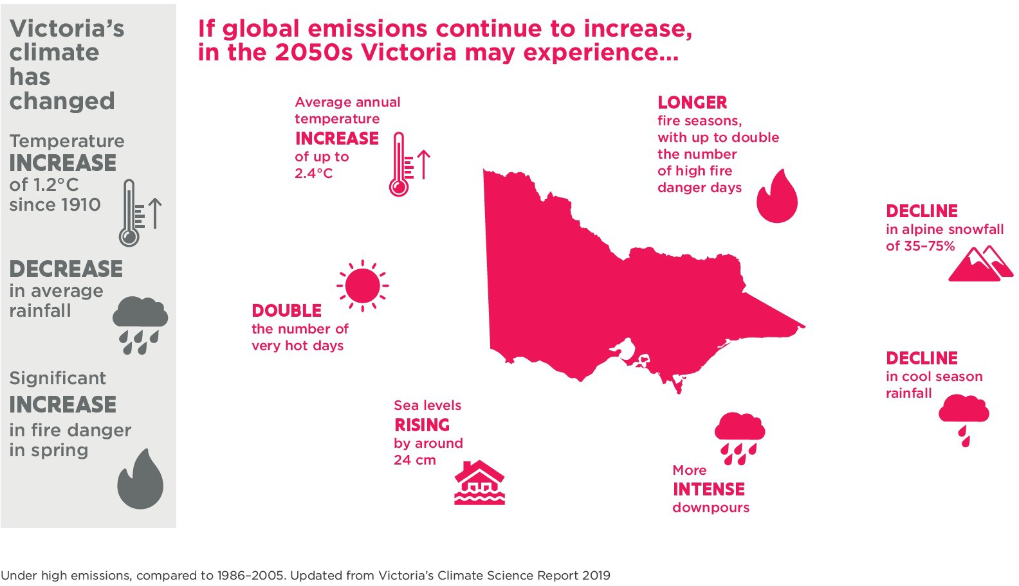

1. Department of Environment, Land Water and Planning 2019, Victorian Climate Science Report
2. Department of Environment, Land Water and Planning, 2021, Victorian Climate Change Strategy

### IMPACTS OF CLIMATE CHANGE ON THE EDUCATION AND TRAINING SYSTEM

Our changing climate is already being felt within the Education and Training system and across society. Students commencing school education this year will not have experienced a below-average year in temperature, with the years 2013 to 2020 all ranking in the warmest years since records began in Australia in 1910.8

Evidence suggests that climate change is a key issue of concern for young people in Victoria and is affecting the mental wellbeing of some young Victorians.9

While the climate trends and associated impacts Victoria has already experienced

are expected to continue, uncertainty remains with the rate and magnitude of change as well as the distribution

of effects. This uncertainty extends to the scale and distribution of impacts on the Education and Training system. It is therefore important to plan for change

and factor in uncertainty. This includes being aware of how the projected doubling of the number of very hot days and more dangerous conditions for bushfires may impact learner and staff wellbeing and their wider community, including potentially:

* increasing threats to the physical and psychological health and safety of learners

and staff

* impacting learning outcomes and productivity (both short term and long term)
* resulting in lost learning days due to illness or disruption, particularly for those with underlying

disabilities/health conditions

* limiting opportunities for physical exercise and outdoor education
* increasing psychological harm due to loss of life in the community, loss of property and natural environment, or increased uncertainty about the future.

Potential direct impacts of hazards exacerbated by a changing climate on buildings and infrastructure over the long term must also be considered, including:

* direct damage to assets
* increased maintenance and recovery costs
* increased pressure on infrastructure to withstand more intense weather events
* implications for insurance costs.

Both indirect impacts on health and wellbeing of learners and staff, and direct impacts on building and infrastructure, may disrupt education and training service provision

and cause challenges for education and training staff, particularly in rural and regional areas.

Climate change sits alongside other pressures on the Education and Training system, such as fast-paced technological change and the trend towards a more complex, competitive and highly skilled job market.

Despite these complex considerations, the Education and Training system is well placed to capitalise on its role, and learner/staff appetite, to engage in conversations and actions that will prepare the workforce for future climate change, and the opportunities this can bring for Victoria. The system directly engages with children and young people and can help them build resilience while developing new skills and competencies for the jobs of the future, as well as ways to effectively advocate for a net-zero emissions, climate- resilient future.

Modelling undertaken for the Macklin Review of Future Skills for Victoria showed

a major opportunity: the health of Victoria’s economy and society depends on its capacity to take action to address climate change in key sectors such as energy, land use, transport, industry, construction and buildings

management.10 The Education and Training system can also support the re-skilling and up- skilling of workers by including climate change considerations in existing education and training, as well as developing new and innovative courses for future implementation.

1. CSIRO, Bureau of Meteorology, 2020; State of the Climate, p.4
2. Department of Premier and Cabinet (2020). What matters to young people in Victoria: Victorian youth strategy discussion paper. Melbourne, Australia: Victorian Government. p.14
3. Macklin J., 2020, Future Skills for Victoria, Driving collaboration and innovation in post-secondary education and training, Victorian Government, Melbourne.p.33

# Key climate change risks and opportunities for the Education and Training system

The Department of Education and Training has conducted an initial assessment of relevant climate change hazards and their current and/or potential impacts and risks, focusing

on health and wellbeing, early childhood education, schools, training and skills, higher education and corporate operations.

The *Climate Change Act 2017*

requires ‘an assessment, in relation to the relevant system, of the extent to which existing policies of the Government of Victoria address the statement of

priorities of Victoria’s Climate Change Strategy’. This has informed the Department of Education and Training’s risk identification and adaptation action development (see section 5). Further analysis of these risks, and development of measures to address them, will be conducted during the

5-year life of this plan.

### NON-CLIMATIC DRIVERS OF CHANGE

The spread of population and jobs growth is and will continue to vary across the state. This, in turn, will influence demand for early

childhood education, school education, training and skills and higher education.

Community concern around climate change is evident with most Victorians thinking that climate change is an issue that requires urgent action now.11

Advances in technology changes and information security presents risks and challenges. Use of technology in our Education and Training system for communication and learning provides potential opportunities to support climate change adaptation actions. The long-term economic trend towards a more complex, competitive and highly skilled job market means Victoria’s Education and Training system will need to adapt. For example, the transition to a climate resilient, low-carbon economy and emerging industries, and those in transition, will be supported by training and skills, and higher education.

### CLIMATE CHANGE RISKS AND

**OPPORTUNITIES FOR THE EDUCATION AND TRAINING SYSTEM**

Education and training services are already experiencing the impacts of climate change. In future, these impacts are anticipated to increase in frequency and severity. The Education and Training system can support both the education and training workforce, and children and young people to build the necessary knowledge, skills and capability to adapt to a world impacted by climate change. Key risks and opportunities the system is facing due to climate change are detailed below.

* + 1. **Health, wellbeing and emergency management**

### RISKS

* Climate projections suggest events such as extremely hot days are likely to increase in frequency, localised flash-flooding is likely to be more intense, and the number of high

fire danger days in Victoria is expected to increase.

These events pose risks to the health, safety and

1. [https://www.sustainability](http://www.vicsrc.org.au/files/).vic.gov[.au/research-data-and-insights/research/climate-change/victorians-perceptions-of-climate-](http://www.sustainability.vic.gov.au/research-data-and-insights/research/climate-change/victorians-perceptions-of-climate-) change, pp.4-9

wellbeing of the people in the Education and Training system.

* Events such as bushfires can cause trauma in children and young people, potentially leading to long- term learning impacts if not addressed appropriately.12 There is a risk that there will be increased demand on teaching staff who provide the first point of contact

and support, and as such additional supports may be required, including an increasing demand for practitioners. Teachers,

educators and support staff will have increased demand to provide ongoing support and/or act as gatekeepers to address learning impacts.

* Children are considered more vulnerable to the impacts of climate change. Children who experience trauma or disadvantage are even more vulnerable. Very young children within early childhood education facilities are especially vulnerable

to the impacts of climate change due to having limited abilities to communicate and self-monitor (for example, awareness of heat health).

Children with disabilities and underlying health conditions may also have communication difficulties, challenging behaviour and difficulty understanding changes to routine caused by an evacuation or similar response to a hazard.

* Hotter weather and more very hot days can impact learning, behaviour and productivity at early childhood education services and schools.13
* Events exacerbated by climate change place increased demand on the Education and Training system’s resources for emergency management, including mitigation, preparedness, response and recovery. This includes providing ongoing psychological support

for learners, staff and communities affected by disasters.

### OPPORTUNITIES

* As well as designing assets and infrastructure to incorporate potential

health, safety and wellbeing impacts of climate change, the Education and Training system can respond through its operational policies, health and wellbeing initiatives, and disaster resilience and emergency management procedures, including prioritising the protection of the most vulnerable people.

* Approaches to raising awareness of climate risk, incorporating climate risk into risk-assessment practices, and building capability to do so, will

ensure that climate change risk is appropriately incorporated in health and wellbeing initiatives and

emergency management.

* Preparedness and recovery activities, such as

strengthening peer supports and relationships within the community and encouraging people to seek support

from existing services, can be used to help increase personal resilience.

* + 1. **Knowledge, capability and adaptive capacity**

### RISKS

* Not incorporating climate projections when planning programs or initiatives could result in inadequate preparation. Appropriate responses to increased demand – for example, for resources to support increased frequency and severity of heatwaves and bushfire – are required.

### OPPORTUNITIES

* Developing information and resources that incorporate current climate change impacts and climate projections into decision making. For example, risk mapping can inform asset and infrastructure upgrade prioritisation to improve climate resilience.
* Increasing education leadership teams’ knowledge and skills to support them in leading response and recovery to more severe natural events within early childhood education services and schools. For example, by developing materials and

1. Gibbs, L, Molyneaux, R, Harms L, Gallagher, H. C, Block, K, Richardson, J, Brandenburg, V, O’Donnell, M, Kellett, C, Quinn, P, Kosta, L, Brady, K, Ireton, G, MacDougall, C, Bryant, R., 2021; 10 Years Beyond Bushfires Report 2020. University of Melbourne, Melbourne, Australia pp..4-28
2. Madden, A.L., Arora, V., Holmes, K.A., Pfautsch, S., 2018. Cool Schools, Western Sydney University pp.11-16

guidance that teach best practices for climate change adaptation and emergency management planning.

* Using operational policies to guide early childhood education services, schools and other education services in their response to climate-related events, such as more very hot days. This could include reflecting the increased frequency and/or severity of climate-related events in operational policy to support decision making and resource allocation.
  + 1. **Teaching and learning, curriculum**

### RISKS

* Lack of knowledge, skills and capability (for example, in government, the education sector,

industry and community) to incorporate climate change adaptation in decision making could lead to exacerbated climate change impacts and maladaptation.

* Lack of clearly defined approaches to education for climate change, climate change adaptation and lack of adequate support for educators (for example, appropriate resources for learning and teaching) may lead to a lack of capability and capacity to build learners’ understanding and knowledge of climate change and its impacts, and in turn their capacity to adapt to impacts.
* Students have demonstrated a keen interest in climate change and want to take action (for example, Victorian Student Representative Council, School Strike 4 Climate).14 Young people may feel anxiety and/or uncertainty about climate change and its current and expected impacts. Educators

need to be equipped with the necessary facts, language and effective, age-appropriate teaching

and learning strategies to build on this interest and help learners effectively prepare for climate change impacts as relevant to their circumstances. This includes working to build agency and prepare learners to identify and work towards their preferred futures.

### OPPORTUNITIES

* Build on materials already available to teachers

to support delivery of climate change curriculum.

Enable teaching through a climate change lens and the capacity to build on programs that build personal resilience. For early childhood education,

this can be underpinned by the Victorian Early Years Learning and Development Framework and the National Quality Framework.

These frameworks include requirements that the early childhood education service cares for the environment and supports children to

become environmentally responsible.

* Marrung, Aboriginal Education Plan supports and encourages early childhood education, school, training, skill and higher education

to engage with Aboriginal people throughout Victoria and embed Aboriginal perspectives into the curriculum. Marrung

and Traditional Owner engagement will guide development of further adaptation options over the life of this adaptation action plan.

* The training and skills, and higher education sector can update curriculum and course content and embed new workplace practices to provide the skills that industry, businesses,

early childhood education services and schools need to adapt to the impacts of climate change.

* In responding to the Macklin review, the Education

and Training system plays a role in enabling industry, businesses and the community to reduce emissions and help build Victoria’s resilience by building capacity to take action to address climate change in key sectors such as energy, land- use, transport, industry,

construction and buildings management. Initiatives such as the Clean Economy Skills and Jobs Task Force can help support business,

1. Victorian Student Representative Council; Congress 2019: ht[tps://s3-ap-southeast-2.amazonaws.com/www](http://www.safertogether.vic.gov.au/).vicsrc.org.au/files/ Congress+Report+2019.pdf pp. 16-17

industry and the community understand climate risk, build knowledge and understanding, and enable climate change adaptation.

* As the expectation for action on climate change grows

– particularly in children and young people – we can engage learners in age-appropriate ways to build knowledge, skills and capabilities that will help

them act and adapt. Further work could be done to engage children and young people to express their views on climate change, and what they need to learn, and this can help inform approaches to classroom teaching and help to identify any support needed by educators.

* Education for sustainability can help learners better understand the impacts

of their activities on the environment, foster a connection to the natural environment and promote sustainable behaviour, while empowering people to address global challenges such as climate change.

However, we need to equip young people with the knowledge, skills, understandings and values they need to adapt to the increasing frequency, intensity and magnitude of extreme weather events

in Victoria. During the last decade, understanding of what constitutes quality

Education for Disaster Risk Reduction (EfDRR) in the Victorian context has

increased substantially. We can continue to support evidence-based approaches to EfDRR in Victorian schools.15

* Forge greater connections between emergency and disaster management preparedness actions and climate change awareness, and continue to support evidence-based approaches to education for disaster

risk reduction. Curriculum, and teaching and learning approaches, can support disaster risk reduction and resilience.

* + 1. **Assets and infrastructure**

### RISKS

* Weather events and bushfires that may be exacerbated by climate change can damage infrastructure and assets and interrupt the delivery of education and training services (for example, property damage due to flooding, storm surge, fire and/or storm). Such events can pose risks to health and safety and have long- term impacts on student learning outcomes, such as learning delays. Such events may increase the costs for maintenance and repair of damaged assets and infrastructure and may increase service disruption

impacts. Rising insurance costs and the potential for some properties/assets to become uninsurable is also a risk.

* A decline in cool-season rainfall may cause deterioration of the condition of vegetation and playing fields and increase hardening of playing surfaces. This could result in increased risk of injury, reduced opportunities for use and limited time for participation in physical activities.

### OPPORTUNITIES

* Educational facilities themselves are potentially vulnerable to the impacts of climate change but also play a key role in protecting people from its impacts. Recent research demonstrates that there is

a link between educational settings (where teaching and learning take place), and health, productivity and academic performance, particularly in relation to thermal comfort in schools.16

* Ensuring that the early childhood education, school education, training and skills, and higher education sectors incorporate climate change adaptation into siting, design and building considerations for education and training infrastructure will result in safer and

more comfortable learning environments (such as

1. [https://www.bnhcrc.com.au/casestudy/schoolbasededucation](http://www.bnhcrc.com.au/news/2018/school-based-education-disaster-risk-reduction) accessed 26 August 2021
2. Madden, A.L., Arora, V., Holmes, K.a., Pfautsch, S., 2018. Cool Schools, Western Sydney University pp.11-16

during heatwaves) and will reduce the need for maintenance and repair due to climate-related intense weather events. While there are examples across the system of how this is currently being implemented, there are significant opportunities to further embed these

considerations by providing support and tools such as regional climate change risk assessments, and design and construction guidance.

### CROSS-SYSTEM CLIMATE CHANGE RISKS

The system-based approach to adaptation action plans is critical to identifying climate change risks that span 2 or more of the 7 adaptation systems. These risks are particularly challenging as they may:

* be newly emerging risks (for example, rising sea levels)
* only occur during particular climatic conditions or are de- prioritised at other times (for example, algal events)
* demand accountability and oversight across multiple stakeholder groups due to their size and complexity (for example, bushfires)
* raise inherent conflicts between the values or goals of different systems (for example, water availability).

A collaborative approach to adaptation action plans is necessary to drive sustained change and address these cross-system climate change risks. The Education and Training system will work with the 6 other systems to identify how best to incorporate the relevant knowledge, skills and capabilities into training and skills, and higher education.

# Existing climate change adaptation policies, programs and projects, and gap analysis

The Education and Training system has programs in place to address climate change impacts. Embedding climate change into decision making and building more capability across the system will further enable development of adaptation actions.

An initial assessment of policy, programs and initiatives against the Victorian Climate Change Strategy priorities has revealed the following areas of focus. The priorities outlined below detail how the existing policies of the Education and Training system policies are potentially impacted or can be refocused to address climate change adaptation, and identify the actions needed to further build adaptive capacity.

### VICTORIA’S CLIMATE CHANGE STRATEGY PRIORITY: ADDRESS CURRENT CLIMATE CHANGE IMPACTS

To date, the Education and Training system has

developed and implemented health and wellbeing programs to address impacts of climate change, such as bushfire recovery support programs, and heat-health and physical education policies and initiatives.

There are emergency management arrangements in place currently to address climate-related emergencies.

At the moment, key activities for the Department of Education and Training are:

* Collaboration with the emergency management sector at all tiers (state, regional and local) – the Department of Education and Training works collaboratively with other departments and agencies at the local, regional and state level through all phases of emergency management (mitigation, preparation and planning, and response and recovery) to support emergency services in their planning

to ensure appropriate and coordinated approaches to hazards and emergencies impacting education communities.

* Coordinated response to emergencies impacting the education portfolio within the Department of Education and Training – when responding to emergencies impacting the portfolios within the Department of Education and Training, coordination is through Incident Management Teams at local, regional

and state levels involving all relevant Department of Education and Training areas.

* Capability building – the Department of Education and Training has several

supports and resources available to schools and educational facilities. This includes policies, advice and guidance for emergency management planning for education facilities, as well as facilitated information workshops. This includes tailored advice to improve awareness of staff about risk profile and appropriate response arrangements/ procedures based on specific sites and service context. These supports

will shortly be extended to online eLearning modules to allow school leadership staff to access an overview of essential information at the time, as needed.

* Wellbeing supports – the Department of Education and Training facilitates student support services, including allied health staff, mental health practitioners and school staff with wellbeing portfolios. Wellbeing

programs strengthen school communities ahead of emergencies and critical incidents. Post-incident

or emergency support is also provided, including psychological first aid, triage and referral for more intensive support, as well as whole-school recovery initiatives.

### IDENTIFIED GAPS

* Build information about how current health and wellbeing programs will be impacted by, and can support, climate change adaptation.
* Increase understanding of current climate change impacts on learners,

teachers and educators, and other education and training staff.

* Improve understanding of current communications procedures to ensure they are effective in light of increased frequency of climate-related risks and events.
* Build understanding of the resource implications for emergency management and ensure that we

can continue to provide capability building for emergency management, including recovery from trauma related to climate- related disasters/events.

* Information, training and guidance on climate risks to the system, including a focus on regions and different asset types, to enable incorporation of

climate projections and risk assessments into planning, siting, building, and ongoing management of education and training assets and infrastructure.

### VICTORIA’S CLIMATE CHANGE STRATEGY PRIORITY: REDUCE BARRIERS TO ADAPTATION

The Victorian Government has partnerships (for example,

the Strategic Partnerships Program) that support the cross-curricular priority of environmental sustainability. These can help build understanding to reduce barriers to both emergency management and education for climate change adaptation.

This adaptation action plan considers how these

partnerships address climate change and opportunities to enhance these.

Data collected through the Department of Education and Training’s reporting

systems and processes could be used to identify trends over time and priority risks

to guide the development of enhanced climate change hazard response programs. To reduce barriers to adaptation, the Education and Training system needs to build its understanding of, and capacity to respond to, climate change, including understanding

of current and expected impacts of climate change and the associated risks and opportunities.

Multiple, simultaneous and cascading emergencies will necessitate more focus on emergency management activities. The continuous improvement of systems – including the ways we prepare, coordinate and engage

with other stakeholders and agencies – will contribute to reducing time and resources in providing remediation efforts. Building educational facility capability in identifying and reducing hazards will also aid adaptation to local hazards.

### IDENTIFIED GAPS

* Build the evidence base for the best approaches to embed climate change into decision making and

enable provision of training and guidance to staff at education and training facilities, and Department of Education and Training staff (for example, training to build understanding of hazards, and the ability to identify risks for a region

and incorporate this into risk management processes).

* Improve understanding of the current capability of teachers and educators in delivering age-appropriate climate change education, and education for climate change adaptation, and use this to identify the most appropriate avenues to support capability development.
* Analyse data on the impacts of past climate-related events, looking for trends

to inform risk analysis and the development of actions that incorporate projected climate futures.

### VICTORIA’S CLIMATE CHANGE STRATEGY PRIORITY: LAY THE FOUNDATIONS FOR TRANSFORMATIONAL ADAPTATION

Environmental sustainability is a cross-curricular

priority within the Victorian curriculum, and this provides an opportunity for schools

to integrate environmental sustainability across their learning programs. Early

childhood education services, schools and teachers can build understanding, capacity, knowledge and skills by incorporating rich, local, and relevant climate change education into their teaching and learning programs, both through specific subjects and by teaching through a climate change lens. This can provide relevance for learners who want to feel empowered to affect their future.

Current partnerships with organisations (for

example, peak stakeholder groups) could also provide opportunities to incorporate environmental sustainability and potentially (where relevant) strengthen the focus on climate change adaptation.

Skills and competencies, such as critical and creative thinking, are a priority to help equip our children, empower our young people, and provide the agency

and tools to understand the problem, respond and change behaviour. Programs such as ResourceSmart Schools and the Clean Economy Workforce Skills Initiative support relevant community and workforce skill development, and these are expected to support climate change adaptation.

Education for environmental sustainability builds awareness of the broad issues and behaviour but this alone will not support adaptation to the impacts of climate change.

Education for environmental sustainability and for climate change adaptation are

two different streams of knowledge, and each requires tailored approaches.

The Victorian Government’s climate change commitments will include activities to improve emergency response activities, update building standards, improve energy efficiency requirements, and promote renewable energy uptake. Such activities are likely to require re-skilling or up-skilling of the workforce – particularly for communities where industries are in transition – and also offer improved quality of life for vulnerable Victorians.

Higher education, and skills and training can deliver the skills and capabilities to enable industry and business to respond to current climate change impacts. This training will also build a workforce with knowledge and understanding about how both current and future climate change will impact their industry. This enables people to identify

climate change risks and to develop adaptation measures relevant to their workplace.

### IDENTIFIED GAPS:

* Industry consultation to explore how climate change is currently addressed/ incorporated and identify skills needs, followed by information/analysis of industry needs and the best approaches to incorporate climate change adaptation into relevant qualifications.
* Evidence and Aboriginal knowledge to inform teaching/learning approaches to education for climate change adaptation.

# Climate change adaptation actions: 5-year plan

The proposed adaptation actions listed in   
Table 3 (below) address the adaptation priorities of Victoria’s Climate Change Strategy and the identified risks, opportunities and gaps

described in sections 4 and 5 of this plan. Refer to Appendix 4 for more detail on the links between actions, key focus areas, risks and opportunities.

**Table 3. Proposed climate change adaptation actions of the Education and Training system**

**Focus area**

**Action number**

**Proposed actions**

Improve understanding of climate change risks and vulnerabilities, and build capability to embed climate change adaptation, where relevant, into decision making, policy and processes. This will inform development and selection of adaptation actions

1. Incorporate the monitoring of climate-related impacts on the school asset portfolios into the Victorian School Building Authority asset information platform to inform climate adaptation planning and responses.
2. Incorporate climate change adaptation into Victorian School Building Authority policies, standards, plans and processes as climate change risks on the school asset portfolio are identified.
3. Explore options to support early childhood education providers to adapt to climate change, such as opportunities to support upgrade of early learning and kindergarten infrastructure to improve resilience, support for education for climate change adaptation in teaching practice and embedding sustainability, and climate change adaptation, into operations.
4. Support the establishment and evaluation of mechanisms for the participation of children and young people in the design and implementation of policies, plans and standards for climate change adaptation and disaster risk reduction.

Cast a climate change lens over policies, with a focus on health and wellbeing policies and programs, including those that protect vulnerable people, and develop strategies to meet

our emergency management obligations

1. Develop a plan to respond to thermal comfort-related impacts of climate change on Victorian government schools.
2. Draft a policy on Environmental Sustainability in schools, including a focus on climate change and climate change adaptation. The policy will reduce environment impact of school operations, build whole-school approaches to environment sustainability and climate change adaptation by providing guidance to schools on the identification of climate-related hazards and incorporating climate risk management into existing systems.

Review existing Department of Education and Training operational policies for schools with a sustainability/climate change/climate adaptation lens to ensure schools are equipped with the resources and capability to address climate-related hazards and opportunities for improved climate change adaptation and environmental sustainability practices, in line with Victorian Government climate change adaptation priorities.

Assist schools to manage climate change hazards relevant to their region, including the identification and application of appropriate, evidence-based approaches to disaster risk reduction. Consider providing analogous guidance to other types of education providers.

1. Use data, research and knowledge building to inform approaches to adaptation, with a focus on occupational health and safety.
2. Review how the content of key health, wellbeing and inclusion programs can be delivered in an environmentally sustainable way and encompass the impacts of climate change, including consideration of the disproportionate impacts on learners experiencing disadvantage.

Improve the climate resilience of assets and infrastructure

1. Incorporate region-based climate adaptation tools and resources (such as flood overlays, and temperature and rainfall projections), supported by appropriate training and guidance, when selecting sites for new education facilities.
2. Incorporate region-based climate adaptation tools and resources (such as flood overlays, and temperature and rainfall projections), supported by appropriate training and guidance, in the planning and design of all capital works projects.
3. Incorporate region-based climate adaptation tools and resources, supported by appropriate training and guidance, in the planning, design and demand forecasting of all Victorian School Building Authority operation and response programs.
4. Develop a plan to respond to increasing climate change impacts on vulnerable asset types.
5. Incorporate climate change into planning, maintenance, emergency preparedness and the upgrade of corporate assets and infrastructure to improve resilience to climate change hazards.
6. Targeted activities with the TAFE sector to improve understanding of the impacts of climate change on TAFE buildings and infrastructure.

Explore how to build climate change adaptation skills and capabilities for Victorian industry, business and community via education and training

1. Incorporate climate change adaptation actions into the Victorian Government’s Clean Economy Workforce Skills initiative.
2. Work with the Victorian TAFE and training system to improve the sector’s understanding of climate change impacts on the training system.
3. Support the Learn Local sector to adapt its service offering so vulnerable cohorts do not experience additional barriers to learning as a result of climate change and so Traditional Owners are engaged.
4. Through the government’s skills industry engagement framework, consult with industry to understand any skills issues arising from both the impacts of climate change and the requirements to transition towards a net-zero carbon economy by 2050, and provide recommendations as relevant to the vocational training sector.

Develop measures to support adaptive capacity of the education and training sector

1. Review current communications processes to ensure they are adequate to respond to projected climate change impacts.
2. Convene a diverse group of students to advise on the most engaging learning and teaching resources relating to climate change, climate change adaptation and disaster risk reduction, and communicate these to schools and TAFEs.
3. Continue to explore ways to support early childhood education providers to build organisational resilience and adapt activities to the impacts of climate change on wellbeing and service delivery.
4. Work with Universities and support research that builds capability and understanding of best- practice climate change adaptation approaches within all components of the Education and Training system. Use this research to inform the development of future adaptation options.

Support collaboration with Universities and research organisations to develop, deliver, monitor and/or evaluate climate change adaptation actions.

Complete a climate change vulnerability assessment to identify the people in our system most vulnerable to the impacts of climate change and options to support adaptation.

# Implementation

The Department of Education and Training will develop an implementation plan to provide further detail on the scope of actions and priorities, as well as the timing and allocation of resources to implement this plan. This will include forming appropriate governance arrangements and stakeholder engagement to oversee and inform implementation, and

to determine how existing networks and partnerships along with any additional advisory mechanisms will inform the delivery of this plan.

# Monitoring, evaluation, reporting and improvement

The Department of Education and Training will develop

an evaluation framework to measure the effectiveness of the plan in achieving its objectives. The Department of Education and Training is

committed to building a strong evidence-based culture.

This is a critical aspect of strategic decision making, accountability, efficient and effective management, and continuous improvement.

Monitoring and evaluation are important aspects of the evidence-based approach at the Department of Education and Training because

they enable us to learn, improve and demonstrate accountability.

A fit-for-purpose Monitoring, Evaluation and Learning framework will be developed within year one (2022) to guide the implementation of this plan. This Framework will draw on appropriate data collection methods and include both quantitative and qualitative data collection methods, which

may include:

* developing a program logic model
* identifying key evaluation questions
* data collection methods
* judgement criteria
* formal evaluation requirements.

Data collection to support monitoring and evaluation will be integrated with the day-to- day implementation of the plan to maximise the effectiveness and efficiency of investment.

# Appendices

### APPENDIX 1. SUMMARY OF POLICIES, PROGRAMS AND LEGISLATION RELEVANT TO THE EDUCATION AND TRAINING SYSTEM

**Policy/program/initiative**

**Link to Victoria’s Climate Change Strategy priorities/enablers**

1. Victorian School Building Authority (VSBA) Building Quality Standards Handbook, May 2021

Address current impacts Reduce barriers

1. Bushfire recovery officers in bushfire-affected regions Address current impacts
2. Emergency Management Planning Address current impacts Reduce barriers
3. Policy and Advisory Library Address current impacts

Reduce barriers

1. Health and wellbeing strategies
   * trauma-informed practice
   * supporting student voices
   * careers programs

Address current impacts

Lay the foundation for transformation

1. Planning new school sites Reduce barriers
2. OHS policies and procedures Address current impacts
3. Strategic Partnerships Program Lay the foundation for transformation
4. ResourceSmart Schools – Sustainability Victoria

Department of Education and Training Sustainable Facilities policy is relevant policy for use in schools and provides a link to ResourceSmart Schools Program

Address current impacts Reduce barriers

Lay the foundation for transformation

1. Asset Management Plan/Policy/Program Address current impacts Reduce barriers
2. Incident Reporting Systems Address current impacts

Reduce barrier

1. Operational maintenance and building upgrade programs, including Make-safe

Address current impacts Reduce barriers

1. Clean Economy Workforce Skills Initiative Lay the foundation for transformation
2. International Student Program Reduce barriers

Lay the foundation for transformation

1. Teaching and learning programs (materials to support best practice such as teaching support materials, for example, FUSE)
2. Award programs – rewarding best practice (for example, Victorian Global Learning Awards and the Department of Education and Training sponsorship

of ResourceSmart Schools Awards)

Address current impacts

Lay the foundation for transformation Lay the foundation for transformation

1. Victorian Early Years Learning and Development Framework – Outcome 2 Respond to current impacts

Lay the foundation for transformation

1. National Quality Framework for Early Childhood Education Respond to current impacts

Lay the foundation for transformation

1. Victorian Government Office Accommodation Guidelines (pending update) Address current impacts

Reduce barriers

Lay the foundation for transformation

1. Local government planning requirements Address current impacts Reduce barriers
2. Clean Economy Workforce Skills Initiative and the Victorian Skills Authority Address current impacts

Reduce barriers

Lay the foundation for transformation

1. Asset Management Planning processes Address current impacts Reduce barriers

Lay the foundation for transformation

1. Make-safe programs Address current impacts
2. Department of Education and Training risk assessment processes (including schools risk management policy)
3. Education State Strategy – the following targets reflect the ambition to improve student outcomes:
   * learning for Life
   * pride and confidence in our schools
   * breaking the link
   * happy, healthy, resilient kids

Address current impacts Reduce barriers

Lay the foundation for transformation Address current impacts

Reduce barriers

Lay the foundation for transformation

1. Disaster recovery and resilience programs Address current impacts
2. Emergency management policy, programs and procedures Address current impacts
3. TAFE and training initiatives and partnerships (for example, skills and jobs centres, Learn Locals)

Address current impacts Reduce barriers

Lay the foundation for transformation

1. Marrung – Aboriginal Education Plan 2016–2026 Address current impacts Reduce barriers

Lay the foundation for transformation

1. Buildings and Grounds policies Address current impacts Reduce barriers
2. Partnership Agreements (for example, partnership with Victorian Council of Social Services community sector)

Address current impacts Reduce barriers

Lay the foundation for transformation

1. School Incident Management System (SIMS) Address current impacts Reduce barrier
2. Air Quality and Outdoor Activity, Guide for schools and childcare centres EPA Publication 1816.1
3. Health and wellbeing-related policies/plans (for example, heat health, SunSmart, asthma management)
4. Specific emergency risk assessment planning and procedures (for example, for excursions)

Address current impacts Reduce barriers Address current impacts

Address current impacts

1. Code Red Day pre-emptive closures and procedures Address current impacts
2. Guidelines for bushfire preparedness (Victorian Registrations and Qualifications Authority)
3. Victorian School Bushfire Risk methodology and association policies and procedures for facilities at risk of bushfire and grassfire (including Bushfire

at Risk Register)

1. Victorian Curriculum F-10 and VCE Environmental Science (Victorian Curriculum and Assessment Authority)
2. Victorian Curriculum and Assessment Authority Bushfire Education website

[https://www.vcaa.vic.edu.au/curriculum/foundation-10/crosscurriculumresources/Pages/](http://www.sustainability.vic.gov.au/research-data-and-insights/research/climate-change/victorians-perceptions-of-climate-) Bushfire-education.aspx

1. Victorian Government's Safer together program [https://www.safertogether](http://www.education.vic.gov.au/about/).vic.gov[.au/](http://www.bnhcrc.com.au/casestudy/schoolbasededucation) community-engagement - Schools in Fire Country

Address current impacts Address current impacts

Reduce barriers

Lay the foundation for transformation

Address current impacts Reduce barrier

Address current impacts Reduce barriers

Lay the foundation for transformation

### APPENDIX 2. KEY TERMS AND ACRONYMS

#### Glossary of terms used in this plan.

**Term Definition**

(Climate change) Adaptation

Any process of adjusting to actual or expected climate and its effects that (a) in human systems, seek to moderate or avoid harm or exploit beneficial opportunities and (b) in natural systems, may be facilitated by human interventions. For types of adaptation, see incremental adaptation and transformative Adaptation.

Adaptive capacity The ability of systems, institutions, humans, and other organisms to adjust to potential damage, to take advantage of opportunities, or to respond to consequences. See also coping capacity.

Assets and infrastructure

An asset is an item, thing or entity that has potential or actual value to an organization (ISO55000). This includes school buildings and land and assets that the Department of Education and Training has invested in and has a stake in or a level of responsibility for (such as early learning and higher education assets).

Capacity building The practice of enhancing the strengths and attributes of, and resources available to, an individual, community, society, or organisation to respond to change.

Climate change A change of climate which is attributed directly or indirectly to human activity that alters the composition of the global atmosphere and which is in addition to natural climate variability observed over comparable time periods.

Climate system The climate system is the highly complex system consisting of five major components: the atmosphere, the hydrosphere, the cryosphere, the lithosphere, and the biosphere, and the interactions among them.

Climate variability Climate variability refers to variations in the mean state and other statistics (such as standard deviations and the occurrence of extremes) of the climate on all spatial and temporal scales beyond that of individual weather events. Variability may be due to natural internal processes within the climate system (internal variability), or to variations in natural or anthropogenic external forcing (external variability).

Cope The use of available skills, resources, and opportunities to address, manage, and overcome adverse conditions, with the aim of achieving basic functioning of people, institutions, organisations, and systems in the short to medium term.

Coping capacity The ability of people, institutions, organisations, and systems, using available skills, values, beliefs, resources, and opportunities, to address, manage, and overcome adverse conditions in the short to medium term. See also adaptive capacity.

Disaster Severe alterations in the normal functioning of a community or a society due to hazardous physical events interacting with vulnerable social conditions, leading to widespread adverse human, material, economic, or environmental effects that require immediate emergency response to satisfy critical human needs and that may require external support for recovery.

Education providers Early childhood education, kindergarten, schools, TAFE and tertiary institutions and training providers.

Exposure The presence of people, livelihoods, species or ecosystems, environmental functions, services, and resources, infrastructure, or economic, social, or cultural assets in places and settings that could be adversely affected.

Greenhouse gas emissions

Emissions of (a) carbon dioxide, methane, nitrous oxide or sulphur hexafluoride or (b) a hydrofluorocarbon or perfluorocarbon that is specified in regulations made under the National Greenhouse and Energy Reporting Act 2007 of the Commonwealth.

Hazard The potential occurrence of a natural or human-induced physical event or trend or physical impact that may cause loss of life, injury, or other health impacts, as well as damage and loss to property, infrastructure, livelihoods, service provision, ecosystems, and environmental resources. In this report, the term hazard usually refers to climate-related physical events or trends or their physical impacts.

Incremental adaptation Adaptation actions where the central aim is to maintain the essence and integrity of a system or process at a given scale.

Maladaptation (maladaptive actions)

Actions that may lead to increased risk of adverse climate-related outcomes, increased vulnerability to climate change, or diminished welfare, now or in the future.

Personal resilience (Psychological resilience)

Refers to an adaptive and healthy state of social and emotional functioning. People who are psychologically resilient are more likely to respond constructively to challenges and difficulties they face in their lives.

Resilience The capacity of social, economic, and environmental systems to cope with a hazardous event or trend or disturbance, responding or reorganising in ways that maintain their essential function, identity, and structure, while also maintaining the capacity for adaptation, learning, and transformation.

Risk The potential for consequences where something of value is at stake and where the outcome is uncertain, recognising the diversity of values. Risk is often represented as probability of occurrence of hazardous events or trends multiplied by the impacts if these events or trends occur.

Sensitivity The degree to which a system or species is affected, either adversely and directly, such as by a change in crop yield in response to a change in the mean, range or variability of temperature; adversely and indirectly, such as by damages caused by an increase in the frequency of coastal flooding due to sea level rise; or beneficially, such as by climate variability or change.

Transformational adaptation

Adaptation that changes the fundamental attributes of a system in response to climate and its effects.

Vulnerability The propensity or predisposition to be adversely affected. Vulnerability encompasses a variety of concepts and elements including sensitivity or susceptibility to harm and lack of capacity to cope and adapt.

### APPENDIX 3. REFERENCES

Bushfire and Natural Hazards CRC; School-based education for disaster risk reduction: https:// [www.bnhcrc.com.au/news/2018/school-based-education-disaster-risk-reduction](http://www.sustainability.vic.gov.au/research-data-and-insights/research/) accessed 25

August 2021

Clarke JM, Grose M, Thatcher M, Hernaman V, Heady C, Round V, Rafter T, Trenham C & Wilson L. 2019. Victorian Climate Projections 2019 Technical Report. CSIRO, Melbourne Australia. CSIRO, Bureau of Meteorology, 2020; State of the Climate, 2020, Commonwealth of Australia

Country Fire Authority, https://news.cfa.vic.gov.au/-/disaster-resilience-education-in-schools, accessed June 2021 Melbourne, Australia: Victorian Government

Department of Education and Training 2020; Department of Education and Training Annual Report 2019–2020, Melbourne, Australia: Victorian Government

Department of Education and Training 2016; Marrung – Aboriginal Education Plan 2016–2026

Department of Environment, Land, Water and Planning, 2019; Victoria’s Climate Science Report 2019. Melbourne, Australia: Victorian Government

Department of Environment, Land, Water and Planning 2021; Victorian Climate Change Strategy, Melbourne, Australia: Victorian Government

Department of Health and Human Services, February 2018; Vulnerable People in Emergencies Policy, Melbourne, Australia: Victorian Government, https://providers.dffh.vic.gov.au/vulnerable- people-emergencies-policy accessed June 2021

Department of Premier and Cabinet 2020; What matters to young people in Victoria: Victorian youth strategy discussion paper. Melbourne, Australia: Victorian Government

Gibbs, L, Molyneaux, R, Harms L, Gallagher, H. C, Block, K, Richardson, J, Brandenburg, V, O’Donnell, M, Kellett, C, Quinn, P, Kosta, L, Brady, K, Ireton, G, MacDougall, C, Bryant, R., 2021; 10 Years Beyond Bushfires Report 2020. University of Melbourne, Melbourne, Australia

Intergovernmental Panel on Climate Change, 2014: Summary for policymakers. In: Climate Change 2014: Impacts, Adaptation, and Vulnerability. Part A: Global and Sectoral Aspects. Contribution of Working Group II to the Fifth Assessment Report of the Intergovernmental Panel on Climate Change [Field, C.B., V.R. Barros, D.J. Dokken, K.J. Mach, M.D. Mastrandrea, T.E. Bilir, M. Chatterjee, K.L. Ebi, Y.O. Estrada,

R.C. Genova, B. Girma, E.S. Kissel, A.N. Levy, S. MacCracken, P.R. Mastrandrea, and L.L. White (eds.)]. Cambridge University Press, Cambridge, United Kingdom and New York, NY, USA, pp. 1-32

Macklin J., 2020: Future Skills for Victoria, Driving collaboration and innovation in post-secondary education and training, Victorian Government, Melbourne

Madden, A.L., Arora, V., Holmes, K.a., Pfautsch, S., 2018: Cool Schools, Western Sydney University

Sustainability Victoria 2017: Summary of key findings – Climate Change Social Research, Victorians Perceptions of

Climate Change [https://www.sustainability](http://www.safertogether.vic.gov.au/).vic.gov[.au/research-data-and-insights/research/](http://www.sustainability.vic.gov.au/research-data-and-insights/research/) climate-change/victorians-perceptions-of-climate-change Melbourne, Australia: Victorian Government accessed June 2021

United Nations Climate Change The Paris Agreement (2021), accessed 25 August 2021. https://unfccc.int/process-and-meetings/the-paris-agreement/the-paris-agreement Victorian Student Representative Council, 2019; Congress Report 2019

### APPENDIX 4. ALIGNMENT BETWEEN FOCUS AREAS AND ADAPTATION ACTIONS

The 22 adaptation actions proposed for the Education and Training system have been framed by 5 focus areas that are informed by the risks and opportunities in section 4 and the gaps identified in section 5 of this plan. The links between these are detailed in the table below.

**Focus areas Actions Risks and opportunities Gaps**

Improve understanding of climate change risks and vulnerabilities, and build capability to embed climate change adaptation, where relevant, into decision making, policy and processes. This

will inform development and selection of adaptation actions.

1, 2, 3, 4 This focus area is a response to the risks that may arise for learners, staff, and assets if climate change projections and knowledge are not incorporated into planning, programs, or initiatives for the education and training sector. It also leverages

opportunities to support education leadership teams in leading

the response and recovery to increasingly severe natural disaster events.

It responds to the importance of participation of children and

young people in the design and implementation of policies, plans and standards for climate change adaptation and disaster risk recovery.

Actions proposed under this focus area seek to assemble the evidence base for best- practice adaptive management in the context of our system; understanding current capabilities in climate change adaptation; and the use of climate-related data to inform risk analysis.

Cast a climate change lens over policies, with a focus on health and wellbeing policies and programs, including those that protect vulnerable people, and develop strategies to meet our emergency management obligations.

5, 6, 7, 8 Addresses the risks to health and wellbeing of learners and staff due to anticipated increase in extreme heat events and bushfires, particularly the

experience of trauma and support required. It also contemplates the increased demand on the sector’s resources in terms of emergency management, including psychological support for learners, staff, and communities affected by these disasters.

Actions proposed under this fill policy gaps in understanding:

* the impacts of climate change upon current health and wellbeing programs and

the support role played by adaptation

* how current health and wellbeing programs can support climate change adaptation
* current climate change impacts on learners, educators and other staff
* resource implications for emergency management capability, including trauma recovery.

Assess the vulnerabilities of people within the system, develop further actions to reduce these vulnerabilities and address any disproportionate impacts on learners experiencing disadvantage.

**Focus areas Actions Risks and opportunities Gaps**

Improve the climate resilience of assets and infrastructure.

9, 10, 11, 12, 13, 14 Responds to the threats posed to educational assets and infrastructure from increasingly frequent and intense natural hazards, in conjunction with the

consequent adverse impacts upon health and wellbeing, and student learning outcomes.

Address the need to build on current understanding of current and expected impacts and incorporate these into asset planning and management practices.

Fill the policy gap in identifying climate risks to the sector

that influence the planning, siting, building, and ongoing management of education and training assets and infrastructure.

Explore how to build climate change adaptation skills and capabilities for Victorian industry, business and community via education and training.

15, 16, 17, 18 Addresses the opportunities that lie in a climate-resilient future, such as: engaging young learners to develop their adaptive capacity; using training to support business, industry and the community in understanding climate risk and enable adaptation; and courses to provide climate change adaptation skills for industry, businesses, early childhood education services, and schools.

Fill policy gaps in identifying the necessary skills for industry to sufficiently address climate change.

Identify the best approaches for incorporating climate change adaptation into relevant training qualifications.

Support skills and training and Learn Local sectors to understand impact of climate change on their services

Develop measures to support adaptive capacity of the education and training sector.

19, 20, 21, 22 Responds to the risk of maladaptation if climate change adaptation knowledge, skills and capabilities are poorly integrated into decision making in the education and training sector.

Also covers opportunities to guide early childhood education services, schools, and other education services in responding to climate-related events and provides support to enable

teaching through a climate change lens, teaching for climate change adaptation and developing programs that build personal resilience.

Seeks to gather evidence and support research to inform the development, delivery and monitoring and evaluation of adaptation options, teaching/ learning approaches to climate change and climate change adaptation.

Improve understanding of communications procedures to ensure efficacy in responding to climate-related risks and events.

Increase understanding of current climate change impacts on learners, teachers and educators, and other education and training staff, with a focus on assessing vulnerabilities to climate change and using this information to develop options to support adaptation.