# Guidance for the Victorian Public Sector: LGBTIQ+ Executive Sponsors

## Context

LGBTIQ+ stands for Lesbian, Gay, Bisexual, Trans and gender diverse, Intersex, Queer and questioning. LGBTIQ+ is used in this document as an inclusive umbrella abbreviation to encompass a range of diverse sexualities, genders and sex characteristics.

It is important to remember that each letter in LGBTIQ+ represents a community within itself. Some staff who identify as LGBTIQ+ may identify with only one of the communities. Examples of this may include an intersex woman, or a gay man. Some staff who identify as LGBTIQ+ may identify with many different LGBTIQ+ communities. Examples of this may include a bisexual non-binary person, or a trans woman who is a lesbian.

It is also important to recognise the diversity of LGBTIQ+ experiences. Being LGBTIQ+ is only one part of any person’s identity. As well as being diverse in their sexuality, gender identity or sex characteristics, LGBTIQ+ staff are diverse in other ways. This might include:

* Aboriginality
* ethnicity
* colour
* nationality
* refugee or asylum seeker background
* migration or visa status
* language
* faith
* ability
* age
* mental health needs
* socioeconomic status
* housing status
* geographic location.

For more information about Victorian LGBTIQ+ communities and targets for LGBTIQ+ employment and inclusion in the Victorian Public Sector (VPS), please read ‘Pride in our Future’, the whole of Victorian government’s 10 year LGBTIQ+ Strategy: [vic.gov.au/victorian-lgbtiq-strategy](https://www.vic.gov.au/victorian-lgbtiq-strategy)

For more information about LGBTIQ+ terminology and implementing LGBTIQ+ inclusive language, please read the VPS inclusive language guide: [vic.gov.au/inclusive-language-guide](https://www.vic.gov.au/inclusive-language-guide)

## Executive Sponsors are critical to creating and sustaining an inclusive work environment

There are three key pillars that must be in place to create and sustain an inclusive work environment for LGBTIQ+ staff. They are:

* Support from leaders, including direct line management and senior leadership.
* Support from peers, including staff networks, LGBTIQ+ peers and allies.
* Support from human resources, including staff policies, programs and training.

The relationships between the pillars, LGBTIQ+ staff and the workplace are illustrated in **Chart 1**.

Chart 1: Pillars of an inclusive work environment

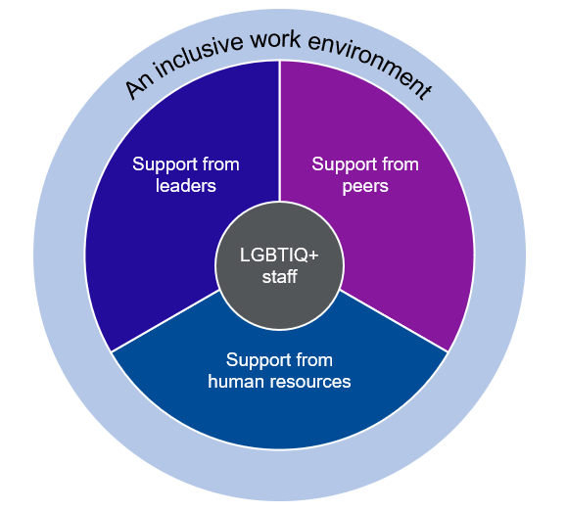

VPS departments and agencies are encouraged to embed the elements of an inclusive work environment in formal policies (for example, in a diversity and inclusion framework), as this improves transparency and accountability to LGBTIQ+ staff. Policies should be supported by relevant data capture and analysis to identify issues and track progress within an organisation and across the sector, with data collected by human resources and shared regularly with peers and leaders.

While informal support for LGBTIQ+ staff is necessary for individual cultural shifts, it should not be relied upon as a driver of organisational change. Relying on informal support from any of the three pillars (leaders, peers or human resources) creates significant risk of disconnection and disruption, which is likely to lead to LGBTIQ+ staff being unable to access support and subsequently to disconnect from the organisation.

Both formal and informal supports are needed across the three pillars to create an inclusive work environment for LGBTIQ+ staff.

## Role purpose

An Executive Sponsor is a formalised element of the “**support from leaders**” pillar.

Without an Executive Sponsor, an organisation may struggle to create or sustain an equitable and inclusive work environment for LGBTIQ+ staff, as LGBTIQ+ staff may not feel visible or acknowledged by leadership, and both human resources and staff may struggle to advocate for or implement cultural change without senior executive support.

Executive Sponsors perform a range of unique functions, primarily focused on improving visibility of and advocating for LGBTIQ+ staff needs across an organisation.

## Process for appointing an Executive Sponsor

Appointment of an Executive Sponsor should be the responsibility of the head of the Department or Agency (for example, Secretary or Commissioner) as a part of the organisation’s commitment to diversity, inclusion and safety in the workplace.

The head of the Department or Agency should actively identify and encourage volunteers for the position from a variety of backgrounds who understand issues impacting LGBTIQ+ communities. Equity, diversity and inclusion should be everyone’s responsibility, and should not fall solely to executives who are also members of an LGBTIQ+ community.

Should an Executive Sponsor wish to resign the position before the end of the appointment (for example, if leaving the organisation), they should submit their resignation to the head of their Department or Agency to enable appointment of a new candidate and appropriate handover.

Executive Sponsors should be a volunteer role, with no additional pay awarded.

Appointments should be for a period of at least twelve (12) months and are recommended to align with the performance and development planning (PDP) cycle.

## Role requirements

Appointee should:

* Be from the most senior level of staff, with a level of influence outside their direct reports. For example, an executive on the Board of Management.
* Demonstrate an interest in, and understanding of, issues impacting LGBTIQ+ communities, including intersections with other identities and communities.
* Incorporate the key accountabilities of the executive sponsor role into their PDP or equivalent.

Appointee should not:

* Have a substantive position related to human resources, diversity or inclusion. A key accountability of the Executive Sponsor (see below) is to liaise with the organisation’s HR and diversity divisions, and therefore the positions cannot be jointly held.

## Key accountabilities

Key accountabilities of an Executive Sponsor should be determined in consultation with the organisation’s LGBTIQ+ staff network. Recommended key accountabilities are:

* **Champion the inclusion and support of LGBTIQ+ staff within the organisation**. This could include challenging bias and role-modelling inclusive language at work with respectful identification and use of correct pronouns.
* **Advocate for LGBTIQ+ staff amongst senior leadership, including with the organisation’s HR and diversity division/s**. This could include advocating for LGBTIQ+ staff needs when developing new staff training, programs, services or strategies.
* **Be a visible and identifiable ally to LGBTIQ+ communities within the organisation**. This could include through internal announcement of the appointee, and the appointee undertaking regular promotion of LGBTIQ+ matters (for example, through newsletters or intranet posts).
* **Consult with and be accessible to LGBTIQ+ staff**. This could include through regular engagement with the organisation’s LGBTIQ+ Network, or, if there is no network, through engagement with the Victorian Public Sector LGBTIQ+ Pride Network and direct engagement with LGBTIQ+ staff in the organisation.
* **Undertake regular training or education about LGBTIQ+ issues, including at the intersections with other identities and communities**. The nature of this training and education will depend on the appointee’s background and experience, but appointees must continuously improve and expand their knowledge of LGBTIQ+ and intersecting issues.
* **Regularly attend or participate in LGBTIQ+ events**. This could include functionshosted by the organisation or in other parts of the Victorian Public Sector, such as participating in the annual Pride March or attending events linked to days of significance for LGBTIQ+ communities.
* **Assist their organisation’s staff LGBTIQ+ network with appropriate advice, support, resources and funding**. This could include resolving disputes. If there is no staff network, this may take the form of regular liaison with and support for the VPS LGBTIQ+ Pride Network or may involve supporting staff to establish governance and operations.
* **Actively seek to align LGBTIQ+ work done by their Department or agency with ‘Pride in our Future’**, the whole of Victorian government’s 10 year LGBTIQ+ Strategy. The strategy can be found here: [vic.gov.au/victorian-lgbtiq-strategy](https://www.vic.gov.au/victorian-lgbtiq-strategy)