Latrobe City

Liquor Accord 2021 – 2024
Version 2
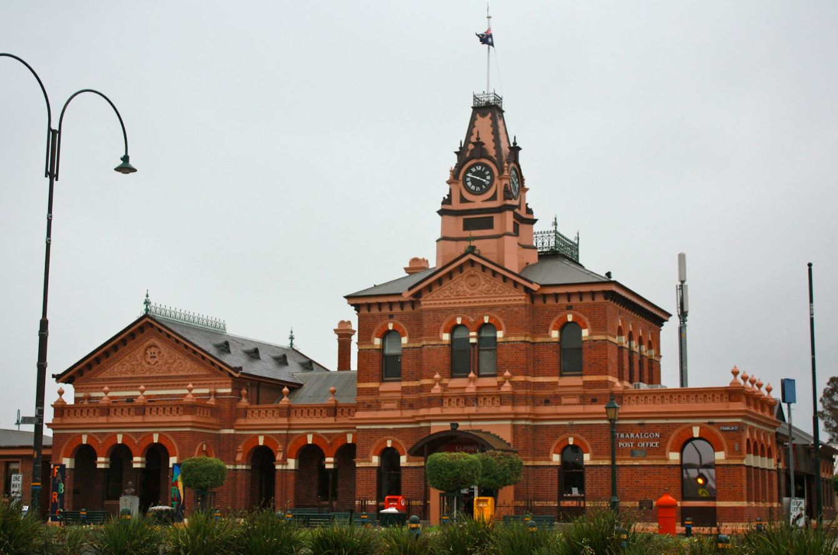


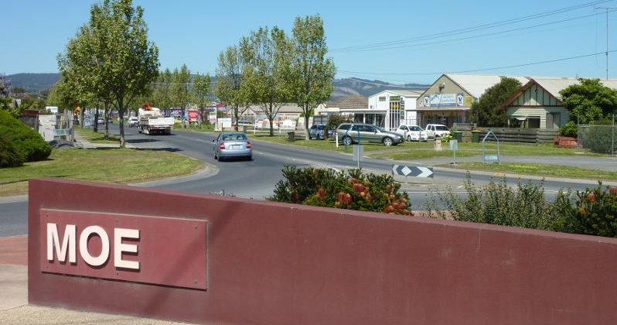

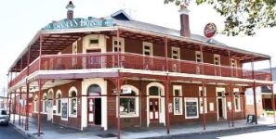
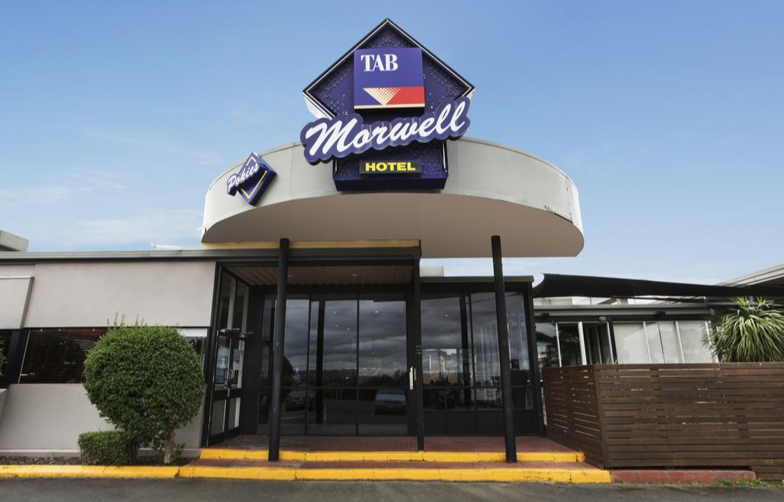

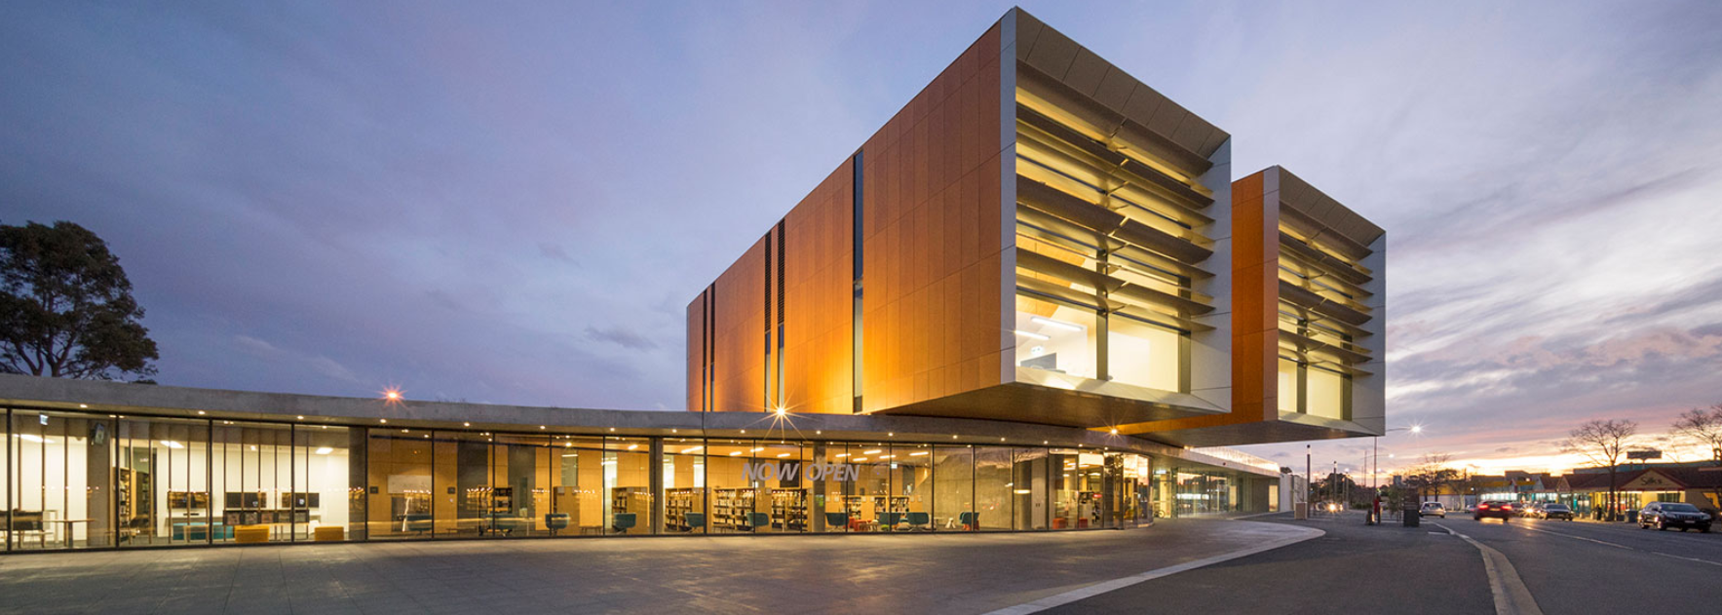

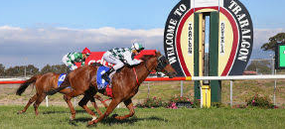
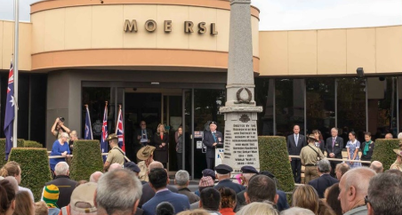

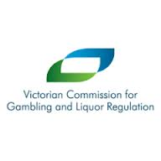



Table of Contents
Accord Structure 3
Accord sub-branches 3
Aims and Objectives 4
Aims 4
Objectives 4
Terms of the Accord 4
Stakeholders 5
Licensees 5
Latrobe City Council 5
Victoria Police 5
Accord forum chairperson / administration 6
Victorian Commission for Gambling and Liquor Regulation (VCGLR) 6
Best Practice Principles 7
Harm minimisation 7
Responsible Service of Alcohol (RSA) 8
No intoxicated patrons 8
No underage drinking 8
Discourage activities that encourage drinking alcohol excessively 8
Promote non-alcoholic or low alcoholic beverages and snacks 9
Ensure all staff are adequately trained 9
Responsible Advertising and Promotions 10
Display signage and avoid promotions condradicting responsible servoce of alcohol 10
Improved Safety and Security 10
Actively monitor the behaviour of patrons/intoxication/inappropriate behaviour 10
Maintain safety and security throughout the premises 10
Maintain records & regular communication with police/other Accord venues 12
Patron and Premise Safety 12
Create a safe environment 12
Amenity and ‘Commitment to Being Good Neighbours’ 13
Improve the local amenity 13
Patron responsibility 13
Packaged Liquor Responsibilities 14
Display the applicable signage 14
Minors on premises 14
Sales by means of mail, facsimile, telephone or the internet 14
Banning Guidelines 15
Release of information for the purpose of enforcing the Accord ban 15
Participating Venues 16
Traralgon & District sub-branch 16
Morwell & District sub-branch 17
Moe & District sub-branch 18

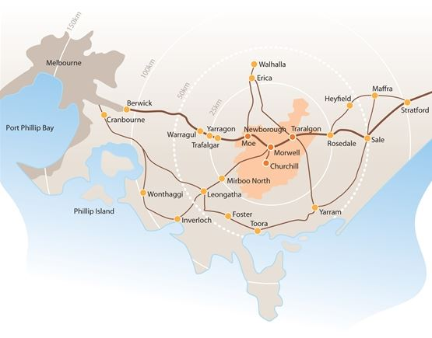
Accord Structure
The Latrobe City region is situated in the centre of Gippsland and is a substantial regional centre offering a diverse range of business, tourism and lifestyle opportunities. Encompassing large regional cities, small rural towns, rural farmlets and forest hideaways, Latrobe City has all of the benefits of a major regional centre while offering unbeatable lifestyle opportunities. Latrobe City townships include Boolarra, Churchill, Glengarry, Moe, Morwell, Newborough, Traralgon, Traralgon South, Toongabbie, Tyers, Yallourn North and Yinnar.

The Latrobe Police Service Area is a composite of the government municipality of Latrobe City and comprises of the Traralgon, Morwell, Moe, Churchill and Boolarra Police Stations.

The Latrobe City Liquor Accord was formed in 2015 and draws together the licensees of licensed venues, packaged liquor outlets and sporting clubs with the support of Victoria Police, Victorian Commission for Gambling and Liquor Regulation (VCGLR), Latrobe City Council and other relevant stakeholders.

Accord sub-branches

The Latrobe City Liquor Accord is the overriding operational accord document within the municipality of Latrobe City and police service area of Latrobe. The accord is divided into localised sub-branches for the purposes of monitoring compliance with the requirements of the Liquor Control Reform Act 1998, special policing arrangements, maintaining key stakeholder relationships and issues related to community interests within the major townships within the municipality.

Underpinning the Latrobe City Liquor Accord are the following accord sub-branches:

- the Traralgon & District sub-branch;
- the Morwell & District sub-branch;
- the Moe& District sub-branch.

The sub-branches regularly meet separately to discuss and address local issues in support of the regional Latrobe City Liquor Accord (the ‘full Accord’). The Latrobe City Liquor Accord banning policy is inclusive of all sub-branches and is enforceable across the municipality and police service area.

Aims and Objectives

Aims
To enhance the safety and wellbeing of residents, visitors and patrons within the municipality of Latrobe City through the combined, committed and active promotion of responsible service, sale and consumption of alcohol.

Objectives
- To foster a collaborative partnership between Victoria Police, Latrobe City, Liquor Licensees and other community stakeholders

- To monitor and discourage anti-social behaviour in and around licensed premises and public spaces

- To encourage preferred behavior by the community in relation to the use of alcohol

- To encourage best practice management of sporting clubs, packaged liquor outlets and licensed premises to ensure lawful and responsible service of alcohol

This document is intended to provide principles and strategies and an overall commitment to which the participating members of the Latrobe City Liquor Accord will adhere. To effectively implement the Latrobe City Liquor Accord, all members of the Accord agree to implement the strategies, policies and practices herein.

Terms of the Accord

- Adhere to the practices and policies outlined in the Latrobe City Liquor Accord

- Facilitate and encourage open and regular communication with stakeholders in relation to relevant issues

- Participate in regular Accord meetings with stakeholders

- Demonstrate a cooperative approach to developing solutions and achieving best practice in alcohol harm mininisation

- Work together to implement strategies to reduce alcohol related harm

Stakeholders
The success of The Accord relies on commitment from the following stakeholders:

Licensees

- Promote and support the Latrobe City Liquor Accord

- Work with the other stakeholders and accord members to assist in maintaining compliance by licensees with relevant laws, licensing regulations and license conditions.

- Participate in meetings and the monitoring and evaluation of the Latrobe City Liquor Accord

- Work in partnership with other stakeholders in related community projects.

Latrobe City Council

- Promote and support the Latrobe City Liquor Accord

- Use reasonable endeavors to provide adequate CCTV in CBD areas and regularly assess its effectiveness.

- Work with other regulatory authorities to ensure all licensed venues are monitored for compliance with relevant laws, licensing regulations and conditions

- Participate in the monitoring and evaluation of the Latrobe City Liquor Accord

- Work in partnership with key stakeholders in related community projects.

Victoria Police

- Monitor compliance of licensed premises with the requirements of the Liquor Control Reform Act 1998 and other relevant legislation

- Provide appropriate data to the Latrobe City Liquor Accord relating to alcohol management and crime

- Maintain membership of the Latrobe City Liquor Accord

- Participate in the monitoring and evaluation of the Latrobe City Liquor Accord

- Work in partnership with key stakeholders in related community projects.

Liquor forum chairperson / administration

- Maintain membership of the Latrobe City Liquor Accord, including up-to-date contact details

- Send timely meeting reminders and minutes to members via email and distribute VCGLR News to members

- Organise guest speakers and maintain the momentum of the liquor accord

- Update the Latrobe City Liquor Accord document as required

Victorian Commission for Gambling and Liquor Regulation (VCGLR)

- Monitor compliance of licensed premises with the requirements of the Liquor Control Reform Act 1998 and other relevant legislation

- Provide on-going support and guidance for the Latrobe City Liquor Accord, licensees and their managers, on the requirements of the Liquor Control Reform Act 1998

- Support the Latrobe City Liquor Accord by providing a monthly newsletter, up-to-date information and advice, and attend meetings where possible

Best Practice Principles
This document is intended to provide best practice principles to which licensees committed to the Latrobe City Liquor Accord will adhere in order to operate. The Latrobe City Liquor Accord’s principles are founded on a harm minimisation approach which aims to minimise and reduce harm to individuals, families and the community as a result of alcohol and other drugs,

All licensees/managers agree to commit to implementing the following proactive initiatives:

- Responsible Service of Alcohol (RSA)

- Responsible Advertising and Promotions

- Improved Safety and Security

- Patron and Premise Safety

- Commitment to Being Good Neighbours

- Responsible Management of Events

- Packaged Liquor Responsibilities

Harm minimisation
The Latrobe City Liquor Accord will implement the following harm minimisation strategies:

- Licensees will only accept VCGLR-approved evidence of age documentation

- Entrance to all venues will be well lit and signed with designated entry/exit points

- A systematic method of counting patrons will be used to guard against overcrowding

- Where gaming machines operate, venues will adhere to the industry’s principles of responsible gaming code of conduct

- Fair and reasonable patron banning provisions will be implemented for the purpose of minimising harm arising from the misuse and abuse of alcohol in relation to behavior that has occurred in or around licensed premises

- Persons banned by the Accord will be supplied a referral to drug and alcohol counselling comprising of education, harm minimisation and intervention, and consideration will be given to a ban reduction or withdrawal upon evidence of engagement

Responsible Service of Alcohol (RSA)

No intoxicated patrons
- Refuse service of alcohol to any patron showing signs of intoxication

- Refuse entry to all intoxicated patrons

- Encourage patrons to drink responsibly and let them know they will be asked to leave if they become intoxicated, disorderly, violent, or quarrelsome

- Notify crowd controllers of patrons who are showing signs of intoxication so that crowd controllers can monitor and manage the situation

No underage drinking
- Actively monitor all patrons/customers to ensure they are not underage, by checking approved proof of age ID at the door/before point of sale

- Prominently display Liquor Licensing signage about restrictions on minors

- If staff believe that a document being presented is false, defaced or in the possession of a person who is not the owner of the ID then the document will be confiscated and forwarded to the police (excluding a valid driver’s license)

Discourage activities that encourage drinking alcohol excessively

- Pricing practices and promotions that encourage rapid consumption of alcohol or possible alcohol abuse are to be monitored to discourage excessive consumption of alcohol

- No drink cards are given out/sold externally

- Promotions such as ‘Happy Hours’ will be completed by midnight on any operating night

- No serving of doubles unless explicitly requested by the patron consuming the drink

- Adhere to the VCGLR Responsible liquor advertising and promotion guidelines

Promote non-alcoholic or low alcoholic beverages and snacks

- At all times, offer and promote the availability of low and non-alcoholic drinks, through signage

- Ensure bottled water is available for purchase and free tap water is available to all patrons

- Promote reasonably priced snacks throughout operating hours

Ensure all staff are adequately trained

- Ensure all staff, who are employed to serve and supply alcohol, complete an accredited Responsible Service of Alcohol course within 1 month of commencing employment.

- The licensee ensures that any minor employed to work on licensed premises is not involved in the sale or supply of liquor other than in a VCGLR approved training program.

- A list/register of minors employed on the premises (which may be the business time and wages record book) is maintained by the licensee and is available upon request for viewing by an authorised officer of the Victorian Police.

- Maintain a register of all staff who have completed an accredited Responsible Service of Alcohol course. Keep copies of the most recent RSA or RSA Refresher certificate

- Provide regular updates to all staff regarding the Accord and related responsible service of alcohol and harm minimisation policies and practices.

- Ensure strict reference checks are conducted on all staff in the context of good recruitment practices, including security staff.

- Ensure staff has access to relevant literature on the Accord, liquor laws and regulations and are committed to ‘responsible service of alcohol’.

Responsible Advertising and Promotions
Display mandatory signage and avoid promotions which contradict responsible service and consumption of alcohol

- Refrain from pricing practices or promotions that encourage rapid consumption of alcohol or alcohol abuse

- Adhere to the VCGLR ‘Guidelines for Responsible Liquor Advertising and Promotions’

- Keep ‘happy hours’ to a maximum of two hours per day

- Promote and ensure free water is available for patrons

Improved Safety and Security
Actively monitor the behaviour of patrons to detect early signs of intoxication or inappropriate behaviour

- Clearly display a house policy that details acceptable and unacceptable behaviour on premises, including non-acceptance of excessive consumption of alcohol or drug use

- Discourage glass in toilets or on the dance floor, to reduce both intentional and accidental injuries

- Ensure internal and external security procedures are well maintained and functioning effectively

- Encourage phased and orderly exit of patrons from premises when closing

Maintain safety and security throughout the premises

- An Emergency Procedures Management Plan is maintained and available to Victoria Police. All staff are trained in emergency procedures and the use of emergency equipment

- Conduct regular WorkSafe crowd control safety and security risk assessment of premises and immediate surrounds

- Ensure entrances and exits are well lit and that immediate surrounds are safe and allow good visibility

- Implement good surveillance systems, such as closed circuit television systems (CCTV), on premises if applicable

- Ensure staff, including security staff, are clearly identifiable (for example, distinctive t-shirts, uniforms, name tags etc)

- Serve alcohol in containers selected to minimise possible harm to patrons. Where possible, glasses are made of shatter proof glass

- Where possible stock liquor in unbreakable containers, such as cans or plastic bottles, instead of glass bottles

- Fully cooperate with police and other Accord members on ways to improve public safety

- Prevent criminal activity and disorderly conduct from occurring on premises and notify police immediately if something illegal or suspicious does occur

- When required, agree to implement additional or local strategies negotiated as part of the Latrobe City Liquor Accord that relate to specific safety and security issues in and around the premises

- Where it is a condition of the licence, abide by the lock-out which states ‘patrons (other than residents of the premises and members of the hospitality industry authorised in accord with the requirements of the Licensing Inspector) are not permitted to enter or re-enter the premises, other than any gaming rooms, after 1.30 a.m. on any day (lock-out)’.

- Door/security, crowd controllers or reception personnel will:

  - Wear clear ID at all times
  - Not harass or intimidate passers-by or potential customers
  - Record incidents of false ID and fraudulent use of ID into the incident book
  - Monitor and discourage anti-social behaviour when patrons leave the premises, both near and immediately surrounding the premises, and call police if necessary
  - Not let people back into premises who have caused a disturbance
  - Immediately contact police and other premises to inform them of patrons that have been ejected and/ or problem patrons in the vicinity
  - Have public transport information available including taxis, trains, buses and car parking for patrons and location of the nearest public telephone
  - Assist patrons in accessing safe transportation out of the area
  - Uphold any statutory requirements relating to security personnel and enter details of any incidents in the incident book

Maintain records of incidents and have regular communication with police and other Accord venues

- Maintain a register of incidents that occur in and around the premises that includes the time, date and nature of the incident and the response taken by staff and management

- Notify police in advance of any special events likely to significantly increase patronage

- Notify other venues of problematic patrons

- Ensure close liaison and open communication with all Latrobe City Liquor Accord Stakeholders

Patron and Premise Safety
Create a safe environment

- Maintain a current list of emergency phone numbers and locate close to all key phones

- Encourage all staff members to undertake first aid courses and ensure one staff member with a first aid certificate is rostered on for each shift

- Ensure that the maximum capacity numbers of patrons are adhered to at all times

- Ensure the telephone listing, for communication with security at other venues is routinely updated

- Ensure that crowd controllers employed by the premises hold a current Private Security License. Validity can be checked online

- Encourage a policy of no pass-outs after midnight

- Train all staff to know help procedures, emergency numbers and how to use the incident register book

Amenity and ‘Commitment to Being Good Neighbours’
Improve the local amenity

- Assist patrons in accessing safe transportation out of the area. For example, door staff can provide information about access to the taxi rank or train station and encourage patrons to use these quickly and quietly when departing

- Minimise noise generated from the premises. Wherever possible, keep doors closed

- Educate patrons, including through signage, about the need to respect the local amenity and to arrive and depart the area in a quiet and orderly manner

- Prevent the unlawful removal of liquor (other than packaged liquor or where permitted) from licensed premises

- Ensure door and security staff, are briefed on local environmental issues, including potential traffic, noise, or security problems

- Ensure police are informed of regular closing hours and any variations, such as special events or new activities

- Record all legitimate complaints in the incident book, respond to resident concerns and take all reasonable steps to ensure the premise is functioning as a ‘good neighbour’

- Communicate with neighbouring premises to discuss any common issues surrounding the premises

Patron Responsibility

- Post signage that clearly explains licensee and patron responsibility regarding the responsible service of alcohol

- Ensure staff are trained appropriately to advise patrons when they will no longer be served and will be asked to leave the premises

Packaged Liquor Responsibilities
Display the applicable signage

The following signs are displayed in a manner that invites customers’ attention:

- “Under 18 No Supply”
- “Intoxicated? Drunk? Disorderly?” and
- “Please do not attempt to buy liquor for under 18s”
- “DirectLine” free call number for Directline – the Victorian Government’s 24-hour, 7-day counseling, information and referral line for people with alcohol and drug problems

The following information is displayed prominently in the liquor outlet:

- Signage relevant to Latrobe City’s Local Law that prohibits the consumption of alcohol in a public place.

Minors on premises

- Minors are not permitted on the licensed premises unless they are accompanied by a parent, spouse or guardian, or a responsible adult

- Where there are reasonable grounds for considering that an adult is purchasing alcohol for a minor, the licensee declines the purchase of the alcohol

Code of Conduct

- Abide by the VCGLR’s packaged liquor Code of Conduct

- In particular, ensure ‘House Rules’ and RSA certificates are available on the premises

Sales by means of mail, facsimile, telephone or the internet

- Licensees who sell liquor by taking orders over the telephone, facsimile or mail order, display their liquor license number in any advertisement or information published in writing or electronically in connection with such sales

- Licensees who advertise or supply liquor by means of the internet, display the following notice prominently on the site at all times so that customers will notice its contents – “WARNING - Under the Liquor Control Reform Act 1998 it is an offence to supply alcohol to a person under the age of 18 years (Penalty exceeds $19,000), or for a person under the age of 18 years to purchase or receive liquor (Penalty exceeds $800)”

- Liquor is only allowed to be purchased by a person aged 18 or over and Proof of Age is to be sighted where appropriate as part of the delivery arrangements

Banning Guidelines
The Liquor Control Reform Act 1998 states that liquor forum members who are party to a liquor accord may make provisions regarding the authorisation of licensees and permittees to ban patrons and share information about banned patrons.

To assist licensees and permittees who are members of liquor accords, these guidelines have been introduced to ensure that liquor accord bans are implemented for the purpose of minimising harm arising from the misuse and abuse of alcohol in relation to behaviour that has occurred in or around licensed premises.

Prior to implementing a liquor accord ban, the Latrobe City Liquor Accord agrees that they will be mindful of the principles of natural justice (also known as procedural fairness).

- The principles of natural justice ensure the process by which a decision is made is fair and reasonable. To maintain natural justice each person which the liquor accord will consider banning will be offered the right to request a review of the banning decision and the opportunity to present one’s case

- When formulating the banning policy all parties to the Accord must ensure that the banning provisions regarding the banning:

- are non-discriminatory and are open and transparent;
- include accurate record keeping processes and have clear and appropriate decision-making guidelines;
- do not breach the Charter of Human Rights and Responsibilities 2006 and privacy legislation;
- provide an opportunity for the (potentially) banned person to request a review of the ban;
- include fair and reasonable banning periods; and
- Include appropriate notification of a ban (i.e. a set of letters notifying the banned person of the ban, the process by which to request a review of the ban, the expiry of the ban and a warning letter (if applicable).

Release of information for the purpose of enforcing the Accord ban

Information will only be disclosed as provided in Section 146D of the Liquor Control Reform Act 1998 for the effective and efficient enforcement of the ban.

This information disclosed is subject to the following:

- The disclosure is for the purpose of enforcing a liquor accord ban
- The licensee or permittee must undertake not to engage in any unauthorised distribution or public display of the information, and must ensure they comply with privacy obligations
- All previous versions of banned lists must be discarded responsibly

List of accord members
Traralgon & District sub-branch

J V Star Bar
29 Grey Street, Traralgon 3844 (03) 5176 6339

Saloon Bar / Inferno Nightclub
19-23 Kay Street, Traralgon 3844 (03) 5176 0464

Traralgon Football and Netball Club
Whittakers Road, Traralgon 3844 (03) 51741062

Crown Hotel
72 Franklin Street, Traralgon 3844 (03) 5174 2094

Traralgon RSL
109-115 Grey Street, Traralgon 3844 (03) 5174 8688

House of Frank
136 Franklin Street, Traralgon 3844 (03) 5174 5265

Turks Sports Bar
108-112 Hotham Street, Traralgon 3844 (03) 5176 1700

Grand Junction Hotel
Cnr Franklin Street & Princes Hwy, Traralgon 3844 (03) 5174 6011

Royal Exchange Hotel
64 Princes Hwy, Traralgon 3844 (03) 5174 1281

Flanagan’s Irish Bar
64 Princes Hwy, Traralgon 3844 (03) 5174 1281

West End IGA
211 Grey Street, Traralgon 3844 (03) 5174 6042

Latrobe Valley Racing Club
McNairn Road, Traralgon 3844 (03) 5127 2465

Ryan’s Hotel
171 Franklin Street, Traralgon 3844 (03) 5174 2058

Spirit Bar and Lounge
19-23 Kay Street, Traralgon 3844 (03) 5176 0464

Glengarry Hotel
25 Main Street, Glengarry 3854 (03) 5192 4222

Traralgon Golf Club
Princes Highway, Traralgon 3844 (03) 5174 1709

Traralgon Bowls Club
50 Liddiard Road, Traralgon 3844 (03) 5174 2156

Liquorland: Traralgon
Stockland Plaza – Cnr Franklin & Grey Streets, Traralgon 3844 (03) 5174 9231

Coffee Corner
1 Church Street, Traralgon 3844 (03) 5176 4970

The 3844
47-49 Princes Street, Traralgon 3844 (03) 5176 4666

Green Olive
1/149 Argyle Street, Traralgon 3844 (03) 5176 6669

Morwell & District sub-branch

Boolarra Hotel
Monash Way, Boolarra 3870 (03) 5169 6420

Churchill Hotel
1 Balfour Place, Churchill 3842 (03) 5122 1800

Foodworks
61 Bridle Road, Morwell 3840 (03) 5133 7203

Italian Australian Sporting Club
499-501 Princes Drive, Morwell 3840 (03) 5134 3541

Liquorland
82 George Street, Morwell 3840 (03) 5133 0544

Monacellars
10 Church Street, Morwell 3840 (03) 5135 6854

Monash University Gippsland Student Union
Building 3N, Federation University Gippsland Campus
Northways Road, Churchill, 3842 (03) 5122 6248

Morwell Bowling Club
52 Hazelwood Road, Morwell 3840 (03) 5134 3449

Morwell Central Bar & Bistro
192 Commercial Road, Morwell 3840 (03) 5133 0429

Morwell Club
136 Helen Street, Morwell 3840 (03) 5134 2671

Morwell Hotel/Motel (Top Pub)
311-327 Princes Drive, Morwell 3840 (03) 5134 1355

Morwell RSL
52 Elgin St, Morwell 3840 (03) 5134 2455

Merten Rush Hotel
Cnr Princes Drv & Collins St, Morwell 3840 (03) 5134 2633

Ritchies Supermarket
5-8 Georgina Way, Churchill 3842 (03) 5122 1231

Woolworths Liquor ( Morwell)
82-90 Princes Dr, Morwell 3840 (03) 5133 7455

Woolworths Liquor (Churchill)
Cnr Marina Drive & Monash Way, Churchill 3842 (03) 5122 1097

Yinnar Hotel
46 Main St, Yinnar VIC 3869 (03) 5163 1263

Moe & District sub-branch

Aldi
7 Saviges Road, Moe 3825 (03) 5127 6455

BWS
Shop 2, 103-105 Albert Street, Moe 3825 (03) 5127 4178

BWS (located in Woolworths)
Cnr George And Anzac Street, Moe 3825 (03) 5122 5805

Criterion Hotel
85 Princes Hwy, Trafalgar 3824 (03) 5633 1055

First Choice Liquor
21-25 Kirk Street, Moe 3825 (03) 5128 1200

Liquorland
92 Albert St, Moe 3825 (03) 5127 5281

Mid City Tavern
1A Moore Street, Moe 3825 (03) 5127 3884

Moe Bowling Club
Saviges Rd, Moe VIC 3825 (03) 5127 3855
Moe Football Netball Club Inc
Ted Summerton Reserve Vale St, Moe 3825 (03) 5127 2258

Moe Hotel
45 Lloyd Street, Moe 3825 (03) 5127 1009

Moe Racing Club (Turfside)
Waterloo Road, Moe 3825 (03) 5120 1333

Moe RSL
63-67 Albert Street, Moe 3825 (03) 5127 1007

Moe United Soccer Club
37 High St, Moe, 3825 (03) 5127 1039

Monash Soccer Club
Torres Street, Newborough 3825 0407 271 292

Newborough Football Club
Reserve, Southwell St., Newborough 3825 (03) 5127 3857

Newborough Bulldogs Cricket Club
19 Treswell Avenue, Newborough 3825 (03) 5127 5430

Newborough Yallourn United Soccer Club
Burrage Reserve, John Field Drive, Newborough 3825 0428 262 062

Rookies Pizzeria Bar & Grill
2 Ollerton Avenue, Newborough 3825 (03) 5127 8900

Rossmore Hotel
58 North Road, Yallourn North 3825 (03) 5167 1401

Yallourn Bowling Club
Monash Road, Newborough 3825 (03) 5127 1913

Yallourn North Bowls Club
Reserve Street Yallourn North VIC 3825 (03) 5167 1666

Yallourn/Newborough RSL
30 Darlimurla Avenue, Newborough 3825 (03) 5127 5720

Yallourn/Yallourn North Football Club
Howlett Track, Yallourn North 3825 (03) 5167 1301

Document History and Version Control
Date | Ver. | Changes | Author
05/06/2015 | 1.0 | Commencement of working document | Sgt STOW
01/04/2021 | 2.0 | Document refresh – harm minimisation | A/S/Sgt STOW

LATROBE CITY LIQUOR ACCORD
CERTIFICATE OF COMMITMENT
Working together to keep our community safe

INSERT VENUE NAME

The aim of the Latrobe City Liquor Accord is to enhance the safety and wellbeing of residents, visitors and patrons within the municipality of Latrobe City through the combined, committed and active promotion of responsible service, sale and consumption of alcohol.

This venue commits to:

- promoting and supplying alcohol responsibly
- providing a safe and welcoming environment to its patrons
- contributing to the health, safety and wellbeing of residents and visitors
- abiding by the aims and objectives of the Latrobe City Liquor Accord

------------------------------------ ------------------------------
Venue representative Victoria Police

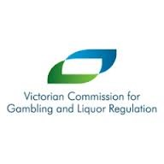





LATROBE CITY LIQUOR ACCORD
PARTICIPATING VENUE
Working together to keep our community safe

A BANNING PROCESS
OPERATES ON THESE PREMISES

IF YOU ARE INVOLVED IN ANTI-SOCIAL BEHAVIOUR ON THESE PREMISES, THE LATROBE CITY LIQUOR ACCORD MAY BAN YOU FROM THESE PREMISES AND OTHER LICENSED VENUES IN THE
LATROBE AND SURROUNDING DISTRICTS

This banning process is supported by the
Latrobe City Liquor Accord

