Best Start

Policy and Guidelines

Contents

Acknowledgements 4

Executive Summary 5

What is Best Start? 5

About Best Start 6

Purpose and focus 6

Defining vulnerability 6

Best Start key directions 6

Best Start outcomes 7

Policy context 8

Policy Context: Why the Early Years are important 8

Victoria: the Education State 8

Early Childhood Reform Plan 8

Roadmap for Reform: Strong Families, Safe Children 8

The Victorian Early Years Learning and Development Framework 9

Marrung Aboriginal Education Plan 2016-2026 9

Government-led Reviews 11

Victorian Parliament inquiry into early childhood engagement of culturally and linguistically diverse communities 11

Victorian Auditor General’s Office Report: Early Years Management in Victorian Sessional Kindergartens 12

Aligning Best Start with Early Years Reform Initiatives 13

Early Years Compact 13

Child Safe Standards 2022 13

Three-Year-Old Kindergarten 13

School Readiness Funding 14

Transition: A Positive Start to School 15

Aboriginal children and families 16

Why focus on all Aboriginal children? 16

Self-determination 16

Community voice 17

How is community voice collected? 17

Respecting community voice 17

Culturally safe partnerships for Aboriginal people 18

Values and qualities held by all Best Start sites working with Aboriginal children 19

Aboriginal Best Start 19

Culturally and Linguistically Diverse (CALD) children and their families 20

Why focus on CALD children and families? 20

The Victorian Early Years Learning and Development Framework (VEYLDF) and cultural inclusivity 20

Children and families from refugee backgrounds 21

Children and families seeking asylum 21

Culturally Responsive Practice 21

Governance 23

Best Start partnerships 25

Partnership members 26

Partner groups 26

Clearly defined roles and responsibilities support strong governance 27

Roles and responsibilities 28

Partnership agreements 31

What makes up a partnership agreement? 31

What to do when a new partner joins? 31

Funding 32

Funding allocation and reporting 32

Budget 32

In-kind support 32

End of year reporting and surplus funds 32

Performance measures and targets 32

Performance measures specific to Best Start 32

Implementing Best Start 33

The four stages 33

Stage 1: Design or review the partnership’s logic model 34

Stage 2: Design, test and implement change ideas 37

Stage 3: Regularly monitor your progress 39

Stage 4: Review and reflect annually 41

Reporting 42

Quarterly summary reports 42

Timelines and responsibilities 42

Annual report 43

Annual financial report 43

Timelines and responsibilities 43

APPENDIX 1: Best Start logo 44

# Acknowledgements

The Department of Education and Training acknowledges and pays respects to Elders and all Victorian Aboriginal communities. We honour and respect Traditional Owners, past and present, and value the rich culture and history of the First Peoples of this land.

Throughout this document, the term Aboriginal is used to refer to both Aboriginal and Torres Strait Islander people. Use of the terms Aboriginal, Aboriginal and Torres Strait Islander and Indigenous are retained in the names of programs and initiatives and unless noted otherwise are inclusive of all Aboriginal and Torres Strait Islander peoples.

All Best Start sites focus on Aboriginal children. The statement of cultural beliefs below underpins the work of Best Start to this day, reflecting values held important by Aboriginal people:

* Our children are our present and our future.
* Our children should have access to good health, wellbeing and education programs so that they will be empowered to achieve their full potential.
* Our children have the right to an education that strengthens their culture and identity.
* Our children have the right to live in communities that are safe and free from violence.
* Our children have the right to identify as Aboriginal Australians, to be proud of our history, cultural beliefs and practices.
* Our children have the right to maintain connection to their land and country.
* Our children have the right to maintain their strong kinship ties and social obligations.
* Our children have a strong contribution to make to enrich the Aboriginal community and as members of the wider community.
* Our children have a right to be taught our cultural heritage by our Elders.
* Our children should be taught to respect their Elders.

# Executive Summary

## What is Best Start?

The first years of life are crucial to lifelong learning, health, wellbeing and success. The Victorian Government is making Victoria the Education State and this begins with giving every child a great start in life by strengthening early childhood services for children and families.

Best Start is a prevention and early intervention program that aims to improve the health, development, learning and wellbeing of all Victorian children from birth through to transition to school.

There is consensus that a loving, healthy and intellectually stimulating early childhood is critical to a person’s wellbeing and success throughout their life. Children who have a strong start in life are more likely to do well academically and socially as they grow older. Conversely, young children who miss out on positive experiences with parents, caregivers and educators are much more likely to struggle to catch up.

Best Start is characterised by an approach that supports parents and caregivers to create a positive environment for children by encouraging communities to work with their local early years services and schools.

Communities and service providers collaborate to address issues as they are experienced at a neighbourhood, local or regional level.

This localised, targeted way of finding solutions, along with actively responding to, challenges faced by families has been shown to be extremely effective. Efforts are focused on boosting children’s participation in universally available programs we know have the best results for setting them up for success, such as kindergarten and Maternal and Child Health (MCH) services. The program also puts in place prevention strategies, such as providing referral pathways when targeted supports are required.

Victoria has a strong early childhood system with high participation rates in MCH services and kindergarten – however some children are missing out. Typically, these are children who are in complex situations and experience vulnerability and disadvantage. These children have the most to gain from engaging in high-quality universal services.

The Best Start program is dedicated to improving participation of these children by providing a platform to identify, co-ordinate and drive initiatives that address participation barriers. There are 30 Best Start sites across rural and metropolitan locations, six of which are Aboriginal Best Start sites that are run by the Aboriginal community for the Aboriginal community.

Best Start is based on partnerships of local agencies and service providers to improve the outcomes for children.

# About Best Start

Vision: Communities work in partnership to improve the learning, health and development outcomes of young children and their families, particularly those in greatest need.

## Purpose and focus

Best Start is a Victorian Government early years, place-based initiative that is funded and administered by the Department of Education and Training (the Department) to support families, caregivers and communities in providing the best possible environment, experiences and care for children from birth to school entry.

Best Start places a strong emphasis on prevention and early intervention, and has a particular focus on all Aboriginal**[1]** children and children experiencing vulnerability. It is based on formal partnerships of local agencies and service providers that plan, deliver and monitor evidence-based strategies to improve outcomes for children.

### Defining vulnerability

In the context of the Best Start program, vulnerability can refer to a broad range of co-occurring factors that may inhibit children’s participation and development. This may include:

* children known to child protection including children in Out of Home Care
* children at risk of abuse or neglect, often known to other key secondary support services such as Enhanced MCH, Family Services and Orange Door
* children from newly arrived migrants/refugee background or people seeking asylum
* children from culturally and linguistically diverse (CALD) backgrounds that are experiencing vulnerability, or
* children with a disability, impairment or developmental delay.

Best Start partnerships should use local data and community knowledge to identify those who are experiencing vulnerability at their sites.

Best Start supports the principle that participation and success in early childhood education should be equitable and should not depend on personal or social circumstances.

## Best Start key directions

Victoria has a strong early childhood system with high participation rates in MCH services and kindergarten – however some children are missing out - typically, the children who are experiencing vulnerability and have the most to gain from engaging in high-quality services.

A comprehensive review of the Best Start program was undertaken in 2015. The review sought to build on the achievements of Best Start since its inception in 2002 and set it up for future success by:

* more closely aligning it with current Government policy priorities for early childhood
* incorporating contemporary knowledge and evidence regarding place-based approaches
* responding to evolving demographic and socio-economic patterns.

The 2015 review of the program confirmed the key directions for the Best Start program as being:

* a continued focus on local partnerships and community engagement as the program’s foundation
* a greater focus on the participation of all Aboriginal children and children experiencing vulnerability in key universal and targeted services, in particular in kindergarten, MCH services and supported playgroups, entering school as confident and involved learners
* improved monitoring, data collection and reporting by Best Start partnerships so that the intended outcomes are realised and sustained.

The 2022 guidelines build on the key directions implemented in 2016 by strengthening links with Victorian early childhood initiatives, including responding to the recommendations of the Victorian Parliament inquiry into early childhood engagement of culturally and linguistically diverse communities. In addition, these guidelines introduce performance measures that will support better outcomes for children.

## Best Start outcomes

Being clear about the outcomes Best Start programs need to achieve is important for several reasons:

* an outcomes focus gives partnerships an unambiguous view of what they need to achieve. Having this information before implementing a strategy means partnerships will think about what they have to deliver to ensure they meet the outcomes
* focus more intently on the change they want to bring about for children and families
* identify the strategies and actions that are most likely to achieve desired outcomes for children and families
* determine whether a service is having the intended effect.

To deliver on these key directions Best Start sites focus on two outcomes that we know make a difference to the lives of children who are at risk of falling behind. The emphasis is still very much on a child’s holistic growth including their learning, health, wellbeing and development. As well as the direct benefits that children receive from active engagement in kindergarten and MCH, these services provide a referral pathway when other, more targeted supports are required.

The Best Start outcomes listed below are medium-term outcomes, and have been devised to focus and organise partnership efforts so that they align with Best Start key directions.

|  |
| --- |
| Best Start outcomes |
| Children engage and participate in early childhood education (kindergarten and supported playgroups) and enter school as confident and involved learners |
| Children and families actively engage with MCH services, attending key ages and stages visits to optimise health, wellbeing, safety, learning and development |

# Policy context

## Policy Context: Why the Early Years are important

### Victoria: the Education State

The Victorian government is making Victoria the Education State by building an education system that produces excellence and reduces the impact of disadvantage.

The first years of life are crucial to lifelong learning, health, wellbeing and success. Creating the Education State begins with giving every child a strong start in life by strengthening early childhood services for children and families.

Early childhood is the best time to transform a person’s life. This is the time when a child’s potential – their imagination, curiosity and creative spark – is first nurtured. Effort and investment well spent during our children’s early years repay themselves many times over – in better lives and in fairer, more prosperous societies. See [Education State](https://www.education.vic.gov.au/about/educationstate/Pages/default.aspx) for more information.

Best Start contributes to achieving these outcomes by having a particular focus on supporting all Aboriginal children and children experiencing vulnerability to increase their participation in kindergarten and MCH services.

### Early Childhood Reform Plan

Making Victoria the Education State starts with the early years. The Early Childhood Reform Plan outlines the Victorian Government’s vision for the early years. This plan will deliver systemic change, targeted at supporting the children who need it most.

These initiatives aim to create a higher quality, more equitable and inclusive early childhood system, helping Victorian families get their kids ready for kindergarten, ready for school and ready for their lives ahead.

The plan outlines four key reform directions:

* supporting higher quality services and reducing disadvantage in early education
* providing more support for parenting
* making early childhood services more accessible and inclusive
* building a better early childhood system.

See [Early childhood reform (education.vic.gov.au)](https://www.education.vic.gov.au/about/educationstate/Pages/earlychildhood.aspx) for more information.

The plan supports the Roadmap for Reform: Strong Families, Safe Children.

Best Start partnerships work to support the reform through identifying barriers to participation for Aboriginal children and those children experiencing vulnerability in their communities and working together using an improvement approach to address those barriers.

### Roadmap for Reform: Strong Families, Safe Children

The Victorian Government is committed to reform that protects families and sets a child up for life, leaving them more likely to be healthy, to form positive relationships, to learn and grow, and to get a job. The Department of Families Fairness and Housing are driving the Roadmap for Reform which will create services that are co-ordinated and work together to meet the needs of vulnerable families and children, forming an important step in the government’s long-term response to the recommendations of the Royal Commission into Family Violence.

Best Start aligns with this work by facilitating a partnership approach via services and communities working together to support children and families, particularly all Aboriginal children and children experiencing vulnerability, to access high-quality early childhood services.

### The Victorian Early Years Learning and Development Framework

The *Victorian Early Years Learning and Development Framework (VEYLDF)* guides all early childhood professionals to work together and with families to support the learning and development of children aged birth to eight.

The VEYLDF describes outcomes for children’s learning and development that provide shared goals for professionals’ work with children and their families. These outcomes are:

* children have a strong sense of identity
* children are connected with and contribute to their world
* children have a strong sense of wellbeing
* children are confident and involved learners
* children are effective communicators.

The VEYLDF identifies Practice Principles for Learning and Development, which describe the most effective ways for early childhood professionals to work together and with children and families to facilitate learning and development. These eight interrelated Practice Principles are:

* Reflective practice
* Partnerships with families
* High expectations for every child
* Respectful relationships and responsive engagement
* Equity and diversity
* Assessment for learning and development
* Integrated teaching and learning approaches
* Partnerships with professionals.

The VEYLDF also emphasises the importance of supporting children’s and families’ transitions as they move within and across services throughout the early childhood period. See [Learning frameworks birth to eight years (education.vic.gov.au)](https://www.education.vic.gov.au/childhood/professionals/learning/Pages/veyldf.aspx)

### Marrung Aboriginal Education Plan 2016-2026

The [Marrung Aboriginal Education Plan](https://www.education.vic.gov.au/Documents/about/programs/aboriginal/Marrung_Aboriginal_Education_Plan_2016-2026.pdf) is a whole of life education strategy to ensure that all Aboriginal Victorians achieve their learning aspirations.

The vision of Marrung, developed in partnership with the Victorian Aboriginal community, is that Victoria will be a state where:

* The rich and thriving culture, knowledge and experience of our First Nations people are celebrated by all Victorians
* Our universal service systems are inclusive, responsive and respectful of Koorie people at every stage of their learning and development journey
* Every Koorie person achieves their potential, succeeds in life, and feels strong in their cultural identity.

Marrung captures outcomes identified through consultation that community and the Department want, and the actions that we can take together to achieve them. The following chart shows the high-level outcomes and actions that Marrung is striving to achieve.

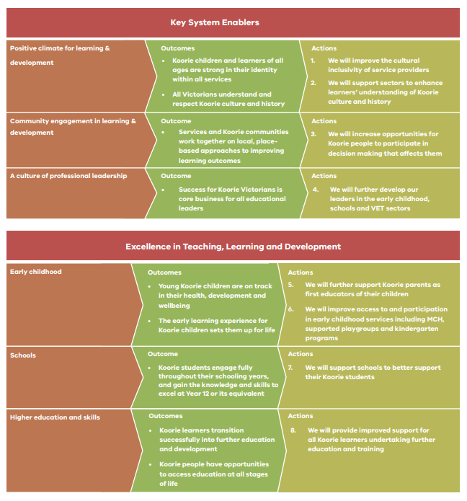



Marrung expands on each of the actions with guidance for all Victorians on how to achieve these goals. All Best Start sites and their partner organisations have a role to play in embedding the practices and principles outlined in Marrung.

## Government-led Reviews

### Victorian Parliament inquiry into early childhood engagement of culturally and linguistically diverse communities

The Legal and Social Issues Committee of the Legislative Assembly conducted an inquiry into early childhood engagement of culturally and linguistically diverse (CALD) communities in 2020.

The inquiry investigated the following:

* barriers to participation and data
* integrated and place-based responses
* the early childhood workforce
* language services
* Maternal and Child Health services
* mental health and disability
* awareness on the importance of early learning
* playgroups
* early childhood education and care
* school education.

The report outlined 45 findings and 49 recommendations for consideration by the government to improve outcomes for CALD children and their families. The government response to this report is available here: [FINAL_response_to_Parl_Inquiry_into_EC_engagement_CALD_communities_tY4kGLTq.pdf (parliament.vic.gov.au)](https://www.parliament.vic.gov.au/images/stories/committees/lsic-LA/Early_childhood_engagement_in_CALD_communities/FINAL_response_to_Parl_Inquiry_into_EC_engagement_CALD_communities_tY4kGLTq.pdf)

Of note, **Finding 7** of the report states:

*The Best Start program developed by the Department of Education and Training is a promising approach that promotes effective service planning and collaboration within local government areas and has proven to improve outcomes for children.*

**Recommendation 9** states:

*That the Victorian Government prioritise and expand funding for place-based and integrated models in early childhood service provision to improve engagement and access for culturally diverse families and their young children. These efforts should be community-driven to provide localised solutions in areas of need and must involve culturally diverse communities and their representative bodies, local councils, relevant service providers and the Municipal Association of Victoria*.

**Recommendation 10** states:

*That the Victorian Government support local councils to coordinate and fund service navigation positions that can directly assist culturally diverse families to navigate the early childhood service system.*

**Recommendation 11** states:

*That the Victorian Government fund effective outreach activities by local councils and service providers to ensure culturally diverse communities can access a range of early childhood services, including playgroups, health services and literacy-based programs.*

The Best Start program is well-positioned to address each of these recommendations, using a proven improvement science methodology to create service systems that lead to positive outcomes for children experiencing vulnerability, including those from CALD backgrounds.

For more information, see [LA_LSIC_59-01_Inquiry_into_early_childhood_engagement_of_CALD_Communities.pdf (parliament.vic.gov.au)](https://www.parliament.vic.gov.au/images/stories/committees/lsic-LA/Early_childhood_engagement_in_CALD_communities/Report/LA_LSIC_59-01_Inquiry_into_early_childhood_engagement_of_CALD_Communities.pdf)

### Victorian Auditor General’s Office Report: Early Years Management in Victorian Sessional Kindergartens

In July 2016, the Department of Education and Training introduced the *Early Years Management (EYM) Policy Framework.* EYM organisations run sessional kindergarten and long day care services. EYM organisations receive support from DET and additional funding from the Victorian Government to deliver services in line with the policy framework’s outcomes.

In 2020 the Victorian Auditor General’s Office (VAGO) examined how the Department planned and implemented the policy framework, and how the Department has supported EYM organisations and monitored their progress to meet the policy framework’s outcomes.

VAGO made five recommendations to the Department aimed at improving its performance framework and monitoring tools, clearly defining performance expectations, assessing if support addresses program challenges, and strengthening its continuous improvement processes. All recommendations were accepted.

The report recommends the Department strengthens the policy framework and allow it to clearly link to broader Department outcomes detailed in its *2016-20 Strategic Plan*, such as:

* achievement – raise standards of learning and development achieved by Victorians using education, training, development and child health services
* engagement – increase the number of Victorians actively participating in education, training, development and child health services.

For more information see [Early Years Management in Victorian Sessional Kindergartens | Victorian Auditor-General's Office](https://www.audit.vic.gov.au/report/early-years-management-victorian-sessional-kindergartens?section=).

Best Start sites work to improve attendance and participation in early years services, aligning directly with the recommendations of the VAGO report.

# Aligning Best Start with Early Years Reform Initiatives

The policy landscape is constantly changing with new initiatives being introduced to support children to get the best start in life. Best Start partnerships should ensure that their work strategically adapts to capitalise on any reform. For example, Child Link will progressively rollout in Victoria from 2022 and will impact on availability of data to inform Best Start logic model development and strategies for better supporting children who are not accessing early years services.

## Early Years Compact

A ten-year agreement between the Department of Education and Training (DET), the Department of Health and Human Services (DHHS) and local government – represented by the Municipal Association of Victoria (MAV).

The compact:

* Establishes a commitment between state and local governments to work together to improve outcomes for young children and their families
* Clarifies the roles and responsibilities for each of the three parties – recognising the key role local government plays in supporting and responding to the needs of children and families at the local level
* Provides a common set of principles to support how the parties will work together improves coordination, collaboration, information sharing and accountability across the early years system
* Sets strategic priorities for joint effort.

Parties to the agreement work together at the local level to integrate planning, coordination, information sharing and accountability across the early years sector in Victoria.

In some instances, the Early Years Compact may set the strategic direction of the Best Start partnership by identifying priority outcomes in the area based on emerging trends and available data. The Best Start partnership may then become the operational arm of the Compact, affecting measurable change in priority areas.

## Child Safe Standards 2022

The Child Safe Standards (the Standards) commenced in Victoria in January 2016. Changes are being made to make the Standards even stronger. Organisations covered by the Standards will need to comply with new Standards by 1 July 2022.

The new Standards set out minimum requirements and outline the actions organisations must take to keep children and young people safe.

These revised Best Start guidelines align with the Standards, ensuring that embedding the revised Standards will support Best Start outcomes.

## Three-Year-Old Kindergarten

Funded Three-Year-Old Kindergarten has become available across Victoria. In 2020 and 2021, 21 local government areas across the state rolled out up to 15 hours of funded kindergarten for three-year-old children. From 2022, three-year-olds across the rest of the state will have access to five hours of a funded program each week, increasing to 15 hours a week by 2029.

A child who has attended two years of a quality kindergarten program will, on average:

* Have better cognitive and social skills when they start school (including better development in language, pre-reading, early number concepts, non-verbal reasoning, independence, concentration and social skills)
* Have higher exam scores at age 16, including better grades in English and maths
* Have better social and emotional outcomes at age 16
* Be more likely to take more final year exams and to go on to higher academic study.[2]

Supporting children to enrol and attend Three-Year-Old Kindergarten is a crucial component of the revised Best Start outcome: *Children engage and participate in early childhood education (kindergarten and supported playgroups) and enter school as confident and involved learners.* Best Start partnerships are ideally placed to ensure that the children who need it most can access a funded Three-Year-Old Kindergarten place.

## School Readiness Funding

School Readiness Funding (SRF) is now a permanent and ongoing part of the Victorian kindergarten funding model. It funds programs and supports that build the capacity of kindergarten services, educators and families to support children’s learning and development outcomes.

Approved providers submit an annual SRF plan for each of their managed services. Annual plans draw on local and service-level data to determine the needs of each service.

The data sets used by services to inform their planning are generally similar to those used by Best Start sites to inform their logic model development (e.g., AEDC, Early Start Kindergarten (ESK) numbers, kindergarten participation rates, School Entrant Health Questionnaire (SEHQ), etc). As such, the priorities for kindergarten services will often align with the priorities of Best Start partnerships.

From 2022 onwards, services will create goal/s for each of the SRF Priority Areas selected, rather than needing a goal for each SRF menu item. The development of the goal/s that aligns with the SRF Priority Areas will be based on analysis of the relevant data, and it will help to guide services with the selection of SRF menu items. The S.M.A.R.T Goals method provides a way to help services develop achievable goals. S.M.A.R.T goals are:

* Specific: Clearly defined
* Measurable: Able to be measured
* Achievable: Able to be reached with existing resources and staffing
* Relevant: Focused on your priority area and directly related to the findings from the data
* Time-bound: Specified as needing to be achieved within 12 months

Kindergarten services across the state are supported in the planning and implementation of SRF by a Kindergarten Improvement Advisor (KIA), based in an Area’s Early Childhood Improvement Branch (ECIB) of the Department. KIAs or their Managers may be invaluable for Best Start partnerships in identifying opportunities for collaboration between Best Start sites and kindergartens or service providers with aligning priorities.

Best Start facilitators may be able to coach kindergartens to embed the learning from their SRF professional development using a measurable improvement approach. This methodology will support kindergarten services to quantify the impact of their SRF more readily in their annual reporting.

**Example thinking:**

A Kindergarten has supported their educators to complete training to better support children from a culturally and linguistically diverse (CALD) background using their SRF. The KIA sits on the Best Start partnership so is aware that the logic model this year is focused on improving kindergarten attendance for children from a CALD background.

The KIA suggests that the Best Start Facilitator connects with the kindergarten to coach the staff on how to break down what they have learnt into small changes in practice. The impact of these changes is measured, and the Facilitator coaches the staff to reflect on the learning from each change as a means of determining the next change in practice.

These changes will be recorded on the Best Start portal as Plan-Do-Study-Act (PDSA) cycles so that the learning may be shared with others in the partnership or across Best Start sites.

The kindergarten agrees to collect deidentified attendance data for the children at the service who come from a CALD background. This data will help inform whether the small changes in practice made at the service are having a measurable impact on attendance.

## Transition: A Positive Start to School

*Transition: A Positive Start to School* is a Victorian government initiative that introduced a consistent approach to guide families, early childhood services, outside school hours care services and schools to support a positive start to school for all children.

It outlines what all families can expect when participating in local transition to school programs and provides a shared understanding about what is important for children and their families during this pivotal time.

As part of this initiative, the [Transition to School Resource Kit (the Kit)](https://www.education.vic.gov.au/childhood/professionals/learning/Pages/transkit.aspx) is designed to provide contemporary, evidence-based, practical guidance for early childhood professionals working with children and families during the transition to school process. The Kit includes strategies for transition for Koorie children, enhanced transitions for children with a disability or developmental delay, transition for children with health conditions, and transition for children from CALD backgrounds. There is also a section on transition for children and their families experiencing vulnerability, including children in out-of-home care.

The updated Best Start outcome ‘*Children engage and participate in early childhood education (kindergarten and supported playgroups) and enter school as confident and involved learners*’ encourages Best Start sites to support transition into the school environment for target children and their families.

# Aboriginal children and families

## Why focus on all Aboriginal children?

The Victorian Government acknowledges that early childhood development is at the heart of its vision for the Education State. Ensuring that all Victorian Aboriginal children have access to and participate in high quality early childhood education and care services is an imperative of this key Victorian Government policy.

Developed in partnership with the community, Marrung recognises that access to high-quality education provides significant short and long-term benefits, not just in terms of academic outcomes, but also in terms of resilience, creativity, health and wellbeing, and economic participation. Education is the cornerstone of economic development and self-determination.

The Victorian Government has recommitted to the Closing the Gap targets under the *National Indigenous Reform Agreement* between the Australian Government and state and territory governments to improve the educational outcomes for Aboriginal children.

Target 3 aims, by 2025, to increase the proportion of Aboriginal children enrolled in year before full time schooling early childhood education to 95 per cent.

In 2020 in Victoria, almost 100 per cent of Aboriginal children were enrolled in year before school kindergarten, highlighting the positive impact that can be made when the community work together with service providers to support outcomes for Aboriginal children.

While the participation outcome is encouraging, [Victorian school entrant health questionnaire](https://www.education.vic.gov.au/about/research/Pages/reportdatahealth.aspx) (SEHQ) data consistently shows a significant disparity between Aboriginal children and their peers when starting school. This data reflects that the impact of intergenerational trauma, dating back to colonisation and stolen generations, continues to be felt by some Aboriginal children today.

Attempting to decrease this disparity is a focus of all Best Start sites in Victoria and requires a genuine commitment to work closely with the Aboriginal community to ensure all our services are culturally safe and responsive.

## Self-determination

The [Victorian Aboriginal Affairs Framework 2018-2023](https://content.vic.gov.au/sites/default/files/2019-09/Victorian-Aboriginal-Affairs-Framework_1.pdf) sets out enablers and principles of self-determination. Best Start partnerships must apply this Framework to ensure self-determination is at the forefront of all work with Aboriginal children and families.

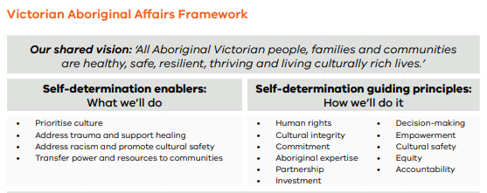

## Community voice

An integral part of self-determination is ensuring community voice is collected and respected through action.

To ensure services are culturally safe, it is imperative that the Aboriginal community are empowered to be at the forefront of decision-making that results in effective service delivery responses.

This is highlighted in the 2022 Child Safe Standard 1: all organisations should establish a culturally safe environment in which the diverse and unique identities and experiences of Aboriginal children and young people are respected and valued. To comply with the standard, an organisation must, at a minimum, ensure:

* 1. A child’s ability to express their culture and enjoy their cultural rights is encouraged and actively supported
  2. Strategies are embedded within the organisation which equip all members to acknowledge and appreciate the strengths of Aboriginal culture and understand its importance to the wellbeing and safety of Aboriginal children and young people.
  3. Measures are adopted by the organisation to ensure racism within the organisation is identified, confronted and not tolerated. Any instances of racism are addressed with appropriate consequences.
  4. The organisation actively supports and facilitates participation and inclusion within it by Aboriginal children, young people and their families.
  5. All of the organisation’s policies, procedures, systems and processes together create a culturally safe and inclusive environment and meet the needs of Aboriginal children, young people and their families.

### How is community voice collected?

There are multiple ways that Best Start partnerships can ensure the voice of community is collected. Some examples that have been used by Best Start partnerships include:

* Partnership representation from Aboriginal community members
* Focus groups or yarning circles
* Surveying of Aboriginal families

All sites should ensure they know who Aboriginal organisations are in their community and the roles and responsibilities of each organisation, ensuring that local protocols are respected.

Some of the most successful examples of collecting Aboriginal community voice have involved informal phone or in-person discussions about what services are doing well and what they can do better. When this information has been collected by trusted people within the Aboriginal community, rather than service providers directly, Aboriginal families have felt safe to provide open and honest feedback.

Importantly, all partnerships should ensure that the mechanisms for collecting community voice allow for Aboriginal children and their families to feel safe to have a voice and be heard, and allow children genuine opportunities for voicing their opinions.

### Respecting community voice

The key learning from gathering feedback from Aboriginal people has been the importance of ensuring the voice is respected. Where families and community members have provided feedback on what can be done better, and they can see that reflected in the practice of service providers – leading to a sense of Aboriginal voices being genuinely respected – engagement with the services has increased markedly. Additionally, this practice has built a trust that more open and honest feedback can be provided with services as it will be acted upon.

Conversely, collecting feedback and failing to act on it has seen significant disengagement from those services.

Best Start sites should ensure that partnerships and service providers seek guidance and feedback from a broad section of the Aboriginal community on how service providers can better meet the needs of Aboriginal children and families, and then act on this feedback

## Culturally safe partnerships for Aboriginal people

It is important that all partnership meetings are culturally safe for Aboriginal people.

Acknowledging the importance of self-determination, the first step in establishing a culturally safe partnership is asking those Aboriginal organisations that form part of the partnership how they would like to see meetings demonstrate cultural safety.

However, culturally safe meetings should also include ensuring a visual acknowledgment of culture that may include artwork, flags or posters recognising Aboriginal culture. It may include holding meetings at Aboriginal organisations. It includes an Acknowledgment of Country at the start of each meeting and acknowledgment of the Aboriginal people in the room. It also includes sharing the values and qualities held by all Best Start sites working with Aboriginal children as per the Best Start policy and guidelines.

Aboriginal people at partnership meetings represent their community, however, are conscious of ensuring they do so in consultation with the community and Elders. Meetings where Aboriginal children and families are discussed should ensure that the Aboriginal voice(s) at the table are given the time and opportunity to appropriately respond on behalf of community - this may include requesting additional time to adequately consult with the Aboriginal community and Elders more broadly.

Aboriginal voice(s) should always be respected and prioritised in response to issues affecting the Aboriginal community. Partnerships should respect the Aboriginal spiritual practice of deep listening, which loosely equates to contemplation. This is an important cultural practice for many Aboriginal people and may result in contemplative silences that should not be interpreted as unwillingness to contribute to discussions.

Partnerships should respect this practice, allowing time for those Aboriginal people at the table to respond as appropriate.

Additionally, partnerships should ensure multiple avenues for collecting the Aboriginal community voice to enable active participation and representation, as highlighted earlier in these guidelines.

## Values and qualities held by all Best Start sites working with Aboriginal children

In 2004, the Aboriginal Best Start Reference Group[3], developed a statement of cultural beliefs that underpin the work of Best Start to this day reflecting values held important by Aboriginal people:

* Our children are our present and our future.
* Our children should have access to good health, wellbeing and education programs so that they will be empowered to achieve their full potential.
* Our children have the right to an education that strengthens their culture and identity.
* Our children have the right to live in communities that are safe and free from violence.
* Our children have the right to identify as Aboriginal Australians, to be proud of our history, cultural beliefs and practices.
* Our children have the right to maintain connection to their land and country.
* Our children have the right to maintain their strong kinship ties and social obligations.
* Our children have a strong contribution to make to enrich the Aboriginal community and as members of the wider community.
* Our children have a right to be taught our cultural heritage by our Elders.
* Our children should be taught to respect their Elders.

## Aboriginal Best Start

Aboriginal Best Start projects have been established to make sure that local Aboriginal communities and organisations are given every possible opportunity to influence outcomes for their children and families.

There are six Aboriginal Best Start sites across Victoria run by the Aboriginal community for the Aboriginal community. While these sites focus specifically on the Aboriginal community, the priority focus for all Best Start sites is Aboriginal children.

All Best Start sites have the same outcomes and accountabilities.

The Department has engaged the Victorian Aboriginal Community Services Association Limited (VACSAL) to provide support to the six Aboriginal Best Start sites, as well as culturally-specific guidance to other Best Start sites. (For more information, refer to Roles and Responsibilities.)

# Culturally and Linguistically Diverse (CALD) children and their families

## Why focus on CALD children and families?

Victoria is home to one of the most culturally diverse societies in the world and is also among the fastest-growing and most diverse states in Australia. Victorians come from more than 200 countries, speak 260 languages and follow 135 different faiths.

Victoria’s CALD communities are not homogenous and have a broad range of education levels, levels of English proficiency, visa types, socio economic circumstances and home environments[4].

The Department of Education and Training is committed to ensuring all children can access a local kindergarten place, including those from CALD backgrounds.

Children from CALD backgrounds, including those who are newly arrived or from a refugee background, are less likely to participate in a kindergarten program. CALD families often face barriers to participating and attending kindergarten services.

The Productivity Commission Inquiry Report on Childcare and Early Childhood Learning (2014)[5] reveals that children from linguistically diverse backgrounds tend to be underrepresented in preschool relative to their share in the general population. They found that 10 per cent of children aged three to five years identified in preschool as Non-English Speaking Background (NESB), while in the entire population of this age, the rate was around 20 per cent.

Children from CALD backgrounds and their families that are experiencing vulnerability are a key priority group for Best Start sites in Victoria. Strengthening culturally responsive practice, building relationships with CALD communities and multicultural community organisations will ensure that all kindergarten services are welcoming and inclusive of CALD children.

For more information about CALD communities across Victoria see: [Local Government areas report on population diversity | Victorian Government (www.vic.gov.au)](https://www.vic.gov.au/local-government-areas-report-population-diversity)

### The Victorian Early Years Learning and Development Framework (VEYLDF) and cultural inclusivity

The VEYLDF underpins the design and delivery of inclusive, child-centred kindergarten programs in Victoria, adopting a comprehensive approach to children’s learning and development.

Equity and Diversity is a Practice Principle of the VEYLDF, describing the most effective ways for early childhood professionals to work together and with children and families to facilitate learning and development. As part of this, early childhood professionals are expected to promote cultural awareness in all children, and to nurture children’s evolving capacity to learn from birth, regardless of their circumstance or ability.

The VEYLDF guides early childhood professionals to work together with families in support of their children, embracing and responding to the cultural and linguistic diversity of the Victorian community and diverse approaches to raising children.

The VEYLDF recognises that children’s identity and their family and cultural histories shape their learning and development. The VEYLDF acknowledges that values and attitudes, understandings of community and individual, and ways of communicating and behaving all impact on children’s sense of belonging and acceptance. When children experience acknowledgement of and respect for diversity, their sense of identity becomes stronger.

For more information see: [Victorian Early Years Learning and Development Framework- Practice Principle Guide- Equity and Diversity](https://www.education.vic.gov.au/Documents/childhood/providers/edcare/pracguideequityanddiversity2017.pdf)

## Children and families from refugee backgrounds

Children and families from refugee backgrounds are a diverse cohort. Some families from refugee backgrounds may have arrived in Australia under the Humanitarian program, some may have experienced persecution in their countries of origin and arrived under another migration program such as a Family Stream visa. Additionally, some children from refugee backgrounds may have been born in Australia and their parents or carers fled persecution.

Families from refugee backgrounds who have been in Australia for over five years may now hold Australian Citizenship and may not want to identify themselves as being from a refugee background.

Many refugee experiences are characterised by exposure to violence, loss, persecution, forced displacement, and a protracted and complex resettlement process. Upon arrival in Australia, families often face challenges in gaining stable employment, securing affordable housing, and learning English, whilst also managing the effects of trauma, loss and separation. Newly arrived families from refugee backgrounds may be unfamiliar with early childhood education services in Victoria.

Early childhood education services play a key role in supporting children and families from refugee backgrounds, particularly during the first few years of their settlement in Australia. Building strong partnerships with families from refugee background helps to improve learning and wellbeing outcomes for children.

For resources on supporting children and families from refugee background in early childhood education see: [Early Years | Foundation House](https://foundationhouse.org.au/specialised-programs/early-years/)

### Children and families seeking asylum

Asylum Seekers are children or adults who have arrived in Australia and sought protection as a refugee, but whose claim for refugee status has not yet been assessed.

The Department of Education and Training funds access to kindergarten for children of asylum seekers who have not yet had their status as refugees assessed.

For more information about Asylum Seekers in Victoria see: [Recent arrivals, asylum seekers and family support services - Better Health Channel](https://www.betterhealth.vic.gov.au/health/servicesandsupport/recent-arrivals-asylum-seekers-and-family-support)

## Culturally Responsive Practice

Best Start sites should seek to incorporate culturally responsive practice to improve outcomes for children and families from CALD backgrounds.

Many Best Start sites currently focus on strategies and actions that are culturally responsive and inclusive of CALD children and families. Establishing and strengthening connections with CALD elders, CALD community groups, faith-based leaders and multicultural organisations will enable Best Start sites to build strong and effective partnerships.

Working in a culturally inclusive and responsive manner with CALD communities will support Best Start sites to strengthen mutual respect and protect cultural dignity.

Best Start sites may also be keen to seek out culturally-specific training and guidance to enhance their knowledge and skills in working effectively with CALD communities. In 2021-22, the Department has engaged Brotherhood of St Laurence to provide Cultural Responsiveness training to sites that may be working with CALD communities. This training builds on the foundations of the Brotherhood of St Laurence report *Improving Culturally and Linguistically Diverse Communities’ Kindergarten Experience*.[6]

# Governance

Best Start partnerships establish governance mechanisms that are strong, clearly defined and transparent. Good governance ensures all partnership members have a voice at the table – it supports their ability to make strong decisions with group agreement and those decisions contribute to achieving Best Start outcomes.

Best Start partnerships must establish and meet the following governance requirements:

* Partners actively support the Best Start fund holder to meet its performance measure, that *Partnership and local organisations are able to demonstrate active progress toward logic model stretch goals through implementation of change ideas through PDSA cycles that are recorded on the Best Start portal*.
* A partnership agreement must be in place. Best Start sites may adapt the standard agreement to suit their local context or develop a locally appropriate version that supports the Best Start partnership.
* A chairperson must be appointed or elected for a specified time and outlined in the Best Start partnership agreement.
* New partners must be provided with an orientation to the improvement work of Best Start.
* In partnership meetings, partnership member representatives must hold sufficient delegated authority to make decisions and commitments on behalf of their organisation, including directing participation of organisation staff in Best Start improvement teams. Partnership member representatives should also have capacity to share relevant data to inform measurement of improvement.
* Best Start partnership members have a shared responsibility for the implementation of Best Start program strategies, with a view to achieving service system change within their own organisation, across the partnership and more broadly.
* Working groups or improvement teams with a wider membership than the core Best Start partners may be established to address specific outcomes.
* Partnership agreements should be reviewed annually and updated every four years, in line with renegotiating Department funding and the service agreement with the Best Start site’s fund holder.
* A local partnership may revisit their partnership agreement on a more regular basis, particularly if there are significant changes in the policy or service context.
* Where the Best Start partnership is part of a larger local early years network, Best Start business, strategies and reporting must appear as a regular agenda item with a clear line of sight to Best Start outcomes. Best Start improvement work must always be documented on the Best Start portal.

#### ***Example thinking:*** *The Best Start partnership is working to achieve similar goals to those in the Early Years Compact of the area, as well as those of a major Early Years Manager (EYM) for their school readiness funding (SRF). The Facilitator works with Compact members to identify opportunities for the Best Start partnership to operationalise the focus of the Compact. Additionally, the Facilitator works with the local Department Kindergarten Improvement Advisor (KIA) and the EYM to understand their focus and goals and how this may align.*

By understanding the strategic context of the area (Compact) and the objectives of service providers, the Best Start Facilitator is able to frame the partnership in a way that brings these stakeholders and their objectives together, to complement each other, rather than compete.

# Best Start partnerships

Best Start Partnerships lead reform at the local level. They play a key role in bringing local services together to deliver on the Best Start outcomes for children and their families, in particular those with the greatest needs. All Best Start partnerships have a role to play in working in a culturally inclusive manner with Aboriginal and diverse communities.

The Best Start partnership works collaboratively to:

* take responsibility for the interests of children, especially all Aboriginal children and children experiencing vulnerability, to actively participate in early childhood education and MCH services
* work in a culturally inclusive, responsive manner with Aboriginal and CALD communities that protects cultural dignity
* define and agree on the barriers and needs for their Best Start site that align with the Best Start vision, key directions, outcomes and the site’s special areas of focus. They are careful to ensure the impact of the partnership is placed ahead of the interests of any individual organisation
* develop a logic model and devise strategies and actions to test through Plan Do Study Act (PDSA) cycles, and engage in improvement cycles to achieve Best Start outcomes
* monitor and report on progress regularly so that improvements can be made to their Best Start strategies and actions.

The diagram below describes the collaborative relationships within a Best Start partnership.

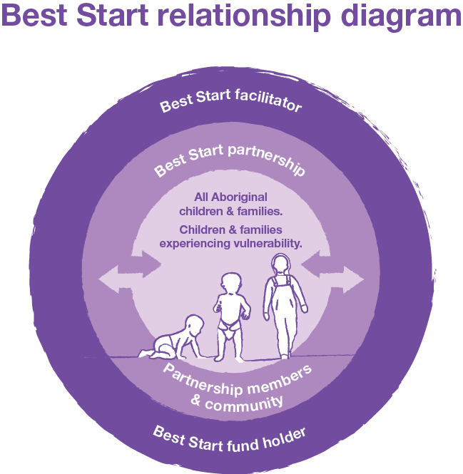

## Partnership members

Best Start partnerships are most effective when the organisations on the partnership commit to actively working together to achieve agreed local targets.

### Partner groups

The partner groups listed below may be included in the Best Start partnership, wherever partner priorities align with Best Start priorities. Alternately, these partner groups may elect not to participate directly in the partnership, but the Best Start facilitator may work closely with these groups to ensure their voice is represented within the work of the partnership.

These partner groups include, but are not limited to:

* **families and other community representatives**, which could include Aboriginal, CALD or faith-based Elders. Parents and families are critical partners in Best Start as they have the first and most enduring impact on their children’s health, learning, development and wellbeing, and are ‘experts’ in their child’s strengths, needs and abilities
* **Early Childhood Improvement Branch members, including Managers, Early Childhood Performance and Planning Advisors, and/or Kindergarten Improvement Advisors**
* **other government departments,** such as the Departments of Health (DoH) or Families, Fairness and Housing (DFFH)
* **local government**. The Victorian Government values and supports the leadership role that local government takes in the planning, coordination and delivery of early years services in Victoria
* **Aboriginal community partners** provide specialist cultural and community advice to ensure the Aboriginal community plays the key role in guiding outcomes for Aboriginal children and families
* **early years education services**, e.g., supported playgroups, long day care providers, early years management organisations and family day care
* **early childhood intervention services**, e.g., speech pathologists, paediatricians and general practitioners
* **Maternal and Child Health services (MCH)**, including services managed and operated by local government, local health services and Aboriginal-controlled services
* **health services**
* **culturally and linguistically diverse community groups, both support based and social connection groups**
* **government and non-government schools**
* **family services**, i.e., services that address the inclusion and participation of families experiencing vulnerability and families with complex needs in universal early years services
* **local community organisations**.

When a partnership determines the strategies they will put in place to progress towards the Best Start outcomes, they should objectively review the partnership members to decide if it has the right make up to affect the change.

#### ***Example thinking:***

The work of the partnership for the year is focused on children from CALD families. Partners know that in their area there are two main organisations that support CALD families and that most children are attending kindergarten at three long day care services. At this time there is a representative from both of the community organisations, as well as good representation from the local EYM organisations, but nobody from the long day care services.

Given what is trying to be achieved through the logic model, the Facilitator will work to engage the long day cares at the local and service provider level.

The Facilitator also realises that the representative from one of the community organisations is unable to commit to making changes within their organisation as they do not have sufficient authority. This prompts the Facilitator to discuss with the organisation their level of commitment to the Best Start objectives and how they would like to participate in the partnership, noting that participation requires a commitment to making changes within each organisation to achieve a collective goal.

## Clearly defined roles and responsibilities support strong governance

Having strong governance in place supports effective and timely decision-making across the partnership. A hallmark of good governance is clearly defined roles and responsibilities.

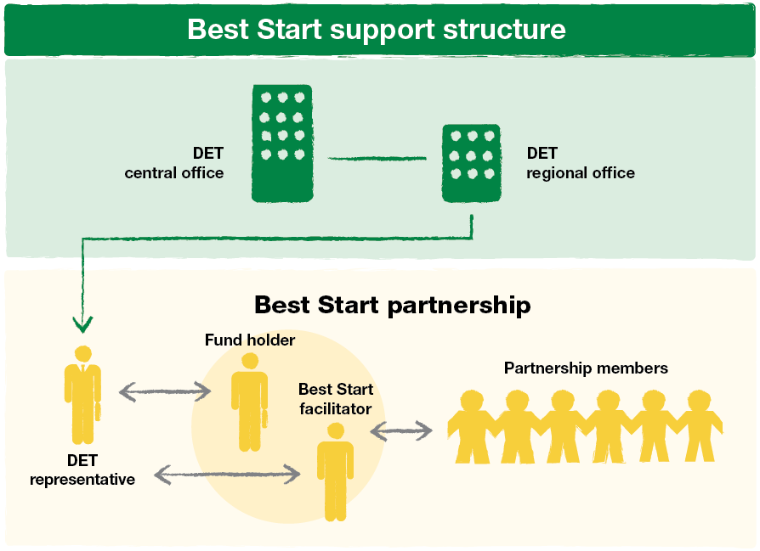

# Roles and responsibilities

For Best Start partnerships, roles and responsibilities provide the clarity that helps many different partnership members to work together under the partnership.

The table below outlines the responsibilities of the various partnership members.

| Partner | Responsibility |
| --- | --- |
| The Department | **Central office** oversees the Best Start program design and implementation, and works in partnership with the regional offices to provide advice and guidance on Best Start requirements, and to facilitate sharing relevant data.  **Regional offices**:   * **are the first point of contact for Best Start sites**. Best Start sites contact their regional office for assistance, negotiation and guidance * **facilitate the sharing of innovative practice** between Best Start sites and partnerships by developing appropriate networks and participating in them * **administer funding and service agreement with fund holders**. The Department enters into a funding and service agreement with the fund holder who is the lead agency for the Best Start site. As the funding body, the Department requires the funded service to be monitored against the performance measures and targets outlined for the activity in the service agreement and this policy document. Monitoring is undertaken through data collection and financial accountability requirements (as specified in the service agreement and in these guidelines). Any proposal by a Best Start site to change the fund holder is discussed and negotiated with the Department through the relevant regional office. If agreed, a new funding and service agreement is established with the new fund holder * **nominate regional representative(s) to participate in a partnership**. This enhances collaboration with the Victorian Government as a key stakeholder. The regional representative: * monitors the funding and service agreement of the Best Start fund holder * provides the connection between the central office and Best Start site, including between key fund-holder managers, facilitators and partnership members.   Regional representatives may actively participate in implementing PDSA cycles relevant to the partnership objectives. |
| Other staff employed by the Department | Other Department employees include, but are not limited to, school principals, Koorie Education Coordinators, and Koorie Engagement Support Officers, and LOOKOUT staff. All staff may actively participate in implementing PDSA cycles relevant to the partnership objectives. |
| Fund holder | The fund holder:   * must be an incorporated body that is able to demonstrate financial viability as the holder of government funds, for example local government or health service * ensures the local Best Start program complies with the conditions of the funding and service agreement * is responsible for: * providing sound financial systems that ensure money is managed and spent in line with the service agreement and these guidelines * employing the Best Start facilitator and providing their professional support * ensuring spending represents value for money * ensuring Best Start reporting requirements, as outlined in these guidelines and any subsequent amendments, are adhered to * is accountable to the Best Start partnership and to the Department for appropriate management of funds and for clear and transparent reporting against expenditure. |
| Best Start facilitators | Facilitators support Best Start partnerships in their designated local area, as they work to achieve improved outcomes for children.  Facilitator responsibilities include, but are not limited to:   * engaging and networking effectively with Aboriginal and community service organisations. They build relationships, gain commitment from partners and work to keep commitment levels high * ensuring community feedback is sought in relation to guiding improvement of the service system * the review of data, evidence and local knowledge with the partnership to identify community needs and develop an annual logic model with strategies and measurable targets to address those needs * coaching partner organisations to use an improvement approach within their services, including designing, planning and implementing change ideas for testing, and studying the results of the tests * facilitating partnership and improvement teams’ interpretation of data, and sharing of learnings * identifying opportunities for improvement * supporting the Best Start monitoring and reporting framework.   While the facilitator plays a role in developing, monitoring and reporting on strategies, this role is not a service delivery or operational role. For more information about facilitator responsibilities, see the sample position description at [www.beststart.vic.gov.au](http://www.beststart.vic.gov.au) |
| Local government | Local government, as the third tier of government, understands and represents the interests of the local community, and is responsible for strategic local area planning that meets the needs of the local community.  Local government plays a key legislated role in strategically planning and coordinating early childhood services within a municipality, and acts in the best interests of the community. It does this through its Municipal Health and Wellbeing Plans and its non-statutory Municipal Early Years Plans.  These plans provide strategic direction for coordinating education, care and health programs and activities within the municipality that affect children – from birth, through kindergarten, to the time they enter school.  It is therefore essential for local government to regularly engage with local early years service providers, including Best Start partnerships, to exchange data and information relating to the needs of the community, such as information on service enrolments, capacity and usage.  This allows all providers to work together in responding to current and future community needs, and ensures that all children – particularly those who are experiencing vulnerability – have access to quality early years services and initiatives within their municipality. |
| VACSAL | The Victorian Aboriginal Community Services Association Ltd (VACSAL) provides:   * intensive support to all six Aboriginal Best Start sites and a select number of other Best Start sites * general culturally specific support and advice to all Best Start sites across the state.   Specifically, VACSAL provides advice and information on evidence-based strategies or emerging strategies that demonstrate they may be effective in addressing barriers to Aboriginal children’s participation in kindergarten, Supported Playgroups and MCH services.  This cultural advice and information sharing is provided through an annual forum, regular contact with Best Start sites and Best Start collaboration site updates. |
| Other place-based partnerships | In Victoria, a range of collaborative, place-based groups exist, including but not limited to Compact, Child FIRST, Local Aboriginal Education Consultative Groups (LAECGs)[7],, and Communities for Children.  When planning Best Start strategies and actions, partnerships must:   * identify existing collaborative structures in the local area and where there is overlap in task and membership, then * identify how the work of the Best Start partnership fits with the existing or emerging groups, and * consider how the relationship between them might work. |

# Partnership agreements

Best Start partnerships may consider how a partnership agreement will best work in the local context. Sites may use the more formal, standard partnership agreement. However, for some partnerships, a signed agreement to work together to achieve logic model goals may be more appropriate.

## What makes up a partnership agreement?

Partnership agreements were historically a more formal, legal type document that reflected accountable use of brokerage funding. However, now that the Best Start guidelines clearly identify the parameters for funding expenditure, the fund holder assumes responsibility for funding accountability.

As such, partnership agreements are now an in-principle agreement to work collaboratively using an improvement science approach to address barriers to participation for all Aboriginal children and children experiencing vulnerability.

The new partnership agreement may include:

* Details of the fund holder/lead agency.
* Details of the geographic focus of the partnership.
* A vision, the shared values and the objectives of the partnership, which are consistent with Best Start key directions and outcomes.
* Partnership accountability mechanisms.
* An outline of the structures that the Best Start partnership will use to implement the Best Start strategies, such as working groups or improvement teams, and an agreement to provide staff for these teams.
* Documented meeting procedures, including how often they are held and who is expected to attend.
* Other key processes, agreed principles and mindsets, including dispute resolution, grievance, communication and confidentiality.
* The signatures of partnership members, and any partnership member that is invited to join the partnership for their specific skills, to implement a particular strategy.

A revised standard partnership agreement template can be found at [**www.beststart.vic.gov.au**](http://www.beststart.vic.gov.au).

As the partnership agreement is no longer required to be a legally binding agreement in relation to funding expenditure, Best Start partnerships may choose to amend the standard partnership agreement to suit their local context.

## What to do when a new partner joins?

If a decision is made to introduce a new partnership member, the Best Start partnership must formally endorse the new member and the new member must sign the existing Best Start partnership agreement.

Details of the additional partnership members and their signatures can be attached to the existing agreement as an addendum.

# Funding

## Funding allocation and reporting

### Budget

Eighty per cent of Best Start funding makes up the Best Start facilitator’s salary and salary-related costs such as long service leave, WorkCover and sick leave. The remaining twenty per cent is for administration costs, including professional supervision and development of the facilitator, and capital inputs such as office equipment, venue hire, and facilitator access to a mobile phone and motor vehicle.

### In-kind support

The Department recognises the generosity of fund holders and partners in providing in-kind support to the Best Start program. They are often willing to use their own premises and infrastructure, for example to run working group meetings or for office space for the facilitator.

### End of year reporting and surplus funds

At the end of each financial year, the fund holder will complete the Best Start Financial Report within 30 days of the end of financial year.

If there is any unexpended funding at the end of financial year, it must be returned to the Department within 90 days of the new financial year or as otherwise agreed.

Unexpended funding may only be retained for the funding purposes specified in these guidelines – that is, to employ to a role that supports the Best Start facilitator in their role, or for professional development of the facilitator. Any retention of funding must be agreed upon, in writing, by the Department and fund holder and must be expended by June 30 of the following financial year.

## Performance measures and targets

The Department monitors government-funded community service organisations against the performance measures and targets specified in their service agreement. Monitoring is undertaken through the data collection and financial accountability requirements specified in the service agreement and in this guidelines and policy document.

### Performance measures specific to Best Start

* Employment of a facilitator for at least 80 per cent of the calendar year.
* Annual logic model is produced that includes strategies and measurable stretch goals
* Partnership and local organisations are able to demonstrate active progress toward stretch goals through implementation of change ideas through PDSA cycles that are recorded on the Best Start portal
* All Best Start reports are submitted by the due date.

Should fund holders be unable to meet the above performance measures, the Department may seek to withhold funding for a period until such time as the site is able to demonstrate adherence to the policy. If the site is unable to meet their funding requirements for the entirety of the financial year, the Department may work to recoup part or all of the funding for the relevant period.

# Implementing Best Start

The Department engaged the Centre for Community Child Health (CCCH), a research group of the Murdoch Children’s Research Institute (MCRI) and department of the Royal Children’s Hospital (RCH), to provide training, coaching and support to facilitators and partnerships to implement an improvement methodology to their work. This support commenced in 2017 and is contracted to continue until the end of 2022.

CCCH reviews the learning on how the improvement methodology is working most effectively in the Best Start context and produces updated resources to support Best Start sites.

Best Start facilitators and partnerships should refer to the most recent Best Start Improvement Approach Guide for detailed information on establishing an improvement approach to the work. This Improvement Approach Guide is found at [www.beststart.vic.gov.au](http://www.beststart.vic.gov.au).

The following guidance briefly describes the overarching principles for embedding an improvement science approach in Best Start sites and is an excerpt from the 2020 Best Start Improvement Approach Guide[8].

## The four stages

A four-stage annual process is used to implement the Best Start improvement approach (summarised in Table 1).

|  |  |  |  |  |
| --- | --- | --- | --- | --- |
| Stage | Group responsible | Role of Best Start facilitator | | Timing |
| 1. **Designing or reviewing a logic mode**l that provides guidance for the focus of improvement work over the course of the year | Partnership | | Facilitate the partnership’s development of the logic model | Logic model review is undertaken at the end of the previous year (see stage 4). |
| 1. **Designing, testing and implementing change ideas** that aim to improve the service system and make progress towards the goals set in the logic model. | Improvement teams | | Coach the team to design the change ideas and subsequently study the results of their tests. Coach individuals to plan and implement their own change idea tests (PDSAs) | Change ideas are designed and tested throughout the year. Improvement teams meet monthly. |
| 1. **Monitoring the progress** being made towards goals through gathering and reviewing monthly data | Partnership and improvement teams | | Facilitate improvement teams’ interpretation of the data and implications for their work. Facilitate the partnership’s interpretation of the data and implications around sustaining and spreading practice changes across the site. | Improvement teams monitor data monthly. Partnership reviews data 2-3 monthly. |
| 1. **Reviewing** a wider data set on an annual basis to draw conclusions about the learning and impact of the year’s work, and identify implications for the following year. | Partnership | | Facilitate the partnership’s interpretation of all data and understanding of what has been learnt. | Full data review is undertaken at the end of the year. |

Table 1: Best Start’s four stages of implementation

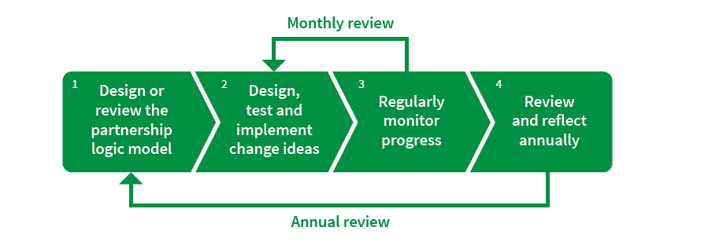

Figure 1: Best Start’s four stages of implementation

The stages are designed to be completed in order, but the sequence also includes two feedback loops:

* The first is a quick-turning loop between testing change ideas (stage two) and monitoring progress (stage three). This loop is completed each month.
* The second is a slower loop between annual reflection (stage four) and review of the logic model (stage one). This loop is completed on an annual basis.

### Stage 1: Design or review the partnership’s logic model

In Best Start, a logic model is developed as the first step of implementation because it provides a high-level plan to guide the work of the Best Start site over twelve months. A pipeline model is applied as shown below.

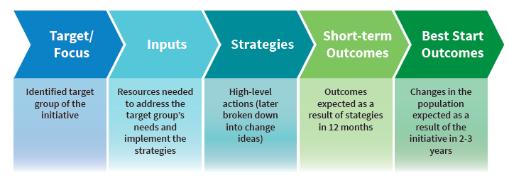

Figure 2: The Best Start logic model template

The pipeline model uses an ‘if… then…’ logic that looks like this:

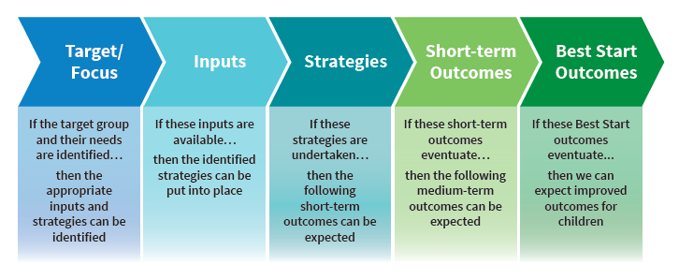

Figure 3: The “if…then…” logic

Best Start sites focus on:

* All Aboriginal children
* Children experiencing vulnerability in their area that may include:
* children known to child protection including children in Out of Home Care
* children at risk of abuse or neglect, often known to other key secondary support services such as Enhanced MCH, Family Services and Orange Door
* children from newly arrived migrants/refugee background or people seeking asylum
* children from culturally and linguistically diverse (CALD) backgrounds that are experiencing vulnerability, or
* children with a disability, impairment or developmental delay.

The Best Start outcomes that all partnerships work toward are:

* Children engage and participate in early childhood education (kindergarten and supported playgroups) and enter school as confident and involved learners
* Children and families actively engage with MCH services, attending key ages and stages visits to optimise health, wellbeing, safety, learning and development.

Best Start has identified six short-term outcome areas that enable the achievement of the Best Start outcomes. These short-term outcome areas have been developed from research and practice evidence and are detailed in Table 2. Sites select the short-term outcome areas that will address the barriers to participation for the target cohort in their area.

|  |  |
| --- | --- |
| **Short-term outcome** | **Definition** |
| **Service accessibility** | Considers **structural** features (e.g., enrolment/intake processes, waiting lists, appointment times, affordability), **physical and environmental** features (e.g., parking, public transport, signage, entrances, location), and the **delivery of information** (type and content of information provided; advertising and marketing; catering for diversity). |
| **Cultural safety for Aboriginal families** | Cultural safety for Aboriginal families is about “an environment that is safe for people: where there is no assault, challenge or denial of their identity, of who they are and what they need. It is about shared respect, shared meaning, shared knowledge and experience, of learning, living and working together with dignity and truly listening” (Williams, 2008). There is a range of ways that services can create a culturally safe environment, including: **developing relationships with Aboriginal people and organisations** and involving Aboriginal people in the planning and delivery of services, **creating a physical environment that acknowledges and is respectful of Aboriginal culture** (e.g. displaying an acknowledgement of the Traditional Owners of the land), and **observing significant events** such as Sorry Day and NAIDOC Week (Commission for Children and Young People, n.d.). |
| **Service continuity and collaboration** | Encompasses information sharing and **communication** between services; **referral** to and from other services; **transitions** between services; and **integrated case planning**. Also considers levels of collaboration between partnership members. |
| **Relationship-based practice** | The quality of the relationship between the service provider/practitioner and client/family is crucial. A fundamental respect for families should be reflected in policies as well as practices. Work with families should be based on the core principles of **family-centred practice** (FCP), including building partnerships with parents, basing services on family priorities, shared decision making and recognising and building on family strengths and competencies. |
| **Active outreach and engagement** | **Special efforts**, including outreach, are made to **reach and engage** Aboriginal families and families experiencing vulnerability, e.g., those with limited social networks or limited trust or interaction with child and family services. |
| **Family awareness and beliefs** | This outcome area focuses on addressing the consistence of messages by local service providers about early childhood development and learning. There are gaps between public opinion and expert understanding about the importance of early learning. Awareness campaigns to address public opinion require resources beyond local Best Start partnerships, however, partnerships should focus on **the consistency of messages about early learning** given to families. |

Table 2 – Short-term outcome area definitions

For each short-term outcome area chosen, the partnership must establish a corresponding 12-month stretch goal that provides the detail about what is to be achieved under that short-term outcome area.

A stretch goal is an ambitious goal that the partnership sets itself to achieve in one year. However, even if the goal has not been entirely met within this time, any progress made towards it is considered a success.

The stretch goal must be measurable and as such, a specific measure (e.g., 90 per cent or *x* number of children) must be attached to the stretch goal.

Strategies are high-level actions the partnership will take to achieve its short-term outcome stretch goals.

Inputs are the resources that the partnership has available to them and/or needs to implement the strategies.

#### ***Example thinking:***

*The partnership has identified that there are many children with developmental delays who are arriving at kindergarten without any previous support. Feedback from the families of these children has identified that some families have not understood how to access NDIS support. In many instances, the families were unable to identify a key practitioner to assist with the challenges in navigating NDIS support.*

*The partnership determines that the response to this issue must be two-fold: ensuring stronger engagement with the MCH service to support referrals; and better referral pathways into NDIS. The partnership focuses on the short-term outcome area of service continuity and collaboration and sets the stretch goal: 100% of eligible children in our area arrive at kindergarten supported through an NDIS plan. The strategy is: Referral pathways are strengthened between early years services and NDIS; MCH, childcare, supported playgroups and partner organisations identify eligible children and support referral to NDIS in a collaborative approach.*

The inputs are reviewed, and the missing partnership members are identified and supported to join the Best Start partnership to progress the work.

### Stage 2: Design, test and implement change ideas

The Model for Improvement (Langley et al., 2009) is an improvement framework that generates, implements, tests and embeds change ideas (small ideas for improvement) in a way that ensures these ideas are connected to the initiative’s broader objectives or goals. The model is divided into a thinking part and an implementation part (see Figure x).

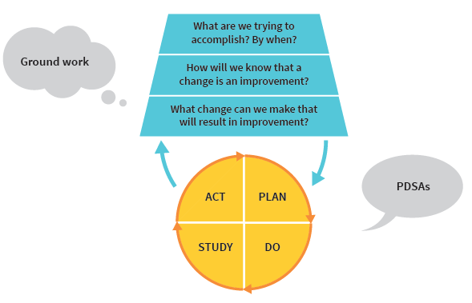

Figure 4: Model for Improvement

The thinking part of the model ensures that the development and testing of these change ideas are tightly connected to the overall goals of your work. In Best Start, this thinking part is referred to as the groundwork. In Best Start the implementation part of the model is referred to as the PDSAs. The Plan-Do-Study-Act (PDSA) cycle ensures that the change ideas are rigorously implemented and that evidence about what works (and what doesn’t) is created (Langley et al., 2009).

The Best Start partnership’s logic model is the foundation for the Model for Improvement to generate and test change ideas. Specifically, it is the strategies and short-term outcome stretch goals that the partnership members have set in their logic model that will directly inform the groundwork part of the model, which will in turn inform the PDSA part. This relationship is outlined in Figure 5.

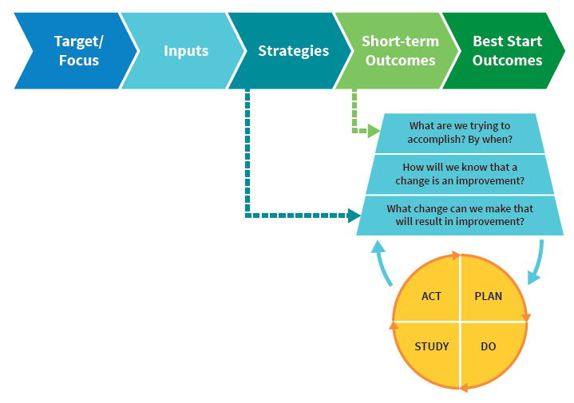

Figure 5: Relationship between the Model for Improvement and the logic model

#### Change ideas

Change ideas are simple and specific actions that are likely to support the achievement of a stretch goal and lead to improvements in the short-term outcome areas. Although all change might not lead to improvement, all improvement requires change.

Change ideas may come from research, those who work in the system (front-line service providers) or use the system (families and children), or from the experience of others who have successfully improved. The change idea(s) are the basis of the PDSA cycle.

Change ideas should be:

* Related to the measure, stretch goal, and short-term outcome area
* Actionable and specific ideas for changing a process, service or system
* Based on the best available evidence (research evidence, practice evidence or families’ lived experience)
* Simple, easy and straight forward (i.e., can be started next week without additional resources).

Change ideas aim to improve the way a service is delivered. Therefore, change ideas are not:

* One-off activities
* Activities that involve information gathering only
* Activities that require funding to test
* Research.

#### Testing change ideas through Plan-Do-Study-Act (PDSA) cycles

The PDSA cycle is completed using a template on the Best Start portal ([www.collaborate.edu.au](http://www.collaborate.edu.au)).

The ***plan*** section outlines the what, where, when and who, a prediction of the expected improvement, and the data that will need to be collected to see if the predicted improvement occurs.

The ***do*** section documents observations and problems regarding implementation, and gathers the data to test the prediction.

The ***study*** section is completed with a small improvement team. The team sets aside time to analyse the data collected and study the results. The improvement team compares the data to the predictions and summarises and reflects on what was learnt. Did the change idea meet the prediction? If not, why not?

Once the data has been analysed, the improvement team decides what to do in the next PDSA cycle as a result of this cycle. The ***act*** section considers, will the change idea be adapted, adopted or abandoned?

Typically, a change idea is tested through multiple PDSA cycles with adaptations each time, to ensure the idea works as well as it can.

### Stage 3: Regularly monitor your progress

Monitoring progress is the third stage of implementation. It is closely related to the second stage because it enables you to assess the effectiveness of the improvement work. It is also closely related to the fourth stage because it supports the annual review process. Progress is assessed through the collection of different types of feedback at different intervals.

In Best Start there are four levels where feedback is collected to measure progress:

* Individual PDSA cycles
* Short-term outcome stretch goals
* Best Start outcomes
* Long-term children’s outcomes.

Best Start uses a community dashboard to collect and visualise feedback against the short-term outcome stretch goals and Best Start outcomes. Each site has a personalised dashboard produced and accessed through the Best Start portal at [www.collaborate.edu.au](http://www.collaborate.edu.au).

#### Monthly measures

Best Start sites are encouraged to establish monthly measures for short-term outcome stretch goals. A monthly measure of a stretch goal will indicate whether progress has been made toward it. To identify a measure, it is helpful to ask: ‘If we make progress towards our stretch goal, what will we see?’ The facilitator supports the relevant improvement team to identify relevant monthly measures for each of the stretch goals.

When identifying measures for stretch goals, the following should be considered:

* They should be easy to collect on a monthly basis: they are likely to be administrative measures (e.g., attendance)
* They must be reliable: it measures the same thing over time so that progress can be tracked over time
* They should be sensitive to change: it tells us if actions are producing better results
* We can ideally set a target for measures: we know what the “best” system anywhere can produce; we have a target we are aiming for.

#### Using data to regularly monitor progress

The facilitator, together with the improvement teams and the partnership, will use the data available to them to monitor progress. There are two levels of feedback for this analysis:

* Data collected against individual PDSAs
* Data collected against short-term outcome stretch goals.

#### Using run charts to determine improvement

Run charts can be used to visualise monthly data and determine more rigorously whether efforts in a site are leading to improvement in the measure (rather than simply ‘eyeballing’ patterns in the data). Run charts plot data across time and include a goal line and a median line (calculated using baseline data) that is used to determine whether improvement has occurred (see Figure x). Run charts can be displayed on the Dashboard of the Best Start portal. Run charts can be used to understand whether change ideas are leading to improvement or not, and can therefore inform next steps throughout the year, e.g. deciding to sustain and/or spread promising change ideas, or ceasing change ideas that aren’t making a difference.

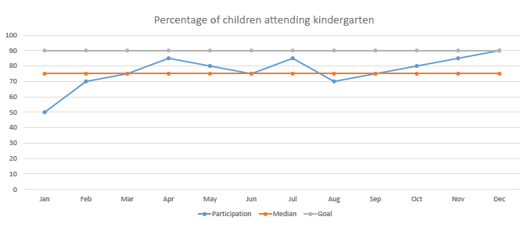

Figure 6: Example of a run chart with goal and median lines

Best Start sites should regularly consult the *Improvement Approach Guide* to ensure they are reflecting on the data using the most robust scientific processes, such as run chart rules.

***Example thinking:***

*The partnership has identified that there are many children in who attend supported playgroups, long day care and kindergarten that have not attended an MCH service for their KAS visits after one year of age. Feedback from families of these children has identified that return to paid work and MCH service hours are factors.*

*The partnership collaborates to strengthen promotion and support access to KAS visits by early childhood practitioners and educators in supported playgroups, long day care and kindergarten. Local MCH services highlight the availability of Saturday morning appointments and strengthen partnerships with supported playgroups, long day care and kindergartens to provide outreach KAS visits. MCH services also provide a letter for parents/carers to support applications for carers leave when appropriate.*

*The MCH service presents data at the end of the financial year to demonstrate an increase in the number of KAS.*

### Stage 4: Review and reflect annually

Undertaking an annual review is the fourth stage of implementation and is part of the slower-turning feedback loop. It connects directly to the first stage of the next cycle where the partnership’s logic model is reviewed. This annual process provides the Best Start partnership with the opportunity to reflect on:

* Changes/improvements against the short-term outcome stretch goals and the Best Start primary outcomes
* The successful practice and system changes that have been implemented
* What has been learnt about what hasn’t worked and to hypothesise why recent efforts have not led to improvement
* The implications of these reflections on the focus of the partnership’s work in the following 12 months.

In preparing for the annual reflection process the facilitator will analyse the four levels of data, develop the narrative and identify key data that supports that narrative.

Collectively partners, supported by the Best Start facilitator, will:

1. Develop a collective understanding of progress and learnings
2. Identify priorities for action
3. Revise the logic model.

**Example thinking:**

A partnership has been focusing on increasing participation for CALD children and families in their kindergarten services over the twelve-month period. The partners reflect on their work and identify culturally responsive and inclusive strategies that have been successful in increasing participation, reviewing the data collected to measure improvement. The partners also identify barriers that were encountered with non-successful strategies.

The work of this year acts as an evidence base that underpins the planning of the next logic model.

The partnership has also focused on ensuring that feedback is received from the CALD community directly to build on responsive and respectful practices.

In addition, partners have participated in Cultural Responsiveness Training offered by the Brotherhood of St Laurence to Best Start sites, providing further opportunities for reflecting on appropriate strategies. This training was based on the learning from the ‘Improving CALD Kindergarten Engagement Project’.

By reviewing the available data on participation for CALD children, using the evidence base gained by the partnership’s most recent work and feedback from families, a research project and professional development, the partnership is able to create a logic model that will drive future work.

# Reporting

## Quarterly summary reports

|  |  |
| --- | --- |
| Report type | More information |
| Quarterly reports | Quarterly reports provide information to the Department on progress of Best Start sites, including PDSA cycles completed, important learning, challenges and successes.  These reports are completed in the template found on the Best Start portal ([www.collaborate.edu.au](http://www.collaborate.edu.au)). |
| PDSAs | PDSAs are completed year-round in the Best Start portal. In most instances, the person making a change in practice will enter the information directly to the portal. In some instances, the facilitator may also support the report being entered on the portal.  There is no minimum or maximum number of reports required, as the number of PDSA cycles will be determined by what is appropriate for the change ideas being tested at each partnership. |

### Timelines and responsibilities

|  |  |  |  |
| --- | --- | --- | --- |
| Report | Responsibility | Reporting period | Report due |
| Quarterly report | Facilitator summarises work of partnership and submits to Department via Best Start portal. | Q1: 1 January–31 March | 30 April |
| Q2: 1 April–30 June | 31 July |
| Q3: 1 July–30 September | 31 October |
| Q4: 1 October–31 December | 31 January |
| PDSA report | Person implementing the PDSA submits the report to the Best Start facilitator on the Best Start portal. Best Start facilitator approves the report. | Ongoing | Quarterly, regardless of which stage of the cycle |

## Annual report

The partnership produces the annual report after the annual review is complete. The report includes:

* data related to the short-term and Best Start (medium-term) outcomes.
* a summary of PDSA actions
* reflections from the partnership about progress and governance.

## Annual financial report

The financial report is prepared and endorsed by the fund holder, and submitted to the Department via the Best Start portal. The report identifies the split between administration costs (no greater than 20 per cent of total funded amount) and facilitator and on-costs.

### Timelines and responsibilities

|  |  |  |  |
| --- | --- | --- | --- |
| Report | Responsibility | Reporting period | Report due |
| Annual report | Partnership prepares and submits to fund holder for endorsement.  Fund holder submits to the Department regional representative via Best Start portal. | 1 January–31 December | 31 January |
| Annual financial report | Fund holder provides an annual financial report to the Department via Best Start portal. | 1 July-30 June | 31 July |

## APPENDIX 1: Best Start logo

Facilitators are encouraged to use the Best Start logo on materials they produce, with consideration of the following key requirements:

* The Best Start logo must always be accompanied by the DET logo
* The best way to use the logos is black on white background
* There should be clear space around each logo, and should be no smaller than approx. 10mm or 60pixels
* If you have any queries about how to use the logos or for an electronic version of the logos, please email [beststart@education.vic.gov.au](mailto:beststart@education.vic.gov.au)

1. Throughout this document the term ‘Aboriginal’ is used to refer to both Aboriginal and Torres Strait Islander people.
2. Reference: Sammons, P., Sylva, K., Melhuish, E., Siraj, I., Taggart, B.,Toth, K. & Smees, R. (2014). Effective Pre-School, Primary and Secondary Education Project, Department for Education, United Kingdom.)
3. Aboriginal Best Start Status Report 2004, Department of Human Services
4. Reference: Rajwani, H., Culos, I., & McMahon, T. (2021). *Stronger starts, brighter futures: Exploring trends in the early development of children from culturally and linguistically diverse backgrounds in Australia*. Settlement Services International
5. Reference: Productivity Commission 2014, Childcare and Early Childhood Learning: Overview, Inquiry Report No. 73, Canberra
6. [BSLs-Improving-Culturally-and-Linguistically-Diverse-Communities-Kindergarten-Engagement-ICALDKE-Summary-Report.pdf](https://assets.bsl.org.au/assets/services/Consultancy/BSLs-Improving-Culturally-and-Linguistically-Diverse-Communities-Kindergarten-Engagement-ICALDKE-Summary-Report.pdf?mtime=20210705121408)
7. There are 30 LAECGs across Victoria who form the community consultative structure of the Victorian Aboriginal Education Association Incorporated (VAEAI). VAEAI is the Department’s principle partner in Koorie education.
8. Centre for Community Child Health (CCCH) 2020. *Best Start Improvement Approach Guide*. Parkville: Centre for Community Child Health at the Murdoch Children’s Research Institute