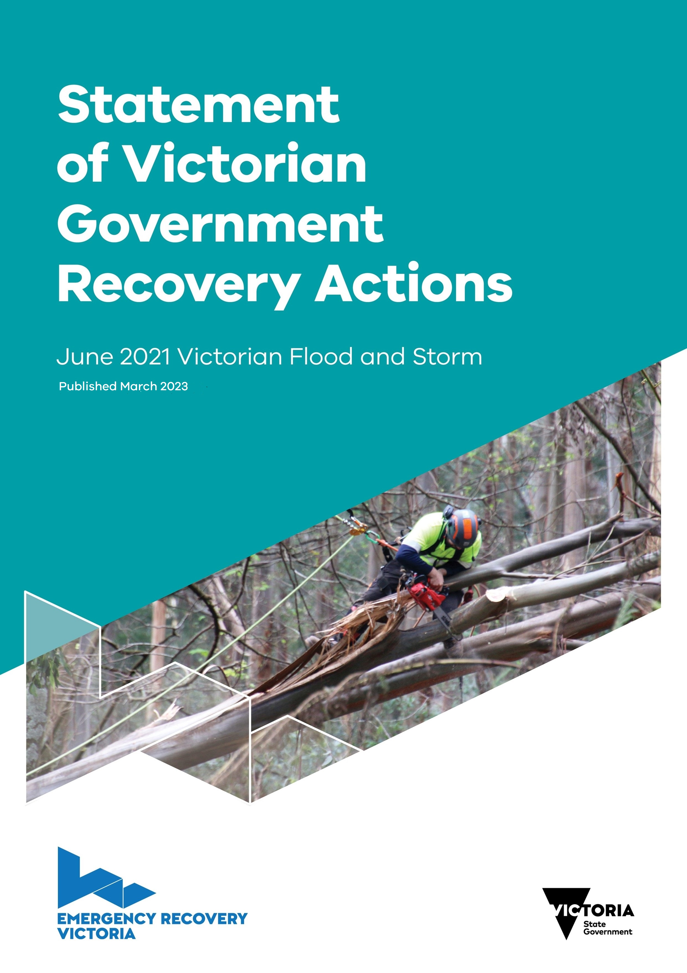

Table of Contents

**List of Departments and Agencies** 3

**1.** **Background and context** 4

1.1 Purpose and scope of this document 4

1.2 The June 2021 Flood and Storm Event 4

1.3 Roles and responsibilities for recovery 4

1.4 How to read this document 6

**2.** **Impacts** 8

2.1 Residential properties 8

2.2 Roads 9

2.3 Access to utilities 10

2.4 Physical and Psychosocial wellbeing 11

2.5 Aboriginal people and Country 11

2.6 Tourism and small business 12

2.7 Primary producers 12

2.8 Fencing 12

2.9 Public land 12

2.10 Natural environment 13

**3.** **Recovery Priorities** 14

3.1 The initial response and relief interventions 14

3.2 Financial arrangements and delivery responsibilities 15

3.3 Whole of Government Recovery Response 16

**Appendix A: State and Commonwealth funded recovery initiatives relevant to recovery from the June 2021 Flood and Storm** 39

##### Acknowledgment of Country

Emergency Recovery Victoria proudly acknowledges the First Peoples of Victoria and their ongoing strength in practising the world’s oldest living culture. In our pursuit to support our communities to recover from the June 2021 Flood and Storm, we acknowledge Aboriginal people as the First Peoples and Traditional Owners and custodians of the land and waterways upon which our recovery is dependent.

We acknowledge and pay our respects to ancestors of this Country, Elders, knowledge holders and leaders – past, present, and emerging. We recognise that Aboriginal communities are steeped in lore and culture having existed within Australia continuously for some 65,000 years. We acknowledge the ongoing contribution of Aboriginal communities across Victoria in leading the recovery of our communities devasted by natural disasters.

This document was prepared by Emergency Recovery Victoria (ERV).

# List of Departments and Agencies

Below is a list of Departments and Agencies referenced in the document and their associated abbreviations.

|  |  |
| --- | --- |
| Department | Acronym |
| Department of Education and Training | DET |
| Department of Environment, Land, Water and Planning | DELWP |
| Department of Families, Fairness and Housing | DFFH |
| Department of Health | DH |
| Department of Jobs, Precincts and Regions | DJPR |
| Department of Justice and Community Safety | DJCS |
| Department of Premier and Cabinet | DPC |
| Department of Transport | DoT |
| Emergency Management Victoria | EMV |
| Emergency Recovery Victoria | ERV |
| National Emergency Management Agency | NEMA |

# Background and context

## Purpose and scope of this document

The *Statement of Victorian Government Recovery Actions for the June 2021 Flood and Storm event* outlines the Victorian Government’s approach to support recovery from this event.

This document sets out the initial recovery support initiatives delivered by the Victorian Government, including support for localised recovery efforts by local government, community groups and non-government organisations.

It provides information on the initial identified impacts of the event, agreed short term State-level recovery initiatives, and the supporting governance and reporting arrangements.

## The June 2021 Flood and Storm Event

Between 9 and 10 June 2021 Victoria experienced a severe weather event that included heavy rainfall and destructive winds. Throughout this 48-hour period, parts of Victoria recorded more than 280 mm of rain and experienced wind gusts of more than 100 km per hour.

The severe weather resulted in major flooding, landslips, debris, and fallen trees and powerlines. This caused extensive damage to residences and critical energy and telecommunications infrastructure, as well as blocking roads and tracks. Two people lost their lives due to flooding.

While the severe weather occurred over 48 hours, the event had multi-faceted and cascading impacts which were experienced by many households and businesses for over a month. In addition, the early emergency response was hampered by blocked roads, hazardous trees, and fallen powerlines. This restricted access to damaged infrastructure and residences, delaying the provision of essential support and assistance to affected residents.

Ongoing heavy rain led to flash flooding and flood warnings across the affected local government areas (LGAs), with Traralgon township in the City of Latrobe experiencing major flooding. On 10 June 2021, an ‘Evacuate Now’ warning was issued for the vicinity of Traralgon, and subsequently Traralgon Creek, and continued until 11 June 2021. The flooding in Traralgon Creek resulted in several evacuations and is the third flood event to impact the community since 2011.

## Roles and responsibilities for recovery

Multiple departments across the Victorian Government are responsible for delivering key recovery activities according to their legislative responsibilities and as noted in Victoria’s State Emergency Management Plan. This is outlined in Figure 1 below.

ERV is responsible for coordinating and supporting the state’s recovery activities for the areas affected by the June 2021 Flood and Storm event – and this document puts this mandate into action. ERV works closely with affected communities, all levels of government, businesses, and non-government organisations to meet recovery needs. This document reflects ERV’s awareness of, and planning for, the compounding effect of COVID-19 on disaster-affected communities during some of the most critical recovery months. The compounding impacts of COVID-19 are likely to endure for the foreseeable future.

ERV is responsible for coordinating the Victorian Government recovery response by collating the recovery needs of communities, facilitating communication across departments, and supporting recovery governance arrangements across the Victorian Government. ERV will also deliver recovery initiatives as directed by Government and where they sit outside of departmental responsibilities.

This document is guided by and intended to be read in conjunction with the Bushfire Recovery Victoria (BRV) Recovery Framework (the Framework). On 17 October 2022 BRV transitioned to become ERV, with ERV’s work still guided by the principles set out in the Framework.

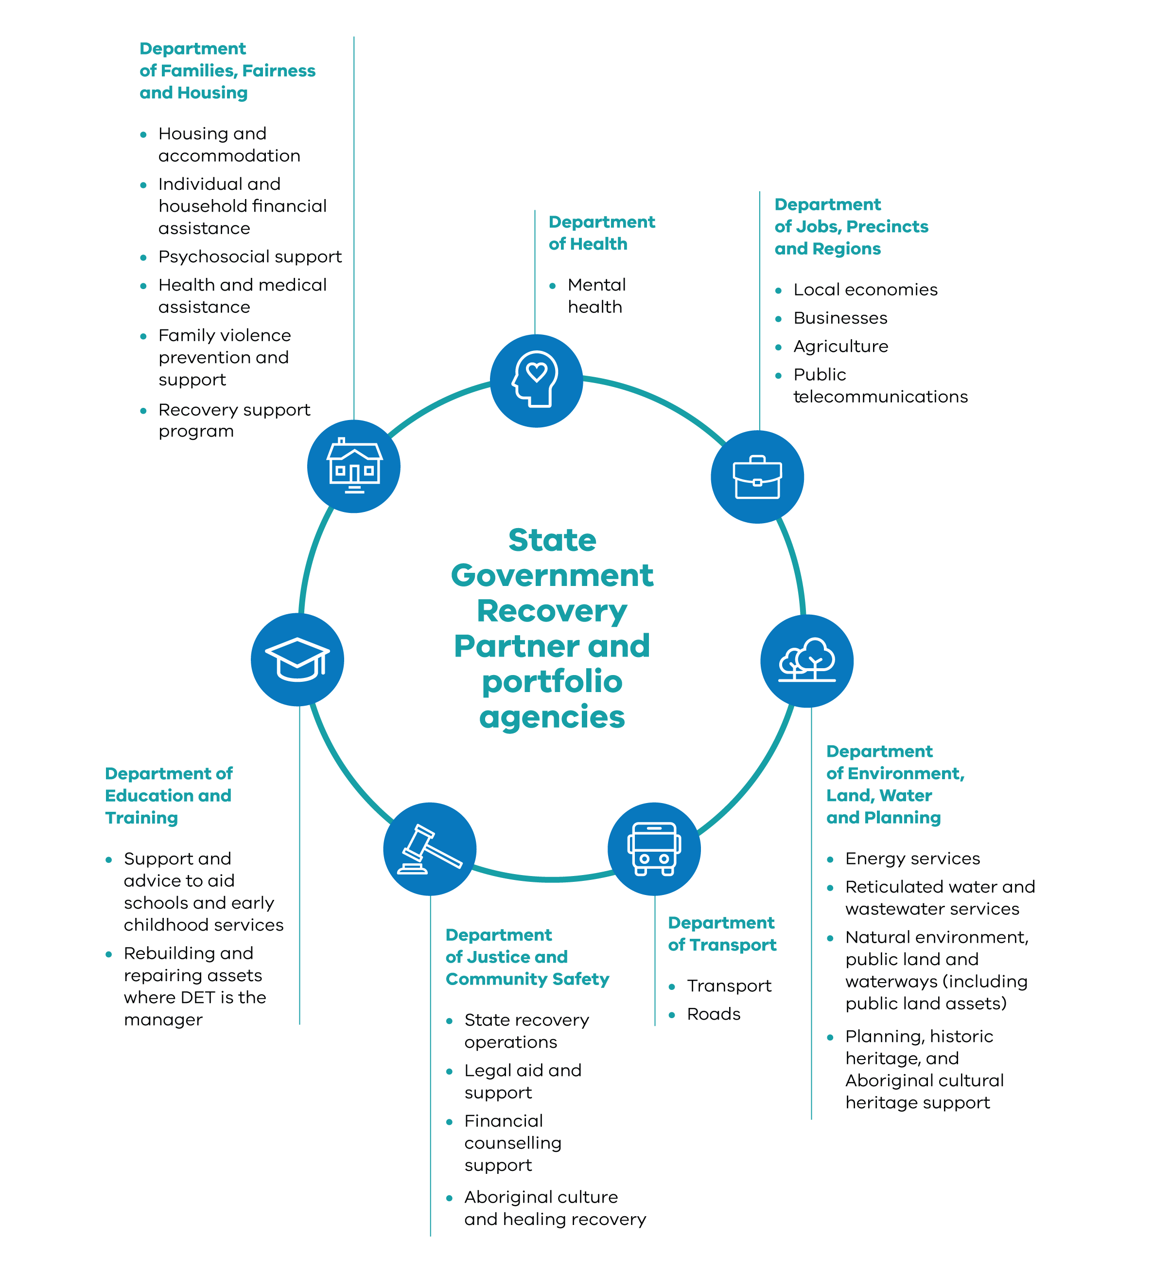

Figure 1: Recovery responsibilities by department

## How to read this document

The document covers recovery activities that the Victorian Government has committed to deliver to date. The recovery activities within this document complement the initial suite of recovery activity undertaken and will support recovery coordination and planning

* Section 1  
  Outlines the purpose of the document and provides context of the June 2021 Flood and Storm event.
* Section 2  
  Documents the impact of the June 2021 Flood and Storms on impacted communities.
* Section 3  
  Outlines the support provided by the Victorian Government to support the initial phase of recovery and outlines the continued investment from the Victorian Government to further support communities to recover.

Recovery activity is grouped into ’lines of recovery’ as outlined in the Recovery Framework. The lines of recovery reflect areas of focus for Victorian Government intervention to support disaster recovery. The five lines of recovery, and the associated lead department for each, are:

* People and wellbeing:Department of Families, Fairness and Housing (DFFH)
* Aboriginal and cultural healing: Department of Premier and Cabinet (DPC)
* Biodiversity and environment: Department of Environment, Land, Water and Planning (DELWP)
* Business and economy: Department of Jobs, Precincts and Regions (DJPR)
* Buildings and infrastructure: DELWP, Department of Transport (DoT); DJPR.

Recovery interventions are guided by the recovery outcomes (Figure 2 below). Victorian Government interventions are designed to support recovery system outcomes, and communities to achieve these recovery outcomes, across each of the lines of recovery.

|  |  |  |  |  |  |
| --- | --- | --- | --- | --- | --- |
| **Line of recovery** | **People &  wellbeing** | **Aboriginal culture &  healing** | **Biodiversity & environment** | **Business &  economy** | **Buildings &  infrastructure** |
| Long-term/ WoVG Outcomes | * People are healthy and well * People are safe and secure * Communities are cohesive and people connected | * Aboriginal land, water and cultural rights are realised * Systems and structures support self-determination * Aboriginal Victorians enjoy social and emotional wellbeing | * Natural environments are healthy, resilient and biodiverse * Natural environments have high levels of amenity * Natural environments are productive and accessible | * Businesses, industries and sectors thrive * People participate in and contribute to the economy * Communities shape their economy | * Utilities and transport are effective and appropriate * Public infrastructure is quality and relevant * The built environment is safe and quality |
| Recovery Outcomes | People are managing their physical and mental health | Aboriginal people’s unique experiences of trauma are addressed, and healing supported | The natural habitat and processes that support threatened and iconic species and ecological communities are restored and protected | Industries and businesses recover and leverage economic strengths and opportunities | Utilities and transport routes are restored and strengthened |
| People have timely access to a safe, stable, and secure home | Recovery and resilience of the whole community are strengthened through Aboriginal culture, knowledge, traditions, and connection to country | The community benefits of parks, forests, and catchments are restored | People participate in established and new employment opportunities | Public infrastructure is resilient and supports recovery |
| Communities recover and build resilience together | Aboriginal communities have increased capability to lead recovery and build resilience | Capability to support environmental recovery and resilience is strengthened | Local economies have increased capacity to respond and adapt to any future disaster | Residential, commercial, and agricultural property is rebuilt and improved |
| System Outcomes | People get the recovery supports they need in a timely, safe, and readily accessible way | | | | |
| Communities are actively involved in decisions affecting their recovery | | | | |
| Aboriginal people are the authorisers and central to decision making for their recovery | | | | |
| Recovery delivery is efficient, coordinated, and evidence informed | | | | |
| Recovery responses strengthen community capability to manage their own recovery and resilience to future disasters | | | | |
| The recovery workforce has the capabilities and support needed to respond to community needs | | | | |

Figure 2: Recovery outcomes by line of recovery

# Impacts

The June 2021 Flood and Storm resulted in a range of initial and emerging impacts across all five lines of recovery, the effects of which may be long-lasting on households and communities across Victoria. Initial impact assessments identified that the severe weather resulted in major flooding, landslips, fallen trees, and damage to residences, public assets and critical energy and telecommunications infrastructure and roads. Sadly, two people lost their lives in the floodwaters that resulted from this event.

Secondary Impact Assessments were completed in the aftermath of the event to provide further information regarding the impact on communities.

Impacts were recorded across 41 LGAs, with many of these experiencing extensive damage. The event was Victoria State Emergency Services’ (SES) busiest 24-hour period on record. Between 9 and 13 June 2021 alone, 1185 requests for assistance were received. This included 759 reports of trees down, 94 reports of building damage, 121 reports of flooding and 57 flood rescues. As demonstrated in Figure 3, Yarra Ranges Shire Council had over 1000 requests for assistance, followed by Macedon Ranges and the Mornington Peninsula. At the time of the event Victoria was in a state-wide lockdown due to the COVID-19 pandemic and shifting restrictions in the weeks and months that followed continued to adversely impact the recovery of people and communities affected by the event.

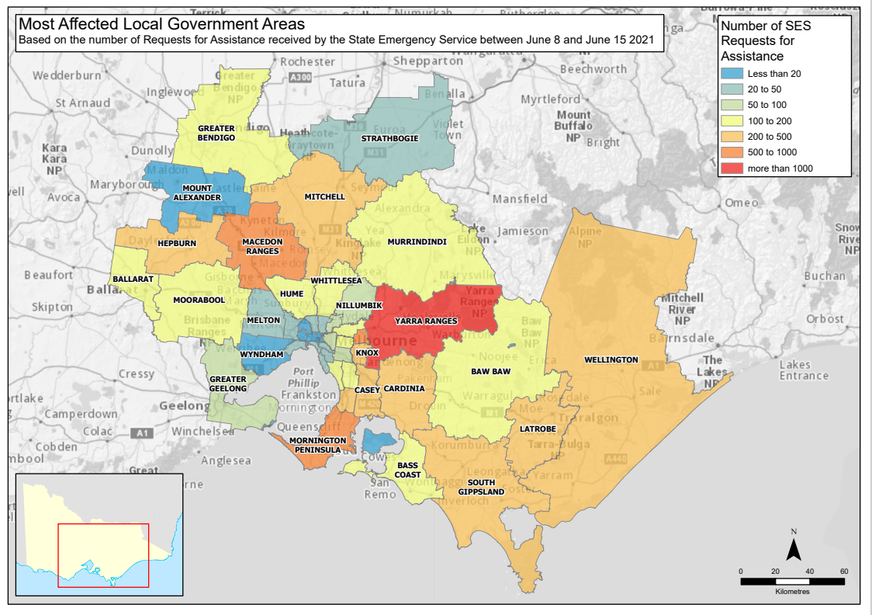

Figure 3. [Most affected local government areas requesting assistance](https://vicgov.sharepoint.com/:b:/r/sites/VG000985/Recovery%20Programs%20Division/7.%20Reporting/3.%20Flood%20and%20Storm%20Recovery%20Plan/The%20S%26F%20Recovery%20Plan/Maps%20for%20SRP-%20F%26S/Fig%203_RFA_by_LGA_June2021_Storm_A4L_1700K.pdf?csf=1&web=1&e=AvZ1gn)

The following themes outline key impacts following the June 2021 Flood and Storm event:

## Residential properties

By 23 June 2021, 2395 initial impact assessments were completed across the state. The initial impact assessment indicated the potential for significant damage to residential, community and business buildings (infrastructure) (refer Figure 4). These assessments indicated that 135 residential properties had been damaged but were habitable, with 129 damaged and uninhabitable. Most impacted properties were in the Dandenong Ranges and Gippsland, with 54 dwellings damaged and 71 destroyed in Yarra Ranges Shire Council alone. For many people, returning to their repaired or rebuilt homes is a long and ongoing process. Widespread demand for domestic building services, a shortage of building materials, tradespeople and a two-week shutdown of the construction industry have all contributed to delays. The extensive damage to residential properties across the state required individuals, couples, and families from approximately 120 households to access alternative temporary accommodation. In some instances, this meant moving in with friends or family, accessing alternative short term rental accommodation including Airbnb, or other forms of temporary accommodation such as motels. Most people accessed temporary accommodation using private savings or insurance, however, in some instances where people had no other way to access temporary accommodation, local government offered safe and suitable temporary accommodation options.

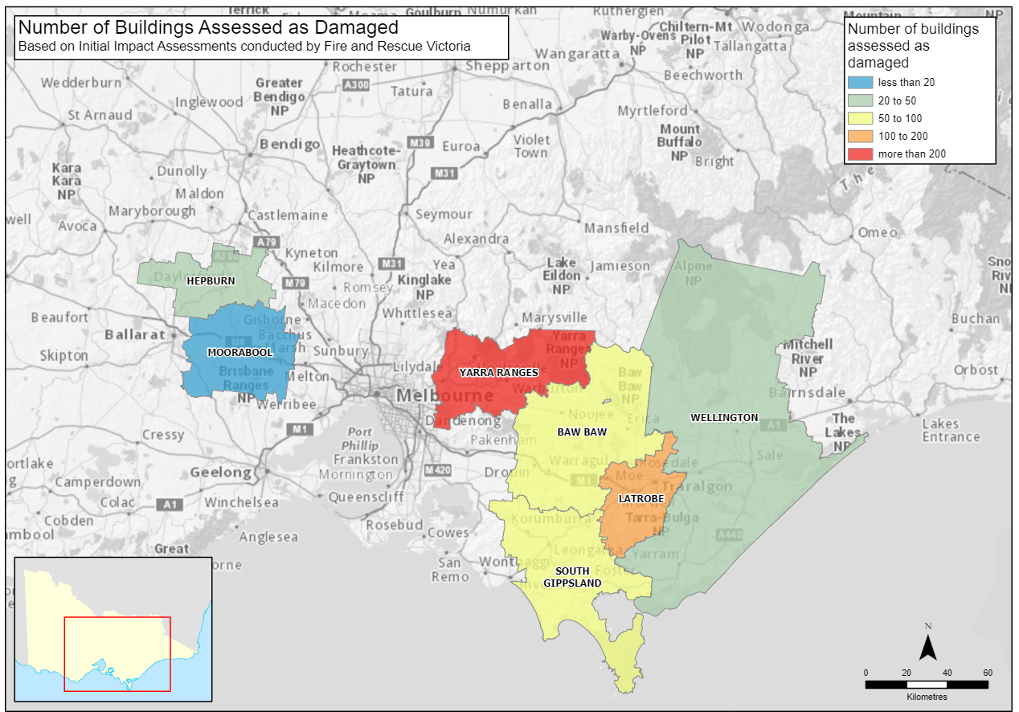

Figure 4. Assessment of building damage by municipality at the time of the initial impact assessments. ([Link](https://vicgov.sharepoint.com/:b:/r/sites/VG000985/Recovery%20Programs%20Division/7.%20Reporting/3.%20Flood%20and%20Storm%20Recovery%20Plan/The%20S%26F%20Recovery%20Plan/Maps%20for%20SRP-%20F%26S/Figure%204_Building%20damage%20by%20LGA_Storm_A4L_1700K.pdf?csf=1&web=1&e=CnsOfD))

## Roads

The June 2021 Flood and Storm caused significant damage to state transport assets including the arterial road network, council managed network and associated road infrastructure. Over 2100 km of the State’s arterial road network were within the storm impact area, with more than 1570 km of arterial roads impacted by fallen trees, vegetation, and/or landslips. Notably, this included the Mount Baw Baw Tourist Road, which restricted access to the Baw Baw Alpine Resort resulting in negative economic impacts on businesses that are serviced by that road network such as the township of Noojee (refer to Figure 5). Additional impacts included damage to pavement, culverts and barriers, land slippage, loss of road sections requiring piling and stabilisation, and general debris and sediment. At the end of July 2021, approximately 12,540 km of public lands roads (including roads within National and State parks) were within the impact area. Of this, 3083 km were Strategic Fire Network roads which were limited to the Heavy or Medium vehicle class.

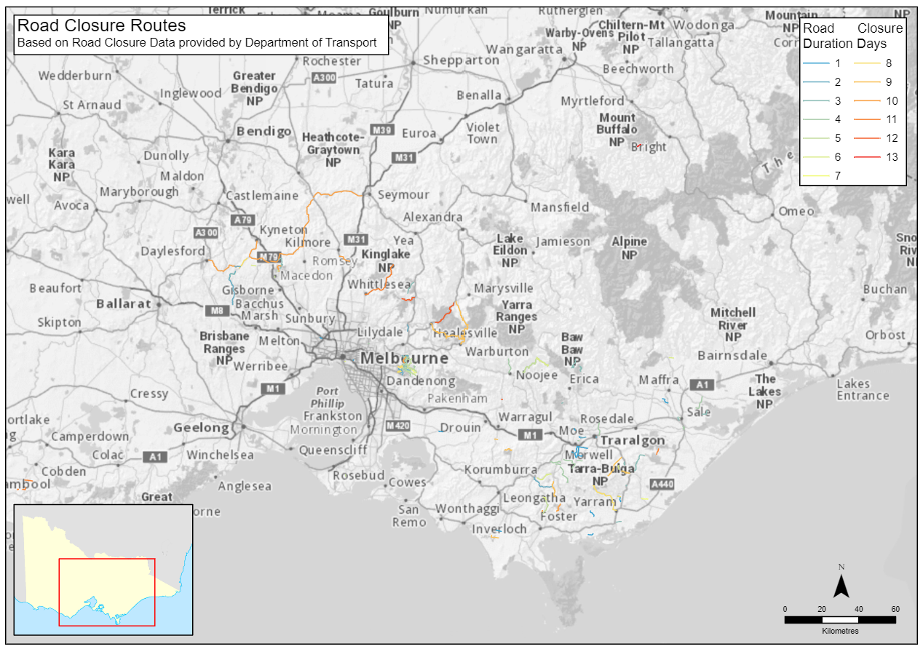

Figure 5. Arterial road closures because of the June Flood and Storm. ([Link](https://vicgov.sharepoint.com/:b:/r/sites/VG000985/Recovery%20Programs%20Division/7.%20Reporting/3.%20Flood%20and%20Storm%20Recovery%20Plan/The%20S%26F%20Recovery%20Plan/Maps%20for%20SRP-%20F%26S/Fig%205_Road_Closure_Routes%20Storm_A4L_1700K.pdf?csf=1&web=1&e=fcVhsS))

## Access to utilities

Critical utility infrastructure was significantly damaged because of the event. More than 330,000 households lost power with 297,000 experiencing this simultaneously. Of these, over 2500 households experienced prolonged power outages of more than a week, and a further 1500 households were without power until early July; up to three weeks in total (refer to Figure 6). Additionally, more than 100 businesses were without power for more than a week. Seventeen health services also experienced disruptions to power supplies and were required to operate backup generators. There were over 120,000 NBN outages and approximately 70,000 households were disconnected from telecommunications infrastructure. On 17 and 18 June 2021, households throughout Melbourne’s outer eastern suburbs were advised not to drink tap water. Six water treatment plants lost mains power and were required to operate on generators. Yallourn power station and mine, which provides approximately 20 per cent of Victoria’s energy, was damaged and came under threat of flooding, resulting in the mass evacuation of the site, with all but one generator being turned off.

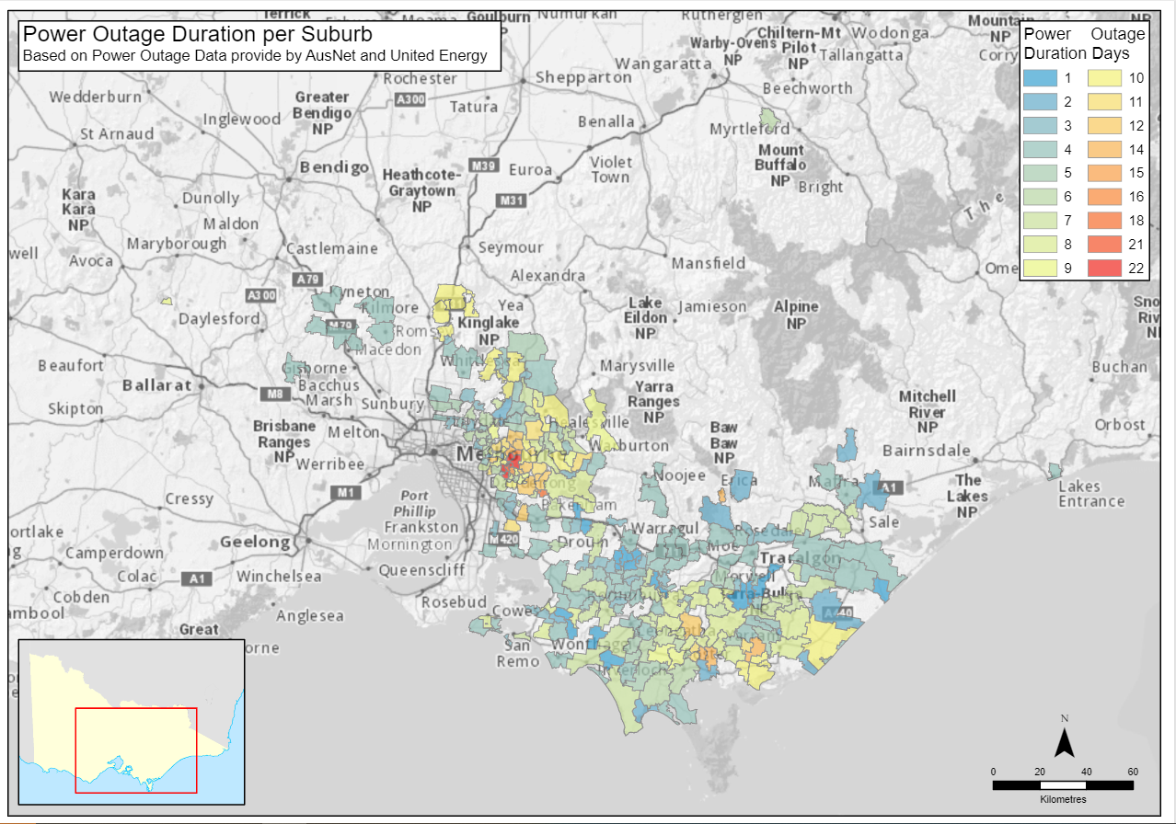

Figure 6. Power outage duration by suburb (data provided by AusNet and United Energy). ([Link](https://vicgov.sharepoint.com/:b:/r/sites/VG000985/Recovery%20Programs%20Division/7.%20Reporting/3.%20Flood%20and%20Storm%20Recovery%20Plan/The%20S%26F%20Recovery%20Plan/Maps%20for%20SRP-%20F%26S/Fig%206_Power_Outage_Suburb_June2021_Storm_A4L_1700K.pdf?csf=1&web=1&e=bBuEaD))

## Physical and Psychosocial wellbeing

Living through an event as severe as the June 2021 Flood and Storm can have a significant impact on people’s psychosocial wellbeing. Some people experienced the full severity of the event, and may have been required to evacuate, or were trapped in their homes (often without power for significant periods of time). While everyone experiences and processes such events differently, it is common for people to experience distress and trauma after a natural disaster. Councils have reported evidence of direct and indirect experiences of psychosocial impacts, including requests for counselling. This is also evident within the Flood and Storm Recovery Support Program, where support for mental health is a core need identified by clients accessing this service. In some instances, people’s experience of the event was further compounded by the prolonged power outages, lack of available Allied Health service providers, damage to roads and facilities, subsequent floods and storms and the prolonged impacts of the COVID-19 pandemic. People’s mental health and wellbeing can also be impacted by their overall recovery experience, including by how they are able to access services or by delays in progress. This was worsened by the fact that some communities who were impacted by the 2019-2020 Eastern Victorian bushfires are now dealing with the impacts from multiple natural disasters.

## Aboriginal people and Country

The event impacted over 2500 registered Aboriginal cultural heritage places or culturally sensitive areas across the six recognised Traditional Owner Group boundaries. In addition, sacred trees of cultural importance and significance on public land were identified as damaged through cultural impact assessments. Clean-up programs have traditionally focused on public safety, however, work is required to ensure clean-up for this event mitigates further impacts to Aboriginal cultural heritage on public and private land by ensuring that clean-up work is undertaken in a mutually respectful process with Traditional Owners and in accordance with *Victorian Aboriginal Cultural Heritage Act.* Aboriginal Community Controlled Organisations (ACCOs) providing support to impacted Aboriginal people have also confirmed that people are experiencing social and emotional stress, increased financial instability. and an increased need for support for social-emotional and mental health factors that have been exacerbated by this event.

## Tourism and small business

The tourism industry and many small business operators, particularly those in the hospitality and tourism sectors, were heavily impacted by the event. Damage to roads and reduced or lost access to the electricity network and ongoing power outages meant that the tourism and hospitality sectors lost revenue. Revenue was also lost due to the concurrent closure of many popular tourist sites, including national parks, and the loss of revenue from COVID-19 restrictions.

## Primary producers

Primary producers were heavily impacted by the event, with 1340 livestock lost, 10,642 hectares of pasture damaged, 827 hectares of crops lost, and 746 tonnes of hay lost. More than 155 farm businesses have reported landslips or erosion, some of which were significant. In turn, some private properties experienced silt and debris deposits that impacted farm production. Subsequently, there was a significant economic impact on primary producers. Estimates indicate $85.47 million in losses across 2021-2022, this includes $45.4 million in infrastructure losses and damage, and $40.3 million in lost production. Key areas impacted by lost production include pasture production, berry production, and dairy enterprises. This figure does not reflect the full economic detriment because it does not include the cost of clean-up activities, ongoing impacts from the damage to the property, or any damage that was not formally reported.

## Fencing

More than 2200 km of fencing was damaged, impacting both public and private land. The damage to fencing has been difficult for many primary producers who rely on their fences to manage and protect livestock, crops, and waterways. Fencing damage consisted of 1310 km of internal fences, 830 km of external fences, and 80 km of Crown land boundary fencing.

## Public land

Several key public assets required assessment to determine the level of damage. This included more than 400 bridges, over 1900 recreation sites and more than 850 km of recreation trails. At the end of July 2021, it was estimated that more than 9000 km of forest roads and tracks were located within the impact zones. At the peak of the event, eight schools in the Dandenong Ranges were closed due to the severe weather. The use of many public recreational areas and facilities was either lost or restricted as amenities such as toilet facilities were rendered unusable and some national parks were shut because they were inaccessible or dangerous, many for more than six months while assessments and repairs were implemented.

## Natural environment

The severe weather had a substantial impact on the natural environment with extensive areas of fallen trees, timber and vegetation damaged and spread across public and private land. The storm damage resulted in extensive areas of landslips, flooding, and erosion which posed a risk to some threatened flora species due to widespread destruction and degradation of their natural habitat. In addition, there were impacts to ground and tree dwelling fauna including direct death and displacement, loss of habitat, and potential exposure and predation due to the loss of nesting and den sites. The impacts also affected waterways with extensive lengths of streambank erosion and loss of water quality due to the large volumes of sediment and debris being transported downstream through catchment processes. After intense rain events, increased sedimentation is known to have adverse effects on aquatic fauna.

Fallen and impacted trees resulted in a risk to life and property, from direct impact as well as blocked access. Many trees became hazardous, posing a further threat to people and infrastructure on both private and public land. Approximately 350 private properties were assessed by VicForests, who found that 100 properties had more than 20 fallen trees on their land, with the remainder having up to 10. Clean-up Program contractors assessed 1435 properties and found that in addition to fallen trees each property had on average four standing hazardous trees potentially impacting structures such as homes and sheds. A small number of rural properties were noted to have widespread impacts to trees on their properties with hundreds of downed and hazardous trees.

The resulting volume of green waste also created logistical challenges for the government to find appropriate solutions to accommodate such large amounts of waste. Within Yarra Ranges LGA alone, the council collected over 25,000 cubic meters of wind-thrown tree material.

# Recovery Priorities

## The initial response and relief interventions

The complex, cascading impacts of the June 2021 Flood and Storm required a large-scale and coordinated response to restore access to, and repair critical infrastructure, and to provide support to isolated residents. Three Incident Control Centres (ICCs) were set up in Traralgon, Ferntree Gully, and Ballarat. Approximately 1000 emergency services personnel were deployed out in the field with the Australian Defence Force providing logistics and planning support. Emergency personnel responded to 259 requests for rescue and 7500 requests for assistance with fallen trees. Within two weeks, access was fully restored to 76 primary arterial roads, a further four were open for resident access and only three were closed (except for emergency services). One hundred and eighty-six generators were supplied to isolated residents whose power could not be restored through repairs to the electricity grid.

Historically, Aboriginal peoples’ experiences and their needs have been overlooked post a natural disaster or interventions have been imposed. Based on self-determination principles, the coordinated approach centred on early engagement with Traditional Owner Groups and ACCOs to ensure that culturally appropriate support services were provided to Aboriginal families impacted by the event. In the response, it is recognised that Country is not inert for many Aboriginal people and that Country is intrinsically interlinked with their culture which requires them to care for Country and we have responded accordingly in the whole of government response.

The Victorian Government administered a range of initial financial supports to households that experienced hardship due to the event. A Prolonged Power Outage Payment of $1680 per week for up to three weeks was extended to all eligible households without power from 17 June 2021. This payment supported 4195 households to buy the basics, find alternative accommodation, and get through the difficult period. In addition, Victorian businesses with an annual payroll of less than $10 million were offered relief payments of $2500 per week for up to three weeks if they were without power on 17 June 2021. Emergency Relief Assistance Payments were administered to 667 households who requested emergency financial support to meet their relieve needs for food, accommodation, and material aid. These payments were up to $560 for an individual and capped at $1960 for families depending on the number of family members. Agencies such as Agriculture Victoria increased their core business services to support recovery. This assistance supported 360 farmers with recovery advice and case manage support, 318 farmers with technical assistance, and held 32 teleconferences and webinars for 1162 farmers.

Applying the lessons from BRV’s Preparedness Handbook, recovery exercises and lessons from the 2019-20 Eastern Victorian Fires, a regional presence was quickly established in the three areas most impacted by the June 2021 Flood and Storm. Dedicated BRV teams were situated in the Central Highlands, Yarra Ranges, Murrindindi and Cardinia, and Central and South West Gippsland regions.

Within two weeks of the incident, BRV established regional staff to support local communities, councils, government agencies and organisations.

On 17 October 2022 BRV transitioned to become ERV.

## Financial arrangements and delivery responsibilities

Table 2 (Appendix A)presents a table of funding initiatives by department and line of recovery for the 2021-22 financial year. In summary, approximately $255 million has been allocated by the Victorian and Commonwealth Governments across 15 initiatives in 2021-22. As of 30 June 2022, the Victorian Government has committed more than $181 million and the Commonwealth more than $73 million (Figure 7). Of this, ERV and DELWP have received the largest allocations with $119 million and $86 million respectively (Figure 8).

In 2022-23, the Victorian Government has so far (as of 29 August 2022) invested more than $12 million. Table 3 (Appendix A) presents a table of funding initiatives by department and line of recovery for the 2022-23 financial year.

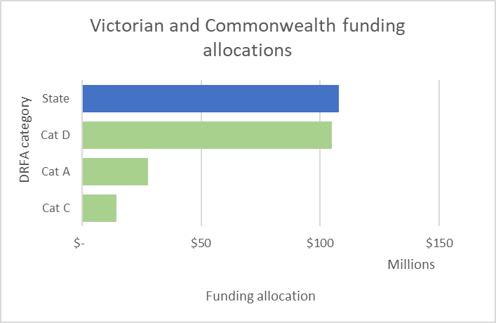

Figure 7. Victorian and Commonwealth Government funding allocation by Disaster Recovery Funding Arrangements (DRFA) category (if relevant). Funding allocation for the 2021-22 financial year.

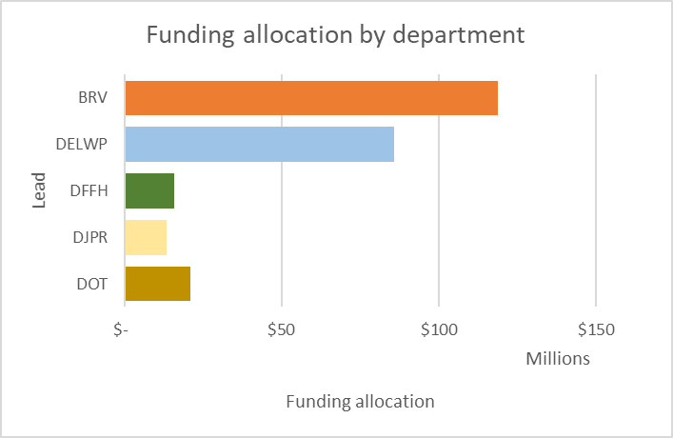

Figure 8. Funding allocation by department for 2021-22 financial year.

Given the infrastructure impacts, a large proportion of the funding was allocated to the buildings and infrastructure line of recovery which includes ERV’s State Coordinated Clean-Up Program (SCCUP), community clean-up and several programs delivered by DELWP and DoT targeting recovery of roads and public infrastructure (Figure 8).

Figure 9 presents the total funding by line of recovery noting that several initiatives have programs directed at multiple lines of recovery.

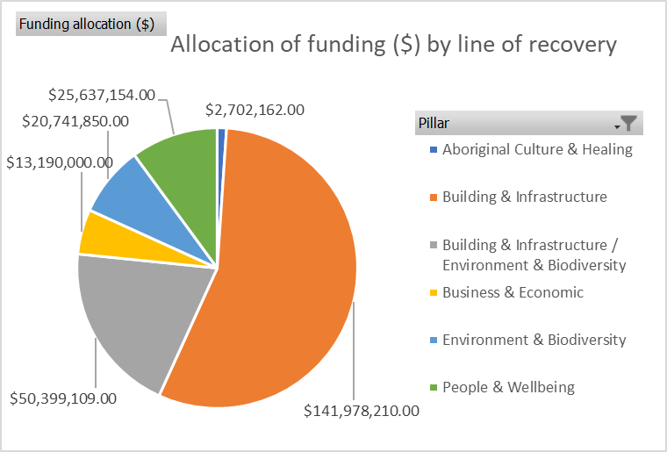

Figure 9. Allocation of recovery funding by line of recovery (across departments). Funding allocation for the 2021-22 financial year.

## Whole of Government Recovery Response

Emergency response and relief activities for this event are complete.

ERV’s recovery strategy recognises that successful recovery is achieved when there are collaborative and genuine partnerships across communities, government, agencies, and businesses. Following the transition from relief to recovery, the Victorian Government, local government authorities, and community have actively delivered services across all lines of recovery, aligned to community needs and priorities. These programs are delivered by several departments across government and align to the recovery outcomes that inform the Victorian Government’s support to community-led recovery from disasters.

Community voice is the critical way by which recovery needs are captured as they emerge, and their input helps to identify priority areas for support. These areas include:

* timely response to the loss of, or damage to, primary residence.
* make safe support to property and public infrastructure clean-up, and transformation of green waste.
* ensuring Traditional Owners and community contribute to the reading and healing of Country, including impact to heritage sites.
* ensuring safe and accessible usage of Victoria’s strategic fire network, public land roads and crossings.
* tourism industry and small business recovery through restoration of key public infrastructure, particularly given the compounding impacts of COVID-19.
* the health and wellbeing of communities, including the need for access to safe, stable, and secure housing; extending to financial health supports, and access to services promoting mental and physical wellbeing, and responses to family violence.

Community connectedness plays a core role in recovery and resilience, and while physical interactions have been impacted by the pandemic, there is still a need to ensure that communities can share their experiences and identify their recovery needs progressively.

These recovery across all lines of recovery. Ensuring that community members can navigate the recovery space priorities are underpinned by fostering community awareness and access to the full suite of supports, services, and resources effectively is crucial to addressing any escalation of needs and ensuring positive recovery outcomes.

|  |
| --- |
| Delivering recovery during the COVID-19 pandemic  Shortly after the Storm and Flood event, Greater Melbourne entered the fifth and sixth lockdowns in response to the COVID-19 pandemic. This included the Yarra Ranges Shire Council, which was heavily impacted the event.  Where access to and delivery of programs has been impacted by the pandemic, delivery timeframes have been extended to reflect this.  Across all regions impacted by this event, COVID-19 has impacted the supply of building materials and tradespeople. This has delayed rebuilding for some people whose homes were damaged or destroyed during the storm and flood event. |

Table 1 details the Whole of Government response to recovery.

Table 1. Whole of Government Recovery Response to the June 2021 Floods and Storm.

| **Recovery Initiative ID**  **Recovery initiative name** | **Program name** | **Recovery description** | **Recovery progress** |
| --- | --- | --- | --- |
| Recovery outcomes: The following initiatives are cross-cutting and address multiple recovery outcomes including:  **Communities recover and build resilience together**  *People are supported and enabled to overcome financial hardship and manage their financial recovery.*  **People are managing their physical and mental health**  *Increased awareness of and access to quality psychosocial support services that are appropriate and respond to the unique needs of diverse communities.*  **People have timely access to a safe, stable, and secure home**  *Increased capability of individuals in affected communities to make**informed decisions about their future and where they will live.* | | | |
| 969.1.1.01. BRV  **Council Support Fund** | **Council Support Fund** | Funding to boost local council resources, to ensure that local government in heavily impacted areas to stand up dedicated local teams to coordinate and drive local recovery efforts. | * $12.96 million in funding available to impacted local councils. Funding has been allocated to 11 councils, and a six-monthly reporting process is in place. |
| 969.2.3.01. DFFH  **Recovery Support Package for Victorians impacted by June 2021 Floods and Storm** | **Recovery Support Package** | Comprehensive $13.755 million package which includes:   * Recovery Support Program – provides impacted families and individuals with a single point of contact to access and navigate the supports they need. * Financial Counselling Program – provides financial advice and support. * Psychosocial First Aid Community Outreach – provides both psychosocial support, and access to other services. * Community briefings – facilitated by a clinical psychologist. * Family Violence Programs – includes training for frontline workers, and targeted outreach and supports for people experiencing or using family violence in affected areas. * Targeted Recovery Programs – aimed at connecting and supporting elements of the community who are most at risk following a disaster. * Wellbeing Support Officers – established on the ground in impacted regions, to help people seeking mental health and wellbeing supports to connect in with appropriate services. | * As of 30 June 2022, 1819 individuals and families have been assisted through the Recovery Support Program. * Both the Financial Counselling Program and Family Violence Programs have commenced. * Nine community briefings facilitated: four by Dr Rob Gordon and two by David Younger, clinical psychologists with extensive expertise in disaster recovery. * Submissions for Targeted Recovery Programs were received throughout February 2022, with 15 Programs commencing in April 2022 and all to conclude by December 2022. * Wellbeing Support Officer roles are in place. |
| 969.2.11.01. BRV  **Community Recovery Package** | **BRV Recovery Hotline** | Helps people navigate the range of information and support services available for people in affected communities.  Helps people identify their immediate needs and to register for clean-up and support services such as the Recovery Support Program, that can assist with accommodation needs. | * 2993 total calls received as of 23 February 2022. Of these, 2497 related to clean-up, hazardous trees, and general flood and storm assistance. * 95 calls have been referred to the Recovery Support Program as of 23 February 2022. |
| **Recovery Outcome: Communities recover and build resilience together**  *People are supported and enabled to overcome financial hardship and manage their financial recovery.* | | | |
| 969.2.14.01. DFFH  **Emergency Re-establishment Payment** | **Personal Hardship Assistance Program (Re-establishment payments)** | Financial assistance to support families and individuals who are experiencing financial hardship to re-establish their homes as quickly as possible after a natural disaster. | * 105 re-establishment payments provided to the value of $1,309,754.00 as of 30 June 2022. This program is now closed. |
| 969.2.14.02. DFFH  **Emergency Relief Assistance Payment** | **Personal Hardship Assistance Program (Relief payments)** | One-off payments provided to meet immediate needs, including emergency food, clothing, medical and accommodation. | * 664 relief payments provided to the value of $732,400 as of 30 June 2022. This program is now closed. |
| 969.2.11.01. BRV  **Community Recovery Package** | **Community Recovery and Resilience Projects Fund** | Immediate financial assistance to support residents who suffer loss or hardship as a direct result of an emergency that occurs within the Gippsland region. | * Gippsland Emergency Relief Fund’s (GERF) annual Gippsland Flood Appeal (2021) received $480,000 in donations, and has distributed $750,000 to 348 community members, with the shortfall paid from reserves. With this funding, GERF was able to assist individuals, families, farms, and small businesses impacted by the disaster that needed immediate relief, across the Bass Coast, Baw Baw, Latrobe, South Gippsland, and Wellington. |
| 969.3.16.01. EMV  **Australian Government Disaster Recovery Programs** | **Australian Government Disaster Recovery Payment (AGDRP) and Disaster Recovery Allowance (DRA).** | The Commonwealth Government (Services Australia) activated the Australian Government Disaster Recovery Payment (AGDRP) and the Disaster Recovery Allowance (DRA) to support those most impacted by the June 2021 Flood and Storm. | * The AGDRP is a one-off, non-means tested payment of $1000 per eligible adult and $400 per child who have been adversely affected by a major disaster either in Australia or overseas. The DRA is a fortnightly payment paid for up to 13 weeks to eligible individuals whose income has been affected by a major disaster. |
| **Recovery Outcome: Aboriginal people’s unique experiences of trauma are addressed, and healing is supported**  *Increased capacity and capability of Aboriginal Traditional Owner Corporations and Aboriginal Community Controlled Organisations to lead community healing services.* | | | |
| 969.2.3.01. DFFH  **Recovery Support Package** | **Social Recovery Package** | Aboriginal Community Organisations (ACCOS) leading healing activities for Aboriginal communities affected by the event.Ramahyuck and District Aboriginal Corporation and Oonah Belonging Place are working with local community to support the healing of Aboriginal people. | * Ramahyuck and District Aboriginal Corporation Recovery Support and Oonah Belonging Place have been engaged to deliver the Recovery Support Program to impacted Aboriginal and Torres Strait Islander residents. |
| **Recovery Outcome: Recovery and resilience of the whole community are strengthened through Aboriginal culture, knowledge, traditions, and connection to Country**  *Increased use of formal and informal mechanisms to listen to Aboriginal people's voices and deep knowledge of resilience, healing and how to restore Country* | | | |
| 969.1.9.04. DELWP  **Funding Boost for Ongoing Storm Repairs** | **Engaging and partnering with Traditional Owners, emergency stabilisation and remediation works on public land to protect Aboriginal heritage places** | The funding of Aboriginal cultural heritage assessment and restorative works by Aboriginal Traditional Owners on damaged sites of cultural significance intervention.  Incorporating Aboriginal culture and healing practices into stabilisation and remediation works. | * More than 2000 registered cultural heritage places sustained damage from the mass movement of water and sediment and other flood and storm hazards, such as falling trees. * A total of $2,702,162 was allocated to the completion of Aboriginal heritage and restoration works. * This program managed the assessment, remediation, and protection of Aboriginal heritage places impacted by the flood and storm events in partnership with Traditional Owners. * Activities completed include 318 Cultural heritage sites assessed in partnership with First Peoples and six Cultural heritage surveys undertaken in partnership with First Peoples. |
| 969.2.2.01. BRV  **Flood and Storm Clean-up** | **State Coordinated Flood and Storm Clean-up** | Ensuring Traditional Owners have the opportunity to undertake cultural heritage assessments to identify potential sites of significant importance on private land.  BRV implemented a cultural heritage induction booklet with the support of the Johns Lyng Disaster Recovery Management to support the clean-up program. A key focus of the booklet is to provide a standard operating procedure to support the effective remediation of cultural heritage places across Victoria. | * The partnership between clean-up contractors, private landowners, and Traditional owners has provided the opportunity for reconciliation, education, and bridging the cultural divide by sharing and participating in heritage. A total of $1,846,000 has been invested into the program. |
| **Recovery Outcome: The natural habitat and processes that support threatened and iconic species and ecological communities are restored and protected.**  *Reduced threats to biodiversity during the vulnerable period following the event.* | | | |
| 969.2.2.01. BRV  **Flood and Storm Clean-up** | **State Coordinated Flood and Storm Clean-up** | Several significant landslips and erosion events have occurred because of the flood and storm events. These are impacting public and private land. | * BRV convened an Erosion and Landslip Working Group to understand and define the problem. Reallocated funding has been provided to undertake a risk evaluation of the landslips across all land tenures. The program was initiated in February 2022 and is still underway. |
| 969.1.9.07. DELWP  **Funding Boost for Ongoing Storm Repairs** | **Wildlife welfare and protecting threatened species** | Wildlife welfare and protecting threatened species. The June 2021 Flood and Storm, along with the associated emergency response and stabilisation works, has created significant biodiversity impacts and risk. Seventeen nationally threatened species and 96 state-listed threatened species had more than 50 per cent of their state-wide modelled habitat in the impact zone.  This program is carrying out immediate actions to address and mitigate impacts to biodiversity. | * This program is still in progress, with activities completed as of 30 June 2022 including: * 48,232ha of weed control; 430ha of pest predator control; 50ha of herbivore control; and 103 monitoring survey assessments. * East and Port Phillip region pest plant and animal projects completed. * A Cultural Assessment and barrier works completed on the existing installed artificial barrier on Shaw Creek. * Development of recovery actions for freshwater crayfish captive breeding in the South Gippsland Spiny Crayfish. An agreement was also reached with the Victorian Fisheries Authority agreement to build and operate a captive breeding hatchery, with a detail design now completed. * A moribund dolphin procedure and policy is to be developed as part of the review of the Victorian Cetacean Emergency Plan. * Wildlife rehabilitator grants now complete, with funding allocated. |
| **Recovery Outcome: Capacity to support environmental recovery and resilience is strengthened**  *Increased opportunities for Victorians to participate in environmental recovery and see, experience, and interact with a recovering environment.*  *Increased participation of private landholders in biodiversity and environmental stewardship.* | | | |
| 969.1.8.01. BRV  **Financial support for not-for-profit groups to support clean-up** | **Community Clean-Up Support 2021-22** | * The volume of timber debris generated in the event on private land is significant. * BRV is coordinating the application process and distribution of funds. The program is demand-driven and around one third of the total funding has been allocated to each of the three most affected regions based on the current understanding of need and capacity in each region: * Central and South West Gippsland (**Latrobe**; South Gippsland; Bass Coast; Baw Baw; and Wellington Shire Councils) * Central Highlands (**Moorabool**; Hepburn and Macedon Ranges Shire Councils) * Yarra Ranges and surrounds (**Yarra Ranges** and Cardinia Shire Councils). | * $2 million was allocated to the Community Clean-Up Support 2021-22 grants program. Funding was equally split between the three most affected regions. This funding assists community service organisations with rental, leasing, and running expenses associated with timber debris removal. All activities will be completed by June 2023. * BRV’s grants funding model has been used for this program to help ensure that community needs are prioritised, and funding is released to support community recovery priorities in a timely and seamless manner. |
| 969.1.5.01. DJPR  **Assessment and harvest planning of windthrown timber harvest planning; and roading infrastructure repair** | **Assessment and harvest planning of windthrown timber harvest planning; and roading infrastructure repair** | Significant volumes of trees were downed or were deemed hazardous.  Vic Forests assistance with the assessment of windthrown timber  Government use of timber was efficient and cost-effective | * A hazardous tree and timber debris working group was established to map out and respond to the need. * Several programs were recommended to respond to community need outside of the residential clean-up program. |
| 969.1.7.01. BRV  **Expanded green waste disposal** | **Yarra Ranges Kerbside Collection** | Significant volumes of trees were downed or are deemed hazardous. This created large volumes of green debris (organic matter) that had to be assessed, collected, and stored appropriately. | * $2 million has been allocated to assist Yarra Ranges Shire Council with kerbside collection throughout 2021 and 2022. * Phase 1 of this program was completed in November 2021, with Phase 2 due for completion in November 2022. |
| 969.1.9.3. DELWP  **Funding Boost for Ongoing Storm Repairs** | **Immediate debris clearing and management across the public land estate** | Immediate debris clearing and management across the public land estate to address windthrown timber, timber debris and hazardous trees. | * This program has been completed. Program activities included: * 163 site assessments carried out; 69ha of excess roadside debris managed; seven Vicforests roadside debris site plans signed off; two Vicforests roadside debris works completed; and 534km of debris management works completed. * Clearing windthrown debris and delivering critical planned burns in areas with a large accumulation of debris and fallen trees following storm events. * These actions have addressed public safety risks, reduced fuel loads, and enabled effective bushfire preparedness and response through managing immediate fire risk, clearing debris, and delivering critical planned burns in areas of increased fuel loads. * Suitable debris will be made available for domestic firewood collection and will benefit locals reliant on firewood supply for home heating and energy, and local businesses experiencing a current shortage in timber supplies. |
| 969.1.9.06. DELWP  **Funding Boost for Ongoing Storm Repairs** | **Protecting Victoria’s waterways and catchments in the emergency works phase** | Protecting Victoria’s waterways and catchments in the emergency works phase. This program will address the significant damage floodwater caused to stream and Catchment Management Authority (CMA) assets and water authority assets within Gippsland and Port Philip regions. | * The repair and replacement of damaged water monitoring gauges has been completed, with 25 gauges restored. * East Gippsland and West Gippsland CMAs, Melbourne Water and Southern Rural Water have completed immediate response and urgent emergency works including the stabilisation of waterways and stream banks. * The following activities are now complete: works addressing erosion risks, debris, and damage to catchments; riparian fencing repairs, weed control and bank battering; and other restoration activities. * West Gippsland CMA has completed recovery activities. The primary focus has been on repairs to waterway structures and earth works to stabilise damaged areas to minimise further waterway health deterioration. * Melbourne Water has completed safe access to waterway and catchment infrastructure activities. These works have helped manage risks associated with further erosion and debris flows in these critical closed catchment areas and avoided adverse impacts to Melbourne’s drinking water supply. * Southern Rural Water has completed all repairs to the Cowwarr Weir structure and the weir is now fully operational. These activities included removal of debris from spillway gates and repairing the damaged weir. |
| **Recovery Outcome: The community benefits of parks, forests, and catchments are restored**  *Timely restoration of public assets and roads so public land and natural areas are safe and accessible to the community and support access to Country for connection to culture and healing.* | | | |
| 969.1.9.05. DELWP  **Funding Boost for Ongoing Storm Repairs** | **Immediate safety works on public land, emergency repairs, and safe access management at public land recreation sites** | Works to ensure visitors can safely access and use Victoria’s public reserves. | * This program is now complete, with safe access cleared and visitor recreation sites and walking trails (including boardwalk, signs, rails, and track surface repair) now repaired. * Over 2000 visitor sites and amenities were within the area impacted by the flood and storm. * These works have provided safe tourist access which is critical to support local and regional economies. |
| 969.1.17.01. DELWP  Emergency access to roads and trails | **Emergency access to roads and trails** | Funding is provided to ensure the safety of the strategic fire network and public land roads and crossings impacted by the storm and flood events from 2021. | * Recovery planning has begun with the intent to commence works in the 2022-23 financial year. |
| 969.1.9.09. DELWP  **Funding Boost for Ongoing Storm Repairs** | **Addressing immediate safety risks on public land to emergency personnel and the public, including restricting access to landslip-prone areas and exposed mineshafts** | Addressing immediate safety risks on public land to emergency personnel and the public, including restricting access to landslip-prone areas and exposed mineshafts. | * This program is complete. Activities included completion of landslip and mineshaft risk assessments and reporting and make safe works at priority sites that were deemed a risk to the public. * Due to the April 2022 storm event, there are still make safe works to be completed at Walhalla. |
| **Recovery outcome: Industries and businesses recover and leverage economic strengths and opportunities**  *Recovery of key industry sectors for the community* | | | |
| 969.1.6.01. DJPR  **Small Business Recovery Program** | **Partners in Wellbeing** | Short-term mental health support made available to the business community to help improve wellbeing, develop coping strategies, and access emotional support. | * $360,000 (exc GST) allocated to small business recovery. * The Partners in Wellbeing (PIW) program for storm-affected regions is currently being stood up and will run until January 2023. * Eastern Allied Community Health (EACH) will deliver the program in the regions. * Monthly reporting will track the number of program referrals, sessions conducted, and engagement activities undertaken. * Businesses and employees who work or reside in storm impacted areas are eligible for the PIW program. |
| 969.2.10.01. DJPR  **Recovery Grants for Primary Producers** | **Recovery Grants for Primary Producers** | Grants of up to $25,000 available to primary producers to assist with clean-up and recovery activities, administered through Rural Finance. This assistance is jointly funded under the Commonwealth-State Disaster Recovery Funding Arrangements (DRFA). | * The Program opened in December 2021 and applications closed May 2022 (pre-approval) with expenditure permitted through to December 2022. |
| **Recovery outcome: People participate in established and new employment opportunities** *Businesses have timely access to critical recovery services and support that meet their needs* | | | |
| 969.2.15.01. EMV  **Prolonged Power Outage Payment for Households and Businesses** | **Prolonged Power Outage Payment for Households and Businesses** | Disaster assistance was made available for businesses that were affected by prolonged power outages from the June 2021 Flood and Storm. | * Businesses with an annual payroll of less than $10 million could apply for payments of $2500 per week – for up to three weeks – if they were without power as of 12.01am Thursday 17 June 2021. If eligible, they would then receive the payment each week, for up to three weeks. * Payments of $1680 per week for up to three weeks for all eligible households without power as of Thursday 17 June 2021. * The payments were administered by Ausnet. * As of 30 June 2022, $11,904,960 was paid out to businesses and households. * This program is now closed. |
| 969.2.12.01. BRV  **Community Recovery Package** | **Community recovery self-organising and planning support** | The Rural Financial Counselling Service (RFCS) provides free financial counselling to farmers and small businesses who are in, or at risk of, financial hardship. | * An allocation of $632,000 was made to support this program. |
| **Recovery outcome: Residential, commercial, and agricultural property is rebuilt and improved** *Rebuilt and improved residential property. Timely rebuilding planning approvals.* | | | |
| 969.2.2.01. BRV  **Flood and Storm clean-up** | **State Coordinated Flood and Storm Clean-up** | Some Victorians whose homes, businesses and sheds were destroyed in the June 2021 Flood and Storm were eligible for the Residential Clean-up Program. The program worked with local contractors to demolish, remove, and dispose of structures including residential and commercial buildings, that were destroyed or damaged beyond repair by the storms. It also included the removal of hazards such as dangerous trees that pose a threat to property or work crews, as well as any vehicles that were damaged beyond repair. Additionally, it included preliminary Aboriginal cultural heritage risk assessment and management plans for sites identified as of cultural value. | * The Residential Clean-up Program was established to manage hazards to residential structures to registered properties. * Registrations for the clean-up program closed on 31 October 2021. As of 31 August 2022: * A total of 1012 registrations were received. * Works are complete on all properties. * Of the 1012 registrations, 86 per cent were for the assessment and treatment of hazardous trees and the remaining 14 per cent were for structures. * A total of 12 Aboriginal personnel were engaged by BRV’s clean-up contractor (Johns Lyng Group) in management roles. Current participation of Aboriginal and Torres Strait Islander personnel is 16 per cent of the Clean-up Program workforce. * Cultural heritage and ecological teams were deployed to ensure an appropriate response to cultural and natural values. * In addition, the Community Assets Clean-up program cleaned up 20 public land sites including heritage railways, public reserves and walking tracks. |
| 969.1.9.08. DELWP  **Funding Boost for Ongoing Storm Repairs** | **Planning and rebuilding – Immediate assessment of needs for historic sites and supporting residential rebuilding** | Planning and rebuilding – Immediate assessment of needs for historic sites and supporting residential rebuilding. | The June 2021 Flood and Storm impacted 41 municipalities with over 250 dwellings destroyed or damaged. This program helps address the planning and rebuilding needs of councils and residents. The program has been completed, with activities delivered including:  Completion of immediate historic heritage assessments to identify and manage damage, environmental, and public safety risks and access issues, and to identify where remediation works may be required at a later stage. A total of 51 Mineshafts and 25 Heritage sites have been assessed at 30 June 2022.  The program also supported communities facing complex rebuilds in bushfire, flood, and landslide-prone areas, including assistance to navigate the regulatory system. Activities included the delivery of four planning and building assistance workshops since March 2022 supporting residents to connect with specialist planners and architects to 'reimagine' their rebuilding.  The program also provided support to those local councils with substantial gaps in planning capacity that required immediate support and planning advice to support clean-up and rebuilding and to assist in developing a more detailed understanding of the scale and extent of potential need for any further residential rebuilding supports in the medium and long term. |
| **Recovery outcome: Utilities and transport routes are restored and strengthened** *Energy and telecommunications are reinstated and are increasingly resilient to the effects of the disaster* | | | |
| 969.1.9.01. DELWP  **Funding Boost for Ongoing Storm Repairs** | Responding to the electricity supply emergency and energy emergency. | Responding to the electricity supply emergency and energy emergency to build resilience into the Victorian energy system. | * This program addressed the significant damage to the Morwell River Diversion caused by the June 2021 Flood and Storms and prevent further risk to the Yallourn Power Station and Victoria’s energy supply. Program activities included:   + Establishment and implementation of Yallourn Emergency Response and Recovery Project and Governance arrangements.   + Completion of Hazelwood diversion and Morwell River Diversion (including low flow channel) water management works.   + Completion of emergency management scenario planning with key emergency management stakeholders and the preparation of an emergency management action plan.   + Completion of energy modelling for the site. * This program is now complete. |
| 969.1.9.02. DELWP  **Funding Boost for Ongoing Storm Repairs** | Clearing and making safe the strategic fire network, public land roads, and crossings | This program will deliver urgent works to assess, clear, and restore safe access to public land roads and crossings across the DELWP, Parks Victoria, and Melbourne Water public land estate. Up to 12,500km of forest and park roads, 7,600 minor crossings, and 500 bridges were within the 1.97 million hectares of public land impacted by the June 2021 storms and floods. | * This program is now complete. Some works were not completed due to unforeseen factors (including weather). These works are scheduled for 2022-23 (subject to securing alternate funding source). * DELWP activities delivered under this program were: completion of road assessments, including hazardous trees; treatment of 5916km of hazardous trees; re-opening of 5930km of roads across the whole network; re-opening of 2854km roads within the strategic road network; and the reinstatement of 77 crossings. * In addition to the DELWP-delivered activities noted above, Parks Victoria treated 780km hazardous trees, re-opened 560km of roads across the whole network, re-opened 554km of roads within the strategic road network and reinstated 11 crossings. |
| 969.1.4.01. DoT  **Reinstatement of the arterial road network** | Reinstatement of the arterial road network | Immediate safety works and reinstatement of damaged and destroyed road and road assets as part of maintaining a safe, operational, and reliable transport system  The June Storm event impacted over 2100 km of the State’s arterial road network, with more than 1570 km of arterial roads impacted by fallen trees, vegetation and/or landslips. The Mt Baw Baw Tourist Road alone sustained 12 landslips over 45 km. | * All arterial road landslips have now been repaired in Gippsland. * The landslip site on Donna Buang Road is under review by geotechnical experts. Donna Buang Road will remain closed between Mount Toolebewong and Mt Donna Buang until repairs are complete and when it is safe to reopen it. * There are three other landslip sites in East Warburton and Warburton. Two are located on Acheron Way and one is located on Donna Buang Road. Works on these sites will occur from Monday 5 September to mid-December 2022. |

# Appendix A: State and Commonwealth funded recovery initiatives relevant to recovery from the June 2021 Flood and Storm

Current state-budgeted recovery initiatives for the June 2021 Flood and Storm are outlined below in Table 2. Delivery of each initiative is the responsibility of the lead Victorian Government department as listed here. Information pertaining to the delivery of these initiatives will be made available to BRV, as per the funding and information schedules agreed between agencies and departments, to facilitate the following:

* public progress reporting on outputs and expenditure
* Commonwealth acquittal of funds as per the requirements of the Disaster Recovery Funding Arrangements (where applicable)
* coordination of state recovery activities
* assessing progress of communities against the recovery outcomes
* annual reporting
* learning, monitoring, evaluation, and continuous improvement purposes.

Table 2. Initiatives relevant to the recovery from the June 2021 Flood and Storm in 2021-22**.**

|  |  |  |  |  |  |
| --- | --- | --- | --- | --- | --- |
| **Initiative ID** | **Initiative Name  (Program Name*)** | **Lead  Department** | **Line of Recovery** | **Funding ($)  2021-22** | **DRFA  funded  in 2021-22  (Category)** |
| 969.1.1.01.BRV | Council Support Fund | BRV | People and wellbeing | $8,200,000 | No |
| 969.2.2.01.BRV | Flood and Storm Clean-up (State Coordinated Flood and Storm Clean-up Program) | BRV | Buildings and infrastructure | $105,000,000 | Yes  (Cat D) |
| 969.1.7.01.BRV | Expanded green waste disposal (Yarra Ranges Kerbside collection) | BRV | Environment and biodiversity | $2,000,000 | No |
| 969.1.8.01.BRV | Financial support for not-for-profit groups to support clean-up (Community Clean-up Support 2021-22) | BRV | Environment and biodiversity | $2,000,000 | No |
| 969.2.11.01.BRV | Community Recovery Package (Community Recovery and Resilience Project Fund) | BRV | People and wellbeing | $1,008,000 | Yes  (Cat C) |
| 969.2.12.01.BRV | Community Recovery Package (Community recovery self-organising and planning support) | BRV | People and wellbeing | $ 632,000 | Yes  (Cat C) |
| 969.1.9.01.DELWP | Funding Boost for Ongoing Storm Repairs (Responding to the electricity supply emergency and energy emergency immediate recovery) | DELWP | Buildings and infrastructure | $15,309,861.00 | No |
| 969.1.9.02.DELWP | Funding Boost for Ongoing Storm Repairs (Clearing and making safe the strategic fire network, public land roads and crossings) | DELWP | Buildings and infrastructure/Environment and biodiversity | $27,584,985.00 | No |
| 969.1.9.03.DELWP | Funding Boost for Ongoing Storm Repairs (Immediate debris clearing and management across the public land estate) | DELWP | Environment and biodiversity | $7,470,919.00 | No |
| 969.1.9.04.DELWP | Funding Boost for Ongoing Storm Repairs (Engaging and partnering with Traditional Owners, emergency stabilisation and remediation works on public land to protect Aboriginal heritage places) | DELWP | Aboriginal Culture and healing | $2,702,162.00 | No |
| 969.1.9.05.DELWP | Funding Boost for Ongoing Storm Repairs (Immediate safety works on public land, emergency repairs and safe access management at public land recreation sites) | DELWP | Buildings and infrastructure/Environment and biodiversity | $7,504,263.00 | No |
| 969.1.9.06.DELWP | Funding Boost for Ongoing Storm Repairs (Protecting Victoria’s waterways and catchments in the emergency works phase) | DELWP | Environment and biodiversity | $7,929,907.00 | No |
| 969.1.9.07.DELWP | Funding Boost for Ongoing Storm Repairs (Wildlife welfare and protecting threatened species) | DELWP | Environment and biodiversity | $1,341,024.00 | No |
| 969.1.9.08.DELWP | Funding Boost for Ongoing Storm Repairs (Planning and rebuilding – Immediate assessment of needs for historic sites and supporting residential rebuilding) | DELWP | Buildings and infrastructure | $ 879,535.00 | No |
| 969.1.9.09.DELWP | Funding Boost for Ongoing Storm Repairs (Addressing immediate safety risks on public land to emergency personnel and the public, including restricting access to landslip-prone areas and exposed mineshafts) | DELWP | Buildings and infrastructure | $3,193,715.00 | No |
| 969.2.15.01.EMV | Prolonged Power Outage Payment for Households and Businesses | DELWP | Buildings and infrastructure | $11,904,960* | Yes  (Cat A) |
| 969.2.3.01.DFFH | Recovery Support Package (Social Recovery Package) | DFFH | People and wellbeing | $ 13,755,000 | Yes  (Cat A) |
| 969.2.14.02.DFFH | Emergency Relief Assistance Payments (Personal Hardship Assistance Program [Relief payments]) | DFFH | People and wellbeing | $732,400* | Yes  (Cat A) |
| 969.2.14.01.DFFH | Emergency Re-establishment Payments (Personal Hardship Assistance Program [Re-establishment payments]) | DFFH | People and wellbeing | $1,309,754* | Yes  (Cat A) |
| 969.1.5.01.DJPR | Assessment and harvest planning of windthrown timber harvest planning; and roading infrastructure repair | DJPR | Building & Infrastructure / Business & Economic | $320,000 | No |
| 969.1.6.01.DJPR | Small business recovery programs (Partners in Wellbeing Program) | DJPR | Business and economy | $ 360,000 | No |
| 969.2.10.01.DJPR | Recovery Grants for Primary Producers | DJPR | Business and economy | $12,830,000 | Yes  (Cat C) |
| 969.1.4.01.DOT | Reinstatement of the arterial road network | DOT | Buildings and infrastructure | $21,000,000 | No |
| 969.3.16.1EMV | Australian Government Disaster Recovery Payment (AGDRP) and Disaster Recovery Allowance (DRA). | EMV | People and wellbeing | - | Yes  (Cat A) |
|  |  | **Total** | | **$254,968,485.00** |  |

* Represents total spent on this initiative as of 30 June 2022, not total allocation

Table 3. Initiatives relevant to the recovery from the June 2021 Flood and Storm in 2022-23**.**

|  |  |  |  |  |  |
| --- | --- | --- | --- | --- | --- |
| **Initiative ID** | **Initiative Name  (Program Name*)** | **Lead Department** | **Line of Recovery** | **Funding ($)  2022-23** | **DRFA funded in 2021-22 (Category)** |
| 969.1.1.01.BRV | Council Support Fund | BRV | People and wellbeing | $4,759,000 | No |
| 969.1.17.01.DELWP | Emergency access to roads and trails | DELWP | Buildings and infrastructure | $7,636,000 | No |
|  |  | **Total** | | **$12,395,000.00** |  |