31 March 2021

**DECISION**

**GREYHOUND RACING VICTORIA**

**and**

**PIA TRIACA**

**Date of hearing:** 10 March 2021

**Panel:** Judge Graeme Hicks (Deputy Chairperson) and Ms Heidi Keighran.

**Appearances:** Mr Marwan El-Asmar appeared on behalf of the Stewards.

Ms Pia Triaca did not attend the hearing.

**Charge:** Local Racing Rule (“LR”) 42.9(a) states:

Where a greyhound has died (whether due to natural causes, accident, misadventure, euthanasia or otherwise):

1. within 2 working days of the date of death (and prior to disposal of the body of the deceased greyhound), the Owner or person responsible for the greyhound must notify the Board in the prescribed form of the death of the greyhound and provide a veterinary certificate of euthanasia where available (including, without limitation, the written certificate or letter referred to in LR 42.8);

Local Racing Rule (“LR”) 42.9(c) states:

Where a greyhound has died (whether due to natural causes, accident, misadventure, euthanasia or otherwise):

(c) the body of the deceased greyhound must be disposed of:

1. via a veterinary clinic;
2. via an animal cremation service approved by the Environmental Protection Authority; or
3. by an alternate method of disposal approved by the Board, the Stewards or an authorised officer on such conditions as they see fit.

Greyhounds Australasia Rule (“GAR”) 105 4(i) states:

A registered person shall within 3 working days of a greyhound coming pursuant to or leaving the person’s care or custody, give notice to the Controlling Body of that occurrence.

**Particulars of charge: Charge 1**

1. You are and were at all relevant times a breeder and public trainer licensed by Greyhound Racing Victoria (GRV) (license number 155905) and a person bound by The Greyhounds Australasia Rules and Local Racing Rules.
2. You were at all relevant times the person responsible for the care and supervision of the Greyhounds housed at your GRV registered kennelling premises, namely, 570 Arcadia Two Chain Road, Arcadia South, VIC 3631 (licensed premises).
3. On 2 September 2019 you notified GRV via FastTrack of the deaths of Legend Debbie (VEOBK), Legend Lana (VDOVH) and Legend Mick (VEDTH) (“the greyhounds”) as occurring by snake bite on 28 May 2019.
4. You did not, within 2 working days of the date of death, being 28 May 2019, notify Greyhound Racing Victoria Board of the death of the said greyhounds.

**Charge 2**

1. You are and were at all relevant times a breeder and trainer licensed by Greyhound Racing Victoria (GRV) (license number 155905) and a person bound by The Greyhounds Australasia Rules and Local Racing Rules.
2. You were at all relevant times the person responsible for the care and supervision of the Greyhounds housed at your GRV registered kennelling premises, namely, 570 Arcadia Two Chain Road, Arcadia South, VIC 3631 (licensed premises).
3. On 19 September 2019 during an inquiry you admitted cremating three (3) greyhounds Legend Debbie (VEOBK), Legend Lana (VDOVH) and Legend Mick (VEDTH) on your property in a manner which was not approved by the Greyhound Racing Victoria Board, the Stewards or an authorised officer on such conditions as they see fit.

**Charge 3**

1. You are and were at all relevant times a breeder and trainer licensed by Greyhound Racing Victoria (GRV) (license number 155905) and a person bound by The Greyhounds Australasia Rules and Local Racing Rules.
2. You were at all relevant times the person responsible for the care and supervision of the Greyhounds housed at your GRV registered kennelling premises, namely, 570 Arcadia Two Chain Road, Arcadia South, VIC 3631 (licensed premises).
3. During an inquiry held 24 October 2019 at Shepparton Race Track you admitted that you had not updated your Fasttrack records to accurately reflect the dogs on your property, and especially after being reminded during visits at your property on 19 and 26 September 2019.
4. You being a registered person failed within 3 working days to give notice to Greyhound Racing Victoria regarding the following greyhounds which had come into your possession:

956000006667783 (VIHEL) Unnamed

956000006666882 (VIHEK) Unnamed

956000006667001 (VIHEI) Unnamed

956000006668459 (VIHEJ) Unnamed

956000005580370 (VGWRN) Episode

956000009480341 (VHEXQ) Unnamed

956000004501546 (NGAEJ) Rapidash

956000009483287 (VHGYW) Unnamed

956000009434145 (VHGYX) Unnamed

956000005408648 (VEAPC) Bounda Boy

956000008269803 (VDM 1433) Grey Nurse

956000008305957 (NBCTN) Smokin Fast

956000008238079 (VRX 3156) Unnamed

956000005421934 (VGDCB) Legend Fancy

**Plea:** Not guilty to all charges

**DECISION**

Ms Pia Triaca has not answered any of the very large number of notifications sent to her by the Assistant Registrar of this Tribunal and also by the Stewards concerning this case. A list of notifications sent by the Assistant Registrar will be annexed to this decision.

Though this a matter for myself, as this is a point of law, we are both comfortably satisfied that the notifications sent to Ms Triaca comply with Section 50O(4) of the *Racing Act 1958* (“the Act”). Pursuant to Section 50Q(1)(a)(ii) of the Act, we propose to proceed with the hearing in Ms Triaca’s absence and enter a plea of not guilty to all charges.

Mr Marwan El-Asmar, who appeared on behalf of the Stewards, tendered the Stewards brief of evidence before us.

On 2 September 2019 Ms Triaca updated her Greyhound Racing Victoria (“GRV”) FastTrack records and reported the death of three greyhounds in her possession being “Debbie”, “Lana” and “Mick”. Ms Triaca reported that these deaths occurred by snakebite on her property on 28 May 2019. She later cremated the greyhounds.

At an enquiry held by Stewards on 24 October 2019, Ms Triaca admitted that she had made up the date and the nature of death of the greyhounds. She admitted that the greyhounds died sometime after 30 June 2019, but was unsure of the date. She admitted that she did not notify GRV of the deaths of the greyhounds at the relevant time. She admitted that she did not seek approval for the disposal of the greyhounds and that she had not updated her FastTrack records as she had been asked to do so on a number of occasions. Ms Triaca stated that she was too busy to do so.

In all the circumstances, we are comfortably satisfied that Ms Triaca is guilty of all charges. In our opinion, these are serious charges. Failing to notify GRV of the death of a greyhound within two working days will often not allow a proper investigation to be carried out as to how the greyhound died. Here it is likely that several months elapsed before Ms Triaca notified Stewards of the death of each greyhound. This greatly undermines animal welfare, which is at the heart the greyhound racing industry. Ms Triaca also failed to dispose of each greyhound in an approved manner and failed to notify GRV of the location of some greyhounds in her possession.

In terms of Ms Triaca’s record, she has a conviction for keeping greyhounds in conditions which were dangerous or detrimental to their health and safety. Until recently, Ms Triaca was still a registered trainer and breeder of greyhounds. She is no longer a registered trainer and breeder of greyhounds and her current whereabouts are unknown to the greyhound racing authorities.

Principles of general and specific deterrence have application in determining an appropriate penalty. Ms Triaca has also not shown any remorse for her actions.

On charge 1, failing to notify GRV the of the death of a greyhound within two working days, Ms Triaca is disqualified for a period of three months and fined $1,000.

On charge 2, failing to dispose of a deceased greyhound in approved manner, Ms Triaca is disqualified for a period of three months and fined $1000.

On charge 3, failing to notify GRV of the location of greyhounds in her possession within three working days, Ms Triaca is disqualified for three months and fined $1000.

We direct each penalty to be served cumulatively, making a total of nine months disqualification and a fine of $3,000.

Kathleen Scully  
Assistant Registrar, Victorian Racing Tribunal

**ANNEXURE – Contact attempts made by Assistant Registrar, Kathleen Scully**

Thursday, 18 February 2021

* Call attempt at 2:40pm – voicemail was left requesting Ms Triaca return call.
* Text message was sent at 2:45pm requesting Ms Triaca return call.

Friday, 19 February 2021

* Call attempt at 11:48am.
* Call attempt at 12:26pm.
* Call attempt at 3:23pm.

Monday, 22 February 2021

* Call attempt at 9:15am.
* Call attempt at 4:04pm.

Tuesday, 23 February 2021

* Call attempt at 10:09am.
* Call attempt at 4:31pm.
* 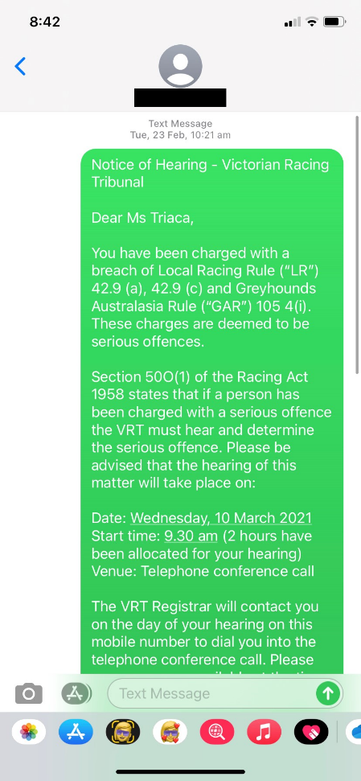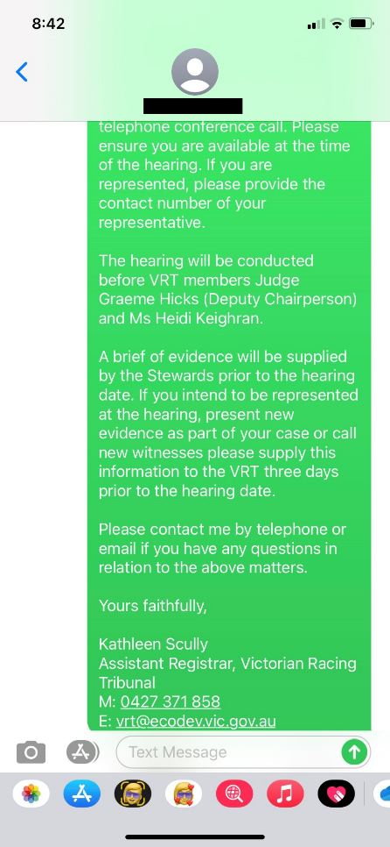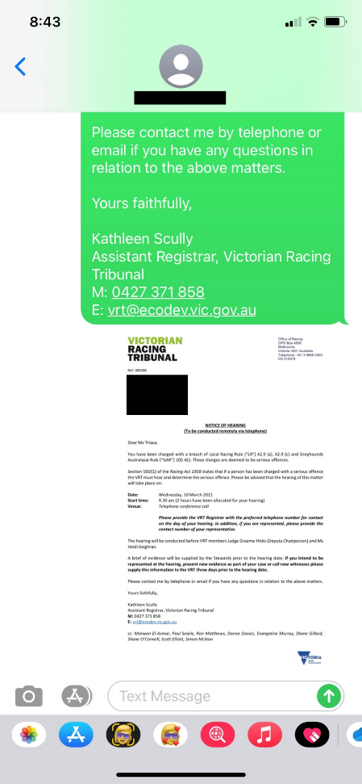Service of hearing notice via text message at 10:21am and 10:23am.

z

Wednesday 24 February 2021

* Call attempt at 11:30am (straight to voicemail, no ring).
* Call attempt at 11:31am (straight to voicemail, no ring) – voicemail left regarding contact attempts made and request for Ms Triaca to return calls as well as confirm receipt of hearing notice.

Friday, 26 February 2021

* Call attempt at 9:14am.
* Call attempt at 4:31pm.

Monday, 1 March 2021

* Call attempt at 4:39pm.

Tuesday, 2 March 2021

* Call attempt at 12:42pm.
* Call attempt at 4:46pm.

Wednesday, 3 March 2021

* Call attempt at 9:09am.
* Call attempt at 1:24pm.

Thursday, 4 March 2021

* Call attempt at 10:04am.
* Call attempt at 2:12pm.

Friday, 5 March 2021

* Call attempt at 10:20am x 2 (straight to voicemail, no ring).
* Call attempt at 1:01pm – voicemail left in relation to the hearing on 10 March 2021, seeking confirmation that notice of hearing was received, attendance at the hearing and request to return call.

Tuesday, 9 March 2021

* Call attempt at 10:44am.
* Call attempt at 2:09pm – voicemail left confirming hearing will proceed as scheduled and to ensure she is available at the time of the call.

Wednesday, 10 March 2021

* Call attempt at 9.29am (straight to voicemail, no ring).
* Call attempt at 9.32am (straight to voicemail, no ring).