COMPANY logo
INDIVIDUAL/COMPANY NAME
KOALA MANAGEMENT PLAN VERSION KOALA MANAGEMENT PLAN DATE

Koalas (Phascolarctos cinereus) are protected in Victoria under the Wildlife Act 1975 (Wildlife Act) and authorisation is required from the Conservation Regulator to disturb them during plantation management operations in blue gum (Eucalyptus globulus) plantations.

Purpose of this document
This document forms the basis for an authorisation under section 28A of the Wildlife Act to disturb koalas. It sets out measures to minimise disturbance to koalas while conducting plantation management operations.

How to complete this plan
This plan must be prepared by the blue gum plantation owner or manager in consultation with an ecologist. Information on how to complete each section of the plan is provided below. You may use your own template provided all of the fields in this template are clearly included. If you require further clarification you may contact the Conservation Regulator.

How to submit this plan
This plan must be submitted in conjunction with an application for an authorisation to disturb koalas during plantation management operations to the Conservation Regulator.

Assessment process
Once received, please allow up to six weeks for your application to be processed. Please note – this is from the time of receipt of a complete application. If further information on your application is requested, additional time will be required to process your application.

Further information
Further information on the legislative and regulatory framework and how to comply is available in the Minimising impacts to Koalas in blue gum plantations: Regulatory Guide available at vic.gov.au/koalas-blue-gum-plantations

Section 1 General Information

Contact details

Main contact for the Conservation Regulator
Name Position title
Telephone Mobile Email

Person who prepared the Koala Management Plan
Provide the name and details of the person who prepared the Koala Management Plan. You must also outline their qualifications and experience that are relevant to the development of this plan. If the person who prepared this plan is not a qualified ecologist, you must also provide details of the ecologist who was consulted during the development of this plan.
Name Position title
QUALIFICATIONS EXPERIENCE
Telephone Mobile Email

Ecologist consulted (as required)
Name Position title
QUALIFICATIONS EXPERIENCE
Telephone Mobile Email

Objectives of this plan
- State the objectives of this Koala Management Plan
- Describe how the plan meets those objectives

Additional information
Additional information can be included in this section as needed. Additional information may include:
- Company background
- Information regarding plantation and koalas in the area
- Documents that were used to develop this plan

Section 2 Risk assessment
This section details the risk assessment and mitigation measures associated with this plan. All potential risks to koalas (e.g. stress, injury, exposure, displacement; death and/or orphaning of juvenile koalas) from plantation management operations must be identified, with options to mitigate these risks outlined.

Things to consider
Consider presence of appropriate remnant native vegetation or blue gum plantation on site or on neighbouring properties that the koalas may disperse to, ability to retain refuge areas, sequence and direction of harvest to prevent isolating koalas from neighbouring habitat, and operations in neighbouring plantations and their potential impact on remaining koalas. Note - that the required retained cluster of nine trees is not suitable habitat as it is insufficient to sustain a koala long-term.

Assessment process
Please provide information on the following points.
- Process to determine koala numbers and locations
- Additional checks put in place during operations
- Risk assessment review frequency

Risk assessment
Please include below an overarching risk assessment that can be applied to each plantation. Note, it is a condition of authorisation that an individual risk assessment for each plantation is completed and available upon request within five (5) business days prior to commencing plantation management operations.
The overarching risk assessment below must identify each type of plantation management operation that may pose a risk to koalas (e.g., harvesting, roading, fire treatment, mechanical coppice management, etc.). If an activity is identified as posing a risk, mitigation measures must be identified and implemented. Record how you will consider the local landscape of each plantation and the presence of any koala refuge areas on and near the site. Please insert your overarching risk assessment below.

Plantation management operations risk assessment
Risk description Likelihood Consequence Risk rating Mitigation measure
e.g., Movement of koalas into the operational area | Possible | Major | Extreme | Check operational area for koalas less than one hour prior to operations commencing

Section 3 Koala Welfare

Determining koala density prior to operations
Survey methodology for koalas prior to harvest. The results of the surveys will feed into the approach for detecting koalas during operations.

Methodology for your surveys for koalas prior to harvest

Detecting koalas during operations
Provide details of the methodology you will use to detect koalas during plantation management operations.
The methodology undertaken must maximise the detection of koalas prior to and during plantation management operations.

Notes
- Separate procedures may be provided for each type of operation.
- Explain your approach to determining the number of spotters that will be in place prior to and during operations (The use of koala spotters is a requirement unless approved by the Conservation Regulator in writing). When determining the number of spotters required, consideration must be given to koala density, koala refuge areas and the health and safety of spotters.
- Explain any additional detection methods (e.g., thermal scopes, drone surveys etc) in this section.
- If a procedure other than spotters is proposed, written approval must be sought from the Conservation Regulator. To obtain this, detail of the proposed procedure, evidence of its effectiveness and process for monitoring and review must be provided below.
To assist, additional guidance is provided in Appendix 1.

Procedure that will be undertaken to detect koalas during operations

Information if approval is sought to use a procedure other than spotters

Tree marking system
Describe your tree marking system that clearly shows the locations of koalas and which trees are to be retained.

Details of your tree marking system

Herbicides or pesticides
Provide details of how spraying herbicides or pesticides will be undertaken to ensure that spray drift onto koalas is minimised.
Information provided in this section must include:
- The types of pesticides or herbicides proposed to be used.
- The procedure (including equipment used, environmental conditions, methods undertaken).

Details of how spraying herbicides or pesticides will be undertaken

Koala incident process
- A koala incident includes any situation where a koala is physically impacted during plantation management operations. The impact could be by trees, machinery, chemicals, fire or people. It includes a koala falling from a tree in the harvest zone or a dependent juvenile koala being separated from its mother.
- Koala incidents do not include near misses or finding a dead or injured koala in a blue gum plantation where the cause is unable to be determined or clearly not related to plantation operations, although the data must be recorded and reported to the Conservation Regulator.
- A koala incident process must be in place, consider the POCTA Act, and include at a minimum information on the following:
    - If an incident or near miss occurs during operations.
    - If an injured, distressed or dead koala is found in a tree or on the ground in a plantation during operations, during a welfare assessment or at any other time.
    - To check for pouch young if a koala dies during operations or a dead Koala is found in the plantation.
    - When a separated or orphaned juvenile koala is found.
    - How a dead koala will be stored and/or disposed of.
  - The equipment that must be used to catch, handle and transport injured or orphaned koalas (including the procedure for using the equipment).
  - When a veterinarian and wildlife rehabilitator is to be consulted.
  - Details on the record keeping process.
- It is recommended that you consult with a person appropriately skilled in koala welfare, or an experienced veterinarian regarding indications of injuries in koalas when developing your welfare assessment process. If this has been undertaken, you must provide information about who was consulted and their relevant qualifications and/or experience.
- To assist, further information on appropriate koala handling and transport equipment is provided in Appendix 2.
- Details of the koala incident process that will be undertaken

Person appropriately skilled in koala welfare or experienced veterinarian consulted to develop the koala incident process.
Name Position title
QUALIFICATIONS EXPERIENCE
Telephone Mobile Email

Koala welfare assessment
A koala welfare assessment must be conducted as per the conditions of your authorisation. Assessments must be undertaken by an appropriately trained person; this includes checking all koalas in trees and on the ground for injuries and unusual behaviour. Koalas in trees must be observed using binoculars.
Outline the frequency of koala welfare assessments that will be undertaken based on factors including koala density, number of koala incidents and near misses and the operation type.
It is recommended that you consult with a person appropriately skilled in koala welfare, or an experienced veterinarian regarding indications of injuries in koalas when developing your welfare assessment process. Indications may include koalas being observed not moving freely. If this has been undertaken, you must provide information about who was consulted and their relevant qualifications and/or experience.

Please provide details of how you will conduct a koala welfare assessment

Person appropriately skilled in koala welfare or experienced veterinarian consulted to develop the welfare assessment process.
Name Position title
QUALIFICATIONS EXPERIENCE
Telephone Mobile Email

Veterinarians and wildlife rehabilitators
Provide details of local veterinarians and wildlife rehabilitators.
Information provided in this section must include at a minimum:
- Names of the veterinarians and wildlife rehabilitators – including who is available after hours.
- The agreement you have with them regarding injured or orphaned koalas.
- Where their contact details will be recorded.
- Who is responsible for storing and maintaining this information and.
- How employees can access this information.

Veterinarian
Name Position title
QUALIFICATIONS EXPERIENCE
Telephone Mobile Email
Explanation of agreement in place

Veterinarian after hours
If the same as the Veterinarian, please write as above in the Name field.
Name Position title
QUALIFICATIONS EXPERIENCE
Telephone Mobile Email
Explanation of agreement in place

Wildlife rehabilitator
Name Position title
QUALIFICATIONS EXPERIENCE
Telephone Mobile Email
Explanation of agreement in place

Person responsible for storing and maintaining veterinarian and wildlife rehabilitator contact details
Name Position title
QUALIFICATIONS EXPERIENCE
Telephone Mobile Email

- Where veterinarian and wildlife rehabilitator contact details will be recorded
- How employees can access veterinarian and wildlife rehabilitator contact details

Koala assessment and handling procedures
Information provided in this section must include at a minimum:
- Who is responsible within the company for managing training in koala assessment and handling.
- How will staff be notified of who to contact if an injured koala is located.

Person responsible within company for managing training in koala assessment and handling
Name Position title
QUALIFICATIONS EXPERIENCE
Telephone Mobile Email

Koala welfare after operations
Consider the following at a minimum when describing how koala welfare will be managed post plantation management operations.
- How you will transfer management of harvested areas
- Any transition arrangements
- When responsibility for koalas transfer to the landowner or subsequent plantation manager/owner
- How this is communicated and agreed upon

Section 4 Incident monitoring, response and continuous improvement
This section outlines the process for monitoring and responding to koala incidents in accordance with the Koala Index (Appendix 3). Blue gum plantation management operations should be conducted in a way that maintains the Koala Index at or above zero.

Monitoring incidents

Procedure that will be followed to monitor koala incidents each month

Detail the procedure that will be followed to monitor koala incidents each month

Koala Index

Procedure if Koala Index requirements for a monitoring period have not been met
Detail the procedure that will be followed if the Koala Index requirements for a monitoring period have not been met. This may include a rectification plan that outlines the number of Koala incidents, the process to determine why incidents occurred, details of issue identified and proposed corrective actions with timeframes.

Response to incidents
Detail the procedure that will be followed if there is an increase in incident numbers, including identification of issues that require corrective action.

Corrective action
Detail the procedure that will be followed to ensure corrective action is undertaken to reduce incident numbers. You must outline what corrective actions will be taken and how these will be implemented.

Continuous improvement
Detail the procedure that will be undertaken to facilitate continuous improvement. This should include information on the review process (e.g. frequency of monitoring) and outline how data entered into ProofSafe will be kept up‑to-date. Note The Conservation Regulator will monitor data on a monthly basis.

Section 5 Capability and training
This section outlines the induction and training requirements for all personnel undertaking operations in the area for which this plan relates. It is a requirement that all personnel involved in plantation management operations are informed of their responsibilities and provided with the required training.
Training must be provided by an appropriately skilled trainer, as this will ensure that all personnel can perform their duties so that koala welfare is protected and impacts minimised. An appropriately skilled trainer is one that can upskill others to locate, assess, monitor, and transport koalas safely and confidently. Training materials and records must be maintained and made available to an Authorised Officer on request.

Induction process
Provide details on the induction process that will ensure all personnel undertaking operations will be made aware of their responsibilities. These responsibilities include the conditions of the authorisation once issued, this Plan, and all relevant legislation.
All personnel must sign a declaration stating that they have received an induction, copies of the signed declarations must be kept and made available to the Conservation Regulator upon request.
To assist, summary of offences under the Wildlife Act and POCTA Act are available in Appendix 4.

Induction process that will be undertaken

Training program
Provide details on the nature of any staff training program that will ensure all personnel are trained in Koala management. Information provided in this section must include at a minimum:
- The training requirements for each role.
- Details on who will develop and deliver the training.
- The training schedule and frequency.
- Details on assessments and verification of competency.
- Information on how training records will be completed and kept.
Whilst it is a requirement that staff receive training in koala management (e.g., koala behaviour, detection, welfare assessments and handling), this must be consistent with their roles and responsibilities. For example, if a machinery operator is not expected to undertake welfare assessments, they would not require training on this aspect. All of the training must be delivered by a person who is appropriately skilled and experienced in the content.
Training materials and records must be maintained and made available to an Authorised Officer on request
To assist, further information on training for staff is provided in Appendix 5.

Training program that will be undertaken

Appendices

Appendix 1 Guidelines for determining number of koala spotters
The guidelines below are recommendations and are additional to the minimum requirements set out in the authorisation to disturb koalas. The minimum requirements under the existing authorisations are:
- If the koala density in the operational area is less than one (1) koala per hectare spotting may be done by the machinery operator appropriately trained in koala detection. The operational area must be re-checked by the spotter or machinery operator at least every three hours during operations to ensure koalas have not moved into the area.
- If the koala density is equal to or greater than one per hectare, a designated on-ground spotter must be used. The operational area must be re-checked by the spotter at least every hour during operations to ensure koalas have not moved into the area.
- An appropriate number of spotters for the observed koalas must be in place, as set out in the recognised Koala Management Plan (Schedule 1). At a minimum, if there are less than fourteen (14) koalas in the harvest zone, one (1) spotter can spot for up to three (3) single grip harvesters, or one (1) feller buncher during harvesting.
- One (1) spotter is required per one (1) single grip harvester when the harvester is cutting gullets.

Guidelines
- Spotter numbers should be determined in Section 3 of this document and should be revised frequently based on koala movements and environmental conditions.
- The location of every koala detected should be verbally communicated to machinery operations by the spotter.
- During plantation management operations, machinery operators should watch for koalas that may have moved or not been identified by spotters.
- If there are fourteen (14) or more koalas in the harvest zone, or if koalas are highly mobile between trees in the harvest zone, then spotters should be increased to at least one (1) spotter per single grip harvester, or two (2) spotters per one (1) feller buncher during harvesting.
- If there is a high density of koalas or koalas are highly mobile, gullets should not be cut at night.

Appendix 2 Koala handling and transport
The authorisation to disturb Koalas during plantation management operations requires that authorisation holders always have appropriate Koala handling and transport equipment on site.
Information on how to handle and transport Koalas has been provided to assist you to comply with the conditions of your authorisation and to ensure the welfare of Koalas requiring handling or transport.
This information is taken from The Management of Koalas in Forestry Plantations, Operational Code of Practice (Phillips, S., Flanagan, C., Wilson, T. and Phillips, C., 2014, ‘The Management of Koalas in Forestry Plantations, Operational Code of Practice’, International Fund for Animal Welfare and National Koala Alliance) and has been reproduced with permission.
Koala capture and handling must only be undertaken by trained personnel.

Transport of Koalas
Koalas must be transported on the back seat of an air-conditioned vehicle or on the floor of a covered van. The internal vehicle temperature should be kept at 22°C. Koalas must not be transported in the back of an open utility. Transport baskets must be secured to prevent movement and must remain covered during transport.

How to assemble a Koala rescue kit for handling and transport
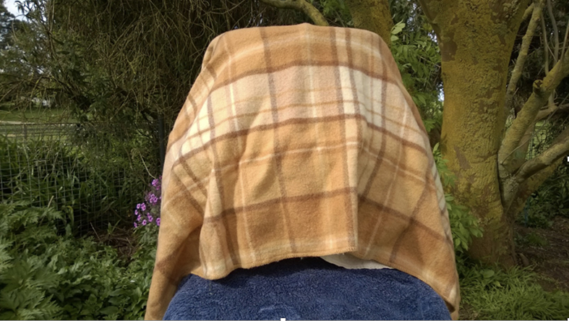 | - Heavy duty wool blankets for capturing Koalas. The Koala can be placed straight into a transport basket with the blanket. This type of blanket can also be used to cover the transport basket in winter.
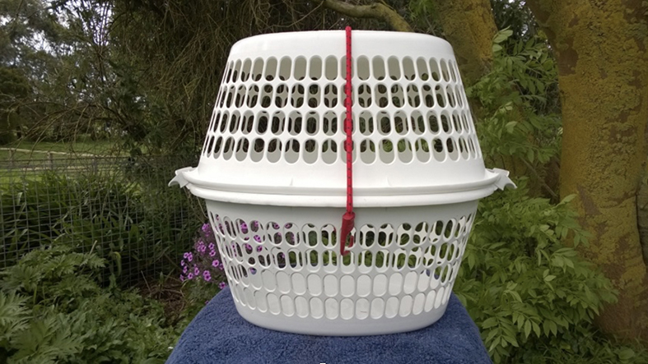 | - A minimum of two Koala transport ‘cages’ that can be quickly assembled from two washing baskets and an octopus strap.
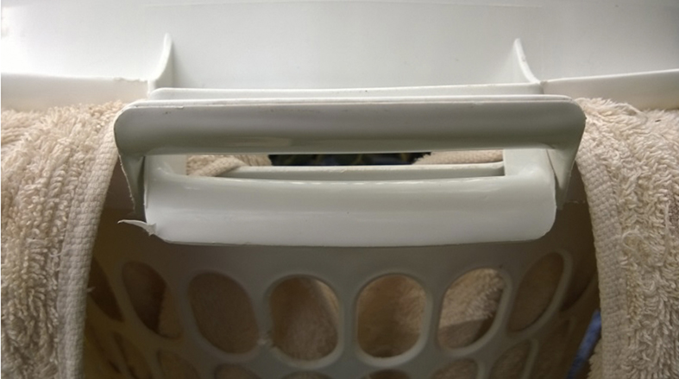 | - Where possible, use baskets which have handles that can interlock.
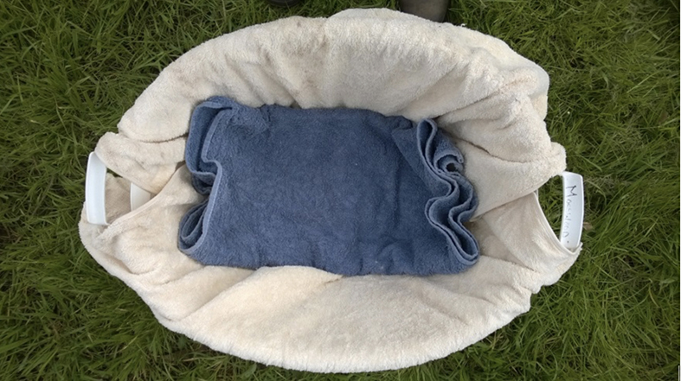 | - Clean towels for lining the baskets, two towels are recommended per basket, one folded in the bottom of the basket to absorb urine.
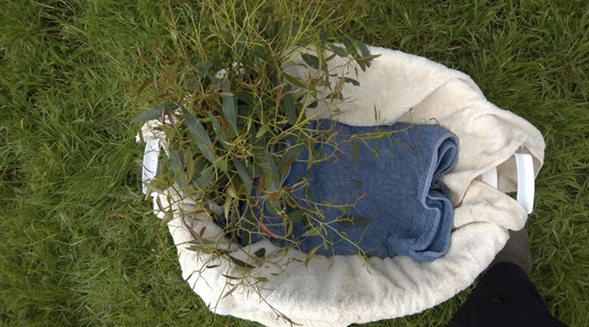 | - Fresh blue gum leaves should be placed into the basket with the Koala.
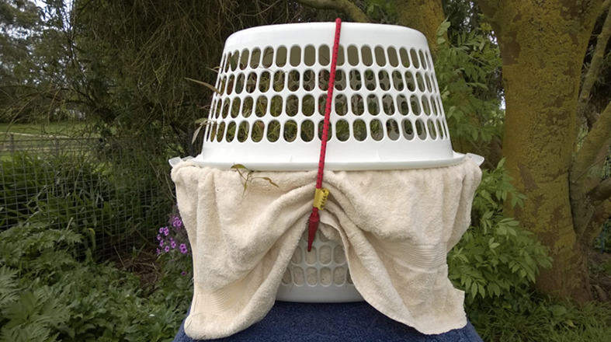 | - A fully constructed transport cage with towels and leaves.
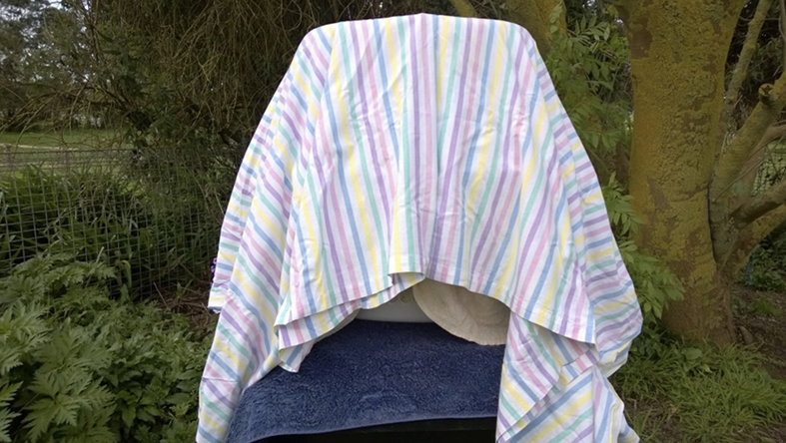 | - Blankets and sheets for covering the cage during transport to reduce stress on the Koala.

Additional equipment required for juvenile Koalas
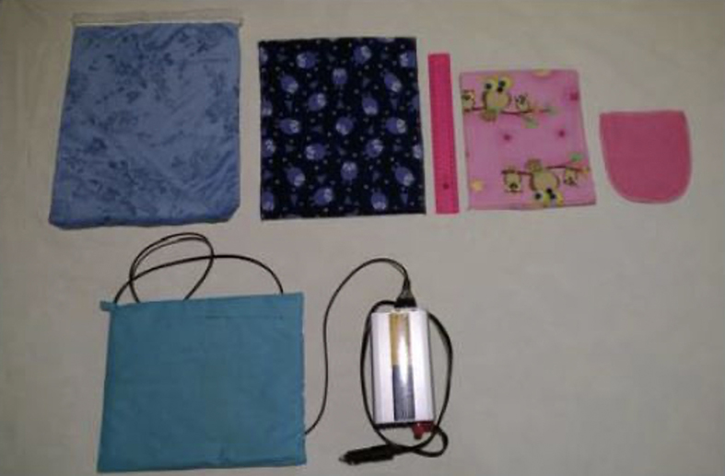 | Artificial ‘pouches’ of varying sizes, these should be made of natural fibres such as cotton or cotton flannelette
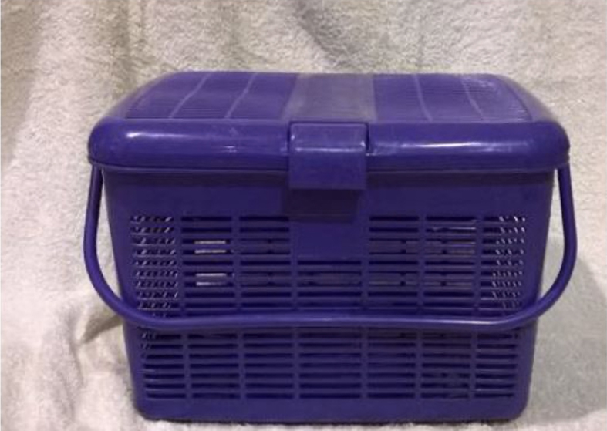 | A minimum of two Rio/picnic basket which can be used to transport juvenile Koalas.  When transporting juvenile Koalas, they must be placed inside a suitable sized pouch which is then placed into a transport basket.  The basket must be covered during transport.

Appendix 3 Koala Index
The Koala Index was developed by the Arthur Rylah Institute for Environmental Research with a generalised linear model (GLM) using a Poisson distribution (Zuur, Ieno, and Smith 2007). The mean Koala incident rate is based on historical Koala incident and population data and estimated using the model.

Calculating the Koala Index
To calculate the Koala Index, the Koala incident rate must first be determined. The Koala incident rate (ut) is calculated over a time period (t) by dividing the total number of Koala incidents by the total number of Koala observations, as per the formula below (refer to Table 1 for variables): | 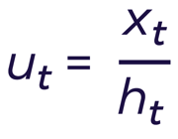
The Koala incident rate (ut) is then used to calculate the Koala Index (zt), as per the formula below (refer to Table 1 for variables): | 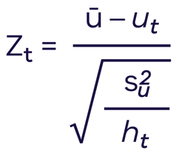

Table 1 Variables used to calculate the Koala index (zt)
Variable | Definition
u_{t} | Koala incident rate over time t
x_{t} | Total number of Koala incidents over time t
ℎ_{t} | Total number of Koala observations over time t
z_{t} | Koala index over time t
ū | Mean Koala incident rate – a value set annually using Koala incident data from operational blue gum plantations. Note: this figure is expressed as expected incidents per 100 observations and may change annually as collection and reporting of data refines the model.
s²_{u} | Variance in Koala incident rate – a value set annually using Koala incident data from operational blue gum plantations. Note: this is a measure of the amount of variability in Koala incident data and may change annually as collection and reporting of data refines the model.
Once the Koala Index has been calculated using the formula above, comparisons over time can be displayed on a line graph, with Koala Index on the y-axis and corresponding time period on the x-axis. For example, if the Koala Index is calculated on a monthly basis, comparisons between months can be displayed (see Figure 2).

Assessing compliance using quality control indicators
The Koala Index provides an indication of a blue gum plantation company’s operations against the expected Koala Index (determined from the mean Koala incident rate across the industry) allowing for an assessment of non-compliance. In general, a Koala Index of zero or greater indicates that the management measures being implemented are at a level that is equal to or better than the industry average (i.e., management measures are effective in reducing Koala incidents). If a Koala Index is less than zero (i.e., negative), the number of Koala incidents occurring across the blue gum plantation company’s operations is poorer than the industry average.
The industry average will be reviewed on a needs basis, noting that the index will only be recalibrated where there has been a material change in industry performance.
The industry is expected to focus on continuously improving its performance. Negative Koala Index results indicate a need to explore options for remedial action.
However, if the Koala Index results are consistently poor or severely low, there is a set of quality control indicators that determine the conduct to be non-compliant. These are consistent with standard rules used in quality control (Nelson 1984). If one or more of the quality control indicators listed below are met, a regulatory investigation may be triggered in order to identify and investigate reasons for poor performance.

Quality control indicators
The Koala index is less than -3 on one or more occasions.
The Koala Index is less than -2 at two of three consecutive time periods.
The Koala Index is less than -1 at four of five consecutive time periods.
The Koala Index has been below 0 for eight consecutive time periods.
The Koala Index has been steadily decreasing for six consecutive time periods.
The Koala Index has 14 points in a row alternating up and down.

References
Nelson, L.S. (1984). The Shewhart Control Chart – tests for Special Causes. Journal of Quality Technology 16 (4), 237-39.
R Core Team (2019). R: A language and environment for statistical computing. R Foundation for Statistical Computing, Vienna, Austria. www.R-project.org.
Venables, W. N. & Ripley, B. D. (2002) Modern Applied Statistics with S. Fourth Edition. Springer, New York. ISBN 0-387-95457-0
Zuur, A.F., E.N. Ieno, and G.M. Smith. (2007). Analysing Ecological Data. Edited by A. Tsiatis M. Gail J. Samet. Statistics for Biology and Health. New York: Springer.

Appendix 4 Summary of offences under the Wildlife Act 1975 and the Prevention of Cruelty to Animals Act 1986
Plantation owners and managers should be aware of the below key offence provisions in both the Wildlife Act 1975 (Wildlife Act) and the Prevention of Cruelty to Animals Act 1986 (POCTA Act).
Please note, this is not an exhaustive list of offences under the Wildlife Act or POCTA Act. Plantation owners and managers should obtain their own legal advice regarding offences or obligations that may be relevant to their situation.
Note Penalty units are set by the Department of Treasury and Finance each financial year. As at 1 July 2022, 1 penalty unit equals $184.92.

Wildlife Act, section 28B
A person to whom an authorisation under section 28A has been granted must comply with the conditions, limitations or restrictions of the authorisation. The penalty for non-compliance is 50 penalty units.

Wildlife Act, section 43
A person must not destroy protected wildlife.

Penalty
50 penalty units or 6 months imprisonment or both the fine and the penalty and an additional 5 penalty units for every head of wildlife in respect of which an offence has been committed.

Wildlife Act, section 58
- Any person who-
  - wilfully molests or injures protected wildlife or wilfully causes protected wildlife to be molested or injured;
  - wilfully disturbs, chases or herds protected wildlife or wilfully causes protected wildlife to be disturbed, chased or herded;
  - wilfully separates protected wildlife from its young or causes it to be so separated-
Shall be guilty of an offence under this Act. The penalty for non-compliance is 20 penalty units.
- Subsection (1) does not apply to a person who is disturbing wildlife or causing wildlife to be disturbed-
  - who holds an authorisation under section 28A(1) that authorises the person to disturb wildlife or cause wildlife to be disturbed, when that person is acting in accordance with the authorisation.

POCTA Act, section 9
A person who:
- wounds, mutilates, tortures, overrides, overdrives, overworks, abuses, beats, worries, torments, or terrifies an animal; or
  - does, or omits to do an act with the result that unreasonable pain or suffering is caused, or is likely to be caused, to an animal; or
  - drives, conveys, carries or packs an animal in a manner or position or in circumstances which subjects or subject, or is likely to subject, it to unnecessary pain or suffering; or
  - is the owner or person in charge of a sick or injured animal and unreasonably fails to provide veterinary or other appropriate attention or treatment for the animal.
Commits an act of cruelty upon that animal and is guilty of an offence and is liable to a penalty of not more than, in the case of a natural person, 250 penalty units or imprisonment for 12 months, or in the case of a body corporate, 600 penalty units.

POCTA Act, section 10
- A person who commits an act of cruelty upon any animal which results in the death or serious disablement of the animal commits an act of aggravated cruelty upon that animal and is guilty of an offence and is liable to a penalty of not more than, in the case of a natural person, 500 penalty units or imprisonment for 2 years or, in the case of a body corporate, 1200 penalty units.
- A person who is guilty of an offence under subsection (1) may be liable to the penalty for that offence in addition to or instead of any other penalty to which the person is liable under section 9.
Under Section 6 (1B) of the POCTA Act, the offences above do not apply to activities done in accordance with the Wildlife Act 1975, therefore as long as the conditions of the authorisation to disturb koalas and the associated approved Koala Management Plan are met, the authorisation holder will not be in breach of the POCTA Act.

POCTA Act, section 15AB Setting or using traps
A person must not set or use a trap that is not of a kind prescribed by regulations under this Act.

Penalty
240 penalty units or imprisonment for 2 years, in the case of a natural person. 1200 penalty units, in the case of a body corporate.

Appendix 5 Minimum koala management training for personnel
Condition 9 of the authorisation to disturb koalas during plantation management operations requires that all personnel must receive training relevant to their role and responsibilities regarding koala management, including koala behaviour, detection, welfare assessments and handling of Koalas.
It is important to note that not all personnel need to receive training in all of the aspects of koala management identified above. The training they receive must be relevant to the role they are expected to undertake in relation to Koala management.
For example, a staff member who is not expected to undertake koala welfare assessments would not need to receive training in that aspect of koala management. However, you may wish to train as many staff as possible in all aspects koala management so that you have more trained staff to draw on during operations.
The following information is a list of topics that your training must cover for each aspect of koala management. Your training must be developed in consultation with a person appropriately skilled in koala welfare and evidence of this must be retained and provided to an Authorised Officer on request.

Koala behaviour
All personnel involved in plantation management operations should receive training in koala behaviour. The following topics must be covered:
- General koala biology.
- Typical behaviour.
- Abnormal behaviour or signs which may indicate injury or illness.

Koala detection
Only personnel who are required to detect koalas need to be trained in koala detection. At a minimum this will be koala spotters and machinery operators.
The following topics must be covered:
- The company’s spotter procedure and spotter and operator responsibilities.
- Thresholds for requiring additional spotters and who to notify that the threshold has been met.
- Tree/stump marking procedure.
- Tree/stump retention requirements.
- What to do if a koala is moving.
- Procedure for detection of koalas in felled timber with retained foliage.
- Koala detection at night.
- OHS requirements.
- Procedure when a koala incident or near miss occurs.
- Record keeping requirements.

Koala welfare assessments
Spotter and personnel expected to undertake Koala welfare assessments need to be trained in koala welfare assessments. The following topics must be covered:
- The company’s koala welfare assessment procedure and responsibilities.
- Typical injuries found in plantations and symptoms to look for.
- Who to contact if an injured or orphaned koala is found.
- Record keeping requirements.

Koala handling
Koala handling training should be given to all personnel who may need to handle koalas. It is a requirement of the authorisation to disturb koalas that at least one person trained in koala handling is on site at all times during plantation management operations. The personnel undertaking koala welfare assessments must be trained in koala handling.
The following topics must be covered:
- Appropriate techniques for handling adult koalas.
- Appropriate techniques for handling juvenile koalas.
- Appropriate koala handling and transport equipment for adult koalas.
- Appropriate koala handling and transport equipment for juvenile koalas.
- OHS requirements.

Other appendices
Add any other appendices relevant to this Plan as detailed above.

Acronyms, abbreviations and definitions
Authorised Officer | An employee of the Department of Environment, Land, Water and Planning who is authorised under section 83(1) of the Conservation, Forests and Lands Act 1987 for the purposes of the Wildlife Act 1975.
Authorisation to disturb koalas | The written authorisation under section 28A(1A) of the Wildlife Act which may be given by the Conservation Regulator to an owner or manager of a plantation to disturb koalas, or cause koalas to be disturbed during plantation management operations. An authorisation will only be considered where a complete application form is received, and a recognised Koala Management Plan is in place.
Conservation Regulator | The Office of the Conservation Regulator. The Conservation Regulator was established by DELWP in 2019 and is responsible for wildlife regulation, including issuing authorisations under the Wildlife Act 1975 (‘the Wildlife Act’), monitoring compliance and taking enforcement action as needed.
Coppice | Regrowth on the stumps of harvested trees left to regenerate.
Coppice management | Any activity which is undertaken on coppice that may impact koalas. At a minimum it includes the application of chemicals (herbicide or pesticide), fire treatment and the mechanical removal or destruction of coppice. It excludes coppice thinning operations where coppice stems are selectively removed.
DELWP | The Department of Environment, Land, Water and Planning.
Expected Koala index | The average koala Index across the industry.
Feller buncher | A harvester that can rapidly cut and gather a number of trees before felling them.
Fire treatment | Any activity which is undertaken using fire. For example, burning coppice or slash.
Gullet | A cleared area created by a harvester felling trees into standing blue gum plantation. As soon as the trees are able to be fallen into previously harvested or open areas then it is not a gullet.
Harvest zone | The area to be harvested in a shift by either a feller buncher or single grip harvest system.
Juvenile Koala | A koala joey that is dependent on its mother and is not yet weaned.
Koala density | The number of koalas per hectare of plantation.
Koala incident | Includes any situation where a koala is physically impacted during blue gum plantation management operations. The impact could be by trees, machinery, chemicals, fire or people. It includes a koala falling from a tree in the harvest zone or a juvenile koala being separated from its mother. Koala incidents do not include near misses or finding a dead or injured koala in a blue gum plantation where the cause is unable to be determined or is clearly not related to plantation operations, although these data must be recorded and reported to the Conservation Regulator.
Koala index | The approach provided in Appendix 3 of this Koala Management Plan.
Koala observation | A record of each individual koala as a separate koala observation. When doing welfare checks on koalas, these are not counted as additional koala observations.
Person appropriately skilled in koala welfare | Someone who is: Experienced in identifying risks to koala welfare in wild settings. Able to make robust judgements of animal-based indicators of welfare, including koala-specific signs of stress and injury. Able to develop effective interventions to mitigate risks/harms to koalas. Has demonstrated experienced in safe capture, restraint and handling techniques for koalas in the wild.
Manager | A blue gum plantation management company that leases a blue gum plantation from the owner of the plantation for the purposes of managing the plantation, or who has been contracted by the owner of the blue gum plantation to undertake the management of the plantation. This includes third party or stumpage agreements where ownership of the trees pass to a company at harvest.
Near miss | A dangerous incident where no harm comes to a koala, but it is exposed to an immediate or imminent serious risk. It includes any incident where a koala is almost physically impacted during operations, either by trees, machinery, chemicals, fire or people, for example a koala walking past a harvester.
Night | The period from last light to first light in each 24 hours for the location that operations are taking place.
Operational area | A single area of variable size, shape and orientation on which a plantation management operation occurs.
Owner | The owner of a blue gum plantation. This can be either a natural person or a body corporate.
Personnel | Employees and contractors of the authorisation holder involved in site operations, including the planning of site operations. It does not include visitors to site such as mechanics or couriers.
Plantation | The blue gum plantation in which the plantation management operations will be undertaken.
Plantation management operations | Any activity that poses welfare risk to koalas. At a minimum this includes harvesting, roading, fire treatment of slash and coppice management.
POCTA Act | Prevention of Cruelty to Animals Act 1986.
ProofSafe | The mobile phone and tablet app that is used by plantations owners and managers to record and report the data required under the authorisation to disturb Koalas.
Qualified ecologist | A person suitably qualified by training, education and experience in koala ecology, management and welfare, such as a landscape ecologist with koala expertise.
Single grip harvester | A harvester that fells, debarks and cuts individual trees.
Slash | Woody debris left after harvest operations.
Spotter | A person employed or engaged to spot koalas in a blue gum plantation during operations.
Veterinarian | A veterinary practitioner registered with the Veterinary Practitioners Registration Board of Victoria or interstate equivalent.
Welfare assessment | An assessment of koala welfare which involves checking the harvested area for koalas, both in trees (using binoculars) and on the ground and assessing their welfare (injuries and behaviour) to determine whether veterinary assessment is required.
Wildlife Act | Wildlife Act 1975.
Wildlife rehabilitator | A person authorised under section 28A(1)(f) of the Wildlife Act to enable the care, treatment or rehabilitation of sick, injured or orphaned wildlife.

