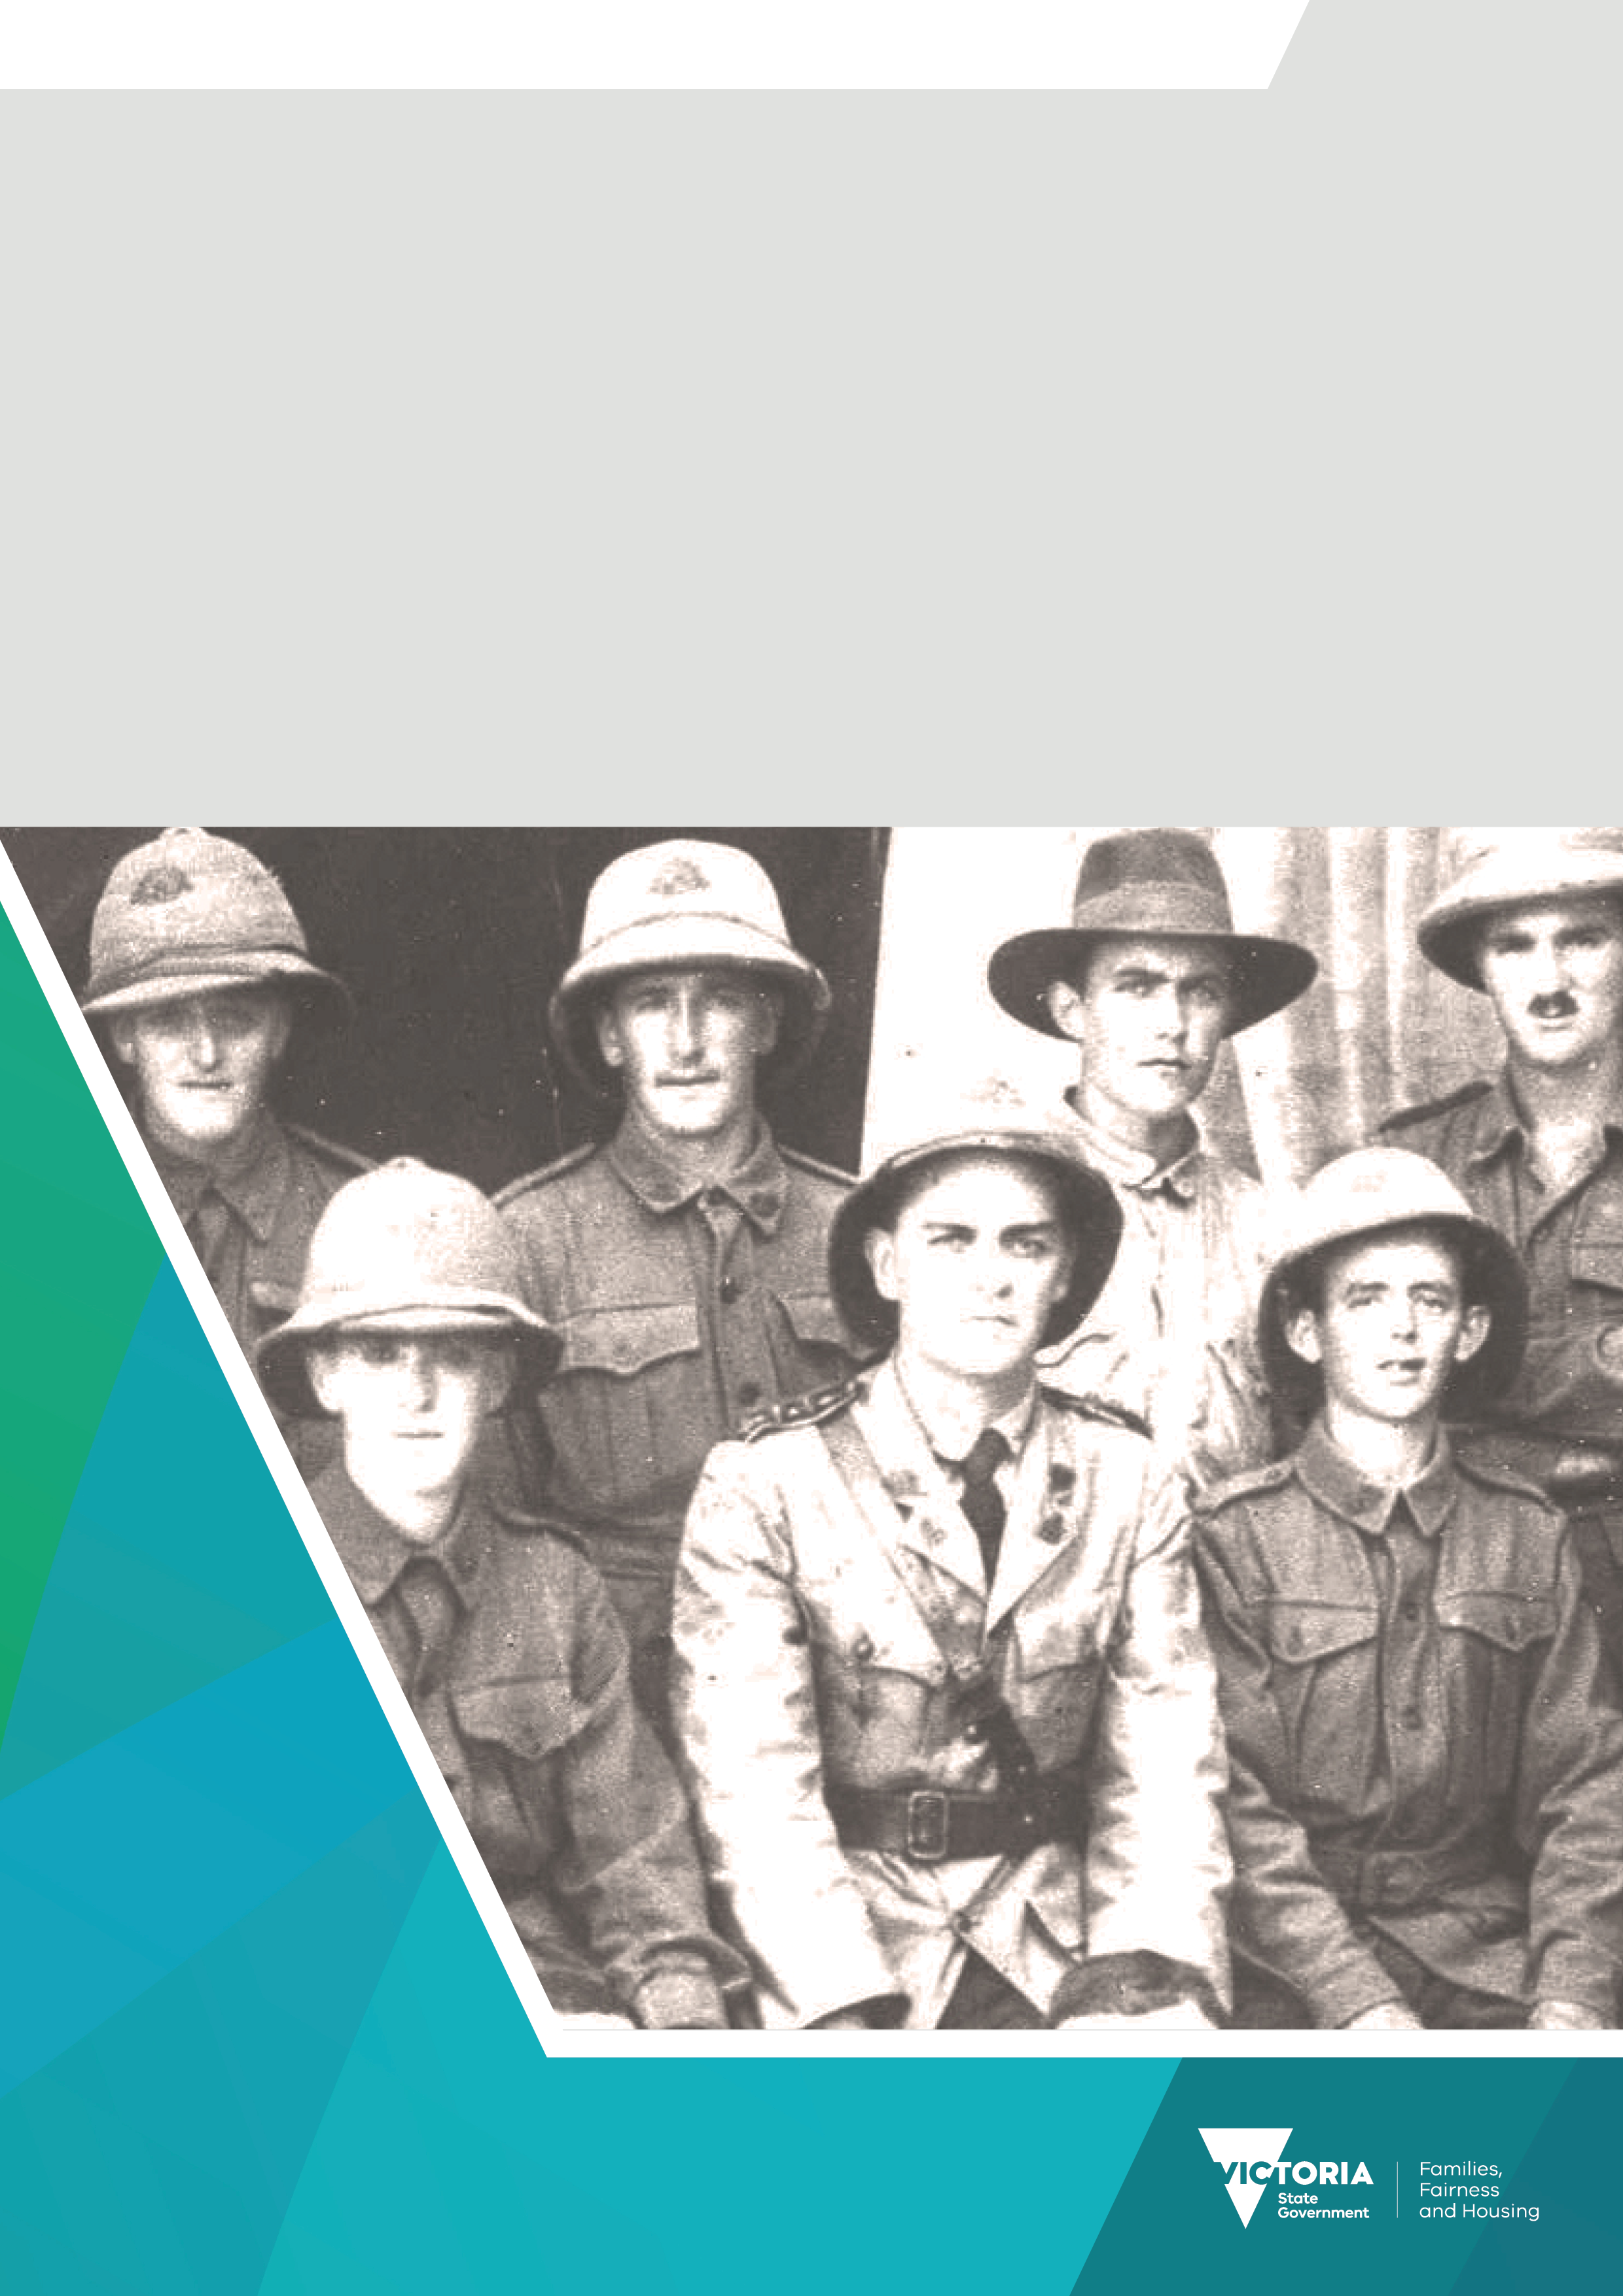

Premier’s Spirit of Anzac Prize
Lesson one
Poster analysis: World War One propaganda posters

Contents
Poster analysis: World War One propaganda posters 3
Visual 3
Verbal 4
Context 4
Sample analysis 5

Poster analysis: World War One propaganda posters
Propaganda posters are a valuable primary source for historians. Learning how to analyse the visual and verbal aspects of a poster is a valuable skill to learn. A useful way to do this is to employ a series of questions to help you identify the key elements of the poster and their intended impact. These questions can be divided into three aspects:
Visual
Verbal
Context

Visual
This aspect is all about what you can see on the poster.

What is the salient image?
What is the first image that your eye is drawn to when looking at the poster?

What is the reading path?
Generally, we ‘read’ images left to right and top to bottom, just the same as if we were reading text. However, sometimes the reading path of an image is set out for us by the placement of the salient image.

What is the composition of the poster?
What has been included or omitted? What effect does this have on the viewer?

What is the layout of the poster?
What is the orientation of various figures within the poster? Do we look up to them or down on them (this is called the point of view).
A good rule to remember is the rule of thirds – images in the top third of the poster are empowered whilst images in the bottom third are considered to be disempowered.

What colours have been used?
The use of colour can be very important as certain colours evoke emotional responses in people.
For example:
- red can mean love and passion or anger, danger, and stop
- white can mean innocence, purity, peace or isolation and cold
- black can mean strength, mystery or death and night
- green can mean nature, abundance, go / proceed or envy and jealousy
- blue can mean peace, trust and serenity or sadness and depression
- yellow can mean warmth, happiness and hope or cowardice and fear.

What is the body language of any of the figures in the poster?
What are the facial expressions, gestures, stance or position of any human figures?

What symbolism has been used?
Symbolism is the use of an image to represent an idea. Are the symbols used clear, dramatic or memorable?

Verbal
This aspect is all about what is stated in the poster, both overtly and implied.

What language is being used?
Does it have positive or negative connotations (the emotional baggage which is associated with the word, as opposed to its actual denotation or definition)?
Is it formal or informal (colloquial)?

Does the language use generalisations, stereotypes, clichés or slogans?
Generalisations are statements made by inferring information from specific cases and then applying it to the whole without enough evidence to support the statement.
Stereotypes are similar to generalisations but are applied to a particular type of person or thing.
Clichés are well-used phrases that refer to common situations.
Slogans are short, sharp phrases most often used in advertising or by governments to encapsulate an idea.

What appeals to the emotions of the reader are being made?
Appeals can be made to many emotions such as fear/safety, authority, tradition, patriotism, love, adventure/challenge, pride/vanity, guilt, inclusion, money or logic.

Context
This aspect is all about the background and purpose of the poster.
Who created it?
When was it created?
What was happening in the society at the time?
Does this have any bearing on the content of the poster?
Who was its intended audience?
Why was it created?
What was its purpose?

Sample analysis
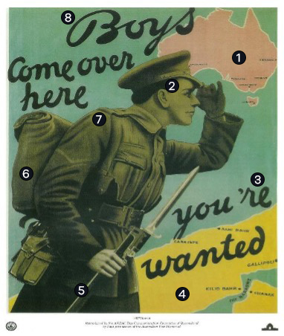
1 | Australia is in the pinkish red of the British Empire as it commonly appeared on maps of the time –  so this is a visual appeal to patriotism.
2 | The soldier appears manly and determined. He is actively seeking the ‘Boys’ back home.
3 | Appeal to inclusion.
4 | The Dardanelles are a little brighter in colour to make them stand out as the destination of the ‘Boys’ and are placed at the bottom right-hand corner as the last part of the reading path to ensure that it is remembered.
5 | The orientation of the soldier is slightly above the viewer. Thus, we are looking up at him which makes him appear more important.
6 | Colours used are mainly muted and reflect the khaki uniform of the Australian soldier.
7 | The figure of the soldier is the salient image as he is the central figure.
8 | Colloquial language is used to make the reader feel comfortable and to target the intended audience  of young men of fighting age.

Source: Artist unknown, ARTV07626, Reproduced by the ANZAC Day Commemoration Committte of Queensland, Australian War Memorial.

Activity
Using the series of questions and sample analysis provided, complete the table below, to identify the key elements of the poster and their intended impact.
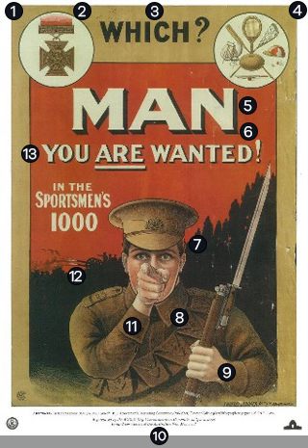
1
2
3
4
5
6
7
8
9
10
11
12
13

Source: Artist unknown, ARTV05005, 1917: Sportsman Recruiting Commissioner (Publisher), Reproduced by the ANZAC Day Commemoration Committee of Queensland, Australian War Memorial.

To receive this document in another format email the Premier's Spirit of Anzac Prize team
<soap@dffh.vic.gov.au>.
Authorised and published by the Victorian Government, 1 Treasury Place, Melbourne.
© State of Victoria, Australia, Department of Families, Fairness and Housing, July 2023.
ISBN 978-1-76130-180-3 (pdf/online/MS word)
Available at SOAP Classroom resources <www.vic.gov.au/premiers-spirit-anzac-prize-classroom-resources>
(2306250)

