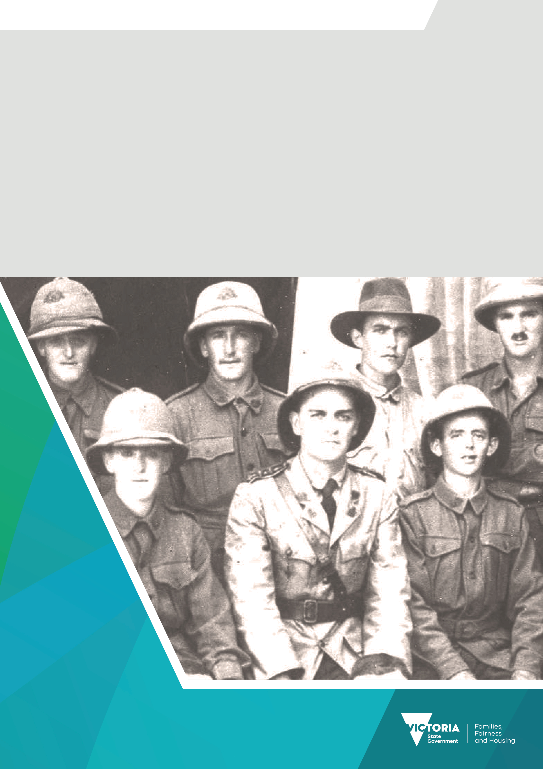

Premier’s Spirit of Anzac Prize
Lesson three
The Anzac Spirit: Brainstorming and drama activities

Contents
The Anzac Spirit: Brainstorming and Drama Activities 3
Task one: Think, Pair, Share 3
Task two: Two-act play 4

The Anzac Spirit: Brainstorming and Drama Activities
As historians, we often need to understand various ideas and concepts – both within their context, or the period we are examining, and how these ideas and concepts are interpreted currently. This is certainly true of the idea of the Anzac Spirit; where we need to understand what it meant in the years following World War I and what it means to us today, over a hundred years later in a very different Australia to that of 1915.
Source: Model: Pat Hanna, “The spirit of Anzac” or “The Digger”; Photographer: Jack Cato; Australian War Memorial.

Task one: Think, Pair, Share

Think
Write the heading ‘The Anzac Spirit’ on a piece of paper or a Word document and divide your page in half.
On the left-hand side write the heading ‘Then,’ and on the right-hand side write ‘Now.’
Write down as many adjectives and phrases as you can about what the Anzac Spirit means then and now.

Pair
With a partner, compare and discuss your brainstorms. o What similarities and differences are there?
On a new page, create a brainstorm that you both agree with.

Share
Next, you and your partner should join up with another pair to compare and discuss your new brainstorms. What similarities and differences are there this time?
On a new page, create a brainstorm that all of you agree with.
[Hint: You can use different coloured highlighters to create a visual way to see the similarities and differences easily.]

Finish
With your partner, write a short paragraph or two outlining what the Anzac Spirit meant in 1915 and the years immediately following World War I, and what it means to our multicultural society today. Be clear in explaining what changes, if any, have occurred over this time.

Task two: Two-act play

Write
Using your answers from Task One, in a small group (four to five students) write a short two-act play that shows your understanding of the Anzac Spirit Post-World War I and how the Anzac Spirit is interpreted today in our multicultural twenty-first-century society.

Structure
- Act One: Post World War I.
- Act Two: Modern times
- All group members must participate in at least one of the following ways:
  - research
  - script writing
  - directing
  - acting.

Perform
Perform your two-act play for the class.

To receive this document in another format email the Premier's Spirit of Anzac Prize team
<soap@dffh.vic.gov.au>.
Authorised and published by the Victorian Government, 1 Treasury Place, Melbourne.
© State of Victoria, Australia, Department of Families, Fairness and Housing, July 2023.
ISBN 978-1-76130-180-3 (pdf/online/MS word)
Available at SOAP Classroom resources <www.vic.gov.au/premiers-spirit-anzac-prize-classroom-resources>
(2306250)

