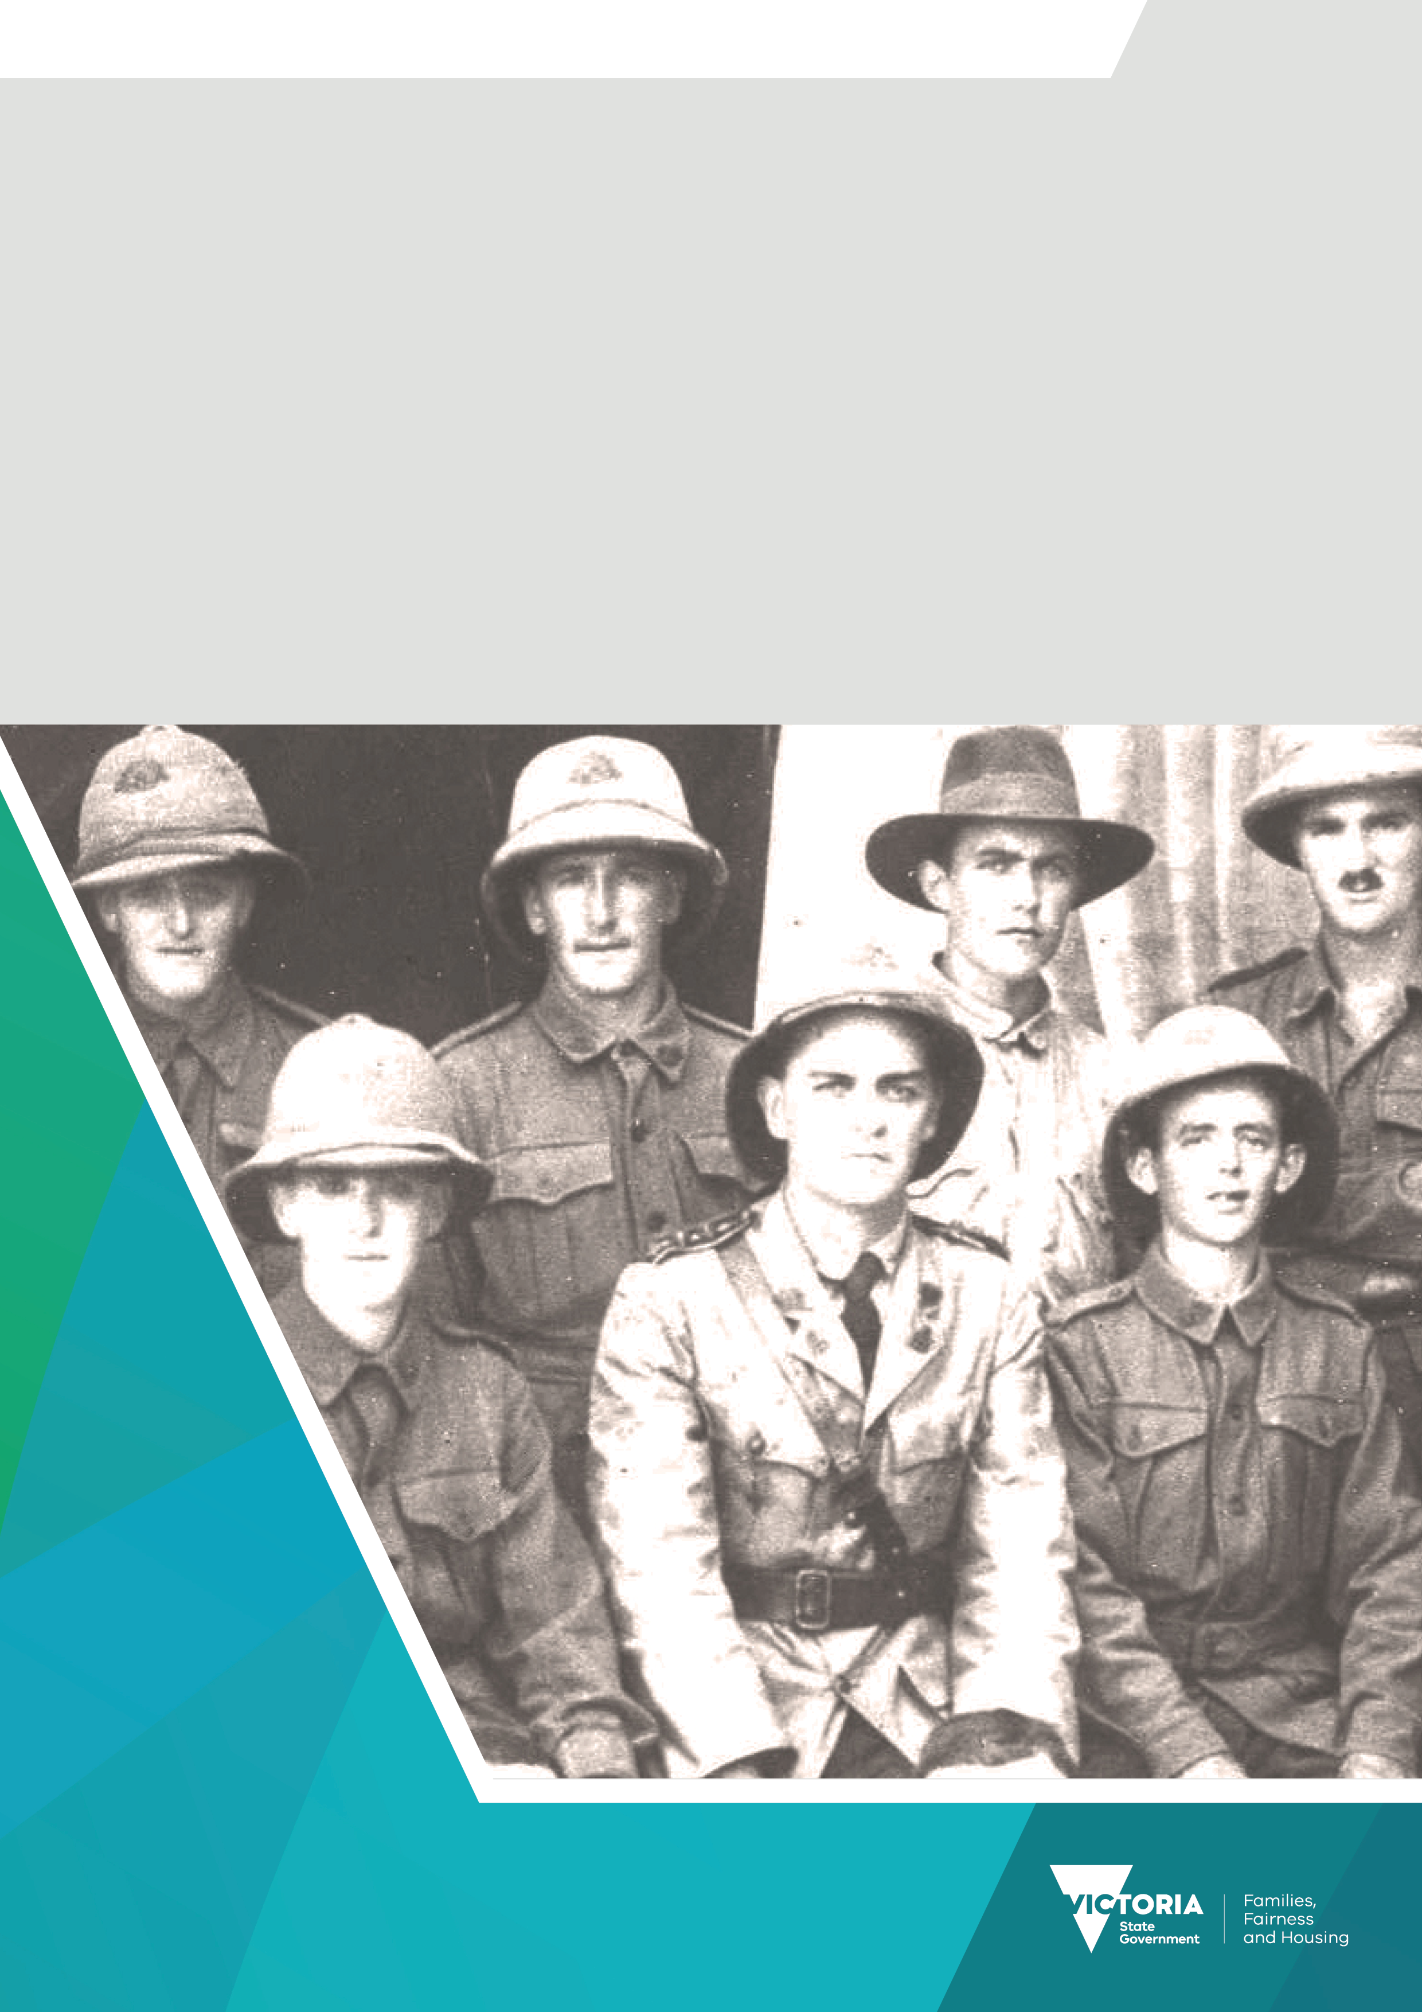

Premier’s Spirit of Anzac Prize
Lesson four:
The effect of war: Analysing the impact of war on Australian society

Contents
The effect of war: Analysing the impact of war on Australian society 3
Task 3
Extract from Australians at war 4

The effect of war: Analysing the impact of war on Australian society
As historians, it is important for us to study the events and campaigns of a war. However, it is also important to consider the impact that these events and campaigns had upon not only those involved but also the wider society.

Task
Read the extract below from the article ‘Australians at War’ and answer the following questions.
Remembering and Understanding
- Explain how Australia’s war history varies from that of many other nations.
- What impact did Australia’s involvement in imperial wars in the late nineteenth century and in World War I have on Australia and Australian society?
- How did Australia’s participation in World War II vary from that of earlier wars?
- How did the Vietnam War change Australia’s perception of its place in the world and its allegiances?
Applying and Analysing
- Using a graphic organiser of your choice (a table or flowchart would work well), analyse the key points of the extract by identifying the topic sentence, or significant point, made in each paragraph.
- Examine the Australian war casualties for World War I, World War II and the Vietnam War listed at the end of the extract, and answer the following questions:
  - Percentage-wise, which war had the highest number of
    - Deaths?
    - Wounded?
    - Prisoners of War
  - What factors might account for this?
[Note: Students may wish to do some further research online, to help them answer this question.]
  - Why are these figures only approximate?
Evaluating and creating
- Using your answer to Question 6a above, which statistics did you find the most unexpected and why?
- Using your answers to Questions 1 to 7 above, in your own words, write 100 to 250 words outlining the impact of war on Australia.

Extract from Australians at war

This article has been contributed by the Australian War Memorial - written by Matthew Higgins.
Over 100,000 Australians have lost their lives through war. Many more thousands have been wounded,
while the number of Australians who have served abroad in wartime is eight to nine times the number who have died.
These bare statistics alone show the significance that war has had for Australia. Australia's history is different from that of many other nations in that since the first coming of the Europeans and their dispossession of the Aboriginals, Australia has not experienced a subsequent invasion; no war has since been fought on Australian soil. Yet Australians have fought in ten wars. Some of these have been in distant lands, others much closer to home. All of them were begun by other nations and involved Australia because of its overseas ties; alliances formed through sentiment, loyalty or simply for reasons of security. Paramount among these ties have been those with Great Britain and, more recently, the United States.
At times war has brought Australian society together. Remarkable displays of patriotic fervour have been created in wartime, as witnessed at the outbreak of World War I. But war has also turned Australian society against itself. During the conscription referenda campaigns of World War I and the moratorium street marches of the Vietnam years (caused, in part, by the conscription issue) the nation experienced great social tension.
War began to have an impact on Australia and Australian society during the later 1800s. Australia's participation in several small imperial wars during the second half of the nineteenth century allowed the colonies to demonstrate their loyalty to Britain and helped to strengthen imperial ties. These overseas involvements also encouraged the colonies to believe that they could occupy a larger place on the international stage.
World War 1, though, had a much greater impact on Australian society. Anzac Day, commemorating the landing of Australian and New Zealand troops on the Gallipoli Peninsula on 25 April 1915, is Australia's most important commemorative day. The Anzac legend, representing the Australian fighting man as a resourceful, resilient, even cheerful warrior, has become part of Australia's folklore. It has been an accepted part of the culture for two generations of Australians. More recently it has been questioned increasingly.
That same Anzac landing really heralded Australia's entry into the First World War, a war that took nearly 60,000 Australian lives. The tremendous cost of the War (Australia's casualty rate, in proportion to the number of troops engaged, was higher than for any other country in the British Empire) left an indelible scar on the nation. Perhaps the most tangible sign of this was the number of memorials, still standing today, built in cities and towns around the country after the end of hostilities. The Australian War Memorial was inspired by that War.
World War 11, for the first time in white Australia's history, placed the country under the very threat of invasion. Australia's total resources were called upon to a degree not seen before. Women increasingly filled the places in primary and secondary industry left by men. By the end of the War in 1945, the place of women in society had changed dramatically. The War also fundamentally altered Australia's relationship with Britain, for it had forced Australia to look away from Britain and towards the United States for support and security.
The Asian wars that followed, in Korea, Malaya, Malaysia and Vietnam, have all helped to change further Australia's outlook on the world. Well before 1972, when the last Australians left Vietnam, Australia had begun to see itself not merely as a part of the European world but, realistically, as a neighbour of South-East Asia. Involvement in these conflicts has strengthened Australia's relationship with the United States.

 | Duration | Numbers enlisted or engaged | Deaths | Wounded | Prisoners of war
First World War | 1914-18 | 417,000 men enlisted in the Australian Imperial Force (including Australian Flying Corps), 330,000 served overseas (no figures for the Royal Australian Navy). | 60,000 from all causes (AIF only). | 155,000 (AIF only) | 4,044 (397 died while captive).
Second World War | 1939-45 | 691,000 men and 35,800 women enlisted in the Australian Military forces (AIF and Militia), 45,000 men and 3,100 women enlisted in the Royal Australian Navy, 189,000 men and 27,000 women enlisted in the Royal Australian Air Force. | 35,000 deaths from all causes (all services). | 66,553 (all services). | 7,289 in the war against Germany (of whom 234 died while captive), 22,376 in the war against Japan (of whom 8,031 died while captive).
Vietnam War |  | 42,700 army personnel engaged, 2,858 navy personnel engaged, 4,443 air force personnel engaged. | 496 deaths from all causes (all services). | 2,398 (all services).

Note: Casualty figures differ between sources due to variations in recording methods, criteria for classification etc; the figures for deaths, wounded and prisoners-of-war should therefore be regarded as approximate only.
DISCLAIMER: Users are warned that historic issues of this publication may contain language or views which, reflecting the authors' attitudes or that of the period in which the item was written, may be considered to be inappropriate or offensive today.
Source: Higgins, M. (2012) Australians at War (feature article), Australian Bureau of Statistics. Available at: https://www.abs.gov.au/ausstats/abs@.nsf/featurearticlesbytitle/00753BC276CCB154CA2570FF000075A8?OpenDocument (Accessed: 18 July 2023).
To receive this document in another format email the Premier's Spirit of Anzac Prize team
<soap@dffh.vic.gov.au>.
Authorised and published by the Victorian Government, 1 Treasury Place, Melbourne.
© State of Victoria, Australia, Department of Families, Fairness and Housing, July 2023.
ISBN 978-1-76130-180-3 (pdf/online/MS word)
Available at SOAP Classroom resources <www.vic.gov.au/premiers-spirit-anzac-prize-classroom-resources>
(2306250)

