Front cover image showing group photo of young Australian soldiers during World War One.

Victoria State Government, Department of Families Fairness and Housing.

|  |
| --- |
| Premier’s Spirit of Anzac Prize |
| **Lesson five** Primary source analysis - War photographs |

Contents

Primary source analysis: war photographs 3

Task 3

# Primary source analysis: war photographs

Primary sources, such as photographs, are a rich source of evidence for historians to examine and find out more about the period they are studying.

## Task

Examine each of the photographs below, taking particular note of their source lines, and answer the following questions for each of photographs A, B, and C.

1. Where and when was the photograph taken?
2. Who or what is the subject of the photograph?
3. Describe what you see in the photograph.
4. How reliable is the source?
5. What is the significance or relevance of each photo? In terms of:

* the war to which it relates
* what differences, if any, it depicts between the three wars: World War I, World War II and the   
  Vietnam War.

1. How useful is the source to a historian?

[NOTE: You may find it useful to write your answers to questions 1 to 4 in a table and then answer questions 5 and 6 in a paragraph each.]

**A.**

Group portrait of the NCO's 59th Battalion, Australian Infantry. 
Source: Huppy, France.23 November 1918. 

Source: Huppy, France.23 November 1918. Group portrait of the NCO's 59th Battalion, Australian Infantry. (Australian War Memorial)

**B.**

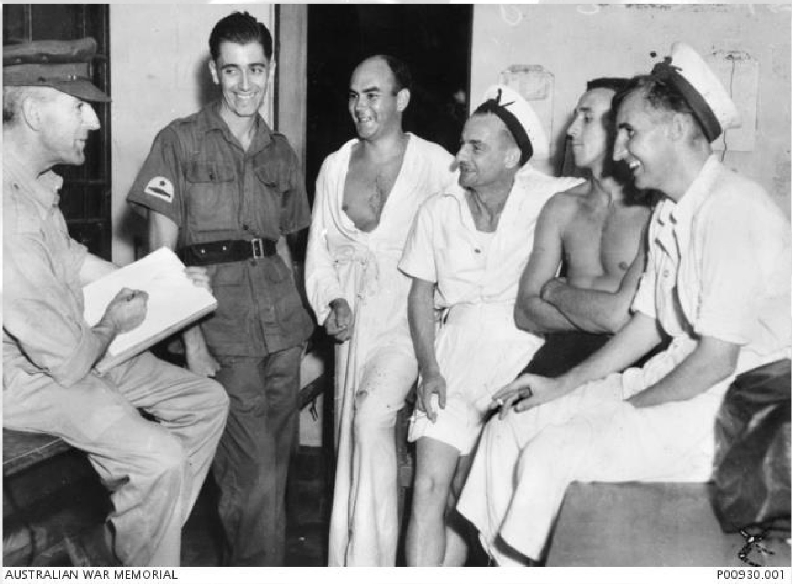

Source: Ernest Buckmaster, war artist, at work drawing a group of servicemen, World War II. (Australian War Memorial)

**C.**

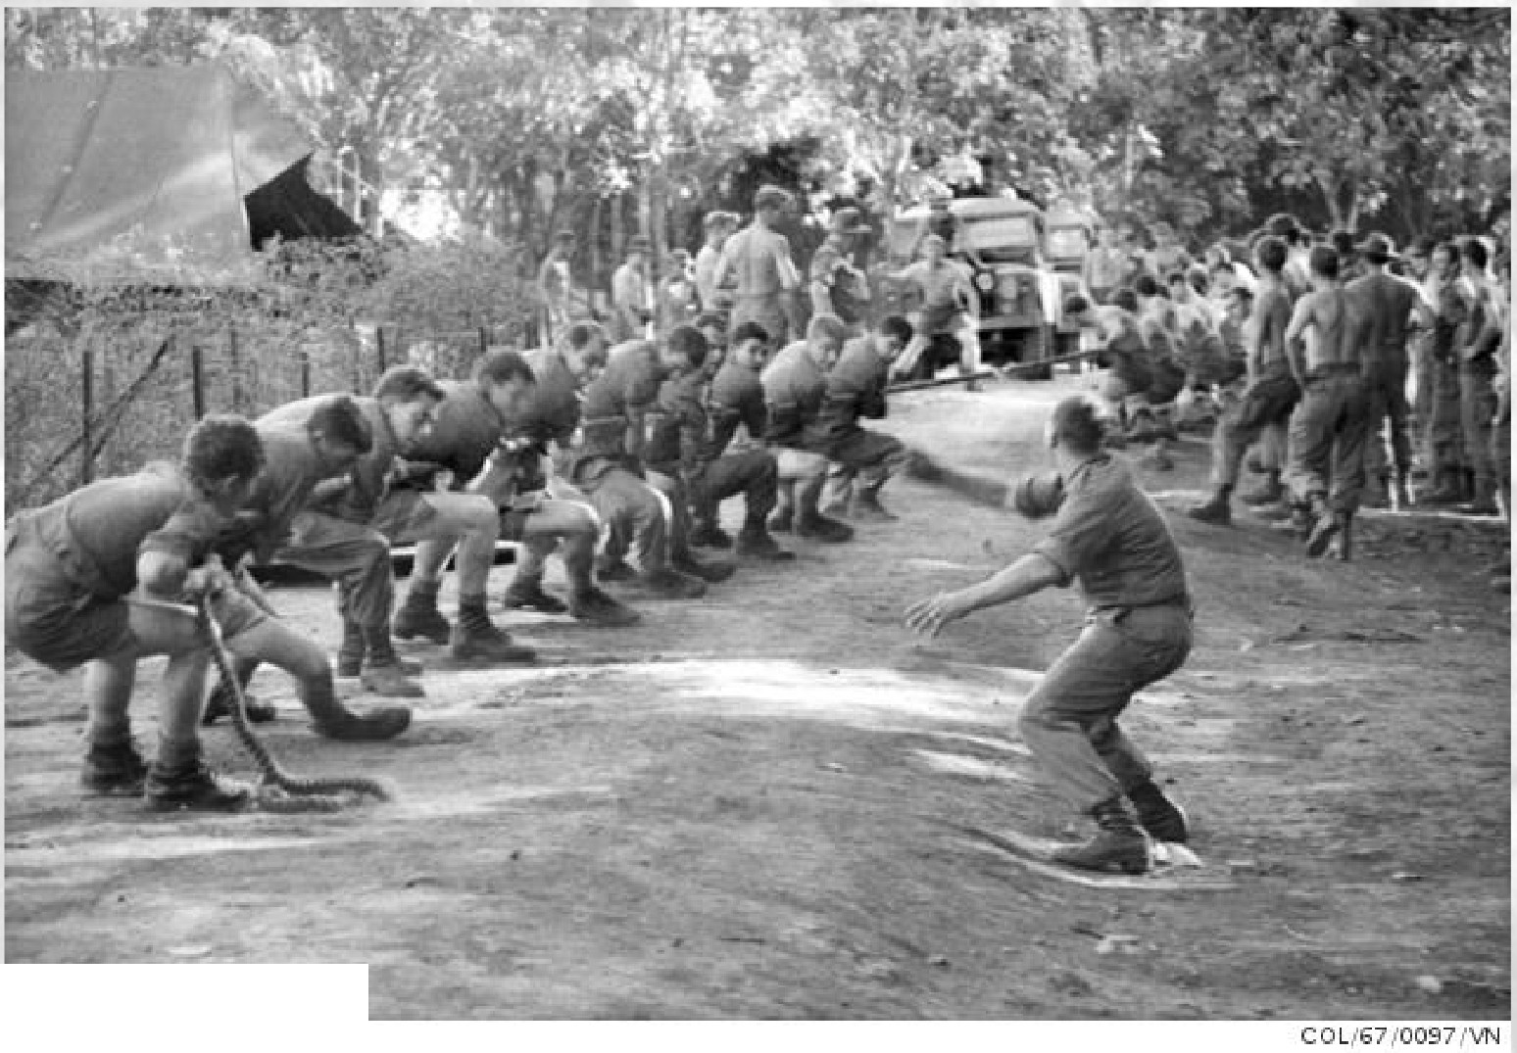

AUSTRALl.oN WAR MEMORIAL

Source: Vietnam, 1967. Soldiers pulling on a rope, enjoying a game of tug of war. (Australian War Memorial)

|  |
| --- |
| To receive this document in another format [email the Premier's Spirit of Anzac Prize team](mailto:soap@dffh.vic.gov.au) <soap@dffh.vic.gov.au>.  Authorised and published by the Victorian Government, 1 Treasury Place, Melbourne.  © State of Victoria, Australia, Department of Families, Fairness and Housing, July 2023.  **ISBN** 978-1-76130-180-3 **(pdf/online/MS word)**  Available at [SOAP Classroom resources](https://www.vic.gov.au/premiers-spirit-anzac-prize-classroom-resources) <www.vic.gov.au/premiers-spirit-anzac-prize-classroom-resources>  (2306250) |