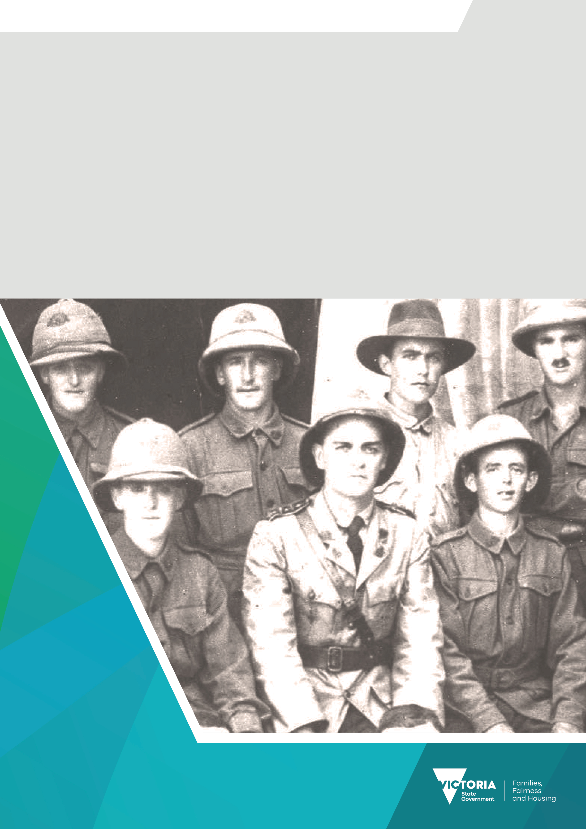

Premier’s Spirit of Anzac Prize
Lesson six
Source analysis: Protest songs

Contents
Source analysis: Protest songs 3
Task 3

Source analysis: Protest songs
There are many of types of sources which allow historians to examine how previous generations viewed significant events. One such example is the protest song, a song which is created to voice the need for social change.

Task
Click on the links below each of these Australian war protest songs to view a clip of the songs being sung and read the lyrics. Then fill in the table below.

‘And the Band Played Waltzing Matilda’ by Eric Bogle
- Video clip <https://www.youtube.com/watch?v=WG48Ftsr3OI>
- Lyrics <https://genius.com/Eric-bogle-and-the-band-played-waltzing-matilda-lyrics>

‘I Was Only Nineteen’ by Redgum
- Video clip <https://www.youtube.com/watch?v=mGDhzVi1bqU>
- Lyrics <https://genius.com/Redgum-i-was-only-19-a-walk-in-the-light-green-lyrics>

 | And the Band Played Waltzing Matilda | I Was Only Nineteen
What is the song about?
What is the message of the song?
How does the title of the song relate to either the meaning or the purpose?
Give three examples of imagery used to convey the message of the song.
What is the songwriter trying to achieve with this song?

To receive this document in another format email the Premier's Spirit of Anzac Prize team
<soap@dffh.vic.gov.au>.
Authorised and published by the Victorian Government, 1 Treasury Place, Melbourne.
© State of Victoria, Australia, Department of Families, Fairness and Housing, July 2023.
ISBN 978-1-76130-180-3 (pdf/online/MS word)
Available at SOAP Classroom resources <www.vic.gov.au/premiers-spirit-anzac-prize-classroom-resources>
(2306250)

