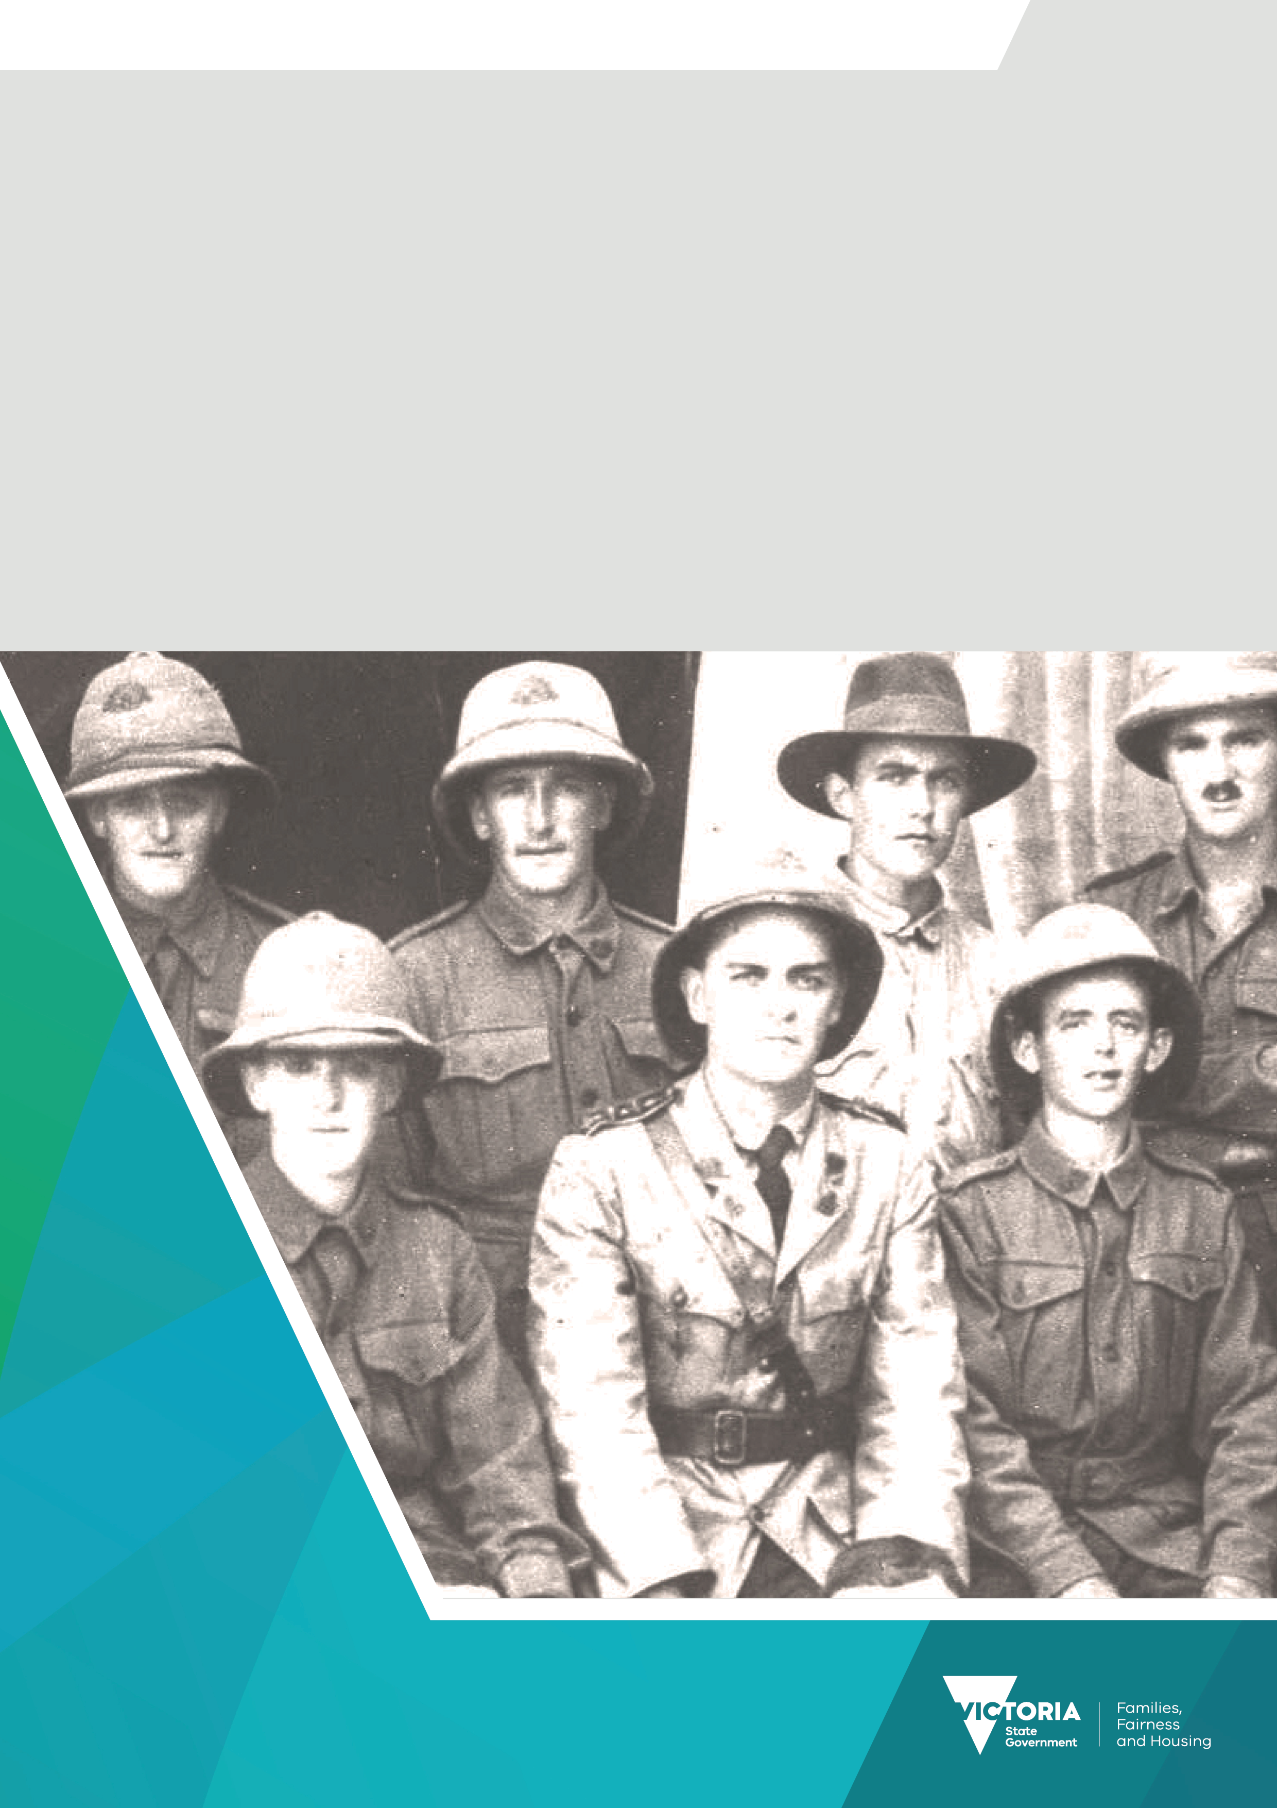

Premier’s Spirit of Anzac Prize
Lesson six
Teachers notes

Contents
Source analysis: Protest songs 3
Task 3
Taking it further 4

Source analysis: Protest songs
There are many of types of sources which allow historians to examine how previous generations viewed significant events. One such example is the protest song, a song which is created to voice the need for social change.

Task
Click on the links below each of these Australian war protest songs to view a clip of the songs being sung and read the lyrics. Then fill in the table below.

‘And the Band Played Waltzing Matilda’ by Eric Bogle
- Video clip <https://www.youtube.com/watch?v=WG48Ftsr3OI>
- Lyrics <https://genius.com/Eric-bogle-and-the-band-played-waltzing-matilda-lyrics>

‘I Was Only Nineteen’ by Redgum
- Video clip <https://www.youtube.com/watch?v=mGDhzVi1bqU>
- Lyrics <https://genius.com/Redgum-i-was-only-19-a-walk-in-the-light-green-lyrics>

 | And the Band Played Waltzing Matilda | I Was Only Nineteen
What is the song about? | A young soldier going to Gallipoli in World War I. | A young soldier going to the Vietnam War.
What is the message of the song? | It is an anti-war song. | It is an anti-war song.
How does the title of the song relate to either the meaning or the purpose? | The title of the song relates to the fact: a) these were Australians going to war; b) it was seen as their patriotic duty to go. | The title of the song relates to the youth of the soldiers being sent off to war
Give three examples of imagery used to convey the message of the song. | - ‘We were butchered like lambs at the slaughter.’  - ‘Now when I was a young man, I carried me pack/And I lived the free life of the rover/From the Murray's green basin to the dusty outback/Well, I waltzed my Matilda all over.’  - ‘In that mad world of blood, death and fire.’ | - ‘Asian orange sunset through the scrub.’  - ‘And why the Channel Seven chopper chills me to my feet?’  - ‘And night-time’s just a jungle ark and a barking M-16.
What is the songwriter trying to achieve with this song? | The songwriter wants the listener to think about the futility of war and its impact on the soldiers. | The songwriter wants the listener to think about the futility of war and its impact on the soldiers.

Taking it further
Students may wish to further their studies of protest songs by examining those of other countries, or those related to other issues.
Possible tasks:
- Complete a table, such as the one above, for two or more songs of your choice.
- Create an AVD (Annotated Visual Display) on one or more of the songs, including the history of the issue being protested and the background of the singer/writer.
Some suggested protest songs include:
- ‘Fortunate Son’ by Creedence Clearwater Revival.
- ‘Blowin’ in the Wind,’ ‘The Times They are A-Changing,’ ‘Masters of War’ and ‘Hurricane’ by Bob
- Dylan.
- ‘Eve of Destruction’ by Barry Maguire.
- ‘Ohio’ by Crosby, Stills, Nash and Young.
- ‘For What It’s Worth’ by Buffalo Springfield.
- ‘Revolution’ by The Beatles.
- ‘Sunday, Bloody Sunday’ by U2.
- ‘Born in the USA’ by Bruce Springsteen.
- ‘Imagine’ and ‘Give Peace a Chance’ by John Lennon.
- ‘Strange Fruit’ by Billie Holliday.
- ‘What’s Going On’ and ‘Mercy, Mercy Me (the ecology)’ by Marvin Gaye.
- ‘A Change is Gonna Come’ by Sam Cooke.
- ‘Get Up, Stand Up’ by Bob Marley.
- ‘Big Yellow Taxi’ by Joni Mitchell.
- ‘Don’t Go Near the Water’ by The Beach Boys.

To receive this document in another format email the Premier's Spirit of Anzac Prize team
<soap@dffh.vic.gov.au>.
Authorised and published by the Victorian Government, 1 Treasury Place, Melbourne.
© State of Victoria, Australia, Department of Families, Fairness and Housing, July 2023.
ISBN 978-1-76130-180-3 (pdf/online/MS word)
Available at SOAP Classroom resources <www.vic.gov.au/premiers-spirit-anzac-prize-classroom-resources>
(2306250)

