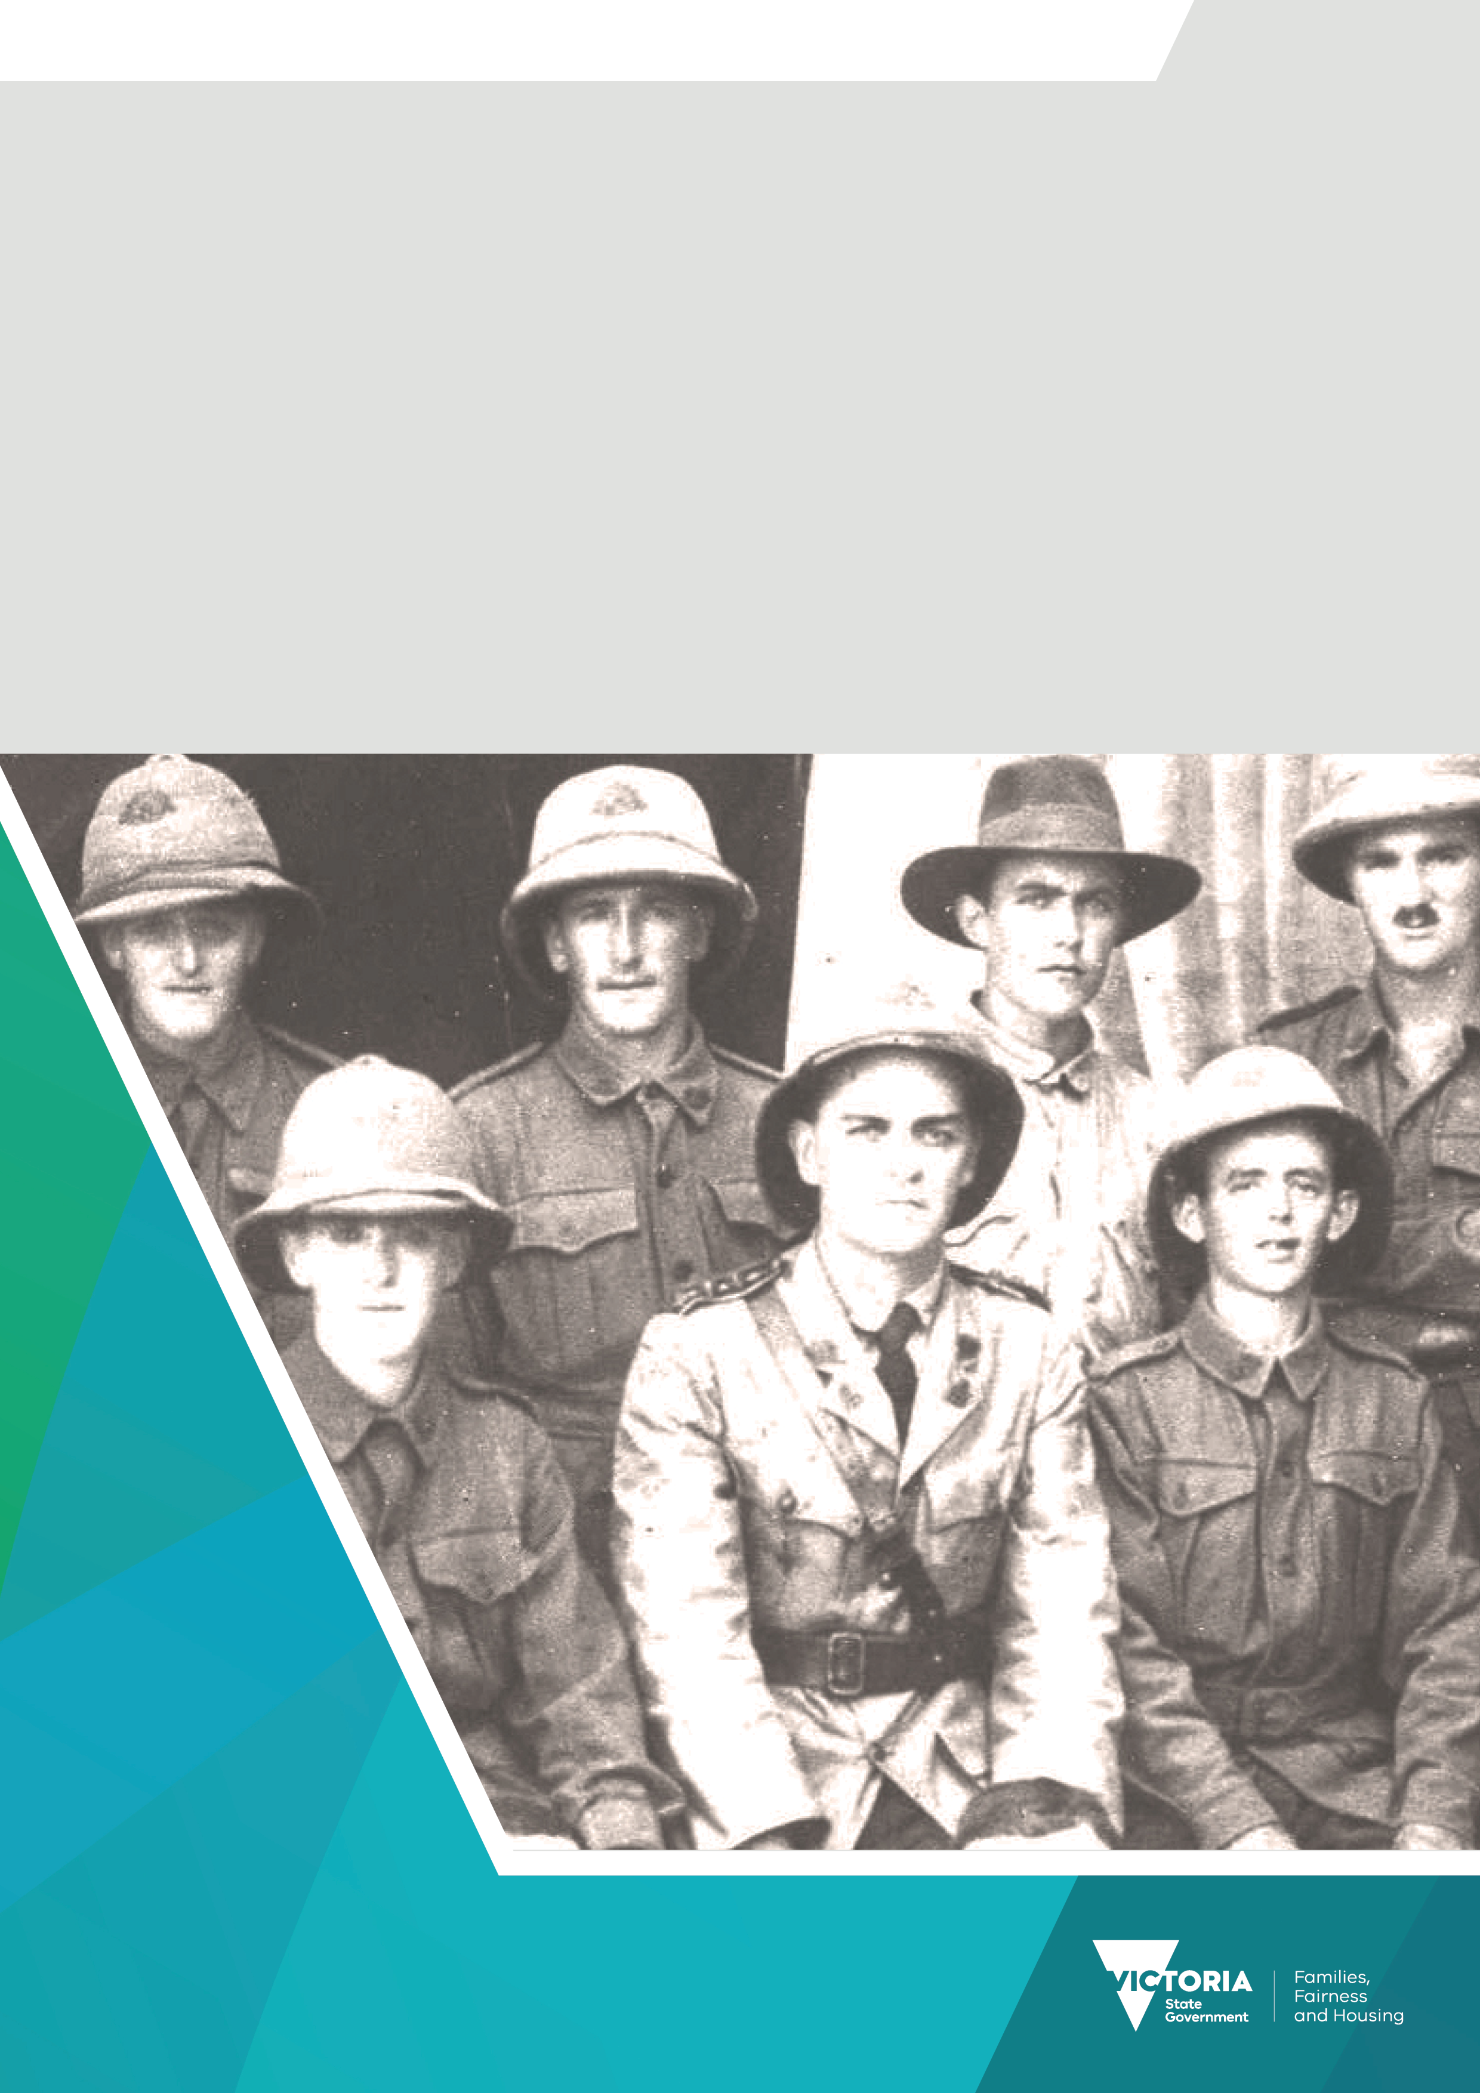

Premier’s Spirit of Anzac Prize
Lesson seven
Preparing a bibliography

Contents
Preparing a bibliography 3
Sample bibliography 3

Preparing a bibliography
It is important to include a bibliography with your historical research that lists all sources you have read or referenced.
There are several rules you need to follow when setting out your bibliography:
- Start your bibliography on a new page at the end of your essay or research paper.
- Each entry starts on a new line, with a one-line space between entries.
- Second and subsequent lines of an entry are indented.
- Entries are made in alphabetical order.
- Normally, each entry begins with the author’s last name.
- When the author is unknown, the entry begins with the title of the source.
- For multiple entries by the same author, a dash replaces the name after its first appearance.
- The title of a book should be in italics.
- The title of an article should be in inverted commas.

Sample bibliography
Adam-Smith, Patsy. Australian Women at War. Melbourne: Thomas Nelson, 1984.
Dugan, Michael. Famous Australians. South Melbourne: Macmillan, 1981.
_ World War II. South Melbourne: Macmillan, 2000.
Hastings, Terry and Ramsey Imam. Australians in the Vietnam War, Database Resource Kit. Collingwood:
HTAV, 1994.
Higgins, Matthew. ‘Australians at War’ in 13010.0 – Year Book, Australia, 1988.
The Malayan Emergency 1948 to 1960, DVA (Department of Veterans’ Affairs) (2021),
https://anzacportal.dva.gov.au/wars-and-missions/malayan-emergency-1948-1960
Vietnam War 1962 – 1975. Australian War Memorial https://www.awm.gov.au/atwar/vietnam/.
Westacott, Eva. ‘Vietnam War Memorial, Flagstaff Hill, Wollongong.’ Photograph. 2000
http://trove.nla.gov.au/version/208683367

To receive this document in another format email the Premier's Spirit of Anzac Prize team
<soap@dffh.vic.gov.au>.
Authorised and published by the Victorian Government, 1 Treasury Place, Melbourne.
© State of Victoria, Australia, Department of Families, Fairness and Housing, July 2023.
ISBN 978-1-76130-180-3 (pdf/online/MS word)
Available at SOAP Classroom resources <www.vic.gov.au/premiers-spirit-anzac-prize-classroom-resources>
(2306250)

