CLEARING THE AIR IN MELBOURNE’S INNER WEST

ACTION PLAN

MAY 2023

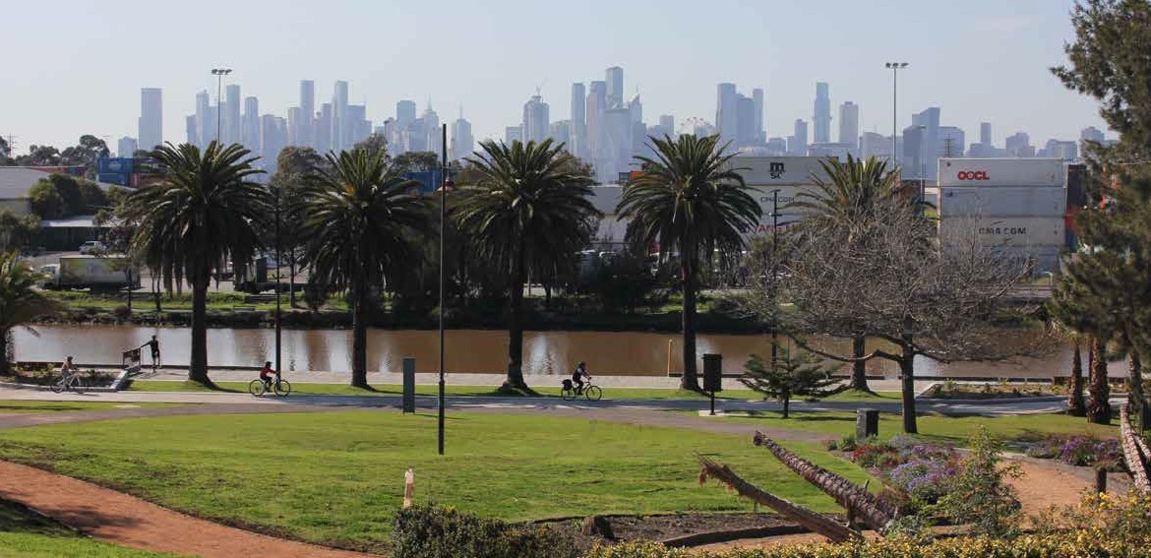

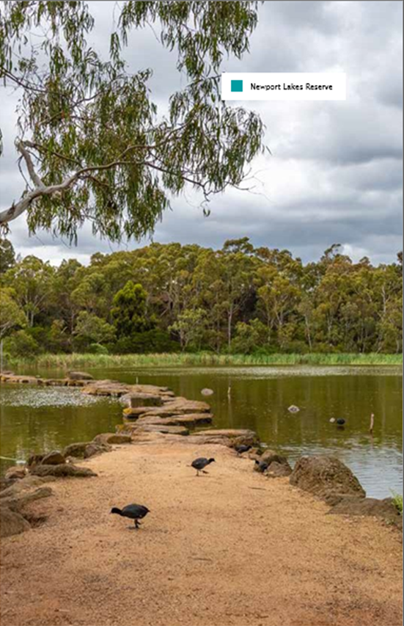

Accessible version

of the document

Please email Department of Transport and Planning

to obtain an accessible version of this document

[**community@transport.vic.gov.au**](mailto:community@transport.vic.gov.au)

Authorised by the Victorian Government, Melbourne.

1 Spring Street Melbourne Victoria 3000

Telephone (03) 9655 6666.

Designed and published by the

Department of Transport and Planning.

Contact us if you need this information in an

accessible format such as large print or audio,

please telephone (03) 9655 6666 or email

[**community@transport.vic.gov.au**](mailto:community@transport.vic.gov.au)

© Copyright State of Victoria

Department of Transport and Planning

Except for any logos, emblems, trademarks,

artwork and photography this document is made

available under the terms of the Creative Commons

Attribution 3.0 Australia licence.

Acknowledgement

of Country

The Department of Transport and Planning

proudly acknowledges Victoria’s Aboriginal

communities and their ongoing strength

in practicing the world’s oldest living

culture. We acknowledge the Traditional

Owners of the lands and waters on which

we live and work, and pay our respect

to their Elders past and present.

Taking action to improve   
air quality in the inner west

The Victorian

Government is

investing $20 billion

in infrastructure

and development

in Melbourne’s west

to create a better place

to live, work and raise

our families.

The transport challenges in this

growing and changing area are

complex and need a coordinated

response across government.

Our vision for the inner west is to

improve air quality and liveability

by reducing heavy vehicle

movements through local streets

and supporting low and

zero-emissions vehicles and

active transport options.

As a government, we know we can

achieve much more when we work

in partnership – with industry, with

our communities and with our peers

at all levels of government.

We want to acknowledge the

constructive and collaborative way

in which it’s come about – from

the Victorian Government, local

community groups and residents,

to the Victorian Transport

Association, the National Heavy

Vehicle Regulator and local

Councils – there’s been great

cooperation and commitment

to get things done.

We’re creating freight connections

for cleaner trucks, shifting more

freight to rail, and improving access

to the port to meet our growing

freight task.

The actions we’re delivering – from

planning and strategies, to trials to

reduce emissions and projects to

enhance communities and improve

health and wellbeing– will make a

difference now, but also stand us in

good stead for when the West Gate

Tunnel opens in 2025.

The inner west of Melbourne’s

proximity to the Port of

Melbourne and the high number

of warehousing and logistics

businesses in the area generate a

large volume of heavy truck traffic.

We recognise the need to balance

the priorities of residents, local road

users and heavy vehicles on the

transport network.

Since 2001, the Department

of Transport and Planning has

implemented a number of time

and mass-based curfews across

the inner west to reduce the

impacts of these vehicles on the

local community.

The Victorian Government will

introduce 24-hour truck bans

on six local roads when the

West Gate Tunnel project

is completed in 2025.

Timeline

**July 2018**

The Inner West Air Quality

Community Reference Group

(CRG) established

**March 2020**

The CRG submitted its final

report to Government

**April 2020 – January 2021**

A Government Committee was

convened to review and respond

to the report

**September 2020**

CRG Report was publicly released on

Department of Energy, Environment

and Climate Action’s website

**May 2021**

The Victorian Government

presented to the CRG on the work

underway to improve air quality

in the inner west

**July 2021**

Government formal written response

was circulated to the CRG

**August 2022**

Government presented a progress

update to the newly formed Inner

West Air Quality Network

**October 2022**

Victoria’s Air Quality

Strategy released

Actions we’re taking to improve air quality in the inner west

1. Modernising our truck fleet

We’ve allocated $15 million for upgrading the truck fleet travelling through the inner west to the port. And $5 million has been set aside for councils to seal roads that carry traffic in or near industry, which will reduce dust pollution.

1. Best Practice guidelines for green vegetation projects

We’re developing best practice guidelines for the roll out of green vegetation projects across the west. These guidelines will help the rollout of local projects that include planting trees and vegetation along busy roads. The goal is to enhance air quality for local residents.

1. Targeting childhood asthma

We’re investing $1.788 million to support local childhood asthma projects. This is part of our strategy to improve the management of childhood asthma in the inner west.

1. Truck curfews

To reduce the impacts trucks on the people living in Footscray, Yarraville, Seddon, and Kingsville, we’ve introduced restrictions on when and where heavy trucks can operate.

1. A truck curfew guide for drivers

A new guide to educate truck drivers about where and when they can travel through the inner west, and to help industry better plan their journey. Now available in six community languages.

1. More trees for a greener, cooler west

In Melbourne’s West, we have already planted 192,000 trees as part of our ambitious plan to plant more 500,000 trees. This includes the establishment of an urban forest in Brooklyn, featuring 3,000 trees. This will help create shaded and cooler neighbourhoods for residents in the west.

1. Greening Brooklyn

Revitalising the Federation Trail route through Pipeline Reserve with landscaping, tree planting, and footpaths under a $500,000 fund from the West Gate Tunnel Neighbourhood Fund. The project also gives young people employment opportunities.

1. Zero-emission bus trials

Victoria’s Bus Plan trial includes two hydrogen and 50 electric buses on 15 school services and 26 routes in Melbourne’s inner west, including Footscray, Sunshine, Yarraville, Newport, and Williamstown. The trial is a partnership between bus services, manufacturers, and energy companies to shift to a green fleet.

1. Support ports to drive supply chains to lower emissions

Victoria’s Commercial Ports Strategy will help the sector support the state’s renewable energy targets and transition to net zero emissions. The Port of Melbourne’s green methanol fuel plans and decarbonization efforts are gaining momentum.

1. Air quality improvement precincts

Two Air Quality Improvement Precincts will be established in the inner and outer west with $2.84 million funding. These precincts aim to reduce air pollution and tackle environmental challenges in collaboration with the community and business.

1. New air monitoring

Six air quality monitoring stations near to the West Gate Tunnel project have been set up to record local air quality. Air quality is being monitored now and up to five years after the tunnel opens. The results are helping find the best solutions for managing air quality and emissions.

1. Heavy Better heavy vehicle signage

New heavy vehicle signs have been installed in Yarraville, West Footscray, Kingsville, and Footscray to inform truck drivers about the existing truck curfews and restrictions. This effort is aimed at improving safety for pedestrians, cyclists, and drivers.

1. Heavy vehicle monitoring camera trial

An innovative heavy vehicle monitoring camera trial is underway, with cameras set up on Somerville Road, Hudsons Road, and Moore Street. These cameras use video analytics technology to capture truck compliance data and help ensure the ongoing safety and well-being of the community.

1. Direct rail link to the port

The $58 million Port Rail Shuttle Network includes a direct link from the SCT Logistics hub at Altona to the port. This will benefit local residents by reducing emissions and decreasing the number of trucks on the roads.

1. New uses for old Melbourne Market site

Re-purpose a site near the port for more freight and transport uses such as truck marshalling and empty container storage, container handling, a truck rest and refuelling stop and an urban freight consolidation, to reduce reliance on the inner west for these services.

1. New pedestrian fences have been installed near schools

New fences have been installed on Wembley Avenue and Hyde Street in Yarraville to improve safety for children and their parents traveling to school. Other measures have been taken to reduce truck noise and a 50km/h speed limit has been implemented on Williamstown Road, Francis Street, Moore Street, and Buckley Street.

1. New and improved pop-up bike routes across inner west

$5.6 million has been allocated to develop cycling and shared use paths in the west. We’re testing new pop-up bike routes in Footscray, Seddon, and Yarraville, making it easier and safer to travel by bike.

1. Improving busy intersections

We’re investing $3.14 million to improve safety for pedestrians accessing Footscray Station and Footscray Market. Moore Street and Hopkins Street intersection will be realigned with new crossings, lights, and safety features. A new 40km/h speed limit has been announced for Moore Street.

1. West Gate Tunnel

The West Gate Tunnel project will help reduce congestion, give a dedicated heavy vehicle link to the port, and connect people to jobs, education, and services.

1. Truck bans

The West Gate Tunnel Project aims to offer a vital alternative to the West Gate Bridge, providing faster and safer journeys. As part of this project, there will be 24-hour truck bans on six local streets, and more than 9,000 trucks will be removed from the inner west.

Next steps to lift air quality across Victoria

1. Net-zero transport emissions

We have committed to bringing forward the target for achieving net-zero emissions from 2050 to 2045 to reduce emissions, enhance communities, and improve health.

1. Victoria’s Air Quality Strategy

The Air Quality Strategy of Victoria outlines our approach to reduce air pollution and address major sources of pollution while also supporting the community, the economy, and the environment.

Download report here: [Victorian Air Quality Strategy (environment.vic.gov.au)](https://www.environment.vic.gov.au/sustainability/clean-air-for-all-victorians)

1. New interstate rail freight terminal in Truganina

We’ve allocated $6.1 million for planning a new interstate rail freight terminal in Truganina. This will allow rail freight services to be moved away from South Dynon, reducing the need for goods to be transported through inner west in the future.

1. More freight on rail

We’ve invested $181 million in rail freight maintenance, in addition to $83 million in COVID-19 stimulus funding to improve rail freight lines. This investment aims to shift more freight from trucks to rail.

1. Port transformation rail project

The $125 million project aims to make freight rail transport more competitive and reduce truck congestion at the port. It will serve as a key connection for moving freight on rail from regional Victoria to the port, helping reduce truck traffic on local roads.

1. Better sites for empty container parks

To improve the liveability in inner west, the plan is to place industry closer to transport connections and key freight hubs. This approach will significantly reduce the freight industry’s reliance on Brooklyn and Tottenham for port access.

1. Cleaner vehicles

We’ve pledged $100 million to the transport sector to support zero emissions vehicles, which includes an innovation fund, government fleet cars, and fast charging networks. The innovation fund includes an electric cement truck trial, electric vehicles for share ride services and postal delivery vehicles. This will not only benefit the environment but also improve residents’ health.

1. Hume Hydrogen Highway trial

Victoria and NSW have committed $10 million to deliver the Australia’s first renewable hydrogen refuelling station. This will help to reduce emissions and meet our new target of net zero by 2045.

[transport.vic.gov.au](http://transport.vic.gov.au/)