High Capacity Metro Trains Project Design engagement Conversation summary - January 2018

Table of Contents
How hundreds of people helped design Melbourne’s new train 1
The Victorian Government is delivering a fleet of 65 new High Capacity Metro Trains to meet the future needs of Melbourne. 1
Snapshot of stakeholder engagement 2
Stakeholders who participated in the design of Melbourne’s new train 2
The engagement program 3
Further steps we took 4
Outcomes of the passenger engagement 5
Passenger group feedback 6
Next steps 6

How hundreds of people helped design Melbourne’s new train
The Victorian Government entered into a public private partnership with Evolution Rail to deliver the High Capacity Metro Trains Project. Evolution Rail worked closely with the Victorian Government to design and deliver stakeholder engagement to input into the train design program.

The Victorian Government is delivering a fleet of 65 new High Capacity
Metro Trains to meet the future needs of Melbourne.
Melbourne’s public transport users and technical and operational stakeholders worked with us from day one on the train design process.
With seven carriages, more seats than existing trains, and the capacity to carry 20 per cent more passengers, Melbourne’s new trains will offer the latest technology for passenger comfort, accessibility and safety.
The new trains will start operating on the Cranbourne and Pakenham lines from mid-2019. Longer term, they will run through the Metro Tunnel to Sunbury.
The new trains will deliver:
- a smoother, quieter and more comfortable ride with improved seating and standing areas
- improved accessibility features including:
  - priority seating throughout the train, located close to doorways and windows
  - two mixed-use spaces in each of the middle three carriages for passengers travelling with bicycles, prams and other large items.
- improved real-time information through dynamic route maps and passenger information displays
- improved passenger safety, with greater CCTV surveillance
- cooling and heating appropriate for Melbourne conditions.
Our priority is to design a train to meet everyone’s access needs. Consultation with passenger groups was therefore a critical part of the overall engagement program.
In three phases of consultation from March – October 2017 we received 2,525 pieces of feedback. Of these, 873 comments came from passengers and as a result we made 157 changes to the design of passenger features for the new trains.

Snapshot of stakeholder engagement
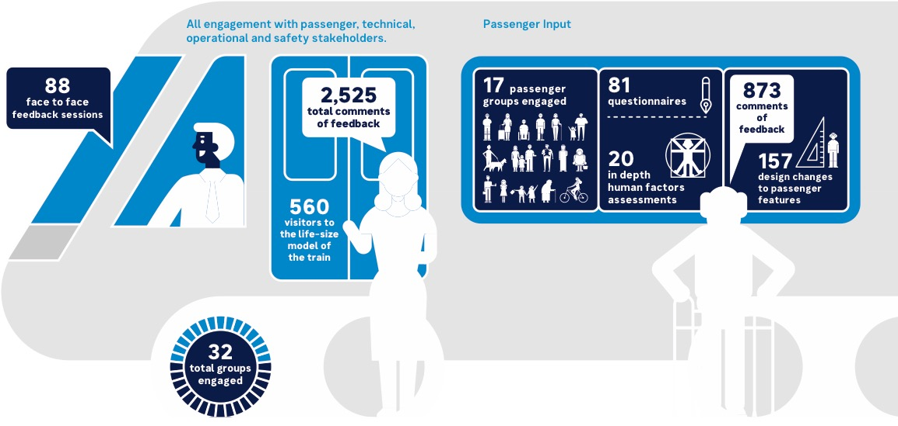

Stakeholders who participated in the design of Melbourne’s new train

Passenger groups
All Aboard network
Bicycle Network
Blind Citizens Australia
Communication Rights Australia
COTA Victoria
Focus groups comprising members of the community
Guide Dogs Victoria
Metropolitan Transport Forum (MTF)
MOVE
Scope
Spina Bifida Foundation Victoria
Public Transport Access Committee
Public Transport Users Association (PTUA)
Vicdeaf
Victorian Advocacy League for Individuals with Disability (VALiD)
Vision Australia
Yooralla
Focus group participants represented different demographics, physical attributes and frequency of train travel.

Technical, operational and safety stakeholders
Ambulance Victoria
Country Fire Authority
Drivers
Level Crossing Removal Authority
Melbourne Metropolitan Rail Authority
Metropolitan Fire Brigade
Metro Trains Melbourne
Office of the National Rail Safety Regulator
Protective Services Officers
Public Transport Victoria
Relevant Unions
VicTrack
Victoria Police
Victoria State Emergency Service
V/Line

The engagement program
In the first three phases of engagement, stakeholders and representatives from the community:
- Told us about the features of a train that are important to them. We used this feedback to inform preliminary design options.
- Commented on a 3D, computer generated model of the new train and viewed which features we had included from our initial discussions. We used this feedback to finalise features for all passenger groups to review in a life-size model of the train.
- Experienced the intended features of the train in a 40 metre, life-size model of selected carriages. We used this feedback to refine the passenger features in the final train design.
The final stage of engagement in early 2018 allows all stakeholders and the general public to view the final model of Melbourne’s new train before manufacturing begins.
Number of passenger comments during the engagement program (excludes comments from technical, operational and safety stakeholders)
Concept Design 174
3D Model Train Review 95
Evaluation of Life-Size Model Train 604
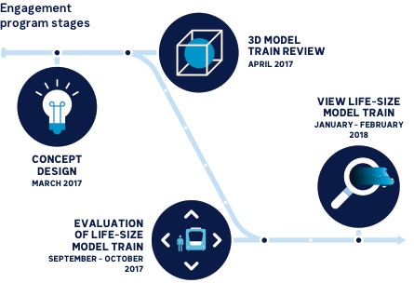

Further steps we took
Passengers are influenced by a wide range of physical and psychological factors when boarding and travelling on trains.
- We used qualified professionals to evaluate how passengers, including those with accessibility needs, interacted with proposed passenger features within the life-size model of the train. Outcomes of those assessments were used to verify or recommend changes to passenger features.
- We conducted a usability test in the life-size model of the train with around 100 people representing all passengers. From this we could understand how the passenger features of the new train would work in practice with real passengers in real life scenarios. We included a mix of passengers in these scenarios, including people with different body types, people travelling with mobility aids, people with vision and hearing impairments, parents with young children, regular commuters and infrequent travellers.
- Passengers evaluated the safety of boarding in both evening and daylight conditions.
All passenger groups recognised that some features that are important to them may conflict with the things that are important to others. Our conversations helped to identify what these key areas may be.
- We worked with the Public Transport Access Committee (PTAC) to consult on the approach for engaging all accessibility advocacy groups and presented feedback at each phase of engagement. PTAC assisted us to evaluate and resolve areas where we received conflicting information.
We received a great deal of feedback relating to the interior signage that is used within trains, particularly from passengers with accessibility requirements.
- We’ve formally engaged experts to help us to make the interior signage accessible to all passengers.

Outcomes of the passenger engagement
Many new features were incorporated into the design of Melbourne’s new train as a result of the feedback from passenger groups.
Train interiors:
- All passengers supported the use of a colour scheme for priority seating that is consistent across Melbourne’s public transport network, and specified the importance of ensuring that it is easy to distinguish priority seating from general seating. This feedback led to a change in the colour scheme for priority seating.
- Passengers requested sufficient space underneath the seats to store bags in order to keep the aisle clear for standing passengers. Groups representing passengers with vision impairment advised that guide dogs are trained to sit under the seats of owners while travelling. The support structure for seating was modified and additional flip down priority seating was added in response.
- All passengers reviewed, and helped us to refine the design of passenger information screens and dynamic route maps.
- Passenger groups and accessibility advocacy groups supported the inclusion of wide aisles and a non-slip floor.
New multi-use zones for passengers who travel with bicycles, prams and other large items:
- Straps for securing bicycles were evaluated and supported by groups representing passengers and cyclists.
- Passenger groups recommended large exterior signage on the outside of carriages that have multi-use zones. This will make it easier for passengers to find the correct doors when boarding with bicycles, prams and other large items.
Hand holds, hand straps and rails:
- Passengers supported the use of a mix of hand holds in order to cater for standing passengers of all heights. Ceiling mounted rails, hand straps, seat mounted hand holds and poles for passengers that are not able reach the higher hand-holds and rails were included in the design.
- All passengers, including those with vision impairments and accessibility requirements advised on the use of rails in priority seating areas and on the back of seats to assist all passengers in finding seats, travelling safely, and moving from seating areas to the doors.
- Passengers supported the inclusion of hand rails to assist passengers as they move between the carriages of the train.
- Feedback from passengers led to the relocation of hand straps so that standing passengers don’t encroach on the space of seating passengers.
- Passengers evaluated and supported the inclusion of hand rails to assist with stepping onto and off the train.
- All passengers told us that a vertical pole in the boarding vestibule was a good outcome for standing passengers, although the difficulty that it presented for the vision impaired and passengers in wheelchairs and mobility scooters was noted. We will continue to discuss if and where a centre pole is to be used in the train design. The train will be designed to allow for both options.
Accessibility features:
- Discussion with groups representing passengers with vision impairments led to a change in design so that all hand holds, hand straps and rails are yellow, providing maximum contrast against seats and other fittings of the train.
- Passengers that travel in wheelchairs and mobility devices provided guidance on the location of grab rails in allocated spaces.
- Passengers advised on the types of door buttons and the location and colour of passenger intercom buttons that are to be installed in each allocated space.
- Passenger evaluation of boarding ramps led to modifications in the design for improved stability and manoeuvrability.
- All passengers stressed the importance of being able to distinguish train doorways for safe boarding. All groups evaluated and advised on two door options, leading to the inclusion of a high contrast yellow border around the door frame.
- Passengers supported the positioning of priority seating next to allocated spaces, which provides seating for carers that accompany those who travel in wheelchairs or mobility devices.

Passenger group feedback
We asked participants what they thought about the consultation process and this was the feedback:
79 per cent of participants told us the overall engagement program was either ‘excellent’ or ‘very good’.
72 per cent of participants told us it was either the first time they have been asked for input so early in the design process, or the earliest they have ever been asked to provide input in a consultation program.
77 per cent of participants told us they felt proud to be playing a role in designing a train to suit the needs of all Victorians. A further 23 per cent of participants told us they felt they were having an impact on public transport in Victoria.

Next steps
We would like to thank everyone for the time and commitment they brought to the year-long train design engagement program.
The new trains will start to run on the Cranbourne and Pakenham lines from mid-2019. Longer term they will run through the Metro Tunnel to Sunbury.

End of January 2018
Final viewing of life-size model of Melbourne’s new train

February 2018
Public display of Melbourne’s new train
For further information on the High Capacity Metro Trains Project visit:
transport.vic.gov.au/biggertrains
Published by the Department of Economic Development, Jobs, Transport and Resources.
Melbourne January 2018
© State of Victoria (DEDJTR) 2018
The copyright in this document is owned by the State of Victoria, or in the case of some materials, by third parties (third party materials). No part may be reproduced by any process except in accordance with the provisions of the Copyright Act 1968 or with permission.
Authorised by the Department of Economic Development, Jobs, Transport and Resources.
1 Spring Street Melbourne, Victoria, 3000.

