

|  |
| --- |
| How to register for the Grants Gateway |
|  |
|  |

Contents

Step 1. Register 1

Step 2. Enter Details 2

Step 3. Confirm Email Address 2

Step 4. Choose Password 2

# Step 1. Register

Select **New? Register here**

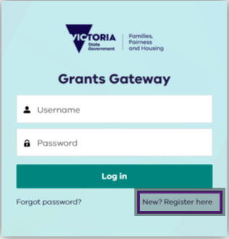

# Step 2. Enter details

Enter account details (salutation, first name, last name, email, phone number) and select **Sign Up.**

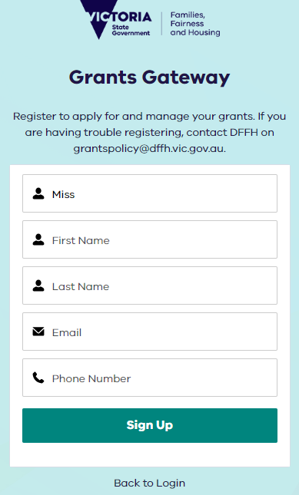

# Step 3. Confirm email address

Check for a confirmation email for the registered account. Open your email inbox and search for subject line ‘Welcome to Grants Gateway’ [email from No Reply Salesforce](mailto:noreply@salesforce.com) <noreply@salesforce.com> on behalf of Grants Gateway.

**Select the link** in the email to confirm your account.

Final steps of the Grants Gateway registration process for the Victorian Governments Department of Families, Fairness and Housing. Directs user to check their email to choose a password.  Confirmation email after registering for the Grants Gateway for the Victorian Governments Department of Families, Fairness and Housing. The email includes a link for the user to choose their password. 

# Step 4. Choose password

Create a password for your account. The password must be:

* 13 characters
* 1 letter
* 1 number
* 1 special character

Confirm your password by retyping it and then select **Change Password.**

You now have access to Grants Gateway

Password setting page for access the Grants Gateway for the Victorian Governments Department of Families, Fairness and Housing. Outlines the password requirements and instructions set and confirm the password. 

|  |
| --- |
| To receive this document in another format, [email Grants Policy](mailto:grantspolicy@dffh.vic.gov.au) grantspolicy@dffh.vic.gov.au  Authorised and published by the Victorian Government, 1 Treasury Place, Melbourne.  © State of Victoria, Australia, Department of Families, Fairness and Housing, August 2023.  Available at [Grants Gateway](https://grantsgateway.dffh.vic.gov.au/) https://grantsgateway.dffh.vic.gov.au/  (2308554) |