Use this form to apply for an authorisation to disturb koalas during plantation management operations

General information
Koalas (Phascolarctos cinereus) are protected in Victoria under the Wildlife Act 1975. Authorisation is required to disturb koalas during plantation management operations in blue gum (Eucalyptus globulus) plantations.
Where koalas are impacted without an authorisation, sanctions for illegally harming wildlife may apply.
The Conservation Regulator is the independent regulator of the Department of Energy, Environment and Climate Action (DEECA). It oversees DEECA’s regulatory functions of timber harvesting, biodiversity, fire prevention and public land-use.
Further information about who should apply, the legislative and regulatory framework and how to comply is available in the regulatory framework for the protection of koalas in blue gum plantations, which is available at vic.gov.au/koalas-blue-gum-plantations.
In addition to this application form, applicants seeking an authorisation to disturb koalas during plantation management operations must also submit a Koala Management Plan which meets the requirements outlined in the Koala Management Plan template. A copy of the template is available at vic.gov.au/koalas-blue-gum-plantations.

Your obligations
If an authorisation is issued by the Conservation Regulator, all plantation management operations within blue gum plantations in Victoria must be conducted in accordance with the conditions of the authorisation and that Koala Management Plan.
The Conservation Regulator will monitor compliance, including through data collection and inspections. Failure to comply with the conditions of the authorisation or the recognised Koala Management Plan may result in suspension or cancellation of your authorisation and/or compliance action being taken by the Conservation Regulator.

Other permission
An authorisation under section 28A(1A) of the Wildlife Act 1975 to disturb koalas during plantation management operations does not absolve the need to comply with any other laws of Victoria, your local government or the Commonwealth.

Application process
Applications can be lodged by emailing the completed application form and Koala Management Plan to your local Region – contacts are listed below. The Conservation Regulator will review the application to determine whether an authorisation to disturb koalas during plantation management operations should be granted.
If your application is incomplete or your Koala Management Plan does not meet the requirements set by the Conservation Regulator, then the application will be returned to you for revision and resubmission.
Please allow up to six weeks for your application to be processed. Please note – this is from the time of receipt of a complete application. If the Conservation Regulator requests further information, additional time will be required to process your application. For faster processing, you are encouraged to submit your application via email, as application forms returned via post may be subject to delays greater than 6 weeks.
For further information on the application process, please email your local regional contact as listed below.
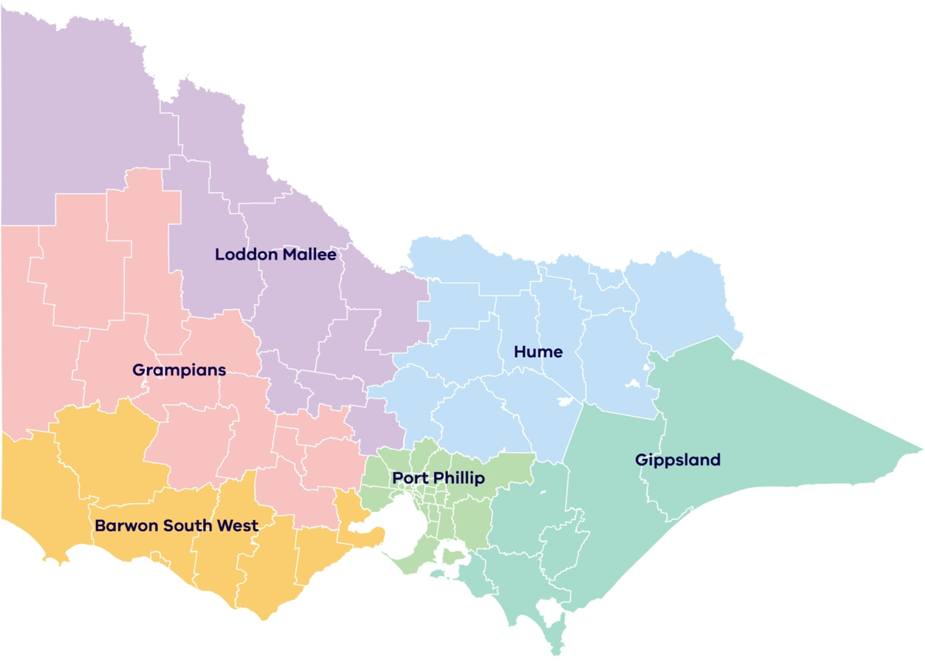
Port Phillip  permissions.portphillipregion@delwp.vic.gov.au  Permissions Lead  DEECA  Private Bag 15  Ferntree Gully Delivery Centre VIC 3156 | Barwon South West  barwonsouthwest.cr@delwp.vic.gov.au  Permissions Lead  DEECA  PO Box 115  Colac VIC 3250 | Grampians  grampians.cr@delwp.vic.gov.au  Permissions Lead  DEECA  402 Mair St  Ballarat VIC 3350
Hume  hume.cr@delwp.vic.gov.au  Permissions Lead  DEECA  1683 Healesville – Kinglake Road  Toolangi VIC 3777 | Gippsland  gippsland.cr@delwp.vic.gov.au  Permissions Lead  DEECA  574 Main Street  Bairnsdale VIC 3875 | Loddon Mallee  permissions.lm@delwp.vic.gov.au  Permissions Lead  DEECA  PO Box 3100  Bendigo Delivery Centre  Bendigo VIC 3551

Application for authorisation to disturb koalas during plantation management operations body corporate
- Body corporate details
REGISTERED COMPANY NAME
TRADING NAME
AUSTRALIAN COMPANY NUMBER (acn) AUSTRALIAN BUSINESS NUMBER (ABN)
- Postal address for all notices under this authorisation
street/building number Street name
City/Suburb/Town Postcode
- Business operating address
STREET/BUILDING NUMBER Street name
City/Suburb/Town Postcode
- Nominated contact
This is an employee nominated by the body corporate to be the main contact for DEECA in relation to the Authorisation. DEECA must be notified via email within five (5) business days if this person changes.
first name other name/s family names
role title telephone mobile
email

Nominee’s business address if different from business operating address
STREET/BUILDING NUMBER Street name
City/Suburb/Town postcode

Office use only
Date received Date actioned Date further information req’d
Date application complete Action officer File number
- Additional information that must be submitted with this application form
In addition to this application form, applicants seeking an authorisation to disturb koalas during plantation management operations must also submit a Koala Management Plan which meets the requirements outlined in the Koala Management Plan template. A copy of the template is available at vic.gov.au/koalas-blue-gum-plantations
- Collection, use and disclosure of personal and business contact information

Privacy and Data Protection Act 2014
DEECA is committed to protecting personal information provided by you in accordance with the principles of the Victorian privacy laws. The information you provide will be used to monitor compliance with permit conditions and to provide information about any changes to legislative requirements. Your contact details may also be used by DEECA or its contracted service providers under confidentiality agreements to survey you about your experience with DEECA. An authorisation may not be issued if the information required is not provided.
The information you provide will also be made available to any authorised law enforcement agency.
You may access the information you have provided to DEECA by contacting the Customer Service Centre on 136 186.
- Declaration by Person/s authorised to make this application
I,
name of authorised person
being the person ultimately responsible for the actions of the body corporate applying for this authorisation to disturb koalas during plantation management operations, acknowledge that it is an offence under section 58B of the Wildlife Act 1975 to provide false or misleading information in, or in connection with the application for an authorisation to disturb koalas during plantation management operations and I state that the information that I have provided is true and correct.
Authorised person’s signature Date

- Checklist
 | Koala Management Plan | A Koala Management Plan must be submitted with your application, and must meet the requirements outlined in the template, which is available at vic.gov.au/koalas-blue-gum-plantations
 | Application is completed and signed | Ensure all fields on your application are completed and your application has been signed by the person/s authorised to make the application.

Once your application has been completed and signed, please submit it to your local DEECA Office.

