Public Transport Victoria
Metropolitan Train Load Standards
Survey Report
May 2016

Table of Contents
1. Introduction 4
2. Network-wide results 5
2.1. AM Peak 5
2.2. PM Peak 6
3. Alamein line results 7
3.1. AM Peak 7
3.2. PM Peak 8
4. Glen Waverley line results 9
4.1. AM Peak 9
4.2. PM Peak 10
5. Ringwood corridor results 11
5.1. AM Peak 11
5.2. PM Peak 12
6. Dandenong corridor results 13
6.1. AM Peak 13
6.2. PM Peak 14
7. Frankston line results 15
7.1. AM Peak 15
7.2. PM Peak 16
8. Sandringham Line 17
8.1. AM Peak 17
8.2. PM Peak 18
9. South Morang line results 19
9.1. AM Peak 19
9.2. PM Peak 20
10. Hurstbridge line results 21
10.1. AM Peak 21
10.2. PM Peak 22
11. Craigieburn line results 23
11.1. AM Peak 23
11.2. PM Peak 24
12. Sunbury line results 25
12.1. AM Peak 25
12.2. PM Peak 26
13. Upfield line results 27
13.1. AM Peak 27
13.2. PM Peak 28
14. Werribee line results 29
14.1. AM Peak 29
14.2. PM Peak 30
15. Williamstown line results 31
15.1. AM Peak 31
15.2. PM Peak 32
16. Notes about the survey 33

Introduction
Metropolitan Train Load Standard Surveys are conducted once a year in May to measure passenger loads against benchmark standards of capacity.
The survey’s findings help pinpoint the times when and on which sections of Melbourne’s 15 rail lines passenger loads are at their highest. The results are used to determine when and where extra services may be needed to reduce crowding.
This bulletin reports on the May 2016 survey which was conducted from 2 to 25 May 2016.

Network-wide results
  - AM Peak
- The May 2016 survey recorded a total of 51 services in breach in the AM Peak period. This is an increase of 4 compared to the May 2015 survey when 47 breaches were observed.
- Between May 2015 and May 2016, no net additional services were added to the Network during the AM Peak.
- The percentage of passengers travelling on services exceeding the benchmark on the Network during the AM Peak period increased from 26.1 per cent to 27.7 per cent between May 2015 and May 2016.
Figure 1: Number of AM Peak services below and above benchmark levels (May 2011 to May 2016)
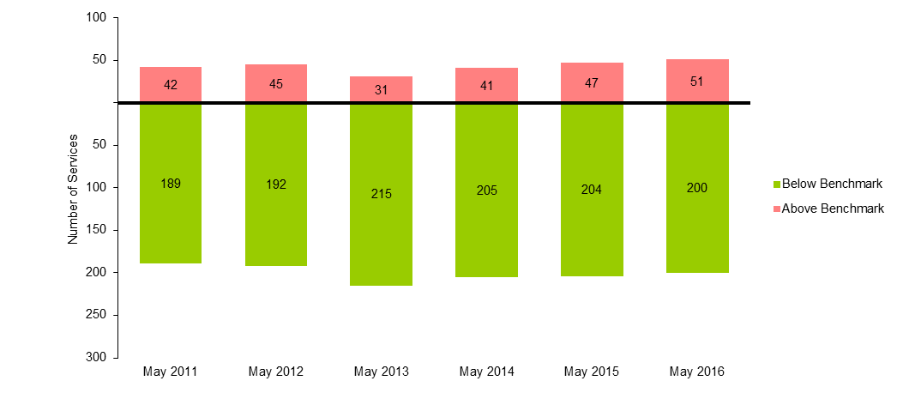
Table 1: AM Peak services above benchmark levels and percentage of passengers travelling on services above benchmark levels (May 2011 to May 2016)
 | May 2011 | May 2012 | May 2013 | May 2014 | May 2015 | May 2016
Number of AM Peak Services Above Benchmark | 42 | 45 | 31 | 41 | 47 | 51
% of AM Peak Services Above Benchmark | 18.2% | 19.0% | 12.6% | 16.7% | 18.7% | 20.3%
% of AM Peak Passengers on Services Above Benchmark | 25.8% | 26.1% | 17.8% | 22.2% | 26.1% | 27.7%
  - PM Peak
- The May 2016 survey recorded a total of 22 services in breach in the PM Peak period. This is a decrease of 8 compared to the May 2015 survey when 30 breaches were observed.
- Between May 2015 and May 2016, no net additional services were added to the Network during the PM Peak.
- The percentage of passengers travelling on services exceeding the benchmark on the Network during the PM Peak period decreased from 15.6 per cent to 11.2 per cent between May 2015 and May 2016.
Figure 2: Number of PM Peak services below and above benchmark levels (May 2011 to May 2016)
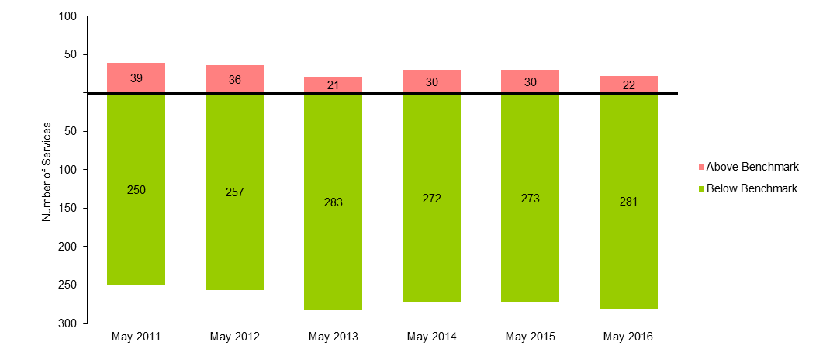
Table 2: PM Peak services above benchmark and passengers using services above benchmark (May 2011 to May 2016)
 | May 2011 | May 2012 | May 2013 | May 2014 | May 2015 | May 2016
Number of PM Peak services above benchmark | 39 | 36 | 21 | 30 | 30 | 22
% of PM Peak services above benchmark | 13.5% | 12.3% | 6.9% | 9.9% | 9.9% | 7.3%
% of PM Peak passengers on services above benchmark | 23.0% | 20.2% | 11.7% | 15.6% | 15.6% | 11.2%

Alamein line results
  - AM Peak
- The May 2016 survey recorded a total of 0 services in breach in the AM Peak period. This is the same result compared to the May 2015 survey.
- Between May 2015 and May 2016, no additional services were added to the Alamein Line during the AM Peak.
- The percentage of passengers travelling on services exceeding the benchmark on the Alamein Line during the AM Peak period stayed constant at 0 per cent during both May 2015 and May 2016.
Figure 3: Number of AM Peak services below and above benchmark levels (May 2011 to May 2016)
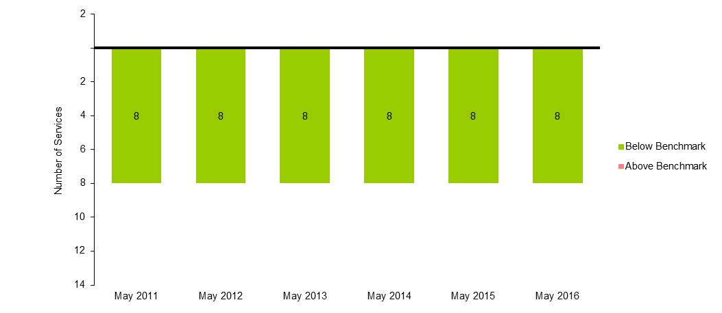
Table 3: AM Peak services above benchmark levels and percentage of passengers travelling on services above benchmark levels (May 2011 to May 2016)
 | May 2011 | May 2012 | May 2013 | May 2014 | May 2015 | May 2016
Number of AM Peak services above benchmark | 0 | 0 | 0 | 0 | 0 | 0
% of AM Peak services above benchmark | 0.0% | 0.0% | 0.0% | 0.0% | 0.0% | 0.0%
% of AM Peak passengers on services above benchmark | 0.0% | 0.0% | 0.0% | 0.0% | 0.0% | 0.0%
  - PM Peak
- The May 2016 survey recorded a total of 0 services in breach in the PM Peak period. This is the same result compared to the May 2015 survey.
- Between May 2015 and May 2016, no additional services were added to the Alamein Line during the PM Peak.
- The percentage of passengers travelling on services exceeding the benchmark on the Alamein Line during the PM Peak period stayed constant at 0 per cent during both May 2015 and May 2016.
Figure 4: Number of PM Peak services below and above benchmark levels (May 2011 to May 2016)
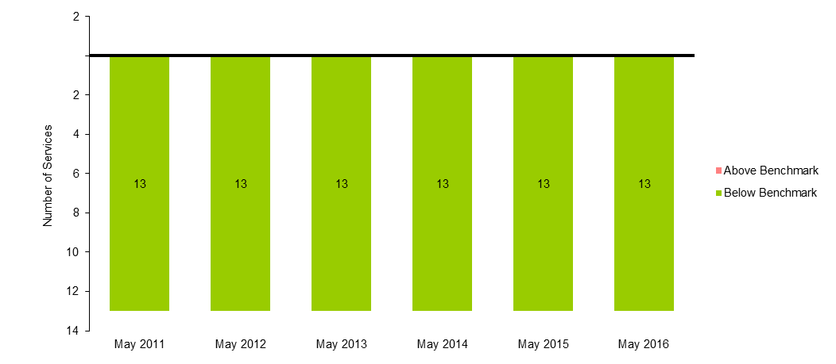
Table 4: PM Peak services above benchmark and passengers using services above benchmark (May 2011 to May 2016)
 | May 2011 | May 2012 | May 2013 | May 2014 | May 2015 | May 2016
Number of PM Peak services above benchmark | 0 | 0 | 0 | 0 | 0 | 0
% of PM Peak services above benchmark | 0.0% | 0.0% | 0.0% | 0.0% | 0.0% | 0.0%
% of PM Peak passengers on services above benchmark | 0.0% | 0.0% | 0.0% | 0.0% | 0.0% | 0.0%

Glen Waverley line results
  - AM Peak
- The May 2016 survey recorded a total of 0 services in breach in the AM Peak period. This is the same result compared to the May 2015 survey.
- Between May 2015 and May 2016, no additional services were added to the Glen Waverley Line during the AM Peak.
- The percentage of passengers travelling on services exceeding the benchmark on the Glen Waverley Line during the AM Peak period stayed constant at 0 per cent during both May 2015 and May 2016.
Figure 5: Number of AM Peak services below and above benchmark levels (May 2011 to May 2016)
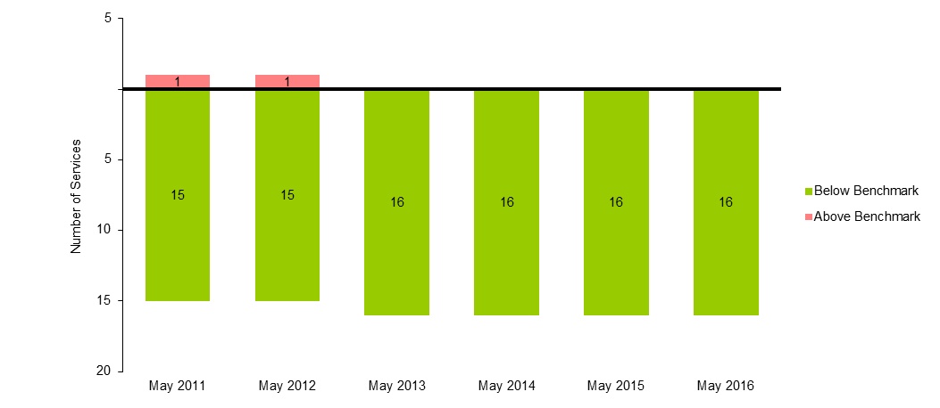
Table 5: AM Peak services above benchmark levels and percentage of passengers travelling on services above benchmark levels (May 2011 to May 2016)
 | May 2011 | May 2012 | May 2013 | May 2014 | May 2015 | May 2016
Number of AM Peak services above benchmark | 1 | 1 | 0 | 0 | 0 | 0
% of AM Peak services above benchmark | 6.3% | 6.3% | 0.0% | 0.0% | 0.0% | 0.0%
% of AM Peak passengers on services above benchmark | 8.8% | 9.5% | 0.0% | 0.0% | 0.0% | 0.0%
  - PM Peak
- The May 2016 survey recorded a total of 0 services in breach in the PM Peak period. This is the same result compared to the May 2015 survey.
- Between May 2015 and May 2016, no additional services were added to the Glen Waverley Line during the PM Peak.
- The percentage of passengers travelling on services exceeding the benchmark on the Glen Waverley Line during the PM Peak period stayed constant at 0 per cent during both May 2015 and May 2016.
Figure 6: Number of PM Peak services below and above benchmark levels (May 2011 to May 2016)
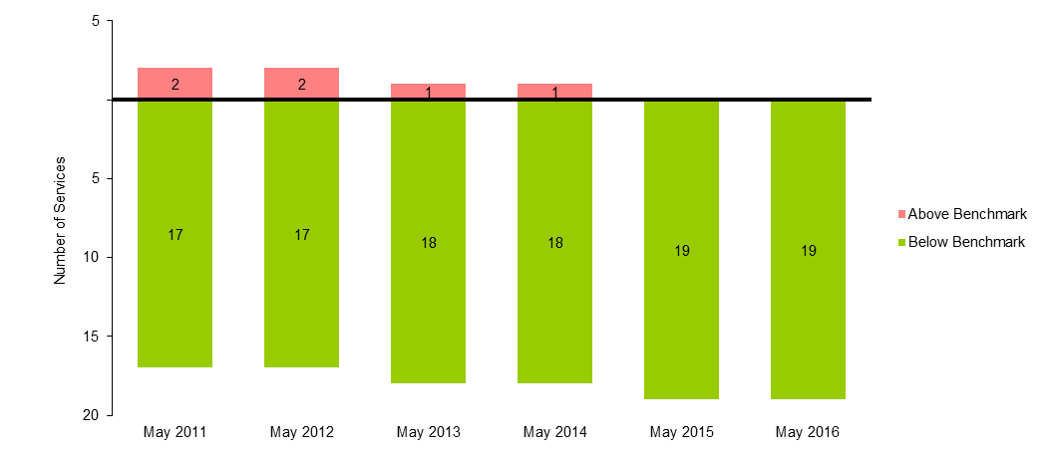
Table 6: PM Peak services above benchmark and passengers using services above benchmark (May 2011 to May 2016)
 | May 2011 | May 2012 | May 2013 | May 2014 | May 2015 | May 2016
Number of PM Peak services above benchmark | 2 | 2 | 1 | 1 | 0 | 0
% of PM Peak services above benchmark | 10.5% | 10.5% | 5.3% | 5.3% | 0.0% | 0.0%
% of PM Peak passengers on services above benchmark | 17.6% | 17.5% | 9.6% | 8.8% | 0.0% | 0.0%

Ringwood corridor results
Note: The Ringwood corridor includes services originating from Lilydale, Mooroolbark, Belgrave, Upper Ferntree Gully, Ringwood and Blackburn stations in the AM and terminating at those stations in the PM.
  - AM Peak
- The May 2016 survey recorded a total of 1 services in breach in the AM Peak period. This is an increase of 1 compared to the May 2015 survey when 0 breaches were observed.
- Between May 2015 and May 2016, no additional services were added to the Ringwood Corridor during the AM Peak.
- The percentage of passengers travelling on services exceeding the benchmark on the Ringwood Corridor during the AM Peak period increased from 0 per cent to 4 per cent between May 2015 and May 2016.
Figure 7: Number of AM Peak services below and above benchmark levels (May 2011 to May 2016)
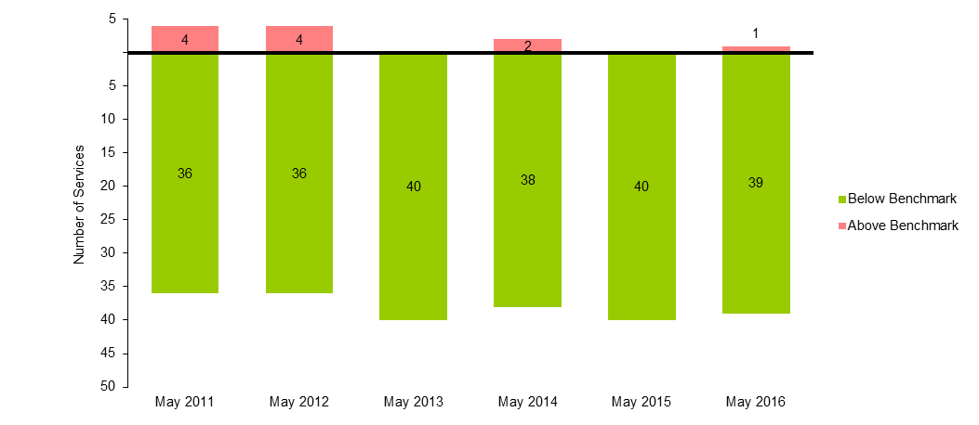
Table 7: AM Peak services above benchmark levels and percentage of passengers travelling on services above benchmark levels (May 2011 to May 2016)
 | May 2011 | May 2012 | May 2013 | May 2014 | May 2015 | May 2016
Number of AM Peak services above benchmark | 4 | 4 | 0 | 2 | 0 | 1
% of AM Peak services above benchmark | 10.0% | 10.0% | 0.0% | 5.0% | 0.0% | 2.5%
% of AM Peak passengers on services above benchmark | 14.7% | 14.3% | 0.0% | 7.0% | 0.0% | 4.0%
  - PM Peak
- The May 2016 survey recorded a total of 1 services in breach in the PM Peak period. This is a decrease of 1 compared to the May 2015 survey when 2 breaches were observed.
- Between May 2015 and May 2016, no additional services were added to the Ringwood Corridor during the PM Peak.
- The percentage of passengers travelling on services exceeding the benchmark on the Ringwood Corridor during the PM Peak period decreased from 7.3 per cent to 3.6 per cent between May 2015 and May 2016.
Figure 8: Number of PM Peak services below and above benchmark levels (May 2011 to May 2016)
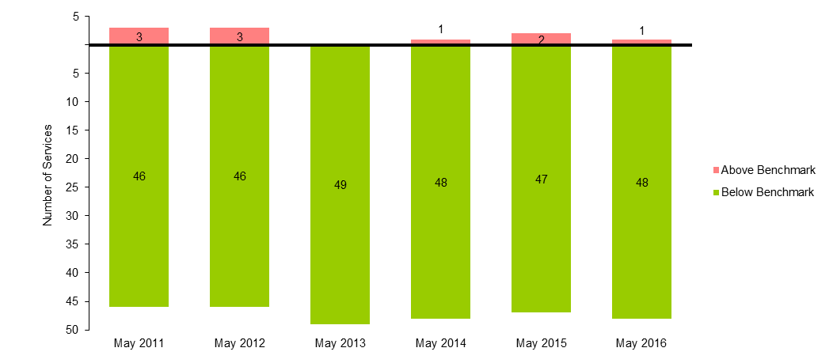
Table 8: PM Peak services above benchmark and passengers using services above benchmark (May 2011 to May 2016)
 | May 2011 | May 2012 | May 2013 | May 2014 | May 2015 | May 2016
Number of PM Peak services above benchmark | 3 | 3 | 0 | 1 | 2 | 1
% of PM Peak services above benchmark | 6.1% | 6.1% | 0.0% | 2.0% | 4.1% | 2.0%
% of PM Peak passengers on services above benchmark | 10.5% | 10.4% | 0.0% | 3.5% | 7.3% | 3.6%

Dandenong corridor results
Note: the Dandenong corridor includes services originating from Pakenham, Berwick, Cranbourne, Dandenong, Westall and Oakleigh stations in the AM and terminating at those stations in the PM.
  - AM Peak
- The May 2016 survey recorded a total of 12 services in breach in the AM Peak period. This is an increase of 3 compared to the May 2015 survey when 9 breaches were observed.
- Between May 2015 and May 2016, no additional services were added to the Dandenong Corridor during the AM Peak.
- The percentage of passengers travelling on services exceeding the benchmark on the Dandenong Corridor during the AM Peak period increased from 39.3 per cent to 47.4 per cent between May 2015 and May 2016.
Figure 9: Number of AM Peak services below and above benchmark levels (May 2011 to May 2016)
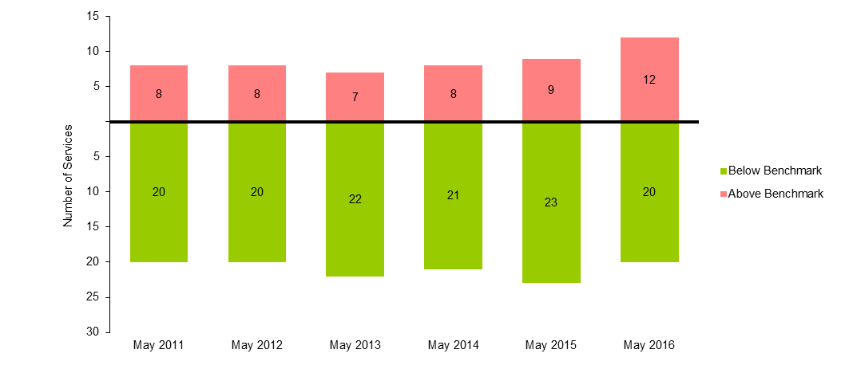
Table 9: AM Peak services above benchmark levels and percentage of passengers travelling on services above benchmark levels (May 2011 to May 2016)
 | May 2011 | May 2012 | May 2013 | May 2014 | May 2015 | May 2016
Number of AM Peak services above benchmark | 8 | 8 | 7 | 8 | 9 | 12
% of AM Peak services above benchmark | 28.6% | 28.6% | 24.1% | 27.6% | 28.1% | 37.5%
% of AM Peak passengers on services above benchmark | 36.1% | 36.0% | 32.6% | 35.5% | 39.3% | 47.4%

  - PM Peak
- The May 2016 survey recorded a total of 10 services in breach in the PM Peak period. This is an increase of 3 compared to the May 2015 survey when 7 breaches were observed.
- Between May 2015 and May 2016, no additional services were added to the Dandenong Corridor during the PM Peak.
- The percentage of passengers travelling on services exceeding the benchmark on the Dandenong Corridor during the PM Peak period increased from 25.6 per cent to 33.9 per cent between May 2015 and May 2016.
Figure 10: Number of PM Peak services below and above benchmark levels (May 2011 to May 2016)
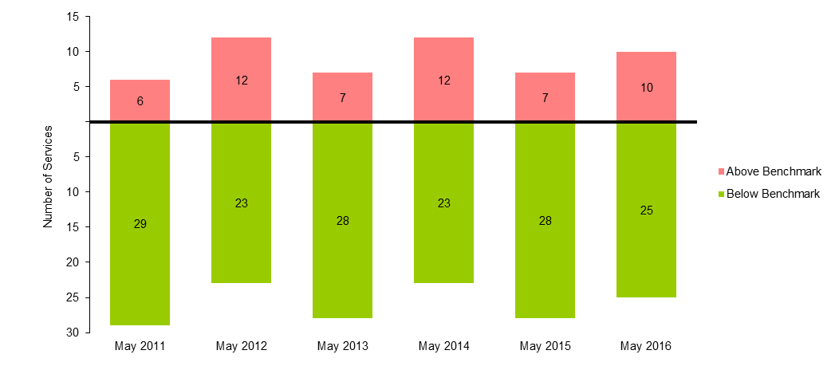
Table 10: PM Peak services above benchmark and passengers using services above benchmark (May 2011 to May 2016)
 | May 2011 | May 2012 | May 2013 | May 2014 | May 2015 | May 2016
Number of PM Peak services above benchmark | 6 | 12 | 7 | 12 | 7 | 10
% of PM Peak services above benchmark | 17.1% | 34.3% | 20.0% | 34.3% | 20.0% | 28.6%
% of PM Peak passengers on services above benchmark | 25.8% | 44.6% | 27.2% | 44.1% | 25.6% | 33.9%

Frankston line results
  - AM Peak
- The May 2016 survey recorded a total of 3 services in breach in the AM Peak period. This is a decrease of 3 compared to the May 2015 survey when 6 breaches were observed.
- Between May 2015 and May 2016, 1 services were removed from the Frankston Line during the AM Peak.
- The percentage of passengers travelling on services exceeding the benchmark on the Frankston Line during the AM Peak period decreased from 32 per cent to 17.4 per cent between May 2015 and May 2016.
Figure 11: Number of AM Peak services below and above benchmark levels (May 2011 to May 2016)
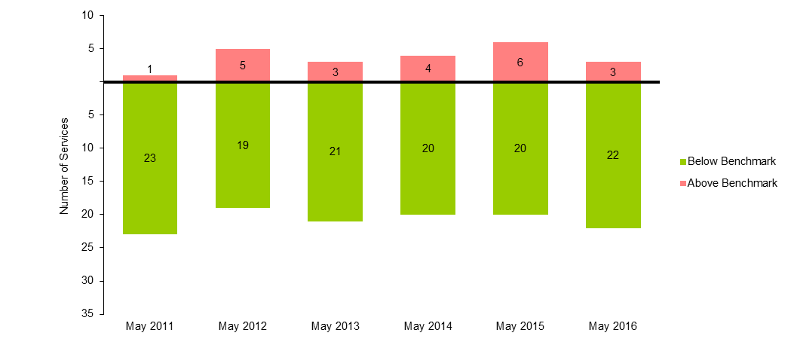
Table 11: AM Peak services above benchmark levels and percentage of passengers travelling on services above benchmark levels (May 2011 to May 2016)
 | May 2011 | May 2012 | May 2013 | May 2014 | May 2015 | May 2016
Number of AM Peak services above benchmark | 1 | 5 | 3 | 4 | 6 | 3
% of AM Peak services above benchmark | 4.2% | 20.8% | 12.5% | 16.7% | 23.1% | 12.0%
% of AM Peak passengers on services above benchmark | 5.4% | 25.9% | 16.7% | 21.6% | 32.0% | 17.4%
  - PM Peak
- The May 2016 survey recorded a total of 0 services in breach in the PM Peak period. This is the same result compared to the May 2015 survey.
- Between May 2015 and May 2016, 1 services were removed from the Frankston Line during the PM Peak.
- The percentage of passengers travelling on services exceeding the benchmark on the Frankston Line during the PM Peak period stayed constant at 0 per cent during both May 2015 and May 2016.
Figure 12: Number of PM Peak services below and above benchmark levels (May 2011 to May 2016)
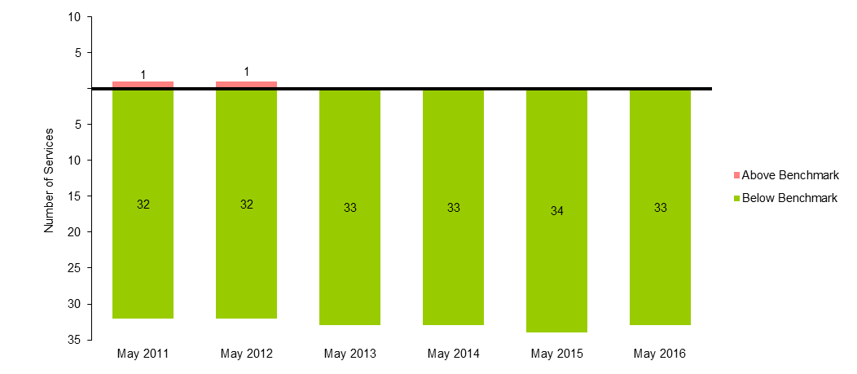
Table 12: PM Peak services above benchmark and passengers using services above benchmark (May 2011 to May 2016)
 | May 2011 | May 2012 | May 2013 | May 2014 | May 2015 | May 2016
Number of PM Peak services above benchmark | 1 | 1 | 0 | 0 | 0 | 0
% of PM Peak services above benchmark | 3.0% | 3.0% | 0.0% | 0.0% | 0.0% | 0.0%
% of PM Peak passengers on services above benchmark | 5.4% | 5.0% | 0.0% | 0.0% | 0.0% | 0.0%

Sandringham Line
  - AM Peak
- The May 2016 survey recorded a total of 5 services in breach in the AM Peak period. This is the same result compared to the May 2015 survey.
- Between May 2015 and May 2016, no additional services were added to the Sandringham Line during the AM Peak.
- The percentage of passengers travelling on services exceeding the benchmark on the Sandringham Line during the AM Peak period decreased from 37.5 per cent to 36.9 per cent between May 2015 and May 2016.
Figure 13: Number of AM Peak services below and above benchmark levels (May 2011 to May 2016)
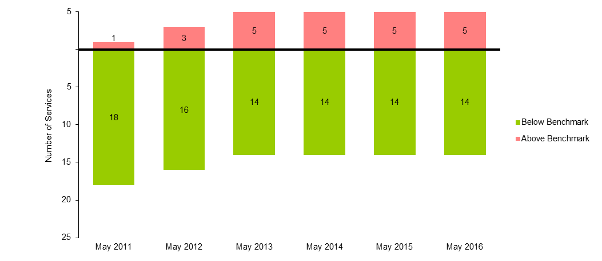
Table 13: AM Peak services above benchmark levels and percentage of passengers travelling on services above benchmark levels (May 2011 to May 2016)
 | May 2011 | May 2012 | May 2013 | May 2014 | May 2015 | May 2016
Number of AM Peak services above benchmark | 1 | 3 | 5 | 5 | 5 | 5
% of AM Peak services above benchmark | 5.3% | 15.8% | 26.3% | 26.3% | 26.3% | 26.3%
% of AM Peak passengers on services above benchmark | 8.3% | 24.1% | 38.3% | 38.4% | 37.5% | 36.9%
  - PM Peak
- The May 2016 survey recorded a total of 0 services in breach in the PM Peak period. This is the same result compared to the May 2015 survey.
- Between May 2015 and May 2016, no additional services were added to the Sandringham Line during the PM Peak.
- The percentage of passengers travelling on services exceeding the benchmark on the Sandringham Line during the PM Peak period stayed constant at 0 per cent during both May 2015 and May 2016.
Figure 14: Number of PM Peak services below and above benchmark levels (May 2011 to May 2016)
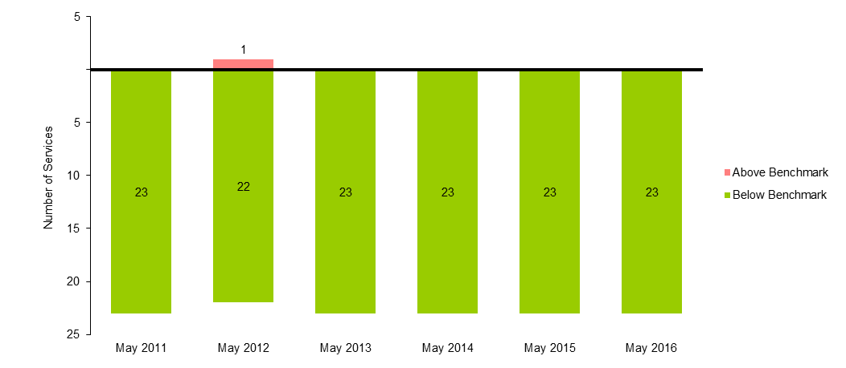
Table 14: PM Peak services above benchmark and passengers using services above benchmark (May 2011 to May 2016)
 | May 2011 | May 2012 | May 2013 | May 2014 | May 2015 | May 2016
Number of PM Peak services above benchmark | 0 | 1 | 0 | 0 | 0 | 0
% of PM Peak services above benchmark | 0.0% | 4.3% | 0.0% | 0.0% | 0.0% | 0.0%
% of PM Peak passengers on services above benchmark | 0.0% | 7.8% | 0.0% | 0.0% | 0.0% | 0.0%

South Morang line results
  - AM Peak
- The May 2016 survey recorded a total of 3 services in breach in the AM Peak period. This is an increase of 2 compared to the May 2015 survey when 1 breaches were observed.
- Between May 2015 and May 2016, no additional services were added to the South Morang Line during the AM Peak.
- The percentage of passengers travelling on services exceeding the benchmark on the South Morang Line during the AM Peak period increased from 9 per cent to 26.2 per cent between May 2015 and May 2016.
Figure 15: Number of AM Peak services below and above benchmark levels (May 2011 to May 2016)
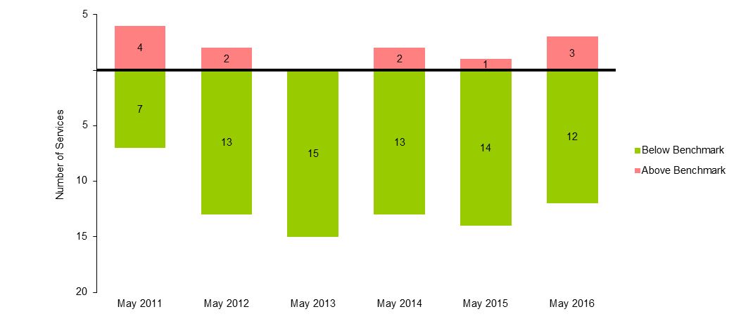
Table 15: AM Peak services above benchmark levels and percentage of passengers travelling on services above benchmark levels (May 2011 to May 2016)
 | May 2011 | May 2012 | May 2013 | May 2014 | May 2015 | May 2016
Number of AM Peak services above benchmark | 4 | 2 | 0 | 2 | 1 | 3
% of AM Peak services above benchmark | 36.4% | 13.3% | 0.0% | 13.3% | 6.7% | 20.0%
% of AM Peak passengers on services above benchmark | 46.7% | 18.1% | 0.0% | 17.1% | 9.0% | 26.2%
  - PM Peak
- The May 2016 survey recorded a total of 1 services in breach in the PM Peak period. This is an increase of 1 compared to the May 2015 survey when 0 breaches were observed.
- Between May 2015 and May 2016, no additional services were added to the South Morang Line during the PM Peak.
- The percentage of passengers travelling on services exceeding the benchmark on the South Morang Line during the PM Peak period increased from 0 per cent to 7.4 per cent between May 2015 and May 2016.
Figure 16: Number of PM Peak services below and above benchmark levels (May 2011 to May 2016)
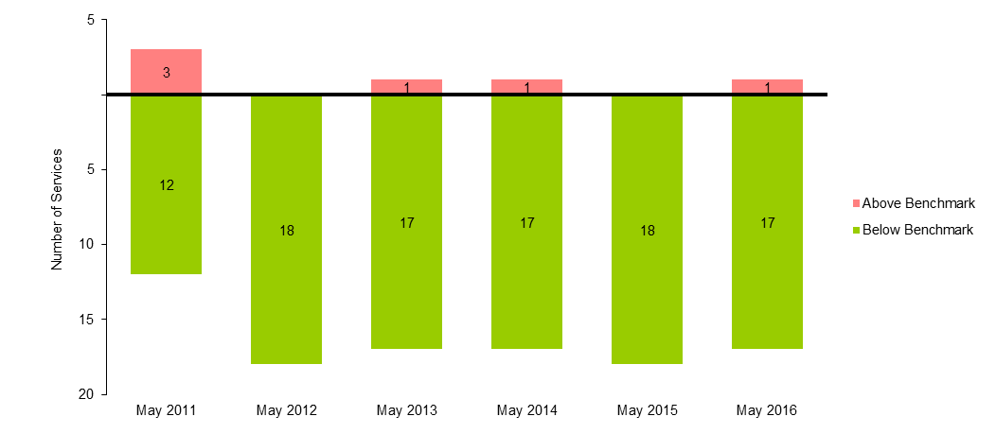
Table 16: PM Peak services above benchmark and passengers using services above benchmark (May 2011 to May 2016)
 | May 2011 | May 2012 | May 2013 | May 2014 | May 2015 | May 2016
Number of PM Peak services above benchmark | 3 | 0 | 1 | 1 | 0 | 1
% of PM Peak services above benchmark | 20.0% | 0.0% | 5.6% | 5.6% | 0.0% | 5.6%
% of PM Peak passengers on services above benchmark | 26.7% | 0.0% | 8.2% | 7.0% | 0.0% | 7.4%

Hurstbridge line results
  - AM Peak
- The May 2016 survey recorded a total of 1 services in breach in the AM Peak period. This is the same result compared to the May 2015 survey.
- Between May 2015 and May 2016, no additional services were added to the Hurstbridge Line during the AM Peak.
- The percentage of passengers travelling on services exceeding the benchmark on the Hurstbridge Line during the AM Peak period increased from 7.4 per cent to 7.8 per cent between May 2015 and May 2016.
Figure 17: Number of AM Peak services below and above benchmark levels (May 2011 to May 2016)
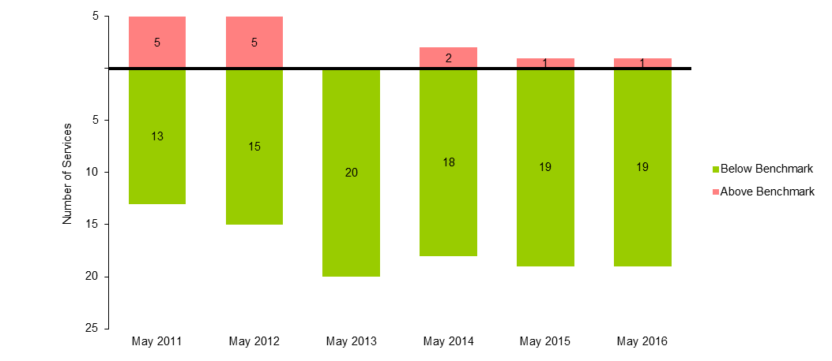
Table 17: AM Peak services above benchmark levels and percentage of passengers travelling on services above benchmark levels (May 2011 to May 2016)
 | May 2011 | May 2012 | May 2013 | May 2014 | May 2015 | May 2016
Number of AM Peak services above benchmark | 5 | 5 | 0 | 2 | 1 | 1
% of AM Peak services above benchmark | 27.8% | 25.0% | 0.0% | 10.0% | 5.0% | 5.0%
% of AM Peak passengers on services above benchmark | 38.1% | 35.2% | 0.0% | 14.0% | 7.4% | 7.8%
  - PM Peak
- The May 2016 survey recorded a total of 0 services in breach in the PM Peak period. This is the same result compared to the May 2015 survey.
- Between May 2015 and May 2016, no additional services were added to the Hurstbridge Line during the PM Peak.
- The percentage of passengers travelling on services exceeding the benchmark on the Hurstbridge Line during the PM Peak period stayed constant at 0 per cent during both May 2015 and May 2016.
Figure 18: Number of PM Peak services below and above benchmark levels (May 2011 to May 2016)
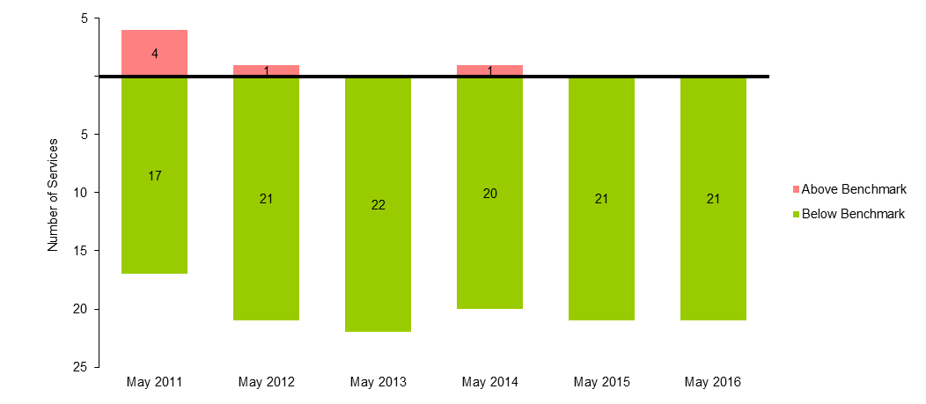
Table 18: PM Peak services above benchmark and passengers using services above benchmark (May 2011 to May 2016)
 | May 2011 | May 2012 | May 2013 | May 2014 | May 2015 | May 2016
Number of PM Peak services above benchmark | 4 | 1 | 0 | 1 | 0 | 0
% of PM Peak services above benchmark | 19.0% | 4.5% | 0.0% | 4.8% | 0.0% | 0.0%
% of PM Peak passengers on services above benchmark | 27.4% | 7.2% | 0.0% | 7.2% | 0.0% | 0.0%

Craigieburn line results
  - AM Peak
- The May 2016 survey recorded a total of 10 services in breach in the AM Peak period. This is an increase of 2 compared to the May 2015 survey when 8 breaches were observed.
- Between May 2015 and May 2016, no additional services were added to the Craigieburn Line during the AM Peak.
- The percentage of passengers travelling on services exceeding the benchmark on the Craigieburn Line during the AM Peak period increased from 47.3 per cent to 57.4 per cent between May 2015 and May 2016.
Figure 19: Number of AM Peak services below and above benchmark levels (May 2011 to May 2016)
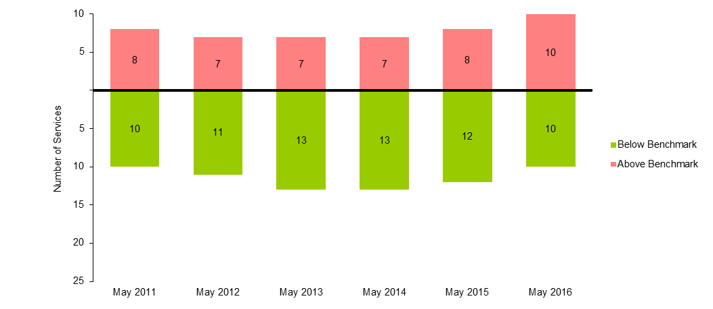
Table 19: AM Peak services above benchmark levels and percentage of passengers travelling on services above benchmark levels (May 2011 to May 2016)
 | May 2011 | May 2012 | May 2013 | May 2014 | May 2015 | May 2016
Number of AM Peak services above benchmark | 8 | 7 | 7 | 7 | 8 | 10
% of AM Peak services above benchmark | 44.4% | 38.9% | 35.0% | 35.0% | 40.0% | 50.0%
% of AM Peak passengers on services above benchmark | 54.5% | 47.3% | 41.8% | 41.7% | 47.3% | 57.4%
  - PM Peak
- The May 2016 survey recorded a total of 3 services in breach in the PM Peak period. This is a decrease of 2 compared to the May 2015 survey when 5 breaches were observed.
- Between May 2015 and May 2016, no additional services were added to the Craigieburn Line during the PM Peak.
- The percentage of passengers travelling on services exceeding the benchmark on the Craigieburn Line during the PM Peak period decreased from 27.9 per cent to 16.8 per cent between May 2015 and May 2016.
Figure 20: Number of PM Peak services below and above benchmark levels (May 2011 to May 2016)
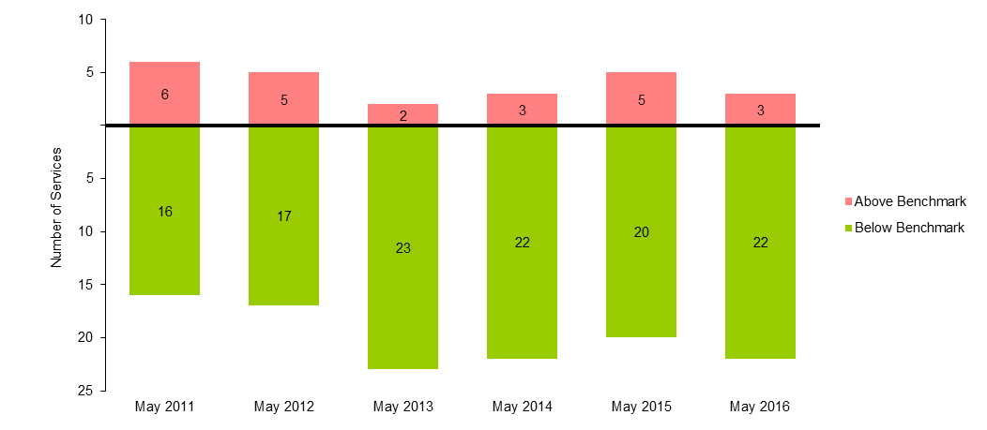
Table 20: PM Peak services above benchmark and passengers using services above benchmark (May 2011 to May 2016)
 | May 2011 | May 2012 | May 2013 | May 2014 | May 2015 | May 2016
Number of PM Peak services above benchmark | 6 | 5 | 2 | 3 | 5 | 3
% of PM Peak services above benchmark | 27.3% | 22.7% | 8.0% | 12.0% | 20.0% | 12.0%
% of PM Peak passengers on services above benchmark | 40.2% | 33.4% | 12.9% | 17.2% | 27.9% | 16.8%

Sunbury line results
  - AM Peak
- The May 2016 survey recorded a total of 8 services in breach in the AM Peak period. This is an increase of 1 compared to the May 2015 survey when 7 breaches were observed.
- Between May 2015 and May 2016, no additional services were added to the Sunbury Line during the AM Peak.
- The percentage of passengers travelling on services exceeding the benchmark on the Sunbury Line during the AM Peak period increased from 43.2 per cent to 46.5 per cent between May 2015 and May 2016.
Figure 21: Number of AM Peak services below and above benchmark levels (May 2011 to May 2016)
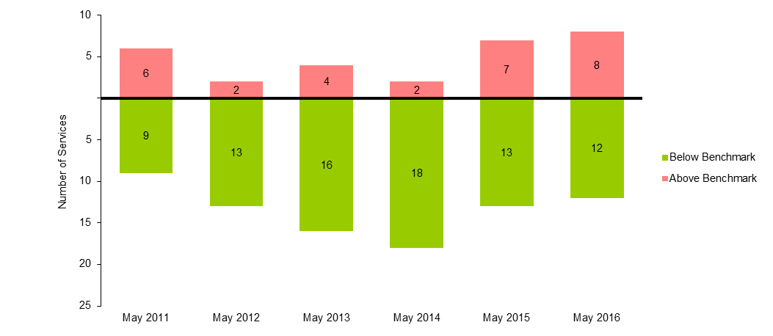
Table 21: AM Peak services above benchmark levels and percentage of passengers travelling on services above benchmark levels (May 2011 to May 2016)
 | May 2011 | May 2012 | May 2013 | May 2014 | May 2015 | May 2016
Number of AM Peak services above benchmark | 6 | 2 | 4 | 2 | 7 | 8
% of AM Peak services above benchmark | 40.0% | 13.3% | 20.0% | 10.0% | 35.0% | 40.0%
% of AM Peak passengers on services above benchmark | 47.0% | 17.4% | 25.4% | 12.1% | 43.2% | 46.5%
  - PM Peak
- The May 2016 survey recorded a total of 3 services in breach in the PM Peak period. This is a decrease of 3 compared to the May 2015 survey when 6 breaches were observed.
- Between May 2015 and May 2016, no additional services were added to the Sunbury Line during the PM Peak.
- The percentage of passengers travelling on services exceeding the benchmark on the Sunbury Line during the PM Peak period decreased from 32.5 per cent to 16.7 per cent between May 2015 and May 2016.
Figure 22: Number of PM Peak services below and above benchmark levels (May 2011 to May 2016)
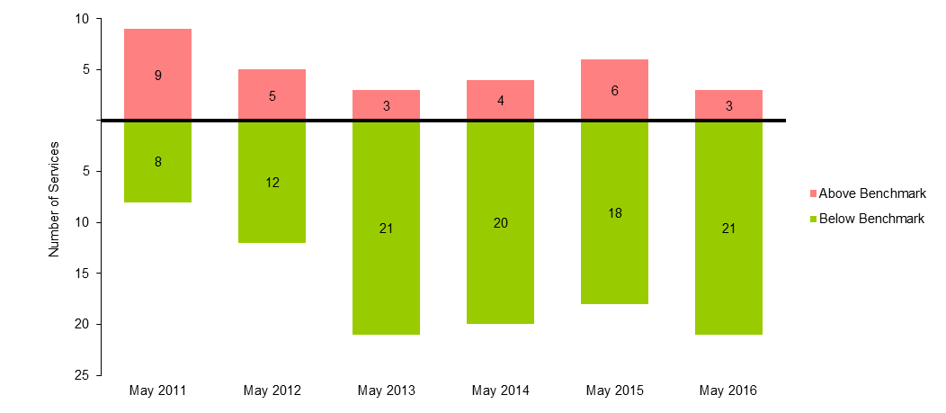
Table 22: PM Peak services above benchmark and passengers using services above benchmark (May 2011 to May 2016)
 | May 2011 | May 2012 | May 2013 | May 2014 | May 2015 | May 2016
Number of PM Peak services above benchmark | 9 | 5 | 3 | 4 | 6 | 3
% of PM Peak services above benchmark | 52.9% | 29.4% | 12.5% | 16.7% | 25.0% | 12.5%
% of PM Peak passengers on services above benchmark | 62.5% | 36.5% | 17.6% | 22.1% | 32.5% | 16.7%

Upfield line results
  - AM Peak
- The May 2016 survey recorded a total of 2 services in breach in the AM Peak period. This is the same result compared to the May 2015 survey.
- Between May 2015 and May 2016, no additional services were added to the Upfield Line during the AM Peak.
- The percentage of passengers travelling on services exceeding the benchmark on the Upfield Line during the AM Peak period increased from 36.3 per cent to 36.4 per cent between May 2015 and May 2016.
Figure 23: Number of AM Peak services below and above benchmark levels (May 2011 to May 2016)
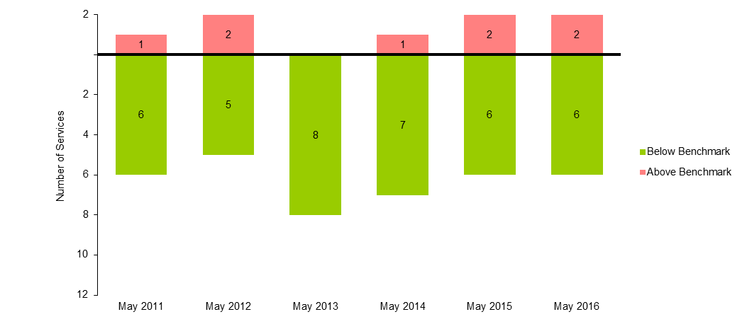
Table 23: AM Peak services above benchmark levels and percentage of passengers travelling on services above benchmark levels (May 2011 to May 2016)
 | May 2011 | May 2012 | May 2013 | May 2014 | May 2015 | May 2016
Number of AM Peak services above benchmark | 1 | 2 | 0 | 1 | 2 | 2
% of AM Peak services above benchmark | 14.3% | 28.6% | 0.0% | 12.5% | 25.0% | 25.0%
% of AM Peak passengers on services above benchmark | 20.4% | 40.6% | 0.0% | 17.8% | 36.3% | 36.4%
  - PM Peak
- The May 2016 survey recorded a total of 0 services in breach in the PM Peak period. This is a decrease of 1 compared to the May 2015 survey when 1 breaches were observed.
- Between May 2015 and May 2016, no additional services were added to the Upfield Line during the PM Peak.
- The percentage of passengers travelling on services exceeding the benchmark on the Upfield Line during the PM Peak period decreased from 14.7 per cent to 0 per cent between May 2015 and May 2016.
Figure 24: Number of PM Peak services below and above benchmark levels (May 2011 to May 2016)
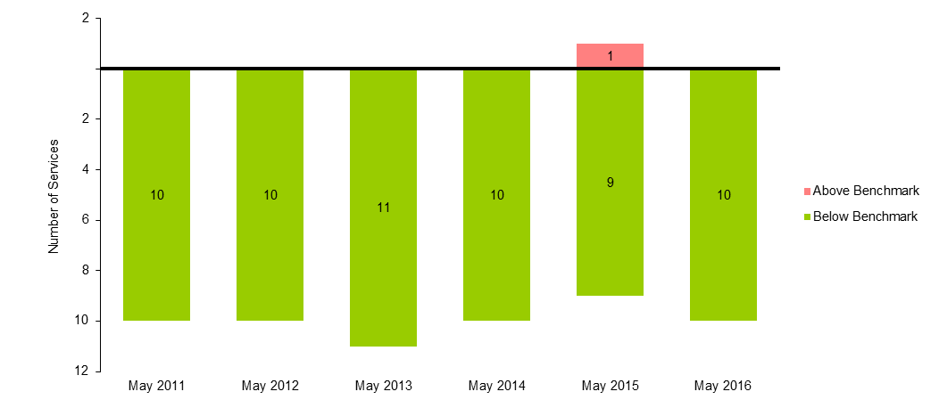
Table 24: PM Peak services above benchmark and passengers using services above benchmark (May 2011 to May 2016)
 | May 2011 | May 2012 | May 2013 | May 2014 | May 2015 | May 2016
Number of PM Peak services above benchmark | 0 | 0 | 0 | 0 | 1 | 0
% of PM Peak services above benchmark | 0.0% | 0.0% | 0.0% | 0.0% | 10.0% | 0.0%
% of PM Peak passengers on services above benchmark | 0.0% | 0.0% | 0.0% | 0.0% | 14.7% | 0.0%

Werribee line results
Note: the Werribee line includes services originating from Werribee and Laverton stations in the AM and terminating at those stations in the PM. The significant improvements in the Werribee line results from May 2016 are due to the introduction of the Regional Rail Link during 2015, and the opening of two new stations in Wyndham’s growth areas that attracted patronage away from the Werribee line.
  - AM Peak
- The May 2016 survey recorded a total of 6 services in breach in the AM Peak period. This is a decrease of 2 compared to the May 2015 survey when 8 breaches were observed.
- Between May 2015 and May 2016, an additional 1 services were introduced to the Werribee Line during the AM Peak.
- The percentage of passengers travelling on services exceeding the benchmark on the Werribee Line during the AM Peak period decreased from 48.9 per cent to 37.5 per cent between May 2015 and May 2016.
Figure 25: Number of AM Peak services below and above benchmark levels (May 2011 to May 2016)
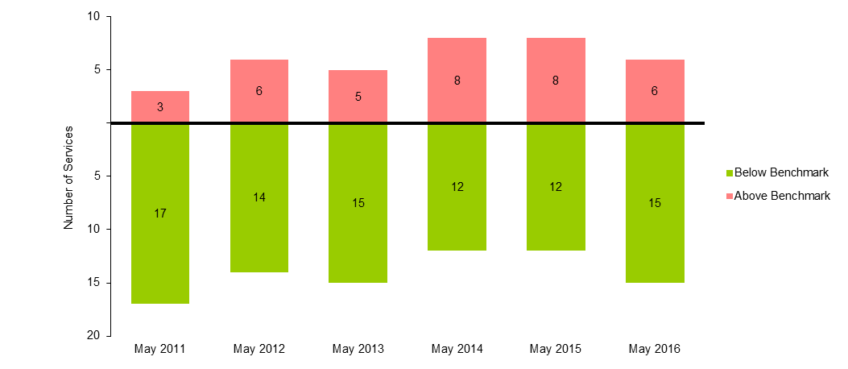
Table 25: AM Peak services above benchmark levels and percentage of passengers travelling on services above benchmark levels (May 2011 to May 2016)
 | May 2011 | May 2012 | May 2013 | May 2014 | May 2015 | May 2016
Number of AM Peak services above benchmark | 3 | 6 | 5 | 8 | 8 | 6
% of AM Peak services above benchmark | 15.0% | 30.0% | 25.0% | 40.0% | 40.0% | 28.6%
% of AM Peak passengers on services above benchmark | 21.2% | 38.6% | 32.7% | 48.7% | 48.9% | 37.5%
  - PM Peak
- The May 2016 survey recorded a total of 4 services in breach in the PM Peak period. This is a decrease of 5 compared to the May 2015 survey when 9 breaches were observed.
- Between May 2015 and May 2016, an additional 1 services were introduced to the Werribee Line during the PM Peak.
- The percentage of passengers travelling on services exceeding the benchmark on the Werribee Line during the PM Peak period decreased from 56.8 per cent to 24.9 per cent between May 2015 and May 2016.
Figure 26: Number of PM Peak services below and above benchmark levels (May 2011 to May 2016)
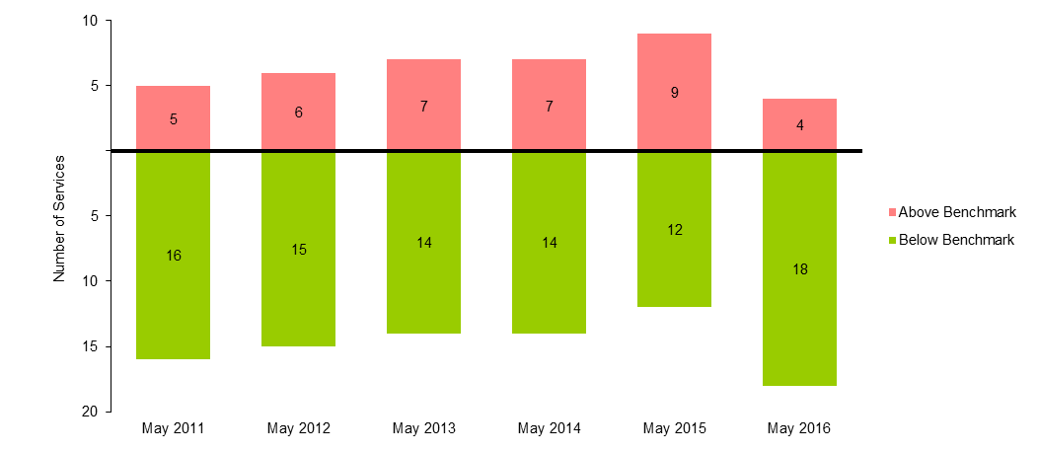
Table 26: PM Peak services above benchmark and passengers using services above benchmark (May 2011 to May 2016)
 | May 2011 | May 2012 | May 2013 | May 2014 | May 2015 | May 2016
Number of PM Peak services above benchmark | 5 | 6 | 7 | 7 | 9 | 4
% of PM Peak services above benchmark | 23.8% | 28.6% | 33.3% | 33.3% | 42.9% | 18.2%
% of PM Peak passengers on services above benchmark | 38.7% | 42.8% | 48.2% | 46.8% | 56.8% | 24.9%

Williamstown line results
  - AM Peak
- The May 2016 survey recorded a total of 0 services in breach in the AM Peak period. This is the same result compared to the May 2015 survey.
- Between May 2015 and May 2016, no additional services were added to the Williamstown Line during the AM Peak.
- The percentage of passengers travelling on services exceeding the benchmark on the Williamstown Line during the AM Peak period stayed constant at 0 per cent during both May 2015 and May 2016.
Figure 27: Number of AM Peak services below and above benchmark levels (May 2011 to May 2016)
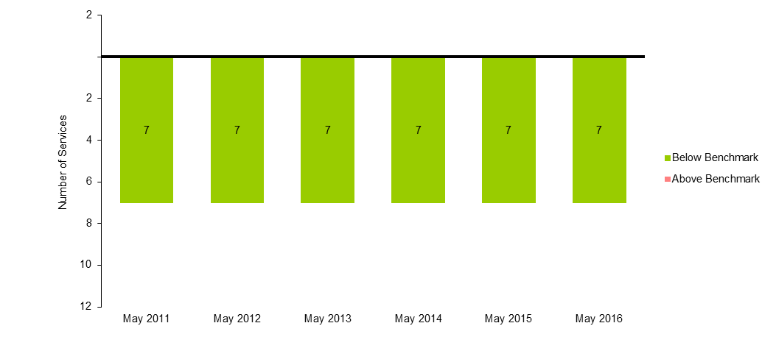
Table 27: AM Peak services above benchmark levels and percentage of passengers travelling on services above benchmark levels (May 2011 to May 2016)
 | May 2011 | May 2012 | May 2013 | May 2014 | May 2015 | May 2016
Number of AM Peak services above benchmark | 0 | 0 | 0 | 0 | 0 | 0
% of AM Peak services above benchmark | 0.0% | 0.0% | 0.0% | 0.0% | 0.0% | 0.0%
% of AM Peak passengers on services above benchmark | 0.0% | 0.0% | 0.0% | 0.0% | 0.0% | 0.0%
  - PM Peak
- The May 2016 survey recorded a total of 0 services in breach in the PM Peak period. This is the same result compared to the May 2015 survey.
- Between May 2015 and May 2016, no additional services were added to the Williamstown Line during the PM Peak.
- The percentage of passengers travelling on services exceeding the benchmark on the Williamstown Line during the PM Peak period stayed constant at 0 per cent during both May 2015 and May 2016.
Figure 28: Number of PM Peak services below and above benchmark levels (May 2011 to May 2016)
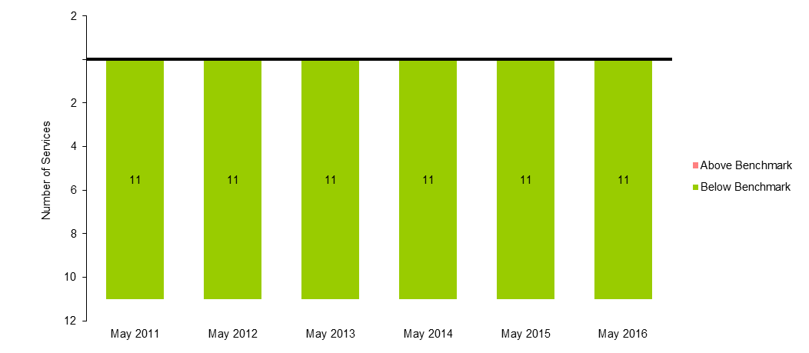
Table 28: PM Peak services above benchmark and passengers using services above benchmark (May 2011 to May 2016)
 | May 2011 | May 2012 | May 2013 | May 2014 | May 2015 | May 2016
Number of PM Peak services above benchmark | 0 | 0 | 0 | 0 | 0 | 0
% of PM Peak services above benchmark | 0.0% | 0.0% | 0.0% | 0.0% | 0.0% | 0.0%
% of PM Peak passengers on services above benchmark | 0.0% | 0.0% | 0.0% | 0.0% | 0.0% | 0.0%

Notes about the survey
- Independent surveyors collected the data for the May 2016 survey over 14 weekdays (Monday to Thursday). Surveying times were between 6:30 am and 12:00 pm for city-bound services and 2:00 pm and 7:00 pm for outbound services.
- For outbound services, surveyors collect the data at three city cordon stations: Jolimont, Richmond and North Melbourne. Cordon stations are those that adjoin the City Loop.
- For inbound services, surveyors collect the data at all stations where services stop directly prior to a cordon station. This could involve collecting data at a variety of stations from where express services run direct to the cordon.
- The peak periods are:
  - AM Peak – between 7.01 am and 9.30 am
  - PM Peak – between 3.31 pm and 7.00 pm.
- The impact of service cancellations and network disruptions on the data are considered. Passenger loads affected by cancellations and disruptions are excluded from the analysis to ensure the survey results provide an accurate picture of how the metropolitan rail network performs.

