**Attachment 4**

**Recovered plastic packaging**

Market insights report – July 2023

### Notable market developments

* **Prices for recovered PET bottles have come off the highs of the middle of 2022 and have been steady across the first quarter of 2023 at around the longer term average.** PET packaging scrap prices have been around $500–$550 per tonne across the January–March 2023 period. Since 1 July 2022 the rPET must be flaked and washed to be exported, which is putting downwards pressure on unprocessed bale prices as local reprocessing capacity catches up with the available local supply.
* **Prices for recovered HDPE bottles have increased across the first quarter of 2023, recovering to a degree from a gradual decline over 2022.** HDPE rigid packaging, and in particular natural HPDE (e.g., milk bottles) is highly sought after locally and overseas. Since 1 July 2022 the rHDPE must be flaked and washed to be exported, which could theoretically be putting downwards pressure on unprocessed bale prices as local reprocessing capacity catches up with the available local supply. However, prices for rHDPE have remained resilient, reflecting the adequate scale of local reprocessing capacity and many end-market applications for this material.
* **In general, many reprocessors reported steady to somewhat increasing prices for reprocessed PET, HDPE and PP rigid plastic packaging. However, this is against a backdrop of sharply increasing costs.** There is benefit in increased local manufacturing to enable local end-markets to match increasing supply, across both packaging and non-packaging plastics recovery
* **Freight costs to overseas markets increased markedly in 2022, and while they have fallen significantly, they are still relatively high.** Over the last couple of years, the impact of increased freight costs has been exacerbated by increases in export licence fees for reprocessed scrap plastics. In addition, the introduction of the Australian Government export licencing rules may have changed end-markets for some forms of reprocessed material. Due to local processing costs, export licence fees, and transport costs, local reprocessors may have needed to change their business models to competitively sell recovered plastics into international markets.
* **A number of Material Recovery Facilities (MFRs) and reprocessors reported sending increased quantities of packaging plastics to landfill.** This particularly relates to PVC and PS based packaging, and to a lesser extent to lower value grades of PET, HDPE and PP packaging. Over the next few years, this issue should be alleviated by the ongoing phase-out by many brand-owners of PVC and PS packaging, and the redesign of PET, HDPE and PP packaging to improve recyclability and increase the value of the recovered material.
* **There is likely to be a market concentration of large scale PET packaging reprocessors moving forward.** From July 2022 export markets were no longer available for unprocessed bales of PET packaging. As a result, the limited number of local reprocessors have greatly increased market purchasing power. There remains a local reprocessing gap for PET packaging until mid-end 2024.

### Material overview and market summary

Plastics collected through kerbside collections are generally sent MRFs and sorted from commingled recycling into a single mixed plastics grade (1–7 plastic-polymer mix), or more commonly, three or four grades, which are PET, HDPE and PP, and a residual mixed plastics grade (a 3–7 plastic-polymer mix, but with some residual quantities of PET, HDPE and PP still present).

It is understood that all three of the major Victorian MRF operators are now positively sorting a PP stream, which is a highly sought-after product, and nationally all the major MRF operators are understood to be moving towards sorting a PP stream. Typically, the recovered PP is not reused in consumer packaging, but is incorporated into more durable goods such as plant pots.

PVC and PS continue to be proactively phased out from use in packaging by many brand-owners, and the quantities of these polymers in kerbside collections are low and continue to fall.

Figure 1 provides data on the change in exports of kerbside recovered plastic packaging since the beginning of 2015. Across the April–June 2022 period there was a significant jump in exports, leading up to the 1 July 2022 export ban on unprocessed single-polymer scrap plastics. From July 2022 there has been a dramatic fall in exports of unprocessed (kerbside sourced) rigid plastic packaging (sorted into single polymer grades).

It is important to highlight that anecdotally it is known that there has been a significant increase in the export of reprocessed (single polymer) plastic packaging. This material is exported under 'primary' plastics codes, and it is not currently possible to separately quantify these exports, and they are not shown in Figure 1. However, further research and analysis is in progress, and it is anticipated that this export flow, potentially by polymer grade, will be available in the next quarterly update of this report.

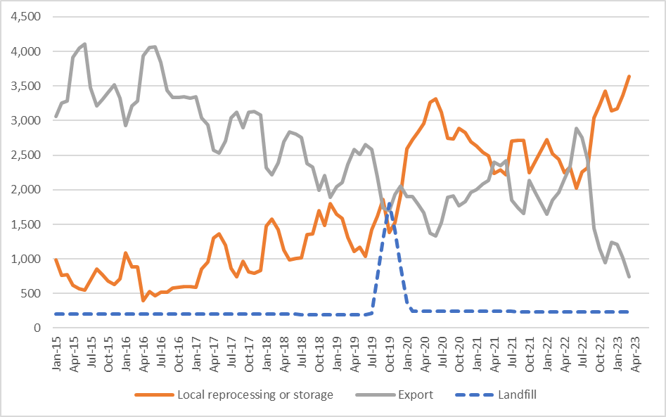

Figure 1: Destination of Victorian MRF outputs (tonnes per month) – kerbside plastic packaging.

Source: Australian Bureau of Statistics (ABS) and IndustryEdge (IE) (Australian Harmonized Export Commodity Classification (AHECC) data by month, classification and destination country, 2023) and Blue Environment.

Note 1: Historical total monthly MRF outputs have been approximated in the figure above to enable comparison with monthly ABS customs export data. The overall trends are the key aspect of the figure.

Note 2: The combined ‘Local reprocessing or storage’ estimate is indicative only, and these fates can't be presented separately due to the lack of sufficiently detailed time-series data. Landfill excludes disposal from storage and is an approximation based on annual waste to landfill rates.

### Prices, demand and supply

There continues to be strong local and export markets for clean PET bales that are collected, sorted and reprocessed to specification. Prices had fallen to around $230 per tonne in October 2020, the lowest price in the available data (from mid-2017). However, prices increased steadily from this low to around $1,200–$1,300 per tonne by May 2022. Since May 2022 prices have again softened to around $500–$550 per tonne by April 2023, which is still above the long-term monthly average across the last 7 years.

There is also increasing development of vertical supply chains in Australia by some large recycling companies and consortia, meaning that they manage their own material from collection to remanufacturing new packaging. Expansion is continuing, either through the upgrade of existing facilities, or the build of new facilities. The open market prices above are not reflective of the internal transfer prices within these vertical supply chains.

The price of recycled resin used to be directly linked to the price for virgin resin. However, there is increasing 'decoupling' of the virgin PET and recycled PET (rPET) prices that has been observed over the last 3–4 years, as brand owners chase packaging grade rPET and rHDPE to meet internal targets on the use of recycled content in packaging. Food-grade rPET, that is virgin equivalent, is now commanding prices between 50% and 100% greater than virgin PET on global markets. However, it is understood that the price premium differential has tightened up somewhat over the last 6 months or so, as increasing quantities of food-grade rPET and rHDPE become available on local and international markets.

Prices for clean HPDE bales have generally been somewhere in the range of $900–$1,100 per tonne since the beginning of 2022. These relatively good prices have been underpinned by the very strong local and international brand owner demand for packaging grade rHDPE. The requirement to reprocess the HDPE locally does not appear to be putting any notable downwards pressure on the price of unprocessed HDPE packaging bales.

As with reprocessed rPET, reprocessed rHDPE, that is virgin equivalent, is now commanding prices between 50% and 150% greater than virgin HDPE on global markets.

### Key end markets and related specifications

Exported plastics packaging has specifications relating mostly to contamination levels. The sorting of PET, HDPE and PP undertaken at MRFs allows the baled material to generally meet these specifications without major difficulty or manual sorting input. However, as outlined above, from July 2022 these single polymer sorted bales need to be reprocessed (chipped and washed at a minimum) to be exportable under the bans.

### Export and interstate market review

Plastics packaging was overwhelmingly exported to China (see Figure 2), until the latest round of Chinese restrictions in 2018. During the 2018–19 financial year Indonesia was the major destination. Since September 2019 Malaysia has usually been the largest destination for Victoria kerbside plastics by a significant margin.

Post-consumer plastic imports into Malaysia from Victoria have been trending down since the beginning of 2019 to March 2023, but with large monthly variability. In March 2023 exports to Malaysia made up two thirds of total exports, with total exports falling dramatically since July 2022.

Victoria is highly exposed to Malaysian import conditions, albeit at a much lower level than the historical levels of exposure to China and then Indonesia.

Regardless, the export bans now in force since July 2022 have largely ended the export of any unprocessed plastics. The kerbside plastic packaging recovery market bottleneck has become onshore reprocessing capacity for PET, HDPE and PP. However, there are numerous significant new reprocessing facilities that have been announced over the last couple of years, with much of this new capacity to be located in Victoria (see Table 1).

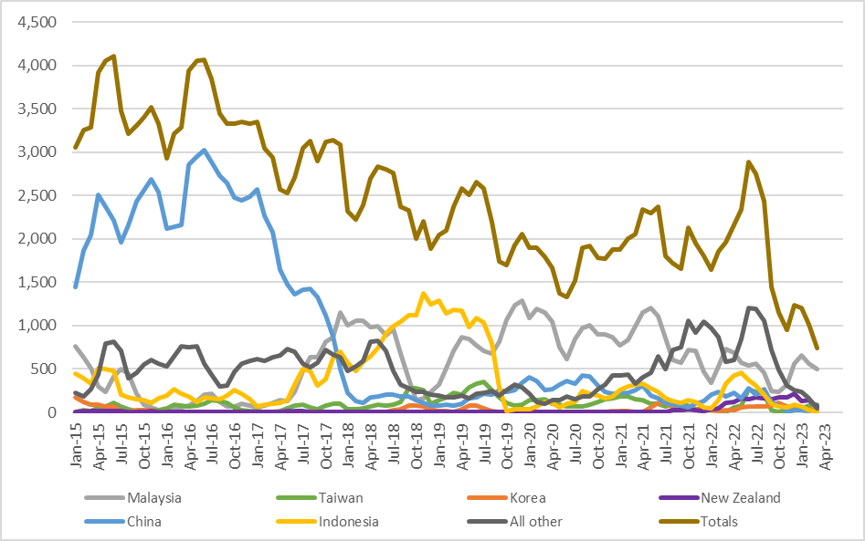

Figure 2: Victorian recovered kerbside plastic packaging, export country (tonnes per month).

Source: ABS and IE (Australian Harmonized Export Commodity Classification (AHECC) data by month, classification and destination country, 2022) and Blue Environment.

Table 1: Annual Victorian recovered kerbside plastic packaging, to export country (tonnes per year).

|  |  |  |  |  |  |  |  |  |
| --- | --- | --- | --- | --- | --- | --- | --- | --- |
| Countrya | 2015–16  (tonnes) | 2016–17  (tonnes) | 2017–18  (tonnes) | 2018–19  (tonnes) | 2019–20  (tonnes) | 2020–21  (tonnes) | 2021–22  (tonnes) | 2022–23b  (tonnes) |
| Malaysia | 1,900 | 1,400 | 10,600 | 6,600 | 11,600 | 11,600 | 7,300 | 4,100 |
| Taiwan | 700 | 700 | 800 | 2,500 | 1,800 | 1,500 | 900 | 700 |
| New Zealand | 100 | 100 | 0 | 0 | 0 | 0 | 700 | 1,400 |
| Korea | 100 | 0 | 0 | 600 | 100 | 200 | 500 | 500 |
| China | 29,600 | 27,100 | 7,700 | 1,600 | 3,500 | 3,300 | 1,900 | 800 |
| Indonesia | 2,100 | 2,000 | 6,900 | 13,700 | 2,700 | 2,900 | 2,500 | 900 |
| All other | 7,300 | 6,600 | 7,700 | 2,900 | 2,500 | 4,200 | 10,100 | 4,500 |
| Total | **41,800** | **37,900** | **33,700** | **27,900** | **22,200** | **23,700** | **23,900** | **12,900** |

Source: ABS and IE (Australian Harmonized Export Commodity Classification (AHECC) data by month, classification and destination country, 2023) and Blue Environment.

1. Countries ranked by average of last 3 months of exports.
2. Partial year across July 2022 to March 2023.

Table 2: Most recent monthly change in Victorian kerbside recovered plastics, to export country

|  |  |  |  |
| --- | --- | --- | --- |
| Country | July 2022  (tonnes) | August 2022  (tonnes) | Change  (%) |
| Malaysia | 600 | 500 | -17% |
| Taiwan | 100 | 100 | 0% |
| New Zealand | 100 | 100 | 0% |
| Korea | 0 | 0 | N/A |
| China | 0 | 0 | N/A |
| Indonesia | 0 | 0 | N/A |
| All other | 200 | 0 | -100% |
| Total | **1,000** | **700** | **-30%** |

Source: ABS and IE (Australian Harmonized Export Commodity Classification (AHECC) data by month, classification and destination country, 2022) and Blue Environment.

### Market opportunities

There continues to be significant and growing local demand for high-quality PET, HDPE and PP packaging recyclate for remanufacturing into many applications, if reprocessed to a high level. In addition, excellent export markets exist for high quality sorted/washed flake and pellets, with price premiums available at around 50%–100% the price of virgin resin.

There is significant new rPET, rHDPE and rPP reprocessing capacity in the pipeline, that appears close to covering the local reprocessing shortfall, including scrap plastics caught up in the Australian unprocessed single-polymer plastics export ban that came into force as of 1 July 2022.

However, as much of the new capacity is not yet operating there is a capacity shortfall for the reprocessing of higher value bales of single polymer kerbside packaging, such as PET and HDPE bottles, that were previously sent directly to export.

Markets for mixed polymer and lower value post-consumer plastic packaging, such as PET thermoforms, rigid PVC, rigid PS, and mixed polymer scrap bales continue to be underdeveloped or non-existent.

These mixed bales can no longer be exported (as of July 2021), and it is understood that most of this material has been sent to landfill over the last 12 months.

Some of the new rPET reprocessing capacity will specifically target PET thermoforms such as strawberry punnets, and with reducing quantities of this format is being laminated with PE or PP, its value as a recovered commodity is increasing. It is anticipated that within 2–3 years the market for thermoformed rPET will be much healthier, and possibly on a par with bottle grade rPET, assuming laminated PET formats continue to be deselected by packaging designers.

It is important to note that rigid PVC and PS based packaging are now being proactively phased out by many, if not all brand owners, and the quantities of these polymers in kerbside collections are already low and continue to fall. Landfill may often be the best fate for rigid plastic packaging made from these polymers, pending their removal from the packaging system.

Continued deselection of PVC and PS, and ongoing improvements in PET, HDPE and PP based packaging design, are anticipated to improve the overall value and recyclability of our PET, HDPE and PP dominated rigid plastic packaging system.

There is significant new capacity that has started operating in the last couple of years or is reported to be coming online in the next 1–3 years. A summary of this future capacity, that has a kerbside packaging focus, is provided in Table 3.

Note that the estimated capacity figures in this table are provisional. Note that there are numerous other significant plastics reprocessing projects under development in Victoria (~10–15) that do not relate to kerbside plastic packaging, these are not listed.

Table 3: Major new or upgraded plastics reprocessing facilities across 2020–2023 (kerbside packaging focussed)

|  |  |  |  |  |
| --- | --- | --- | --- | --- |
| Facility name | Location | Est. capacity  (tonnes/year) | Highest reprocessing level | Other comments |
| Advanced Circular Polymers (ACP) | Somerton VIC | 20,000–70,000 | Sorting and shredding/granulation | Non-food grade flake production of PE and PP (mostly). |
| Australian Recycled Plastics | Narrabri NSW | 5,000 | Sorting, shredding/ granulation and pelletising | Non-food grade rPET and rHDPE production. |
| Circular Plastics Australia PET  Pact/Asahi/Cleanaway | Albury NSW | 25,000–30,000 | Sorting, shredding/ granulation and pelletising | Food grade rPET and rHDPE production.  Operating from Dec 2021. |
| Circular Plastics Australia PET  Pact/Asahi/Cleanaway | Altona North VIC | 20,000 | Sorting, shredding/ granulation and pelletising | Food grade rPET production.  Start-up in 2023. |
| Circular Plastics Australia PE  Pact/Cleanaway | Laverton VIC | 20,000 | Sorting, shredding/ granulation and pelletising | Food/non-food grade rHDPE and rPP production. Start-up Dec 2022. |
| Pact Group/Astron | Wacol QLD | 10,000 | Sorting, shredding/ granulation and pelletising | rHDPE and rPET kerbside reprocessing, also rLDPE film. Start-up TBC. |
| Pact Group/Astron | WA | 15,000 | Sorting, shredding/ granulation and pelletising | rHDPE, rPET and rPP kerbside reprocessing. Start-up TBC. |
| Martogg LCM | Dandenong VIC | 23,000 | Sorting, shredding/ granulation and pelletising | Food grade rPET production.  Start-up in 2022. |
| Martogg LCM | VIC | >6,000 | Sorting and shredding/granulation | Food grade rHDPE production. Start-up in 2021. |
| Recycled Plastics Australia | Kilburn SA | 20,000–25,000 | Sorting, shredding/ granulation and pelletising | Non-food grade flake and pellet production PE and PP (mostly). |
| Total | **-** | **164,000–324,000** | **-** | **-** |

Note: Updated to June 2023.

Not listed in the table above are a number of prospective advanced (chemical recycling) projects nationally that are at varying degrees of project development. These will tend not to target the rigid consumer packaging generated by kerbside recycling but will target flexible plastic packaging collected from consumer sources. Projects include:

* APR Plastics, Plastoil Australia and Biofabrik Technologies (~220,000 tonnes per year) – Early-stage project development. Plan to be fully operational in ~5–8 years.
* Brightmark NSW (~200,000 tonnes per year) – Late-stage project development, planned to be operational in 2025.
* Licella and Advanced Recycling Victoria (initially 20,000 tonnes per year, and then increasing to 120,000 tonnes per year) – Late-stage project development, planned to be operational end 2023.
* Qenos, Cleanaway and Plastic Energy (~100,000 tonnes per year) – Early-stage project development. Plan to be fully operational by 2025.
* Samsara Eco, CSIRO & Woolworths enzyme recycling (5,000 tonnes per year) – Trial stage in 2022.

### Disclaimer

The information on this report was prepared in conjunction with Blue Environment.

While reasonable efforts have been made to ensure that the contents of this publication are factually correct, Recycling Victoria gives no warranty regarding its accuracy, completeness, currency or suitability for any particular purpose and to the extent permitted by law, does not accept any liability for loss or damages incurred as a result of placed upon the content of this publication.

This publication is provided on the basis that all persons accessing it undertake responsibility for assessing the relevance and accuracy of its content.

Recycling Victoria does not accept any liability for loss or damage arising from your use of or reliance on the Data. The inclusion of information in this report does not constitute Recycling Victoria’s endorsement of any particular facility, or any associated organisation, product or service.

|  |  |
| --- | --- |
| © The State of Victoria Department of Energy, Environment and Climate Action 2023  Creative Commons BYThis work is licensed under a Creative Commons Attribution 4.0 International licence. You are free to re-use the work under that licence, on the condition that you credit the State of Victoria as author. The licence does not apply to any images, photographs or branding, including the Victorian Coat of Arms, the Victorian Government logo and the Department of Energy, Environment and Climate Action (DEECA) logo. To view a copy of this licence, visit <http://creativecommons.org/licenses/by/4.0/>  Disclaimer  This publication may be of assistance to you, but the State of Victoria and its employees do not guarantee that the publication is without flaw of any kind or is wholly appropriate for your particular purposes and therefore disclaims all liability for any error, loss or other consequence which may arise from you relying on any information in this publication. | Accessibility  If you would like to receive this publication in an alternative format, please telephone the DEECA Customer Service Centre on 136186, email [customer.service@delwp.vic.gov.au](mailto:customer.service@delwp.vic.gov.au) or via the National Relay Service on 133 677 [www.relayservice.com.au](http://www.relayservice.com.au). This document is also available on the internet at [www.recycling.vic.gov.au](https://www.vic.gov.au/strengthening-our-waste-and-recycling-system?redirectSrc=www.recycling.vic.gov.au) |

Keep all content above this instruction text line. Delete only when document formatting is complete.

