PTV REPORT
Metropolitan Train
Peak Passenger Loads
May 2014

Contents

1. Introduction 4
2. Network-wide results 5
2.1. AM Peak 5
2.2. PM Peak 6
3. Line/Corridor Results 7
3.1. Alamein Line 7
3.1.1. AM Peak 7
3.1.2. PM Peak 8
3.2. Glen Waverley Line 9
3.2.1. AM Peak 9
3.2.2. PM Peak 10
3.3. Ringwood Corridor 11
3.3.1. AM Peak 11
3.3.2. PM Peak 12
3.4. Dandenong Corridor 13
3.4.1. AM Peak 13
3.4.2. PM Peak 14
3.5. Frankston Line 15
3.5.1. AM Peak 15
3.5.2. PM Peak 16
3.6. Sandringham Line 17
3.6.1. AM Peak 17
3.6.2. PM Peak 18
3.7. South Morang Line 19
3.7.1. AM Peak 19
3.7.2. PM Peak 20
3.8. Hurstbridge Line 21
3.8.1. AM Peak 21
3.8.2. PM Peak 22
3.9. Craigieburn Line 23
3.9.1. AM Peak 23
3.9.2. PM Peak 24
3.10. Sunbury Line 25
3.10.1. AM Peak 25
3.10.2. PM Peak 26
3.11. Upfield Line 27
3.11.1. AM Peak 27
3.11.2. PM Peak 28
3.12. Werribee Line 29
3.12.1. AM Peak 29
3.12.2. PM Peak 30
3.13. Williamstown Line 31
3.13.1. AM Peak 31
3.13.2. PM Peak 32
4. Notes about the survey 33

Introduction

Metropolitan Train Load Standard Surveys are conducted twice yearly (in May and October) to measure passenger loads against benchmark standards of capacity.

The survey’s findings help pinpoint the times when and on which sections of Melbourne’s 15 rail lines passenger loads are at their highest. The results are used to determine when and where extra services may be needed to reduce crowding.

This bulletin reports on the May 2014 survey which was conducted from 5 to 29 May 2014.

Network-wide results

  - AM Peak

- The May 2014 survey recorded a total of 41 services in breach in the AM Peak period. This is an increase of 10 compared to the May 2013 survey when 31 breaches were observed.
- Between May 2013 and May 2014, an additional two services were introduced to the Network during the AM Peak.
- The percentage of passengers travelling on services exceeding the benchmark on the Network during the AM peak period increased from 17.8 per cent to 22.1 per cent between May 2013 and May 2014.
Figure 1 Number of AM Peak services below and above benchmark levels (May 2009 to May 2014)
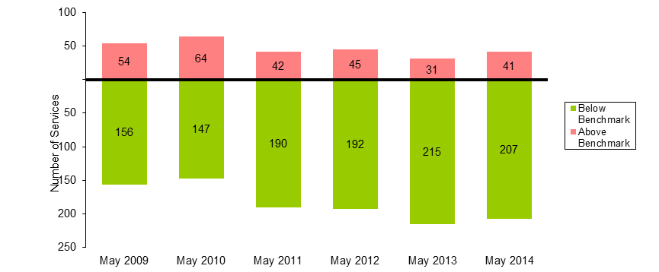

Table 1 AM Peak Services Above Benchmark Levels And Percentage of Passengers Travelling on Services Above Benchmark Levels (May 2009 to May 2014)
 | May 2009 | May 2010 | May 2011 | May 2012 | May 2013 | May 2014
Number of AM Peak Services Above Benchmark | 54 | 64 | 42 | 45 | 31 | 41
Number of AM Peak Services Below Benchmark | 156 | 147 | 190 | 192 | 215 | 207
% of AM Peak Services Above Benchmark | 25.7 | 30.3 | 18.1 | 19.0 | 12.6 | 16.5
% of AM Peak Passengers on Services Above Benchmark | 35.8 | 41.4 | 25.7 | 26.1 | 17.8 | 22.1
  - PM Peak

- The May 2014 survey recorded a total of 30 services in breach in the PM Peak period. This is an increase of nine compared to the May 2013 survey when 21 breaches were observed.
- Between May 2013 and May 2014, two services were removed from the Network during the PM Peak.
- The percentage of passengers travelling on services exceeding the benchmark on the Network during the PM Peak period increased from 11.7 per cent to 15.6 per cent between May 2013 and May 2014.

Figure 2 Number of PM Peak services below and above benchmark levels (May 2009 to May 2014)

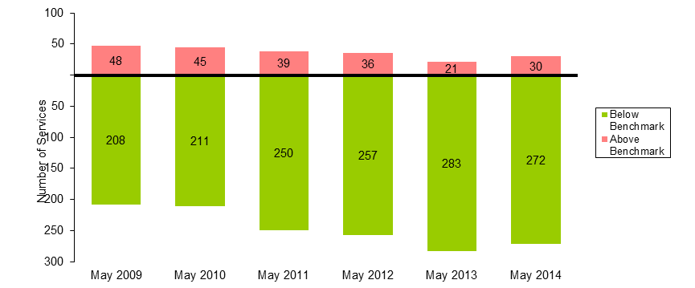

Table 2 PM Peak Services Above Benchmark and Passengers Using Services Above Benchmark (May 2009 to May 2014)
 | May 2009 | May 2010 | May 2011 | May 2012 | May 2013 | May 2014
Number of PM Peak Services Above Benchmark | 48 | 45 | 39 | 36 | 21 | 30
Number of PM Peak Services Below Benchmark | 208 | 211 | 250 | 257 | 283 | 272
% of PM Peak Services Above Benchmark | 18.8 | 17.6 | 13.5 | 12.3 | 6.9 | 9.9
% of PM Peak Passengers on Services Above Benchmark | 29.8 | 27.8 | 23.0 | 20.2 | 11.7 | 15.6

Line/Corridor Results

  - Alamein Line
    - AM Peak

- The May 2014 survey continued to record no services in the AM Peak period where passenger loads exceeded the benchmark.
- Between May 2013 and May 2014, one additional service was introduced to the Alamein Line during the AM Peak.

Figure 3 Number of AM Peak services below and above benchmark levels (May 2009 to May 2014)
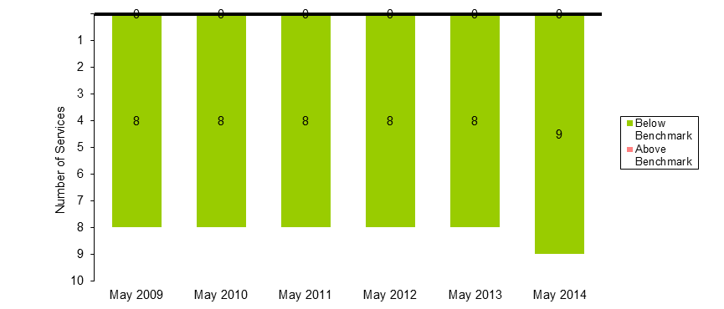

Table 3 AM Peak Services Above Benchmark Levels And Percentage of Passengers Travelling on Services Above Benchmark Levels (May 2009 to May 2014)
 | May 2009 | May 2010 | May 2011 | May 2012 | May 2013 | May 2014
Number of AM Peak Services Above Benchmark | 0 | 0 | 0 | 0 | 0 | 0
Number of AM Peak Services Below Benchmark | 8 | 8 | 8 | 8 | 8 | 9
% of AM Peak Services Above Benchmark | 0.0 | 0.0 | 0.0 | 0.0 | 0.0 | 0.0
% of AM Peak Passengers on Services Above Benchmark | 0.0 | 0.0 | 0.0 | 0.0 | 0.0 | 0.0

    - PM Peak

- The May 2014 survey continued to record no services in the PM Peak period where passenger loads exceeded the benchmark.

Figure 4 Number of PM Peak services below and above benchmark levels (May 2009 to May 2014)
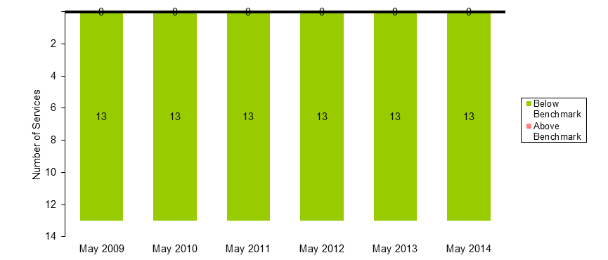
Table 4 PM Peak Services Above Benchmark and Passengers Using Services Above Benchmark (May 2009 to May 2014)
 | May 2009 | May 2010 | May 2011 | May 2012 | May 2013 | May 2014
Number of PM Peak Services Above Benchmark | 0 | 0 | 0 | 0 | 0 | 0
Number of PM Peak Services Below Benchmark | 13 | 13 | 13 | 13 | 13 | 13
% of PM Peak Services Above Benchmark | 0.0 | 0.0 | 0.0 | 0.0 | 0.0 | 0.0
% of PM Peak Passengers on Services Above Benchmark | 0.0 | 0.0 | 0.0 | 0.0 | 0.0 | 0.0

  - Glen Waverley Line
    - AM Peak
- The May 2014 survey recorded a total of zero services in breach in the AM Peak period. This is the same result compared to the May 2013 survey.
Figure 5 Number of AM Peak services below and above benchmark levels (May 2009 to May 2014) 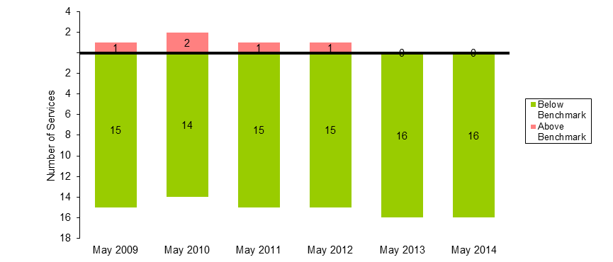

Table 5 AM Peak Services Above Benchmark Levels And Percentage of Passengers Travelling on Services Above Benchmark Levels (May 2009 to May 2014)
 | May 2009 | May 2010 | May 2011 | May 2012 | May 2013 | May 2014
Number of AM Peak Services Above Benchmark | 1 | 2 | 1 | 1 | 0 | 0
Number of AM Peak Services Below Benchmark | 15 | 14 | 15 | 15 | 16 | 16
% of AM Peak Services Above Benchmark | 6.3 | 12.5 | 6.3 | 6.3 | 0.0 | 0.0
% of AM Peak Passengers on Services Above Benchmark | 8.9 | 18.9 | 8.8 | 9.5 | 0.0 | 0.0

    - PM Peak

- The May 2014 survey recorded a total of one service in breach in the PM Peak period. This is the same result compared to the May 2013 survey.
- The percentage of passengers travelling on services exceeding the benchmark on the Glen Waverley Line during the PM Peak period decreased from 9.6 per cent to 8.8 per cent between May 2013 and May 2014.

Figure 6 Number of PM Peak services below and above benchmark levels (May 2009 to May 2014) 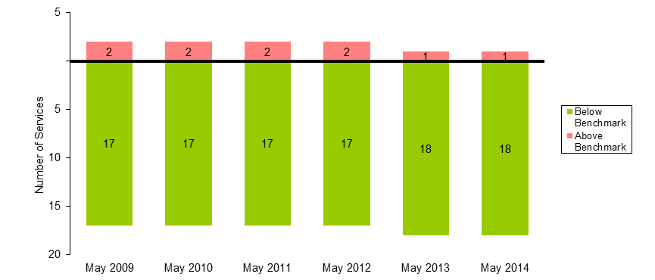

Table 6 PM Peak Services Above Benchmark and Passengers Using Services Above Benchmark (May 2009 to May 2014)
 | May 2009 | May 2010 | May 2011 | May 2012 | May 2013 | May 2014
Number of PM Peak Services Above Benchmark | 2 | 2 | 2 | 2 | 1 | 1
Number of PM Peak Services Below Benchmark | 17 | 17 | 17 | 17 | 18 | 18
% of PM Peak Services Above Benchmark | 10.5 | 10.5 | 10.5 | 10.5 | 5.3 | 5.3
% of PM Peak Passengers on Services Above Benchmark | 18.9 | 16.7 | 17.6 | 17.5 | 9.6 | 8.8
  - Ringwood Corridor

Note: The Ringwood Corridor includes services originating from Lilydale, Mooroolbark, Belgrave, Upper Ferntree Gully, Ringwood and Blackburn stations in the AM and terminating at those stations in the PM.

    - AM Peak

- The May 2014 survey recorded a total of two services in breach in the AM Peak period. This is an increase of two compared to the May 2013 survey when zero breaches were observed.
- The percentage of passengers travelling on services exceeding the benchmark on the Ringwood Corridor during the AM peak period increased from 0.0 per cent to 7.0 per cent between May 2013 and May 2014.

Figure 7 Number of AM Peak services below and above benchmark levels (May 2009 to May 2014)

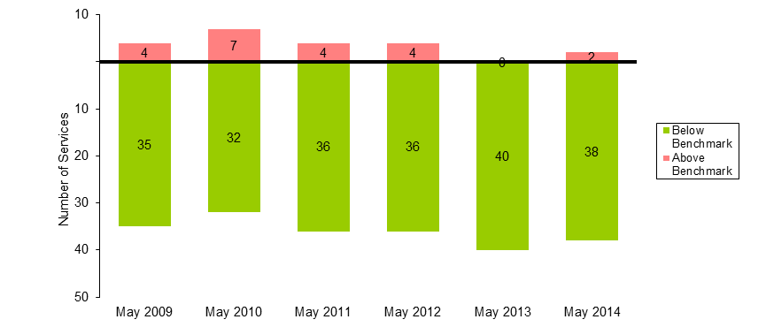

Table 7 AM Peak Services Above Benchmark Levels And Percentage of Passengers Travelling on Services Above Benchmark Levels (May 2009 to May 2014)

 | May 2009 | May 2010 | May 2011 | May 2012 | May 2013 | May 2014
Number of AM Peak Services Above Benchmark | 4 | 7 | 4 | 4 | 0 | 2
Number of AM Peak Services Below Benchmark | 35 | 32 | 36 | 36 | 40 | 38
% of AM Peak Services Above Benchmark | 10.3 | 17.9 | 10.0 | 10.0 | 0.0 | 5.0
% of AM Peak Passengers on Services Above Benchmark | 16.7 | 26.3 | 14.7 | 14.3 | 0.0 | 7.0

    - PM Peak

- The May 2014 survey recorded a total of one service in breach in the PM Peak period. This is an increase of one compared to the May 2013 survey when zero breaches were observed.
- The percentage of passengers travelling on services exceeding the benchmark on the Ringwood Corridor during the PM Peak period increased from 0.0 per cent to 3.5 per cent between May 2013 and May 2014.
Figure 8 Number of PM Peak services below and above benchmark levels (May 2009 to May 2014)
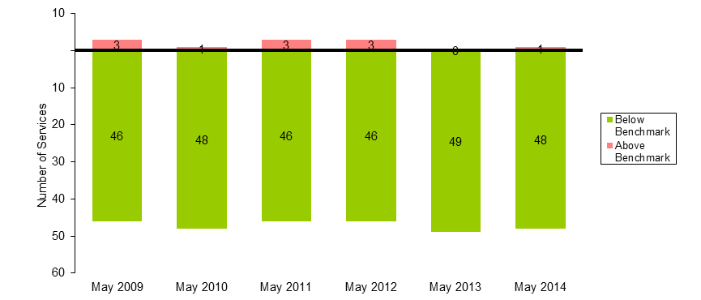

Table 8 PM Peak Services Above Benchmark and Passengers Using Services Above Benchmark (May 2009 to May 2014)
 | May 2009 | May 2010 | May 2011 | May 2012 | May 2013 | May 2014
Number of PM Peak Services Above Benchmark | 3 | 1 | 3 | 3 | 0 | 1
Number of PM Peak Services Below Benchmark | 46 | 48 | 46 | 46 | 49 | 48
% of PM Peak Services Above Benchmark | 6.1 | 2.0 | 6.1 | 6.1 | 0.0 | 2.0
% of PM Peak Passengers on Services Above Benchmark | 10.7 | 3.5 | 10.5 | 10.4 | 0.0 | 3.5
  - Dandenong Corridor

Note: the Dandenong Corridor includes services originating from Pakenham, Berwick, Cranbourne, Dandenong, Westall and Oakleigh stations in the AM and terminating at those stations in the PM.

    - AM Peak

- The May 2014 survey recorded a total of eight services in breach in the AM Peak period. This is an increase of one compared to the May 2013 survey when seven breaches were observed.
- The percentage of passengers travelling on services exceeding the benchmark on the Dandenong Corridor during the AM peak period increased from 32.6 per cent to 35.5 per cent between May 2013 and May 2014.

Figure 9 Number of AM Peak services below and above benchmark levels (May 2009 to May 2014)
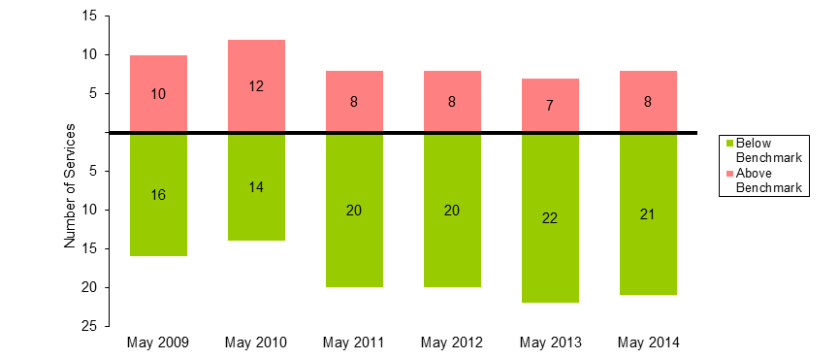

Table 9 AM Peak Services Above Benchmark Levels And Percentage of Passengers Travelling on Services Above Benchmark Levels (May 2009 to May 2014)
 | May 2009 | May 2010 | May 2011 | May 2012 | May 2013 | May 2014
Number of AM Peak Services Above Benchmark | 10 | 12 | 8 | 8 | 7 | 8
Number of AM Peak Services Below Benchmark | 16 | 14 | 20 | 20 | 22 | 21
% of AM Peak Services Above Benchmark | 38.5 | 46.2 | 28.6 | 28.6 | 24.1 | 27.6
% of AM Peak Passengers on Services Above Benchmark | 47.5 | 57.4 | 36.1 | 36.0 | 32.6 | 35.5

    - PM Peak

- The May 2014 survey recorded a total of 12 services in breach in the PM Peak period. This is an increase of five compared to the May 2013 survey when seven breaches were observed.
- The percentage of passengers travelling on services exceeding the benchmark on the Dandenong Corridor during the PM Peak period increased from 27.2 per cent to 44.1 per cent between May 2013 and May 2014.

Figure 10 Number of PM Peak services below and above benchmark levels (May 2009 to May 2014)
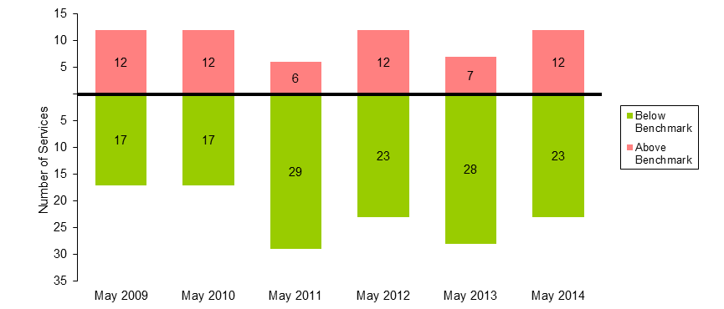

Table 10 PM Peak Services Above Benchmark and Passengers Using Services Above Benchmark (May 2009 to May 2014)
 | May 2009 | May 2010 | May 2011 | May 2012 | May 2013 | May 2014
Number of PM Peak Services Above Benchmark | 12 | 12 | 6 | 12 | 7 | 12
Number of PM Peak Services Below Benchmark | 17 | 17 | 29 | 23 | 28 | 23
% of PM Peak Services Above Benchmark | 41.4 | 41.4 | 17.1 | 34.3 | 20.0 | 34.3
% of PM Peak Passengers on Services Above Benchmark | 52.6 | 51.6 | 25.8 | 44.6 | 27.2 | 44.1

  - Frankston Line

    - AM Peak

- The May 2014 survey recorded a total of four services in breach in the AM Peak period. This is an increase of one compared to the May 2013 survey when three breaches were observed.
- The percentage of passengers travelling on services exceeding the benchmark on the Frankston Line during the AM peak period increased from 16.7 per cent to 21.6 per cent between May 2013 and May 2014.
Figure 11 Number of AM Peak services below and above benchmark levels (May 2009 to May 2014) 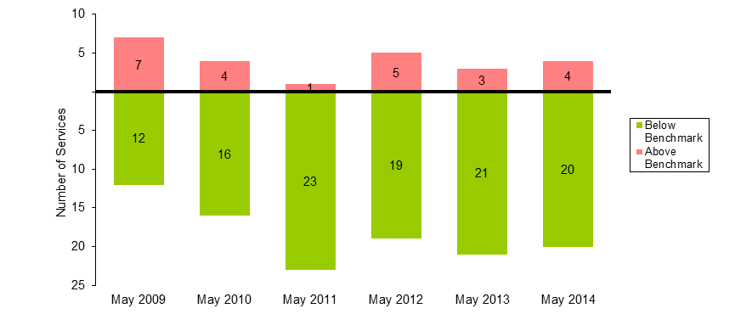

Table 11 AM Peak Services Above Benchmark Levels And Percentage of Passengers Travelling on Services Above Benchmark Levels (May 2009 to May 2014)
 | May 2009 | May 2010 | May 2011 | May 2012 | May 2013 | May 2014
Number of AM Peak Services Above Benchmark | 7 | 4 | 1 | 5 | 3 | 4
Number of AM Peak Services Below Benchmark | 12 | 16 | 23 | 19 | 21 | 20
% of AM Peak Services Above Benchmark | 36.8 | 20.0 | 4.2 | 20.8 | 12.5 | 16.7
% of AM Peak Passengers on Services Above Benchmark | 43.7 | 24.9 | 5.4 | 25.9 | 16.7 | 21.6

    - PM Peak

- The May 2014 survey recorded a total of zero services in breach in the PM Peak period. This is the same result compared to the May 2013 survey.

Figure 12 Number of PM Peak services below and above benchmark levels (May 2009 to May 2014)

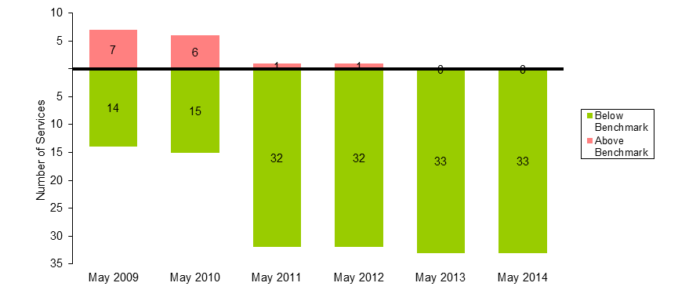

Table 12 PM Peak Services Above Benchmark and Passengers Using Services Above Benchmark (May 2009 to May 2014)
 | May 2009 | May 2010 | May 2011 | May 2012 | May 2013 | May 2014
Number of PM Peak Services Above Benchmark | 7 | 6 | 1 | 1 | 0 | 0
Number of PM Peak Services Below Benchmark | 14 | 15 | 32 | 32 | 33 | 33
% of PM Peak Services Above Benchmark | 33.3 | 28.6 | 3.0 | 3.0 | 0.0 | 0.0
% of PM Peak Passengers on Services Above Benchmark | 40.7 | 36.8 | 5.4 | 5.0 | 0.0 | 0.0
  - Sandringham Line

    - AM Peak

- The May 2014 survey recorded a total of five services in breach in the AM Peak period. This is the same result compared to the May 2013 survey.
- The percentage of passengers travelling on services exceeding the benchmark on the Sandringham Line during the AM peak period increased from 38.3 per cent to 38.4 per cent between May 2013 and May 2014.
Figure 13 Number of AM Peak services below and above benchmark levels (May 2009 to May 2014) 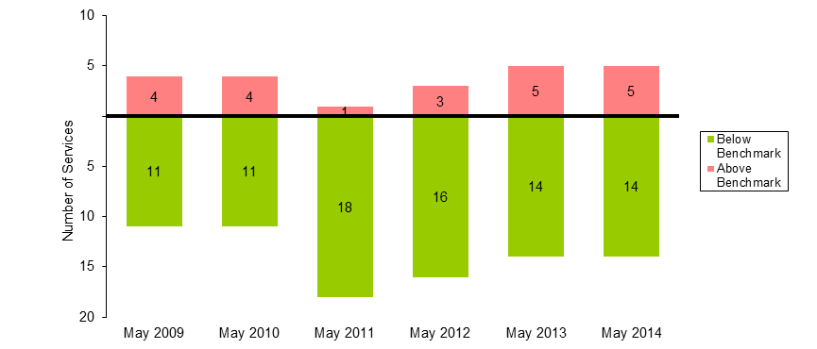

Table 13 AM Peak Services Above Benchmark Levels And Percentage of Passengers Travelling on Services Above Benchmark Levels (May 2009 to May 2014)
 | May 2009 | May 2010 | May 2011 | May 2012 | May 2013 | May 2014
Number of AM Peak Services Above Benchmark | 4 | 4 | 1 | 3 | 5 | 5
Number of AM Peak Services Below Benchmark | 11 | 11 | 18 | 16 | 14 | 14
% of AM Peak Services Above Benchmark | 26.7 | 26.7 | 5.3 | 15.8 | 26.3 | 26.3
% of AM Peak Passengers on Services Above Benchmark | 37.8 | 38.1 | 8.3 | 24.1 | 38.3 | 38.4

    - PM Peak
- The May 2014 survey continued to record no services in the PM Peak period where passenger loads exceeded the benchmark.

Figure 14 Number of PM Peak services below and above benchmark levels (May 2009 to May 2014)


Table 14 PM Peak Services Above Benchmark and Passengers Using Services Above Benchmark (May 2009 to May 2014)

 | May 2009 | May 2010 | May 2011 | May 2012 | May 2013 | May 2014
Number of PM Peak Services Above Benchmark | 2 | 2 | 0 | 1 | 0 | 0
Number of PM Peak Services Below Benchmark | 17 | 17 | 23 | 22 | 23 | 23
% of PM Peak Services Above Benchmark | 10.5 | 10.5 | 0.0 | 4.3 | 0.0 | 0.0
% of PM Peak Passengers on Services Above Benchmark | 18.9 | 19.0 | 0.0 | 7.8 | 0.0 | 0.0
  - South Morang Line

    - AM Peak

- The May 2014 survey recorded a total of two services in breach in the AM Peak period. This is an increase of two compared to the May 2013 survey when zero breaches were observed.
- The percentage of passengers travelling on services exceeding the benchmark on the South Morang Line during the AM peak period increased from 0.0 per cent to 17.1 per cent between May 2013 and May 2014.
Figure 15 Number of AM Peak services below and above benchmark levels (May 2009 to May 2014)
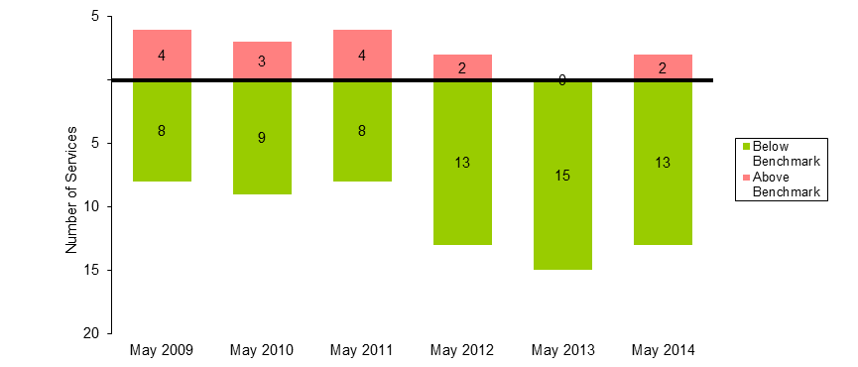
Table 15 AM Peak Services Above Benchmark Levels And Percentage of Passengers Travelling on Services Above Benchmark Levels (May 2009 to May 2014)

 | May 2009 | May 2010 | May 2011 | May 2012 | May 2013 | May 2014
Number of AM Peak Services Above Benchmark | 4 | 3 | 4 | 2 | 0 | 2
Number of AM Peak Services Below Benchmark | 8 | 9 | 8 | 13 | 15 | 13
% of AM Peak Services Above Benchmark | 33.3 | 25.0 | 33.3 | 13.3 | 0.0 | 13.3
% of AM Peak Passengers on Services Above Benchmark | 43.2 | 33.0 | 43.7 | 18.1 | 0.0 | 17.1

    - PM Peak

- The May 2014 survey recorded a total of one services in breach in the PM Peak period. This is the same result compared to the May 2013 survey.
- The percentage of passengers travelling on services exceeding the benchmark on the South Morang Line during the PM Peak period decreased from 8.2 per cent to 7.0 per cent between May 2013 and May 2014.

Figure 16 Number of PM Peak services below and above benchmark levels (May 2009 to May 2014)
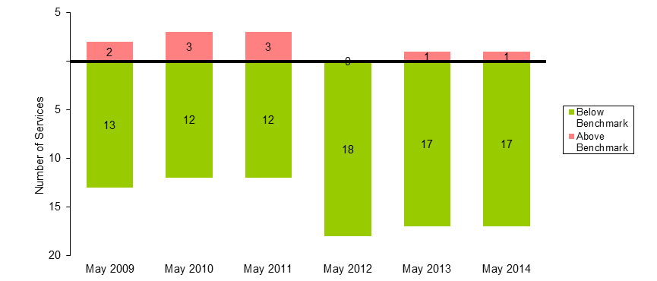

Table 16 PM Peak Services Above Benchmark and Passengers Using Services Above Benchmark (May 2009 to May 2014)

 | May 2009 | May 2010 | May 2011 | May 2012 | May 2013 | May 2014
Number of PM Peak Services Above Benchmark | 2 | 3 | 3 | 0 | 1 | 1
Number of PM Peak Services Below Benchmark | 13 | 12 | 12 | 18 | 17 | 17
% of PM Peak Services Above Benchmark | 13.3 | 20.0 | 20.0 | 0.0 | 5.6 | 5.6
% of PM Peak Passengers on Services Above Benchmark | 18.7 | 27.3 | 26.7 | 0.0 | 8.2 | 7.0
  - Hurstbridge Line

    - AM Peak

- The May 2014 survey recorded a total of two services in breach in the AM Peak period. This is an increase of two compared to the May 2013 survey when zero breaches were observed.
- The percentage of passengers travelling on services exceeding the benchmark on the Hurstbridge Line during the AM peak period increased from 0.0 per cent to 14.0 per cent between May 2013 and May 2014.
Figure 17 Number of AM Peak services below and above benchmark levels (May 2009 to May 2014) 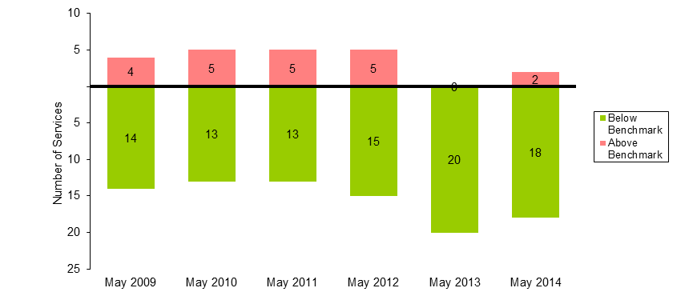

Table 17 AM Peak Services Above Benchmark Levels And Percentage of Passengers Travelling on Services Above Benchmark Levels (May 2009 to May 2014)
 | May 2009 | May 2010 | May 2011 | May 2012 | May 2013 | May 2014
Number of AM Peak Services Above Benchmark | 4 | 5 | 5 | 5 | 0 | 2
Number of AM Peak Services Below Benchmark | 14 | 13 | 13 | 15 | 20 | 18
% of AM Peak Services Above Benchmark | 22.2 | 27.8 | 27.8 | 25.0 | 0.0 | 10.0
% of AM Peak Passengers on Services Above Benchmark | 30.5 | 37.8 | 38.1 | 35.2 | 0.0 | 14.0

    - PM Peak

- The May 2014 survey recorded a total of one services in breach in the PM Peak period. This is an increase of one compared to the May 2013 survey when zero breaches were observed.
- Between May 2013 and May 2014, one service was removed from the Hurstbridge Line during the PM Peak.
- The percentage of passengers travelling on services exceeding the benchmark on the Hurstbridge Line during the PM Peak period increased from 0.0 per cent to 7.2 per cent between May 2013 and May 2014.

Figure 18 Number of PM Peak services below and above benchmark levels (May 2009 to May 2014)
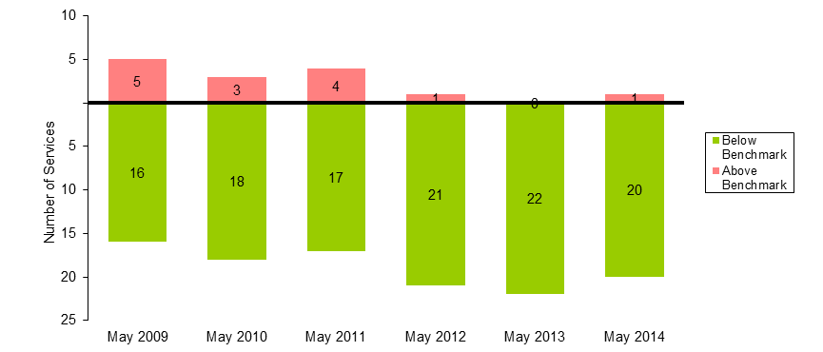
Table 18 PM Peak Services Above Benchmark and Passengers Using Services Above Benchmark (May 2009 to May 2014)
 | May 2009 | May 2010 | May 2011 | May 2012 | May 2013 | May 2014
Number of PM Peak Services Above Benchmark | 5 | 3 | 4 | 1 | 0 | 1
Number of PM Peak Services Below Benchmark | 16 | 18 | 17 | 21 | 22 | 20
% of PM Peak Services Above Benchmark | 23.8 | 14.3 | 19.0 | 4.5 | 0.0 | 4.8
% of PM Peak Passengers on Services Above Benchmark | 36.0 | 22.0 | 27.4 | 7.2 | 0.0 | 7.2
  - Craigieburn Line

    - AM Peak

- The May 2014 survey recorded a total of seven services in breach in the AM Peak period. This is the same result compared to the May 2013 survey.
- The percentage of passengers travelling on services exceeding the benchmark on the Craigieburn Line during the AM peak period decreased from 41.8 per cent to 41.7 per cent between May 2013 and May 2014.

Figure 19 Number of AM Peak services below and above benchmark levels (May 2009 to May 2014)
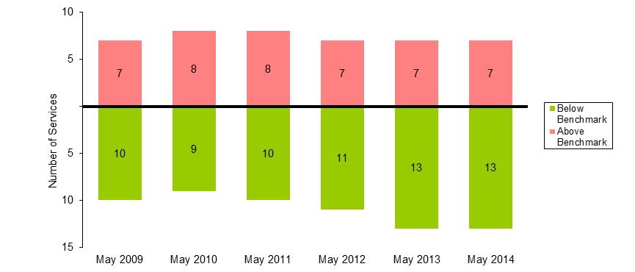

Table 19 AM Peak Services Above Benchmark Levels And Percentage of Passengers Travelling on Services Above Benchmark Levels (May 2009 to May 2014)
 | May 2009 | May 2010 | May 2011 | May 2012 | May 2013 | May 2014
Number of AM Peak Services Above Benchmark | 7 | 8 | 8 | 7 | 7 | 7
Number of AM Peak Services Below Benchmark | 10 | 9 | 10 | 11 | 13 | 13
% of AM Peak Services Above Benchmark | 41.2 | 47.1 | 44.4 | 38.9 | 35.0 | 35.0
% of AM Peak Passengers on Services Above Benchmark | 51.2 | 57.3 | 54.5 | 47.3 | 41.8 | 41.7

    - PM Peak

- The May 2014 survey recorded a total of three services in breach in the PM Peak period. This is an increase of one compared to the May 2013 survey when two breaches were observed.
- The percentage of passengers travelling on services exceeding the benchmark on the Craigieburn Line during the PM Peak period increased from 12.9 per cent to 17.2 per cent between May 2013 and May 2014.

Figure 20 Number of PM Peak services below and above benchmark levels (May 2009 to May 2014)
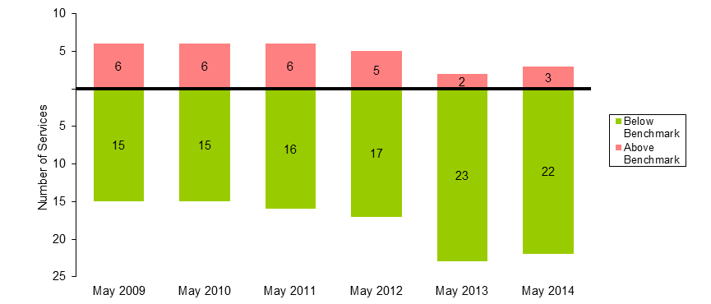
Table 20 PM Peak Services Above Benchmark and Passengers Using Services Above Benchmark (May 2009 to May 2014)

 | May 2009 | May 2010 | May 2011 | May 2012 | May 2013 | May 2014
Number of PM Peak Services Above Benchmark | 6 | 6 | 6 | 5 | 2 | 3
Number of PM Peak Services Below Benchmark | 15 | 15 | 16 | 17 | 23 | 22
% of PM Peak Services Above Benchmark | 28.6 | 28.6 | 27.3 | 22.7 | 8.0 | 12.0
% of PM Peak Passengers on Services Above Benchmark | 41.5 | 42.6 | 40.2 | 33.4 | 12.9 | 17.2
  - Sunbury Line

    - AM Peak

- The May 2014 survey recorded a total of two services in breach in the AM Peak period. This is a decrease of two compared to the May 2013 survey when four breaches were observed.
- The percentage of passengers travelling on services exceeding the benchmark on the Sunbury Line during the AM peak period decreased from 25.4 per cent to 12.1 per cent between May 2013 and May 2014.
Figure 21 Number of AM Peak services below and above benchmark levels (May 2009 to May 2014)
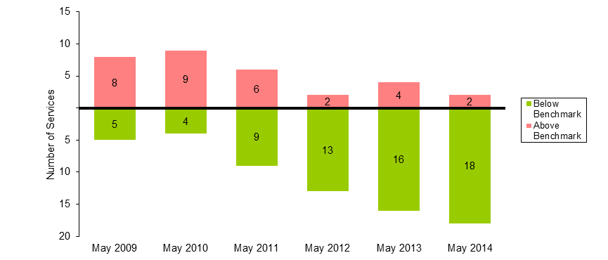

Table 21 AM Peak Services Above Benchmark Levels And Percentage of Passengers Travelling on Services Above Benchmark Levels (May 2009 to May 2014)

 | May 2009 | May 2010 | May 2011 | May 2012 | May 2013 | May 2014
Number of AM Peak Services Above Benchmark | 8 | 9 | 6 | 2 | 4 | 2
Number of AM Peak Services Below Benchmark | 5 | 4 | 9 | 13 | 16 | 18
% of AM Peak Services Above Benchmark | 61.5 | 69.2 | 40.0 | 13.3 | 20.0 | 10.0
% of AM Peak Passengers on Services Above Benchmark | 69.0 | 76.4 | 47.0 | 17.4 | 25.4 | 12.1

    - PM Peak

- The May 2014 survey recorded a total of four services in breach in the PM Peak period. This is an increase of one compared to the May 2013 survey when three breaches were observed.
- The percentage of passengers travelling on services exceeding the benchmark on the Sunbury Line during the PM Peak period increased from 17.6 per cent to 22.1 per cent between May 2013 and May 2014.

Figure 22 Number of PM Peak services below and above benchmark levels (May 2009 to May 2014)
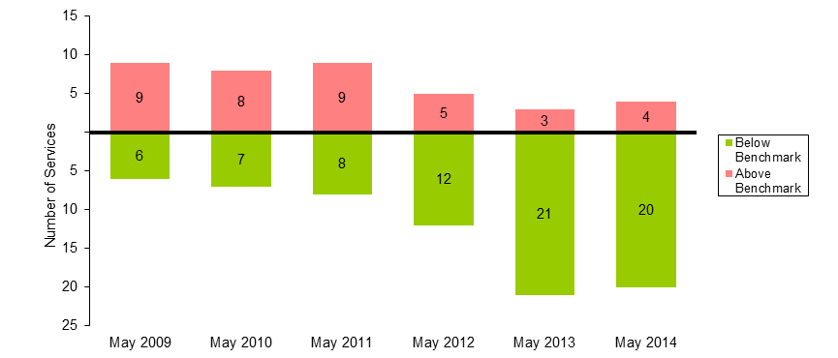
Table 22 PM Peak Services Above Benchmark and Passengers Using Services Above Benchmark (May 2009 to May 2014)

 | May 2009 | May 2010 | May 2011 | May 2012 | May 2013 | May 2014
Number of PM Peak Services Above Benchmark | 9 | 8 | 9 | 5 | 3 | 4
Number of PM Peak Services Below Benchmark | 6 | 7 | 8 | 12 | 21 | 20
% of PM Peak Services Above Benchmark | 60.0 | 53.3 | 52.9 | 29.4 | 12.5 | 16.7
% of PM Peak Passengers on Services Above Benchmark | 69.4 | 63.0 | 62.5 | 36.5 | 17.6 | 22.1
  - Upfield Line

    - AM Peak

- The May 2014 survey recorded a total of one services in breach in the AM Peak period. This is an increase of one compared to the May 2013 survey when zero breaches were observed.
- The percentage of passengers travelling on services exceeding the benchmark on the Upfield Line during the AM peak period increased from 0.0 per cent to 17.8 per cent between May 2013 and May 2014.
Figure 23 Number of AM Peak services below and above benchmark levels (May 2009 to May 2014)
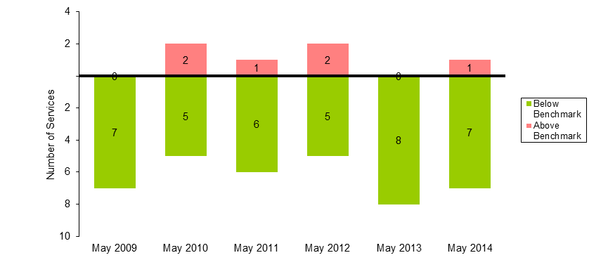

Table 23 AM Peak Services Above Benchmark Levels And Percentage of Passengers Travelling on Services Above Benchmark Levels (May 2009 to May 2014)
 | May 2009 | May 2010 | May 2011 | May 2012 | May 2013 | May 2014
Number of AM Peak Services Above Benchmark | 0 | 2 | 1 | 2 | 0 | 1
Number of AM Peak Services Below Benchmark | 7 | 5 | 6 | 5 | 8 | 7
% of AM Peak Services Above Benchmark | 0.0 | 28.6 | 14.3 | 28.6 | 0.0 | 12.5
% of AM Peak Passengers on Services Above Benchmark | 0.0 | 41.8 | 20.4 | 40.6 | 0.0 | 17.8

    - PM Peak

- The May 2014 survey recorded no services in the PM Peak period where passenger loads exceeded the benchmark.
- Between May 2013 and May 2014, one service was removed from the Upfield Line during the PM Peak.

Figure 24 Number of PM Peak services below and above benchmark levels (May 2009 to May 2014)
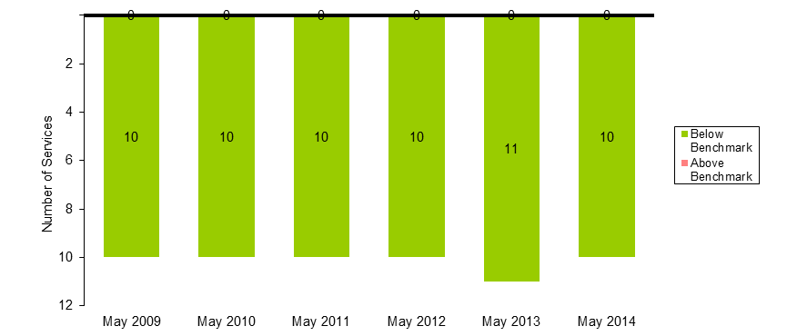
Table 24 PM Peak Services Above Benchmark and Passengers Using Services Above Benchmark (May 2009 to May 2014)

 | May 2009 | May 2010 | May 2011 | May 2012 | May 2013 | May 2014
Number of PM Peak Services Above Benchmark | 0 | 0 | 0 | 0 | 0 | 0
Number of PM Peak Services Below Benchmark | 10 | 10 | 10 | 10 | 11 | 10
% of PM Peak Services Above Benchmark | 0.0 | 0.0 | 0.0 | 0.0 | 0.0 | 0.0
% of PM Peak Passengers on Services Above Benchmark | 0.0 | 0.0 | 0.0 | 0.0 | 0.0 | 0.0
  - Werribee Line

Note: the Werribee Line includes services originating from Werribee and Laverton stations in the AM and terminating at those stations in the PM.

    - AM Peak

- The May 2014 survey recorded a total of eight services in breach in the AM Peak period. This is an increase of three compared to the May 2013 survey when five breaches were observed.
- Between May 2013 and May 2014, an additional one service was introduced to the Werribee Line during the AM Peak.
- The percentage of passengers travelling on services exceeding the benchmark on the Werribee Line during the AM peak period increased from 32.7 per cent to 46.7 per cent between May 2013 and May 2014.
Figure 25 Number of AM Peak services below and above benchmark levels (May 2009 to May 2014)
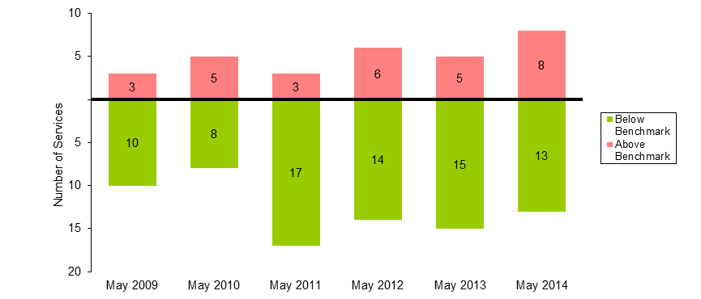

Table 25 AM Peak Services Above Benchmark Levels And Percentage of Passengers Travelling on Services Above Benchmark Levels (May 2009 to May 2014)
 | May 2009 | May 2010 | May 2011 | May 2012 | May 2013 | May 2014
Number of AM Peak Services Above Benchmark | 3 | 5 | 3 | 6 | 5 | 8
Number of AM Peak Services Below Benchmark | 10 | 8 | 17 | 14 | 15 | 13
% of AM Peak Services Above Benchmark | 23.1 | 38.5 | 15.0 | 30.0 | 25.0 | 38.1
% of AM Peak Passengers on Services Above Benchmark | 33.1 | 50.8 | 21.2 | 38.6 | 32.7 | 46.7

    - PM Peak

- The May 2014 survey recorded a total of seven services in breach in the PM Peak period. This is the same result compared to the May 2013 survey.
- The percentage of passengers travelling on services exceeding the benchmark on the Werribee Line during the PM Peak period decreased from 48.2 per cent to 46.8 per cent between May 2013 and May 2014.
Figure 26 Number of PM Peak services below and above benchmark levels (May 2009 to May 2014)
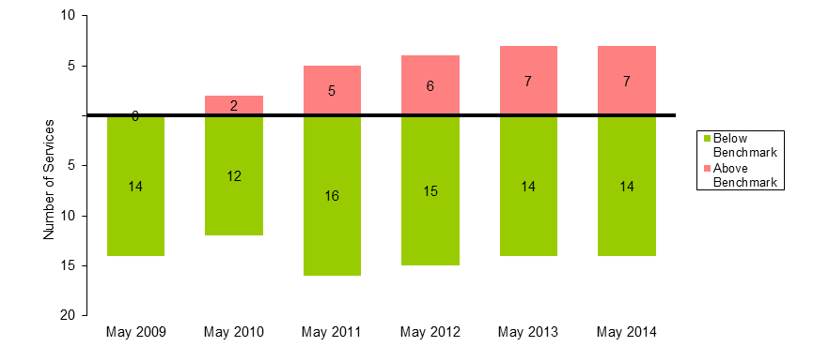
Table 26 PM Peak Services Above Benchmark and Passengers Using Services Above Benchmark (May 2009 to May 2014)
 | May 2009 | May 2010 | May 2011 | May 2012 | May 2013 | May 2014
Number of PM Peak Services Above Benchmark | 0 | 2 | 5 | 6 | 7 | 7
Number of PM Peak Services Below Benchmark | 14 | 12 | 16 | 15 | 14 | 14
% of PM Peak Services Above Benchmark | 0.0 | 14.3 | 23.8 | 28.6 | 33.3 | 33.3
% of PM Peak Passengers on Services Above Benchmark | 0.0 | 18.7 | 38.7 | 42.8 | 48.2 | 46.8
  - Williamstown Line

    - AM Peak

- The May 2014 survey recorded a total of zero services in breach in the AM Peak period. This is the same result compared to the May 2013 survey.

Figure 27 Number of AM Peak services below and above benchmark levels (May 2009 to May 2014)
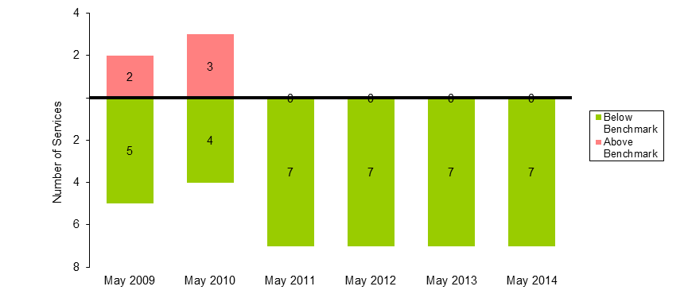

Table 27 AM Peak Services Above Benchmark Levels And Percentage of Passengers Travelling on Services Above Benchmark Levels (May 2009 to May 2014)
 | May 2009 | May 2010 | May 2011 | May 2012 | May 2013 | May 2014
Number of AM Peak Services Above Benchmark | 2 | 3 | 0 | 0 | 0 | 0
Number of AM Peak Services Below Benchmark | 5 | 4 | 7 | 7 | 7 | 7
% of AM Peak Services Above Benchmark | 28.6 | 42.9 | 0.0 | 0.0 | 0.0 | 0.0
% of AM Peak Passengers on Services Above Benchmark | 41.8 | 56.8 | 0.0 | 0.0 | 0.0 | 0.0

    - PM Peak

- The May 2014 survey recorded a total of zero services in breach in the PM Peak period. This is the same result compared to the May 2013 survey.

Figure 28 Number of PM Peak services below and above benchmark levels (May 2009 to May 2014) 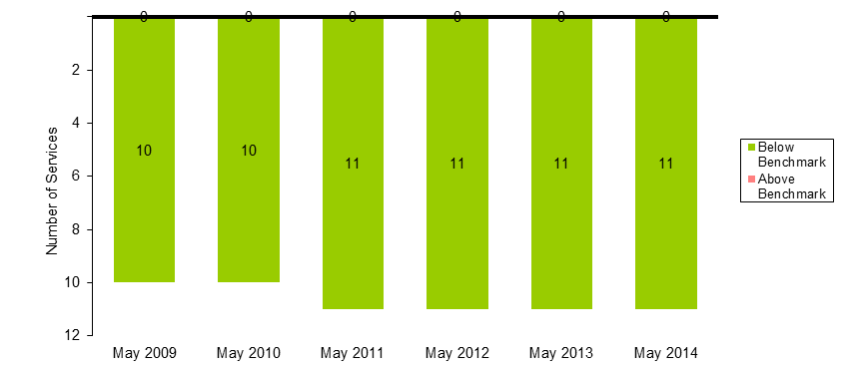

Table 28 PM Peak Services Above Benchmark and Passengers Using Services Above Benchmark (May 2009 to May 2014)
 | May 2009 | May 2010 | May 2011 | May 2012 | May 2013 | May 2014
Number of PM Peak Services Above Benchmark | 0 | 0 | 0 | 0 | 0 | 0
Number of PM Peak Services Below Benchmark | 10 | 10 | 11 | 11 | 11 | 11
% of PM Peak Services Above Benchmark | 0.0 | 0.0 | 0.0 | 0.0 | 0.0 | 0.0
% of PM Peak Passengers on Services Above Benchmark | 0.0 | 0.0 | 0.0 | 0.0 | 0.0 | 0.0

Notes about the survey

- Independent surveyors collected the data for the May 2014 survey over 12 weekdays (Monday to Thursday). Surveying times were between 6 am and 12 pm for City-bound services and 2 pm and 10 pm for outbound services.
- For outbound services, surveyors collect the data at three city cordon stations: Jolimont, Richmond and North Melbourne. Cordon stations are those that abut the City Loop.
- For inbound services, surveyors collect the data at all stations where services stop directly prior to a cordon station. This could involve collecting data at a variety of stations from where express services run direct to the cordon.
- The peak periods are:
  - AM – between 7.01 am and 9.30 am
  - PM – between 3.31 pm and 7 pm.
- The impact of service cancellations and network disruptions on the data are considered. Passenger loads affected by cancellations and disruptions are excluded from the analysis to ensure the survey results provide an accurate picture of how the metropolitan rail network performs.
- Results from the May and October surveys are not compared as seasonality can impact on passenger loads. Therefore, it is more valuable to compare results of the year-to-year surveys.

