Public Transport Victoria
Metropolitan Train Load Standards
Survey Report
May 2015

Table of Contents
1. Introduction 4
2. Network-wide results 5
2.1. AM Peak 5
2.2. PM Peak 6
3. Line/Corridor Results 7
3.1. Alamein Line 7
3.1.1. AM Peak 7
3.1.2. PM Peak 8
3.2. Glen Waverley Line 9
3.2.1. AM Peak 9
3.2.2. PM Peak 10
3.3. Ringwood Corridor 11
3.3.1. AM Peak 11
3.3.2. PM Peak 12
3.4. Dandenong Corridor 13
3.4.1. AM Peak 13
3.4.2. PM Peak 14
3.5. Frankston Line 15
3.5.1. AM Peak 15
3.5.2. PM Peak 16
3.6. Sandringham Line 17
3.6.1. AM Peak 17
3.6.2. PM Peak 18
3.7. South Morang Line 19
3.7.1. AM Peak 19
3.7.2. PM Peak 20
3.8. Hurstbridge Line 21
3.8.1. AM Peak 21
3.8.2. PM Peak 22
3.9. Craigieburn Line 23
3.9.1. AM Peak 23
3.9.2. PM Peak 24
3.10. Sunbury Line 25
3.10.1. AM Peak 25
3.10.2. PM Peak 26
3.11. Upfield Line 27
3.11.1. AM Peak 27
3.11.2. PM Peak 28
3.12. Werribee Line 29
3.12.1. AM Peak 29
3.12.2. PM Peak 30
3.13. Williamstown Line 31
3.13.1. AM Peak 31
3.13.2. PM Peak 32
4. Notes about the survey 33

Introduction
Metropolitan Train Load Standard Surveys are conducted once a year in May to measure passenger loads against benchmark standards of capacity.
The survey’s findings help pinpoint the times when and on which sections of Melbourne’s 15 rail lines passenger loads are at their highest. The results are used to determine when and where extra services may be needed to reduce crowding.
This bulletin reports on the May 2015 survey which was conducted from 4 to 25 May 2015.

Network-wide results
  - AM Peak
- The May 2015 survey recorded a total of 47 services in the AM peak period where passenger loads did not meet PTV standards; this is six more than in May 2014.
- Between May 2014 and May 2015, three additional services were introduced to the Network during the AM Peak.
- The percentage of passengers travelling on services exceeding the benchmark during the AM peak period increased from 22.1 per cent to 26.1 per cent between May 2014 and May 2015.
Figure 1: Number of AM peak services below and above benchmark levels (May 2009 to May 2015)
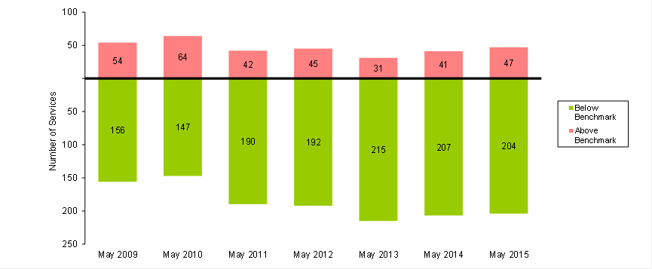
Table 1: AM Peak Services Above Benchmark Levels And Percentage of Passengers Travelling on Services Above Benchmark Levels (May 2009 to May 2015)
 | May 2009 | May 2010 | May 2011 | May 2012 | May 2013 | May 2014 | May 2015
Number of AM Peak Services Above Benchmark | 54 | 64 | 42 | 45 | 31 | 41 | 47
Number of AM Peak Services Below Benchmark | 156 | 147 | 190 | 192 | 215 | 207 | 204
% of AM Peak Services Above Benchmark | 25.7 | 30.3 | 18.1 | 19.0 | 12.6 | 16.5 | 18.7
% of AM Peak Passengers on Services Above Benchmark | 35.8 | 41.4 | 25.7 | 26.1 | 17.8 | 22.1 | 26.1
  - PM Peak
- The May 2015 survey recorded a total of 30 services in the PM Peak period where passenger loads did not meet PTV standards; this is no change compared to May 2014 .
- Between May 2014 and May 2015, one additional service was added to the Network during the PM Peak.
- The percentage of passengers travelling on services exceeding the benchmark during the PM Peak period remained the same at 15.6 per cent between May 2014 and May 2015.
Figure 2: Number of PM peak services below and above benchmark levels (May 2009 to May 2015)
Table 2: PM peak services above benchmark and passengers using services above benchmark (May 2009 to May 2015)
 | May 2009 | May 2010 | May 2011 | May 2012 | May 2013 | May 2014 | May 2015
Number of PM Peak Services Above Benchmark | 48 | 45 | 39 | 36 | 21 | 30 | 30
Number of PM Peak Services Below Benchmark | 208 | 211 | 250 | 257 | 283 | 272 | 273
% of PM Peak Services Above Benchmark | 18.8 | 17.6 | 13.5 | 12.3 | 6.9 | 9.9 | 9.9
% of PM Peak Passengers on Services Above Benchmark | 29.8 | 27.8 | 23.0 | 20.2 | 11.7 | 15.6 | 15.6

Line/Corridor Results
  - Alamein Line
    - AM Peak
- The May 2015 survey continued to record no services in the AM Peak period where passenger loads did not meet PTV standards.
Figure 3: Number of AM peak services below and above benchmark levels (May 2009 to May 2015)
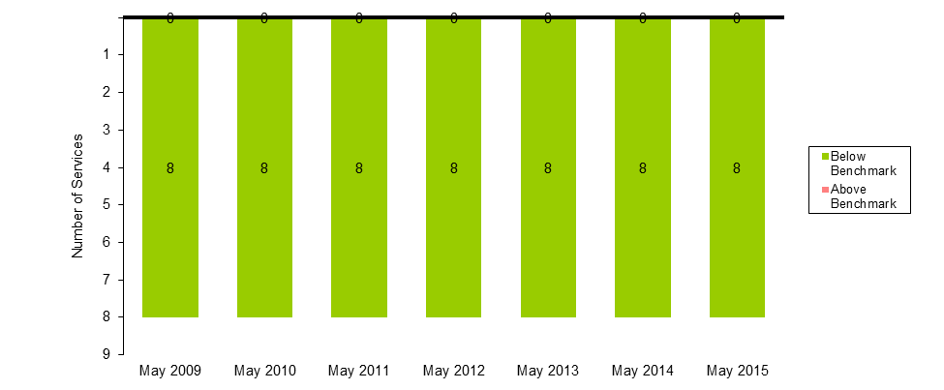
Table 3: AM peak services above benchmark levels and percentage of passengers travelling on services above benchmark levels (May 2009 to May 2015)
 | May 2009 | May 2010 | May 2011 | May 2012 | May 2013 | May 2014 | May 2015
Number of AM Peak Services Above Benchmark | 0 | 0 | 0 | 0 | 0 | 0 | 0
Number of AM Peak Services Below Benchmark | 8 | 8 | 8 | 8 | 8 | 8 | 8
% of AM Peak Services Above Benchmark | 0.0 | 0.0 | 0.0 | 0.0 | 0.0 | 0.0 | 0.0
% of AM Peak Passengers on Services Above Benchmark | 0.0 | 0.0 | 0.0 | 0.0 | 0.0 | 0.0 | 0.0
    - PM Peak
- The May 2015 survey continued to record no services in the PM Peak period where passenger loads did not meet PTV standards.
Figure 4: Number of PM peak services below and above benchmark levels (May 2009 to May 2015)
Table 4: PM peak services above benchmark and passengers using services above benchmark (May 2009 to May 2015)
 | May 2009 | May 2010 | May 2011 | May 2012 | May 2013 | May 2014 | May 2015
Number of PM Peak Services Above Benchmark | 0 | 0 | 0 | 0 | 0 | 0 | 0
Number of PM Peak Services Below Benchmark | 13 | 13 | 13 | 13 | 13 | 13 | 13
% of PM Peak Services Above Benchmark | 0.0 | 0.0 | 0.0 | 0.0 | 0.0 | 0.0 | 0.0
% of PM Peak Passengers on Services Above Benchmark | 0.0 | 0.0 | 0.0 | 0.0 | 0.0 | 0.0 | 0.0
  - Glen Waverley Line
    - AM Peak
- The May 2015 survey recorded a total of zero services in the AM Peak period where passenger loads did not meet PTV standards; this is same result as May 2014.
Figure 5: Number of AM peak services below and above benchmark levels (May 2009 to May 2015)
Table 5: AM peak services above benchmark levels and percentage of passengers travelling on services above benchmark levels (May 2009 to May 2015)
 | May 2009 | May 2010 | May 2011 | May 2012 | May 2013 | May 2014 | May 2015
Number of AM Peak Services Above Benchmark | 1 | 2 | 1 | 1 | 0 | 0 | 0
Number of AM Peak Services Below Benchmark | 15 | 14 | 15 | 15 | 16 | 16 | 16
% of AM Peak Services Above Benchmark | 6.3 | 12.5 | 6.3 | 6.3 | 0.0 | 0.0 | 0.0
% of AM Peak Passengers on Services Above Benchmark | 8.9 | 18.9 | 8.8 | 9.5 | 0.0 | 0.0 | 0.0
    - PM Peak
- The May 2015 survey recorded a total of zero services in the PM Peak period where passenger loads did not meet PTV standards; this is one less than in May 2014.
- The percentage of passengers travelling on services exceeding the benchmark during the PM Peak period decreased from 8.8 per cent to 0.0 per cent between May 2014 and May 2015.
Figure 6: Number of PM peak services below and above benchmark levels (May 2009 to May 2015)
Table 6: PM Peak services above benchmark and passengers using services above benchmark (May 2009 to May 2015)
 | May 2009 | May 2010 | May 2011 | May 2012 | May 2013 | May 2014 | May 2015
Number of PM Peak Services Above Benchmark | 2 | 2 | 2 | 2 | 1 | 1 | 0
Number of PM Peak Services Below Benchmark | 17 | 17 | 17 | 17 | 18 | 18 | 19
% of PM Peak Services Above Benchmark | 10.5 | 10.5 | 10.5 | 10.5 | 5.3 | 5.3 | 0.0
% of PM Peak Passengers on Services Above Benchmark | 18.9 | 16.7 | 17.6 | 17.5 | 9.6 | 8.8 | 0.0
  - Ringwood Corridor
Note: The Ringwood Corridor includes services originating from Lilydale, Mooroolbark, Belgrave, Upper Ferntree Gully, Ringwood and Blackburn stations in the AM and terminating at those stations in the PM.
    - AM Peak
- The May 2015 survey recorded that no service in the AM Peak period where passenger loads did not meet PTV standards; this is two less than in May 2014.
- The percentage of passengers travelling on services exceeding the benchmark during the AM peak period decreased from 7.0 per cent to 0.0 per cent between May 2014 and May 2015.
Figure 7: Number of AM peak services below and above benchmark levels (May 2009 to May 2015)
Table 7: AM peak services above benchmark levels and percentage of passengers travelling on services above benchmark levels (May 2009 to May 2015)
 | May 2009 | May 2010 | May 2011 | May 2012 | May 2013 | May 2014 | May 2015
Number of AM Peak Services Above Benchmark | 4 | 7 | 4 | 4 | 0 | 2 | 0
Number of AM Peak Services Below Benchmark | 35 | 32 | 36 | 36 | 40 | 38 | 40
% of AM Peak Services Above Benchmark | 10.3 | 17.9 | 10.0 | 10.0 | 0.0 | 5.0 | 0.0
% of AM Peak Passengers on Services Above Benchmark | 16.7 | 26.3 | 14.7 | 14.3 | 0.0 | 7.0 | 0.0
    - PM Peak
- The May 2015 survey recorded a total of two services in breach in the PM Peak period where passenger loads did not meet PTV standards; this is one more than in May 2014.
- The percentage of passengers travelling on services exceeding the benchmark during the PM Peak period increased from 3.5 per cent to 7.3 per cent between May 2014 and May 2015.
Figure 8: Number of PM peak services below and above benchmark levels (May 2009 to May 2015)
Table 8: PM peak services above benchmark and passengers using services above benchmark (May 2009 to May 2015)
 | May 2009 | May 2010 | May 2011 | May 2012 | May 2013 | May 2014 | May 2015
Number of PM Peak Services Above Benchmark | 3 | 1 | 3 | 3 | 0 | 1 | 2
Number of PM Peak Services Below Benchmark | 46 | 48 | 46 | 46 | 49 | 48 | 47
% of PM Peak Services Above Benchmark | 6.1 | 2.0 | 6.1 | 6.1 | 0.0 | 2.0 | 2.0
% of PM Peak Passengers on Services Above Benchmark | 10.7 | 3.5 | 10.5 | 10.4 | 0.0 | 3.5 | 7.3
  - Dandenong Corridor
Note: the Dandenong Corridor includes services originating from Pakenham, Berwick, Cranbourne, Dandenong, Westall and Oakleigh stations in the AM and terminating at those stations in the PM.
    - AM Peak
- The May 2015 survey recorded a total of nine services in the AM Peak period where passenger loads did not meet PTV standards; this is one more than in May 2014.
- Between May 2014 and May 2015, three additional services were added to the Network during the AM Peak.
- The percentage of passengers travelling on services exceeding the benchmark during the AM peak period increased from 35.5 per cent to 39.3 per cent between May 2014 and May 2015.
Figure 9: Number of AM peak services below and above benchmark levels (May 2009 to May 2015)
Table 9: AM peak services above benchmark levels and percentage of passengers travelling on services above benchmark levels (May 2009 to May 2015)
 | May 2009 | May 2010 | May 2011 | May 2012 | May 2013 | May 2014 | May 2015
Number of AM Peak Services Above Benchmark | 10 | 12 | 8 | 8 | 7 | 8 | 9
Number of AM Peak Services Below Benchmark | 16 | 14 | 20 | 20 | 22 | 21 | 23
% of AM Peak Services Above Benchmark | 38.5 | 46.2 | 28.6 | 28.6 | 24.1 | 27.6 | 28.1
% of AM Peak Passengers on Services Above Benchmark | 47.5 | 57.4 | 36.1 | 36.0 | 32.6 | 35.5 | 39.3

    - PM Peak
- The May 2015 survey recorded a total of seven services in the PM Peak period where passenger loads did not meet PTV standards; this is five fewer than in May 2014.
- The percentage of passengers travelling on services exceeding the benchmark during the PM Peak period decreased from 44.1 per cent to 25.6 per cent between May 2014 and May 2015.
Figure 10: Number of PM peak services below and above benchmark levels (May 2009 to May 2015)
Table 10: PM peak services above benchmark and passengers using services above benchmark (May 2009 to May 2015)
 | May 2009 | May 2010 | May 2011 | May 2012 | May 2013 | May 2014 | May 2015
Number of PM Peak Services Above Benchmark | 12 | 12 | 6 | 12 | 7 | 12 | 7
Number of PM Peak Services Below Benchmark | 17 | 17 | 29 | 23 | 28 | 23 | 28
% of PM Peak Services Above Benchmark | 41.4 | 41.4 | 17.1 | 34.3 | 20.0 | 34.3 | 20.0
% of PM Peak Passengers on Services Above Benchmark | 52.6 | 51.6 | 25.8 | 44.6 | 27.2 | 44.1 | 25.6

  - Frankston Line
    - AM Peak
- The May 2015 survey recorded a total of six services in the AM Peak period where passenger loads did not meet PTV standards; this is two more than in May 2014.
- Between May 2014 and May 2015, two additional services were introduced to the Network during the AM Peak.
- The percentage of passengers travelling on services exceeding the benchmark during the AM peak period increased from 21.6 per cent to 32.0 per cent between May 2014 and May 2015.
Figure 11: Number of AM peak services below and above benchmark levels (May 2009 to May 2015)
Table 11: AM Peak services above benchmark levels and percentage of passengers travelling on services above benchmark levels (May 2009 to May 2015)
 | May 2009 | May 2010 | May 2011 | May 2012 | May 2013 | May 2014 | May 2015
Number of AM Peak Services Above Benchmark | 7 | 4 | 1 | 5 | 3 | 4 | 6
Number of AM Peak Services Below Benchmark | 12 | 16 | 23 | 19 | 21 | 20 | 20
% of AM Peak Services Above Benchmark | 36.8 | 20.0 | 4.2 | 20.8 | 12.5 | 16.7 | 23.1
% of AM Peak Passengers on Services Above Benchmark | 43.7 | 24.9 | 5.4 | 25.9 | 16.7 | 21.6 | 32.0
    - PM Peak
- The May 2015 survey recorded a total of zero services in the PM Peak period where passenger loads did not meet PTV standards; this is the same result as May 2014.
- Between May 2014 and May 2015, one additional service was added to the Network during the PM Peak.
Figure 12: Number of PM peak services below and above benchmark levels (May 2009 to May 2015)
Table 12: PM peak services above benchmark and passengers using services above benchmark (May 2009 to May 2015)
 | May 2009 | May 2010 | May 2011 | May 2012 | May 2013 | May 2014 | May 2015
Number of PM Peak Services Above Benchmark | 7 | 6 | 1 | 1 | 0 | 0 | 0
Number of PM Peak Services Below Benchmark | 14 | 15 | 32 | 32 | 33 | 33 | 34
% of PM Peak Services Above Benchmark | 33.3 | 28.6 | 3.0 | 3.0 | 0.0 | 0.0 | 0.0
% of PM Peak Passengers on Services Above Benchmark | 40.7 | 36.8 | 5.4 | 5.0 | 0.0 | 0.0 | 0.0
  - Sandringham Line
    - AM Peak
- The May 2015 survey recorded a total of five services in the AM peak period where passenger loads did not meet PTV standards; this is the same result as May 2014.
- The percentage of passengers travelling on services exceeding the benchmark during the AM peak period decreased from 38.4 per cent to 37.5 per cent between May 2014 and May 2015.
Figure 13: Number of AM peak services below and above benchmark levels (May 2009 to May 2015)
Table 13: AM peak services above benchmark levels and percentage of passengers travelling on services above benchmark levels (May 2009 to May 2015)
 | May 2009 | May 2010 | May 2011 | May 2012 | May 2013 | May 2014 | May 2015
Number of AM Peak Services Above Benchmark | 4 | 4 | 1 | 3 | 5 | 5 | 5
Number of AM Peak Services Below Benchmark | 11 | 11 | 18 | 16 | 14 | 14 | 14
% of AM Peak Services Above Benchmark | 26.7 | 26.7 | 5.3 | 15.8 | 26.3 | 26.3 | 26.3
% of AM Peak Passengers on Services Above Benchmark | 37.8 | 38.1 | 8.3 | 24.1 | 38.3 | 38.4 | 37.5

    - PM Peak
- The May 2015 survey continued to record no services in the PM Peak period where passenger loads did not meet PTV standards.
Figure 14: Number of PM peak services below and above benchmark levels (May 2009 to May 2015)
Table 14: PM peak services above benchmark and passengers using services above benchmark (May 2009 to May 2015)
 | May 2009 | May 2010 | May 2011 | May 2012 | May 2013 | May 2014 | May 2015
Number of PM Peak Services Above Benchmark | 2 | 2 | 0 | 1 | 0 | 0 | 0
Number of PM Peak Services Below Benchmark | 17 | 17 | 23 | 22 | 23 | 23 | 23
% of PM Peak Services Above Benchmark | 10.5 | 10.5 | 0.0 | 4.3 | 0.0 | 0.0 | 0.0
% of PM Peak Passengers on Services Above Benchmark | 18.9 | 19.0 | 0.0 | 7.8 | 0.0 | 0.0 | 0.0
  - South Morang Line
    - AM Peak
- The May 2015 survey recorded a total of one service in the AM Peak period where passenger loads did not meet PTV standards; this is one less than in May 2014.
- The percentage of passengers travelling on services exceeding the benchmark during the AM peak period decreased from 17.1 per cent to 9.0 per cent between May 2014 and May 2015.
Figure 15: Number of AM peak services below and above benchmark levels (May 2009 to May 2015)
Table 15: AM peak services above benchmark levels and percentage of passengers travelling on services above benchmark levels (May 2009 to May 2015)
 | May 2009 | May 2010 | May 2011 | May 2012 | May 2013 | May 2014 | May 2015
Number of AM Peak Services Above Benchmark | 4 | 3 | 4 | 2 | 0 | 2 | 1
Number of AM Peak Services Below Benchmark | 8 | 9 | 8 | 13 | 15 | 13 | 14
% of AM Peak Services Above Benchmark | 33.3 | 25.0 | 33.3 | 13.3 | 0.0 | 13.3 | 6.7
% of AM Peak Passengers on Services Above Benchmark | 43.2 | 33.0 | 43.7 | 18.1 | 0.0 | 17.1 | 9.0

    - PM Peak
- The May 2015 survey recorded zero services in the PM Peak period where passenger loads did not meet PTV standards; this is one less than in May 2014.
- The percentage of passengers travelling on services exceeding the benchmark during the PM Peak period decreased from 7.0 per cent to 0.0 per cent between May 2014 and May 2015.
Figure 16: Number of PM peak services below and above benchmark levels (May 2009 to May 2015)
Table 16: PM peak services above benchmark and passengers using services above benchmark (May 2009 to May 2015)
 | May 2009 | May 2010 | May 2011 | May 2012 | May 2013 | May 2014 | May 2015
Number of PM Peak Services Above Benchmark | 2 | 3 | 3 | 0 | 1 | 1 | 0
Number of PM Peak Services Below Benchmark | 13 | 12 | 12 | 18 | 17 | 17 | 18
% of PM Peak Services Above Benchmark | 13.3 | 20.0 | 20.0 | 0.0 | 5.6 | 5.6 | 0.0
% of PM Peak Passengers on Services Above Benchmark | 18.7 | 27.3 | 26.7 | 0.0 | 8.2 | 7.0 | 0.0
  - Hurstbridge Line
    - AM Peak
- The May 2015 survey recorded a total of one services in the AM Peak period where passenger loads did not meet PTV standards; this is one when less than in May 2014.
- The percentage of passengers travelling on services exceeding the benchmark during the AM peak period decreased from 14.0 per cent to 7.4 per cent between May 2014 and May 2015.
Figure 17: Number of AM peak services below and above benchmark levels (May 2009 to May 2015)
Table 17: AM peak services above benchmark levels and percentage of passengers travelling on services above benchmark levels (May 2009 to May 2015)
 | May 2009 | May 2010 | May 2011 | May 2012 | May 2013 | May 2014 | May 2015
Number of AM Peak Services Above Benchmark | 4 | 5 | 5 | 5 | 0 | 2 | 1
Number of AM Peak Services Below Benchmark | 14 | 13 | 13 | 15 | 20 | 18 | 19
% of AM Peak Services Above Benchmark | 22.2 | 27.8 | 27.8 | 25.0 | 0.0 | 10.0 | 5.0
% of AM Peak Passengers on Services Above Benchmark | 30.5 | 37.8 | 38.1 | 35.2 | 0.0 | 14.0 | 7.4

    - PM Peak
- The May 2015 survey recorded a total of zero service in the PM Peak period where passenger loads did not meet PTV standards; this is one less than in May 2014.
- The percentage of passengers travelling on services exceeding the benchmark during the PM Peak period decreased from 7.2 per cent to 0.0 per cent between May 2014 and May 2015.
Figure 18: Number of PM peak services below and above benchmark levels (May 2009 to May 2015)
Table 18: PM peak services above benchmark and passengers using services above benchmark (May 2009 to May 2015)
 | May 2009 | May 2010 | May 2011 | May 2012 | May 2013 | May 2014 | May 2015
Number of PM Peak Services Above Benchmark | 5 | 3 | 4 | 1 | 0 | 1 | 0
Number of PM Peak Services Below Benchmark | 16 | 18 | 17 | 21 | 22 | 20 | 21
% of PM Peak Services Above Benchmark | 23.8 | 14.3 | 19.0 | 4.5 | 0.0 | 4.8 | 0.0
% of PM Peak Passengers on Services Above Benchmark | 36.0 | 22.0 | 27.4 | 7.2 | 0.0 | 7.2 | 0.0
  - Craigieburn Line
    - AM Peak
- The May 2015 survey recorded a total of eight services in the AM Peak period where passenger loads did not meet PTV standards; this is one service more than in May 2014.
- The percentage of passengers travelling on services exceeding the benchmark during the AM peak period increased from 41.7 per cent to 47.3 per cent between May 2014 and May 2015.
Figure 19: Number of AM peak services below and above benchmark levels (May 2009 to May 2015)
Table 19: AM peak services above benchmark levels and percentage of passengers travelling on services above benchmark levels (May 2009 to May 2015)
 | May 2009 | May 2010 | May 2011 | May 2012 | May 2013 | May 2014 | May 2015
Number of AM Peak Services Above Benchmark | 7 | 8 | 8 | 7 | 7 | 7 | 8
Number of AM Peak Services Below Benchmark | 10 | 9 | 10 | 11 | 13 | 13 | 12
% of AM Peak Services Above Benchmark | 41.2 | 47.1 | 44.4 | 38.9 | 35.0 | 35.0 | 40.0
% of AM Peak Passengers on Services Above Benchmark | 51.2 | 57.3 | 54.5 | 47.3 | 41.8 | 41.7 | 47.3
    - PM Peak
- The May 2015 survey recorded a total of five services in the PM Peak period where passenger loads did not meet PTV standards; this is two more than in May 2014.
- The percentage of passengers travelling on services exceeding the benchmark during the PM Peak period increased from 17.2 per cent to 27.9 per cent between May 2014 and May 2015.
Figure 20: Number of PM peak services below and above benchmark levels (May 2009 to May 2015)
Table 20: PM peak services above benchmark and passengers using services above benchmark (May 2009 to May 2015)
 | May 2009 | May 2010 | May 2011 | May 2012 | May 2013 | May 2014 | May 2015
Number of PM Peak Services Above Benchmark | 6 | 6 | 6 | 5 | 2 | 3 | 5
Number of PM Peak Services Below Benchmark | 15 | 15 | 16 | 17 | 23 | 22 | 20
% of PM Peak Services Above Benchmark | 28.6 | 28.6 | 27.3 | 22.7 | 8.0 | 12.0 | 20.0
% of PM Peak Passengers on Services Above Benchmark | 41.5 | 42.6 | 40.2 | 33.4 | 12.9 | 17.2 | 27.9
  - Sunbury Line
    - AM Peak
- The May 2015 survey recorded a total of seven services in the AM Peak period where passenger loads did not meet PTV standards; this is five more than in May 2014.
- The percentage of passengers travelling on services exceeding the benchmark during the AM peak period increased from 12.1 per cent to 43.2 per cent between May 2014 and May 2015.
Figure 21: Number of AM peak services below and above benchmark levels (May 2009 to May 2015)
Table 21: AM peak services above benchmark levels and percentage of passengers travelling on services above benchmark levels (May 2009 to May 2015)
 | May 2009 | May 2010 | May 2011 | May 2012 | May 2013 | May 2014 | May 2015
Number of AM Peak Services Above Benchmark | 8 | 9 | 6 | 2 | 4 | 2 | 7
Number of AM Peak Services Below Benchmark | 5 | 4 | 9 | 13 | 16 | 18 | 13
% of AM Peak Services Above Benchmark | 61.5 | 69.2 | 40.0 | 13.3 | 20.0 | 10.0 | 35.0
% of AM Peak Passengers on Services Above Benchmark | 69.0 | 76.4 | 47.0 | 17.4 | 25.4 | 12.1 | 43.2
    - PM Peak
- The May 2015 survey recorded a total of six services in the PM Peak period where passenger loads did not meet PTV standards; this is two more than in May 2014.
- The percentage of passengers travelling on services exceeding the benchmark during the PM Peak period increased from 22.1 per cent to 32.5 per cent between May 2014 and May 2015.
Figure 22: Number of PM peak services below and above benchmark levels (May 2009 to May 2015)
Table 22: PM peak services above benchmark and passengers using services above benchmark (May 2009 to May 2015)
 | May 2009 | May 2010 | May 2011 | May 2012 | May 2013 | May 2014 | May 2015
Number of PM Peak Services Above Benchmark | 9 | 8 | 9 | 5 | 3 | 4 | 6
Number of PM Peak Services Below Benchmark | 6 | 7 | 8 | 12 | 21 | 20 | 18
% of PM Peak Services Above Benchmark | 60.0 | 53.3 | 52.9 | 29.4 | 12.5 | 16.7 | 25.0
% of PM Peak Passengers on Services Above Benchmark | 69.4 | 63.0 | 62.5 | 36.5 | 17.6 | 22.1 | 32.5
  - Upfield Line
    - AM Peak
- The May 2015 survey recorded a total of two services in the AM Peak period where passenger loads did not meet PTV standards; this is one more than in May 2014.
- The percentage of passengers travelling on services exceeding the benchmark during the AM peak period increased from 17.8 per cent to 36.3 per cent between May 2014 and May 2015.
Figure 23: Number of AM peak services below and above benchmark levels (May 2009 to May 2015)
Table 23: AM peak services above benchmark levels and percentage of passengers travelling on services above benchmark levels (May 2009 to May 2015)
 | May 2009 | May 2010 | May 2011 | May 2012 | May 2013 | May 2014 | May 2015
Number of AM Peak Services Above Benchmark | 0 | 2 | 1 | 2 | 0 | 1 | 2
Number of AM Peak Services Below Benchmark | 7 | 5 | 6 | 5 | 8 | 7 | 6
% of AM Peak Services Above Benchmark | 0.0 | 28.6 | 14.3 | 28.6 | 0.0 | 12.5 | 25.0
% of AM Peak Passengers on Services Above Benchmark | 0.0 | 41.8 | 20.4 | 40.6 | 0.0 | 17.8 | 36.3
    - PM Peak
- The May 2015 survey recorded one service in the PM Peak period where passenger loads did not meet PTV standards; this is one more than in May 2014.
Figure 24: Number of PM Peak services below and above benchmark levels (May 2009 to May 2015)
Table 24: PM peak services above benchmark and passengers using services above benchmark (May 2009 to May 2015)
 | May 2009 | May 2010 | May 2011 | May 2012 | May 2013 | May 2014 | May 2015
Number of PM Peak Services Above Benchmark | 0 | 0 | 0 | 0 | 0 | 0 | 1
Number of PM Peak Services Below Benchmark | 10 | 10 | 10 | 10 | 11 | 10 | 9
% of PM Peak Services Above Benchmark | 0.0 | 0.0 | 0.0 | 0.0 | 0.0 | 0.0 | 0.0
% of PM Peak Passengers on Services Above Benchmark | 0.0 | 0.0 | 0.0 | 0.0 | 0.0 | 0.0 | 0.0
  - Werribee Line
Note: the Werribee Line includes services originating from Werribee and Laverton stations in the AM and terminating at those stations in the PM.
    - AM Peak
- The May 2015 survey recorded a total of eight services in the AM Peak period where passenger loads did not meet PTV standards; this remained the same as May 2014.
- The percentage of passengers travelling on services exceeding the benchmark during the AM peak period remained stable at 48.9 per cent.
Figure 25: Number of AM peak services below and above benchmark levels (May 2009 to May 2015)
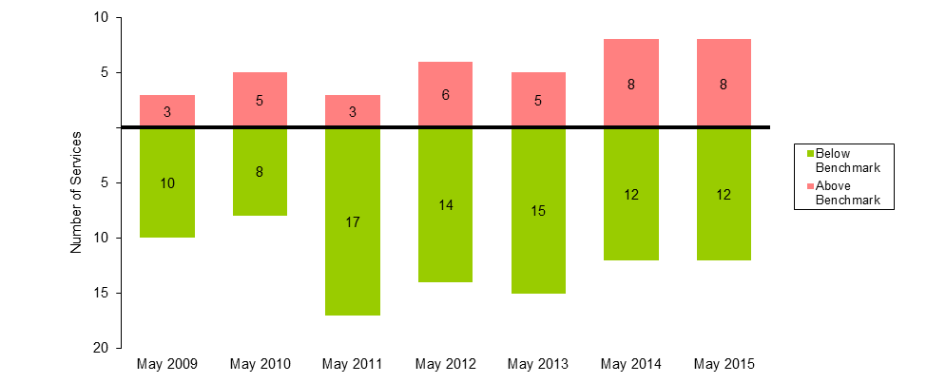
Table 25: AM Peak services above benchmark levels and percentage of passengers travelling on services above benchmark levels (May 2009 to May 2015)
 | May 2009 | May 2010 | May 2011 | May 2012 | May 2013 | May 2014 | May 2015
Number of AM Peak Services Above Benchmark | 3 | 5 | 3 | 6 | 5 | 8 | 8
Number of AM Peak Services Below Benchmark | 10 | 8 | 17 | 14 | 15 | 12 | 12
% of AM Peak Services Above Benchmark | 23.1 | 38.5 | 15.0 | 30.0 | 25.0 | 40.0 | 40.0
% of AM Peak Passengers on Services Above Benchmark | 33.1 | 50.8 | 21.2 | 38.6 | 32.7 | 48.7 | 48.9
    - PM Peak
- The May 2015 survey recorded a total of nine services in PM peak where passenger loads did not meet PTV standards; this is two more than in May 2014.
- The percentage of passengers travelling on services exceeding the benchmark during the PM Peak period increased from 46.8 per cent to 56.8 per cent between May 2014 and May 2015.
Figure 26: Number of PM peak services below and above benchmark levels (May 2009 to May 2015)
Table 26: PM peak services above benchmark and passengers using services above benchmark (May 2009 to May 2015)
 | May 2009 | May 2010 | May 2011 | May 2012 | May 2013 | May 2014 | May 2015
Number of PM Peak Services Above Benchmark | 0 | 2 | 5 | 6 | 7 | 7 | 9
Number of PM Peak Services Below Benchmark | 14 | 12 | 16 | 15 | 14 | 14 | 12
% of PM Peak Services Above Benchmark | 0.0 | 14.3 | 23.8 | 28.6 | 33.3 | 33.3 | 42.9
% of PM Peak Passengers on Services Above Benchmark | 0.0 | 18.7 | 38.7 | 42.8 | 48.2 | 46.8 | 56.8
  - Williamstown Line
    - AM Peak
- The May 2015 survey recorded a total of zero services in the AM Peak period where passenger loads did not meet PTV standards; this is the same result as May 2014.
Figure 27: Number of AM peak services below and above benchmark levels (May 2009 to May 2015)
Table 27: AM Peak services above benchmark levels and percentage of passengers travelling on services above benchmark levels (May 2009 to May 2015)
 | May 2009 | May 2010 | May 2011 | May 2012 | May 2013 | May 2014 | May 2015
Number of AM Peak Services Above Benchmark | 2 | 3 | 0 | 0 | 0 | 0 | 0
Number of AM Peak Services Below Benchmark | 5 | 4 | 7 | 7 | 7 | 7 | 7
% of AM Peak Services Above Benchmark | 28.6 | 42.9 | 0.0 | 0.0 | 0.0 | 0.0 | 0.0
% of AM Peak Passengers on Services Above Benchmark | 41.8 | 56.8 | 0.0 | 0.0 | 0.0 | 0.0 | 0.0
    - PM Peak
- The May 2015 survey recorded a total of zero services in the PM Peak period where passenger loads did not meet PTV standards; this is the same result as May 2014.
Figure 28: Number of PM peak services below and above benchmark levels (May 2009 to May 2015)
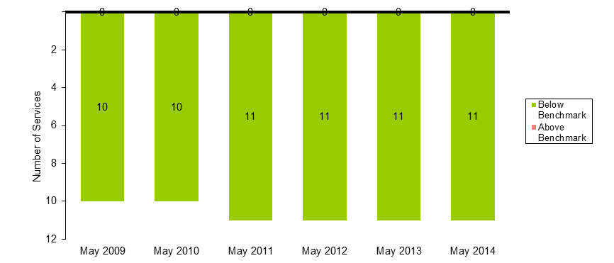
Table 28: PM peak services above benchmark and passengers using services above benchmark (May 2009 to May 2015)
 | May 2009 | May 2010 | May 2011 | May 2012 | May 2013 | May 2014 | May 2015
Number of PM Peak Services Above Benchmark | 0 | 0 | 0 | 0 | 0 | 0 | 0
Number of PM Peak Services Below Benchmark | 10 | 10 | 11 | 11 | 11 | 11 | 11
% of PM Peak Services Above Benchmark | 0.0 | 0.0 | 0.0 | 0.0 | 0.0 | 0.0 | 0.0
% of PM Peak Passengers on Services Above Benchmark | 0.0 | 0.0 | 0.0 | 0.0 | 0.0 | 0.0 | 0.0

Notes about the survey
- Independent surveyors collected the data for the May 2015 survey over 13 weekdays (Monday to Thursday). Surveying times were between 6:30 am and 12:00 pm for City-bound services and 2:00 pm and 7:00 pm for outbound services.
- For outbound services, surveyors collect the data at three city cordon stations: Jolimont, Richmond and North Melbourne. Cordon stations are those that abut the City Loop.
- For inbound services, surveyors collect the data at all stations where services stop directly prior to a cordon station. This could involve collecting data at a variety of stations from where express services run direct to the cordon.
- The peak periods are:
  - AM – between 7.01 am and 9.30 am
  - PM – between 3.31 pm and 7 pm.
- The impact of service cancellations and network disruptions on the data are considered. Passenger loads affected by cancellations and disruptions are excluded from the analysis to ensure the survey results provide an accurate picture of how the metropolitan rail network performs.
- Results from the May and October surveys are not compared as seasonality can impact on passenger loads. Therefore, it is more valuable to compare results of the year-to-year surveys.

