Movement and Place in Victoria

Developed in partnership with VicRoads

Published by:

Department of Transport, 1 Spring Street Melbourne, Victoria 3000

Telephone +61 (0) 3 9655 6666

February 2019.

© Copyright State Government of Victoria 2019

This publication is copyright. No part may be reproduced by any process except in accordance with provisions of the *Copyright Act 1968*.

Authorised by the Victorian Government, Melbourne.

Designed by DJPR Design Studio

ISBN 978-1-76090-079-3 (Print)

ISBN 978-1-76090-080-9 (pdf/online/MS word)

**Disclaimer**

The information contained in this report is provided for general guidance and assistance only and is not intended as advice. You should make your own inquiries as to the appropriateness and suitability of the information provided. While every effort has been made to ensure the currency, accuracy or completeness of the content we endeavour to keep the content relevant and up to date and reserve the right to make changes as required. The Victorian Government, authors and presenters do not accept any liability to any person for the information(or the use of the information) which is provided or referred to in the report.

Except for any logos, emblems, trademarks, artwork and photography this document is made available under the terms of the Creative Commons Attribution3.0 Australia licence.

**Accessibility**

This document is available in PDF at transport.vic.gov.au

# Contents

Foreword 5

Introduction 6

What is Movement and Place? 7

Framework components 10

Overview of the four modules 10

Overview of the Framework 11

Module 1 – Network classifications matrix 12

Module 2 – Network performance 16

Module 3 – Options development 18

Module 4 – Options assessment 27

Bringing it all together 29

Legislative and Policy Context 33

# About this document

This document provides an overview of movement and place thinking and steps through the four modules in the Movement and Place Framework.

The Department of Transport and VicRoads will continue to work with transport and planning agencies, local councils and stakeholders on our shared movement and place approach as projects, plans and opportunities present themselves.

Practitioners using movement and place thinking in transport and land use planning will need network maps, technical guidance, and classification information to conduct their own movement and place assessments.

# Foreword

## The challenge

Pressures mount on our transport network as Victoria faces a period of strong population growth and change. Many of our roads are limited in widths by existing infrastructure which means we need to consider how these roads can meet growing demand. We need a new approach to designing, planning and delivering a modern transport system that meets the increasing needs of people and businesses whilst creating and improving great places that make up our state.

## The opportunity

Globally, many cities and regions are undergoing a paradigm shift in the way they are managing their transport network. Cities from New York to Shanghai, Adelaide, Sydney, Perth and Toronto are adopting progressive new standards, guidelines and best practice designs that support integrated transport and land-use planning. Along with SmartRoads, the ‘Link and Place’ approach, adopted by Transport for London, have been the main building blocks for Victoria’s development of the Movement and Place Framework.

Link and Place thinking is being applied across a variety of cities in the UK, Australia and New Zealand. Very similar objectives have evolved out of new ways of working in North American cities, who have embraced ‘Complete Streets’ approaches. We are embracing new ways of thinking and new tools from these leading global cities and regions.

## The evolution

We recognise our SmartRoads thinking needs to evolve to face our future challenges. Movement and place offers progressive ways of working so that a variety of considerations and outcomes in land-use and transport planning are better integrated.

# Introduction

## Our transport planning principles

Three principles underline the Department of Transport (DoT)’s approach to transport planning.

1. **People first**

**We put transport users at the centre of everything we do.**

Transport enables people to get on with their lives and do business. We need to make sure that we understand what people and business need and respond effectively. We seek to understand how the system is performing from the perspective of different users and ensure that people have input into the design and decision-making process.

1. **Outcomes focused**

**We focus on outcomes that deliver more choice, connections and confidence in our travel.**

By looking at the outcomes we need to achieve for Victorians, we’re understanding the problems and the wider opportunities from every transport decision. However, there is natural tension between outcomes and trade-offs. That is why in designing the future transport system, we need to use and improve on all our tools.

1. **One system**

**We think as one system, not individual projects or modes.**

This enables us to get the balance right in managing demand, make the most of existing assets, take up new technologies and plan for major infrastructure. It helps us consider future changes and identify options to adapt to changing needs.

We consider all transport modes in our planning so that they work in harmony to move people and freight effectively and efficiently. Where modes share the same space, we must ensure they do so in a way that balances the needs of its different users.

# What is Movement and Place?

Fundamental to movement and place thinking is recognising that streets perform multiple functions. Transport links not only move people from A to B, they also serve as key places and destinations in their own right.

There is a natural tension between these two functions. As a movement corridor, every link aims to minimise travel time and keep people and goods moving. Contrarily as a destination, it aims to increase visitor dwell time.

Not all streets can be popular destinations, just as not all streets can prioritise vehicle movement. Sometimes streets and roads change functions several times along the way. It is important to recognise the competing demands between movement and place on our roads and streets. Finding the right balance between the two is fundamental to integrated transport planning.

This way of thinking means that when we plan and develop the transport network, we need to consider the breadth of community needs, expectations and aspirations for the places they live and the roads and streets they pass through.

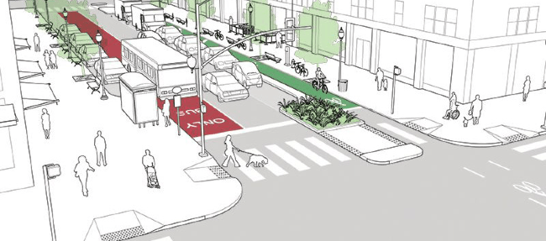

Figure 1: An example from NACTO Complete Streets showing improved urban streetscapes with tree canopies, a high frequency bus lane and wide footpaths for improved amenity.

The Movement and Place Framework turns strategic aspirations into action. It brings to life the strategic objectives of both transport and planning in Victoria to achieve movement and place goals in the context of road safety and environmental outcomes.

It provides a tool to translate the broad transport outcomes we are seeking through the Transport Integration Act, into priority changes to improve link and place performance for communities.

The Framework supports how DoT plans the road and transport network. We seek to understand the needs of transport users and potential network solutions in local contexts. It translates the broader transport network into a series of aspirations for individual roads, streets and interchanges based on their desired functions within the network as well as balancing the needs of people and communities.

## Evolution of road planning in Victoria

Traditional transport classifications have been focused on the levels of motor traffic movement. The past ten years has seen a revolution of thinking to better reflect the broader spectrum of transport and place outcomes.

### From the functional classification language...

Still in use today, functional classification systems group roads and streets by their capacity to keep vehicles moving. Examples of such classifications include primary arterials, major roads, collectors and local traffic streets.

### to SmartRoads...

Over the last decade, the SmartRoads network operating plans were developed in consultation with local councils, government agencies and relevant stakeholders.

SmartRoads expanded on the ideas of functional classification. It considered not only the operational capacity of the roads, but also the different transport modes sharing the network.

The SmartRoads plans were focused on examining current operations of the network. It illustrates which transport modes have priority on the road and at local intersections at different times of the day.

### to a movement and place approach

The Movement and Place Framework takes a future-focused, multi-modal approach to network planning. It takes into consideration the diverse role places play in planning the types of transport modes appropriate to a local road or street.

In this new language, roads and streets are defined by the context of a local place and assigned various ‘movement’ and ‘place’ classifications.

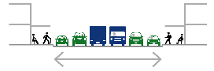

Figure 2: Carriageway only

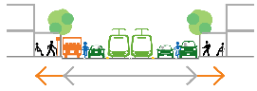

Figure 3: Footpath, carriageway

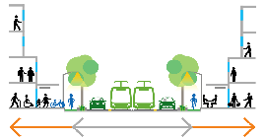

Figure 4: Footpath, carriageway and land-use

## A common language

The Framework offers a common language for coordinated transport planning between transport and planning agencies and local governments.

The Framework provides a consistent approach to assessing the performance of the road and transport network, identifying project requirements and assessing project solutions.

This common language also supports meaningful engagement between the state and local governments and stakeholders and the community. The Framework helps to improve consistency in how transport projects and plans are communicated and discussed with the community.

At a time when communities are expecting a greater say in transport and infrastructure decision-making, movement and place provides opportunities to have discussions about how we can address and prioritise our future transport challenges.

|  | Movement | Place |
| --- | --- | --- |
| **Planning** | Transport planners | Urban planners |
| **Design** | Traffic engineers | Urban designers  Landscape architects |

# Framework components

## Overview of the four modules

The Movement and Place Framework has many uses at the strategic network planning and development level and at the detailed project level. It marries network-wide and localised considerations. At its heart, the Framework organises transport links by their ‘place’ and ‘movement’ roles into road and street types. A set of priority uses, performance measures and potential interventions are then developed for each road and street type.

**Module 1** Network classifications

Graphic representation of Module 1. 

**Module 2** Network performance

Graphic representation of Module 2.

**Module 3** Options development

Graphic representation of Module 3.

**Module 4** Options assessment

Graphic representation of Module 4.

### Strategic level uses

At the strategic level, the Framework can:

* set aspirations to enact the State’s vision for an integrated and sustainable transport system
* classify the transport network and assign future vision for roads and streets
* promote thinking about the performance of the network as a whole rather than as individual transport links
* assess network problems, assist with investment decisions and project identification and prioritisation.

### Project or local level uses

At the project level, the Framework can:

* translate the experience and requirements of different users during their journey within a street
* provide design guidance for the development of project options and solutions
* provide a framework for project impact evaluation that can be aligned with wider network performance assessment
* guide asset maintenance regimes
* assist community engagement.

## Overview of the Framework

The Framework follows a four-part process, with each part building onto the next. Changes in policy and strategic directions can also be incorporated at any point in the process as needed.

**Module 1** Network classifications

**Module 2** Network performance

* Movement
* Place
* Road safety
* Environment

**Module 3** Options development

* Options development
* Road and street types
* Options toolbox
* Design guides

**Module 4** Options assessment

A diagram showing the four-part process of the Movement and Place Framework. 

# Module 1 – Network classifications matrix

The Movement and Place Framework is a system of classifying transport links and hierarchies based on the broader network outcomes we are seeking to achieve. However unlike previous classification systems, it considers the future needs of both the movement and place functions of roads, streets and interchanges on the network.

To determine the classification of a transport link, it is mapped against a movement and a place axis according to the significance of its future aspirational movement and place functions. Transport links are mapped with consideration to the mix and balance of transport modes, the built environment, the aesthetic quality and character of the place and the   
types of modes appropriate to the place.

The process of defining these classifications takes into consideration:

* Place – define the land-use vision and user experience that transport needs to support.
* Movement – consider the mix of transport modes and define priority for moving people and goods safely.

This is a five-by-five matrix that shows the significance of movement of links on the vertical axis and the significance of place of links on the horizontal axis. Movement is defined by a M1 to M5 scale, where M1 is most significant and M5 is least significant. Place is defined by a P1 to P5 scale, where P1 is most significant and P5 is least significant. 

Figure 6: This 5x5 matrix has been developed for Victoria. It is based on a M1-M5 and P1-P5 scale, defined by a link’s significance on a state, regional, municipal, neighbourhood or local scale.

## Movement classifications

Movement classifications represent the mix of transport links that are required to support the overall demand for movement across a network.

Movement classifications communicate the broad aspirational movement function of a transport link in relation to its place function. The classification of M1 to M5 is determined by examining the overall mix and function   
of different transport modes on the link.

### Movement definitions

| Classification | Definition |
| --- | --- |
| M1 | Mass movement of people and/or goods on routes with a state or national-level movement function or provides primary access to state-level places. |
| M2 | Significant movement of people and/or goods on routes connecting across multiple municipalities or provides primary access to regional-level places. |
| M3 | Moderate movement of people and/or goods on routes connecting municipalities or provides primary access to municipal-level places. |
| M4 | Movement of people and/or goods within a municipality. |
| M5 | Local movement. |

### Mode classification types

Victoria’s multi-modal transport system is represented in a series of sub-movement types with a defined hierarchy within each.

* General traffic
* Rail
* Tram
* Bus
* Freight
* Tourist
* Interchange
* Cycling
* Walking

#### Examples of mapping which shows various movement classifications on arterial road networks

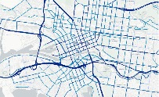

Figure 7: Melbourne

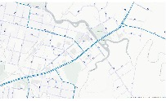

Figure 8: Wangaratta

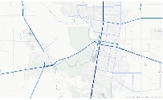

Figure 9: Shepparton

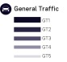

## Place classifications

Place classifications are defined by State-level planning strategies such as the Plan Melbourne’s activity centre hierarchy, State Planning Policy Framework, Planning Zones and regional growth plans.

Place classifications represent the future vision for a place. It is the first classification applied to a link and takes account of all place characteristics that have an impact on movement.

### Place definitions

| **Classification** | **Definition** |
| --- | --- |
| P1 | Place of state or national significance. |
| P2 | Place of regional significance. |
| P3 | Place of municipal significance. |
| P4 | Place of neighbourhood significance. |
| P5 | Place of local significance. |

### Place classification types

Place categories are currently being defined to identify three different types of places, and how they are experienced by users.

#### Places of activity

Applies to areas with differing street-based activity such as areas with retail and commercial frontages and public uses.

Typical areas classified:

* Activity centres with strip shopping areas.
* Precincts with active ground floor frontages as part of their zoning requirements.
* Parks and public amenities.

#### Places of off-street activity

Applies to areas often set-back from the street but still having an impact on the road & street network.

Typical areas classified:

* Shopping centres and land-uses set-back from the street
* Industrial areas
* Event spaces such as stadia and sports complexes

#### Places of landscape and culture

Applies to open space zoning of places of landscape or cultural significance. Predominantly urban parks and in regional Victoria.

Typical areas classified:

* Rural and regional landscapes
* Farming zones
* National parks and world-heritage areas
* Urban open space.

#### Examples of mapping which shows various place classifications on arterial road networks

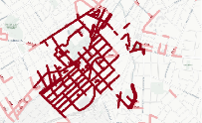

Figure 10: Central Bendigo

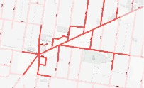

Figure 11: Kew Junction

This is the key for reading the maps.

# Module 2 – Network performance

Module 1 defines the functions of each link in the transport network and Module 2 looks at how well links perform toward their aspirational functions and meet user requirements.

The performance of the transport network is considered under four themes:

* Movement
* Place
* Road safety
* Environment.

While each of these themes can be looked at separately, it is important to examine the inter-relationships between them and compare their performance levels. Overall performance levels can then be derived at the link, corridor and network levels.

To assess the performance of a link or corridor, its current performance is compared with its aspirational state. The resulting varying levels of performance are then described in a level of service (LoS) scale.

This is an example of how LoS is applied to the classification matrix. Links are graded on an LoS scale of A to E as defined by their performance levels. This is an example of aspirational levels of service for general traffic.

Figure 12: An example of how LoS is applied to the classification matrix. Links are graded on an LoS scale of A to E as defined by their performance levels. This is an example of aspirational levels of service for general traffic.

The below are examples of performance indicators used in measuring performance. These have been selected as they are representative of the themes and impacts being considered.

1. **Movement**

* Travel speed
  + The score is based on the operating speed and signed speed. Scores are reported for general traffic, buses, trams and freight.
* Cycling
  + The score is based on level of traffic stress faced by cyclists as determined by infrastructure and speed limits.
* Walking
  + The score is based on the likely delays faced by pedestrians at crossings.

1. **Place**

* Accessibility
  + The score measures the distance of the segment of link from public transport.
* Safety and comfort
  + The score measures whether the environment offers a sense of safety and comfort to pedestrians and therefore supports on-street activity.

1. **Road safety**

* Crash history
  + The score is based on the number of crashes occurring on the segment of a transport link relative to other segments.

1. **Environment**

* Greenhouse gas emissions
  + The score is based on whether vehicles (generally traffic and heavy vehicles)   
    on the road are operating at the speeds at which they are most energy efficient.
* Noise
  + The score is based on estimated noise emitted by traffic.

At the end of Module 2, we have:

* Determined how the network is performing compared to aspirations against each of the four themes,
* Identified the scale of gaps in performance,
* Established what outcomes we need to focus our change.

Module 3 then goes into establishing specific project objectives and developing options to respond to these.

# Module 3 – Options development

Through modules 1 and 2, priority functions are defined and performance parameters are established. Module 3 provides tools and guidance to develop different options in order to close the gap between actual and aspirational performance.

Project objectives are established at the start of this module. These objectives should take into account the local context and the performance gap identified in previous modules. Additionally, a set of movement and place impacts relevant to this part of the network are identified.

The process for then developing potential options is informed by the below.

### Defining the road and street type of the transport link

By grouping movement and place classifications into road and street types, transport links can be compared to examples of roads and streets successfully operating in similar contexts in the existing network. This helps to determine the nature and scale of change required to transform the link so that it becomes closer to its aspirational state. Street types are discussed further in this module.

### Using the options toolbox to determine a set of potential interventions

Once an aspiration is set for a transport link, a broad range of interventions can be developed into potential options. Depending on the specific context, particular types of intervention or combinations of interventions will typically be found to more effective than others in closing the performance gap. Details of different types of interventions available are discussed further in this module.

### Considering interventions with reference to available design guides

When considering how to make changes to the environment, design guides can provide guidance on a technical design level. Details are discussed further in this module.

## Road and street types

The Framework recognises that a liveable, productive and successful state needs a variety of road and street types that serve different roles and functions in different places and at different times of the day.

Movement and place classifications are grouped into road and street types that have similar land-use activities and share similar combinations of users. They provide greater detail and understanding of the different movement and place roles transport links play across the network. Each type varies according to a modal hierarchy determined initially through SmartRoads classifications and provides the basis for discussions on future changes.

There are six general road and street types that define the variety of different roads and streets on our network. The road and street types for Victoria have been developed based on place and movement functions for now and how they could be into the future, ensuring more liveable, reliable, sustainable and inclusive transport outcomes.

This relatively simple categorisation aims to make it practical to apply and help transport planners, councils, community groups and other stakeholders by providing a framework to assist with balancing competing demands. Ideally, major place and streetscape planning schemes can succeed in delivering improvements for many different users at the same time.

An amended version of the five-by-five matrix which shows the different road and street types grouped together. Road and street types include City Hubs, City Streets, City Places, Activity Streets and Boulevards, Connectors and Local Streets. 

Figure 13: An amended 5x5 matrix showing road and street types

### City Hubs

Successful City Hubs are dense and vibrant places that have a high demand for movement. They are also places providing focal points for businesses and culture. City Hubs should aim to reduce the impact of high traffic volumes while accommodating high pedestrian numbers, multi-modal journeys and access to public transport and essential emergency services.

### City Streets

Successful City Streets should provide a world class pedestrian friendly environment. They aim to support businesses, on-street activity and public life while ensuring excellent connections with the wider transport network.

### City Places

City Places are roads and streets with high demand for pedestrian activities and lower levels of vehicle movement. City Places are places communities value and for people and visitors to enjoy.

### Activity Streets and Boulevards

Successful Activity Streets and Boulevards provide access to shops and services by all modes. There is high demand for movement as well as place with a need to balance different demands within the available road space. Activity Streets and Boulevards aim to ensure a high quality public realm with a strong focus on supporting businesses, traders and neighbourhood life.

### Connectors

Successful Connectors should provide safe, reliable and efficient movement of people and goods between regions and strategic centres and mitigate the impact on adjacent communities.

### Local Streets

Successful Local Streets should provide quiet, safe and desirable residential access for all ages and abilities that foster community spirit and local pride. They are part of the fabric of our neighbourhoods, where we live our lives and facilitate local community access.

## Road and street type examples

### Swanston Street

Road and street type = City Hubs

Most of Swanston Street between University of Melbourne and Princes Bridge would be classified as a P1 place as many people are shopping, chatting and enjoying the street. It also has a high-level (M1) movement, mostly by tram users and pedestrians.

A matrix diagram showing the classifications M1, P1 for Swanston Street. 

Figure 14: Swanston Street

### Little Collins Street

Road and street type = City Places

As a busy active street, Little Collins sees relatively low levels of movement but is at the same time a significant destination. It is in the retail heart of Melbourne and plays an important part in the experience and character of the city.

A matrix diagram showing the classifications M4, P1 for Little Collins Street. 

Figure 15: Little Collins Street

### Wurundjeri Way

Road and street type = Connectors

As a busy arterial corridor, this connector plays an important role in bypass movement out of the immediate CBD area. This link allows drivers to enjoy a smooth, reliable journey by car.

A matrix diagram showing the classifications M2, P5 for Wurundjeri Way. 

Figure 16: Wurundjeri Way

### Burke Road, Camberwell

Road and street type = Activity Streets & Boulevards

Strip shopping streets like Burke Road are typical streets that have high movement and place conflicts. They typically suffer from limited road space and require careful consideration of transportation mix to improve the user experience.

A matrix diagram showing the classifications M3, P3 for Burke Road, Camberwell. 

Figure 17: Burke Road, Camberwell

### St Kilda Road

Road and street type = Activity Streets & Boulevards, Connector and City Hub

A long and diverse road like St Kilda Road (from the Yarra River to Shrine of Remembrance) has high movement function of trams and high strategic importance for bikes with varying place values of P1 to P3.

A matrix diagram showing the classifications M1, P1 to P3 and M2, P3 for St Kilda Road. 

Figure 18: St Kilda Road

### Eastern Freeway

Road and street type = Connectors

Freeways and motorways are the primary movement corridors across the state. They have a different place classification compared to areas that have on-street activity or environmental importance.

A matrix diagram showing the classifications M1, P5 for Eastern Freeway. 

Figure 19: Eastern Freeway

### Main Street, Maldon

Road and street type = Local Streets

Maldon’s Main Street, like many in regional Victoria, comprises beautifully preserved historic buildings surrounding a local movement corridor. While local roads vary across the region, there are several towns with historic significance and main street thoroughfares. These roads are critical to the local area, however, may not be of high regional significance.

A matrix diagram showing the classifications M5, P4 for Main Street, Maldon. 

Figure 20: Main Street, Maldon

### Benson Street, Benalla

Road and street type = Local Streets

Benson Street is a typical local street in regional Victoria. Smaller roads with wide nature strips and roadside trees are common.

A matrix diagram showing the classifications M5, P5 for Benson Street, Benalla. 

Figure 21: Benson Street, Benalla

### Clifton Street, Euroa

Road and street type = Activity Streets & Boulevards

Clifton Street is an arterial connection through the heart of Euroa. It provides a connection between Euroa town centre and the Hume Freeway.

A matrix diagram showing the classifications M3, P4 for Clifton Street, Euroa. 

Figure 22: Clifton Street, Euroa

### Hume Freeway

Road and street type = Connectors

The Hume Freeway is a movement corridor of national significance. The freeway provides a connection between Melbourne, Brisbane and Sydney whilst supporting local connections between regional centres. The freeway environment is of little place value, however the road provides vistas and landscapes demonstrating the environmental significance of the region.

A matrix diagram showing the classifications M1, P5 for Hume Freeway. 

Figure 23: Hume Freeway

### Elgin Boulevard, Wodonga

Road and street type = City Places

Next to Elgin Boulevard is an area of land repurposed from an existing rail line to create an area of high activity and regional significance. Junction Place supports multiple shops, cafes, historical sites of interest and recreational areas with farmers and craft markets. Destinations like Junction Place provide regions with a thriving environment, drawing visitors from across the state.

A matrix diagram showing the classifications M4, P2 for Elgin Boulevard, Wodonga. 

Figure 24: Elgin Boulevard, Wodonga

### Bendigo-Murchison Road, Colbinabbin

Road and street type = Connectors

Bendigo-Murchison Road provides a key east-west connection between Victoria’s Northern and North Eastern regions. Roads like the Bendigo-Murchison Road provide high speed, low place value connections, servicing tourism, local traffic movements, freight and agriculture.

A matrix diagram showing the classifications M3, P5 for Bendigo-Murchison Road, Colbinabbin. 

Figure 25: Bendigo-Murchison Road, Colbinabbin

## Options toolbox

Given the challenges posed by a growing population, we need to pursue a broader range of interventions and tools in order to develop options to meet growing demand. To do this, we need to define and categorise our current tools and guides.

Many of the tools in the toolbox are already in use, but their application may need to be more broadly adopted. Other tools are untested and may need to be trialled to understand their effectiveness in the context of Melbourne and Victoria.

The road and street type, network operating parameters and the gap between current and future levels of service will together determine how each intervention will be employed in a given location.

### Fitter assets for the future

Transport assets need to be fit for purpose now and resilient to future use and adaptations.

### More efficient/flexible use of space

This is about making better use of the space within our transport network. This could be improving the reliability and predictability of travel times for different modes along key movement corridors or improving the quality of places where people go to work, shop and play.

### Intelligent systems and management

This is about employing technology to optimise the use of space and time within our transport network. Examples of these tools include freeway managed motorway systems, variable speed limits and on-road information.

### Changing behaviour/managing demand

It is sometimes about influencing travel patterns. This is done by encouraging changes in individuals’ and businesses’ travel behaviour to help them make informed decisions.

### Substitute/improve/re-locate capacity

We can increase the capacity for movement and place-making through the building of new streets, infrastructure and public spaces.

## Design guides

Various design and performance guidelines will also be used to develop options that respond to the performance gaps identified through Module 2.

These design guides will cover both strategic-level and detailed design guidance, from setting the urban design vision we are seeking to achieve to determining how this translates into designing specific elements of the transport network.

Depending on the road and street type, some movement functions may become less important for the benefit of the transport system as a whole, and some place aspects may become secondary to others to achieve the most efficient use of investment in the space.

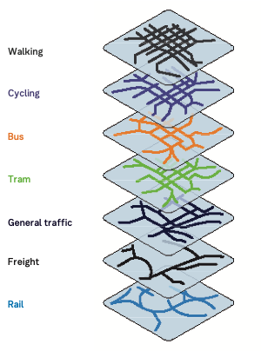

### An example of a design guide

Urban design policy has added active street frontages to new developments. Below is an example of a visual style design guide that explains the current issues and future opportunities of city streets, including the characteristics of the road and street type, transport modes in use and other aspects of transport network management.

* Laneway access can often restrict tram stop length and locations.
* Widened footpaths have allowed for tree planting to improve microclimate along the street.
* Older tram stop designs not long enough for double loading and longer rolling stock.
* Pedestrian volumes in certain areas exceed 40,000 per day.
* Tram stop designs constrict pedestrian movement when busy.
* Space for bike lanes often limited at platform stops. Line markings have however helped keep cars to the right of cyclists.
* Yellow separators have helped improve tram reliability.
* Motorcycle parking at certain locations contribute to congested footpaths.
* Car parking and loading spaces often in conflict with large pedestrian loads on footpaths.
* Vehicles turning from laneways creates frequent conflicts along key pedestrian and cycling routes

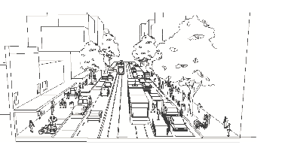

# Module 4 – Options assessment

Options developed in Module 3 should align with the aspirational functions of transport links and support better movement, place, road safety and environment outcomes established through Modules 1 and 2.

The transport network often has to respond to constraints or ideas that may not align with these options and so trade-offs need to be made.

Further technical guidance is being developed to support options assessments.

Module 4 involves assessing options to determine its impact on the existing transport network. By systematically working through and applying Modules 1, 2 and 3 in line with the following process, trade-offs can be also balanced.

### Choosing relevant indicators

The project objectives and impacts are used to determine the relevant indicator or outcome to be tested.

There are varying levels of ‘strength’ that a project objective can include depending on how far performance is away from the aspiration.

The varying levels of “strength” are provided below:

* Strongly support changes that enhance/reduce/head towards
* Support changes that enhance/reduce/head towards
* Mitigate impacts of changes
* Balance impacts of changes.

Table 1: An example of indicators used in the framework to assess options against each theme.

| Theme | Indicator |
| --- | --- |
| Movement | * Travel speed * Cyclist stress * Pedestrian delay |
| Place | * Access to public transport * Safety and user comfort |
| Road safety | * Crash history |
| Environment | * Greenhouse gas emissions * Noise |

### Assessing options against project objectives

The overall aim is to assess how well a potential option improves the performance of the network in-line with the aspirations established through Modules 1 and 2.

A simple assessment methodology, that uses the nominated indicators to rate how well any option meets the project objectives, is used as follows:

* Meets objectives well
* Meets objectives moderately well
* Meets objectives
* Does not meet objectives.

The overall aim should be to ensure that at least all aspects of the option ‘meets project objectives’. Where there are multiple links in a network, then an assessment needs to be done for each link and trade offs made.

Table 2: Example summary of a project solution being assessed against a series of project objectives all of which have been met.

| Project objective | Assessment |
| --- | --- |
| 1. Strongly support changes that head towards a safe system. | Meets |
| 1. Supports changes that enhance cycling. | Meets moderately |
| 1. Support changes that enhance the ‘place’ function for the activity centre, including amenity, access and walkability. | Meets moderately |
| 1. Mitigate impacts on the general traffic performance for the highway. | Meets moderately |

# Bringing it all together

The Movement and Place Framework can communicate problems and solutions at a variety of levels and in a variety of ways. The Framework often involves describing things visually and diagrammatically   
so that issues and ideas are easier to understand for the many planning practitioners and community users that have a voice in planning.

## Metropolitan and inner urban

This visual collage shows how the Framework applies in a metropolitan Melbourne context. This representation brings together the variety of factors and competing demands on roads and streets so they are all considered in future decision-making. It also allows for the decision-making process to be communicated in a transparent manner.

This is an example of how movement and place might be applied in an inner urban setting.

* Allowing for innovative approaches of managing stormwater and water-sensitive design outcomes.
* Ensuring our streets can become urban forests that support local environments.
* Ensuring new transport investments have positive benefits to the local places along it.
* Ensuring safety and Towards Zero goals are embedded across all projects.
* Providing guidance on   
  best-practice infrastructure designs for the future.
* Balancing local access needs with future demands for road space.
* Ensuring intelligent systems and future technology support future network priorities.
* Safe speeds and safe infrastructure for all road users.
* Balancing local place activity needs with through-movement needs.
* Designing for local access that protects quiet neighbourhoods.
* Ensuring future land-use changes are considered in transport investments.

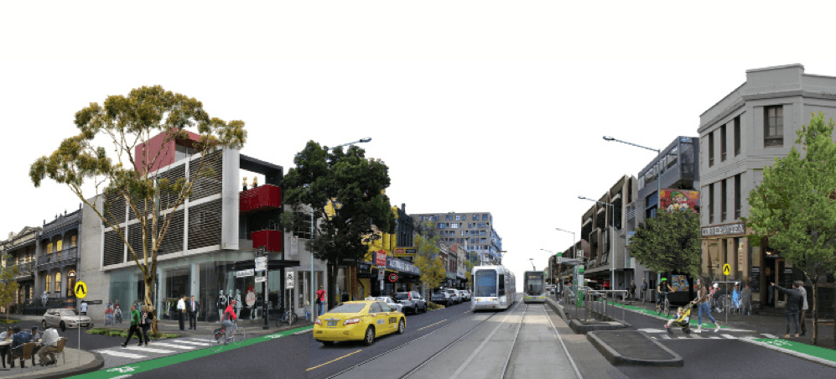

## Regional centres and towns

Equally for regional Victoria, the Framework has the flexibility to incorporate specific aspects to different contexts across the state.

Urban regional Victoria has many of the same place and movement problems as urban metropolitan areas and share many similar road and street types.

The Framework has been adopted at regional level contexts elsewhere. The visual collage below describes how regional ambitions or interventions can have an equal role in the Framework.

* Ensuring new transport investments have positive benefits to the local places along it.
* Ensuring intelligent systems and future technology support future network priorities.
* Helping balance safety and environmental outcomes along our road corridors.
* Balancing local place activity needs with through-movement needs.
* Designing for water-sensitive road environments.
* Safe speeds and safe infrastructure for all road users.
* Transport investments supporting local tourist and economic needs.
* Respecting local character and ecologies through appropriate specifies plantings.
* Balancing local access needs by designing for different users.

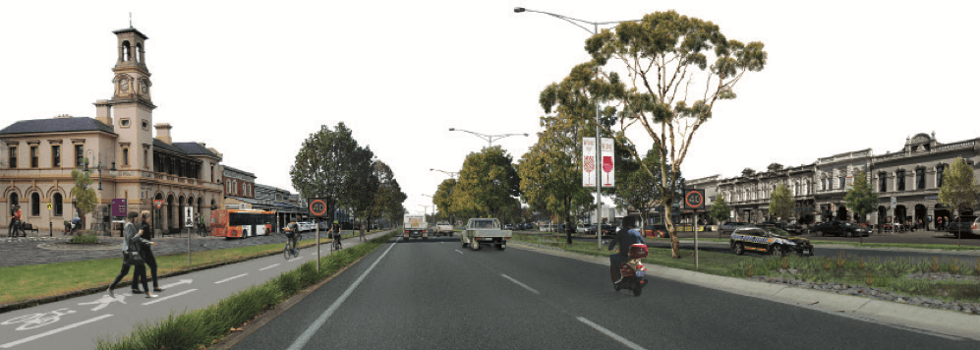

## Rural

For rural roads the performance measures for understanding environment and safety outcomes are key, enabling constructive discussions about trade-offs with movement outcomes.

An important consideration in rural areas will be protection and maintenance of roadside vegetation, safe system design and connecting rural towns to regional centres.

* Hard shoulder for improved safety.
* Ensuring intelligent systems and future technology support future network priorities.
* Providing access to key tourist destinations, including alpine and ocean regions, food and beverage and other key places of interest nationally and internationally.
* Roadside infrastructure supporting key road functions, including weighbridges and rest stops.
* Safe systems design (centreline rumble strips).
* Infrastructure to improve safe speed (guard rail).
* Protection and maintenance of roadside vegetation.

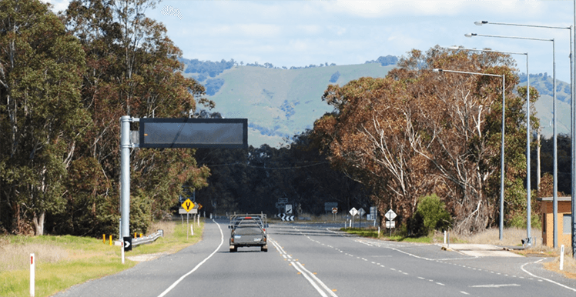

## Middle and outer urban

Within the Framework, some key considerations for middle and outer urban areas in Victoria include connectivity to key interchanges with mass movement and major activity centres.

The example below of the Ringwood Railway Station upgrade shows how creating a boulevard improves the pedestrian experience and road safety.

* Speed limit set at 40km/h to improve safety for all transport users.
* Facilities for easy bus to train interchange for passengers.
* Pedestrian plaza opens up to the pedestrian crossing, providing a direct connection from train to bus and the shopping centre.
* Heritage building retained and repurposed.
* Dedicated bike lanes to minimise conflict.
* Wombat style crossing for pedestrians to connect to place at ground level.
* Tree plantings to create a boulevard, which reduces the heat island effect and calms traffic.

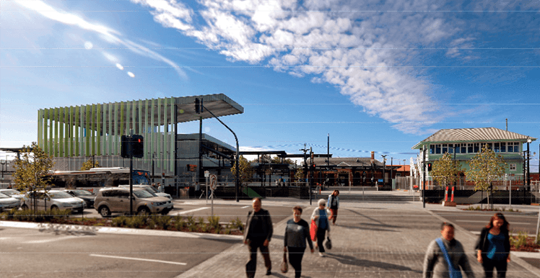

# Legislative and Policy Context

The Movement and Place Framework (the Framework) aligns with key legislative requirements and provides a basis for the integration of transport and land use planning considerations.

## Plan Melbourne 2017

The development of the Movement and Place Framework is a direct recommendation from Plan Melbourne 2017. Plan Melbourne states that this new transport planning approach is to be delivered to optimise the relationships between the transport network and the people and places that this network serves.

## Planning and Environment Act 1987

The Planning and Environment Act sets out several objectives of planning in Victoria, including protecting natural and man-made resources, securing a pleasant, efficient and safe working, living and recreational environment, and conserving and enhancing places of special cultural value.

The Framework can better integrate the relevant objectives of the Act in its processes and outcomes than traditional transport planning approaches. It recognises the value and need for protecting, enhancing and diversifying natural and man-made environments. It incorporates place measures into the transport network classifications and considers place and environment factors in assessing the performance of roads and streets.

## Transport Integration Act 2010

The Framework delivers on the Act’s requirement for integration of transport and land use and is aligned with all other objectives. It can incorporate both the desired objectives and address the decision-making principles outlined in the Act. It requires collaboration among movement and place stakeholders and authorities and in this way enables integrated decision making.

Under the Framework, the performance of the transport network is considered under four themes (movement, place, environment, safety) which support the six transport system objectives of the Transport Integration Act 2010.

This relationship is described in the table below:

Table 3: Relationship between Framework themes and Transport System Objectives

| Framework Theme | Transport System Objective | Relationship |
| --- | --- | --- |
| Movement | Social and economic inclusion  Economic prosperity  Efficiency, coordination and reliability | Optimising network wide capacity and integrating across all transport modes by prioritising movement functions and setting aspirations based on the relative roles that different modes on different parts of the network play in moving people and goods and providing access to employment and services |
| Place | Integration of land use and transport | Recognising the significance of land use adjacent to movement corridors and having regard to desired outcomes for both land use and transport |
| Road safety | Safety, health and wellbeing | Supporting the avoidance and minimisation of the risk of harm to persons arising from the transport system through adoption of the safe system approach |
| Environment | Environmental sustainability | Considering the impacts of transport on desired outcomes for biodiversity, cultural heritage and climate resilience |

## Road Management Act 2004

The Road Management Act states that in urban and rural areas, VicRoads is the Responsible Road Authority for the maintenance of traffic and on-road bicycle lanes, medians and shoulders on declared arterial roads. In urban and rural areas, Councils are the Responsible Road Authority for the maintenance of footpaths, off-road bicycle lanes and nature strips.

As movement and place functions are inextricably linked, state transport agencies and local councils play an equal role in the development of places. The integration provided by the Framework allows transport agencies to better recognise various planning, environmental and urban design strategies. The Framework offers consistent language and tools that can be used by transport agencies and authorities and local councils to facilitate this integrated management of roads and streets.

## Local Government Act 1989

Under the Act, councils are required to prepare a Council Plan every four years which outlines the council’s vision for improving the overall quality of life of people in the local community. The Framework offers consistent language and tools to support the preparation of Council Plans, alongside budgets and local laws, when looking at how local streets and places can contribute to an improved quality of life.