Passenger Rail Infrastructure Noise Policy – fact sheet
Construction of new passenger rail infrastructure is essential to Victoria’s future growth and liveability. However additional noise from rail operations can impact local communities. This new policy aims to help transport planners and communities to understand rail noise and balance the benefits of new passenger rail with the impacts on those living nearby.
Victoria’s population is expected to increase to more than 8 million people in the next 40 years.
With this growth, Victoria is seeing an unprecedented increase in demand for public transport services and in particular passenger rail services.
Melbourne is also experiencing growth in inner city development and increasing high density development close to public transport. There is also new growth and development occurring in Melbourne’s outer suburban areas close to current or proposed rail corridors.
The Victorian Government is investing in major improvements to the passenger rail system such as the Regional Rail Link project and the planned Melbourne Metro rail project.
These projects are essential to improve the efficiency and capacity of Melbourne’s rail network and respond to passenger demands for more train services. However careful planning is required to minimise noise impacts on nearby communities.

Existing laws
Victoria has a range of laws that relate to management of noise.
Day to day passenger rail operations are exempt from liability for nuisance in relation to noise under the Environment Protection Act 1970 and the Local Government Act 1989.
Other legislation includes broad obligations to manage or take account of noise. This includes the Major Transport Projects Facilitation Act 2009, the Environment Effects Act 1978, the Planning and Environment Act 1987 and the Transport Integration Act 2010.
Until now, there has been limited detailed guidance on how to apply these broad legislative requirements to noise from new passenger rail infrastructure.

Why is a Passenger Rail Infrastructure Noise Policy needed?
The Victorian Government has developed a policy to ensure the need to develop Victoria’s passenger rail network can be balanced with the amenity impacts on nearby communities.
The Passenger Rail Infrastructure Noise Policy recognises there is a need to ensure the amenity of local communities and residents is considered when there is a major change to the rail infrastructure in close proximity to their homes or plans to allow new homes close to rail infrastructure.
The policy provides a clear, step by step process for planners to consider and address the noise generated by new passenger rail projects.
It allows rail projects to be assessed in a consistent and transparent manner early in the planning process.

When does the policy apply?
- The policy is triggered when there is a statutory approval required for:
  - construction of new passenger rail infrastructure
  - redevelopment of existing passenger rail infrastructure
  - a change in land use adjacent to a rail corridor
- The policy applies in both metropolitan and regional Victoria

When does the policy not apply?
- The policy does not cover impacts from existing passenger or freight operations
- The policy does not apply if a statutory approval is not required – for example purchasing new rolling stock or upgrading signalling
- The policy does not apply to new freight rail infrastructure – the existing noise regulation applies to freight.

How is the noise impact assessed?
An assessment must be undertaken to see if the noise levels will exceed the investigation thresholds set out in the policy.
There are different thresholds for day and night noise.
The investigation thresholds use both L_{Aeq} and L_{Amax} to describe noise levels.
L_{Aeq} describes the “average” noise level and accounts for a number of “louder” events over the day or the night.
L_{Amax} is the “maximum” noise level and focuses on the “loudest” noise. This allows for better consideration of potential sleep disturbance that results from noise within the night period.

Investigation thresholds for redevelopment of existing passenger rail infrastructure
Where the investigation relates to the redevelopment of existing passenger rail infrastructure both the absolute levels of noise and changes in levels of noise must be considered.
This means the predicted noise levels following completion of the project must meet the investigation thresholds and have increased the overall noise by 3dB(A) or more.
Predicted noise levels are calculated by combining existing, pre-project noise levels and the increase in noise from rail operations following the project’s completion.

What are the policy principles?
If the predicted noise levels will exceed the investigation thresholds, transport bodies and planning authorities should consider options for reducing rail noise by applying the policy principles:

Integrated early consideration
- Impacts of noise from rail projects and options for noise reduction should be considered early in the development of a proposal for new/redevelopment of passenger rail or a change in land use. An integrated approach should be taken to identifying the options to avoid or reduce noise and its impacts

Balancing objectives
- Decisions about managing the impact of noise should balance economic, social and environmental objectives within the context of the wider objectives of a passenger rail project or change to land use.

Best fit solutions
- All reasonable efforts to limit impacts of noise should be made taking account of what is practicable, reasonable and cost effective, given the specific local circumstances and the broader public good.

Investigation thresholds
Table A: Investigation thresholds for new passenger rail infrastructure or change in land use near a planned rail corridor
Time | Type of receiver | Investigation threshold(s)
Day  (6am – 10pm)  dB(A) External | - Residential dwellings and other buildings where people sleep including aged person homes, hospitals, motels and caravan parks  - Noise sensitive community buildings including schools, kindergartens, libraries | 60 L_{Aeq} or 80 L_{Amax}
Night  (10pm – 6am)  dB(A) External | - Residential dwellings and other buildings where people sleep including aged person homes, hospitals, motels and caravan parks | 55 L_{Aeq} or 80 L_{Amax}
Table B: Investigation thresholds for change in land use near an existing rail corridor
Time | Type of receiver | Investigation threshold(s)
Day  (6am – 10pm)  dB(A) External | - Residential dwellings and other buildings where people sleep including aged person homes, hospitals, motels and caravan parks  - Noise sensitive community buildings including schools, kindergartens, libraries | 65 L_{Aeq} or 85 L_{Amax}
Night  (10pm – 6am)  dB(A) External | - Residential dwellings and other buildings where people sleep including aged person homes, hospitals, motels and caravan parks | 60 L_{Aeq} or 85 L_{Amax}
Table C: Investigation thresholds for redevelopment of existing passenger rail infrastructure
Time | Type of receiver | Investigation threshold(s)
Day  (6am – 10pm)  dB(A) External | - Residential dwellings and other buildings where people sleep including aged person homes, hospitals, motels and caravan parks  - Noise sensitive community buildings including schools, kindergartens, libraries | 65 L_{Aeq} and change in L_{Aeq} of 3 dB(A) or more  or  85 L_{Amax} and change in L_{Amax} of 3 dB(A) or more
Night  (10pm – 6am)  dB(A) External | - Residential dwellings and other buildings where people sleep including aged person homes, hospitals, motels and caravan parks | 60 L_{Aeq} and change in L_{Aeq} of 3 dB(A) or more  or  85 L_{Amax} and change in L_{Amax} of 3 dB(A) or more

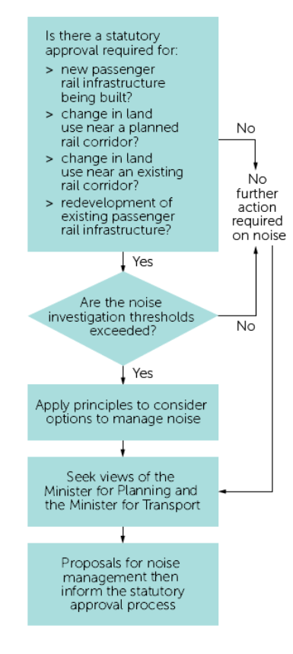

What sort of measures might be put in place to minimise noise?
Following discussion with stakeholders and transport and planning agencies, the following noise reduction measures may be considered:
- specifying the types of land use in proximity to the rail line
- requiring set back from a rail reserve
- rail infrastructure design features such as vertical and horizontal alignment of the track and track design
- building and architectural treatments such as building orientation, design of floor plans, type of building materials used, double glazing
- engineering treatments such as construction of barriers

Working with the community
The noise policy has been established following consultation with key stakeholders and the community.
The community living in and around proposed new rail infrastructure will be consulted when determining how the noise policy should apply.

For more information
Department of Transport
Visit www.transport.vic.gov.au
Email railnoise@transport.vic.gov.au

Authorised and published by the Victorian Government
121 Exhibition Street, Melbourne
Print managed by Finsbury Green
April 2013
If you would like to receive this publication in an accessible format, please telephone Information Victoria on 1300 366 356.

