**Attachment 5**

**Recovered metal packaging**

Market insights report – July 2023

### Notable Market developments

* **Prices for recovered tin-plate steel cans and aluminium beverage cans have recovered strongly over the last three years from the mid-2020 lows. They are trading at relatively high levels, coming off price peaks around March 2022.** Prices for both tin-plate steel cans and aluminium beverage cans decreased from the very high prices seen in the first half of 2022, but have been strong and steadily rising across early 2023.
* **Exports of tin-plate steel cans and aluminium beverage cans fell steeply from a mid-2021 peak across the 2021–22 financial year but have been rising since mid-2022.** The high prices across the 2021–22 financial year probably reduced stockpiles of baled cans built up by material recovery facility (MRF) operators and scrap metal traders during the period of very low prices across the 2020 calendar year. This stockpile drawdown is now complete, and exports have likely stabilised at close to the level of MRF sorting, with the higher prices providing little incentive to stockpile. Exports have trended upwards in 2023 so far, following increasing scrap metal prices.
* **Container costs have returned to near pre-COVID-19 levels.** International freight costs were very high across the period from mid-2020 to early 2023, putting downward pressure on exports. It is likely that the high freight costs contributed to the high metals price across this period, as exporters had to recoup the container contract cost. Freight costs trended steeply downwards across 2022 and reached near pre-COVID levels by early 2023.

### Material overview and market summary

Steel and aluminium cans, mostly recovered through household kerbside recycling collections, only account for a small fraction of overall metals recovery in Victoria.

MRFs are well equipped to separate these materials from household collections into marketable grades of recyclate, which although small in volume (around 3–4% of the average household recycling bin) represent a valuable source of revenue for MRFs.

Recovered steel packaging is considered a low value form of steel post-consumer, but is still saleable into overseas markets, sometimes by blending it into mixed grade steel products such as 'black iron'. It is not purchased by local smelter operators in any volume.

Figure 1 provides data on the change in exports of kerbside recovered metal packaging since the start of 2017. The jump in metal packaging exports from July 2020 to April 2022 is likely due to the large increase in scrap metal prices across the (approximately) same period. Scrap metal prices decreased slightly towards mid-late 2022, bringing down exported quantities – probably in tandem with a depletion of local stockpiles – but prices and quantities have steadily risen into and across 2023.

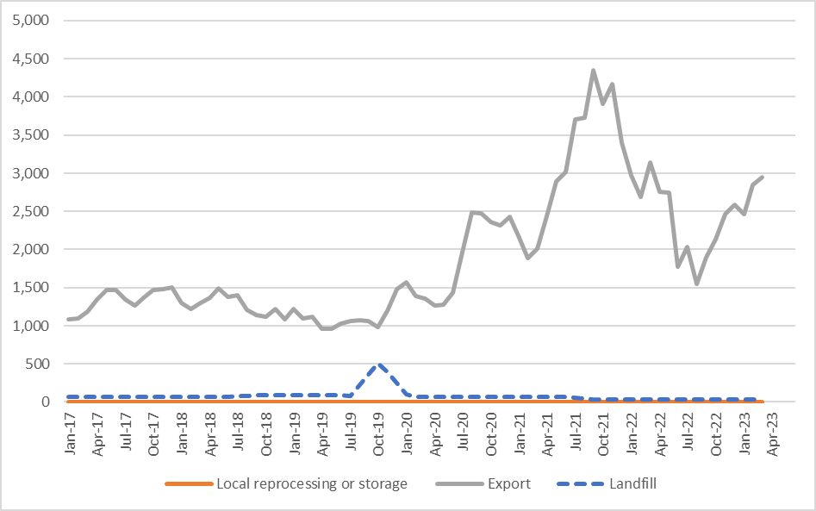

Figure 1: Destination of Victorian MRF outputs (tonnes per month) – metal packaging.

Source: Australian Bureau of Statistics (ABS) (Australian Harmonized Export Commodity Classification (AHECC) data by month, classification, and destination country, 2023) and Blue Environment.

Note 1: Historical total monthly MRF outputs have been approximated in the figure above to enable comparison with monthly ABS customs export data. The overall trends are the key aspect of the figure.

Note 2: The combined ‘Local reprocessing or storage estimate is indicative only, and these fates will be presented separately if this level of data becomes available. Landfill excludes disposal from storage and is an approximation based on annual waste to landfill rates.

Throughout the 2022–23 financial year, baled steel and aluminium packaging was sent to many different countries, with the main destinations being Indonesia, South Korea, Taiwan, India and Thailand. Almost all recovered metal packaging is sold into export markets, with no Victorian tin-plated steel or aluminium packaging identified as being reprocessed in Australia. This is reportedly due to the much better export prices on offer, relative to local interest and prices.

There are trials of small quantities of tin-plated and aluminium packaging reported as reprocessed in other states, and it is expected that these quantities will increase over coming years.

### Prices, demand and supply

While there is currently little steel or aluminium packaging post-consumer reprocessed in Australia, international markets for these commodities remain strong.

There are two aluminium smelter operators in Australia that are reportedly investigating upgrading their facilities to take used aluminium beverage cans. These are in Tasmania and Queensland. This may provide some increased surety of local reprocessing capacity, and a buffer from international trading conditions, should they deteriorate.

There is no reported significant distressed storage of steel or aluminium packaging. This is supported by the spike in exports seen around the 2021–22 financial year.

The price of steel packaging is strongly linked to global steel pricing. The current price (April 2023) received for baled steel packaging is around $400–$450 per tonne (Ex Works (EXW) MRF). This illustrates strong growth from the price of around $90–$100 per tonne seen back in the middle of 2020.

The price of shipped aluminium packaging is linked to virgin aluminium pricing. The current price (April 2023) received for baled aluminium beverage cans is approximately $2,200–$2,400 per tonne (EXW MRF). This is strong growth from the price of around $800–$900 per tonne seen back in the middle of 2020.

### Key end markets and related specifications

Exported steel packaging has specifications relating to contamination levels and bale density. The sorting that is undertaken at MRFs allows the baled material to meet these specifications without major difficulty or manual sorting input. A similar situation exists for aluminium packaging.

Generally steel and aluminium packaging is recycled back into the respective post-consumer metal pools and go into durable applications such as vehicles, building materials and many other products.

### Export and interstate market review

The exported steel and aluminium packaging are sold into large markets with most metal coming from non-packaging sources. The material flows from all countries and is destined for wherever the demand requires material for production. Unlike some other materials, there is no way of knowing the origin of the steel or aluminium in new product. Demand and pricing can increase or decrease based on worldwide supply and demand conditions.

Exports of kerbside recovered metal packaging have increased in recent months from a short lull in mid-late 2022, driven by high exports to India, increases in exports to South Korea, Taiwan and Malaysia, and relatively high prices through late 2022 and early 2023.

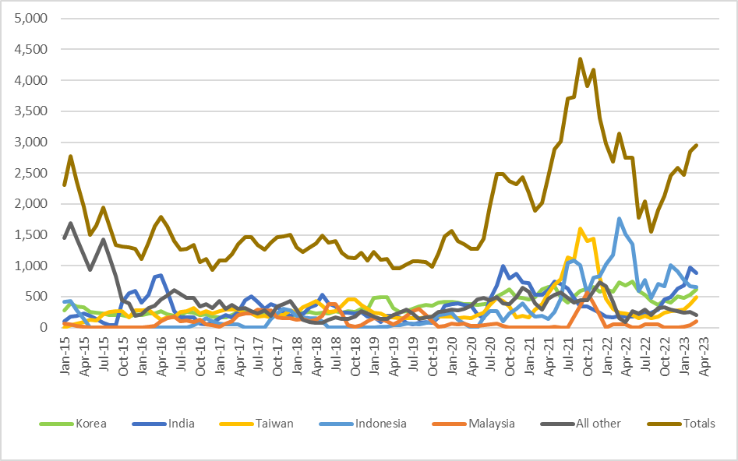

Figure 2: Victorian recovered kerbside metal packaging, to export country (tonnes per month).

Source: ABS and IndustryEdge (IE) (Australian Harmonized Export Commodity Classification (AHECC) data by month, classification, and destination country, 2023) and Blue Environment.

Prior to the pandemic and the current tight market for containers, the typical 12 month contracted price for 50 twenty-foot container movements to southeast Asia, with a capacity of 20 tonnes each, was in the order of $USD300 per container, CIF (at the destination port) and excluding the Australian road freight cost, and was even much lower for scrap material movements (which received lower ‘back hauling’ prices), which were in the order of $USD100–200 per container.

Back hauling pricing reportedly dried up and container prices spiked in 2022 to contract costs in the order of $USD2700–3500 per container, with no reduced price for scrap materials. However, across 2023 prices have reportedly fallen considerably to around $USD400–600 per container. This is still significantly higher than the pre-COVID cost

It is worth noting that there is little container freight provider competition from Australia to the major destinations for scrap metal packaging. The Australian Competition and Consumer Commission, along with US, Canadian, New Zealand and UK governments have recognised that there may be collusive price practices occurring within the international container shipping industry and have highlighted this issue as a possibly serious problem globally.

Table 1: Annual Victorian recovered kerbside recovered metals, to export country

|  |  |  |  |  |  |  |  |  |
| --- | --- | --- | --- | --- | --- | --- | --- | --- |
| Countrya | 2015–16  (tonnes) | 2016–17  (tonnes) | 2017–18  (tonnes) | 2018–19  (tonnes) | 2019–20  (tonnes) | 2020–21  (tonnes) | 2021–22  (tonnes) | 2022–23b  (tonnes) |
| Korea | 2,600 | 2,600 | 2,600 | 3,900 | 4,500 | 6,400 | 7,300 | 4,300 |
| India | 5,200 | 2,400 | 4,000 | 2,400 | 2,700 | 8,400 | 3,400 | 4,900 |
| Taiwan | 2,700 | 3,100 | 3,200 | 3,300 | 2,100 | 4,800 | 9,100 | 2,400 |
| Indonesia | 0 | 600 | 1,700 | 200 | 1,300 | 3,000 | 12,700 | 6,600 |
| Malaysia | 500 | 1,400 | 2,400 | 1,500 | 1,200 | 200 | 1,900 | 300 |
| All other | 6,900 | 4,500 | 2,600 | 2,300 | 3,400 | 5,700 | 4,900 | 2,400 |
| **Total** | **17,900** | **14,600** | **16,500** | **13,600** | **15,200** | **28,500** | **39,300** | **20,900** |

Source: ABS and IE (Australian Harmonized Export Commodity Classification (AHECC) data by month, classification, and destination country, 2023) and Blue Environment.

1. Countries ranked by average of last 3 months of exports.
2. Partial year across July 2022 to March 2023.

Table 2: Most recent monthly change in Victorian recovered metals, to export country

|  |  |  |  |
| --- | --- | --- | --- |
| Country | February 2023  (tonnes) | March 2023  (tonnes) | Change  (%) |
| Korea | 500 | 600 | 20% |
| India | 1,000 | 900 | -10% |
| Taiwan | 400 | 500 | 25% |
| Indonesia | 700 | 700 | 0% |
| Malaysia | 0 | 100 | N/A |
| All other | 300 | 200 | -33% |
| **Total** | **2,900** | **3,000** | **3%** |

Source: ABS and IE (Australian Harmonized Export Commodity Classification (AHECC) data by month, classification, and destination country, 2023) and Blue Environment.

### Market opportunities

The global steel and aluminium markets have been able to consistently absorb metal packaging from kerbside collections, better than the local or global markets for any of the other packaging materials. This is primarily due to the lack of barriers in returning MRF sourced metal packaging back into the global scrap pool and then into many steel and aluminium products beyond packaging.

Tin-plate steel packaging is only reprocessed in very small quantities and has relatively low value, with reports of high levels of contamination. There is an increasing risk of future import restrictions by receiving countries, particularly if mixed grade post-consumer steel imports such as 'black iron' scrap grades are restricted for any reason, as tin-plate steel is often 'shandied' (blended) into other scrap steel grades to enable its sale. Australian governments may wish to assess the potential to facilitate the establishment of local pre-processing capacity, such as hammer-mills to decontaminate the tin-plate steel. This may make the tin-plate steel more attractive to local and international smelter operators.

If there was a markedly negative shift in supply/demand at a global level, this could lead to significant price reductions for baled steel, which would leave this material stranded in Australia with minimal local reprocessing capacity. This would be exacerbated if it coincided with a surge in freight costs, like the one observed across the pandemic.

### Disclaimer

The information on this report was prepared in conjunction with Blue Environment.

While reasonable efforts have been made to ensure that the contents of this publication are factually correct, Recycling Victoria gives no warranty regarding its accuracy, completeness, currency, or suitability for any particular purpose and to the extent permitted by law, does not accept any liability for loss or damages incurred as a result of placed upon the content of this publication.

This publication is provided on the basis that all persons accessing it undertake responsibility for assessing the relevance and accuracy of its content.

Recycling Victoria does not accept any liability for loss or damage arising from your use of or reliance on the Data. The inclusion of information in this report does not constitute Recycling Victoria’s endorsement of any facility, or any associated organisation, product or service.

|  |  |
| --- | --- |
| © The State of Victoria Department of Energy, Environment and Climate Action 2023  Creative Commons BYThis work is licensed under a Creative Commons Attribution 4.0 International licence. You are free to re-use the work under that licence, on the condition that you credit the State of Victoria as author. The licence does not apply to any images, photographs or branding, including the Victorian Coat of Arms, the Victorian Government logo and the Department of Energy, Environment and Climate Action (DEECA) logo. To view a copy of this licence, visit http://creativecommons.org/licenses/by/4.0/  Disclaimer  This publication may be of assistance to you, but the State of Victoria and its employees do not guarantee that the publication is without flaw of any kind or is wholly appropriate for your particular purposes and therefore disclaims all liability for any error, loss or other consequence which may arise from you relying on any information in this publication. | Accessibility  If you would like to receive this publication in an alternative format, please telephone the DEECA Customer Service Centre on 136186, email [customer.service@delwp.vic.gov.au](mailto:customer.service@delwp.vic.gov.au) or via the National Relay Service on 133 677 [www.relayservice.com.au](http://www.relayservice.com.au). This document is also available on the internet at [www.recycling.vic.gov.au](https://www.vic.gov.au/strengthening-our-waste-and-recycling-system?redirectSrc=www.recycling.vic.gov.au) |

