**Attachment 7**

**Paper and paperboard packaging**

Market insights report – July 2023

### Notable market developments

* **Global pulp prices have fallen significantly in the first half of 2023.** After reaching all-time highs in the July–December 2022 period, pulp prices fell in line with other commodities, as a result of the global slowdown.
* **Mixed recovered paper prices were stable in Asia in the June quarter, but demand remains soft.**
* **Local market conditions are also under demand-side pressure.** Australia’s economic slowdown may have begun to flow through to demand for recovered paper.
* **Opal Australian Paper’s closure of paper machines at the Maryvale mill has implications for recovered paper demand.**

### Material overview and market summary

The first half of 2023 saw global market and economic conditions deteriorate, feeding into softer demand for Australian recovered paper. Less demand for goods, inevitably resulted in reduced demand for packaging materials, especially the mainstay recycled corrugated boxes.

Australia’s experience is little different right now, with some expectations market downturns may be lagging those elsewhere in the world.

Only two major grades of recovered paper are traded in any significant volume: old, corrugated cardboard, including those sorted from kerbside collections and the mixed volume derived entirely from kerbside and municipal collections. The packaging related commercial and industrial (C&I) materials, including liquid packaging board (LPB) and coated boards have stable markets, almost entirely for export.

Other traditional grades derived from the C&I stream are dwindling as printed media and communications continue to decline. In mid-2022, Opal Australian Paper ceased producing office and copy paper on the smaller of its two printing and communication paper machines at the Maryvale mill in the Latrobe Valley. That machine now produces packaging grades and is understood to use some recovered fibre.

In early 2023, Opal closed the larger of the two machines, meaning there is no longer any office paper production in Australia. All supply into the market is now imported.

Opal continues to operate three paper machines at the Maryvale mill, manufacturing a range of packaging paper grades. The smallest of those machines is slated to close in 2023.

The implications of Opal’s production profile changing and reducing are important for recovered paper demand and supply, for the following reasons:

1. Demand for recovered white office paper at the Maryvale mill has ended, with the mill’s Deinking Plant no longer producing recycled pulp for use in recycled office paper grades.
2. Demand for old, corrugated cardboard has increased, because the Maryvale mill uses recovered paper on the repurposed paper machine that previously manufactured copy and office paper.

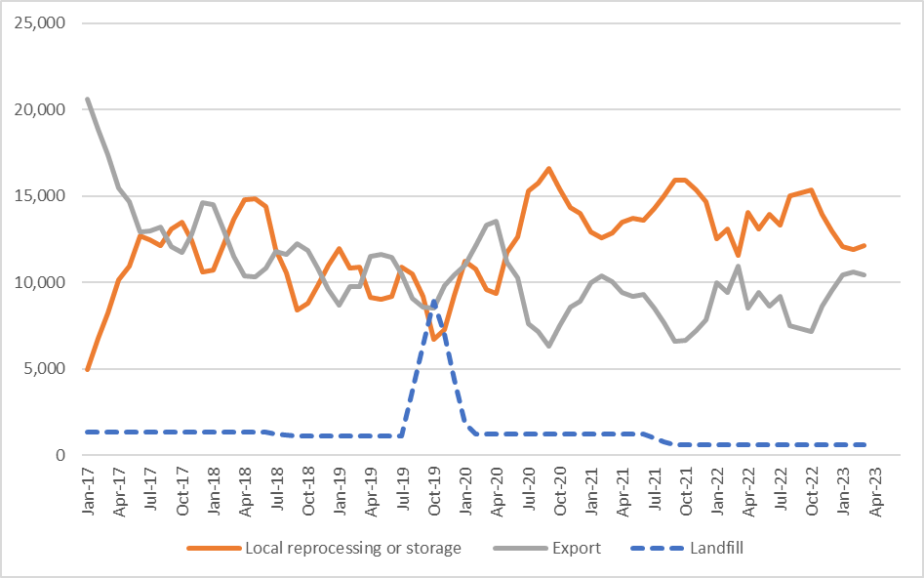

Figure 1: Destination of Victorian material recovery facility (MRF) outputs (tonnes per month) – kerbside paper and paperboard.

Source: Australian Bureau of Statistics (ABS) (Australian Harmonized Export Commodity Classification (AHECC) data by month, classification, and destination country, 2023) and Blue Environment.

Note 1: Historical total monthly MRF outputs have been approximated in Figure 1 to enable comparison with monthly ABS customs export data. The overall trends are the key aspect of the figure.

Note 2: The combined ‘Local reprocessing or storage’ estimate is indicative only, and these fates will be presented separately if this level of data becomes available. Landfill excludes disposal from storage and is an approximation based on annual waste to landfill rates.

### Prices, demand and supply

Through to the end of May 2023, global fibre prices had fallen significantly over the course of 2023, dropping from record highs posted in late 2022. Virgin wood fibre prices, such as woodchips have begun to experience collateral declines, but they are lagging the falls recorded for pulp. Recovered fibre prices are under similar pressure.

From the start of 2023 to the end of May, the price of Bleached Eucalypt Kraft (BEK) pulp had declined by 41%, and for Bleached Softwood Kraft (BSK) by 25% (which typically has more stable prices).

Recovered fibre prices have stumbled lower in international markets, with supply and demand both moderating as global economies are impacted by inflation and interest rates.

### Key end markets and related specifications

There are no new end markets for kerbside recovered paper, despite increased attention on a small number of solutions.

Most prominent of those in the first half of 2023 has been the production of solid board products from liquid packaging and other coated boards (see [*saveBOARD*](https://www.saveboard.com.au/)). The Victorian Government has co-invested in a facility for this product, which is expected to be operational in late 2023 or early 2024.

Other developments, like those involving moulded fibre and fibre-based insulation, can be small scale, but require very specific recovered feedstock. One key to the further deployment of these secondary solutions is improved sorting of the MSW stream of recovered paper.

The greatest competition in recovered paper markets continues to be for recovered office papers and newsprint, obtained from commercial sources, not kerbside sources. Local paper producers in packaging, tissue and pet care products, all seek office papers and newsprint for different purposes.

The exit of production of recycled office papers – see above – by the Victorian producer, Opal Australian Paper, does remove a major competitor from the local market, but at the same time, consumption and recovery continue to decline, providing little comfort to the other buyers.

For recovered newsprint, very little of which is derived from the MSW stream, the major end-use application continues to be pet care products, whose underlying capacity to pay is significantly greater than any other known application.

### Export and interstate market review

Victoria’s exports of recovered paper continue to average around 8,500 tonnes per month, as has been the case since the start of the pandemic at the beginning of 2020. Prior to that, exports had been trending down.

One reason for Victoria’s gradual reduction has been declining consumption and recovery of newsprint and office papers, but other factors have also been at play. Import constraints to China, the emergence of new markets and increased efforts to operate more locally all reduced Victoria’s exports.

The latter point applies as much to other states, including South Australia. South Australia routinely shipped large volumes of recovered paper to Victoria, where the major sorters and handlers were engaged in aggregation and optimisation exercises. They would assemble export loads in Melbourne, from volumes derived from multiple states, after ensuring domestic needs were met with their preferred supply.

As sorting and other practices have improved in other states, internal supply to Victoria, for that aggregation exercise has slowed. Exports from South Australia have for example, increased until the economic downturn began in mid-2022, reducing movement of goods and therefore the use and availability for recovery of a range of materials, including fibre packaging.

Industry is also of the view that an increased proportion of recovered paper is making its way ‘net-net’ to the nation’s paper and board mills focussed on production of corrugated packaging. Damaging forest fires in 2019-20 destroyed large areas of plantations that were providing new fibre for many purposes, including the replacement fibre for packaging, when it has been recycled multiple times.

Less wood fibre means more use of recycled fibre, consequently reducing the volumes available for export.

As Indonesia has grown its share of the Victorian (and Australian) export volumes, it has brought with it an unfamiliar experience for Australian trade: proximity. A major exporter advised recently they had been able to position their supply into the Indonesian market in part because of the cheaper freight cost compared to North America and Europe.

Victoria’s shipments of recovered paper to Indonesia – alongside those from much of Australia and most of New Zealand – have continued into 2023. Although they have declined marginally, these exports are expected to be a mainstay of export arrangements because the very large packaging paper and board mills utilising the fibre have a huge appetite for it.

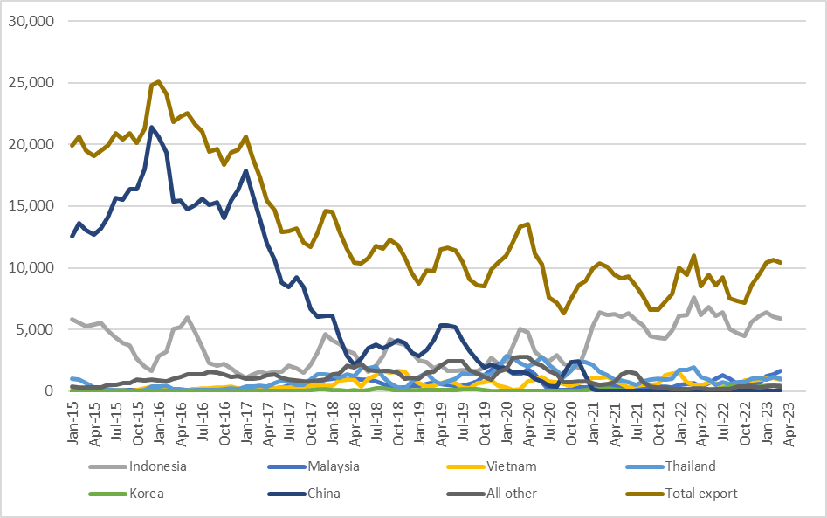

Figure 2: Victorian recovered kerbside paper and paperboard, to export country (tonnes per month).

Source: ABS and IndustryEdge (IE) (Australian Harmonized Export Commodity Classification (AHECC) data by month, classification, and destination country, 2023) and Blue Environment.

Table 1: Annual Victorian recovered kerbside paper and paperboard, to export country

|  |  |  |  |  |  |  |  |  |
| --- | --- | --- | --- | --- | --- | --- | --- | --- |
| Countrya | 2015–16  (tonnes) | 2016–17  (tonnes) | 2017–18  (tonnes) | 2018–19  (tonnes) | 2019–20  (tonnes) | 2020–21  (tonnes) | 2021–22  (tonnes) | 2022–23b  (tonnes) |
| Indonesia | 45,000 | 22,000 | 34,000 | 32,000 | 34,000 | 51,000 | 68,000 | 51,000 |
| Malaysia | 1,000 | 2,000 | 10,000 | 6,000 | 16,000 | 4,000 | 6,000 | 9,000 |
| Vietnam | 2,000 | 3,000 | 7,000 | 12,000 | 7,000 | 9,000 | 9,000 | 7,000 |
| Thailand | 2,000 | 4,000 | 14,000 | 11,000 | 24,000 | 19,000 | 13,000 | 8,000 |
| Korea | 0 | 0 | 1,000 | 1,000 | 1,000 | 1,000 | 0 | 3,000 |
| China | 204,000 | 171,000 | 67,000 | 48,000 | 24,000 | 9,000 | 0 | 0 |
| All other | 11,000 | 15,000 | 16,000 | 20,000 | 24,000 | 12,000 | 5,000 | 3,000 |
| Total | 265,000 | 217,000 | 149,000 | 130,000 | 130,000 | 105,000 | 101,000 | 81,000 |

Source: ABS and IE (Australian Harmonized Export Commodity Classification (AHECC) data by month, classification and destination country, 2023) and Blue Environment.

1. Countries ranked by average of last 3 months of exports.
2. Partial year across July 2022 to March 2023.

Table 2: Example monthly change in Victorian recovered kerbside paper and paperboard, to export country

|  |  |  |  |
| --- | --- | --- | --- |
| Country | February 2023  (tonnes) | March 2023  (tonnes) | Change  (%) |
| Indonesia | 6,000 | 5,900 | -2% |
| Malaysia | 1,400 | 1,600 | 14% |
| Vietnam | 1,100 | 900 | -18% |
| Thailand | 1,200 | 1,000 | -17% |
| Korea | 500 | 400 | -20% |
| China | 0 | 100 | N/A |
| All other | 400 | 300 | -25% |
| Total | **10,600** | **10,200** | **-4%** |

### Market opportunities

In addition to supply chain consolidations continuing, the market anticipates the application of export regulations and standards from mid-2024 will result in a revision to the underlying market structure.

Under this expected scenario, smaller collection facilities and MRFs would either be ineligible or would be incapable of meeting export licencing requirements. The consequence is likely to see a strengthening of the ‘hub and spoke’ model that starts in Victoria’s regions and essentially ends in Melbourne, either fated to supply local paper and paperboard producers, or at the Port of Melbourne, destined for shipment to Asia.

As set out above, where there are opportunities to establish new recycling opportunities in Victoria, analysis indicates they will all be directly linked to specific and reliable ‘positive sorting’ of the material they require to be successful.

### Disclaimer

The information on this report was prepared in conjunction with IndustryEdge and Blue Environment.

While reasonable efforts have been made to ensure that the contents of this publication are factually correct, Recycling Victoria gives no warranty regarding its accuracy, completeness, currency or suitability for any particular purpose and to the extent permitted by law, does not accept any liability for loss or damages incurred as a result of placed upon the content of this publication.

This publication is provided on the basis that all persons accessing it undertake responsibility for assessing the relevance and accuracy of its content.

Recycling Victoria does not accept any liability for loss or damage arising from your use of or reliance on the Data. The inclusion of information in this report does not constitute Recycling Victoria’s endorsement of any particular facility, or any associated organisation, product or service.

|  |  |
| --- | --- |
| © The State of Victoria Department of Energy, Environment and Climate Action 2023  Creative Commons BYThis work is licensed under a Creative Commons Attribution 4.0 International licence. You are free to re-use the work under that licence, on the condition that you credit the State of Victoria as author. The licence does not apply to any images, photographs or branding, including the Victorian Coat of Arms, the Victorian Government logo and the Department of Energy, Environment and Climate Action (DEECA) logo. To view a copy of this licence, visit <http://creativecommons.org/licenses/by/4.0/>  Disclaimer  This publication may be of assistance to you, but the State of Victoria and its employees do not guarantee that the publication is without flaw of any kind or is wholly appropriate for your particular purposes and therefore disclaims all liability for any error, loss or other consequence which may arise from you relying on any information in this publication. | Accessibility  If you would like to receive this publication in an alternative format, please telephone the DEECA Customer Service Centre on 136186, email [customer.service@delwp.vic.gov.au](mailto:customer.service@delwp.vic.gov.au) or via the National Relay Service on 133 677 [www.relayservice.com.au](http://www.relayservice.com.au). This document is also available on the internet at [www.recycling.vic.gov.au](https://www.vic.gov.au/strengthening-our-waste-and-recycling-system?redirectSrc=www.recycling.vic.gov.au) |

Keep all content above this instruction text line. Delete only when document formatting is complete.

