Extractive Industries in South Gippsland

Supply Chain Study

**Published by**

Freight Victoria  
Department of Transport   
8 Exhibition Street,   
Melbourne Victoria 3000

Telephone (03) 8392 7954

March 2019

© Copyright State Government of Victoria 2019

This publication is copyright. No part may be reproduced by any process except in accordance with the provisions of the Copyright Act 1968.

Authorised by the Victorian Government, Melbourne

Printed by Finsbury Green

Designed by DJPR Design Studio

ISBN 978-1-76090-106-6 (Print)  
ISBN 978-1-76090-107-3 (pdf/online/MS word)

**Disclaimer**

The information contained in this document is provided for general guidance and assistance only and is not intended as advice. You should make your own inquiries as to the appropriateness and suitability of the information provided. While every effort has been made to ensure the currency, accuracy and completeness of the content, we endeavour to keep the content relevant and up-to-date and reserve the right to make changes as required. The Victorian Government, authors and presenters do not accept any liability to any person for the information (or the use of the information) which is provided or referred to in the document.

Except for any logos, emblems, trademarks, artwork and photography, this document is made available under the terms of the Creative Commons Attribution 3.0 Australia licence.

# Contents

1. Purpose and scope of study 3

2. Consultation 5

3. Strategic policy context 6

4. The freight task 7

5. Key transport issues 9

6. Current government investment 12

7. Next steps 13

# 1. Purpose and scope of study

This supply chain study (the Study) focuses on extractive resources in South Gippsland and identifies the key transport issues and the supply chain options to meet the demand projections to 2050. The Study provides input into policy and investment to further the aims of the 2018 Extractive Resources Strategy, *Helping Victoria Grow*, and the 2018 Victorian Freight Plan, *Delivering the Goods*.

Extractive resources include sand, rock, gravel and clay that are used in building and infrastructure construction.

The South Gippsland region has been identified as one of the top five strategic extractive resource locations in Victoria. It is a critical location for hard rock, sand and gravel, driven partly by its proximity to markets in Greater Melbourne.

The region comprises the “extractive industry interest areas” around Lang Lang, Nyora and Grantville through to Leongatha South.[1] These are predominantly within Bass Coast and South Gippsland Local Government Areas (LGAs), with smaller deposits in Cardinia Shire. The primary transport routes westwards from South Gippsland pass through Cardinia Shire and the City of Casey before dispersing across Greater Melbourne.

The scope of the Study includes:

* origin and destination of materials and annual volumes from South Gippsland
* optimal routes and network capacity
* options to improve capacity and efficiency of the freight transport system
* implications in terms of investment (government and industry) and planning processes.

While the Study focuses on the South Gippsland region, it also identifies generic issues that apply state-wide across the extractive industries, as well as broader issues relating to the freight transport network.

The study area is represented on the map (see Figure 1).

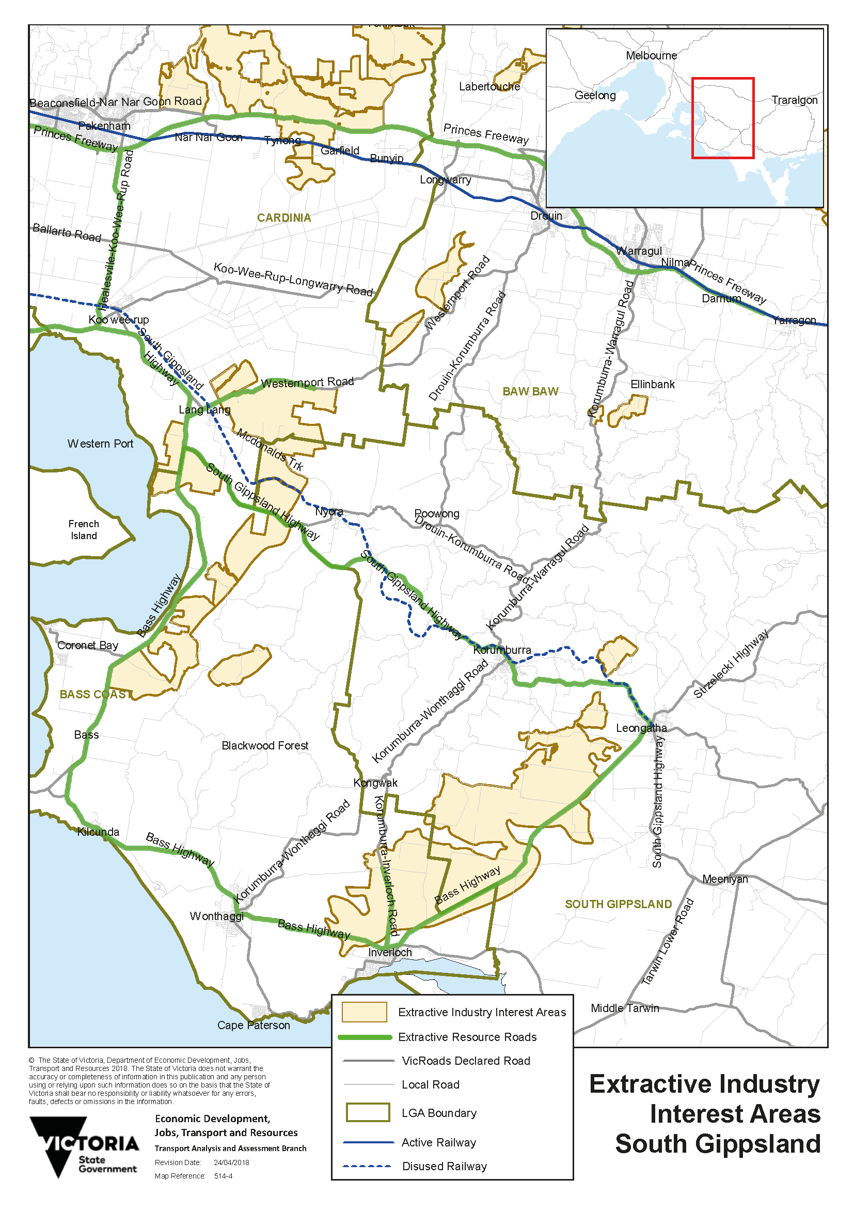

Figure 1: South Gippsland supply chain study area.

# 2. Consultation

The research for this report has included consultation with other Victorian Government departments, local government and industry, including:

* South East Metro Integrated Transport Group (SEMITG)[2]
* Minerals Development Victoria
* Department of Environment Land Water and Planning (DELWP)
* City of Casey
* Cardinia Shire
* Bass Coast Shire
* South Gippsland Shire
* Construction Material Processors Association
* Cement, Concrete and Aggregates Association
* Holcim (Australia) Pty Ltd
* Hansen (Heidelberg Cement Group)
* individual quarry operators.

In April 2018 the key findings of the Study were presented to the Extractive Industries Taskforce established by the Minister for Resources.

# 3. Strategic policy context

In June 2018 the Victorian Government released its strategy for extractive resources, *Helping Victoria Grow* (the Strategy). The Strategy outlines the areas for action to ensure the continued supply of extractive resources to support rapid population growth to 2050.

The Strategy is informed by a comprehensive study commissioned by Minerals Development Victoria, released in 2016.[3] This 2016 study presented forecasts of the demand and supply of extractive resources state-wide to 2050, by resource type and by each of Victoria’s 79 local government areas.

However, the current 2018 data indicates that demand for extractive resources is tracking even higher than the ‘high demand’ scenario forecast in the 2016 study (see Figure 2 below).

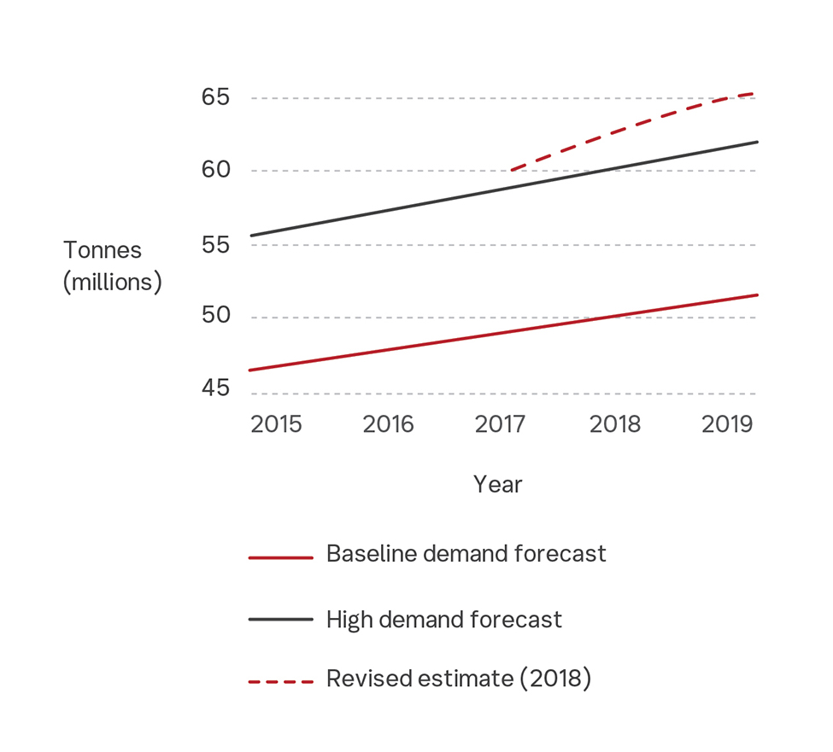

Figure 2: Revised demand forecasts for Victorian extractive resources (DEDJTR 2018).

This unprecedented demand is due to the increase in major transport infrastructure investment while underlying housing and commercial construction remains strong.

State-wide extractives production is expected to exceed 100 million tonnes per annum by 2050, more than double the 2016 level, driven by continued demand for infrastructure projects, including transport and renewable energy.

While demand grows, anticipated resource supplies are being limited by delays in approval processes, strong competition for land and restrictions on existing quarry operating conditions. The outcome is that projected demand for materials is not being met by planned supply.

This Study takes the data from the Extractive Resources in Victoria, Demand and Supply Study 2015-2050 and assesses the transport implications for extractive resources from South Gippsland.

Based on the data from the 2016 study it is assessed that the planned supply of hard rock from South Gippsland can meet its allocated demand, whereas the planned supply from Inner South East (which includes Bass Coast and Cardinia) will meet less than half its allocated demand by 2050. This shortfall will require a significant amount of new supply to come on-stream, either by expanding existing sites or opening new quarries.

Given the competing development pressures on land in the Inner South East, it is highly likely that this shortfall will require expanded and new production in South Gippsland, being relatively close to major demand centres in Greater Melbourne. The shortfall may also be made up from other locations more distant from Melbourne.

The actions in the 2018 Strategy, *Helping Victoria Grow*, aim to address this supply shortfall state-wide. One initiative currently underway is the South Gippsland Strategic Extractive Resource Areas pilot project, that aims to secure sand resources for the long term through use of appropriate planning policies.

# 4. The freight task

Data from the 2016 supply-demand study shows a step change in the projected demand for extractive resources from South Gippsland. The demand is projected to grow rapidly from below 4 million tonnes in 2015 to over 16 million tonnes in 2025 and over 24 million tonnes by 2050 (see Figure 3).

The demand growth is driven by two factors:

* South Gippsland will become a critical location for hard rock as supply is exhausted from other locations, including the Inner South East region.[4] The region is projected to supply approximately 33 per cent of the state’s hard rock needs between 2015 and 2050.
* The relative proximity to key sources of demand favours South Gippsland over more distant supply locations. By 2050, 80 per cent of South Gippsland’s extractive resources is estimated to be required by Greater Melbourne, driven largely by residential and commercial construction. The remaining 20 per cent of the demand comes in part from regional cities such as Greater Geelong and Ballarat, and from other areas close to Melbourne’s fringe such as Mitchell and Macedon Ranges.

This projected supply from South Gippsland is highly likely to be an underestimate for three reasons:

* Observations since the 2016 study indicate that demand overall is exceeding the high-level scenario used in the modelling, therefore the figures above may be conservative.
* “Hard rock” does not include Bass Coast or Cardinia, which is aggregated into “Inner South East” in the 2016 study and not included above.
* The data above is based on “allocated demand”, i.e. the demand driven by the requirement for materials, rather than by the level of planned supply. The 2016 study identified a significant shortfall between allocated demand and projected supply from Inner South East, which will require additional production to be planned for and brought on-stream. Much of this is expected to come from South Gippsland and, if so, the projected total supply would grow to over 31 million tonnes in 2050.

The transport implications of this substantial demand growth for materials can be estimated in terms of truck movements based on an assumption of a 40-tonne payload and 6 days per week operation.

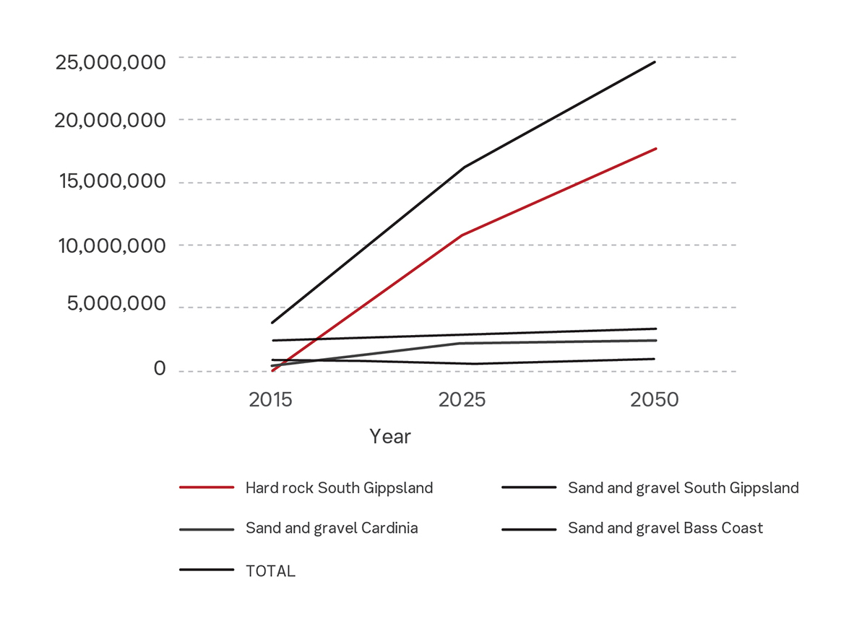

Figure 3: Projected demand to 2050, tonnes per annum (DEDJTR 2016, Tables 14 and 15).

Estimated truck journeys per day

|  |  |  |  |
| --- | --- | --- | --- |
|  | **2015** | **2025** | **2050** |
| Vehicle movements per day (loaded) | 303 | 1,293 | 1,970 |
| Vehicle movements per day (loaded and return)[5] | 607 | 2,586 | 3,940 |

If the projected supply shortfall from Inner South East is met entirely by increased production from South Gippsland, the estimated truck journeys in 2050 would be over 5,000 per day (loaded and return).

This projected increase in transport demand is an order of magnitude. It will place significant pressure on the road network, throughout the supply chain from the source in South Gippsland through to destinations predominantly in Greater Melbourne.

The supply chain for extractive resources from the South Gippsland region is currently road-based. It has key characteristics that determine the nature of the freight task, such as:

* clustered multiple source locations to dispersed destinations
* changing destinations, e.g. construction sites, although some are fixed, e.g. concrete batching plants
* a trend towards 24/7 operations, to meet forecast volumes and the demands of just-in-time delivery
* the need to stockpile materials overnight for draw down during the day.

Transport of extractive resources has traditionally been undertaken using rigid body vehicles (tip trucks, cement trucks) on short hauls up to 30 km from source to destination, although these distances are steadily increasing. Industry is increasing transport capacity through ‘truck and dog trailer’ combinations delivering payloads of up to 40 tonnes.

The main supply chain routes are shown in the map of the study area above (Figure 1). The key arterial roads are the Bass Highway and South Gippsland Highway, linking to the Princes Freeway via the Healesville Koo Wee Rup Road. McDonalds Track at Lang Lang is the most significant local road providing access to supply sites. Local roads also provide ‘last mile’ access at destination.

Historically, the South Gippsland Railway transported sand from Nyora to processing sites in Greater Melbourne, but this line has been disused since 1998.

# 5. Key transport issues

## Resource costs impact directly on government infrastructure projects.

The cost of extractive resources has a direct impact on infrastructure investment for state and local government, including transport projects. This cost includes both the material and transport components. There is therefore a strong driver for government to secure adequate supply and to facilitate supply chain efficiencies to ensure that the cost of raw materials for its infrastructure projects remains within budget.

## Competing development pressures will push new supplies to more distant locations.

Encroachment of urban development into existing extractive resource areas is limiting supply. Industry will therefore have to source new supplies that are likely to be more distant from the demand. This will increase transportation costs for operators and require increased investment in transport capacity by government.

## Extractive resources are not uniform products and entail differentiated supply chains.

Sand is a relatively uniform product, which improves the potential for industry collaboration on, for example, aggregated loads and modal shift.

Hard rock is a differentiated product, with various types and grades for specific purposes. This differentiation adds complexity to supply chains, particularly the process of stockpiling materials, or the potential aggregation into bulk loads, for example using rail.

## The resources are finite, supply will be exhausted and locations will change.

Industry will move on once a resource is exhausted. Similarly, the demand locations change with every construction site – there are few fixed sites. Transport investment therefore needs to be cognisant of the changing shape of the supply chain, and particularly to avoid over-investment in assets that may have limited time use or become stranded.

## Responsibility for transport investment is shared between all levels of government.

Commonwealth and state governments invest in the road and rail networks. Local government is responsible for local roads, and manages access and permits for roads in their areas. A collaborative management and investment approach is therefore required between state and local government, along with industry as the main beneficiary from improved transport provision.

## There is potential for government and industry co-investment.

Industry is likely to be supportive of investments that reduce costs and improve efficiency. An investment model needs to be developed and agreed, for example production-based whereby industry contributes at an agreed rate based on tonne-kilometre. Investment could focus on specific infrastructure improvements, particularly ‘first and last mile’ access, or on more strategic investments around aggregation or modal shift.

## A network of perpetual sites should be established to improve supply chain capacity.

Perpetual sites are permanent locations for aggregation, distribution or processing of extractive resources.

Perpetual sites at the demand end are already established for perishable products such as concrete, however several of these concrete plants are at capacity. New sites could be identified with improved access, for example to realise the efficiencies of High Productivity Freight Vehicles (HPFVs) or support multi-modal transport. Amendments to the planning definitions could also allow concrete batching and asphalt plants to be located within quarries to reduce transport inefficiencies. Sites are also needed to aggregate, process and return recyclable materials to the supply chain.

Perpetual sites can also provide storage. This enables material to be transported out of the licensed extractive industry site to be stockpiled, from where it can be transported to the final destination.

An integrated planning approach is required to identify a new network of perpetual sites, particularly in metropolitan areas, from which materials can be distributed quickly and efficiently to market.

## Planning needs to address the need for perpetual sites with 24/7 operation.

The planning guidelines associated with perpetual sites will need to be reviewed.

This review will then inform local planning schemes. The review could:

* make a distinction between the quarry operations and transport operations within sites
* identify new land that can be rezoned for perpetual sites, at the supply and demand end
* assess the suitability for 24/7 transport operations, considering factors such as first and last mile access, night curfews, day time restrictions and permitted routes, particularly through towns and residential areas.

## There are significant amenity and cost issues with trucks on roads.

The projected increase in truck journeys will have significant impacts in terms of amenity, noise and safety, particularly through urban areas and rural towns. Damage to roads will also increase, resulting in increased road maintenance costs and an associated increase in congestion and traffic delays, alongside significant safety issues.

A cost-benefit assessment of the major increase in truck journeys should consider the broader impacts such as emissions, safety and neighbourhood amenity, as well as comparing with other options; including aggregation and modal shift.

## There is pressure from industry to increase vehicle size.

Industry is seeking to use HPFVs up to 80 tonnes payload to improve efficiency as haulage distances increase. Current VicRoads policy stipulates conditions for HPFVs, including weight limits and permitted routes.[6] An increase in vehicle size will require an assessment of infrastructure capacity and pavement structures, that may need to be strengthened to support additional mass.

## Longer supply chains favour modal shift to rail, but this requires integrated planning on routes and transport nodes.

Extractive resources are commodities ideally suited to rail. They are high in mass and a non-perishable commodity that can be transported in bulk or packaged in containers. While rail routes exist, the route and node options for aggregation need to be identified and the cost-benefit assessed. This requires detailed study across transport and land-use planning, including earth resources.

## The supply chain challenge for extractive industries requires integrated land-use and transport planning.

The Victorian Government has a responsibility for integrated transport and land-use planning under the *Transport Integration Act 2010.*

The 2016 supply-demand study found that 34 per cent of demand for extractives in 2050 will need to be sourced from quarries not yet built or planned.

The challenges for extractive industries identified in the 2018 Strategy, *Helping Victoria Grow*, require a proactive policy approach to identify the optimal configuration of supply locations, perpetual sites and transport investment. Criteria will need to be defined by which options can be assessed on a whole-of-system basis. An integrated approach will allow transport investment and the planning implications to be assessed strategically in the context of rapid demand growth.

# 6. Current government investment

The preferred routes for extractive resources from South Gippsland to markets in Greater Melbourne and beyond are from Leongatha via the Bass Highway, and from Lang Lang via the South Gippsland Highway and the Healesville Koo Wee Rup Road to the Princes Freeway East. These are the priority routes for road investment, including potential upgrades to allow HPFVs.

On-going road investments by the Victorian Government in South Gippsland include:

* **Healesville Koo Wee Rup Road:** $300 million upgrades and dual carriageway between Pakenham and Manks Road, Koo Wee Rup, announced in April 2018
* **Koo Wee Rup bypass:** VicRoads has undertaken a planning study to upgrade to dual carriageway and a Public Acquisition Overlay is implemented in the Cardinia Shire Planning Scheme
* **South Gippsland Highway:** $300,000 for VicRoads to plan for road safety improvements around Coal Creek, Korrumburra
* **Bass Highway:** $500,000 for VicRoads to assess potential improvements between Leongatha South and Lang Lang.

The $2.2 billion Suburban Roads Program in the 2018 Budget will bring significant improvements to local and arterial roads in Melbourne’s south-east, including Stage 3 of the Thompsons Road upgrade at Cranbourne.

In addition, Bass Coast Shire is planning a freight bypass of Wonthaggi, and Cardinia Shire Council is proposing a bypass of Lang Lang.

# 7. Next steps

This Study identifies a step change in the projected supply of extractive resources from South Gippsland from below 4 million tonnes in 2015 to over 24 million in 2050. The estimated truck journeys would increase from around 600 per day in 2015 to at least 4,000 per day in 2050.

The Study notes some significant issues that cannot be assessed and resolved at a regional level alone. These require broader research and modelling of supply chains, to support integrated transport and land-use decision-making.

This work would support delivery of three of the short-term priority actions in *Helping Victoria Grow*:[7]

* Recognise critical extractive resource transport networks in Victorian Government transport and infrastructure plans
* Improve data collection and sharing
* Conduct an initial study into transport impacts and network development needs.

The Department of Transport will work with Minerals Development Victoria and Earth Resources in the development of transport strategies and plans by identifying transport networks that are critical to the movement of extractive resources.

Minerals Development Victoria is currently revising the 2016 supply-demand data based on current observations. It is also reviewing its in-house data management and analysis to allow government to access current reliable data to support decision-making on transport projects. This research and modelling would draw on the new data to assess the transport implications with the identification of sources (supply) and destinations (demand) of extractive materials by LGA – current and projected.

An integrated approach to land use and transport planning would identify the options for existing and new supply sites, including the potential to develop new multi-mode transport supply chains. New extractive areas may be identified at locations currently less transport-constrained.

The study would also identify the options for a network of new perpetual sites.

Further components in the research would include:

* Policy analysis and assessment criteria by which to assess perpetual sites for 24/7 operations
* Cost-benefit analysis and policy implications of larger HPFVs
* Assessment of multi-modal options, including an evaluation of rail to support the movement of extractive resources compared to road at a state-wide level. This assessment would include policy settings, economies of scale, externalities, cost-benefit and barriers to entry.

The research would be expected to build on the Strategic Extractive Resource Areas program and the 2016 study commissioned by the former DEDJTR to identify ways in which Victoria’s planning system could be used to secure strategically important extractive resource areas.[8]

On-going policy development and investment by Freight Victoria in the Department of Transport is also addressing supply chain issues. For example:

* The 2018 Victorian freight plan, *Delivering the Goods*, confirms the need to expand the Principle Freight Network (PFN). The PFN is intended to guide land-use planning and development applications to ensure that routes and places of freight significance are protected. Strengthening the protection of the PFN in relevant planning schemes will support Victorian supply chains, including for extractive industries.
* Making better use of rail freight is one of the priority areas in the Victorian freight plan. A freight infrastructure fund will also support the establishment of intermodal terminals and other critical freight infrastructure, particularly to remove first and last mile impediments.
* The possibility of road pricing trials is being considered in Green Triangle Region of South West Victoria.

1. Extractive Industry Interest Areas (EIIA) were established by the Geological Survey of Victoria to indicate where extractive industry operations were more likely to be established, and are recognised in Plan Melbourne and Regional Growth Plans. A priority action in *Helping Victoria Grow* is to review the EIIA and assess options to strengthen protection through planning.
2. SEMITG is a strategic transport planning group representing the LGAs of Bass Coast, Cardinia, Casey, Frankston, Greater Dandenong, Kingston, Mornington Peninsula and Yarra Ranges.
3. *Extractive Resources in Victoria, Demand and Supply Study 2015-2050*, report by PWC for DEDJTR, May 2016.
4. Inner South-East region incorporates Bass Coast, Cardinia, Casey, Frankston, Knox, Mornington Peninsula, Whitehorse and Yarra Ranges.
5. Return vehicle movements are empty, therefore the road impacts are different (e.g. in terms of route, maintenance cost and noise).
6. *Moving more with less*, VicRoads, November 2017.
7. Priority actions for transport and local infrastructure planning: p44.
8. *Strategic Extractive Resource Areas: Victoria’s existing planning system*, Jacobs Consulting, October 2016