WESTERN DISTRIBUTOR AND MONASH FREEWAY UPGRADE

# Key findings from the business case December 2015

## Snapshot

The business case for the Western Distributor recommends a solution to congestion on the M1 and the West Gate Bridge along with other network improvements to support Victoria’s growth.

A new 6.3 kilometre link that ends Melbourne’s over-reliance on the West Gate Bridge is at the heart of the project, along with direct freeway links to the Port of Melbourne and inner city, and the Monash Freeway Upgrade.

In March 2015 the Victorian Government received a market-led proposal for the Western Distributor from Transurban, operator of CityLink. The Government determined that the best way for Victorians to have confidence in the project was to test it against a public sector benchmark through a State business case.

The business case assesses additions to the original Transurban proposal to address increasing demand and congestion, with more investment in Victoria’s critical economic spine, the M1 corridor.

Strengthened links between health, education and employment clusters along the M1 will ensure a growing number of Victorians can access jobs and economic opportunities as Melbourne grows to a city of 7 million people.

The business case confirms the Western Distributor has investment merit and will bring significant value to Victoria and the nation. Greater productivity, a more competitive port, less reliance on the West Gate Bridge and better liveability are the key benefits, along with an $11 billion boost to the gross state product by 2031, and 5,600 jobs at the peak of construction.

The business case finds a benefit cost ratio (BCR) of 1.3 using conservative State modelling. What this means is for every $1 invested, the project will bring at least $1.30 benefit. The capital cost of the project is an estimated $5.5 billion, subject to final scope and design.

The Victorian Government is the first in Australia to release its business case for a multi-billion dollar road project at this point in the process. A transparent planning process will be undertaken by the Victorian Government, in consultation with Transurban. It will engage communities and stakeholders on all aspects of the project scope, including the best option for tunnel portals and inner-city connections.

|  |
| --- |
| The business case is a 300 page document. This summary provides a brief outline of the key findings including:   * why a Western Distributor is needed * the network solution considered in the business case * an assessment of qualitative and economic benefits * options for tolling * some potential impacts and how they will be managed. |

## Timeline

|  |  |
| --- | --- |
| March 2015 | Transurban submits a market-led proposal for the Western Distributor |
| April 2015 | The Premier announces the Western Distributor will progress to the next stage of assessment based on its potential to represent a unique value proposition for Victoria |
| September 2015 | Transurban releases a ‘design update’ to the community, outlining its revised project concept |
| November 2015 | The Government announces the Monash Freeway Upgrade, which with the Western Distributor, provides a network wide solution that will see critical investment in the M1 corridor  The business case for the Western Distributor is submitted to the Commonwealth Government for joint consideration |
| December 2015  and ongoing | The business case is released to the public and the Government announces it will commit to building the Western Distributor  The Government continues exclusive negotiations with Transurban to deliver the project and further develops the ongoing design in consultation with the community and stakeholders |

## Key elements of the Western Distributor

The Western Distributor will link the West Gate Freeway and CityLink; upgrade and widen the West Gate Freeway from the M80 Ring Road to Williamstown Road; improve access from the West Gate Freeway to the Port of Melbourne; and upgrade access to Webb Dock. The business case also includes the Monash Freeway Upgrade.

Together these elements will significantly improve the way people and freight move around Melbourne.

The project’s alignment and design will be refined throughout the planning process in consultation with the community, councils, and key stakeholders.

## Strengthening the M1: better connecting the west

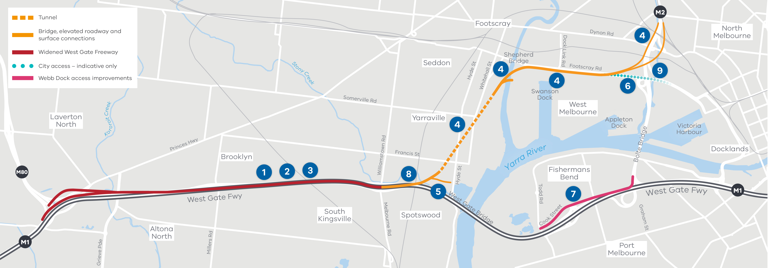

Figure 1 The Western Distributor

1. Widening the West Gate Freeway from 8 to 12 lanes between the M80 interchange and Williamstown Road. Six lanes will be split into two carriageways each way to separate traffic going to and from the new tunnel and the West Gate Bridge
2. A 90 kilometre stretch of managed motorway system from Werribee to Pakenham will be the longest in Australia
3. Upgrade of existing bridges to accommodate high productivity freight vehicles
4. A new connection from the West Gate Freeway to the Port of Melbourne and CityLink via a tunnel under Yarraville, a bridge over the Maribyrnong River, and an elevated road above Footscray Road
5. Direct connection to Hyde Street to enable over-height trucks and vehicles carrying dangerous goods (banned from tunnels) to avoid residential streets
6. Direct access to the Port of Melbourne at Mackenzie Road and Appleton Dock Road
7. Direct access for trucks travelling from Webb Dock to CityLink
8. Completing the Federation Trail between Fogarty Avenue and Hyde Street
9. Connections to the city to be refined in consultation with key stakeholders including the City of Melbourne

## THE WESTERN DISTRIBUTOR WILL

|  |  |  |
| --- | --- | --- |
| Make a return trip from the west up to 20 minutes faster | Extend truck bans in the inner west to reduce trucks by 28 per cent | Make driving safer and more reliable, reducing serious crashes by up to 55 a year |
| Create 5,600 new construction jobs | Cut travel time to the Port of Melbourne by up to 50 per cent | Reduce Melbourne’s reliance on the West Gate Bridge |
| Boost the Victorian economy by $11 billion | Reduce vehicle emissions by 2.3 million tonnes a year | Use smart technology to extend Australia’s largest managed freeway network |
| Take 50 to 75 per cent of trucks off Francis Street and Somerville Road | Take up to 22,000 vehicles a day, including 6,000 trucks, off the West Gate Bridge | Build the missing link for cyclists on Federation Trail |
|  | Take up to 6,000 trucks off local streets in the inner west |  |

## Why do we need this project now?

Pressure on the M1 freeway network is increasing. One million people a day rely on it and this number is set to reach 1.6 million by 2031, with the west growing at twice the pace as the rest of Melbourne.

Even a relatively minor incident on the West Gate Bridge can cause traffic chaos across the network, while the impact on the inner west is more severe because more trucks use residential streets to avoid congestion to reach Australia’s busiest container port.

## Investing in the west

Population growth in the west is increasing travel pressures on the road network. Nearly 285,000 more people are expected to live in the west by 2046, supported by only 93,000 more jobs, meaning more people will need to travel outside the region for work.

The Western Distributor will improve cross-city links for people living in the west, and put seven per cent more job opportunities within a 45 minute commute. Better connections will also help attract an additional 2,200 extra jobs to the region and improve access to education, health and other services in the inner north.

Neighbourhoods will be safer and more attractive places when thousands of trucks are removed from local streets.

## Freight

Freight is a critical part of the Victorian economy, and the M1 is Melbourne’s most important land freight route with up to 28,000 heavy vehicles travelling over the West Gate Bridge every day.

The movement of freight across Victoria is set to triple by 2050, and the planned expansion of the Port of Melbourne depends on reliable and timely truck access. The Western Distributor will lift the competitiveness of Melbourne as a national freight and logistics hub by providing a high capacity, high speed alternative route to the port from the west and north-west of the city.

Trucks will save as much as 50 per cent of the time on a current trip to the port, delivering estimated annual savings to commercial vehicle operators of $35 million through lower operating costs.

The long-standing issue of trucks using local roads to avoid congestion will also be addressed with extended truck curfews and superior links to the port precinct. Up to 75 per cent of trucks along Francis Street and Somerville Road will be removed every day, and up to 6,000 trucks a day off local streets in the inner west.

A long term freight strategy will be developed in close consultation with the community and freight industry to further reduce trucks in the inner west.

## The importance of the M1 as Melbourne’s economic spine

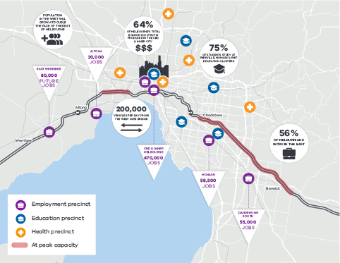

Figure 2 Creating better connectivity to link people with health, education and employment clusters

|  |  |  |
| --- | --- | --- |
| Melbourne is experiencing unprecedented population growth – with the west growing twice as fast as the rest of Melbourne | 285,000 more people will live in the west by 2046 | The cost of congestion in Melbourne and Geelong is set to reach $9 billion by 2031 |
| 77% of weekday city trips will be by car even with Melbourne Metro | Creating better connections for people to access jobs, health and education services is critical for productivity and wellbeing |

## A network solution

The Victorian Government’s plans and policies support consistent investment in the road network and public transport system.

The Western Distributor will build on the Victorian Government’s major road and rail improvements already underway including:

* the $11 billion Melbourne Metro rail expansion
* removing 50 level crossings
* $2 billion investment in new trains and trams
* expanding the High Productivity Freight Vehicle network
* the CityLink Tulla Widening and M80 Ring Road upgrade
* the Mernda Rail Link and Cranbourne-Pakenham Line Upgrade, and
* Hoddle Street streamlining.

The business case reveals a critical gap in planned investment for the M1 Corridor.

This project will mean the Government is undertaking upgrades and extra capacity on Melbourne’s three busiest freeways – the West Gate, the Monash, and the Tullamarine.

## Benefits assessment

### Productivity and growth for Melbourne

By reducing congestion, improving travel times, improving travel time reliability and lowering the operating costs of running a vehicle, the Western Distributor will play a key role in unlocking productivity in Melbourne.

By 2031, travel times for a return trip will be up to 20 minutes faster from the west in the peak, and up to 10 minutes faster from the south-east on the Monash Freeway. Travel times will be far more reliable and consistent, instead of, for example, taking 14 minutes one day and 25 the next.

### A more liveable Melbourne

The Western Distributor will reduce noise, crashes and pollution, and better connect people to jobs, health, education and other services. The biggest benefits will be in Melbourne’s inner west, where rat running of trucks through residential streets to reach the port precinct has been a longstanding and growing problem.Trucks along Francis Street and Somerville Road in Yarraville will be reduced by 50-75 per cent, and by up to 28 per cent more broadly across the inner west, making it a far more attractive place to live and work.

Safety improvements along the M1 will help avoid up to 55 serious crashes a year. Vehicle emissions will be reduced by 2.3 million tonnes a year.

Cycling will be supported with the completion of the main cycling route, the Federation Trail. The Trail now ends abruptly at Fogarty Avenue in Yarraville, forcing cyclists to navigate busy roads. The Western Distributor will build a new connection over Williamstown Road to Stony Creek Reserve, connecting up with the path at Hyde Street.

### More competitive port and freight sector

The competitiveness of Australia’s busiest container port will be greatly improved by a new link to the Port of Melbourne that is suitable for high productivity freight vehicles. Freight capacity will get a big boost with 100 per cent of the container trade that moves through the Port of Melbourne having direct freeway access. Travel times to the port will be up to 50 per cent less than today. Superior freight links, with unimpeded access for high productivity freight vehicles will deliver $15 to $20 per trip cost efficiency savings.

### Reduced reliance on the West Gate Bridge

Demand for cross-city road travel will grow strongly. Today there are 200,000 trips a day across the West Gate Bridge. By 2031 this will be 250,000 trips a day. Building the Western Distributor will make Melbourne far less vulnerable to the significant delays caused by major incidents. In 2014, there were 750 breakdowns and 14 casualty crashes on the West Gate Bridge alone.

The Western Distributor will free up capacity on the bridge by taking up to 22,000 vehicles off it a day (including 6,000 trucks).

### Economic development

Economic activity in Victoria will be lifted by $11 billion. During the peak of construction, 5,600 jobs will be created.

Growth in the west will be supported with better connections to education, health and other services and employment opportunities.

## Economic assessment

A cost benefit analysis (CBA) was carried out using the Department of Treasury and Finance guidelines for assessing transport projects.

The assessment found the Western Distributor will generate substantial benefits for road users and freight, and economy-wide benefits for Victoria and Australia.

The CBA result shows a benefit cost ratio (BCR) of 1.3 applying Victorian Government guidelines without wider economic benefits. Under Infrastructure Australia’s guidelines without wider economic benefits, the BCR is 1.9.

A BCR greater than 1.0 indicates benefits outweigh costs.

## Tolling

The business case finds tolling is a very important tool to encourage the most efficient use of roads and manage flows across the network. It recommends a tolling strategy be developed to provide greater flexibility in the tolling system: for example with incentives for freight to use freeways at night; time-of-day tolling; and a premium toll for CBD access in the morning peak.

The tolling points will be determined through the planning phase in negotiation with Transurban. Indicative prices are recommended to be the same as adjacent toll roads: around $3 for cars and $13 for trucks.

On the upgraded West Gate Freeway only heavy commercial vehicles and HPFVs will be tolled, reflecting the significant operational savings for commercial operators.

The business case uses three toll points:

1. West Gate Freeway between Millers Road and Williamstown Road: applying to heavy commercial vehicles and HPFVs in both directions
2. On the Western Distributor ramps at Hyde Street: applying to cars, light commercial vehicles and motorcycles using the tunnel or Hyde Street ramps
3. On the ramps connecting to city access roads: for cars, light commercial vehicles and motorcycles in the city-bound direction in morning peak only. Tolls will not apply to westbound traffic.

The Monash Freeway will remain toll free and the West Gate Freeway will remain toll free for cars.

## Addressing the key impacts

A major transport project in an urban area involves unavoidable impacts, particularly during construction. A tunnel under Yarraville avoids many of the community impacts that would be associated with a surface road.

The business case design includes a tunnel starting north of the West Gate Freeway near Hyde Street, similar to Transurban’s revised proposal.

The pros and cons of the tunnel length and portal entrance will be fully explored during the planning process including consideration of residential and other property impacts, traffic disruption on the West Gate Freeway during construction, and cost. This will be a key issue during community consultation.

Transurban’s design will be considered as part of the planning process.

## Next steps

The business case is based on an initial design. A final design will be guided by consultation with the community, local government, and industry during a transparent statutory planning process.

The release of the business case is the starting point for community involvement in a city-shaping project.