Growing Our Rail Network

2018-2025
With the Major Transport Infrastructure Program well underway, Transport for Victoria is leading new approaches to planning the future investments in the transport system which focus on choice, connection and making everyone’s journey easy.
We are focused on designing a system which caters for everyone, with accessible, turn up and go services to get people where they need to be, when they need to be there.

Meeting the growing demand for rail services
Melbourne is expected to reach a population of 8 million in 2051, up from 4.5 million in 2017. Regional Victoria is on track to reach 2.1 million, up from 1.2 million in 2017.
Our transport services and infrastructure need to adapt and expand to meet the needs of our growing State, and support Melbourne and Victoria’s liveability and productivity into the future.
Rail is a highly effective way of connecting these places. With modern high capacity metro trains capable of carrying more than 1,500 passengers, modern signalling and exclusive right of way when level crossings are removed, urban rail can carry more than 35,000 passengers per hour on a single line.
This network plan outlines the funded investments in rail across the State over the next seven years and shows the operating configuration for the network when the Metro Tunnel is opened in 2025.
It supports the key principles outlined within Plan Melbourne for a sustainable, productive and liveable city and state.

Context

Population growth
- Melbourne is Australia’s fastest growing city with a current annual growth of approximately 2.4 per cent, or around 110,000 people each year. The national average is 1.6 per cent.
- If Melbourne continues to grow at this rate, it will replace Sydney as the country’s most populous city in the 2030s.
- More than 40 per cent of Melbourne’s population growth in the next 15 years is expected in new residential developments in the north, west and south-east.
- Regional Victoria is also growing fast. The current annual growth rate is 1.3 per cent, or around 19,400 people each year

Economy
- Melbourne’s economy is predicted to continue to diversify, with the traditional reliance on manufacturing being added to by knowledge-based services.
- The distribution of employment across the city is also expected to change, as identified by Plan Melbourne, with an increasing number of knowledge-based jobs concentrated in central Melbourne and in national employment and innovation clusters across the city.
- Central Melbourne is expected to become Australia’s largest business centre with jobs projected to grow to almost 900,000 by 2051, an increase of 107 per cent from 435,000 in 2011.

Transport needs
- Growth in population and jobs is driving the need for Government to invest in infrastructure and services to move people and goods on our roads, public transport, freight and port networks. By 2051 Melbourne’s transport network will need to handle an extra 10.4 million trips per day.
- As Melbourne’s population increases, and knowledge-based jobs become more centralised, so does the demand for reliable and convenient travel for work, education and social activities in the central city and employment precincts.
- There is a growing need to ensure the efficiency of freight operations through intermodal freight terminals and access to ports.
- Fast-growing regions across Victoria increasingly require better and more efficient commuter-style rail services
to connect them with employment, education and commercial hubs.
- As the number of people using the rail network grows, so does the importance of intermodal connections and looking after the end to end journey.

Rail network

Metropolitan Rail
- Patronage on Melbourne’s rail network has grown at unprecedented rates and is forecast to continue to increase significantly as Melbourne grows.
- Currently 236.8 million passenger trips are taken each year, close to double the 124.2 million trips taken in 2000.
- By 2051, Melbourne’s transport network – public transport, vehicle and cycling and walking – will need to cater for 23 million trips a day or 10.4 million additional trips per day.
- Since 2004, demand for peak-hour metropolitan rail services has grown by 61 per cent. Similar growth is expected over the next decade.

Regional Rail
- Patronage on the regional rail network has increased significantly since the opening of Regional Rail Link. Passenger trips have grown from 6.7 million in 2006 to 17.9 million in 2017.
- Over the previous decade major investments such as Regional Fast Rail and Regional Rail Link have changed the way people in regional areas travel, drawing an ever larger area of the state into the commuter catchment of Melbourne. They have progressively supported the growth and prosperity of key regional centres and their surrounds, with increasing services to and from the regions.

Major Transport Infrastructure Program – heavy Rail Projects
The Government’s $30 billion Major Transport Infrastructure Program (MTIP) has seen investment in public transport and road projects that Victoria needs to keep moving and retain its status as home of the world’s most liveable city.
People now work a much wider variety of hours, shops trade for longer, and entertainment precincts operate later – this is changing how people want to travel. Victoria has also seen a change in type of trip, where cross-town travel has increased as a proportion of total trip demand. We know from patterns of travel on the road network that off-peak travel forms a significant part of total demand, but our train timetables do not currently reflect this.
The MTIP is delivering a series of projects to transition the network to a ‘turn up and go’ service, which will deliver:
- More peak services, reduced wait times and improved connection times
- More frequent services throughout the day, with more services outside of peak periods to support non-peak travel
- Improved journey experience, including getting to and from the station and transport interchanges.
Transport users also need choice. By improving rail connections between the central city and outer suburbs, and to and from regional Victoria, people will have greater options of where to live and work.
Funded projects underway:

Metro Tunnel
The Metro Tunnel will enable 39,000 more passengers to travel by train during peak hours and is the first step towards a ‘turn up and go’ rail network for Melbourne.
The project will create a new rail line, with high capacity trains, from Sunbury in the west to Pakenham and Cranbourne in the south-east.
By running three of our busiest train lines through a new tunnel under the city, and freeing up space in the City Loop, more trains will be able to run in and out of the central city.
The 9km twin rail tunnels, and five new underground stations, will deliver more frequent and reliable and more reliable trains that run more often.

High capacity metro trains and high capacity signalling
The 65 new trains will carry around 20 per cent more passengers and have the latest technology for passenger comfort, accessibility and safety. High capacity signalling will maximise the efficiency of these bigger, better trains.
The trains will start running on the Pakenham/Cranbourne Line from mid-2019, and through the completed Metro Tunnel to Sunbury by 2025.

Level Crossing Removal Program
By 2022, 50 of Melbourne’s most dangerous and congested level crossings will have been removed. This will improve travel around the city by increasing safety and enabling more trains to run more often, and on time.
As well as removing the 50 level crossings, the program is also upgrading or building over 20 train stations, laying many kilometres of new track and making associated rail improvements. This is helping to stimulate economic growth and revitalise local communities by creating thousands of jobs during construction.

Mernda Rail
Melbourne’s north is one of Victoria’s fastest growing areas and needs more local transport. To help connect this area to employment, education and entertainment precincts, eight kilometres of rail line and three new stations are being developed from South Morang Station to the new Mernda Town Centre.
The new stations will provide trains for up to 8000 commuters a day, helping to ease congestion along Plenty Road. The stations will allow for approximately 2000 car parking spaces, as well as bicycle storage and bus facilities. A walking and cycling path will connect the stations, and offer alternative travel options.

Hurstbridge Line Upgrade
The Hurstbridge Line upgrade is duplicating the section of track between Heidelberg and Rosanna, to improve the frequency and reliability of services in Melbourne’s north east.
By removing a significant bottleneck on the Hurstbridge Line, services will run more efficiently.
This upgrade is being delivered together with two level crossing removals – the Grange Road, Alphington level crossing and the Lower Plenty Road, Rosanna level crossing.
The project includes a new train station at Rosanna, redesigned timetables for the Hurstbridge and South Morang lines and a new bus route between Greensborough and Diamond Creek.

Regional Rail Revival
The Regional Rail Revival program is a joint initiative of the Australian and Victorian Governments, and will upgrade every regional passenger train line in Victoria. It is one of the programs that will help deliver the passenger outcomes of Victoria’s Regional Network Development Plan (RND) 2016.
The RNDP responds to changing regional travel needs and has been shaped by feedback from people, businesses and organisations across regional Victoria.
Regional Rail Revival will deliver:
- The infrastructure needed for more frequent and reliable regional trains and modern rolling stock
- New and upgraded stations, track duplication, upgraded level and pedestrian crossings, and signalling upgrades
- Better connectivity from our regions to Melbourne and between regional centres
- More opportunities for regional Victorians to access jobs, education, healthcare and housing.

2025 Victorian Rail Map
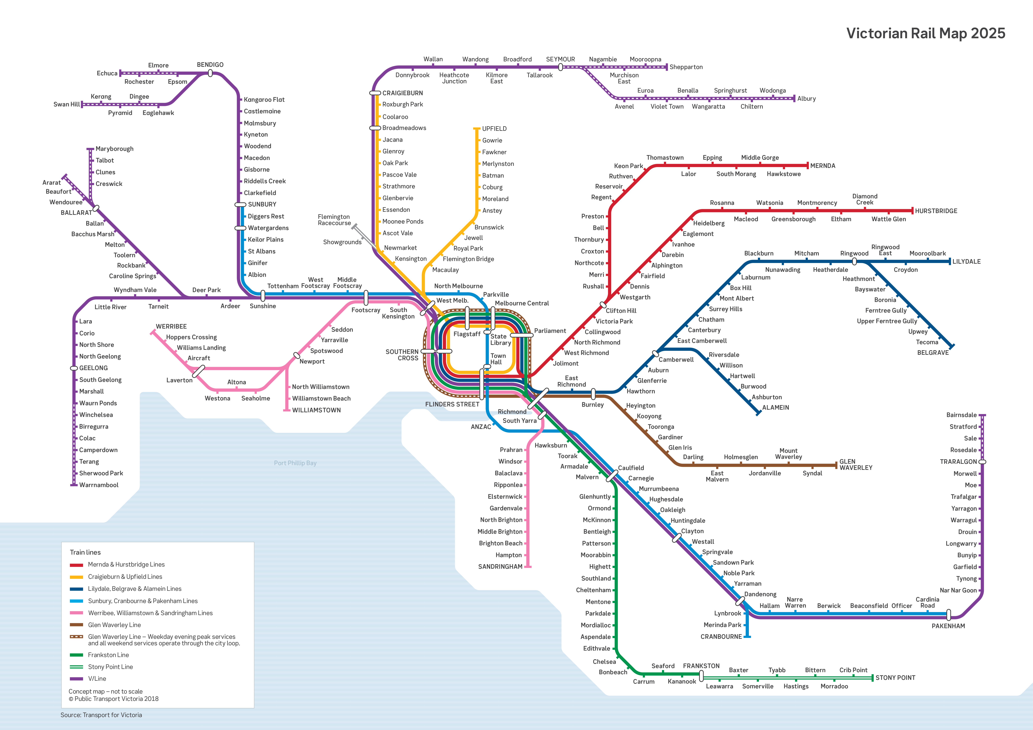
This map shows currently funded rail projects that will combine to enable reliable and efficient operation of the network when the Metro Tunnel opens in 2025.
- Metro Tunnel including five new underground metro stations
- High capacity signalling
- 65 high capacity metro trains running turn up and go services from Pakenham and Cranbourne to Sunbury
- Sunbury and Dandenong corridor upgrades to support high capacity metro train
- 50 level crossings removed
- Mernda Line extension and timetable change to deliver services to new stations
- Hurstbridge Line upgrade

Beyond 2025
With the Metro Tunnel complete, the foundations will be in place for further investment and expansion of the metropolitan and regional rail network.
Our rail network will continue to evolve to help meet the transport needs that come from our unprecedented growth.
Planning is already underway for possible future investments in the transport network including:
- Airport rail link
- Fast rail to regional Victoria, starting with Geelong
- Electrification of the metropolitan rail network to growth areas including Melton and Wyndham
- South Geelong – Waurn Ponds duplication
- Cranbourne line duplication
- Hurstbridge line duplication stage 2
- Rail infrastructure upgrades between Upfield and Somerton
- Planning for electrification to Baxter.

Contact details
Transport for Victoria
transport.vic.gov.au/railnetwork

