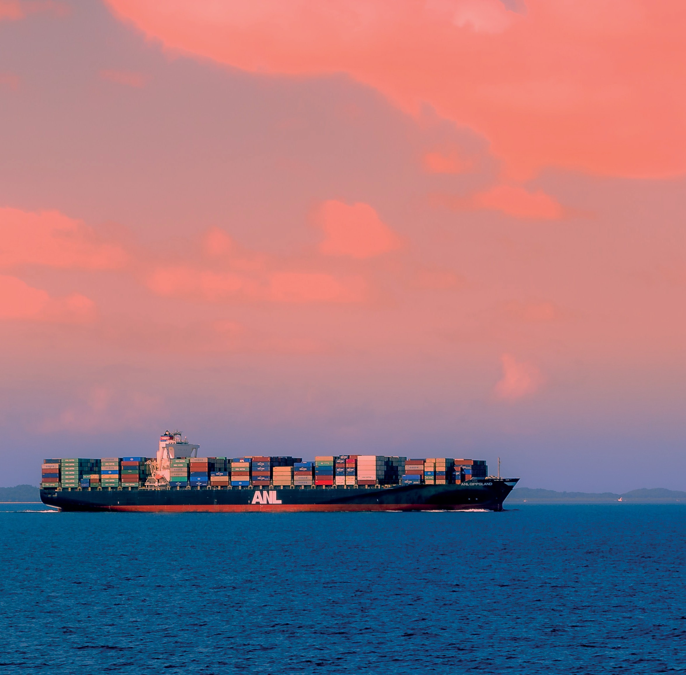

Navigating our Port Futures
The Victorian Commercial Ports Strategy
JULY 2022

Acknowledgement of Country
The Department of Transport proudly acknowledges Victoria’s Aboriginal communities and their ongoing strength in practicing the world’s oldest living culture. We acknowledge the Traditional Owners of the lands and waters on which we live and work, and pay our respect to their Elders past and present.
We acknowledge the ongoing leadership role of the Aboriginal community in addressing and preventing family violence. As First Peoples, Aboriginal Victorians are best placed to determine a culturally appropriate path to gender equality in their communities and we join with our First Peoples to eliminate family violence from all communities.
Accessible version of the document
Please email enterprise architecture advisory to obtain an accessible version of this document.
ea.advisory@transport.vic.gov.au
Authorised by the Victorian Government, Melbourne
1 Spring Street Melbourne Victoria 3000
Telephone (03) 9655 6666
Designed and published by the
ISBN 978-0-7311-9204-5 (Print)
ISBN 978-0-7311-9205-2 (pdf/online/MS word)
Contact us if you need this information in an accessible format such as large print or audio, please telephone (03) 9655 6666 or email community@transport.vic.gov.au
© Copyright State of Victoria Department of Transport
Except for any logos, emblems, trademarks, artwork and photography this document is made available under the terms of the Creative Commons Attribution 3.0 Australia licence.
Contents

Foreword 5
Introduction 7
Policy context 8
The Government’s port reform journey 9
Overview of Victoria’s Commercial Ports System 10
Port of Portland 13
Port of Geelong 15
Port of Melbourne 17
Port of Hastings 19
Economic value of Victoria’s commercial ports 20
Trade mix and forecasts 23
The Government’s plan for the Victorian Ports System 26
Responding to a changing environment 28
Strategic objectives guiding action areas 29
Action Plan 2022 – 2027 32
1. Responsive to market demands 33
Planning for growth at the Port of Melbourne 33
A new Port of Hastings multi-use facility for bulk-trade diversification 34
Planning for the future of cruise shipping at Station Pier 36
Continue delivery of the Port Rail Shuttle Network 37
Geelong channel optimisation 38
2. Well planned, balancing the needs of industry and the community 39
Enhancing statutory planning arrangements at our commercial ports 39
Commercial port landside access plans 41
Delivering the next round of Port Development Strategies 42
Putting in place planning protections for a future port at Bay West 44
Review of land protected for development at the Port of Hastings 46
3. Efficient, productive and resilient in a changing global environment 47
Ports Victoria as a more active participant in the Victorian ports system 47
Building on the success of the Voluntary Port Performance Model 48
Ports supporting Victoria to drive supply chains to net zero emissions 56
Responding to Essential Services Commission’s Port of Melbourne Lease inquiries 60
4. Safe, and operated with clear roles and responsibilities 61
Ports Victoria’s expanded role in statewide navigational safety 61
Strengthening the maritime elements of port Safety and Environment Management Plans 62
Implementing new licensing regimes for pilotage and towage 63
Local ports and waterway reforms to improve marine asset planning and maintenance outcomes 65
Summary of the Government’s Action Plan 66

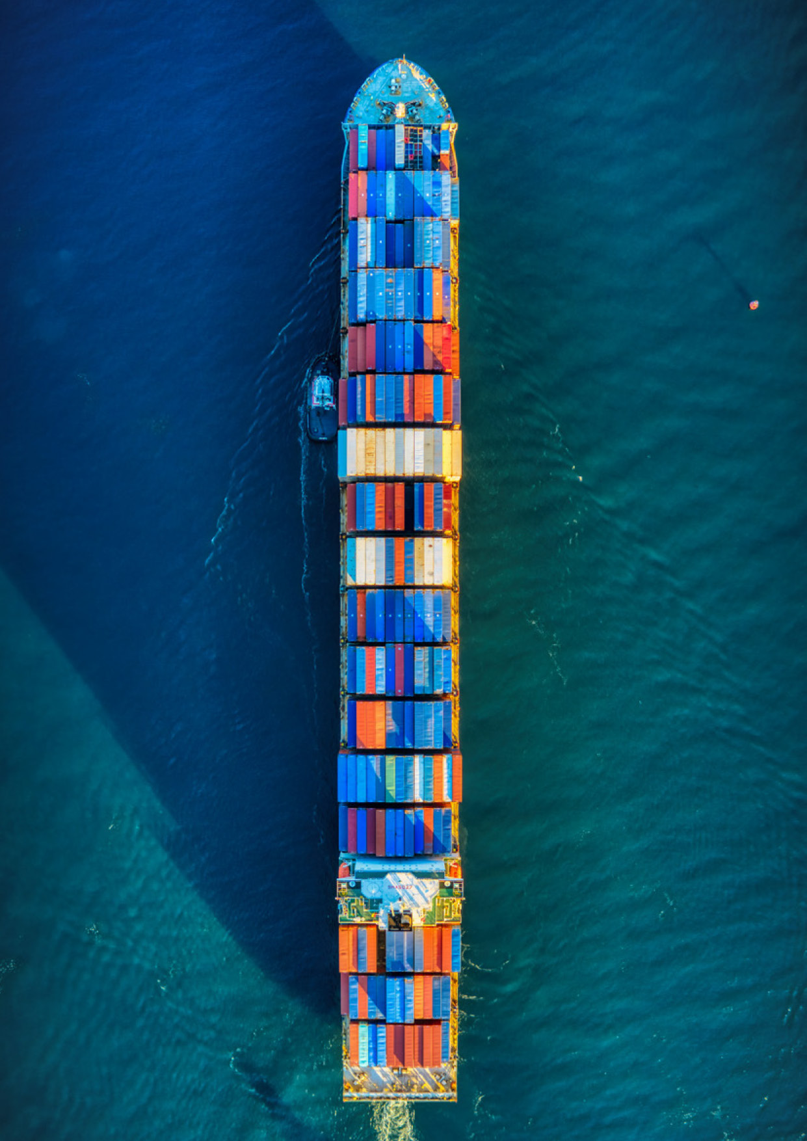

Foreword

Our ports have long been integral to the success of Victoria’s economy and the wellbeing of its people. They’re also key to Victoria’s status as the nation’s biggest exporter of agricultural commodities and manufactured goods.
The COVID-19 pandemic highlighted the vital role our commercial ports play in the lives of every Victorian.
As shipping delays, labour shortages and container imbalances disrupted global supply chains, it fell to our ports to step up and help maintain the movement of goods.
It was the resilience and adaptability of our ports that ensured the flow of everything from life-saving pharmaceuticals to vital food exports was maintained.
With Victoria’s gross state product set to grow by $40 billion over the next three decades and freight volumes expected to more than double, ensuring our ports are operating at peak efficiency is a key economic priority.
It’s these factors driving Navigating our Port Futures: The Victorian Commercial Ports Strategy.
The Victorian Government plays an important role in the management and regulation of our four commercial ports; and a far more significant role in charting the long-term strategic positioning of these assets and their contribution to the Victorian economy.
This Strategy is a key part of fulfilling that role.
It outlines how the Victorian Government will protect and enhance our four commercial ports’ land and seaside connections; reserve and plan for the land and seaside connections needed for a second container port; and ensure long-term policy settings are in place that recognise the contribution our commercial ports make to the enduring vibrancy of the Victorian economy.
Melissa Horne MP
Minister for Ports and Freight

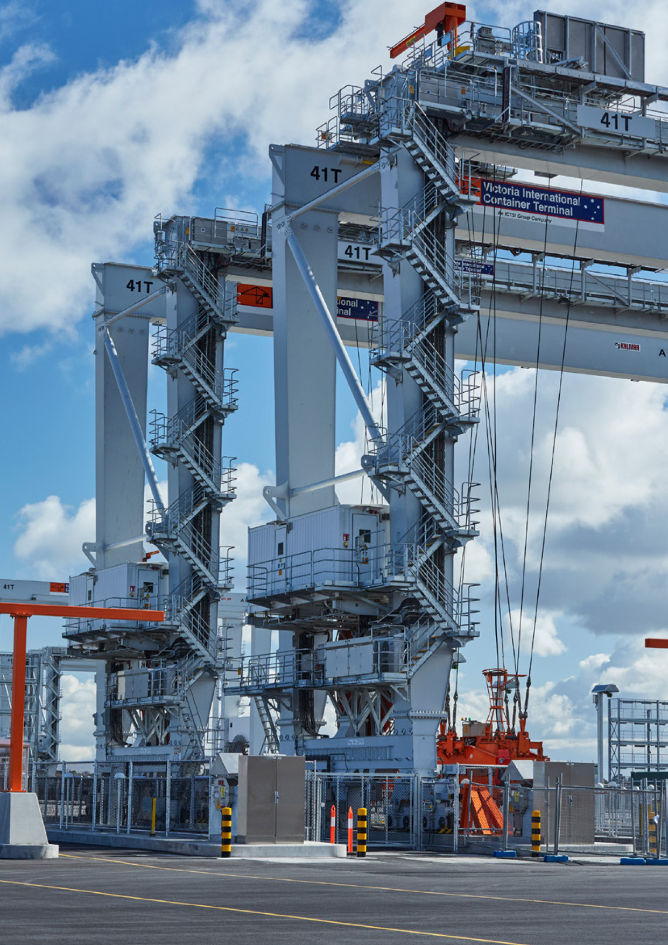


Introduction
Victoria’s commercial ports are essential to our businesses and our communities: while goods are moving, our economy is moving and people have jobs. Around 98 per cent of Victoria’s exports by volume move via our commercial ports. Over $85 billion worth of goods were imported into Victoria last year, largely via our ports.

Victoria’s last statewide ports strategy was completed in 2009. There has been significant change across the ports sector since, including the 50 year lease of the Port of Melbourne to a private operator.
Recent disruptive events have also exposed vulnerabilities in Victoria’s international maritime supply chains. In addition to disruptions from the COVID-19 pandemic, the sector has been further subject to more frequent and extreme weather events including bushfires and floods, international trade tensions, regional conflicts and changing market dynamics, resulting in rapidly increasing sea freight costs as shipping lines consolidated. These issues are all creating a more volatile and uncertain operating environment.
Navigating our Port Futures: The Victorian Commercial Ports Strategy (this Strategy) is the Victorian Government’s 30 year strategy, vision and action plan to position our ports system to grow and thrive in this new operating environment.
The Strategy reconfirms the role of the State Government in setting the strategic framework for the port sector as a whole, to accommodate Victoria’s growing freight task.
The Victorian Government’s 30 year vision is that:
Our commercial ports will continue to be responsive and resilient to change, providing efficient market access to support the economic and social wellbeing of all Victorians.
This vision is supported by four strategic objectives which will guide the State’s action over the next five years. The objectives and actions will be reviewed and updated every five years over the 30 year horizon of the Strategy. They will provide industry and community stakeholders with greater clarity and certainty on the State’s ports system priorities and the operating environment changes over time.
The State’s objectives are for a ports system that is:
            - Responsive to market demands
            - Well planned, balancing both industry and community needs
            - Efficient, productive and resilient in a changing global environment
            - Safe, and operated with clear roles and responsibilities.
The Strategy outlines the Government’s plan for the ports system, including priority actions under each objective.

Policy context
This Strategy integrates and actions Victorian Government ports and maritime freight-related legislation, strategy and policy initiatives. The Strategy’s alignment with the legislative and policy setting and key Government commitments are outlined below.

Legislation
- Transport Integration Act 2010: Creates a framework for an integrated and sustainable transport system in Victoria. It outlines an objective to facilitate economic prosperity by enabling efficient and effective access for people and goods. It also sets public governance arrangements for ports infrastructure.
- Ports Management Act 1995: Provides for the establishment, management and operation of commercial and local trading ports. It sets economic regulation of certain port services.
- Marine Safety Act 2010 (MSA): Provides for safe maritime operations by setting a range of safety duties and provides for a framework around safe vessel navigation.
- Marine and Coastal Act 2018: Establishes an integrated and coordinated whole-of-government approach to protect and manage Victoria’s marine and coastal environment and creates the legislative framework for the Victoria’s Marine and Coastal Policy 2020.

Regional policy and strategy
- Plan Melbourne 2017 – 2050: Sets the strategic direction for the city’s growth. It outlines policy for an integrated transport system that connects people to jobs and services and goods to market. It outlines the vision and actions for Melbourne’s continued development as a sustainable, liveable and resilient city.
- Victoria’s Regional Statement 2015: Identifies the State’s long-term vision for a regional Victoria that is productive, sustainable and supports jobs and economic growth. It acknowledges the role of freight networks in efficiently delivering products to market.
- Strong, innovative, sustainable: A new strategy for agriculture in Victoria, 2020: Sets a target for the value of Victoria’s food and fibre exports to reach $20 billion by 2030. Reliable sea freight connections will play an important part in meeting this goal.
- Melbourne Industrial and Commercial Land Use Plan, 2020: Outlines current and future needs for industrial and commercial land across metropolitan Melbourne and sets a planning framework to support state and local governments to plan for future employment and industry needs more effectively.

Transport policy and strategy
- Delivering the Goods: The Victorian Freight Plan 2018 – 2050: Sets statewide freight policy via short, medium and long-term priorities to support our freight and logistics system to respond to growth and change. This Strategy builds on the Plan by taking an integrated approach to maritime and landside freight policy.
- Growing our Rail Network 2018 – 2025: Sets statewide policy for Victoria’s rail network and highlights the growing need to ensure efficiency of rail freight operations using intermodal terminals to deliver more efficient access to ports.
- Revised Clause 18 (Transport) in the Victorian Planning Provisions: In December 2021, Amendment VC204 updated the State planning policy to support an integrated transport system. It is simpler and more certain for decision makers, infrastructure providers and the community. It recognises the four commercial ports as Principal Transport Gateways.
- Principal Freight Network: Identifies and protects Victoria’s key port, road and rail freight routes and places. It includes freight corridors and places of national, state and regional significance that support high-capacity and efficient freight movements around Victoria.
Visit www.transport.vic.gov.au or www.planning.vic.gov.au to view these policies, strategies and legislation.

The Government’s port reform journey
This Strategy represents the culmination of a once-in-a-generation ports reform journey.
In 2020, the Minister for Ports and Freight announced the Independent Review of the Victorian Ports System (the Review).
The Review’s purpose was to investigate and recommend strategic policy and governance framework reforms needed to maximise the ports’ economic and community benefits.
Stakeholder and community engagement was a critical component of the Review process. In total, over 80 stakeholder consultation sessions and more than 70 written submissions informed the process. Figure 1 provides an overview of the ports reform journey.
The Review’s Final Report was published in November 2020. It made a total of 63 recommendations focusing on delivering more fit-for-purpose governance arrangements, reducing complexity and inconsistencies in navigational safety controls and outlining a pathway for a more effective strategic framework for Government and industry.
The State responded to the Review by signalling a new phase of the State’s ports management which outlines three key components:
            - Public governance reforms centred on the creation of Ports Victoria, which amalgamated the Victorian Regional Channels Authority and the Victorian Ports Corporation Melbourne, in July 2021
            - The delivery of a new Victorian Commercial Ports Strategy to reflect the State’s transition to a stewardship role of the ports
            - Local ports and waterway management reforms to more effectively support and enable the economic and community value of local ports.
The Government’s response to the Review also included a proposed scope for the new Victorian Commercial Ports Strategy. The Department of Transport engaged with industry from August to October 2021 to confirm the proposed scope and help shape the development of content for the Strategy.
Figure 1. Victorian Ports Reform: Journey to date
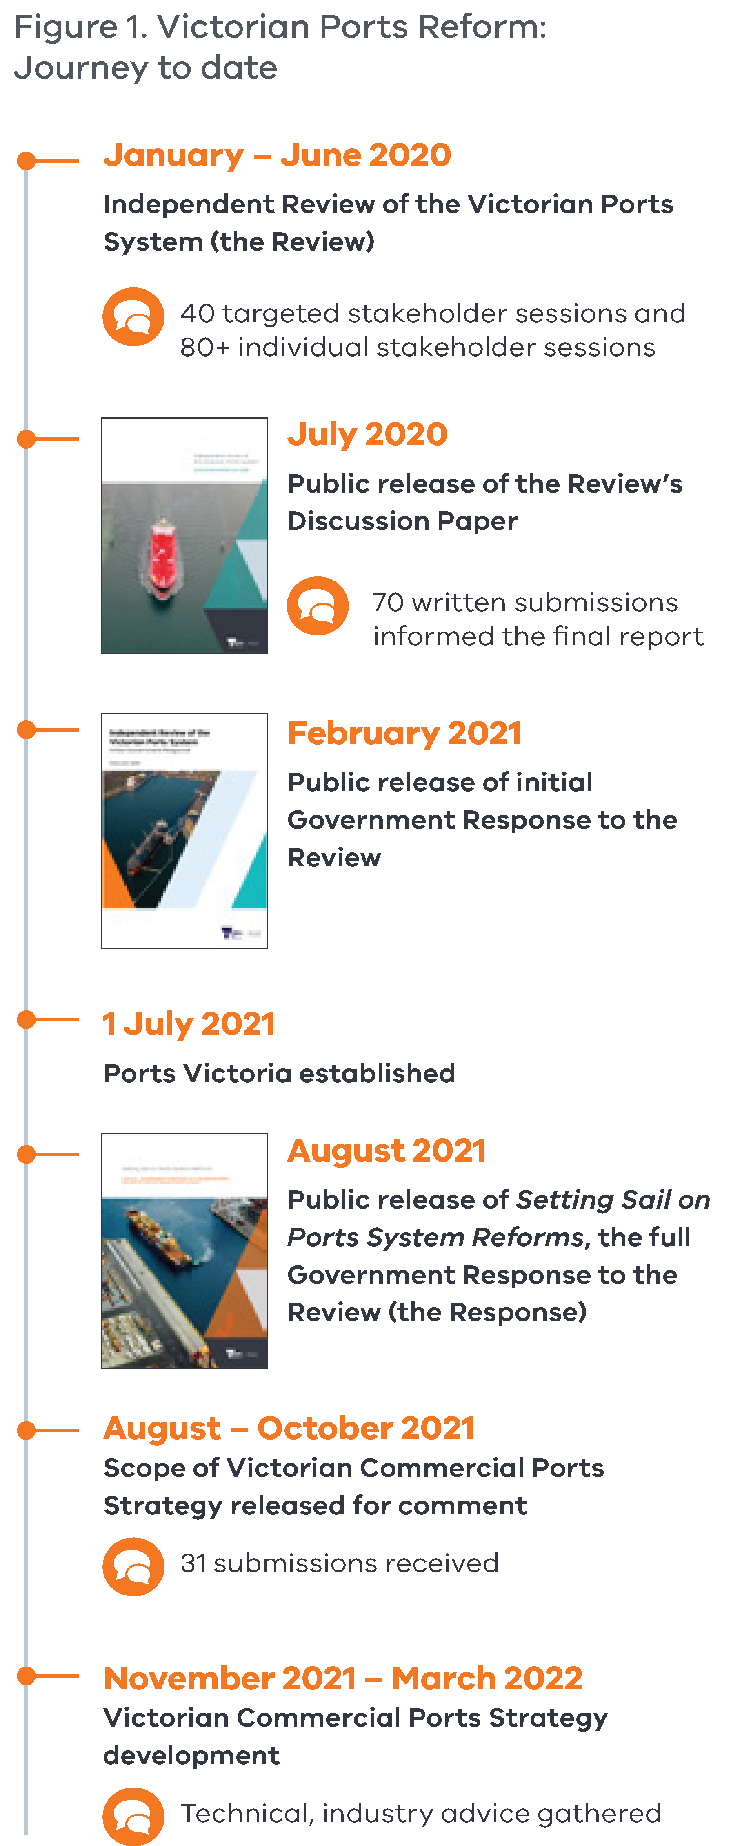
This process involved discussions with commercial port operators and industry, and consideration of 31 written submissions received from industry. Following this, the Department also completed a range of targeted technical studies which involved further consultation with industry.


Overview of Victoria’s Commercial Ports System
Victoria’s commercial ports system encompasses four commercial trading ports, declared under the Port Management Act 1995. These are the ports of Portland, Geelong, Melbourne and Hastings.
Figure 2. Victoria’s commercial ports system
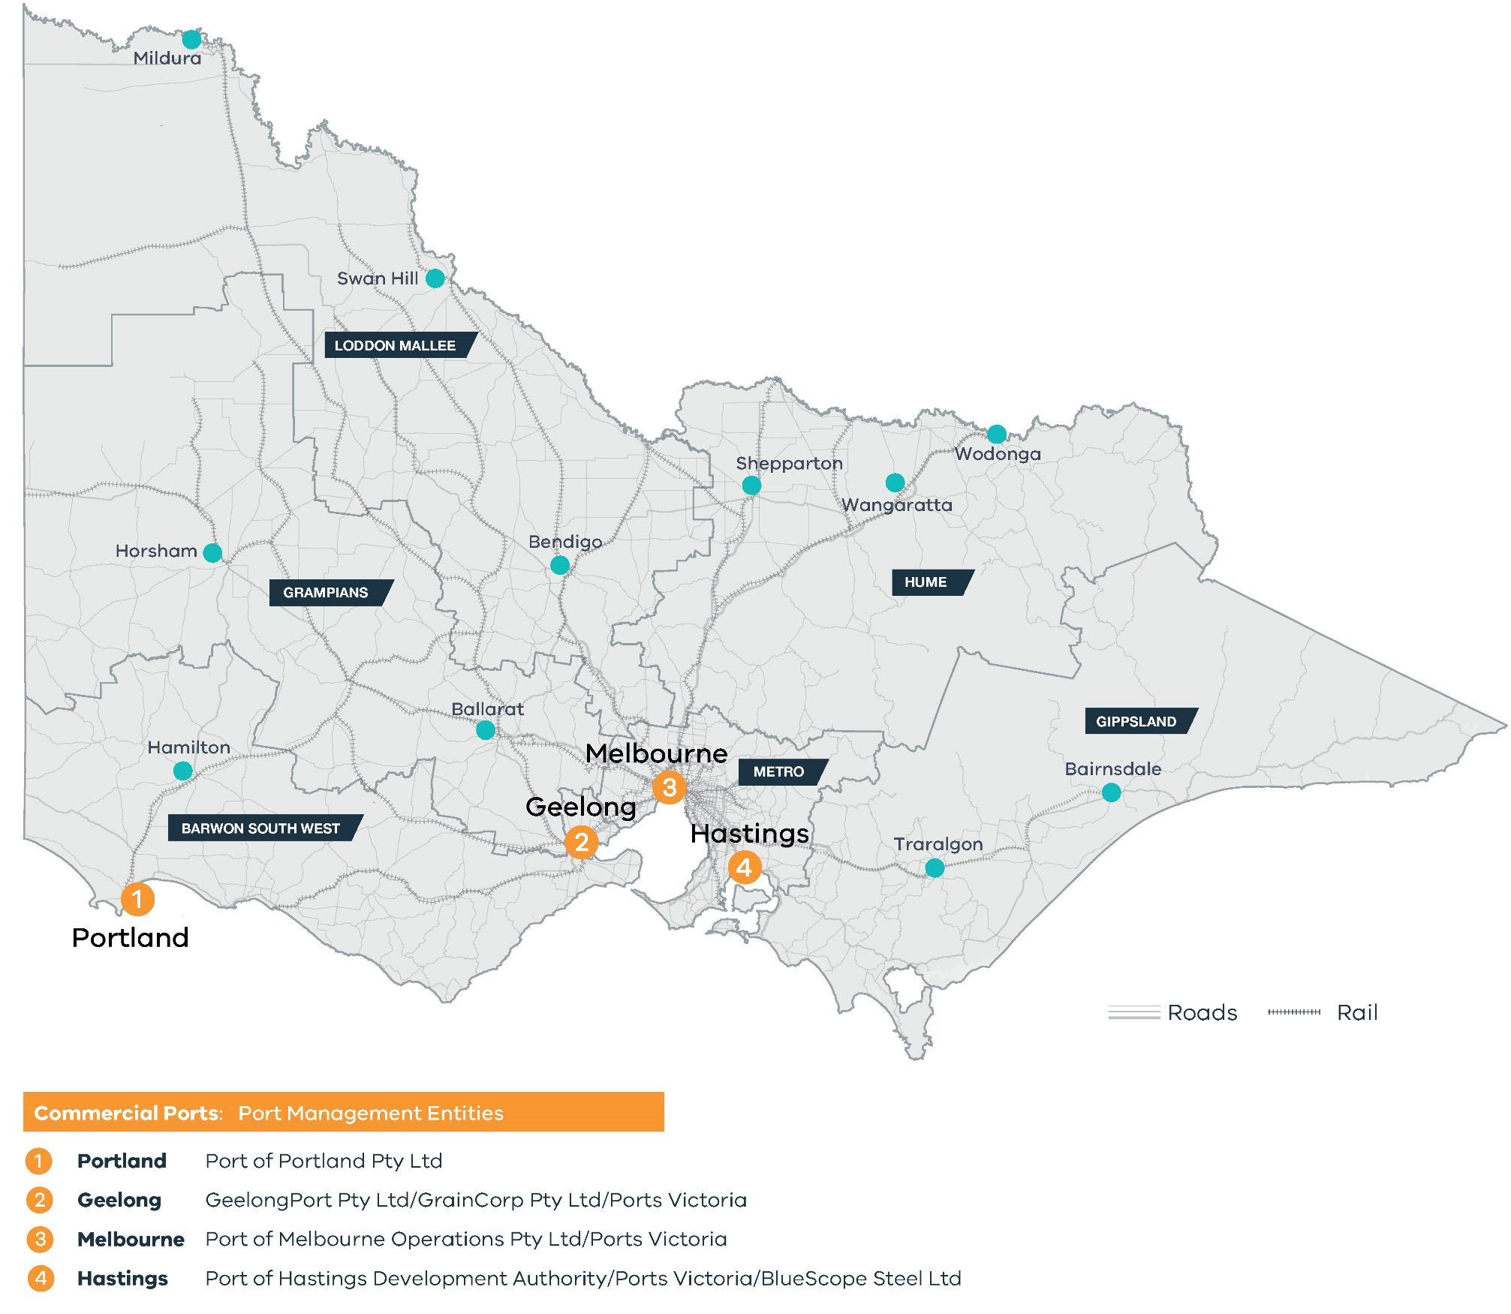

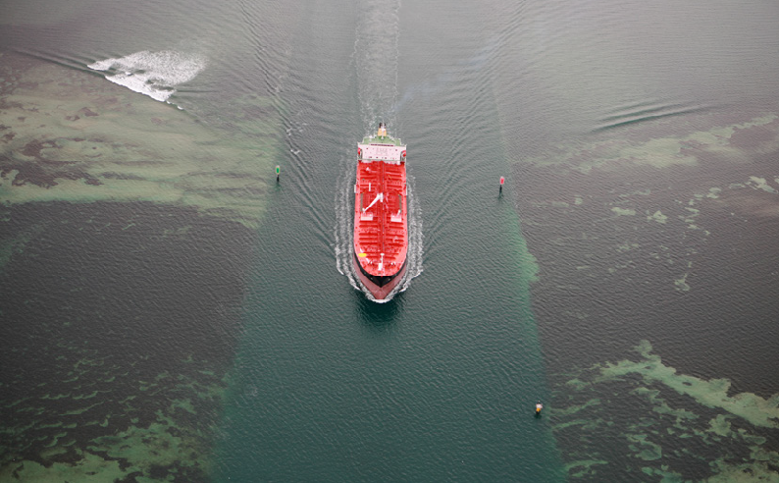
The Victorian ports system is a complex mix of shipping and land-side infrastructure that is well established and subject to varying management arrangements and interdependencies. The system is governed ultimately by the Minister for Ports and Freight and the Treasurer who oversee a range of regulators and state oversight bodies that in turn govern a number of public and private land and waterside port managers as defined by the Port Management Act 1995. Figure 3 outlines the current roles and responsibilities within the ports system.
Figure 3. Victorian Commercial Ports Governance Structure
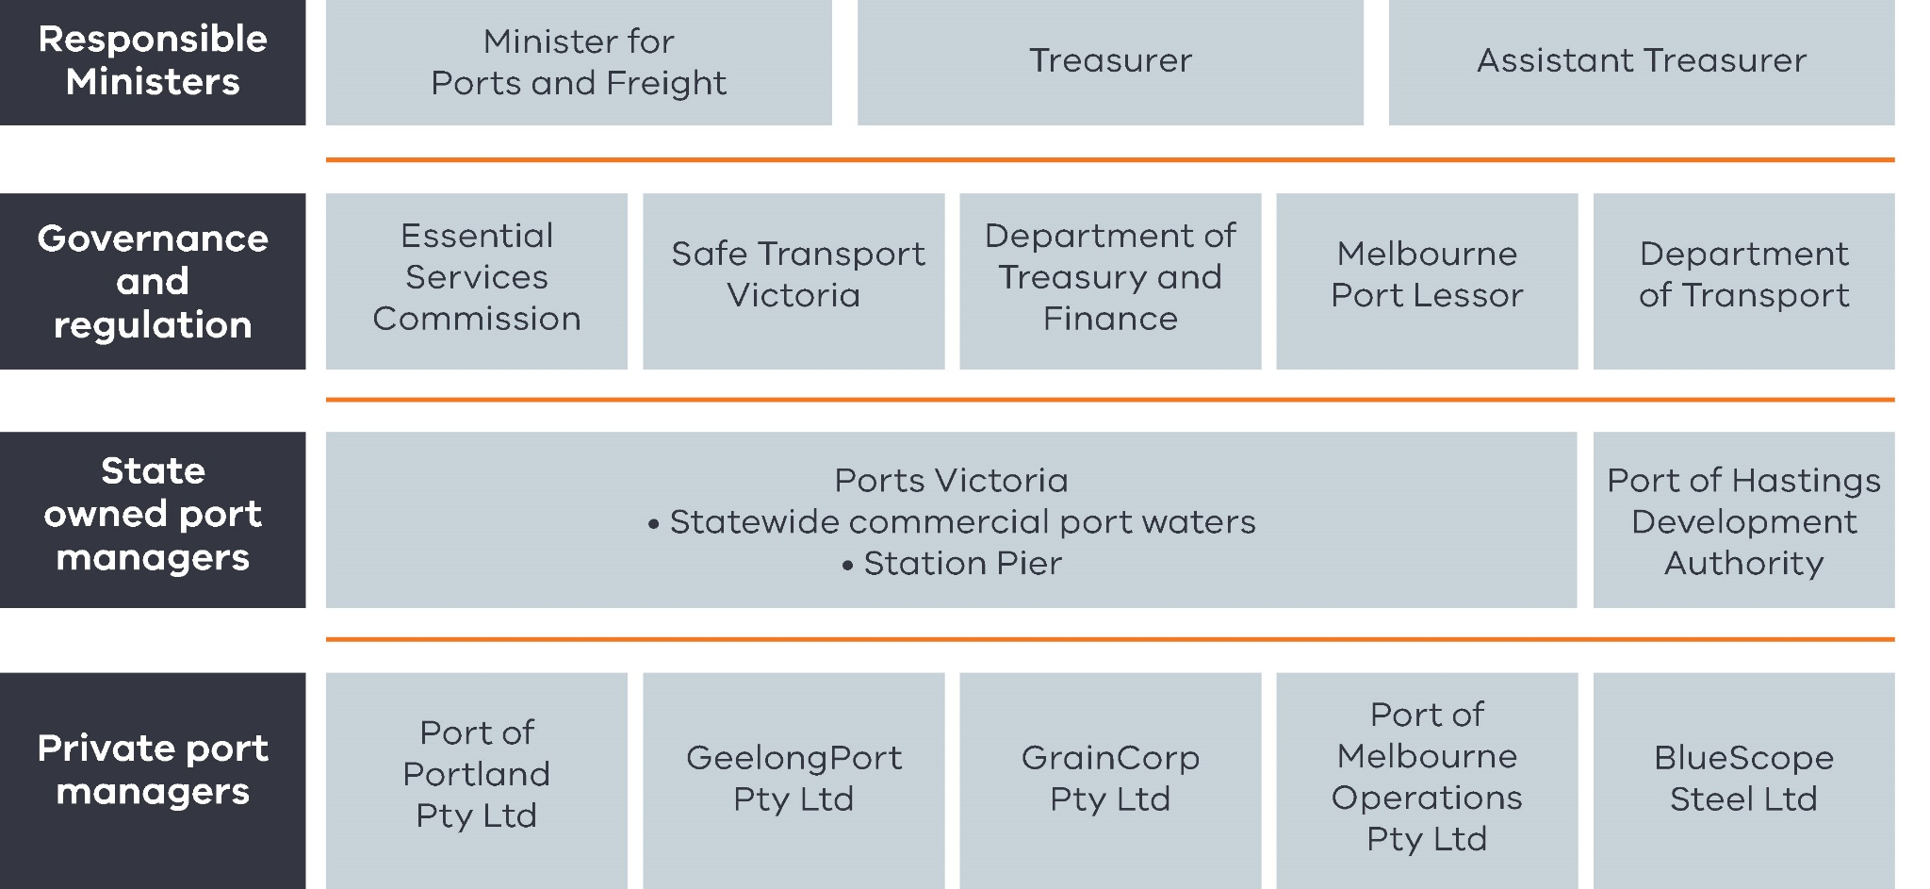

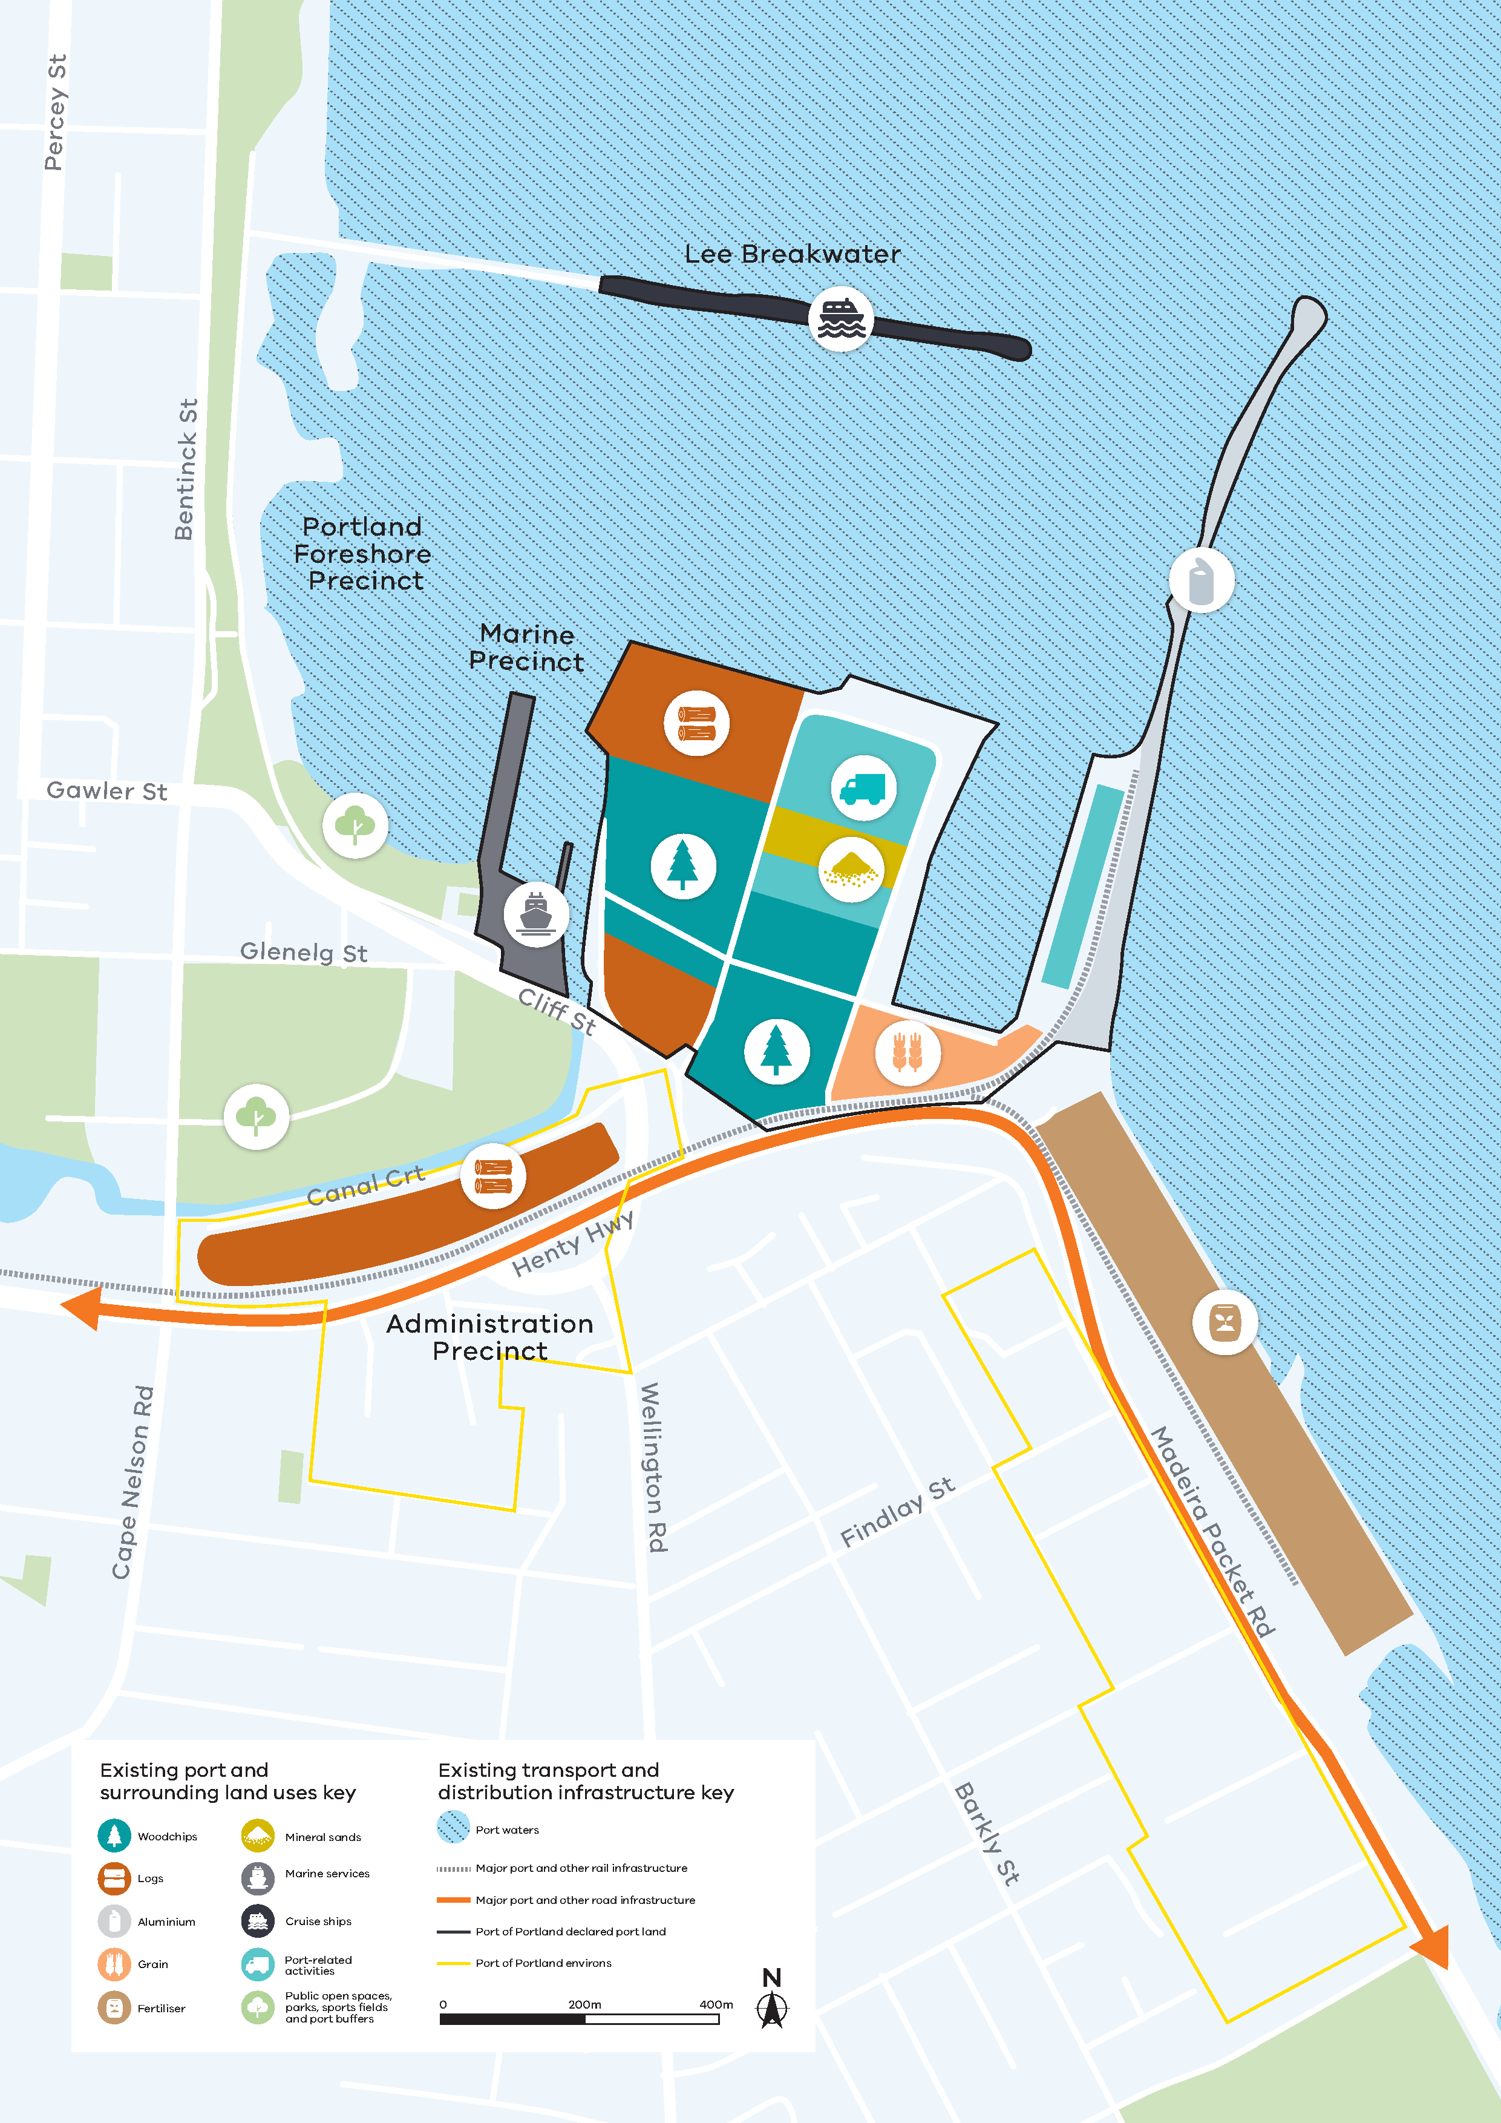
This is a map of the Port of Portland.
It shows the locations of two main groups: first, existing port and surrounding land uses; second, the existing transport and infrastructure.
To the north of the Henty Highway the port and land are used for: woodchips, logs, aluminium, grain, mineral sands, marine services, cruise ships, and port-related activities. To the east of the Madeira Packet Road the port and land use is for fertiliser.

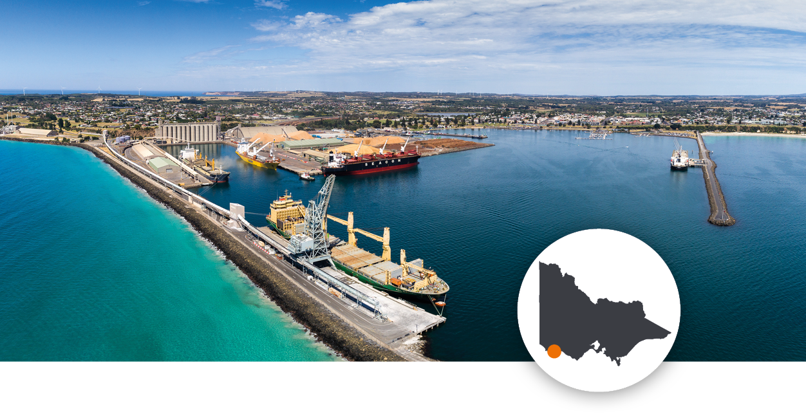
Port of Portland
The Port of Portland is located between Melbourne and Adelaide. It is a deepwater port which mostly handles bulk commodities. The Port of Portland is privately owned and operated.
The Port of Portland is located close to the Green Triangle, an area of land which contains 17 per cent of Australia’s plantation estate. Its main trade is forestry products, although it also handles grains, fertiliser, livestock and mineral sands from this region. Of the forestry products handled, over half are hardwood chips, while softwood chips and logs are also handled. Aluminium is another significant trade.
The port’s competitive advantage is its proximity to the Green Triangle and Murray Basin regions, as well as the Portland aluminium smelter. Channel depths of 13.6 metres mean the large vessels needed to export these goods can access the port.
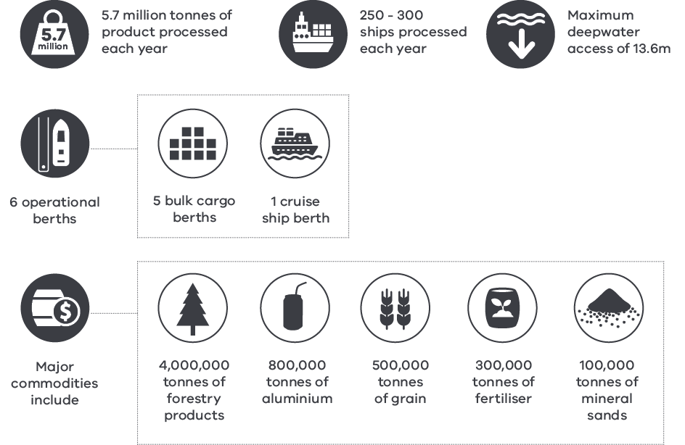

This is a map of the Port of Geelong.
It shows the locations of two main groups: first, existing port and surrounding land uses; second, the existing transport and infrastructure.
To the east of the Princes Highway the port and land are used for: liquid bulk, dry bulk, grain, dry/break bulk, Bass Strait trade, and industrial, freight and employment activities.
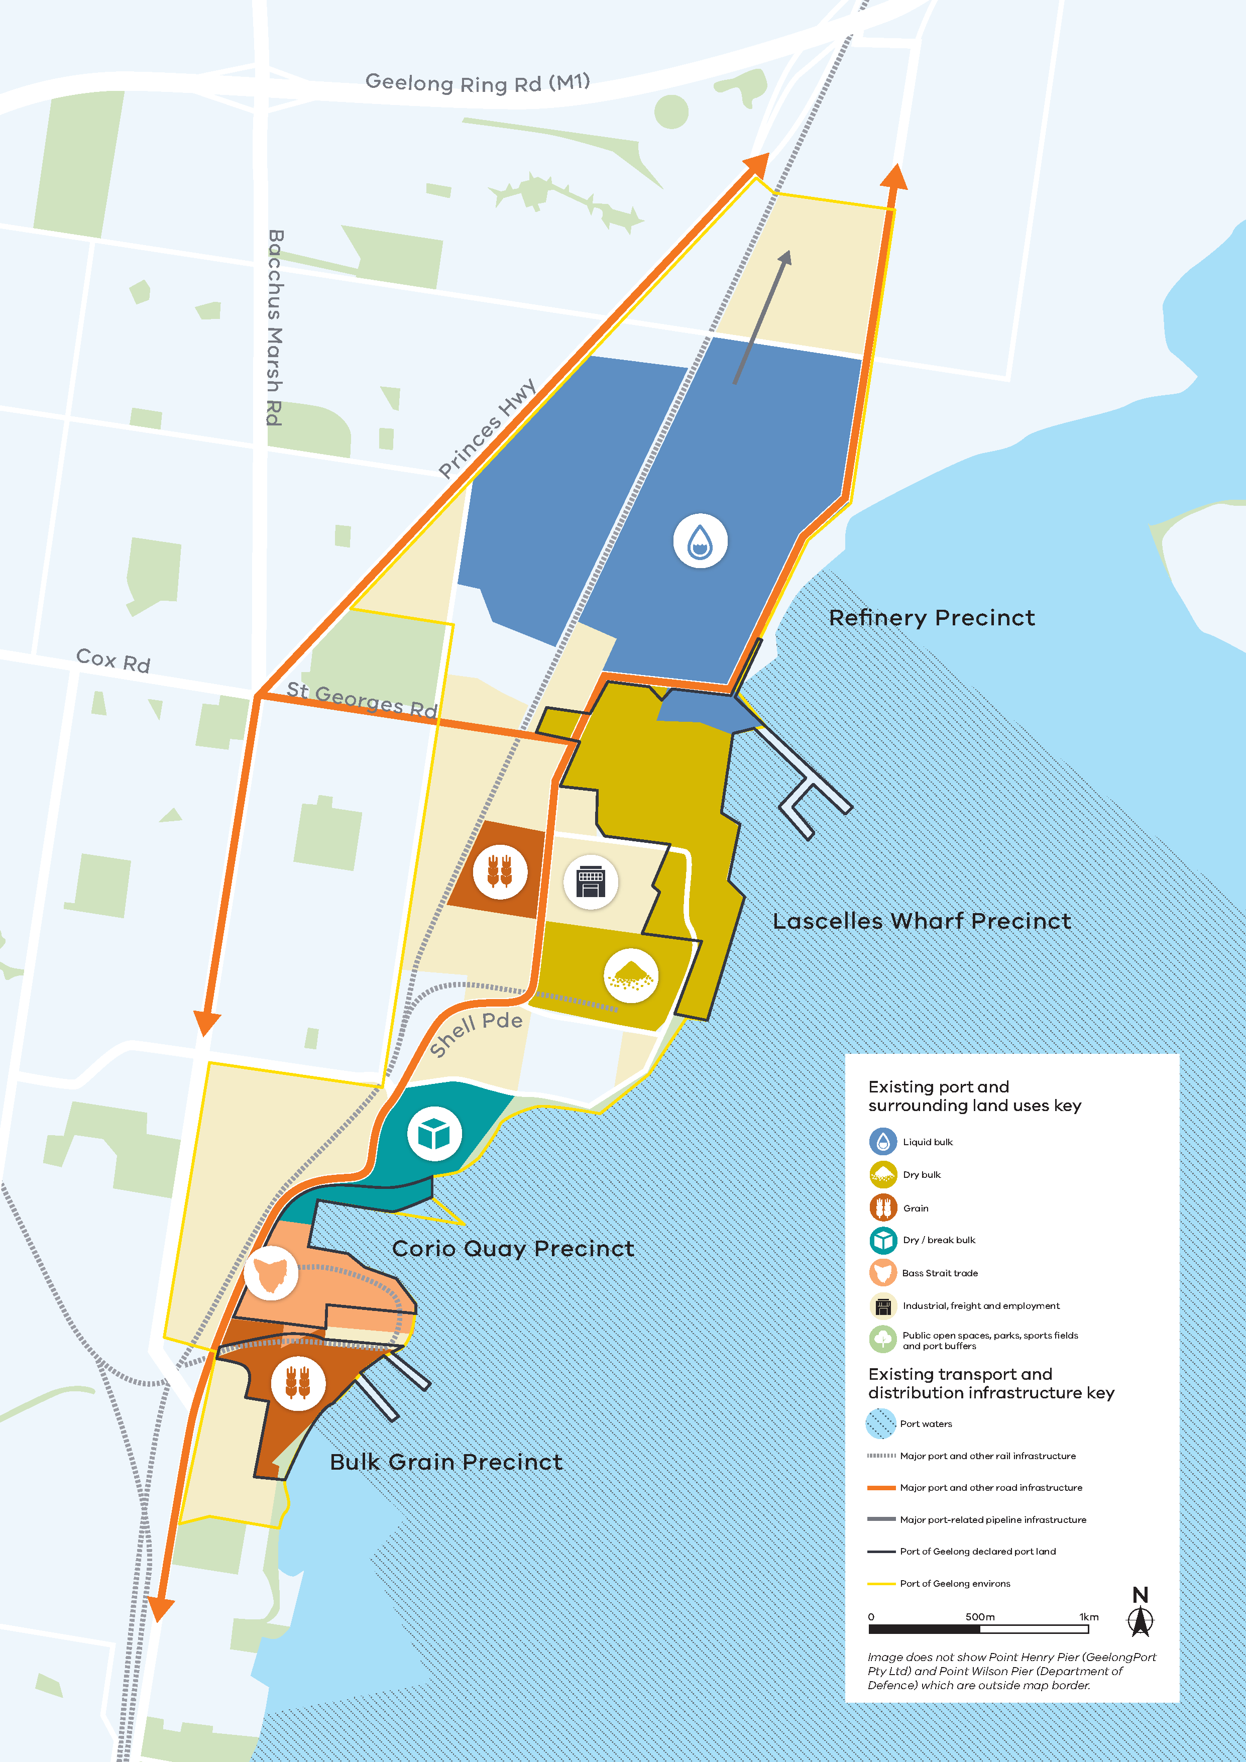

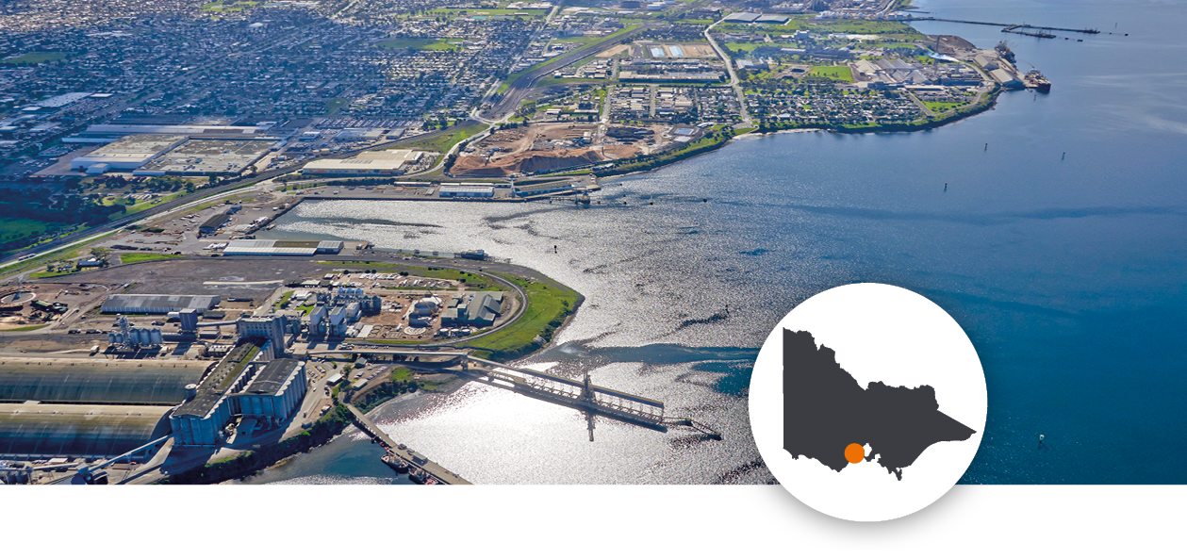
Port of Geelong

The Port of Geelong is the state’s largest gateway for international bulk trade with energy and fuel products being the major trade through the port. The Port of Geelong is privately owned and operated.
The Port of Geelong is based at Corio Bay, 75 kilometres south-west of Melbourne. It is Victoria’s second largest port and a hub for both dry and liquid bulk products. Imports account for just over 60 per cent of the cargo through the port, mainly comprising crude oil and fertiliser. Exports are made up of petroleum products, woodchips and grains.
The Port of Geelong is also a major freight hub which caters to value-added businesses with national distribution profiles. From late 2022 the Spirit of Tasmania ferry service will relocate its Victorian operations from Station Pier to Corio Quay within the Port of Geelong.
Compared to other Victorian ports, the Port of Geelong has adequate land available to it, enabling the port to pursue expansion opportunities and possibly grow trade volumes through emerging trade or shifts in trade flows. It can potentially support greater bulk trade in Victoria.
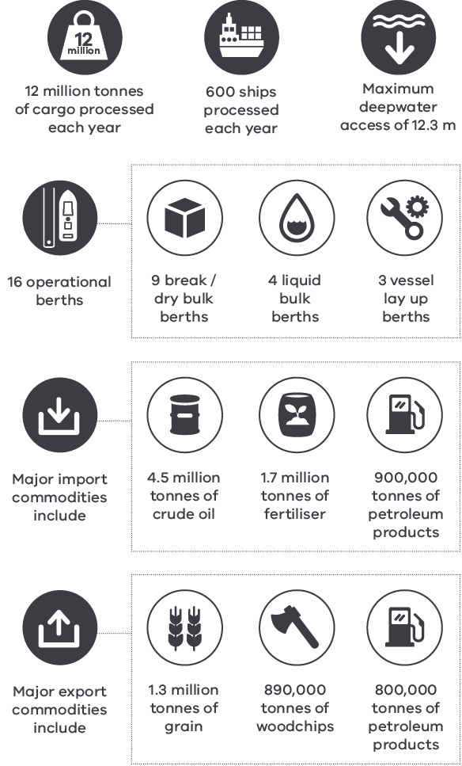

This is a map of the Port of Melbourne.
It shows the locations of two main groups: first, existing port and surrounding land uses; second, the existing transport and infrastructure.
The port and land area uses are: West - fuel distribution/oil refinery facilities, industrial freight facilities and employment, break bulk, and port-related activities; North - containers, liquid bulk, break bulk, dry bulk, and port-related activities; South - break bulk, Bass Strait trade, motor vehicle, containers and port-related activities.
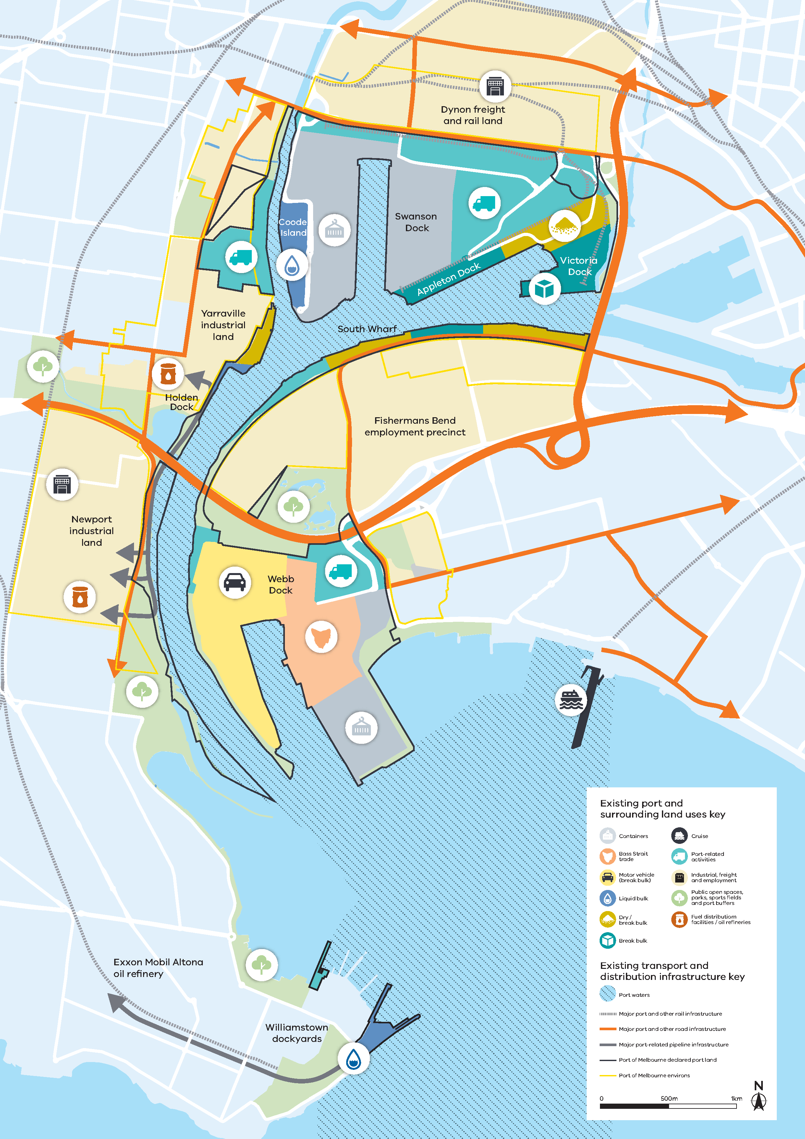

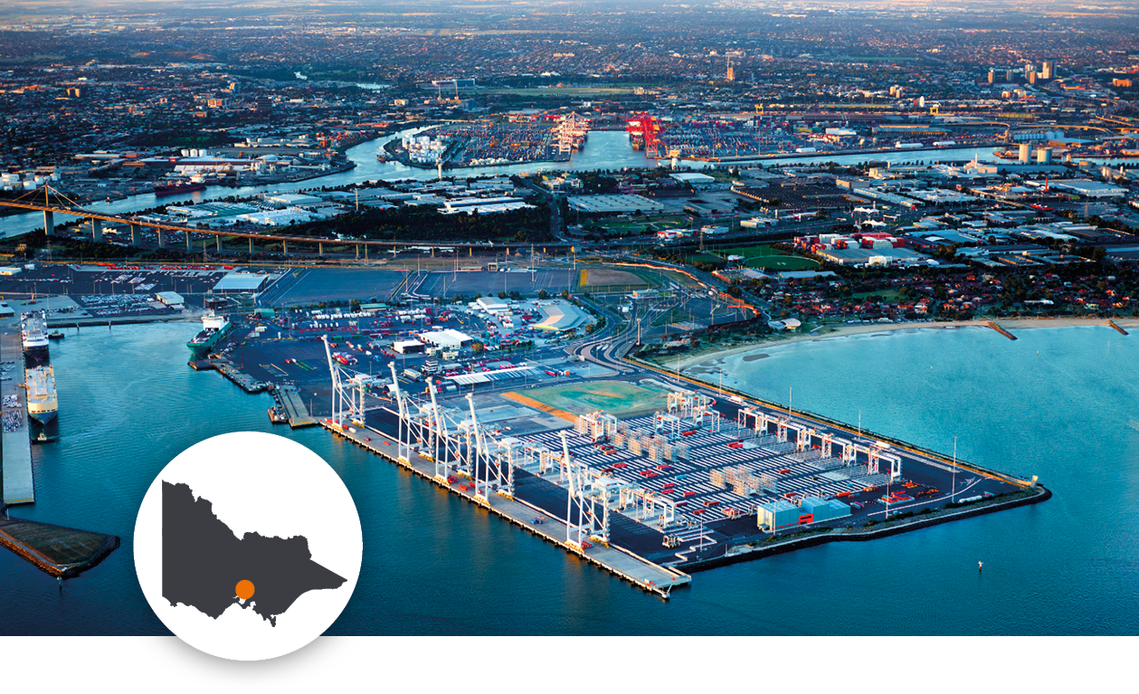
Port of Melbourne
The Port of Melbourne is Australia’s largest container, automotive and general cargo port and Victoria’s only container port. It serves as a key domestic and international trade gateway for Tasmania.
The Port of Melbourne’s central location in Melbourne supports an efficient and cost-effective freight transport and logistics network that benefits thousands of cargo owners across Australia’s south-eastern seaboard. The Port of Melbourne is owned by the State of Victoria and is privately operated under a long-term 50 year lease arrangement, with the exception of Station Pier, which is operated by Ports Victoria.
Each day, on average, the port handles nine ship arrivals carrying over 8,000 containers, almost 1,000 cars and around 2,800 tonnes of dairy products. It handles everyday necessities such as furniture, household appliances and mattresses, as well as industry requirements such as mining goods.
Melbourne’s trade volumes account for approximately half of Victoria’s liquid bulk, most of Victoria’s break bulk and a significant amount of dry bulk. As well as handling international and coastal trade, the port also services most of the trade across Bass Strait.
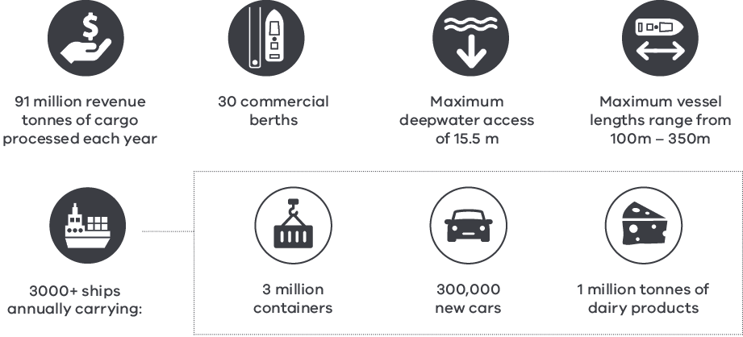

This is a map of the Port of Hastings.
It shows the locations of two main groups: first, existing port and surrounding land uses; second, the existing transport and infrastructure.
The port and land are used as follows. North of Bayview Road for steel, South of Bayview Road, general purpose and liquid bulk. Crib Point further south is also used for liquid bulk. Further south still, Stony Point is used for marine support and ferry services.
The Port of Hastings environs cover two areas - the larger to the north of the port area. The smaller opposite Crib Point.
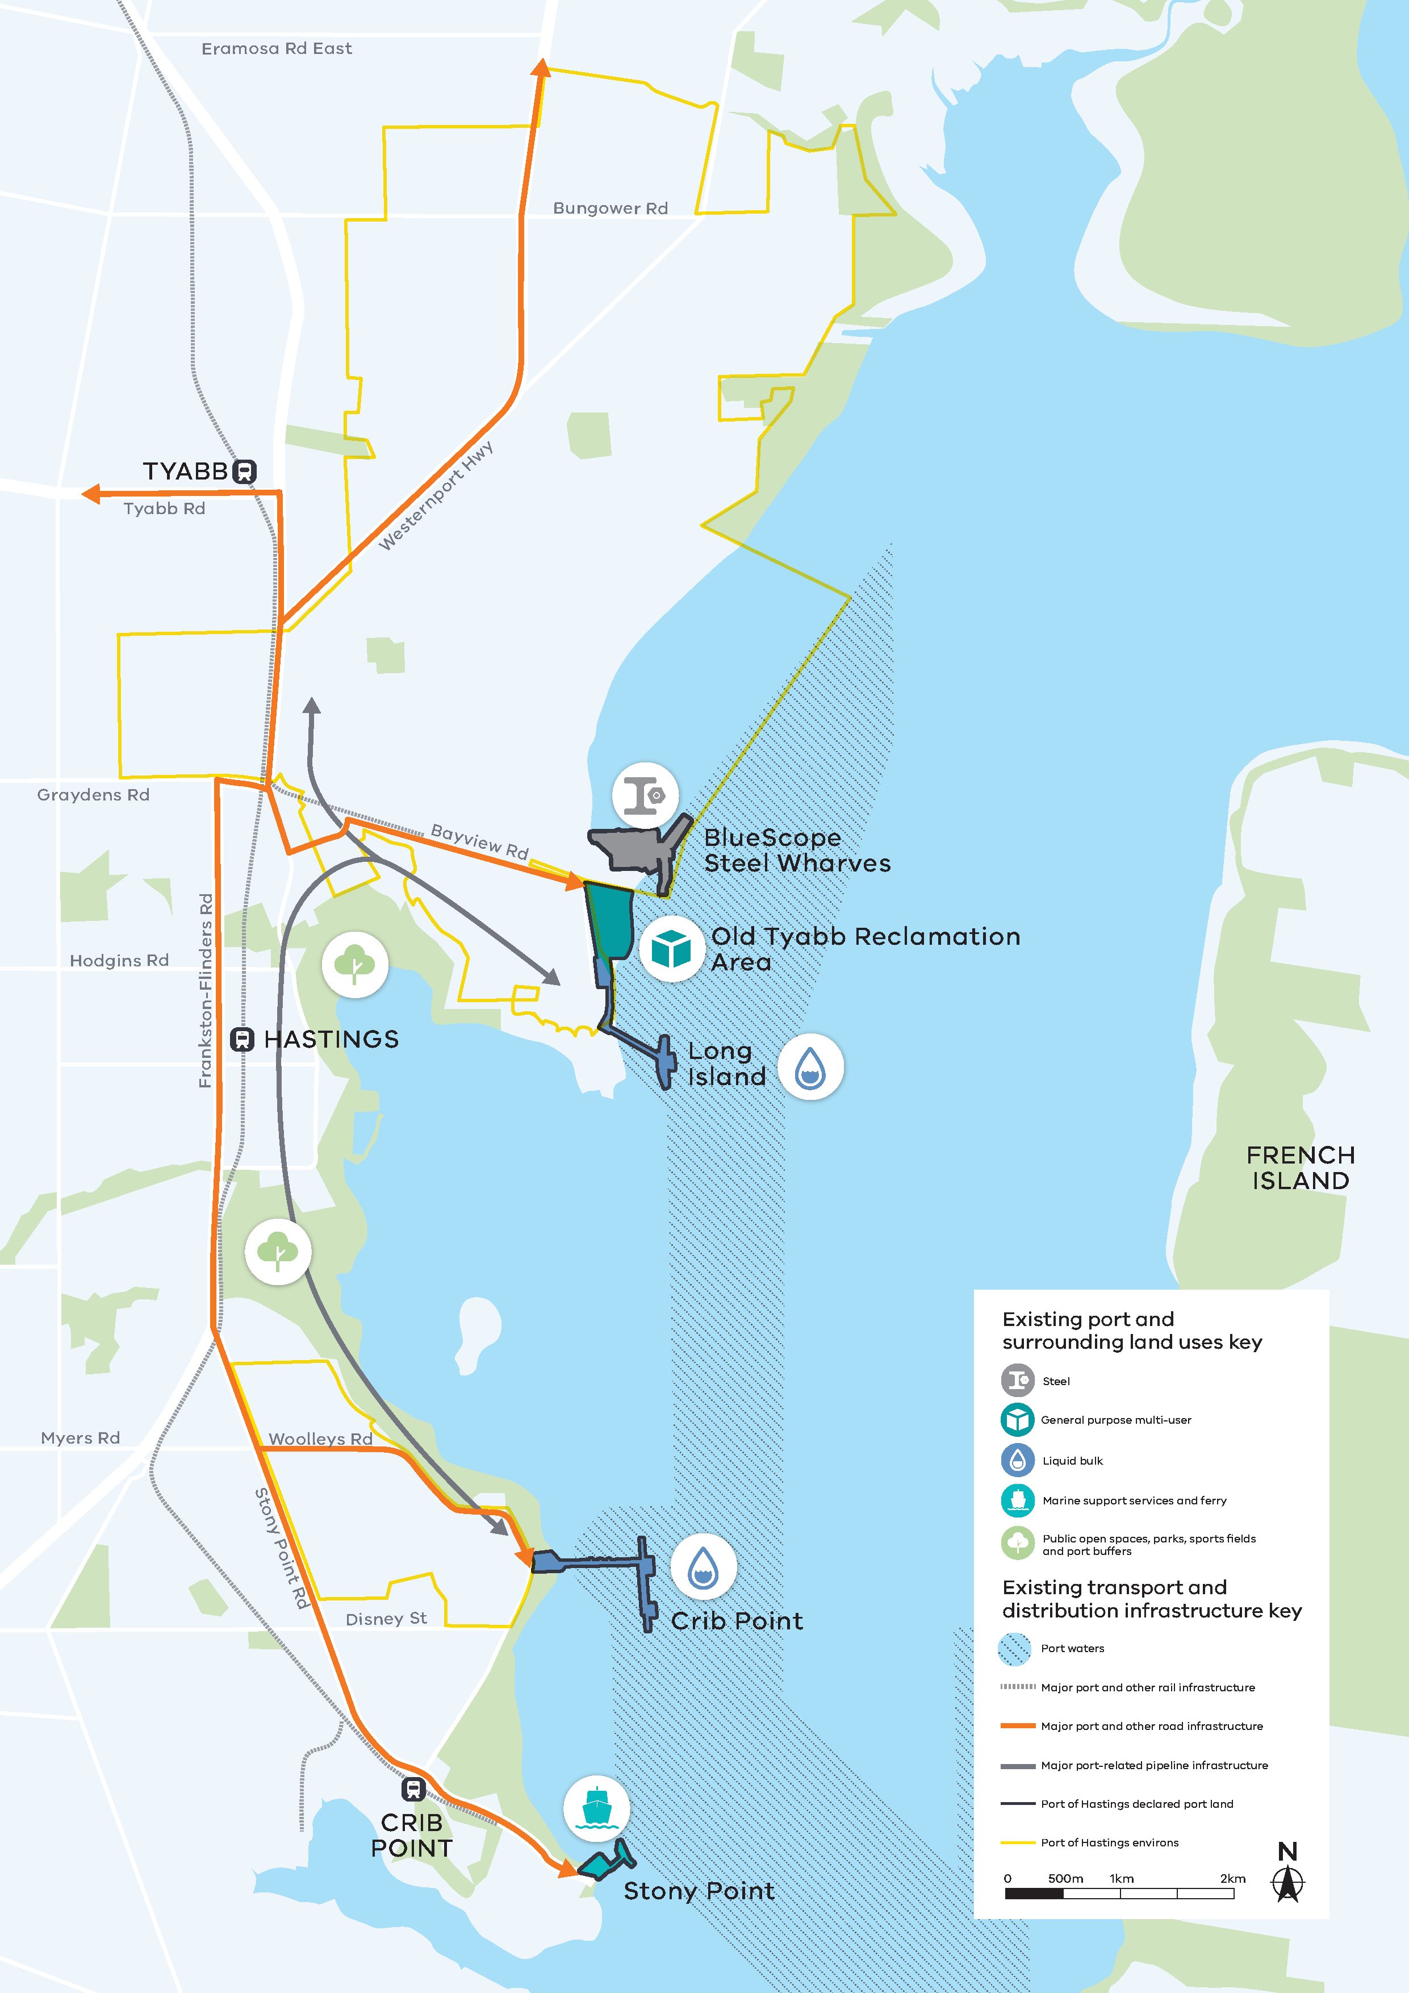

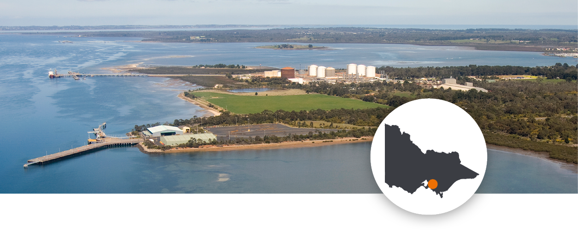
Port of Hastings
The Port of Hastings plays an important role in providing energy for Victoria and south-east Australia and has an advantageous connection and proximity to Gippsland that will support a range of future industries onshore and offshore in the region. The Port of Hastings is owned and operated by the State of Victoria through the Port of Hastings Corporation, except for the BlueScope Steel Jetty, which is a privately owned facility.
The Port of Hastings is located approximately 70 kilometres south-east of Melbourne and it is responsible for around 8 per cent of Victoria’s liquid bulk throughput. Liquefied petroleum gas is the port’s largest export and refined petroleum is its largest import. Other key exports handled at this port are oil and steel, with steel-related commodities also a key import. In 2022, the Port of Hastings became the first site in Australia to export liquid hydrogen, which was successfully exported to Japan.
The Port of Hastings has the deepest berths in Victoria at 15.7 metres, and the Long Island Point and Crib Point berths have the potential to facilitate even larger vessels than they do currently. The Westernport-Altona-Geelong pipeline is estimated to be operating at around 25 per cent of capacity, which suggests the port could increase gas and liquid bulk trade in the future to service other ports and industries.
The road network surrounding the Port of Hastings is good quality. Up to 3,500 hectares of nearby land could be made available to support future capacity needs.
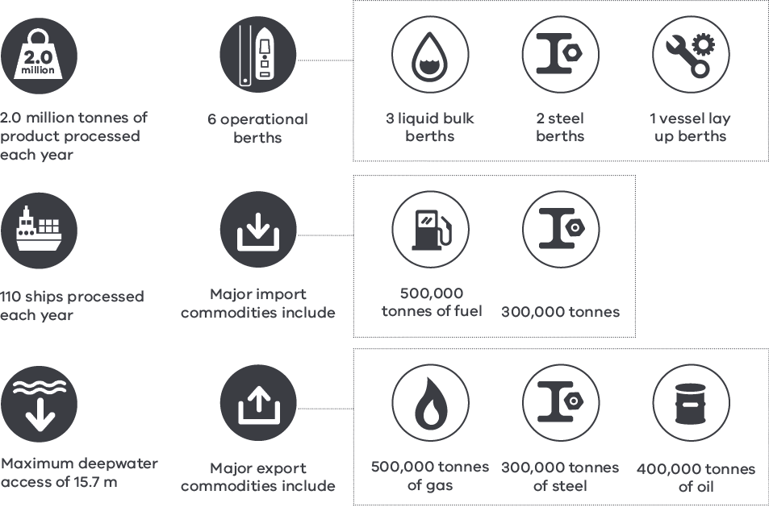

Economic value of Victoria’s commercial ports

Victoria’s commercial ports play a critical role in enabling economic activity in the state.
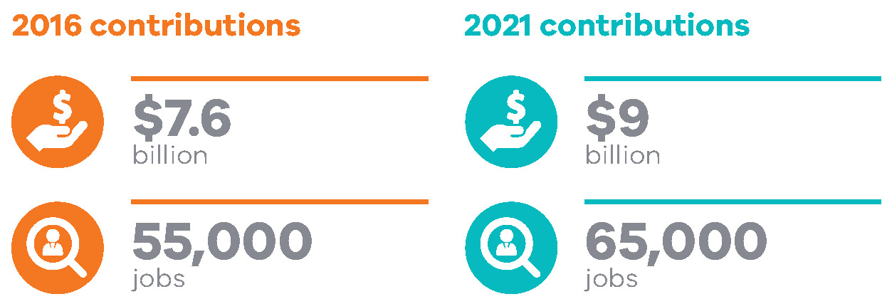
Source: Deloitte, 2022

Victoria, as part of an island nation, is heavily reliant on its ports system to overcome its vast distance from global markets. The cost and reliability of Victoria’s supply chains are vital for ensuring the economy has access to, at a reasonable cost, critical inputs used and consumed daily by Victoria’s businesses and communities. From shore to door, Victorians depend on the maritime freight supply chain for everyday items like cars and clothing, medical products, fuel, steel and timber.
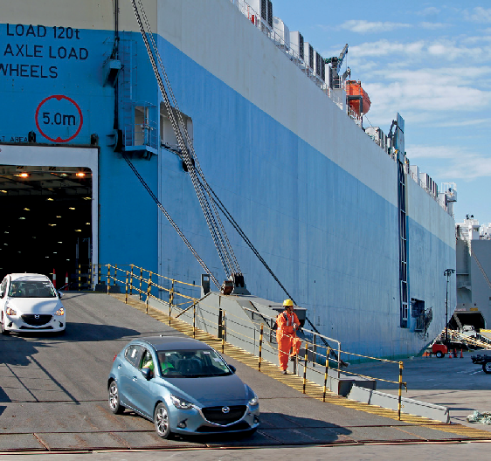
Victoria is also Australia’s national freight and logistics hub. Victoria’s ports enable vital import and export opportunities to businesses and people across New South Wales, Tasmania, and South Australia.
The commercial ports sector contributed $9 billion to the Victorian economy in 2021. This includes both direct activity at each port and along the port supply chain such as warehousing and storage, container parks and related maintenance and repair services.
The commercial ports’ contribution to the economy includes $3.8 billion of industry value added and 28,000 jobs supported in the port precincts and surrounds, with another $5.1 billion of value added and 38,700 jobs supported across the rest of Victoria.
This represents a growth of 17 per cent in value added and 21 per cent in employment over the period 2016 to 2021.

Figure 4. Value of commercial ports to the Victorian economy in 2021, industry value add, and jobs
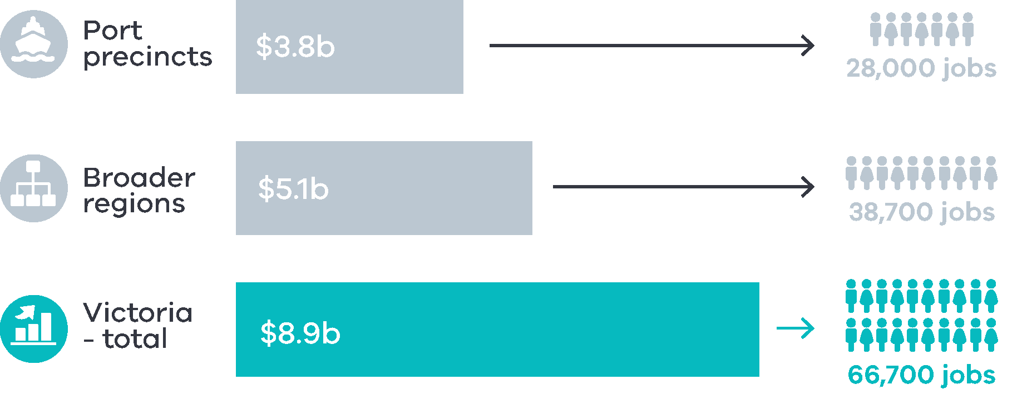

Chart 1. Estimated contribution of Victoria’s commercial ports to the state’s economy, 2016 and 2021 Source: Deloitte, 2022
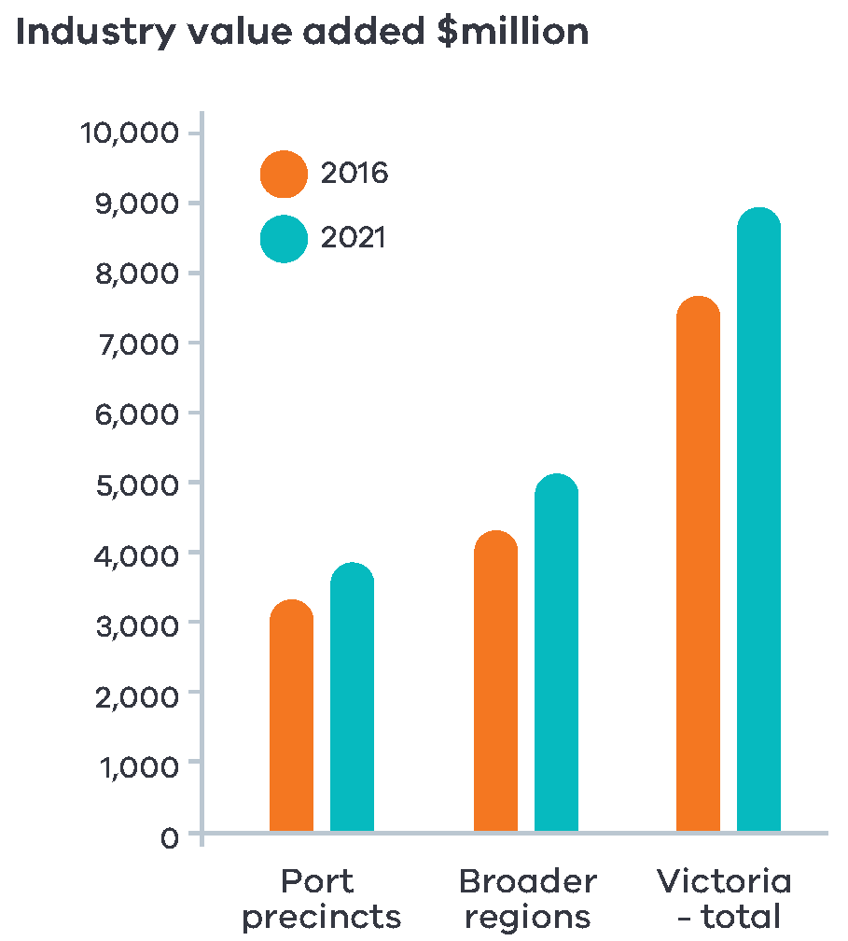
Source: Deloitte, 2022
Victoria’s projected long-term population and economic growth will flow through to a strong increase in the freight task for industries including agriculture, energy, resources, manufacturing, construction, and other services.
Each port plays a vital role to enable projected trade growth and support emerging industries, and to manage the challenges that growth presents – including the need for transport network capacity, optimised shipping channels, and commercial port land use protections, in which the State has a role to play in shaping the policy, planning and regulatory environments for the ports to optimally operate.

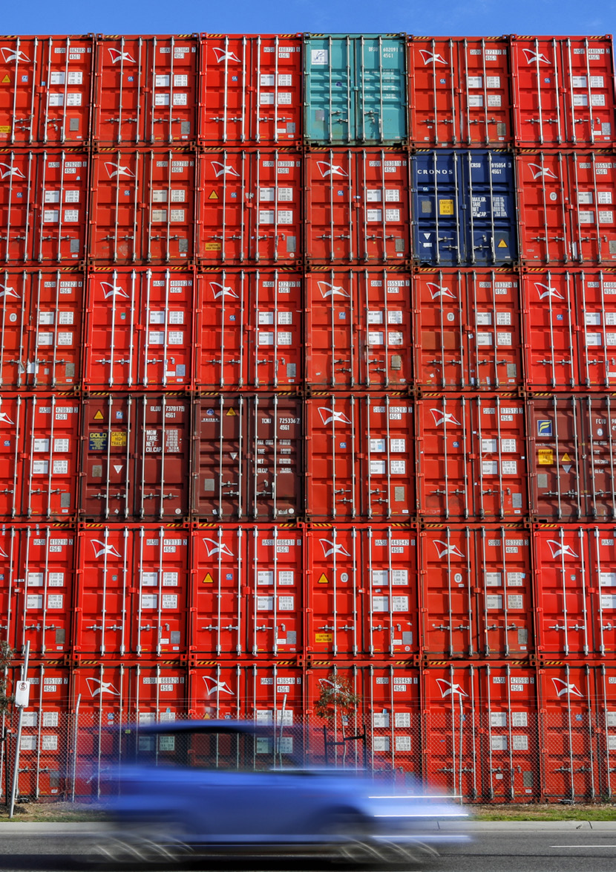

Trade mix and forecasts
Current and emerging trades and industry trends will affect the composition and size of Victoria’s future freight task, including the ongoing transition to a renewable energy mix, a shift in Victoria’s domestic refining and smelting activity, and a shift in consumer behaviour that is driving high demand for freight services globally.
Table 1. Summary of 30 year trade forecasts
Trade | Unit | History 2020–21 | Forecast 2051–52 | Forecast CAGR (2020-21 –  2051-52)
Existing trades
Liquid bulk | Million tonnes | 11.9 | 12.7 | 0.2%
Dry bulk | Million tonnes | 14.2 | 20.5 | 1.2%
Break bulk (excl. new windfarm cargo) | Million tonnes | 2.7 | 2.6 | -0.2%
Motor vehicles | Millions | 0.3 | 0.5 | 1.3%
Containers | Million TEUs | 3.3 | 7.3 | 2.6%
Emerging trades
Hydrogen | Million tonnes | - | 2.2 | -
Liquefied natural gas | Million tonnes | - | 3.0 | -
Windfarm cargo | Million tonnes | - | 0.9 | -

TEU: Twenty-foot Equivalent Units CAGR: Compound Annual Growth Rate Source: Deloitte, 2022
Each port plays a vital role to enable projected trade growth and support changing composition of trade

Chart 2.
Container trade baseline forecast
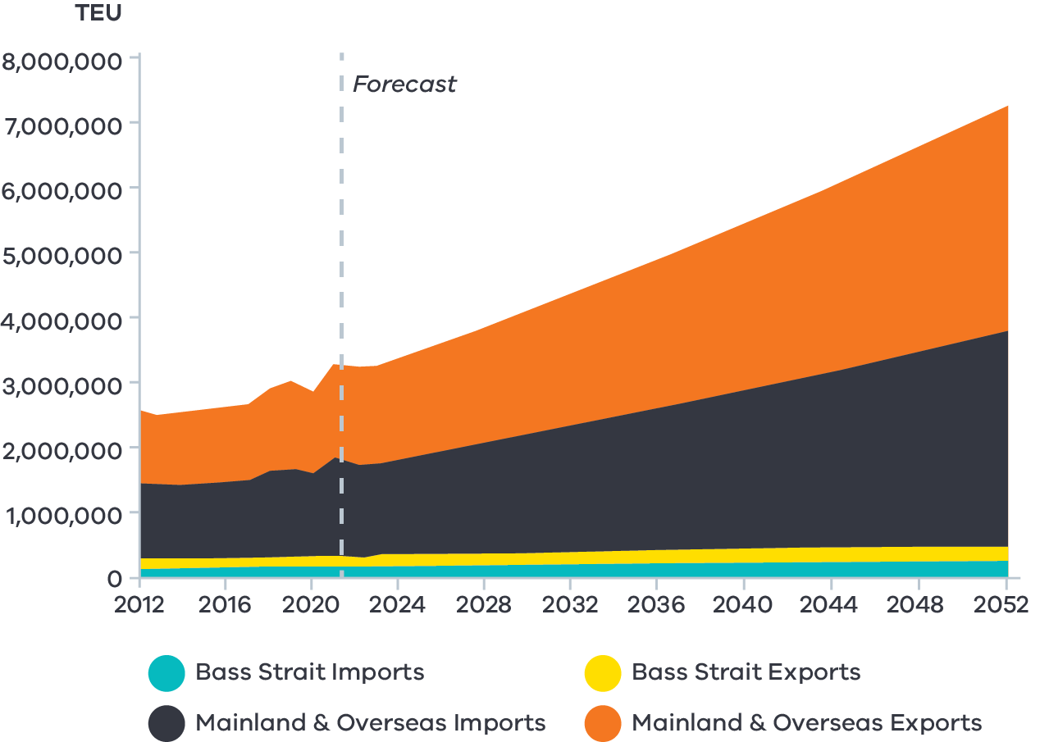
Source: Deloitte, 2022
Chart 3.
Liquid bulk trade baseline forecast
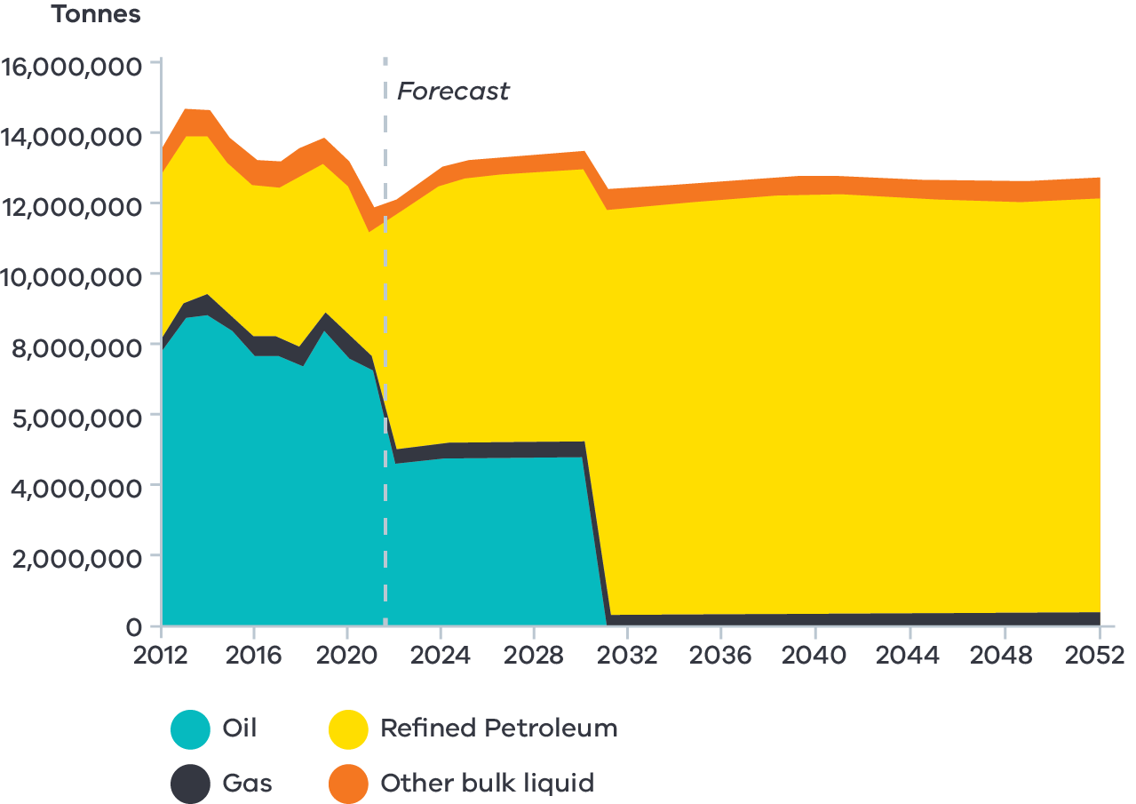
Source: Deloitte, 2022

Container trade
Container trade is serviced through the Port of Melbourne and includes mainland and overseas imports and exports, and Bass Strait imports and exports (that is, goods shipped between the island state of Tasmania and mainland Australia via the Bass Strait channel). A range of everyday consumer goods are moved through refrigerated and non-refrigerated containers including food and wine, clothing, toys, medical products, appliances, furniture and paper. Container import volumes are closely associated with wider trends in the import of goods for Victoria, while export growth is driven by long-term trends in export levels of Victorian goods.
Container trade volumes are expected to grow from 3.3 million twenty-foot equivalent units (TEUs) per annum in 2021 to 7.3 million TEU per annum in 2052.

Liquid bulk
Historically, liquid bulk has been dominated by imports of crude oil at the Port of Melbourne and the Port of Geelong which are refined into petroleum products including jet fuel, petrol and diesel. In addition, the Long Island Point plant at the Port of Hastings processes gas liquids and stores crude oil before it is distributed to other refineries and overseas.
The Port of Hastings also provides for the import of refined fuels, albeit at a smaller scale than the ports of Melbourne or Geelong, as well as the export of liquid hydrogen. Overall, liquid bulk is projected to grow moderately, but with significant change to its composition.
The composition of liquid bulk throughput is shifting away from the importation of crude oil toward the importation of refined petroleum products and interest in the import of liquid natural gas. This is in part due to the closure of the Altona Refinery at the end of 2021 and its conversion to an import terminal. (The refinery had supplied over an estimated 40 per cent of Victoria’s liquid fuel demand.) The shift will be strengthened by new diesel storage facilities being built in Geelong and Newport as part of the Commonwealth’s Boosting Australia’s Diesel Storage Program and the Commonwealth’s upcoming Minimum Stockholding Obligation which will take effect from October 2022. The Minimum Stockholding Obligation will require fuel importers and refiners to maintain baseline levels of refined fuels, ultimately increasing the total stocks of diesel, jet fuel and unleaded fuel across Australia.
These two initiatives will increase the total amount of fuel storage that is maintained in Victoria from 2022 onwards which in turn will temporarily increase the amount of throughput of refined fuels required at Victoria’s ports.

Chart 4.
Break bulk trade baseline forecast
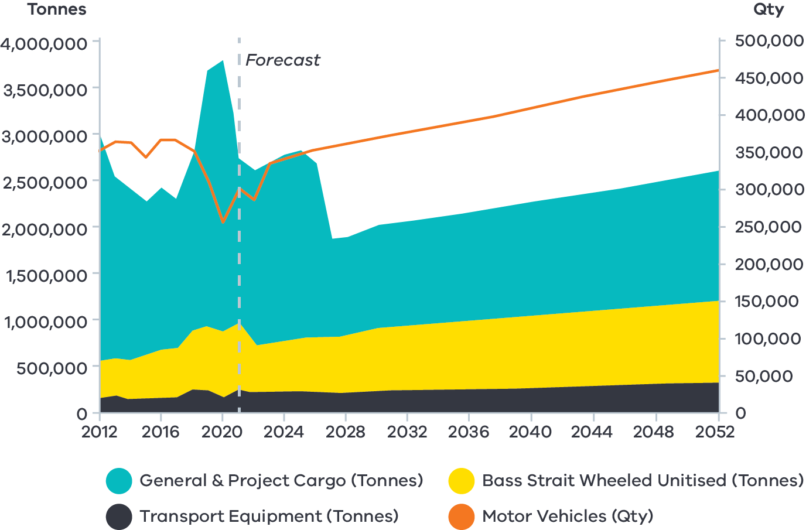
Source: Deloitte, 2022
Chart 5.
Dry bulk trade baseline forecast
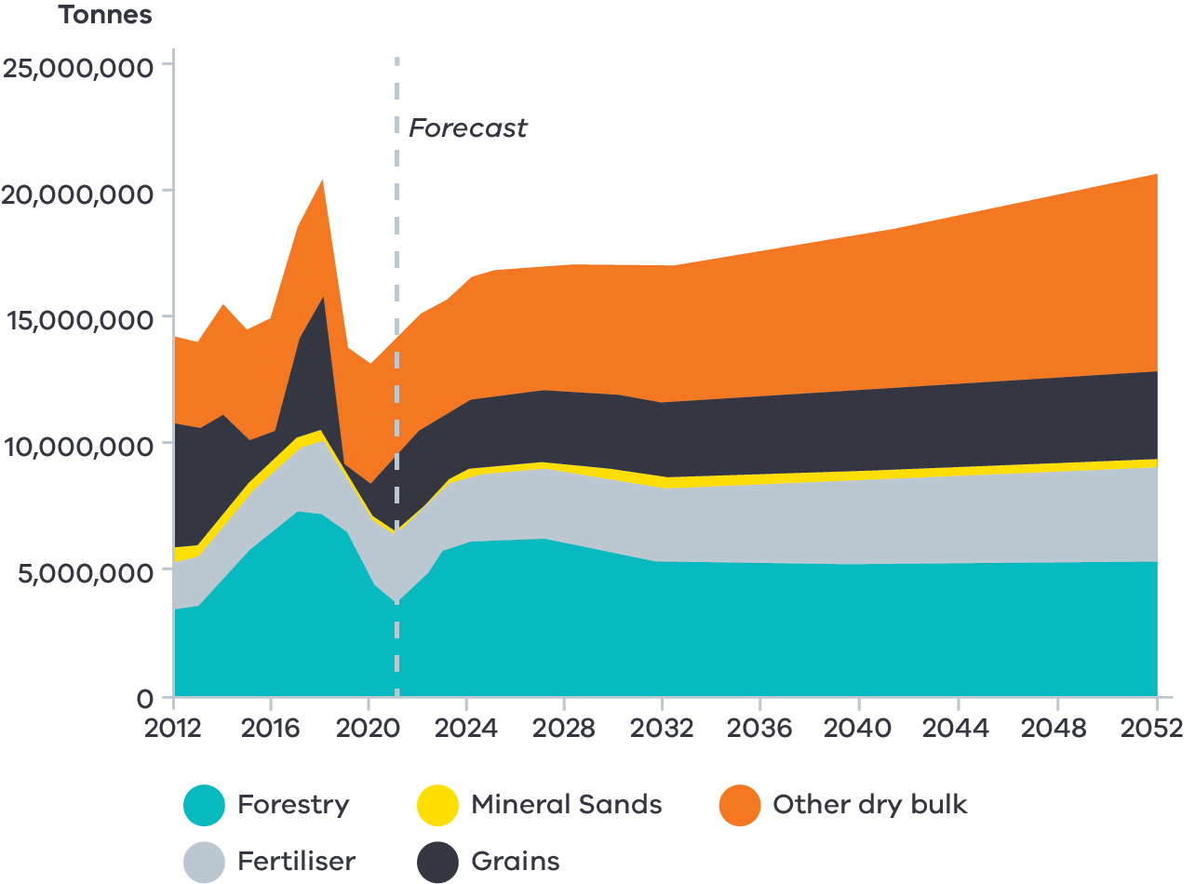
Source: Deloitte, 2022

From a base of 3.6 million tonnes per annum in 2021, refined petroleum imports are forecast to reach a long-term throughput of 11.8 million tonnes per annum in 30 years (Deloitte, 2022). (The conversion of Altona Refinery representing an estimated additional 4.5 million tonnes).
This throughput figure depends on the speed of Victoria’s ongoing transition to clean energy and electric technologies. It is expected that ports will be required to facilitate this transition.

Break bulk
Break bulk trade includes general and project cargo, motor vehicles, transport equipment and Bass Strait wheeled unitised cargo. General and project cargo refers to a range of break bulk cargo shipped through Victoria’s commercial ports including machinery, iron, steel, equipment, livestock and smelter exports from Portland, and oversized cargo used primarily in construction or engineering projects. Bass Strait wheeled unitised cargo includes a range of break bulk cargo that is shipped between Tasmania and Victoria via roll-on roll-off shipping services.
Motor vehicles, Bass Strait wheeled unitised cargo and transport equipment are shipped through the Port of Melbourne while the ports of Hastings and Geelong are positioned to handle future motor vehicle trade in the event volumes exceed capacity at Melbourne.
Our commercial ports are expected to handle 2.6 million tonnes per annum of break bulk cargo and close to half a million motor vehicles per annum in the long run.

Dry bulk
Dry bulk commodities include forestry, fertiliser, mineral sands and grains. Forecasts for dry bulk assume a recovery in forestry exports which historically have been exported through the ports of Portland and Geelong, and strong growth in fertiliser imports brought into Victoria through the ports of Geelong, Melbourne and Portland. Dry bulk throughput is expected to grow from 14.2 million to 20.5 million tonnes per annum over the next 30 years.

The Government’s plan for the Victorian Ports System
From 1991 to 2020, Australia experienced the longest recession-free period of sustained economic growth by a developed country since World War II. While many complex and interrelated factors contribute to economic growth, commercial ports play an important role in facilitating population-driven household consumption, export trade and domestic industries reliant on imports, such as the construction sector.

During Australia’s nearly 30 year period of unprecedented economic growth, Victoria’s ports system experienced considerable governance change through a steady commercialisation of port assets. Privatisation has succeeded in enabling port operators to respond more dynamically to market needs. This journey has however resulted in the State Government having limited ability to influence, or intervene, should there be a need to address any market failure or system risks.
While the Victorian Government remains focused on supporting competition and ensuring open market access, the State has progressed to a stewardship role of the ports system. This reflects the need for the State to safeguard recent privatisation processes with the policy tools required to protect key port operations and support port system efficiency.
The stewardship role reflects that the State retains responsibility for key influencers of port system effectiveness such as land use and transport planning, infrastructure investment, economic and education policy and facilitating trade links.
To support prosperous port operations in Victoria the Government uses key principles when setting port policy:
- Partnership approach: The State recognises the central role of the private sector in delivering its freight policy outcomes as evidenced in the State’s commitment to stakeholder engagement throughout its port reform process and the development of a new Strategy and five yearly reviewed Action Plan to provide industry with greater investment certainty.
- Integrated land use and transport planning: The State’s ability to proactively apply its land use and transport planning tools to preserve future port and landside transport corridors – both road and rail – is key to ensuring the ports system can accommodate the growing demand for goods.
- Supply chain approach to port policy: Ports are an essential part of a larger functioning freight supply chain. The State’s primary role in international trade is providing efficient road and rail connections for import and export products to move efficiently through its ports and around Victoria. Effective port policy should take a holistic view of the entire maritime and landside freight supply chain to support informed government decision making.

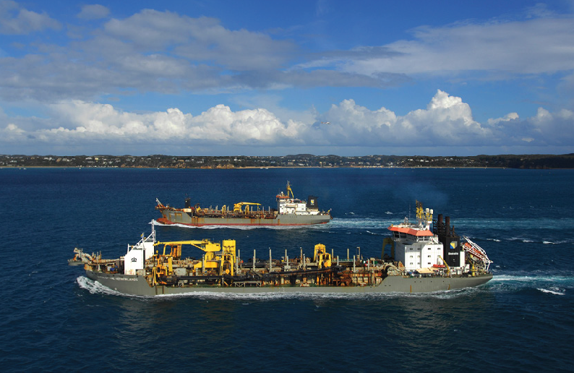
- Facilitation of data and performance transparency at ports: Freight supply chains are complex, with multiple transactions and transport journeys between origin and destination. A lack of visibility tends to contribute to complexity and inefficiency.
Government is best placed to facilitate greater information sharing between private companies to influence better practices and allow for more informed decision-making that results in better use of existing assets.
- Continuous improvement of safety and environmental practices: Safe port operations are the State’s responsibility and are administered by Ports Victoria, with recent reforms focusing on the importance of clear roles and accountabilities in delivering safety outcomes. The State is also committed to preserving community amenities and environmental outcomes along Victoria’s thriving coastlines and waters.

Victoria remains focused on supporting competition and ensuring open market access

Responding to a changing environment

The COVID-19 pandemic has highlighted the risks associated with a limited ability for Government to respond to operational risks in the supply chain.
The pandemic signalled the end of Australia’s sustained period of economic growth. It brought into sharp focus our reliance on sea freight supply chains, the vulnerabilities that exist in them, and the risks these vulnerabilities pose to Victoria’s economy and standard of living.
While management of the COVID-19 pandemic has transitioned to focus on economic recovery, its impacts on the supply chain will persist for some time. These impacts are creating structural shifts in air and sea connections to Australia, increasing costs and potentially reducing access to some markets. Key observations of the impact of COVID-19 on supply chains are outlined below.
- COVID-19 has caused supply and demand disruptions: Global sea freight capacity has reduced due to a range of factors including ship fleet scrappage at the start of the pandemic, and global port shutdowns to contain COVID-19 outbreaks. In Australia, domestic lockdowns and flight groundings reduced landside and air freight logistics capacity. As lockdowns limited access to services and social activities, consumers’ demand for goods increased. Localised economic responses to the pandemic, such as cash injections into the United States’ economy, further increased household consumption.
- Geopolitical shifts and regional events have exacerbated pandemic-related impacts: Russia’s invasion of Ukraine in February 2022 resulted in fuel cost increases of over 30 per cent in March 2022 which is likely to increase the cost of shipping. Economic sanctions on Russia have resulted in a 40 per cent reduction in container ships docking at Russian ports, adding to worldwide shipping congestion and delays.
- Sea freight congestion has increased costs and reduced reliability: Changing supply and demand has resulted in changing vessel rotation, re-routing and increased off-window ship arrivals, reducing vessel reliability. This particularly impacts exporters of agricultural products and other perishable goods whose premium products depend on reliable freight timings to reach destination markets in a saleable condition. Driven by increased sea freight congestion and shipping costs, shipping lines are directing reduced shipping capacity to the more lucrative United States–China route. This further constrains sea freight capacity and has increased shipping costs in Australia. As an example, freight rates from Shanghai to Melbourne have increased 484 per cent from August 2019 to August 2021.
- Businesses are adapting to volatility: ‘Just in case’ logistics has become more commonplace as businesses hold more inventory to prevent lockdown- or shipping reliability-related stock shortages. This transition from ‘just in time’ logistics increases businesses’ storage needs. It will have medium-term impacts to shipping volumes and storage availability.
- Focus on environmental sustainability is accelerating: The ongoing transition to more sustainable and environmentally- friendly operations is likely to accelerate as world economies progress towards carbon emission reduction commitments. This is expected to impact ship design and may have flow-on effects for port infrastructure and re-fuelling facilities.
The Victorian Government is committed to playing its part to address performance and productivity issues in the commercial ports system. This Strategy outlines priority action areas for the State Government to improve port system resilience and performance within a changing environment.

Strategic objectives guiding action areas
The purpose of the Strategy is to provide an overarching vision for the ports system that articulates the State’s economic, resilience and liveability priorities and how these intersect with port operations.
The Strategy is based on four key objectives. These will be met through an action plan which will be reviewed and updated every five years. All actions in the Strategy have an implementation timeframe of either up to 2 years, 3 to 5 years or ongoing.
The four objectives and action plan areas are outlined below.
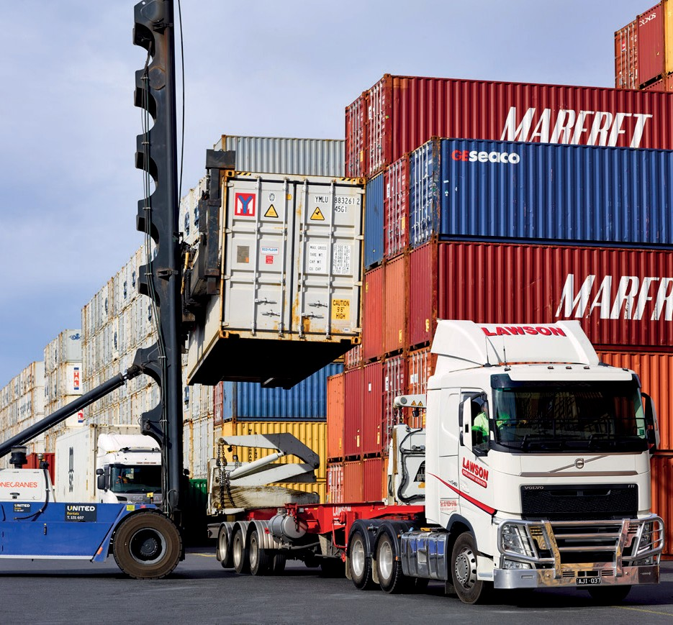

Responsive to market demands

The State Government has a key role supporting the ports system to accommodate Victoria’s rapidly growing freight task. The huge capital cost of port infrastructure and limited amount of suitable locations highlights the need for Government to provide strategic direction, planning and investment support to maximise value and productivity of Victoria’s four commercial ports.
Over the next five years the State Government will focus on several key policy positions to meet projected trade growth, support emerging industries, and respond to the challenges of growth by optimising existing port and transport infrastructure capacity. Policy will focus on:
- Supporting capacity growth at the Port of Melbourne: While the Port of Melbourne is privately operated, the State has a role in working with the private operator to support its planning processes to accommodate projected container growth. The Victorian Government is also responsible for delivering potential road and rail upgrades which ensure that the State’s transport system is capable of meeting projected freight capacity growth.
- Port of Hastings multi-use facility: There is opportunity to further investigate how to develop the Old Tyabb Reclamation Area (OTRA) to support emerging bulk and break bulk trade diversification.
- Station Pier and the future of Victoria’s cruise shipping: Government will lead further work to determine the most suitable option for continuing cruise shipping at Station Pier. This must balance local precinct and visitor experience outcomes with the complexity and cost of maintaining the aged heritage pier. The work will be complemented by a statewide cruise shipping strategy developed with stakeholders to maximise the economic and social benefits of cruise shipping services across regional Victoria and metropolitan Melbourne.
- Geelong channel optimisation: Recent assessments indicate that while deepening Geelong channels is physically possible, it is not currently economically viable for the State to dredge the channels. The Victorian Government will consider private sector proposals to deepen the channels and Ports Victoria will investigate and implement local investment opportunities to maximise the Geelong channel capacity.

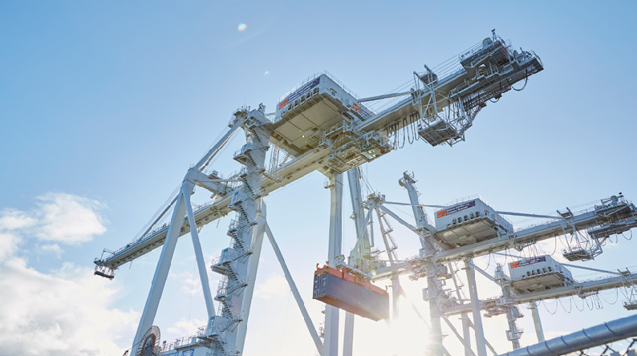

Well planned, balancing both industry and community needs

As gateways to international markets, commercial ports are focal points for transport and land use planning. Ports need both protection for urban growth and active management of amenity impacts to local communities.
Over the next five years the Victorian Government will focus on setting the appropriate planning frameworks to protect ports and their transport corridors from sensitive-use encroachment while managing potential urban amenity impacts. This focus reflects the key role of the planning system in appropriately balancing the economic needs of the State with liveability and community aspirations. Key actions include:
- Enhancing Statutory Planning arrangements at our commercial ports: The State will enhance existing port-related provisions in the Victorian Planning Scheme to provide greater clarity on the appropriate level of development within the port environs and introduce further planning mechanisms such as referrals to protect ports and communities from land use conflicts.
- Preparing commercial port landside access plans: The State retains responsibility for planning and managing land use transport access around Victoria’s four commercial ports. We will work with port managers and stakeholders to prepare landside transport access plans for each commercial port. The plans will be updated as the ports develop.
- Delivering the next Port Development Strategies (PDSs): PDSs are a significant part of the State’s planning and port development framework. The Minister for Ports and Freight will publish updated PDS Ministerial Guidelines to support the preparation of PDSs by port managers.
- Planning protections for Bay West: Land use and transport planning protections must be progressed to preserve Bay West as a viable future location for Victoria’s second container port. Government will formulate and implement a roadmap to deliver planning protections to secure necessary land and protect Bay West as a future container port.

Efficient, productive and resilient in a changing global environment
Today’s heightened risk of economic disruption places impetus on the State Government to set the policy direction needed to govern a ports system that is adaptable and resilient to changing market dynamics. At the same time, the rising global costs of doing business places greater emphasis on ‘doing more with less’ and driving more efficient and productive commercial ports.
Over the next five years the State Government will develop key policy tools to support an efficient and effective ports system. Key actions include:
- Embedding Ports Victoria’s advisory role: Ports Victoria, via its expanded charter, will become the State’s principal advisor on commercial ports matters. It will lead performance monitoring and industry engagement, and provide advice relating to sector planning and resilience.
- Expanding the Voluntary Port Performance Model (VPPM): The Department of Transport will expand the VPPM. This will include the development of a port supply chain guide, a Voluntary Industry Code of Practice, and the expansion of the existing Voluntary Performance Monitoring Framework indicators. The Department of Transport will also investigate the value of a Ports Community System to support Government and industry to predict more effectively – and respond to – congestion and vulnerability in the sea freight supply chain.
- Supporting Victoria’s transition to net zero emissions: The Victorian Government is committed to transitioning the transport sector to net zero emissions by 2050. It will look at opportunities to use commercial ports as a catalyst for transitioning industry to using reduced emissions trucks.
- Enabling an appropriately qualified and skilled workforce: Ports Victoria and the Department of Transport will work with the Victorian Skills Authority to develop a cross- government action plan to meet workforce and skills shortages in the maritime sector.

Safe and operated with clear roles and responsibilities
Safe port system operations are a vital function of the State. Ports Victoria’s new charter provides the necessary governance arrangements to ensure clear and consistent safety accountabilities across the Victorian ports system. The new charter outlines Ports Victoria’s role as the State’s leading ports advisory organisation, providing oversight of critical safety functions such as maritime navigation, licensing of pilotage and towage services and operational support for local port managers.
Over the next five years, the State will focus on implementing the following key actions:
- Codifying the Safety and Environment Management Plans (SEMP) process: A marine safety code will be added to the SEMP preparation and review process to provide an industry-wide marine safety standard for all State waters and a scalable approach to marine safety risk management.
- Engaging on pilotage and towage: The Victorian Government will conduct stakeholder engagement to establish a non-exclusive licence scheme for towage and pilotage services at commercial ports. Standards will be set by Ports Victoria and implemented from 2023.

- Reforming MSA waterways to improve marine asset planning and maintenance outcomes: We will consolidate local ports and MSA waterways functions across the public service to provide a more consistent approach to local ports and waterways matters.
As gateways to international markets, commercial ports are focal points for
transport and land
use planning.

Action Plan 2022 – 2027
See a list of all actions at Summary of the Government’s Action Plan.
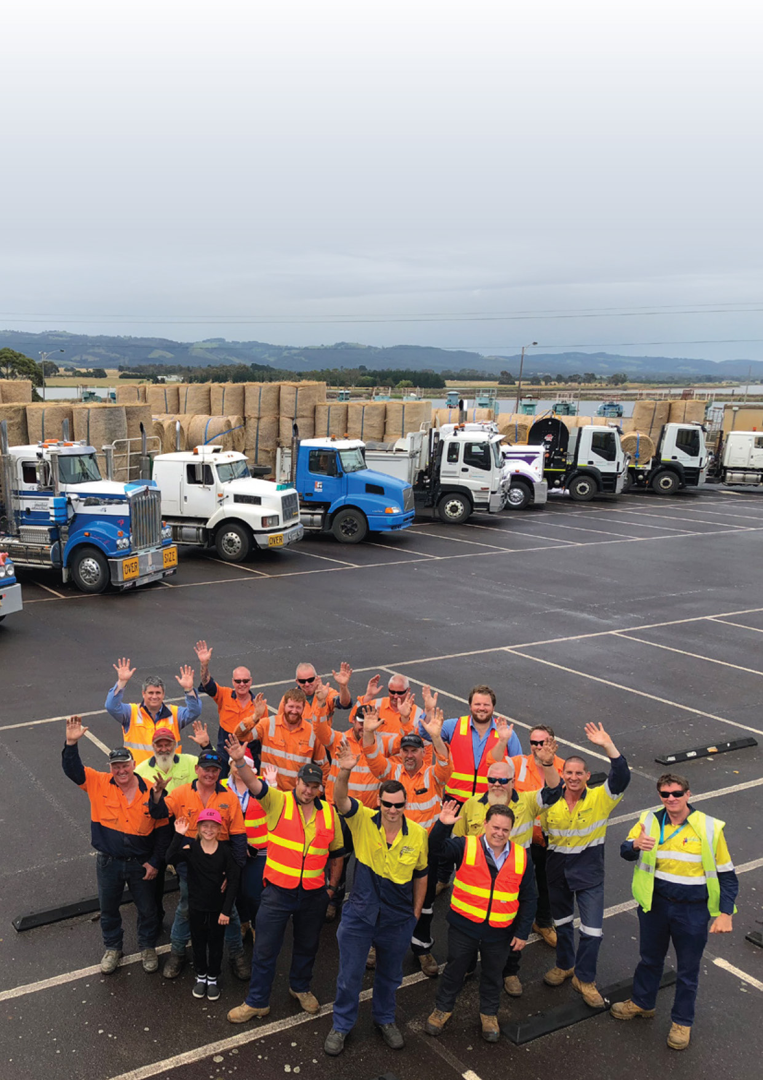

Responsive to market demands

Planning for growth at the Port of Melbourne

The Port of Melbourne is a key economic asset for the State. The port is the largest container and general cargo port in Australia servicing a catchment area covering southern New South Wales, South Australia, Tasmania and all of Victoria. Key inputs of production and economic activity flow through the port every day. Many export-focused industries across southern Australia rely on the efficiency of the Port of Melbourne to access consumer markets across the globe.
The Victorian Government entered a long-term lease arrangement for the Port of Melbourne
in 2016. Under this arrangement the port’s private operator, the Port of Melbourne Group (PoM), has taken on a lead role planning for the growth of the port to meet market demands and ensure the port remains efficient and productive, and capable of handling growing ship sizes. The Government works closely with the private operator to ensure that the port can handle growing volumes of trade and is supported through effective road and rail transport connections.
The port’s PDS identifies that over the coming decade significant planning work is needed to develop the next major tranche of new container handling capacity in the northern area of Webb Dock at the mouth of the YarraRiver.
The Government is aware the PoM considers that additional capacity is likely to be needed and ready for operation by around 2030.
The Department of Transport has undertaken initial work to consider the potential impacts of growing road volumes around Webb Dock as the port grows. This will need to be carefully managed to ensure the growth of the port progresses effectively alongside the adjoining Fishermans Bend development precinct, which will also grow in coming years.
Government will continue to work closely with the PoM to support the growth of the port to 2051 and beyond. We will consider the PoM’s proposal for a potential new rail connection to Webb Dock via a new bridge over the Yarra River and rail staging sidings in the vicinity of the Old Melbourne Market site. These plans will be considered as part of the usual PDS process and the planning requirement under the Port of Melbourne Lease. The Department of Transport will continue to consider requirements for upgrades to the heavy vehicle network servicing Webb Dock, such as at Bolte Bridge, to ensure transport to and from the port remains productive and efficient.

Number | Action | Timeframe
Action 1 | The Department of Transport will continue to work with the PoM to support its planning for the next tranche of container capacity, noting that the PDS outlined that additional capacity is expected to be required around 2030 to support Victoria’s forecast trade demand. | Ongoing
Action 2 | The Department of Transport will work with the PoM on the land transport connection planning for the port generally including planning for any new road and rail network capacity needed to support the growth of trade volumes at Webb Dock. | 3 – 5 years

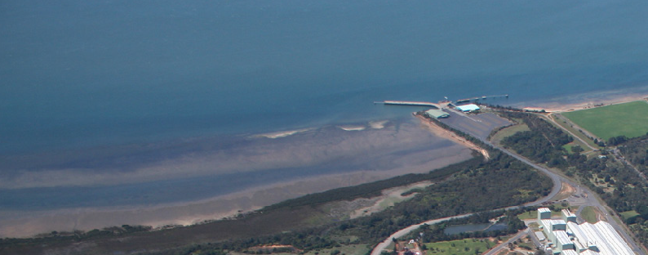

A new Port of Hastings multi-use facility for bulk-trade diversification

The Port of Hastings plays an important role as a trade gateway for bulk liquid products as well as some break bulk volumes through the BlueScope Steel Jetty in the northern area of the port. While Hastings is no longer expected to be developed in future years to handle container trade, the port remains a strategic state asset well-suited to support dry and liquid bulk trade, with deep approach channels and land set aside for further development.
To confirm the Port of Hastings emerging role in the ports system supporting general cargo (moving away from the previous focus on the potential development of container handling facilities), the Victorian Government
has amended the Charter of the State-owned enterprise which operates the Port of Hastings to remove the reference from the ports charter regarding planning for development of container handling capacity. As such, the port entity is being renamed from the Port of Hastings Development Authority to the Port of Hastings Corporation. These changes have passed parliament via the Transport Legislation Amendments (Ports Reform and Other Matters Bill) 2022.
The Port of Hastings is particularly well-placed to play a crucial role supporting the growth of several emerging trade opportunities. We are currently exploring options such as supporting offshore wind, further development of onshore wind across Gippsland and building on the successful trial of the export of hydrogen to Japan. There are also a range of other potential bulk and break bulk opportunities such as importing of aggregate construction materials which the Port of Hastings is also investigating.
A new multi-use facility could be located within the Long Island precinct on the OTRA between the existing BlueScope Steel Wharf and the Esso Long Island Point Jetty. The developed OTRA site could accommodate a multi-purpose double berth of over 350 metres long supported by up to 35 hectares of land. Development of this multi-purpose berth could accommodate a mix of trades.

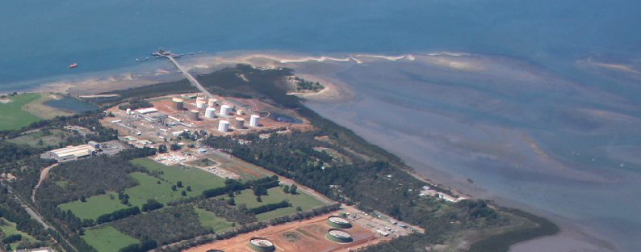

Figure 5. New Port of Hastings multi-use facility
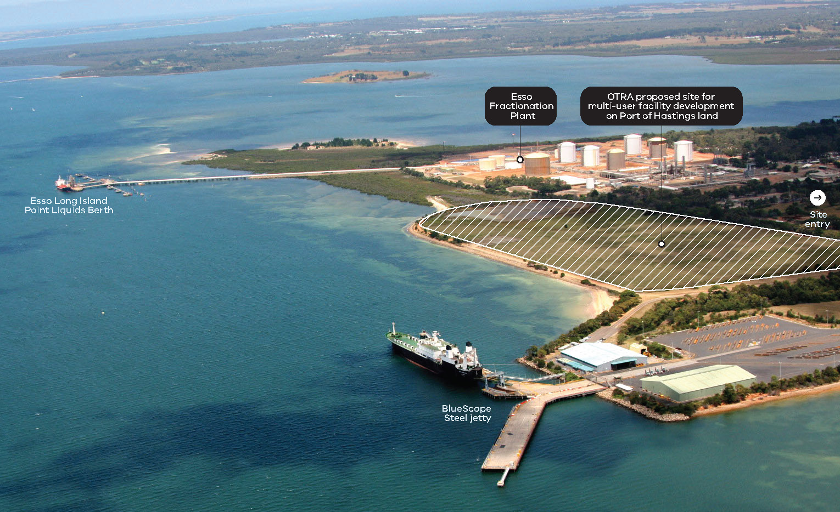

Number | Action | Timeframe
Action 3 | Port of Hastings Development Authority to be renamed Port of Hastings Corporation, reflecting its refocused legislative charter. | Up to 2 years
Action 4 | Port of Hastings Corporation will prepare an investment case for a new multi-user facility on the OTRA able to support future and new trades including hydrogen related projects, aggregate imports, supporting construction of offshore and onshore wind developments and other new bulk and break bulk trades. | Up to 2 years

Planning for the future of cruise shipping at Station Pier

The Station Pier precinct in the Port of Melbourne is Victoria’s premier cruise shipping destination. Managed by Ports Victoria, the facility was first built in 1854 and has been redeveloped many times over the years. Today the pier is approximately 600 metres long, 58 metres wide and includes two terminal buildings.
In recent years Station Pier has accommodated around 700,000 passengers annually. While the COVID-19 pandemic dramatically impacted the global cruise shipping industry, the sector is expected to bounce back strongly. Before 2019, domestic and international cruise was experiencing steady and significant passenger growth of around –15-20 per cent per year.
A major change in Station Pier’s use is underway. TT-Line Company Pty Ltd, the operator of daily passenger ferry and freight services between Tasmania and mainland Australia, is ceasing operations from Station Pier and will relocate its service base to Geelong by late 2022. With TT-Line’s departure from Station Pier, there is an opportunity to restore this State significant heritage asset taking into account development and use of the facility.
The Department of Transport has begun initial planning work with Ports Victoria on the future uses of Station Pier. The work has confirmed that the Station Pier precinct continues to be the best location for the State’s primary cruise shipping operations relative to any alternatives for the State. The assessment showed that cruise shipping is a positive and valued attribute for the Station Pier precinct and that no compelling alternative port exists for hosting a full suite of cruise services that would support growth.
Critically, the work completed to date has also confirmed that Station Pier itself is a heritage asset that requires a high level of specialised maintenance to continue operating as a port facility in its current form. The Department of Transport will continue to work with Ports Victoria to develop further advice on the best way to retain cruise shipping in the precinct, whilst balancing the social, community and commercial considerations of operating a heritage facility as a working port asset.

Number | Action | Timeframe
Action 5 | Ports Victoria will prepare a business case, for government consideration, to support the future of cruise shipping in the Station Pier precinct. This will confirm the optimal arrangement for cruise operations within the precinct, identify the best use of the current pier and plan for an integrated transport and land use outcome for the precinct. A key aspect of this planning is ensuring the valued heritage of Station Pier is protected for future generations. | Up to 2 years
Action 6 | In parallel with work on the Station Pier Precinct Business Case, Ports Victoria will commence development of a Victorian Cruise Shipping Strategy which assesses opportunities for growing the Victorian cruise shipping sector. Working with key stakeholders such as Visit Victoria, the Strategy will assess opportunities for further development of cruise services servicing regional areas, considering operational requirements and the economic and social benefits. | Up to 2 years

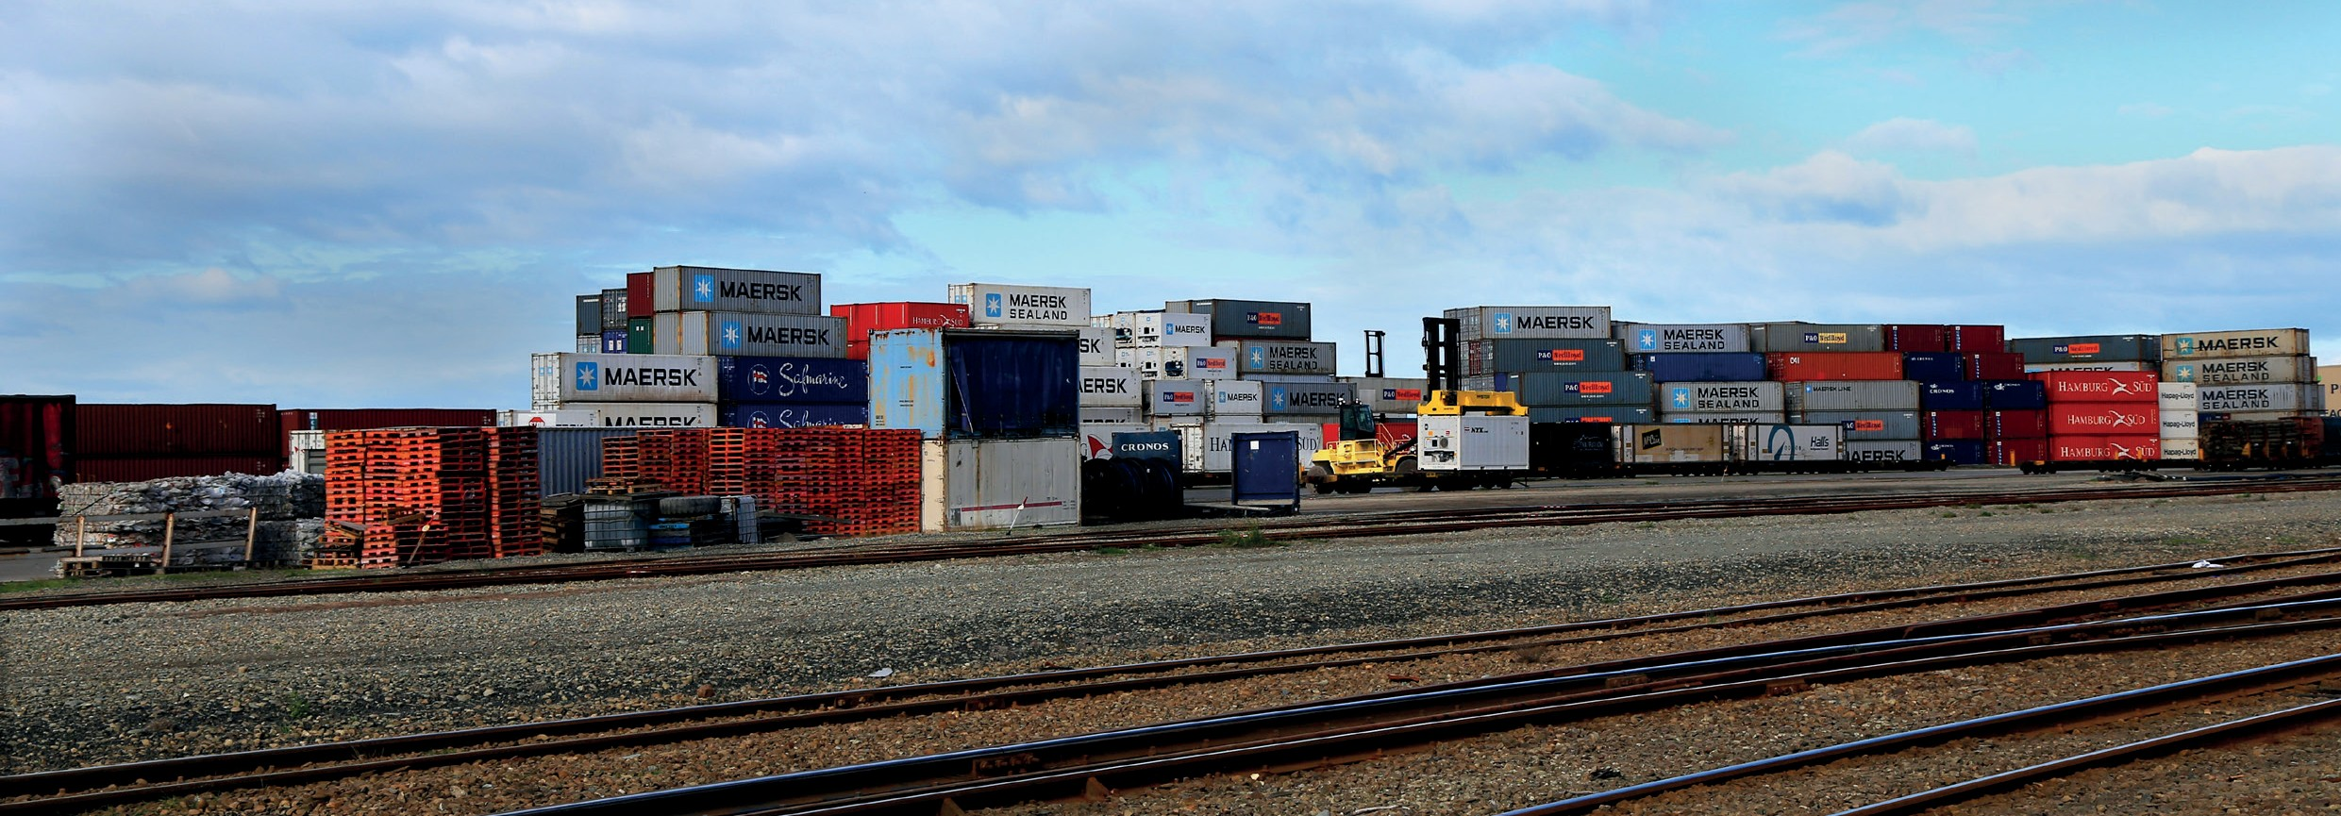

Continue delivery of the Port Rail Shuttle Network

The Port Rail Shuttle Network (PRSN) is a $58 million government initiative to increase the share of container transport handled by rail that will provide new rail connections on public land and unlock millions of dollars of private sector investment for capital works and operational upgrades at privately owned intermodal terminals.
The PRSN involves connecting privately-owned suburban freight terminals in Melbourne’s north (Somerton), west (Altona) and south-east (Dandenong South) to the existing rail network, and operating regular port rail shuttles (600 m long freight trains) to move shipping containers between these freight terminals and the Port of Melbourne.
It aims to enable an efficient and cost-effective alternative to road transport for the 87 per cent of import containers that travel to destinations less than 50 kilometres from the port gate. When complete, instead of going to the port, trucks will be able to deliver to or pick up containers from the Somerton, Altona or Dandenong South outer metropolitan rail terminals.
By 2050, the PRSN is expected to move 30 per cent of Melbourne’s containers by rail, avoiding millions of truck trips on roads each year.

Grants of nearly $54 million have now been allocated jointly between State and Commonwealth Governments to Austrak, Salta and SCT Logistics to connect their respective facilities at Somerton, Dandenong South and Altona to the rail network. The completion of these new rail connections
is scheduled to enable port rail shuttles to progressively commence running from late 2022. Construction of rail connections at Altona and Dandenong South is in progress, while construction of the rail connection at Somerton is expected to commence in late 2022.
With work well underway to deliver the physical infrastructure needed to support PRSN operations, the Department of Transport is progressing a detailed review of pricing, access and coordination arrangements needed to support the operation when it progressively comes online from late 2022. Arrangements must be in place to support the commercial viability of the network and guarantee that the various, broader social and environmental benefits of shifting some port trade throughput from road to rail are captured. Subject to the findings of the review, further action to ensure the success of the PRSN will be considered by the Victorian Government if it is required.

Number | Action | Timeframe
Action 7 | The Department of Transport will continue working with Port Rail Shuttle proponents and the Port of Melbourne to finalise plans for the commencement of operations and ensure the viability of the system. | Up to 2 years

Geelong channel optimisation

The Port of Geelong generates over $360 million in economic activity and close to 1,000 full-time jobs for the Barwon region. In 2016 – 2017, the cargo trade had an estimated value of approximately $7.8 billion (Victorian Regional Channels Authority, 2018).
The Port of Geelong’s primary customers are:
- Viva Energy Australia, the owner and operator of the Geelong Oil Refinery in the Port of Geelong which accounts for approximately 50 per cent of the port’s trade. The refinery is also one of only two remaining oil refineries in Australia
- Incitec Pivot Ltd which is Australia’s largest supplier of fertilisers
- Midway Ltd which is Australia’s largest exporter of wood fibre which includes bulk products of both woodchips and logs
- GrainCorp Pty Ltd export grain harvested throughout rural Victoria via their Bulk Grain precinct facilities. Depending on seasonality, grain volumes can account for approximately half of the export volume through the port.
Ships access the Port of Geelong from Port Phillip Bay via a network of dredged channels through Corio Bay to the northernmost terminal at the Refinery Pier. Primary channels are the Point Richards, Wilson Spit, Hopetoun and
Corio channels which extend 33 kilometres or 18 nautical miles and have a declared depth of 12.3 metres.
Some Port of Geelong users have identified increased channel depth as critical to drive trade development of their future business.
In response to this user interest, Ports Victoria has completed a range of investigations into the feasibility of optimising the Port of Geelong channels.
This work found that while technically feasible, deepening or widening the channel would be costly and, critically, the benefits would likely support only a small number of specific port users who would not be able to finance the cost of the project individually. This analysis concluded that without significant increases in trade volumes that would benefit from greater depth, it is not justified for the State Government to progress further work at this time to deepen the Geelong channels.
Trade through the Port of Geelong is forecast to continue to grow and new trades to the port, such as TT-Line’s Spirit of Tasmania service, will continue to influence consideration of the optimal channel capacity needed at Geelong. As such, it is important for Ports Victoria to continue to monitor the investment case over time should conditions change. The Government would consider any market-led proposals to deepen the Geelong channels based on the commercial merits at that time.
Importantly, Ports Victoria will continue considering opportunities to further optimise channel access at Geelong as a part of its ongoing role as the manager of waterside access at all of Victoria’s ports. This could include consideration of various targeted investments
in channel management resources and infrastructure that would achieve efficiencies within the current bounds of the channel’s physical capacity. Ports Victoria will continue engaging with all users about these opportunities.

Number | Action | Timeframe
Action 8 | Ports Victoria will continue to investigate and implement low investment optimisation options for the Geelong Channel based on commercial and economic viability. Options analysis will take into consideration the safety and efficiency aspects of the trade and vessel profiles. | Ongoing
Action 9 | Ports Victoria will revisit the case for significant investment optimisation if a credible proposition is put forward by a private proponent. | Ongoing

Well planned, balancing the needs of industry and the community

Enhancing statutory planning arrangements at our commercial ports

Victoria’s commercial ports have long grappled with the inherent tension between growing freight capacity requirements, and the State and local planning policy that actively promotes the intensification and revitalisation of inner urban areas. This has tended to result in an ongoing encroachment of sensitive uses around ports that threatens to constrain port development. It is important that the planning scheme responds to, and appropriately balances, these challenges.
This issue was recognised in 2010 by the Minister for Planning’s appointed Port and Environs Advisory Committee. The Committee recommended a Port Environs Overlay be implemented to manage incompatible land uses at the interface between ports and their surrounding neighbourhoods.
The more recent Review of the Victorian ports system notes that despite improvements delivered through the Port Environs Planning Advisory Committee and set out in Planning Advisory Note 56 in 2014, the approach to buffer controls for comparable uses in the land surrounding the port requires further strengthening. The following are some examples of the challenges for ports within the current planning framework:
- The application of an industrial zone is the most common way to manage sensitive use encroachment to ports. As these zones are not designed for port purposes, this often results in decision making that does not consider the impact of the proposed use on ports operations. The ports of Melbourne and Portland are surrounded by industrial zones that facilitate sensitive uses such as accommodation, education facilities and places of assembly including the General Residential Zone, the Capital City Zone and the Docklands Zone.
- Where controls such as the Design and Development Overlay and the Environmental Significance Overlay have been applied to manage the impact of encroachment on port environs, they have tended to fail as these controls cannot determine use. This means sensitive uses such as accommodation, educational facilities and places of assembly do not trigger a planning permit, rendering the controls of little use despite the expectation that encroachment will be managed.
- Ministerial Direction 14 which is designed to prevent planning scheme amendments occurring in port environs, maps the port environs based on risks emanating from the port, such as an explosion from a petroleum storage unit, rather than protecting the port from encroachment. This does not provide protection when existing zones allow for sensitive uses. Examples include the Docklands Zone and Capital City Zone in the City of Melbourne, the General Residential Zone in the City of Port Phillip and the General Residential Zone in Glenelg Shire.
- There is no formal notice or referral to the Department of Transport, Head of Transport for Victoria or any of the port operators for uses within the port environs. This limits the ability to proactively respond to potential sensitive use conflicts early in the planning process.

The Department of Transport will continue to work closely with the Department of Environment, Land, Water and Planning to identify and implement the most appropriate planning mechanism to address these matters. Examples of potential resolutions include:
- developing a new overlay to protect commercial ports by controlling both sensitive use and development that may occur in the port environs
- revising Clause 18.02-6S of the Victorian Planning Scheme to include key planning directions outlined in the PDSs and specify the port environs and buffer areas
- revising and updating Ministerial Direction 14 and Advisory Note 56 to ensure they align.
Engaging with local councils accommodating ports is an important part of determining the most suitable planning pathway.

Number | Action | Timeframe
Action 10 | The Minister for Ports and Freight in collaboration with the Minister for Planning will review and strengthen planning scheme policy and provisions to:  - recognise the location and strategic significance of commercial ports  - update the Planning Policy Framework to reflect the Commercial Ports Strategy and PDSs  - incorporate the Principal Transport Gateways plan  - protect the commercial ports from encroachment from incompatible use and development more effectively  - facilitate use and development around ports that complements and strengthens the role of the ports  - introduce a notice requirement to commercial ports lessors and referral Head, Transport for Victoria that are for uses in close proximity of commercial ports to ensure all views can be considered in the decision-making process and that inappropriate uses are identified early in the planning process. | Up to 2 years
Action 11 | The Minister for Planning in collaboration with the Minister for Ports and Freight will review Ministerial Direction 14 Port Environs to:  - align the definition of sensitive uses with the definition in Advisory Note 56: Planning for Ports and their environs  - direct how the interface between commercial ports and surrounding areas will be managed to provide certainty to port operators and surrounding landowners  - prepare advice to specify how the extent of port environs be determined. | Up to 2 years
Action 12 | The Minister for Ports and Freight will update the PDS Ministerial Guidelines to specify that each port manager must:  - map the port environs, being the area to be protected from encroachment from incompatible use and development, and where use and development that complements and strengthens the role of the ports should be facilitated based on technical advice and information about the potential health, safety and significant amenity impacts from port operations  - map any Major Hazard Facilities within the Port Zone that should have the Buffer Area Overlay applied to protect surrounding areas from risk  - proceed with a Planning Scheme Amendment to formalise this work through the application of appropriate planning tools. | Up to 2 years

Commercial port landside access plans

The efficient operation of Victoria’s commercial ports relies on the availability of effective waterside connections provided by the commercial shipping industry, and the provision of efficient stevedoring and wharf side services. Just as important is the ability for industry to efficiently access ports from the landside via Victoria’s road, rail and pipeline infrastructure.
While port managers are responsible for planning port and quayside facilities in ports, the Victorian Government retains lead responsibility for planning landside transport access to ports. The Government’s role in planning landslide access to ports is delivered via planning and development of the State’s road and rail networks, including through:
- the Principal Freight Network, which describes Victoria’s priority road and rail corridors connecting key freight-generating land uses like ports, airports and major industrial and warehousing areas
- ensuring that High Productivity Freight Vehicle road networks are fit for purpose for these efficient road vehicles which carry more containers on each journey
- managing Oversize Overmass networks which accommodate very large movements of objects like wind turbines, industrial generators or other oversized equipment requiring special planning and management.
Work to develop these networks has provided strong landside connections to Victoria’s four commercial ports. However, no single source of information describes the planning arrangements and landside access development plans for each port – information which is critical for successful access and growth. Government can strengthen port landside connections by preparing consolidated plans setting out existing access arrangements and future options for road, rail and pipeline access to and from each commercial port.
The Department of Transport will, as a part of the PDS process led by each port manager, prepare a Landside Access Plan (LAP) for each commercial port. Each LAP will recognise ongoing investigations and initiatives across Victoria and apply an integrated approach which benefits all commercial ports. The State’s objectives for each LAP are to:
- provide consistent planning for an integrated transport network development approach
- identify how major commodities are being moved to and from each port i.e. road or rail- based supply chains
- identify specific issues surrounding each commercial port that reduces the performance of supply chains
- define the key pieces of work related to transport
- promote collaboration between port entities and the State Government.
Based on these objectives, the LAPs will address transport access issues, foster future growth and ease any outstanding issues. This includes, but is not limited to:
- improving connectivity of High Productivity Freight Vehicles between the commercial ports and customers
- improving the overall efficiency, connectivity and integration of the road network for future movements out of the ports
- ensuring that there is suitable port access for large and heavy cargo
- providing a 20 year outlook of how cargo volumes will be accommodated and efficiently transport around Victoria’s transport networks.

Number | Action | Timeframe
Action 13 | The Department of Transport will prepare, and keep up to date, a Port Landside Access Plan for each commercial trading port, supporting the development of PDSs by each port manager. | Up to 2 years

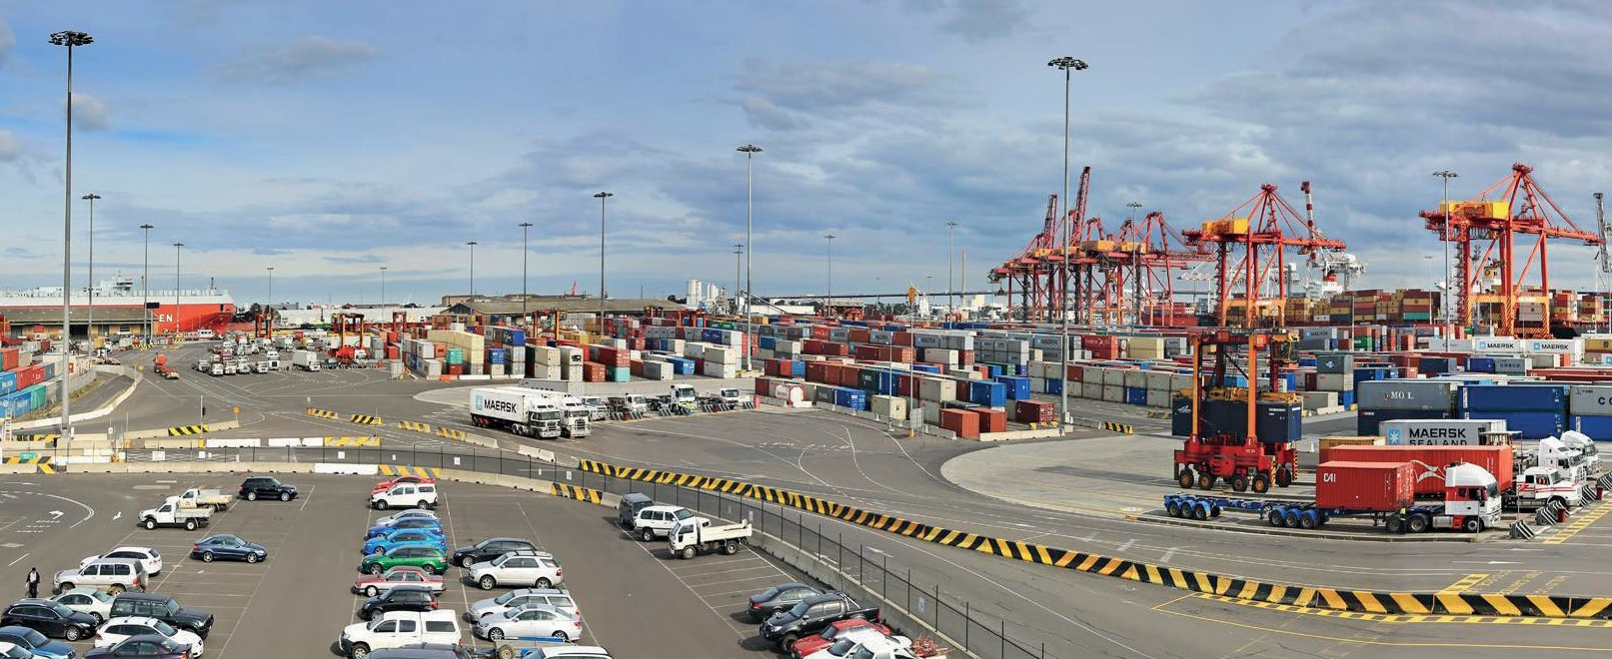

Delivering the next round of Port Development Strategies

PDSs provide considerable value to the ports system. As public documents that are prepared for each commercial port every five years, the PDSs provide transparency and certainty to industry and community stakeholders on the port manager’s land use planning and strategic development priorities.
First established as Port Land Use Strategies, from 2004 commercial ports have been required to publish land use strategies supporting capacity planning. The strategies provide a medium and long-term ‘port development vision’ to:
- create economic value by supporting industry confidence and investment
- maximise efficient allocation of critical port land and infrastructure
- support supply chain efficiency by outlining broader transport network requirements
- provide strategic information to support an understanding of significant environmental and social issues, which have the potential to impact port operations and development
- enable stakeholder engagement on port development operations and matters.
The PDS process promotes continuous improvement in port planning as ports adapt them to changing policy frameworks, stakeholder and system needs. Since 2009, the requirement for each port to prepare a PDS has been a legislative requirement supported by Ministerial Guidelines which set out the content, method and process ports must follow in preparing their plans. The Guidelines are updated from time to time to incorporate new expectations or requirements, enabling the process to remain up-to-date and reflect community expectations. Communities and stakeholders expect to be consulted as part of significant land use planning processes, and they expect port managers to consider both the industries the port supports and the communities which live near each port. The Department of Transport will be preparing updated Ministerial Guidelines to inform preparation of the next round of plans.
When all four plans are published at the same time, the State Government and industry sees a holistic view of expected trade forecasts and plans for port development across the four ports. Over time, timelines of the four commercial ports’ PDS submissions have become misaligned.

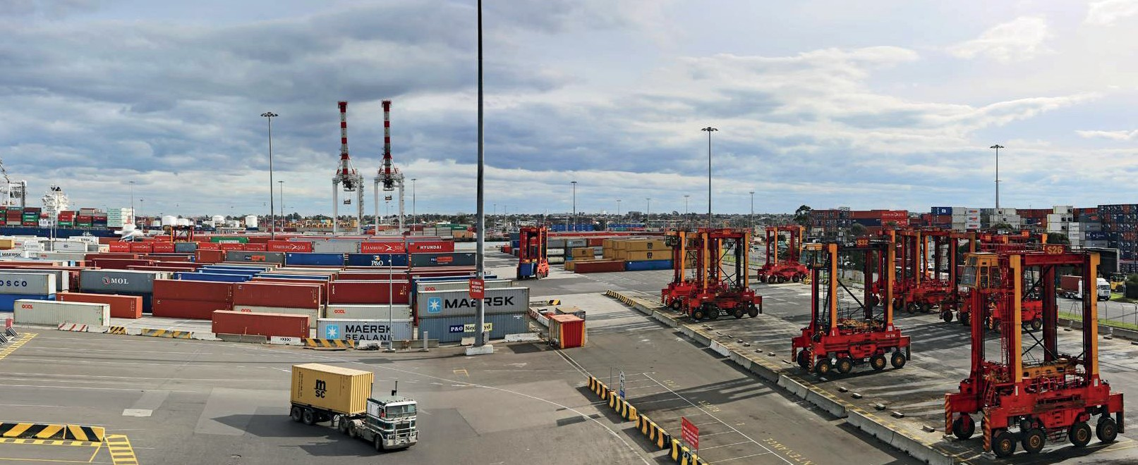

Three of the most recent PDSs were finalised in 2018 while the Port of Melbourne finalised its most recent PDS in 2020.
Initially, the PDSs were expected to be updated every five years. Under this timing, the next four PDSs would be due for completion between 2023 and 2025. As part of preparing an update of the Ministerial Guidelines the Department of Transport will consult with each port to confirm the most appropriate timeframes for their next PDS, noting the intention to bring the four ports back into alignment with a consistent timeframe.
A key part of the future PDS process will be a new and more active role for Ports Victoria supporting the four commercial ports to develop their plans, and providing advice and analysis to the Minister for Ports and Freight on each PDS as drafts are completed. This role will add coordination to the PDS process to increase strategic alignment across Victoria’s ports system. Having agreement on core assumptions, informing forecasts and planning across the sector will support the further growth and success of the ports system. Ports Victoria has been provided funding through the 2022-23 State Budget to commence activity across a range of its new functions including its new PDS role.

Number | Action | Timeframe
Action 14 | The Department of Transport will engage with port managers to revise the PDS Ministerial Guidelines and confirm the due date for the next PDS, with a target completion date between 2024 and 2025. This will support progressively aligning all four PDSs back into the same completion year. | 3 – 5 years
Action 15 | Ports Victoria will establish its new function providing technical support and advice regarding preparation of PDSs. | 3 – 5 years

Putting in place planning protections for a future port at Bay West

The Port of Melbourne is Australia’s busiest and Victoria’s only container port, handling around 3 million TEU per annum. Annual growth is forecast to average 3.5 per cent to 2050, which would result in throughput of around 8.9 million TEU in 2050 (Port of Melbourne, 2020), almost three times the current volume. Whilst the Port of Melbourne is planned to have capacity to accommodate growth for many years up to beyond 2050, it is vital the State has a clear and protected plan for further port capacity in place to activate whenever it is needed.
In 2017, Infrastructure Victoria provided advice to Government, which the Government accepted, that when additional port capacity is needed it should be developed at Bay West to the west of the mouth of the Werribee River. The first action required in the development of any port at Bay West is to confirm the land that will be needed and to protect it.
Early work has now been completed by the Department of Transport, in consultation with Melbourne Water and Wyndham City Council to broadly confirm the land that will be required at Bay West. This includes the land needed for the port itself as well as associated road and rail connections. This work has considered the potential for Bay West to not only handle containers, but also other trades, such as dry and break bulk, grain and roll-on roll-off commodities, including cars, larger vehicles and wheeled equipment.
Figure 6 outlines the potential broad geographical area that has been identified by the Department of Transport to inform planning protection work for Bay West.
The Department of Transport’s work has identified that waterside structures in the order of 300 hectares and 1,000 hectares of land needs to be protected to allow for future development at Bay West.

Figure 6. Indicative location of Bay West
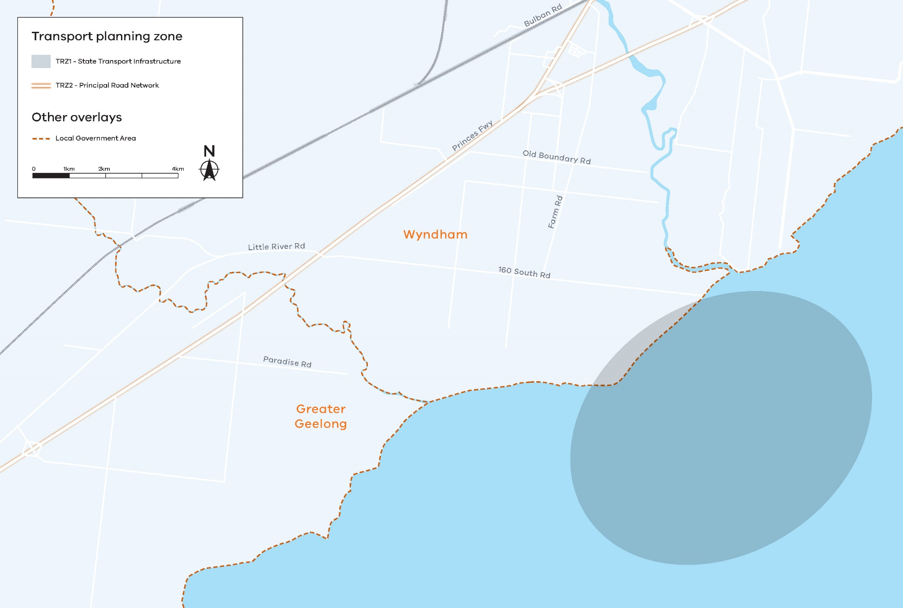

Confirming the scope of road and rail capacity to be connected to the port is key to determining the future port’s landside requirements. The Department’s initial work indicates that a transport corridor cross section may need to be up to 240 metres wide to accommodate adequate long-term road and rail capacity into the port. This width would allow for:
- four truck traffic lanes in each direction
- four rail tracks
- rail maintenance access routes
- an easement for pipelines
- appropriate encroachment zones and allowance for future growth.
The transport access infrastructure required will likely need to be raised on piers to minimise ground contact in accordance with requirements to meet Ramsar Convention listing protocols, requirements for groundwater flow to support the Melbourne Water water treatment facility and to generally minimise flood risk and impact. Such considerations as these and other design elements will need to be assessed in more detail.
While it is currently expected that there will not be a need for a new port at Bay West until around 2050 or later, there is a possibility that additional capacity at Bay West will be needed earlier. It is vital that work proceed now to start protecting the option of a port at Bay West for whenever it may be needed.
The Government will be directing its new statewide port corporation, Ports Victoria, to lead the next phase of planning work in close collaboration with the key transport, environment and planning authorities. This work will need to determine the governance arrangements for Bay West. As it is located in Port Phillip Bay, it does not currently fall within a planning scheme area and sits outside the current Victorian Port Waters boundary.
Options include extending the boundary of Victorian Port Waters to include potential Bay West marine areas, incorporating Bay West land into the Port of Melbourne or Wyndham Planning Schemes, and putting a committee of management arrangement in place.
Bay West is a complex site due to its location within a Ramsar listed wetland and the Melbourne Water treatment facility. In protecting the Bay West site for a major port and associated freight corridors, several assessments will need to be undertaken and these could be specified in the proposed planning controls.
As a first step, the objective will be to confirm the area for an appropriate planning overlay to be put in place to protect the site from any developments and encroachment of urban development that may hinder the ability to efficiently develop a port at Bay West when it’s needed. Such an overlay will provide councils, landowners, and other stakeholders with greater clarity earlier in the strategic and statutory planning process.

Number | Action | Timeframe
Action 16 | The Minister for Ports and Freight in collaboration with the Minister for Planning will advance strategic planning for Bay West by:  - confirming the land that forms an area of interest for the future Bay West  - introducing a notice requirement to Head, Transport for Victoria for new uses in the area of interest for the new container port  - examining planning scheme protection options and strategic justification to reserve land required for the future Bay West to be developed as commercial port  - identifying land required for transport corridors, associated infrastructure and related port activities that will support the development and use of Bay West as a premium container port. | Up to 2 years

Review of land protected for development at the Port of Hastings

The Port of Hastings was established with supporting land use planning arrangements allowing the port to grow and significantly develop over time. To protect it for future port-related development, a vast area of land was put aside with zoning controls. This area is zoned as Special Use Zone 1 (SUZ1) in the area’s planning scheme. Figure 7 outlines the Port of Hastings SUZ1 controls.
SUZ1 is far larger than the declared port area and includes the entirety of the Esso and BlueScope Steel sites, a number of smaller industrial and rural uses and even a small proportion of residential properties. The provisions of the SUZ1 encourage uses that create effective buffers to port-related uses. The land within the SUZ1 is currently not available for industrial development apart from development of the port and port-related industries.
This strategic land-use planning preserves access to areas required to directly undertake port activities, maintains buffers to protect amenity and provides the transport corridors required to link the port to the wider freight network.
Whilst the large land reserves are strategically important and sections should remain protected, as time has passed, it has become clear that it is no longer necessary to retain the entirety of this SUZ1 area as being protected for port related industries. A broader economic development approach for the use of this land would be more appropriate.
If the land within SUZ1 that isn’t needed for port development were rezoned in partnership with the local council, the area may potentially be opened to a range of new industrial-based employment opportunities, in both traditional, and emerging higher value sectors including wind energy.
Figure 7. Port of Hastings Special Use Zone 1
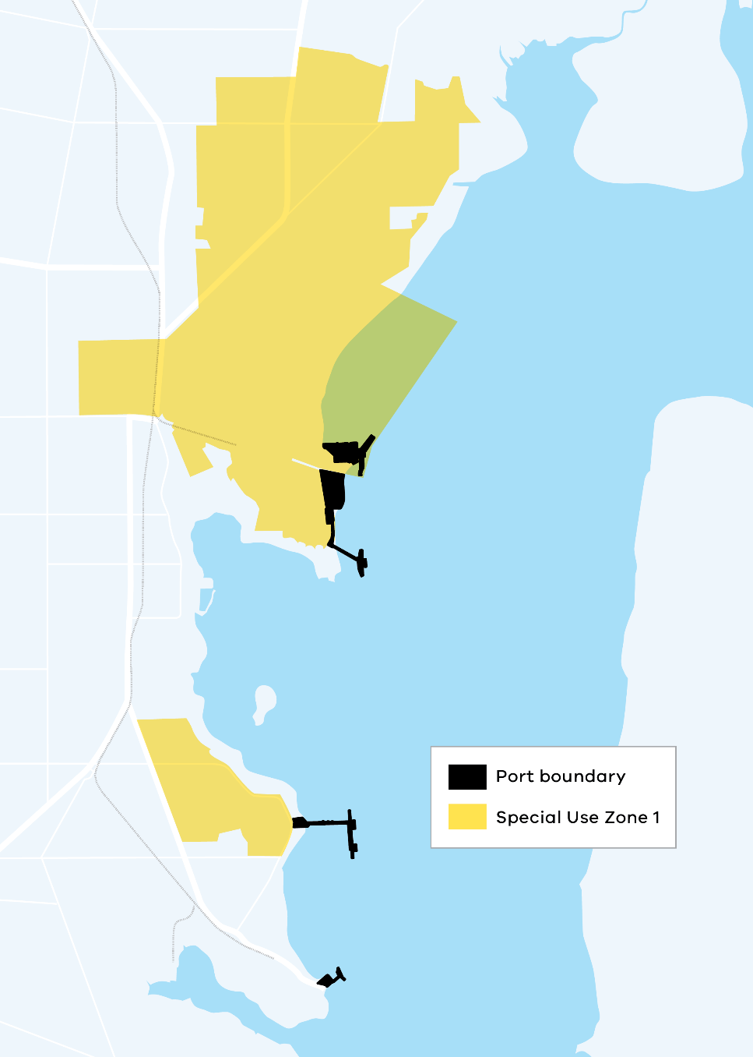
In any process to rezone parts of the SUZ1 no longer needed for port development, the State Government will need to consider a range of complex issues concerning existing and required infrastructure, access and services, interactions with surrounding land uses, and site impediments.
The Minister for Ports and Freight will direct the Port of Hastings Corporation to complete a strategic assessment of the SUZ1 area in consultation with the Council to determine the land requirements needed to support the ongoing operations of Port of Hastings into the future.

Number | Action | Timeframe
Action 17 | The Minister for Ports and Freight in collaboration with the Minister for Planning will review the extent of the Port of Hastings Special Use Zone to unlock surplus land that will not be needed for future port development and enable complementary industrial land-use to occur, such as innovative industrial precincts to support the energy transition. | Up to 2 years
Action 18 | The Minister for Ports and Freight will direct Port of Hastings Corporation to confirm the area of land it requires to be retained for port planning purposes in the next iteration of the PDS. | Up to 2 years

Efficient, productive and resilient in a changing global environment

Ports Victoria as a more active participant in the Victorian ports system

The Government has strengthened the oversight and coordinated planning of Victoria’s ports system through establishing Ports Victoria. Legislation formalising the role and responsibilities of this vital new body was passed by the Victorian Parliament in 2022. The changes reflect that Victoria’s ports don’t operate in isolation; they are key hubs in the broader transport and logistics network across the state. There is a need to support a high level shared purpose and vision for the future of our ports across the whole Victorian ports system.
Ports Victoria’s charter has been expanded beyond the traditional functions of management and control of Victoria’s commercial port waters to make Ports Victoria a key advisor to the Department of Transport, delivering technical advice on maritime operational matters and on the development of Victoria’s commercial port sector. Ports Victoria will also act as a central communicator to the sector, incorporating monitoring, engagement and advice relating to the PDS process, sector trends, and capacity development.
A key element of Ports Victoria’s new role will be to work with all ports as they develop their PDSs to ensure consideration of a consistent statewide perspective on trade forecasts, key industry trends, and assessment of infrastructure requirements. Ports Victoria will also support the Department of Transport to review and update the Ministerial Guidelines which set out PDS requirements.
Ports Victoria’s expanded role will help the Victorian Government ensure that Victoria’s ports complement each other and work together well as a system. In concert, they will provide the most efficient possible combination of capacity and capability to accommodate Victoria’s rapidly expanding trading requirements into the foreseeable future.
Communicating and facilitating information across the Victorian port sector will be an important function for Ports Victoria. Together with the Department of Transport, it will work to establish a regular forum bringing Victoria’s commercial ports and marine stakeholders together to share information and support the whole sector working together towards the vision and objectives of this Strategy.

Number | Action | Timeframe
Action 19 | Ports Victoria will implement its new legislative charter which gives the corporation a new role as a technical advisor to the Secretary of the Department of Transport on port development and maritime-related matters. | Up to 2 years
Action 20 | Ports Victoria will convene a regular industry forum to be agreed with the Department of Transport which includes key port and maritime stakeholders to support industry intelligence sharing and engagement | Up to 2 years

Building on the success of the Voluntary Port Performance Model

In 2020, the Victorian Government completed the Port Pricing and Access Review (PPAR) which was Australia’s first state-based review of landside terminal access charges. It was developed in response to industry concerns about increasing landside terminal access charges levied by stevedores at the Port of Melbourne.
The PPAR provided a comprehensive understanding of pricing and access through the port supply chain. Critically, it found no compelling case for economic regulation of stevedore charges. However, the PPAR report acknowledged that a lack of pricing and performance transparency and insufficient notice of pricing changes was impacting port system users. To address this, the PPAR recommended the implementation of a voluntary scheme to establish greater transparency on port pricing and performance.
In response to the PPAR recommendations, in January 2020 the Minister for Ports and Freight announced the creation of the Voluntary Port Performance Model (VPPM). There are two parts to the existing VPPM:
- a Voluntary Pricing Protocol
- a Voluntary Performance Monitoring Framework (VPMF).
The VPPM formally commenced operating from 1 July 2020 when the Voluntary Pricing Protocol came into effect.
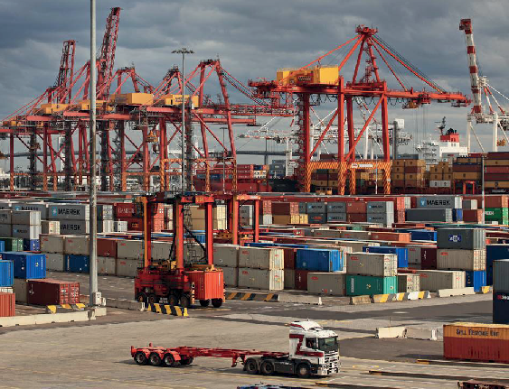
This Strategy confirms the Government’s commitment to continue implementing the VPPM whilst monitoring pricing behaviours across the port supply chain.

Voluntary Pricing Protocol
The Voluntary Pricing Protocol establishes a process for stevedores changing or introducing new landside terminal access charges at the Port of Melbourne. Core features are:
- Frequency: Stevedores are requested to change pricing no more than once per annum.
- Notification: Stevedores must provide 60 days initial notice to industry and Government which provides detail and reasoning for the proposed price change. A final, 30 day notice is also required which addresses any feedback from industry received on the 60 day notice.
- Engagement: The industry engagement period requires any comments to be provided to the stevedore in writing, to support increased consultation between parties on price changes.
A recent review of the VPPM undertaken by the Department of Transport indicates that whilst some parties continue to propose the need for regulation, overall industry participants consider the pricing protocol has added value and responded to some of the key concerns identified in the PPAR.
Observing these generally positive views, the National Transport Commission recently put in place voluntary national guidelines for port pricing that closely align with the Victorian model.
The Government is committed to continue implementation of the Pricing Protocol whilst monitoring arrangements between industry participants. The voluntary protocol can be adjusted and updated with the agreement of the port sector should any changes in the industry require it.

Voluntary Performance Monitoring Framework

To support the introduction of the VPPM, the Department of Transport also developed a VPMF. This involves publishing a quarterly set of performance indicators of the Port of Melbourne’s landside container supply chain operations. The indicators give industry and Government greater transparency on these operations.
Many of the indicators and their definitions are consistent with the Commonwealth Government’s Waterline reporting, helping stevedores provide a consistent and standardised data set to the State and Federal government agencies with which they interact. The VPMF provides a monthly view of port performance by terminal. The published data responds to the findings of the PPAR that the sector would benefit from a greater degree of transparency and a shared understanding of performance that can be used to inform logistics pricing. Figure 8 provides a summary of the VPMF’s existing 19 performance indicators.

Figure 8. Voluntary Performance Monitoring Framework, Performance Metrics – Quarter 1, 2022
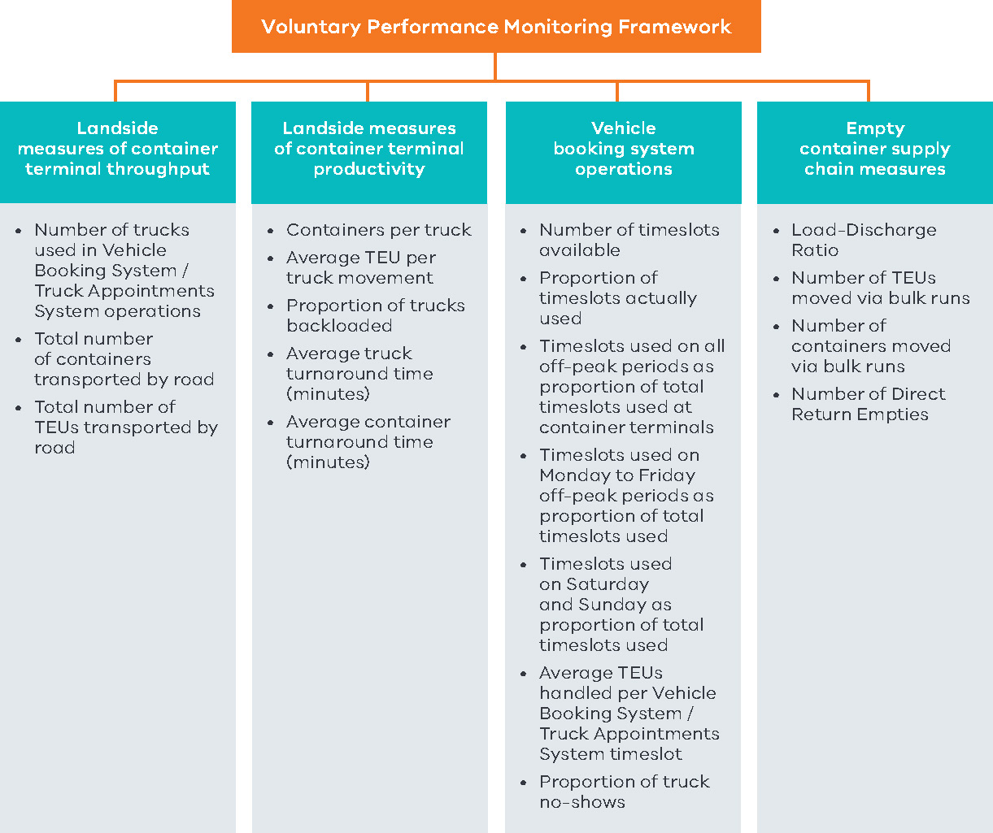

The VPPM influencing national port strategy

In March 2022, the National Transport Commission finalised a new national voluntary guideline for port stevedore pricing which every State and Territory has endorsed as a basis for monitoring pricing behaviour in our ports. This National Transport Commission guideline was largely based on the Victorian experience of introducing the VPPM. There is an opportunity to further develop this work based on work currently being undertaken by the Productivity Commission.
In December 2021, the Federal Government announced a Productivity Commission Inquiry into Australia’s Maritime Logistics System. In recognition of the complexity of the container freight supply chain and the need for a whole-of-supply-chain approach when considering policy options, the Victorian Government advocated in its submission to the Commission’s Inquiry that there is a need for the Commonwealth Government to be playing a more active coordinating role, supporting the states through setting national standards and objectives for the port system which are monitored and reported against.

Under the current federal arrangements, each of the three levels of government have clear roles and responsibilities which need to be carried out – the Commonwealth sets national policy governing the operation of international gateways, States manage access and oversee operation of port assets while local government has a role in the land use planning.
These roles can be delivered more effectively when there is an overarching strategy that guides each level in delivering their responsibilities.
Key points from the Victorian Government’s submission to the Productivity Commission capturing the direction included:
- a need for greater collaboration between the State and Commonwealth Governments to develop national benchmarks for performance of our port sector, supported by analysis of current performance relative to these benchmarks to identify areas where improvement is most needed
- a need to consider a more formalised forum between the Commonwealth and the States to provide a platform to work together and coordinate responses to port performance issues
- a proposed review of Commonwealth Government’s sector performance monitoring through the Bureau of Infrastructure and Transport Research Economics’ Waterline Report and the Australian Competition and Consumer Commission’s stevedore monitoring report to work towards setting some targets for the sector which could be supported through delivery of roles and responsibilities at a state level.

Each of the three levels of Australian government have roles and responsibilities regarding logistics supply chains

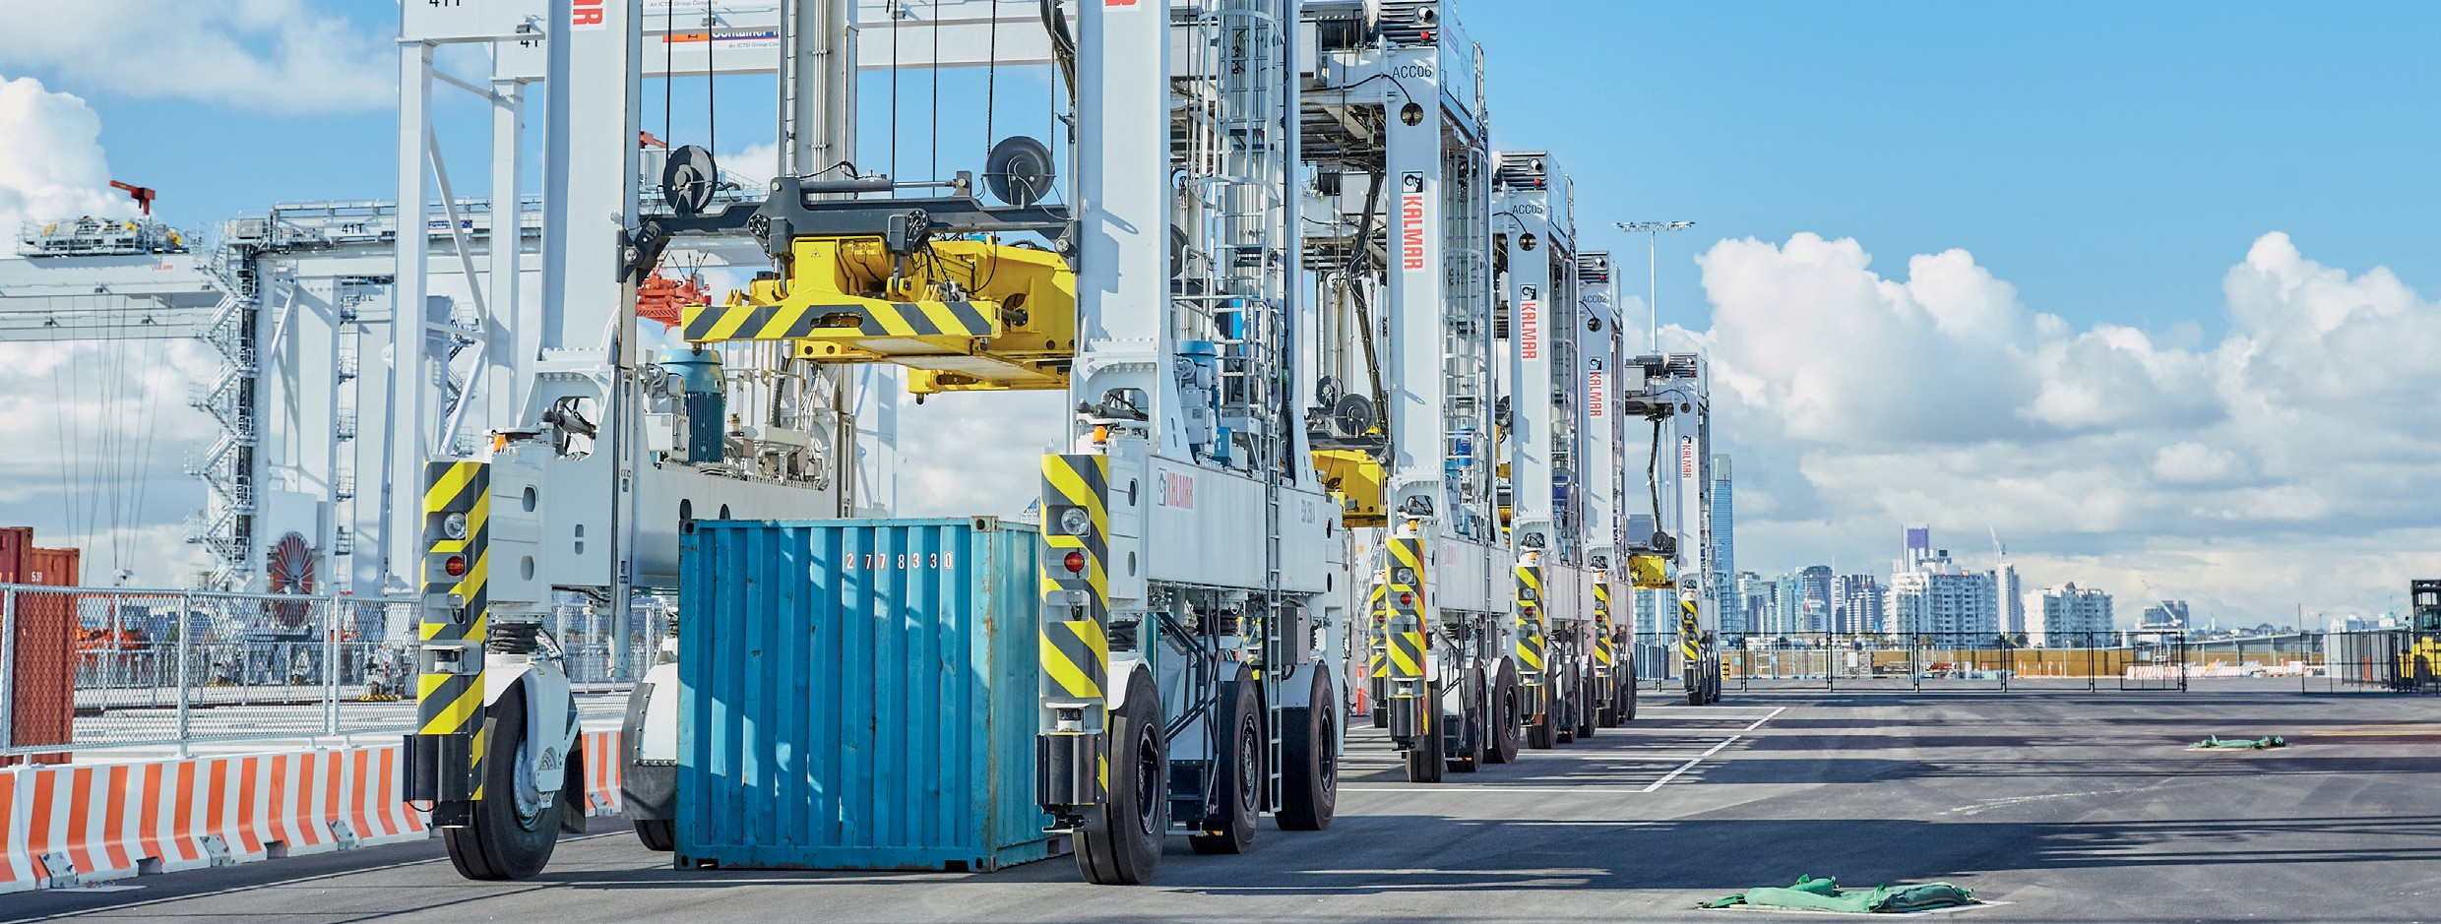

Responding to the increased supply chain volatility and the next phase of the VPPM

In February 2022, the Department of Transport established the Container Storage Working Group (CSWG) to provide immediate advice to Government on current supply chain pressures around the storage of full and empty shipping containers. Convened for an eight week period, the CSWG involved key stakeholders across the supply chain such as shipping lines, transport operators, stevedores, peak bodies and PoM.
The CSWG identified several factors that had impacted the movement of containers through the supply chain between December 2021 and February 2022. During this period transport operators experienced significant challenges in being able to deliver containers to customers, and have them unpacked and returned empty for de-hire in the required timeframes. Full containers built up in significant numbers in transport operator yards above their holding capacity.
The primary cause of this problem was delays in the arrival of some deliveries due to constraints right up the supply chain to the source of imports – this is known as vessel bunching. Labour constraints due to COVID-19 impacts also limited the ability of transport companies to handle the higher volumes.
Vessel bunching is not a new phenomenon. However, there is a growing recognition within the port industry that the growing frequency of bunching, and other disruptions, shows the world has entered a new phase of heightened supply chain volatility.
In response to the increasing volatility the CSWG endorsed the idea of developing a ‘playbook’ that would provide:
- clear and concise information to the sector on roles and responsibilities
- data on performance to indicate when the supply chain is interrupted
- some agreed actions that industry would take when disruption is underway, to reduce impacts for all parties.
To respond to this proposal from the CSWG, the Department of Transport will be commencing work on a range of actions to be incorporated into the VPPM. Work will include:
- developing a port supply chain guide with key information for all participants
- expanding the current VPMF indicators to include a specific package of indicators that supply chain disruption was occurring including vessel arrival, transport yard capacity and empty container handling indicators
- developing a new port system Voluntary Code of Practice for consultation which will include agreed industry responses to assist with the impacts of disruption
- investigating the opportunity to develop a Victorian Ports Community System as a future tool for sharing detailed, real-time information directly between supply chain participants.
Figure 9 provides a view of the proposed makeup of the full VPPM scheme.

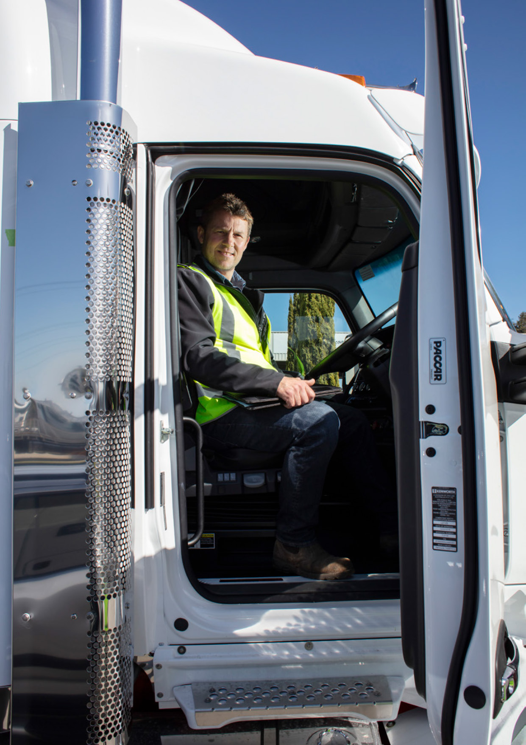

Port Supply Chain Guide
The CSWG highlighted the importance of further embedding a whole-of-supply chain approach further into the VPPM. When the supply chain is under pressure it becomes more important that each supply chain participant has a greater understanding and visibility of other parts of the supply chain to support decision-making and behavioural change that helps alleviate, rather than contribute, to the disruption. The Port Supply Chain Guide will be a tool to lift collective supply chain understanding of the activities, players and interdependencies across the current end-to- end supply chain. It will establish an agreed understanding of the issues and contact points across industry.
Producing the Port Supply Chain Guide will be the first action of the next phase of the VPPM. Industry engagement will be a key component in developing the Guide, building on the success of the VPPM and reflecting the recommendations for refinement from work to date by bodies such as the CSWG.

Expanded VPMF indicators
The second part of the VPPM’s next phase is expanding the current landside performance indicators to facilitate a more end-to-end view of the supply chain. This will build on current work underway by the Department of Transport to add empty container park indicators, including quayside measures like vessel off- window arrival, vessel berthing and forecast port activity.
The Department of Transport will work with industry to expand the VPMF, with the new indicators to focus on metrics that are able to indicate, or predict, container flow disruptions.

Developing a Voluntary Code of Practice
The third component of progressing an industry partnership approach to responding to supply chain volatility is the development of a port system Voluntary Code of Practice (VCOP). This builds on the shared understanding and data gathered by the Port Supply Chain Guide and expanded VPMF indicators to support industry- wide action in response to supply chain disruption or pressure.
Activation of the responses will be voluntary, and the details of the proposals will need to be worked up in close consultation with all participants. Examples of potential responses to disruptions in the container supply chain include:
- working with shipping lines on options for providing multiple/alternative de-hire locations at times of peak congestion, to give greater flexibility to transport operators to de-hire containers at the most efficient locations
- temporarily increasing stacking heights at empty container parks and transport operators, where safe to do so. Where appropriate and safe, increased container stacking heights will temporarily improve the use of existing land at storage facilities and increase container capacity
- other options to share capacity across the sector when constraints emerge across parts of the container supply chain.
The Department of Transport will continue to work with industry and relevant government partners to draft and deliver the VCOP.

Investigating development of a Victorian Ports Community System

There is a need to improve container freight support chain information flows and accessibility to increase data transparency and visibility between supply chain participants.
A Ports Community System (PCS) has been implemented in other jurisdictions to respond to this need. A PCS is an independent and open information system that improves data sharing among businesses and Government in the freight supply chain. This supports more streamlined and efficient decision-making processes to reduce costs.
PCSs respond to supply chain complexity, like fragmented multi-party transactions, insufficient information exchange and inconsistent IT penetration, which reduces the capacity of stakeholders to proactively manage supply chain pressures.
Combined with the lack of container or cargo visibility across the supply chain, there is a risk of duplicated efforts and wasted resources.
Without a whole-of- supply-chain approach to data sharing and performance, it is difficult for industry and Government to consider new ways to improve supply chain efficiencies which can reduce congestion and maximise value of existing infrastructure assets.
PCSs help public and private parties improve, manage, and automate port and logistics procedures, making business interactions between supply chain stakeholders easier.
Given the commercial sensitivities, it is appropriate for the State to consider facilitating and coordinating the development of a PCS to improve performance transparency, innovation and visibility along the Victorian supply chain.

Figure 9. Voluntary Port Performance Model
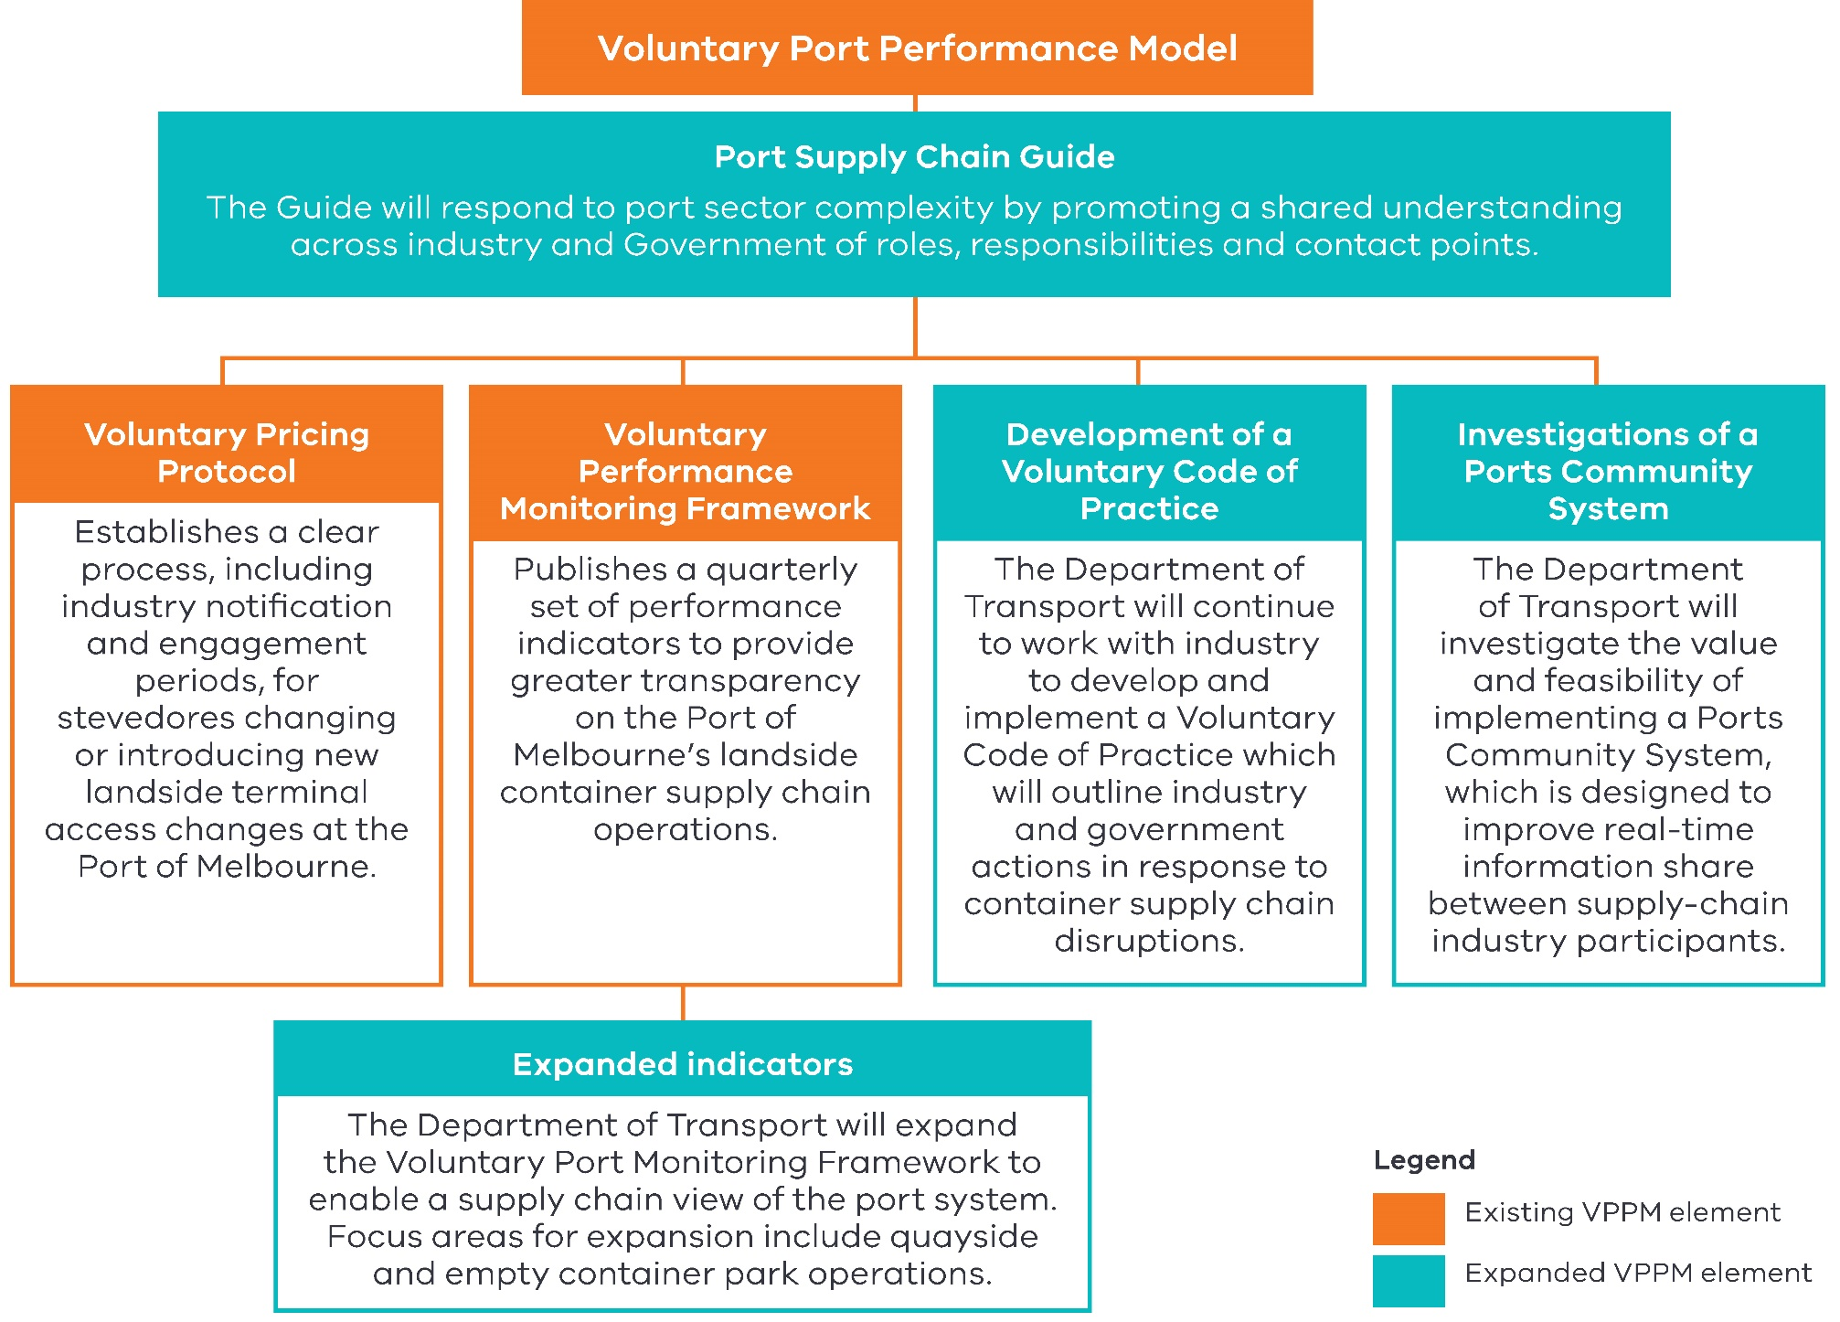

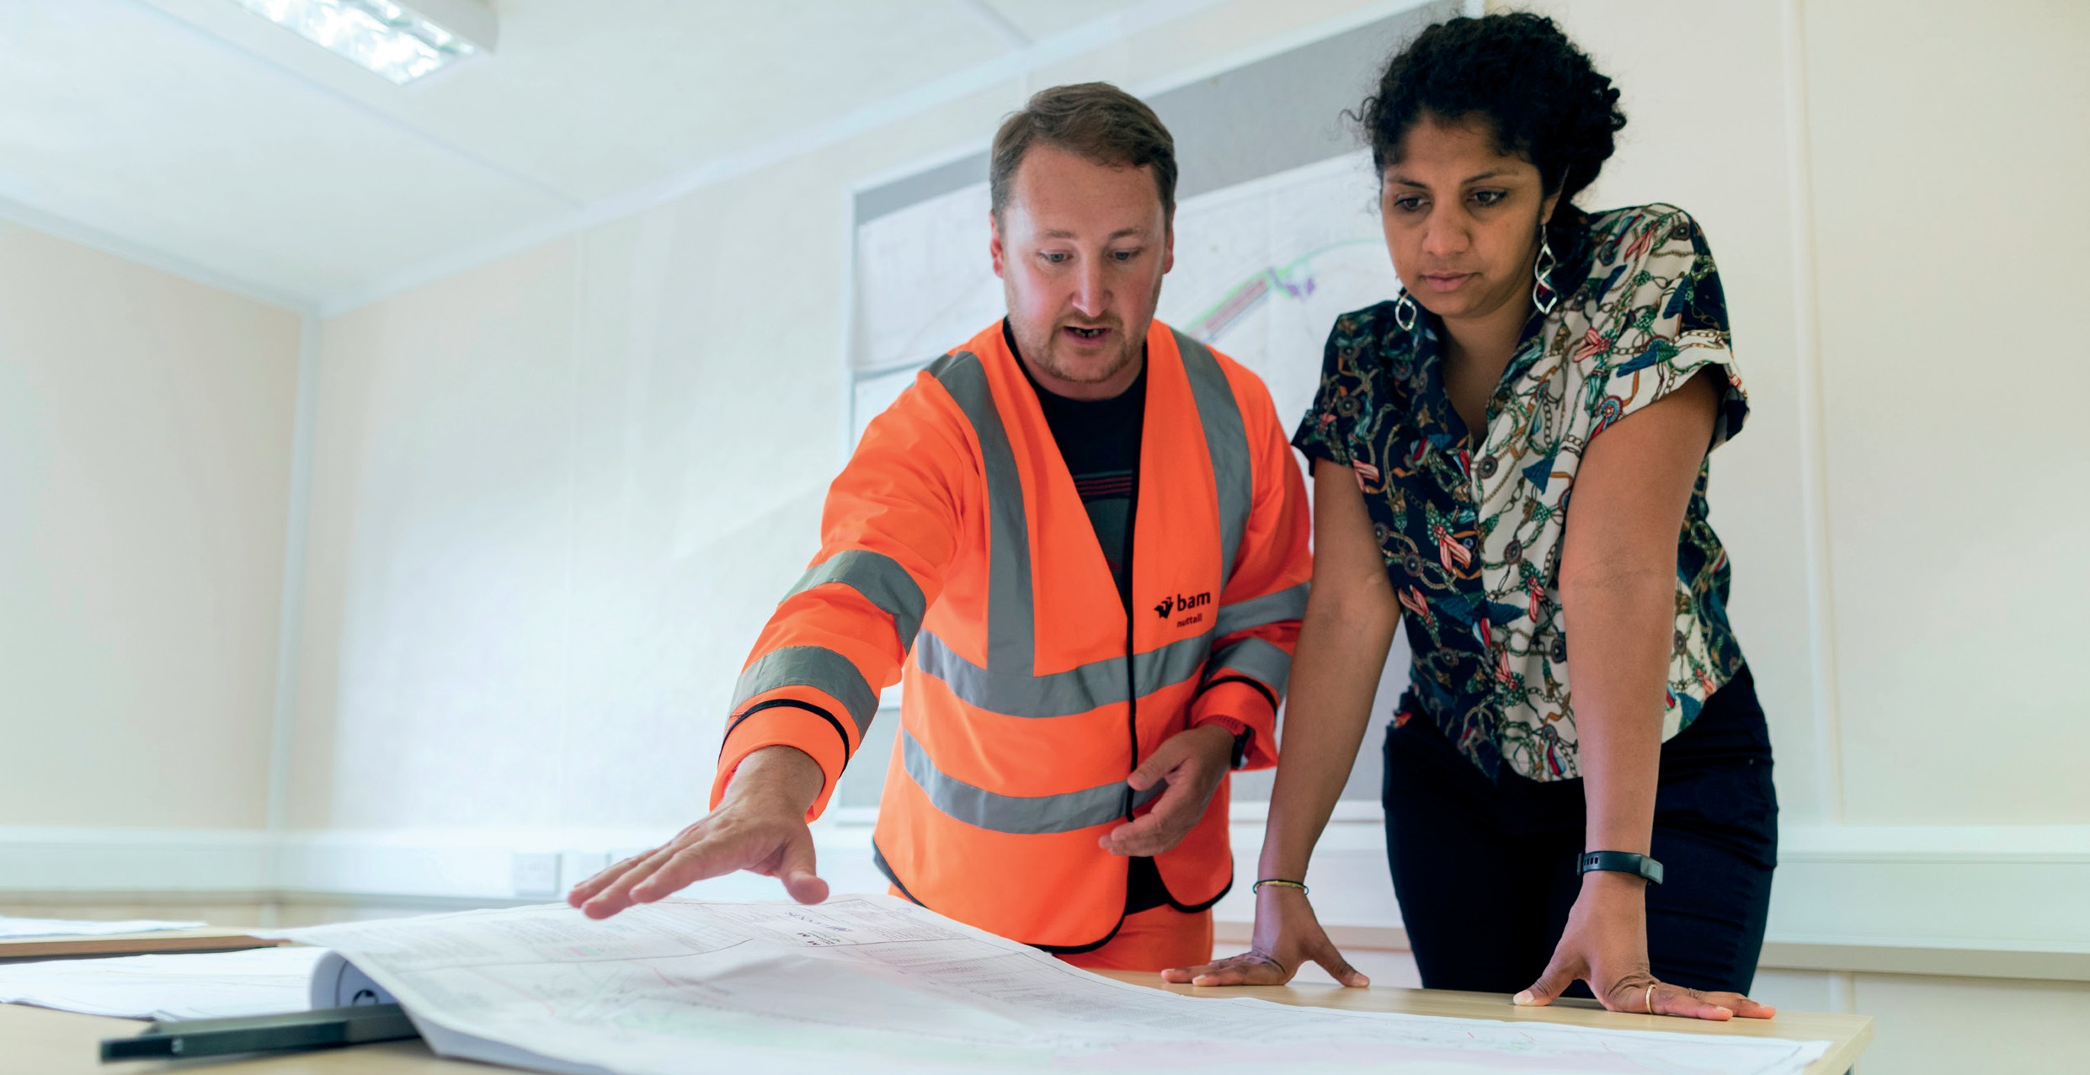
Number | Action | Timeframe
Action 21 | The Department of Transport will continue to monitor the effectiveness and implementation of the Voluntary Pricing Protocol. | Up to 2 years
Action 22 | The Department of Transport will continue to expand the Voluntary Port Monitoring Framework metrics to provide industry and government with an end-to-end, supply chain view of the performance of the container freight supply chain. Focus areas for expansion will include adding performance metrics for quayside arrivals and empty container park operations. | Up to 2 years
Action 23 | The Department of Transport will work with the Federal Government on relevant findings from the federal Productivity Commission’s Inquiry into Australia’s Maritime Logistics System. | Up to 2 years
Action 24 | The Department of Transport will prepare a ‘port supply chain guide’ confirming roles and responsibilities of industry participants to promote a shared understanding across the sector. This guide will also confirm the indicators to be used to measure that disruption of container flows is occurring. | Up to 2 years
Action 25 | The Department of Transport will continue working with industry to further develop a Voluntary Code of Practice for how industry works together to respond to a blockage in container flows when it occurs. | Up to 2 years
Action 26 | Ports Victoria will develop advice for the Minister for Ports and Freight on opportunities for improving container freight supply chain information flows between supply chain participants. This will include investigation of the long-term role and feasibility of a ports community system in Victoria. | Up to 2 years

Ports supporting Victoria to drive supply chains to net zero emissions

Victoria is transitioning to a clean energy future. Transition will be driven through new technologies, private sector adoption and investment, and government incentives supporting change. Victoria met its first Victorian Renewable Energy Target of 25 per cent renewable energy generation by 2020 and is continuing to transition toward meeting the legislated targets of 40 per cent by 2025 and 50 per cent by 2030. In addition to these specific energy generation targets Australia has committed to reaching net zero emissions across our national economy by 2050.
Victoria’s ports system will be integral to this energy transition, with a role contributing to our economy’s shift towards the production, distribution and use of new energy. Importantly, in the short-to-medium term, ports may be needed to support the State’s supply of liquid natural gas as Victoria shifts to other energy sources. In the long-term, Victoria will work toward decarbonising its domestic economy through investing significantly in wind generation among other renewable sources. Ports will feature significantly in this new industry, supporting the construction and maintenance of new offshore wind turbines.
The Government has recently announced a commitment to progress planning for offshore wind power generation to be in place and producing energy from 2028 with targets of 2 gigawatts to be produced by 2032, 4 gigawatts by 2035 and 9 gigawatts by 2040. The Department of Transport will continue working with the Victorian ports sector and the Department of Environment, Land, Water and Planning to confirm the best approach for the development of port capacity supporting offshore wind as the role of this exciting new industry emerges in coming years.
Victoria’s energy transition will potentially include emerging new industry producing and exporting hydrogen to the world. Port infrastructure at the Port of Hastings is already playing a key role in piloting the export of hydrogen to Japan, with planning underway for potential commercial scale export volumes through the port by 2030. The Department of Transport will work with Ports Victoria to ensure that statewide, ports play an active and effective role supporting the ongoing energy transition of our state.
In addition to supporting the supply lines of energy products to and from Victoria, port supply chains are a key user of energy to power the plant and equipment, trains and trucks that are moving trade through our ports. The Government is committed to working with the sector to identify opportunities to support transition across the industry to low and zero emissions vehicles and other equipment and will consider any proposals from the sector which support the objective of a net zero port sector. Opportunities to trial the refuelling and operation of hydrogen vehicles through the port supply chain will be a particular focus of further investigation.
The Department of Transport will commence work with the operator of the Port of Melbourne to encourage transition in the vehicle fleet currently servicing the port. Some of the trucks servicing the port are the oldest vehicles now operating in the State, with trucks being demoted as they age from long haul tasks to jobs covering a shorter distance, such as staging movements from the port to near port depots. There is an opportunity to progressively encourage and, ultimately, require a higher standard of emissions for vehicles that access the port. Once designed, such an approach to requiring higher emissions standards to access a key node such as the Port of Melbourne could be used as a model for encouraging low emissions for vehicles accessing other key freight and logistics zones across Victoria.

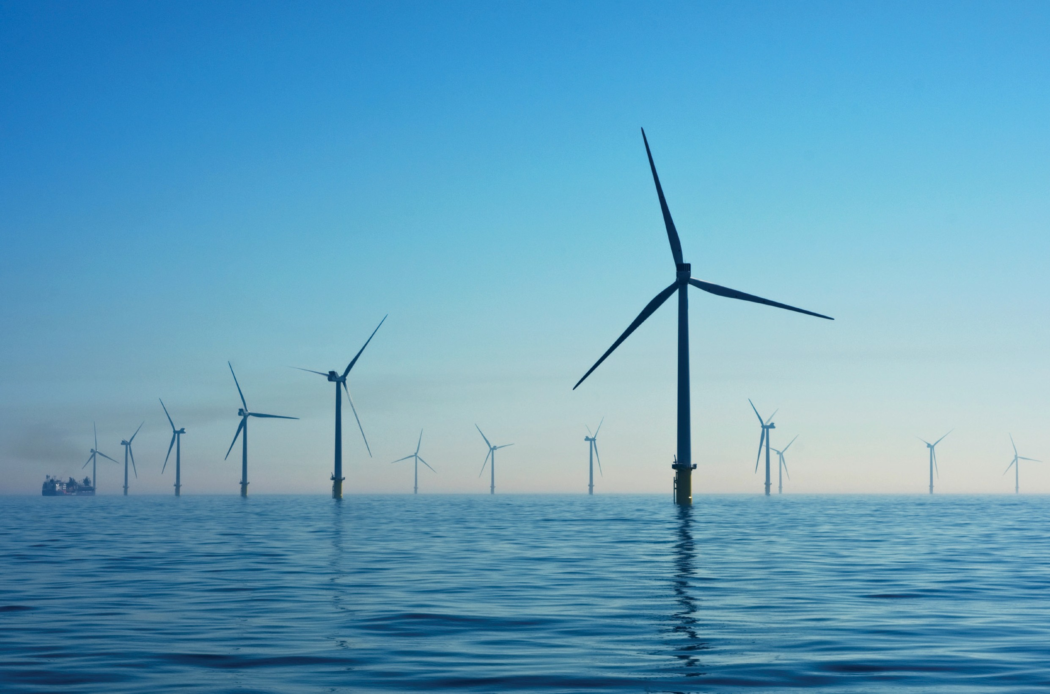
Number | Action | Timeframe
Action 27 | The Department of Transport will continue working with the Department of Environment, Land, Water and Planning, Ports Victoria and the ports sector to help the commercial ports support the State’s renewable energy targets and transition to a net zero emissions economy by 2050. This will include consideration and further investigation of decarbonisation of ports activities and facilitating change in liquid bulk commodities. | 3 – 5 years
Action 28 | Government will work with the ports sector to trial and promote lower emissions across the port supply chain. A focus will include further investigation of opportunities to trial and test hydrogen trucks and refuelling facilities. | Ongoing
Action 29 | The Department of Transport will work with the Port of Melbourne to design and implement arrangements which progressively encourage and then require a higher standard of emissions for vehicles that access the port. | 3 – 5 years

Workforce and skills

In 2021, sea freight supported over 290,000 full-time equivalent jobs in Victoria both directly and indirectly, through enabling imports and exports. This reflects the critical role of skilled labour in delivering freight from ship to shore to door.
The Federal Government’s Vulnerable Supply Chains, Productivity Commission Study Report (July 2021) noted that a large number of skilled and a smaller proportion of highly skilled workers are a key component of the transport system, and skilled labour shortages pose a risk to supply chain resilience. The report acknowledges that highly specialised skills, such as those held by Harbour Masters, are more difficult to substitute or replace, however tend to have less demand by volume.
The Productivity Commission suggests a greater risk is a widespread shortage of skills, which are more effectively responded to through skills policy and education systems.
Education and training are a key policy purview of the State Government and an important lever in delivering an efficient and effective ports and freight system.
Before the COVID-19 pandemic, it was well documented that the maritime, freight and logistics workforce was experiencing considerable workforce shortage. For example, in a recent industry survey led by the Victorian Transport Association, 95 per cent of 75 Victorian operators surveyed were experiencing driver shortages – totalling nearly 1,800 existing vacancies. Figure 10 shows a summary of workforce needs across the various parts of the maritime, freight and logistics supply chain.

Figure 10. Summary of key maritime freight and logistics workforce needs
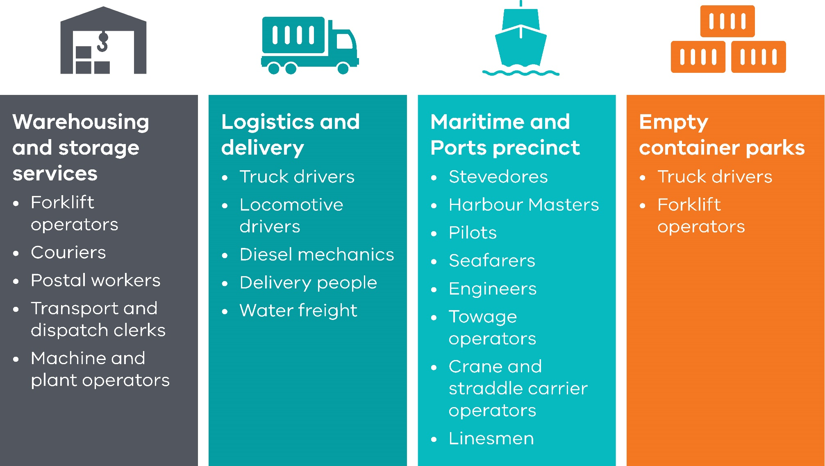

The maritime freight and logistic sector is an aging workforce with a significantly higher representation of men than women; around 71 per cent of workers are male. Approximately 37 per cent of workers are aged over 50 years; this is higher than the Australian average of 30 per cent of workers being over 50 years old.
The Victorian Skills Authority has identified several barriers to workforce entry:
- high entry-level requirements, particularly relating to licensing for heavy and multi combination vehicles
- rapid adoption of new technology and ‘big data’, driving new skill requirements
- low awareness of the industry and employment opportunities that would encourage new entrants and diversity
- a perception of poor work conditions and greater safety risk and accidents for industry participants, deterring new entrants to the sector
- high casualisation and insufficient secure employment opportunities.
The State Government is already progressing programs to address these workforce shortages. For example, the Victorian Transport Association has been allocated $500,000 per year over 3 years for the delivery of the Transport & Logistics Industry Based Training Program. This funding will support a total of 120 new heavy vehicle drivers in the Victorian freight sector. The Department of Transport will continue to work with the Skills Authority to develop effective plans to continue supporting the freight and logistics sector to access the workforce it needs to operate well.
Establishing Ports Victoria as a Centre of Excellence for the Victorian port sector will provide a unique opportunity for a new look at what else could be done to support more Victorians taking up a maritime career. Harbour Masters, towage operators, service vessel operators and, in the future, maritime skills supporting the construction of offshore wind turbines, are all high skilled and critical occupations that Victoria’s future economy will rely on to grow. As part of its expanded charter Ports Victoria will be asked to prepare advice for the Minister for Ports and Freight on what could be done to support the growth of training and provision of clear employment pathways for Victorians seeking a maritime career.

Number | Action | Timeframe
Action 30 | Ports Victoria will be asked to prepare advice for the Minister for Ports and Freight on options and opportunities to support Victorians to establish a career in the maritime industry. This advice will complement the work underway by the Victorian Skills Authority, supported by the Department of Transport, on workforce priorities for the transport and logistics sector more generally. | Up to 2 years
Action 31 | The Victorian Government will continue to work with the Commonwealth to investigate opportunities to sustainably develop a coastal shipping industry as a key platform for Victorians to work and gain maritime workplace experience. | Ongoing

Responding to Essential Services Commission’s Port of Melbourne Lease inquiries

In 2016 the Victorian Government leased the land, channels and infrastructure forming the Port of Melbourne to the private PoM for a period of 50 years. While there are considerable benefits to privatising state assets, there is a need for the Victorian Government to ensure the port promotes the long-term interests of Victorian consumers and businesses.
Recognising this, the State Government developed a robust regulatory framework around the PoM lease under the Port Management Act 1995 and the Delivering Victorian Infrastructure (Port of Melbourne Lease Transaction) Act 2016.
Since 2016, the Essential Service Commission (ESC) has become responsible for various regulatory roles safeguarding the interests of Victorian consumers by monitoring the efficient, fair and reasonable provision of pricing and services at the port. There are three aspects to the ESC’s regulatory regime:
- pricing and provision of prescribed services
- setting of rents for Port of Melbourne land
- functions relating to the potential development of a second international container port in Victoria.
The ESC completed its first Market Rent Review into the PoM’s port tenant rents covering activities for the first three years of the Port Lease between November 2016 to October 2019.
In response to ESC’s findings and recommendations, PoM has, in consultation with port stakeholders, prepared and released publicly a Tenancy Customer Charter to enhance the transparency, clarity, and processes of its rent negotiations.
On 28 January 2022 the ESC released its first inquiry into the PoM’s compliance with the Pricing Order covering the five year period to 30 June 2021. While PoM was compliant in some areas the ESC found that it has not been fully compliant with State Government’s legislative requirements for how it should set prices for services, including:
- three significant and sustained non- compliances in return on capital, aggregate revenue requirement, and effective consultation with port users
- four sustained but not significant non- compliances in operating expenditure, cost allocation, prescribed service tariffs, and tariff compliance statements.
The Victorian Government has accepted a package of enforceable commitments made on pricing and consultation from the PoM that it will make pricing and stakeholder consultation fairer and more transparent and ensure the port operates to the benefit of all Victorians.
The package of commitments, including a legally binding Undertaking, is designed to remedy the non-compliance identified by the ESC inquiry.

Number | Action | Timeframe
Action 32 | The Department of Transport and Department of Treasury and Finance will continue to review the performance and effectiveness of the Tenancy Customer Charter and PoM’s package of commitments including its enforceable Undertaking. | Ongoing

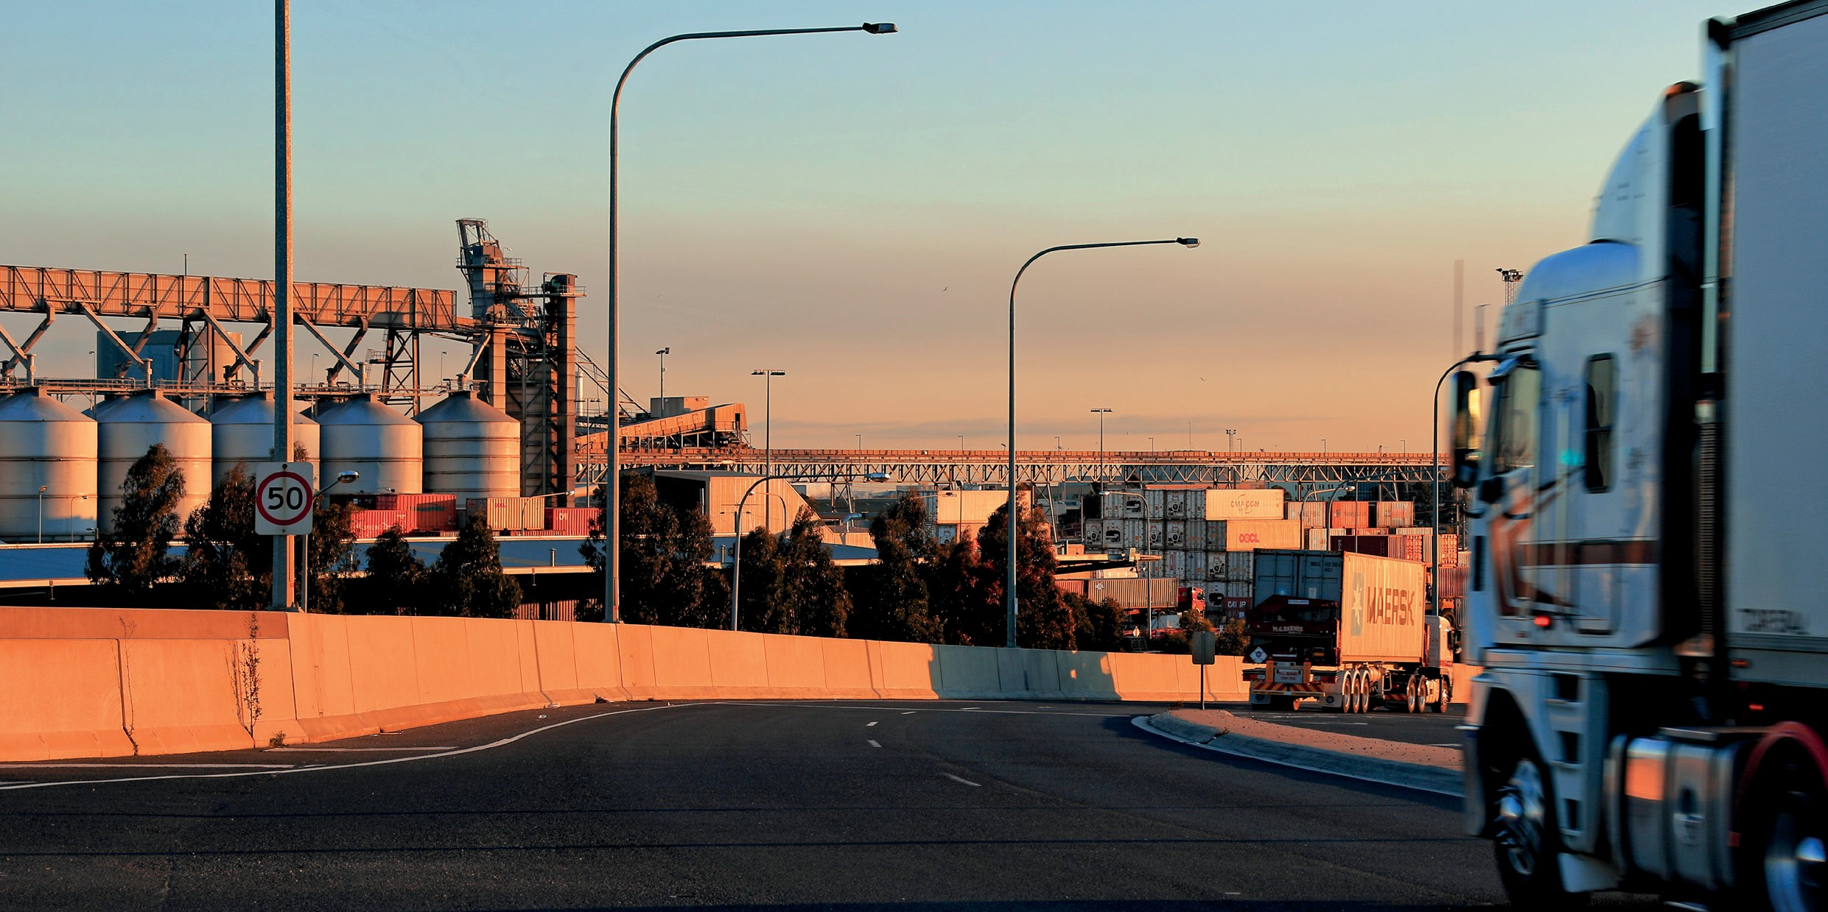

Safe, and operated with clear roles and responsibilities

Ports Victoria’s expanded role in statewide navigational safety

Ports Victoria has now been established as Victoria’s preeminent port safety advisory body. Ports Victoria’s charter has been amended to give it oversight of maritime navigation across all of Victoria’s commercial port waters and all State waters where requested by the Maritime Safety Director at Safe Transport Victoria (the transport safety regulator). Ports Victoria will gain a new expanded role to deliver safety advisory, licensing of pilotage and towage services, support for local port managers, and advice to Government on a range of port and freight matters.
In keeping the state’s commercial port waters safe and accessible, Ports Victoria will work to integrate the state’s maritime navigational safety systems.

Its activities and services must support safe and accessible navigation, appropriately provided and overseen.
Reforms identified in the Government’s Response to the Independent Review of Victoria’s Ports System will be implemented by Ports Victoria, including non-exclusive license regimes for towage and pilotage services.
As part of its advisory role to Government, Ports Victoria will support the Department of Transport as it plans to develop the Victorian Ports System and obtain planning protections for a future port at Bay West.

Number | Action | Timeframe
Action 33 | Ports Victoria will work with key users and operators across the Victorian Ports System to establish its new role as the lead technical maritime safety expert in Victoria. | Up to 2 years

Strengthening the maritime elements of port Safety and Environment Management Plans

Under Part 6A of the Port Management Act 1995 all commercial and local port managers must prepare a SEMP. When preparing a SEMP, port managers systematically examine port-wide activities to ensure all hazards and risks are identified and controlled, either by the port manager or by other responsible parties. SEMPs are intended to complement existing requirements under marine safety, occupational health and safety and environmental legislation and regulations.
Under section 91G of the Act, the Minister may issue Ministerial Guidelines on the form, content and process for preparing a SEMP. New or amended SEMP Ministerial Guidelines were last published in 2012.
The Review concluded it was timely for the Department of Transport to review the current Ministerial Guidelines given the current reforms to roles and responsibilities in Victoria’s ports system – most significantly the creation of Ports Victoria. As a part of updating the Ministerial Guidelines, there is an opportunity to strengthen Victoria’s SEMP arrangement through introducing a new marine or port safety code as a component of the SEMP framework.
Ports are by their nature risky environments. An accident in a port can be catastrophic economically, environmentally, reputationally and in human cost.
Internationally, Port Marine Safety Codes have their origins in such accidents. The first code established in the United Kingdom was created after the devastating Sea Empress accident in Wales in 1996. Following this, port marine safety codes have been developed across the world and have arguably helped mitigate marine and port risks despite exponential growth in maritime trade and traffic.
A new maritime safety code for commercial ports will be introduced through an update of the Ministerial Guidelines and approval of SEMP auditors who are specialists in maritime safety to support the introduction of the new requirement. Currently, the Ministerial Guidelines supporting the maritime safety component of SEMPs emphasise the process that must be followed by port managers.
SEMP auditors are generally safety systems specialists rather than marine safety experts.
The Department of Transport will work with Safe Transport Victoria and Ports Victoria to prepare updated Ministerial Guidelines that will include a port marine safety code. The new code will enhance the existing SEMP process by defining clear standards that commercial port managers will need to meet to safely manage Victorian waters.

Number | Action | Timeframe
Action 34 | The Department of Transport will work with Safe Transport Victoria and Ports Victoria to develop a new port marine safety code for the Victorian Ports System which will form part of SEMP preparation and review processes. | 3 – 5 years
Action 35 | The Department of Transport will work with key stakeholders to ensure that the SEMP Ministerial Guidelines effectively and appropriately respond to recent legislative and regulatory changes, including relevant functions related to the functions of the transport safety regulator. | Ongoing

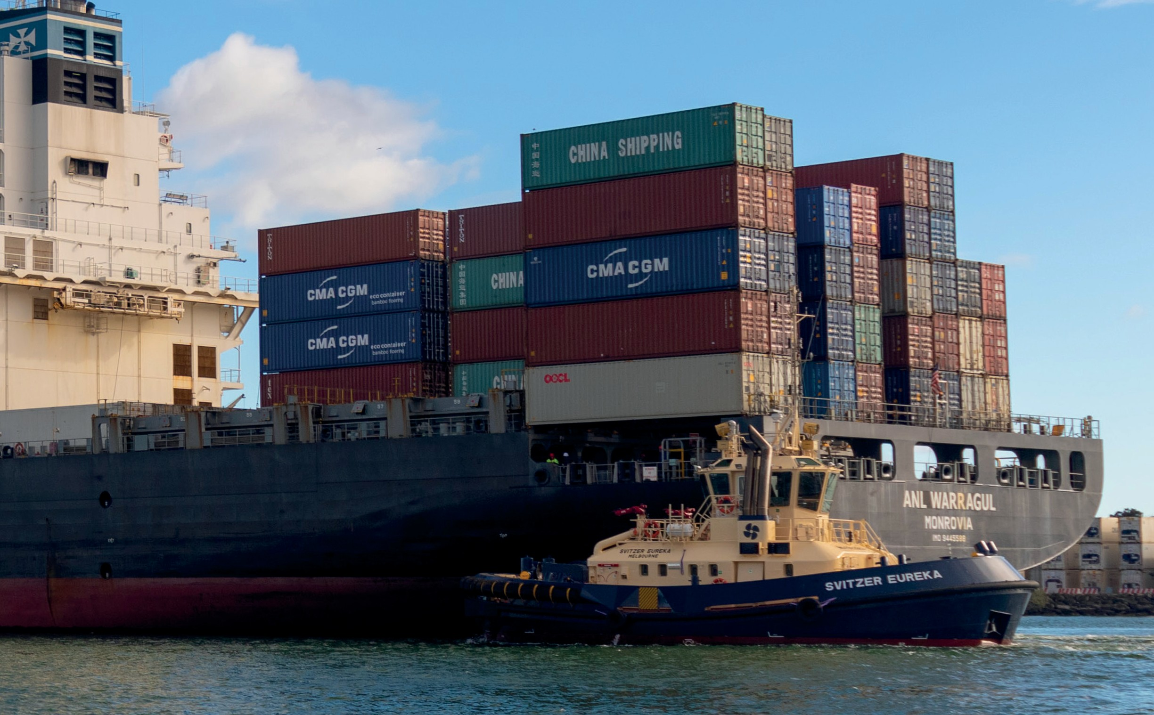

Implementing new licensing regimes for pilotage and towage

Pilotage

The Review found there was a case for stronger regulation of pilotage services operations in Victoria, particularly when implementing safe operating practices and adhering to an effective performance management framework.
Under the new regime to be implemented in 2023, Ports Victoria will be responsible for issuing a licence to any pilotage service provider meeting the standards and requirements set out under the licensing scheme. Safe Transport Victoria will retain
responsibility for licensing individual pilots and registering pilotage service providers after the issue of a licence by Ports Victoria.
The issue of a licence by Ports Victoria effectively certifies the applicant has demonstrated to Ports Victoria that they have sufficient knowledge, skills and expertise on Victorian port navigation systems, including Harbour Masters Directions.
Consistent with the licensing scheme to be applied to towage service providers, under the new regime it will be an offence to provide pilotage services without being licensed. Safe Transport Victoria will continue to register Pilot Services Providers once licensed by Ports Victoria.
The new licensing scheme will come into effect after Ports Victoria has developed the standards and requirements it wishes to apply across different ports and port waters.
The transport safety regulator will retain responsibility for licensing individual pilots and developing appropriate standards of training for pilots and pilot-exempt masters, and related matters.

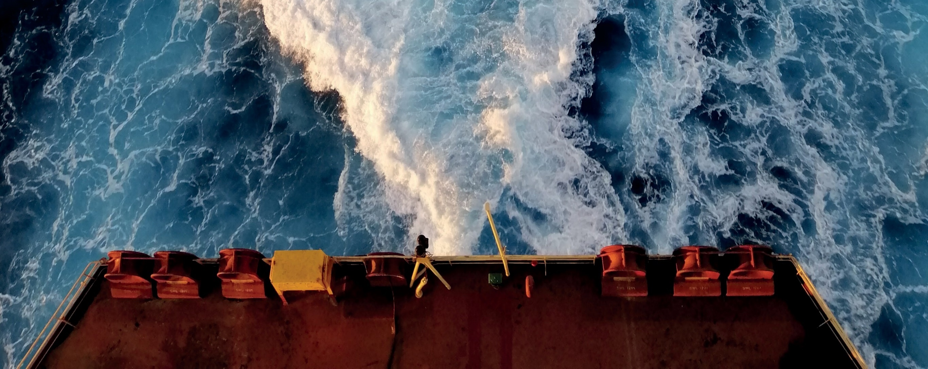

Towage

The Response to the Independent Review supported the establishment of a non-exclusive towage licensing scheme to replace the current provisions in the Port Management Act 1995 (Vic). The provisions are based on the principle that Ports Victoria (or a delegated port operator) is best placed to ensure operational continuity of towage services in Victoria’s various commercial ports under general licence conditions. The new regime will:
- support operational, emergency response and safety standards
- ensure that, where possible, licensed towage services are available in commercial trading ports
- ensure that Ports Victoria should be empowered to directly procure towage services if a service availably gap exists until a suitable commercial operator is found.
Under the new regime Ports Victoria will have the power to specify licence conditions that apply to licence holders and will be able to set varying towage standards and requirements across ports and port waters.
The transport safety regulator will retain responsibility for licensing towage masters and developing appropriate standards of training, and related matters. Ports Victoria will have the ability to establish a non-exclusive license scheme for towage services in Victorian commercial ports.
The new licensing scheme will come into effect after Ports Victoria has developed the standards and requirements it wishes to apply across different ports and port waters.

Number | Action | Timeframe
Action 36 | Establish a non-exclusive license regime for pilotage services in Victoria, with standards to be set by Ports Victoria to come into effect from 2023. The standards will be determined following consultation with key stakeholders to ensure the outcomes of reform are met. | Up to 2 years
Action 37 | Establish a non-exclusive license scheme for towage services at Victorian commercial ports, with standards to be set by Ports Victoria to come into effect from 2023. The standards will be determined following consultation with key stakeholders to ensure the outcomes of reform are met. | Up to 2 years

Local ports and waterway reforms to improve marine asset planning and maintenance outcomes

Victoria’s local ports enhance community life, and support physical and mental health and leisure activities including recreational boating and fishing, commercial fishing and passenger charters and waterfront promenading.
Local ports and waterways exist in a complex governance environment, with multiple agencies responsible for overseeing a diverse range of marine operation functions. This means there are often inconsistent or inefficient approaches to asset planning, maintenance and use of resources. Until recently there has been little strategic oversight of vital community assets, resulting in pier closures, stranded assets and a high level of community frustration.
The Sustainable Local Ports Framework represents a more strategic approach to prioritising local port assets across the State. With the Framework now in place, it is time to consider tailored governance arrangements, improved oversight and accountability for marine asset planning and maintenance.
Responsibility for local port functions are set out in the MSA and are separate to the waterway management functions set out under Part 10 of the Water Act 1989. The local ports and waterways functions, as specified under the MSA, are currently managed across a range of agencies including Freight Victoria, Department of Transport Marine Pollution, Parks Victoria, Department of Land, Water, Environment and Planning, Better Boating Victoria, Safe Transport Victoria, and the declared local port and MSA waterway managers. The result of this devolved arrangement is that there is currently no one entity responsible for developing and implementing statewide local port and waterway management policy and strategy.
Current arrangements for local port and waterway management lack:
- coordinated marine asset policy and strategic planning functions – currently this is provided by multiple agencies
- consistent service delivery standards for asset maintenance and development – multiple port and MSA waterway managers rely on different organisational policies for asset standards
- clear public asset investment and prioritisation frameworks that service the needs of the community and visitor economy
- a way to capture economies of scale across the State supported by clear and joined-up statewide strategy.
The Review concluded there is more synergy between the MSA functions of local port managers and MSA waterway managers than between local port managers and commercial port managers. The size of vessels, and the related economic implications and safety risks associated with commercial trading ports are a much larger scale than those experienced in the local ports and waterways.
Combining the oversight of both local ports and managed waterways functions will enable the Victorian Government to address their respective management, funding and risk profiles in a consistent way. This may lead to greater consistency in the way waterways and local ports are managed. Any changes to oversight will be considered in the context of the State’s Marine and Coastal Policy and the Marine Spatial Planning Framework to ensure an integrated approach with planning for the coastal and marine environment.

Number | Action | Timeframe
Action 38 | The Government will develop a plan to consolidate local ports and MSA waterways functions in a new Ports and Marine group in consultation with the relevant agencies. The new group will be accountable for local ports and waterways policy and strategy, bringing together existing functions now sitting across several areas under the MSA . | Up to 2 years

Summary of the Government’s Action Plan
Number | Action | Lead Agency | Timeframe
 | Objective 1: Responsive to market demands
Action 1 | The Department of Transport will continue to work with the PoM to support its planning for the next tranche of container capacity, noting that the PDS outlined that additional capacity is expected to be required around 2030 to support Victoria’s forecast trade demand. | Department of Transport | Ongoing
Action 2 | The Department of Transport will work with the PoM on the land transport connection planning for the port generally including planning for any new road and rail network capacity needed to support the growth of trade volumes at Webb Dock. | Department of Transport | 3 – 5 years
Action 3 | Port of Hastings Development Authority to be renamed Port of Hastings Corporation, reflecting its refocused legislative charter. | Department of Transport | Up to 2 years
Action 4 | The Port of Hastings Corporation will prepare an investment case for a new multi-user facility on the OTRA able to support future and new trades including hydrogen related projects, aggregate imports, supporting construction of offshore and onshore wind developments and other new bulk and break bulk trades. | Port of Hastings Corporation | Up to 2 years
Action 5 | Ports Victoria will prepare a business case, for government consideration, to support the future of cruise shipping in the Station Pier precinct. This will confirm the optimal arrangement for cruise operations within the precinct, identify the best use of the current pier and plan for an integrated transport and land use outcome for the precinct. A key aspect of this planning is ensuring the valued heritage of Station Pier is protected for future generations. | Ports Victoria | Up to 2 years
Action 6 | In parallel with work on the Station Pier Precinct Business Case, Ports Victoria will commence development of a Victorian Cruise Shipping Strategy which assesses opportunities for growing the Victorian cruise shipping sector. Working with key stakeholders such as Visit Victoria, the Strategy will assess opportunities for further development of cruise services servicing regional areas, considering operational requirements and the economic and social benefits. | Ports Victoria | Up to 2 years
Action 7 | The Department of Transport will continue working with Port Rail Shuttle proponents and the Port of Melbourne to finalise plans for the commencement of operations and ensure the viability of the system. | Department of Transport | Up to 2 years
Action 8 | Ports Victoria will continue to investigate and implement low investment optimisation options for the Geelong Channel based on commercial and economic viability. Options analysis will take into consideration the safety and efficiency aspects of the trade and vessel profiles. | Ports Victoria | Ongoing
 | Objective 2: Well planned, balancing the needs of industry and the community
Action 9 | Ports Victoria will revisit the case for significant investment optimisation if a credible proposition is put forward by a private proponent | Ports Victoria | Ongoing
Action 10 | The Minister for Ports and Freight in collaboration with the Minister for Planning will review and strengthen planning scheme policy and provisions to:  - recognise the location and strategic significance of commercial ports  - update the Planning Policy Framework to reflect the Commercial Ports Strategy and PDSs  - incorporate the Principal Transport Gateways plan  - protect the commercial ports from encroachment from incompatible use and development more effectively  - facilitate use and development around ports that complements and strengthens the role of the ports  - introduce a notice requirement to commercial ports lessors and referral Head, Transport for Victoria that are for uses in close proximity of commercial ports to ensure all views can be considered in the decision-making process and that inappropriate uses are identified early in the planning process. | Department of Transport and the Department of Environment, Land Water and Planning | Up to 2 years
Action 11 | The Minister for Planning in collaboration with the Minister for Ports and Freight will review Ministerial Direction 14 Port Environs to:  - align the definition of sensitive uses with the definition in Advisory Note 56: Planning for Ports and their environs  - direct how the interface between commercial ports and surrounding areas will be managed to provide certainty to port operators and surrounding landowners  - prepare advice to specify how the extent of port environs be determined. | Department of Environment, Land, Water and Planning | Up to 2 years
Action 12 | The Minister for Ports and Freight will update the PDS Ministerial Guidelines to specify that each port manager must:  - map the port environs, being the area to be protected from encroachment from incompatible use and development, and where use and development that complements and strengthens the role of the ports should be facilitated based on technical advice and information about the potential health, safety and significant amenity impacts from port operations  - map any Major Hazard Facilities within the Port Zone that should have the Buffer Area Overlay applied to protect surrounding areas from risk  - proceed with a Planning Scheme Amendment to formalise this work through the application of appropriate planning tools. | Department of Transport | Up to 2 years
Action 13 | The Department of Transport will prepare, and keep up to date, a Port Landside Access Plan for each commercial trading port, supporting the development of PDSs by each port manager. | Department of Transport | Up to 2 years
Action 14 | The Department of Transport will engage with port managers to revise the PDS Ministerial Guidelines and confirm the due date for the next PDS, with a target completion date between 2024 and 2025. This will support progressively aligning all four PDSs back into the same completion year. | Department of Transport | 3 – 5 years
Action 15 | Ports Victoria will establish its new function providing technical support and advice regarding preparation of PDSs. | Ports Victoria | 3 – 5 years
Action 16 | The Minister for Ports and Freight in collaboration with the Minister for Planning will advance strategic planning for Bay West by:  - confirming the land that forms an area of interest for the future Bay West  - introducing a notice requirement to Head, Transport for Victoria for new uses in the area of interest for the new container port  - examining planning scheme protection options and strategic justification to reserve land required for the future Bay West to be developed as commercial port  - identifying land required for transport corridors, associated infrastructure and related port activities that will support the development and use of Bay West as a premium container port. | Department of Transport | Up to 2 years
Action 17 | The Minister for Ports and Freight in collaboration with the Minister for Planning will review the extent of the Port of Hastings Special Use Zone to unlock surplus land that will not be needed for future port development and enable complementary industrial land-use to occur, such as innovative industrial precincts to support the energy transition. | Department of Transport | Up to 2 years
Action 18 | The Minister for Ports and Freight will direct Port of Hastings Corporation to confirm the area of land it requires to be retained for port planning purposes in the next iteration of the PDS. | Port of Hastings Corporation | Up to 2 years
 | Objective 3: Efficient, productive, and resilient in a changing global environment
Action 19 | Ports Victoria will implement its new legislative charter which gives the corporation a new role as a technical advisor to the Secretary of the Department of Transport on port development and maritime- related matters. | Ports Victoria | Up to 2 years
Action 20 | Ports Victoria will convene a regular industry forum to be agreed with the Department of Transport which includes key port and maritime stakeholders to support industry intelligence sharing and engagement. | Ports Victoria | Ongoing
Action 21 | The Department of Transport will continue to monitor the effectiveness and implementation of the Voluntary Pricing Protocol. | Department of Transport | Up to 2 years
Action 22 | The Department of Transport will continue to expand the Voluntary Port Monitoring Framework metrics to provide industry and government with an end-to-end, supply chain view of the performance of the container freight supply chain. Focus areas for expansion will include adding performance metrics for quayside arrivals and empty container park operations. | Department of Transport | Up to 2 years
Action 23 | Department of Transport will work with the Federal Government on relevant findings from the federal Productivity Commission’s Inquiry into Australia’s Maritime Logistics System. | Department of Transport | Up to 2 years
Action 24 | The Department of Transport will prepare a ‘port supply chain guide’ confirming roles and responsibilities of industry participants to promote a shared understanding across the sector. This guide will also confirm the indicators to be used to measure that disruption of container flows is occurring. | Department of Transport | Up to 2 years
Action 25 | The Department of Transport will continue working with industry to further develop a Voluntary Code of Practice for how industry works together to respond to a blockage in container flows when it occurs. | Department of Transport | Up to 2 years
Action 26 | Ports Victoria will develop advice for the Minister for Ports and Freight on opportunities for improving container freight supply chain information flows between supply chain participants. This will include investigation of the long-term role and feasibility of a ports community system in Victoria. | Ports Victoria | Up to 2 years
Action 27 | The Department of Transport will continue working with Ports Victoria and the ports sector to help the commercial ports support the State’s renewable energy targets and transition to a net zero emissions economy by 2050. This will include consideration and further investigation of decarbonisation of ports activities and facilitating change in liquid bulk commodities. | Department of Transport | 3 – 5 years
Action 28 | Government will work with the ports sector to trial and promote lower emissions across the port supply chain. A focus will include further investigation of opportunities to trial and test hydrogen trucks and refuelling facilities. | Department of Transport | Ongoing
Action 29 | The Department of Transport will work with the PoM to design and implement arrangements which progressively encourage and then require a higher standard of emissions for vehicles that access the port. | Department of Transport | 3 – 5 years
Action 30 | Ports Victoria will be asked to prepare advice for the Minister for Ports and Freight on options and opportunities to support Victorian’s establish a career in the maritime industry. This advice will complement the work underway by the Victorian Skills Authority, supported by the Department of Transport, on workforce priorities for the transport and logistics sector more generally. | Ports Victoria | Up to 2 years
Action 31 | The Victorian Government will continue to work with the Commonwealth to investigate opportunities to sustainably develop a coastal shipping industry as a key platform for Victorians to work and gain maritime workplace experience. | Department of Transport | Ongoing
Action 32 | The Department of Transport and Department of Treasury and Finance will continue to review the performance and effectiveness of the Tenancy Customer Charter and PoM’s package of commitments including its enforceable Undertaking. | Department of Transport | Ongoing
 | Objective 4: Safe and operated with clear roles and responsibilities
Action 33 | Ports Victoria will work with key users and operators across the Victorian Ports System to establish its new role as the lead technical maritime safety expert in Victoria. | Ports Victoria | Up to 2 years
Action 34 | The Department of Transport will work with Safe Transport Victoria and Ports Victoria to develop a new port marine safety code for the Victorian Ports System which will form part of SEMP preparation and review processes. | Department of Transport | 3 – 5 years
Action 35 | The Department of Transport will work with key stakeholders to ensure that the SEMP Ministerial Guidelines effectively and appropriately respond to recent legislative and regulatory changes, including relevant functions related to the functions of the transport safety regulator. | Department of Transport | Ongoing
Action 36 | Establish a non-exclusive license regime for pilotage services in Victoria, with standards to be set by Ports Victoria to come into effect from 2023. The standards will be determined following consultation with key stakeholders to ensure the outcomes of reform are met. | Department of Transport | Up to 2 years
Action 37 | Establish a non-exclusive license scheme for towage services at Victorian commercial ports, with standards to be set by Ports Victoria to come into effect from 2023. The standards will be determined following consultation with key stakeholders to ensure the outcomes of reform are met. | Department of Transport | Up to 2 years
Action 38 | The Government will develop a plan to consolidate local ports and MSA waterways functions in a new Ports and Marine group in consultation with the relevant agencies. The new group will be accountable for local ports and waterways policy and strategy, bringing together existing functions now sitting across several areas under the MSA. | Department of Transport | Up to 2 years

Abbreviations
CAGR | Compound Annual Growth Rate
CSWG | Container Storage Working Group
ESC | Essential Services Commission
LAP | Landside Access Plan
MSA | Marine Safety Act 2020
OTRA | Old Tyabb Reclamation Area, part of the Port of Hastings
PCS | Ports Community System
PDS | Port Development Strategy
PoM | Port of Melbourne Group
PPAR | Port Pricing and Access Review
PRSN | Port Rail Shuttle Network
SEMP | Safety and Environmental Management Plan
TEU | Twenty-foot Equivalent Units
VCOP | Voluntary Code of Practice
VPMF | Voluntary Performance Monitoring Framework
VPPM | Voluntary Port Performance Model

List of charts, figures and tables
Figure | Title | Page
Figure 1. | Victorian Ports Reform: Journey to date | 9
Figure 2. | Victoria’s commercial ports system | 10
Figure 3. | Victorian Commercial Ports Governance Structure | 11
Figure 4. | Value of commercial ports to the Victorian economy in 2021, industry value add, and jobs | 21
Chart 1. | Estimated contribution of Victoria’s commercial ports to the state’s economy, 2016 and 2021 Source: Deloitte, 2022 | 21
Table 1. | Summary of 30 year trade forecasts | 23
Chart 2. | Container trade baseline forecast | 24
Chart 3. | Liquid bulk trade baseline forecast | 24
Chart 4. | Break bulk trade baseline forecast | 25
Chart 5. | Dry bulk trade baseline forecast | 25
Figure 5. | New Port of Hastings multi-use facility | 35
Figure 6. | Indicative location of Bay West | 44
Figure 7. | Port of Hastings Special Use Zone 1 | 46
Figure 8. | Voluntary Performance Monitoring Framework, Performance Metrics – Quarter 1, 2022 | 49
Figure 9. | Voluntary Port Performance Model | 54
Figure 10. | Summary of key maritime freight and logistics workforce needs | 58


