**Rail Safety Investigation**

**Report No 2007 / 08**

Derailment of

V/Line Passenger Train 8324A

Seymour

4 June 2007

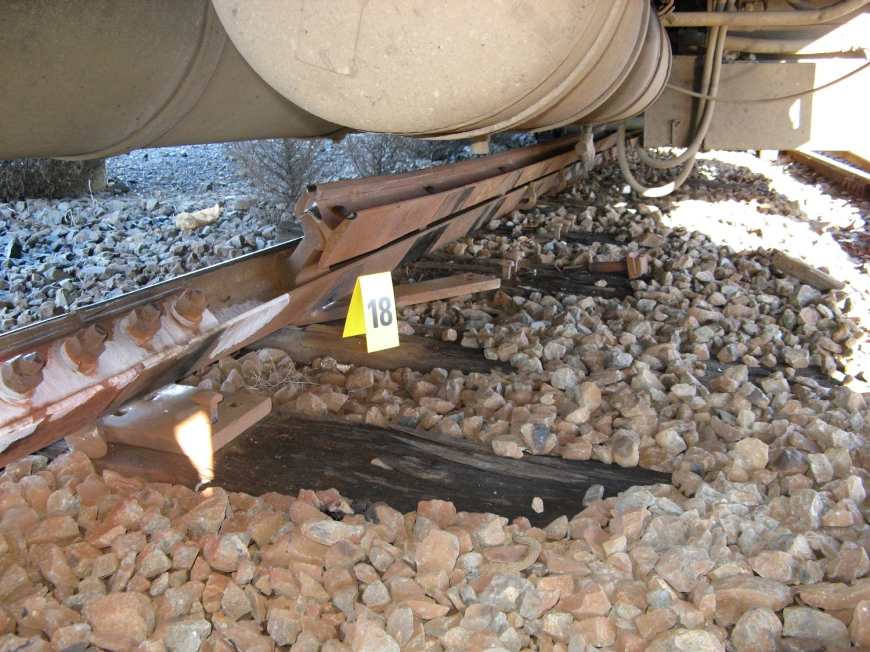

**TABLE OF CONTENTS**

THE CHIEF INVESTIGATOR 5

1. EXECUTIVE SUMMARY 7

2. CIRCUMSTANCES 9

2.1 Background 9

2.2 The event 9

2.3 Consequences 11

3. FACTUAL INFORMATION 13

3.1 Personnel information 13

3.1.1 Train crew 13

3.1.2 Passengers 13

3.2 Rail vehicle 14

3.2.1 General description 14

3.2.2 Train inspection at site 14

3.2.3 Post incident locomotive inspection 15

3.2.4 Event recorder 15

3.3 Infrastructure 15

3.3.1 General description of crossover 15

3.3.2 Damage 15

3.3.3 Point of Derailment 17

3.3.4 Post incident track condition 17

3.3.5 Track management 19

3.3.6 Track remedial works – planned maintenance 19

3.3.7 Management of special risk locations 19

3.3.8 Authorised speed for crossover 20

3.4 Environment 20

4. ANALYSIS 21

4.1 The derailment 21

4.2 Train operations 21

4.3 Track fit for purpose 22

4.4 Parting of locomotive from passenger cars 22

5. CONCLUSIONS 23

5.1 Findings 23

5.2 Contributing factors 23

6. SAFETY ACTIONS 25

6.1 Safety actions taken since the event 25

6.2 Recommended safety actions 25

# THE CHIEF INVESTIGATOR

The Chief Investigator, Transport and Marine Safety Investigations is a statutory position established on 1 August 2006 under Part V of the *Transport Act 1983*.

The objective of the position is to improve public transport and marine safety by independently investigating public transport and marine safety matters.

The primary focus of an investigation is to determine what factors caused the incident, rather than apportion blame for the incident, and to identify issues that may require review, monitoring or further consideration. In conducting investigations, the Chief Investigator will apply the principles of ‘just culture’ and use a methodology based on systemic investigation models.

The Chief Investigator is required to report the results of investigations to the Minister for Public Transport and / or the Minister for Roads and Ports. However, before submitting the results of an investigation to the Minister, the Chief Investigator must consult in accordance with section 85A of the *Transport Act 1983*.

The Chief Investigator is not subject to the direction or control of the Minister(s) in performing or exercising his or her functions or powers, but the Minister may direct the Chief Investigator to investigate a public transport safety matter or a marine safety matter.

# **1. EXECUTIVE SUMMARY**

At 1552[1] on 4 June 2007, an Albury to Seymour V/Line passenger train comprising an N class locomotive hauling five passenger cars derailed as it approached Seymour Railway Station. Due to its intended termination at Seymour, the train had been routed via a crossover not normally used by the regular Albury to Melbourne service.

In the incident the locomotive and the two leading passenger cars derailed. In addition, the passenger car set and the locomotive uncoupled. The locomotive and all passenger cars remained upright.

There were two reported minor injuries amongst the (approximately) 110 passengers. No members of the train crew were injured. The rail vehicles received minor damage and the track was substantially damaged.

The investigation concluded that the derailment occurred within the crossover and was due to rollover and spreading of the Up rail (the left-hand rail looking in the direction of travel). It is very probable that the rollover of the rail resulted from the inability of the rail fasteners to restrain the rail against the lateral loading from the locomotive. The loss of effectiveness of rail fasteners was almost certainly due to the degraded condition of the track in this section and specifically the condition of a number of timber sleepers.

The train was found to have been operated within the authorised speed limit for the crossover. The condition of the train was also found to be satisfactory and did not contribute to the incident.

At the time of the incident the track comprising this crossover was programmed for remedial work in the forthcoming days. The works were subsequently completed prior to the re-opening of the line.

Following the incident, V/Line initiated the development of procedures to identify risks associated with altered train running conditions during planned maintenance shutdowns.

The investigation recommends that V/Line reviews the application of its procedures for the management of special risk locations associated with defects identified by the inspection regime but as yet uncorrected by the maintenance and renewals effort.

The investigation also recommends that V/Line reviews the type of couplers used within its fleet of locomotive-hauled passenger trains.

# **2. CIRCUMSTANCES**

## 2.1 Background

Planned bridge work at Kilmore East between Seymour and Melbourne had necessitated the termination of southbound rail services at Seymour. As a result, V/Line intercity Passenger Train 8324A[2] was operating on an amended timetable from Albury to Seymour.

On its approach to Seymour Railway Station, the train was to proceed from the Albury main line to the number 2 track servicing platform 1. The crossover connecting the main line to number 2 track is bounded by 37D and 37U points. This route contrasted with the regular Albury to Melbourne service which would typically continue on the main line (number 1 track) to platform 2.

PLATFORM 1

PLATFORM 2

No. 1 Track

No. 2 Track

37U

37D

Train

Shepparton Mainline

Albury Mainline

Figure 1 - Schematic of relevant tracks in the approach to Seymour Railway Station

## 2.2 The event

On 4 June 2007, V/Line passenger service 8324A from Albury to Seymour was five minutes behind schedule approaching Seymour. At about 1552, the train comprising a locomotive hauling five passenger cars derailed on the crossover between numbers 37D and 37U points.

The trailing bogie of the locomotive derailed as did both bogies of the first passenger car and the leading bogie and leading wheel-set of the trailing bogie of the second car. During the derailment the locomotive parted from the passenger car set.

The train came to a stand with the locomotive just north of the north end of Seymour Railway Station Platform 1. The leading end of the passenger car set came to rest about three metres behind the locomotive with its leading end offset by about two metres with the bogie outside the rail gauge. The locomotive and all passenger cars remained upright.

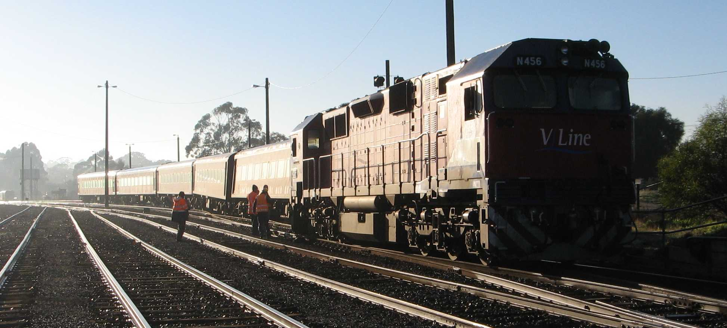

Figure 2 - Locomotive and passenger cars looking back towards Albury.

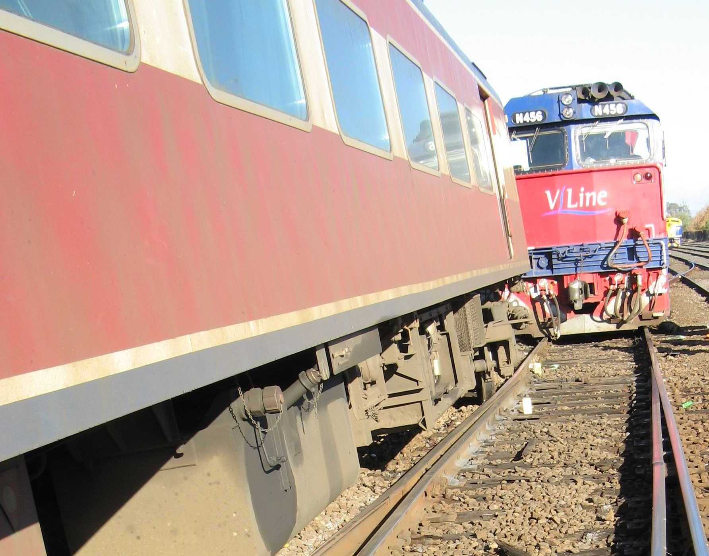

Figure 3 - Leading passenger car (ACN51) derailed and outside rail gauge.

The train conductors and Area Services Manager Seymour assisted passengers to detrain via the Buffet Car east end, platform side.

The locomotive and cars were re-railed on 5 June 2007 and sent for inspection at Newport Workshops, Melbourne. The track was reinstated incorporating the planned remedial works and the line re-opened for service on 11 June 2007.

## 2.3 Consequences

Two passengers were reported to have received minor injuries. None of the train crew received injuries.

The locomotive and passenger cars sustained minor damage.

The track sustained significant damage in the area of the derailment.

# **3. FACTUAL INFORMATION**

## 3.1 Personnel information

### 3.1.1 Train crew

The train was crewed by a locomotive driver and two conductors, one of whom was responsible for operating the buffet car.

#### **Locomotive Driver**

The locomotive driver was experienced in driving locomotive hauled passenger services. Information on his driver certification including route familiarity was not made available by the operator of the service.

The driver reported that he had just passed through the points of the northeast line towards number 2 platform (actually number 2 track) when the locomotive started to ride rough. He recalled applying the brakes and then observing that the lead passenger car was “off the road”. He reported that he informed “control” and then checked if anyone was injured.

The driver was uninjured in the incident.

#### **Conductors**

It was reported that at the time of the incident that one of the conductors was located in the Buffet Car and the other at the workstation in the luggage compartment.

Both conductors were uninjured in the incident.

### 3.1.2 Passengers

At the time of the incident there were approximately 110 passengers[3] on board the train.

A number of passengers commented that at the time of the incident they were out of their seats preparing to get off the train at Seymour and transfer to the waiting coach.

Two passengers lodged formal reports of injury. One passenger reported bumping her head and having a sore knee. The other reported having a sore neck.

## 3.2 Rail vehicle

### 3.2.1 General description

The train consisted of an N class locomotive N456 hauling five N class passenger cars ACN51, BRN49, BN4, BZN274 and BTN263 as configured below.

**Figure 4- Locomotive and passenger cars**

**N456**

**ACN51**

**BRN49**

**BN4**

**BZN274**

**BTN263**

The N class locomotive has a mass of approximately 124 tonnes and the N class passenger cars an average mass of about 43 tonnes, giving a total train mass in this instance of approximately 340 tonnes.

### 3.2.2 Train inspection at site

#### **Resting location of train**

The front of the locomotive came to rest approximately 116 metres past the toe of the blades of points 37D. The front of the locomotive was also about 66 metres past the most northern point of derailment.

#### **Couplers**

The coupler knuckles of the locomotive and passenger car ACN51 were found to be in the closed and locked position. Inspection indicated that the couplers had separated as a result of differential vertical displacement during the derailment.

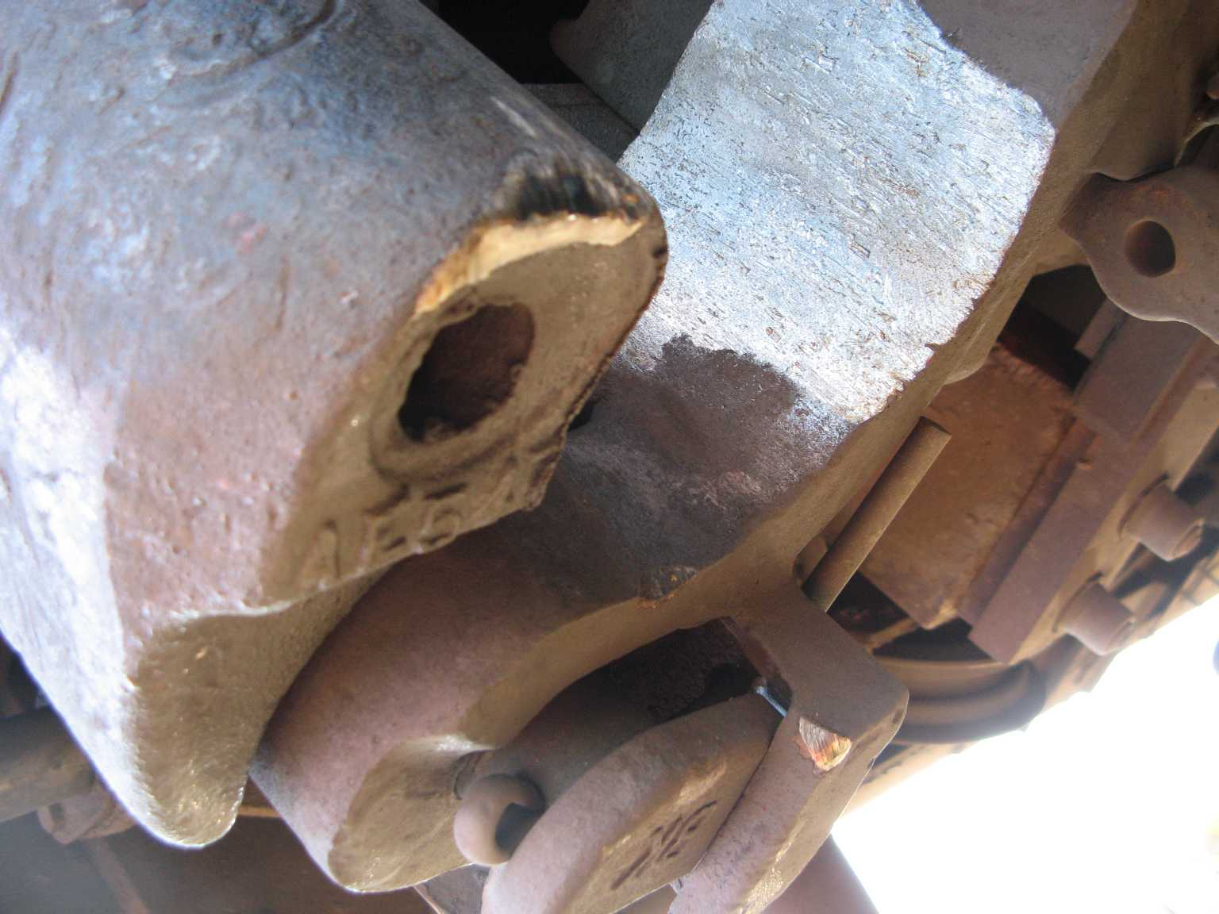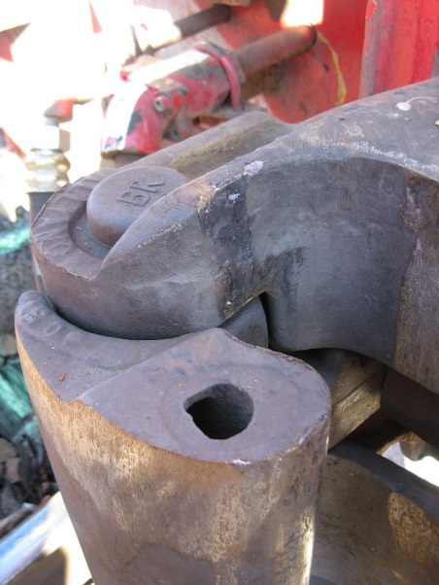

Figure 5 - Couplers of ACN51 (left) and the locomotive (right).

### 3.2.3 Post incident locomotive inspection

An independent inspection of locomotive N456 was conducted at Seymour on 6 June 2007 with particular attention to the condition of wheels and bogies. The wheel tread profiles were found to be relatively unworn, suitable for service and would not have contributed to the derailment. The bogies were found to be in a satisfactory condition and would not have contributed to the derailment.

### **3.2.4 Event recorder**

Locomotive N456 was fitted with an event recorder which logs a number of parameters associated with the performance and operation of the locomotive including speed and brake application.

The recorded data indicates that in the lead up to the incident, the train decelerated from a speed of around 110 km/h to about 25 km/h prior to transiting points 37D. Subsequently, at 15:52:29 and with the train now travelling at about 20 km/h, the record shows a sharp reduction in brake pipe pressure. At 15:52:37 and after travelling a further distance of about 28 metres, the locomotive was recorded as coming to rest.

The event recorder indicates that slowing prior to the crossover was predominantly under dynamic braking which was disengaged shortly prior to the locomotive entering the crossover.

## 3.3 Infrastructure

### 3.3.1 General description of crossover

The crossover connects the broad gauge main line tracks numbers 1 and 2 just north of Seymour Railway Station. The most common use of this crossover is in the Down direction, heading north. In this instance, the reverse movement was planned with the train to proceed in a southbound (Up) direction and cross from number 1 track to number 2 track to arrive at platform 1.

### 3.3.2 Damage

The track suffered significant damage at the crossover with the Up rail rolled over and spread from about 50 metres south of 37D points and extending for the remainder of the crossover to just prior to the transition to No. 2 Track.

No. 1 Track

No. 2 Track

37U

37D

Train

Figure 6 - Approximate location of most significant damage to Up rail (highlighted).

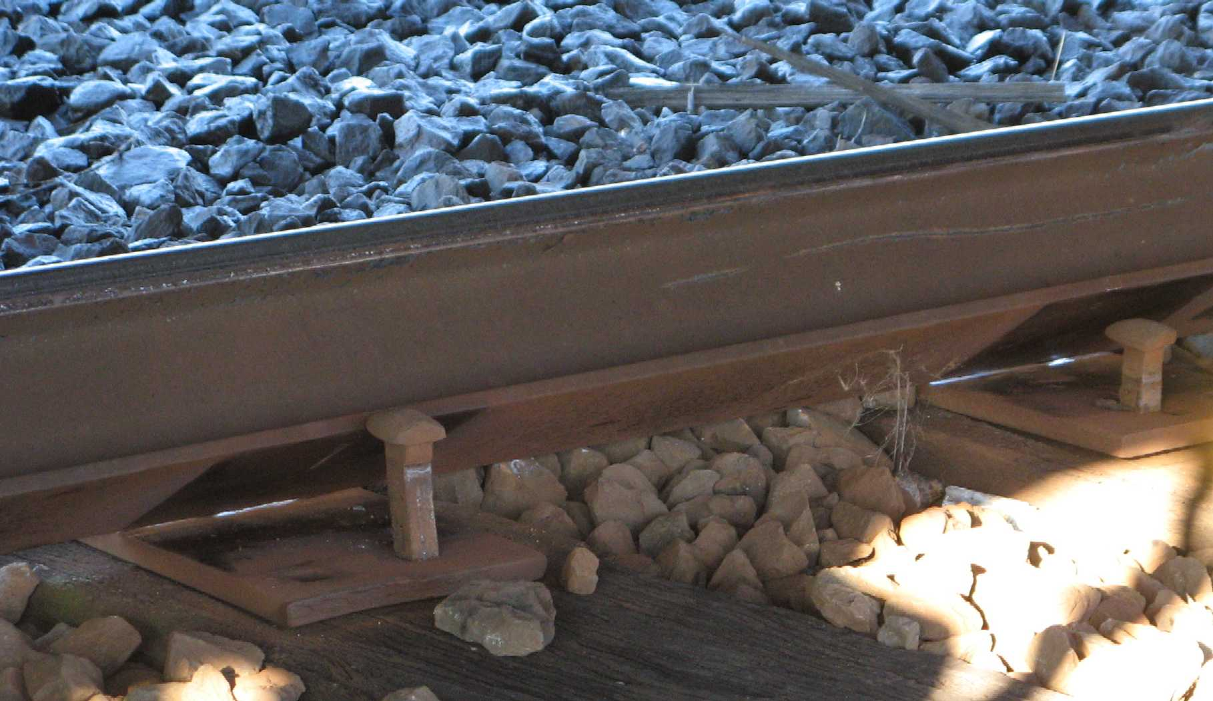

Figure 7 - View of Up rail rolled over.

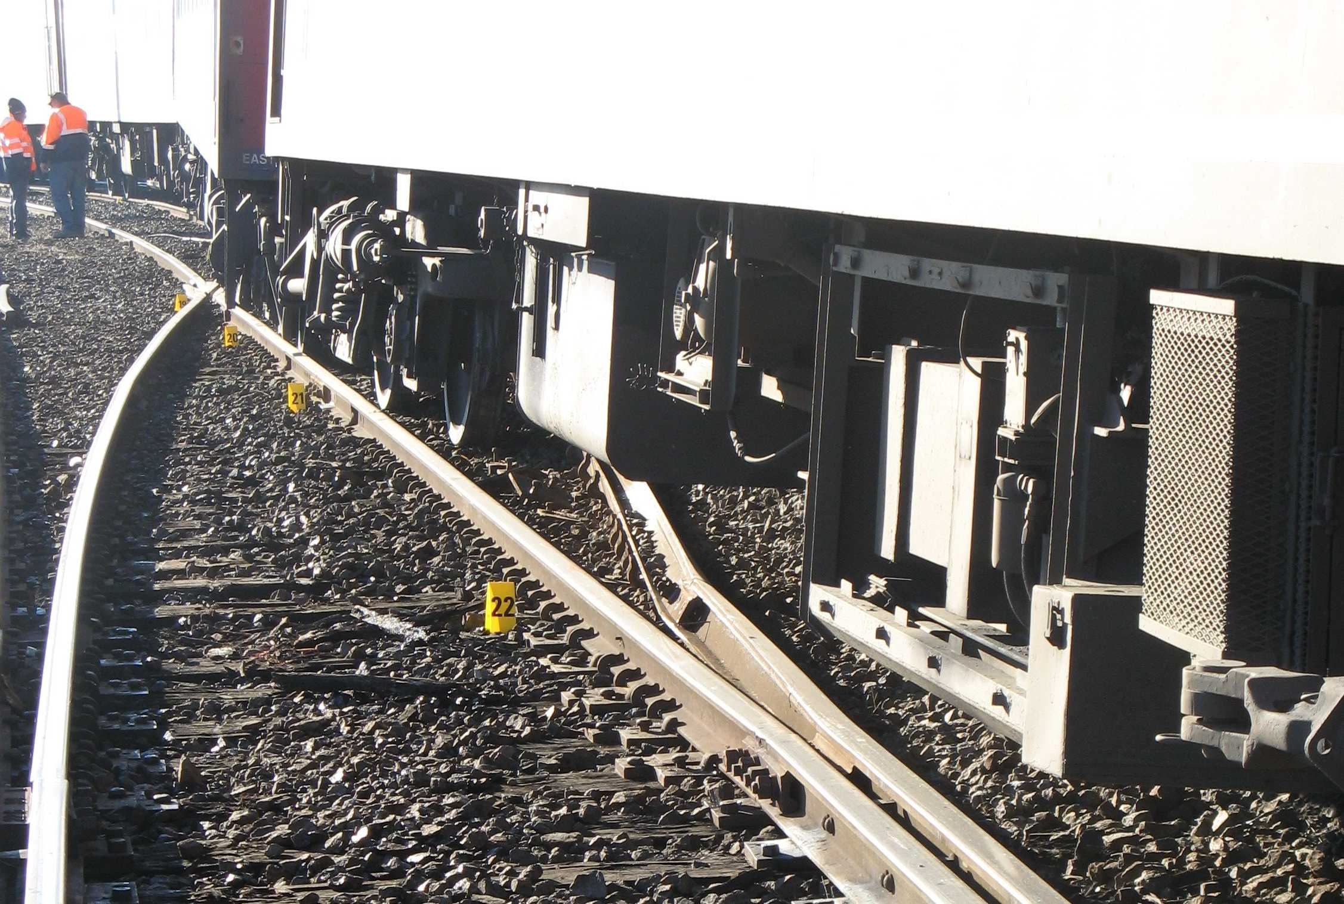

Figure 8 - Up rail damage, looking in the Down direction (towards Albury) from turnout 37U.

### 3.3.3 Point of Derailment

Inspection along the track from points 37D identified a rail head mark indicating that a wheel had dropped off the Down rail about 50 metres past the toe of 37D points blade. There were no indications of derailment prior to this point.

In the Up direction from this point, there were several marks associated with derailment. There were also marks indicating that wheels on the Up rail had initially run along the web of the rolled rail.

### 3.3.4 Post incident track condition

#### **Sleepers and fastenings**

A number of sleepers were found to be in poor condition and fasteners loose.

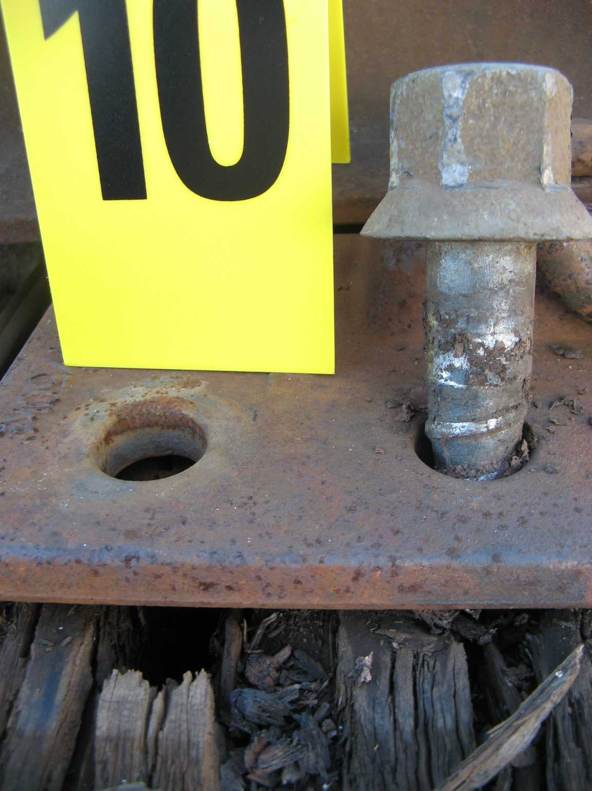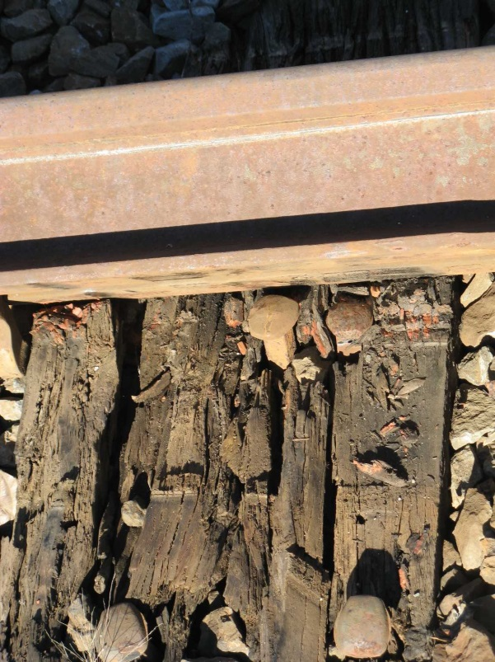

Figure 9 - Typical condition of degraded sleepers in turnouts and crossover.

#### **Track gauge and cant**

Using the northern most point of derailment as a reference point and progressing in the Down (north) direction, track gauge and cant[4] measurements are shown below.

| Distance (Down) from Ref Point of Derailment | Gauge | Cant | Remarks |
| --- | --- | --- | --- |
| (metres) | (metres) | (mm) |  |
| 0 | 1655 | -5 | Rail lifted approximately 20 mm |
| 2 | 1635 | -18 | Rail slightly lifted |
| 4 | 1596 | -23 | Noted slightly tight gauge |
| 6 | 1618 | -21 |  |
| 8 | 1631 | -14 |  |
| 10 | 1622 | -7 |  |
| 12 | 1618 | -3 |  |
| 14 | 1614 | -3 |  |
| 16 | 1611 | -8 |  |
| 18 | 1601 | -3 |  |
| 20 | 1602 | -2 |  |

#### **Radius of curve following points 37D**

Track chord measurements were taken in the vicinity of the reference (northern) point of derailment and the radius of the right-hand curve estimated in each case. It was noted that the track also exhibited a lateral angular discontinuity at a joint about five metres before this point of derailment.

| Distance (Down) from Ref Point of Derailment | Chord | Versine | Estimated Radius | Remarks |
| --- | --- | --- | --- | --- |
| (metres) | (metres) | (mm) | (metres) |  |
| 0 | 10 | 63 | 198 |  |
| 5 | 10 | 146 | 86 | incl. discontinuity |
| 10 | 10 | 68 | 184 |  |
| 5 | 20 | 420 | 119 | incl. discontinuity |

#### **Cant deficiency**

For a given train speed and track curve radius, there is a relative height between inner and outer rails at which there is a zero transverse force acting on the track and vehicle. The height difference compensates for centrifugal forces generated as the train traverses a curve. This condition is known as equilibrium cant and exists for a single operational condition. It is not abnormal for track to have either a cant excess, where a train is travelling at a speed lower than that to achieve equilibrium or cant deficiency, where a train is travelling at a speed greater than that to achieve equilibrium. Cant excess and deficiency are managed by defining operational limits.

In this instance there existed a cant deficiency resulting from the actual negative cant of the track and the motion of the train. While the cant deficiency was within typical operational limits, its presence confirms the existence of a transverse load on the outer rail on the right-hand curve following points 37D.

### 3.3.5 Track management

The track was managed by the accredited rail infrastructure manager V/Line Network and Access which assumed this role from Pacific National on 5 May 2007. A key role of the network manager is to inspect infrastructure for defects and schedule maintenance to assure that the track is in a fit for purpose condition.

### 3.3.6 Track remedial works – planned maintenance

The requirement to undertake remedial works on this portion of track at Seymour had been identified by the previous track manager, Pacific National, and was included in the 06/07 Major Periodic Maintenance (MPM) program. MPM works are funded by government under an arrangement separate to the infrastructure lease.

The MPM project brief covering these works described the issue, in part, as “the timber bearers in the mainline turnouts are in poor condition. The rail fastenings are loose on account of the poor timber condition and the ironworks moves under traffic.” The brief also notes that if the works are not carried out then “speed restrictions will need to be impose(d) for both passenger and freight services”.

The relevant Seymour elements of the MPM works were formally scheduled for May/June 2007 to coincide with track closures associated with planned works at Craigieburn and / or Dry Creek Bridge. The works at Seymour were reportedly to be commenced by the new network manager, V/Line, within the next two days (following the date of the incident). Works were to include selected sleeper and fastener replacement.

### 3.3.7 Management of special risk locations

V/Line internal procedures (NIPR: 2603) require the identification of special risks and their management through a special risk location register. Included in special risks are “long term defects identified by the inspection regime but as yet uncorrected by the maintenance and renewals efforts”. The works at Seymour could be categorised as such.

The procedures go on to describe the need for a management strategy to address identified special risks. In this instance, other than inclusion within the MPM works program, the investigation did not identify any ongoing or interim risk management strategy.

### 3.3.8 Authorised speed for crossover

The standing authorised speed for the crossover was 40 km/h. There was no Temporary Speed Reduction (TSR) identified by the investigation for this portion of the track.

## 3.4 Environment

Weather conditions were fine. Temperature was approximately 12 degrees Celsius and relative humidity about 71 per cent.

# **4. ANALYSIS**

## 4.1 The derailment

After traversing number 37D facing points[5] and having entered the initial curve of the crossover, it is almost certain that the Up rail on the outside of the right-hand curve began to roll over and spread under the transverse loads imposed by the locomotive. The initial movement of the rail is likely to have commenced around 50 metres past the toe of the blade of number 37D points. At the time, the train was travelling at between 20 and 25 km/h.

There is sufficient evidence to indicate that the movement of the Up rail was primarily due to the condition of the track and its inability to withstand the lateral loads of the transiting train. There is no evidence to suggest that the condition of either the preceding points or the rail vehicles contributed to the derailment.

The movement of the Up rail resulted in a widening of the track gauge leading to the rear bogie of the locomotive derailing. It is probable that the left hand wheels of the rear bogie initially tracked along the web of the Up rail while the right hand wheels dropped inside the Down rail. However, with its forward bogie remaining on the rails, the locomotive continued to generally track along the crossover.

Directly behind the locomotive, passenger car ACN51 would have been presented with both a widened gauge and overturned Up rail. This resulted in the derailment of both bogies. At some point following the derailment, ACN51 became uncoupled from the locomotive due to different coupler heights, allowing them to vertically slide apart and become disconnected. There was also a loss of brake pipe pressure about eight seconds prior to the locomotive coming to rest. Without the directional pull of the locomotive along the crossover, ACN51 derailed further with the lead bogie coming to rest outside the track gauge.

The second passenger car, BRN49, would have similarly been presented with damaged track. This resulted in the derailment of the lead bogie as BRN49 tracked behind ACN51. The rear of the car came to a halt near the undamaged portion of the track which resulted in only the right hand leading wheel of the trailing bogie dropping off the Down rail. It is probable that the derailment of this wheel resulted in the northern-most derailment mark.

## 4.2 Train operations

The train was found to have entered the turnout into the crossover, coasting at a speed of around 25 km/h which was well within the authorised speed for the track. The investigation considers this a normal approach and entry to a crossover.

Due to minor gaps in available data, it could not be ascertained with certainty whether initiation of the air brakes after derailment was the result of driver action or the loss of air system integrity when the locomotive parted from passenger car ACN51. This is not considered of importance to the investigation.

## 4.3 Track fit for purpose

The condition of the track was recognised by the previous and current network manager as requiring remedial works. It is therefore considered appropriate that the network manager scheduled works to address identified deficiencies in the track.

It is also the role of the network manager to ensure that the track is fit for purpose. In this instance, notwithstanding the pending maintenance activity, a speed restriction was not placed on the line. In hindsight, it would have been appropriate to have either restricted access to the crossover or applied an appropriate speed restriction until completion of maintenance activity.

As the crossover was predominantly used in the Down direction, it is probable that the use of the line in the Up direction introduced additional risks. Given the crossover is bi-directional, its fitness for purpose should have been assured for both directions of travel.

## 4.4 Parting of locomotive from passenger cars

The design of the couplers currently used allows them to slide in a vertical direction and where the height difference between adjacent vehicles is sufficient, come apart. In this instance, the parting of the vehicles did not have a significant bearing on the outcome.

The likelihood of parting of the couplers could be reduced by use of types such as double shelf or tightlock couplers.

# **5. CONCLUSIONS**

## 5.1 Findings

1. The condition of the locomotive was satisfactory and there was no aspect of the train which is considered to have contributed to the derailment.
2. The crossover was traversed by the train at a speed significantly below that authorised for the section of track.
3. The crossover was traversed in a direction not typically travelled by locomotive-hauled passenger trains.
4. The derailment occurred on the track curve after the turnout at points 37D.
5. The track failed to withstand the lateral loads imposed by the locomotive resulting in the Up rail rolling over and spreading.
6. At the derailment location, the track was in a deteriorated condition.
7. Remedial works were planned for the section of track.
8. No special conditions or restrictions had been applied to the use of the section of track.

## 5.2 Contributing factors

1. The network manager did not have an adequate method of assuring that risks associated with this special risk location were appropriately managed.
2. A restriction was not placed on the crossover despite it being recognised that its condition was deteriorated.
3. The track was not in a condition suitable for locomotive-hauled passenger train operations at normal service speeds in the Up direction.

# **6. SAFETY ACTIONS**

## 6.1 Safety actions taken since the event

Following the incident, V/Line initiated action to develop a process and supporting procedure to identify all risks associated with altered train running conditions during planned maintenance shutdowns.

While considered a useful exercise to assess risks associated with any unusual activity, the investigation considers that a bi-directional track should be fit for purpose in both directions irrespective of operational requirements that may arise on a planned or ad-hoc basis.

## 6.2 Recommended safety actions

### RSA 2008008

That V/Line reviews the application of its procedures for the management of special risk locations associated with *“…defects identified by the inspection regime but as yet uncorrected by the maintenance and renewals effort”*.

### RSA 2008009

That V/Line reviews the type of couplers used within its fleet of locomotive-hauled passenger trains.

1. All times are Australian Eastern Standard Time.
2. Train № 8324A (amended Timetable) was operating what would normally be train № 8324, the 1310 service from Albury to Southern Cross. Train № 8324A was scheduled to arrive at and terminate in Seymour at 1548 hrs.
3. V/Line do not have a records system by which passenger numbers aboard a service can be verified or confirmed for any portion of a journey.
4. Cant (superelevation) is a measure of the height of the outer rail on a curve above the inner rail
5. *Facing points* are the movable switch rails facing an approaching rail vehicle by which that vehicle can be directed via one route or another – usually either straight ahead or onto a diverging path.