**Rail Safety Investigation**

**Report No 2007 / 10**

Level crossing collision

Connex Passenger Train 8504 with a motor vehicle at Bungower Road Somerville

Victoria

22 August 2007

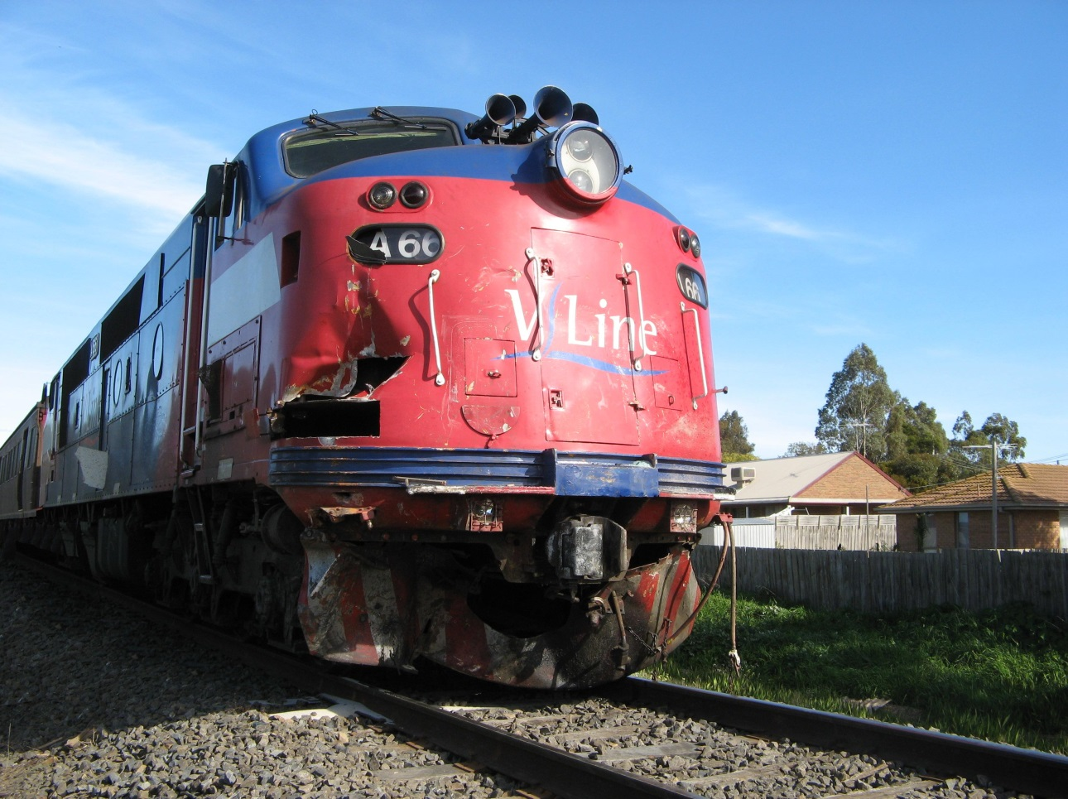

**TABLE OF CONTENTS**

THE CHIEF INVESTIGATOR 5

1. EXECUTIVE SUMMARY 7

2. CIRCUMSTANCES 9

3. FACTUAL INFORMATION 11

3.1 Rail 11

3.1.1 The train 11

3.1.2 The locomotive 11

3.1.3 Locomotive crew 13

3.1.4 On-board customer service personnel 13

3.1.5 Train Control 13

3.1.6 Passenger information 14

3.2 Operation 14

3.3 Road 15

3.3.1 Vehicle 15

3.3.2 Driver / Occupant 15

3.4 Infrastructure 16

3.4.1 Rail level crossing 16

3.4.2 Level crossing signage and active protection requirements 16

3.4.3 Level crossing signage non-conformance 17

3.4.4 Level crossing flashing lights 18

3.4.5 Level crossing safety assessment 18

3.5 Weather information 19

3.6 Emergency response 19

4. ANALYSIS 21

4.1 Level crossing environment (Appendix A) 21

4.2 Locomotive warning horn 22

5. CONCLUSIONS 25

5.1 Findings 25

5.2 Contributing factors 25

6. SAFETY ACTIONS 27

6.1 Identified Safety Issues and Recommended Safety Actions 27

7. APPENDIX 29

Appendix A – Intersection aerial photograph 29

# THE CHIEF INVESTIGATOR

The Chief Investigator, Transport and Marine Safety Investigations is a statutory position established on 1 August 2006 under Part V of the *Transport Act 1983*.

The objective of the position is to improve public transport and marine safety by independently investigating public transport and marine safety matters.

The primary focus of an investigation is to determine what factors caused the incident, rather than apportion blame for the incident, and to identify issues that may require review, monitoring or further consideration. In conducting investigations, the Chief Investigator will apply the principles of ‘just culture’ and use a methodology based on systemic investigation models.

The Chief Investigator is required to report the results of investigations to the Minister for Public Transport and / or the Minister for Roads and Ports. However, before submitting the results of an investigation to the Minister, the Chief Investigator must consult in accordance with section 85A of the *Transport Act 1983*.

The Chief Investigator is not subject to the direction or control of the Minister(s) in performing or exercising his or her functions or powers, but the Minister may direct the Chief Investigator to investigate a public transport safety matter or a marine safety matter.

# **1. EXECUTIVE SUMMARY**

On Wednesday 22 August 2007 at about 1037[1] a light commercial vehicle drove into the path of diesel-hauled Connex passenger train, service № 8504, at the Bungower Road level crossing in Somerville on the Mornington Peninsula. Bungower Road level crossing has ‘active control’ protection consisting of flashing lights and bells. There are 14 to 16 daily passenger train movements over this level crossing as well as four daily freight train movements.

As a consequence of the collision the road vehicle was destroyed and its male driver was fatally injured. During the collision sequence the driver was ejected from the vehicle and thrown a considerable distance. There were minor injuries to one passenger and no injuries to the crew-members of the train.

Train 8504 was terminated at the scene and road coaches were used to transfer the passengers to Frankston. Ambulance services attended and paramedics checked the passengers prior to their leaving the site. One passenger was taken to hospital and later discharged. The track and associated infrastructure was inspected and declared fit for normal service at about 1230 the following day.

The investigation concluded that the level crossing warning equipment was operating correctly and that the occupant of the motor vehicle failed to stop as required at the crossing. It also noted that the level crossing advance warning signage was partly obscured by vegetation and that several aspects of the road pavement marking did not conform to the current standard.

This report makes recommendations in the areas of:

* Duration of sounding of the locomotive warning horn when trains are approaching level crossings.
* The development of protocols for the rectification of non-compliant railway level crossing signage and equipment revealed by an ALCAM or any other assessment.
* The provision of appropriate additional advance warning treatment on road approaches to the Bungower Road level crossing.

# **2. CIRCUMSTANCES**

Train № 8504 is the scheduled 1015 Connex passenger service from Stony Point to Frankston, where it connects with Connex electrified services to Melbourne. It was conveying approximately 60 passengers.

Tyabb Station was the last stop made by the train prior to the collision. The departure time from this location was 1034:59, approximately two minutes behind schedule.

As the train approached the Bungower Road level crossing the locomotive warning horn on A66 was sounded twice. Due to trees and foliage on the right-hand side of the track there is no prospect for locomotive drivers of Up (in this case, northbound) trains being able to sight westbound traffic approaching the Bungower Road level crossing. As a result, the crew members of train 8504 were unaware of the impending collision.

The motor vehicle ⎯ a light commercial truck ⎯ was travelling along Bungower Road in a westbound direction in an 80 km/h zone. The weather was fine and clear, the temperature approximately 13°C and the road was dry. Visibility was excellent and traffic at the time reported as ‘light’. As the truck entered the crossing, the locomotive ⎯ travelling at 94 km/h ⎯ collided with its passenger side in a full, side-on impact. A witness in a vehicle following the truck stated that no obvious evasive action was taken by its driver.

The vehicle was propelled and / or rolled ahead of and partly beneath the locomotive leading coupler along the railway line for some distance before separating and coming to rest down the steep, right-hand embankment about 78 metres from the crossing and 9.5 metres from the track centre-line.

During this sequence, the sole occupant of the vehicle — a 57 year old male — was thrown from it with the body coming to rest 48.5 metres from the crossing and 12.6 metres from the track centre-line on the left-hand side of the track, down a slight embankment.

The locomotive sustained considerable collision damage to the front pilot (or ‘cowcatcher’), pneumatic piping and multi-unit air hoses, and the nose superstructure including the right-hand leading axle sander equipment housed therein. Paint marks on the leading coupler evidenced the heavy impact and a large piece of the motor vehicle’s load of joinery penetrated and became embedded in the fibreglass body-side panelling part-way along the right-hand side of the locomotive (see cover photo).

Due to the impact damage to air pipes and the subsequent loss of air pressure, the locomotive brake system went into an Emergency application upon impact with the motor vehicle. Train 8504 immediately began to decelerate, eventually coming to a stand approximately 450 metres past the level crossing. This Emergency braking distance is within the limits specified by V/Line for air braking of locomotive-hauled trains.

The train did not derail as a result of the collision.

After stopping, the locomotive driver initiated an emergency radio call reporting the collision, specifying the location, and requesting emergency services.

# **3. FACTUAL INFORMATION**

## 3.1 Rail

### 3.1.1 The train

Train 8504 comprised A-class locomotive № 66, and two ‘Saloon Trailer’ passenger cars; MTH104 and MTH102. The total weight of the train consist was 199 tonnes.

In accordance with company operating procedures, train 8504 had been brake-tested and certified fit for service prior to departure from Frankston at the beginning of the days’ cycle of duty. Further ‘continuity’ tests to verify the integrity of the pneumatic brake pipe throughout the train were conducted each time the locomotive was recoupled after changing to the other end of the train at Stony Point and Frankston.

The passenger cars did not sustain any collision damage.

### 3.1.2 The locomotive

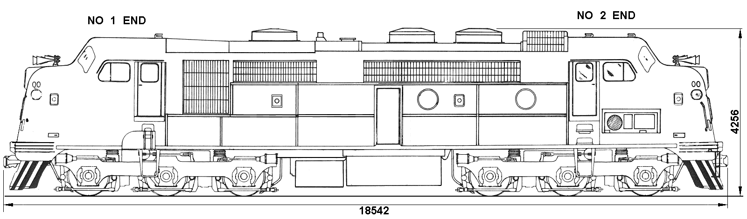

**Figure 1**

The A-class locomotive is a full-width carbody-type diesel-electric locomotive with an operating cab at each end. The nose superstructure ahead of each operator’s cab is pronounced (see Figure 1 above and section 3.1.3) The locomotive is 18.5 metres long and has a mass of 121 tonnes and a power rating of 1680 kW (2,250 hp). Its maximum operating speed is 115 km/h.

#### Locomotive event recorder

The locomotive is equipped with a Fischer Mk 2 event recorder which is also referred to as the On-Train Monitor / Recorder. This device records a number of operating parameters associated with the performance and operation of the locomotive. These parameters include time, direction, active cab, speed, air brake pressures, dynamic braking, crew alerter operation and air horn operation; however the operation of both head- and ditch lights is not recorded. The locomotive headlight was illuminated when investigators arrived at the scene although both ditch lights had been shattered during the impact and rendered non-operable.

On this locomotive the event recorder parameters registering the locomotive warning horn operation were incorrectly wired such that the output trace for the Country (High-note) horn is transposed with that for the Town (or Low-note) horn. Once identified, this matter was not relevant to the investigation.

Information from the event recorder indicated that train 8504 was operating within the permitted speed for this section of track.

#### Locomotive warning horn

The locomotive is fitted with a Leslie RS-5 air horn providing five separately-tuned manifold-mounted trumpets as the primary audible warning device; this being referred to by various V/Line sources as either the ‘High-note’ or ‘Normal’ horn. The locomotive event recorder presents the device as the ‘Country’ horn. In addition, there is a single-trumpet ‘Low-note’ air horn as a secondary warning device for use in confined areas such as a depot environment. This is presented by the event recorder as the ‘Town’ horn.

The Leslie RS-5 air-horn cluster is recommended specifically for passenger railroad applications. It has operating specifications of 115 dB at 30.5 metres with a decaying effect of 6 dB as distance doubles. (See Figure 2)

| Distance  (Metres) | Sound Level  (dB) |
| --- | --- |
| 30.5 | 115 |
| 61 | 109 |
| 122 | 103 |
| 244 | 97 |

Figure 2

The event recorder on locomotive A66 indicates two soundings of the High-note warning horn approaching the Bungower Road level crossing. Each sounding was for approximately 1.5 seconds; the first commencing at a distance of approximately 424 metres from the level crossing (just prior to the location of the Up ‘whistle’ board) and the second at 115 metres from the crossing. The locomotive entered the level crossing 2.76 seconds after the end of the sounding of this second warning.

It should be noted that operation of the locomotive High-note warning horn is recorded by the event recorder system only so long as air pressure in the pneumatic supply line from the operating valve in the cab to the horn itself is sufficient to close a spring-loaded pressure switch, which then sends an electrical signal to the event recorder. Thus, in each case, the horn may actually be sounded fractionally longer than the duration recorded.

#### Locomotive lighting

Daytime safety lighting on an A-class locomotive consists of the locomotive headlight, which must be on High beam when approaching level crossings, and ditch lights. ‘Ditch lights’ are low-mounted, short-range, 24v headlight-style illumination fitted as a result of industry studies and programs to improve locomotive conspicuity at level crossings. They are focused ‘inwards’ at 7-8 degrees from the forward parallel. Although their application is not mandatory, if fitted they must be illuminated at all times the locomotive is moving. The headlight and ditch-light switches were found by investigators post-collision to be in their ‘ON’ positions.



### 3.1.3 Locomotive crew

The V/Line A-class locomotive has a characteristically high-set, forward nose configuration with the air-horn cluster mounted atop this structure and ahead of the windscreen. As a result, forward crew visibility from the operator’s cab is restricted, necessitating a two-person crew.

Both locomotive drivers operating train 8504 were qualified on the locomotive being operated and the safeworking procedures for the route. They were assigned to Connex’s Frankston Crew Depot and each had in excess of 27 years’ passenger and freight train driving experience. Their shift had commenced at 0417 that morning. It was their second consecutive shift following three days off duty. The driver handling the locomotive used eyeglasses for reading only and neither crew member was taking any medication at the time of the occurrence.

The locomotive driver said that he was mindful of the limited visibility available to train crews of road traffic approaching the Bungower Road level crossing, and for this reason ‘hung onto’ the warning horn for longer than usual when approaching the crossing. He could not recall precisely how long he had sounded the locomotive horn on this occasion but thought it could have been for about five seconds. He said that the proximity of residential dwellings and concern for their occupants would not have influenced him to reduce the length or intensity of the horn sounding.

Neither locomotive driver sustained injury as a result of the incident. Post-occurrence preliminary breath tests ⎯ returning a negative result ⎯ were conducted by police on both locomotive drivers at the scene.

### 3.1.4 On-board customer service personnel

The single conductor aboard the train had 19 years experience as a train conductor and was based at the Frankston Railway Station. His on-board duties involve advising passengers on the purchase of tickets, operating the door controls and making sure that passengers are safely aboard when entraining or safely clear when detraining, and signalling the locomotive driver when to proceed from a station stop. He was standing in the aisle of the leading passenger car when the level crossing collision occurred. He was not injured.

The conductor’s shift for the day was 0445 to 1245, and the incident occurred on his third round trip. He used his mobile phone to alert the Station Master at Frankston of the incident and to advise on bus requirements. He was not breath-tested by attending police.

### 3.1.5 Train Control

The V/Line Train Control centre (Centrol) manages operations over the Frankston to Stony Point railway. On receipt of the emergency call from the locomotive driver, train control contacted the Police Communications office who mobilised police and alerted the ‘000’ Emergency operator. A transcript of radio communications between the locomotive driver and Centrol indicates that due to an habitual tendency on the part of the driver to begin speaking before he keyed the Press-To-Talk switch on his radio handset, there was a brief delay as the train controller sought to identify the name of the road. Further to this, the ‘000’ Emergency operator experienced some difficulty in interpreting her map and was initially unable to locate Bungower Road and thus the level crossing.

### 3.1.6 Passenger information

Approximately 60 passengers were being conveyed. One passenger reported a minor abdominal injury to ambulance officers and was taken to hospital and later discharged.

## 3.2 Operation

The line between Frankston and Stony Point is owned by VicTrack[2] and leased via the Public Transport Division of the Department of Infrastructure, to Connex. The Bungower Road railway level crossing is situated approximately 57.5 rail kilometres from Melbourne and 13.5 km from Frankston on the Stony Point extension of the Melbourne to Frankston railway line.

The track owner’s Network Service Plan (“Network Operating Requirements”) identifies the line speed for the track between Stony Point and Frankston as 95 km/h for passenger trains hauled by A-class locomotives.

The train departed Stony Point on time and ran without incident to Tyabb, making four other station stops. Departing Tyabb the service was almost two minutes behind schedule.

## 3.3 Road

### 3.3.1 Vehicle

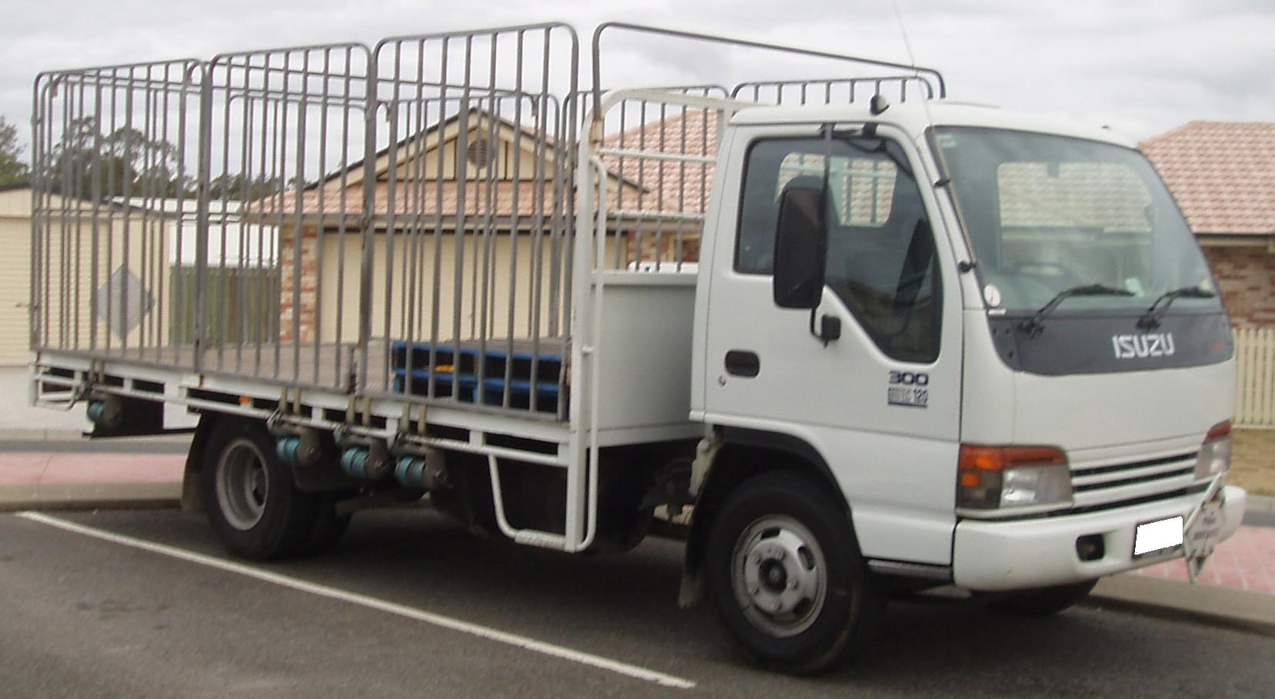

**Figure 3**

The road vehicle involved in the collision was a 1999 Isuzu Model NPR300 rigid wheelbase, two-axle light commercial tray truck (see example in Figure 3 above) with a kerb weight of 2.5 tonnes. The vehicle carried current registration.

There were no tyre skid marks leading up to the point of impact, however post-impact tyre marks on the crossing evidenced where the vehicle had been swept laterally off the crossing by the locomotive. The vehicle had been travelling in its correct lane.

The condition of the vehicle was such that it was not possible to identify the status of the vehicle entertainment system at the time of the collision. The driver’s seatbelt was found to have parted approximately 300 mm from its lap anchor-point beside the driver’s seat cushion.

A post-collision mechanical inspection conducted by the Victoria Police Mechanical Investigation Unit found that the vehicle did not have any mechanical fault that would have contributed to the collision and stated that prior to impact this vehicle would have been classed as roadworthy.

### 3.3.2 Driver / Occupant

The vehicle was occupied by the 57 year old male driver, who resided in the nearby suburb of Tyabb and worked as a builder. He held a current Victorian drivers licence and as a local resident was known to be familiar with the route along Bungower Road. It is reasonable to expect that he would also have been familiar with the railway level crossing and the amount of rail traffic across it. At the time of the collision he was reported to be on his way home to pick up a step ladder for his next job.

The vehicle driver was also reported to be in good health but dependent on prescriptive lenses for driving. The investigation could not determine whether the driver was wearing these at the time. Evidence from his optometrist indicated that he underwent regular biennial eye examination and that his corrected visual acuity was within accepted standards. His optometrist did, however, mention that it was common for the driver’s glasses to be scratched and that this could create a visual impediment in conditions of glare.

On the morning of the incident, the driver had arisen at about 0545 after what his wife described as ‘presumably’ about 7½ hours’ sleep. She also stated that there were no domestic or other matters troubling her husband.

Post-incident toxicology tests were negative for alcohol and drugs and a pathology examination did not identify any illness that would have contributed to the driver’s actions. There was no evidence of any mobile phone traffic to or from the driver’s phone at the time of the collision.

The driver was thrown from the vehicle. He suffered fatal injuries as a result of the incident.

## 3.4 Infrastructure

### 3.4.1 Rail level crossing

Bungower Road is a single-carriageway, two-lane, local arterial road running almost due east-west with an 80 km/h speed limit. It is bitumen-sealed and intersects with the railway at 90 degrees on an almost level gradient. The width of the sealed surface on the approaches to the level crossing is approximately 3.7 metres for each lane, broadening out to almost 4.1 metres for each lane at the crossing itself. The level crossing is situated approximately 760 metres westward along Bungower Road from its intersection with the Frankston – Flinders Road.

A combination of surrounding vegetation to the left of the road and the fact that northbound trains emerge directly onto the crossing from a low cutting, prevent the westbound motorist being able to sight approaching northbound trains (i.e. trains approaching from the motorist’s left).

Railway ‘Whistle posts’ ⎯ located alongside the track approximately 400 metres prior to a railway level crossing ⎯ support ‘whistle boards’, which are presented as a small white x-shaped cross. These boards are both a reminder to train drivers of the existence and location of a level crossing and a marker for the sounding of the locomotive or train warning device. If the level crossing is equipped with a Healthy State Indicator ⎯ as is the case with the Bungower Road crossing ⎯ these Whistle boards are required to be painted yellow as a further indication to train crew. Neither the Up nor Down Whistle boards at the Bungower Road level crossing were painted yellow.

### 3.4.2 Level crossing signage and active protection requirements

Railway level crossing protection is applied in accordance with the provisions of the *Manual of Uniform Traffic Control Devices Part 7:* *Railway crossings* (Australian Standard 1742.7⎯2007). The standard specifies traffic control devices to be used to warn and control road traffic in advance of and at railway level crossings together with the manner in which they are to be applied.

Road traffic control at railway level crossings is referred to as being either ‘active’ or ‘passive’. AS 1742.7 defines ‘active control’ as, *“Control of the movement of vehicular or pedestrian traffic across a railway level crossing by devices such as flashing light signals, gates or barriers, or a combination of these, where the device is actuated prior to and during the passage of a train through the crossing.”*

Bungower Road level crossing is an actively-controlled level crossing protected by flashing lights and warning bells supplemented by pavement markings, plus advance warning and STOP signage. The investigation found that the ‘active’ protection equipment had been maintained to specification and post-collision testing of the system confirmed its correct operation. The crossing lights had been previously upgraded from incandescent globes to light-emitting diodes (LEDs) and were focused correctly. The activation warning time for the lights and bells exceeded the minimum requirement.

### 3.4.3 Level crossing signage non-conformance

The investigation found that some aspects of pavement marking and signage did not comply with the requirements of AS 1742.7 (see part 3.4.3). The approach from the east toward the Bungower Road level crossing is indicated initially by an advance warning sign (W7-4). This sign is located on the left-hand side of the road 127.3 metres prior to the crossing and is adjacent to the large, white-painted RAIL and X pavement markings. The sign was partly obscured by hanging tree foliage (see figure, p21).

Control of vegetation growth within the road reserve is the responsibility of the local civic authority. The Mornington Peninsula Shire operates an Annual Vegetation Programme as a system to control vegetation in their urban areas, including on the road approach to railway crossings. This programme is contracted out, with all work being endorsed by Shire supervisory staff. Completed locations are then planned to be regularly checked for storm damage. The investigation was unable to ascertain from the Mornington Peninsula Shire details of how their Annual Vegetation Programme is managed and was therefore unable to determine the reason for the state of overgrowth that partially obscured the roadside advance warning sign.

The large RAIL and X pavement markings were also non-compliant in that they had been applied across the entire carriageway instead of centred within the applicable traffic lane. In addition, there was insufficient longitudinal distance between the RAIL and X markings and the W7-4 sign. As well as this non-compliance, the central barrier line pavement marking was deficient by not extending back from the crossing as far as the W7-4 advance warning sign.

### 3.4.4 Level crossing flashing lights

The locomotive crew reported that the active level crossing protection was operating at the time of the collision; however, when interviewed by police, a motorist driving behind the victim at the time of the collision stated that they did not see the flashing lights operating. Resulting from this statement police returned to the Bungower Road level crossing and shot video footage from the railway track of the locomotive drivers’ view approaching the level crossing. From this footage they determined that the indication for the locomotive crew as to the correct operation of crossing protection was limited by a lack of conspicuity of the Healthy State Indicator[3].

Acting on this information, an investigator made a trip from Frankston to Stony Point in the cab of an A-class locomotive to observe and record video footage of several active level crossing locations. This exercise had the benefit of placing the observer at the eye-level of the locomotive crew and revealed that not only was the Bungower Road level crossing Healthy State Indicator functioning noticeably but that the ‘sidelight’ LED indicators in the flashing light units were also conspicuous.

The Bungower Road level crossing has a significant recorded history of vandalism and theft of pole-strung copper wiring resulting in frequent aberrant activation of the protection system. The level crossing also has a significant anecdotal history, as evidenced by local residents and police, of anomalous activation by local youth who know how to maliciously ‘shunt’ the track circuits to operate the protection systems. Both of these last two items often result in the flashing lights and bells operating spuriously during both day and night-time hours.

### 3.4.5 Level crossing safety assessment

The Australian Level Crossing Assessment Model (ALCAM) is a mathematical tool for use in the risk assessment of road and pedestrian railway level crossings. It models the characteristics of crossings and the protective controls present to determine the likelihood of given accident mechanisms occurring.

The presence of vegetation on the road reserve approaching the level crossing may obstruct sighting distances and is included in an ALCAM assessment. Such vegetation can affect:

* advance visibility of the crossing protection as the road user approaches;
* visibility of an approaching train as the road user approaches the crossing; and
* visibility of an approaching train as the road user sits stationary at the crossing.

Road-side vegetation on the approach to a level crossing is expected to be controlled by an appropriate Vegetation Maintenance Program conducted by the relevant local authority. The conduct of such a programme is monitored by the ALCAM assessor’s observations of vegetation management during a visual inspection as part of a survey.

ALCAM assessment of the Bungower Road Level Crossing

The ALCAM assessment on the Bungower Road level crossing was conducted on 4 July 2006. This assessment identified the following anomalies in signage, equipment location, and pavement markings for the westward approach lane:

* The W7-4 advance warning sign for the western approach incorporated a non-compliant triangular sign.
* The carriageway Central Barrier Line pavement marking did not extend out to the advance warning Sign.
* The ‘RAIL’ and ‘X’ pavement markings were placed centrally across the carriageway instead of within the traffic lane.
* The ‘RAIL’ and ‘X’ pavement markings were placed longitudinally too close to the advance warning sign.
* The RX-5 assembly (RAILWAY CROSSING cross arm, flashing lights, and STOP ON RED SIGNAL sign) was located marginally too close to the reference point (i.e. the closest rail line).
* The RX-5 assembly STOP ON RED SIGNAL sign was of a superseded design.

Similar irregularities existed for the eastward approach to the level crossing, and other physical and graffiti damage to signage was also noted on the assessment.

Despite the recording and reporting of these non-compliances as part of the ALCAM assessment, they still existed at the time of the occurrence. Since 2005 the Public Transport Division of the Department of Infrastructure has been working on the implementation of a project to inform relevant authorities of the results of ALCAM Field Surveys. This program was completed in February 2008 with the development of the ALCAM ‘Issues’ website which provides relevant road and rail authorities with notification of issues identified at ALCAM Field Surveys.

## 3.5 Weather information

The weather conditions were fine and sunny, with minimal cloud and an ambient temperature of 13°C.

## 3.6 Emergency response

Ambulance services arrived on site within fifteen minutes of the incident being reported. Ambulance officers met passengers as they walked to a nearby road and advised that they were required to check passengers before they departed the site.

# **4. ANALYSIS**

## 4.1 Level crossing environment (Appendix A)

At the time of this occurrence the level crossing advance warning signage on the westbound road approach was incorrectly presented and partly obscured by roadside foliage (see section 3.4.3). Both of these factors, which are the responsibility of the local civic authority, impact adversely upon level crossing safety in that they are degraded visual cues that diminish the motorists’ forewarning of the hazard ahead.

Due to a combination of roadside and private property vegetation in the forward, left-hand quadrant on the approach to the level crossing, motorists travelling west along Bungower Road have no prior sighting of a train approaching from their left.

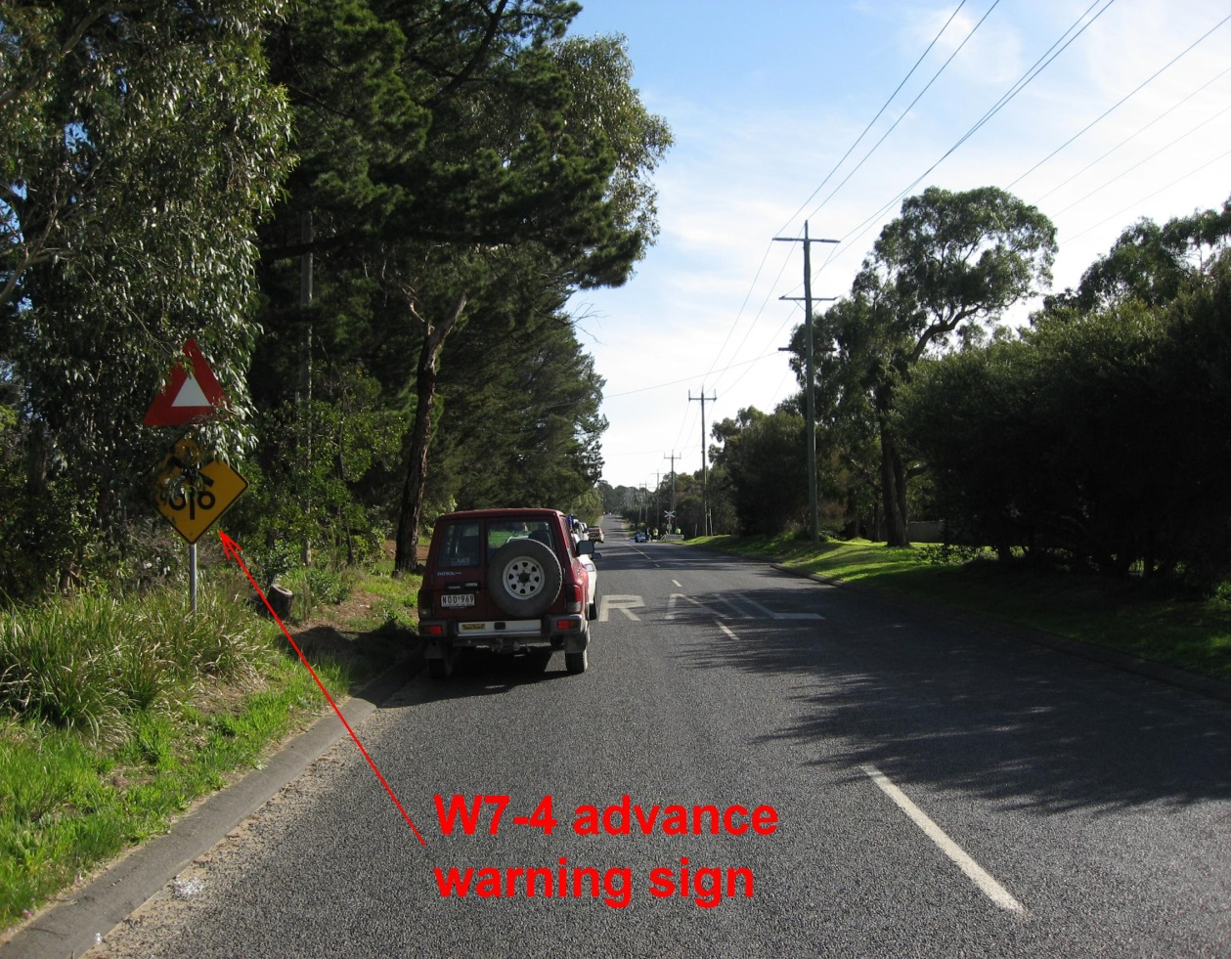

**Figure 4**

A further environmental characteristic of this level crossing was its eminence as a frequent target for delinquent attention and for the theft of copper communications wire from the railway pole line. Both of these phenomena had resulted over a considerable period of time in abnormal triggering of the active crossing protection. Local residents and police confirmed that this activity frequently happened at night and often lasted for considerable periods as technicians were called out to rectify the damage and to switch off the flashing lights. During these extended intervals police were obliged to be present at the crossing to direct traffic via a detour route. A motorist who encountered this activity frequently might be expected to become indifferent to the potential hazard posed by the level crossing.

## 4.2 Locomotive warning horn

### Rules and operating procedures

Use of the warning horn

The Victorian railways Book of Rules and Operating Procedures 1994 refers to the locomotive warning horn as the ‘whistle’ and addresses the manner of its sounding, generally, in Section 10.1 (a), headed TRAIN WHISTLE. This instruction specifies that;

“The driver is to use the train whistle in accordance with the rules and operating procedures, unless otherwise instructed; this being a long whistle. The sound of the whistle should be distinct and used in proportion to the distance at which the whistle is required to be heard.”

It is apparent that locomotive drivers are being instructed to sound a long whistle when approaching railway level crossings, unless ‘otherwise instructed’. It is also mandatory to again sound the ‘whistle’, “…when near the level crossing…”. The manner of the sounding of the warning device, including a determination of the meaning of ‘long’ (in the context of duration) and the definition of ‘near’ is at the subjective discretion of the locomotive driver or crew member. In this occurrence the locomotive driver thought he had sounded the warning horn for an appropriate duration; in each case for about five seconds. However the locomotive event recorder, showing horn activation for 1.44 and 1.63 seconds respectively, does not support this.

Section 9.2 (d) of the Book of Rules and Operating Procedures 1994, in the context of a part headed DEFECTIVE SIGNALLING AT LEVEL CROSSINGS (referring, presumably, to defective flashing lights) provides extra definition. In this instance the instruction states;

“The sound of the whistle should be distinct, with intensity, duration or repetition appropriate to the distance at which the warning is required to be heard.”

(Note the context of ‘defective signalling’ is not pertinent to this occurrence.)

It could be asked why this specific wording is applied only to this instruction when it would appear that it is entirely appropriate also to section 10.1 (a).

**Whistle boards**

Permanent indicators (referred to as ‘Whistle Posts’ and mounting an X-shaped Whistle board) are located 400 metres on the rail approach from each direction to a level crossing. They denote the distance from a crossing at which the warning horn is required to be sounded. It is assumed, although not specified by published Rules and Procedures, that locomotive drivers may ⎯ at their discretion ⎯ also sound the warning horn prior to the WHISTLE board and again at any point closer to the crossing.

A study in the USA[4] has reported that the sound of a train horn is effective as a warning only if the road vehicle driver recognises it as a train horn, and that this recognition is affected by the vehicle interior **noise levels, exterior traffic noise, the sound characteristics of the train horn, vehicle driver expectations, and ‘insertion loss’[5]. The report also states that audiological research has found that in order to be identified the warning signal must be three to eight dB above the ‘threshold of detection’[6] and to reach the alerting level it must be about 10 dB above the ambient noise level such as to be ‘attention-getting’. Other environmental characteristics that affect the audibility of a locomotive warning horn include surrounding or nearby terrain, buildings and landscape elements as well as sound attenuation materials included within vehicle body shells.**

For these reasons, the report concludes;

“…it is difficult for a [road vehicle] driver to detect the presence of a train by its audible warning only and still have sufficient time to react to its presence. “

In this context it is debatable whether the two brief horn blasts sounded by the locomotive driver as his train approached this level crossing would have served as an adequate warning to any vehicle driver approaching it from the west.

### Human and situational factors

**Situational awareness****⎯** in the context of the human cognitive process of acquiring and processing task-related information (in this case, the driving of a motor vehicle) ⎯ requires of the operator (the vehicle driver) the capacity to identify and interpret salient cues that might exist within the operational environment. Part of this process involves the operator being able to recognise situations that are inconsistent with expectations (the development of expectations in the first place being a product of experience). In 2003 the Australian Transport Council reported that;

*“Most* [level crossing] *crashes occur where the driver has local understanding of the railway level crossing.”* [7]

**Inattentional blindness,** also referred to by human factors commentators as the ‘blank stare’ phenomenon,is the failure to see an object because attention is not focused on it. Research conducted in this area[8] indicates that in performing tasks ⎯ often as in operating a vehicle ⎯ the operator fails to see what should have been plainly visible and afterwards, cannot explain why. If an object, of its own accord, captures our attention it is ‘conspicuous’ however if we focus attention on too many things at once we may miss something that is critical. Additionally, expectation affects our ability to see and to notice. Our past experiences exert a strong control on attention because we ‘learn’ what we believe is and isn’t relevant. Expectation may encourage us to see what isn’t there and it can also make us miss what should be obvious.

Another cause of inattentional blindness is low arousal caused by too moderate a mental load. When people become bored they cease to pay close attention and their attention wanders. Green states;

*“People may …go on ‘auto-pilot’ when performing highly practised tasks, such as driving.”*

## Summary

The vehicle driver ⎯ a local building contractor ⎯ lived within about five kilometres of a railway level crossing that carried up to 20 train movements per day and also had a history of frequent anomalous activation of its protective systems. Being a local arterial route, he may have used it frequently and thus may have often experienced both the frequent train movements and the ‘phantom’ operation of the crossing alarms (refer to comments in section 3.4.2 and to 4.1 above). Under these circumstances vehicle drivers may become desensitised to passive warnings such as signs and to visual and aural warnings such as flashing lights and train warning horns.

The vehicle drove into the path of a train at a level crossing at which flashing warning lights were operating. There was no weather-related aspect, acknowledged human behaviour or health condition by which this event can easily be explained. Neither is there evidence of any fatigue-related aspect to the drivers’ behaviour. He simply appears not to have comprehended that he was approaching a level crossing and its activated warning signals.

The locomotive warning horn was therefore rendered ⎯ by default ⎯ the only active signal that might have alerted the vehicle driver to the presence of the approaching train. In this instance the operation of the locomotive horn assumed critical significance, and the warning should ideally have been sounded for sufficient duration to provide ⎯ theoretically at least ⎯ the final opportunity of arousing the vehicle driver.

# **5. CONCLUSIONS**

## 5.1 Findings

1. The Bungower Road level crossing active protection was identified by the train crew as operating correctly as they approached the crossing. The system was also confirmed by technical specialists as operating correctly immediately following the occurrence.

2. Some aspects (refer to section 3.4.3) of the signage and pavement markings applied to the level crossing at the time of the incident did not comply with Australian Standard AS 1742.7-2007.

3. The W7-4 advance warning sign (denoting ‘Railway Crossing Flashing Signals Ahead’) was partly obscured by foliage.

4. All train crew members were qualified for their duty.

5. Train 8504 was in possession of the safeworking authority for the section of track being traversed.

6. Train 8504 was being operated within the permitted track speed.

7. The driver of train 8504 sounded the locomotive warning horn as required on the approach to Bungower Road.

8. Following the collision, train 8504 went into Emergency braking and decelerated to a standstill at a rate consistent with expected performance.

9. The occupant of the motor vehicle was a licensed driver with no known health condition that may have contributed to the occurrence.

10. The occupant of the motor vehicle did not yield to the passage of train 8504 or take any obvious action to avoid the collision.

11. Post-collision inspection of the motor vehicle determined that it was roadworthy at the time of the occurrence.

1. The weather and road conditions did not contribute to the collision.

13. Motor vehicle drivers approaching the Bungower Road railway level crossing from the east cannot see trains approaching from the Stony Point direction until the trains enter the crossing. Thus there is total reliance on seeing and comprehending the flashing warning lights.

## 5.2 Contributing factors

For reasons this investigation was unable to determine, the driver of the motor vehicle did not respond to the level crossing signs and flashing signals.

# **6. SAFETY ACTIONS**

## 6.1 Identified Safety Issues and Recommended Safety Actions

### Safety Issue

Drivers of road vehicles approaching the Bungower Road railway level crossing from the east cannot see trains approaching from the Stony Point direction until the trains enter the crossing, thus there is total reliance on seeing and comprehending the flashing warning lights. Although motorists are expected to remain alert while driving and should be able to see and comprehend railway level crossing warnings, railway operators may consider it prudent to provide explicit instructions to locomotive and train drivers regarding the duration of sounding of locomotive and train audible warning devices.

**RSA 2008010**

That Connex, in association with the Victorian Network Rules Consultative Committee and the Department of Infrastructure Public Transport Division consider amending the Book of Rules and Operating Procedures 1994 to specify the length of time for which locomotive and train drivers must sound the locomotive or train warning horn or whistle when approaching level crossings; such period to be of practical duration.

### Safety Issue

Roadside vegetation partly obscured the level crossing eastern advance warning road sign.

**RSA 2008011**

That the Mornington Peninsula Shire reviews the management of their programme for the control of foliage in the road reserve approaching rail level crossings.

### Safety Issue

The number of motor vehicle drivers approaching and traversing railway level crossings with an apparent lack of awareness of either their proximity to the crossing or the approach of a train is a cause for concern. Some of the possible reasons for this phenomenon are discussed in the Analysis section of this report and may arise from the evolution of cultural and environmental conditions of driving. Bungower Road is an arterial road running roughly east-west and connecting three major highways (including, eventually, the proposed Mornington Peninsula Freeway). It is predominantly straight throughout its length, and in the location of this incident is a sealed, 80 km/h two-lane carriage-way. Despite its active protection, it is also a crossing that is prominent for the extremely limited view available to motorists of approaching trains. In light of the programme of railway crossing safety modifications currently being carried out throughout the state, the provision of enhanced warning signage at this level crossing should be contemplated.

**RSA 2008012**

That the Mornington Peninsula Shire considers providing appropriate additional advance warning treatment to both east and westward road approaches to the Bungower Road level crossing.

# **7. APPENDIX**

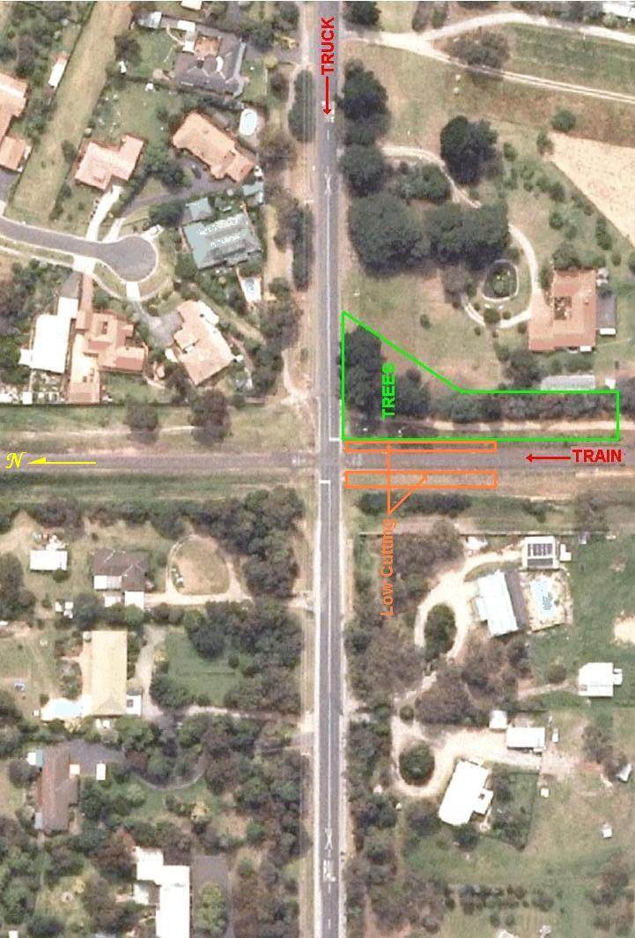Appendix A – Intersection aerial photograph

1. All times are denoted in Australian Eastern Standard Time.
2. VicTrack is a Victorian Government business enterprise established to own land and infrastructure used for the public train and tram services and to ensure the maintenance of that land and infrastructure.
3. This device is a white pulsing light atop a prominent mast, usually a level crossing flashing light assembly pole. It indicates to drivers of approaching trains that the active protection equipment at the level crossing is functioning correctly. The device augments the indication provided by the sidelights in the flashing light units (which can sometimes be inconspicuous due to the focus angle of the flashing light unit relative to the approaching train). Many level crossings throughout Victoria have been equipped with Healthy State Indicators. They may not provide long-range conspicuity in daylight.
4. NTSB 1998 - *Safety at Passive Grade Crossings*
5. *Insertion loss* is the difference between the measured values of a sound from an exterior sound source taken outside the highway vehicle and from inside the vehicle.
6. The *threshold of detection* is the sound level at which the person is aware of the sound.
7. *National Railway Level Crossing Safety Strategy*, August 2003.
8. Green, M. (2004) Visual Expert Human Factors: Inattentional Blindness & Conspicuity.