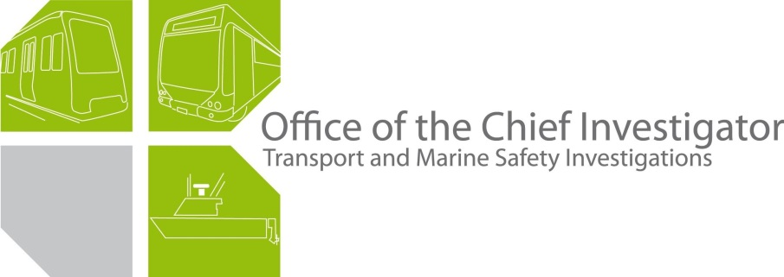

**Rail Safety Investigation**

**No 2008 / 02**

Brief Report

Overrun and derailment of Connex Train X163

in storage siding at Sandringham

20 February 2008

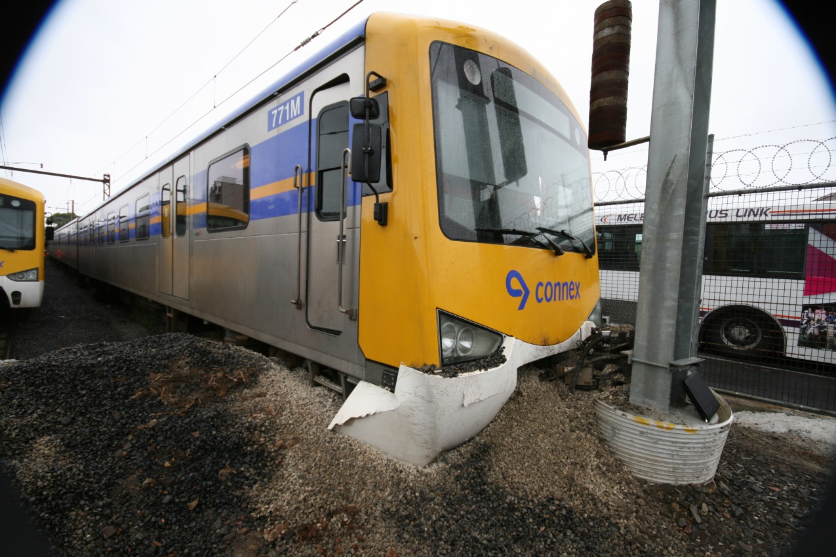

# Scope and Reporting

The Chief Investigator

The Chief Investigator, Transport and Marine Safety Investigations is a statutory position established on 1 August 2006 under Part V of the *Transport Act 1983*.

The objective of the position is to improve public transport and marine safety by independently investigating public transport and marine safety matters.

The primary focus of an investigation is to determine what factors caused the incident, rather than apportion blame for the incident, and to identify issues that may require review, monitoring or further consideration. In conducting investigations, the Chief Investigator will apply the principles of ‘just culture’ and use a methodology based on systemic investigation models.

The Chief Investigator is required to report the results of investigations to the Minister for Public Transport and / or the Minister for Roads and Ports. However, before submitting the results of an investigation to the Minister, the Chief Investigator must consult in accordance with section 85A of the *Transport Act 1983*.

The Chief Investigator is not subject to the direction or control of the Minister(s) in performing or exercising his or her functions or powers, but the Minister may direct the Chief Investigator to investigate a public transport safety matter or a marine safety matter.

Issuing of a Brief Report

In those cases where an investigation is curtailed or a full investigation report is not considered warranted, the Chief Investigator may issue a Brief Report.

A Brief Report will typically include the particulars of the event, a description of the incident, a summary of pertinent investigation information and key findings and, as applicable, a description of identified safety issues and recommended safety actions.

# Occurrence Details

**Date:** 20 February 2008

**Time:** 0852

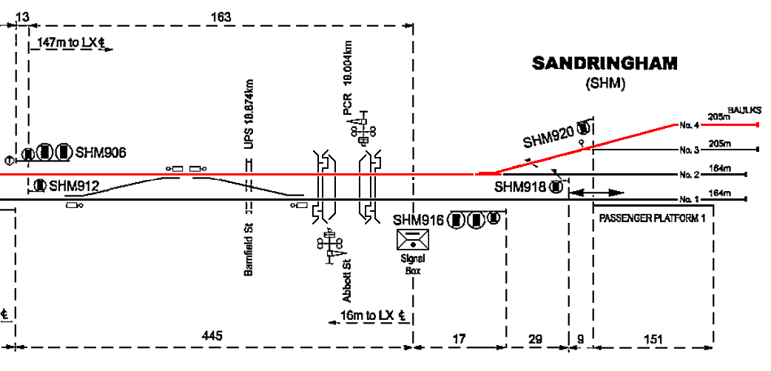Location

Siding 4, Sandringham Railway Station yard. Diagram below shows route taken from signal SHM906 to siding 4.

**Trip / route details**

The train was a scheduled ‘Empty Cars’ service departing from Flinders Street at 0827 and running to Sandringham thence directly to Siding 4 for storage until the evening peak period. Scheduled arrival time into Sandringham was 0857 whilst the actual arrival time (and time of occurrence) was 0852.

Incident outcomes

There were no passengers involved, and no injuries to crew.

The vehicle was impounded by the Connex Rail Safety Officer until released by the Chief Investigator. Following inspection and testing by Connex, Siemens and WorleyParsons personnel, the train was operated at restricted speed to Newport workshops for repair.

Vehicle details

The train comprised two Siemens 3-car sets forming a 6-car set with vehicle designations from the leading end, 771DMA - 2536T – 772DMB and 816DMB - 2558T – 815DMA.

Total consist length was 143.6 metres and total weight was 241.6 tonnes.

The vehicles’ braking system comprises electro-dynamic (ED) and electro-pneumatic (EP) systems. To assist the management of wheel slip and slide in low adhesion conditions, the braking control system includes a wheel-slip / slide-protection (WSP) feature which activates automatically on the detection of loss of traction when under power or the on-set of wheel slide under braking.

Vehicle operator

Connex Melbourne Pty Ltd

Infrastructure manager

Connex Melbourne Pty Ltd

Environmental details

Misty rain had moved across Melbourne during the morning and prior to the time of the reported incident. Ambient temperature at the time was approximately 22 degrees Celsius.

The track was wet.

# Circumstances

Background / context

There had been intermittent issues with the braking performance of the Siemens fleet of vehicles since their introduction into service in 2003.

Sequence of events

The train operated a scheduled service ‘empty of passengers’ from Flinders Street Station to berth in storage at Sandringham until the evening peak.

Data from the train event recording system produced the following information:

After stopping at the Down Home-Arrival signal SHM906, the train received the requisite Low Speed indication (maximum speed 15 km/h) and proceeded forward to the mainline points, thence into the station yard, and down into storage track 4. From signal SHM906 to the end of track 4, the distance is approximately 436 metres. Ninety metres after passing the signal, the train reached a speed of about 40 km/h before slowing to 30 km/h and then slowing at a lesser rate to about 22 km/h over the next 100 metres. It then continued at this speed until a point approximately 77 metres prior to the end-of-rail overrun, when moderate-to-heavy braking was applied (electro-dynamic) over the next 40 metres. ED braking was initiated to a maximum of step 4 (Full Service braking being step 6).

From this point, the available adhesion was exceeded, with the data recorder showing the adhesion factor instantly reducing from 15 per cent to 5 per cent for a brief distance (about 9 metres). Coincident with this, traction motor torque was retarded under the influence of the Wheel Slide Protection system, reducing the electro-dynamic braking effort and extending the stopping distance.

Over the next 10 metres, at a speed reducing to about 15 km/h, the traction control system attempted to correct the partial wheel-slide by making successive, rapid variations in motor torque (braking effort). The braking system then transitioned from ED to EP braking and, although the master controller handle position (in this case, at Braking 6) was presented on the event recorder download, all physical evidence of the amount of braking effort being applied disappeared as the Siemens train event recording system does not provide an indication of pneumatic brake cylinder pressure. Thus, for the final 22 metres until the end-of-rail overrun the train was subject to an undetermined degree of pneumatic braking.

Significantly, the rate of speed retardation indicated during this attempt to slow the train as it approached the end of the siding was somewhat less than that obtained earlier when the train was bought to a stand on the main line for the Down Home-Arrival signal.

At the end of the siding the train struck and dislodged the timber baulks secured across the rails and continued for approximately a further two metres whereupon it ploughed into the ballast trap before striking the catenary stanchion located in a ‘between-rails’ position beyond the ballast trap. The train driver did not initiate Emergency braking; however an Emergency brake application did occur late in the sequence; most likely from the Emergency trip lever being fouled at some point during these impacts. This Emergency brake application occurred about four metres from impact with the end-of-track stanchion and thus too late to prevent the derailment.

# Summary Investigation Information and Findings

Personnel

The driver held current qualifications in his route knowledge and the train being operated. He was medically fit, and had passed continuation (refresher) training as required in August 2007. It was reportedly his first experience of an overrun of this nature in a Siemens vehicle.

Vehicle(s) and equipment

The train was checked on-site for damage and was also able to be tested for proper operation to enable recovery to Newport Workshops at reduced-speed.

Wheel inspection evidenced no flat spots on any wheels. This indicates that none of the axles locked up to a 100 per cent skid during the stopping and collision sequence.

Infrastructure

There is no available information on the friction properties of the rail-head at the time of the incident although the weather at the time was a light, misty rain. Visual inspection following the incident indicated no significant amounts of vegetation matter or other obvious contaminants on the rail head. Notably, significant lengths of the rail in the siding were either sufficiently head-worn or were imperfectly bedded on the sleepers such that the rail head was canted to one side or another and thus not well-presented to the wheel, and in some locations the area of available wheel / rail contact was limited to either the gauge or field corner of the rail head. There was no obvious evidence of wheel-slide.

Of note is that another overrun incident occurred at exactly this location in June 2007. Following this previous occurrence a technical report[1] commissioned by Connex Melbourne Pty Ltd to assess the condition of the track and train wheels found that:

* The track structure was second-hand jointed rail, dog-spiked to timber sleepers and in average condition.
* № 4 Road is a low-speed siding.
* Track gauge varied between 1591 mm and 1612 mm from the standard 1600 mm.
* The rail profile throughout the location varied significantly.
* Rail-to-wheel contact along № 4 Road was predominantly to gauge-corner areas of the rail head.
* Values of friction coefficient measured at the location showed an average reduction of around 35 per cent in available friction under wet conditions and that increased stopping distance for a train may result. The report stated that these measured values were typical of measurements taken elsewhere on the Connex rail network.
* Rail-head swab samples taken at all measurement points and the leading axle wheels showed the dominant material to be iron oxide (rust) and aluminium silicate (mineral clay). It is possible that a mixture of these materials under damp or wet conditions could reduce available rail surface adhesion.

As Connex considered the track standard of № 4 Road to be fit for purpose at the stipulated speed, no remedial work to the siding was considered necessary following the previous occurrence, apart from increasing the size of the ballast trap at the end. Therefore it is reasonable to assume that similar track environmental conditions existed for this more recent occurrence.

Operations

Train № X163 is a scheduled service running ‘empty-of-passengers’ from Flinders Street, following the end of the morning peak period, to Sandringham for storage until the evening peak. After berthing the train in the Sandringham station yard, the driver was scheduled to return as a passenger on the 0935 service from Sandringham to Flinders Street Station to take up the running of a service to Eltham (his ‘home’ depot) where he would complete his shift.

Regulatory systems

The rail operator – Connex – manages operational risk, with oversight by the safety regulator, Public Transport Safety Victoria (PTSV).

PTSV has advised that it is continuing to monitor the braking performance issue to ensure that Connex is managing the risks in an appropriate manner.

# Identified Safety Issues

Braking performance of train

This incident is one of a number of cases where in-service braking performance of a Siemens train has been below expectation.

Although there are variations in operating conditions across the metropolitan network, overrun incidents have not commonly occurred with other types of vehicles and accordingly the braking issues are considered unique to the Siemens fleet. The braking performance of the Siemens train is unpredictable in some low-adhesion operating conditions.

Evidence collected during this investigation indicates that train speed after passing the ‘low-speed’ indication on signal SHM906 was initially 25 km/h above that permitted and then during the latter stages of progress along the storage siding was almost 8 km/h faster than the stipulated limit.

Refer to **Sequence Of Events** section for details of driver braking actions.

Driver actions

The train driver entered the siding and continued along it at speeds above those permitted. Given the wet conditions and the general degradation of braking performance to be expected in such circumstances the driver has not operated the train in a manner appropriate for the prevailing conditions.

Driver training

The process of slowing and stopping a train involves complex interaction between the train driver, the train’s braking systems and the track infrastructure in the context of the environmental conditions at that point in time. Driver control actions can be critical to the outcome of a wheelslide event and it can reasonably be expected that drivers of Siemens trains will be trained in and will understand those systems and consequent operational requirements unique to these trains.

The intermittent failure in performance of this interactive system and the role of each of its components has been the subject of considerable and lengthy research and investigation by Connex.

Remedial treatment to track infrastructure

Resulting from a previous similar overrun occurrence, Connex commissioned a report that assessed the infrastructure conditions pertaining to the event. Connex considered the track standard of № 4 Road to be fit for purpose at the stipulated speed and that no remedial work was necessary apart from increasing the size of the ballast trap at the end. In light of this latest occurrence, it may be prudent for Connex to revisit this decision and at least reconsider the extent of additions to the ballast trap at the end of the siding.

# Safety actions taken since the event

In the past 12 months, Connex has continued to investigate the braking system issues and improve the braking performance of the Siemens fleet of trains. This matter is the subject of a separate report by the Chief Investigator.

Other action taken by Connex in the context of these incidents has been to review the adequacy of driver training for Siemens trains. Connex has also identified a number of areas for further consideration and potential action. These include:

* Installing a Wheelslip / slide indicator in the driver’s cab. This is currently being trialled, with one such unit under operational testing.
* Further reviewing driver conversion training on Siemens trains. This is currently being progressed via:
  + A driver training group which is looking at the development of a training package explaining the software modifications. This cannot be further progressed until wet-testing of the software modifications is completed in early April 2008 and the results collated.
  + The production of an additional driver training module, *Brake Handling and Defensive Driving Techniques*. Among other things, this training module aims to provide students with a clear understanding of the impact that adverse seasonal and climatic conditions may have upon train braking.

Although a number of matters remain to be addressed, a reduction in overrun incidents suggests that progress has been made on addressing braking performance issues.

# Decision to Curtail Investigation

Further investigation into this incident by the Office of the Chief Investigator is not considered warranted. Although a similar incident occurred at Sandringham station yard in June 2007, the reduction generally, of overrun incidents suggests that considerable ground has been made on addressing braking performance issues.

It is recognised that the issue of Siemens vehicle braking performance is broader than this isolated incident and that the matter has been the subject of extensive investigation by Connex during the 12 months prior to this incident.

Connex investigations have been supported by a wide range of local and international specialists and accordingly it is considered appropriate that the braking performance issues continue to be led by Connex until the satisfactory resolution of all outstanding matters.

It is also recognised that ongoing monitoring of the issue to final and complete resolution rests with the safety regulator.

1. Monash University Institute of Railway Technology (IRT) Final Report № Monash/RT/2007/289