

Rail Safety Investigation

Report No 2009/01

Load shift and dangerous goods leak

Pacific National Train 2MA5

Stawell/Horsham

5 January 2009

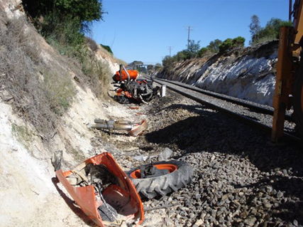

TABLE OF CONTENTS

The Chief Investigator 5

Executive Summary 7

1. Background 9

2. Circumstances 9

3. Factual information 11

3.1 Personnel 11

3.2 The train 11

3.3 Track infrastructure 19

3.4 Recorded information 20

3.5 Weather 20

3.6 Standards and guidelines 20

3.7 Load handling procedures 22

3.8 Kubota M6040 tractor tie-downs 23

3.9 Tractor counterweight and tarpaulin tie-downs 25

3.10 Network requirements 26

3.11 Specialist examination and testing 27

4. Analysis 29

4.1 Sequence of events 29

4.2 Load shifts 29

4.3 Train condition monitoring. 31

4.4 Relationship between the occurrences 31

5. Conclusions 33

5.1 Findings 33

5.2 Contributing factors 33

6. Safety Actions 35

6.1 Safety Actions taken since the event 35

6.2 Recommended Safety Actions 35

The Chief Investigator

The Chief Investigator, Transport and Marine Safety Investigations is a statutory position established on 1 August 2006 under Part V of the *Transport Act 1983*.

The objective of the position is to improve public transport and marine safety by independently investigating public transport and marine safety matters.

The primary focus of an investigation is to determine what factors caused the incident, rather than apportion blame for the incident, and to identify issues that may require review, monitoring or further consideration. In conducting investigations, the Chief Investigator will apply the principles of ‘just culture’ and use a methodology based on systemic investigation models.

The Chief Investigator is required to report the results of investigations to the Minister for Public Transport and/or the Minister for Roads and Ports. However, before submitting the results of an investigation to the Minister, the Chief Investigator must consult in accordance with section 85A of the *Transport Act 1983*.

The Chief Investigator is not subject to the direction or control of the Minister(s) in performing or exercising his or her functions or powers, but the Minister may direct the Chief Investigator to investigate a public transport safety matter or a marine safety matter.

Executive Summary

On Monday 5 January 2009 a Pacific National Melbourne to Adelaide freight train made an unscheduled stop on the approach to Horsham, Victoria when the train crew observed a loss of air from the brake system. When one of the crew investigated the cause he found irregularities with the loads on three consecutive wagons in about the middle of the train. An ISO tank container was leaking Terpene Hydrocarbon, a tractor was missing from its wagon and the cladding on another ISO tank container had come loose and was out-of-gauge. The train crew had been previously unaware of the loading problems. The leaking Terpene Hydrocarbon triggered a dangerous goods incident, which caused both the interstate rail line and the Henty Highway to be closed for several hours.

The tractor load shift resulted in the tractor striking a support for the Colquhoun Street overpass near Stawell, about 80 kilometres before the train was stopped near Horsham.

The investigation identified that the Terpene Hydrocarbon leak resulted from a fatigue fracture in a high load point on the ISO tank container transporting this liquid.

In respect to the tractor load shift, the investigation identified two likely causal scenarios for this event to occur:

* the strength and condition of the tie-down securing points for the tractor; and
* the tensioning of the tractor tie-down chains at point of loading.

The out of gauge container cladding resulted from the failure of the securing mechanism of the cladding due to corrosion and wear and tear.

Although all three incidents occurred on consecutive wagons the investigation did not identify a link between them.

The investigation has recommended safety actions related to the securing of mobile plant and other loads to freight wagons and the auditing of in-field loading practices.

# Background

Pacific National despatches daily freight trains from its MFT (Melbourne Freight Terminal) to Adelaide, Perth, Sydney and Brisbane. Loads in the form of various containers are received and transhipped from road to rail either directly or after being off-loaded at allocated locations within the terminal. Train 2MA5 is the 1810 Monday service from Melbourne to Adelaide.

Interstate rail routes are referred to as the DIRN (Defined Interstate Rail Network) which is managed by the ARTC (Australian Rail Track Corporation) and maintained by ARTC contractor, Downer EDI Works.

# Circumstances

On Monday 5 January 2009 Simon National Carriers accepted, from Kubota Tractors Australia, two M6040 tractors and associated counterweights loaded on a Transi-flat[1]. The Simon’s truck driver tied down the load at the Kubota yard prior to transporting the Transi-flat and load to the MFT. On arrival at the MFT the load was accepted by Pacific National and loaded onto train 2MA5. The train departed at 1750 with the journey reported as uneventful until about 2300, when the train was approaching Horsham.

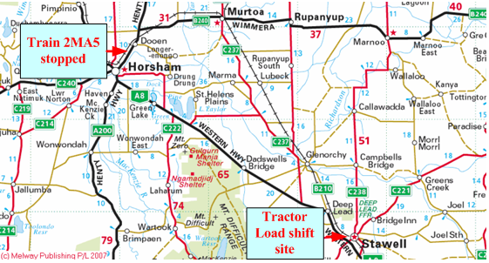

Figure 1 – Location of Stawell and Horsham. (Copyright Melway Publishing 2007. Reproduced from e-Way Electronic Street Directory with permission.)

At this time, the train crew identified a gradual loss of brake pipe pressure and brought their train to a stand to investigate. During the inspection the following was identified:

* a leaking tank container - (Dangerous Goods incident);
* a damaged tank container - (out-of-gauge);
* a load shift (part of the load of one wagon was missing).

Local police and emergency services responded to the Dangerous Goods leak incident and immediately closed the Henty Highway. One train crew member was affected by fumes and was taken to the Horsham Hospital and released after treatment.

The missing load, a tractor and associated debris, was subsequently found by the crew of a following train about 800 metres on the Melbourne side of Stawell Station. The load was beside the track in a cutting about 10 metres beyond the Colquhoun Street overpass. Fresh tyre scuff marks on the southern abutment of this bridge were consistent with the tractor impacting it.

The ARTC subsequently conducted inspections of the rail infrastructure between Dooen and Stawell. These inspections did not identify any other components of the train, its load, or damage to the track or other line-side infrastructure.

At about 0300 on 6 January 2009 the site was released by the emergency services and 2MA5 was propelled back to Dooen siding where the three wagons involved plus the immediate trailing wagon were detached and secured for inspection.

The rail line remained closed until about 0430.

# Factual information

## Personnel

### Train crew

2MA5 was crewed by a locomotive driver trainer and a trainee driver. Both crew members were appropriately qualified for their roles and possessed current medical certification.

The trainee driver was supervised by the trainer who monitored and instructed him as part of his on-the-job training. At the time of the incident the trainee driver was controlling the train.

When the train stopped near Horsham, the stationary inspection was conducted by the trainee driver who was overcome by fumes.

### Truck driver

The truck driver who loaded the tractors onto the Transi-flat for shipment had been employed by Simon National Carriers since 1987. He was one of four drivers employed by Simon as primary rail consignment loaders. He was held in high regard by the company for his expertise in securing loads and this incident was the first load shift involving freight loaded by him. He had received training in the requirements of both the Simon’s Load Restraint Manual and the relevant sections of the Pacific National Freight Loading Manual.

## The train

Train 2MA5 consisted of two NR class locomotives and 25 wagons. The weight of the wagons and their load was 2033.7 tonnes. The train was 1202.3 metres long and was conveying four dangerous goods loads. The wagon conveying the tank of Terpene Hydrocarbon was correctly identified on the train manifest and was loaded in accordance with the Dangerous Goods segregation requirements for this product.

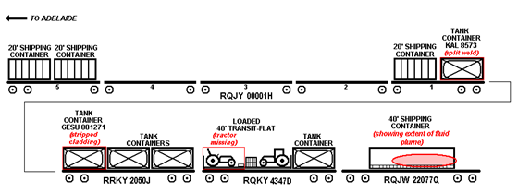

Figure 2 – Identifies the wagons and the loading position of containers involved in the incidents

### Wagon RQJY 00001H

RQJY 00001H was the lead vehicle of those removed from the train at Dooen, and carried the leaking tank container conveying the Terpene Hydrocarbon. The wagon was a five-platform articulated container wagon fitted with 70-tonne ride control bogies[2] with 10 standard 20-foot ISO container ‘slots’.

The leading-end platform was loaded with two 20-foot containers and the intermediate platforms were empty. The trailing-end platform was loaded with a standard 20-foot container and tank container KAL 8573, which was loaded directly over the bogie. The general condition of this wagon was observed to be good with no discernable signs of excessive wear on any of the bogie components.

### Container KAL 8573

This container was an ISO stainless steel tank with a capacity of 19,800 litres, owned and operated by FBT Transwest. On this occasion it was conveying 19,324 litres of Terpene Hydrocarbons, DG Class 3, commodity 9310. Prior to departure this container was removed from RQJY 00001H pending the provision of the relevant dangerous goods information from the consignee. When this information was provided the container was reloaded into the same position.

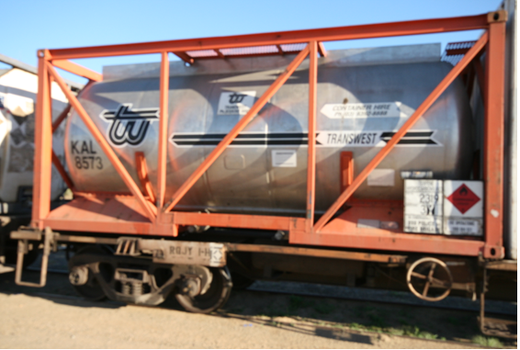

Figure 3 – KAL 8573 in position on RQJY 00001H

The stainless steel tank of container KAL 8573 was retained within a framed box-like structure by four longitudinal mounting ribs welded to the tank via doubler plates (see Figure 4). The ribs, located at each lower ‘corner’ of the tank, extend and curve upward at the ends of the tank. The crack that enabled the leak was across the top edge of the weld attachment of the doubler of the left, trailing longitudinal rib support. The investigation was informed by FBT that cracks across the top edge of these welds at the tank ends was not uncommon given the handling and stress exposures incurred in the various modes of transport.

At Dooen the fracture was plugged with (*DENZO)* putty by the fire brigade. This action successfully prevented any further leakage. The remaining product was transferred to another tank container at Dooen.

There are conflicting records as to the amount of lost product. At Dooen, the flow meter on-site recorded a 1632 litres loss from the initial load whereas calculations from both the Pacific National MFT weighbridge and a public weighbridge at Sunshine resulted in net gains of product.

Container KAL 8573 was returned to the MFT under quarantine for scientific evaluation; however, it was released to the owner by Pacific National local representatives without authority and repaired by Victorian Tank Services before any metallurgical appraisal could be conducted.

**Container damage inspection report**

Victorian Tank Services reported that a full-thickness crack had been present at the toe of the weld of one of the underside support brackets. It was also reported that an internal inspection detected cracking in the toe region of the other three support brackets. The cracked weld toes were all at the highest secured points of the container and as such would have been the most likely point of bending under load. The movement of the liquid contents would place the inner surface of the tank ends under a tensile load with the point of highest stress being directly opposite the weld toe. Even at relatively low stress loads the cumulative effect of many repeated cycles over an extended period of exposure could have been sufficient to initiate fatigue cracking.

The weld toe area is normally a region of high stress concentration and as the container was approximately 31 years old, fatigue-induced cracking becomes the most likely failure mechanism.

The cracked region was ground out in preparation for welding and an internal stainless steel patch placed over the cracked regions and fillet-welded in place. The container was then inspected by an independent body, certified and returned to service.

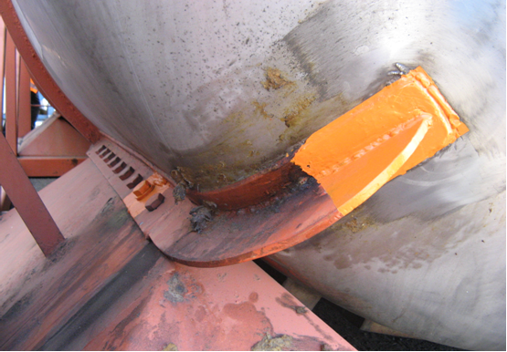

Figure 4 – Container KAL 8573 post repair

### Terpene Hydrocarbons

Terpene Hydrocarbons are usually extracted from plant material and are employed mainly for fragrance and flavour purposes in the pharmaceutical and chemical industries.

Terpene may be ignited by heat, sparks or flame and its vapours will spread along the ground and collect in low or confined areas. When mixed with air, explosions may result. Health side-effects include irritation to both the eyes and skin. In a vapour form it may also cause dizziness or drowsiness such as experienced by the trainee driver when inspecting the train at Dooen.

Terpene Hydrocarbon carries a UN code of 2319 and is classified as a Class 3 flammable dangerous goods commodity. Guide 15 of the *Standards Australia Dangerous Goods Initial Emergency Response Guide SAA/SNZ HB 76: 2004* outlines the hazards and emergency response procedures for this commodity. The local emergency response agencies responded to this incident in accordance with the requirements of the guide.

A sample of the Terpene Hydrocarbon was examined to determine its friction properties. Of particular interest was whether the lubricating properties were closer to water or to oil. The outcome of the test was that the Terpene material was similar to water. It is therefore reasonable to conclude that any contamination from the Terpene leak would not have had a negative effect on the ride performance of any of the wagons involved.

A scraping of residue taken from the plume of fluid on the Taultliner was chemically examined in order to determine its composition and origin. The composition of the residue was identified as a mixture of a Phthalate Ester compound, Aluminium Silicate (clay) and dirt/dust particles. Lubricants and other fluids used in tractors were not detected in the scraping sample.

### Wagon RRKY 2050J

RRKY 2050J was a 63-foot container wagon equipped to convey three 20-foot ISO containers or any combination thereof and was fitted with 50-tonne ride control bogies. This wagon was marshalled immediately behind RQJY 00001H and immediately ahead of the wagon conveying the tractor loads. It was loaded with three tank containers, with the out-of-gauge container (loose cladding) on the leading or Adelaide-end platform.

### Container GESU 801271

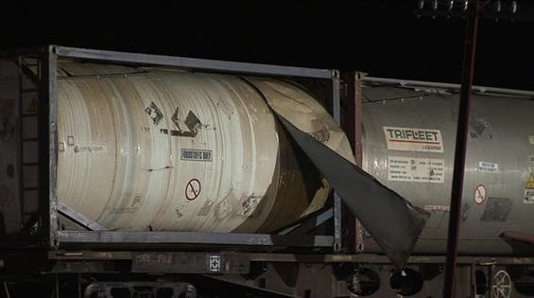

Figure 5 – The out-of-gauge condition of GESU 801271 on RRKY 2050J at Dooen

There were no marks or indications on the out-of-gauge cladding to indicate that it had struck any line-side structures.

Inspection of the underside of the container identified that rivet holes had corroded to such a degree that would have allowed the rivets to fall out. Significant levels of chlorine were detected in the corrosion deposits which was consistent with exposure to saline water. In addition to this, the seam of the lining showed evidence of previous repairs and many more holes than expected were observed in the edge of the sheet, consistent with previous sets of rivets having been replaced. There was no evidence of tearing of the rivet holes or scratches consistent with the rivet heads shearing off.

The remaining cladding panel seams were also observed to be in poor condition with signs of dirt and moisture penetrating the lining (Figure 6).

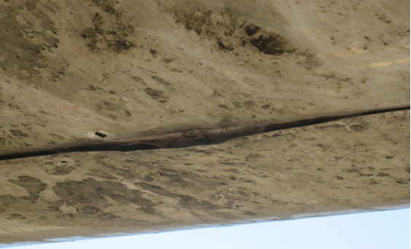

Figure 6 – Cladding condition of GESU 801271

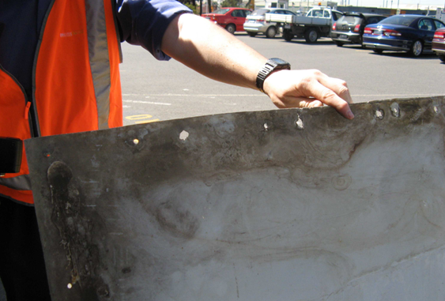

Figure 7 – Additional rivet holes and damage on the loose lining

### Wagon RQKY 4347D

RQKY 4347D was a 63-foot container wagon equipped to convey three 20-foot ISO containers or any combination thereof and was fitted with 50-tonne ride control bogies. This wagon was conveying the 40-foot Transi-flat loaded with two tractors and two small palletised loads at the leading end with a tank container on the trailing position. These loads were observed (via video) to be intact passing through Gheringhap and no negative report was received after a ‘Roll-by’ inspection at Wingeel Loop.

The bogies were found to be in good condition with no signs of excessive wear or evidence of unsatisfactory ride performance. The vehicle had sustained some superficial damage – ballast and chain-strike bruising – to the bogies and under-gear.

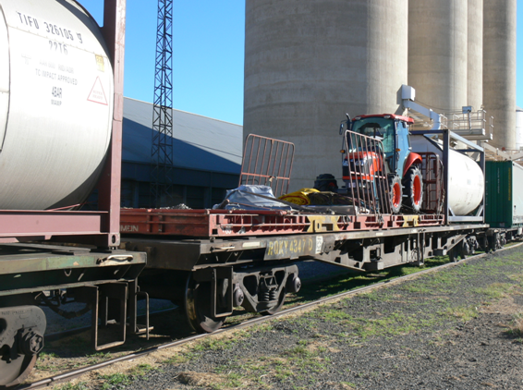

Figure 8 – RQKY 4347D at Dooen

The dirt collector on the control valve had been struck and damaged with the dirt collector filter missing. This damage is consistent with the loss of brake pipe pressure that alerted the train crew to a problem on the train.

**Tractor, counterweight and miscellaneous loading**

Kubota Tractor Australia Pty Ltd load tractors at their factory for rail transport on 40-foot Transi-flats supplied by Simon National Carriers. On 5 January 2009 the load presented to Simon consisted of two model M6040 tractors, two sets of shrink-wrapped counterweights loaded on a pallet and a bundle of tarpaulins also loaded on a pallet. Simon’s truck drivers are responsible for securing loads presented by Kubota for transport. Both tractors were secured with four eight-millimetre transport chains with the shrink-wrapped counterweights and tarpaulins secured to the Transi-flat with web-straps.

### Wagon RQJW 22077Q

RQJW 22077Q was an 80-foot container wagon equipped to convey four ISO containers or any combination thereof and was fitted with rigid frame primary suspension bogies. It was conveying a 40-foot Taultliner[3] container loaded in the centre of the wagon. Apart from superficial damage due to flying debris no abnormalities with the vehicle or bogie components were identified. The curtain on the left-hand side (in direction of travel) was noted to have a fresh stain, extending from about half-way along the curtain to the trailing end. This was not evident on the video taken of 2MA5 as it passed through Gheringhap.

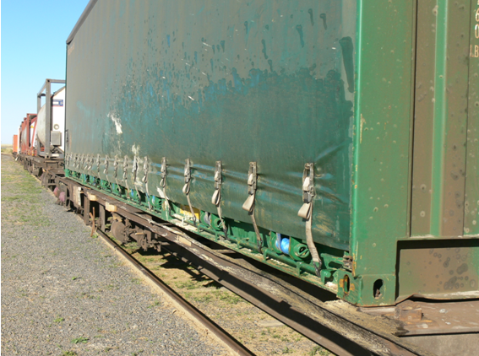

Figure 9 – Showing fluid stain on curtainsider

## Track infrastructure

The main line between Melbourne and Horsham is divided into various segments of 47 kg/metre rail on timber sleepers and 60 kg/metre rail on concrete sleepers. The tractor load shift and loss occurred on a section of track which consisted of 47 kg/metre rail on timber sleepers.

ARTC has engaged EDI Downer Works to undertake track maintenance under a long-term alliance. EDI conduct routine track inspections (minimum of three per fourteen-day cycle) utilising a Hi-Rail vehicle. In addition to these visual inspections Electronic Track Condition Monitoring is conducted every 13 to 18 weeks utilising a train carrying track measuring equipment.

The visual inspections trigger reactive maintenance, whereas electronic monitoring is utilised as a planning tool for track maintenance. The last electronic track condition monitoring was conducted over this section in October 2008.

On the day of the incidents there were 17 track-related TSRs (Temporary Speed Restrictions) in force between Melbourne and Horsham. The conditions for these speed restrictions were, poor rail condition, ballast mud holes and track geometry. In isolation these track conditions should not have induced extreme forces to trigger any of the events identified with 2MA5.

Track curvature and gradient in the area of the load shift consisted of left and right-hand curves with rising and falling 1:50 gradients (Figure 10).

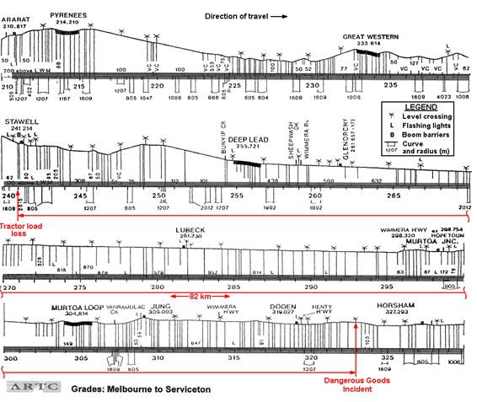

Figure 10 – Gradients and curves Ararat – Horsham

Following the incident an investigator undertook a return locomotive ride on a similar service to 2MA5 between Melbourne and Dimboola to experience the ride condition of the track under normal operations. The location identified as having the most significant effect on ride quality – lateral movement – was a right-hand curve at the 194 kilometre marker. At this location there was a temporary speed restriction of 90 km/h (imposed after the incident) categorised under ‘track condition other’. This section of track between 193.5 and 194.5 kilometres is recognised for cant defects which effectively result in a twist fault that continually requires lifting and packing every four to eight weeks.

## Recorded information

### Melbourne Freight Terminal CCTV

A review of CCTV footage at the Melbourne terminal entry gate confirmed the position and securing method applied to the tractor loads on the Transi-flat when delivered. Video footage of the departure of 2MA5 shows the two containers and tractor involved loaded with no sign of load shift, damage or leaking product.

### Track side video - Gheringhap

Gheringhap is a hamlet in South West Victoria about 83 kilometres from Melbourne where passing trains are automatically recorded on video by a local rail enthusiast. Video sourced from this location showing the left-hand side (in the direction of travel) of 2MA5 indicated that at this point in the journey there was no fluid leaking from container KAL 8573, no load shift of the tractor on RQKY4347 or any damage to the outer cladding on container GESU8012717. The curtainside on wagon RQJW 22077Q showed no sign of a fluid plume.

### Locomotive data logger

A review of the event recorder data from the lead locomotive of 2MA5 indicated that there were no train-handling issues and that the line speed and temporary speed restrictions were complied with.

## Weather

The weather at both Stawell and Horsham was fine with little or no cloud. The recorded temperature at Horsham was about 19 degrees Celsius.

## Standards and guidelines

### ISO Tank containers

ISO containers are used for the intermodal transport of freight and are manufactured according to specifications from the International Standards Organisation (ISO). Tank containers are built to the same standard dimensions as other ISO containers, but are cylindrical vessels mounted in a rectangular steel frame. Typically, these containers are used to transport liquid or bulk materials.

All ISO containers are issued a container safety certificate (CSC) by the manufacturer that must be renewed every 30 months by a certified inspector. If necessary, an approved continuous examination program (ACEP) can be used in place of this procedure. Both tank containers involved had current compliance certificates.

### Chains

Australian Standard *AS 4344:2001* outlines the types of materials, design and manufacturing processes required in the production of transport chain to ensure a minimum breaking strength of 73.6 kN.

Figure 11 shows the chain used to secure the Kubota Tractor. Note the insignia ‘4344-4.0’ which identifies the manufacturing standard as AS 4344 and lashing capacity 4000 kg. While not specifically relating to rail transport, the chain capacity and breaking loads are comparable to the requirements in the RISSB Freight Loading Manual. (see paragraph 3.6.3).

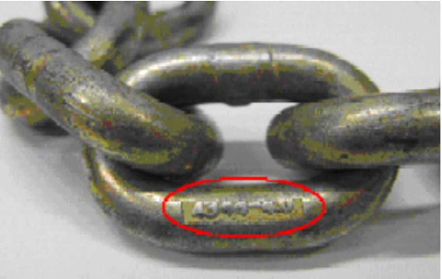

Figure 11 – AS stamp on chain link ex tractor tie down

### Rail Industry Safety and Standards Board

RISSB (Rail Industry Safety and Standards Board) is a rail industry body that develops and manages standards, rules and codes of practice for industry. RISSB – *Rolling Stock Freight Loading Manual* *January 2003* (clause 4.6.2) outlines the minimum accelerations that load securing systems (other than container securing devices), lashing equipment and components should be designed to withstand. Both the RISSB manual and Pacific National FLM (Freight Loading Manual) give the minimum accelerations against which the load is to be secured as 2g longitudinal, 1g vertical and 1g lateral.

The RISSB Freight Loading Manual states that chains used as part of load securing assemblies should comply with AS 2321-2006, and be short-link chain for lifting purposes with link material not less than eight millimetres in diameter. The tractor load in this case required four eight millimetre chains.

AS 2321-2006 specifies the requirements of short-link chains for lifting purposes. It identifies the type of materials to be used, the design and manufacturing process and outlines the mechanical properties and strength test characteristics of chains needed to provide a safe and deformity-free chain.

## Load handling procedures

### Kubota

Kubota Tractor Australia Pty Ltd conducts training programs with their freight forwarders at the beginning of a contract with the company. The training course outlines the processes and techniques which are to be used for the transportation of their goods.

### Simon National Carriers Load Restraint Manual

This manual primarily focuses on road transport requirements and is based on *The National Transport Commission - Load Restraint Guide (2nd Edition 2004).* Simon is provided access to Pacific National’s Freight Loading Manual (FLM) which, at section 2.7.3, outlines requirements when forwarding rail loads.

### Pacific National Freight Loading Manual

Pacific National has its own freight loading manual (FLM 06-07-2007) which is written with reference to the standards and guidelines set out by the *RISSB Rolling Stock Freight Loading Manual 2003.*

The Pacific National manual outlines the general procedures for all types of loads conveyed by Pacific National services. The procedure titled *Mobile Plant and Equipment* stipulates who is responsible for compliance with the procedure and lists customers and their loading contractors together with Pacific National Terminal Operators and planners. Mobile plant is identified as being any plant that has wheels or tracks for transport purposes and includes rubber-tyred vehicles, such as tractors. The General section of this procedure identifies ‘Direct Restraint’ as the preferred method of securing mobile plant and equipment. It also states (in part):

* ‘In accordance with best industry practice, direct lashings should be applied in pairs in order to provide the required restraint in all directions, based on the restraint factors for rail of 2g longitudinally, 1g vertically and 1g laterally.’
* ‘The wagon/Transi-flat must be fitted with complete solid floors and appropriate lashing securement points.’
* ‘It is recommended that all wheels are chocked to eliminate any movement, the chocks must be secured in a manner that will not allow them to move or protrude from the wagon. The chocks are to be of a suitable size and material, for example hardwood (75 millimetre x 75 millimetre).’ The company advised that typically wheel chocking applies when equipment larger than the Kubota M6040 tractor is transported.
* ‘Manufacturer’s recommendations for transportation are to be followed in regards to positioning of the gearbox or transmission.’
* ‘Where web straps and chains pass over sharp edges or sharp corners, an approved form of corner edge protection must be used.’

The FLM outlines the methods for securing lashings and states that the following restraint configuration is to be used where possible:

#### ‘Lashing chains or web straps are to be securely tightened’;

#### ‘Load binder handles are to be wired or cable-tied closed’;

#### ‘Loose ends of web straps or chains are to be secured’;

* ‘The end diagonal restraints are to be as near as possible to 45 degrees from the wagon’s centreline and 30 degrees from the wagon deck (horizontal)’.

Vehicles or equipment with a mass of up to 2.5 tonnes are to be secured with a minimum of six web straps and ratchets with a minimum lashing capacity of 2.5 tonnes or four eight-millimetre ‘transport’ chains and load binders with a minimum lashing capacity of 3.8 tonne.

## Kubota M6040 tractor tie-downs

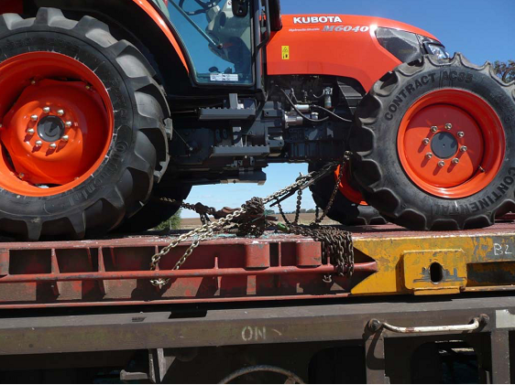

Figure 12 – View of remaining tractor at Dooen 7 January 2009

Kubota reported that the tractor loading and securing method is standard; therefore the securing method for the surviving tractor (Figure 12) should have been the same as that for the lost tractor. Chains secure the tractor from four points on the Transi-flat chassis. These chains are tensioned with load binders which in turn are cable-tied or wired closed.

The chains used to transport the incident tractor were designed in accordance with AS 4344: *Motor Vehicle Cargo Restrain Systems*. The chains had a minimum breaking strength of around 78 kN, which is comparable to grade T chains specified in RISSB standard AS 2321:2006 – *Short Link Chain for Lifting Purposes.*

The type and number of chains used to tie down the tractor complied with the RISSB standard and Pacific National FLM. However, the angular configuration of the chains deviated from the ‘near as possible’ angles as summarised below:

|  |  |  |
| --- | --- | --- |
|  | Suggested tie angles | Actual chain angles |
| Longitudinal (to centreline) | 45 degrees | 44 degrees (to front axle)  25 degrees (to rear drawbar) |
| Vertical (to wagon deck) | 30 degrees | 12 degrees (to front axle)  9 degrees (to rear drawbar) |

The Pacific National FLM specifies that handbrakes on all plant machinery are to be applied while in transit.

### 3.8.1 Side gate support pockets

Side-gate pockets are fitted to the edges of Transi-flats to locate and support side-gates. The upper, inboard edge of the side-gate pocket is fully welded along its length to the edge of the Transi-deck. The lower, inboard edge of the pocket is welded to the longitudinal tie-down pipe at its fore and aft corners. These lower attachment points are of much smaller cross-sectional area than the upper connection.

The welds attaching one of the side-gate support brackets was found to be broken (Figure 13). The investigation was able to confirm that this area of the Transi-flat had been used as a tie-down point for one of the chains which was attached to the rear of the tractor. The detailed method used to attach the chain to or around the pocket could not be determined.

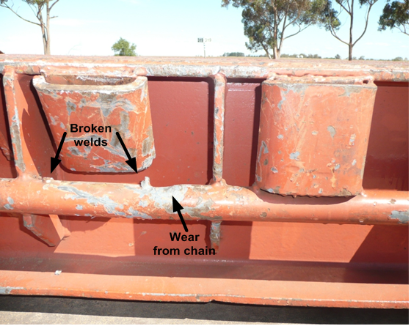

Figure 13 – Side gate pocket at the tie down point

## Tractor counterweight and tarpaulin tie-downs

The pallet of tractor counterweights shifted laterally to the extent that a corner was hanging over the Transi-flat edge and was out-of-gauge (Figure14).

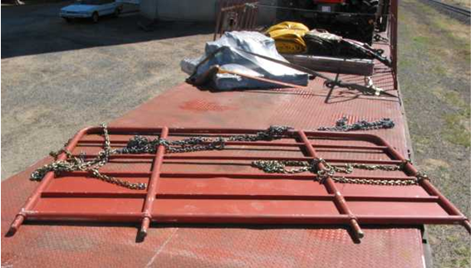

Figure 14 – The out-of-gauge pallet of counterweights on the Transi-flat at Dooen

The National Transport Commission - *Load Restraint Guide (2nd Edition 2004)* suggests the maximum weight that each 50 millimetre webbing strap can restrain. Using the conditions presented in the counterweight shift, a 50 millimetre webbing strap at an angle of approximately 15–30 degrees with a medium coefficient of friction can restrain up to 150 kg per webbing strap.

The counterweight load which weighed about 485 kg was only secured by two webbing straps at an angle of between 15 degrees – 30 degrees. This strapping arrangement did not meet the guidelines and was insufficient to secure the load during transport.

The miscellaneous tarpaulin load was also secured by two webbing straps, however this load weighed less than 300 kg and therefore the restraint method met the guidelines and was sufficient to secure the load during transit.

## Network requirements

Train operators are required to comply with the rail network manager’s (in this case the ARTC) train inspection requirements prior to departure. Operators must ensure that loads are secure and that rolling stock is fit to travel. They are then required to issue a Train Inspection Certificate to the train crew. In this incident, the train operator was not able to provide a copy of the certificate provided to the train crew.

ARTC Network and Pacific National procedures require train crew, when crossing other trains, to conduct ‘Roll-by’ train inspections. Train 2MA5 received such an inspection from a train crew at Wingeel Loop, 174 rail kilometres before the tractor was lost from the Transi-flat. The crew of the other train did not report observing any problems either with the general condition or the loading of 2MA5.

## Specialist examination and testing

### Loading demonstration

Simon National Carriers conducted a demonstration of the loading method for the Kubota M6040 tractor for the investigation. This demonstration was performed by the same truck driver involved with the loading on 5 January 2009. The load was secured in a similar manner with the exception of the use of carpet-type filler between chains at areas of overlap.

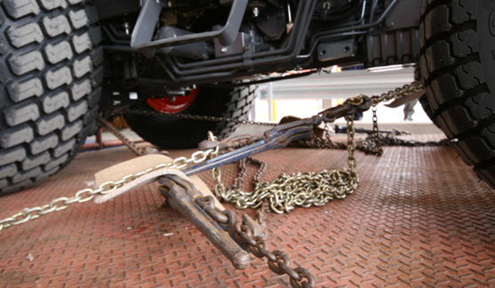

Figure 15 – Typical tractor tie down

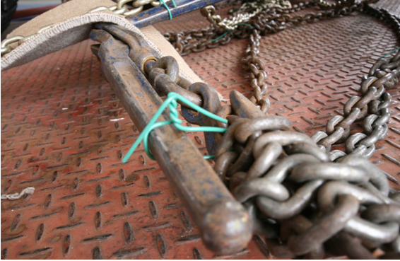

Figure 16 – Showing typical method of securing tension device with a wire twist

The tension applied to the tie-down chains is reliant on the variable exertion applied by an individual when tightening the chains. Other influences on the chain tension would be the use or non-use of carpet fillers and corner edge protection.

None of the loads were observed to employ corner edge protection between the chains and the Transi-flat sides.

### Metallurgical testing of chains

Sections of chain used to secure the tractor were submitted for independent scientific evaluation. The evaluation incorporated chemical analysis, mechanical testing and micro structural evaluation for both the fractured link and an intact link:

* Chemical analysis - The sample chain complied with the requirement of AS 4344 for a carbon content of 0.45 per cent maximum.
* Mechanical testing - The tensile properties of the chain exceeded the minimum requirement of AS 4344 for eight millimetre nominal chain (73.6 kN failure load and 17 per cent elongation at failure). The average hardness of the fractured link was slightly higher and more variable than the intact link which is consistent with it having been deformed in the fracture event.
* Micro-structural evaluation - The fracture showed some evidence of thinning and elongation typical of a tensile overload.

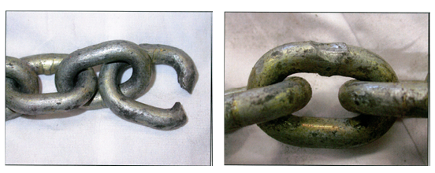

Figure 17 – Showing fractured and damaged chain links

The tensile testing performed on the apparently unaffected link resulted in higher-than-minimum code requirements, as did the hardness comparison. No significant evidence of corrosion, progressive cracking or other significant damage was observed in either link which would have been likely to result in a premature failure of the chain or indicate that the chain – as a whole – was in a compromised condition. The elongation of the links on one side of the fracture is consistent with the securing hook having been engaged on the fractured link with the single end having taken a load in excess of the chain’s SWL (Safe Working Load).

The type of chain used for the tractor tie-down was compliant with the RISSB and Pacific National loading manuals. The chain had a SWL of 4000 kg (with a breaking strength of 8000 kg) and was appropriately certified. The chains tested by the investigation met specification.

# 

# Analysis

## Sequence of events

The train was inspected prior to and when departing the Melbourne Freight Terminal and by ‘Roll-by’ inspection at Wingeel Loop. No abnormal issues with the train or its loading were identified on any of these occasions.

2MA5 continued its journey, passing through Maroona and then Ararat Station, 210 kilometres from Melbourne without incident. It then passed between two signal masts (almost opposite each other) at 238.100 kilometres. These two signals, like the many others on the corridor, are positioned about 2.4 metres from the track centre and did not show evidence of any impact damage.

Just beyond these signals there were marks consistent with a tractor tyre (believed to be the front right hand wheel of the incident tractor) having been dragged in the ballast shoulder. These drag marks continue across Ararat Road level crossing to the Colquhoun Street over-bridge. At the bridge, the tractor struck the abutment (evidenced by a large tyre scuff mark) and was subsequently dumped in the cutting, with debris spread in the drainage ditch beside the track over about 200 metres.

Train 2MA5 continued, without striking or damaging any further line-side infrastructure, until the train crew became aware of a loss of brake pipe pressure between Dooen and Horsham – at the 324 kilometre post – and brought the train to a stand.

Evidence indicated that the first point where the tractor actually moved partially off the Transi-flat and became significantly out-of-gauge (the presence of a wheel gouge in the shoulder of the ballast) was just beyond signal 2381, about 700 metres before the Ararat Road level crossing and about 2.2 kilometres before the Colquhoun Street over-bridge. Had the tractor been out-of-gauge before this signal it was not to the degree where the wheel was dragging in the ballast shoulder or sufficiently outside the wagon profile to make contact with the signal mast, which was the last line-side structure prior to the Colquhoun Street over-bridge.

The fact that 2MA5 was able to continue without incident for a further 82 kilometres without fouling any line-side structure or equipment also indicates that it is highly unlikely that any loose chains were flaying or that the damaged container cladding was fouling beyond the loading gauge.

In respect to the leak associated with container KAL 8573 or damaged cladding on container GESU 801271 the investigation was unable to determine at what stage during the journey these first occurred.

## Load shifts

The tie-down arrangement of the tractor was similar to that used on at least 270 previous tractor loads. While all chain angles to the Transi-flat deck were less than that recommended by the RISSB and Pacific National standards, the type and numbers of chains used were consistent with these standards. Calculations performed as part of the investigation indicated that it was unlikely that the chains would break unless subjected to extreme loads; significantly above those expected to have applied during this journey. The system of securing the tractors using four chains and lever-type load binders would be adequate providing all chains remain tensioned.

A variable factor in the effectiveness of the tie-down process is introduced by the individual loader, their skills and their performance on the day. Whilst there is no evidence to identify that the loader’s actions on this occasion had any influence on the event it must be recognised that any variation in the tensioning of the tie down chains would have an effect on the security of loading.

The marks on and around the damaged side gate pocket indicate that a chain was secured around the tie bar and this pocket to prevent the chain sliding along the bar and loosening. The loosening of one chain would have allowed movement of the tractor and loosening of other chains and potentially, the release of the chain tensioning devices.

For the tractor to move to the extent it did it would require lateral forces sufficient to overcome the friction between the tractor tyres and the Transi-flat deck. Lateral forces are generally higher when negotiating curves and points and crossings, or they may occur as the result of abnormal ride performance such as hunting, particularly when combined with poor track geometry. The bogies fitted to RQKY 4347D were in good condition and did not show signs of poor ride.

It is possible that the wagon conveying the tractors could have suffered a severe sideways jerk at the 194 kilometre marker that may have strained or snapped one or more of the right-side chains securing the tractor. The same right-hand 'wrench' on the other subject wagons may have strained the degraded cladding attachments on tank container GESU 801271 and contributed to the stress at the longitudinal mounting rib on tank container KAL 8573.

All wagons sustained an 'event' on their left-hand side in the direction of travel; the tractor fell from the left-hand side of the train, the cladding on the liquid foodstuffs tank container released to the left-hand side of the train and the tank container leak occurred at the longitudinal mounting rib on the left-hand, trailing end of the tank.

There was evidence of a pre-existing crack at the weld on the damaged side-gate pocket which would have made the pocket more susceptible to failure. While the actual loading on the welds would have been highly dependent on the detail of the manner of attachment in this area together with the presence of a pre-existing crack, the side-gate pocket may have fractured as a result of chain tension during transit. In these circumstances it would have been more likely for the welds on the side-gate pocket to fail before the chain.

The fact that the second tractor, which was similarly tied down, did not move supports the scenario of the side-gate pocket failure or the chain tensioning process contributing to the tractor load shift.

In summary, the most likely scenario is that the side gate pocket weld failed leading to a loss of tension in the right-hand side chain attached to the tractor drawbar. This loss of tension would have rendered the tie down system ineffective. Once tension in the system was lost, the tractor was in a condition that allowed sideways movement in reaction to the natural lateral and longitudinal movement of the rail wagon to the point where the tractor became out-of-gauge.

## Train condition monitoring.

The last check given to the train was a visual ‘Roll-by’ inspection about 260 kilometres prior to Stawell. The inspection frequency during a journey is reliant on the volume and pattern of rail traffic on any given day and it is common for trains to travel long distances without having a ‘Roll-by’ inspection. On this occasion 2MA5’s crew were unaware of any issues associated with their train until the loss of brake pipe pressure when approaching Horsham, 82 kilometres from where the tractor load shift/out-of-gauge incident occurred

The ARTC network does provide trackside equipment to monitor some rolling stock performance characteristics; however these installations do not monitor out-of-gauge events.

## Relationship between the occurrences

The coincidence of three incidents on the same train and within the distance of three coupled wagons is highly unusual and improbable, therefore factors that may link the incidents were considered. The ride and track conditions identified at the curves at the 194 kilometre mark may have had sufficient impact on the ride quality to trigger the individual load issues. The connection between the Terpene leak and the tractor load shift was also of interest; however, the fact that the lubricity of Terpene and water are similar indicated that the Terpene leak and the tractor load shift were not related, nor did the investigation identify any connection between the out-of-gauge cladding and the other two load incidents.

# 

# Conclusions

## Findings

1. The chain used for securing the tractor met the requirements of both the Pacific National Freight Loading Manual and the RISSB standards.
2. The method used to secure the tractor to the Transi-flat did not meet the recommended tie-down angles for securing chains as specified in the Pacific National Freight Loading Manual.
3. The tie-down arrangement used to secure the tractor counterweight pallet was inadequate for the weight of the load and not in accordance with the standard.
4. There was no evidence to suggest significant loss of dynamic performance or the initiation of bogie hunting on the freight wagons involved.
5. The loss of Terpene Hydrocarbon product was due to an undetected flaw in ISO tank container KAL 8573.
6. The investigation was unable to determine at what stage in the journey the Terpene Hydrocarbon leak commenced.
7. The investigation was unable to determine at what stage in the journey the out-of-gauge condition of ISO tank container GESU 801271 occurred.

## Contributing factors

### Tractor load shift

1. The weld that attached the side-gate support bracket to the wagon was not of sufficient strength to carry the loads applied by the tie-down chains.
2. Pacific National had well-documented and prescriptive procedures for mobile plant loading; however, these requirements were not enforced with the contractor or at an operational level within Pacific National.

### Terpene hydrocarbon leak incident

1. ISO tank container KAL 8573 had a flaw which was undetected at loading and developed further during transit.

### Out-of-gauge incident

1. The maintenance of ISO tank container GESU 801271 was inadequate.

# 

# Safety Actions

## Safety Actions taken since the event

Pacific National have reinforced with the freight forwarder that they are required to comply with the Freight Loading Manual regarding the securing method for mobile plant.

Pacific National has instructed train inspection staff that the mobile plant securing requirements of the Freight Loading Manual are to be adhered to.

## Recommended Safety Actions

**Issue 1**

The arrangement used to secure the tractor counterweight pallet was found to be inadequate and not to standard for the weight on the pallet.

RSA 2009013

That Pacific National reviews the securing of tractor counterweights when shipped as palletised loading on Transi-flat containers to ensure the tie-downs for the weight carried meet the standard.

**Issue 2**

Using Transi-flat side-gate pockets as securing points for tractor loads can introduce weak points; potentially leading to a loss of tension within the securing system.

RSA 2009014

That Pacific National considers updating its Freight Loading Manual to reflect this risk.

1. A Transi-flat container is a container base with removable sides and no roof structure.
2. Ride control bogies are fitted with specific suspension components to improve the ride characteristics of wagons.
3. Tautliner is used as a generic name for curtain-sided [trucks](http://en.wikipedia.org/wiki/Truck)/[trailers](http://en.wikipedia.org/wiki/Trailer_(vehicle)). The curtains contain load-retaining straps which, when released, allow the curtain to be pulled back and a [forklift](http://en.wikipedia.org/wiki/Forklift) to be used for easy and efficient loading and unloading.